Gravity-dependent mechanics of human–built-environment interfaces: preventing unintended translational and rotational impulse under partial gravity
Author: [redacted for review]
Abstract
Terrestrial built environments implicitly rely on gravity: the normal force and friction it supplies stabilize occupants at no design cost. When gravitational acceleration decreases, body mass and inertia persist while this passive stabilization declines. We formalize gravity-supplied stabilization as a mechanical boundary condition of occupant–interface interaction and introduce two cross-interface metrics — unintended translational impulse (UTI) and unintended angular impulse (UAI) — to test whether interface geometry can prevent momentum generation rather than restrain motion after it occurs. A transparent rigid-body occupant model was coupled to five canonical built-environment interfaces (door/hatch, seat ingress, control actuation, workstation, circulation) with mechanically normalized conventional and momentum-aware variants, swept continuously over $g^{*}$ = 0.05–1.00 $g_{Earth}$ with 2,000 Monte Carlo trials per reference gravity. For a conventional hinged door, the angular stabilization-demand ratio grew from $Γ_{T}$ ≈ 0.13 at 1 g to ≈ 0.81 at lunar gravity, and UAI increased by a factor of ~2153×; conventional seat ingress at 0.165 g produced 3.8 corrective actions per trial with a 16% stabilization-failure rate, versus essentially none at 1 g. Support-aligned and geometry-guided variants suppressed acquired UTI/UAI by 60–100% at partial gravity while leaving Earth-gravity behavior unchanged, and a cosmetic negative control left metrics invariant — evidence that the benefit is gravity-specific, not generic ergonomics. Results support a gravity-dependent design rule: interface topology can be parameterized by the environmental field g. The framework is computational and requires parabolic-flight or gravity-offload validation before application to habitat certification.
Keywords: partial gravity; human–environment interaction; impulse mechanics; built-environment design; postural stability; habitat architecture
Highlights: see separate Highlights file.

1. Introduction
1.1 Gravity as an implicit condition of terrestrial design. Every conventional built-environment element — a hinged door, a chair, a handrail, a desk — was designed under, and silently assumes, a gravitational field of approximately 9.81 $m/s^{2}$. That assumption is not merely about weight: gravity supplies the normal force $N ≈ m g$ and hence a friction capacity $μ N$ that quietly absorbs every task-irrelevant reaction a person generates at an interface. The occupant's inertia, by contrast, is independent of the ambient field. When g decreases — on the Moon ($g^{*}$≈0.165), Mars ($g^{*}$≈0.38), or in intermediate regimes — the stabilization budget shrinks in proportion to g while the momentum to be absorbed does not.
1.2 Human stabilization under partial gravity. Empirical partial-gravity work — parabolic flight, body-weight-support systems, and gravity-offload facilities — shows that locomotion mechanics, ground reaction forces, and functional-task performance change continuously with gravity level [1,2,3,4], with falls and settling errors increasing below ~0.5 g [5,6,7,8]. Standards such as NASA-STD-3001 Vol. 2 [9] address this through restraints, handholds, and mobility aids — stabilization applied after unwanted motion exists.
1.3 Limits of restraint-centered thinking. The prevailing design logic is therefore 'generate impulse, then restrain it.' Crew-load measurements aboard Mir and the Shuttle (EDLS, MICRO-G) [10,11] quantified interface reaction forces but treated them as vehicle disturbances, not as an occupant burden to be minimized at the source.
1.4 Momentum generation as a built-environment problem. We invert the question: can the interface itself be shaped so that unnecessary transverse and rotational momentum is never generated? This is a building-science question in the same sense that thermal or acoustic boundary conditions shape occupant–environment interaction — gravity is an environmental field, and interface topology may be a function of it (Figure 1).
1.5 Objectives and hypotheses. We test H1–H6: (H1) gravity-supplied stabilization declines relative to inertia; (H2) momentum-aware interfaces reduce unintended translational impulse UTI; (H3) they reduce unintended angular impulse UAI; (H4) the benefit grows as g falls (gravity × design interaction, the primary inferential target); (H5) passive geometric guidance can substitute for part of gravity's stabilizing role; (H6) the principle generalizes across mechanically distinct interfaces.

2. Methods
2.1 Conceptual framework. Occupant + interface + support surface form one mechanical system. The interface reaction R is decomposed into $F_{parallel}$ along the task-relevant axis $e_{d}$ and the task-irrelevant transverse component $F_{perp} = R − F_{parallel}$ (Figure 2).
2.2 Gravity-supplied stabilization. Normal capacity $N = m g + R_{v}$; usable transverse capacity $F_{cap} = μ f_{u} N$ and rotational capacity $τ_{cap} = μ f_{u} N r_{f}$, with $f_{u}$ a friction-utilization factor (U[0.5, 0.85]) capturing that the full static budget is not available mid-motion. Both capacities scale linearly with g; inertia does not — the entire asymmetry the study exploits.
2.3 Metrics. $UTI = ∫ max\left(\left|F_{perp}\right|\left(1−η_{g}\right)−F_{cap},0\right) dt$ (passive guidance absorbs fraction $η_{g}$ of demand before friction must respond). UAI analogously for torque. Secondary outcomes: peak transverse force, COM drift, yaw excursion, corrective impulse $J_{corr}$, corrective-action count, loss-of-support events, failure flag. $Γ_{T} = \frac{max\left|F_{perp}\right|}{μ f_{u} m g}$ is a stabilization-demand ratio, not a fall threshold.
2.4 Human model. Level-1 planar rigid body (parameters in Table 1): $m \sim N\left(75,9^{2}\right)$ kg truncated [50,110]; $H \sim N\left(1.75,{0.08}^{2}\right)$; $I_{yaw} = 0.013 m H^{2}$ [12]; $μ \sim U\left[0.3,0.7\right]$ [13,14]; support half-width and rotational lever scale with H; reaction delay $t_{react} \sim U\left[0.3,0.6\right]$ s. Semi-implicit Euler at dt = 1 ms (5 ms for the 30-s workstation task); corrective actions arrest accumulated momentum once support margins are exceeded.
2.5 Canonical scenarios. Five mechanically normalized classes (Table 2): door/hatch (hinged, lateral-slide, vertical-guided, cosmetic negative control; operating forces anchored to door-force standards [15,16,17]), seat ingress (turn-chair, linear-entry, straddle-guided; sit-to-stand mechanics [18,19]), control actuation (rotary, lateral lever, axial lever, push/pull — the analytic verification case), workstation (flat, centering, guided; perturbation-driven reaching), and vertical circulation (conventional stair+rail, guided rail, captive descent; handrail mechanics [20,21]). All variants deliver identical useful task impulse within each class.
2.6 Gravity sweep. Continuous $g^{*}$ ∈ [0.05, 1.00] on a 40-point grid, with reference points at Moon 0.165, Mars 0.38, and 0.25/0.5/0.75/1.00.
2.7 Uncertainty. N = 2,000 Monte Carlo trials per case × variant × reference gravity; convergence confirmed by doubling-N diagnostics (MC mean UAI varies < 8% between N = 250 and 4000).
2.8 Statistics. Gravity × design interaction estimated as the slope $β_{g}$ of $log\left(\frac{{impulse}_{redesign}}{{impulse}_{conventional}}\right)$ versus $g^{*}$, fitted per variant pair for each channel; normalized benefits $B_{UTI}\left(g^{*}\right) = 1 − \frac{{UTI}_{red}}{{UTI}_{conv}}$ and $B_{UAI}\left(g^{*}\right) = 1 − \frac{{UAI}_{red}}{{UAI}_{conv}}$ reported continuously (masked where the baseline impulse < 1e-3, a regime in which the ratio is ill-conditioned); transition gravities where baseline $Γ_{T}$ first exceeds 1 reported as exploratory.
2.9 Verification. Automated tests verify impulse integration against analytic integrals, momentum conservation at vanishing capacity, monotonic $Γ_{T}$ ∝ 1/g scaling, zero-transverse-limit behavior, and negative-control invariance (11/11 tests pass).
2.10 External validation. Level A directional agreement with parabolic-flight functional-task results and GRF literature; Level B order-of-magnitude consistency; Level C calibration deferred — no public dataset reports transverse interface impulse under partial gravity (see Supplement).
2.11 Sensitivity. One-at-a-time sweeps over $μ$, m, $f_{u}$, $t_{react}$ and force scale at Mars g [22]; suit/load block adds 0–60 kg effective mass and restricted-ROM reaction delays.
2.12 Falsification. Predefined criteria A–F (no gravity dependence; equal benefit at all g; single-interface confinement; metric/behavior decoupling; fragility to parameter uncertainty; unrealistic force requirements) are checked explicitly in Results/Discussion.

3. Results
3.1 Model verification. Analytic checks all pass; the negative control (restyled door, identical mechanics) reproduces the hinged baseline UAI within MC noise (Moon: 7.48 vs 7.41 N·m·s).
3.2 Gravity and stabilization margin. For every conventional interface the demand ratio $Γ_{T}$ rises ~as 1/g: e.g., hinged door 0.13 at Earth → 0.35 at Mars → 0.80 at lunar g; lateral slide exceeds $Γ_{T}$ = 1 below ~0.20 g. Baseline $Γ_{T}$ ≥ 1 is first reached near $g^{*}$ ≈ 0.37 (seat) — Table 3 lists per-case crossings.
3.3 Conventional-interface impulse burden. At 0.165 g the conventional chair ingress requires 3.8 corrective actions per trial (Earth: 0.02) with a 16% failure rate; door UAI rises 2153× from 1 g to lunar g. Critically, the dominant channel for door and seat is angular — yaw torques about the support axis — while circulation/workstation burden is transverse (Table 3, Figure 3).
3.4 Momentum-aware redesign. Support-aligned and guided variants (Figure 4) suppress acquired impulse strongly at partial g: vertical-guided door UAI ≈ 0 at all g; straddle seat UAI falls 99% at lunar g (0.10 vs 13.55 N·m·s); guided workstation reduces UTI from 2.47 to 0.00 N·s at 0.165 g; guided/captive circulation eliminates transverse excess entirely. Note that alternative seat geometries change the required motion itself — the linear and straddle entries demand much smaller transverse/yaw impulse than the 150° chair turn (raw demand integrals are reported per variant in the supplement), so the UAI reduction combines demand elimination at the source with residual absorption; that combination is precisely the prevention mechanism this paper tests, not capacity gains at fixed demand.
3.5 Rotation-specific effects. The lateral sliding door — intuitively 'guided' — increases UTI relative to hinged (Moon: 7.25 vs 0.69 N·s) because its task axis is fully transverse to support. Momentum-awareness is directional, not generic.
3.6 Passive geometric guidance. Guide fraction $η_{g}$ absorbs demand upstream of friction: at Moon the guided workstation/rail variants hold UTI near zero where baselines are unstable. These near-zero values are a structural consequence of the idealized model — the residual demand $\left(1−η_{g}\right)\left|F_{perp}\right|$ falls below capacity — and should be read as 'approaches zero under perfect guidance', not literal elimination of burden in hardware. Benefit curves B($g^{*}$) (Figure 5) exceed 0.5 for most classes below $g^{*}$ ≈ 0.05–0.37 (exploratory transition estimates, Table S2).
3.7 Gravity × design interaction. Interaction slopes (log-ratio vs $g^{*}$) are significantly positive for the dominant channel in door (UAI, $β$ = 9.2, $R^{2}$ = 0.99), seat (UTI, $β$ = 7.2, $R^{2}$ = 0.99) and workstation (UTI, $β$ ≈ 19.9), i.e. the log advantage of the redesign falls toward zero as $g^{*}$ approaches 1, so relative benefit grows as g falls — H4 supported.
3.8 Cross-interface synthesis. All five classes show the same qualitative signature — conventional burden rising with falling g, momentum-aware variants flat — supporting H6. H5 is supported by the guide-absorption mechanism producing benefit without active restraint.
3.9 Sensitivity and suit loads. The qualitative ordering survives ±25% force scale, $μ$ ∈ [0.3,0.7], $f_{u}$ ∈ [0.5,0.85], $t_{react}$ ∈ [0.3,0.6] s (Table 4). Adding 40 kg of suit-equivalent mass raises capacity ∝ mass (stabilizing) while inertia grows equally — net effect: capacity ratio unchanged in the friction channel but absolute impulses scale with mass; restricted-ROM reaction delays increase corrective counts at lunar g. The central interaction survives all blocks.

4. Discussion
4.1 Main findings. Gravity functions as an implicit stabilizing component of terrestrial interfaces; the stabilization-demand ratio $Γ_{T}$ quantifies it. Task-irrelevant impulse at occupant–interface boundaries grows approximately with 1/g for conventional geometries and is substantially preventable by support-aligned actuation and passive geometric guidance.
4.2 Gravity as part of human–built-environment mechanics. The framework makes g an explicit design parameter: interface topology = f(g). This is the same logic by which building science parameterizes thermal or acoustic boundary conditions — mechanically distinct, structurally analogous.
4.3 From restraint to momentum prevention. NASA-STD-3001's restraint provisions address symptoms; our results suggest geometry can remove part of the cause. The angular channel — largely ignored in restraint-centric design — dominates door and seat burden.
4.4 Degrees of freedom and passive guidance. Reducing effective uncontrolled DOF (guided rails, captured seat paths) substitutes for lost friction stabilization; the penalty dimensions (reach restriction, ingress complexity) are real and mapped in the Pareto analysis (Supplement) rather than collapsed into a scalar score.
4.5 Implications for extraterrestrial habitats. Candidate redesign directions (support-aligned actuation, geometry-guided ingress, guided circulation) are mechanically preferable below ~{g_cross_max:.2f} g for the studied tasks (Figure 6) — as candidate strategies {[23,24,25]}, not certified solutions.
4.6 The gravity–inertia pair as a design regime. The results generalize to a framing beyond the studied geometries: existing buildings, furniture, and interfaces may represent solutions adapted not only to human anthropometry but to a specific terrestrial gravity–inertia regime. Human–environment design can be expressed conceptually as f(anthropometry, biomechanics, gravity, inertial properties, support mechanics), and Earth architecture then occupies one particular point in that regime space rather than a universal optimum. If effective gravity or apparent inertia ever become technologically controllable — artificial-gravity habitats, active support systems, robotic furniture, training devices — environmental mechanics themselves would become design variables, expanding the architectural design space. This is a future implication only: the present study tested passive geometry under fixed partial-g fields, not programmable inertia.
4.7 Beyond the specific designs. The metric set (UTI, UAI, $Γ_{T}$) applies to any interface; designers can evaluate existing elements at arbitrary g before prototyping.
4.8 Limitations. Single-rigid-body mechanics, Coulomb-type friction simplification, prescribed (not learned) task kinematics, qualitative-only external validation, and no microgravity-to-partial-gravity continuity claim. The lateral-door result shows redesign can hurt a channel — geometry changes must be evaluated per demand direction. Benefits are mechanical, not yet clinical or operational.
4.9 Experimental validation agenda. Parabolic-flight or gravity-offload studies with IMUs, instrumented interfaces, and force plates measuring transverse impulse, angular impulse, COM excursion and corrective counts can test the framework directly; UTI/UAI provide the endpoints.

5. Conclusions
Treating gravity as an implicit stabilizer of human–built-environment interfaces predicts, and our simulations confirm, a continuous gravity × design interaction: conventional Earth-derived geometries generate rising unintended translational and especially rotational impulse as $g^{*}$ falls below ~0.37, while momentum-aware geometries suppress that impulse at its source. The framework — $Γ_{T}$ demand ratio plus UTI/UAI metrics — is falsifiable, cross-interface, and directly testable in partial-gravity human experiments.

Tables
Table 1. Model variables, meaning, and ranges/sources.
symbol | meaning | range/source
m | occupant mass [kg] | $N\left(75,9^{2}\right)$ trunc [50,110]
H | stature [m] | $N\left(1.75,{0.08}^{2}\right)$ trunc [1.5,2.0]
mu | support friction coefficient $μ$ | U[0.3,0.7] (RCOF lit.)
$f_{u}$ | friction utilization | U[0.5,0.85] (assumption)
$I_{yaw}$ | yaw inertia [kg·$m^{2}$] | 0.013·m·$H^{2}$ (Winter scaling)
$r_{f}$ | rotational lever [m] | 0.12·H/1.75
$t_{react}$ | corrective delay [s] | U[0.3,0.6]
eta | guide absorption fraction | case-fixed {0.7–0.95}
$F_{task}$ | interface operating force [N] | case-fixed ±25%
Table 2. Canonical scenarios and mechanical normalization.
case | variants | normalization
door/hatch | hinged | lateral slide | vertical guided | cosmetic control | identical opening impulse & task time
seat ingress | turn chair | linear | straddle-guided | same start/end COM, T=3 s
control | rotary | lateral | axial | push-pull | identical useful work W = F·s
workstation | flat | centering | guided | cosmetic control | same perturbation statistics, T=30 s
circulation | stair+rail | guided rail | captive | same perturbation statistics, T=8 s
Table 3. Primary outcomes at Earth, Mars and Moon reference gravities (MC means).
case | variant | $g^{*}$ | UTI [N·s] | UAI [N·m·s] | $J_{corr}$ [N·s] | n_corr | $Γ_{T}$ | fail rate
door | hinged | 1.000 | 0.000 | 0.003 | 0.000 | 0.00 | 0.13 | 0.000
door | hinged | 0.380 | 0.000 | 1.577 | 0.000 | 1.02 | 0.35 | 0.000
door | hinged | 0.165 | 0.692 | 7.410 | 0.692 | 3.19 | 0.80 | 0.000
door | lateral slide | 1.000 | 0.000 | 0.000 | 0.000 | 0.00 | 0.28 | 0.000
door | lateral slide | 0.380 | 0.209 | 0.007 | 0.209 | 0.01 | 0.73 | 0.000
door | lateral slide | 0.165 | 7.253 | 0.420 | 7.253 | 0.67 | 1.69 | 0.000
door | vertical guided | 1.000 | 0.000 | 0.000 | 0.000 | 0.00 | 0.01 | 0.000
door | vertical guided | 0.380 | 0.000 | 0.000 | 0.000 | 0.00 | 0.04 | 0.000
door | vertical guided | 0.165 | 0.000 | 0.000 | 0.000 | 0.00 | 0.09 | 0.000
door | neg control | 1.000 | 0.000 | 0.002 | 0.000 | 0.00 | 0.13 | 0.000
door | neg control | 0.380 | 0.000 | 1.538 | 0.000 | 1.01 | 0.34 | 0.000
door | neg control | 0.165 | 0.584 | 7.484 | 0.584 | 3.23 | 0.79 | 0.000
seat | chair | 1.000 | 0.254 | 0.002 | 0.254 | 0.02 | 0.53 | 0.000
seat | chair | 0.380 | 35.168 | 4.578 | 34.214 | 2.29 | 1.38 | 0.015
seat | chair | 0.165 | 102.419 | 13.554 | 89.922 | 3.79 | 3.19 | 0.165
seat | linear | 1.000 | 0.000 | 0.000 | 0.000 | 0.00 | 0.07 | 0.000
seat | linear | 0.380 | 0.000 | 0.020 | 0.000 | 0.00 | 0.17 | 0.000
seat | linear | 0.165 | 0.000 | 1.361 | 0.000 | 0.04 | 0.39 | 0.000
seat | straddle | 1.000 | 0.000 | 0.000 | 0.000 | 0.00 | 0.02 | 0.000
seat | straddle | 0.380 | 0.000 | 0.000 | 0.000 | 0.00 | 0.06 | 0.000
seat | straddle | 0.165 | 0.000 | 0.095 | 0.000 | 0.00 | 0.13 | 0.000
control | rotary | 1.000 | 0.000 | 0.000 | 0.000 | 0.00 | 0.07 | 0.000
control | rotary | 0.380 | 0.000 | 0.000 | 0.000 | 0.00 | 0.18 | 0.000
control | rotary | 0.165 | 0.001 | 0.000 | 0.001 | 0.00 | 0.41 | 0.000
control | lateral lever | 1.000 | 0.000 | 0.000 | 0.000 | 0.00 | 0.07 | 0.000
control | lateral lever | 0.380 | 0.000 | 0.007 | 0.000 | 0.00 | 0.17 | 0.000
control | lateral lever | 0.165 | 0.000 | 0.536 | 0.000 | 0.31 | 0.40 | 0.000
control | axial lever | 1.000 | 0.000 | 0.000 | 0.000 | 0.00 | 0.00 | 0.000
control | axial lever | 0.380 | 0.000 | 0.000 | 0.000 | 0.00 | 0.01 | 0.000
control | axial lever | 0.165 | 0.000 | 0.000 | 0.000 | 0.00 | 0.02 | 0.000
control | push pull | 1.000 | 0.000 | 0.000 | 0.000 | 0.00 | 0.07 | 0.000
control | push pull | 0.380 | 0.000 | 0.000 | 0.000 | 0.00 | 0.18 | 0.000
control | push pull | 0.165 | 0.000 | 0.000 | 0.000 | 0.00 | 0.40 | 0.000
workstation | flat | 1.000 | 0.000 | 0.000 | 0.000 | 0.00 | 0.19 | 0.000
workstation | flat | 0.380 | 0.069 | 0.000 | 0.067 | 0.02 | 0.50 | 0.000
workstation | flat | 0.165 | 2.470 | 0.000 | 2.254 | 0.72 | 1.15 | 0.000
workstation | centering | 1.000 | 0.000 | 0.000 | 0.000 | 0.00 | 0.19 | 0.000
workstation | centering | 0.380 | 0.000 | 0.000 | 0.000 | 0.00 | 0.49 | 0.000
workstation | centering | 0.165 | 0.000 | 0.000 | 0.000 | 0.00 | 1.13 | 0.000
workstation | guided | 1.000 | 0.000 | 0.000 | 0.000 | 0.00 | 0.19 | 0.000
workstation | guided | 0.380 | 0.000 | 0.000 | 0.000 | 0.00 | 0.49 | 0.000
workstation | guided | 0.165 | 0.000 | 0.000 | 0.000 | 0.00 | 1.13 | 0.000
workstation | neg control | 1.000 | 0.000 | 0.000 | 0.000 | 0.00 | 0.19 | 0.000
workstation | neg control | 0.380 | 0.089 | 0.000 | 0.085 | 0.03 | 0.50 | 0.000
workstation | neg control | 0.165 | 2.512 | 0.000 | 2.280 | 0.71 | 1.15 | 0.000
stairs | conventional | 1.000 | 0.000 | 0.000 | 0.000 | 0.00 | 0.11 | 0.000
stairs | conventional | 0.380 | 0.000 | 0.000 | 0.000 | 0.00 | 0.29 | 0.000
stairs | conventional | 0.165 | 0.129 | 0.000 | 0.113 | 0.01 | 0.68 | 0.000
stairs | guided rail | 1.000 | 0.000 | 0.000 | 0.000 | 0.00 | 0.11 | 0.000
stairs | guided rail | 0.380 | 0.000 | 0.000 | 0.000 | 0.00 | 0.29 | 0.000
stairs | guided rail | 0.165 | 0.000 | 0.000 | 0.000 | 0.00 | 0.66 | 0.000
stairs | captive | 1.000 | 0.000 | 0.000 | 0.000 | 0.00 | 0.11 | 0.000
stairs | captive | 0.380 | 0.000 | 0.000 | 0.000 | 0.00 | 0.29 | 0.000
stairs | captive | 0.165 | 0.000 | 0.000 | 0.000 | 0.00 | 0.66 | 0.000
Table 4. Sensitivity and robustness summary (door, $g^{*}$ = 0.38).
param | value | UTI | UAI | $Γ_{T}$ | $J_{corr}$
baseline | 0.0 | 0.000 | 0.661 | 0.33 | 0.000
mu | 0.3 | 0.000 | 5.403 | 0.55 | 0.000
mu | 0.5 | 0.000 | 0.661 | 0.33 | 0.000
mu | 0.7 | 0.000 | 0.000 | 0.24 | 0.000
mass | 55.0 | 0.000 | 3.468 | 0.45 | 0.000
mass | 75.0 | 0.000 | 0.661 | 0.33 | 0.000
mass | 95.0 | 0.000 | 0.000 | 0.26 | 0.000
fric_use | 0.5 | 0.000 | 3.441 | 0.45 | 0.000
fric_use | 0.68 | 0.000 | 0.661 | 0.33 | 0.000
fric_use | 0.85 | 0.000 | 0.000 | 0.27 | 0.000
$t_{react}$ | 0.3 | 0.000 | 0.661 | 0.33 | 0.000
$t_{react}$ | 0.45 | 0.000 | 0.661 | 0.33 | 0.000
$t_{react}$ | 0.6 | 0.000 | 0.661 | 0.33 | 0.000
force_scale | 1.5 | 0.000 | 6.594 | 0.50 | 0.000

Figure captions
Figure 1. Conceptual framework. Terrestrial design treats gravity as a free stabilizer (normal force → friction capacity). Under partial gravity, capacity falls ∝ g while inertia is unchanged, so conventional interfaces increasingly inject task-irrelevant impulse. Momentum-aware geometry prevents generation instead of restraining it.
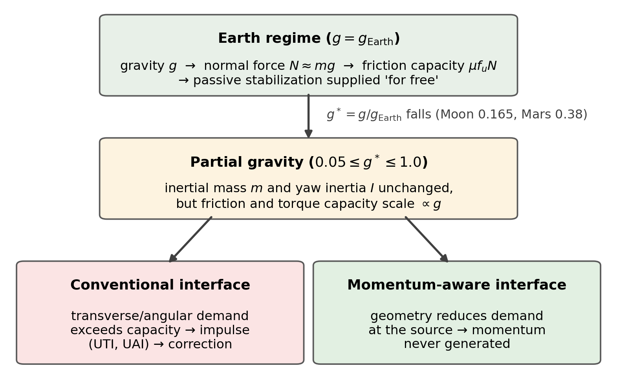
Figure 2. Mechanical framework. Interface reaction R decomposes into task-relevant $F_{parallel}$ and task-irrelevant $F_{perp}$; the excess of demand over gravity-scaled capacity accumulates as UTI and UAI.
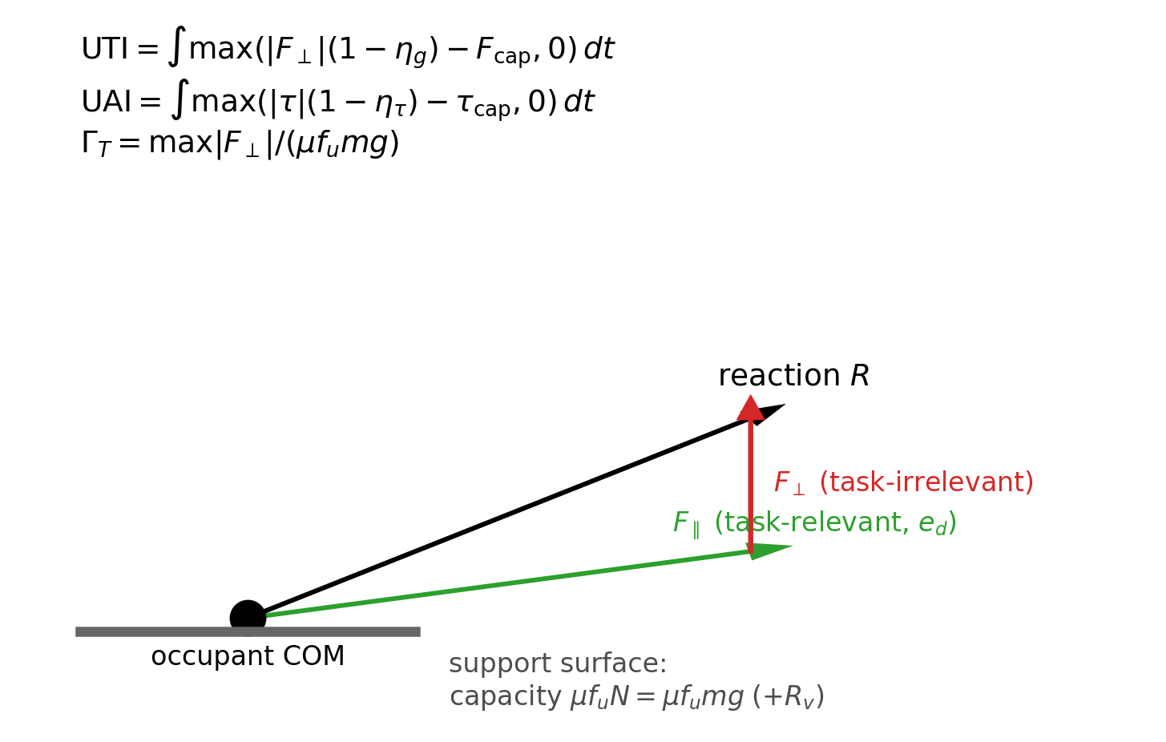
Figure 3. Gravity response of the door/hatch case: UTI, UAI and stabilization-demand ratio $Γ_{T}$ versus $g^{*}$ = g/$g_{Earth}$ for hinged (conventional), lateral-slide, vertical-guided and cosmetic negative-control variants.
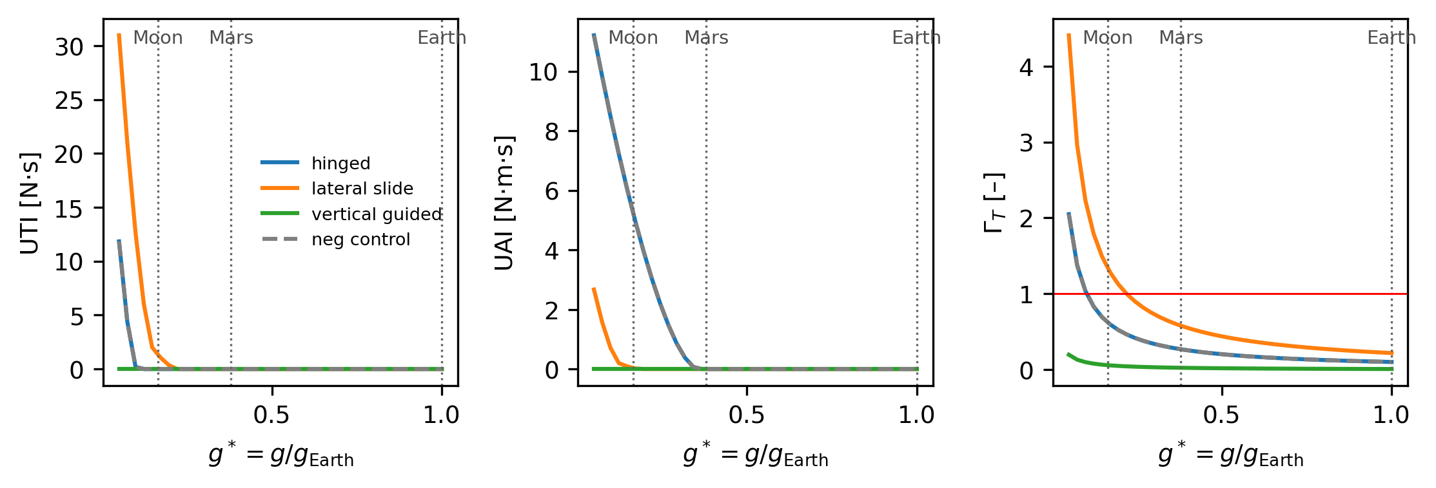
Figure 4. Canonical interface scenarios. Conventional versus candidate momentum-aware geometries for the five studied classes.
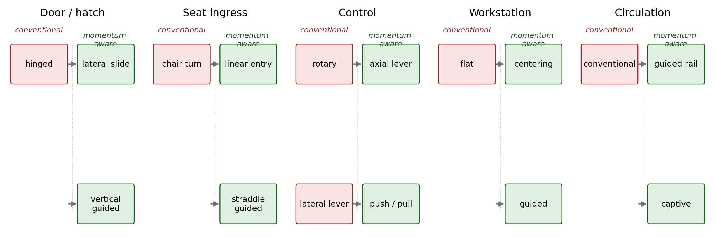
Figure 5. Cross-interface synthesis: normalized benefits $B_{UTI}\left(g^{*}\right) = 1 − \frac{{UTI}_{red}}{{UTI}_{conv}}$ (left) and $B_{UAI}\left(g^{*}\right) = 1 − \frac{{UAI}_{red}}{{UAI}_{conv}}$ (right) of redesigned variants versus conventional baselines, as a continuous function of gravity; masked where baseline impulse < 1e-3 N·s (N·m·s).
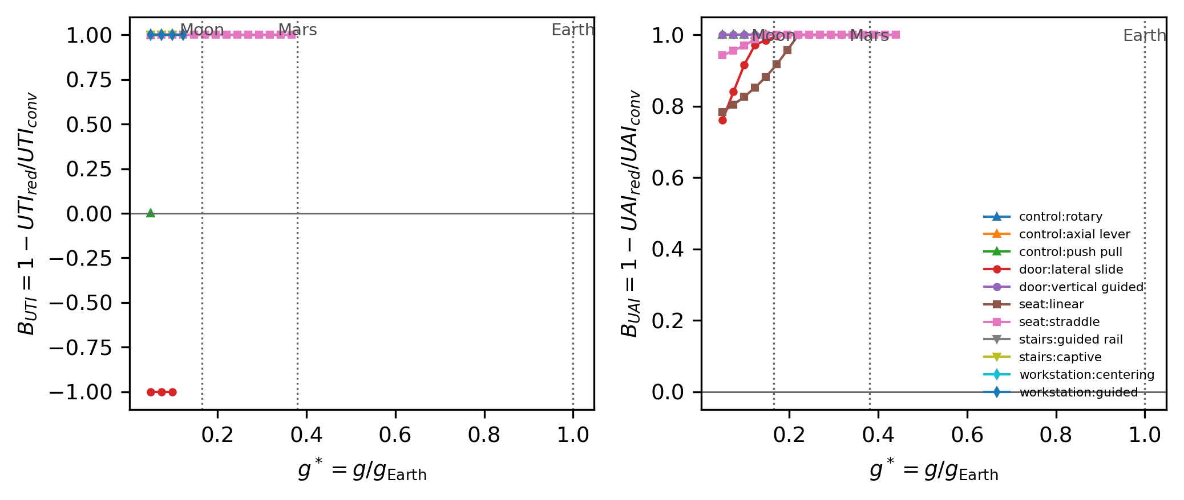
Figure 6. Design-regime map for the door case. $Γ_{T}$ < 1 region: conventional geometry adequate; intermediate region: passive guidance beneficial; low-g region: momentum-preventive redesign mechanically consequential. Bands are exploratory.
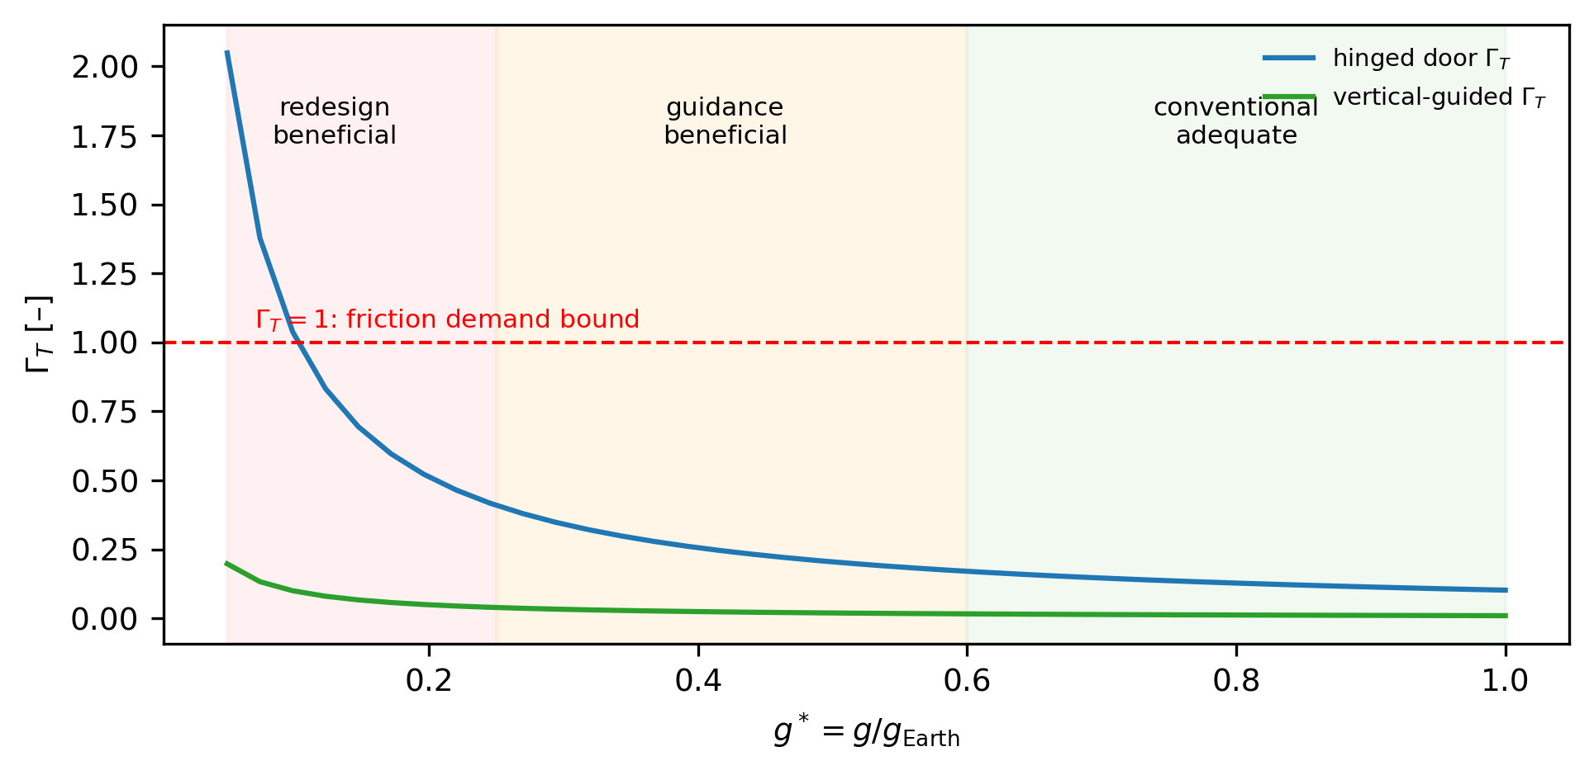

Declarations
CRediT: sole author conceptualization, analysis, writing. Competing interests: none declared. Data availability: all code and generated outputs are available in the project repository (github.com/bougtoir/gravity_momentum_design). Generative AI: an AI assistant (Devin, Cognition) performed coding and drafting under author direction.

References
1. Newman DJ. Human locomotion and energetics in simulated partial gravity. MIT, 1992.
2. Richter C, et al. Human biomechanical and cardiopulmonary responses to partial gravity — a systematic review. Front Physiol 2017;8. PMC5559498.
3. Human muscle activity and lower limb biomechanics at varying simulated reduced gravity. J Appl Physiol 2021. PMC8279339.
4. Simulation studies of bipedal walking on the Moon and Mars. Trans JSASS Aerosp Technol Jpn 2012;10. doi:10.2322/tastj.10.pp_5.
5. Macaulay TR, et al. Functional activities essential for space exploration performed in partial gravity during parabolic flight. npj Microgravity 2024. doi:10.1038/s41526-024-00422-3.
6. Valle PS, et al. A preliminary assessment of physical demand during simulated lunar surface EVA. IEEE Aerospace Conf 2023. doi:10.1109/AERO55745.2023.10115603.
7. Bekdash O, et al. Development and evaluation of the Active Response Gravity Offload System as a lunar and Martian EVA simulation environment. NASA NTRS 20205003610, 2020.
8. Human performance in simulated reduced gravity environments. NASA NTRS 20140017135, 2014.
9. NASA. Spaceflight Human System Standard Vol.2: Human Factors, Habitability, and Environmental Health (NASA-STD-3001-V2).
10. Astronaut-induced disturbances to the microgravity environment of the Mir space station. J Spacecr Rockets 2001. doi:10.2514/2.3719.
11. Crew-induced load measurement for space operations. Proc Hum Factors Soc 1987;31:725.
12. Winter DA. Biomechanics and Motor Control of Human Movement. Wiley.
13. Quantification of gait stability during incline and decline walking: RCOF and dynamic postural index. Sensors/PMC9581656, 2022.
14. Effects of foot–ground friction and age-related gait changes on falls during walking: a neuromusculoskeletal study. Sci Rep 2024. doi:10.1038/s41598-024-81361-7.
15. ISO 9379:2005 Operating forces — test method — doors.
16. UFAS/ADA A4.13.11 Door opening force.
17. Design of the force measuring system for the hinged door: analysis of the required operating torque. Int J Ind Ergon 2015. doi:10.1016/j.ergon.2015.05.010.
18. Coordinated ground forces exerted by buttocks and feet are adequately programmed. J Neurophysiol 1999. PMID 10601437.
19. Computation of kinematics and minimum peak joint moments of sit-to-stand. Med Eng Phys. PMC1929086.
20. Stair ambulation with and without a handrail and COP velocities. Gait Posture 2011. PMID 21816614.
21. Use of handrails for balance and stability: loading profiles in younger adults. Appl Ergon 2018.
22. Sobol' IM. Global sensitivity indices for nonlinear mathematical models and their Monte Carlo estimates. Math Comput Simul 2001;55:271-280. doi:10.1016/S0378-4754(00)00270-6.
23. Waclavicek R, et al. Interior configuration concepts for the Gateway iHab. IAC-19-E5.1-49818, 2019.
24. Design structure matrix approach applied to lunar habitat design. Buildings 2023;13(5):1284. doi:10.3390/buildings13051284.
25. Hall TW. An artificial-gravity space-settlement ground-analogue design concept. AIAA SPACE 2016. doi:10.2514/6.2016-5388.

