Comment

Hansen's disease remains a barrier to entry: 20 countries still screen work visa applicants for a curable, low-transmission disease

[Author Name(s)]
[Affiliation(s)]
Correspondence to: [Corresponding Author Email]

Word count: ~1,500 words | 4 Figures | 1 Table | 15 References

Hansen’s disease (leprosy) is among the oldest documented infectious diseases in human history, yet its place in modern immigration law remains strikingly anachronistic. Despite being curable with WHO’s multidrug therapy (MDT) within 6–12 months, non-highly transmissible (approximately 95% of the global population has natural immunity to Mycobacterium leprae), and having a global new case detection rate below 200,000 per year, Hansen’s disease continues to be listed as a ground for medical inadmissibility in immigration regulations across multiple countries.
We conducted a scoping review following PRISMA-ScR guidelines to systematically map which of the 197 UN member states and observer entities (193 member states plus Taiwan, Palestine, Vatican City, and Kosovo) require disease-specific medical screening for work visa applicants, with particular attention to whether Hansen’s disease is explicitly named. Our search encompassed official government legislation, immigration medical examination forms, published regulatory frameworks, the International Federation of Anti-Leprosy Associations (ILEP) discriminatory laws database, and peer-reviewed academic literature.
We identified 20 countries and territories (10·2% of those examined) that explicitly name Hansen’s disease in their work visa medical requirements (Table 1). The six Gulf Cooperation Council (GCC) states—Saudi Arabia, UAE, Qatar, Kuwait, Oman, and Bahrain—operate a unified medical screening system through the GCC Approved Medical Centers Association (GAMCA), which lists leprosy as a condition rendering applicants “medically unfit.” Given that the GCC collectively hosts over 35 million migrant workers, predominantly from South and Southeast Asia, this represents the single largest population affected by Hansen’s disease-based immigration screening globally.
Beyond the GCC, five countries in East and Southeast Asia (China, Thailand, Taiwan, Malaysia, and the Philippines) require certification of non-infection with Hansen’s disease for foreign workers. South Africa and Namibia retain colonial-era provisions in their immigration medical certificates. Russia’s Federal Law on the Legal Status of Foreign Citizens includes leprosy among conditions warranting denial of entry. The United States, despite its 2010 removal of HIV from its list of inadmissible conditions, continues to classify “infectious leprosy” as a Class A condition under INA §212(a)(1)(A)(i), though in practice the CDC Technical Instructions now allow admission of individuals who have completed or are undergoing treatment.
Our data accessibility varied by language of source. Of 197 countries examined, 110 (55·8%) were fully characterized through English-language sources alone: 58 with confirmed disease-specific screening and 52 with confirmed absence of such requirements. For the remaining 87 countries (44·2%), English sources were insufficient. Supplementary multilingual research in Arabic, Vietnamese, Sinhala, Indonesian, and other official languages yielded specific screening data for 5 additional countries (2·5%)—Jordan, Lebanon, Vietnam, Sri Lanka, and Indonesia—bringing confirmed information to 115 countries (58·4%). The remaining 82 countries (41·6%) could not be fully characterized despite multilingual research; notably, 39 of these have English as an official language, suggesting non-public dissemination to panel physicians rather than language barriers as the primary factor. None of the 5 additionally confirmed countries screened for Hansen’s disease, suggesting that the 20 countries identified may represent a near-complete enumeration.
The persistence of Hansen’s disease screening in immigration medical examinations is difficult to justify on public health grounds. Hansen’s disease ranked as the 5th most commonly named disease in work visa screening (34·5% of 58 countries with disease-specific requirements), despite its low transmissibility, long incubation period (3–5 years), and the availability of free, curative treatment worldwide. This positions it alongside diseases with far higher transmission potential and public health burden. Tuberculosis (94·8%), HIV/AIDS (82·8%), syphilis (65·5%), and hepatitis B (51·7%) are all more frequently screened, but each carries demonstrably greater epidemiological justification for pre-entry detection.
Japan’s experience offers an instructive counter-example. Having abolished its Leprosy Prevention Law (らい予防法) in 1996 and acknowledged through landmark litigation in 2001 that forced isolation constituted a violation of constitutional rights, Japan does not include Hansen’s disease in its immigration medical screening. Japan’s pre-entry TB screening programme (JPETS) demonstrates that evidence-based, disease-specific screening is feasible without perpetuating stigma against conditions that do not meet the threshold for border health intervention.
The UN General Assembly Resolution A/RES/65/215 (2010) calls upon member states to eliminate discrimination against persons affected by Hansen’s disease, with Principle 7 explicitly affirming the right of affected persons to freedom of movement, including entry into and exit from countries. The UN Special Rapporteur on leprosy, appointed in 2017, has documented ongoing discriminatory laws in immigration contexts. Yet our findings indicate that at least 20 countries maintain provisions that directly contravene these principles.
We call on the following actions: (1) Countries currently screening for Hansen’s disease in immigration medical examinations should review these requirements against current epidemiological evidence and WHO guidelines; (2) the GCC states should consider removing leprosy from the GAMCA/WAFID medical unfitness criteria, given the disproportionate impact on millions of migrant workers; (3) WHO should issue explicit guidance that Hansen’s disease does not meet the threshold for pre-entry screening at international borders; and (4) the UN Human Rights Council should monitor progress in eliminating Hansen’s disease-based immigration restrictions as part of the Special Rapporteur’s mandate.
The administrative requirement to certify absence of Hansen’s disease for work visa purposes represents a clear divergence from standard medical practice (標準医療との乖離). When a disease is curable, non-highly transmissible, and undetectable through routine examination due to its long incubation period, border screening serves neither public health nor individual welfare—it serves only stigma. The time to align immigration medical requirements with modern evidence is long overdue.

Table 1: Countries and territories explicitly naming Hansen’s disease in work visa medical requirements
Region | Country/Territory | Legal Instrument | Provision Type
GCC / Middle East | Saudi Arabia | GAMCA/WAFID Regulations (6th Version, 2021) | Automatic exclusion
 | UAE | GAMCA/WAFID Regulations | Automatic exclusion
 | Qatar | GAMCA/WAFID Regulations | Automatic exclusion
 | Kuwait | GAMCA/WAFID Regulations | Automatic exclusion
 | Oman | GAMCA/WAFID Regulations | Automatic exclusion
 | Bahrain | GAMCA/WAFID Regulations | Automatic exclusion
East / SE Asia | China | Foreigner Physical Examination Form | Certification of absence
 | Thailand | Emergency Decree on Managing Foreign Workers B.E. 2560 | Prohibited disease
 | Taiwan | Employment Gold Card / Work Permit Regulations | Certification of absence
 | Malaysia | FOMEMA Medical Examination Requirements | Medical unfitness
 | Philippines | Overseas Workers Welfare Admin. Requirements | Certification of absence
Africa | South Africa | Immigration Act 2002; Form BI-811 | Certification of absence
 | Namibia | Immigration Control Act 1993 | Medical prohibition
Europe | Russia | Federal Law No. 115-FZ (2002) | Deportation ground
 | Malta | Immigration Act (Cap. 217) | Medical inadmissibility
Americas | United States | INA §212(a)(1)(A)(i); 42 CFR §34.2 | Class A condition*
 | Barbados | Immigration Act (Cap. 190) | Medical prohibition
 | US Virgin Islands | Follows US federal immigration law | Class A condition*
South Asia | India | Various state employment laws; 108 discriminatory laws (ILEP) | Employment restriction
 | Hong Kong SAR | Immigration Ordinance (Cap. 115) | Medical inadmissibility
*Note: USA classifies "infectious leprosy" as Class A but CDC Technical Instructions (2018) allow waiver for individuals completing or having completed MDT treatment.

Figure 1
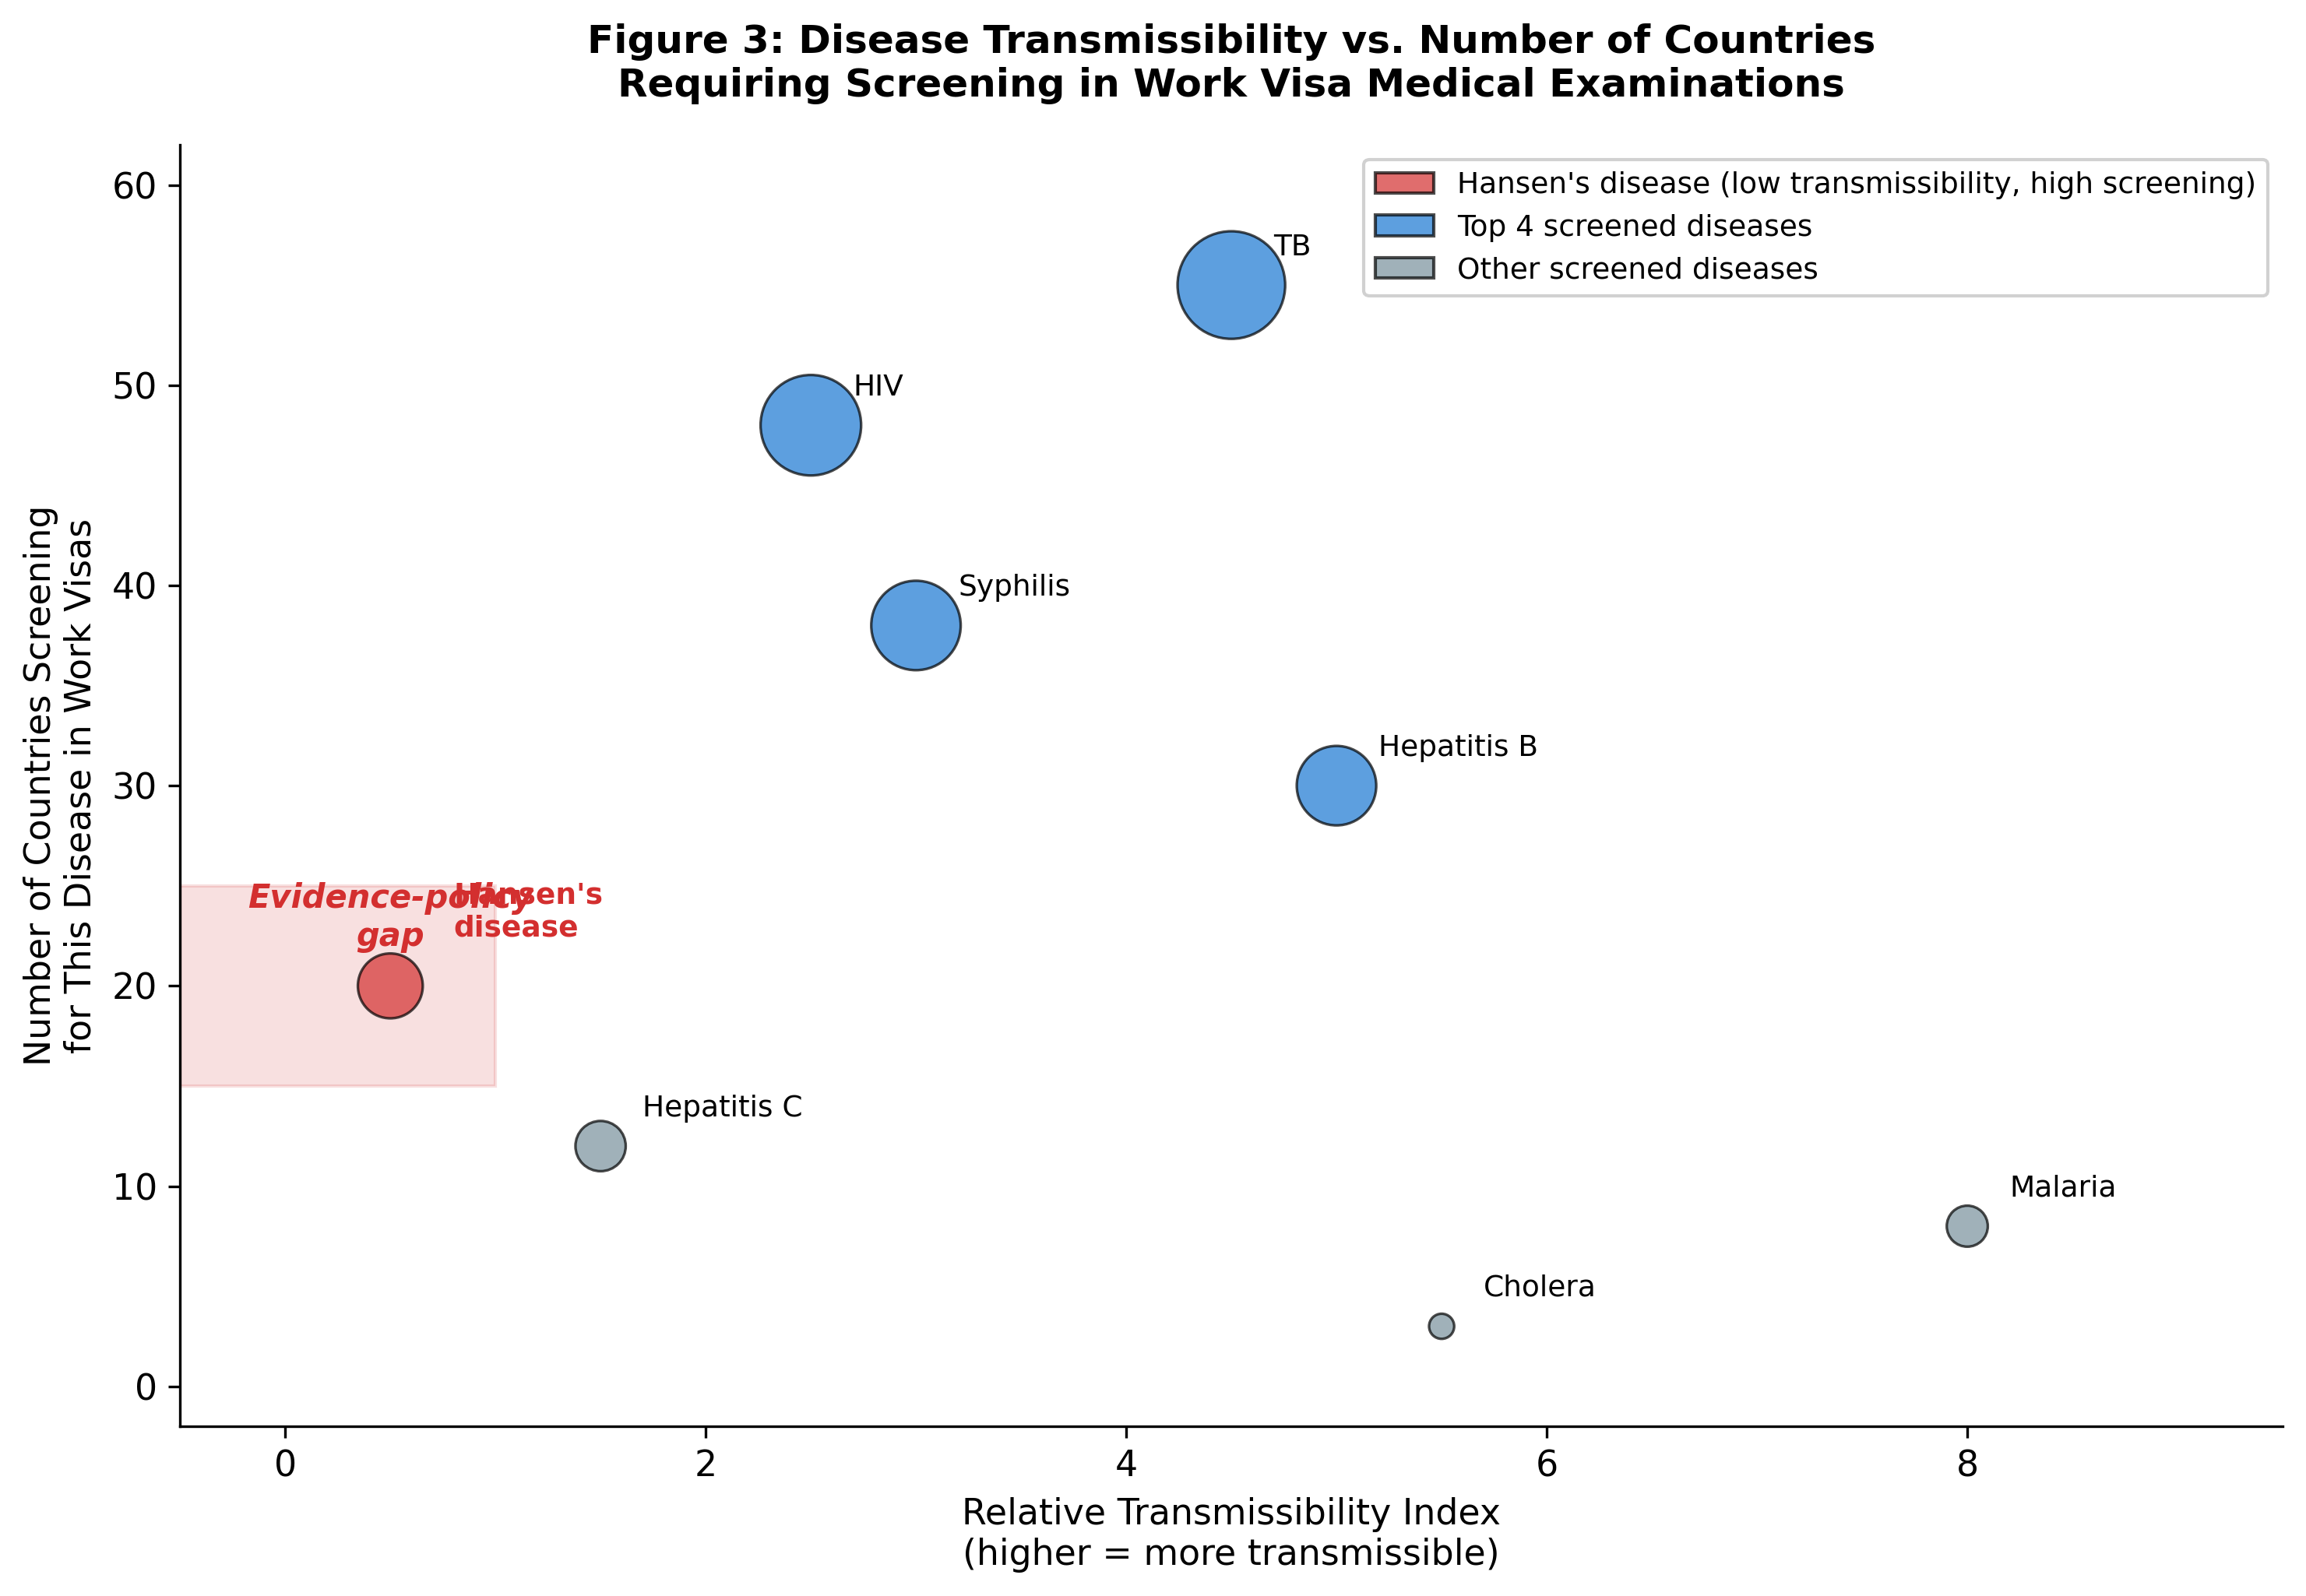
Figure 1: Relationship between disease transmissibility and frequency of screening in work visa medical examinations across 58 countries. Hansen’s disease (red) occupies a unique position: low transmissibility but high screening frequency, indicating an evidence-policy gap. Bubble size proportional to number of countries screening for each disease.

Figure 2
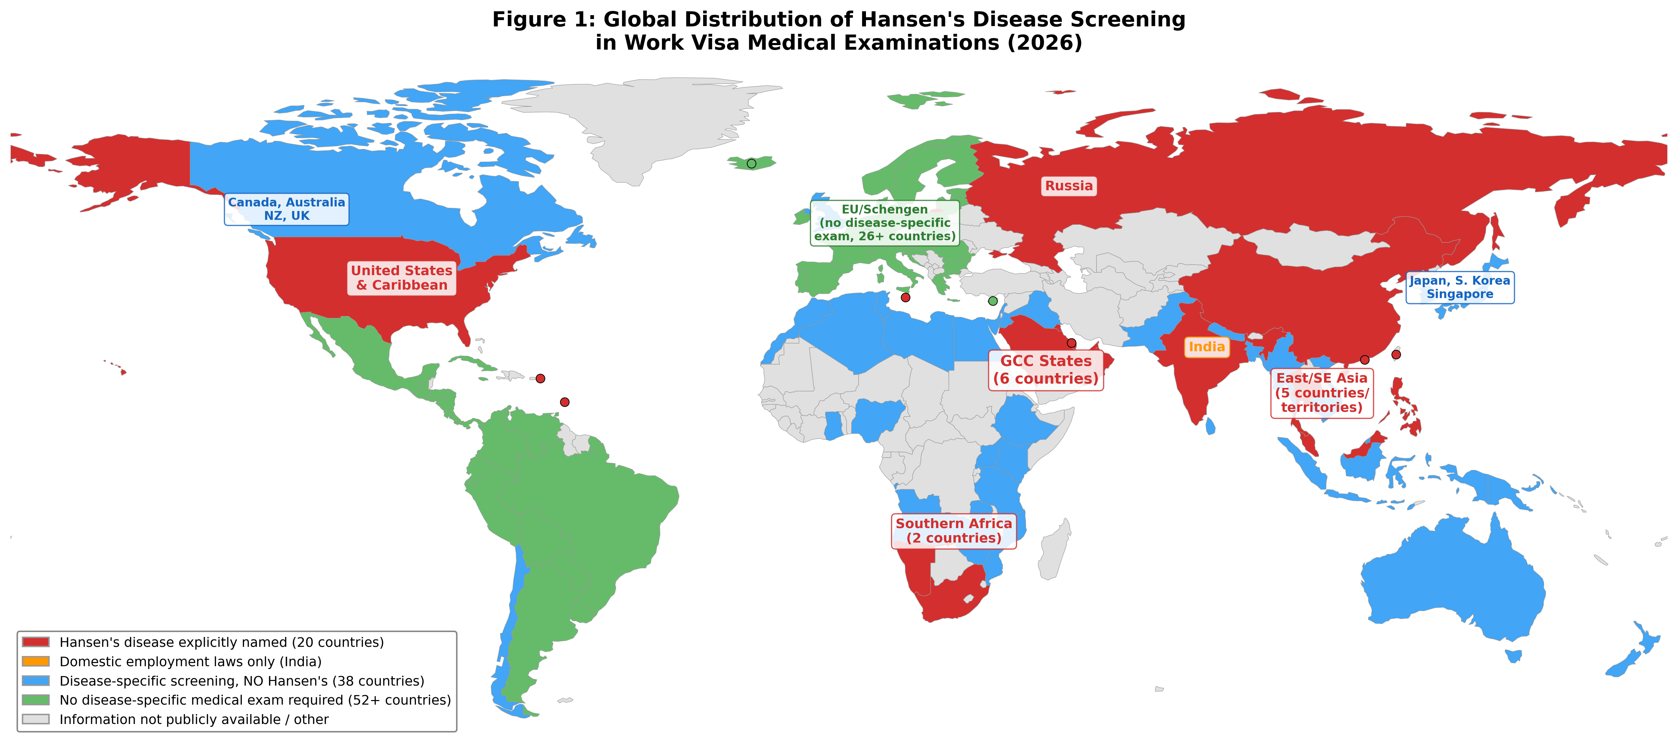
Figure 2: Global distribution of Hansen’s disease screening in work visa medical examinations. Red: Hansen’s disease explicitly named (20 countries); Blue: disease-specific screening without Hansen’s disease (38 countries); Green: no disease-specific medical exam required (52+ countries); Gray: information not publicly available.

Figure 3
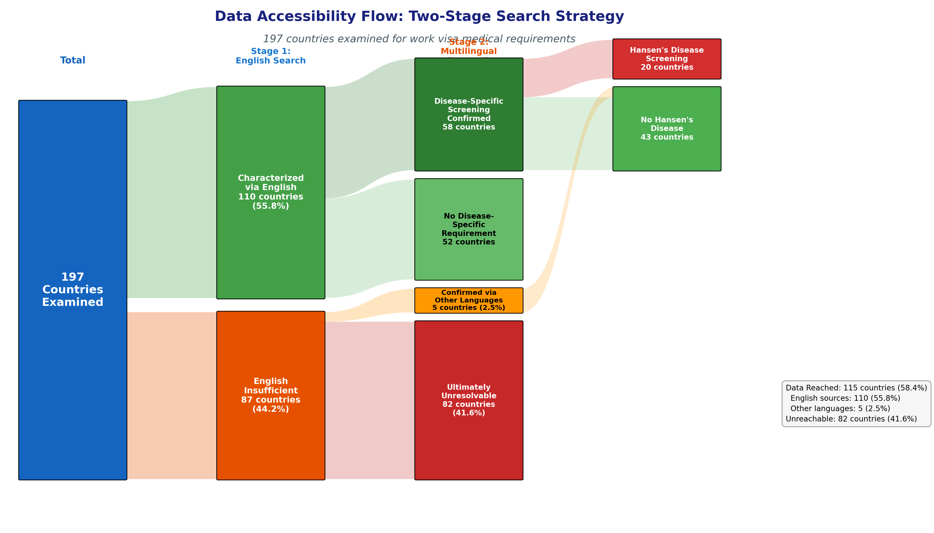
Figure 3: Data accessibility flow diagram showing the two-stage search strategy. Of 197 countries examined, 110 were characterized via English sources (58 with disease-specific screening confirmed, 52 with confirmed absence), 5 via multilingual research, and 82 remained unreachable. Among 63 countries with confirmed screening, 20 explicitly named Hansen’s disease.

Figure 4
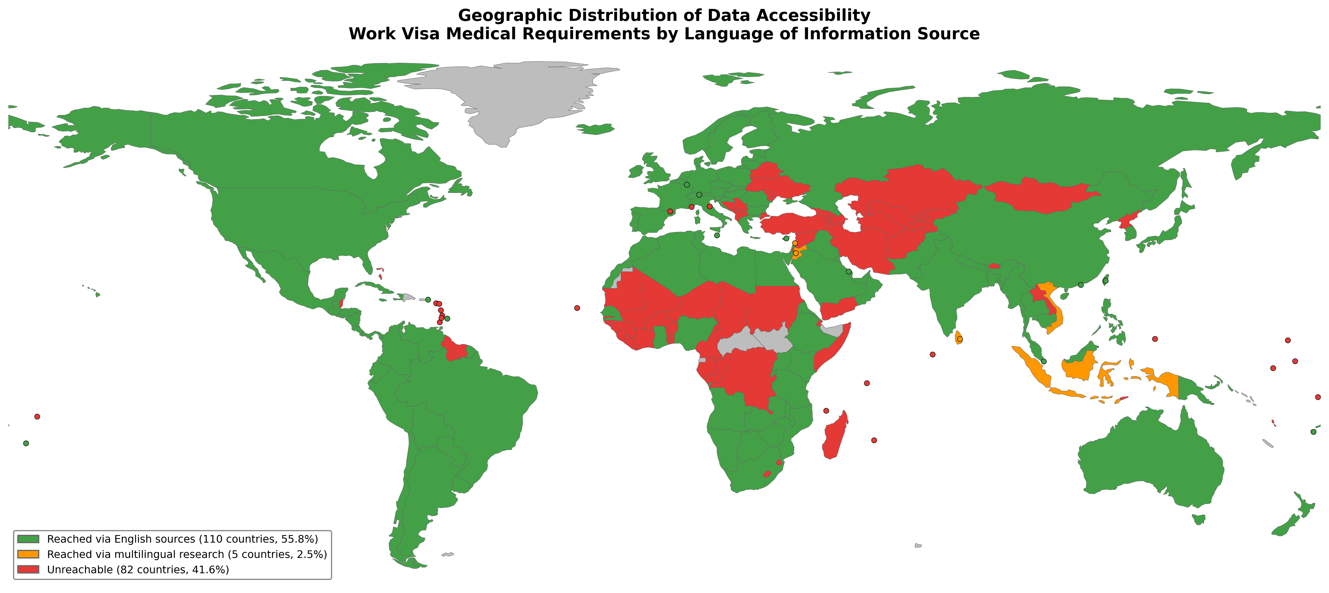
Figure 4: Geographic distribution of data accessibility for work visa medical requirements. Green: reached via English-language sources (110 countries, 55.8%); Orange: reached via multilingual research (5 countries, 2.5%); Red: unreachable (82 countries, 41.6%).

References
1. WHO. Weekly epidemiological record: Global leprosy (Hansen disease) update, 2024. Wkly Epidemiol Rec 2025; 100: 377–96.
2. Tricco AC, Lillie E, Zarin W, et al. PRISMA Extension for Scoping Reviews (PRISMA-ScR): Checklist and explanation. Ann Intern Med 2018; 169: 467–73.
3. GCC Approved Medical Centers Association. WAFID Medical Examination Regulations, 6th Version. Riyadh: GAMCA Secretariat, 2021.
4. Republic of South Africa. Immigration Act No. 13 of 2002; Form BI-811 (Medical Certificate). Department of Home Affairs.
5. United States Congress. Immigration and Nationality Act §212(a)(1)(A)(i); 42 CFR §34.2 (Medical examination of aliens).
6. CDC. Technical Instructions for Hansen’s Disease for Panel Physicians. Atlanta: Centers for Disease Control and Prevention, 2018.
7. Kingdom of Thailand. Emergency Decree on Managing the Work of Aliens B.E. 2560 (2017). Royal Thai Government Gazette.
8. People’s Republic of China. Foreigner Physical Examination Form. Ministry of Health.
9. Russian Federation. Federal Law No. 115-FZ on the Legal Status of Foreign Citizens (2002), as amended.
10. ILEP. Discriminatory Laws Database. International Federation of Anti-Leprosy Associations, 2024. https://ilepfederation.org/discriminatory-laws/
11. UN General Assembly. Resolution A/RES/65/215: Elimination of discrimination against persons affected by leprosy and their family members. New York: United Nations, 2010.
12. UN Human Rights Council. Principles and guidelines for the elimination of discrimination against persons affected by leprosy and their family members. A/HRC/RES/15/10, 2010.
13. Nanri T. Initiatives to address leprosy as a human rights issue through the mandate of UN Special Rapporteur. PLoS Negl Trop Dis 2022; 16: e0010201.
14. Abubakar I, Aldridge RW, Devakumar D, et al. The UCL–Lancet Commission on Migration and Health. Lancet 2018; 392: 2606–54.
15. Atkins H. Healthy Enough to Enter? Exploring the nexus of the body and the border through South African visa medical requirements. Linköping University, 2020.

Declaration of interests
We declare no competing interests.
Acknowledgements
[To be added]

