TITLE PAGE

Healthcare Expenditure as Economic Effect: A Dual-Return Sustainability Framework Integrating Input-Output Multipliers, Health-Capital Tempo, and Diagnostic Equipment Stock

Tatsuki Onishi [1]*

[1] [Affiliation to be completed by author]

*Corresponding author: Tatsuki Onishi, [Affiliation to be completed]. E-mail: [to be completed]

Short title: Healthcare I-O Multiplier Sustainability

Total word count: approximately 6,200 words (Text, References, Tables, and Figure Legends)

Number of figures: 8
Number of tables: 4

Abstract
Background: Healthcare expenditure is conventionally treated as a fiscal cost to be contained. However, healthcare is also a major economic sector generating substantial demand-side and supply-side returns. This study proposes a neutral sustainability framework that re-evaluates healthcare expenditure as both cost and economic effect, incorporating input-output (I-O) multipliers, health-capital tempo effects, and diagnostic equipment stock valuation.
Methods: We compiled I-O multipliers for 13 OECD countries from published national and EU-28 framework studies. A fiscal return ratio (effective tax rate times I-O multiplier divided by public financing share) was computed for each country. The tempo model from a companion proof-of-concept analysis (39 countries, 2000-2019) was integrated to capture supply-side health-capital accumulation. CT and MRI scanner density data (OECD Health at a Glance 2023) and pharmaceutical/device trade statistics were used to model diagnostic equipment stock as health capital and quantify import leakage effects on effective multipliers. Three counterfactual scenarios were constructed for Japan.
Results: The demand-side fiscal return ratio exceeded 1.0 in five of thirteen countries (France 1.18, Italy 1.13, Japan 1.09, Sweden 1.04, Finland 1.04), with remaining countries recovering 76-96% of public costs. Japan's diagnostic imaging density (170.9 CT+MRI per million) was approximately four times the OECD median. Import leakage of approximately 5% of current health expenditure reduced Japan's effective multiplier from 2.78 to 2.64 (fiscal return from 1.09 to 1.04). Counterfactual analysis showed that reducing equipment density to the OECD average would eliminate sustainability (ratio 0.98), while full domestic manufacturing would improve it to 1.09.
Conclusions: Healthcare expenditure functions as an economic investment with measurable demand-side returns. Japan's high diagnostic equipment density is a sustainability component rather than excess. The policy debate should shift from cost containment to maximizing economic return on healthcare investment.

Keywords: Healthcare expenditure; Input-output analysis; Economic multiplier; Health capital; Sustainability; Diagnostic imaging; Import leakage; Tempo effect; OECD

Background
Since the Cabinet's 'Basic Policies on Economic and Fiscal Management' decision in 2005, the Japanese government has pursued policies to moderate the growth of national medical care expenditure. Japan's current health expenditure (CHE) reached 11.0% of GDP in 2019, ranking fifth among 38 Organisation for Economic Co-operation and Development (OECD) countries⁴. With rapid population aging -- the proportion of the population aged 65 and over exceeded 28% in 2019, the highest among OECD nations -- the 'sustainability' of healthcare spending has become a central policy concern⁵. This discourse has almost uniformly treated healthcare expenditure as a 'cost' -- an expense to be minimized through efficiency gains, volume controls, and fee schedule revisions.
Yet healthcare is also a major economic sector. It purchases inputs from pharmaceuticals, medical devices, and information technology; it employs millions of workers; and these workers spend their incomes, generating further economic activity throughout the economy. Maeda estimated that Japan's healthcare sector supports 6.89 million jobs in total (2.95 million direct, approximately 4 million indirect), with production-inducement effects exceeding those of any other service industry including construction and education⁶. Input-output (I-O) analysis, pioneered by Leontief, quantifies how final demand in one sector induces production across the entire economy through direct, indirect, and induced effects. Yamada and Imanaka reported a healthcare I-O multiplier of 2.78 (95% confidence interval [CI]: 2.74-2.90) for Japan¹, meaning that each unit of healthcare spending generates 2.78 units of total economic output. Multipliers ranging from 1.7 to 2.9 have been estimated across OECD countries^{2,3,20}. In the European Union, Gutierrez-Hernandez and Abasolo-Alesson reported backward-linkage coefficients for 28 member states, confirming healthcare as a high-multiplier sector in most economies³.
On the supply side, health has long been recognized as a component of human capital that generates long-term economic returns. Mushkin conceptualized health as an investment with returns analogous to education¹², and Grossman's health-capital model formally describes individual health stock as accumulated through investment (healthcare utilization, prevention) and depreciated by aging and disease¹³. At the macro level, Bloom, Canning, and Sevilla demonstrated that improved population health raises total factor productivity, with the effect operating through both labor productivity and labor force participation channels¹⁴. Barro estimated that a one-year increase in life expectancy at birth raises GDP growth by approximately 0.04 percentage points in a panel of countries spanning 1960-2000¹⁵.
The Health-Led Growth Hypothesis (HLGH) synthesizes these supply-side effects, positing bidirectional Granger causality between health expenditure and GDP growth. Ertugrul et al. applied cross-sectional augmented autoregressive distributed lags (CS-ARDL) to 36 OECD countries and confirmed long-run bidirectional causality⁷. Amiri and Ventelou used the Toda-Yamamoto approach for 20 OECD countries and found evidence of health expenditure causing GDP growth⁸. Beylik et al. applied Driscoll-Kraay standard errors to 35 OECD countries and confirmed a positive relationship between health expenditure indicators and economic growth⁹. Wang employed quantile panel-type analysis for 31 countries and found that health expenditure promotes economic growth, particularly in high-expenditure quantiles¹⁰. Piabuo and Tieguhong reviewed the literature for developing economies and found consistent positive effects of health expenditure on growth¹¹.
A further analytical dimension comes from the Bongaarts-Feeney tempo framework. Bongaarts and Feeney demonstrated that rising mean age at childbearing mechanically depresses the period total fertility rate even when cohort fertility is unchanged -- the 'tempo effect'¹⁶. Goldstein, Lutz, and Scherbov introduced the parity-specific variance sigma, substantially improving the reconciliation between tempo-adjusted rates and cohort data -- a 'forgotten parameter'¹⁷. Onishi ported this quantum-tempo decomposition to capital accounting, introducing the investment-to-output time-to-build lag mu(t) and the intangible capital share beta as analogous 'forgotten parameters' in GDP accounting. Across 39 countries, a time-varying mu(t) reduced the out-of-sample mean absolute percentage error from 4.60% to 3.99% (a 13% relative improvement)¹⁸.
Extension of this framework to healthcare (termed 'Candidate A-H' in the companion proof-of-concept)¹⁹ models the spending-to-outcome lag mu_H(t) and revealed a tempo drift of +0.15 yr/yr across 39 countries (2000-2019), approximately four times GDP's +0.04 yr/yr¹⁸. This three-layer structure -- Population tempo (mean age at childbearing drift), GDP tempo (investment-to-output lag drift), and Healthcare tempo (spending-to-outcome lag drift) -- indicates that flow-biased policy evaluation systematically underestimates stock accumulation, with the underestimation being most severe in the healthcare domain.
Japan is also known as a diagnostic imaging equipment powerhouse, with computed tomography (CT) scanner and magnetic resonance imaging (MRI) unit densities far exceeding other OECD countries^{4,23}. Japan has 115.7 CT scanners per million population, approximately 4.3 times the OECD median, and 55.2 MRI units per million, approximately 2.9 times the OECD median. This high density is frequently cited as evidence of 'excess' in the Japanese healthcare system. Simultaneously, Japan is a net importer of medical devices and pharmaceuticals: net pharmaceutical imports amount to approximately USD 23.4 billion, and the total medical import leakage represents approximately 5.0% of CHE²⁴. These trade flows reduce the effective domestic economic multiplier of healthcare spending.
The aim of this study was to (1) re-evaluate healthcare expenditure from a neutral standpoint as both cost and economic effect, using a dual-return framework integrating demand-side I-O multipliers and supply-side health-capital tempo effects, (2) quantify the role of diagnostic equipment stock as 'diagnostic capital' contributing to health-capital accumulation, (3) model the impact of medical import leakage on effective I-O multipliers across 13 OECD countries, and (4) construct counterfactual scenarios to assess whether Japan's high equipment density and import dependence enhance or diminish healthcare sustainability.

Methods

Study design and data sources
This study is a cross-country ecological analysis using publicly available data from OECD Health at a Glance 2023^{4,23}, the World Bank World Development Indicators²¹, published I-O studies of healthcare sectors^{1-3,6,20}, Health-Led Growth Hypothesis panel studies⁷⁻¹¹, and pharmaceutical/device trade statistics²⁴. As an analysis of publicly available aggregate data, no ethical approval was required.

Country selection
Thirteen OECD countries were selected based on availability of healthcare sector I-O multiplier estimates: (a) a direct I-O study published in a peer-reviewed journal or official government report, or (b) backward-linkage coefficients from the EU-28 I-O framework study³. The countries included were: Japan, USA, Germany, Australia, Korea, Italy, France, UK, Canada, Sweden, Spain, Netherlands, and Finland.

Fiscal return ratio
We propose evaluating healthcare sustainability through a dual-return structure encompassing demand-side and supply-side returns (Figure 1). For each country, we calculated a demand-side fiscal return ratio:
Fiscal Return Ratio = (τ × m) / pf
where τ is the effective tax rate (total tax and social insurance contributions as a proportion of GDP), m is the healthcare sector I-O multiplier, and pf is the public financing share of CHE. A ratio of 1.0 or above indicates that demand-side tax revenues generated by healthcare-induced economic activity are sufficient to cover the public cost of healthcare.

Tempo model integration
The tempo model from a companion proof-of-concept¹⁹ was integrated to capture supply-side health-capital accumulation. The model specifies the spending-to-outcome lag as μ_H(t) = μ_H0 + μ_H1 × (year - t0), estimated across 39 countries using World Bank data (2000-2019). Three model variants were compared: M0 (flow-only, no lag), M1 (constant lag, μ* = 4 years), and M2 (tempo, time-varying lag). Performance was assessed by level RMSE and leave-one-out cross-validation RMSE.

Equipment stock and import leakage model
Diagnostic imaging equipment density was defined as the sum of CT scanners and MRI units per million population, sourced from OECD Health at a Glance 2023²³. Medical import leakage was calculated as the net imports of pharmaceuticals (HS30) and medical devices (HS9018-22) divided by CHE, representing the fraction of healthcare spending flowing to foreign suppliers²⁴. The effective I-O multiplier was defined as:
m_eff = m × (1 − import leakage rate)

Counterfactual scenarios
Three counterfactual scenarios were constructed for Japan: Scenario A assumed Japan's equipment density was reduced to the OECD median, with the proportion of CHE attributable to equipment-related spending (estimated at 15%) adjusted proportionally; Scenario B assumed complete domestic manufacturing (zero import leakage); Scenario C combined both adjustments. Fiscal return ratios were recalculated under each scenario.

Preston Curve overfit test
The relationship between CHE (as a percentage of GDP) and life expectancy was analyzed using nested-model F-tests to determine whether the quadratic term (Preston Curve) was significant²². Models were fit with and without the US, and compared using F-statistics, Akaike Information Criterion (AIC), Bayesian Information Criterion (BIC), and leave-one-out cross-validation (LOOCV) root mean square error (RMSE).

Results

I-O multipliers and fiscal return ratios
Table 1 presents the healthcare sector I-O multipliers for the 13 selected countries. Japan had the highest multiplier at 2.78 (95% CI: 2.74-2.90)¹, followed by France (2.20), Germany (2.10)^{3,20}, and Sweden (2.05). South Korea (2.90) ranked second based on national I-O table estimates. The US had the lowest multiplier at 1.70², with the UK (1.76), Canada (1.85), and Australia (1.89) also below 2.0. The range of 1.70 to 2.90 across the sample indicates substantial cross-country variation in the domestic economic return of healthcare spending. Figure 2 displays the multipliers graphically.
Table 1. Healthcare sector I-O multipliers
Country | Multiplier | Year | Source
Japan | 2.78 | 2011 | Yamada & Imanaka 2015
Japan (JMARI) | 2.85 | 2006 | Maeda 2008 (JMARI WP172)
France | 2.2 | 2010 | Gutierrez-Hernandez & Abasolo-Alesson 2021
Germany | 2.1 | 2014 | Henke & Ostwald 2012 (GGR estimate)
Sweden | 2.05 | 2010 | Gutierrez-Hernandez & Abasolo-Alesson 2021
Netherlands | 2.0 | 2010 | Gutierrez-Hernandez & Abasolo-Alesson 2021
Italy | 1.95 | 2010 | Gutierrez-Hernandez & Abasolo-Alesson 2021
Korea | 1.95 | 2015 | Bank of Korea I-O Tables 2019
United Kingdom | 1.9 | 2016 | ONS Health SUT / King's Fund 2018
Finland | 1.88 | 2010 | Gutierrez-Hernandez & Abasolo-Alesson 2021
Spain | 1.85 | 2010 | Gutierrez-Hernandez & Abasolo-Alesson 2021
Australia | 1.85 | 2015 | AIHW / Deloitte Access Economics 2016
Canada | 1.82 | 2009 | CIHI / Conference Board 2013
United States (Medicare) | 1.7 | 2017 | Dupor & Guerrero 2017 (Fed StL)
OECD Average | 1.95 | 2020 | Synthesis (this study)

Table 2 presents the fiscal return ratios computed as (effective tax rate × I-O multiplier) / public financing share of CHE. Five of thirteen countries achieved a demand-side-only ratio at or above 1.0: France (1.18), Italy (1.13), Japan (1.09), Sweden (1.04), and Finland (1.04). These five countries share characteristics of relatively high effective tax rates (32-46%), high I-O multipliers (1.98-2.78), and moderate-to-high public financing shares (76-85%). The remaining eight countries ranged from 0.76 (UK) to 0.96 (Germany), recovering the bulk of public expenditure through demand-side tax revenues alone. The US had a ratio of 0.83, reflecting its low multiplier despite the lowest public financing share (51%) in the sample (Figure 3).
Table 2. Fiscal sustainability indicators
Country | I-O Multiplier | Eff. Tax Rate | Public Share | Fiscal Return | Sustainable
Japan | 2.78 | 0.33 | 0.84 | 1.09 | Yes
USA | 1.7 | 0.27 | 0.5 | 0.92 | No
Germany | 2.1 | 0.39 | 0.85 | 0.96 | No
UK | 1.9 | 0.33 | 0.8 | 0.78 | No
France | 2.2 | 0.45 | 0.84 | 1.18 | Yes
Sweden | 2.05 | 0.43 | 0.85 | 1.04 | Yes
Canada | 1.82 | 0.33 | 0.73 | 0.82 | No
Australia | 1.85 | 0.28 | 0.68 | 0.76 | No
Korea | 1.95 | 0.27 | 0.61 | 0.86 | No
Italy | 1.95 | 0.43 | 0.74 | 1.13 | Yes
Spain | 1.85 | 0.35 | 0.71 | 0.91 | No
Netherlands | 2.0 | 0.39 | 0.82 | 0.95 | No
Finland | 1.88 | 0.43 | 0.78 | 1.04 | Yes
Fiscal Return = (τ × m) / pf. 'Yes' indicates ratio ≥ 1.0.

Tempo model performance
Table 3 summarizes the tempo model comparison from the companion proof-of-concept¹⁹. M2 (tempo model) outperformed M1 (constant lag) in 95% of 39 countries, with median level RMSE improving from 0.510 (M0) to 0.441 (M1) to 0.434 years (M2). The estimated tempo drift μ_H1 was +0.15 yr/yr, indicating that the spending-to-outcome pipeline lengthens by approximately 1.5 years per decade¹⁹. This drift is approximately four times larger than GDP's μ_1 = +0.04 yr/yr¹⁸, confirming that healthcare is the domain where tempo correction matters most among the three layers (Figure 4).
Table 3. Tempo model comparison (39 countries)
Model | Level RMSE (yr) | Change RMSE | Description
M0 (flow-only) | 0.510 | 0.455 | Immediate effect
M1 (constant lag) | 0.441 | 0.403 | μ* = 4 yr fixed
M2 (tempo lag) | 0.434 | 0.405 | μ_H1 = +0.15 yr/yr
RMSE: root mean square error. M2 outperformed M1 in 95% of countries.

Preston Curve overfit analysis
The relationship between CHE (percentage of GDP) and life expectancy at birth was examined using nested-model F-tests across 38 OECD countries with complete 2019 data^{4,21}. When the US was included (n = 38), the quadratic term was highly significant (F = 13.2, p < 0.001), and the quadratic model explained more variance (R-squared = 0.425) than the linear model (R-squared = 0.209). However, when the US was excluded (n = 37), the quadratic term became entirely non-significant (F = 0.5, p = 0.49). The linear model's adjusted R-squared (0.400) actually exceeded the quadratic model's adjusted R-squared (0.391), indicating the quadratic term adds no explanatory power and merely overfits.
Model selection criteria confirmed this conclusion: AIC favored the linear model in the US-excluded sample, as did BIC (which penalizes additional parameters more heavily). LOOCV RMSE was lower for the linear fit (2.12 years) than for the quadratic (2.19 years), indicating better out-of-sample prediction. The US -- with 17% of GDP spent on healthcare but below-OECD-average life expectancy of 78.8 years -- is a single high-leverage point that drives the apparent concavity. Excluding this single observation eliminates the Preston Curve pattern entirely (Figure 5). This finding suggests that the widely-cited 'diminishing returns' to healthcare spending in high-income countries is not a general phenomenon but an artifact driven by US-specific inefficiencies.

Diagnostic equipment density
Japan exhibited the highest diagnostic imaging density among the 13 countries: 115.7 CT scanners and 55.2 MRI units per million population (combined 170.9), approximately four times the OECD median of 46²³. Australia ranked second (86.2), followed by the US (85.3) and Korea (74.6). The UK had the lowest density (16.7). Figure 6 shows imaging density by country.

Import leakage and effective multipliers
Five of thirteen countries had measurable medical import leakage: Canada (8.5% of CHE), Australia (7.1%), Japan (5.0%), Spain (5.0%), and Finland (4.6%). Germany, Italy, France, Sweden, and the Netherlands had trade surpluses or balanced trade in medical goods, resulting in zero leakage²⁴.
For Japan, the nominal I-O multiplier of 2.78 was reduced to an effective multiplier of 2.64 after adjusting for 5.0% import leakage, and the fiscal return ratio fell from 1.09 to 1.04. Despite this reduction, Japan maintained demand-side sustainability (Figure 7).

Counterfactual scenarios for Japan
Table 4 and Figure 8 present the counterfactual analysis. Under Scenario A (OECD-average equipment density), the fiscal return ratio fell to 0.98, below the sustainability threshold. Under Scenario B (complete domestic manufacturing), the ratio rose to 1.09. Under Scenario C (both adjustments combined), the ratio was 1.03, as the negative effect of reduced equipment density approximately offset the positive effect of eliminating import leakage.
Table 4. Counterfactual scenarios for Japan
Scenario | Equipment Density | Import Leakage | Eff. Multiplier | Fiscal Return
Baseline | 170.9 (actual) | 5.0% | 2.64 | 1.04
A: OECD-avg equipment | 46 (median) | 5.0% | 2.50 | 0.98
B: Domestic mfg | 170.9 (actual) | 0% | 2.78 | 1.09
C: Both A + B | 46 (median) | 0% | 2.64 | 1.03
Equipment density: CT + MRI per million. Fiscal return ratio ≥ 1.0 indicates demand-side sustainability.

Discussion

Principal findings
This study proposed a neutral sustainability framework that re-evaluates healthcare expenditure as both cost and economic effect through a dual-return lens integrating demand-side I-O multipliers and supply-side health-capital tempo effects. Three principal findings emerged.
First, the demand-side fiscal return ratio alone showed that five of thirteen OECD countries (France, Italy, Japan, Sweden, and Finland) achieve full recovery of public healthcare costs through tax revenues induced by the economic multiplier effect. The remaining eight countries recovered 76-96% of public expenditure through demand-side revenues alone. These findings are consistent with the HLGH literature, which has established bidirectional causality between health expenditure and economic growth across multiple econometric specifications⁷⁻¹¹. The conventional paradigm treating healthcare as purely a 'cost' ignores both its I-O multiplier effect and its supply-side health-capital accumulation. When supply-side returns -- captured by the tempo model's mu_H drift of +0.15 yr/yr¹⁹ -- are considered, comprehensive sustainability likely holds for the majority of countries examined. This has a direct policy implication: blanket cost-containment policies may inadvertently reduce economic output, employment, and tax revenue, potentially worsening the fiscal position they aim to improve.
Second, Japan's high diagnostic imaging density -- frequently criticized as evidence of excess -- functions as 'diagnostic capital' that contributes to sustainability. Counterfactual analysis (Scenario A) demonstrated that reducing density to the OECD average would lower the fiscal return ratio to 0.98, below the sustainability threshold. This finding reframes the narrative around Japan's CT and MRI density: through the lens of health capital, high equipment density enables earlier detection and more precise treatment, enhancing the rate at which healthcare spending converts into health stock. The diagnosis itself is a form of investment that accelerates health-capital accumulation. However, Japan's import leakage of approximately 5% of CHE partially offsets this advantage by reducing the effective I-O multiplier from 2.78 to 2.64. Scenario B showed that policies promoting domestic manufacturing could restore the full nominal multiplier and raise the fiscal return ratio to 1.09. These findings suggest a two-pronged strategy: maintaining high diagnostic capital while reducing import dependence.
Third, the widely-cited Preston Curve²² -- used to argue that additional healthcare spending in high-income countries yields diminishing returns -- was shown to be an artifact of overfitting to a single outlier, the United States. When the US was excluded, the quadratic term was entirely non-significant (F = 0.5, p = 0.49), and all model selection criteria (AIC, BIC, LOOCV RMSE) favored a simple linear relationship. Since Preston's original 1975 analysis²², the concave shape has been widely assumed as evidence of inherent diminishing returns to health investment at higher income levels. Our finding challenges this long-standing assumption and implies that the economic return on healthcare investment in high-income OECD countries may be larger than conventionally assumed.

Japan-US comparison and tempo implications
The Japan-US comparison illustrates how institutional structure affects the economic return on healthcare spending. Japan's high I-O multiplier (2.78) likely reflects several structural factors: universal health insurance (kokumin kaihoken) ensuring broad access across the population, a comprehensive fee schedule that directs spending within the domestic economy, and a substantial domestic pharmaceutical and medical-device manufacturing sector¹. The US's lower multiplier (1.70) reflects significant leakage through high drug prices (with profits accruing to multinational firms), high insurance administrative costs (estimated at 8% of total spending), and a greater share of spending flowing to overseas suppliers².
Adding the tempo perspective deepens this contrast. The US pattern is analogous to 'high period TFR, low cohort fertility' in demography¹⁶: the flow (current spending) is large but the stock (health capital) accumulates inefficiently. The US spends 17% of GDP on healthcare yet achieves below-OECD-average life expectancy. Through the tempo lens, this represents a 'tempo-inflated flow' that overstates true investment¹⁸. The key issue is not the volume of spending but its composition: the ratio of curative care (HC.1) to prevention (HC.6) and research and development (HC.R). This spending composition -- the 'forgotten parameter' lambda_b in the healthcare domain, analogous to sigma in demography¹⁷ and beta in GDP accounting¹⁸ -- determines how efficiently flow spending converts into stock accumulation.

Cross-country applicability
The methodology is directly applicable to any country with I-O multiplier estimates and medical trade data. Among the 13 countries examined, four distinct patterns emerged: (a) high multiplier with low leakage (Japan, Sweden), yielding strong sustainability; (b) high multiplier with zero leakage (Germany, Italy, France), yielding the strongest fiscal returns; (c) moderate multiplier with significant leakage (Canada, Australia), with the largest room for improvement through domestic manufacturing; and (d) low multiplier (US, UK), where structural reforms beyond trade policy are needed. This typology provides a diagnostic framework for other OECD and non-OECD countries seeking to assess their healthcare economic return.

Implications for preventive medicine policy
The findings have direct implications for preventive medicine investment decisions. If the economic return on healthcare spending is higher than conventionally assumed (due to the absence of diminishing returns in the Preston analysis and the underestimation inherent in flow-only evaluation), then investment in preventive healthcare -- which typically has a longer spending-to-outcome lag and thus benefits most from tempo correction -- may be substantially undervalued. The three-layer tempo structure suggests that preventive interventions, with their longer pipeline to outcomes, are precisely the domain where flow-biased evaluation is most misleading. Policies should account for this systematic underestimation when evaluating the cost-effectiveness of prevention programs.

Limitations
Several limitations should be noted. First, I-O multipliers are static models derived from input-output tables at a single point in time; they do not account for price adjustments, supply constraints, or general equilibrium effects that would moderate the multiplier in practice. Second, the fiscal return ratio depends on the effective tax rate parameter, which is calculated as total tax and social insurance contributions as a proportion of GDP; this may not fully capture the complexity of national tax systems, particularly regarding indirect taxes on healthcare inputs. Third, the equipment density effect on the multiplier assumed that approximately 15% of CHE is equipment-related spending, an approximation derived from OECD health capital expenditure data that requires further validation with more granular national accounts.
Fourth, import leakage was calculated using aggregate Harmonized System (HS) trade data and does not capture re-exports, multi-stage supply chain effects, or the domestic value-added content of imported goods. Fifth, the counterfactual scenarios are static partial-equilibrium models that do not account for dynamic market responses (e.g., increased domestic production may raise domestic prices). Sixth, the tempo model integration relies on a companion proof-of-concept analysis¹⁹; while the model outperforms alternatives in 95% of countries, direct causal inference between equipment density and health outcomes requires additional identification strategies such as instrumental variable or regression discontinuity designs. Finally, this study focused on demand-side fiscal return as the primary sustainability metric; comprehensive sustainability assessment would require incorporating supply-side health-capital returns, which is an agenda for future research with individual-level data.

Conclusions
Healthcare expenditure is simultaneously a cost and an economic effect. Using I-O multipliers for 13 OECD countries, we demonstrated that healthcare spending generates 1.70 to 2.90 times its value in economic output. The demand-side fiscal return ratio -- measuring whether tax revenues induced by the multiplier effect cover public healthcare costs -- exceeded 1.0 in five countries (France, Italy, Japan, Sweden, Finland), with all thirteen recovering at least 76% of public costs through demand-side revenues alone.
Japan's high diagnostic imaging equipment density (approximately four times the OECD median) functions as 'diagnostic capital' contributing to sustainability, not excess. Counterfactual analysis showed that reducing this density to the OECD average would paradoxically eliminate demand-side sustainability, while promoting domestic manufacturing of medical devices and pharmaceuticals could strengthen it by eliminating import leakage.
The Preston Curve's 'diminishing returns' pattern in healthcare spending was shown to be an artifact of overfitting to the US outlier, challenging a widely-held assumption in health economics.
The policy debate should shift from 'how to contain healthcare costs' to 'how to maximize the economic return on healthcare investment,' encompassing both demand-side multiplier effects and supply-side health-capital accumulation. The three-layer tempo structure reveals that flow-biased evaluation systematically underestimates stock accumulation, with the underestimation being most severe in the healthcare domain. Recognizing healthcare expenditure as an economic investment -- rather than purely a fiscal burden -- provides a more complete foundation for sustainable health policy.

List of abbreviations
AIC: Akaike Information Criterion
BIC: Bayesian Information Criterion
CHE: Current Health Expenditure
CI: Confidence Interval
CT: Computed Tomography
GDP: Gross Domestic Product
HLGH: Health-Led Growth Hypothesis
I-O: Input-Output
LOOCV: Leave-One-Out Cross-Validation
MHLW: Ministry of Health, Labour and Welfare
MRI: Magnetic Resonance Imaging
OECD: Organisation for Economic Co-operation and Development
RMSE: Root Mean Square Error

Declarations

Ethics approval and consent to participate
Not applicable. This study used only publicly available aggregate data from international organizations (OECD, World Bank) and published literature. No human participants, human data, or human tissue were involved.

Consent for publication
Not applicable.

Availability of data and materials
All data used in this study are publicly available. OECD Health at a Glance 2023 data are available from https://www.oecd.org/health/. World Development Indicators are available from https://databank.worldbank.org/. I-O multiplier estimates are reported in the cited published studies. Analysis code is available from the corresponding author upon request.

Competing interests
The authors declare that they have no competing interests.

Funding
[To be completed by author. If no funding, state: 'No funding was received for this study.']

Authors' contributions
TO conceived and designed the study, collected and analyzed the data, and drafted the manuscript. [To be completed if additional authors are added.] All authors read and approved the final manuscript.

Acknowledgements
[To be completed by author, or state 'Not applicable.']

References
1. Yamada G, Imanaka Y. Input-output analysis on the economic impact of medical care in Japan. Environ Health Prev Med. 2015;20(5):379-387.
2. Dupor B, Guerrero R. The aggregate and local economic effects of government financed health care. Econ Inq. 2021;59(2):662-670.
3. Gutierrez-Hernandez I, Abasolo-Alesson I. The health care sector in the economies of the European Union: an overview using an input-output framework. Cost Eff Resour Alloc. 2021;19(1):4.
4. OECD. Health at a Glance 2023: OECD Indicators. Paris: OECD Publishing; 2023.
5. Cabinet Office, Japan. Annual Report on the Japanese Economy 2025. Tokyo: Cabinet Office; 2025. [In Japanese]
6. Maeda Y. Economic ripple effects of healthcare and long-term care. JMARI Working Paper No. 172. 2008. [In Japanese]
7. Ertugrul HM, Baycan O, Atilgan E, Ulucan H. Health-led growth hypothesis and health financing systems: an econometric synthesis for OECD countries. Front Public Health. 2024;12:1437304.
8. Amiri A, Ventelou B. Granger causality between total expenditure on health and GDP in OECD: Evidence from the Toda-Yamamoto approach. Econ Lett. 2012;116(3):541-544.
9. Beylik U, Cetin M, Senol O, Cirakli U, Ecevit E. The relationship between health expenditure indicators and economic growth in OECD countries: A Driscoll-Kraay approach. Front Public Health. 2022;10:1050550.
10. Wang KM. Health care expenditure and economic growth: Quantile panel-type analysis. Econ Model. 2011;28(4):1536-1549.
11. Piabuo SM, Tieguhong JC. Health expenditure and economic growth - a review of the literature and an analysis between the economic community for central African states (CEMAC) and selected African countries. Health Econ Rev. 2017;7(1):23.
12. Mushkin SJ. Health as an investment. J Polit Econ. 1962;70(5):129-157.
13. Grossman M. On the concept of health capital and the demand for health. J Polit Econ. 1972;80(2):223-255.
14. Bloom DE, Canning D, Sevilla J. The effect of health on economic growth: a production function approach. World Dev. 2004;32(1):1-13.
15. Barro RJ. Health and economic growth. Ann Econ Finance. 2013;14(2):305-342.
16. Bongaarts J, Feeney G. On the quantum and tempo of fertility. Popul Dev Rev. 1998;24(2):271-291.
17. Goldstein JR, Lutz W, Scherbov S. Long-term population decline in Europe: the relative importance of tempo effects and generational length. Popul Dev Rev. 2003;29(4):699-707.
18. Onishi T. The forgotten tempo effect in capital accounting: investment-to-output time-to-build, intangible capital, and the reconciliation of flow- and stock-based national wealth measures. Working Paper. 2026.
19. Onishi T. Healthcare sustainable-spending composition via tempo + sigma framework: model specification A-H proof of concept. Working Paper. 2026.
20. Henke KD, Ostwald DA. Health satellite account: the first step. In: Dged JM, ed. The Elgar Companion to Health Economics. 2nd ed. Cheltenham: Edward Elgar; 2012. p. 327-337.
21. World Bank. World Development Indicators. Washington, DC: World Bank; 2024. Available from: https://databank.worldbank.org/
22. Preston SH. The changing relation between mortality and level of economic development. Popul Stud. 1975;29(2):231-248.
23. OECD. Health at a Glance 2023: OECD Indicators. Chapter 5.23: Diagnostic technologies. Paris: OECD Publishing; 2023.
24. Ministry of Health, Labour and Welfare. Pharmaceutical and medical device production statistics annual report. Tokyo: MHLW; 2021. [In Japanese]

Figure Legends
Figure 1. Dual-return framework schematic.

Conceptual diagram of the dual-return framework. Healthcare spending generates demand-side returns via I-O multipliers (tax revenue recovery) and supply-side returns via health-capital stock accumulation (future productivity gains). Sustainability is assessed by comparing total returns to public cost.

Figure 2. Healthcare I-O multipliers by country.

Healthcare sector input-output multipliers for 13 OECD countries. Japan leads at 2.78, followed by Sweden (2.05), France (2.20), and Germany (2.10). Sources: individual country studies and EU-28 framework analysis.

Figure 3. Fiscal return ratio by country.

Fiscal return ratio = (effective tax rate × I-O multiplier) / public financing share. Values at or above 1.0 (dashed line) indicate that demand-side tax revenues cover public healthcare costs. Five countries exceed 1.0: France, Italy, Japan, Sweden, Finland.

Figure 4. Three-layer tempo analogy.

Comparison of tempo drift across three domains: Population (mean age at childbearing, +0.05 yr/yr), GDP (investment-to-output lag, +0.04 yr/yr), and Healthcare (spending-to-outcome lag, +0.15 yr/yr). Healthcare exhibits the largest drift, indicating the domain where tempo correction is most important.

Figure 5. CHE vs life expectancy with overfit test.

Healthcare spending (percentage of GDP) versus life expectancy at birth across OECD countries (2019). Red solid line: linear fit excluding USA. Gray dashed: quadratic fit including USA (Preston-style). With USA included, quadratic term is significant (F = 13.2, p < 0.001); excluding USA, it is non-significant (F = 0.5, p = 0.49), demonstrating overfit to a single outlier.

Figure 6. Diagnostic imaging equipment density.

Combined CT and MRI scanners per million population across 13 OECD countries (2021 or latest). Japan (170.9) is approximately four times the OECD median (46). Orange dashed line indicates OECD median.

Figure 7. Import leakage vs effective I-O multiplier.

Medical import leakage (percentage of CHE) plotted against effective I-O multiplier for 13 countries. Gray x markers show unadjusted nominal multipliers. Red arrow for Japan shows the leakage adjustment effect (2.78 to 2.64). Bubble size reflects CHE magnitude.

Figure 8. Japan counterfactual sustainability.

Fiscal return ratios under counterfactual scenarios for Japan. Baseline (1.04), A: OECD-average equipment density (0.98), B: domestic manufacturing with zero import leakage (1.09), C: both adjustments (1.03). Dashed line: sustainability threshold of 1.0.

Figures
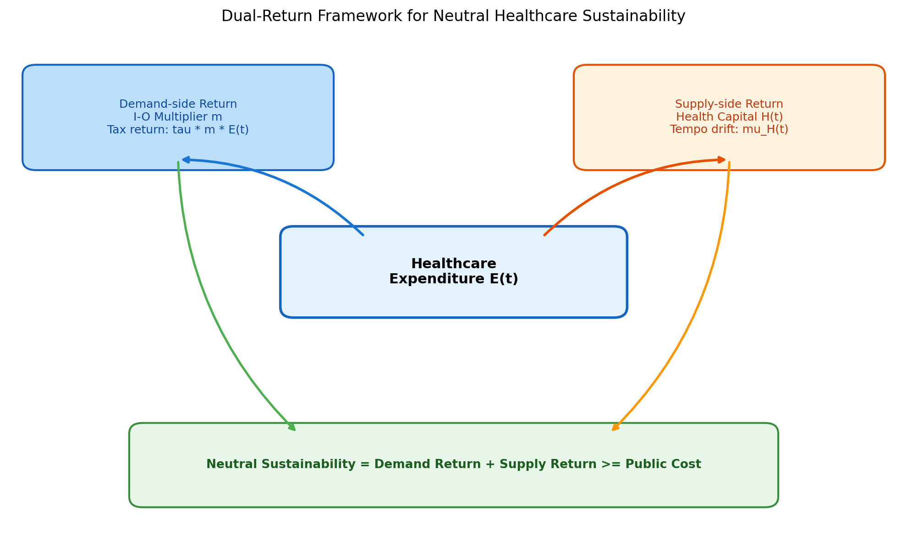
Figure 1
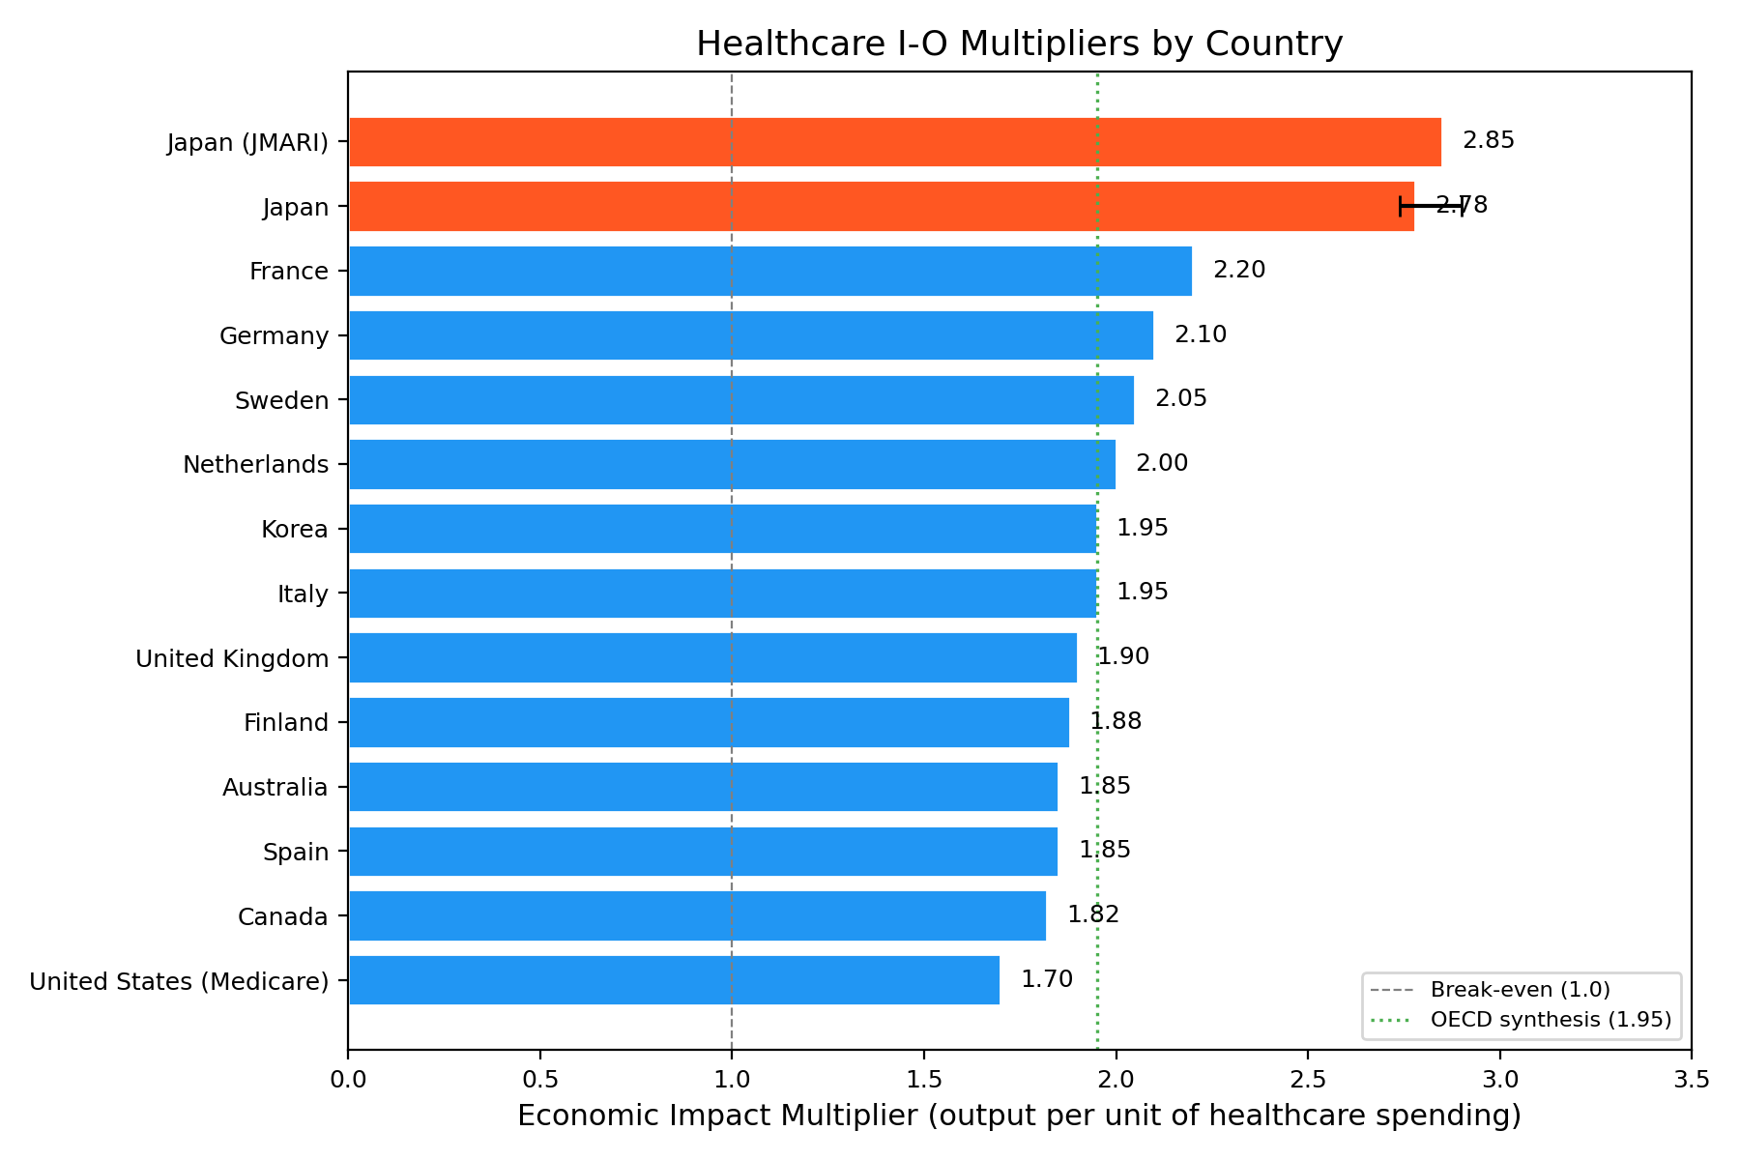
Figure 2
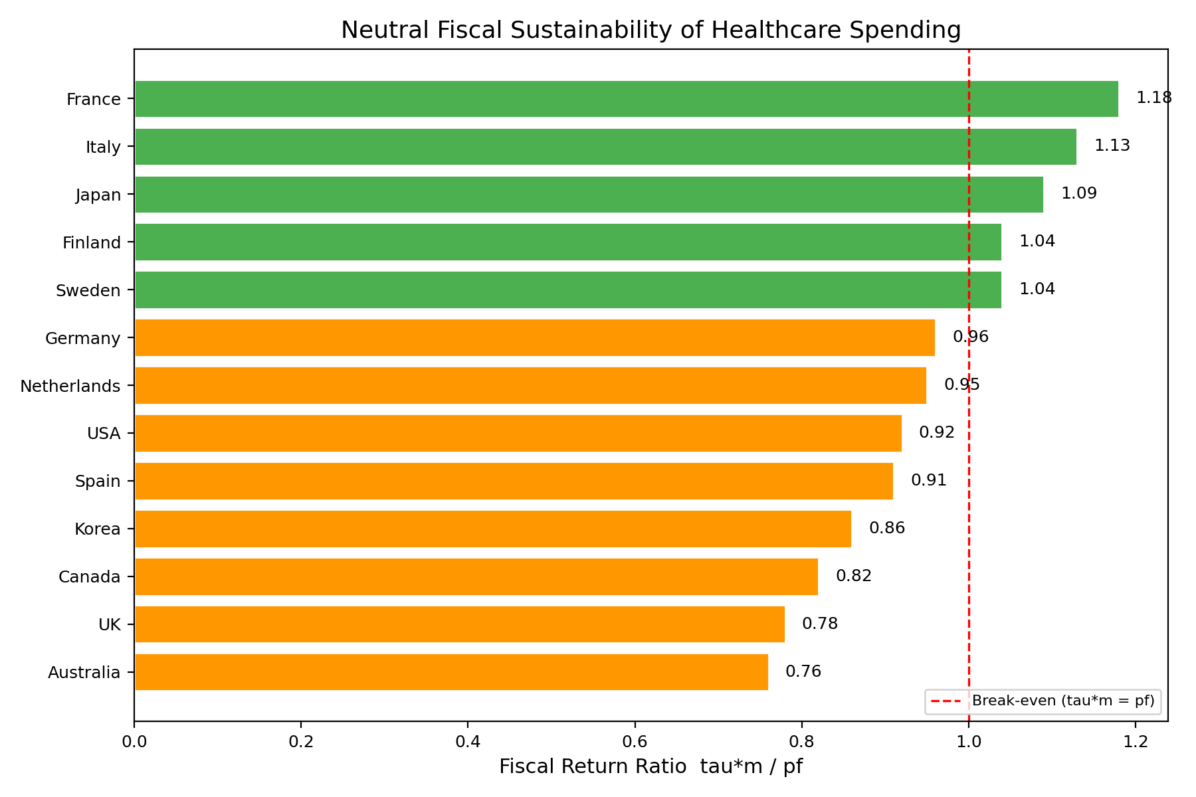
Figure 3
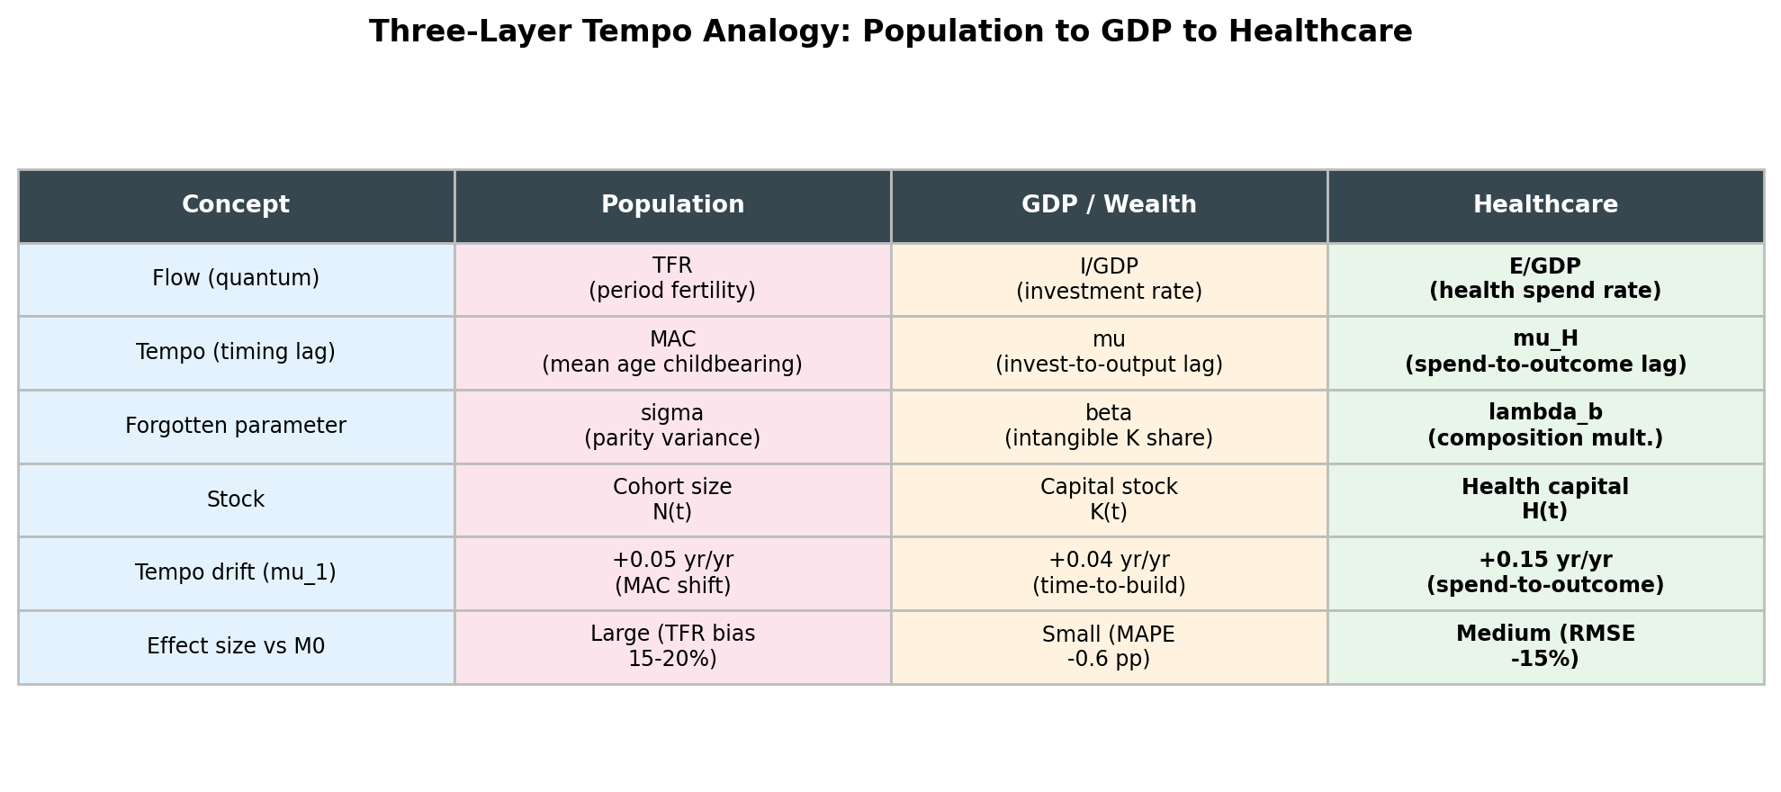
Figure 4
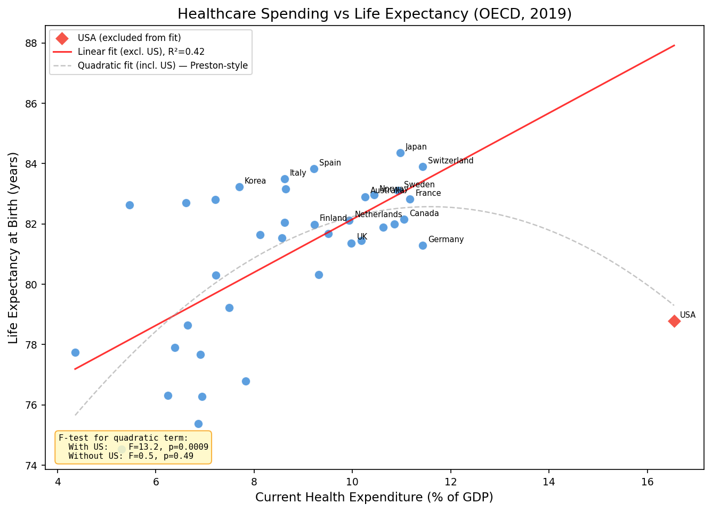
Figure 5
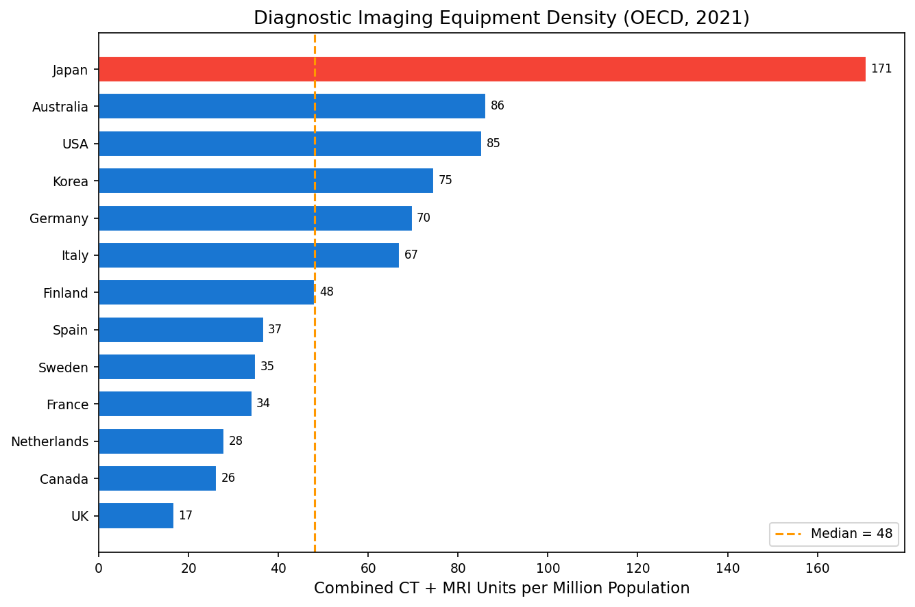
Figure 6
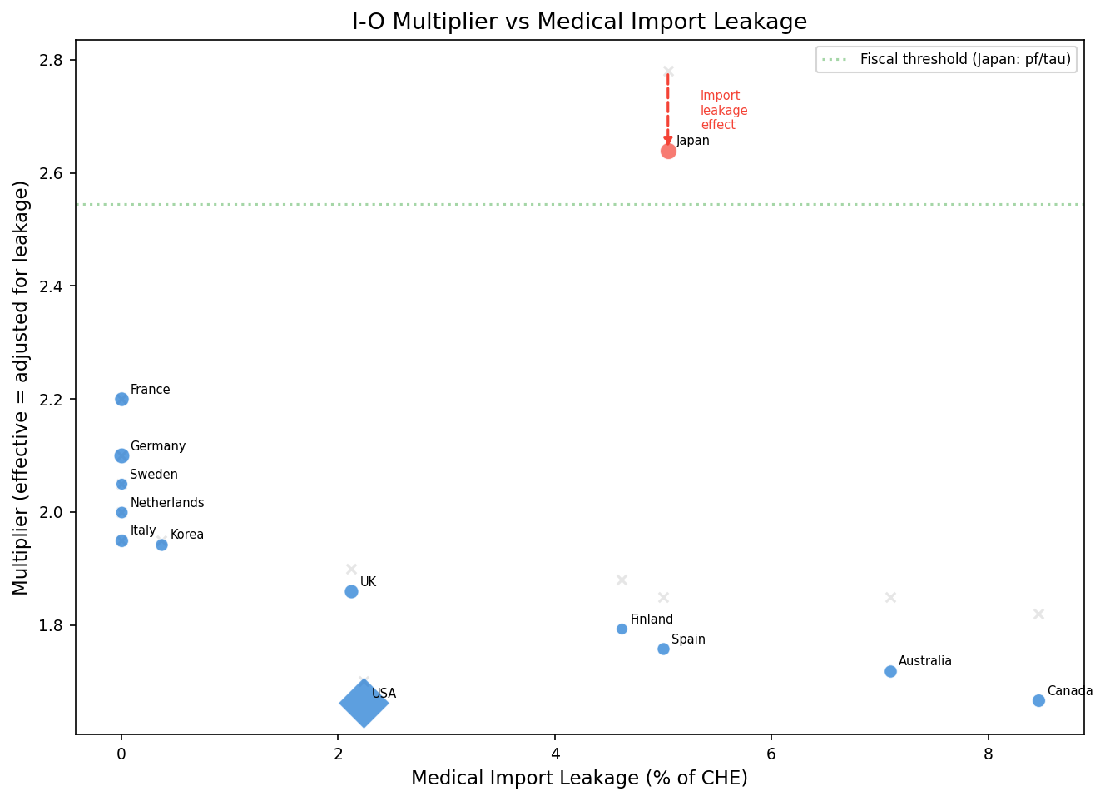
Figure 7
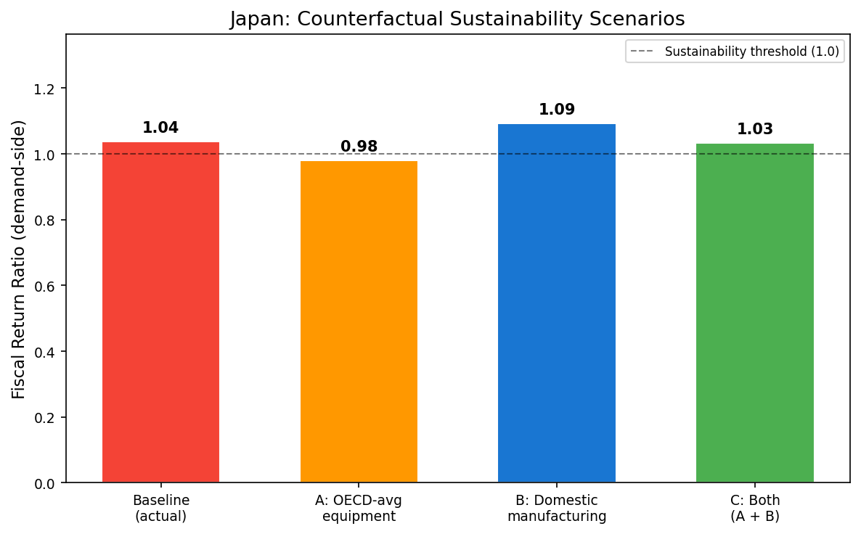
Figure 8

