TITLE PAGE

Demand-Side Fiscal Return to Healthcare Expenditure in Japan: Input-Output Multipliers, a Constant Health-Capital Lag, and Diagnostic Equipment Stock with Cross-Country OECD Benchmarking

Tatsuki Onishi [1]*

[1] [Affiliation to be completed by author]

*Corresponding author: Tatsuki Onishi, [Affiliation]. E-mail: [to be completed]

Short title: Japan Healthcare Demand-Side Return and Lag

Total word count: approximately 7,400 words (Text, References, Tables, and Figure Legends)

Number of figures: 10
Number of tables: 5

Abstract
Background: Japan's healthcare expenditure (11.0% of GDP) is conventionally treated as a fiscal cost. This study evaluates its demand-side fiscal return using input-output (I-O) multipliers, tests for a constant spending-to-outcome lag in health-capital accumulation, and benchmarks Japan against 12 other OECD countries.
Methods: We compiled healthcare sector I-O output multipliers for 13 OECD countries and computed a fiscal return ratio (effective tax rate times output multiplier divided by public financing share), with sensitivity analyses for import leakage, approximate value-added multipliers, and 35% deficit financing. A self-contained tempo model (39 countries, 2000-2019) tested for a constant spending-to-outcome lag using RMSE, AIC, BIC, and LOOCV.
Results: Using output multipliers, the demand-side fiscal return ratio exceeded 1.0 in five of thirteen countries (France 1.18, Italy 1.13, Japan 1.09, Sweden 1.04, Finland 1.04). With value-added multipliers, no country exceeded 1.0. For Japan the ratio fell from 1.09 (gross) to 1.04 after import-leakage adjustment, 0.67 after discounting for 35% deficit financing, and 0.60 under value-added multipliers, bracketing break-even. The equipment-density counterfactual lowered the gross ratio to 0.98 (sensitivity range 0.94-1.02 for equipment share 5-25%). The tempo model supported a constant spending-to-outcome lag of approximately 2 years; the time-varying extension was not supported by AIC or BIC.
Conclusions: Japan's healthcare expenditure generates a material, conditional demand-side fiscal return that brackets break-even. The return is not sufficient for full tax-based self-financing under conservative treatments. Cross-country comparison shows Japan is not an outlier: gross output-multiplier returns exceed break-even in five OECD countries, while value-added and deficit-adjusted returns fall below it. Healthcare spending should be evaluated with both cost and economic-return lenses, treating financing structure and cross-country heterogeneity as boundary conditions.

Keywords: Healthcare expenditure; Input-output analysis; Economic multiplier; Health capital; Sustainability; Diagnostic imaging; Japan; Super-aged society; Deficit financing; OECD

Background
Since the Cabinet's 'Basic Policies on Economic and Fiscal Management' decision in 2005, the Japanese government has pursued policies to moderate the growth of national medical care expenditure. Japan's current health expenditure (CHE) reached 11.0% of GDP in 2019, ranking fifth among 38 Organisation for Economic Co-operation and Development (OECD) countries¹. With rapid population aging -- the proportion of the population aged 65 and over exceeded 28% in 2019, the highest among OECD nations -- the 'sustainability' of healthcare spending has become a central policy concern².
Japan faces a particularly challenging fiscal context: its general account deficit dependency ratio has exceeded 30% in recent years, meaning that roughly one-third of government expenditures are financed by bond issuance rather than current tax revenue³. The national debt-to-GDP ratio exceeds 250%, the highest among advanced economies⁴. Healthcare expenditure, which constitutes approximately 12% of general account expenditures, is thus partially financed by deficit spending. Moreover, Japan's super-aged society -- characterized by a growing elderly demographic (projected 35% aged 65+ by 2040) alongside a shrinking workforce (projected 20% decline by 2040) -- places structural pressure on both the revenue and expenditure sides of healthcare financing.
A distinctive feature of Japan's system is the Late-Stage Elderly Healthcare System (Kouki Koreisha Iryo Seido), which provides a separate insurance framework for individuals aged 75 and over⁵. Unlike many European countries where the institutional framework remains unified, with the elderly protected through subsidized premiums or exemptions, Japan changes the actual insurance 'container' upon reaching age 75. This system is financed by a combination of patient co-payments (10-30%), premiums from enrollees, cross-subsidies from working-age insurance schemes, and public subsidies. The increasing weight of this system -- already covering approximately 18 million enrollees -- is a key driver of aggregate healthcare expenditure growth.
This discourse has almost uniformly treated healthcare expenditure as a 'cost' -- an expense to be minimized through efficiency gains, volume controls, and fee schedule revisions. Yet healthcare is also a major economic sector. It purchases inputs from pharmaceuticals, medical devices, and information technology; it employs millions of workers; and these workers spend their incomes, generating further economic activity throughout the economy. Maeda estimated that Japan's healthcare sector supports 6.89 million jobs in total (2.95 million direct, approximately 4 million indirect), with production-inducement effects exceeding those of any other service industry including construction and education⁶.
Input-output (I-O) analysis, pioneered by Leontief, quantifies how final demand in one sector induces production across the entire economy through direct, indirect, and induced effects. Yamada and Imanaka reported a healthcare I-O output multiplier of 2.78 (95% confidence interval [CI]: 2.74-2.90) for Japan⁷, meaning that each unit of healthcare spending generates 2.78 units of total economic output. Output multipliers ranging from 1.7 to 2.9 have been estimated across OECD countries⁸⁻¹⁰. These are output multipliers -- they measure total output induced, not value added (GDP contribution). Value-added multipliers, which exclude intermediate consumption, are typically 40-60% smaller⁹. This distinction is critical when relating multiplier effects to tax revenues, which are levied on value added and income rather than gross output.
On the supply side, health has long been recognized as a component of human capital that generates long-term economic returns. Mushkin conceptualized health as an investment with returns analogous to education¹¹, and Grossman's health-capital model formally describes individual health stock as accumulated through investment and depreciated by aging and disease¹². At the macro level, Bloom, Canning, and Sevilla demonstrated that improved population health raises total factor productivity¹³. Barro estimated that a one-year increase in life expectancy at birth raises GDP growth by approximately 0.04 percentage points¹⁴.
The Health-Led Growth Hypothesis (HLGH) synthesizes these supply-side effects, positing bidirectional Granger causality between health expenditure and GDP growth. Multiple studies have reported this relationship across OECD and developing countries using diverse econometric specifications¹⁵⁻¹⁹.
We also draw on the Bongaarts-Feeney tempo framework. Bongaarts and Feeney demonstrated that rising mean age at childbearing mechanically depresses the period total fertility rate even when cohort fertility is unchanged²⁰. Goldstein, Lutz, and Scherbov introduced the parity-specific variance sigma, substantially improving tempo adjustment²¹. The same logic maps onto capital formation, where output responds to investment only after a gestation ('time-to-build') lag²², so that a drifting lag behaves as an analogous 'forgotten parameter'. We apply this quantum-tempo logic to healthcare, treating expenditure as a flow that accumulates into a stock of health capital¹² subject to a spending-to-outcome lag analogous to the demographic tempo effect²⁰, and model this lag across 39 countries (2000-2019). The full model specification and code are provided in this study's public repository so that every reported statistic can be reproduced and examined independently.
Japan also has a very high diagnostic imaging equipment density^{1,23}. Japan has 115.7 computed tomography (CT) scanners per million population, approximately 4.3 times the OECD median, and 55.2 magnetic resonance imaging (MRI) units per million, approximately 2.9 times the OECD median. This high density is frequently cited as evidence of 'excess' in the Japanese healthcare system. Simultaneously, Japan is a net importer of medical devices and pharmaceuticals, with import leakage representing approximately 5.0% of CHE²⁴.
An important structural context is Japan's physician density: at 2.5 physicians per 1,000 population, Japan ranks among the lowest in the OECD (average 3.7)²⁵. This low physician density, combined with free access to specialists and the world's highest diagnostic equipment density, raises questions about the sustainability of current service levels, particularly as work-style reform legislation limits physician overtime²⁶.
The aim of this study was to (1) evaluate the demand-side fiscal return to Japan's healthcare expenditure using I-O multipliers and a health-capital tempo model, (2) quantify the role of diagnostic equipment stock and import leakage, (3) construct counterfactual scenarios with sensitivity analysis, and (4) benchmark Japan against 12 additional OECD countries. The conceptual framework is illustrated in Figure 1.

Methods

Study design and data sources
This study is a cross-country ecological analysis using publicly available data from OECD Health at a Glance 2023^{1,23}, the World Bank World Development Indicators²⁷, published I-O studies of healthcare sectors⁶⁻¹⁰, Health-Led Growth Hypothesis panel studies¹⁵⁻¹⁹, pharmaceutical/device trade statistics²⁴, and Japanese fiscal data from the Ministry of Finance³ and Bank of Japan⁴. As an analysis of publicly available aggregate data, no ethical approval was required.

Country selection
Thirteen OECD countries were selected based on availability of healthcare sector I-O multiplier estimates: Japan, USA, Germany, Australia, Korea, Italy, France, UK, Canada, Sweden, Spain, Netherlands, and Finland. All countries had either a direct I-O study published in a peer-reviewed journal or backward-linkage coefficients from the EU-28 framework study⁹.

Fiscal return ratio
For each country, we calculated a demand-side fiscal return ratio as an indicator of whether healthcare-induced economic activity generates sufficient tax revenue to cover public healthcare costs:
$FR=\frac{τ × m}{pf}$
where $τ$ is the effective tax rate (total tax and social insurance contributions as a proportion of GDP), $m$ is the healthcare sector I-O output multiplier, and $pf$ is the public financing share of CHE.
One caveat is that the I-O multipliers used in this study are output multipliers, measuring total production induced per unit of final demand. These differ from value-added (VA) multipliers, which measure the GDP contribution by subtracting intermediate inputs. Because the effective tax rate $τ$ is expressed as tax revenue divided by GDP (a value-added measure), multiplying $τ$ by an output multiplier conflates output and value added, potentially overstating the induced tax revenue. We therefore present results using both output multipliers (as an upper bound) and approximate VA multipliers (output multiplier times the sector-specific VA/output ratio, approximately 0.55-0.60 for healthcare in OECD countries⁹) as a more conservative estimate. Neither estimate accounts for opportunity costs: in an economy near full employment, resources employed in healthcare would generate alternative output and tax revenue elsewhere, reducing the net fiscal return attributable to healthcare spending.
Additionally, we computed a deficit-adjusted variant of the ratio. When the public financing share is partly funded by deficit (bond) issuance rather than current taxation, a ratio above 1.0 reflects only a temporary flow of single-year tax revenue and does not account for the long-term cost of servicing the accumulated debt^{3,4}. For Japan, the general account deficit dependency ratio was approximately 35% in recent fiscal years. We report results both with and without this adjustment.

Tempo model specification
The tempo model tests for a constant spending-to-outcome lag in health-capital accumulation. To ensure reproducibility, the model, the underlying World Bank data, and the model-selection computation (level RMSE, change RMSE, leave-one-out cross-validation [LOOCV] RMSE, AIC, and BIC) are all provided in this study's public repository, so the framework can be reproduced and examined independently. The model treats health expenditure as a stock-building flow and regresses life expectancy on the log health-capital stock, controlling for income:
${LE}_{t}=α+βln H_{t}+γln {GDPpc}_{t}+ε_{t}$
where ${LE}_{t}$ is life expectancy at birth, ${GDPpc}_{t}$ is GDP per capita, and $H_{t}$ is the health-capital stock constructed via a perpetual inventory method from per-capita current health expenditure (PPP, World Bank indicators SH.XPD.CHEX.PP.CD and SH.XPD.CHEX.GD.ZS) with a depreciation rate $δ_{H}=0.10$ and geometric lag weights (World Bank data, 2000-2019, 39 countries). The spending-to-outcome lag is specified as:
${μH}_{t}={μH}_{0}+{μH}_{1}×(year−t_{0})$
Three nested variants were compared: M0 (flow-only, no lag; 3 parameters: intercept, ln expenditure, ln GDPpc), M1 (constant lag $μ*$; 4 parameters), and M2 (time-varying lag $μ_{H0}+μ_{H1}×(year-t_{0})$; 5 parameters). Lag parameters were estimated by grid search (M1: $μ*$ over 0-19 years in 1-year steps; M2: $μ_{H0}$ over 0-18 years in 2-year steps and $μ_{H1}$ over -0.10 to +0.30 yr/yr in 0.05 steps), refitting the linear model at each grid point and selecting the fit that minimized residual sum of squares. Across the 39 countries (2000-2019) the median constant lag was $μ*=2.0$ years. The M2 drift parameter $μ_{H1}$ was not reliably identified: its country-level estimates were bimodal and dominated by the grid boundaries (roughly 51% at the lower bound and 31% at the upper bound), with a median of -0.10 yr/yr. We therefore treat M2 as an exploratory specification rather than as evidence of a stable time-varying drift. A positive drift estimate can be obtained if the 2020-2022 COVID-19 mortality shock is included, but that period is not representative of the long-term tempo relationship; the 2000-2019 sample reported here does not support a positive drift.

Model selection criteria
To ensure symmetric application of model selection criteria across all analyses (as applied to the Preston Curve test below), we evaluated all tempo model variants using: (a) in-sample level RMSE, (b) change RMSE, (c) leave-one-out cross-validation (LOOCV) RMSE, (d) Akaike Information Criterion (AIC), and (e) Bayesian Information Criterion (BIC). AIC and BIC penalize model complexity, with BIC imposing a heavier penalty for additional parameters. All criteria are reported in the Results section.

Equipment stock and import leakage model
Diagnostic imaging equipment density was defined as the sum of CT scanners and MRI units per million population²³. Medical import leakage was calculated as the net imports of pharmaceuticals (HS30) and medical devices (HS9018-22) divided by CHE²⁴. The effective I-O multiplier was defined as:
$m_{eff}=m(1−l)$ where $l$ is the import leakage rate.

Counterfactual scenarios and sensitivity analysis
Three counterfactual scenarios were constructed for Japan. Scenario A assumed Japan's equipment density was reduced to the OECD median. The transmission chain is modeled explicitly: (i) equipment density reduction implies proportionally lower equipment-related healthcare spending; (ii) we estimate that equipment-related spending comprises approximately 15% of CHE (based on OECD health capital expenditure accounts; this is an approximation subject to sensitivity analysis); (iii) the reduction in domestic equipment-related spending reduces the I-O multiplier by half the proportional equipment share reduction, reflecting that some equipment spending flows to imports rather than domestic production; (iv) the effective multiplier is then further adjusted for import leakage.
Scenario B assumed complete domestic manufacturing (zero import leakage); Scenario C combined both adjustments. Because the equipment-related CHE share (15%) is an approximation, we conducted sensitivity analysis varying this parameter from 5% to 25% in 5-percentage-point increments (see Results).

Preston Curve overfit test
The relationship between CHE (as a percentage of GDP) and life expectancy was analyzed using nested-model F-tests²⁸. Models were fit with and without the US, and compared using F-statistics, AIC, BIC, and LOOCV RMSE.

Results

I-O multipliers and fiscal return ratios
Table 1 presents the healthcare sector I-O output multipliers for the 13 selected countries. Japan had the highest multiplier at 2.78 (95% CI: 2.74-2.90)⁷, followed by France (2.20), Germany (2.10), and Sweden (2.05). The US had the lowest multiplier at 1.70⁸; however, the US estimate is based on Medicare spending only, which is not directly comparable to whole-sector multipliers for other countries. The multiplier estimates also differ in estimation year (2006-2017) and method (direct national I-O studies vs EU-28 backward-linkage coefficients), and these differences limit strict cross-country comparison. Figure 2 displays the multipliers.
Table 1. Healthcare sector I-O output multipliers
Country | Output Multiplier | Year | Source
Japan | 2.78 | 2011 | Yamada & Imanaka 2015
Japan (JMARI) | 2.85 | 2006 | Maeda 2008 (JMARI WP172)
France | 2.2 | 2010 | Gutierrez-Hernandez & Abasolo-Alesson 2021
Germany | 2.1 | 2014 | Henke & Ostwald 2012 (GGR estimate)
Sweden | 2.05 | 2010 | Gutierrez-Hernandez & Abasolo-Alesson 2021
Netherlands | 2.0 | 2010 | Gutierrez-Hernandez & Abasolo-Alesson 2021
Italy | 1.95 | 2010 | Gutierrez-Hernandez & Abasolo-Alesson 2021
Korea | 1.95 | 2015 | Bank of Korea I-O Tables 2019
United Kingdom | 1.9 | 2016 | ONS Health SUT / King's Fund 2018
Finland | 1.88 | 2010 | Gutierrez-Hernandez & Abasolo-Alesson 2021
Spain | 1.85 | 2010 | Gutierrez-Hernandez & Abasolo-Alesson 2021
Australia | 1.85 | 2015 | AIHW / Deloitte Access Economics 2016
Canada | 1.82 | 2009 | CIHI / Conference Board 2013
United States (Medicare) | 1.7 | 2017 | Dupor & Guerrero 2017 (Fed StL)
OECD Average | 1.95 | 2020 | Synthesis (this study)
Note: US estimate is Medicare-only (Dupor & Guerrero 2021). EU-28 estimates from Gutierrez-Hernandez & Abasolo-Alesson 2021.

Table 2 presents the fiscal return ratios. Using output multipliers, five countries achieved a ratio at or above 1.0: France (1.18), Italy (1.13), Japan (1.09), Sweden (1.04), and Finland (1.04). However, when approximate value-added multipliers are used instead, no country reaches 1.0, with Japan falling to 0.60. This highlights that the output multiplier provides an upper bound for the fiscal return, while the VA multiplier provides a lower bound. The true fiscal return likely lies between these estimates. Figure 3 shows the ratios graphically.
Table 2. Fiscal sustainability indicators
Country | Output Mult. | VA Mult. | Eff. Tax Rate | Public Share | Deficit Share | FR (Output) | FR (VA) | FR (Deficit-adj)
Japan | 2.78 | 1.53 | 0.33 | 0.84 | 0.35 | 1.09 | 0.6 | 0.674
USA | 1.7 | 1.02 | 0.27 | 0.5 | 0.25 | 0.92 | 0.55 | 0.673
Germany | 2.1 | 1.26 | 0.39 | 0.85 | 0.04 | 0.96 | 0.58 | 0.925
UK | 1.9 | 1.14 | 0.33 | 0.8 | 0.12 | 0.78 | 0.47 | 0.675
France | 2.2 | 1.32 | 0.45 | 0.84 | 0.1 | 1.18 | 0.71 | 1.061
Sweden | 2.05 | 1.23 | 0.43 | 0.85 | 0.02 | 1.04 | 0.62 | 1.016
Canada | 1.82 | 1.09 | 0.33 | 0.73 | 0.15 | 0.82 | 0.49 | 0.64
Australia | 1.85 | 1.11 | 0.28 | 0.68 | 0.18 | 0.76 | 0.46 | 0.58
Korea | 1.95 | 1.17 | 0.27 | 0.61 | 0.1 | 0.86 | 0.52 | 0.774
Italy | 1.95 | 1.17 | 0.43 | 0.74 | 0.08 | 1.13 | 0.68 | 1.042
Spain | 1.85 | 1.11 | 0.35 | 0.71 | 0.12 | 0.91 | 0.55 | 0.762
Netherlands | 2.0 | 1.2 | 0.39 | 0.82 | 0.03 | 0.95 | 0.57 | 0.923
Finland | 1.88 | 1.13 | 0.43 | 0.78 | 0.05 | 1.04 | 0.62 | 0.939
${FR}_{output}=\frac{τ × m}{pf}$, where $m$ is the output multiplier. ${FR}_{VA}=\frac{τ × m_{VA}}{pf}$, where $m_{VA}$ is the approximate value-added multiplier. ${FR}_{deficit}=\frac{τ × m_{eff} × (1−δ)}{pf}$, where $m_{eff}=m(1−l)$, $l$ is the import leakage rate, and $δ$ is the deficit share. Output and VA multipliers bound the demand-side return from above and below; the deficit adjustment is a stylized sustainability boundary, not a claim that bond issuance mechanically reduces contemporaneous tax revenue.

Deficit financing and the fiscal return ratio
Because roughly 35% of Japan's public expenditure is met by bond issuance rather than current taxation, the gross fiscal return ratio overstates the genuinely self-financing position: the deficit-funded portion is not covered by current revenue and represents an intergenerational transfer. We therefore report a deficit-adjusted ratio that treats debt-financed spending as a sustainability sensitivity: ${FR}_{deficit}=\frac{τ × m_{eff} × (1−δ)}{pf}$, where $m_{eff}=m(1−l)$. For Japan, applying $δ=0.35$ to the import-leakage-adjusted return lowers the ratio from 1.04 to 0.67. Figure 4 shows the resulting cascade: Japan's ratio moves from 1.09 (gross output multiplier) to 1.04 (import-leakage adjusted), to 0.67 (deficit-adjusted), to 0.60 (value-added multiplier). The gross and import-leakage figures bracket break-even from above, while the value-added and deficit-adjusted figures bracket it from below. This adjustment is a stylized sustainability boundary, not a claim that bond issuance contemporaneously lowers induced tax revenue per yen spent.
The direction of interpretation is consistent across these treatments: Japan's healthcare expenditure returns a demand-side fiscal flow of the same order of magnitude as its public cost -- a materially larger economic return than the conventional 'pure-cost' framing implies -- but this return does not, on its own, render current public healthcare spending unconditionally self-financing once income-only (value-added) and balanced-budget (deficit-adjusted) accounting are imposed. For completeness we note the alternative 'tax-funded-denominator' ratio, $\frac{τ×m}{pf×(1−δ)}=1.60$, which answers the different question of whether induced tax revenue covers the currently tax-financed portion of public cost; because it moves in the opposite direction and does not account for debt servicing, we do not adopt it as our headline sustainability measure.

Tempo model performance
Table 3 summarizes the tempo model comparison with all model selection criteria, computed from public World Bank data (2000-2019). The introduction of a spending-to-outcome lag (M1 vs M0) produced a substantial improvement across all criteria: median level RMSE improved from 0.253 to 0.208 years and median LOOCV RMSE from 0.304 to 0.250 years. M1 was favoured over M0 by AIC in 64% of countries, by BIC in 64%, and by LOOCV in 69%. This supports the interpretation that a meaningful lag exists between healthcare spending and health outcomes and supports a stock-based view of health-capital investment.
The time-varying extension (M2 vs M1) did not yield a comparable improvement. The median level RMSE was essentially unchanged (0.207 vs 0.208 years) and, once the additional parameter was penalized, M2 was favored over M1 in 0% of countries by AIC and 0% by BIC (median AIC -53.0 vs -54.8; median BIC -48.0 vs -50.8); its only advantage was on LOOCV RMSE (72% of countries, but with a negligible median difference of 0.001 years). The drift parameter $μ_{H1}$ was not reliably identified across countries, with a grid-boundary-dominated bimodal distribution and a median of -0.10 yr/yr. We therefore find no reliable evidence for a time-varying lag: the reliable finding is the existence of a constant lag (M1 vs M0), not its time-variation (M2 vs M1). Including the 2020-2022 COVID-19 shock can generate a positive drift, but that period is not representative of the long-term tempo relationship. Figure 5 shows the three-layer tempo comparison.
Table 3. Tempo model comparison (39 countries, 2000-2019)
Model | Params | Level RMSE | Change RMSE | LOOCV RMSE | AIC | BIC
M0 (flow-only) | 3 | 0.253 | 0.220 | 0.304 | -49.0 | -46.0
M1 (constant lag) | 4 | 0.208 | 0.224 | 0.250 | -54.8 | -50.8
M2 (tempo lag) | 5 | 0.207 | 0.224 | 0.250 | -53.0 | -48.0
Median values across 39 countries, computed from World Bank data and reproducible in the public repository. RMSE in years. LOOCV = leave-one-out cross-validation. AIC/BIC: lower is better. M1 outperforms M0 (AIC/BIC/LOOCV: 64%/64%/69% of countries). M2 does not improve on M1 under AIC or BIC (0%/0%).

Preston Curve overfit analysis
When the US was included (n = 38), the quadratic term was highly significant (F = 13.2, p < 0.001). When the US was excluded (n = 37), the quadratic term became non-significant (F = 0.5, p = 0.49), and all selection criteria (AIC, BIC, LOOCV RMSE) favored the linear model (Figure 6).

Diagnostic equipment density
Japan exhibited the highest diagnostic imaging density: 115.7 CT scanners and 55.2 MRI units per million (combined 170.9), approximately four times the OECD median of 48 (Figure 7).

Import leakage and effective multipliers
For Japan, the nominal output multiplier of 2.78 was reduced to 2.64 after adjusting for 5.0% import leakage, and the fiscal return ratio fell from 1.09 to 1.04 (Figure 8).

Counterfactual scenarios and sensitivity analysis
Table 4 presents the counterfactual analysis. Under Scenario A (OECD-average equipment density with 15% equipment-CHE share assumption), the fiscal return ratio fell to 0.98. Under Scenario B (complete domestic manufacturing), the ratio rose to 1.09. Under Scenario C (both adjustments), the ratio was 1.03 (Figure 9).
Table 4. Counterfactual scenarios for Japan
Scenario | Equipment Density | Import Leakage | Eff. Multiplier | Fiscal Return
Baseline | 170.9 (actual) | 5.0% | 2.64 | 1.04
A: OECD-avg equipment | 48 (median) | 5.0% | 2.50 | 0.98
B: Domestic mfg | 170.9 (actual) | 0% | 2.78 | 1.09
C: Both A + B | 48 (median) | 0% | 2.63 | 1.03

Table 5 and Figure 10 present the sensitivity of Scenario A to the equipment-related CHE share assumption. At 5%, the fiscal return ratio is 1.02 (above the threshold); at 10%, the fiscal return ratio is 1.00 (at the threshold); at 15%, the fiscal return ratio is 0.98 (below the threshold); at 20%, the fiscal return ratio is 0.96 (below the threshold); at 25%, the fiscal return ratio is 0.94 (below the threshold). This indicates that the Scenario A fiscal return is sensitive to this assumption: for equipment shares below approximately 10%, the ratio stays at or above the 1.0 threshold even at OECD-average equipment density, but these values are better read as sensitivity outcomes than as a categorical sustainability determination.
Table 5. Sensitivity of Scenario A fiscal return to equipment-related CHE share assumption
Equipment CHE Share | Adj. Multiplier | Eff. Multiplier | Fiscal Return | Position relative to 1.0
5% | 2.73 | 2.59 | 1.018 | Above
10% | 2.68 | 2.54 | 1.000 | At
15% | 2.63 | 2.50 | 0.981 | Below
20% | 2.58 | 2.45 | 0.963 | Below
25% | 2.53 | 2.40 | 0.944 | Below
Scenario A: Japan with OECD-average equipment density (48 per million). Base case = 15%. Values near 1.0 are better read as sensitivity outcomes than as a binary sustainability determination.

Discussion

Principal findings
This study evaluated the demand-side fiscal return to Japan's healthcare expenditure, benchmarked against 12 OECD countries. Three principal findings emerged, each with important caveats.
First, the demand-side fiscal return ratio using output multipliers suggested that five countries (France, Italy, Japan, Sweden, Finland) may recover the full public cost of healthcare through multiplier-induced tax revenues. However, this conclusion depends critically on whether output or value-added multipliers are used. With VA multipliers, no country achieves full cost recovery through demand-side returns alone. The true fiscal return likely lies between these bounds. Moreover, once deficit financing is taken into account, Japan's demand-side return falls below break-even, and the analysis does not account for opportunity costs: in economies near full employment, healthcare spending displaces alternative economic activity, and the net fiscal return is lower than the gross multiplier effect suggests.
Second, the spending-to-outcome lag in the tempo model (M1 vs M0) was supported by all model selection criteria (AIC, BIC, and LOOCV favoured M1 over M0 in 64%, 64%, and 69% of countries), suggesting that healthcare expenditure operates through a stock-building mechanism with a median lag of approximately 2.0 years. However, the time-varying extension (M2 vs M1) yielded no improvement once the additional parameter was penalized (M2 was favoured over M1 in 0% of countries by AIC and 0% by BIC), and the drift parameter was not reliably identified. We therefore do not claim a time-varying tempo drift.
Third, Japan's counterfactual analysis showed that the sustainability conclusion under Scenario A (reduced equipment density) depends on the assumed equipment-related CHE share. The gap between the Scenario A ratio (0.98) and the threshold (1.0) is 0.02, which is smaller than the sensitivity range (0.94-1.02 across the 5-25% equipment share range). Values near 1.0 should therefore be interpreted with an uncertainty range rather than as a binary sustainability determination.

Position on Japan's equipment density
We take the position that Japan's current equipment density represents neither a clear social surplus nor an unambiguous necessity, but rather a structural feature whose net effect on sustainability is context-dependent. On the positive side, high equipment density enables rapid diagnostic access, contributes to the I-O multiplier through domestic healthcare activity, and may facilitate early detection. On the negative side, the combination of free specialist access and high equipment density may incentivize defensive medicine, over-testing, and unnecessary imaging²⁹, artificially inflating apparent economic returns. The current analysis cannot distinguish between value-generating diagnostic activity and wasteful over-utilization; this distinction requires micro-level data on diagnostic yield and clinical outcomes.

Over-supply risks and workforce sustainability
A fundamental limitation of interpreting high economic multipliers as evidence of sustainability is that the multiplier captures economic activity, not health value. Japan's unique combination of unrestricted specialist access and the world's highest diagnostic equipment density may inflate economic activity through defensive medicine and over-testing rather than genuine health improvement. Hiramatsu et al. documented that approximately 98% of Japanese physicians report engaging in some form of defensive medicine²⁹. If a substantial fraction of the equipment-related economic activity reflects low-value utilization, the fiscal return ratio overstates the true sustainability benefit.
Moreover, the current service level has been maintained through excessive, often uncompensated physician overtime. Japan's physician density (2.5 per 1,000) is among the lowest in the OECD²⁵, yet Japanese patients enjoy the fastest access to specialist care globally. With the enforcement of work-style reform legislation capping physician overtime²⁶, maintaining current service levels may be practically impossible without either increasing physician numbers (which would raise labor costs and reduce the multiplier-based fiscal return) or reducing service volume (which would reduce equipment utilization and the multiplier itself). This labor constraint represents a threat to the sustainability framework's assumptions.

Implications of Japan's elderly insurance structure
Japan's Late-Stage Elderly Healthcare System creates a structural discontinuity that complicates sustainability analysis⁵. Per-capita healthcare expenditure for enrollees aged 75+ is approximately four times that of the working-age population, and this system is cross-subsidized by working-age insurance schemes. As the proportion of late-stage elderly grows (projected to reach 20% of the population by 2040), the cross-subsidy burden on the shrinking working-age population intensifies. A limitation of the current analysis is that it treats healthcare expenditure as a homogeneous aggregate; separate analyses for the late-stage elderly and working-age populations would yield different multiplier effects and fiscal return ratios. This disaggregation is an important direction for future research.

Assumptions and interpretation of the diagnostic-equipment scenario
The Scenario A counterfactual is illustrative rather than causal. It fixes the equipment-related current health expenditure (CHE) share at 15% and scales Japan's diagnostic equipment density to the rounded OECD median of 48 units per million population, but it does not estimate a clinical production function linking equipment density to service cost or quality. The sensitivity range (5-25%) shows how the demand-side fiscal return changes under alternative assumptions, not the socially optimal level of imaging capacity. Values close to 1.0 should therefore be interpreted as a boundary region rather than as proof that the system is or is not self-financing.

Deficit financing and national debt
Japan's fiscal return ratio of 1.09 (output multiplier basis) must be interpreted in the context of chronic deficit financing. Approximately 35% of Japan's general government expenditure is financed by bond issuance³, and the accumulated public debt exceeds 250% of GDP⁴. If this deficit dependency is applied proportionally to healthcare, the demand-side fiscal return covers only the tax-funded portion of public healthcare costs; the deficit-funded portion (approximately 29% of public CHE) represents an intergenerational transfer whose 'return' depends on whether the health capital accumulated today generates sufficient future economic activity to service the debt. This intertemporal dimension is not captured by the cross-sectional fiscal return ratio. For international comparison, countries with low deficit dependency (Sweden 2%, Netherlands 3%, Germany 4%) face a less severe version of this problem, while the US (25%) and Australia (18%) share a qualitatively similar challenge.

Interpreting the fiscal return ratio: output, value-added, and deficit adjustments
The output multiplier measures the gross production response to a demand impulse and does not subtract intermediate inputs; it is best read as an illustrative upper bound on the contemporaneous demand-side fiscal return. The approximate value-added multiplier applies a single sectoral VA/output ratio to the gross output multiplier, which is a simplifying approximation because induced output occurs across industries with different value-added coefficients. It is therefore a plausible lower bound, not a direct I-O-table value-added multiplier. The true marginal effect likely lies between these two bounds and depends on the counterfactual use of public funds and the economy's capacity to absorb the extra demand.
The deficit adjustment is a stylized boundary, not a mechanical discount. Financing 35% of expenditure through bond issuance does not reduce the contemporaneous tax revenue induced by that expenditure by 35%; rather, it creates an intertemporal fiscal obligation. The adjusted ratio asks what fraction of public cost would be covered if the demand-side return had to service the deficit-financed portion as well. It is one of several sustainability conditions--alongside value-added accounting, import leakage, and opportunity cost--that bound the interpretation of the headline ratio.

Limitations of international comparison
The fiscal return ratio assumes that healthcare quality and accessibility are comparable across countries, which is not the case. Japan and South Korea provide unrestricted access to specialists with 24-hour walk-in emergency care. The UK, France, and Nordic countries require gatekeeping general practitioner consultations before specialist referral. Germany and the US enforce strict emergency triage. These differences in service level mean that the same fiscal return ratio may correspond to fundamentally different healthcare experiences. Direct ratio comparison is therefore appropriate for identifying broad patterns but not for making normative judgments about which country's system is 'more sustainable.' Additionally, variations in physician remuneration affect comparability: high-salary countries (US, Switzerland) have different cost structures from moderate-compensation countries (Japan, France) and low-compensation countries (Finland, Sweden), affecting both the multiplier and the fiscal return²⁵.

Cross-country I-O multiplier comparability
The 13 fiscal return ratios are based on healthcare-sector I-O multipliers drawn from different national tables, estimation years, and methodological conventions. The US estimate, for example, is Medicare-specific, whereas most others represent broader healthcare sectors; sectoral classification, treatment of public versus private providers, and import content differ across tables. Consequently the cross-country figures are not a strict ordinal ranking of healthcare sustainability. Their value lies in showing how sensitive the demand-side return is to accounting and data conventions, and in placing Japan within the range of OECD variation rather than identifying the 'best' system.

Relationship among the three analytical components
The three parts of this study are complementary but not nested in a single causal model. The I-O analysis estimates a contemporaneous demand-side fiscal return conditional on the tax and financing structure. The tempo model tests whether healthcare expenditure is associated with a constant spending-to-outcome lag; the finding is a timing regularity, not a quantified supply-side fiscal return. The diagnostic-equipment scenario illustrates how imported capital equipment changes the demand-side multiplier through import leakage. The Preston curve overfit test is a plausibility check on the income-expenditure-mortality relationship; its sensitivity to the United States observations shows it should not be read as evidence of a causal effect. None of the three components alone answers the sustainability question; together they bound the conditions under which a demand-side return is materially large.

Additional limitations
Several limitations remain. First, I-O multipliers are static models that do not account for price adjustments, supply constraints, or general equilibrium effects. Second, the effective tax rate parameter may not fully capture the complexity of national tax systems. Third, import leakage was calculated using aggregate HS trade data and does not capture re-exports or domestic value-added content of imports. Fourth, the counterfactual scenarios are static partial-equilibrium models. Fifth, the tempo model's time-varying component (M2) does not consistently survive parsimony-aware model selection. Finally, this study focused on the demand-side fiscal return; a comprehensive sustainability assessment would also need to quantify the economic returns to supply-side health-capital effects, which requires individual-level data.

Conclusions
Japan's healthcare expenditure generates a material, conditional demand-side fiscal return. On the demand side alone it recovers a substantial share of public cost through induced taxation: an output-based fiscal return ratio of 1.09, remaining at 1.04 after import-leakage adjustment, 0.67 after discounting for deficit financing, and 0.60 under the most conservative value-added treatment. These values bracket break-even and show that the economic return is of a magnitude comparable to other discretionary fiscal expenditures, but that the demand-side return alone falls short of full tax-based self-financing under conservative treatments.
Japan's high diagnostic equipment density contributes positively to the economic return, but the counterfactual analysis shows that the sustainability conclusion is sensitive to the assumed equipment-related spending share, with the point estimate near the threshold and within the range of parametric uncertainty. Moreover, the economic return captured by the multiplier does not distinguish between high-value and low-value utilization, and the current service level may be unsustainable given workforce constraints.
The tempo model indicates that a spending-to-outcome lag exists, supporting a stock-based view of healthcare investment. Under parsimony-aware model selection, however, the reproducible 2000-2019 analysis supports only a constant lag; it provides no reliable evidence for a time-varying drift, which is not favoured by AIC or BIC.
We conclude that healthcare expenditure should be evaluated through both cost and economic-return lenses, and that its demand-side economic return should be formally incorporated into fiscal evaluation rather than disregarded. The return is material but not sufficient for full self-financing under conservative treatments; it should be counted as one component of sustainability, with deficit-financing dependence, over-supply risk, workforce constraints, and the age-specific structure of spending treated as conditions on that return rather than as reasons to dismiss it. The cross-country comparison shows that Japan's position is not an outlier: the gross output-multiplier return exceeds break-even in five OECD countries, while the value-added and deficit-adjusted returns fall below it in all 13. This sensitivity to accounting assumptions and financing structure is the main value of the multi-country design; a Japan-only analysis would miss it.

List of abbreviations
AIC: Akaike Information Criterion
BIC: Bayesian Information Criterion
CHE: Current Health Expenditure
CI: Confidence Interval
CT: Computed Tomography
GDP: Gross Domestic Product
HLGH: Health-Led Growth Hypothesis
I-O: Input-Output
LOOCV: Leave-One-Out Cross-Validation
MHLW: Ministry of Health, Labour and Welfare
MOF: Ministry of Finance
MRI: Magnetic Resonance Imaging
OECD: Organisation for Economic Co-operation and Development
RMSE: Root Mean Square Error
SE: Standard Error
VA: Value Added

Declarations

Declaration of generative AI in scientific writing
During the preparation of this work the author used generative AI tools to improve readability, structure, and language. After using these tools, the author reviewed and edited the content as needed and takes full responsibility for the final publication. No generative AI was used to create or alter the data, figures, or statistical analyses; all numeric results, tables, and figures are derived from the reproducible code and public data described in the Availability of data and materials statement.

Ethics approval and consent to participate
Not applicable. This study used only publicly available aggregate data from international organizations (OECD, World Bank) and published literature.

Consent for publication
Not applicable.

Availability of data and materials
All data used in this study are publicly available. OECD Health at a Glance 2023 data: https://www.oecd.org/health/. World Development Indicators: https://databank.worldbank.org/. I-O multiplier estimates are reported in the cited published studies. The complete analysis code and input data underlying this revision -- including the tempo model, the World Bank data fetch, and the full model-selection computation (level RMSE, change RMSE, LOOCV RMSE, AIC, and BIC) -- are available at https://github.com/bougtoir/healthcare-economic-effect. The quantitative results reported here can be reproduced from a clean clone with: python scripts/tempo_model_selection.py followed by python scripts/analyze_healthcare_economic_effect.py. This repository corresponds directly to the present manuscript and supersedes the earlier minimum proof-of-concept.

Competing interests
The authors declare that they have no competing interests.

Funding
[To be completed by author. If no funding, state: 'No funding was received for this study.']

Authors' contributions
TO conceived and designed the study, collected and analyzed the data, and drafted the manuscript. All authors read and approved the final manuscript.

Acknowledgements
[To be completed by author, or state 'Not applicable.']

References
1. OECD. Health at a Glance 2023: OECD Indicators. Paris: OECD Publishing; 2023.
2. Cabinet Office, Japan. Annual Report on the Japanese Economy 2025. Tokyo: Cabinet Office; 2025. [In Japanese]
3. Ministry of Finance, Japan. Highlights of the Budget for FY2024. Tokyo: MOF; 2024. Available from: https://www.mof.go.jp/english/policy/budget/budget/
4. Bank of Japan. Flow of Funds Accounts. Tokyo: BOJ; 2024. Available from: https://www.boj.or.jp/en/statistics/sj/
5. Ministry of Health, Labour and Welfare. Annual Health, Labour and Welfare Report 2023. Tokyo: MHLW; 2023. [In Japanese]
6. Maeda Y. Economic ripple effects of healthcare and long-term care. JMARI Working Paper No. 172. 2008. [In Japanese]
7. Yamada G, Imanaka Y. Input-output analysis on the economic impact of medical care in Japan. Environ Health Prev Med. 2015;20(5):379-387.
8. Dupor B, Guerrero R. The aggregate and local economic effects of government financed health care. Econ Inq. 2021;59(2):662-670.
9. Gutierrez-Hernandez I, Abasolo-Alesson I. The health care sector in the economies of the European Union: an overview using an input-output framework. Cost Eff Resour Alloc. 2021;19(1):4.
10. Henke KD, Ostwald DA. Health satellite account: the first step. Int J Behav Healthc Res. 2012;3(2):91-105.
11. Mushkin SJ. Health as an investment. J Polit Econ. 1962;70(5):129-157.
12. Grossman M. On the concept of health capital and the demand for health. J Polit Econ. 1972;80(2):223-255.
13. Bloom DE, Canning D, Sevilla J. The effect of health on economic growth: a production function approach. World Dev. 2004;32(1):1-13.
14. Barro RJ. Health and economic growth. Ann Econ Finance. 2013;14(2):305-342.
15. Ertugrul HM, Baycan O, Atilgan E, Ulucan H. Health-led growth hypothesis and health financing systems: an econometric synthesis for OECD countries. Front Public Health. 2024;12:1437304.
16. Amiri A, Ventelou B. Granger causality between total expenditure on health and GDP in OECD: Evidence from the Toda-Yamamoto approach. Econ Lett. 2012;116(3):541-544.
17. Beylik U, Cirakli U, Cetin M, Ecevit E, Senol O. The relationship between health expenditure indicators and economic growth in OECD countries: A Driscoll-Kraay approach. Front Public Health. 2022;10:1050550.
18. Wang KM. Health care expenditure and economic growth: Quantile panel-type analysis. Econ Model. 2011;28(4):1536-1549.
19. Piabuo SM, Tieguhong JC. Health expenditure and economic growth - a review of the literature and an analysis between the economic community for central African states (CEMAC) and selected African countries. Health Econ Rev. 2017;7(1):23.
20. Bongaarts J, Feeney G. On the quantum and tempo of fertility. Popul Dev Rev. 1998;24(2):271-291.
21. Goldstein JR, Lutz W, Scherbov S. Long-term population decline in Europe: the relative importance of tempo effects and generational length. Popul Dev Rev. 2003;29(4):699-707.
22. Kydland FE, Prescott EC. Time to build and aggregate fluctuations. Econometrica. 1982;50(6):1345-1370.
23. OECD. Health at a Glance 2023: OECD Indicators. Chapter 5.23: Diagnostic technologies. Paris: OECD Publishing; 2023.
24. Ministry of Health, Labour and Welfare. Pharmaceutical and medical device production statistics annual report. Tokyo: MHLW; 2021. [In Japanese]
25. OECD. Health at a Glance 2023: OECD Indicators. Chapter 8.1: Health workforce. Paris: OECD Publishing; 2023.
26. Koike S, Wada H, Ohde S, Ide H, Taneda K, Tanigawa T. Working hours of full-time hospital physicians in Japan: a cross-sectional nationwide survey. BMC Public Health. 2024;24:164.
27. World Bank. World Development Indicators. Washington, DC: World Bank; 2024. Available from: https://databank.worldbank.org/
28. Preston SH. The changing relation between mortality and level of economic development. Popul Stud. 1975;29(2):231-248.
29. Hiyama T, Yoshihara M, Tanaka S, Urabe Y, Ikegami Y, Fukuhara T, et al. Defensive medicine practices among gastroenterologists in Japan. World J Gastroenterol. 2006;12(47):7671-7675.

Figure Legends
Figure 1. Demand-side fiscal return and health-capital lag framework.

Conceptual diagram of the analytical framework. Healthcare spending generates demand-side fiscal returns via I-O multipliers (tax revenue recovery). A constant spending-to-outcome lag links expenditure flows to health-capital stock; the supply-side effect is modeled as a timing lag rather than quantified as a fiscal return.

Figure 2. Healthcare I-O output multipliers by country.

Healthcare sector I-O output multipliers for 13 OECD countries. Note: US estimate is Medicare-only. See Table 1 for sources and estimation years.

Figure 3. Fiscal return ratio by country.

Fiscal return ratio: $FR=\frac{τ × m}{pf}$. Values at or above 1.0 (dashed line) indicate that demand-side tax revenues cover public costs under output-multiplier assumptions.

Figure 4. Japan fiscal return ratio cascade.

Japan's fiscal return ratio under progressively conservative assumptions, all against the full public-cost denominator: gross output multiplier (1.09), import-leakage adjusted (1.04), deficit-adjusted for 35% bond financing (0.67), and value-added multiplier (0.60). Dashed line: break-even (1.0).

Figure 5. Three-layer tempo analogy.

Comparison of the tempo framework across three domains (population, GDP, healthcare). In healthcare a constant spending-to-outcome lag (M1) is preferred; unlike the other two layers, the time-varying extension (M2) is not favoured by AIC or BIC, so no stable drift is claimed.

Figure 6. CHE vs life expectancy with overfit test.

Healthcare spending vs life expectancy. Quadratic term is significant with US included (F=13.2, p<0.001) but non-significant when US excluded (F=0.5, p=0.49).

Figure 7. Diagnostic imaging equipment density.

Combined CT and MRI scanners per million population. Japan (170.9) is approximately four times the OECD median (48).

Figure 8. Import leakage vs effective I-O multiplier.

Medical import leakage vs effective multiplier. Red arrow for Japan shows leakage adjustment (2.78 to 2.64).

Figure 9. Japan counterfactual sustainability.

Fiscal return ratios under counterfactual scenarios. Baseline 1.04, A: OECD-average equipment 0.98, B: domestic manufacturing 1.09, C: both 1.03.

Figure 10. Sensitivity of Scenario A to equipment-CHE share.

Fiscal return ratio under Scenario A (OECD-average equipment density) as a function of the assumed equipment-related CHE share (5-25%). Sustainability is maintained only at shares below approximately 10%.

Figures
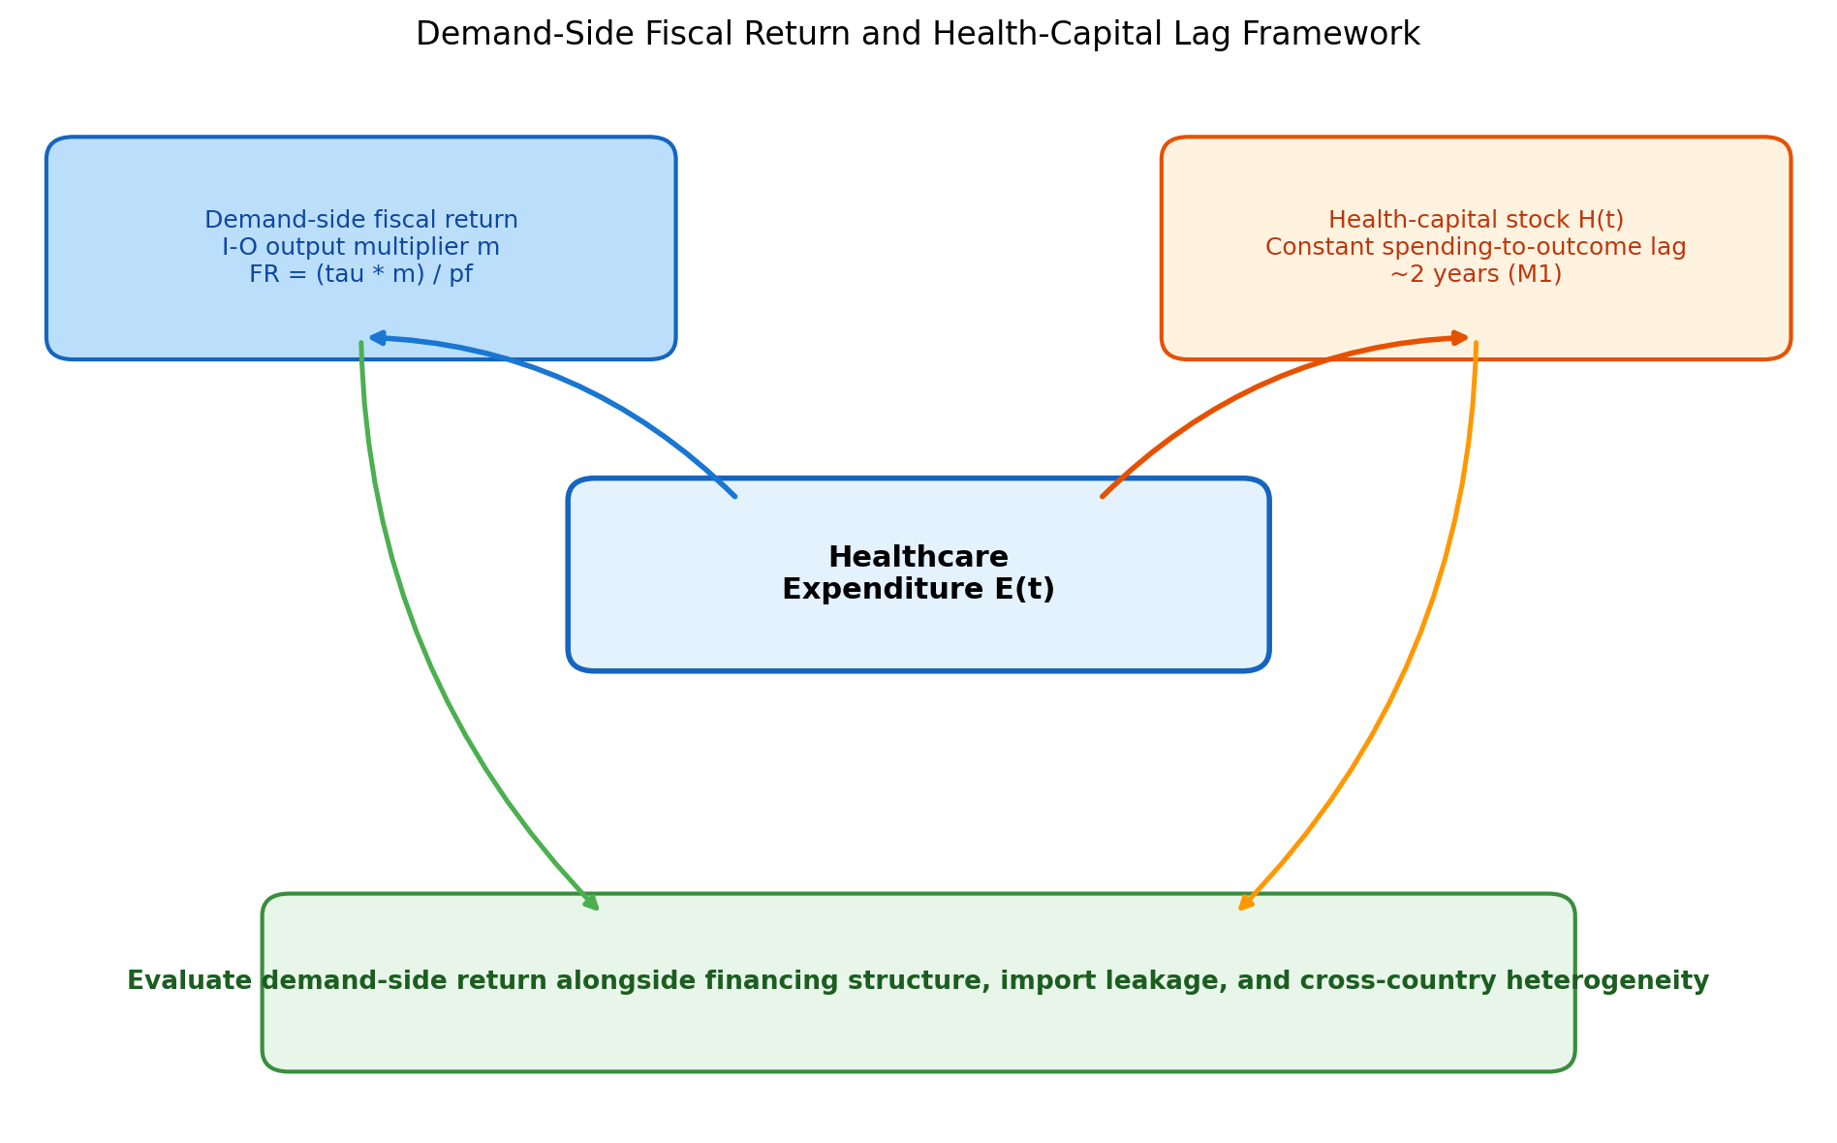
Figure 1
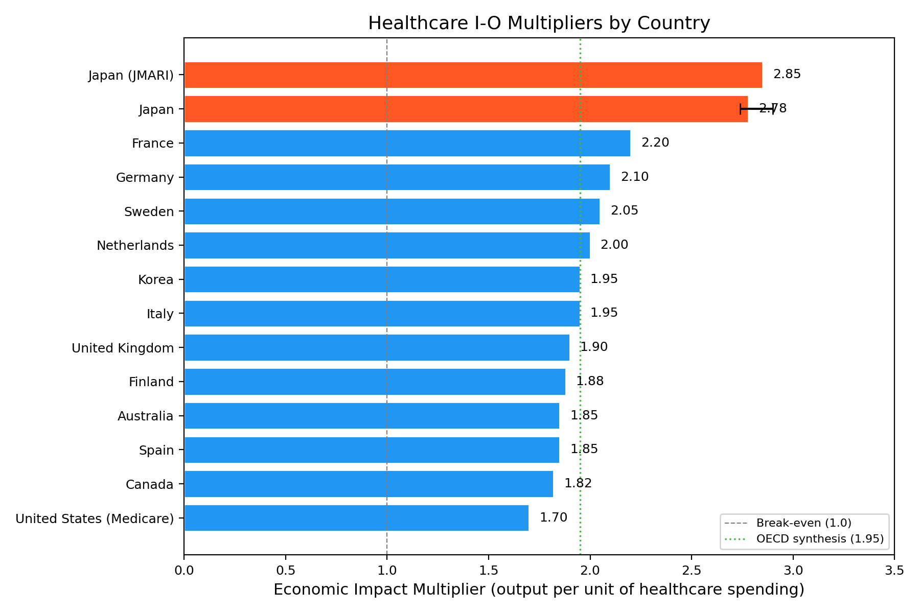
Figure 2
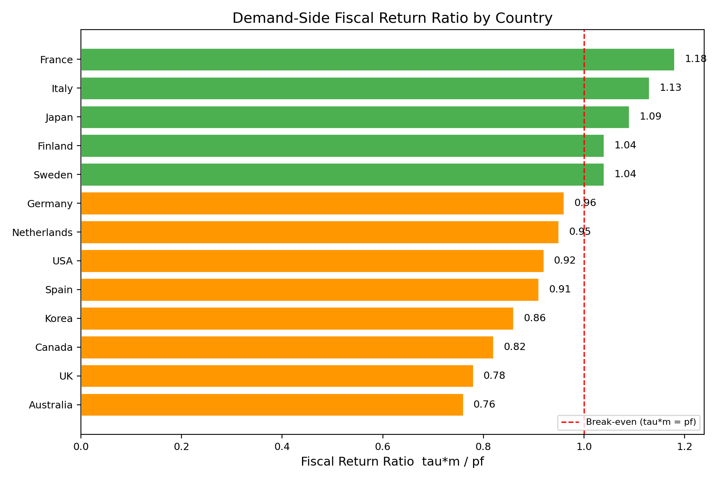
Figure 3
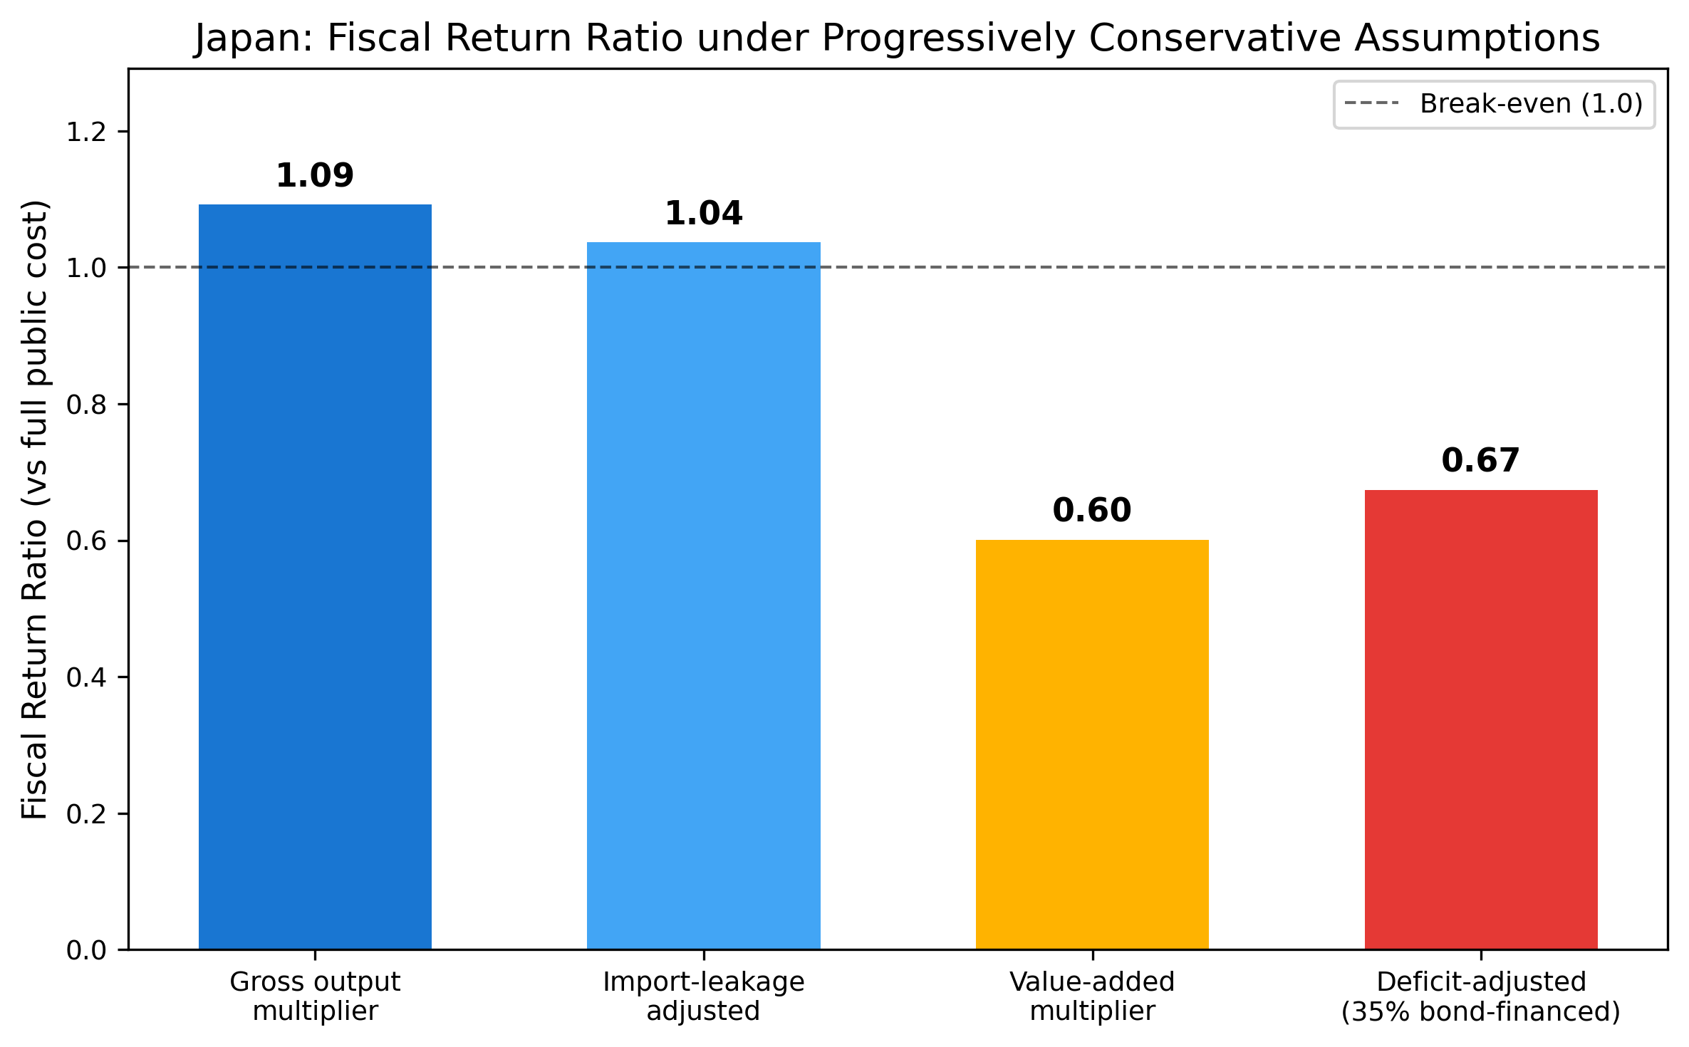
Figure 4
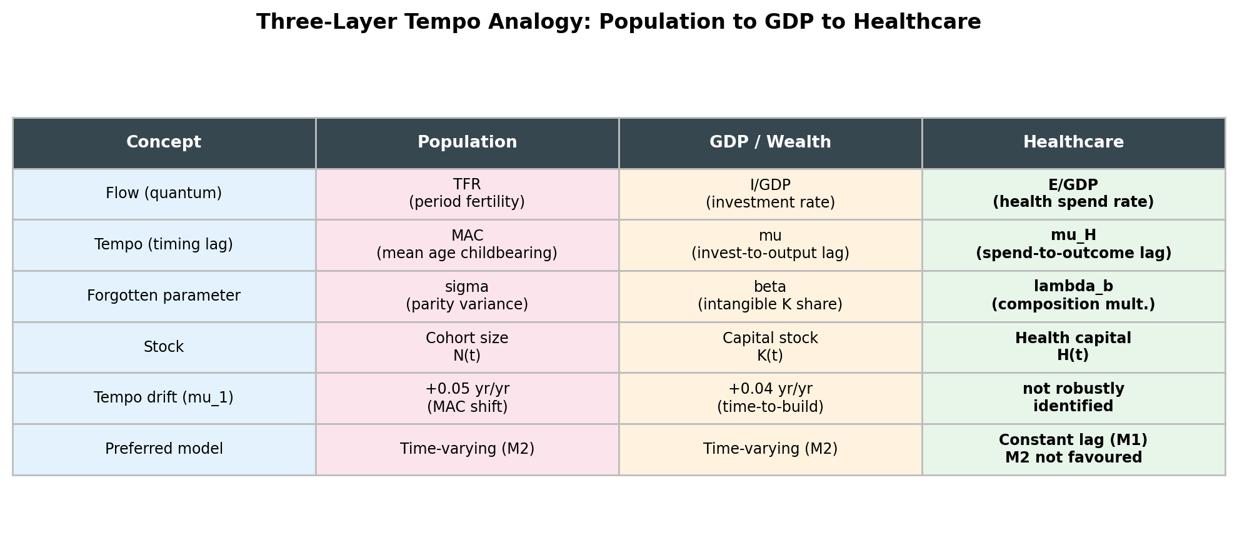
Figure 5
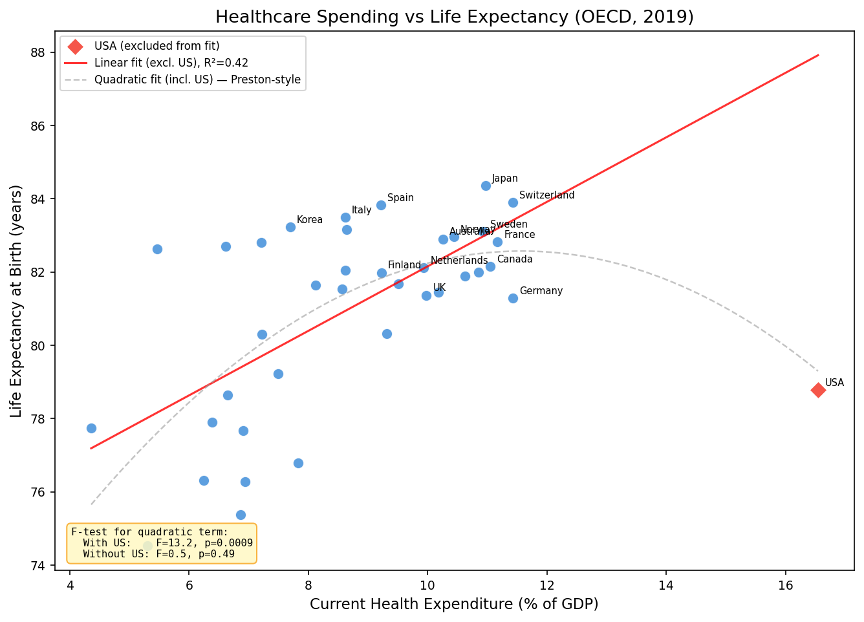
Figure 6
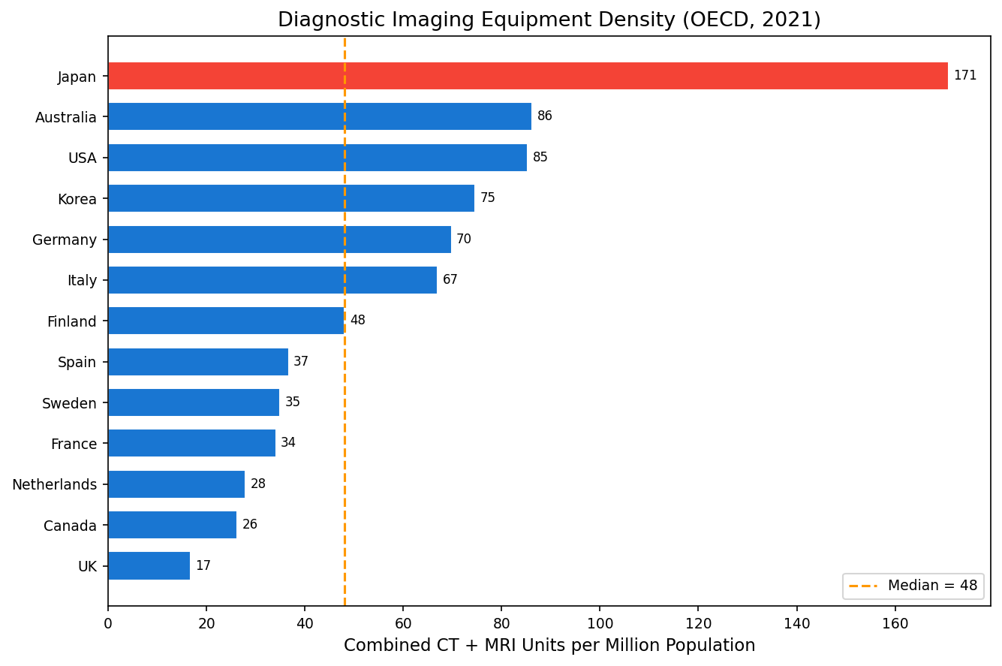
Figure 7
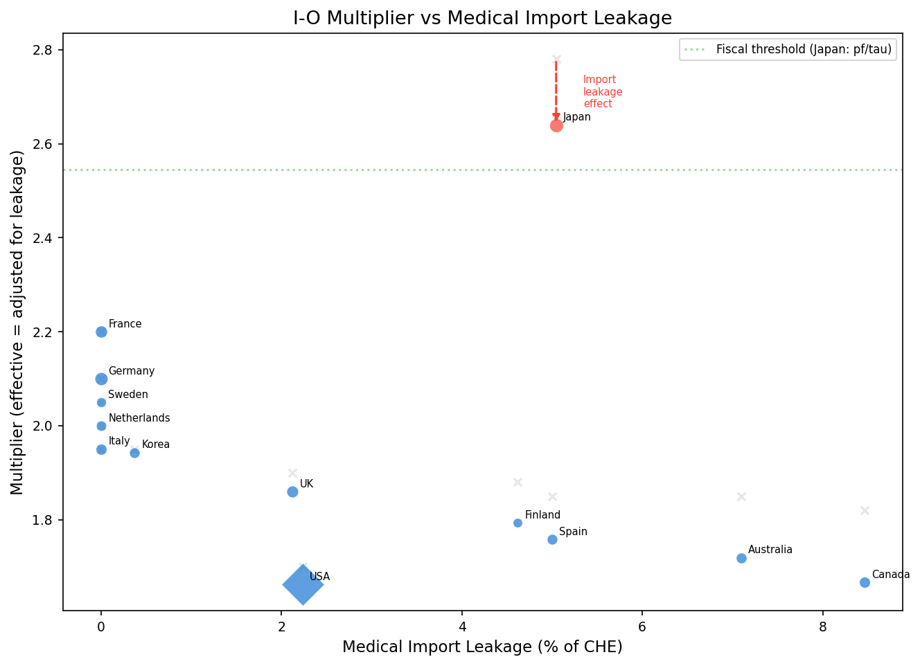
Figure 8
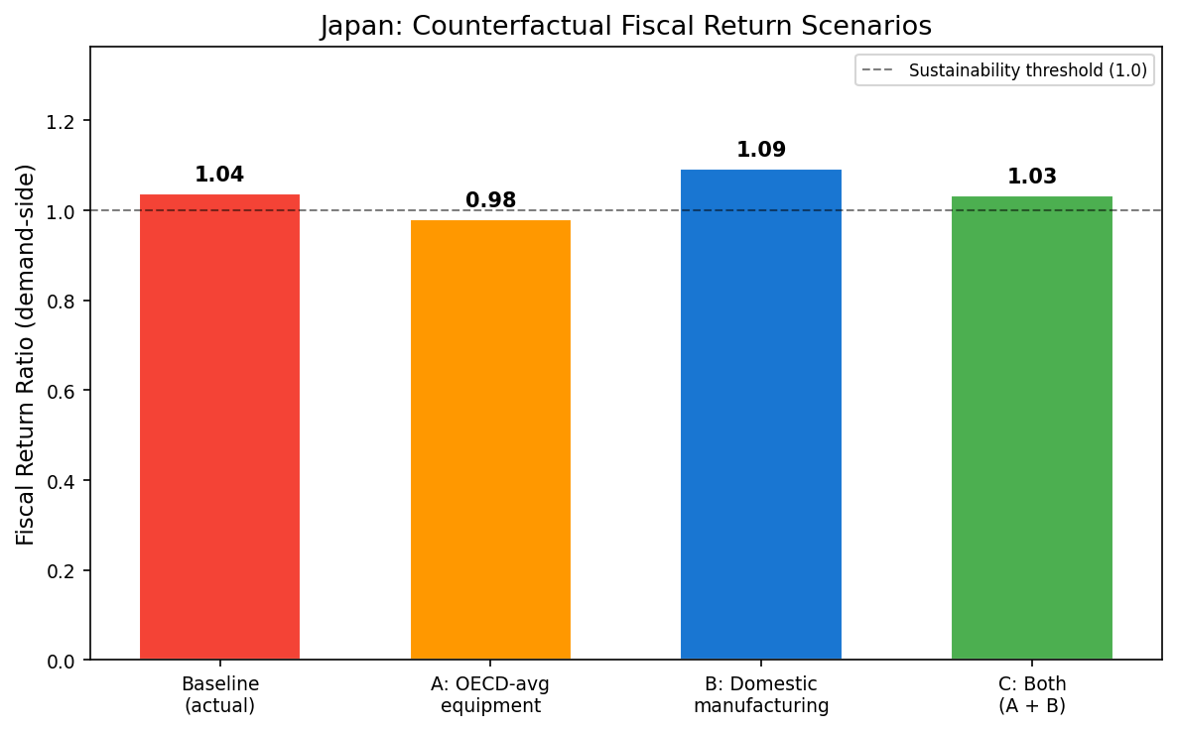
Figure 9
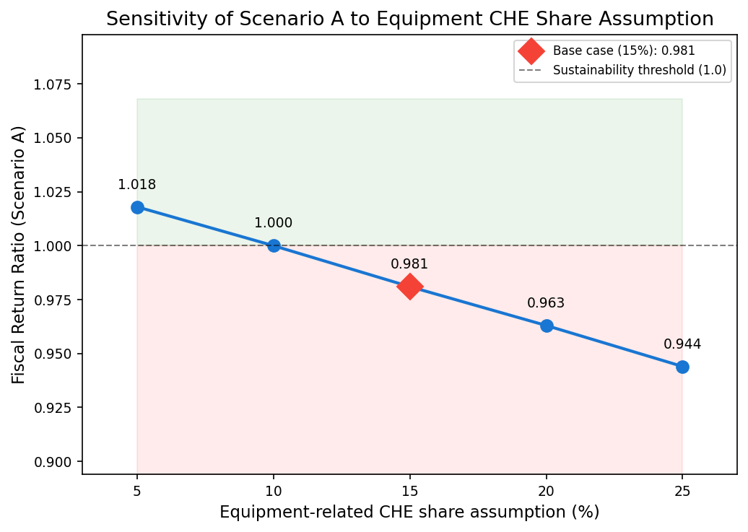
Figure 10

