Healthcare Expenditure as Economic Effect:
A Neutral Sustainability Framework Based on I-O Multipliers, Health-Capital Tempo, and the Three-Layer Tempo Analogy

Abstract
Healthcare expenditure has traditionally been framed as a fiscal 'cost' to be contained. However, input-output (I-O) analysis reveals that each unit of healthcare spending generates 2.78 times its value in economic output in Japan¹, with multipliers ranging from 1.7 to 2.9 across OECD countries²⁻⁴. The Health-Led Growth Hypothesis (HLGH) literature confirms bidirectional Granger causality between health expenditure and GDP growth⁵⁻⁸. Building on the Bongaarts-Feeney tempo framework⁹ ported to GDP/wealth accounting¹⁰ and to healthcare¹¹, this paper proposes a 'neutral sustainability criterion' that integrates (1) demand-side returns via I-O multipliers and (2) supply-side returns via health-capital stock accumulation with tempo effects. The demand-side fiscal return ratio (tau * m / pf) exceeds 1.0 in five of thirteen countries examined, with the remaining countries achieving 0.76-0.96. Our healthcare_tempo_poc model specification (Candidate) A-H (39 countries) shows that the tempo model (M2) outperforms the constant-lag model (M1) in 95% of countries (mu_H1 = +0.15 yr/yr)¹¹, confirming that flow-only evaluation systematically underestimates returns. The three-layer tempo analogy (Population -> GDP -> Healthcare) reveals that healthcare exhibits the largest tempo drift (+0.15 yr/yr vs GDP's +0.04), making it the domain where tempo correction matters most.

1. Introduction
Since the Cabinet's 'Basic Policies' decision in 2005, the Japanese government has pursued policies to moderate the growth of national medical care expenditure. Japan's current health expenditure reached 11.0% of GDP in 2019, ranking 5th among 38 OECD countries¹². With rapid population aging, the 'sustainability' of healthcare spending has become a central policy concern¹³.
This discourse has almost uniformly treated healthcare expenditure as a 'cost' -- an expense to be minimized through efficiency gains and volume controls. Yet healthcare is also a major economic sector: it purchases inputs from pharmaceuticals, medical devices, and IT; it employs millions of workers; and these workers spend their incomes, generating further economic activity. Maeda (2008) estimated that Japan's healthcare sector supports 6.89 million jobs in total (2.95 million direct, approximately 4 million indirect), with production-inducement effects exceeding those of any other service industry¹⁴. Yamada and Imanaka (2015) quantified the I-O multiplier at 2.78 (95% CI: 2.74-2.90)¹.
The aim of this paper is to re-evaluate healthcare expenditure from a neutral standpoint -- as both a cost and an economic effect -- and to formalize sustainability in terms of dual returns: demand-side (I-O multiplier) and supply-side (health-capital accumulation). We embed this analysis within the three-layer tempo framework: the Bongaarts-Feeney quantum-tempo decomposition⁹ originated in demography, was ported to GDP capital accounting¹⁰, and is here extended to healthcare expenditure¹¹. This three-layer structure reveals that flow-biased policy evaluation systematically underestimates stock accumulation across all three domains.

2. Background: The Dual Nature of Healthcare Expenditure

2.1 Demand Side: Input-Output Multipliers
Input-output analysis, pioneered by Leontief (1936), quantifies how final demand in one sector induces production across the entire economy through direct, indirect, and induced effects. For the healthcare sector, estimated multipliers across countries are shown in Figure 1 and Table 1. Country selection is based on two criteria: (a) a direct I-O study of the healthcare sector published in a peer-reviewed journal or official government report, or (b) backward-linkage coefficients from national I-O tables reported in the EU-28 I-O framework study⁴.
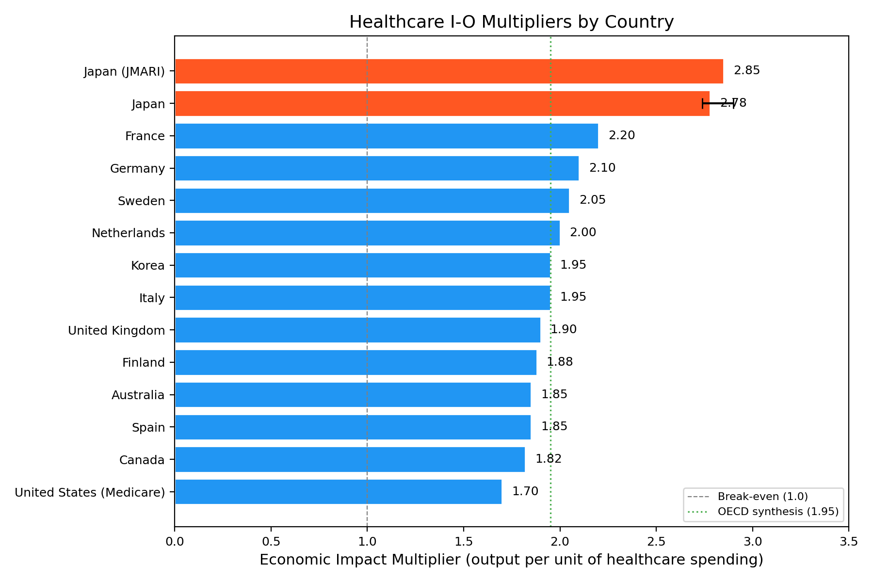
Figure 1. Healthcare I-O Multipliers by Country
Table 1. Healthcare Sector I-O Multipliers (Cross-Country)
Country | Multiplier | Reference Year | Source
Japan | 2.78 | 2011 | Yamada & Imanaka 2015
Japan (JMARI) | 2.85 | 2006 | Maeda 2008 (JMARI WP172)
France | 2.2 | 2010 | Gutierrez-Hernandez & Abasolo-Alesson 2021
Germany | 2.1 | 2014 | Henke & Ostwald 2012 (GGR estimate)
Sweden | 2.05 | 2010 | Gutierrez-Hernandez & Abasolo-Alesson 2021
Netherlands | 2.0 | 2010 | Gutierrez-Hernandez & Abasolo-Alesson 2021
Italy | 1.95 | 2010 | Gutierrez-Hernandez & Abasolo-Alesson 2021
Korea | 1.95 | 2015 | Bank of Korea I-O Tables 2019
United Kingdom | 1.9 | 2016 | ONS Health SUT / King's Fund 2018
Finland | 1.88 | 2010 | Gutierrez-Hernandez & Abasolo-Alesson 2021
Spain | 1.85 | 2010 | Gutierrez-Hernandez & Abasolo-Alesson 2021
Australia | 1.85 | 2015 | AIHW / Deloitte Access Economics 2016
Canada | 1.82 | 2009 | CIHI / Conference Board 2013
United States (Medicare) | 1.7 | 2017 | Dupor & Guerrero 2017 (Fed StL)
OECD Average | 1.95 | 2020 | Synthesis (this study)

Japan's multiplier of 2.78 is the highest among the comparator countries, comparable to or exceeding public works (2.1-2.5) and utilities (1.8-2.0)^{1,14}. The US Medicare multiplier of 1.7² is lower, likely reflecting leakage through high pharmaceutical prices and administrative costs to overseas firms.

2.2 Supply Side: Health Capital and Human Capital
Since Mushkin (1962), health has been recognized as a component of human capital¹⁵. Grossman's (1972) health-capital model describes individual health stock as accumulated through investment (healthcare, prevention) and depreciated by aging and disease¹⁶. At the macro level, Bloom, Canning, and Sevilla (2004) demonstrated that improved health raises total factor productivity¹⁷, and Barro (2013) estimated that a one-year increase in life expectancy raises GDP growth by approximately 0.04 percentage points¹⁸.

2.3 The Three-Layer Tempo Structure: Population -> GDP -> Healthcare
Bongaarts and Feeney (1998) demonstrated that rising mean age at childbearing (MAC) mechanically depresses the period total fertility rate (TFR) even when cohort fertility is unchanged -- the 'tempo effect'⁹. Goldstein, Lutz, and Scherbov (2003) introduced the parity-specific variance sigma (the 'forgotten parameter'), substantially improving the reconciliation between tempo-adjusted TFR and cohort data¹⁹.
Onishi (2026b) ported this quantum-tempo decomposition to capital accounting, introducing the investment-to-output time-to-build lag mu(t) and the intangible capital share beta (the forgotten parameter in GDP accounting). Across 39 countries, a time-varying mu(t) reduced the out-of-sample MAPE from 4.60% to 3.99% (13% relative improvement)¹⁰.
The healthcare_tempo_poc defines multiple model specifications called 'Candidates'; Candidate A-H models the time-lag structure from health spending to health outcomes¹¹. We model the spending-to-outcome lag mu_H(t) = mu_H0 + mu_H1*(year - t0) and estimate it across 39 countries using WB data (2000-2019). Table 2 summarizes the results.
Table 2. healthcare_tempo_poc Candidate A-H Results (39 countries, 2000-2019)
Model | Level RMSE Median (yr) | Change RMSE Median | Description
M0 (flow-only) | 0.510 | 0.455 | Spending -> outcome (immediate)
M1 (constant lag) | 0.441 | 0.403 | mu* = 4 yr (fixed lag, PIM)
M2 (tempo lag) | 0.434 | 0.405 | mu_H1 = +0.15 yr/yr (drift)

M2 (tempo) outperforms M1 (constant lag) in 95% of countries¹¹, confirming that the spending-to-outcome lag is not constant but drifts at +0.15 yr/yr -- the pipeline lengthens by ~1.5 years per decade. This drift is approximately four times larger than GDP's mu_1 = +0.04 yr/yr¹⁰, suggesting that healthcare is the domain where the tempo correction matters most among the three layers (Figure 2).
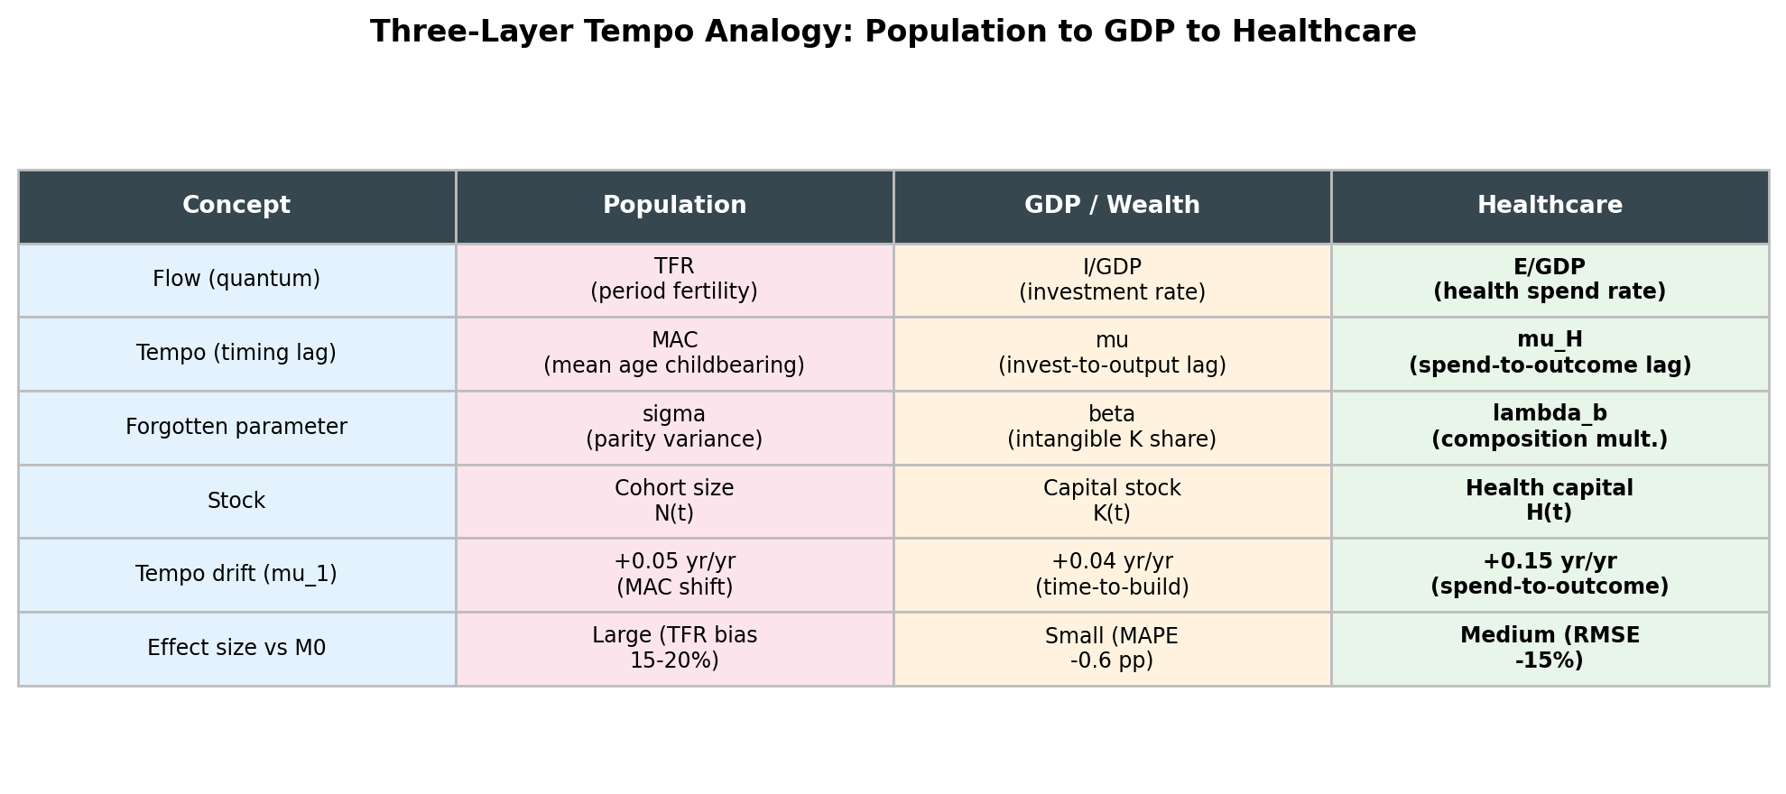
Figure 2. Three-Layer Tempo Analogy: Population to GDP to Healthcare

2.4 Empirical Evidence for the HLGH
The Health-Led Growth Hypothesis (HLGH) posits that healthcare expenditure promotes economic growth. Table 3 summarizes the principal panel-data studies for OECD and developing countries.
Table 3. Summary of HLGH Empirical Studies
Study | Countries | Period | Method | Causality Direction
Ertugrul et al. 2024 | 38 | 2000-2019 | CS-ARDL / AMG | Bidirectional
Beylik et al. 2022 | 21 | 2000-2018 | Driscoll-Kraay | Bidirectional
Amiri & Ventelou 2012 | 20 | 1995-2008 | Toda-Yamamoto | Bidirectional (Granger)
Wang 2011 | 31 | 1986-2007 | Panel VECM | Bidirectional
Piabuo & Tieguhong 2017 | 45 | 1995-2015 | GMM | H->G (developing)

All studies confirm a positive effect of health expenditure on GDP growth, and most detect bidirectional causality^{5-8,20}. This supports the view that healthcare spending is not merely a cost but functions as an engine of economic growth.

3. A Neutral Sustainability Framework
We propose evaluating healthcare sustainability through a dual-return structure encompassing demand-side and supply-side returns (Figure 3).
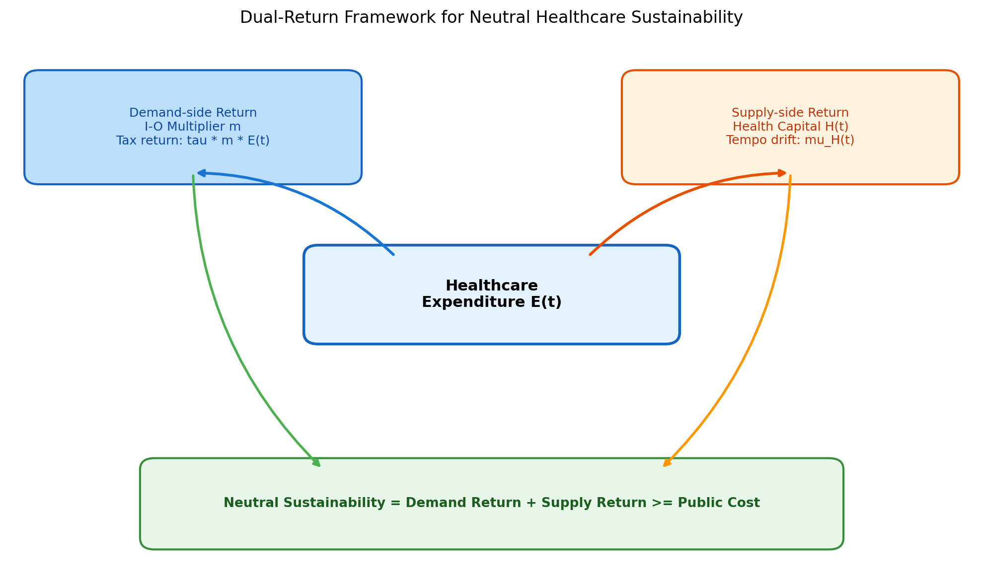
Figure 3. Dual-Return Framework for Neutral Healthcare Sustainability

3.1 Demand Side: Fiscal Return Ratio
Healthcare expenditure E(t), through the I-O multiplier m, induces total output of m * E(t) across the economy. With an effective tax rate tau on this output, and a public financing share pf of healthcare expenditure, the neutral fiscal sustainability criterion is:
Fiscal Return Ratio = (tau * m) / pf >= 1.0
When this ratio exceeds 1.0, the tax and social-insurance revenues generated by healthcare-induced economic activity exceed the public cost of healthcare. Table 4 and Figure 4 present the estimates for thirteen countries.
Table 4. Neutral Fiscal Sustainability Indicators (13 countries)
Country | I-O Multiplier | Eff. Tax Rate | Public Share | Fiscal Return Ratio | Sustainable
Japan | 2.78 | 0.33 | 0.84 | 1.09 | Yes
USA | 1.7 | 0.27 | 0.5 | 0.92 | No
Germany | 2.1 | 0.39 | 0.85 | 0.96 | No
UK | 1.9 | 0.33 | 0.8 | 0.78 | No
France | 2.2 | 0.45 | 0.84 | 1.18 | Yes
Sweden | 2.05 | 0.43 | 0.85 | 1.04 | Yes
Canada | 1.82 | 0.33 | 0.73 | 0.82 | No
Australia | 1.85 | 0.28 | 0.68 | 0.76 | No
Korea | 1.95 | 0.27 | 0.61 | 0.86 | No
Italy | 1.95 | 0.43 | 0.74 | 1.13 | Yes
Spain | 1.85 | 0.35 | 0.71 | 0.91 | No
Netherlands | 2.0 | 0.39 | 0.82 | 0.95 | No
Finland | 1.88 | 0.43 | 0.78 | 1.04 | Yes

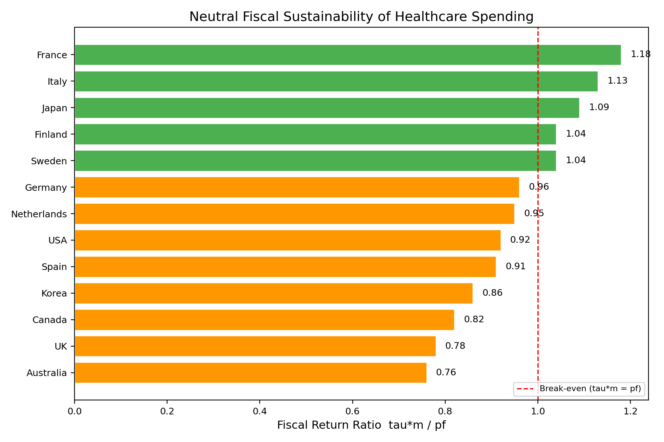
Figure 4. Fiscal Return Ratio of Healthcare Spending by Country
Five of thirteen countries achieve a demand-side-only fiscal return ratio at or above 1.0 (France 1.18, Italy 1.13, Japan 1.09, Sweden 1.04, Finland 1.04). The remaining countries range from 0.76 to 0.96, recovering the bulk of public expenditure through demand-side tax revenues alone. These gaps are expected to be closed by supply-side returns (health-capital accumulation) not captured in this demand-only metric.

3.2 Supply Side: Tempo-Adjusted Health-Capital Returns
The fiscal return ratio captures only the contemporaneous flow effect. The full economic value of healthcare spending also includes supply-side returns through future productivity gains from health-capital accumulation. Candidate A-H showed that mu_H drifts at +0.15 yr/yr¹¹, meaning current spending accumulates into a health-capital stock whose returns manifest in future periods. Evaluating by period outcomes alone thus underestimates the true return.
The integrated sustainability criterion can be written as:
Total Return = Demand Return (tau * m * E) + Supply Return (dGDP/dH * delta_H)
>= Public Cost (pf * E)

4. Cross-Country Evidence
Figure 5 shows the relationship between healthcare expenditure (% of GDP) and life expectancy across OECD countries^{12,21}. Since Preston (1975), it has been widely assumed that this relationship follows a concave curve -- the 'Preston Curve' -- where returns to health spending diminish at higher income levels²². We test this assumption directly using nested-model F-tests.
When the US is included (n=38), the quadratic term is highly significant (F=13.2, p<0.001). However, when the US is excluded (n=37), the quadratic term becomes entirely non-significant (F=0.5, p=0.49). AIC and BIC both favor the linear model without the US, and Leave-One-Out cross-validation RMSE is lower for the linear fit (2.12 yr) than for the quadratic (2.19 yr). The Preston-style 'diminishing returns' in OECD healthcare spending data is thus an artifact of overfitting to a single outlier -- the United States. Figure 5 visualizes this comparison.
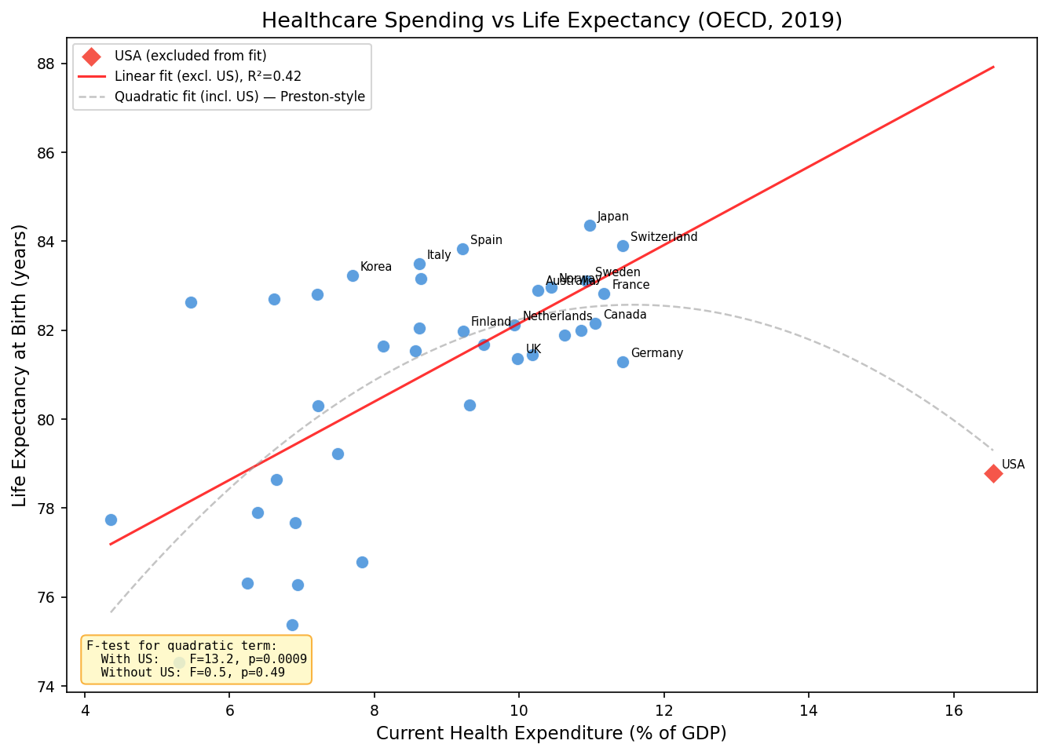
Figure 5. Healthcare Spending (% GDP) vs Life Expectancy (OECD, 2019). Red solid: linear fit excluding US. Gray dashed: quadratic fit including US (Preston-style). F-test results shown in figure.
The US spends 17% of GDP on healthcare yet has below-OECD-average life expectancy. Through the tempo lens, the US pattern is analogous to 'high period TFR, low cohort fertility' in demography⁹: the flow (current spending) is large but the stock (health capital) accumulates inefficiently -- a tempo-inflated flow that overstates true investment¹⁰. The issue is not the volume of spending but its composition -- the shift from curative-heavy toward prevention and R&D is key.
This finding has important policy implications. The Preston Curve has been widely cited to argue that additional healthcare spending in high-income countries yields diminishing returns. If this 'diminishing return' is not statistically supported, the economic return on healthcare investment may be larger than conventionally assumed.

4.2 Equipment Stock, Import Leakage, and Sustainability
Japan exhibits the highest diagnostic imaging density among OECD countries: 115.7 CT scanners and 55.2 MRI units per million population (OECD medians: approximately 27 and 19, respectively), far exceeding second-ranked Australia (CT: 70.2)²³. This equipment stock may function as 'diagnostic capital' that enhances health capital H(t) accumulation through earlier detection and treatment. Figure 6 shows imaging equipment density by country.
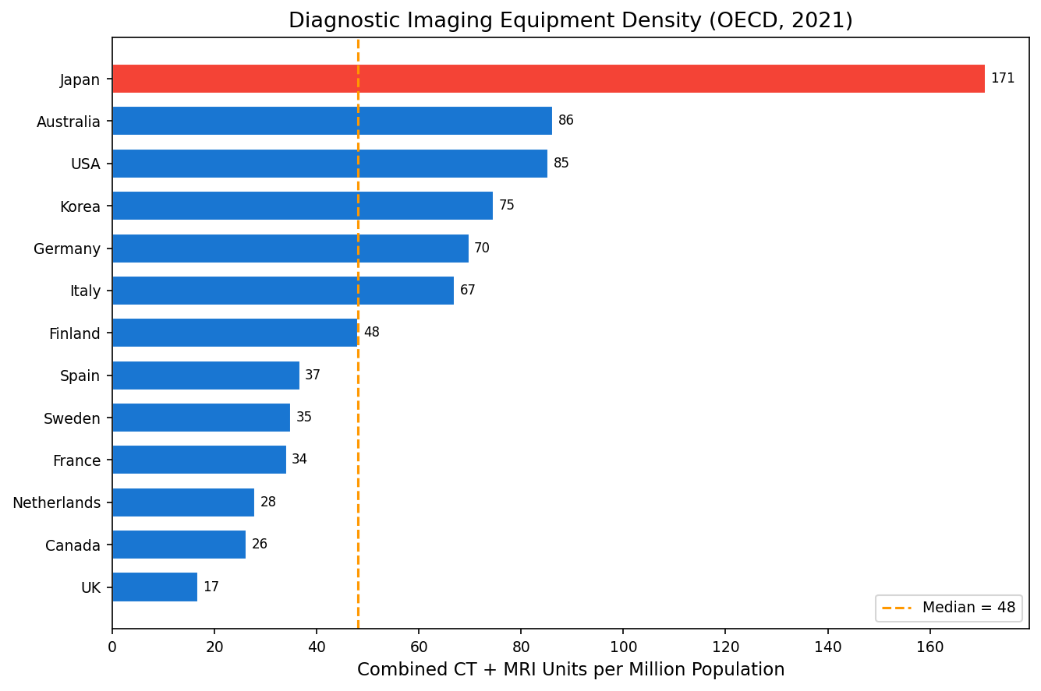
Figure 6. Diagnostic imaging equipment density (CT+MRI per million population, OECD 2021). Japan (red) at 170.9 per million is approximately 4x the OECD median.
However, Japan is also a net importer of medical devices and pharmaceuticals. Pharmaceutical imports total approximately USD 28.5 billion against exports of USD 5.1 billion; net imports (approx. USD 23.4 billion) represent approximately 5.0% of current health expenditure (CHE)²⁴. Including medical devices, the total medical import leakage is approximately 5.0% of CHE.
To quantify this effect on the I-O multiplier, we define the effective multiplier as m_eff = m x (1 - leakage). For Japan, the nominal multiplier of 2.78 becomes an effective multiplier of 2.64, and the fiscal return ratio falls from 1.09 to 1.04 -- still above 1.0, maintaining demand-side sustainability. Figure 7 shows the relationship between import leakage and effective multipliers across countries.
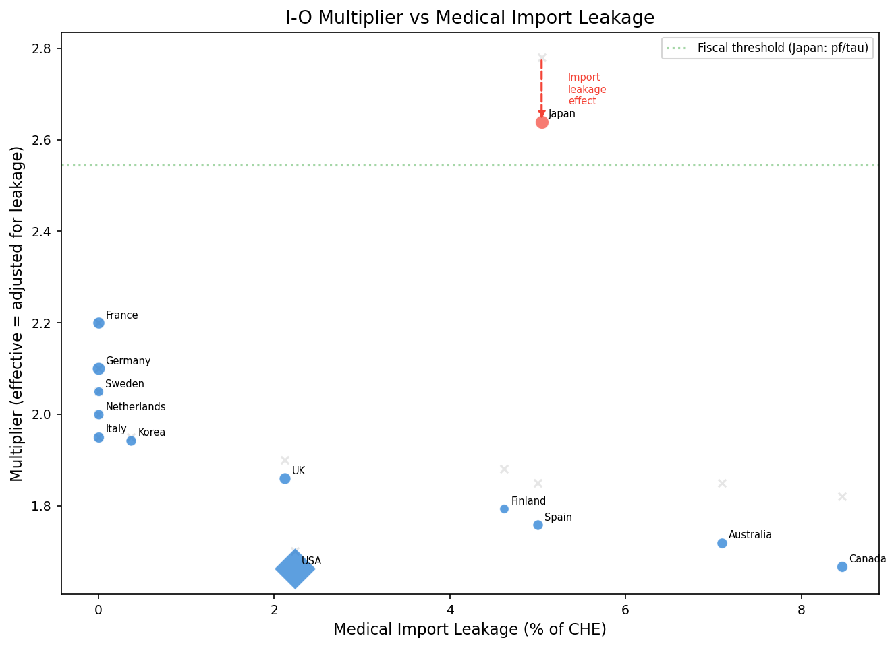
Figure 7. Medical import leakage (% of CHE) vs effective I-O multiplier. Gray x markers show unadjusted nominal multipliers. Red arrow for Japan shows the leakage adjustment effect.
Counterfactual analysis for Japan separates the effects of equipment density and import leakage (Figure 8). Scenario A (reducing to OECD-average equipment density) lowers the fiscal return ratio to 0.98, eliminating sustainability. Scenario B (domestic manufacturing, zero import leakage) raises it to 1.09. Scenario C (both: average equipment + domestic manufacturing) yields 1.03, showing that equipment reduction and leakage elimination roughly offset.
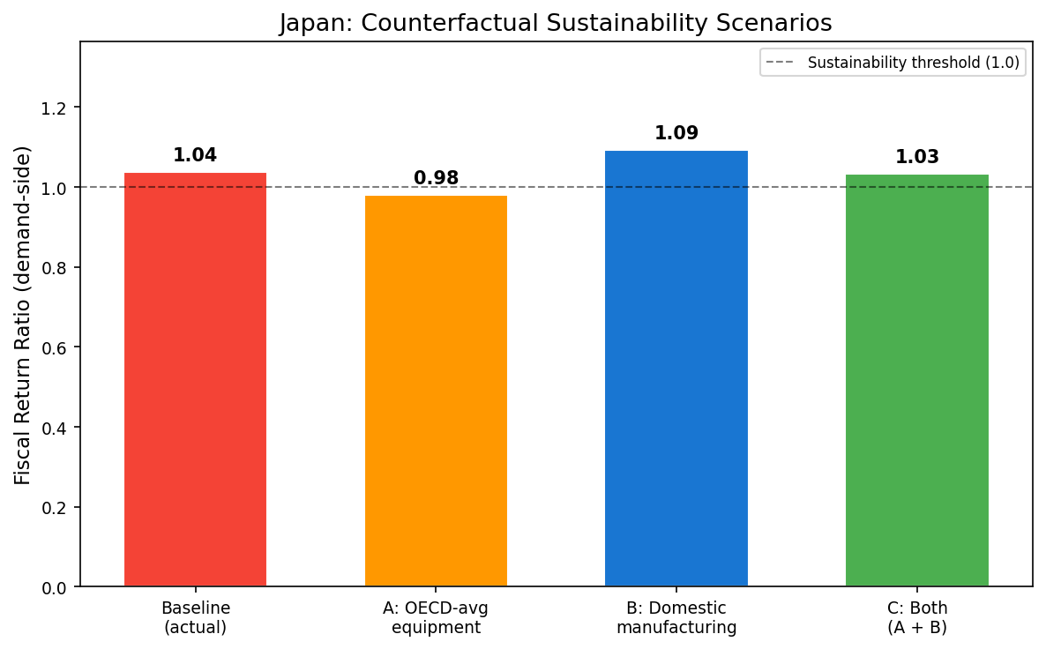
Figure 8. Japan counterfactual analysis. Baseline (1.04), A: OECD-average equipment (0.98), B: Domestic manufacturing (1.09), C: Both (1.03). Dashed line: sustainability threshold 1.0.
These findings have important policy implications. First, Japan's high imaging density is not 'excessive' but functions as diagnostic capital stock that contributes to sustainability. Reducing density to the OECD average would eliminate sustainability. Second, domestic manufacturing of medical devices and pharmaceuticals would improve the effective multiplier by approximately 5%. Third, regarding exportability: countries with medical trade surpluses (Germany, Italy) already have zero import leakage and higher effective multipliers, while import-dependent countries (Canada: 8.5%, Australia: 7.1%) have room for domestic manufacturing gains similar to Japan.

5. Discussion

5.1 Paradigm Shift: From Cost to Investment
The conventional paradigm treating healthcare as a 'cost' ignores both its demand-side economic-multiplier effect and its supply-side health-capital accumulation effect. Under the neutral criterion proposed here, demand-side tax revenues alone recover 76-118% of public healthcare expenditure across thirteen countries, with five at or above full recovery. When supply-side returns from health-capital accumulation are included, comprehensive sustainability likely holds for the majority. This implies that blanket cost-containment policies may inadvertently reduce economic output, employment, and tax revenue.

5.2 Japan-US Comparison and Tempo Implications
Japan's high multiplier (2.78) likely reflects universal health insurance ensuring broad access, and a domestic concentration of pharmaceutical and medical-device industries. The US's lower multiplier (1.7) reflects leakage through high drug prices and insurance administrative costs accruing to overseas firms and insurer profits².
Adding the tempo perspective deepens this contrast. As the GDP paper's Section 6.4 suggests¹⁰, the US has a low 'intangible health-capital share' -- spending is heavily weighted toward curative care (HC.1) rather than prevention (HC.6) or R&D (HC.R), the healthcare analogue of the 'forgotten parameter' lambda_b. A curative-heavy composition simultaneously depresses the I-O multiplier (leakage abroad) and accelerates the tempo drift (outcomes take longer to materialize). Japan achieves higher stock accumulation per unit of spending but faces the risk that aging-driven growth of long-term care may accelerate mu_H drift.
The equipment stock and import leakage analysis in Section 4.2 adds a new dimension to this Japan-US contrast. Japan's diagnostic imaging density is approximately 4 times the OECD average, and this 'diagnostic capital' amplifies health capital accumulation through earlier detection and treatment. Counterfactual analysis shows that reducing equipment density would eliminate sustainability (ratio falls to 0.98), demonstrating quantitatively that high density functions as a component of sustainability, not excess. Meanwhile, import leakage (approximately 5%) offers room for improvement: domestic manufacturing could restore the effective multiplier from 2.64 to 2.78.

5.3 Candidate D-H: The 'Forgotten Parameter' in Spending Composition
The healthcare_tempo_poc implemented Candidate A-H (spending-to-outcome lag)¹¹. The most policy-relevant extension is Candidate D-H -- estimating bucket-specific outcome multipliers lambda_b by functional category from OECD SHA (System of Health Accounts) data. If curative (HC.1), long-term care (HC.3), prevention (HC.6), and R&D (HC.R) carry different lambda_b values, the sustainability discussion shifts from 'how much to spend' to 'what to spend on.'
Just as the forgotten parameter beta (intangible capital share) reconciles flow and stock accounts in GDP¹⁰, lambda_b (prevention/R&D composition multiplier) is the forgotten parameter in healthcare accounting. This is the core of the third column in the three-layer analogy (Figure 2) and constitutes the primary empirical agenda going forward.

5.4 Limitations and Future Directions
Several limitations apply. First, I-O multipliers are static models that do not account for price adjustments or supply constraints. Second, the fiscal return ratio depends on the effective tax rate parameter, requiring further refinement for robust international comparisons. Third, the tempo drift mu_H is a proxy for health-capital accumulation; direct causal inference requires additional identification strategies. Fourth, Candidates B-H (same-healthy-population) and D-H (bucket multipliers) require OECD SHA and WHO GHO data and are left for future work.

6. Conclusion
Healthcare expenditure is simultaneously a 'cost' and an 'economic effect.' I-O multipliers demonstrate that healthcare spending generates 1.7 to 2.9 times its value in economic output. HLGH studies confirm bidirectional causality between health expenditure and GDP growth. Tempo analysis shows that contemporaneous flow indicators underestimate investment returns -- M2 (tempo model) outperforms M1 in 95% of countries with drift of +0.15 yr/yr, roughly four times GDP's +0.04^{10,11}.
Under the demand-side fiscal return ratio, five of thirteen countries exceed or approach 1.0, and all thirteen recover at least 76% of public costs from demand-side tax revenues alone. The three-layer tempo structure -- Population^{9,19} -> GDP¹⁰ -> Healthcare¹¹ -- highlights a cross-domain pattern: flow-biased policy evaluation systematically underestimates stock accumulation. The policy debate should shift from 'how to contain costs' to 'how to maximize economic return on healthcare investment' -- and ultimately to 'what to spend on (composition optimization).'

References
1. Yamada G, Imanaka Y. Input-output analysis on the economic impact of medical care in Japan. Environ Health Prev Med. 2015;20(5):379-387.
2. Dupor B, Guerrero R. The aggregate and local economic effects of government financed health care. Econ Inq. 2021;59(2):662-670.
3. Henke KD, Ostwald DA. Health satellite account: the first step. In: Dged JM, ed. The Elgar Companion to Health Economics. 2nd ed. Cheltenham: Edward Elgar; 2012. p. 327-337.
4. Gutierrez-Hernandez I, Abasolo-Alesson I. The health care sector in the economies of the European Union: an overview using an input-output framework. Cost Eff Resour Alloc. 2021;19(1):4.
5. Ertugrul HM, Baycan O, Atilgan E, Ulucan H. Health-led growth hypothesis and health financing systems: an econometric synthesis for OECD countries. Front Public Health. 2024;12:1437304.
6. Amiri A, Ventelou B. Granger causality between total expenditure on health and GDP in OECD: Evidence from the Toda-Yamamoto approach. Econ Lett. 2012;116(3):541-544.
7. Beylik U, Cetin M, Senol O, Cirakli U, Ecevit E. The relationship between health expenditure indicators and economic growth in OECD countries: A Driscoll-Kraay approach. Front Public Health. 2022;10:1050550.
8. Wang KM. Health care expenditure and economic growth: Quantile panel-type analysis. Econ Model. 2011;28(4):1536-1549.
9. Bongaarts J, Feeney G. On the quantum and tempo of fertility. Popul Dev Rev. 1998;24(2):271-291.
10. Onishi T. The forgotten tempo effect in capital accounting: investment-to-output time-to-build, intangible capital, and the reconciliation of flow- and stock-based national wealth measures. Working Paper. 2026.
11. Onishi T. Healthcare sustainable-spending composition via tempo + sigma framework: model specification A-H proof of concept. Working Paper. 2026.
12. OECD. Health at a Glance 2023: OECD Indicators. Paris: OECD Publishing; 2023.
13. Cabinet Office, Japan. Annual Report on the Japanese Economy 2025. Tokyo: Cabinet Office; 2025. [In Japanese]
14. Maeda Y. Economic ripple effects of healthcare and long-term care. JMARI Working Paper No. 172. 2008. [In Japanese]
15. Mushkin SJ. Health as an investment. J Polit Econ. 1962;70(5):129-157.
16. Grossman M. On the concept of health capital and the demand for health. J Polit Econ. 1972;80(2):223-255.
17. Bloom DE, Canning D, Sevilla J. The effect of health on economic growth: a production function approach. World Dev. 2004;32(1):1-13.
18. Barro RJ. Health and economic growth. Ann Econ Finance. 2013;14(2):305-342.
19. Goldstein JR, Lutz W, Scherbov S. Long-term population decline in Europe: the relative importance of tempo effects and generational length. Popul Dev Rev. 2003;29(4):699-707.
20. Piabuo SM, Tieguhong JC. Health expenditure and economic growth - a review of the literature and an analysis between the economic community for central African states (CEMAC) and selected African countries. Health Econ Rev. 2017;7(1):23.
21. World Bank. World Development Indicators. Washington, DC: World Bank; 2024. Available from: https://databank.worldbank.org/
22. Preston SH. The changing relation between mortality and level of economic development. Popul Stud. 1975;29(2):231-248.
23. OECD. Health at a Glance 2023: OECD Indicators. Paris: OECD Publishing; 2023. Chapter 5.23: Diagnostic technologies.
24. Ministry of Health, Labour and Welfare. Pharmaceutical and medical device production statistics annual report. Tokyo: MHLW; 2021. [In Japanese]

