The Forgotten Tempo Effect: How Delayed Childbearing Shapes Simultaneously Living Population Size Across OECD Countries
Tatsuki Onishi
[Affiliation]
Correspondence
Word count: ~300 words (excluding references and figure legend)
Population decline projections typically focus on total fertility rate (TFR), yet the timing of births—the tempo effect—exerts an independent and underappreciated influence on simultaneously living population size. Bongaarts and Feeney formalised tempo-adjusted fertility in 1998,¹ and Goldstein, Lutz, and Scherbov demonstrated that delayed childbearing reduces the number of generations alive at any moment for EU-15 countries.² However, this mechanism remains largely absent from contemporary policy discourse on demographic decline.
We constructed an endogenous renewal model coupling age-specific fertility (normal schedule centred on mean age at childbearing [MAC]) with Gompertz survival, calibrated to life expectancy at birth. Using UN World Population Prospects 2024 data,³ we validated the model across 38 OECD member states plus China and the Democratic Republic of the Congo (DRC) over 1970–2023. A dynamic variant updating TFR, life expectancy, and MAC every decade achieved a median absolute percentage error of 4·6% (mean 6·7%) against observed population trajectories (figure). France (0·4%), Japan (1·6%), and Italy (1·4%) showed excellent fit. Even the parsimonious static model (fixed 2000 parameters) yielded median error of 4·7% over 23 years.
The policy implication is direct: because MAC determines generational overlap, a 5-year shift in mean childbearing age (e.g., from 25 to 30) reduces simultaneously living population by approximately one-sixth, independent of TFR.⁴ This suggests that pronatalist policies addressing only quantum (number of children) while ignoring tempo (timing) will systematically overestimate their population impact. Conversely, policies that modestly lower AFB—through housing support, childcare infrastructure, or educational reform—could buffer population decline even without raising TFR.
Our 40-country validation demonstrates that this simple demographic identity reproduces observed population dynamics with surprising accuracy. The tempo effect deserves renewed attention as a policy lever for managing the pace of demographic transition.⁵
References
1. Bongaarts J, Feeney G. On the quantum and tempo of fertility. Popul Dev Rev 1998; 24: 271–91.
2. Goldstein JR, Lutz W, Scherbov S. Long-term population decline in Europe: the relative importance of tempo effects and generational length. Popul Dev Rev 2003; 29: 699–707.
3. United Nations, Department of Economic and Social Affairs, Population Division. World Population Prospects 2024. https://population.un.org/wpp/
4. Bongaarts J, Sobotka T. A demographic explanation for the recent rise in European fertility. Popul Dev Rev 2012; 38: 83–120.
5. Lutz W, Skirbekk V, Testa MR. The low-fertility trap hypothesis: forces that may lead to further postponement and fewer births in Europe. Vienna Yearb Popul Res 2006; 4: 167–92.

Figure
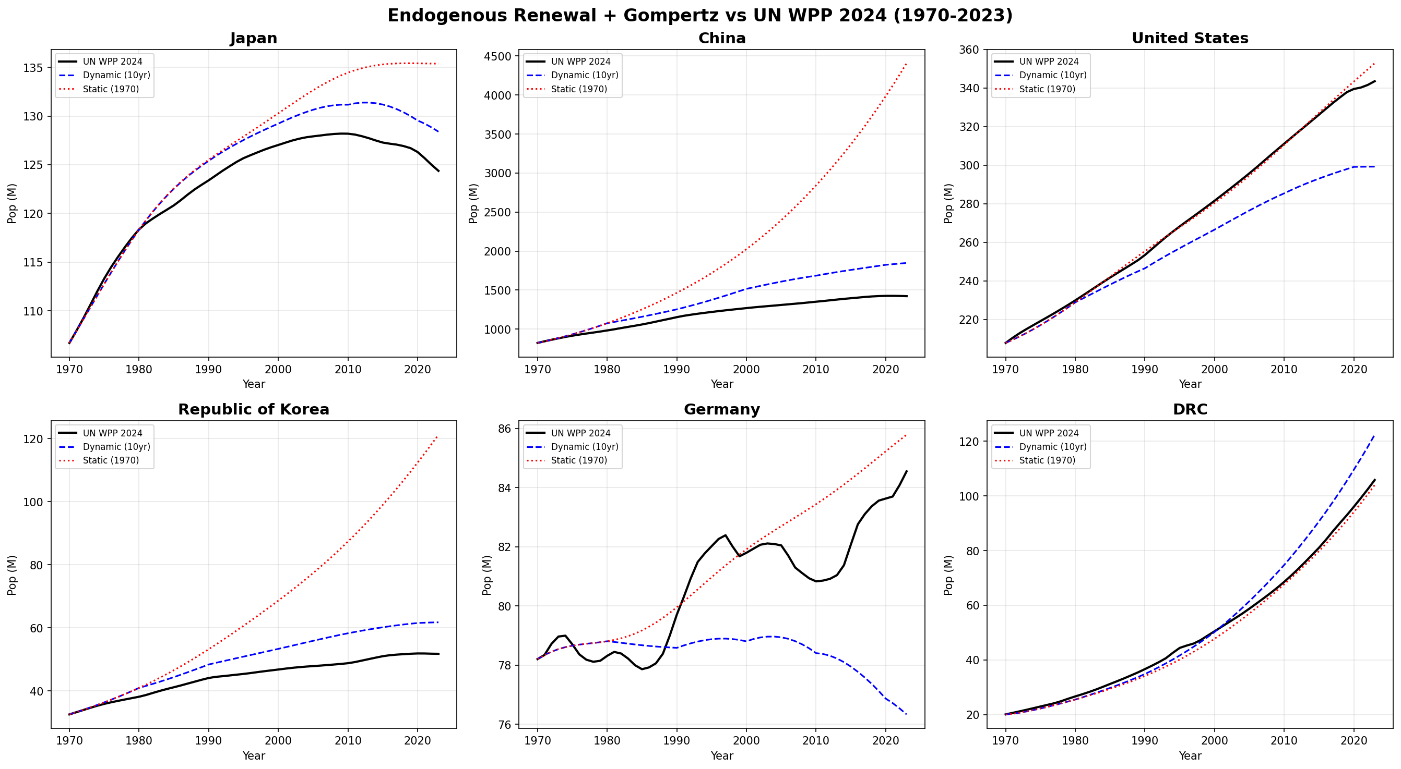
Figure. Endogenous renewal model with Gompertz survival versus UN WPP 2024 observed population, 1970–2023. Dynamic model (blue dashed) updates parameters every 10 years; static model (red dotted) uses fixed 1970 parameters. Black line = UN WPP 2024 estimates. Six representative countries shown: Japan, China, United States, Republic of Korea, Germany, and DRC.

