Ambient heat as an under-recognised risk factor for US traffic-crash mortality: a distributed-lag analysis with road-safety implications
Tatsuki Onishi
Data Science and AI Innovation Research Promotion Center, Shiga University of Medical Science, Seta Tsukinowa-cho, Otsu, Shiga 520-2192, Japan
Correspondence to: Tatsuki Onishi, Data Science and AI Innovation Research Promotion Center, Shiga University of Medical Science, Seta Tsukinowa-cho, Otsu, Shiga 520-2192, Japan. E-mail: bougtoir@gmail.com. ORCID: [iD to be added]

Summary
Background Ambient heat is an established mortality risk factor; because driving continues in heat, fatal crashes may involve heat-related impairment or unrecorded heat illness. We quantified the acute association between local heat anomalies and daily traffic-crash mortality in the US and Japan.
Methods We fitted quasi-Poisson distributed-lag models of local seasonal temperature anomalies to US state-day and Japan prefecture-day panels, adjusting for spatial, seasonal, trend and day-of-week effects. Data were FARS (2016-2022), Japanese NPA open data (2019-2024) and GHCN-Daily.
Findings In the USA (272,586 crash deaths), a +9°C anomaly raised same-day crash mortality, RR 1.165 (95% CI 1.135-1.196), and remained similar in a VIF-screened full-controls model (VIF threshold 10; retained log-population offset, daily precipitation and estimated WBGT anomaly; iteratively dropped vmt_state, humidex_anom, heat_index_anom; RR 1.170 (1.122-1.219); cumulative RR 1.086 (1.019-1.157)). The excess was larger for open-air users (motorcyclists RR 2.140, pedestrians RR 1.215) than vehicle occupants (RR 1.050). Net heat-attributable deaths were 528 per year (1.36%), similar to 527 recorded direct-heat deaths (ICD-10 X30); +1 to +3°C warming projected 347-1009 additional deaths per year. Japan data (11,576 deaths) were too sparse for a precise estimate.
Interpretation Unusually hot days are associated with an acute excess of US crash deaths comparable to recorded direct-heat mortality, concentrated in heat-exposed road users and projected to grow with warming. This is consistent with an under-recognised heat contribution, but cannot establish heat illness in any individual crash and open-air gradient may partly reflect weather-related activity. Findings suggest heat-aware road safety and climate adaptation planning could address an uncounted burden.
Funding None.

Research in context
Evidence before this study Ambient heat is a well-established driver of daily mortality, and distributed-lag and distributed-lag non-linear models linking temperature to death are a mature methodology. Prior work has largely focused on cardiovascular, respiratory, and all-cause mortality; heat illness is thought to be substantially under-recorded because it is rarely investigated after death. Traffic-crash deaths, which seldom undergo a heat-oriented post-mortem examination, have received little attention as a possible reservoir of unrecognised heat mortality. We are not aware of national population-level studies quantifying the acute crash-mortality burden of hotter-than-normal days alongside officially recorded direct-heat deaths.
Added value of this study Using only public data, we show at the population level that days hotter than the local seasonal norm carry an acute excess of US traffic-crash deaths that persists after adjustment for national driving activity, is concentrated in heat-exposed open-air road users, and is comparable in magnitude to all officially recorded direct-heat mortality. We provide scenario projections showing this hidden burden would grow under uniform warming, and we report a much weaker, imprecise signal in Japan.
Implications of all the available evidence The results suggest that routine cause-of-death coding may miss a heat contribution to road deaths of societal importance, and that this burden is sensitive to future warming. Because the analysis is ecological, it cannot attribute any individual crash to heat illness and cannot exclude weather-related changes in activity; it motivates individual-level investigation, such as heat-aware forensic assessment of crash fatalities.

Introduction
Road traffic crashes are a leading cause of preventable death, and climate change is adding a heat-related layer of risk. Heat waves are becoming more frequent, and ambient heat is an established driver of mortality.^{1,2} Recent syntheses also link higher ambient temperature to increased road traffic accidents and injuries.^{3,4} Occupational and driving activity do not stop during heat, so some fatal accidents plausibly involve heat-related impairment or overt heat illness. Traffic-crash deaths are of particular interest because decedents rarely undergo the post-mortem assessment that would identify a heat contribution, so any such contribution would be largely invisible in routine cause-of-death coding. We therefore ask whether days that are hotter than the local seasonal norm carry excess traffic-crash mortality, and how the magnitude compares with officially recorded direct-heat deaths. This is an ecological, population-level study whose aim is to gauge the potential societal burden of under-recognised heat illness—the deaths that would be missing from official heat statistics—rather than to diagnose heat illness in any individual crash. If population-level heat contributes to road deaths, heat-aware road safety messaging and occupational protections for outdoor riders and drivers could reduce a burden currently invisible to both heat-mortality and road-safety surveillance.

Methods
We built daily panels of traffic-crash deaths by US state (Fatality Analysis Reporting System [FARS], 2016-2022)⁵ and by Japanese prefecture (National Police Agency [NPA] accident open data, 2019-2024).⁶ Daily mean temperature was taken from the Global Historical Climatology Network-Daily (GHCN-Daily) stations⁷ as the mean of TMAX and TMIN, aggregated to each spatial unit from its nearest reporting stations. State-level precipitation (PRCP) and, in sensitivity analyses, daily average dew point (ADPT), relative humidity (RHAV) and average wet-bulb temperature (AWBT) were taken from the same GHCN-Daily stations and used to compute humidex, the US National Weather Service heat index (converted back to degrees Celsius) and an estimated wet-bulb globe temperature (0.7 times wet-bulb plus 0.3 times air temperature). For every unit we estimated a cyclic day-of-year climatology and defined the temperature anomaly as the observed temperature minus that climatology,
$$A_{u,t} = T_{u,t} − {\overline{T}}_{u}(d_{t})$$
for the anomaly A of spatial unit u on day t, where T is the observed daily mean temperature and the barred T is the day-of-year climatology d(t) for that unit.
Absolute temperature is strongly confounded by the seasonal cycle of driving exposure, so our primary model used the anomaly. We fitted a quasi-Poisson distributed-lag model⁸ of the form
$$log E(Y_{u,t}) = \sum_{k}{f_{k}(A_{u,t})} + α_{u} + s_{r(u)}(d_{t}) + h(t) + δ_{dow(t)}$$
where Y is the daily crash-death count, the fₖ are constant-free natural cubic splines of the anomaly within three lag windows (same day, 1-3 days, 4-10 days) summed over k, αᵤ are spatial fixed effects, s is a region-specific cyclic seasonal spline of day of year, h a long-term time trend and δ a day-of-week effect. Each exposure-response spline had 4 df (3 effective df after removing the constant); the US and Japanese seasonal splines had 8 and 6 df respectively, and the long-term trend had 3 df per study year. Overdispersion was handled with a quasi-Poisson dispersion parameter. Net heat-attributable deaths were computed by the method of Gasparrini and Leone⁹ with Monte Carlo (MC) confidence intervals (CIs). As sensitivity analyses for the US we added (i) national vehicle-miles travelled (VMT)¹⁰ and finished-motor-gasoline product supplied¹¹ as activity proxies, and (ii) a richer control set with state annual population entered as a log offset¹², state annual VMT¹³ and daily state precipitation, all as z-scored linear terms except the population offset, plus GHCN-derived heat-stress metrics (humidex, NOAA heat index, and an estimated wet-bulb globe temperature) expressed as anomalies relative to their day-of-year climatology. Because heat-stress metrics are functions of temperature and can be collinear with the anomaly exposure, we selected the primary full-controls model by a variance-inflation-factor (VIF) screen (iteratively dropping added controls with VIF > 10). A stricter VIF < 5 screen and an unscreened model retaining all candidate controls were also fitted and reported as sensitivity analyses. Heat-stress metrics were tested individually because they are functions of temperature. State fixed effects capture time-invariant cross-state differences in baseline risk, while the log-population offset scales expected counts within each state across years; because state annual VMT is correlated with population size, the two partly adjust for the same scale factor, so their simultaneous use is reported as a sensitivity analysis rather than the primary specification. Officially recorded direct-heat deaths (International Classification of Diseases, 10th revision [ICD-10] code X30) were obtained from CDC WONDER.¹⁴ We performed three further US analyses: (i) refitting the same-day model within crash-hour bands to test whether the excess concentrates in the hottest hours; (ii) refitting it by road-user type (vehicle occupant, motorcyclist, pedestrian, cyclist) and age band from FARS person records, as a mechanistic and vulnerability analysis; and (iii) projecting the additional crash deaths under uniform warming scenarios of the daily temperature distribution (+1, +2, +3 °C), holding activity and baseline rates constant. All data are public and the full pipeline is reproducible from source (see Data availability). Reporting follows the Strengthening the Reporting of Observational Studies in Epidemiology (STROBE) guideline (checklist provided).
The +9 °C anomaly level was chosen because it lies near the upper end of the observed positive-anomaly range while remaining within the support of the estimated anomaly response (approximately -12 to +10 °C), so the estimate does not require extrapolation. The quasi-Poisson variance accounts for overdispersion but does not model residual temporal autocorrelation explicitly; the distributed-lag, seasonal, trend and day-of-week terms absorb most short-term serial correlation, but any remaining autocorrelation could affect confidence intervals (see Limitations).
No ethics approval was required because the study used publicly available, aggregated and de-identified data with no individual patient records.
Generative artificial-intelligence tools were used to assist with code development and manuscript drafting; the author reviewed and verified all content and takes full responsibility for the final work.

Results
The panels comprised 272,586 US crash deaths over 7 years (50 states) and 11,576 Japanese crash deaths over 6 years (47 prefectures); descriptive characteristics and the quasi-Poisson dispersion are summarised in Table 1.
Table 1. Panel description and model summary.
 | United States | Japan
Crash deaths | 272,586 | 11,576
Years | 7 | 6
Spatial units | 50 states | 47 prefectures
Dispersion (phi) | 1.23 | 1.05

In the descriptive absolute-temperature model, US crash mortality peaked at mild temperatures and declined at extreme heat (Fig. 1); this reflects the seasonal driving-exposure envelope and cannot be read as an acute heat effect. When we instead used the temperature anomaly, days hotter than the seasonal norm carried higher crash mortality (Fig. 2). A +9 °C anomaly was associated with higher same-day crash deaths, RR 1.165 (95% CI 1.135-1.196), with a cumulative lag 0-10 RR of 1.076 (95% CI 1.017-1.139).

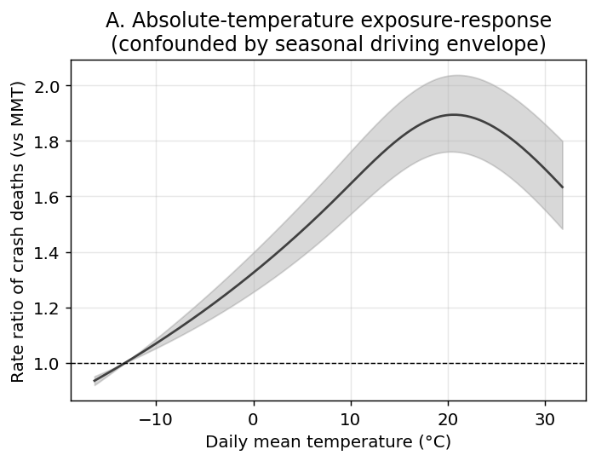
Figure 1. United States absolute-temperature exposure-response for daily traffic-crash deaths (cumulative over lag 0-10 days), relative to the minimum-mortality temperature. The curve peaks at mild temperatures and declines at extreme heat, reflecting the seasonal driving-exposure envelope rather than an acute heat effect. Black-and-white version: line styles and marker shapes distinguish categories.

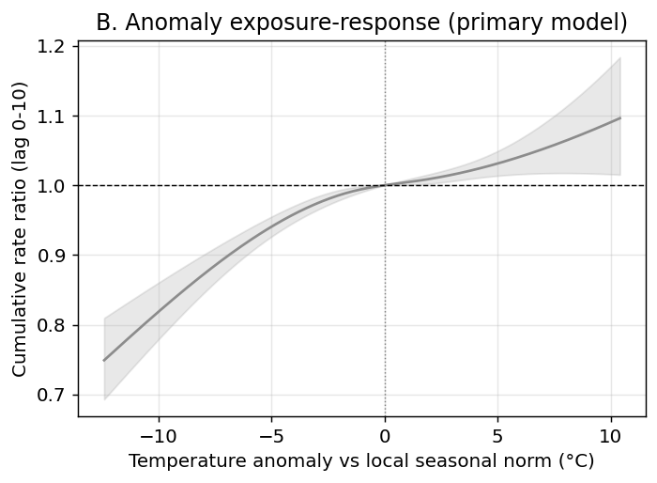
Figure 2. United States temperature-anomaly exposure-response (primary analysis): cumulative rate ratio of crash deaths versus the local day-of-year seasonal norm. Days hotter than normal carry higher crash mortality. Black-and-white version: line styles and marker shapes distinguish categories.

The lag structure showed an acute same-day excess followed by a deficit at 1-3 days, RR 0.936 (0.904-0.968), consistent with short-term displacement (harvesting) rather than a net addition of deaths (Fig. 3; Table 2). The same-day association was essentially unchanged after adjusting for national vehicle-miles travelled and gasoline supplied (RR 1.163, 95% CI 1.133-1.194; cumulative RR 1.075 (1.015-1.138)). A variance-inflation-factor (VIF) screened full-controls model—starting with state population as a log offset plus z-scored state annual VMT, daily precipitation and the three heat-stress metrics, then iteratively dropping any added control with VIF > 10—retained log-population offset, daily precipitation and estimated WBGT anomaly. Iteratively dropped variables were vmt_state, humidex_anom, heat_index_anom. Its same-day RR remained similar (RR 1.170 (1.122-1.219)), but the cumulative 0-10 day RR was attenuated (RR 1.086 (1.019-1.157)). A stricter VIF < 5 screen retained daily precipitation (RR 1.165 (1.135-1.196); cumulative RR 1.083 (1.023-1.146)), while the unscreened full-controls model attenuated toward the null (RR 1.070 (1.021-1.121); cumulative RR 1.005 (0.941-1.073); max control VIF 323.8). Heat-stress metrics were tested individually because they are functions of temperature and can be collinear with the anomaly; they yielded variable same-day estimates and the heat-index model attenuated toward the null.

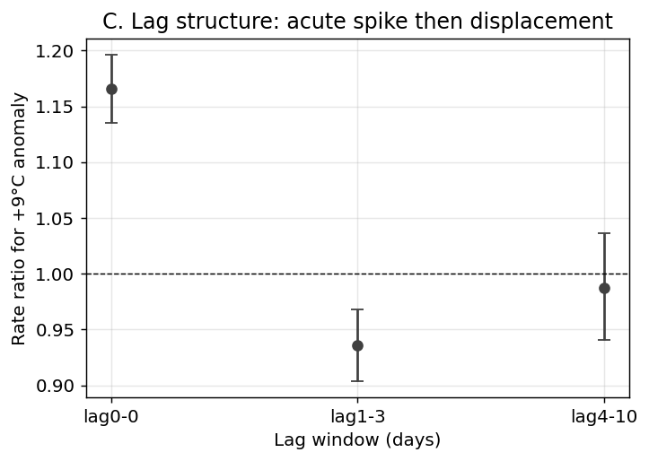
Figure 3. United States lag structure of the crash-death response to a +9 °C anomaly: an acute same-day excess followed by a 1-3 day deficit consistent with short-term displacement (harvesting) rather than a net addition of deaths. Black-and-white version: line styles and marker shapes distinguish categories.

Table 2. Rate ratio of traffic-crash deaths for a +9 °C temperature anomaly, by lag window.
Lag window (days) | United States | Japan
0 (same day) | 1.165 (1.135-1.196) | 0.940 (0.743-1.190)
1-3 | 0.936 (0.904-0.968) | 1.146 (0.739-1.779)
4-10 | 0.987 (0.941-1.036) | 0.521 (0.217-1.249)
Cumulative 0-10 | 1.076 (95% CI 1.017-1.139) | 0.562 (95% CI 0.207-1.525)

Two exploratory analyses were consistent with a heat mechanism, although neither can exclude residual confounding. First, the same-day excess differed by road-user exposure (Fig. 4; Table 3). The effect was small for enclosed, often air-conditioned vehicle occupants, RR 1.050 (1.017-1.085), but much larger for open-air users: motorcyclists, RR 2.140 (2.000-2.290); pedestrians, RR 1.215 (1.147-1.288); and cyclists, RR 1.243 (1.038-1.490), a pattern consistent with direct bodily heat exposure and physical exertion.¹⁵ This gradient could also partly reflect greater discretionary open-air travel (motorcycling, cycling, walking) on hotter-than-normal days, which our aggregate activity proxies do not capture by mode. Across age bands the excess was similar: age <25 y RR 1.123 (1.059-1.190); 25-64 y RR 1.176 (1.139-1.215); 65+ y RR 1.176 (1.113-1.242) (Table 3), giving no clear age gradient. Second, the excess was largest for crashes in the hottest part of the day (12-17 h), RR 1.217 (1.160-1.276), and weakest in the cool morning (06-11 h), RR 1.062 (1.001-1.127); the overnight band was also elevated (00-05 h), RR 1.176 (1.108-1.249), so the diurnal pattern is not a clean daytime-only gradient (Fig. 5). These subgroup analyses are hypothesis-generating: they involve multiple unadjusted comparisons and are not individual-level tests of susceptibility or mechanism.

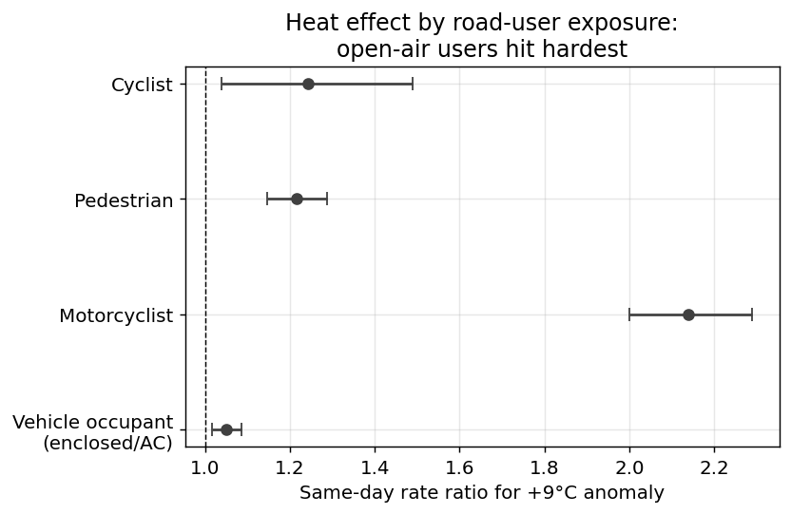
Figure 4. United States same-day rate ratio of crash death for a +9 °C anomaly by road-user type. Open-air users (motorcyclists, pedestrians, cyclists) show much larger heat effects than enclosed, often air-conditioned, vehicle occupants—a gradient that tracks direct heat exposure rather than driving volume. This subgroup analysis is exploratory and is not adjusted for multiple comparisons. Black-and-white version: categories are distinguished by the y-axis labels.

Table 3. United States same-day rate ratio of crash death for a +9 °C anomaly, by road-user type and age band (vulnerability analysis).
Subgroup | Crash deaths | Same-day RR (95% CI)
Vehicle occupant | 179,618 | 1.050 (1.017-1.085)
Motorcyclist | 38,644 | 2.140 (2.000-2.290)
Pedestrian | 46,429 | 1.215 (1.147-1.288)
Cyclist | 6,382 | 1.243 (1.038-1.490)
Age <25 y | 54,404 | 1.123 (1.059-1.190)
Age 25-64 y | 168,001 | 1.176 (1.139-1.215)
Age 65+ y | 50,068 | 1.176 (1.113-1.242)

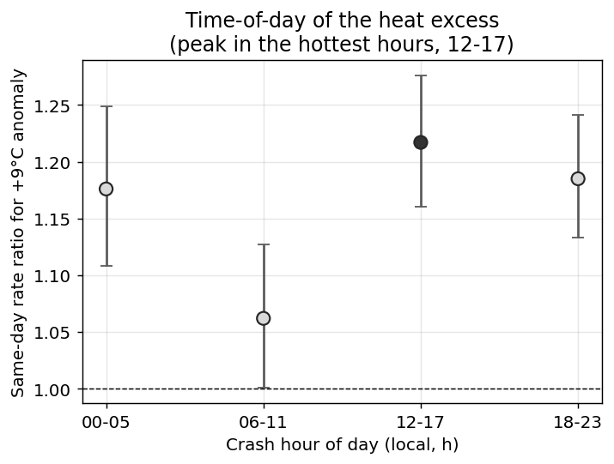
Figure 5. United States same-day rate ratio of crash death for a +9 °C anomaly by crash hour of day. The excess is largest for crashes in the hottest part of the day (12-17 h) and weakest in the cool morning (06-11 h). This subgroup analysis is exploratory and is not adjusted for multiple comparisons. Black-and-white version: the 12-17 h point is filled and the others are open to highlight the peak band.

Net heat-attributable crash deaths were 528 per year (95% CI 425-631), an attributable fraction of 1.36% (Fig. 6; Table 4). This is of the same order as the 527 officially recorded direct-heat deaths per year (ICD-10 X30, 2016-2020; Fig. 7), so a heat contribution to road deaths on the scale of recorded direct-heat mortality could go unrecorded in cause-of-death statistics.

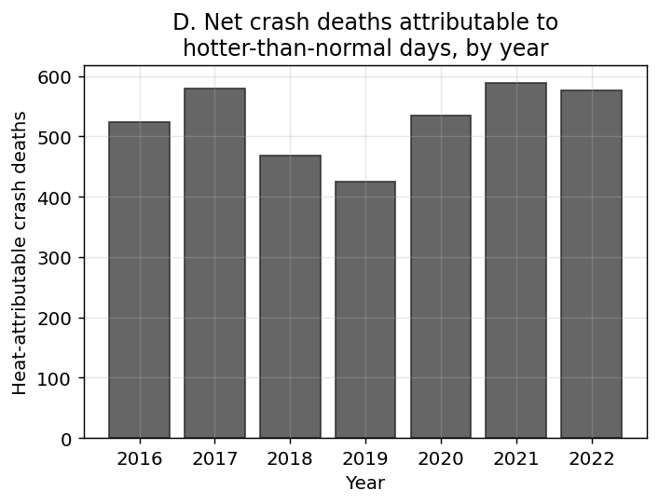
Figure 6. United States estimated net heat-attributable crash deaths per year, 2016-2022. Black-and-white version: line styles and marker shapes distinguish categories.

Table 4. United States net heat-attributable crash deaths versus officially recorded direct-heat deaths.
Quantity | Estimate
Net heat-attributable crash deaths / year | 528
Attributable fraction (%) | 1.36
Official direct-heat deaths / year (X30, 2016-2020) | 527

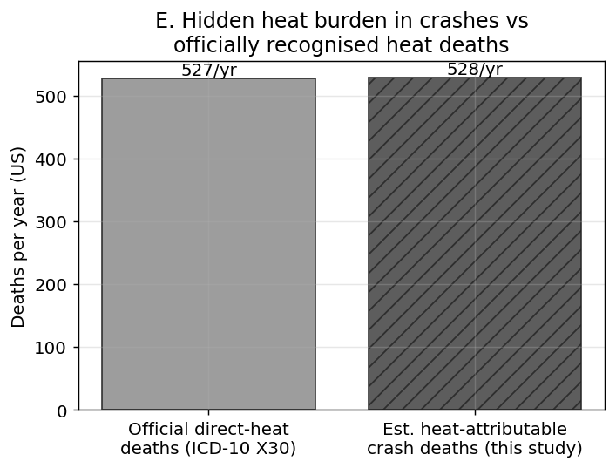
Figure 7. United States comparison of estimated net heat-attributable crash deaths per year with officially recorded direct-heat deaths (ICD-10 X30) from CDC WONDER. Black-and-white version: the right-hand (estimate) bar is hatched to distinguish it from the left-hand (official) bar.

To gauge the trajectory under continued warming, we applied the estimated anomaly exposure-response to uniformly warmer daily temperatures, holding driving activity and baseline rates constant.¹⁶ A uniform +1 °C shift projected 347 additional US crash deaths per year (95% CI 257-436), rising to 1009 (667-1384) at +3 °C (Fig. 8; Table 5). These are scenario projections, not observed quantities, and assume the anomaly response is stable under a warmer mean climate.

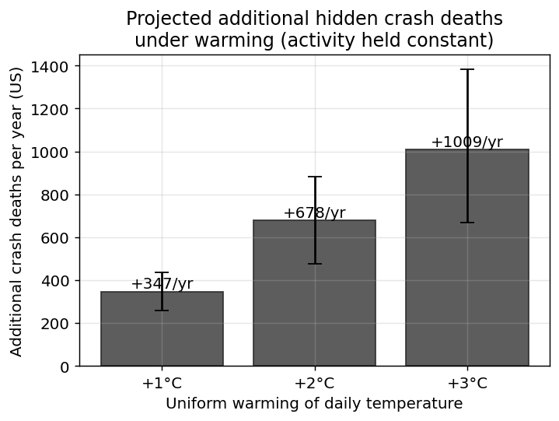
Figure 8. United States projected additional traffic-crash deaths per year under uniform warming of the daily temperature distribution by +1, +2 and +3 °C, holding driving activity and baseline rates constant. Bars show the point estimate with 95% Monte Carlo confidence intervals; this is a scenario projection, not an observed quantity. Black-and-white version: line styles and marker shapes distinguish categories.

Table 5. United States projected additional traffic-crash deaths per year under uniform warming (activity held constant); scenario projection, not observed.
Warming | Additional deaths/year (95% CI)
+1°C | 347 (257-436)
+2°C | 678 (474-881)
+3°C | 1009 (667-1384)

Sensitivity to activity, precipitation and heat-stress controls is summarized in Table 6. All added continuous terms were z-scored linear terms; state population entered as a log offset, and heat-stress metrics were expressed as anomalies relative to their day-of-year climatology. The primary full-controls model was selected by iteratively removing added controls with VIF > 10; dropped variables were vmt_state (VIF=323.8); humidex_anom (VIF=63.5); heat_index_anom (VIF=24.5). A stricter VIF < 5 screen and an unscreened full-controls model are also shown. Heat-stress metrics showed high collinearity with the temperature anomaly when entered individually, so they are reported separately as sensitivity analyses rather than being included simultaneously.
Table 6. United States sensitivity of the +9 °C anomaly association to activity, precipitation and heat-stress controls. All added continuous controls were z-scored; population entered as a log offset; heat-stress metrics were anomaly-derived. The VIF < 10 row is the primary full-controls model, selected by iteratively removing added controls with VIF > 10. A stricter VIF < 5 screen and an unscreened model are also shown. Heat-stress metrics were tested individually because they are functions of temperature and can be collinear with the anomaly.
Model | Same-day RR (95% CI) | Cumulative RR (95% CI) | Max control VIF
National VMT + motor gasoline | 1.163 (1.133-1.194) | 1.075 (1.015-1.138) | 5.3
State population offset | 1.165 (1.135-1.196) | 1.075 (1.015-1.138) | -
+ state annual VMT | 1.165 (1.135-1.196) | 1.073 (1.014-1.136) | 323.8
+ state VMT + precipitation | 1.165 (1.135-1.196) | 1.082 (1.022-1.145) | 323.8
Full controls, no VIF screen | 1.070 (1.021-1.121) | 1.005 (0.941-1.073) | 323.8
VIF-screened full controls (VIF < 10) | 1.170 (1.122-1.219) | 1.086 (1.019-1.157) | 8.5
VIF-screened full controls (VIF < 5) | 1.165 (1.135-1.196) | 1.083 (1.023-1.146) | 1.1
+ humidex anomaly | 1.176 (1.128-1.226) | 1.089 (1.023-1.160) | 323.8
+ heat-index anomaly | 1.049 (1.002-1.097) | 0.989 (0.927-1.055) | 323.8
+ estimated WBGT anomaly | 1.168 (1.120-1.217) | 1.083 (1.017-1.154) | 323.8

Exploratory external validation: Japan comparison
We did not pool the Japanese estimates with the US estimates; the comparison is presented only as an exploratory external validation. In Japan (11,576 crash deaths over 6 years) the anomaly exposure-response was imprecise, with a wide confidence band that included the null throughout (Fig. 9); the same-day point estimate for a +9 °C anomaly was 0.940 (95% CI 0.743-1.190) and was not stable across specifications. A direct comparison of the two countries (Fig. 10) shows a precise acute effect in the US, whereas the Japanese panel—with roughly 20-fold fewer annual crash deaths and sparser temperature coverage—is underpowered.

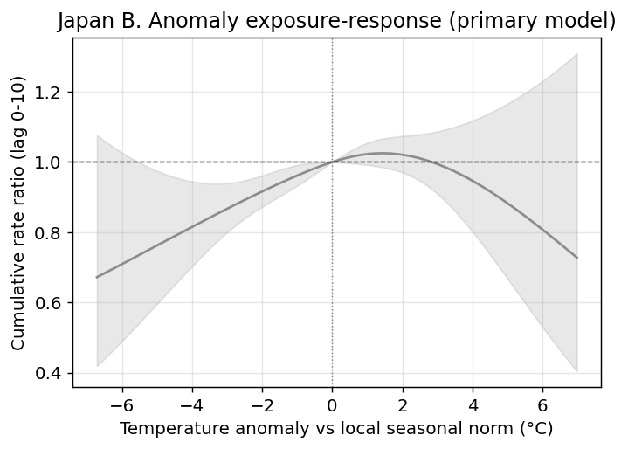
Figure 9. Japan temperature-anomaly exposure-response (2019-2024). The estimate is imprecise: the confidence band is wide and includes the null throughout. Black-and-white version: line styles and marker shapes distinguish categories.

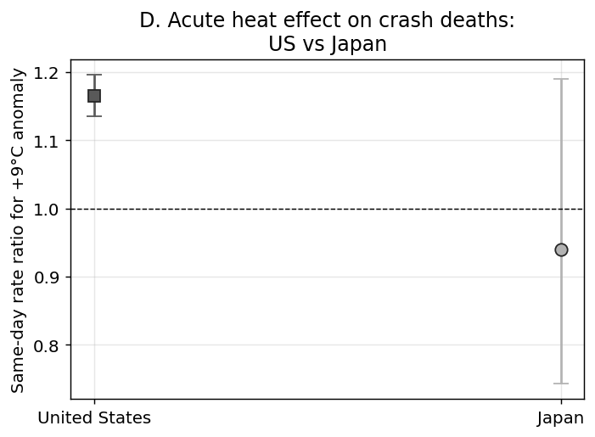
Figure 10. Same-day rate ratio of traffic-crash deaths for a +9 °C anomaly, United States versus Japan. The US shows a precise acute effect; the Japanese estimate is underpowered. This comparison is exploratory and is not adjusted for multiple comparisons. Black-and-white version: US (square) and Japan (circle) estimates use different marker shapes.

Discussion
A +9 °C temperature anomaly was associated with a same-day rate ratio of 1.165 (95% CI 1.135-1.196) for US traffic-crash deaths, and the net annual heat-attributable burden was 528 deaths (95% CI 425-631), similar to the 527 officially recorded direct-heat deaths per year. This acute, same-day excess was not explained by aggregate driving activity, and it remained in the VIF-screened full-controls model (added controls iteratively removed when VIF > 10, retaining log-population offset, daily precipitation and estimated WBGT anomaly; dropped: vmt_state, humidex_anom, heat_index_anom), RR 1.170 (1.122-1.219)). The cumulative 0-10 day RR in that model was attenuated (RR 1.086 (1.019-1.157)). The 1-3 day deficit indicates that part of the excess reflects short-term displacement (harvesting). These findings are consistent with heat-related impairment or under-recognised heat illness contributing to road deaths without appearing in cause-of-death data.^{3,4}
Two features of the data argue against confounding by overall driving volume and are consistent with a direct heat effect. The excess rose with direct heat exposure: it was small for enclosed, often air-conditioned vehicle occupants but several-fold larger for motorcyclists, pedestrians and cyclists, who are directly exposed and often physically exerting. It was also largest in the hottest hours of the day. Both patterns are consistent with heat degrading psychomotor and cognitive performance. These gradients are not proof of mechanism, however: open-air travel is itself weather-sensitive, so more motorcycling, cycling and walking on hotter-than-normal days could inflate the open-air estimates through greater exposure rather than physiology, and our activity proxies are national and not mode-specific. Applied to a warmer mean climate, the same exposure-response implies hundreds of additional US crash deaths per year per degree of warming; because these deaths would continue to be coded as ordinary crashes, the societal heat burden they represent would remain uncounted by heat-mortality surveillance.

Implications for road safety
These results point to practical implications for road safety and climate adaptation. Because the same-day excess was largest among open-air road users and in the hottest hours, heat warnings and travel advice could be targeted at motorcyclists, cyclists, pedestrians and outdoor delivery riders during hot periods. Shared e-scooter and e-bike fleets and public bikeshare systems should also be considered: their batteries, motors and tyres are heat-stressed and may become prone to sudden power loss or brake failure in hot weather, while docking and charging points without shade expose users and maintenance staff to thermal load during check-out, parking and battery swap. Service operators could temporarily reduce or suspend rentals above high-temperature thresholds, relocate or shade docking and charging infrastructure, and integrate heat warnings into app-based routing. Linking shared-mobility heat alerts with public transit and cooled shelter maps would help preserve access for users who depend on these modes, particularly in low-income neighbourhoods where private air-conditioned transport is less available. Road safety agencies typically classify fatal crashes by driver error, vehicle failure or road conditions; the possibility that ambient heat impairs psychomotor or cognitive performance is rarely considered. Integrating temperature forecasts into crash-prevention messaging and ensuring heat-health plans reach outdoor workers and commuters is consistent with a Safe System approach to environmental risk and could reduce a burden that is currently invisible to both heat-mortality and road-safety surveillance, though intervention studies are needed to test whether such heat-aware measures reduce crash risk.
Several limitations apply. First, this is an ecological, population-level association: it cannot establish that heat caused illness in any specific crash, and neither FARS nor NPA records post-mortem heat diagnosis. Second, exposure is measured at the state/prefecture level from the nearest GHCN-Daily station; this misclassifies individual exposure and does not capture sub-unit variation such as urban heat islands. We therefore added state population as an offset and evaluated GHCN-derived humidity, heat-index and estimated wet-bulb globe temperature metrics in sensitivity models, but these station-based heat-stress measures still do not measure personal exposure. Third, activity adjustment used national monthly proxies for the main model and annual state VMT for the sensitivity model; neither is daily, mode-specific or shared-mobility-specific, and daily state-level or mode-specific activity could alter the road-user and time-of-day gradients. In particular, publicly available daily national counts of pedestrian, bicycle and shared-mobility trips are not available, so we cannot directly separate a weather-related activity shift from a physiological or mechanical heat effect for those modes. Fourth, the Japanese analysis is an exploratory external validation only; its shorter series, far smaller death counts and sparser GHCN-Daily coverage preclude a precise estimate, and we do not pool the two countries. Fifth, the warming projection is a scenario calculation that holds driving activity, the vehicle fleet and behaviour fixed and assumes the anomaly response is stable under a warmer mean climate; it should be read as illustrative of magnitude, not as a forecast. Sixth, the road-user, age and time-of-day subgroup analyses are exploratory: they entail multiple comparisons without formal adjustment, and the open-air road-user gradient may in part reflect weather-related differences in activity rather than physiology. Seventh, the quasi-Poisson model accounts for overdispersion but does not include an explicit autoregressive error term; although the distributed-lag, seasonal, trend and day-of-week controls absorb much short-term temporal autocorrelation, unmodelled residual serial correlation could affect confidence intervals. Eighth, the findings are drawn from the United States and Japan because, among high-income countries with comparably robust road-crash and meteorological data collection, no other country currently provides a fully open, daily, individual-level crash record equivalent to FARS or the Japanese NPA open data; the EU CARE database contains detailed individual accident records but is not publicly available at the daily individual level, and national open road-safety datasets in Europe are not harmonised, so the United States and Japan represent the best available public sources for this study design.¹⁷ These findings should motivate, but cannot replace, individual-level studies linking crash decedents to ambient heat and, where available, post-mortem findings.

Conclusion
Unusually hot days are associated with an acute, same-day excess of US traffic-crash mortality comparable to recorded direct-heat deaths, supporting the plausibility of an under-recognised heat contribution to road deaths. The findings suggest heat-aware road safety and climate adaptation planning could reduce an uncounted burden, although the Japanese data are too sparse for a firm conclusion and individual-level mechanistic evidence is still needed.

Contributors
Tatsuki Onishi conceived the study, performed the analysis, drafted the manuscript, and approved the final version. The author had full access to all data and verified the reported results.

Declaration of competing interests
We declare no competing interests.

Funding
There was no specific funding for this study. The corresponding author had full access to all the data and had final responsibility for the decision to submit for publication.

Declaration of generative AI use
During the preparation of this work the author used generative artificial intelligence tools to assist with code development and manuscript drafting. After using these tools, the author reviewed and edited the content and takes full responsibility for the published content.

Data availability
All data are public: FARS, GHCN-Daily, CDC WONDER, US Census Bureau Population Estimates Program, FHWA Highway Statistics VM-2, FHWA/FRED, EIA and the Japanese NPA accident open data (see References for sources). Processed data files are provided in the repository so the manuscript and figures can be regenerated without API keys. The complete analysis code and reproducible pipeline (make all for raw data and figures, then make ehp for the EHP submission package) is openly available at https://github.com/bougtoir/heat-accidents-mortality; every reported number, figure and table is regenerated from source with no hard-coded values.

References
1. Gasparrini A, Guo Y, Hashizume M, et al. Mortality risk attributable to high and low ambient temperature: a multicountry observational study. Lancet 2015;386:369-75.
2. Basu R. High ambient temperature and mortality: a review of epidemiologic studies from 2001 to 2008. Environ Health 2009;8:40.
3. Liang M, Min M, Guo X, Song Q, Wang H, Li N, et al. The relationship between ambient temperatures and road traffic injuries: a systematic review and meta-analysis. Environ Sci Pollut Res 2022;29(33):50647-60.
4. Liang M, Zhao D, Wu Y, Ye P, Wang Y, Yao Z, et al. Short-term effects of ambient temperature and road traffic accident injuries in Dalian, Northern China: A distributed lag non-linear analysis. Accid Anal Prev 2021;153:106057.
5. National Highway Traffic Safety Administration. Fatality Analysis Reporting System (FARS). US Department of Transportation. https://www.nhtsa.gov/research-data/fatality-analysis-reporting-system-fars
6. National Police Agency of Japan. Traffic accident statistics open data. https://www.npa.go.jp/publications/statistics/koutsuu/opendata/
7. Menne MJ, Durre I, Vose RS, Gleason BE, Houston TG. An overview of the Global Historical Climatology Network-Daily database. J Atmos Ocean Technol 2012;29:897-910.
8. Gasparrini A, Armstrong B, Kenward MG. Distributed lag non-linear models. Stat Med 2010;29:2224-34.
9. Gasparrini A, Leone M. Attributable risk from distributed lag models. BMC Med Res Methodol 2014;14:55.
10. Federal Highway Administration. Traffic Volume Trends. https://www.fhwa.dot.gov/policyinformation/travel_monitoring/tvt.cfm
11. US Energy Information Administration. Weekly finished motor gasoline product supplied (PET.WGFUPUS2.W). https://www.eia.gov/
12. US Census Bureau. Population Estimates Program. Annual state population estimates. https://www.census.gov/programs-surveys/popest.html
13. Federal Highway Administration. Highway Statistics VM-2: Annual state vehicle-miles travelled. https://www.fhwa.dot.gov/policyinformation/statistics.cfm
14. Centers for Disease Control and Prevention. CDC WONDER Underlying Cause of Death database. https://wonder.cdc.gov/
15. Daanen HAM, van de Vliert E, Huang X. Driving performance in cold, warm, and thermoneutral environments. Appl Ergon 2003;34:597-602.
16. IPCC. Climate Change 2021: The Physical Science Basis. Contribution of Working Group I to the Sixth Assessment Report of the Intergovernmental Panel on Climate Change. Cambridge: Cambridge University Press; 2021.
17. European Commission, Directorate-General for Mobility and Transport. Community database on road accidents (CARE). https://road-safety.transport.ec.europa.eu/european-road-safety-observatory/methodology-and-research/care-database_en

