Lifecycle Data Exposure in Shared Micromobility: A Scoping Review and a Global Audit of Public GBFS Vehicle Feeds and Operator Disclosures
[Author name]
[Department, institution, city, postal code, country]
Corresponding author: [Corresponding author email]; ORCID [ORCID]

Abstract
Background: Shared micromobility produces continuous location, motion, and battery telemetry, yet evidence on data exposure is scattered and the device lifecycle beyond real-time position is rarely examined.
Objective: To map the direct evidence for micromobility data exposure, to measure which vehicle fields operators publish worldwide, and to assess how completely operators disclose lifecycle data handling.
Methods: We combined a scoping review reported using the Preferred Reporting Items for Systematic Reviews and Meta-Analyses extension for Scoping Reviews (PRISMA-ScR) of 2,169 records, a cross-sectional field audit of public General Bikeshare Feed Specification (GBFS) feeds, and a structured disclosure audit of public operator privacy notices across 14 domains, using deterministic screening and explicit denominators with 95% Wilson confidence intervals (CIs).
Results: Eighteen direct studies were included (5 direct-empirical, 9 direct-documentary, and 4 near-domain), with the strongest evidence at the operation stage. Across 813 motorized micromobility feeds, vehicle identifiers appeared in 100% and coordinates in 99.4%, while battery percentage appeared in 68.9%. Operator notices documented operational processing thoroughly but were silent on device disposal and vulnerability reporting.
Conclusions: Persistent identifiers and precise positions are widely disclosed, and lifecycle end-of-life handling is largely undocumented. These are disclosure and evidence signals, not demonstrations of harm; we propose a lifecycle model whose controls remain to be validated.

Policy Significance Statement
Shared e-scooters and e-bikes are connected devices that cities and residents use but neither own nor decommission. This study gives policymakers an evidence-based map of what these systems actually disclose. A global audit of public vehicle feeds shows that persistent identifiers and precise locations are published almost universally, while operator privacy notices rarely address device disposal or vulnerability reporting. For regulators and procuring authorities, this indicates that oversight focused only on real-time location understates lifecycle exposure. We provide a transparent, reproducible lifecycle framework that ties each stage to the strength of its evidence, helping agencies target disclosure requirements, procurement clauses, and end-of-life data-handling rules where public accountability is currently weakest. The whole audit relies only on public data and open code.
Keywords: shared micromobility; location privacy; data lifecycle; open mobility data; data governance

1. Introduction
Shared micromobility - dockless electric scooters and bicycles rented through a smartphone application - has become a visible class of connected devices that organizations and the public use but do not own, maintain, or decommission. Each vehicle continuously produces location, motion, and battery telemetry that is transmitted to an operator backend and, in many cities, republished through open data feeds. Prior work has shown that such telemetry can support re-identification and tracking well beyond the individual rental that generated it (de Montjoye et al. 2013; Elzer et al. 2025).
Security research on shared micromobility has grown quickly but unevenly. Studies span privacy measurement of rental applications, firmware and protocol attacks on scooters, location-spoofing threats, and forensic recovery from returned devices (Casagrande et al. 2023; Hilgert et al. 2021; Vinayaga-Sureshkanth et al. 2022; Yilmaz and Karsligil 2023). These contributions are scattered across security, transportation, and forensics venues, use different threat models and units of analysis, and have not been assembled into a single map of what is actually demonstrated as opposed to argued. As a result, it is difficult to state precisely which data-exposure pathways rest on direct empirical evidence and which rest on analogy.
A second gap concerns exposure that persists across the device lifecycle. Attention typically concentrates on real-time position during a rental, yet information created at deployment, maintenance, recall, and disposal can remain accessible after custody changes hands (Joshi and Raval 2018; Liu et al. 2023). Battery and diagnostic channels, in particular, can leak activity patterns even when positioning is restricted (Basic et al. 2023; Marchiori et al. 2025). Whether operators disclose these lifecycle practices to the public is largely unexamined.
This article addresses both gaps with an empirical, reproducible package rather than a conceptual argument. We (i) conduct a scoping review, following the Preferred Reporting Items for Systematic Reviews and Meta-Analyses extension for Scoping Reviews (PRISMA-ScR) (Tricco et al. 2018), of evidence on micromobility data exposure; (ii) audit the fields that operators actually publish worldwide through the General Bikeshare Feed Specification (GBFS) (MobilityData 2024); and (iii) audit what a matched set of operator privacy notices discloses about collection, retention, transfer, and device end-of-life. Our research questions are: RQ1, what data-exposure pathways in shared micromobility are supported by direct evidence; RQ2, which vehicle-level fields are publicly disclosed, and at what prevalence; and RQ3, how completely do public operator documents describe lifecycle data handling.
We are deliberately conservative about interpretation. Publishing a field, or remaining silent about a practice, is a disclosure signal; it is not by itself evidence of a privacy harm, a compromise, or a regulatory violation. The contribution is a transparent evidence base and a lifecycle model that ties each stage to the strength of its supporting evidence and to controls whose effectiveness remains to be tested.

2. Methods

2.1. Design and reporting
The study combines three prespecified components: a scoping review (work package WP1), a cross-sectional field audit of public GBFS feeds (WP2), and a structured disclosure audit of public operator documents (WP3). The review component is reported in line with PRISMA-ScR (Tricco et al. 2018) and follows the scoping-review framework of Arksey and O'Malley (2005). Eligibility criteria and data sources for all three components are summarized in Table 1. The protocol, screening rules, coding sheets, and analysis code are openly available so that the counts reported here can be regenerated.
Table 1. Eligibility criteria and data sources for the three study components.
Component | Unit of analysis | Inclusion criteria | Primary source
Scoping review (WP1) | Study | Peer-reviewed or archival works reporting a data path in or transferable to shared micromobility | Bibliographic search of 2,169 records (Arksey and O'Malley 2005; Tricco et al. 2018)
GBFS field audit (WP2) | System/feed | Public GBFS systems in the frozen registry with a reachable auto-discovery endpoint | GBFS systems catalogue and live feeds (MobilityData 2024; MobilityData 2026)
Disclosure audit (WP3) | Operator document | Publicly reachable operator privacy notice for an audited GBFS operator | Operator privacy notices; governance guidance (European Data Protection Board 2021; Open Mobility Foundation 2021)

2.2. Scoping review (WP1)
We compiled 2,169 records from programmatic searches of open bibliographic metadata. Abstracts were retrieved automatically where a digital object identifier (DOI) was available (1,539 of 2,116 DOI records; 72.7%); the remaining records were screened on title and available metadata only. Title/abstract screening applied a deterministic rule set that combined target-domain relevance with the presence of a described data path, and recorded a decision and reason for every record. Because the rules are deterministic, we re-applied them to a delayed 20% sample (n = 447) and reproduced every original decision (100% agreement); this demonstrates computational reproducibility rather than inter-rater reliability, as a single reviewer conducted the screening.
Records marked include or uncertain were sought for full-text assessment. Each retrieved study was classified by evidence distance: D4, direct target-domain empirical evidence; D3, direct target-domain documentary evidence; D2, near-domain empirical evidence; D1, mechanism analogy; and N, normative evidence. This ordering is an operational classification defined for the present study; it is conceptually related to the GRADE notion of indirectness (Guyatt et al. 2011) but is not a GRADE certainty rating. We did not treat a title/abstract decision as equivalent to a confirmed full-text finding, and we did not claim to have read full text that could not be retrieved. From the included studies we built a study-level extraction table capturing device or service, design, data fields, access path, reported outcome, and limitations.

2.3. Public GBFS field audit (WP2)
We froze a snapshot of the public GBFS systems catalogue (MobilityData 2026) and recorded its checksum. For each system we attempted to reach the auto-discovery endpoint, to locate a declared vehicle-status feed, to retrieve that feed, and to record which specification fields it contained. The unit of analysis is the system/feed. To respect the study's safety constraints, we recorded only the presence or absence of each field; raw vehicle identifiers, exact coordinates, and vehicle-specific deep links were not retained. Unavailable or empty feeds were separated from feeds that were retrieved but omitted a field, and all proportions are reported against explicit denominators with 95% Wilson confidence intervals (CIs). Because several large operators run many city systems, we also computed an operator-domain sensitivity analysis to check whether prevalence was driven by a few operators.

2.4. Public-document disclosure audit (WP3)
We selected operators from the audited GBFS population and retrieved their public privacy notices. For each operator document we coded 14 disclosure domains - location; trip and time data; vehicle identifiers; battery or diagnostic data; maintenance or repair records; account, payment, and device data; analytics or profiling; retention; processors or contractors; international transfers; data-subject rights; incident contact; vulnerability disclosure; and device return, recycling, or disposal - using the values explicit, partial, not found, not applicable, and unavailable. A not-found coding means the document did not address the domain; it is not evidence that the practice does not occur. Each coding is accompanied by a short verbatim locator quotation in the coding sheet so that a third party can check it. Coding was computer-assisted and reviewed by a single reviewer; governance and standards documents (Boyens et al. 2022; European Data Protection Board 2021; European Parliament and Council 2023; Kissel et al. 2014; Open Mobility Foundation 2021) were used as reference points and were not coded as operator practices.

3. Results

3.1. Scoping review (RQ1)
Of 2,169 records screened, 1,945 were excluded at title/abstract and 224 were sought for full text (Fig. 1). Of these, 79 could not be retrieved and were recorded as such rather than assessed; 127 retrieved records were excluded because they contained no relevant data path (90) or described a mechanism that did not transfer to the target domain (37). Eighteen direct studies were included: 5 at evidence distance D4, 9 at D3, and 4 at D2 (Fig. 2; Table 2).
The included D4 studies provide the strongest evidence. A long-term real-world analysis reconstructed rider-relevant patterns from operator data (Elzer et al. 2025); investigative studies of rental applications and scooter ecosystems demonstrated collection and protocol weaknesses (Casagrande et al. 2023; Casagrande et al. 2024; Vinayaga-Sureshkanth et al. 2022); and a forensic analysis recovered data from micromobility devices (Hilgert et al. 2021). D3 studies document platform architectures, location-spoofing threats, data-acquisition frameworks, and user-facing traceability concerns (Hannemann et al. 2023; Isik et al. 2023; Li and Zhang 2020; Petersen 2019; Sato et al. 2025; Vinayaga-Sureshkanth et al. 2020; Yilmaz and Karsligil 2022; Yilmaz and Karsligil 2023; Zhou 2024). D2 studies transfer from adjacent domains: battery side channels and battery-management data (Basic et al. 2023; Marchiori et al. 2025), residual data in reused IoT devices (Liu et al. 2023), and cloud data remanence (Joshi and Raval 2018). No included study, on its own, demonstrated an end-to-end lifecycle compromise; the evidence is strongest for operation and weakest for recall and disposal.
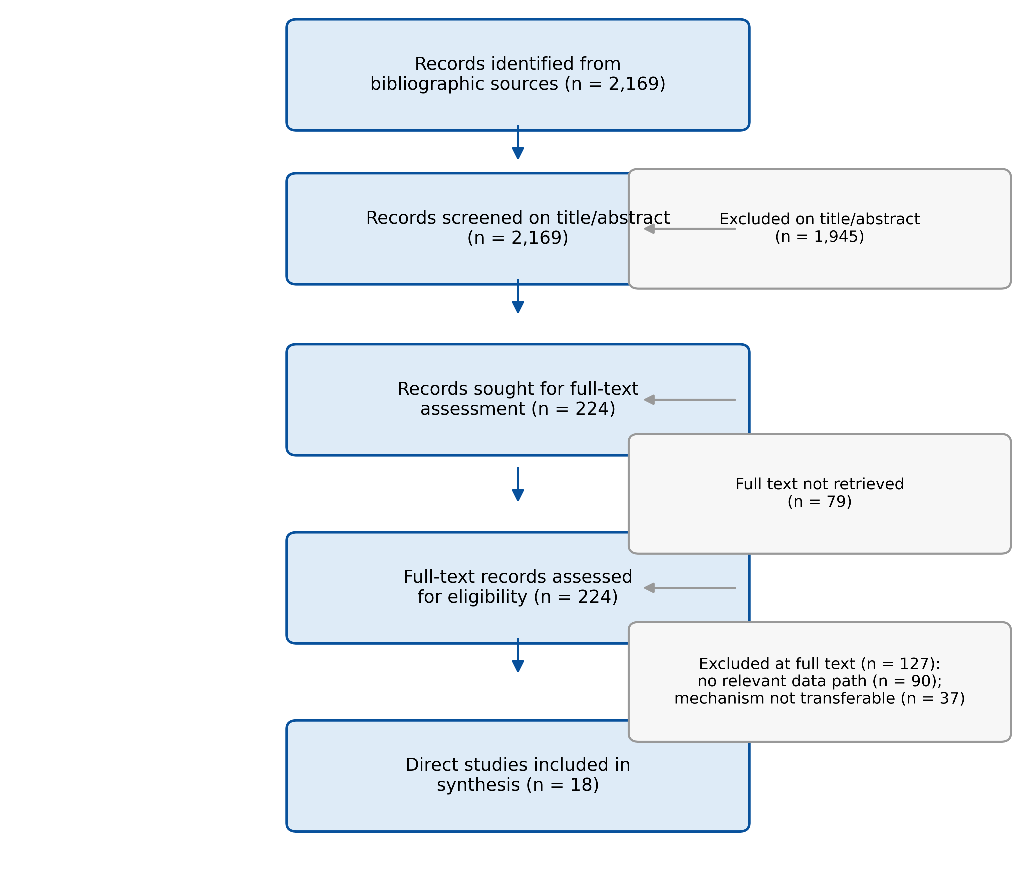
Figure 1. PRISMA-ScR flow of record identification, title/abstract screening, full-text eligibility assessment, and inclusion. Counts are reproduced from the committed screening sheet.
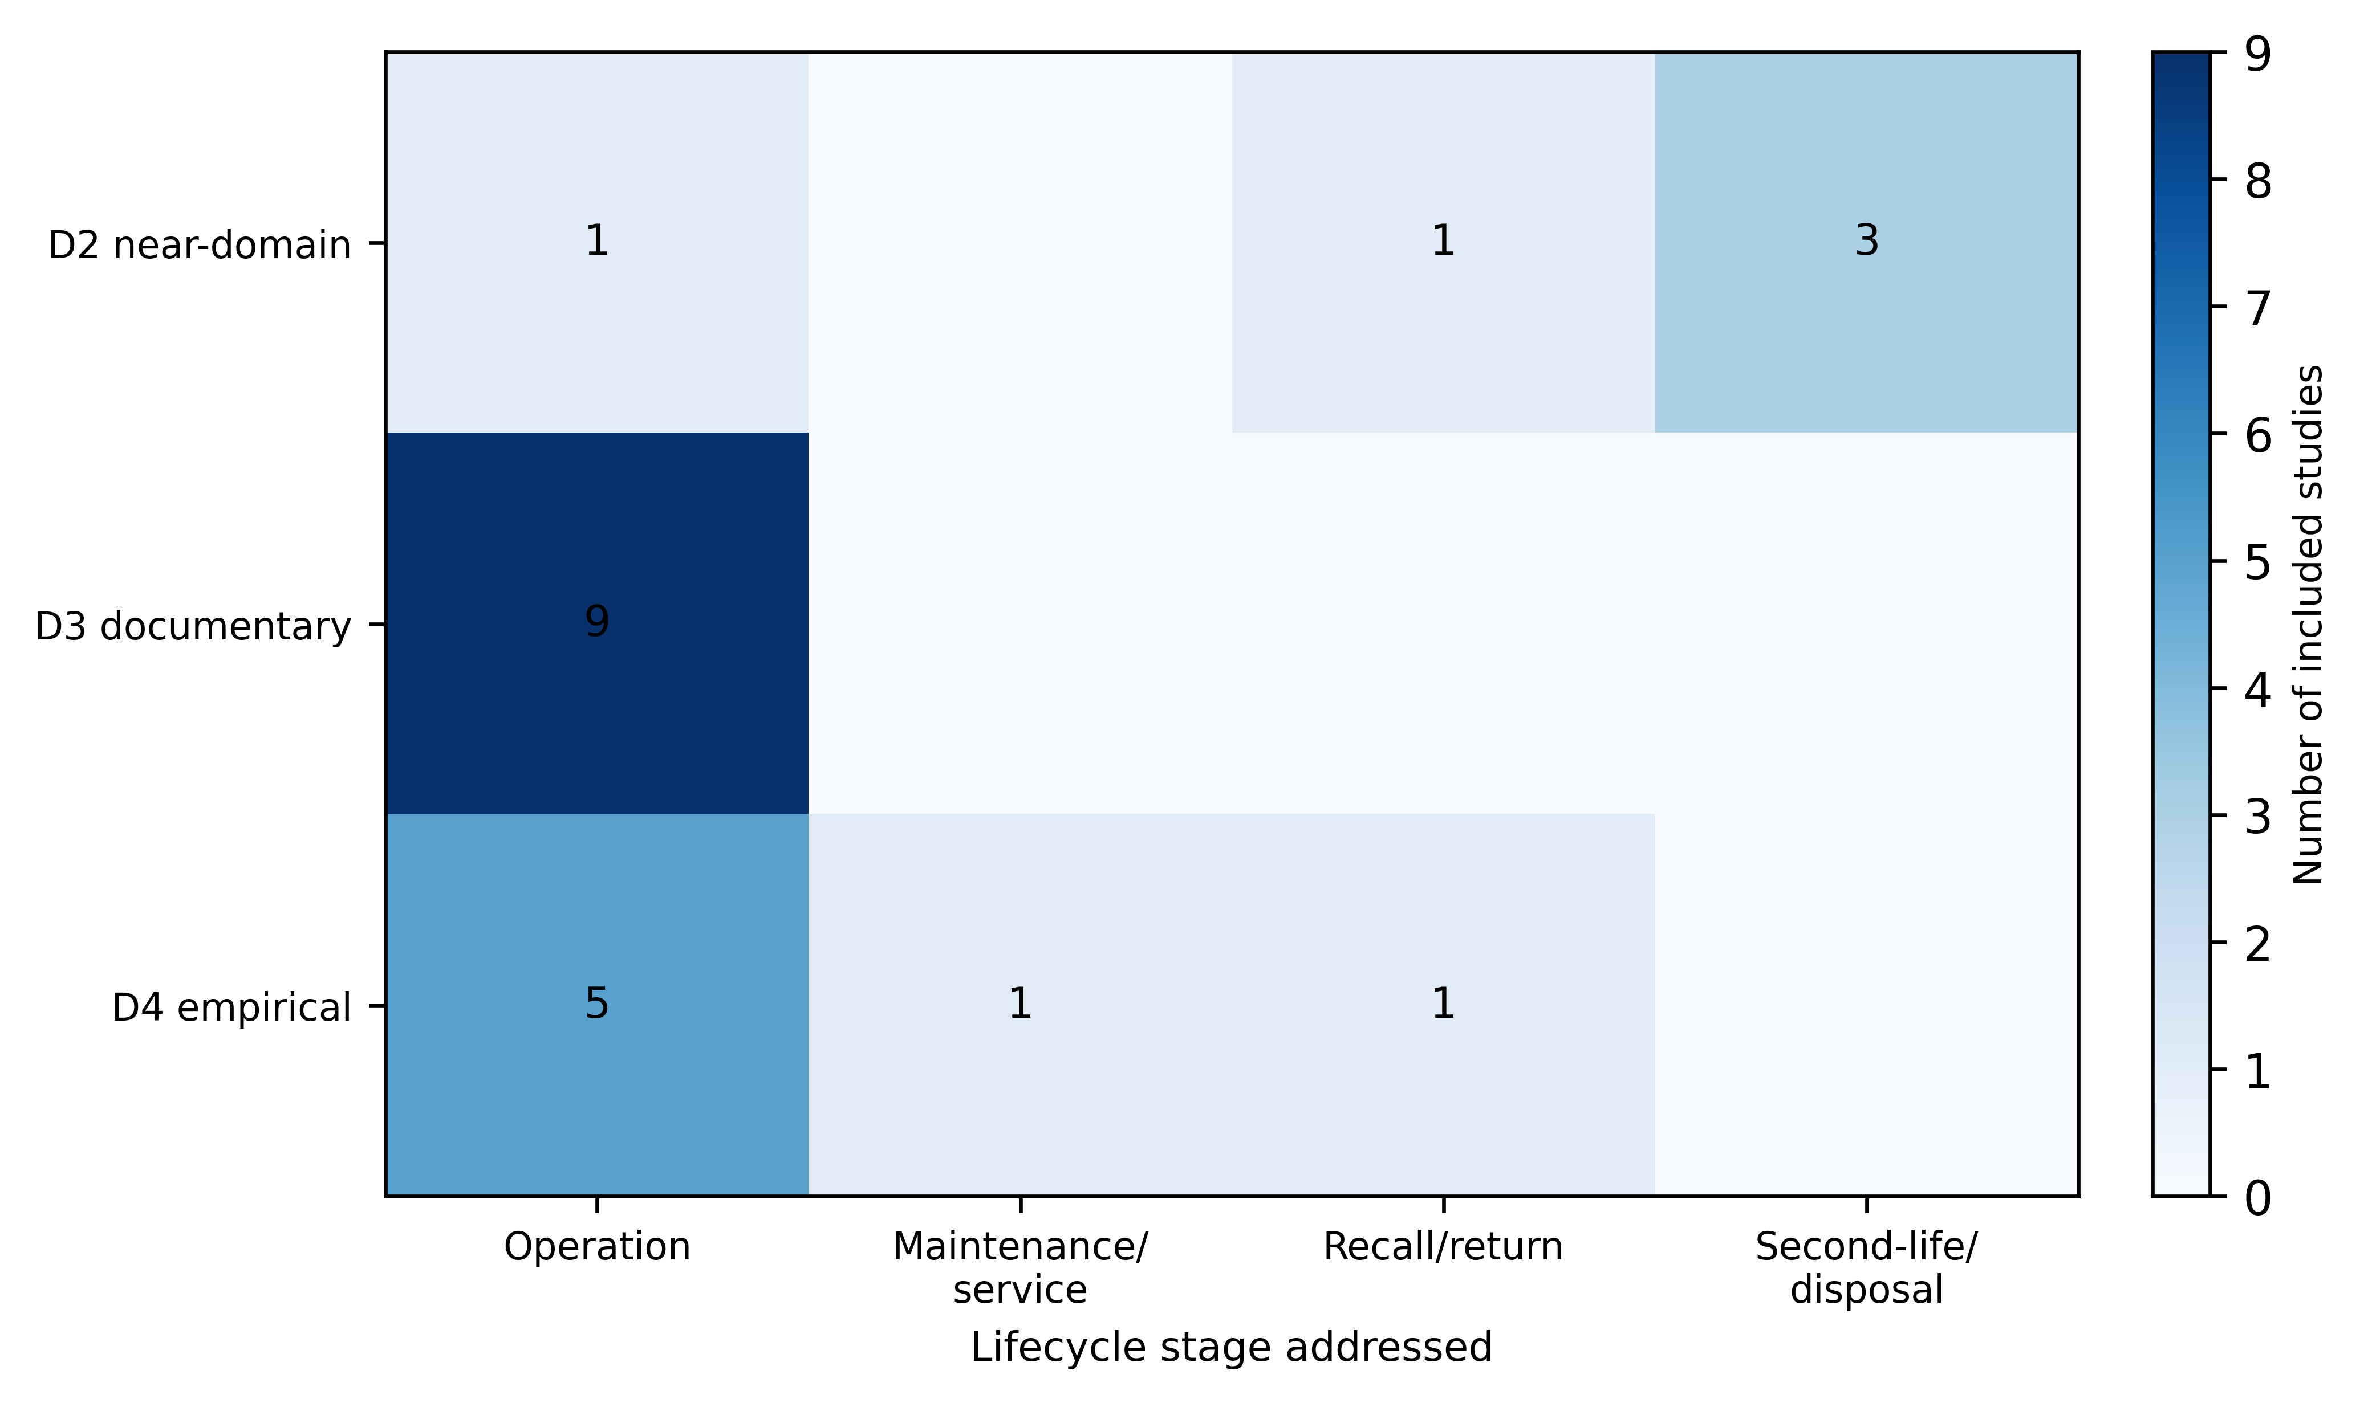
Figure 2. Evidence map of the 18 included direct studies by evidence distance (D4 direct empirical, D3 direct documentary, D2 near-domain empirical) and lifecycle stage addressed. A study that addresses more than one stage is counted in each relevant stage, so row totals may exceed the number of studies at that distance.
Table 2. Included direct studies (n = 18), ordered by evidence distance. Key results are as reported by the source; this review did not reproduce the underlying experiments.
Study | Evidence distance | Device or service | Reported key result
Casagrande et al (2023) | D4 empirical | Xiaomi e-scooter ecosystem and Mi Home app | Proprietary BLE protocol exploitable to steal or disable scooters and expose data
Casagrande et al (2024) | D4 empirical | Xiaomi M365 and ES3 e-scooters with companion app | Battery-powered embedded internals expose tracking, DoS, ransomware, and data-leak surfaces
Elzer et al (2025) | D4 empirical | Shared e-scooter and e-bike systems (public provider feeds) | Public feed state changes reconstruct individual mobility patterns exploitable for stalking or burglary
Hilgert et al (2021) | D4 empirical | Micromobility rental apps (bikes and e-scooters) | Micromobility apps retain recoverable movement and account artifacts of investigative value
Vinayaga-Sureshkanth et al (2022) | D4 empirical | Mobile e-scooter rental applications | Rental apps collect privacy-sensitive data as a functional requirement and embed third-party trackers
Hannemann et al (2023) | D3 documentary | Smart-mobility platforms (incl. rental bikes, e-scooters) | Smart mobility shares sensitive personal data across parties; FHE mitigations remain costly
Isik et al (2023) | D3 documentary | E-scooter sharing platforms (ESPs) | ESP architecture exposes resource abuse, DoS, and personal-data breach surfaces
Li et al (2020) | D3 documentary | E-scooter sharing platforms | Traceable route information drives distinct privacy concern and protective responses
Petersen (2019) (2019) | D3 documentary | Rental scooters (Bird, Lime, Spin) | Rental scooters yield a uniquely identifying rider dataset that may be shared or sold
Sato et al (2025) | D3 documentary | Micromobility vehicles (data-acquisition testbed) | A reproducible framework measures cyberphysical security-attack impact on micromobility vehicles
Vinayaga-Sureshkanth et al (2020) | D3 documentary | Intelligent urban micromobility ecosystem | The vehicle-provider-rider ecosystem is an exploitable attack surface for security and privacy
Yilmaz et al (2022) | D3 documentary | E-scooter sharing (GPS/Wi-Fi positioning) | Shared e-scooter positioning inherits known spoofing vulnerabilities
Yilmaz et al (2023) | D3 documentary | E-scooter sharing (geo-location services) | E-scooter positioning is vulnerable to spoofing affecting cost, reliability, and safety
Zhou (2024) (2024) | D3 documentary | Dockless bikeshare platforms | Trajectory data extraction is core to bikeshare business models but poorly understood by users
Basic et al (2023) | D2 near-domain | Battery management systems (EV batteries) | Regulated battery passports generate lifecycle data spanning use, second-life, and recycling
Joshi (2018) (2018) | D2 near-domain | Cloud storage media | Inadequate media sanitization leaves recoverable residual data via remanence
Liu et al (2023) | D2 near-domain | Used IoT devices (resale market) | Resold IoT devices frequently retain recoverable sensitive user data
Marchiori et al (2025) | D2 near-domain | Electric vehicles (battery side channel) | Battery side channels leak operational information without explicit location data

3.2. Public GBFS field audit (RQ2)
Of 1,520 registry systems, 94.0% (95% CI 92.6-95.0%; n = 1,428) exposed a reachable auto-discovery endpoint, 90.8% of reachable systems declared a vehicle-status feed, and 89.5% of successfully retrieved feeds contained at least one vehicle (Table 3). Restricting to the 813 non-empty feeds that declared motorized micromobility, a vehicle identifier was present in 100.0% of feeds and latitude/longitude in 99.4% (Fig. 3). Fields with more operational specificity were less uniformly published: current range in 98.7%, vehicle-specific rental links in 79.1%, last-reported timestamps in 77.4%, and battery or fuel percentage in 68.9%.
The operator-domain sensitivity analysis indicates that these are not artefacts of a few large operators. Across 147 eligible operator domains, a vehicle identifier appeared in every eligible feed for 100.0% of domains and latitude/longitude for 96.6%, whereas battery percentage was present in at least one eligible feed for only 64.0% of domains. These figures describe what is disclosed publicly; they do not describe what operators collect or store on their backends, which the public feed cannot reveal.
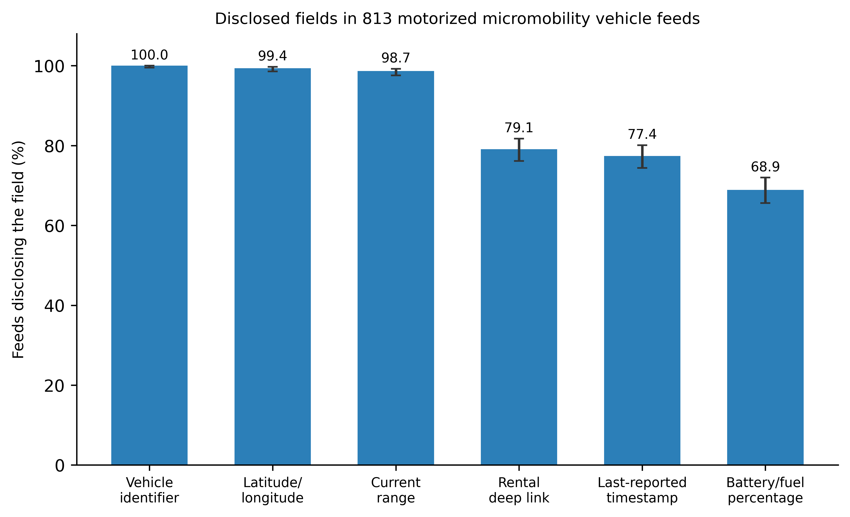
Figure 3. Prevalence of disclosed fields in 813 successfully retrieved, non-empty public vehicle-status feeds that declared motorized micromobility. Bars show the point estimate; whiskers show the 95% Wilson confidence interval. Field presence is a disclosure signal, not evidence of a privacy harm.
Table 3. GBFS audit sampling and outcomes with 95% Wilson confidence intervals. Denominators are stated explicitly; unavailable or empty feeds are separated from absent fields.
Stratum / outcome | n | Denominator | Percent | 95% CI
Reachable auto-discovery endpoint | 1428 | 1520 | 94.0% | 92.6-95.0%
Vehicle-status feed declared | 1297 | 1428 | 90.8% | 89.2-92.2%
Retrieved feed with >=1 vehicle | 1155 | 1291 | 89.5% | 87.7-91.0%
Vehicle identifier (motorized feeds) | 813 | 813 | 100.0% | 99.5-100.0%
Latitude/longitude (motorized feeds) | 808 | 813 | 99.4% | 98.6-99.7%
Last-reported timestamp (motorized feeds) | 629 | 813 | 77.4% | 74.4-80.1%
Battery/fuel percentage (motorized feeds) | 560 | 813 | 68.9% | 65.6-72.0%

3.3. Public-document disclosure audit (RQ3)
We coded 13 operator privacy notices across 14 domains; two further operators could not be retrieved as reproducible text and were recorded as unavailable (Fig. 4; Table 4). Operational and account-level processing was disclosed almost universally: location data were explicit for 11 of 13 operators, and retention, processors or contractors, and account/payment/device data were explicit for most. Data-subject rights and international transfers were explicit or partial for the large majority, consistent with a predominantly European operator sample governed by the General Data Protection Regulation (European Parliament and Council 2016).
Disclosure was markedly thinner for device-centred and lifecycle domains. Battery or diagnostic data collection was not found in 8 of 13 notices, even though such data are technically central to these vehicles (Basic et al. 2023; Marchiori et al. 2025). No operator notice in the sample described a vulnerability-disclosure channel (13 of 13 not found), and none addressed device return, recycling, or disposal handling (13 of 13 not found). We stress that these are gaps in public documents, not proof that the corresponding practices are absent; they nonetheless mark the parts of the lifecycle that are least visible to the public and to procuring organizations.
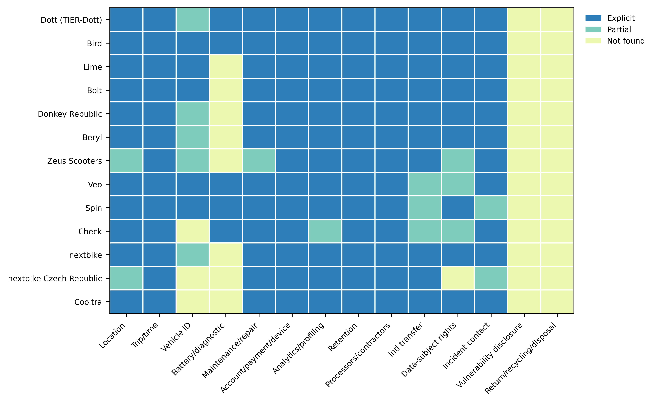
Figure 4. Disclosure-domain coding of public operator privacy notices across 14 domains (n = 13 coded operators; 2 further operators were unavailable for reproducible retrieval). Cells show explicit, partial, or not-found coding; not-found denotes silence in the document, not evidence that a practice is absent.
Table 4. Disclosure-domain coding of public operator privacy notices (n = 13 coded operators). Counts of explicit, partial, and not-found codings per domain; not-found denotes document silence, not evidence that a practice is absent.
Disclosure domain | Explicit | Partial | Not found
Location | 11 | 2 | 0
Trip/time | 13 | 0 | 0
Vehicle ID | 5 | 5 | 3
Battery/diagnostic | 5 | 0 | 8
Maintenance/repair | 12 | 1 | 0
Account/payment/device | 13 | 0 | 0
Analytics/profiling | 12 | 1 | 0
Retention | 13 | 0 | 0
Processors/contractors | 13 | 0 | 0
Intl transfer | 10 | 3 | 0
Data-subject rights | 9 | 3 | 1
Incident contact | 11 | 2 | 0
Vulnerability disclosure | 0 | 0 | 13
Return/recycling/disposal | 0 | 0 | 13

4. Discussion
Read together, the three components describe a consistent pattern. Direct evidence for data exposure is concentrated in the operation stage, where audits and attack studies demonstrate collection, tracking, and re-identification potential (Casagrande et al. 2023; Elzer et al. 2025; Vinayaga-Sureshkanth et al. 2022). The public feed audit shows that the raw materials for such analyses - persistent identifiers and precise positions - are disclosed at high prevalence worldwide, while more operationally sensitive fields are published less uniformly. The disclosure audit shows that operators describe operational data handling in detail but are largely silent on the device end-of-life and on security-reporting channels, which is exactly where the review found only near-domain (D2) evidence (Joshi and Raval 2018; Liu et al. 2023).
We integrate these observations in a six-stage lifecycle model that links each stage to the evidence distance of its supporting sources and to a proposed control (Fig. 5; Table 5). The model makes the strength of the underlying evidence explicit: procurement, deployment, operation, and maintenance are anchored by direct (D3-D4) evidence, whereas recall/return and second-life/disposal rest on near-domain (D2) analogy and on governance and standards guidance (Boyens et al. 2022; European Parliament and Council 2023; Kissel et al. 2014). The controls - field minimization, local processing, access and retention limits, controlled contractor access, chain-of-custody for returned units, and verified media sanitization - are proposals whose effectiveness this study did not test; Table 5 records their effectiveness evidence conservatively.
For procuring organizations, the practical implication is that a narrow focus on real-time position understates exposure. A telemetry inventory that spans identifiers, timestamps, range, and battery state, and that follows devices through maintenance and disposal, is a more faithful basis for assessment than the intuition that coordinates alone are the only sensitive field.
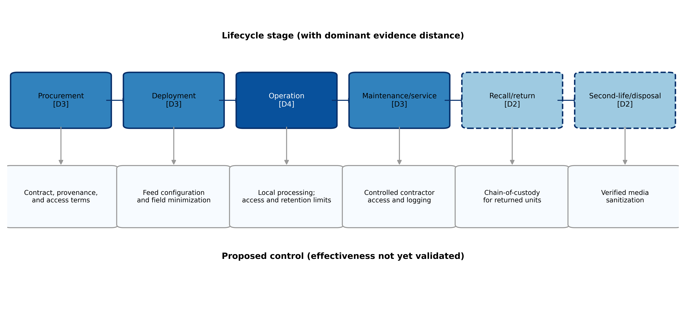
Figure 5. Lifecycle data-exposure model linking each stage to the evidence distance of its supporting sources and to a proposed, as-yet unvalidated control. Solid boxes denote stages with direct (D3-D4) evidence; dashed boxes denote stages supported only by near-domain (D2) evidence.
Table 5. Evidence-to-control traceability across the lifecycle model. Effectiveness evidence is stated conservatively; the proposed controls have not been empirically validated in this study.
Lifecycle stage | Exposure path | Supporting evidence (distance) | Proposed control | Effectiveness evidence
Procurement | Contract and provenance terms set who can access backend data | Governance guidance (N) (Boyens et al. 2022; European Data Protection Board 2021) | Provenance and access clauses; data-processing terms | Not validated; governance-based
Deployment | Feed configuration determines which fields are published | GBFS field presence (D4) (Elzer et al. 2025; MobilityData 2024) | Field minimization; coarse or delayed positions | Not validated; design-based
Operation | Identifiers, positions, and timestamps enable tracking and re-identification | Empirical audits (D4) (Elzer et al. 2025; Vinayaga-Sureshkanth et al. 2022); mobility re-identification (D2) (de Montjoye et al. 2013) | Local processing; access and retention limits | Partly supported by attack studies; controls not validated
Maintenance/service | Contractor access to devices and records | Forensic and platform studies (D3-D4) (Hilgert et al. 2021; Isik et al. 2023) | Controlled contractor access; audit logging | Not validated
Recall/return | Returned units retain stored data | IoT reuse study (D2) (Liu et al. 2023) | Chain-of-custody for returned units | Not validated; analogy-based
Second-life/disposal | Residual data on storage and batteries | Data remanence and battery side-channel (D2) (Basic et al. 2023; Joshi and Raval 2018; Marchiori et al. 2025); sanitization guidance (N) (Kissel et al. 2014) | Verified media sanitization before resale or recycling | Not validated; standards-based

4.1. Limitations
Several limitations bound these findings. Screening and coding were performed by a single reviewer with computer assistance; although the process is deterministic and reproducible, it does not provide inter-rater reliability, and some included studies were characterized from abstracts and curated metadata rather than from independently reproduced experiments. The GBFS audit observes only what is published in public feeds at a single point in time; it cannot show what operators collect or retain internally, and field presence is not a measure of harm. The disclosure audit reflects the public documents we could retrieve; not-found codings denote silence, two operators were unavailable, and the operator sample is weighted toward European and North American providers. Finally, the lifecycle controls are proposals; validating them would require intervention studies or operator cooperation that were outside this study's scope.

5. Conclusion
Shared micromobility offers a tractable, fully public setting in which to study lifecycle data exposure in connected devices that organizations use but do not control. A scoping review of 2,169 records identified 18 direct studies whose strongest evidence concerns the operation stage; a global audit of 1,428 public GBFS systems showed that persistent identifiers and precise positions are disclosed at high prevalence; and a disclosure audit showed that operators document operational processing thoroughly but are silent on device disposal and vulnerability reporting. These are disclosure and evidence signals, not demonstrations of harm. The lifecycle model and its traceability table turn them into an auditable agenda: extend assessment beyond real-time location, close the documentation gaps at end-of-life, and empirically validate the proposed controls.
Acknowledgements. The author thanks the maintainers of the public GBFS ecosystem and the open bibliographic sources that made this audit possible.
Data availability statement. The data and code that support the findings of this study are openly available in the project repository at https://github.com/bougtoir/discharged-secrets-scoping-review. This includes the frozen GBFS registry snapshot and its checksum, the title/abstract and full-text screening decisions, the disclosure-audit coding sheets with verbatim locator quotations, the analysis results, and the figure- and table-generation code. Raw vehicle identifiers, exact coordinates, and vehicle-specific deep links were not retained. Every count, proportion, and confidence interval reported in the article can be regenerated from these materials with a single build command.
Funding statement. This research received no specific grant from any funding agency, commercial or not-for-profit sectors.
Competing interests. The author declares none.
Author contributions. [Author name]: conceptualization; methodology; software; formal analysis; data curation; writing - original draft; writing - review and editing.
Ethical standards. The research meets all ethical guidelines, including adherence to the legal requirements of the study jurisdiction. No human participants were recruited. The study analysed only publicly accessible feeds and documents and did not attempt authentication, access-control circumvention, or interaction with individual users.
Use of generative AI. No generative AI tool was used to produce scientific content, analysis, or interpretation. Any use was limited to routine language editing and was reviewed by the author, who takes full responsibility for the text.

References
Arksey, H. and O'Malley, L. (2005) Scoping studies: towards a methodological framework. International Journal of Social Research Methodology 8(1), 19-32. https://doi.org/10.1080/1364557032000119616.
Basic, F., Gaertner, M. and Steger, C. (2023) Secure data acquisition for battery management systems. In 2023 26th Euromicro Conference on Digital System Design (DSD). IEEE. https://doi.org/10.1109/DSD60849.2023.00082.
Boyens, J., Smith, A., Bartol, N., Winkler, K., Holbrook, A. and Fallon, M. (2022) NIST Special Publication 800-161 Revision 1: Cybersecurity Supply Chain Risk Management Practices for Systems and Organizations. National Institute of Standards and Technology. https://doi.org/10.6028/NIST.SP.800-161r1.
Casagrande, M., Losiouk, E., Conti, M., Payer, M. and Antonioli, D. (2023) E-Spoofer: attacking and defending Xiaomi electric scooter ecosystem. In Proceedings of the 16th ACM Conference on Security and Privacy in Wireless and Mobile Networks (WiSec). ACM. https://doi.org/10.1145/3558482.3590176.
Casagrande, M., Losiouk, E., Conti, M., Payer, M. and Antonioli, D. (2024) E-Trojans: ransomware, tracking, DoS, and data leaks on battery-powered embedded systems. arXiv:2411.17184. https://doi.org/10.48550/arXiv.2411.17184.
de Montjoye, Y.-A., Hidalgo, C.A., Verleysen, M. and Blondel, V.D. (2013) Unique in the crowd: the privacy bounds of human mobility. Scientific Reports 3, 1376. https://doi.org/10.1038/srep01376.
Elzer, T., Ruben, M., Classen, J. and Hollick, M. (2025) They see me scooting: a long-term real-world data analysis of shared micro-mobility services. In 2025 IEEE 10th European Symposium on Security and Privacy (EuroS&P). IEEE. https://doi.org/10.1109/EuroSP63326.2025.00014.
European Data Protection Board (2021) Guidelines 01/2020 on processing personal data in the context of connected vehicles and mobility related applications, version 2.0.
European Parliament and Council (2016) Regulation (EU) 2016/679 (General Data Protection Regulation). Official Journal of the European Union L119, 1-88.
European Parliament and Council (2023) Regulation (EU) 2023/1542 concerning batteries and waste batteries. Official Journal of the European Union L191, 1-117.
Guyatt, G.H., Oxman, A.D., Kunz, R., Woodcock, J., Brozek, J., Helfand, M., et al. (2011) GRADE guidelines: 8. Rating the quality of evidence - indirectness. Journal of Clinical Epidemiology 64(12), 1303-1310. https://doi.org/10.1016/j.jclinepi.2011.04.014.
Hannemann, A., Buchholz, E. and Ziegler, D. (2023) Is homomorphic encryption feasible for smart mobility? In Annals of Computer Science and Information Systems, vol. 35 (FedCSIS). https://doi.org/10.15439/2023F695.
Hilgert, J.-N., Lambertz, M., Rybalka, M., Schell, R. and Vogt, R. (2021) A forensic analysis of micromobility solutions. Forensic Science International: Digital Investigation 38, 301137. https://doi.org/10.1016/j.fsidi.2021.301137.
Isik, A.B., Dag, T. and Ozkan, K. (2023) E-scooter sharing platforms: understanding their architecture and cybersecurity threats. In 2023 IEEE 26th International Conference on Intelligent Transportation Systems (ITSC). IEEE. https://doi.org/10.1109/ITSC57777.2023.10421849.
Joshi, A. and Raval, M.S. (2018) Standards and techniques to remove data remanence in cloud storage. In 2018 IEEE Punecon. IEEE. https://doi.org/10.1109/PUNECON.2018.8745370.
Kissel, R., Regenscheid, A., Scholl, M. and Stine, K. (2014) NIST Special Publication 800-88 Revision 1: Guidelines for Media Sanitization. National Institute of Standards and Technology. https://doi.org/10.6028/NIST.SP.800-88r1.
Li, Y. and Zhang, X. (2020) Linking privacy concerns for traceable information and information privacy protective responses. In Proceedings of the 53rd Hawaii International Conference on System Sciences (HICSS). https://doi.org/10.24251/HICSS.2020.105.
Liu, Y., Zhou, Z., Zhang, J., et al. (2023) How IoT re-using threatens your sensitive data: exploring the user-data disposal in used IoT devices. In 2023 IEEE Symposium on Security and Privacy (SP). IEEE. https://doi.org/10.1109/SP46215.2023.10179294.
Marchiori, A., Losiouk, E., Conti, M. and Antonioli, D. (2025) Leaky batteries: a novel set of side-channel attacks on electric vehicles. In Computer Security - ESORICS 2025, Lecture Notes in Computer Science. Springer. https://doi.org/10.1007/978-3-032-00624-0_16.
MobilityData (2024) General Bikeshare Feed Specification (GBFS), version 3.0. Available at https://gbfs.org/ (accessed 12 July 2026).
MobilityData (2026) GBFS systems catalogue (systems.csv). Available at https://github.com/MobilityData/gbfs (accessed 8 July 2026).
Open Mobility Foundation (2021) MDS privacy guide for cities. Available at https://www.openmobilityfoundation.org/ (accessed 12 July 2026).
Petersen, M.L. (2019) Scoot over smart devices: the invisible costs of rental scooters. Surveillance & Society 17(1/2), 267-273. https://doi.org/10.24908/ss.v17i1/2.13112.
Sato, K., Fukushima, N., Fujii, K. and Kitani, T. (2025) Data acquisition framework for micromobility vehicles toward driving risk prediction. IEEE Security & Privacy 23(1). https://doi.org/10.1109/MSEC.2024.3441731.
Tricco, A.C., Lillie, E., Zarin, W., O'Brien, K.K., Colquhoun, H., Levac, D., et al. (2018) PRISMA Extension for Scoping Reviews (PRISMA-ScR): checklist and explanation. Annals of Internal Medicine 169(7), 467-473. https://doi.org/10.7326/M18-0850.
Vinayaga-Sureshkanth, N., Maiti, A., Jadliwala, M., Crager, K., He, J. and Rathore, H. (2020) Security and privacy challenges in upcoming intelligent urban micromobility transportation systems. In Proceedings of the Second ACM Workshop on Automotive and Aerial Vehicle Security (AutoSec). ACM. https://doi.org/10.1145/3375706.3380559.
Vinayaga-Sureshkanth, N., Maiti, A., Jadliwala, M., Crager, K., He, J. and Rathore, H. (2022) An investigative study on the privacy implications of mobile e-scooter rental apps. In Proceedings of the 15th ACM Conference on Security and Privacy in Wireless and Mobile Networks (WiSec). ACM. https://doi.org/10.1145/3507657.3528551.
Yilmaz, S. and Karsligil, M.E. (2022) Analysis of location spoofing threats on e-scooter sharing. In 2022 30th Signal Processing and Communications Applications Conference (SIU). IEEE. https://doi.org/10.1109/SIU55565.2022.9864946.
Yilmaz, S. and Karsligil, M.E. (2023) Geo-location spoofing on e-scooters: threat analysis and prevention framework. Balkan Journal of Electrical and Computer Engineering 11(2). https://doi.org/10.17694/bajece.1231384.
Zhou, Y. (2024) Data extraction in dockless bikeshare: an analysis from users' perspective. Big Data & Society 11(4). https://doi.org/10.1177/20539517241299724.

