Pairwise sharing of Neanderthal and Denisovan introgression across global populations: An exploratory geographic analysis
Research Article
Tatsuki Onishi
Data Science and AI Innovation Research Promotion Center, Shiga University of Medical Science, Otsu, Japan
Tatsuki Onishi, Data Science and AI Innovation Research Promotion Center, Shiga University of Medical Science, Seta Tsukinowa-cho, Otsu, Shiga 520-2192, Japan; Email: bougtoir@gmail.com
Running title: Geography of archaic DNA sharing

Abstract
Archaic introgression is usually summarized as ancestry proportion within individuals or populations. We evaluated whether pairwise similarity in the genomic distribution of Neanderthal- and Denisovan-like segments provides an additional, explicitly geographic description of population relationships. High-confidence hmmix calls from 3,134 individuals in 66 populations were summarized in 500-kb windows, producing 2,145 unique population pairs. Sharing was quantified as the Pearson correlation between population-level window-frequency vectors and modeled against geographic distance, maximum European-admixture fraction, and same-continent status. Matrix-level association was assessed with Mantel permutation tests in non-admixed populations. Neanderthal and Denisovan sharing declined with distance (raw r=-0.485 and -0.466; partial r=-0.311 and -0.300). Corrected models explained 51.0% and 49.5% of pairwise variation, respectively. Non-admixed Mantel correlations were -0.616 and -0.581 (both permutation p=0.0001). No positive-residual population pair survived false-discovery-rate correction at q<0.10. Exploratory analysis of a 500-kb interval centered on ABO identified two Neanderthal-like segments among 41 Indigenous American HGDP individuals; both were closest to Vindija among three reference genomes, but only one overlapped the ABO gene. These observations do not demonstrate a migration route. Pairwise archaic sharing captures broad geographic structure, while specific residual and locus-level patterns remain hypothesis-generating and require independent modern and ancient genomic validation.
Keywords: archaic introgression; Neanderthal; Denisovan; population genetics; geographic distance; ABO; human migration

Introduction
Genomic comparisons established that present-day non-African populations carry ancestry inherited from Neanderthals and that several Asian and Oceanian populations also carry ancestry related to Denisovans.^{1,2} Subsequent maps of introgressed sequence showed that the amount and genomic distribution of archaic ancestry vary among populations, reflecting demographic history, drift, selection, and multiple episodes of gene flow.³⁻⁵ These features make archaic segments potentially informative about population relationships, but they also create substantial scope for confounding.
The present study was motivated by the long-recognized high frequency of blood group O in Indigenous American populations. ABO is an unusually persistent polymorphic system with trans-species and population-specific histories.^{6,7} Ancient-DNA work has tested founder-effect explanations for Native American ABO frequencies, and archaic genomes contain distinguishable ABO allelic backgrounds.^{8,9} We therefore began with ABO as a focused, biologically interpretable locus and then asked whether any locus-level observation was accompanied by a broader genome-wide geographic pattern.
Quilodran and colleagues modeled the spatial distribution of Neanderthal ancestry and demonstrated that past range expansions can generate broad geographic gradients.¹⁰ Our framework differs in four respects. First, it jointly describes Neanderthal and Denisovan sharing rather than a single ancestry proportion. Second, the unit of analysis is a population pair and its correlation across genomic windows. Third, residuals are examined only after explicit adjustment for designated recent admixture and continental grouping. Fourth, Wallace Line and Lydekker Line interpretations are treated as geographic visualizations of a bivariate signal, not as direct tests of a particular migration event.
We hypothesized that pairwise similarity in the genomic distribution of archaic segments would decline with geographic distance and that the combined Neanderthal-Denisovan pattern would differentiate continental and Oceanian population structure. The objectives were to quantify this decay, assess robustness to designated recent admixture, test matrix-level association, identify any statistically supported positive-residual pairs, and place a reproducible ABO-centered analysis within the genome-wide context. All locus-level and residual analyses were prespecified as exploratory and hypothesis-generating.

Materials and Methods

Data sources and study populations
We analyzed publicly available archaic-introgression segments generated with hmmix, a method designed to detect archaic sequence without requiring an unadmixed modern outgroup.¹¹ Segment files for the 1000 Genomes Project and Human Genome Diversity Project (HGDP) were obtained from Zenodo record 14136628. The files include similarity counts to Altai, Vindija, Denisova, and Chagyrskaya references; the Vindija reference derives from a high-coverage Neanderthal genome.¹² Population metadata followed the source 1000 Genomes and HGDP resources.^{13,14}
Segments with mean posterior probability below 0.8 were excluded. Populations with fewer than seven represented individuals were excluded from the genome-wide analysis, leaving 3,134 individuals in 66 populations. Calls were retained as Neanderthal, Denisovan, or Both according to the source annotation. The analysis used de-identified public data and involved no new recruitment, sampling, or individual-level phenotype inference.

Genome-wide population vectors and pairwise sharing
The autosomal genome was partitioned into 500-kb windows. For each population and archaic category, overlapping high-confidence calls were converted to a diploid-normalized frequency vector by dividing the number of called haplotypes by twice the number of individuals. Pairwise sharing was the Pearson correlation between two population vectors. Separate 66 by 66 Neanderthal and Denisovan matrices yielded 2,145 unique off-diagonal population pairs for each ancestry type.
Population coordinates were assigned from sampling-location metadata or population centroids used in the original analysis scripts. Great-circle distance was computed with the Haversine formula. Correlation coefficients summarize similarity in the spatial distribution of called windows; they do not establish identity by descent.

Confounding correction and sensitivity analysis
For population pair i,j, sharing was modeled as a linear function of geographic distance, the maximum designated European-admixture fraction of the two populations, and an indicator that both populations belonged to the same continental group. Designated fractions were Puerto Rican (PUR) 0.64, Colombian in Medellín (CLM) 0.57, Mexican ancestry in Los Angeles (MXL) 0.48, Peruvian in Lima (PEL) 0.16, African Caribbean in Barbados (ACB) 0.04, and African ancestry in the southwestern United States (ASW) 0.20. These values are operational sensitivity metadata, not individual ancestry estimates.
We report uncorrected and corrected coefficients of determination, raw correlations, and partial correlations obtained by residualizing distance and sharing against the admixture and same-continent covariates. Because pairwise rows share populations, conventional row-level p values do not represent independent observations and are not used as primary evidence. Sensitivity analyses excluded all pairs involving a designated admixed population.

Residual outliers and matrix-level testing
Positive corrected residuals were standardized within ancestry type. Pairs with z>2.0 were evaluated with permutation-derived nominal p values, bootstrap confidence intervals, and Benjamini-Hochberg false discovery rate (FDR) correction.¹⁵ The prespecified reporting threshold was q<0.10. Results from admixed pairs were retained for diagnostic comparison but were not interpreted as evidence for ancient migration.
Matrix-level association between geographic distance and sharing was tested in non-admixed populations using a Mantel permutation test with 9,999 population-label permutations.¹⁶ The permutation acts on population labels and therefore preserves the dependence structure of symmetric distance and sharing matrices.

ABO-centered exploratory analysis
The ABO gene was defined on GRCh38 as chr9:133,233,278-133,276,024. We analyzed both strict gene overlap and a 500-kb interval (chr9:133.0-133.5 Mb). The same mean-probability threshold of 0.8 was applied. Population carrier frequencies used unique individuals as the numerator and all represented individuals as the denominator.
For each Neanderthal or Both segment in the 500-kb interval, Altai, Vindija, and Chagyrskaya similarity counts were compared. A unique maximum defined the closest reference; equal maxima were retained as ties rather than assigned arbitrarily. Indigenous American HGDP populations were Pima, Maya, and Colombian; PEL, MXL, CLM, and PUR were analyzed separately as admixed American populations.
The O2-defining variant was rs41302905, evaluated on the GRCh38 reference orientation as the T allele. Population frequencies were retrieved from Ensembl Variation for 1000 Genomes Phase 3 and compared descriptively with published New Georgia, Solomon Islands ABO*O02 frequencies.¹⁷ This comparison does not establish that the modern allele was inherited from a specific archaic lineage.

Ancient-genome comparison and software
Ancient ABO-window observations were secondarily extracted from public outputs associated with the Neanderthal-ancestry-through-time study. The resulting individual-level summary was used only for a descriptive visualization because ancient and modern calls were produced by different pipelines and coverage regimes. No formal temporal trend test was performed.
Analyses were conducted in Python using pandas, NumPy, SciPy, statsmodels, Matplotlib, and seaborn. Document outputs used python-docx, python-pptx, and Pillow. Exact package versions are recorded by the execution environment when the package is rebuilt.

Results

Genome-wide distance decay
Across 2,145 population pairs, Neanderthal sharing correlated negatively with distance (raw r=-0.4847), as did Denisovan sharing (raw r=-0.4656). After residualization against designated European-admixture fraction and same-continent status, the corresponding partial correlations were -0.3105 and -0.3001. The corrected models explained 51.00% of Neanderthal and 49.53% of Denisovan pairwise variation, compared with 23.50% and 21.67% in distance-only models (Figure 1; Table 1).
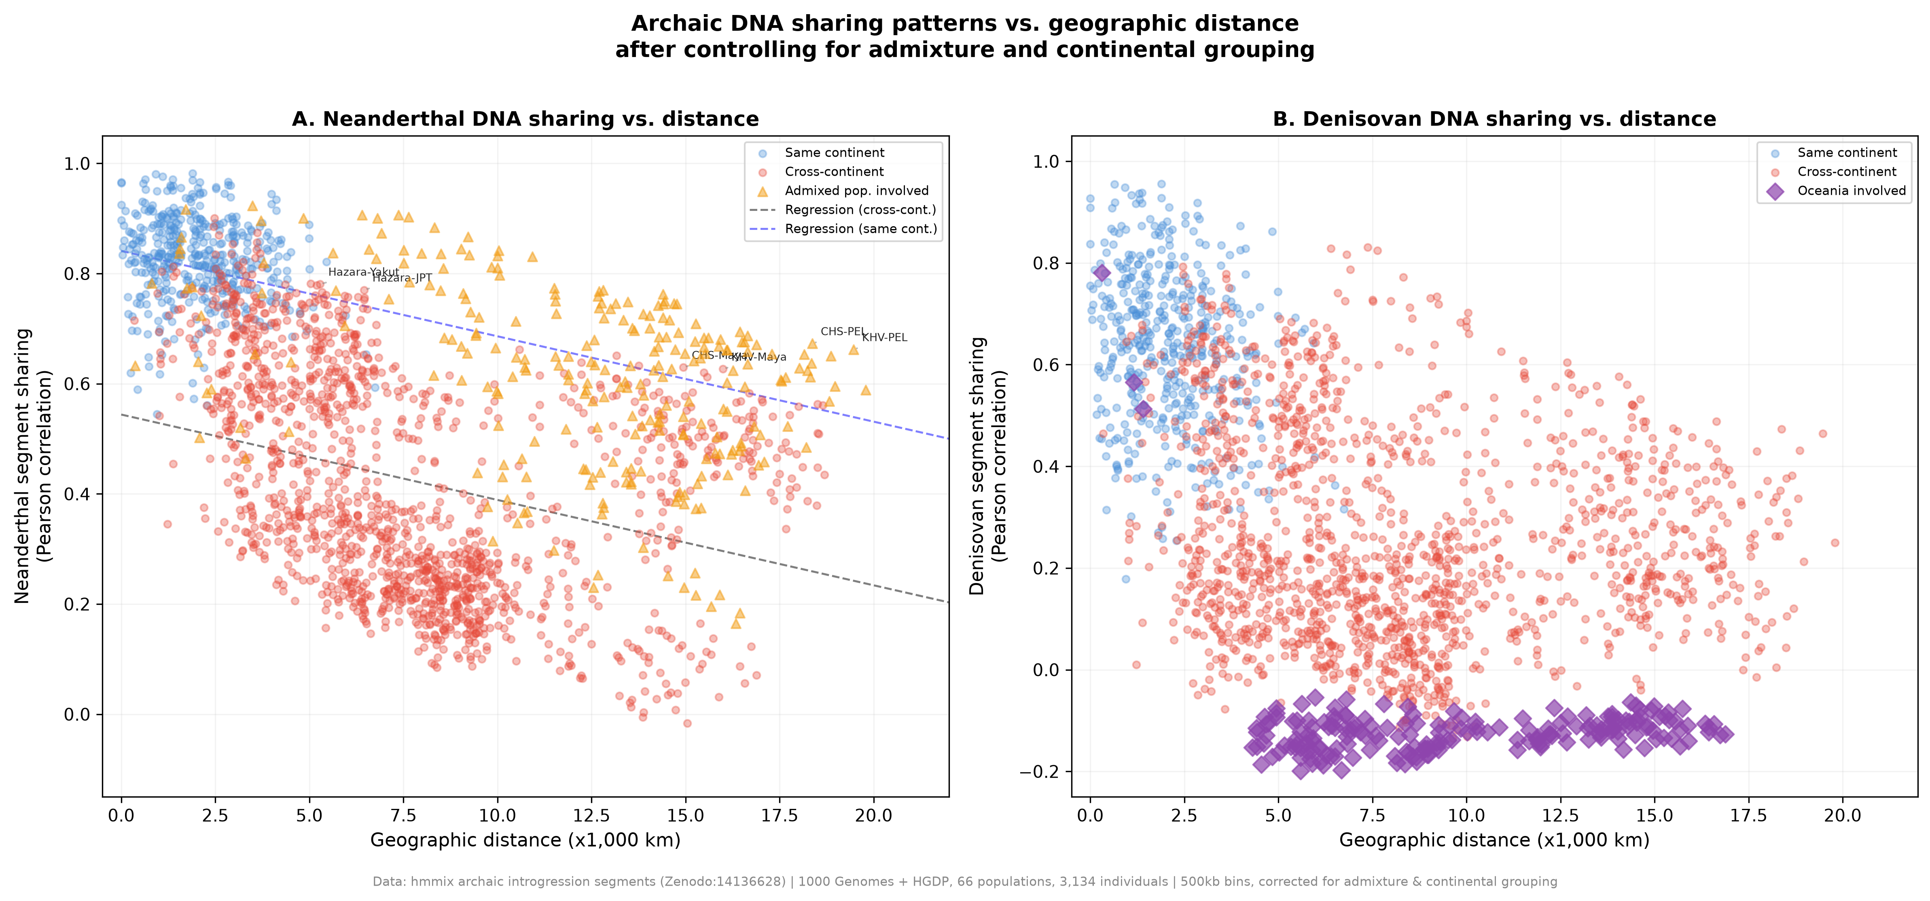
Figure 1. Archaic-segment sharing and geographic distance. Each point is a population pair. Lines summarize distance associations for Neanderthal and Denisovan sharing. Source identifiers in selected labels include CHS (Southern Han Chinese), FIN (Finnish), and PEL (Peruvian in Lima). Pairwise rows are dependent and are not interpreted as independent observations.
Table 1. Corrected geographic-distance models and matrix-level tests
Metric | Neanderthal | Denisovan | Interpretation
Populations / unique pairs | 66 / 2,145 | 66 / 2,145 | Same pair set
Raw sharing-distance r | -0.4847 | -0.4656 | Pairwise descriptive correlation
Partial r | -0.3105 | -0.3001 | Controls maximum admixture and same continent
Distance-only R² | 0.2350 | 0.2167 | Uncorrected model
Corrected R² | 0.5100 | 0.4953 | Distance plus two confounders
Non-admixed Mantel r | -0.6157 | -0.5809 | 9,999 label permutations
Mantel p | 0.0001 | 0.0001 | Matrix-level inference
FDR q<0.10 positive outliers | 0 | 0 | Non-admixed pairs
Note. Partial correlations use pairwise rows and should not be interpreted as independent-sample inference. Mantel tests used non-admixed population matrices.

Population structure in sharing matrices
Heat maps of 31 geographically representative populations showed broad within-region blocks in both matrices, with a sharper Oceanian contrast for Denisovan sharing (Figure 2). The display is a selected subset for legibility; all 66 populations contributed to the statistical analysis.
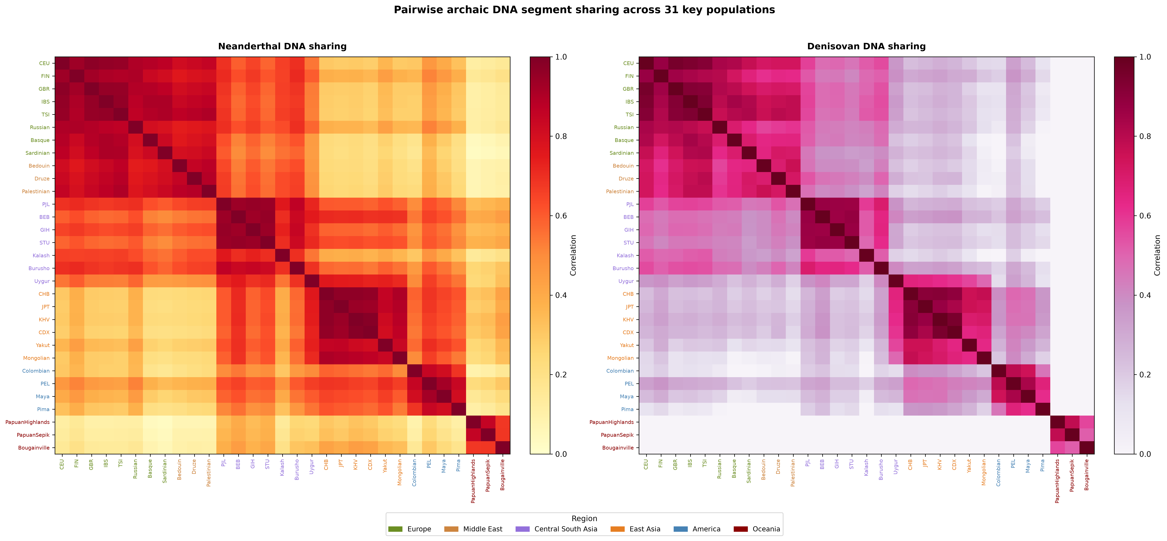
Figure 2. Pairwise sharing heat maps for 31 representative populations. Axis labels are source population identifiers. The displayed subset improves legibility; regression and Mantel analyses used all 66 populations.

Geographic interpretation
A schematic places the sharing analysis within established broad dispersal and archaic-admixture contexts (Figure 3). It intentionally does not encode estimated migration magnitudes. The bivariate signal is consistent with a strong change in Denisovan-related ancestry across island Southeast Asia toward Sahul. Wallace Line and Lydekker Line terminology is used as biogeographic context, not as a claim that the present analysis dates or uniquely identifies a crossing event.
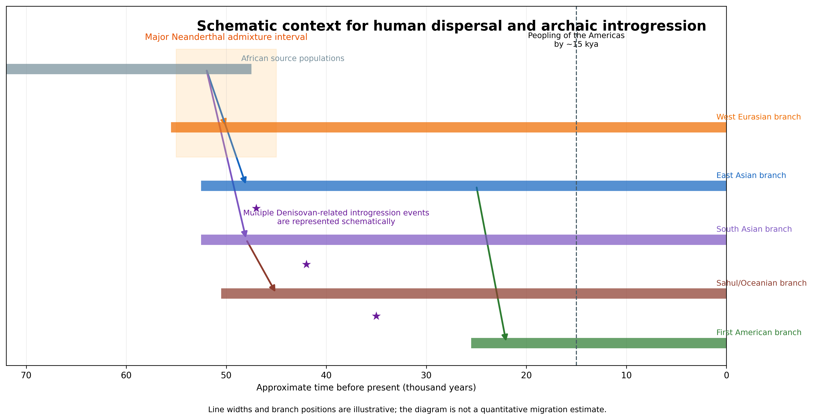
Figure 3. Schematic context for human dispersal and archaic introgression. Line widths and branch positions are illustrative and do not estimate migration magnitude, ancestry proportion, or event timing beyond the labeled broad intervals.

Sensitivity to designated recent admixture
Excluding every pair involving PUR, CLM, MXL, PEL, ACB, or ASW strengthened the raw Neanderthal distance correlation from approximately -0.485 to -0.615 (Figure 4). Several high positive residuals in the full analysis involved admixed American populations, including PEL. These patterns are compatible with recent ancestry mixtures and were not used as independent support for a Beringian migration interpretation.
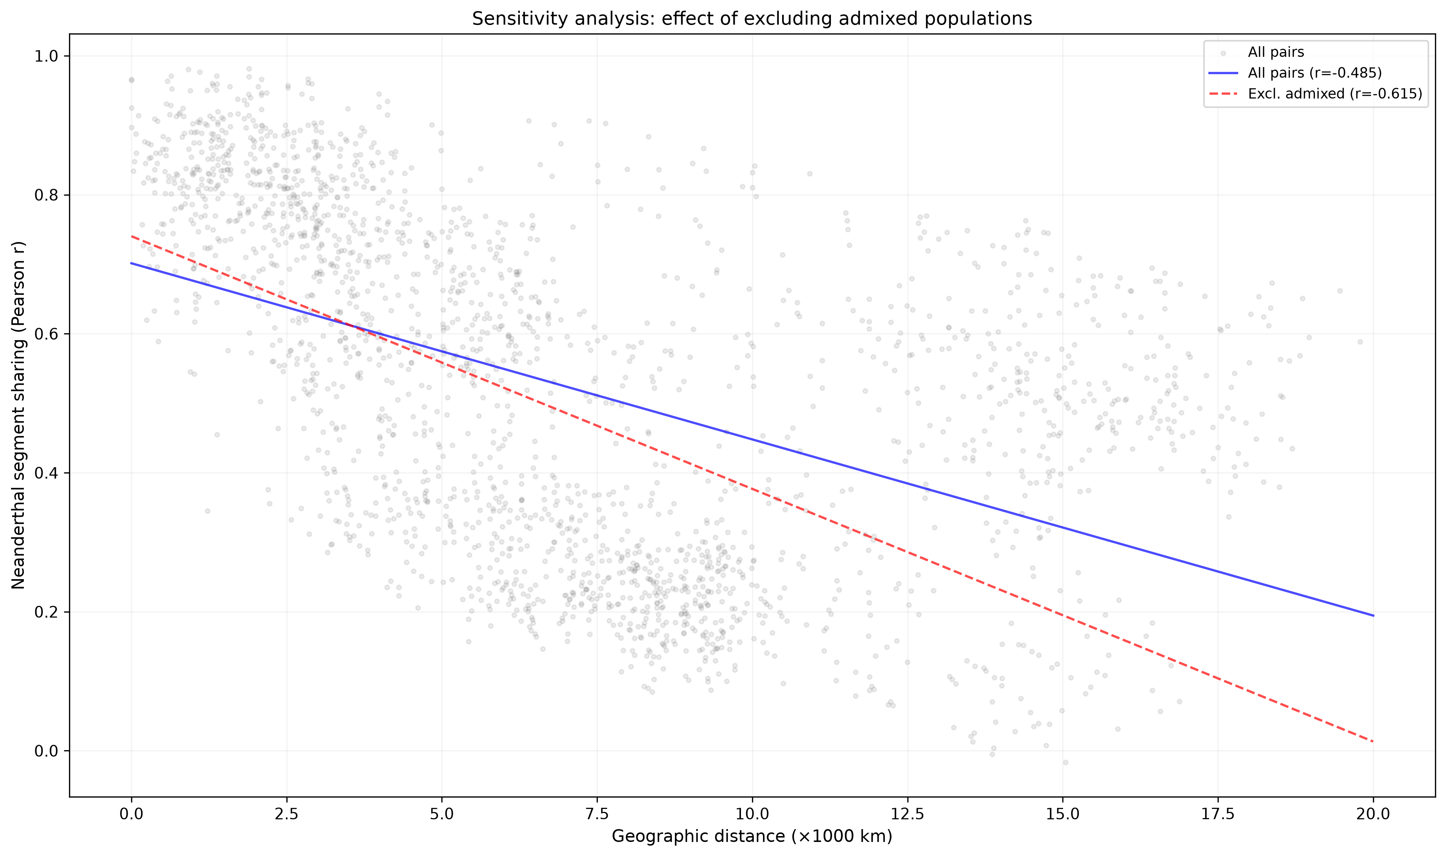
Figure 4. Sensitivity of Neanderthal sharing-distance correlation to exclusion of designated admixed populations. Correlations describe pairwise rows and are accompanied by matrix-level tests in the main analysis.

Residual outlier testing
Among non-admixed pairs, the Mantel correlation was -0.6157 for Neanderthal sharing and -0.5809 for Denisovan sharing; both permutation p values were 0.0001. No positive-residual pair survived false-discovery-rate correction at q<0.10 for either ancestry type. Nominal residual rankings are therefore reported only as exploratory diagnostics rather than statistically supported outliers.

ABO-window segment composition
The reproducible 500-kb ABO-centered scan identified 834 Neanderthal or Both segments, of which 129 overlapped the gene itself. Closest-reference composition varied by broad group, but 335 of 834 segments had tied maximum similarity and were not forced to a lineage. In the Indigenous American HGDP subset, two segments were observed among 41 individuals: one in Pima overlapped ABO and one in Maya lay downstream within the 500-kb interval. Both were Vindija-closest, but n=2 cannot support a regional proportion or ancestry-route conclusion (Figure 5; Table 2).
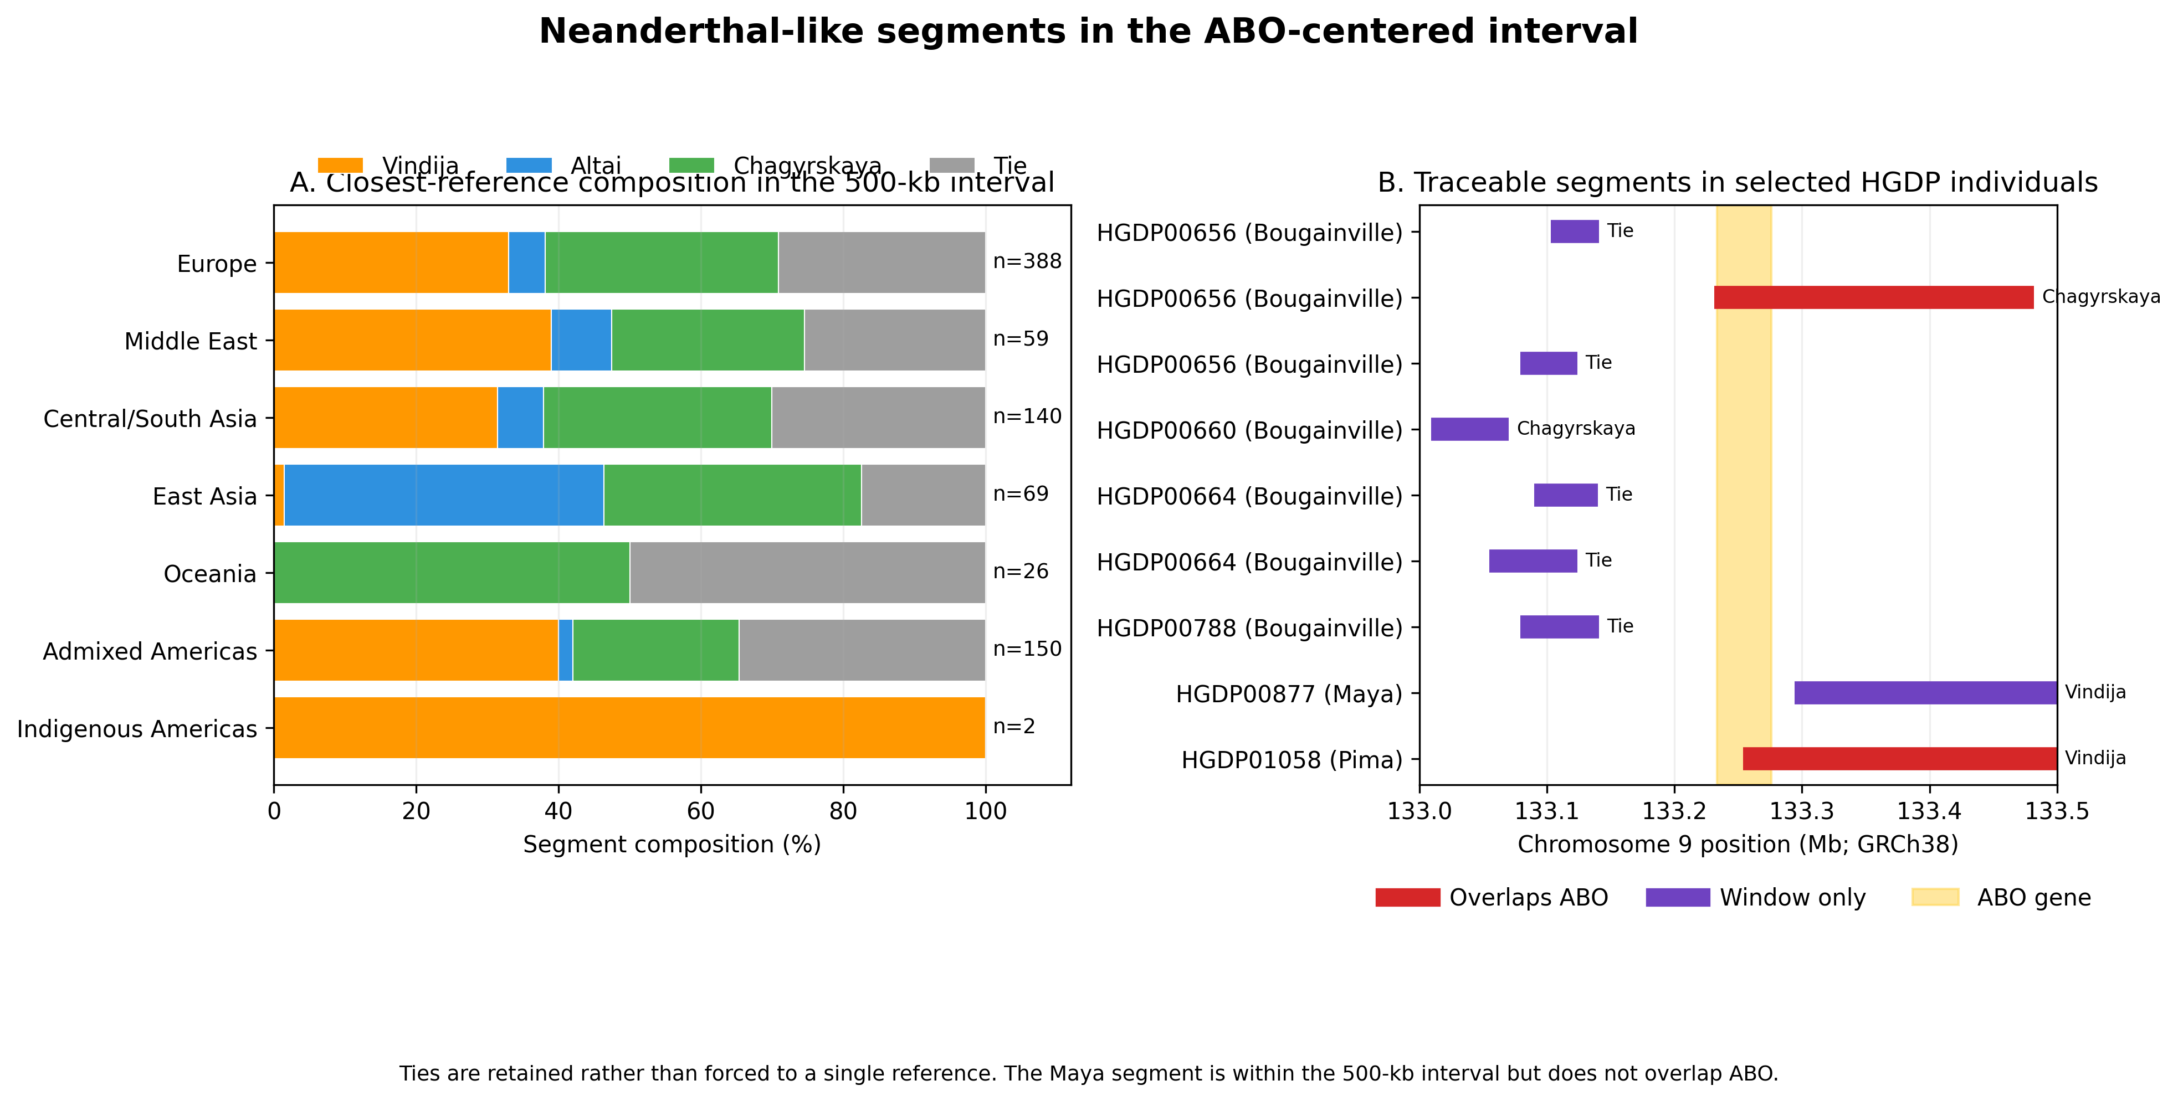
Figure 5. Neanderthal-like segments in the 500-kb ABO-centered interval. (A) Closest-reference composition retains tied maxima. n denotes segments, not individuals. (B) Traceable segments for selected HGDP individuals. The Pima and one Bougainville segment overlap ABO; the Maya segment is within the interval but downstream of the gene.
Table 2. Descriptive Neanderthal-reference composition in the 500-kb ABO-centered interval
Group | Segments | Vindija % | Altai % | Chagyrskaya % | Tie % | Strict ABO overlap
Europe | 388 | 33.0 | 5.2 | 32.7 | 29.1 | 56
Middle East | 59 | 39.0 | 8.5 | 27.1 | 25.4 | 8
Central/South Asia | 140 | 31.4 | 6.4 | 32.1 | 30.0 | 31
East Asia | 69 | 1.4 | 44.9 | 36.2 | 17.4 | 12
Oceania | 26 | 0.0 | 0.0 | 50.0 | 50.0 | 1
Admixed Americas | 150 | 40.0 | 2.0 | 23.3 | 34.7 | 20
Indigenous Americas | 2 | 100.0 | 0.0 | 0.0 | 0.0 | 1
Note. Counts are segments, not individuals. Equal maximum similarity counts are reported as ties. The Indigenous American row contains two segments, only one of which overlaps ABO.

O2 allele and introgression-window frequencies
The O2-defining rs41302905 T allele had published frequencies of 5.1%, 16.3%, and 14.1% in Munda, Paradise, and Rawaki, respectively, whereas selected 1000 Genomes frequencies were lower and concentrated mainly in European and admixed American populations.¹⁷ In contrast, carrier frequencies for any Neanderthal-like segment in the 500-kb ABO interval were 7/8 in Papuan Sepik and 7/9 in Papuan Highlands, despite no strict ABO overlap in either population. The two panels therefore summarize different biological quantities and should not be interpreted as a locus-level association (Figure 6).
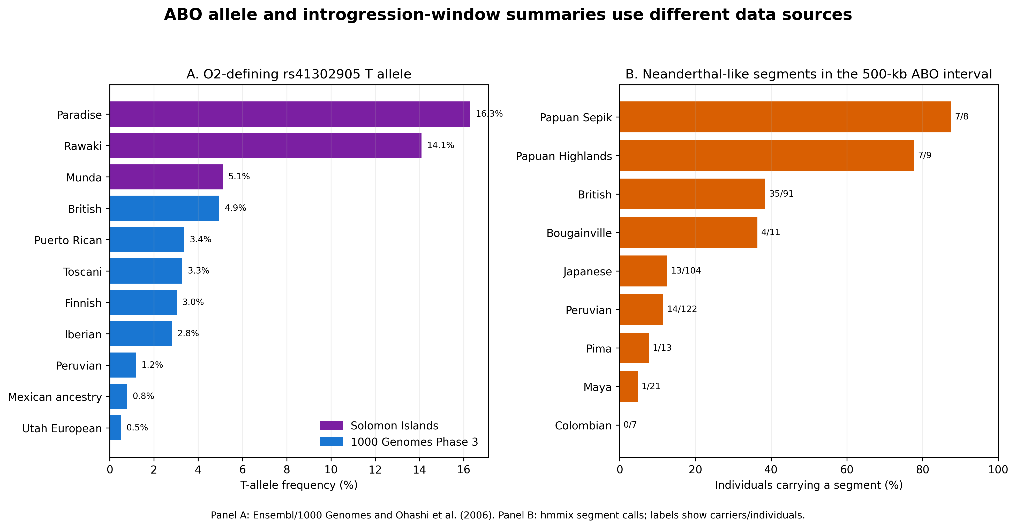
Figure 6. Distinct summaries of the O2-defining allele and ABO-window introgression. (A) rs41302905 T-allele frequencies from Ensembl/1000 Genomes and Ohashi et al. (2006). (B) Frequency of individuals carrying any Neanderthal-like segment in chr9:133.0-133.5 Mb. The panels use different sources and are not an association analysis.

ANE hypothesis and ancient comparison
Ancient North Eurasian (ANE) ancestry contributes to published models of First American ancestry.¹⁸ Figure 7 shows how an ANE-mediated pathway could generate a testable hypothesis for the two modern Indigenous American ABO-window segments, while explicitly separating the hypothesis from evidence. A descriptive extraction from ancient-genome outputs showed heterogeneous reference matches and several individuals with no recorded interval segment. Because those calls and modern hmmix calls were generated differently, Figure 8 presents no temporal test or turnover estimate.¹⁹
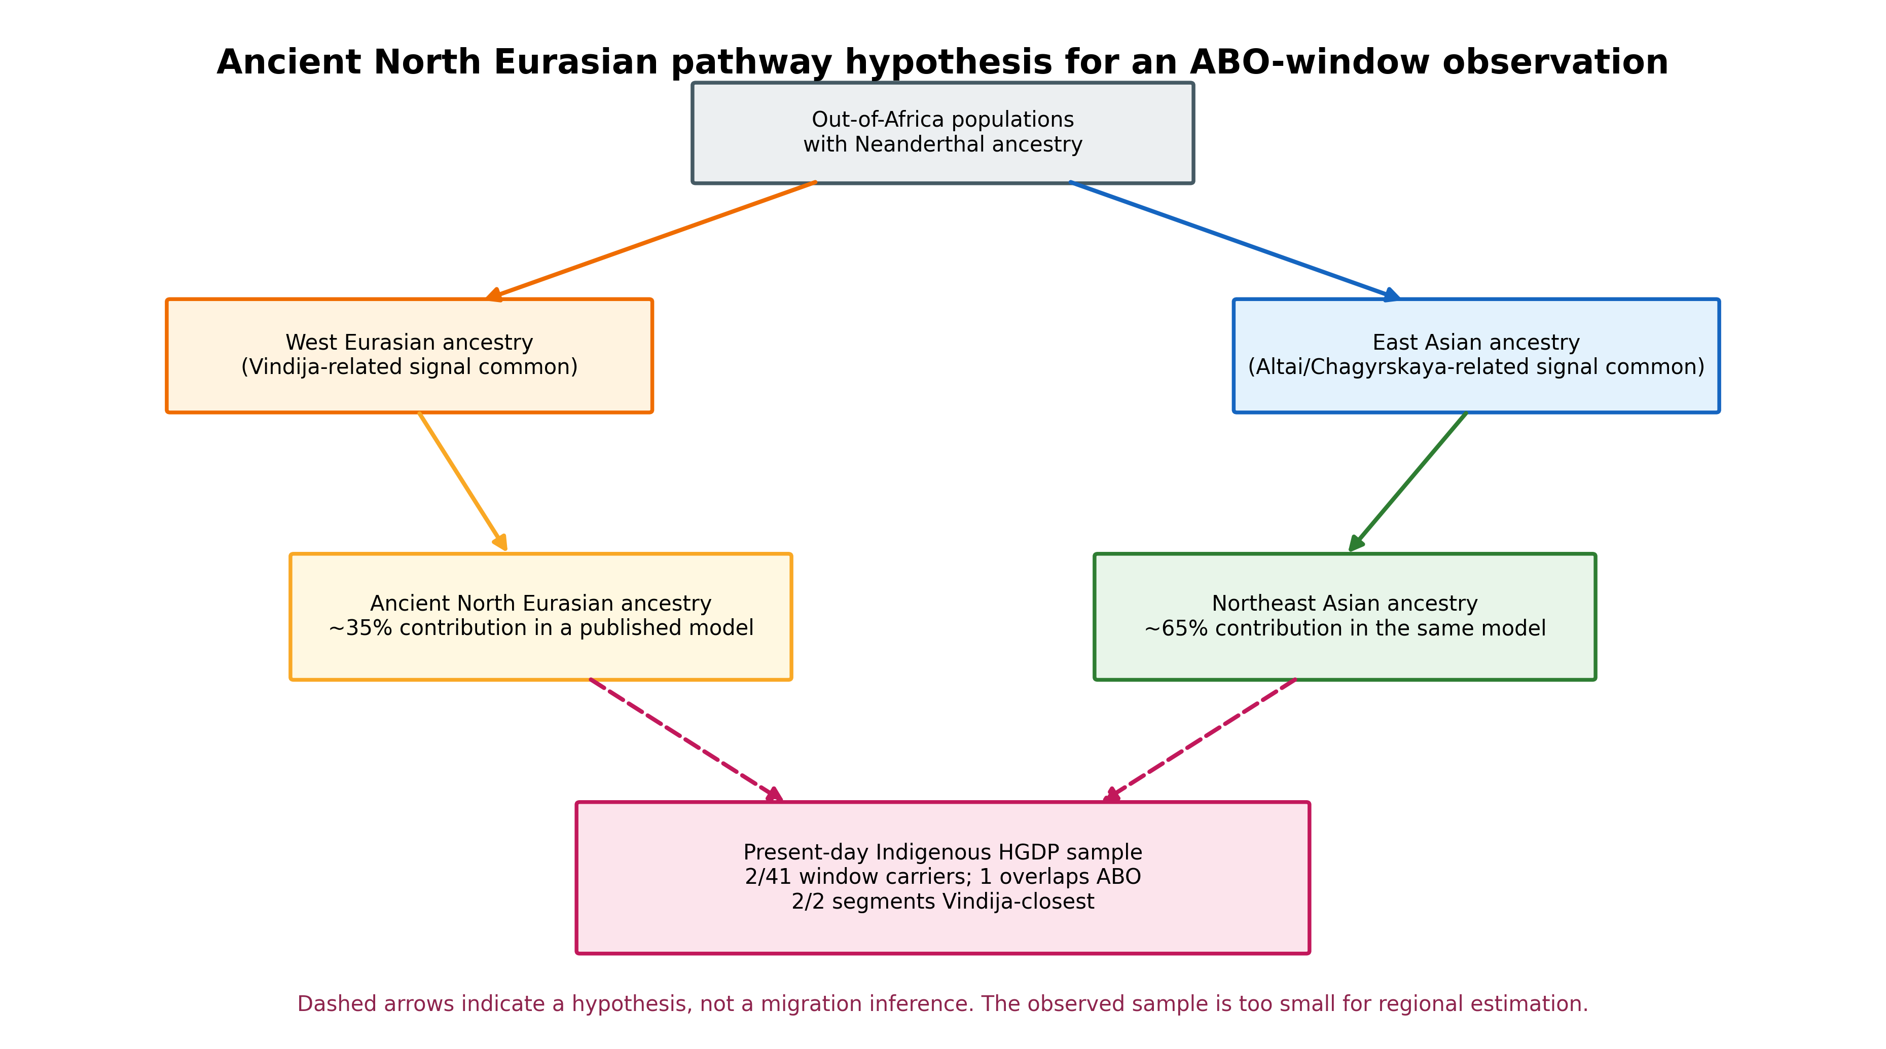
Figure 7. Ancient North Eurasian pathway hypothesis. Dashed arrows connect a published broad ancestry model to the modern ABO-window observation. The diagram is hypothesis-generating and does not infer that either segment followed a particular route.
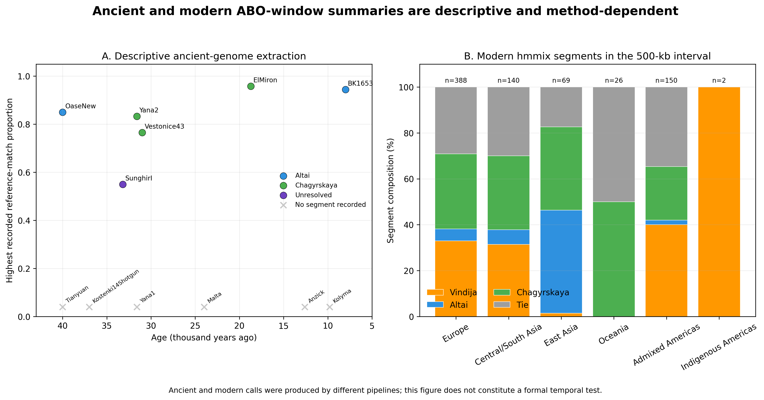
Figure 8. Descriptive ancient and modern ABO-window summaries. Ancient observations were secondarily extracted from public outputs associated with Iasi et al. (2024); modern calls use hmmix. Different pipelines and coverage preclude a formal temporal comparison.

Bivariate global summary
A literature-derived bivariate map summarizes the complementary geographic distributions of Neanderthal- and Denisovan-related ancestry (Figure 9).²⁻⁵ Neanderthal ancestry is broadly distributed outside Africa, whereas high Denisovan ancestry is concentrated in Oceania and some island Southeast Asian groups. The map is contextual and is not used in the regression or residual tests.
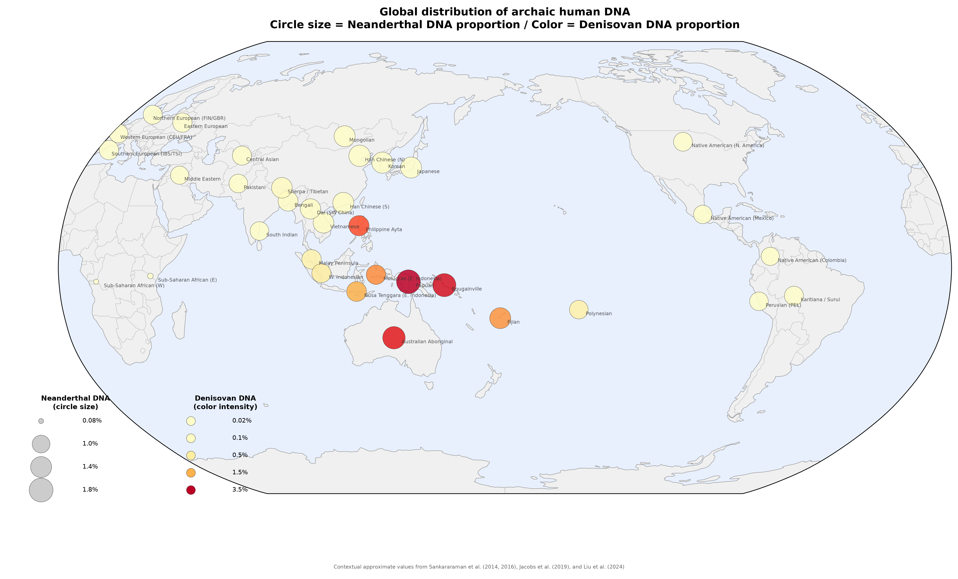
Figure 9. Literature-derived bivariate global context. Circle size represents approximate Neanderthal ancestry and color intensity represents approximate Denisovan ancestry. Source identifiers shown in parentheses are FIN (Finnish), GBR (British), CEU (Utah residents with Northern and Western European ancestry), FRA (French), IBS (Iberian), and TSI (Toscani). Values are contextual approximations from published studies and were not used in the pairwise statistical models.

Discussion
Pairwise correlations across genomic windows captured broad geographic structure in both Neanderthal and Denisovan calls. Adjustment for designated recent admixture and continental grouping increased explained variance, indicating that uncorrected distance decay combines multiple demographic processes. Matrix-level Mantel tests supported a robust negative geographic association, but the absence of false-discovery-rate-significant residual outliers is equally important: the present data support broad structure, not specific exceptional population connections.
The distinction from the framework of Quilodran et al.¹⁰ is structural rather than competitive. Their spatial models ask how expansions shape Neanderthal ancestry across populations. Our bivariate approach asks whether two populations distribute archaic calls similarly across windows and whether this pairwise similarity changes with distance. Joint Neanderthal and Denisovan views can distinguish populations with superficially similar total archaic burdens, but correlation also discards absolute ancestry levels and can be sensitive to sparse windows.
The Denisovan matrix and global map reproduce the qualitative contrast between continental Asia and Oceania. Wallace and Lydekker lines are useful labels for discussing this transition, but neither line is itself a statistical covariate in the current models. Denser island sampling and explicit spatial models would be required to localize a discontinuity or attribute it to a specific pulse of settlement or introgression.
The ABO analysis illustrates both the appeal and danger of a focal locus. ABO has deep allelic history and plausible immune-related selection, while long-term selection can reshape the retention of Neanderthal sequence.^{6,20} However, a 500-kb carrier call is not equivalent to an ABO allele, and the O2-defining variant cannot be labeled Neanderthal-derived solely because similar ABO backgrounds occur in an archaic genome. Recombination, linkage disequilibrium, reference similarity, and independent persistence of ancestral variation all complicate interpretation.
The two Vindija-closest Indigenous American window segments are particularly underpowered. Only the Pima segment overlaps the gene; the Maya segment does not. Two segments among 41 sampled individuals do not justify a 100% regional estimate, and similarity to a reference genome is not proof that the segment traveled through ANE or Beringia. Published ANE and Population Y models provide testable demographic contexts, not confirmation of this locus-level route.^{18,21}
Post-Columbian admixture is a major concern for American population pairs. The sensitivity analysis showed that removal of designated admixed populations strengthened distance decay, and PEL-containing residuals were prominent in diagnostic rankings. Such pairs may be informative about recent mixture or reference-panel composition, but they should not be treated as decisive evidence for ancient trans-Beringian continuity.
Several statistical limitations remain. Population pairs are not independent because each population appears in many rows; accordingly, partial-correlation p values from row-level calculations would be anticonservative if interpreted as independent-sample tests. The Mantel procedure addresses matrix dependence for the global distance association but does not solve every inferential issue. Window correlations also ignore linkage disequilibrium, variable callability, segment age, and whether similarities are identity by descent or identity by state. Population-level ecological associations cannot be transferred to individuals.
Power is constrained by modest population sample sizes, sparse Denisovan calls outside Oceania, and multiple testing across 2,145 pairs. The absence of significant outliers may reflect both genuinely smooth structure and limited power, but it cannot be converted into evidence for a nominated pair. Independent validation should use larger modern panels, ancient genomes from Beringia and island Southeast Asia, haplotype phylogenies, independent genetic-distance covariates, and spatial mixed models.
The framework yields concrete predictions. If the ABO-window observation is linked to ANE ancestry, homologous haplotypes should occur in independently sequenced ANE-related and Beringian genomes with a coherent local genealogy. If the Oceanian discontinuity reflects multiple Denisovan ancestries, haplotype-resolved calls should change across island transects rather than only in total proportion. Northeast Asian and Japanese datasets can test whether the low-Denisovan, high-Neanderthal bivariate position is stable across methods and sampling schemes.^{22,23} ABO and O2 predictions should be tested directly with phased alleles, not inferred from nearby segment calls.
In conclusion, pairwise archaic-segment sharing is a useful descriptive complement to ancestry proportions and recovers a reproducible geographic distance-decay signal. The corrected analysis does not identify any non-admixed pair as a statistically supported positive outlier, and the ABO-centered findings are based on very small counts. The appropriate interpretation is exploratory: the analyses prioritize hypotheses and sampling targets for independent genomic validation rather than demonstrate a previously unknown migration route.

Acknowledgements
The author acknowledges the investigators and participants who generated the publicly available 1000 Genomes, HGDP, hmmix, and ancient-genome resources.

Data Availability
Analysis scripts, derived data, figures, and document-generation code are available at https://github.com/bougtoir/denisovan-archaic-dna-analysis. The source hmmix segment calls are available from Zenodo record 14136628 (https://doi.org/10.5281/zenodo.14136628).

Funding
This research received no specific grant from any funding agency in the public, commercial, or not-for-profit sectors.

Conflict of Interest
The author declares no conflict of interest.

Ethics Statement
This secondary analysis used de-identified, publicly available genomic data and involved no new participant recruitment or specimen collection. Ethical approval and consent procedures are described in the original source studies.

Author Contributions
Tatsuki Onishi: Conceptualization, methodology, formal analysis, visualization, writing—original draft, and writing—review and editing.

Literature Cited
1. Green RE, Krause J, Briggs AW, et al. A draft sequence of the Neandertal genome. Science. 2010;328(5979):710-722. doi:10.1126/science.1188021.
2. Reich D, Green RE, Kircher M, et al. Genetic history of an archaic hominin group from Denisova Cave in Siberia. Nature. 2010;468(7327):1053-1060. doi:10.1038/nature09710.
3. Sankararaman S, Mallick S, Dannemann M, et al. The genomic landscape of Neanderthal ancestry in present-day humans. Nature. 2014;507(7492):354-357. doi:10.1038/nature12961.
4. Sankararaman S, Mallick S, Patterson N, Reich D. The combined landscape of Denisovan and Neanderthal ancestry in present-day humans. Curr Biol. 2016;26(9):1241-1247. doi:10.1016/j.cub.2016.03.037.
5. Jacobs GS, Hudjashov G, Saag L, et al. Multiple deeply divergent Denisovan ancestries in Papuans. Cell. 2019;177(4):1010-1021.e32. doi:10.1016/j.cell.2019.02.035.
6. Segurel L, Thompson EE, Flutre T, et al. The ABO blood group is a trans-species polymorphism in primates. Proc Natl Acad Sci U S A. 2012;109(45):18493-18498. doi:10.1073/pnas.1210603109.
7. Calafell F, Roubinet F, Ramirez-Soriano A, et al. Evolutionary dynamics of the human ABO gene. Hum Genet. 2008;124(2):123-135. doi:10.1007/s00439-008-0530-8.
8. Halverson MS, Bolnick DA. An ancient DNA test of a founder effect in Native American ABO blood group frequencies. Am J Phys Anthropol. 2008;137(3):342-347. doi:10.1002/ajpa.20887.
9. Condemi S, Mazières A, Faux P, et al. Blood groups of Neandertals and Denisova decrypted. PLoS One. 2021;16(7):e0254175. doi:10.1371/journal.pone.0254175.
10. Quilodran CS, Rio J, Tsoupas A, Currat M. Past human expansions shaped the spatial pattern of Neanderthal ancestry. Sci Adv. 2023;9(42):eadg9817. doi:10.1126/sciadv.adg9817.
11. Skov L, Hui R, Shchur V, et al. Detecting archaic introgression using an unadmixed outgroup. PLoS Genet. 2018;14(9):e1007641. doi:10.1371/journal.pgen.1007641.
12. Prüfer K, de Filippo C, Grote S, et al. A high-coverage Neandertal genome from Vindija Cave in Croatia. Science. 2017;358(6363):655-658. doi:10.1126/science.aao1887.
13. 1000 Genomes Project Consortium. A global reference for human genetic variation. Nature. 2015;526(7571):68-74. doi:10.1038/nature15393.
14. Bergström A, McCarthy SA, Hui R, et al. Insights into human genetic variation and population history from 929 diverse genomes. Science. 2020;367(6484):eaay5012. doi:10.1126/science.aay5012.
15. Benjamini Y, Hochberg Y. Controlling the false discovery rate: A practical and powerful approach to multiple testing. J R Stat Soc Series B Stat Methodol. 1995;57(1):289-300. doi:10.1111/j.2517-6161.1995.tb02031.x.
16. Mantel N. The detection of disease clustering and a generalized regression approach. Cancer Res. 1967;27(2):209-220.
17. Ohashi J, Naka I, Kimura R, et al. Polymorphisms in the ABO blood group gene in three populations in the New Georgia group of the Solomon Islands. J Hum Genet. 2006;51(5):407-411. doi:10.1007/s10038-006-0375-8.
18. Raghavan M, Skoglund P, Graf KE, et al. Upper Palaeolithic Siberian genome reveals dual ancestry of Native Americans. Nature. 2014;505(7481):87-91. doi:10.1038/nature12736.
19. Iasi LNM, Chintalapati M, Skov L, et al. Neanderthal ancestry through time: Insights from genomes of ancient and present-day humans. Science. 2024;386(6727):eadq3010. doi:10.1126/science.adq3010.
20. Petr M, Pääbo S, Kelso J, Vernot B. Limits of long-term selection against Neandertal introgression. Proc Natl Acad Sci U S A. 2019;116(5):1639-1644. doi:10.1073/pnas.1814338116.
21. Skoglund P, Mallick S, Bortolini MC, et al. Genetic evidence for two founding populations of the Americas. Nature. 2015;525(7567):104-108. doi:10.1038/nature14895.
22. Mao X, Zhang H, Qiao S, et al. The deep population history of northern East Asia from the Late Pleistocene to the Holocene. Cell. 2021;184(12):3256-3266.e13. doi:10.1016/j.cell.2021.04.040.
23. Liu X, Koyama S, Tomizuka K, et al. Decoding triancestral origins, archaic introgression, and natural selection in the Japanese population by whole-genome sequencing. Sci Adv. 2024;10(16):eadi8419. doi:10.1126/sciadv.adi8419.

