ORIGINAL ARTICLE

What zeroing cannot fix: detecting residual gain and dynamic-response errors after zero calibration in invasive arterial pressure monitoring
Running title: What zeroing cannot fix

[Author names to be completed]
[Affiliations to be completed]

Corresponding author:
[Name, address, email, ORCID]

Word count (main text): ~4,600
Tables: 2 Figures: 6 References: (numbered in order of appearance)

Keywords: arterial pressure monitoring; zero calibration; concordance correlation coefficient; Bland–Altman analysis; proportional bias; dynamic response; fast-flush test; method comparison

Abstract
Objective
Zero calibration of an invasive arterial pressure transducer removes the direct-current (DC) offset but not sensor-gain (scale) error. We examined which of the analyses commonly reported in device-validation studies actually detect a residual gain error after zeroing, and how a frequency-dependent dynamic-response error behaves.
Methods
Using seeded simulations we generated paired device–reference systolic pressures (n = 150 per scenario) for four cases: offset only, ideal zeroing, uncompensated gain error, and a gain error masked by a compensating offset. Each case was assessed with the minimal Bland–Altman summary (mean bias, limits of agreement), Bland–Altman difference-versus-mean regression, Deming and Passing–Bablok regression, and Lin’s concordance correlation coefficient (CCC) with its scale-shift component. Synthetic arterial waveforms were passed through optimally-, under-, and over-damped second-order catheter–transducer models.
Results
When a 10% gain error was masked by a compensating offset, the mean bias was +0.3 mmHg (apparently acceptable), yet the Bland–Altman regression slope (0.103), Deming slope (1.109), Passing–Bablok slope (1.111) and CCC scale shift (v = 1.108) all detected it. Underdamping inflated pulse pressure by 24% and overdamping attenuated it by 8%; these errors persist after zeroing and are diagnosed by the fast-flush test. CCC rose with the sampled pressure range for one fixed device (from 0.60 to 0.96).
Conclusions
A mean-bias limits-of-agreement summary can miss a clinically relevant gain error; proportional-bias–aware analyses and an explicit dynamic-response check should be reported alongside it.

1. Introduction
Invasive arterial pressure monitoring is among the most frequently performed measurements in anaesthesia and critical care. After inserting an arterial catheter, the clinician zeroes the pressure transducer to atmosphere at the level of the phlebostatic axis before monitoring ^{1–2}, and repeats zeroing whenever the height relationship between transducer and catheter changes ³.
In a fluid-filled arterial line the external transducer is connected to the catheter tip by a saline column, which introduces direct-current (DC) offsets: the hydrostatic pressure difference between transducer and measurement site, the atmospheric reference of gauge pressure, and slow transducer drift^{4–5}. Zero calibration removes all of these offsets at once.
Zeroing, however, is purely an offset correction: it does not verify the gain (sensitivity) of the system—the proportionality between a true pressure change and the displayed value. If the gain is wrong, the waveform is scaled and the error persists after zeroing. A second, frequency-dependent gain error arises from the dynamic response of the fluid-filled system: under- or over-damping distorts the pulsatile signal and therefore pulse pressure⁶.
Validation studies for arterial pressure and derived haemodynamic monitors overwhelmingly report the Bland–Altman summary (mean bias and 95% limits of agreement) ⁷ and the Critchley percentage error ⁸, with attention to the precision of the reference method ⁹. The original Bland–Altman method also includes regression of the differences on the mean to detect proportional bias ¹⁰, but this step is frequently omitted, and the mean-bias summary alone can be misleading when an offset and a gain error partially cancel.
We do not claim that gain error is invisible to a properly conducted Bland–Altman analysis. Rather, we quantify—using a reproducible simulation—which of the analyses actually reported in the literature detect a residual gain error after zeroing, and we position Lin’s concordance correlation coefficient (CCC) and its scale-shift component ^{11–12}, together with Deming ¹³ and Passing–Bablok ¹⁴ regression, as complementary diagnostics. We also integrate the dynamic-response (damping) error, which is specifically clinically relevant to fluid-filled arterial lines, and discuss the range-dependence of the CCC ^{15–16}.

2. Methods

2.1. Arterial pressure as DC plus AC components
An arterial pressure waveform can be decomposed into a slowly varying DC level (mean arterial pressure plus any external offset) and a pulsatile alternating-current (AC) component driven by cardiac ejection. Pulse pressure (PP = systolic [SBP] − diastolic [DBP] pressure) is a pure AC quantity and is therefore independent of any additive DC offset but proportional to sensor gain (Fig. 1). An offset shifts the baseline without changing PP, whereas a gain error scales the whole waveform and changes PP.
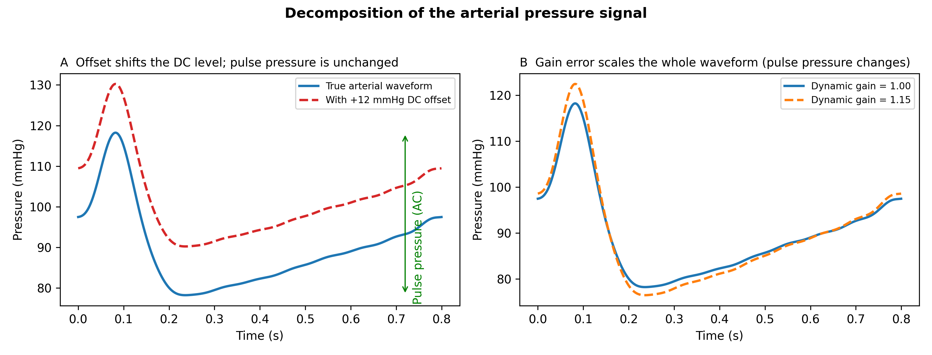
Figure 1. Decomposition of the arterial pressure signal. (A) A DC offset shifts the baseline but leaves pulse pressure unchanged. (B) A gain error scales the entire waveform, so pulse pressure changes in proportion to the gain. Zeroing corrects the offset in (A) but cannot correct the gain error in (B).

2.2. Statistical methods
For each paired dataset we computed: (i) the minimal Bland–Altman summary—mean bias, 95% limits of agreement (mean bias ± 1.96 SD) and percentage error ⁸; (ii) the Bland–Altman regression of the differences on the mean, whose slope tests for proportional bias ¹⁰; (iii) Deming regression, which allows for error in both methods, with jackknife confidence intervals ¹³; (iv) Passing–Bablok non-parametric regression ¹⁴; and (v) Lin’s CCC ¹¹.
Lin’s CCC (ρc) decomposes as ρc = r × C_b, where r is Pearson’s correlation (precision) and C_b is the bias-correction factor (accuracy) ¹². C_b further decomposes as:
C_b = 2 / (v + 1/v + u²)
where v = σ_device/σ_reference is the scale shift (the gain ratio) and u = (μ_device − μ_reference)/√(σ_deviceσ_reference) is the location shift (offset). Zeroing drives u toward zero but leaves v unchanged; a residual gain error keeps v ≠ 1 even after perfect zeroing.
We used fixed a-priori detection rules, reported here so they cannot be chosen post hoc: the mean-bias summary flags an error if |mean bias| > 5.0 mmHg; the Bland–Altman regression flags if the slope 95% confidence interval (CI) excludes 0; Deming and Passing–Bablok flag if the slope 95% CI excludes 1; and the CCC scale shift flags if |v − 1| > 0.05. Strength of agreement was interpreted using published CCC criteria ¹⁷.

2.3. Dynamic response and the fast-flush test
The fluid-filled catheter–transducer system behaves as a second-order system characterised by a natural frequency f_n and a damping coefficient ζ ⁶. We modelled its transfer function H(f) = 1/[1 − (f/f_n)² + i·2ζ(f/f_n)] and applied it to the Fourier harmonics of synthetic arterial waveforms. Under-damping (low ζ, resonance near the arterial harmonics) causes systolic overshoot and PP over-estimation; over-damping attenuates PP. Both are gain errors on the pulsatile signal that zeroing cannot correct, and both are quantified at the bedside by the fast-flush (square-wave) test ^{18–19}.

2.4. Simulation design and reproducibility
All data in this study are simulated, not measured in patients. Static scenarios comprised n = 150 paired systolic pressures drawn uniformly over 80–180 mmHg with Gaussian measurement noise (SD = 3.0 mmHg): S1 offset only (+12.0 mmHg, gain 1.0); S2 ideal zeroing (offset removed, gain 1.0); S3 uncompensated gain error (gain 1.10); and S4 the same gain error with a compensating negative offset chosen so the mean difference is approximately zero. Dynamic scenarios passed synthetic waveforms through optimal, under-damped and over-damped systems. A range-dependence experiment sampled one fixed device (5% gain error) over pressure ranges of increasing width. The random seed, all parameters and the full pipeline (simulate → analyse → figures → manuscript) are provided in the public repository so that a third party can regenerate every number, table and figure from a clean clone.

3. Results

3.1. Static scenarios
Concordance plots for the four static scenarios are shown in Fig. 2 and the full metrics in Table 1. Ideal zeroing (S2) gave near-perfect agreement (mean bias +0.1 mmHg, CCC 0.995, v 0.990). An uncompensated 10% gain error (S3) was obvious on every analysis, including the mean bias (+12.7 mmHg): gain error is not invisible to a Bland–Altman analysis.
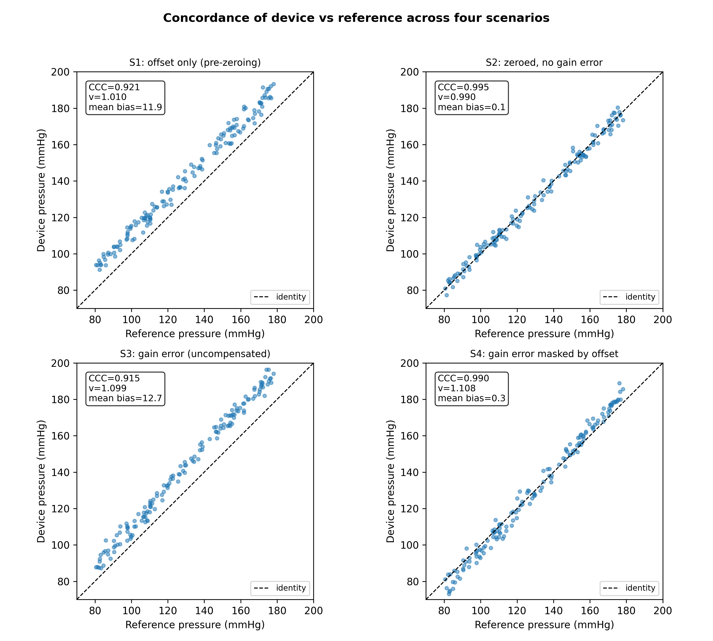
Figure 2. Device-versus-reference concordance for the four static scenarios (dashed line = identity). Each panel shows the CCC, the CCC scale shift v, and the Bland–Altman mean bias. S4 has a near-zero mean bias despite a 10% gain error.
The decisive case is S4, where a compensating offset makes the mean bias only +0.3 mmHg—within the ±5.0 mmHg acceptance band—so the minimal Bland–Altman summary does not flag any problem. Every proportional-bias–aware analysis nonetheless detects the hidden gain error: the Bland–Altman regression slope is 0.103 (95% CI 0.087 to 0.119), the Deming slope 1.109 (95% CI 1.091 to 1.126), the Passing–Bablok slope 1.111 (95% CI 1.092 to 1.130), and the CCC scale shift v = 1.108. The detection pattern across all scenarios is summarised in Fig. 3, and the difference-versus-mean plots for S2 and S4 in Fig. 4.
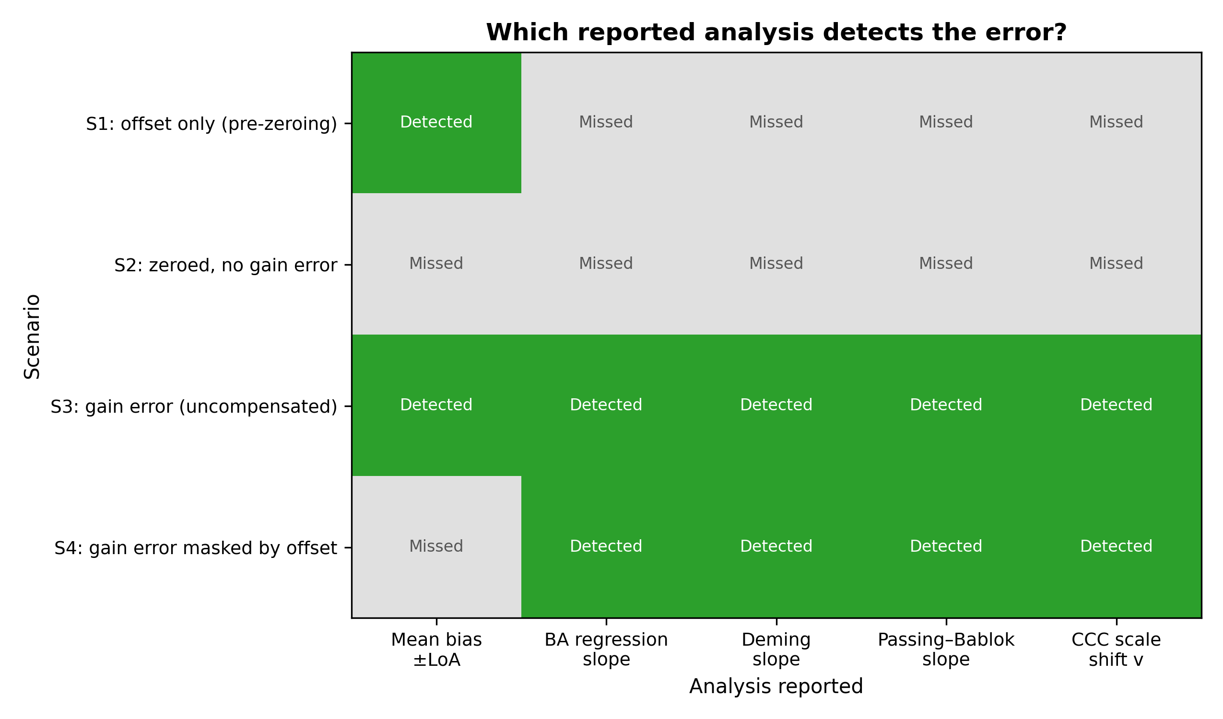
Figure 3. Which reported analysis detects the error in each scenario (green = detected, grey = missed). In S4 the mean-bias summary misses the gain error that every proportional-bias–aware analysis detects.
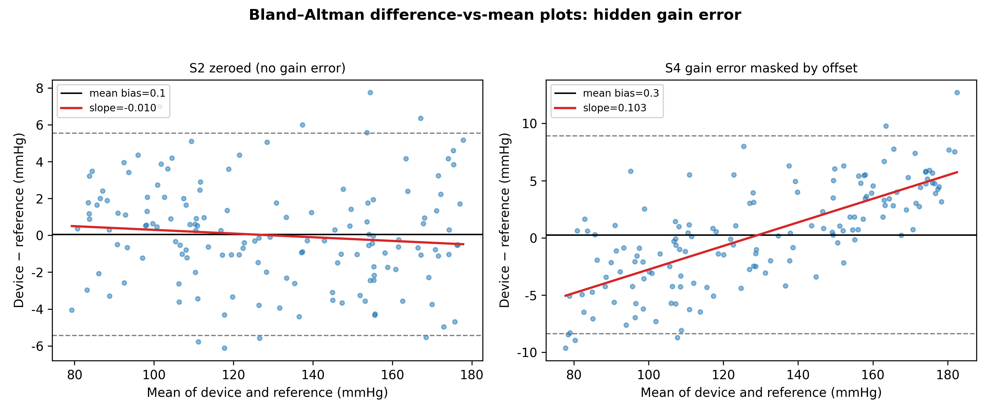
Figure 4. Bland–Altman difference-versus-mean plots. In S2 the regression slope is flat; in S4 the slope is clearly positive despite a near-zero mean bias, revealing the masked proportional (gain) error.

3.2. Dynamic-response scenarios
Dynamic-response metrics are given in Table 2 and illustrated in Fig. 5. The optimal system reproduced PP faithfully (PP ratio 1.01). Under-damping produced systolic overshoot and inflated PP by 24% (PP ratio 1.24, CCC scale shift v = 1.28); over-damping attenuated PP by 8% (PP ratio 0.92). These are gain errors on the pulsatile signal that survive zeroing. Because the distortion is frequency-dependent (it varies with heart rate rather than with pressure amplitude), it maps only partially onto the amplitude-proportional model underlying the static regression statistics, which is why it is best characterised directly by the fast-flush test parameters (f_n, ζ).
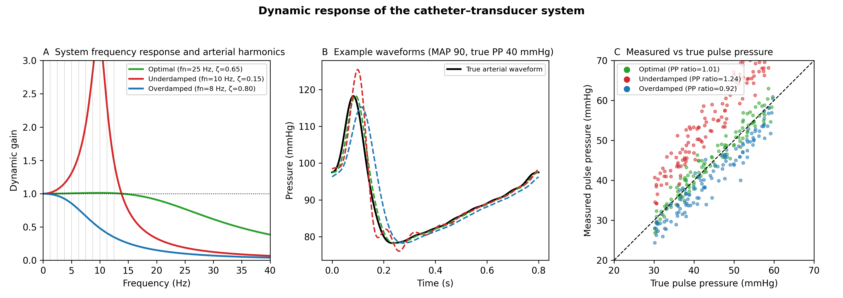
Figure 5. Dynamic response of the catheter–transducer system. (A) Frequency response of optimal, under-damped and over-damped systems with the arterial harmonics overlaid. (B) Example waveforms. (C) Measured versus true pulse pressure, with the mean PP ratio per system.

3.3. Range-dependence of the CCC
For a single device with a fixed 5% gain error, the CCC rose from 0.60 when sampled over a narrow pressure range (20 mmHg wide) to 0.96 over a wide range (100 mmHg), while the scale shift v remained close to its true value (Fig. 6). The CCC therefore should be reported together with the sampled pressure range; the structural components (C_b, v) are more transportable across studies ¹⁵.
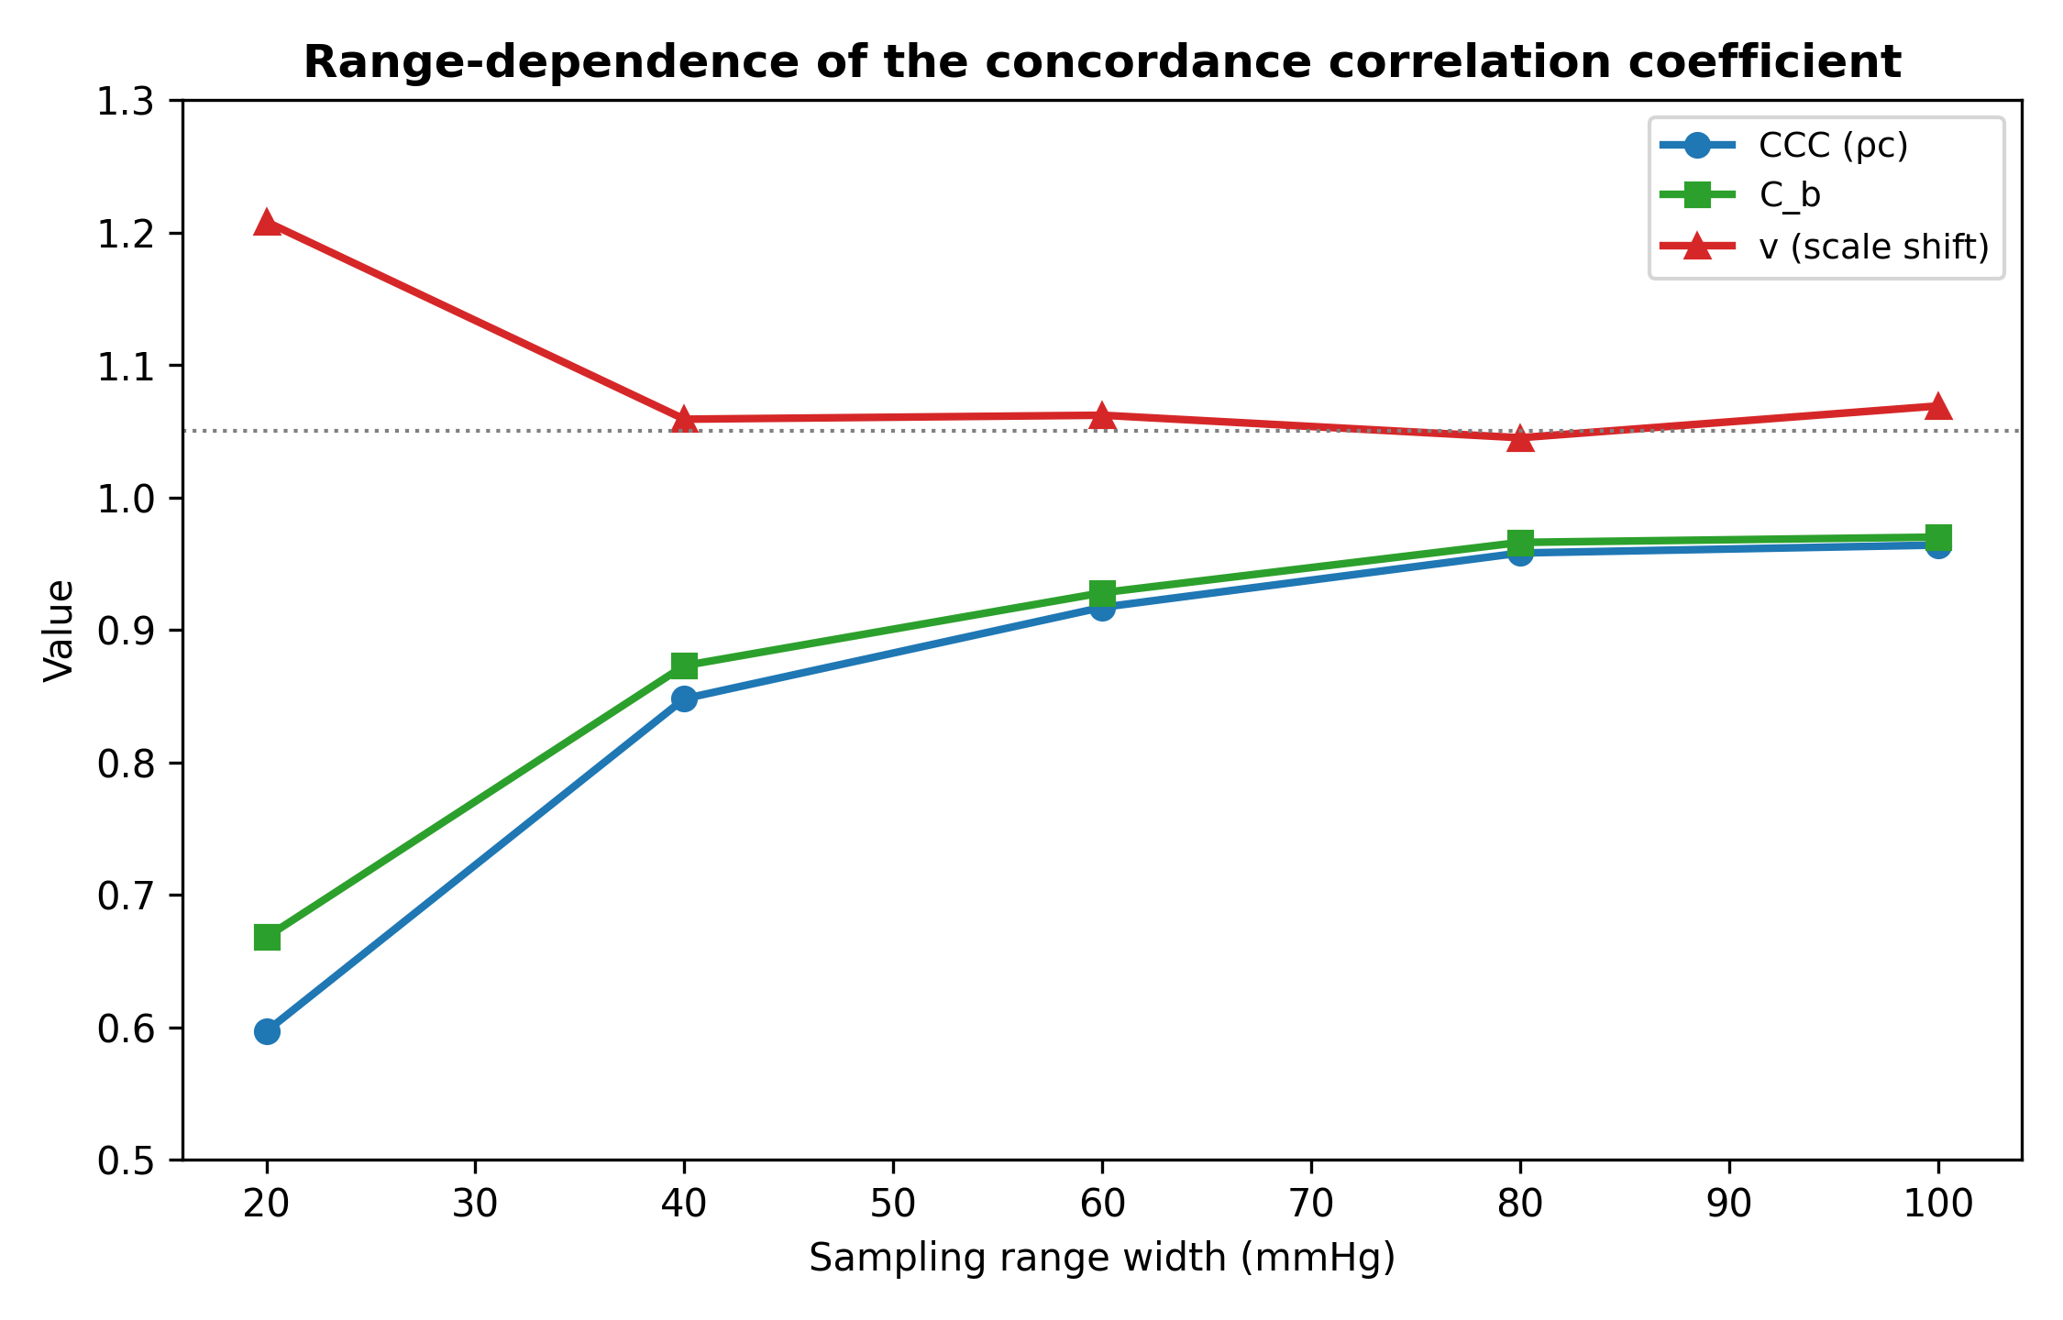
Figure 6. Range-dependence of the CCC. For one fixed device, the CCC and C_b increase as the sampled pressure range widens, whereas the scale shift v stays close to the true gain ratio.

4. Discussion
Our central finding is narrow and, we believe, defensible: the mean-bias–plus–limits-of-agreement summary that dominates device-validation reporting can miss a clinically relevant gain error when a coincidental offset cancels its effect on the mean, whereas the Bland–Altman difference-versus-mean regression ¹⁰, Deming ¹³ and Passing–Bablok ¹⁴ regression, and the CCC scale shift ¹² all detect it. This is a critique of common reporting practice, not of the Bland–Altman method itself.

4.1. Recommendations for validation reporting
Validation studies of arterial pressure and derived monitors ^{20–21} should therefore report, in addition to mean bias and limits of agreement: (i) the Bland–Altman regression slope with its CI (or, equivalently, a Deming or Passing–Bablok slope); (ii) the CCC with its decomposition into r, C_b, u and v; and (iii) the sampled pressure range, because the CCC is range-dependent ^{15–16}. Notably, C_b alone is relatively insensitive to a pure gain error (in S4, C_b was 0.995 despite v = 1.108); the scale shift v should be reported explicitly. These additions cost nothing beyond a few lines of analysis and would let regulators and clinicians ²² distinguish offset-corrected agreement from genuine gain accuracy.

4.2. Dynamic response is a distinct, clinical gain error
The dynamic-response error is specific to fluid-filled systems and is routinely encountered at the bedside as under-damping (air bubbles, long compliant tubing) or over-damping (clots, kinks) ^{6,19}. Because it is frequency-dependent, it is not fully captured by static method-comparison statistics and is best assessed directly with the fast-flush test, from which f_n and ζ are read ¹⁸. We therefore recommend that a fast-flush dynamic-response check accompany any accuracy statement for a fluid-filled arterial line; pulse pressure is the sensitive readout, because it is proportional to gain but independent of offset.

4.3. Implications for sensor design
The offset that zeroing corrects can also be removed by design. Catheter-tip micro-electro-mechanical systems (MEMS) sensors abolish the hydrostatic column ^{23–24}; absolute sensors with barometric compensation remove the atmospheric reference; and self-calibrating MEMS references limit drift ²⁵. High-fidelity pressure wires already demonstrate accurate catheter-based pressure measurement ²⁶. With offset removed by design and gain verified by accurate PP reproduction, the residual systematic error is expressed entirely in v, giving a concrete design target (v ≈ 1, C_b ≥ 0.99 without calibration) ¹⁷. Modern piezoresistive MEMS sensors achieve non-linearity well below 0.1% of full scale ²⁷, supporting the assumption that gain verified over the pulsatile range generalises across the physiological range.

4.4. Extension to derived haemodynamic monitors
The offset-versus-gain distinction extends to derived monitors whose auto-calibration routines re-optimise a setpoint—an offset correction—without correcting the gain of the pressure- or impedance-to-flow conversion ^{28–31}. Reporting the scale shift v for these devices would make their dependence on calibration explicit.

4.5. Limitations
This is a simulation study; the data are synthetic and chosen to isolate specific error structures, and they are not a substitute for a prospective clinical comparison against an invasive reference of stated precision ⁹. The static model assumes sensor linearity, and the dynamic model is a single second-order approximation. The value of the work is to make explicit, and reproducibly quantify, which reported analyses detect a residual gain error—a prelude to, not a replacement for, empirical validation.

5. Conclusion
Zero calibration corrects offset but not gain. A mean-bias–plus–limits-of-agreement summary can miss a residual gain error when an offset masks it, whereas Bland–Altman regression, Deming and Passing–Bablok regression, and the CCC scale shift detect it. Dynamic-response error is a distinct, frequency-dependent gain error diagnosed by the fast-flush test. We recommend that arterial pressure validation studies report a proportional-bias–aware analysis, the CCC decomposition with the sampled range, and an explicit dynamic-response check.

Conflicts of interest
[To be completed by authors]

Funding
[To be completed by authors]

Data availability
All simulation code and generated data are openly available in the public replication repository (https://github.com/bougtoir/bpm-zero-calibration). Every number, table and figure in this article can be regenerated from a clean clone by running the analysis pipeline.

Table 1
Table 1. Method-comparison metrics for the four static scenarios (n = 150 paired measurements each).
Scenario | Mean bias  (mmHg) | 95% LoA  (mmHg) | PE (%) | BA reg. slope  (95% CI) | Deming slope  (95% CI) | P–B slope  (95% CI) | CCC | C_b | v
S1 offset only | +11.9 | 5.6 to 18.2 | 4.6 | 0.010  (-0.007, 0.028) | 1.010  (0.993, 1.028) | 1.010  (0.990, 1.029) | 0.921 | 0.926 | 1.010
S2 zeroed (ideal) | +0.1 | -5.4 to 5.5 | 4.2 | -0.010  (-0.025, 0.006) | 0.990  (0.975, 1.006) | 0.985  (0.971, 1.001) | 0.995 | 1.000 | 0.990
S3 gain error | +12.7 | 4.7 to 20.7 | 5.9 | 0.094  (0.080, 0.109) | 1.099  (1.082, 1.117) | 1.100  (1.081, 1.117) | 0.915 | 0.919 | 1.099
S4 gain masked | +0.3 | -8.4 to 8.9 | 6.7 | 0.103  (0.087, 0.119) | 1.109  (1.091, 1.126) | 1.111  (1.092, 1.130) | 0.990 | 0.995 | 1.108
BA = Bland–Altman; CI = confidence interval; LoA = limits of agreement; PE = percentage error; P–B = Passing–Bablok; CCC = concordance correlation coefficient; C_b = bias-correction factor; v = scale shift. S4 has a near-zero mean bias yet a clearly non-zero regression / Deming / Passing–Bablok slope and v > 1, i.e. a gain error hidden from the mean-bias summary.

Table 2
Table 2. Dynamic-response metrics for pulse pressure (PP) and systolic pressure (SBP).
System (f_n, ζ) | PP ratio | PP mean bias  (mmHg) | CCC (PP) | v (PP) | SBP mean bias  (mmHg)
Optimal (25 Hz, 0.65) | 1.01 | +0.3 | 0.973 | 1.030 | +0.2
Underdamped (10 Hz, 0.15) | 1.24 | +10.7 | 0.588 | 1.277 | +7.6
Overdamped (8 Hz, 0.80) | 0.92 | -3.4 | 0.891 | 0.989 | -3.4
PP ratio = mean(measured PP / true PP); f_n = natural frequency; ζ = damping coefficient. Under-damping inflates and over-damping attenuates pulse pressure; the mean arterial (DC) level is preserved, so zeroing does not correct these errors.

Figure legends
Figure 1. Decomposition of the arterial pressure signal. (A) A DC offset shifts the baseline but leaves pulse pressure unchanged. (B) A gain error scales the entire waveform, so pulse pressure changes in proportion to the gain. Zeroing corrects the offset in (A) but cannot correct the gain error in (B).
Figure 2. Device-versus-reference concordance for the four static scenarios (dashed line = identity). Each panel shows the CCC, the CCC scale shift v, and the Bland–Altman mean bias. S4 has a near-zero mean bias despite a 10% gain error.
Figure 3. Which reported analysis detects the error in each scenario (green = detected, grey = missed). In S4 the mean-bias summary misses the gain error that every proportional-bias–aware analysis detects.
Figure 4. Bland–Altman difference-versus-mean plots. In S2 the regression slope is flat; in S4 the slope is clearly positive despite a near-zero mean bias, revealing the masked proportional (gain) error.
Figure 5. Dynamic response of the catheter–transducer system. (A) Frequency response of optimal, under-damped and over-damped systems with the arterial harmonics overlaid. (B) Example waveforms. (C) Measured versus true pulse pressure, with the mean PP ratio per system.
Figure 6. Range-dependence of the CCC. For one fixed device, the CCC and C_b increase as the sampled pressure range widens, whereas the scale shift v stays close to the true gain ratio.

References
1. Saugel B, Kouz K, Meidert AS, Schulte-Uentrop L, Romagnoli S. How to measure blood pressure using an arterial catheter: a systematic 5-step approach. Crit Care. 2020;24:172.
2. Saugel B, Sessler DI. Perioperative blood pressure management. Anesthesiology. 2021;134:250–61.
3. Gupta D, Jain A, Ismaeil M. Zero arterial catheters with every change in the height difference of pressure transducer and catheter insertion site. Ann Card Anaesth. 2025;28:205.
4. Mark JB. Atlas of Cardiovascular Monitoring. New York: Churchill Livingstone; 1998.
5. McGhee BH, Bridges MEJ. Monitoring arterial blood pressure: what you may not know. Crit Care Nurse. 2002;22:60–79.
6. Gardner RM. Direct blood pressure measurement—dynamic response requirements. Anesthesiology. 1981;54:227–36.
7. Bland JM, Altman DG. Statistical methods for assessing agreement between two methods of clinical measurement. Lancet. 1986;327:307–10.
8. Critchley LAH, Critchley JAJH. A meta-analysis of studies using bias and precision statistics to compare cardiac output measurement techniques. J Clin Monit Comput. 1999;15:85–91.
9. Cecconi M, Rhodes A, Poloniecki J, Della Rocca G, Grounds RM. Bench-to-bedside review: the importance of the precision of the reference technique in method comparison studies. Crit Care. 2009;13:201.
10. Bland JM, Altman DG. Measuring agreement in method comparison studies. Stat Methods Med Res. 1999;8:135–60.
11. Lin LI-K. A concordance correlation coefficient to evaluate reproducibility. Biometrics. 1989;45:255–68.
12. Lin LI-K. A note on the concordance correlation coefficient. Biometrics. 2000;56:324–5.
13. Linnet K. Estimation of the linear relationship between the measurements of two methods with proportional errors. Stat Med. 1990;9:1463–73.
14. Passing H, Bablok W. A new biometrical procedure for testing the equality of measurements from two different analytical methods. J Clin Chem Clin Biochem. 1983;21:709–20.
15. Atkinson G, Nevill A. Comment on the use of concordance correlation to assess the agreement between two variables. Biometrics. 1997;53:775–7.
16. Barnhart HX, Haber MJ, Lin LI. An overview on assessing agreement with continuous measurements. J Biopharm Stat. 2007;17:529–69.
17. McBride GB. A proposal for strength-of-agreement criteria for Lin’s concordance correlation coefficient. NIWA Client Report HAM2005-062; 2005.
18. Kleinman B, Powell S, Kumar P, Gardner RM. The fast flush test measures the dynamic response of the entire blood pressure monitoring system. Anesthesiology. 1992;77:1215–20.
19. Romagnoli S, Ricci Z, Quattrone D, et al. Accuracy of invasive arterial pressure monitoring in cardiovascular patients: an observational study. Crit Care. 2014;18:644.
20. Kim S-H, Lilot M, Sidhu KS, et al. Accuracy and precision of continuous noninvasive arterial pressure monitoring compared with invasive arterial pressure. Anesthesiology. 2014;120:1080–97.
21. Joosten A, Desebbe O, Suehiro K, et al. Accuracy and precision of non-invasive cardiac output monitoring devices in perioperative medicine: a systematic review and meta-analysis. Br J Anaesth. 2017;118:298–310.
22. Odor PM, Bampoe S, Cecconi M. Cardiac output monitoring: validation studies—how results should be presented. Curr Anesthesiol Rep. 2017;7:410–15.
23. Hasenkamp W, Theumer T, Nolte J, Aschenbrenner L, Dietzel A, Büttgenbach S. Polyimide/SU-8 catheter-tip MEMS gauge pressure sensor. Biomed Microdevices. 2012;14:819–28.
24. Song P, Ma Z, Ma J, et al. Recent progress of miniature MEMS pressure sensors. Micromachines. 2020;11:56.
25. Kang Y, Ge C, Hu Y, et al. Development of a flexible integrated self-calibrating MEMS pressure sensor using a liquid-to-vapor phase change. Sensors. 2022;22:9737.
26. Scalia A, Ghafari C, Navarre W, et al. High fidelity pressure wires provide accurate validation of non-invasive central blood pressure and pulse wave velocity measurements. Biomedicines. 2023;11:1235.
27. Barlian AA, Park W-T, Mallon JR, Rastegar AJ, Pruitt BL. Review: semiconductor piezoresistance for microsystems. Proc IEEE. 2009;97:513–52.
28. Chatterjee K. The Swan–Ganz catheters: past, present, and future. Circulation. 2009;119:147–52.
29. Ameloot K, Palmers PJ, Malbrain MLNG. The accuracy of noninvasive cardiac output and pressure measurements with finger cuff: a concise review. Curr Opin Crit Care. 2015;21:232–9.
30. Squara P, Denjean D, Estagnasie P, Brusset A, Dib JC, Dubois C. Noninvasive cardiac output monitoring (NICOM): a clinical validation. Intensive Care Med. 2007;33:1191–4.
31. Manecke GR. Edwards FloTrac sensor and Vigileo monitor: easy, accurate, reliable cardiac output assessment using the arterial pulse wave. Expert Rev Med Devices. 2005;2:523–7.

