Targeted environmental regulation without observable collateral market damage: the EU desflurane ban and secondary market vaporizer prices

[Author names to be inserted]
[Affiliations to be inserted]

Corresponding author: [Name, Department, Institution, Address, Country. Tel: [number]; e-mail: [address]]

Abstract word count: ~280 (max 300)
Number of references: 19
Number of tables: 2 (+1 supplementary)
Number of figures: 6

Keywords: anesthetic vaporizer, desflurane, environmental regulation, F-gas, secondary market, EU regulation, equipment management, capital asset lifecycle

Abstract
Background: The European Union prohibited desflurane—the volatile anesthetic with the highest global warming potential (GWP ≈ 2540 CO₂ equivalents)—for routine use from 1 January 2026 under Regulation (EU) 2024/573. Whether this targeted environmental regulation produced collateral economic effects on non-targeted anesthetic equipment markets has not been examined. We investigated whether the EU desflurane regulation was associated with changes in secondary market prices of anesthetic vaporizers, and whether any such changes were agent-specific or extended to non-regulated agents (sevoflurane, isoflurane).
Methods: We conducted a cross-sectional time-series analysis of completed eBay sales of desflurane, sevoflurane, and isoflurane vaporizers over three years (March 2023 to March 2026), spanning the full EU regulatory timeline. Temporal trends were assessed using Spearman rank correlation and Kendall τ across ordered regulatory phases. Pre-/post-ban comparison used the Mann–Whitney U test with Cohen’s d effect size.
Results: 1033 completed sales were analyzed (158 desflurane, 321 sevoflurane, 554 isoflurane). Desflurane vaporizer prices showed a significant downward trend (Spearman ρ=-0.28, P<0.001; Kendall τ=-0.12, P=0.049), with a 31% decline from pre-ban (mean US$238 ± 195) to post-ban (US$164 ± 113; Cohen’s d=-0.47). Neither sevoflurane (ρ=0.01, P=0.862) nor isoflurane (ρ=-0.09, P=0.044) showed significant temporal trends.
Conclusions: The EU desflurane regulation was associated with an agent-specific decline in secondary market vaporizer prices, beginning during the legislative process. Non-regulated agents remained stable, suggesting that this targeted regulation did not observably destabilize the broader anesthetic equipment market.

Introduction
Environmental regulation of healthcare products is accelerating. The European Union prohibited desflurane—the volatile anesthetic with the highest global warming potential (GWP ≈ 2540 CO₂ equivalents)^{1–5}—for routine use from 1 January 2026 under Regulation (EU) 2024/573.² The American Society of Anesthesiologists has recommended deactivation of central nitrous oxide piping on environmental grounds.⁶ NHS England and NHS Scotland have independently decommissioned desflurane.^{7,8} Each of these measures targets a specific agent or delivery system, yet whether such targeted restrictions produce collateral economic effects on non-targeted equipment markets has not been empirically examined.
The EU desflurane ban provides an opportunity to address this question as a natural experiment. First, only a single agent is targeted; sevoflurane (GWP ≈ 130) and isoflurane (GWP ≈ 510)^{9,10} remain in unrestricted use and serve as natural controls. Second, the regulatory process advanced through clearly dated milestones — European Commission proposal (April 2022), European Parliament plenary vote (March 2023), trilogue provisional agreement (October 2023), formal adoption (February 2024), and prohibition (January 2026) — enabling time-series analysis across successive phases. Third, anesthetic vaporizers are agent-specific capital assets with typical lifespans of 10–15 years, so the economic consequences of regulation may be reflected in secondary market values.
Previous studies have addressed the financial rationale for discontinuing desflurane,¹¹ the clinical and policy implications of decommissioning programs,^{12,13} the effectiveness of vaporizer removal at the institutional level,¹⁴ and the cost savings from reduced volatile anesthetic consumption.^{15,16} The secondary market for pre-owned medical equipment has been characterized for other device categories.¹⁷ However, to our knowledge, no study has examined whether environmental regulation of a single anesthetic agent produces targeted economic effects or whether it destabilizes the broader equipment market.
We hypothesized that (1) the EU desflurane regulation would be associated with a progressive decline in secondary market prices of desflurane vaporizers, and (2) this decline would be agent-specific—sevoflurane and isoflurane vaporizer prices would remain stable, suggesting that the regulation produced targeted economic effects without observable collateral market damage.

Materials and Methods

Ethics
Ethical approval was not required for this study. The study analyzed publicly available, anonymized completed sale data from an online marketplace (eBay). No individual-level, patient, or human participant data were collected.

Reporting guidelines
This study is reported in accordance with the Strengthening the Reporting of Observational Studies in Epidemiology (STROBE) guidelines for cross-sectional studies.¹⁸ The completed STROBE checklist is provided as supplementary material.

Study design and data source
We conducted a cross-sectional time-series analysis of anesthetic vaporizer prices using completed (sold) listings on eBay (www.ebay.com). Data were retrieved using Terapeak, eBay’s official product research tool integrated within eBay Seller Hub. Terapeak provides access to up to three years of historical completed sale data, including item titles, sale prices, sale dates, and quantities sold. Data were collected in March 2026, covering the period from 28 March 2023 to 24 March 2026.
Although the three-year window reflects the maximum retrievable period within Terapeak, this timeframe is analytically meaningful: it begins shortly after the European Parliament plenary vote approving the revised F-gas Regulation (March 2023) and captures the full legislative trajectory from the European Commission’s original proposal (April 2022) through to the post-ban period, encompassing all key regulatory milestones. We used a single marketplace (eBay) rather than integrating data from multiple platforms to avoid the risk of counting cross-listed items more than once.

Eligibility criteria
We searched Terapeak for completed sales using the search terms “desflurane vaporizer,” “sevoflurane vaporizer,” and “isoflurane vaporizer” with a three-year date range filter. Inclusion criteria were: (1) completed (sold) listings; (2) standalone anesthetic vaporizer units; and (3) valid sale price and date. Exclusion criteria were: (1) non-vaporizer items (keyed fillers, bottle adapters, accessories, pour-fill adapters, anti-spill caps); (2) veterinary-specific anesthesia systems or machines (rather than standalone vaporizers); (3) lot listings containing multiple heterogeneous items; and (4) listings with missing or implausible price data.

Variables
The primary outcome was sale price in US dollars. For each listing, we recorded: item title, sale price (USD), sale date, and quantity sold. The primary exposure variable was the regulatory period, classified relative to key milestones in the EU F-gas Regulation timeline. The primary comparison used 1 January 2026 (the desflurane prohibition effective date) as the cutpoint. A secondary multi-period classification divided the study period into four phases: post-proposal (after EC proposal, April 2022), post-agreement (after trilogue, October 2023), post-adoption (after formal adoption, February 2024), and post-ban (after 1 January 2026). These ordered phases were used for trend analysis.

Statistical analysis
The primary analysis was a time-series trend assessment using Spearman rank correlation between sale date and price for each agent type separately. This was complemented by Kendall τ, computed between the ordered regulatory phase (1–5) and sale price, to test whether prices changed progressively across successive milestones. These trend tests, applied to each agent type independently, allowed direct comparison of temporal patterns between the regulated agent (desflurane) and the unregulated comparators (sevoflurane, isoflurane). Quarterly median prices were also assessed using Spearman correlation to evaluate the trend at an aggregated level.
The pre-/post-ban comparison (Mann–Whitney U test and Welch’s t-test) was conducted as a secondary, exploratory analysis. Given the small post-ban sample size (n=17 for desflurane), this comparison has limited statistical power, and its results should be interpreted with caution. Effect sizes were estimated using Cohen’s d with 95% confidence intervals. To test whether the magnitude of the pre-/post-ban price change differed between agent types, pairwise z-tests for independent Cohen’s d values were performed using the large-sample variance approximation.
Descriptive statistics included mean, standard deviation (SD), median, interquartile range (IQR), and range for each agent type and regulatory period. The Kruskal–Wallis test was used for multi-period comparisons across regulatory phases. LOWESS (locally weighted scatterplot smoothing) trend lines were fitted to visualize price trajectories. Analyses were performed using Python 3.12 with pandas 2.2, scipy 1.14, and statsmodels 0.14. Statistical significance was set at P < 0.05 (two-sided). No a priori sample size calculation was performed, as this study aimed to capture all available transactions within the Terapeak data window.

Results
A total of 1033 completed eBay sales of anesthetic vaporizers were identified and included in the analysis after applying exclusion criteria: 158 desflurane, 321 sevoflurane, and 554 isoflurane vaporizers. The study period spanned from 28 March 2023 to 24 March 2026 (three years). Desflurane vaporizers were predominantly Datex-Ohmeda/GE Tec 6 Plus and Dräger D-Vapor models; sevoflurane vaporizers included Dräger Vapor 2000, Penlon Sigma Delta, and Tec 7 models; isoflurane vaporizers included Ohmeda Tec 3, Tec 5, Tec 7, and Dräger Vapor 2000 models (Fig. 1).

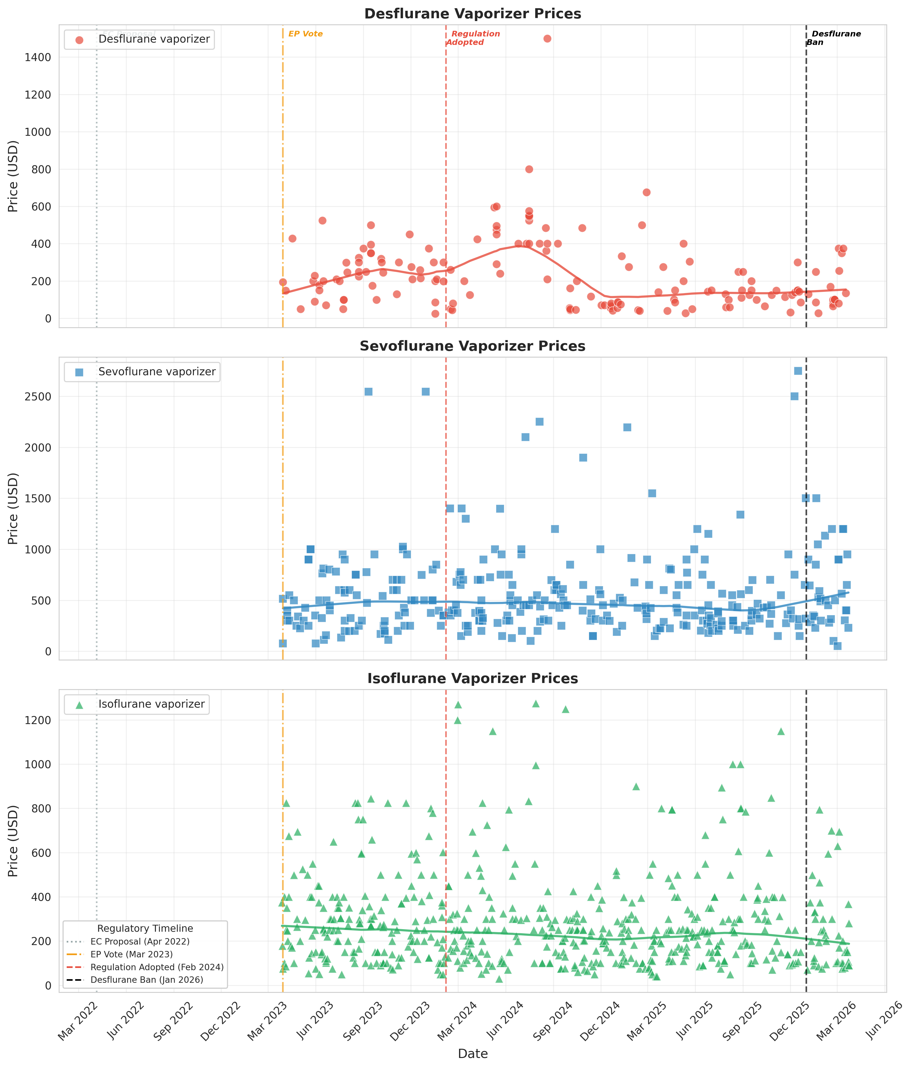
Fig. 1. Time series of eBay completed sale prices for desflurane (red), sevoflurane (blue), and isoflurane (green) vaporizers over three years (March 2023 to March 2026). Vertical dashed lines indicate key EU regulatory milestones. Curved lines represent LOWESS trend estimates (fraction = 0.3). Data source: eBay Terapeak.

Table 1. Time-series trend analysis of vaporizer prices by agent type. Spearman rank correlation tests monotonic association between sale date and price; Kendall τ tests association between ordered regulatory phase and price.
Agent | Spearman ρ | P value | Kendall τ | P value | Quarterly ρ | P value
Desflurane | -0.277 | <0.001 | -0.121 | 0.049 | -0.601 | 0.039
Sevoflurane | 0.010 | 0.862 | 0.039 | 0.365 | -0.092 | 0.777
Isoflurane | -0.086 | 0.044 | -0.074 | 0.025 | -0.321 | 0.285

Table 2. Pre- and post-ban vaporizer prices by agent type with between-agent effect size comparison. Values are mean ± SD in US dollars.
Panel A. Descriptive statistics and within-agent effect sizes (pre- vs post-ban)
Agent | n (pre/post) | Pre-ban mean ± SD | Post-ban mean ± SD | % change | Cohen’s d | 95% CI
Desflurane | 141/17 | $238 ± 195 | $164 ± 113 | -31.4% | -0.47 | -0.97 to 0.04
Sevoflurane | 287/34 | $545 ± 415 | $612 ± 365 | +12.3% | 0.17 | -0.18 to 0.53
Isoflurane | 510/44 | $287 ± 215 | $255 ± 191 | -11.2% | -0.16 | -0.47 to 0.15

Panel B. Between-agent comparison of effect sizes (z-test for independent Cohen’s d)
Comparison | Δd | SE | z | P value
Desflurane vs Sevoflurane | -0.64 | 0.316 | -2.03 | 0.043
Desflurane vs Isoflurane | -0.31 | 0.302 | -1.03 | 0.303
Sevoflurane vs Isoflurane | 0.33 | 0.240 | 1.37 | 0.171
Within-agent P values (Mann–Whitney U): Desflurane U P=0.148, t P=0.027; Sevoflurane U P=0.150, t P=0.326; Isoflurane U P=0.184, t P=0.297.

Desflurane vaporizer prices showed a statistically significant downward trend over the three-year study period (primary analysis). Spearman rank correlation demonstrated a significant negative monotonic association between sale date and price (ρ=-0.28, P<0.001). Kendall τ analysis confirmed that prices decreased across successive regulatory phases (τ=-0.12, P=0.049) (Fig. 2). At the aggregated level, quarterly median prices also showed a significant downward trend (ρ=-0.60, P=0.039) (Table 1; Fig. 3).

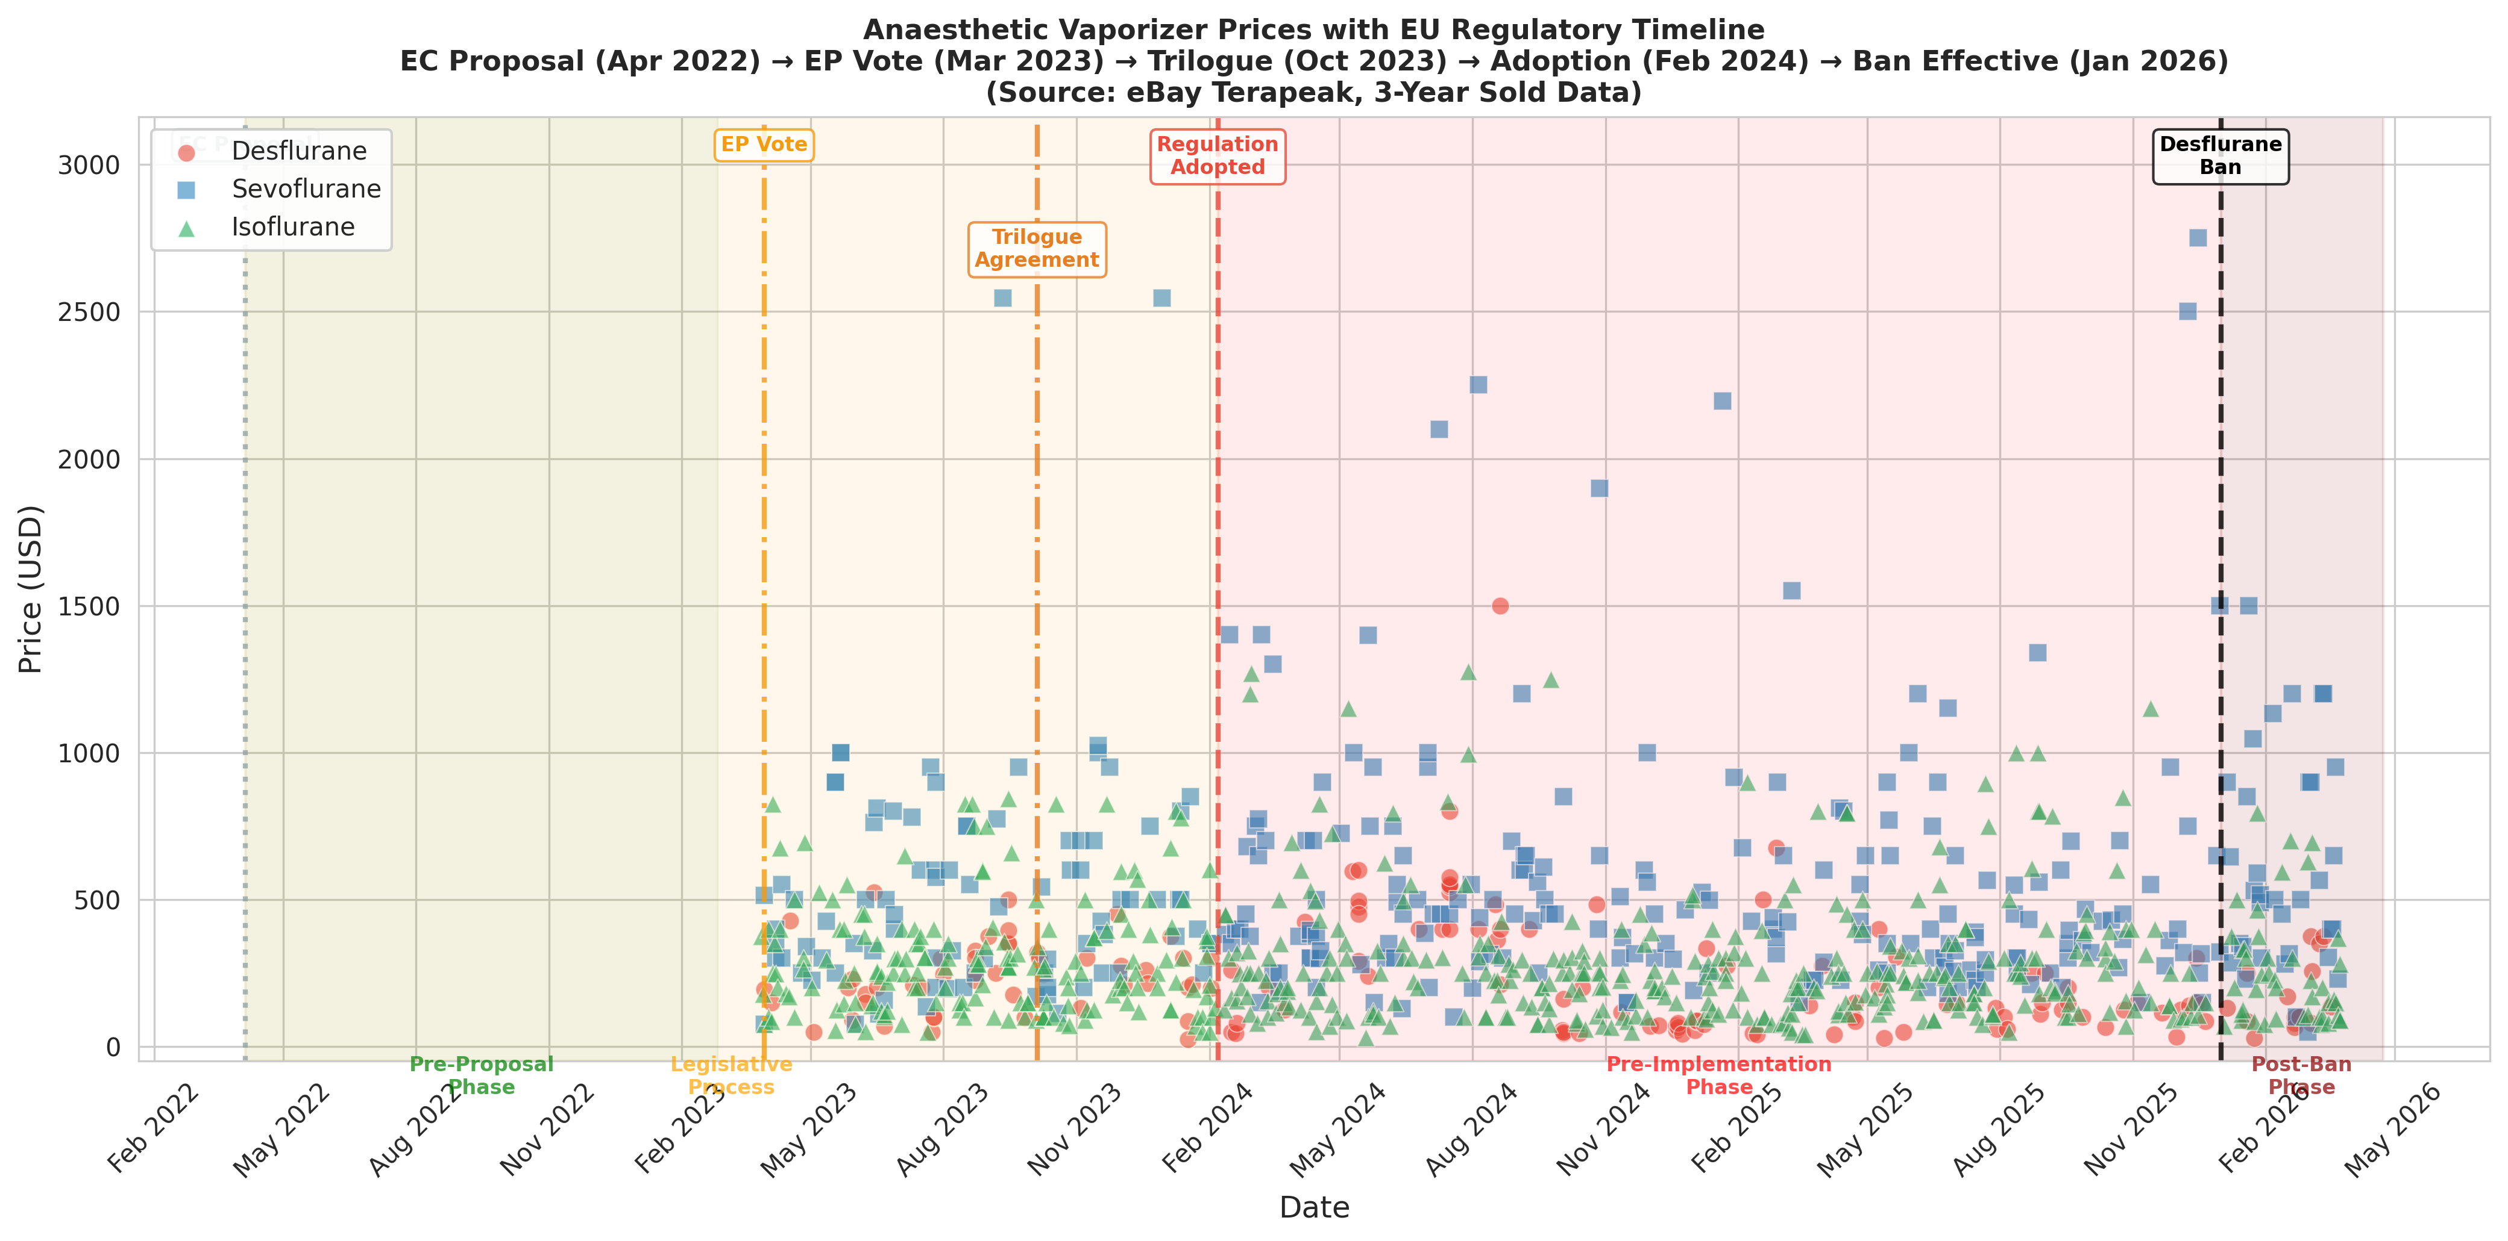
Fig. 2. Anesthetic vaporizer prices mapped against the EU regulatory timeline. Shaded regions indicate regulatory phases. Data source: eBay Terapeak.

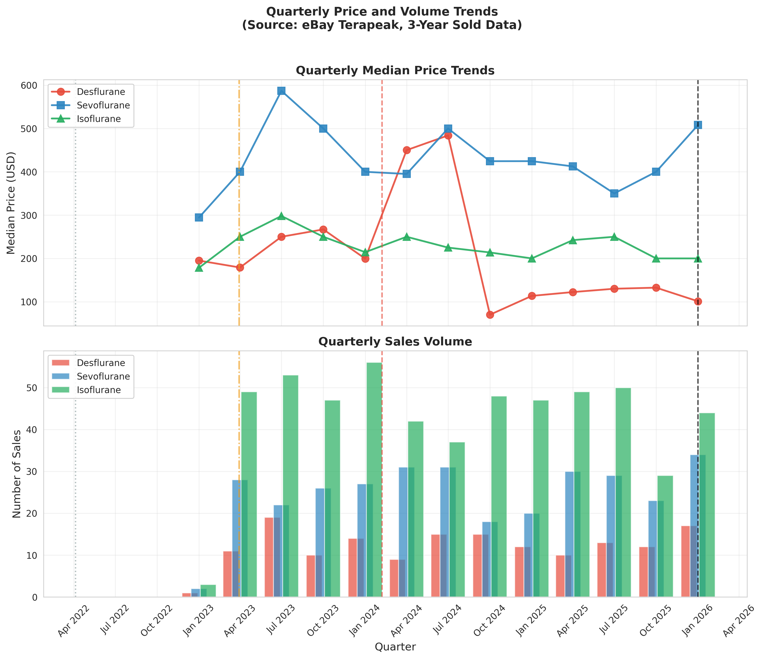
Fig. 3. Quarterly median price trends (upper panel) and sales volume (lower panel). Data source: eBay Terapeak.

In the exploratory pre-/post-ban comparison, the post-ban mean price (US$164 ± 113) was 31% lower than the pre-ban mean (US$238 ± 195). This difference was statistically significant on Welch’s t-test (P=0.027) but did not reach significance on the Mann–Whitney U test (P=0.148), likely reflecting the small post-ban sample (n=17). The effect size was medium (Cohen’s d=-0.47) (Table 2, Panel A; Fig. 4).

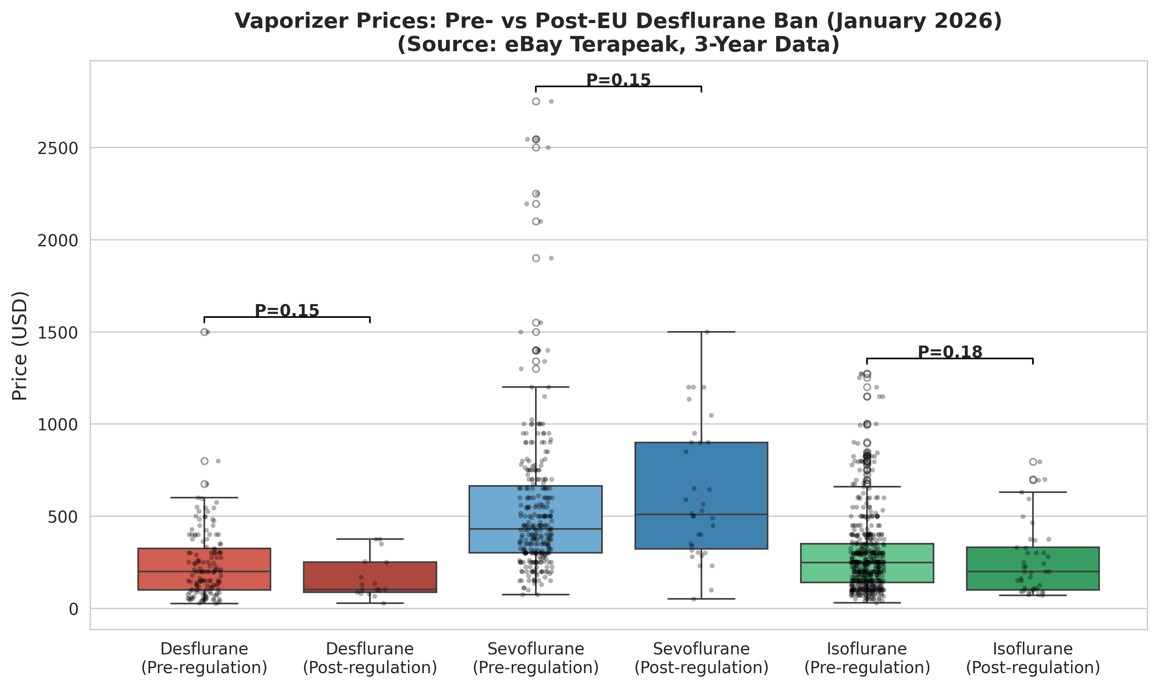
Fig. 4. Box plot comparison of vaporizer prices before and after the EU desflurane ban (1 January 2026). Individual data points are shown as jittered dots. Data source: eBay Terapeak.

In contrast, sevoflurane vaporizer prices showed no significant temporal trend (Spearman ρ=0.01, P=0.862; Kendall τ=0.04, P=0.365). Pre-/post-ban comparison showed a non-significant 12% increase (P=0.150, Mann–Whitney U) (Fig. 5).

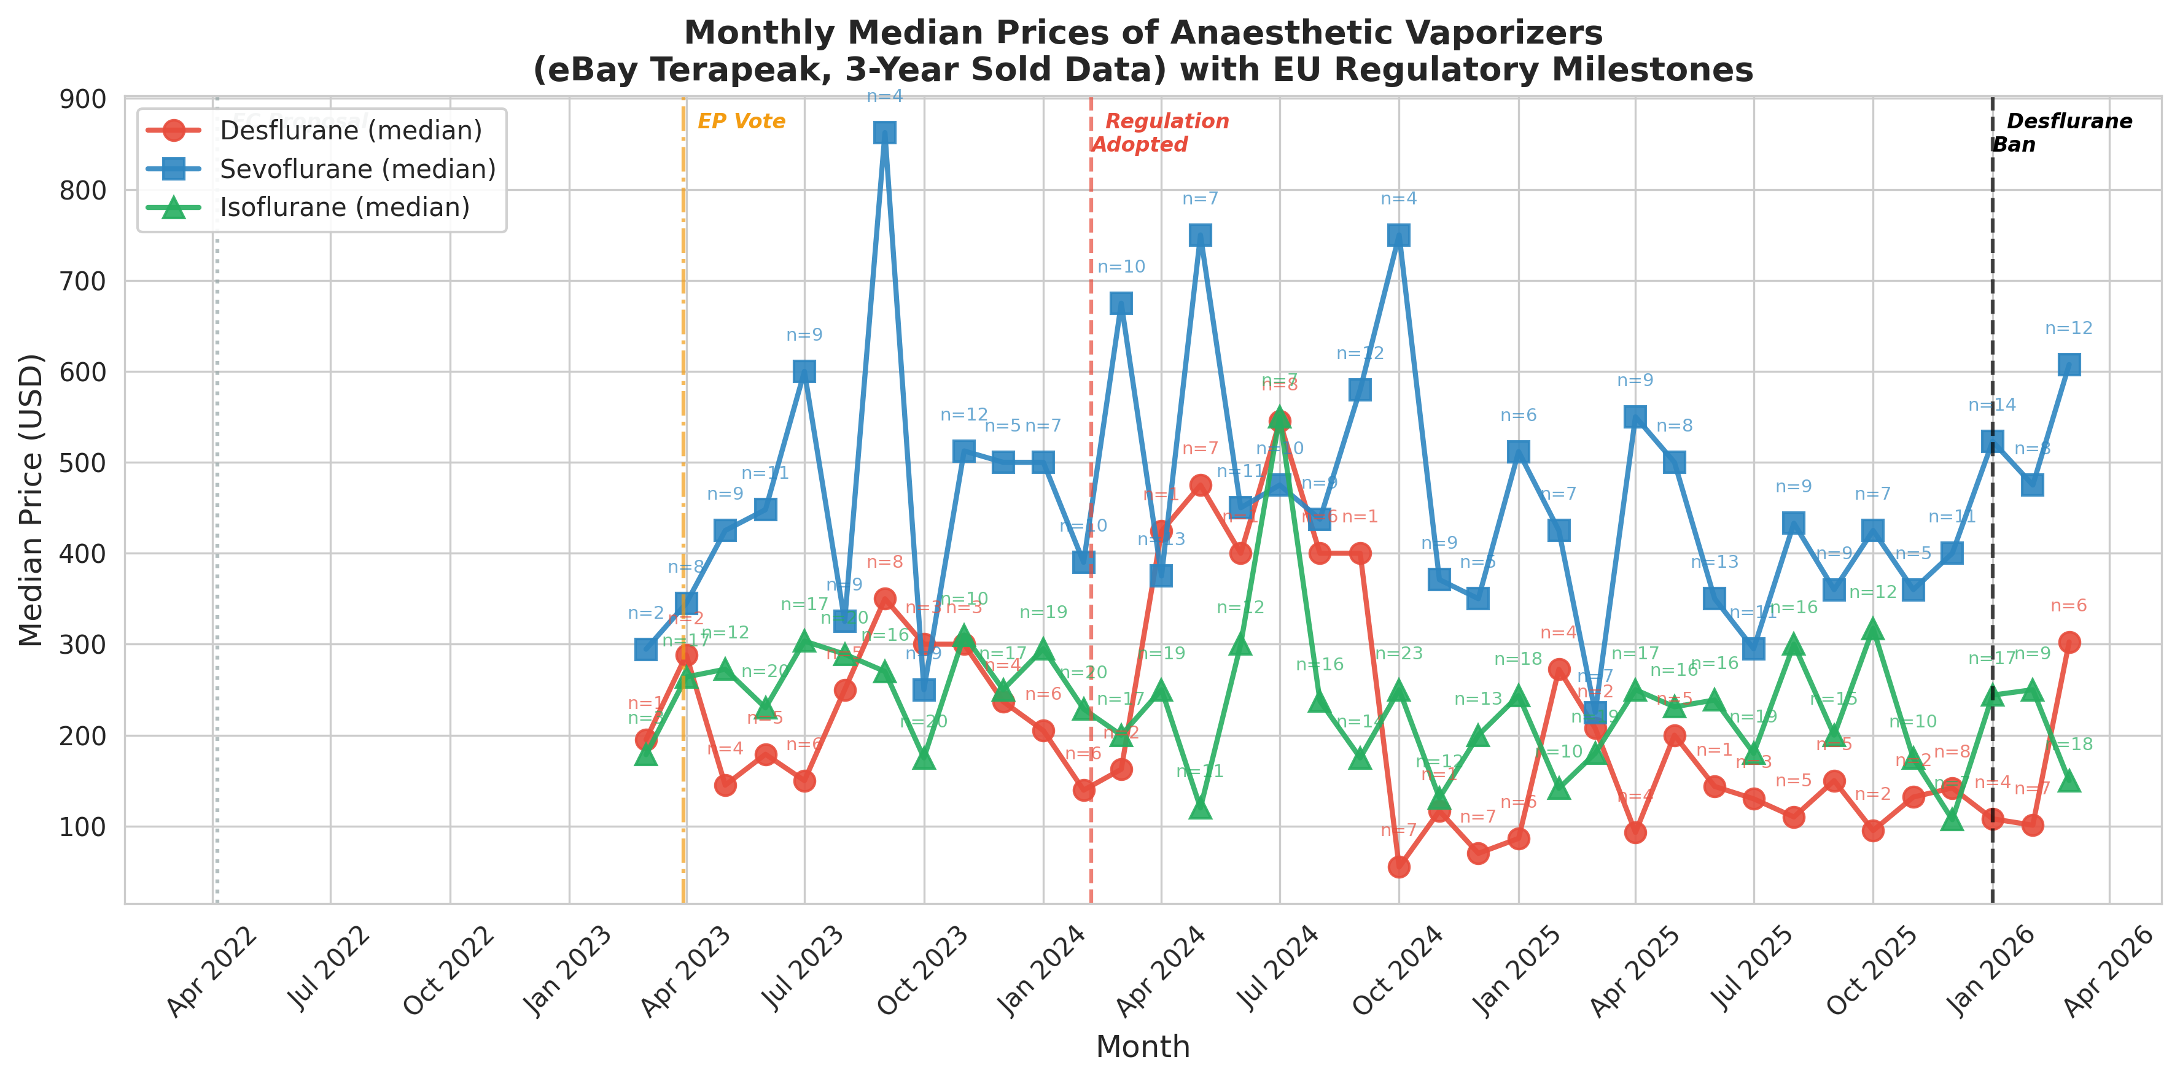
Fig. 5. Monthly median prices of anesthetic vaporizers on eBay. Annotations indicate the number of transactions per month (n). Data source: eBay Terapeak.

Isoflurane vaporizer prices were similarly stable. Although Spearman correlation reached nominal significance (ρ=-0.09, P=0.044), the magnitude was small and the quarterly median trend was not significant (ρ=-0.32, P=0.285). The pre-/post-ban comparison showed a non-significant 11% decline (P=0.184, Mann–Whitney U) (Fig. 6).

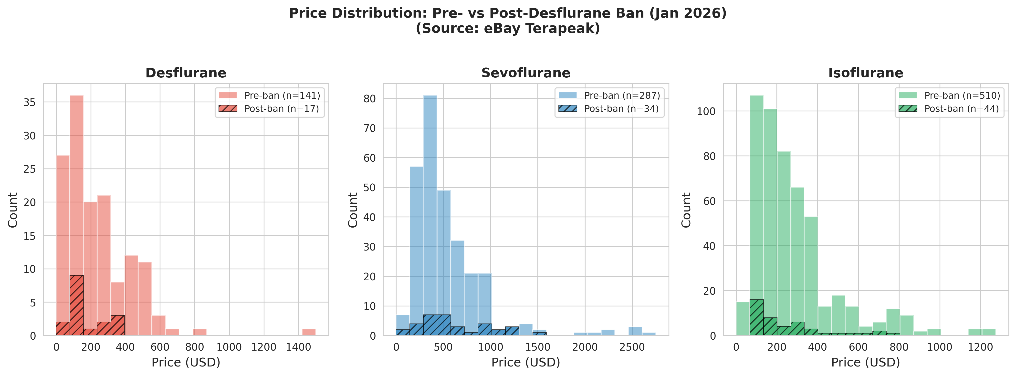
Fig. 6. Price distribution histograms for each vaporizer type, comparing pre-ban (solid fill) and post-ban (hatched) periods. Data source: eBay Terapeak.

Between-agent comparison tested whether the magnitude of pre-/post-ban price change differed across agent types (Table 2, Panel B). The effect size for desflurane (d=-0.47; 95% CI -0.97 to 0.04) was significantly larger than that for sevoflurane (d=0.17; 95% CI -0.18 to 0.53; Δd=-0.64, z=-2.03, P=0.043). The difference relative to isoflurane (d=-0.16; 95% CI -0.47 to 0.15) did not reach statistical significance (Δd=-0.31, z=-1.03, P=0.303).
In a supplementary cross-sectional analysis of 120 current eBay asking prices (Table S1; active listings, 27 March 2026), desflurane vaporizers had the lowest median asking price (US$178), approximately one-seventh that of sevoflurane (US$1277) and one-third that of isoflurane (US$556; Kruskal–Wallis H=66.0, P<0.001). The desflurane asking–sold price spread (43%) was substantially narrower than for sevoflurane (184%) or isoflurane (178%), suggesting that sellers have already adjusted their price expectations to reflect post-regulation market conditions.

Discussion
This study provides the first empirical evidence that environmental regulation of a single anesthetic agent is associated with agent-specific effects on the secondary equipment market. Using three years of eBay completed sale data and complementary statistical approaches, we found that desflurane vaporizer prices declined progressively over the study period, with the decline apparently accelerating through successive regulatory milestones. Sevoflurane and isoflurane vaporizer prices remained stable throughout—despite being traded on the same marketplace and subject to the same macroeconomic conditions. The convergence of evidence from Spearman rank correlation (P=<0.001 for desflurane, P=0.862 for sevoflurane), Kendall τ (P=0.049 vs P=0.365), and the between-agent effect size comparison (P=0.043) suggests a progressive and agent-specific price decline.
The stability of non-regulated agent prices is noteworthy. One concern sometimes raised about targeted regulation is that restricting a single product might destabilize the broader market—through supply-chain disruption, panic purchasing of alternatives, or generalized loss of confidence in equipment longevity. Our data suggest that these concerns did not materialize for the EU desflurane ban: between-agent comparison showed a significant difference only between the regulated agent and sevoflurane (Δd=-0.64, P=0.043), while the two non-regulated agents were indistinguishable from each other (Δd=+0.33, P=0.171). However, several alternative explanations should be considered. The stability of sevoflurane prices could partly reflect a concurrent shift toward total intravenous anesthesia (TIVA), which might have offset any increase in sevoflurane demand following desflurane removal. Additionally, institutional stock reallocation—whereby facilities redistributed existing non-desflurane vaporizers internally rather than purchasing on the secondary market—may have dampened market effects.
To our knowledge, no previous study has examined the secondary market impact of environmental regulation on anesthetic equipment. Lehmann et al.¹⁴ demonstrated that combining education with physical removal of desflurane vaporizers reduced desflurane-attributable CO₂ equivalent emissions by 86%, but their study measured drug consumption rather than equipment resale values. Meyer¹¹ and Mohammed and Metta¹³ articulated the global and financial rationale for desflurane discontinuation, while Moonesinghe¹² discussed the broader implications of decommissioning programs, but none examined downstream effects on the secondary equipment market. Our findings are consistent with the broader literature on environment-related stranded assets,¹⁹ where anticipated regulatory restrictions are associated with anticipatory declines in asset values.
The timing of the price decline may have practical implications. A substantial proportion of the depreciation appears to have occurred before the ban took effect, during the legislative process itself. For anesthesia departments, this observation suggests that early compliance with well-designed regulation may not only be a legal obligation but also an economic advantage: institutions that transitioned away from desflurane during the consultative or legislative phase—rather than waiting for formal prohibition—would potentially have achieved better cost recovery on the secondary market.
Strengths of this study include the use of actual completed sale prices (rather than asking prices), a three-year observation window spanning both the legislative process and ban implementation, the use of multiple complementary statistical approaches (Spearman correlation, Kendall τ trend test, pre-/post-ban comparison), the availability of natural comparator groups (sevoflurane and isoflurane), and the use of a standardized data source (eBay Terapeak). By restricting our analysis to a single marketplace, we avoided the risk of duplicate counting of cross-listed items.
This study has several important limitations. First, this is an observational study of secondary market data; no causal inference can be drawn. The association between regulatory milestones and price changes may be confounded by unmeasured factors, including changes in clinical practice patterns, technological evolution of anesthesia delivery systems, or broader economic conditions. Second, eBay represents only one segment of the secondary medical equipment market. Prices on specialized platforms (e.g., DOTmed, Bimedis) or private dealer networks may behave differently, and our findings may not generalize to those channels. Third, we could not control for equipment age, model year, service history, cosmetic condition, or the presence of manufacturer calibration certificates—factors that substantially influence vaporizer pricing. Fourth, the post-ban period (January–March 2026) comprised only 17 desflurane, 34 sevoflurane, and 44 isoflurane transactions, limiting statistical power for the pre-/post-ban comparison. Although the time-series trend analyses (which use all data points) suggest a progressive decline, the pre-/post-ban comparison should be considered exploratory. Fifth, eBay is a global marketplace; we could not distinguish between EU and non-EU buyers or sellers, nor could we assess whether sellers were institutions disposing of regulated equipment or private resellers. Finally, the three-year observation period does not extend to the pre-proposal period (before April 2022), limiting our ability to establish a true baseline unaffected by regulatory signals.
Looking ahead, environmental pressures are likely to prompt further regulatory interventions in anesthesia and healthcare more broadly. Nitrous oxide, for example, is already subject to emerging regulatory and institutional restrictions on environmental grounds.⁶ Our findings provide preliminary evidence that the EU desflurane ban—the first mandatory, agent-specific environmental restriction in anesthesia—was associated with targeted economic effects without observable destabilization of the wider equipment market. Future studies with larger post-ban samples, multiple marketplaces, and controlled comparisons will be needed to confirm these findings and to determine whether they generalize to other regulatory contexts.

Conclusion
The EU desflurane ban—the first mandatory environmental restriction on a specific anesthetic agent—was associated with a progressive, agent-specific decline in secondary market vaporizer prices, while non-regulated agents remained stable. These findings suggest that targeted, transparently enacted environmental regulation may achieve its intended economic effects without observable collateral damage to the broader equipment market. These results should be interpreted as hypothesis-generating rather than definitive, given the observational design and the limitations of single-platform data.

CRediT authorship contribution statement
[To be completed by authors using CRediT taxonomy]

Disclosure statement
The authors declare that they have no known competing financial interests or personal relationships that could have appeared to influence the work reported in this paper.

Ethical statement
Ethical approval was not required for this study, which analyzed publicly available completed sale data from eBay. No individual-level or patient data were collected.

Funding
This research did not receive any specific grant from funding agencies in the public, commercial, or not-for-profit sectors.

Data availability
The datasets generated during this study are available from the corresponding author on reasonable request. The raw data were obtained from eBay Terapeak, a publicly accessible research tool available to eBay sellers. Analysis code is available at https://github.com/bougtoir/vaporizer-price-study.

Declaration of competing interest
The authors declare that they have no known competing financial interests or personal relationships that could have appeared to influence the work reported in this paper.

Acknowledgments
None.

References
¹ Varughese S, Ahmed R. Environmental and occupational considerations of anesthesia: a narrative review and update. Anesth Analg. 2021;133:826–35.
² Regulation (EU) 2024/573 of the European Parliament and of the Council of 7 February 2024 on fluorinated greenhouse gases. Official Journal of the European Union. 2024;L 2024/573.
³ Sherman J, Le C, Lamers V, et al. Life cycle greenhouse gas emissions of anesthetic drugs. Anesth Analg. 2012;114:1086–90.
⁴ Hendrickx JFA, Nielsen OJ, De Hert S, et al. The science behind banning desflurane: a narrative review. Eur J Anaesthesiol. 2022;39:818–24.
⁵ White SM, Shelton CL, Gelb AW, et al. Principles of environmentally-sustainable anaesthesia: a global consensus statement from the World Federation of Societies of Anaesthesiologists. Anaesthesia. 2022;77:201–12.
⁶ American Society of Anesthesiologists Committee on Environmental Health. Statement on deactivating central piped nitrous oxide to mitigate avoidable health care pollution. Schaumburg, IL: ASA, 2024.
⁷ McGain F, Muret J, Guen CL, et al. Environmental sustainability in anaesthesia and critical care. Br J Anaesth. 2020;125:680–92.
⁸ NHS England. Decommissioning of desflurane in the NHS. 2023.
⁹ Sulbaek Andersen MP, Sander SP, Nielsen OJ, et al. Inhalation anaesthetics and climate change. Br J Anaesth. 2010;105:760–6.
¹⁰ Ryan SM, Nielsen CJ. Global warming potential of inhaled anesthetics: application to clinical use. Anesth Analg. 2010;111:92–8.
¹¹ Meyer MJ. Desflurane should des-appear: global and financial rationale. Anesth Analg. 2020;131:1317–22.
¹² Moonesinghe SR. Desflurane decommissioning: more than meets the eye. Anaesthesia. 2024;79:237–41.
¹³ Mohammed A, Metta H. Is it time to bid adieu to desflurane? J Anaesthesiol Clin Pharmacol. 2025;41:211–2.
¹⁴ Lehmann H, Werning J, Baschnegger H, et al. Minimising the usage of desflurane only by education and removal of the vaporisers – a before-and-after-trial. BMC Anesthesiol. 2025;25:108.
¹⁵ Rauchenwald V, Heuss-Azeez R, Ganter MT, et al. Sevoflurane versus desflurane—an economic analysis. BMC Anesthesiol. 2020;20:272.
¹⁶ Beard J, Kennedy R, Philip J, et al. Environmental and economic impacts of end-tidal control of volatile anesthetics: a scoping review and analysis. Open Anesthesiol J. 2025;19:e25896458355905.
¹⁷ Shukla S, Kalaiselvan V, Raghuvanshi RS. How to improve regulatory practices for refurbished medical devices. Bull World Health Organ. 2023;101:412–7.
¹⁸ von Elm E, Altman DG, Egger M, et al. The Strengthening the Reporting of Observational Studies in Epidemiology (STROBE) statement: guidelines for reporting observational studies. BMJ. 2007;335:806–8.
¹⁹ Shimbar A. Environment-related stranded assets: what does the market think about the impact of collective climate action on the value of fossil fuel stocks? Energy Econ. 2021;103:105579.

Supplementary material
[Table S1: Current eBay asking prices — uploaded as separate file]

