SPECIAL ARTICLE

Pulse Pressure Accuracy as an Implicit Gain Validator: A Theoretical Framework for Zero-Calibration-Free Arterial Pressure Monitoring
Running title: Zero-calibration-free arterial monitoring

[Author names to be completed]
[Affiliations to be completed]

Corresponding author:
[Name, address, email, telephone]

Word count: ~3,800 (main text, excluding references, tables, and figure legends)
Tables and Figures: 2 Tables, 8 Figures
References: 30

Keywords: arterial pressure monitoring; zero calibration; pulse pressure; concordance correlation coefficient; MEMS pressure sensor; bias correction factor; device design

Summary
Background: Zero calibration of invasive arterial pressure transducers is universally practised and accepted as indispensable in haemodynamic monitoring. However, zero calibration is exclusively a DC offset correction; it does not verify or correct the gain (sensitivity) of the transducer. Whether this procedure is a fundamental physical necessity or merely a consequence of conventional system architecture has not been formally examined.
Methods: We developed a theoretical framework analysing arterial pressure measurement through decomposition into AC (pulsatile) and DC (mean offset) components. We formalised the argument using Lin's concordance correlation coefficient (CCC) decomposition into precision (r) and accuracy (C_b), where C_b is further decomposed into location shift (u) and scale shift (v). Monte Carlo simulations (n = 200 per scenario) across four clinically relevant error scenarios were performed to quantify the effects of offset error, gain error, and zero calibration on CCC, C_b, Bland-Altman bias, limits of agreement, and percentage error.
Results: Pulse pressure (PP = systolic minus diastolic), as a differential quantity, is mathematically independent of DC offset. Accurate PP measurement therefore implicitly validates transducer gain (v = 1). Three engineering solutions—catheter-tip MEMS sensors, absolute pressure measurement with barometric compensation, and self-calibrating MEMS with internal reference cavities—eliminate all sources of DC offset (u = 0) by design. Simulation confirmed that zero calibration corrects only the location shift (u) component of C_b (Scenario A: C_b improved from 0.632 to 0.999) while leaving scale shift (v) entirely unaddressed (Scenario C: C_b = 0.961 despite zero calibration). Bland-Altman analysis failed to distinguish offset-dominant from gain-dominant error when bias and limits of agreement were numerically similar (Scenarios B vs C).
Conclusions: A properly designed arterial pressure sensor can achieve C_b ≈ 1.0 by construction (v = 1 from PP accuracy, u = 0 from engineering design), making manual zero calibration theoretically redundant. This framework has implications for device development, regulatory validation methodology—where CCC decomposition should complement Bland-Altman analysis—and for the design of next-generation haemodynamic monitors.

Introduction
Invasive arterial pressure monitoring is one of the most frequently performed measurements in anaesthesia and critical care. After insertion of an arterial catheter, the clinician must zero the pressure transducer to atmospheric pressure at the level of the phlebostatic axis before initiating haemodynamic monitoring.1,2 This zeroing procedure must be repeated whenever the height relationship between the transducer and the catheter insertion site changes—for example, when the operating table is tilted or the bed angle is adjusted.3 Despite decades of technological advancement in pressure sensing, the need for manual zero calibration has remained essentially unchanged since the introduction of external fluid-filled transducer systems.
The persistence of this requirement is not a fundamental physical necessity but a consequence of how conventional monitoring systems are designed. In a standard fluid-filled arterial line, the pressure transducer is located externally, connected to the intravascular catheter tip by a column of saline. This architecture introduces three systematic sources of DC offset: (1) the hydrostatic pressure difference between the transducer and the measurement site (ΔP = ρgh, approximately 0.74 mmHg per centimetre of height difference); (2) the need to measure gauge pressure relative to atmospheric pressure (~760 mmHg); and (3) transducer drift over time due to mechanical creep or thermal effects in the strain gauge.4,5 Zero calibration removes all three offsets simultaneously by exposing the transducer to atmosphere and resetting the output to zero.
However, zero calibration is exclusively an offset correction. It does not verify or correct the gain (sensitivity) of the transducer—that is, the proportionality between the true pressure change and the electrical output. If the gain is incorrect, the measured waveform will be scaled up or down, and this error will persist after zeroing. This distinction between offset error and gain error is not merely academic; it has direct implications for how we validate monitoring devices and, as we argue below, for how they should be designed.
In this article, we propose that if a device measures pulse pressure (PP) accurately, zero calibration is rendered unnecessary through appropriate sensor design. We formalise this argument using Lin’s concordance correlation coefficient (CCC) decomposition,6,7 identify the engineering solutions that eliminate each source of DC offset, and discuss the implications for arterial pressure monitoring and beyond.

The logical argument: from pulse pressure to zero-free monitoring

Arterial pressure as the sum of AC and DC components
An arterial pressure waveform P(t) can be decomposed into a slowly varying component (the DC level, determined by mean arterial pressure and any external offsets) and a pulsatile component (the AC signal, driven by cardiac ejection). Pulse pressure (PP = SBP – DBP) is a pure AC quantity: it represents the difference between the maximum and minimum of the pulsatile excursion and is, by definition, independent of any additive DC offset (Fig. 1, panels A and B).
This independence has a critical implication. If a sensor measures PP correctly, its gain (transduction sensitivity, in mV/mmHg or equivalent units) must be correct, because PP accuracy requires that the electrical output difference corresponding to the true pressure difference (SBP – DBP) is exact. Conversely, if the gain is incorrect (e.g., the sensor reads 1.15 mV per mmHg instead of 1.00 mV per mmHg), the measured PP will be proportionally distorted (Fig. 1, panel C). PP accuracy therefore serves as an implicit validator of sensor gain.
This relationship is demonstrated quantitatively in Figure 7, which shows simulated arterial waveforms under correct gain (panel A), gain error (panel B), and DC offset only (panel C). Panels D and E confirm that the PP regression slope against a reference directly estimates sensor gain, providing a practical validation tool. The logical chain from PP accuracy to zero-calibration-free monitoring is summarised in panel F.

The three sources of DC offset and their engineering elimination
If gain is correct (validated by PP accuracy), the only remaining source of measurement error is the DC offset. As noted above, three distinct sources contribute to this offset in conventional systems (Table 1). Importantly, each can be eliminated by established engineering solutions:
(1) Hydrostatic column offset: Catheter-tip MEMS pressure sensors (e.g., Millar Mikro-Cath) place the sensing element directly at the catheter tip, eliminating the fluid column entirely.8,9 The sensor measures pressure at the point of interest, making the measurement independent of the transducer-to-patient height relationship. Millar’s own documentation states that “there is no need to calibrate to patient height or insertion angle.”10
(2) Atmospheric pressure reference: Absolute pressure sensors measure total pressure relative to an internal vacuum reference rather than to atmosphere. By incorporating a barometric pressure sensor in the monitor and electronically subtracting atmospheric pressure, the gauge pressure can be computed without manual atmospheric zeroing. This approach is already implemented in chronic implantable sensors such as Millar’s TiSense platform, which combines an absolute half-bridge sensor with an external barometric sensor for compensation.11
(3) Transducer drift: Self-calibrating MEMS sensors incorporate internal reference pressure cavities that provide known pressure points for periodic auto-calibration.12 By cycling through a reference pressure (e.g., via liquid-to-vapour phase transition in a sealed micro-cavity), the sensor continuously corrects for zero drift without external intervention. Kang et al.12 demonstrated a flexible MEMS sensor with integrated self-calibration achieving long-term stability.
When all three solutions are implemented simultaneously—tip sensor, absolute pressure with barometric compensation, and self-calibrating reference—every source of DC offset is eliminated by design. Manual zero calibration becomes redundant (Fig. 3).

Formalisation through the CCC decomposition

Lin’s CCC and its components
Lin’s concordance correlation coefficient (ρc) quantifies the agreement between paired measurements along the 45-degree line of perfect concordance.6 It decomposes as:
ρc = r × Cb
where r (Pearson’s correlation coefficient) measures precision (the tightness of data around the best-fit line) and Cb (bias correction factor) measures accuracy (how far the best-fit line deviates from the identity line). Cb is further decomposed as:
Cb = 2 / (v + 1/v + u²)
where v = σ1/σ2 is the scale shift (ratio of standard deviations, reflecting gain error) and u = (μ1 – μ2)/√(σ1σ2) is the location shift (normalised mean difference, reflecting offset).7

What zero calibration does—and does not do—in CCC terms
Zero calibration is an operation that drives u toward zero by removing the systematic offset between the device reading and the true pressure. In CCC terms, successful zeroing achieves u ≈ 0, which maximises Cb with respect to the location component. However, zeroing has no effect on v: if the sensor gain is incorrect (v ≠ 1), Cb remains below 1.0 even after perfect zeroing (Fig. 2, Fig. 4).
This asymmetry is illustrated in Figure 2, which shows four simulated scenarios of arterial pressure measurement. Scenario A (offset only, before zeroing) shows reduced CCC (0.855) due to location shift (u = –0.55). Scenario B (after zeroing) shows near-perfect agreement (CCC = 0.986, Cb = 1.000) because the offset has been removed and no gain error exists. Scenario C (gain error, v = 1.11) shows that zeroing cannot improve Cb (0.870) because the scale shift persists. Scenario D (gain + offset) has CCC = 0.976; zeroing would improve it to Scenario C but not to Scenario B.
The critical comparison is between Scenarios B and C: the Bland-Altman analysis (Fig. 5, Fig. 8 lower panels) shows near-zero bias in both cases, yet CCC decomposition reveals fundamentally different error structures (Table 2). Scenario B has Cb = 1.000 (no systematic error) while Scenario C has Cb = 0.870 (hidden gain error, v = 1.11). This demonstrates that BA analysis alone cannot distinguish true agreement from agreement achieved by offset cancellation that masks gain error.
Figure 4 presents the Cb diagnostic space as a contour plot over the u–v plane. Zero calibration moves a device horizontally (u → 0) but not vertically (v is unchanged). The critical insight is that only devices with both u = 0 and v = 1 achieve Cb = 1.0. A sensor with correct gain (v = 1)—validated by PP accuracy—combined with offset-free design (u = 0) achieves this ideal without calibration.
The sensitivity analysis in Figure 6 quantifies these relationships. Panel A shows Cb as a function of gain error and DC offset, confirming that zero calibration (vertical movement toward zero offset) improves Cb only when gain is correct. Panel B shows how CCC degrades with increasing gain error at different levels of sensor precision (r), demonstrating that even high-precision sensors (r = 0.99) suffer substantial CCC loss when gain error exceeds ±10%. Notably, typical MEMS sensors achieve gain accuracy within ±5%, corresponding to Cb > 0.99 in the zero-offset condition.

The complete argument
Combining the engineering and statistical perspectives, the argument can be stated formally:
(1) PP is accurate → gain is correct → v = 1 (no scale shift)
(2) Catheter-tip sensor + barometric compensation + self-calibrating MEMS → all DC offsets eliminated → u = 0 (no location shift)
(3) v = 1 and u = 0 → Cb = 1.0
(4) CCC = r × 1.0 = r
That is, the performance of a properly designed sensor is limited only by its precision (r), which reflects random measurement noise. All systematic error—both offset and gain—is resolved by design, not by calibration. The sensor’s Cb approaches 1.0 as a design specification rather than a calibration outcome.

Discussion

Implications for device development
The framework presented here reframes zero calibration from a clinical necessity to a design workaround. Conventional fluid-filled systems require zeroing because their architecture inherently introduces DC offsets. Rather than continuing to refine calibration procedures, device manufacturers should pursue designs that eliminate the need for calibration entirely. The component technologies—catheter-tip MEMS, absolute pressure sensing, barometric compensation, and self-calibrating references—already exist individually in commercial or near-commercial products.8–12 Their integration into a single clinical arterial pressure monitoring system is an engineering challenge, not a scientific one.
The CCC decomposition provides a quantitative design target: device developers should aim for Cb ≥ 0.99 without any calibration step, verifiable by comparing the uncalibrated device output against a reference standard. If Cb < 0.99 prior to calibration, the device has a residual systematic error that calibration can only partially mask. The decomposition into u and v further identifies whether the residual error is an offset (addressable by zeroing) or a gain error (requiring hardware or algorithmic correction).

Implications for regulatory validation
Current regulatory pathways (e.g., FDA 510(k)) do not prescribe specific statistical methods for validating arterial pressure monitors.13 Published validation studies overwhelmingly rely on Bland-Altman analysis and percentage error.14,15 However, the Bland-Altman plot of a zeroed device will show bias ≈ 0, potentially masking proportional bias (gain error) within the limits of agreement. CCC reporting, particularly the Cb component, would provide an additional layer of scrutiny that distinguishes offset correction from genuine measurement accuracy.
Our simulation analysis demonstrates this limitation quantitatively. As shown in Table 2 and Figure 8, Scenarios B (after zeroing, no gain error) and D (gain + offset) produce similar BA bias values (approximately 0 and 1 mmHg, respectively), yet their CCC values differ substantially (0.986 vs. 0.976) and their Cb values even more so when gain error alone is considered (B: 1.000 vs. C: 0.870). The Bland-Altman framework, while invaluable for detecting fixed bias, is inherently insensitive to proportional (gain-dependent) error when the device has been zeroed.
We suggest that validation studies for arterial pressure monitors should report: (1) CCC with decomposition into r and Cb; (2) Cb before and after zero calibration, to quantify the device’s dependence on calibration; and (3) the individual contributions of u and v to any Cb deficit. This information would enable regulators and clinicians to assess whether a device achieves accuracy through good design or through calibration-dependent offset removal.

Extension to non-invasive cardiac output monitors
The principle that calibration corrects only offset (u) while leaving gain error (v) untouched extends naturally to non-invasive cardiac output (CO) monitors. ClearSight’s Physiocal algorithm periodically re-optimises the volume clamp setpoint—essentially an offset correction.16 NICOM/Starling’s bioreactance phase reference provides a baseline offset for the phase-to-stroke-volume conversion.17 FloTrac’s arterial waveform calibration adjusts the mean pressure offset.18 In every case, the auto-calibration routine addresses u (location shift) but does not correct v (scale shift)—that is, the gain of the pressure-to-CO or impedance-to-SV conversion.
This observation, combined with the CO monitoring validation framework proposed by Odor et al.19 and the CCC-based extension we previously advocated,20 suggests a unified principle: for any haemodynamic monitoring device, the bias correction factor Cb should be decomposed into u and v components, and the device’s reliance on calibration to achieve acceptable Cb should be explicitly quantified. A device that requires frequent recalibration to maintain Cb close to 1.0 has a fundamental design limitation that calibration can only partially compensate.

Assumptions and limitations
Our argument rests on the assumption that sensor response is linear across the physiological pressure range. If the sensor exhibits significant non-linearity, PP accuracy at one pressure level would not guarantee gain correctness at other levels. However, modern MEMS piezoresistive sensors typically achieve non-linearity < 0.1% of full-scale output over 0–300 mmHg,21 well within the requirements for clinical arterial pressure monitoring.
The framework addresses systematic error only. Random measurement noise (which determines r) is a separate concern that is not affected by calibration or the design features discussed here. A zero-calibration-free sensor with high random noise would still have poor CCC despite achieving Cb = 1.0.
Finally, we acknowledge that the clinical adoption of catheter-tip MEMS sensors for routine arterial monitoring faces practical barriers including cost, disposability, and compatibility with existing monitoring infrastructure. Our aim is not to mandate immediate clinical change but to establish the theoretical principle that zero calibration is a designable-out limitation, and to provide a quantitative framework (CCC decomposition) for evaluating progress toward this goal.

Clinical perspective
For practising clinicians, the immediate practical message is nuanced. Zero calibration remains essential with current fluid-filled systems and should continue to be performed rigorously, as emphasised by Saugel et al.2 and Gupta et al.3 However, clinicians should be aware that even perfect zeroing corrects only offset, not gain. A zeroed transducer with a 10% gain error will display SBP 132 instead of 120 and DBP 88 instead of 80—a clinically significant overestimation that would not be detected by the zeroing procedure and would appear as a widened PP (52 vs. 40 mmHg) rather than a shifted baseline.
The recognition that PP accuracy implies gain correctness also suggests a simple clinical check: if the invasively measured PP is physiologically plausible and consistent with the non-invasive cuff measurement, the sensor gain is likely correct. An implausible PP (e.g., very narrow or very wide relative to the patient’s condition) may indicate a gain problem that zeroing cannot resolve.

Conclusion
We have presented a theoretical framework demonstrating that zero calibration of arterial pressure transducers is rendered unnecessary by appropriate sensor design. The argument combines two insights: (1) pulse pressure accuracy validates sensor gain, eliminating scale shift (v = 1); and (2) catheter-tip MEMS sensors, absolute pressure measurement with barometric compensation, and self-calibrating MEMS references together eliminate all sources of DC offset (u = 0). Formalised through Lin’s CCC decomposition, this means Cb = 1.0 is achievable by design rather than by calibration. The framework provides a quantitative basis for next-generation arterial pressure monitor design, regulatory validation requirements, and a deeper understanding of what calibration does—and does not do—in haemodynamic monitoring.

Declarations of interest
[To be completed by authors]

Funding
[To be completed by authors]

Authors’ contributions
[To be completed by authors]

Acknowledgements
[To be completed by authors]

References
1. Saugel B, Kouz K, Meidert AS, Schulte-Uentrop L, Romagnoli S. How to measure blood pressure using an arterial catheter: a systematic 5-step approach. Crit Care 2020; 24: 172. doi:10.1186/s13054-020-02859-w
2. Saugel B, Sessler DI. Perioperative blood pressure management. Anesthesiology 2021; 134: 250–61. doi:10.1097/ALN.0000000000003610
3. Gupta D, Jain A, Ismaeil M. Zero arterial catheters with every change in the height difference of pressure transducer and catheter insertion site. Ann Card Anaesth 2025; 28: 205. doi:10.4103/aca.aca_198_24
4. Mark JB. Atlas of Cardiovascular Monitoring. New York: Churchill Livingstone, 1998.
5. McGhee BH, Bridges MEJ. Monitoring arterial blood pressure: what you may not know. Crit Care Nurse 2002; 22: 60–79. doi:10.4037/ccn2002.22.2.60
6. Lin LI-K. A concordance correlation coefficient to evaluate reproducibility. Biometrics 1989; 45: 255–68. doi:10.2307/2532051
7. Lin LI-K. A note on the concordance correlation coefficient. Biometrics 2000; 56: 324–5. doi:10.1111/j.0006-341X.2000.00324.x
8. Hasenkamp W, Theumer T, Nolte J, et al. Polyimide/SU-8 catheter-tip MEMS gauge pressure sensor. Biomed Microdevices 2012; 14: 819–28. doi:10.1007/s10544-012-9661-8
9. Song P, Ma Z, Ma J, et al. Recent progress of miniature MEMS pressure sensors. Micromachines 2020; 11: 56. doi:10.3390/mi11010056
10. Millar, Inc. Mikro-Cath Pressure Catheter – Product Information. https://millar.com/Clinical/MikroCath/ (accessed 25 March 2026).
11. Millar, Inc. TiSense – Chronic Pressure Sensing. https://millar.com/Clinical/MikroCath/Continuous-Compartment-Pressure-Measurements/ (accessed 25 March 2026).
12. Kang Y, Ge C, Hu Y, et al. Development of a flexible integrated self-calibrating MEMS pressure sensor using a liquid-to-vapor phase change. Sensors 2022; 22: 9737. doi:10.3390/s22249737
13. U.S. Food and Drug Administration. Premarket Notification 510(k). https://www.fda.gov/medical-devices/premarket-submissions-selecting-and-preparing-correct-submission/premarket-notification-510k (accessed 25 March 2026).
14. Joosten A, Desebbe O, Suehiro K, et al. Accuracy and precision of non-invasive cardiac output monitoring devices in perioperative medicine: a systematic review and meta-analysis. Br J Anaesth 2017; 118: 298–310. doi:10.1093/bja/aew461
15. Bland JM, Altman DG. Statistical methods for assessing agreement between two methods of clinical measurement. Lancet 1986; 327: 307–10. doi:10.1016/S0140-6736(86)90837-8
16. Ameloot K, Palmers PJ, Malbrain MLNG. The accuracy of noninvasive cardiac output and pressure measurements with finger cuff: a concise review. Curr Opin Crit Care 2015; 21: 232–9. doi:10.1097/MCC.0000000000000198
17. Squara P, Denjean D, Estagnasie P, Brusset A, Dib JC, Dubois C. Noninvasive cardiac output monitoring (NICOM): a clinical validation. Intensive Care Med 2007; 33: 1191–4. doi:10.1007/s00134-007-0640-0
18. Manecke GR. Edwards FloTrac sensor and Vigileo monitor: easy, accurate, reliable cardiac output assessment using the arterial pulse wave. Expert Rev Med Devices 2005; 2: 523–7. doi:10.1586/17434440.2.5.523
19. Odor PM, Bampoe S, Cecconi M. Cardiac output monitoring: validation studies—how results should be presented. Curr Anesthesiol Rep 2017; 7: 410–15. doi:10.1007/s40140-017-0239-0
20. [Author(s)]. Lin’s concordance correlation coefficient: a missing metric in cardiac output monitor validation. [Journal, Year; details to be completed].
21. Barlian AA, Park W-T, Mallon JR, Rastegar AJ, Pruitt BL. Review: semiconductor piezoresistance for microsystems. Proc IEEE 2009; 97: 513–52. doi:10.1109/JPROC.2009.2013612
22. Critchley LAH, Critchley JAJH. A meta-analysis of studies using bias and precision statistics to compare cardiac output measurement techniques. J Clin Monit Comput 1999; 15: 85–91. doi:10.1023/A:1009982611386
23. Critchley LA, Lee A, Ho AM-H. A critical review of the ability of continuous cardiac output monitors to measure trends in cardiac output. Anesth Analg 2010; 111: 1180–92. doi:10.1213/ANE.0b013e3181f08a5b
24. Cecconi M, Rhodes A, Poloniecki J, Della Rocca G, Grounds RM. Bench-to-bedside review: the importance of the precision of the reference technique in method comparison studies. Crit Care 2009; 13: 201. doi:10.1186/cc7129
25. McBride GB. A proposal for strength-of-agreement criteria for Lin’s concordance correlation coefficient. NIWA Client Report HAM2005-062. 2005.
26. Bland JM, Altman DG. Measuring agreement in method comparison studies. Stat Methods Med Res 1999; 8: 135–60. doi:10.1177/096228029900800204
27. Romagnoli S, Ricci Z, Romano SM, et al. FloTrac/Vigileo (third generation) and MostCare/PRAM versus echocardiography for cardiac output estimation in vascular surgery. J Cardiothorac Vasc Anesth 2013; 27: 1114–21. doi:10.1053/j.jvca.2013.04.017
28. Scalia A, Ghafari C, Navarre W, Delmotte P, Phillips R, Carlier S. High fidelity pressure wires provide accurate validation of non-invasive central blood pressure and pulse wave velocity measurements. Biomedicines 2023; 11: 1235. doi:10.3390/biomedicines11041235
29. Kim S-H, Lilot M, Sidhu KS, et al. Accuracy and precision of continuous noninvasive arterial pressure monitoring compared with invasive arterial pressure. Anesthesiology 2014; 120: 1080–97. doi:10.1097/ALN.0000000000000226
30. Chatterjee K. The Swan-Ganz catheters: past, present, and future. Circulation 2009; 119: 147–52. doi:10.1161/CIRCULATIONAHA.108.811141

Table 1
Table 1. Sources of DC offset in conventional arterial pressure monitoring and engineering solutions for their elimination.
Offset source | Physical mechanism | Magnitude | Engineering solution | CCC effect
Hydrostatic column | ΔP = ρgh (height difference between transducer and catheter tip) | ~0.74 mmHg/cm | Catheter-tip MEMS sensor (eliminates fluid column) | Reduces u (location shift)
Atmospheric pressure reference | Gauge pressure measured relative to atmosphere (~760 mmHg) | Entire baseline | Absolute pressure sensor + built-in barometer for electronic subtraction | Reduces u (location shift)
Transducer drift | Mechanical creep, thermal effects in strain gauge | ~1–5 mmHg/day | Self-calibrating MEMS with internal reference pressure cavity | Reduces u (location shift)
Gain error (NOT corrected by zeroing) | Sensitivity mismatch: output per unit pressure ≠ nominal | 1–15% typical | Factory calibration; PP accuracy as implicit gain check | Affects v (scale shift); zeroing has no effect

Table 2
Table 2. Complete statistical comparison across four simulated scenarios (n = 150 paired measurements). Simulation parameters: reference mean = 100 mmHg, SD = 22 mmHg; offset = 12 mmHg; gain = 0.89; noise SD = 3.5 mmHg.
Scenario | CCC | r | Cb | u | v | BA Bias  (mmHg) | LOA lower  (mmHg) | LOA upper  (mmHg) | PE (%)
A: Before zeroing  (offset only) | 0.855 | 0.986 | 0.867 | −0.55 | 0.99 | 11.9 | 4.8 | 19.0 | 7.2
B: After zeroing  (offset removed) | 0.986 | 0.986 | 1.000 | 0.01 | 0.99 | −0.1 | −7.2 | 7.0 | 7.2
C: Gain error  (zeroing cannot fix) | 0.855 | 0.982 | 0.870 | 0.54 | 1.11 | −10.9 | −19.4 | −2.4 | 8.7
D: Gain + offset  (zeroing fixes only offset) | 0.976 | 0.982 | 0.993 | −0.05 | 1.11 | 1.1 | −7.4 | 9.6 | 8.7
Note: Scenarios A and B have identical v (0.99, no gain error); zeroing moves A→B by removing offset (u: −0.55→0.01). Scenarios C and D have identical v (1.11, gain error); zeroing moves D→C by removing offset but v remains unchanged. BA bias in D (≈1 mmHg) appears deceptively small because gain-dependent and offset-dependent biases partially cancel. CCC = concordance correlation coefficient; r = Pearson correlation; Cb = bias correction factor; u = location shift; v = scale shift; BA = Bland-Altman; LOA = limits of agreement; PE = percentage error.

Figures
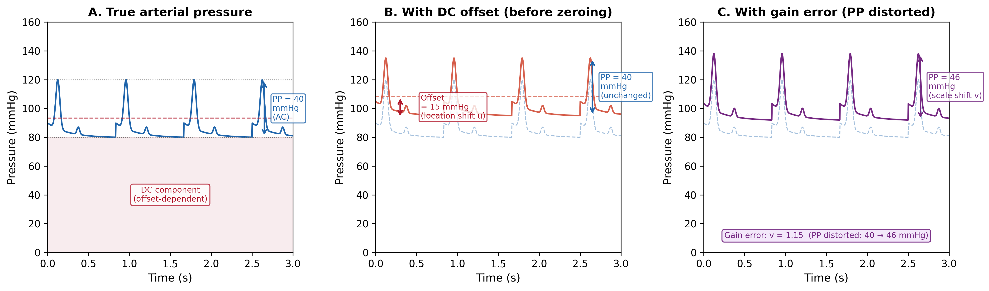
Figure 1. Arterial pressure waveform decomposition. (A) True arterial pressure with DC component (offset-dependent baseline) and AC component (pulse pressure, PP = 40 mmHg). (B) With DC offset of 15 mmHg (e.g., from hydrostatic column): PP remains unchanged at 40 mmHg because it is a differential quantity. (C) With gain error (v = 1.15): PP is distorted from 40 to 46 mmHg, demonstrating that PP accuracy validates sensor gain. Zero calibration corrects the offset in (B) but cannot correct the gain error in (C).

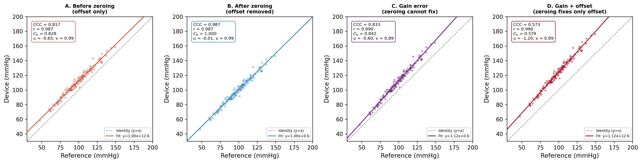
Figure 2. Concordance plots for four simulated scenarios (n = 150 paired measurements). (A) Before zeroing: offset produces location shift u = –0.55, reducing Cb to 0.867. (B) After zeroing: offset removed, CCC = 0.986 with Cb = 1.000. (C) Gain error (v = 1.11): zeroing cannot improve Cb (0.870) because the scale shift persists. (D) Gain + offset: CCC = 0.976; zeroing moves device from D to C but not to B. Dashed line = identity (y = x); solid line = best fit.

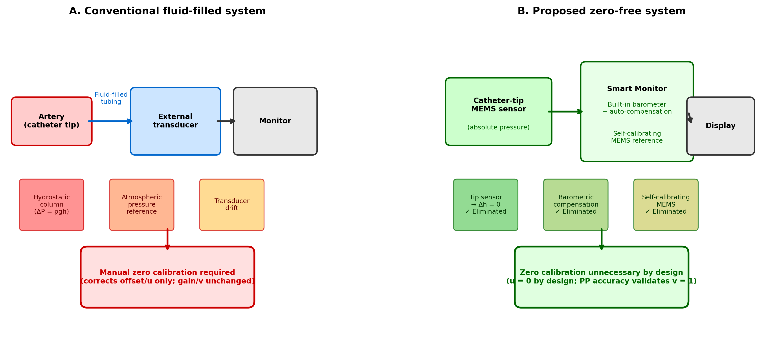
Figure 3. Comparison of conventional and proposed zero-free arterial pressure monitoring systems. (A) Conventional fluid-filled system: three sources of DC offset (hydrostatic column, atmospheric pressure reference, transducer drift) necessitate manual zero calibration, which corrects offset (u) only. (B) Proposed zero-free system: catheter-tip MEMS sensor eliminates hydrostatic column; built-in barometer provides electronic atmospheric compensation; self-calibrating MEMS eliminates drift. All offset sources are eliminated by design, and PP accuracy validates gain (v = 1).

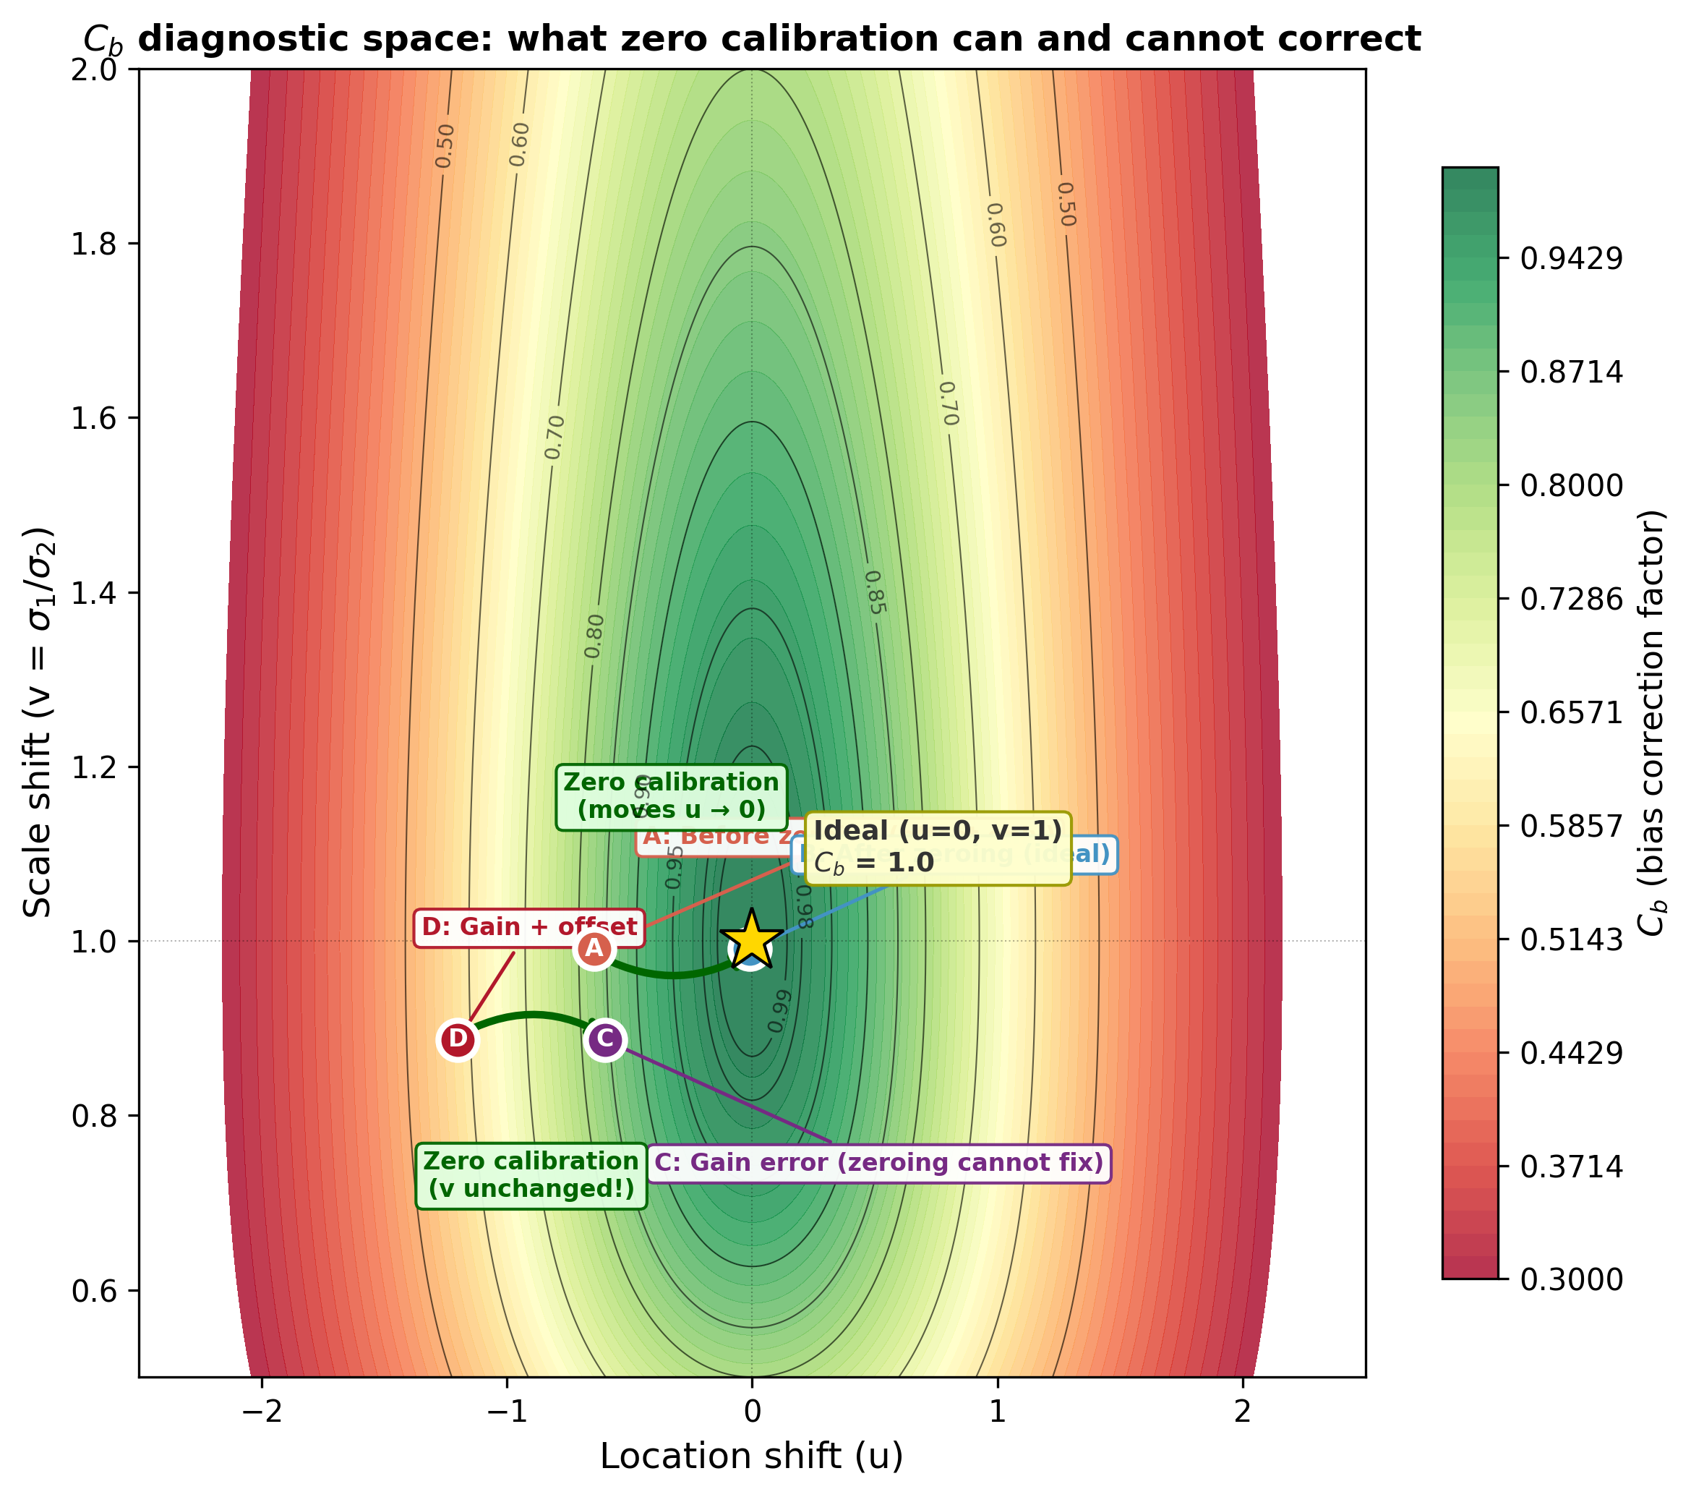
Figure 4. Bias correction factor (Cb) as a function of location shift (u) and scale shift (v). Contour lines show iso-Cb values. Zero calibration moves a device horizontally (u → 0, green arrows) but does not change v. Points A–D correspond to the scenarios in Figure 2. The gold star marks the ideal (u = 0, v = 1, Cb = 1.0). A device with correct gain (v = 1, validated by PP accuracy) and offset-free design (u = 0) achieves Cb = 1.0 without calibration.

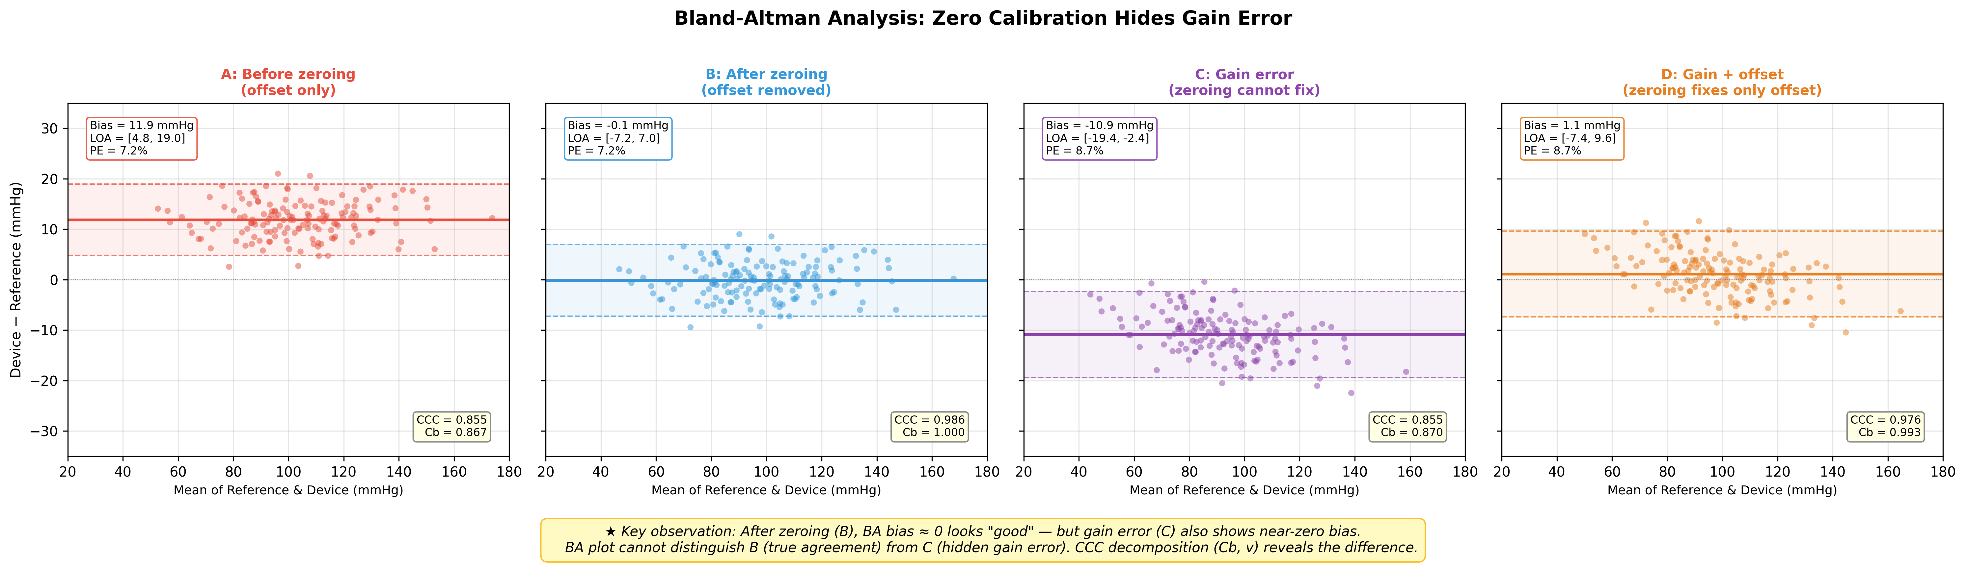
Figure 5. Bland-Altman analysis for the same four scenarios as Figure 2. Key observation: After zeroing (B), bias ≈ 0 appears as good agreement. However, gain error (C) also shows near-zero bias with similar limits of agreement, despite a fundamentally different error structure (v = 1.11). The Bland-Altman plot alone cannot distinguish true agreement (B) from hidden gain error (C). Compare CCC values in the lower-right corner of each panel: B has Cb = 1.000 while C has Cb = 0.870.

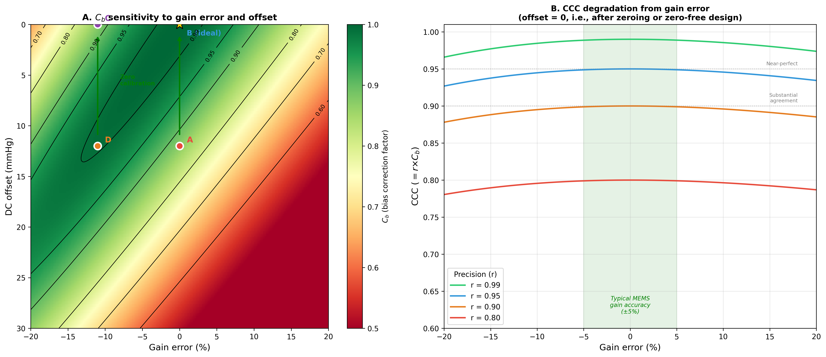
Figure 6. Sensitivity analysis. (A) Cb as a function of gain error (%) and DC offset (mmHg), showing that zero calibration (green arrows, vertical movement toward zero offset) improves Cb only when gain is correct. Points A–D correspond to the four scenarios. (B) CCC as a function of gain error for different levels of sensor precision (r), with offset = 0. The green-shaded zone shows typical MEMS gain accuracy (±5%), within which Cb > 0.99. Even highly precise sensors (r = 0.99) suffer substantial CCC degradation beyond ±10% gain error.

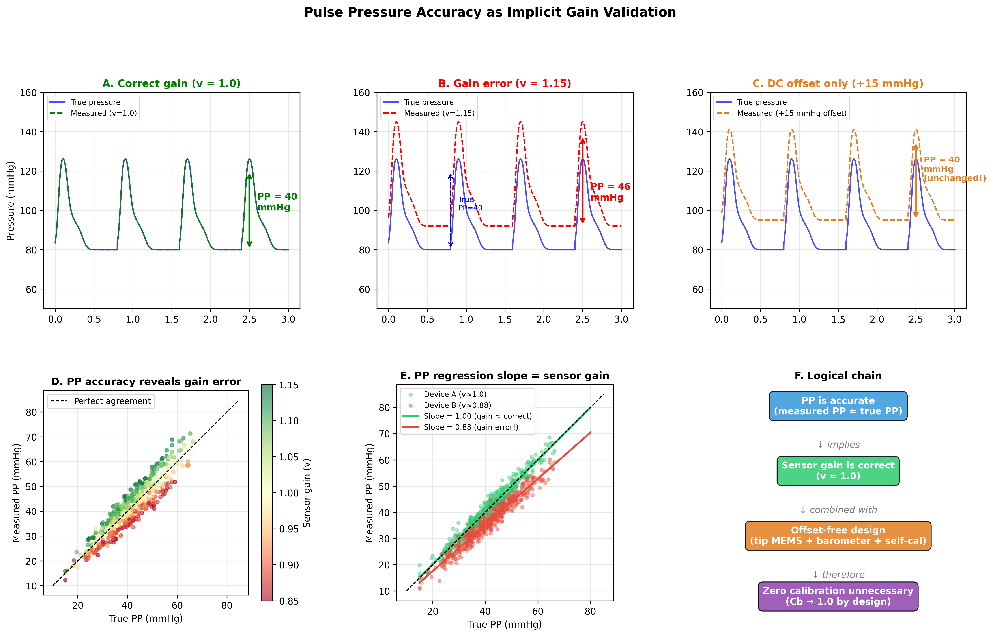
Figure 7. Pulse pressure accuracy as implicit gain validation. (A) Correct gain (v = 1.0): measured waveform matches true pressure, PP = 40 mmHg preserved. (B) Gain error (v = 1.15): waveform is amplitude-scaled, PP distorted from 40 to 46 mmHg. (C) DC offset only (+15 mmHg): waveform is shifted but PP remains 40 mmHg, unchanged. (D) Scatter plot showing that PP measurement accuracy correlates with sensor gain, colour-coded by actual gain. (E) PP regression: slope directly estimates sensor gain (Device A: correct gain, slope = 1.00; Device B: gain error, slope = 0.88). (F) Logical chain from PP accuracy to zero-calibration-free monitoring via gain validation and offset-free design.

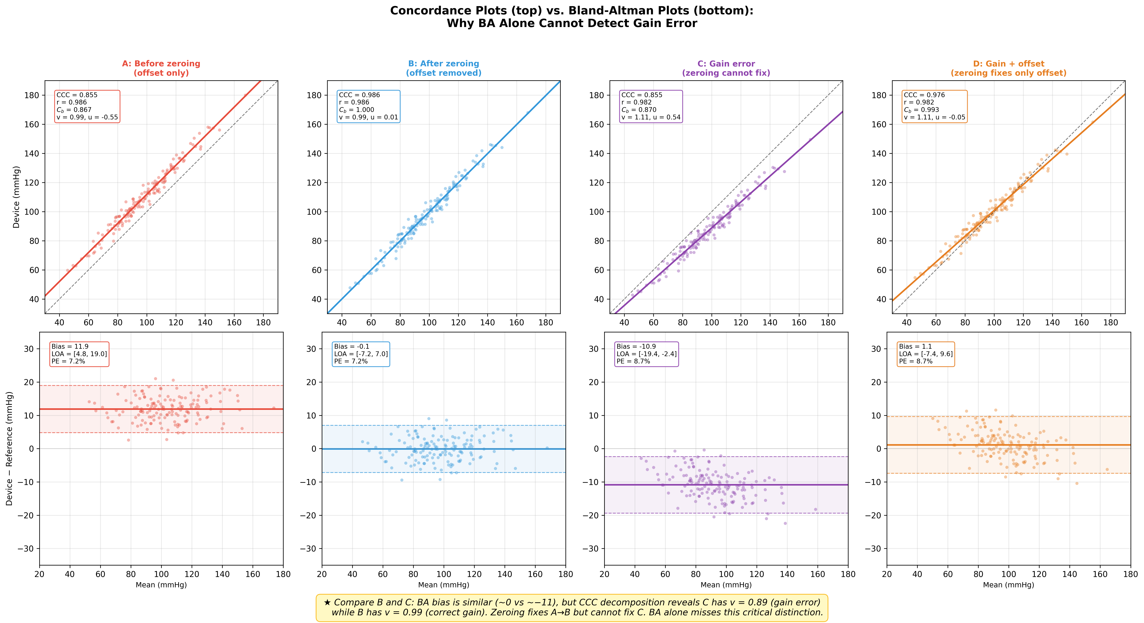
Figure 8. Direct comparison of concordance plots (top row) and Bland-Altman plots (bottom row) for all four scenarios, demonstrating why Bland-Altman analysis alone is insufficient. The concordance plots reveal the error structure through CCC decomposition (r, Cb, u, v), while the BA plots show only bias and limits of agreement. Critical comparison: Scenarios B and C have similar BA profiles (bias ≈ 0 vs. ≈11 mmHg), but concordance analysis reveals B has Cb = 1.000 (true agreement) while C has Cb = 0.870 (hidden gain error, v = 1.11). This distinction is invisible on the BA plot alone.

