Ambient heat as an under-recognised risk factor for US traffic-crash mortality: a distributed-lag analysis with road-safety implications
[PLACEHOLDER author list — Given-name Family-name, degrees; ... — replace before submission]
[PLACEHOLDER affiliations, numbered to authors]
Correspondence to: [PLACEHOLDER corresponding author, address, email, ORCID]

Abstract
Ambient heat is an established risk factor for mortality, and heat waves are increasing. Because driving continues in heat, some fatal crashes may involve heat-related impairment or unrecorded heat illness. We estimated the US traffic-crash mortality burden and explored the same question in Japan. We fitted quasi-Poisson distributed-lag models of the local seasonal temperature anomaly to state-day (USA) and prefecture-day (Japan) panels, adjusting for spatial, seasonal, trend and day-of-week terms. Data were FARS (2016-2022), Japanese NPA accident open data (2019-2024) and GHCN-Daily temperature. In the USA (270,497 crash deaths), a +9°C anomaly was associated with higher same-day crash mortality, RR 1.165 (95% CI 1.134-1.196), and the association remained positive after adjustment for driving activity, RR 1.162 (95% CI 1.132-1.193). The excess was larger for open-air users (motorcyclists RR 2.141, pedestrians RR 1.213) than vehicle occupants (RR 1.050). Net heat-attributable deaths were 513 per year (1.33%), similar to 527 recorded direct-heat deaths (ICD-10 X30); +1 to +3°C warming projected 339-983 additional deaths per year. An exploratory Japan comparison (11,576 deaths) found the data too sparse for a precise estimate. Unusually hot days are associated with an acute excess of US crash deaths comparable to recorded direct-heat mortality, concentrated in heat-exposed road users and projected to grow with warming. This is consistent with an under-recognised heat contribution, but the study cannot establish heat illness in any individual crash and the open-air gradient may partly reflect weather-related activity. The findings suggest heat-aware road safety and climate adaptation planning could address an uncounted burden.
Keywords: heat; traffic crash; mortality; climate change; distributed-lag model; road safety

1. Introduction
Road traffic crashes are a leading cause of preventable death, and climate change is adding a heat-related layer of risk. Heat waves are becoming more frequent, and ambient heat is an established driver of mortality [1,2]. Recent syntheses also link higher ambient temperature to increased road traffic accidents and injuries [3,4]. Occupational and driving activity do not stop during heat, so some fatal accidents plausibly involve heat-related impairment or overt heat illness. Traffic-crash deaths are of particular interest because decedents rarely undergo the post-mortem assessment that would identify a heat contribution, so any such contribution would be largely invisible in routine cause-of-death coding. We therefore ask whether days that are hotter than the local seasonal norm carry excess traffic-crash mortality, and how the magnitude compares with officially recorded direct-heat deaths. This is an ecological, population-level study whose aim is to gauge the potential societal burden of under-recognised heat illness—the deaths that would be missing from official heat statistics—rather than to diagnose heat illness in any individual crash. If population-level heat contributes to road deaths, heat-aware road safety messaging and occupational protections for outdoor riders and drivers could reduce a burden currently invisible to both heat-mortality and road-safety surveillance.

2. Methods
We built daily panels of traffic-crash deaths by US state (FARS, 2016-2022) [5] and by Japanese prefecture (NPA accident open data, 2019-2024) [6]. Daily mean temperature was taken from GHCN-Daily stations [7] as the mean of TMAX and TMIN, aggregated to each spatial unit from its nearest reporting stations. For every unit we estimated a cyclic day-of-year climatology and defined the temperature anomaly as the observed temperature minus that climatology,
$$A_{u,t} = T_{u,t} − {\overline{T}}_{u}(d_{t})$$
for the anomaly A of spatial unit u on day t, where T is the observed daily mean temperature and the barred T is the day-of-year climatology d(t) for that unit.
Absolute temperature is strongly confounded by the seasonal cycle of driving exposure, so our primary model used the anomaly. We fitted a quasi-Poisson distributed-lag model [8] of the form
$$log E(Y_{u,t}) = \sum_{k}{f_{k}(A_{u,t})} + α_{u} + s_{r(u)}(d_{t}) + h(t) + δ_{dow(t)}$$
where Y is the daily crash-death count, the fₖ are constant-free natural cubic splines of the anomaly within three lag windows (same day, 1-3 days, 4-10 days) summed over k, αᵤ are spatial fixed effects, s is a region-specific cyclic seasonal spline of day of year, h a long-term time trend and δ a day-of-week effect. Overdispersion was handled with a quasi-Poisson dispersion parameter. Net heat-attributable deaths were computed by the method of Gasparrini and Leone [9] with Monte Carlo (MC) confidence intervals (CIs). As a sensitivity analysis for the US we added national vehicle-miles travelled (VMT) [10] and finished-motor-gasoline product supplied [11] as activity proxies. Officially recorded direct-heat deaths (International Classification of Diseases, 10th revision [ICD-10] code X30) were obtained from CDC WONDER [12]. We performed three further US analyses: (i) refitting the same-day model within crash-hour bands to test whether the excess concentrates in the hottest hours; (ii) refitting it by road-user type (vehicle occupant, motorcyclist, pedestrian, cyclist) and age band from FARS person records, as a mechanistic and vulnerability analysis; and (iii) projecting the additional crash deaths under uniform warming scenarios of the daily temperature distribution (+1, +2, +3 °C), holding activity and baseline rates constant. All data are public and the full pipeline is reproducible from source (see Data availability). Reporting follows the Strengthening the Reporting of Observational Studies in Epidemiology (STROBE) guideline (checklist provided).
No ethics approval was required because the study used publicly available, aggregated and de-identified data with no individual patient records.

3. Results
The panels comprised 270,497 US crash deaths over 7 years (50 states) and 11,576 Japanese crash deaths over 6 years (47 prefectures); descriptive characteristics and the quasi-Poisson dispersion are summarised in Table 1.
Table 1. Panel description and model summary.
 | United States | Japan
Crash deaths | 270,497 | 11,576
Years | 7 | 6
Spatial units | 50 states | 47 prefectures
Dispersion (phi) | 1.23 | 1.05

In the descriptive absolute-temperature model, US crash mortality peaked at mild temperatures and declined at extreme heat (Fig. 1); this reflects the seasonal driving-exposure envelope and cannot be read as an acute heat effect. When we instead used the temperature anomaly, days hotter than the seasonal norm carried higher crash mortality (Fig. 2). A +9 °C anomaly was associated with higher same-day crash deaths, RR 1.165 (95% CI 1.134-1.196), with a cumulative lag 0-10 RR of 1.074 (95% CI 1.015-1.137).

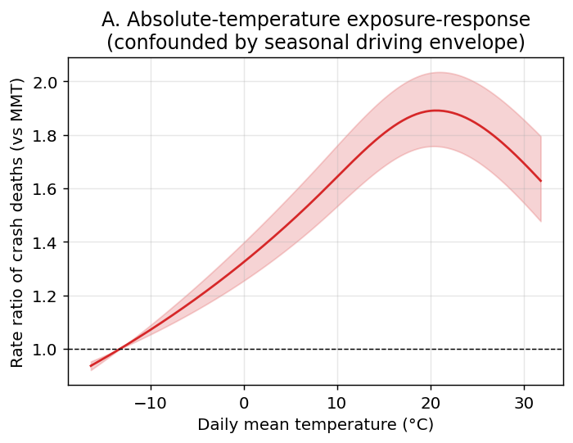
Figure 1. United States absolute-temperature exposure-response for daily traffic-crash deaths (cumulative over lag 0-10 days), relative to the minimum-mortality temperature. The curve peaks at mild temperatures and declines at extreme heat, reflecting the seasonal driving-exposure envelope rather than an acute heat effect.

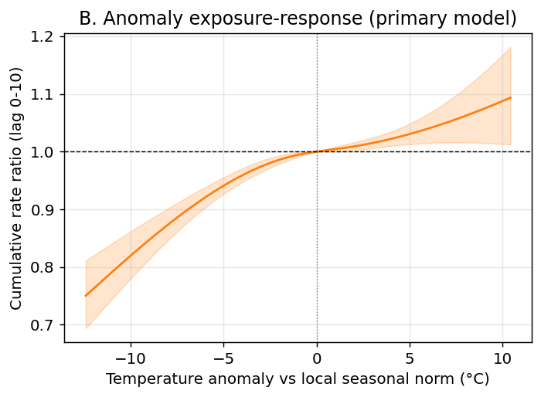
Figure 2. United States temperature-anomaly exposure-response (primary analysis): cumulative rate ratio of crash deaths versus the local day-of-year seasonal norm. Days hotter than normal carry higher crash mortality.

The lag structure showed an acute same-day excess followed by a deficit at 1-3 days, RR 0.934 (0.902-0.967), consistent with short-term displacement (harvesting) rather than a net addition of deaths (Fig. 3; Table 2). The same-day association was essentially unchanged after adjusting for national vehicle-miles travelled and gasoline supplied (RR 1.162, 95% CI 1.132-1.193), suggesting that day-to-day driving volume alone does not explain the effect.

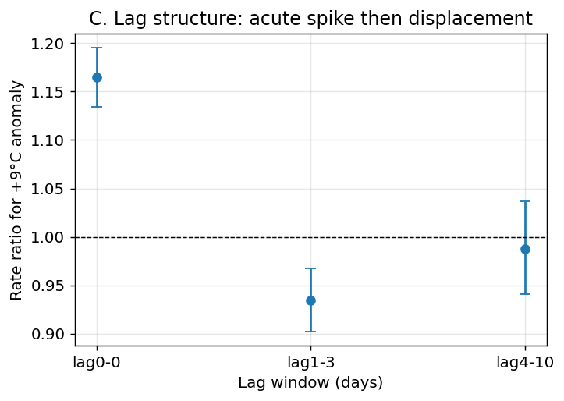
Figure 3. United States lag structure of the crash-death response to a +9 °C anomaly: an acute same-day excess followed by a 1-3 day deficit consistent with short-term displacement (harvesting) rather than a net addition of deaths.

Table 2. Rate ratio of traffic-crash deaths for a +9 °C temperature anomaly, by lag window.
Lag window (days) | United States | Japan
0 (same day) | 1.165 (1.134-1.196) | 0.940 (0.743-1.190)
1-3 | 0.934 (0.902-0.967) | 1.146 (0.739-1.779)
4-10 | 0.988 (0.941-1.037) | 0.521 (0.217-1.249)
Cumulative 0-10 | 1.074 (95% CI 1.015-1.137) | 0.562 (95% CI 0.207-1.525)

Two exploratory analyses were consistent with a heat mechanism, although neither can exclude residual confounding. First, the same-day excess differed by road-user exposure (Fig. 4; Table 3): the effect was small for enclosed, often air-conditioned, vehicle occupants, RR 1.050 (1.016-1.085), but larger for open-air users—motorcyclists, RR 2.141 (2.000-2.292); pedestrians, RR 1.213 (1.145-1.286); and cyclists, RR 1.237 (1.032-1.484)—a gradient consistent with direct bodily heat exposure and physical exertion [13], though it could also partly reflect greater discretionary open-air travel (motorcycling, cycling, walking) on hotter-than-normal days, which our aggregate activity proxies do not capture by mode. Across age bands the excess was of similar size: age <25 y RR 1.123 (1.059-1.191); 25-64 y RR 1.177 (1.140-1.216); 65+ y RR 1.167 (1.104-1.234) (Table 3), giving no clear age gradient. Second, the excess was largest for crashes in the hottest part of the day (12-17 h), RR 1.212 (1.155-1.272), and weakest in the cool morning (06-11 h), RR 1.062 (1.000-1.127); the overnight band was also elevated (00-05 h), RR 1.179 (1.110-1.253), so the diurnal pattern is not a clean daytime-only gradient (Fig. 5). These road-user, age and time-of-day analyses are hypothesis-generating: they involve multiple unadjusted comparisons and are not individual-level tests of susceptibility or mechanism.

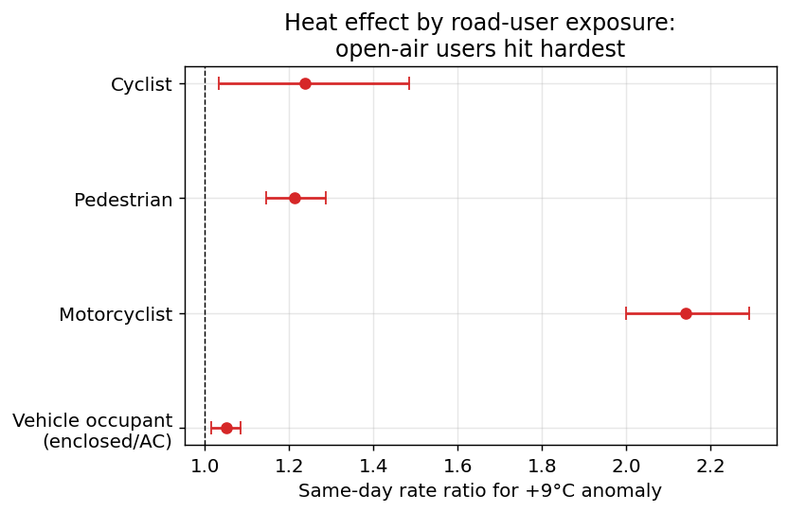
Figure 4. United States same-day rate ratio of crash death for a +9 °C anomaly by road-user type. Open-air users (motorcyclists, pedestrians, cyclists) show much larger heat effects than enclosed, often air-conditioned, vehicle occupants—a gradient that tracks direct heat exposure rather than driving volume.

Table 3. United States same-day rate ratio of crash death for a +9 °C anomaly, by road-user type and age band (vulnerability analysis).
Subgroup | Crash deaths | Same-day RR (95% CI)
Vehicle occupant | 178,365 | 1.050 (1.016-1.085)
Motorcyclist | 38,248 | 2.141 (2.000-2.292)
Pedestrian | 46,022 | 1.213 (1.145-1.286)
Cyclist | 6,356 | 1.237 (1.032-1.484)
Age <25 y | 54,003 | 1.123 (1.059-1.191)
Age 25-64 y | 166,699 | 1.177 (1.140-1.216)
Age 65+ y | 49,680 | 1.167 (1.104-1.234)

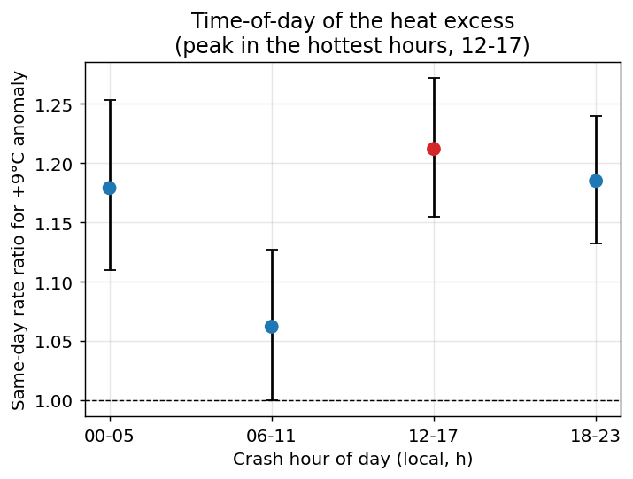
Figure 5. United States same-day rate ratio of crash death for a +9 °C anomaly by crash hour of day. The excess is largest for crashes in the hottest part of the day (12-17 h) and weakest in the cool morning (06-11 h).

Net heat-attributable crash deaths were 513 per year (95% CI 410-615), an attributable fraction of 1.33% (Fig. 6; Table 4). This is of the same order as the 527 officially recorded direct-heat deaths per year (ICD-10 X30, 2016-2020; Fig. 7), so a heat contribution to road deaths on the scale of recorded direct-heat mortality could go unrecorded in cause-of-death statistics.

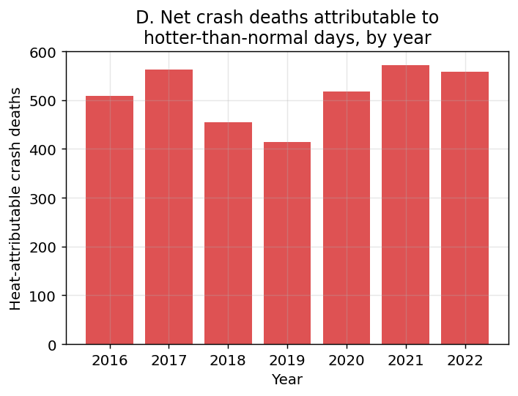
Figure 6. United States estimated net heat-attributable crash deaths per year, 2016-2022.

Table 4. United States net heat-attributable crash deaths versus officially recorded direct-heat deaths.
Quantity | Estimate
Net heat-attributable crash deaths / year | 513
Attributable fraction (%) | 1.33
Official direct-heat deaths / year (X30, 2016-2020) | 527

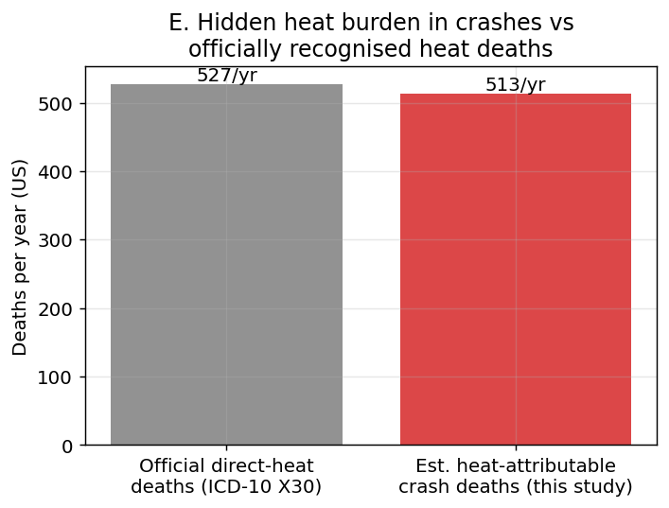
Figure 7. United States comparison of estimated net heat-attributable crash deaths per year with officially recorded direct-heat deaths (ICD-10 X30) from CDC WONDER.

To gauge the trajectory under continued warming, we applied the estimated anomaly exposure-response to uniformly warmer daily temperatures, holding driving activity and baseline rates constant [14]. A uniform +1 °C shift projected 339 additional US crash deaths per year (95% CI 250-428), rising to 983 (644-1356) at +3 °C (Fig. 8; Table 5). These are scenario projections, not observed quantities, and assume the anomaly response is stable under a warmer mean climate.

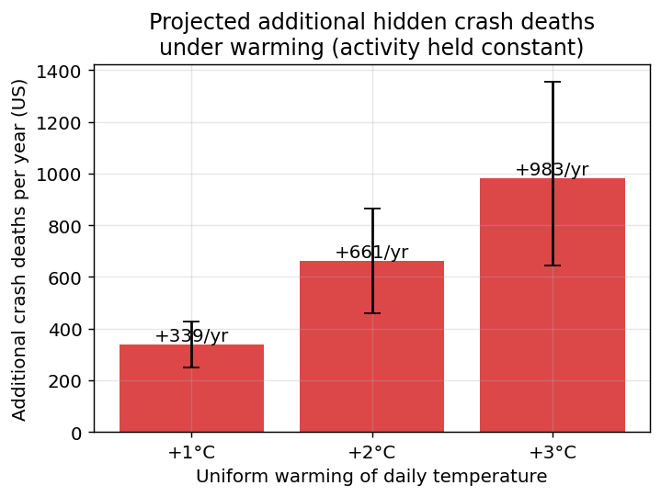
Figure 8. United States projected additional traffic-crash deaths per year under uniform warming of the daily temperature distribution by +1, +2 and +3 °C, holding driving activity and baseline rates constant. Bars show the point estimate with 95% Monte Carlo confidence intervals; this is a scenario projection, not an observed quantity.

Table 5. United States projected additional traffic-crash deaths per year under uniform warming (activity held constant); scenario projection, not observed.
Warming | Additional deaths/year (95% CI)
+1°C | 339 (250-428)
+2°C | 661 (459-864)
+3°C | 983 (644-1356)

Exploratory Japan comparison
In Japan (11,576 crash deaths over 6 years) the anomaly exposure-response was imprecise, with a wide confidence band that included the null throughout (Fig. 9); the same-day point estimate for a +9 °C anomaly was 0.940 (95% CI 0.743-1.190) and was not stable across specifications. A direct comparison of the two countries (Fig. 10) shows a precise acute effect in the US, whereas the Japanese panel—with roughly 20-fold fewer annual crash deaths and sparser temperature coverage—is underpowered.

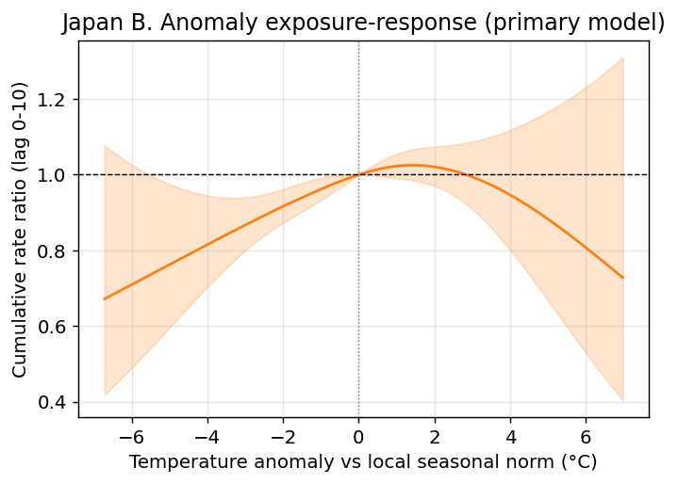
Figure 9. Japan temperature-anomaly exposure-response (2019-2024). The estimate is imprecise: the confidence band is wide and includes the null throughout.

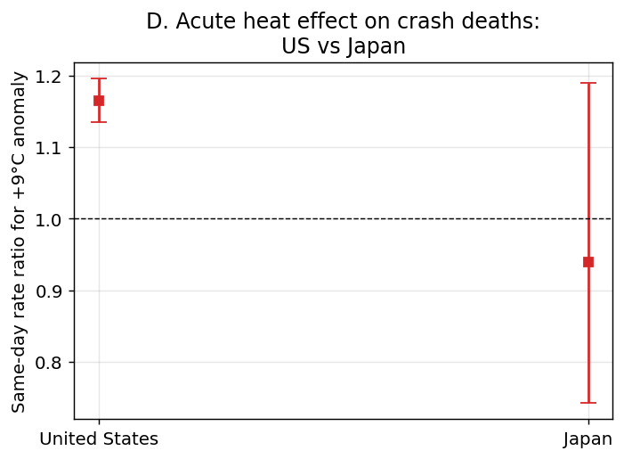
Figure 10. Same-day rate ratio of traffic-crash deaths for a +9 °C anomaly, United States versus Japan. The US shows a precise acute effect; the Japanese estimate is underpowered.

4. Discussion
A +9 °C temperature anomaly was associated with a same-day rate ratio of 1.165 (95% CI 1.134-1.196) for US traffic-crash deaths, and the net annual heat-attributable burden was 513 deaths (95% CI 410-615), similar to the 527 officially recorded direct-heat deaths per year. This acute, same-day excess was not explained by aggregate driving activity, and the 1-3 day deficit indicates that part of the excess reflects short-term displacement (harvesting). These findings are consistent with heat-related impairment or under-recognised heat illness contributing to road deaths without appearing in cause-of-death data [3,4].
Two features of the data are consistent with a direct heat effect rather than confounding by overall driving volume. The excess was graded by bodily heat exposure—minimal for enclosed, frequently air-conditioned vehicle occupants but several-fold larger for motorcyclists, pedestrians and cyclists, who are directly exposed and often physically exerting—and it was largest in the hottest hours of the day. Both patterns are consistent with heat degrading psychomotor and cognitive performance. These gradients are not proof of mechanism, however: open-air travel is itself weather-sensitive, so more motorcycling, cycling and walking on hotter-than-normal days could inflate the open-air estimates through greater exposure rather than physiology, and our activity proxies are national and not mode-specific. Applied to a warmer mean climate, the same exposure-response implies hundreds of additional US crash deaths per year per degree of warming; because these deaths would continue to be coded as ordinary crashes, the societal heat burden they represent would remain uncounted by heat-mortality surveillance.

Implications for road safety
These results point to practical implications for road safety and climate adaptation. Because the same-day excess was largest among open-air road users and in the hottest hours, heat warnings and travel advice could be targeted at motorcyclists, cyclists, pedestrians and outdoor delivery riders during hot periods. Road safety agencies typically classify fatal crashes by driver error, vehicle failure or road conditions; the possibility that ambient heat impairs psychomotor or cognitive performance is rarely considered. Integrating temperature forecasts into crash-prevention messaging and ensuring heat-health plans reach outdoor workers and commuters is consistent with a Safe System approach to environmental risk and could reduce a burden that is currently invisible to both heat-mortality and road-safety surveillance, though intervention studies are needed to test whether such heat-aware measures reduce crash risk.
Several limitations apply. First, this is an ecological, population-level association: it cannot establish that heat caused illness in any specific crash, and FARS and NPA carry no post-mortem heat diagnosis. Second, activity adjustment used national, not daily state-level, proxies. Third, exposure is measured at the spatial-unit level and misclassifies individual exposure. Fourth, the Japanese analysis is underpowered and inconclusive; its shorter series, far smaller death counts and sparser GHCN-Daily coverage preclude a firm estimate, and we therefore do not pool the two countries. Fifth, the warming projection is a scenario calculation that holds driving activity, the vehicle fleet and behaviour fixed and assumes the anomaly response is stable under a warmer mean climate; it should be read as illustrative of magnitude, not as a forecast. Sixth, the road-user, age and time-of-day subgroup analyses are exploratory: they entail multiple comparisons without formal adjustment, and the open-air road-user gradient may in part reflect weather-related differences in activity rather than physiology. Finally, we used a quasi-Poisson dispersion parameter but did not model residual serial correlation explicitly, which could affect confidence intervals. These findings should motivate, but cannot replace, individual-level studies linking crash decedents to ambient heat and, where available, post-mortem findings.

5. Conclusion
Unusually hot days are associated with an acute, same-day excess of US traffic-crash mortality comparable to recorded direct-heat deaths, supporting the plausibility of an under-recognised heat contribution to road deaths. The findings suggest heat-aware road safety and climate adaptation planning could reduce an uncounted burden, although the Japanese data are too sparse for a firm conclusion and individual-level mechanistic evidence is still needed.

Contributors
[PLACEHOLDER — replace before submission.] All authors contributed to the study design, data analysis, interpretation and drafting, and approved the final manuscript. [Specify each author's contribution and who verified the underlying data.]

Declaration of competing interests
[PLACEHOLDER — replace before submission.] We declare no competing interests.

Funding
[PLACEHOLDER — replace before submission.] There was no specific funding for this study. The corresponding author had full access to all the data and had final responsibility for the decision to submit for publication.

Declaration of generative AI use
[PLACEHOLDER — confirm and adapt before submission.] Generative AI assistance was used to help develop analysis code and draft text; all methods, results and interpretations were verified by the authors, who take full responsibility for the content.

Data availability
All data are public: FARS, GHCN-Daily, CDC WONDER, FHWA/FRED, EIA and the Japanese NPA accident open data (see References for sources). The complete analysis code and reproducible pipeline (make all for data and figures, then make aap for the manuscript and submission package) are openly available in the project repository; every reported number, figure and table is regenerated from source with no hard-coded values.

References
1. Gasparrini A, Guo Y, Hashizume M, et al. Mortality risk attributable to high and low ambient temperature: a multicountry observational study. Lancet 2015;386:369-75.
2. Basu R. High ambient temperature and mortality: a review of epidemiologic studies from 2001 to 2008. Environ Health 2009;8:40.
3. Liang M, Min M, Guo X, Song Q, Wang H, Li N, et al. The relationship between ambient temperatures and road traffic injuries: a systematic review and meta-analysis. Environ Sci Pollut Res 2022;29(33):50647-60.
4. Liang M, Zhao D, Wu Y, Ye P, Wang Y, Yao Z, et al. Short-term effects of ambient temperature and road traffic accident injuries in Dalian, Northern China: A distributed lag non-linear analysis. Accid Anal Prev 2021;153:106057.
5. National Highway Traffic Safety Administration. Fatality Analysis Reporting System (FARS). US Department of Transportation. https://www.nhtsa.gov/research-data/fatality-analysis-reporting-system-fars
6. National Police Agency of Japan. Traffic accident statistics open data. https://www.npa.go.jp/publications/statistics/koutsuu/opendata/
7. Menne MJ, Durre I, Vose RS, Gleason BE, Houston TG. An overview of the Global Historical Climatology Network-Daily database. J Atmos Ocean Technol 2012;29:897-910.
8. Gasparrini A, Armstrong B, Kenward MG. Distributed lag non-linear models. Stat Med 2010;29:2224-34.
9. Gasparrini A, Leone M. Attributable risk from distributed lag models. BMC Med Res Methodol 2014;14:55.
10. Federal Highway Administration. Traffic Volume Trends. https://www.fhwa.dot.gov/policyinformation/travel_monitoring/tvt.cfm
11. US Energy Information Administration. Weekly finished motor gasoline product supplied (PET.WGFUPUS2.W). https://www.eia.gov/
12. Centers for Disease Control and Prevention. CDC WONDER Underlying Cause of Death database. https://wonder.cdc.gov/
13. Daanen HAM, van de Vliert E, Huang X. Driving performance in cold, warm, and thermoneutral environments. Appl Ergon 2003;34:597-602.
14. IPCC. Climate Change 2021: The Physical Science Basis. Contribution of Working Group I to the Sixth Assessment Report of the Intergovernmental Panel on Climate Change. Cambridge: Cambridge University Press; 2021.

