Traffic-crash mortality during unusually hot days in the United States: distributed-lag and road-user-specific analyses
Tatsuki Onishi
Data Science and AI Innovation Research Promotion Center, Shiga University of Medical Science, Seta Tsukinowa-cho, Otsu, Shiga 520-2192, Japan
Corresponding author: Tatsuki Onishi (bougtoir@gmail.com)

Abstract
Prior studies have linked heat and heat waves to road crashes, including fatal crashes, but less is known about locally unusual heat relative to seasonal norms, its lag structure, and the mortality burden involved. We fitted quasi-Poisson distributed-lag models relating daily mean-temperature anomalies (departures from each spatial unit's day-of-year climatology) to traffic-crash deaths in US state-day (Fatality Analysis Reporting System, 2016-2022; 272,586 deaths) and Japanese prefecture-day (National Police Agency, 2019-2024; 11,576 deaths) panels. In the US, a +9 °C anomaly was associated with higher same-day mortality (rate ratio 1.165, 95% CI 1.135-1.196), followed by a 1-3 day deficit consistent with short-term temporal displacement in aggregate crash mortality; the cumulative 0-10 day rate ratio was 1.076 (1.017-1.139). The excess was much larger for open-air road users (motorcyclists, pedestrians, cyclists) than for vehicle occupants. Model-based net heat-attributable mortality was about 528 deaths per year (1.36% of crash deaths), numerically similar to officially coded direct-heat mortality, although the two measures represent different constructs. Japanese estimates were imprecise and did not provide clear replication. Days that are unusually hot for the local season are associated with an acute excess of US crash mortality, with substantially larger associations among open-air road users.
Keywords: temperature anomaly; extreme heat; traffic-crash mortality; distributed-lag model; road-user heterogeneity; biometeorology

Introduction
Road traffic crashes are a leading cause of preventable death worldwide, and ambient heat is an established driver of daily mortality (Gasparrini et al. 2015; Basu 2009). That heat also affects road safety is likewise well documented. In a nationwide time-stratified case-crossover analysis of the continental United States, fatal traffic crashes were 3.4% (95% CI 0.9-5.9%) more frequent on heat-wave days than on non-heat-wave days (Wu et al. 2018), and daily time-series studies have reported increases in crash and injury risk with higher temperatures and during heat waves (Basagaña et al. 2015; Liang et al. 2021; Liang et al. 2022). More recent work has extended this evidence to road-traffic mortality and to vulnerable road users: across 272 Latin-American cities, road-traffic mortality rose monotonically with temperature, with the largest risks among adolescents, males, motorcyclists and bicyclists (Hsu et al. 2025), and across 177 Californian cities, extreme heat was associated with fatal and severe crashes, particularly at intersections and among pedestrians and bicyclists (Hsu et al. 2026). In Japan, a nationwide case-crossover study spanning 1972-2019 estimated that transport accident mortality increased by 1.47% (95% CI 1.10-1.85%) per 1 °C of daily mean temperature (Pan et al. 2024).
Three aspects of this relationship remain less well characterised. First, most prior studies used absolute temperature or fixed heat-wave thresholds; how locally unusual heat—departures from the seasonal conditions to which populations and travel behaviour are adapted—relates to crash mortality has received less attention, even though anomaly-based metrics are central to biometeorological studies of heat-health relationships. Second, the temporal structure of the association—whether an acute excess is followed by compensating deficits, i.e. a temporal redistribution pattern—has rarely been decomposed for crash mortality, leaving open whether the association adds deaths or reflects short-term displacement at the population level. Third, the population mortality burden attributable to such exposure, in deaths per year, has not been quantified at the national scale alongside the risk ratios that dominate the literature.
We therefore analysed nationwide US traffic-crash mortality (Fatality Analysis Reporting System [FARS], 2016-2022) against daily mean-temperature anomalies relative to each state's day-of-year climatology, using a quasi-Poisson distributed-lag model that separates an acute same-day component from subsequent lag windows. We examined heterogeneity by road-user type, age, hour of day and crash circumstances as hypothesis-generating analyses, estimated the net heat-attributable mortality burden, and assessed external transportability using a harmonized prefecture-level analysis of Japanese accident statistics (2019-2024). We hypothesised that hotter-than-normal days would carry a same-day excess of crash deaths, that the excess would be larger for road users with greater bodily heat exposure, and that part of the acute excess would be offset at longer lags.

Methods

Data and panels
We built daily panels of traffic-crash deaths by US state (FARS, 2016-2022)(NHTSA n.d.) and by Japanese prefecture (National Police Agency [NPA] accident open data, 2019-2024)(NPA n.d.). Daily mean temperature was taken from the Global Historical Climatology Network-Daily (GHCN-Daily) stations(Menne et al. 2012) as the mean of daily maximum and minimum temperature, aggregated to each spatial unit from its nearest reporting stations. State-level precipitation and, in sensitivity analyses, daily average dew point, relative humidity and average wet-bulb temperature were taken from the same stations and used to compute the humidex, the US National Weather Service heat index and an estimated wet-bulb globe temperature (0.7 times wet-bulb plus 0.3 times air temperature).

Exposure definition
For every spatial unit we estimated a cyclic day-of-year climatology and defined the exposure as the anomaly of observed daily mean temperature from that climatology,
$$A_{u,t} = T_{u,t} − {\overline{T}}_{u}(d_{t})$$
for the anomaly A of spatial unit u on day t, where T is the observed daily mean temperature and the barred T is the day-of-year climatology d(t) for that unit. The anomaly isolates locally unusual heat: absolute temperature is strongly confounded by the seasonal cycle of driving exposure (summer days are both warmer and busier), so an absolute-temperature model is reported only descriptively (Fig. S1) and the anomaly is the primary exposure. The reference point for all contrasts is an anomaly of 0 °C, i.e. a day exactly at the local seasonal norm.

Statistical model
We fitted a quasi-Poisson distributed-lag model(Gasparrini et al. 2010) of the form
$$log E(Y_{u,t}) = \sum_{k}{f_{k}(A_{u,t})} + α_{u} + s_{r(u)}(d_{t}) + h(t) + δ_{dow(t)}$$
where Y is the daily crash-death count, the fₖ are constant-free natural cubic splines of the anomaly within three lag windows (same day, 1-3 days, 4-10 days) summed over k, αᵤ are spatial fixed effects, s is a region-specific cyclic seasonal spline of day of year, h a long-term time trend and δ a day-of-week effect. Each exposure-response spline had 4 df (3 effective df after removing the constant); the US and Japanese seasonal splines had 8 and 6 df respectively, and the long-term trend had 3 df per study year. Overdispersion was handled with a quasi-Poisson dispersion parameter. The +9 °C reporting contrast lies near the upper end of the observed positive-anomaly range while remaining within the support of the estimated response (approximately −12 to +10 °C), so no extrapolation is involved; as a robustness check we report the same-day and cumulative rate ratios at +5 °C and at the empirical 95th percentile of the anomaly distribution alongside +9 °C (Table S1).

Attributable burden and scenario translation
Net heat-attributable deaths were computed by the method of Gasparrini and Leone(Gasparrini and Leone 2014) with Monte Carlo confidence intervals (CIs): for each day the excess relative to the seasonal norm was accumulated from the fitted exposure-response and summed over the study period. To gauge the order of magnitude of this model-based burden we juxtaposed it with officially coded direct-heat deaths (International Classification of Diseases, 10th revision code X30) obtained from CDC WONDER(CDC n.d.); the two quantities measure different constructs (a modelled attributable burden versus a coded cause of death) and are not equivalent. Separately, we applied the fitted anomaly association to a uniform +1, +2 and +3 °C shift of the daily temperature distribution as an illustrative scenario translation(IPCC 2021)—holding baseline population, driving activity, the vehicle fleet and adaptation constant—reported in the supplement (Fig. S4, Table S3); it is not a forecast.

Sensitivity and stratified analyses
As sensitivity analyses for the US we added (i) national vehicle-miles travelled (VMT)(FHWA n.d.) and finished-motor-gasoline product supplied(US EIA n.d.) as activity proxies, and (ii) a richer control set with state annual population entered as a log offset(US Census Bureau n.d.), state annual VMT(FHWA n.d.) and daily state precipitation, all as z-scored linear terms except the population offset, plus GHCN-derived heat-stress metrics expressed as anomalies relative to their day-of-year climatology. Because heat-stress metrics are functions of temperature and can be collinear with the anomaly exposure, the primary full-controls model was selected by a variance-inflation-factor (VIF) screen that iteratively drops added controls with VIF > 10; a stricter VIF < 5 screen and an unscreened model were also fitted. Because crash spikes have been reported around daylight-saving-time transitions, we also refit the primary model excluding state-days within 7 days of each US clock change. Stratified refits by road-user type (vehicle occupant, motorcyclist, pedestrian, cyclist), age band, crash hour band and crash circumstances (manner of collision, weather condition, rural/urban land use, police-reported driver drinking) are exploratory subgroup analyses; they involve multiple comparisons without formal adjustment and are interpreted as hypothesis-generating rather than confirmatory.

External transportability analysis
The Japanese prefecture-day panel was analysed with the same anomaly definition and model family as a harmonized exploratory external-transportability assessment. Because the Japanese death counts are much smaller and GHCN-Daily coverage sparser, we did not pool the two countries and we interpret the Japanese results as an external comparison of the direction and precision of the association, not as a confirmatory replication.
No ethics approval was required because the study used publicly available, aggregated and de-identified data with no individual records. Generative artificial-intelligence tools were used to assist with code development and manuscript drafting; the author reviewed and verified all content and takes full responsibility for the work. Reporting follows the STROBE guideline (checklist provided).

Results
The panels comprised 272,586 US crash deaths over 7 years (50 states) and 11,576 Japanese crash deaths over 6 years (47 prefectures) (Table 1). In the descriptive absolute-temperature model, US crash mortality peaked at mild temperatures and declined at extreme heat (Fig. S1); this reflects the seasonal driving-exposure envelope and cannot be read as an acute heat effect.
Table 1 Panel description and model summary.
 | United States | Japan
Crash deaths | 272,586 | 11,576
Years | 7 | 6
Spatial units | 50 states | 47 prefectures
Dispersion (phi) | 1.23 | 1.05

Using the temperature anomaly as the exposure, days hotter than the seasonal norm carried higher crash mortality (Fig. 1). A +9 °C anomaly was associated with higher same-day crash deaths, RR 1.165 (95% CI 1.135-1.196). The lag structure showed an acute same-day excess followed by a deficit at 1-3 days, RR 0.936 (0.904-0.968), consistent with short-term temporal displacement in aggregate crash mortality rather than a net addition of deaths at every lag (Fig. 2; Table 2); the cumulative 0-10 day RR was 1.076 (95% CI 1.017-1.139). The conclusion was not sensitive to the choice of contrast: same-day and cumulative RRs were similar at +5 °C and at the empirical 95th-percentile anomaly (Table S1).

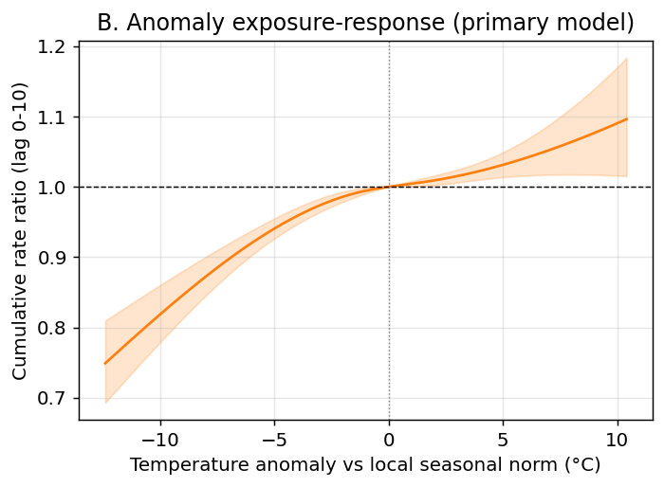
Fig. 1 United States temperature-anomaly exposure-response (primary analysis): cumulative rate ratio of traffic-crash deaths versus the local day-of-year seasonal norm. Days hotter than normal carry higher crash mortality.

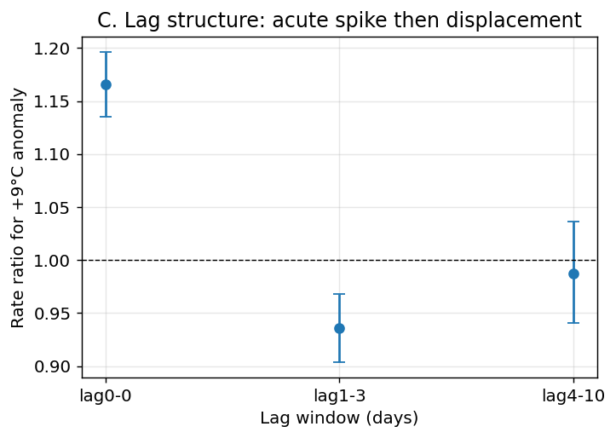
Fig. 2 United States lag structure of the crash-death response to a +9 °C anomaly: an acute same-day excess followed by a 1-3 day deficit consistent with short-term temporal displacement in aggregate crash mortality.

Table 2 Rate ratio of traffic-crash deaths for a +9 °C temperature anomaly relative to the seasonal norm, by lag window.
Lag window (days) | United States | Japan
0 (same day) | 1.165 (1.135-1.196) | 0.940 (0.743-1.190)
1-3 | 0.936 (0.904-0.968) | 1.146 (0.739-1.779)
4-10 | 0.987 (0.941-1.036) | 0.521 (0.217-1.249)
Cumulative 0-10 | 1.076 (95% CI 1.017-1.139) | 0.562 (95% CI 0.207-1.525)

The same-day association was essentially unchanged after adjusting for national vehicle-miles travelled and gasoline supplied (RR 1.163, 95% CI 1.133-1.194; cumulative RR 1.075 (1.015-1.138)). A VIF-screened full-controls model—starting with state population as a log offset plus z-scored state annual VMT, daily precipitation and the three heat-stress metrics, then iteratively dropping any added control with VIF > 10—retained log-population offset, daily precipitation and estimated WBGT anomaly (dropped: vmt_state, humidex_anom, heat_index_anom); the same-day RR remained similar (RR 1.170 (1.122-1.219)) while the cumulative 0-10 day RR was attenuated (RR 1.086 (1.019-1.157)). A stricter VIF < 5 screen gave 1.165 (1.135-1.196) and the unscreened model 1.070 (1.021-1.121) (max control VIF 323.8). Excluding state-days around daylight-saving-time transitions left the estimate unchanged (same-day RR 1.166 (1.136-1.197)). All sensitivity results are in Table 3.
Table 3 United States sensitivity of the +9 °C anomaly association to activity, precipitation and heat-stress controls. All added continuous controls were z-scored; population entered as a log offset; heat-stress metrics were anomaly-derived. The VIF < 10 row is the primary full-controls model; a stricter VIF < 5 screen and an unscreened model are shown for comparison.
Model | Same-day RR (95% CI) | Cumulative RR (95% CI) | Max control VIF
National VMT + motor gasoline | 1.163 (1.133-1.194) | 1.075 (1.015-1.138) | 5.3
State population offset | 1.165 (1.135-1.196) | 1.075 (1.015-1.138) | -
+ state annual VMT | 1.165 (1.135-1.196) | 1.073 (1.014-1.136) | 323.8
+ state VMT + precipitation | 1.165 (1.135-1.196) | 1.082 (1.022-1.145) | 323.8
Full controls, no VIF screen | 1.070 (1.021-1.121) | 1.005 (0.941-1.073) | 323.8
VIF-screened full controls (VIF < 10) | 1.170 (1.122-1.219) | 1.086 (1.019-1.157) | 8.5
VIF-screened full controls (VIF < 5) | 1.165 (1.135-1.196) | 1.083 (1.023-1.146) | 1.1
+ humidex anomaly | 1.176 (1.128-1.226) | 1.089 (1.023-1.160) | 323.8
+ heat-index anomaly | 1.049 (1.002-1.097) | 0.989 (0.927-1.055) | 323.8
+ estimated WBGT anomaly | 1.168 (1.120-1.217) | 1.083 (1.017-1.154) | 323.8
Excluding +/-7 d around DST transitions | 1.166 (1.136-1.197) | 1.072 (1.012-1.135) | -

The same-day excess differed markedly by road-user type (Fig. 3; Table 4): small for enclosed, often air-conditioned vehicle occupants (RR 1.050 (1.017-1.085)) but several-fold larger for motorcyclists (RR 2.140 (2.000-2.290)), pedestrians (RR 1.215 (1.147-1.288)) and cyclists (RR 1.243 (1.038-1.490)). This heterogeneity is compatible with differences in heat exposure, vehicle protection, travel behaviour and other mode-specific factors; it does not by itself demonstrate a physiological mechanism, because discretionary open-air travel may also increase on hotter-than-normal days. Across age bands the excess was similar (<25 y RR 1.123 (1.059-1.190); 25-64 y RR 1.176 (1.139-1.215); 65+ y RR 1.176 (1.113-1.242)). The excess was largest for crashes in the hottest part of the day (12-17 h, RR 1.217 (1.160-1.276)) and weakest in the cool morning (06-11 h, RR 1.062 (1.001-1.127)), although the overnight band was also elevated, so the diurnal pattern is not a clean daytime-only gradient (Fig. S2).

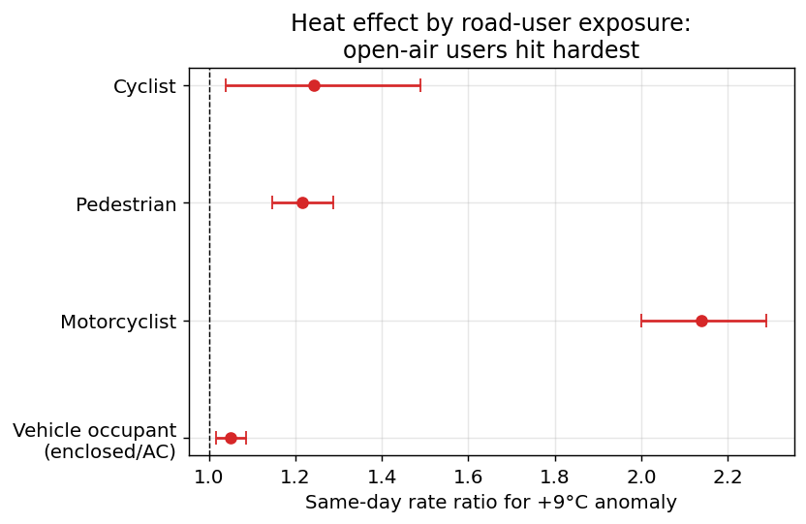
Fig. 3 United States same-day rate ratio of crash death for a +9 °C anomaly by road-user type. Estimates for open-air users (motorcyclists, pedestrians, cyclists) are larger than for enclosed, often air-conditioned, vehicle occupants. This gradient is compatible with differences in heat exposure, vehicle protection, travel behaviour and other mode-specific factors; the subgroup analysis is exploratory and not adjusted for multiple comparisons.

Table 4 United States same-day rate ratio of crash death for a +9 °C anomaly, by road-user type and age band. Exploratory subgroup analysis, not adjusted for multiple comparisons.
Subgroup | Crash deaths | Same-day RR (95% CI)
Vehicle occupant | 179,618 | 1.050 (1.017-1.085)
Motorcyclist | 38,644 | 2.140 (2.000-2.290)
Pedestrian | 46,429 | 1.215 (1.147-1.288)
Cyclist | 6,382 | 1.243 (1.038-1.490)
Age <25 y | 54,404 | 1.123 (1.059-1.190)
Age 25-64 y | 168,001 | 1.176 (1.139-1.215)
Age 65+ y | 50,068 | 1.176 (1.113-1.242)

Crash-circumstance strata provided additional descriptive checks (Fig. 4; Table S2). The same-day excess was larger for single-vehicle crashes (RR 1.199 (1.161-1.238)) than for multi-vehicle collisions (RR 1.113 (1.066-1.162)), persisted on clear or cloudy days (RR 1.185 (1.148-1.224)) and in adverse weather (RR 1.119 (1.054-1.188)), was similar in rural (RR 1.139 (1.096-1.184)) and urban (RR 1.190 (1.150-1.232)) settings, and was present with similar magnitude whether or not a driver was reported to have been drinking (RR 1.178 (1.133-1.224) and 1.191 (1.119-1.269); police-reported drinking is under-ascertained in FARS).

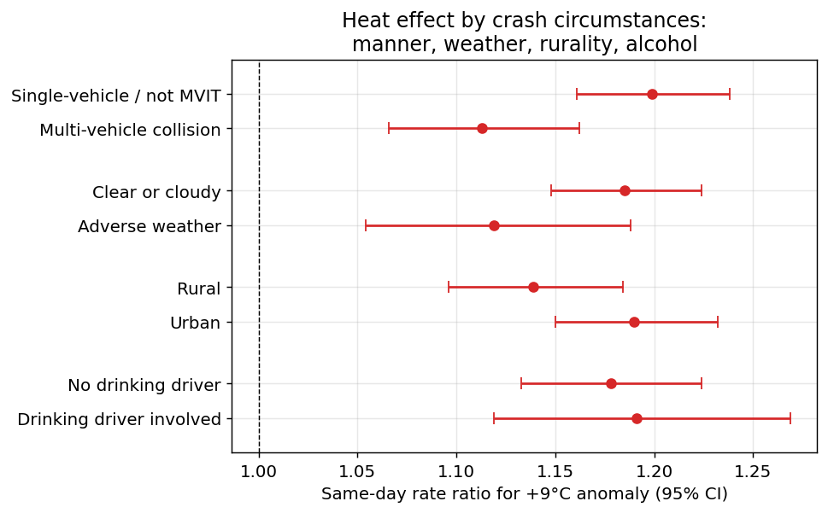
Fig. 4 United States same-day rate ratio of crash death for a +9 °C anomaly by crash circumstances: manner of collision, weather condition, rural/urban land use and police-reported driver drinking. The excess is present on clear or cloudy days, is larger for single-vehicle crashes than multi-vehicle collisions, and is similar regardless of reported driver drinking. These analyses are exploratory and are not adjusted for multiple comparisons.

Model-based net heat-attributable crash deaths were 528 per year (95% CI 425-631), an attributable fraction of 1.36% of all crash deaths (Fig. 5; Table 5). For magnitude context, this model-based burden is numerically similar to the 527 officially coded direct-heat deaths per year (ICD-10 X30, 2016-2020; Fig. S3), although the two measures represent different constructs. The illustrative scenario translation(IPCC 2021) implied 347-1009 additional deaths per year for a uniform +1 to +3 °C shift of the temperature distribution, holding other factors constant (Fig. S4; Table S3).

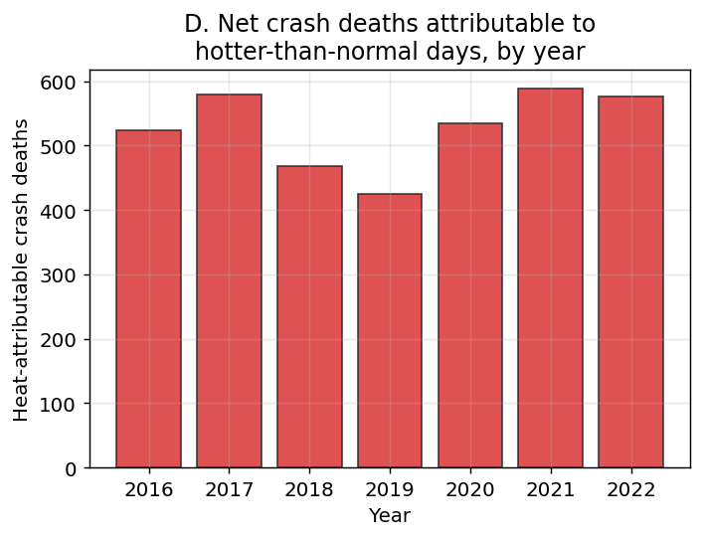
Fig. 5 United States estimated net heat-attributable crash deaths per year, 2016-2022 (model-based attributable burden, not a count of coded deaths).

Table 5 United States model-based net heat-attributable crash deaths alongside officially coded direct-heat deaths. The two quantities measure different constructs (modelled burden vs coded cause of death) and are juxtaposed only to gauge magnitude.
Quantity | Estimate
Net heat-attributable crash deaths / year (model-based) | 528
Attributable fraction (%) | 1.36
Officially coded direct-heat deaths / year (ICD-10 X30, 2016-2020) | 527

External transportability: Japan
In Japan (11,576 crash deaths over 6 years) the anomaly exposure-response was imprecise, with a wide confidence band that included the null throughout (Fig. S5); the same-day point estimate for a +9 °C anomaly was 0.940 (95% CI 0.743-1.190) and the cumulative 0-10 day RR was 0.562 (95% CI 0.207-1.525). The external comparison (Fig. 6) therefore did not provide clear replication: the US shows a precise acute association, whereas the Japanese panel—with roughly 20-fold fewer annual crash deaths and sparser temperature coverage—is underpowered. Japanese stratified estimates were likewise imprecise (Fig. S6; Table S4).

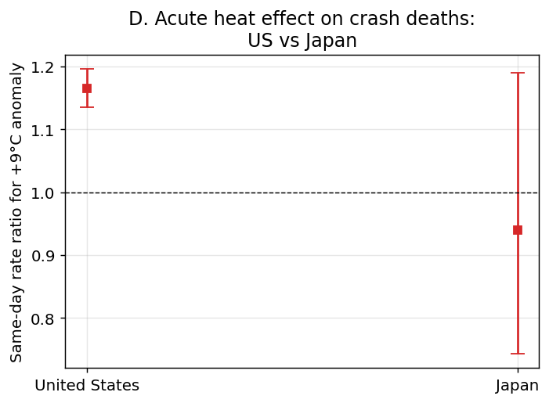
Fig. 6 Same-day rate ratio of traffic-crash deaths for a +9 °C anomaly, United States versus Japan. The US shows a precise acute association; the Japanese estimate is underpowered. This external-transportability comparison is exploratory and not adjusted for multiple comparisons.

Discussion
Principal findings. A +9 °C temperature anomaly relative to the local seasonal norm was associated with a same-day rate ratio of 1.165 (95% CI 1.135-1.196) for US traffic-crash deaths. The excess was acute: the 1-3 day window showed a deficit consistent with short-term temporal displacement, and the cumulative 0-10 day association was positive but smaller (RR 1.076 (95% CI 1.017-1.139)). The model-based net heat-attributable burden was 528 deaths per year, about 1.36% of crash deaths.
Relationship to prior evidence. These findings are consistent with, and extend, an established literature linking heat to road crashes and crash mortality. A nationwide US case-crossover analysis found 3.4% more fatal crashes on heat-wave days(Wu et al. 2018); time-series studies reported more crashes and injuries at higher temperatures and during heat waves(Basagaña et al. 2015; Liang et al. 2021; Liang et al. 2022); and recent multi-city analyses documented higher road-traffic mortality on hot days, concentrated in motorcyclists, bicyclists and other vulnerable road users in Latin America(Hsu et al. 2025) and California(Hsu et al. 2026). Our results align with that evidence while adding three elements: an exposure metric defined relative to local seasonal conditions, a distributed-lag decomposition separating an acute excess from subsequent temporal displacement, and a national attributable-burden estimate for fatal crashes.
What the anomaly adds. Because absolute temperature is entangled with the seasonal cycle of driving exposure, the anomaly isolates departures from the conditions to which local travel patterns and behaviour are adapted. The approximately linear rise of crash mortality with positive anomalies, and the stability of the same-day association to the contrast used (Table S1), indicate that locally unusual heat—not extreme heat alone—carries measurable excess crash mortality. This complements heat-wave-based designs, which capture only the most extreme days(Wu et al. 2018), and absolute-temperature DLNM analyses(Pan et al. 2024), which mix seasonal exposure differences with acute effects.
Road-user heterogeneity and mechanism. The several-fold larger same-day excess among motorcyclists, pedestrians and cyclists than among vehicle occupants, the peak in the hottest hours, and the larger estimate for single-vehicle than multi-vehicle crashes are compatible with differences in heat exposure, vehicle protection, travel behaviour and other mode-specific factors. They are also coherent with experimental evidence that heat degrades psychomotor and driving performance(Daanen et al. 2003) and with prior reports that vulnerable road users bear the largest heat-associated risks(Hsu et al. 2025; Hsu et al. 2026). However, these ecological gradients are not proof of a bodily-heat mechanism: open-air travel volumes themselves change with the weather, and our activity proxies are national and not mode-specific, so exposure substitution cannot be separated from physiology.
Attributable burden in context. The model-based estimate of 528 net heat-attributable crash deaths per year is of similar numerical magnitude to the 527 officially coded direct-heat deaths per year in CDC WONDER, but the two quantities are different constructs—a modelled attributable burden versus coded cause-of-death counts—and the comparison is offered only to indicate that the possible scale is not negligible. It should not be read as evidence that a comparable number of crashes are individually caused by heat illness.
External transportability. The harmonized Japanese analysis did not provide clear replication: point estimates were below the US values with wide intervals. Plausible explanations—fewer crash deaths per year, different modal composition, greater availability of cooled public transport, different vehicle fleets and climate adaptation—are hypotheses only; the prefecture-density split was too imprecise to test them. The Japanese estimates are therefore presented as an exploratory external comparison, and prior Japanese evidence linking absolute temperature to transport-accident mortality(Pan et al. 2024) suggests that the exposure metric and period analysed may matter for whether an association is detectable.
Limitations. This is an ecological, population-level association and cannot establish that heat caused illness in any specific crash; neither FARS nor NPA records post-mortem heat diagnosis. Exposure is measured at the state or prefecture level from the nearest GHCN-Daily stations, misclassifying individual exposure and missing sub-unit variation such as urban heat islands. Activity adjustment used national monthly proxies and annual state VMT; no daily, mode-specific or shared-mobility activity denominators are publicly available, so weather-related activity shifts cannot be fully separated from a heat effect. Subgroup analyses involve multiple comparisons without adjustment. Police-reported drinking is incompletely ascertained. The quasi-Poisson model accounts for overdispersion but not an explicit autoregressive term; although the lag, seasonal, trend and day-of-week terms absorb much short-term autocorrelation, residual serial correlation could affect confidence intervals. The warming translation is an illustrative scenario holding population, travel, vehicle fleet and adaptation constant, not a forecast. Finally, the study is restricted to the United States and Japan because, among high-income countries with robust crash and meteorological records, they provide the best public daily data for this design; the European CARE database is not publicly available at the daily individual level(European Commission n.d.), so transportability to other settings is uncertain.
Biometeorological and adaptation relevance. Within the biometeorology literature this study places traffic-crash mortality alongside other acute heat-health outcomes quantified with anomaly-based, distributed-lag methods, and identifies open-air road users as a group in whom heat exposure is occupational or behavioural rather than incidental. The displacement pattern implies that the acute signal is larger than the net burden, which matters for the timing of heat-health warnings. Whether heat-targeted advisories for motorcyclists, cyclists, pedestrians and outdoor workers reduce crash risk is a testable hypothesis for intervention studies, not a conclusion of this analysis.

Conclusion
Days that are unusually hot relative to the local seasonal norm were associated with an acute, same-day excess of US traffic-crash mortality, with substantially larger associations among open-air road users and followed by a short-term deficit compatible with temporal displacement at the population level. The model-based attributable burden was of a similar numerical magnitude to officially coded direct-heat mortality, although the two constructs differ. A harmonized analysis in Japan was too imprecise to establish transportability. The results refine and extend prior evidence that heat is associated with road-crash mortality; they do not establish individual-level causation, and individual-level studies linking crash decedents to ambient heat exposure are needed.

Declarations
Ethics approval: not required; the study used publicly available, aggregated and de-identified data.
Competing interests: the author declares no competing interests.
Funding: no specific funding was received for this study.
Author contributions: Tatsuki Onishi conceived the study, performed the analysis, drafted the manuscript and approved the final version. The author had full access to all data and verified the reported results.
Data availability: all data are public (FARS, GHCN-Daily, CDC WONDER, US Census Bureau Population Estimates, FHWA, EIA and the Japanese NPA accident open data; see References). Processed data files are included in the repository so the manuscript and figures can be regenerated without API keys. The complete analysis code and reproducible pipeline (make all for data and figures, make ijbm for this submission package) is openly available at https://github.com/bougtoir/heat-accidents-mortality; every reported number, figure and table is regenerated from source with no hard-coded values.
Declaration of generative AI use: during the preparation of this work the author used generative artificial-intelligence tools to assist with code development and manuscript drafting; the author reviewed and edited the content and takes full responsibility for the published content.

References
Basagaña X, Escalera-Antezana JP, Dadvand P, Llatje Ò, Barrera-Gómez J, Cunillera J, Medina-Ramón M, Pérez K (2015) High ambient temperatures and risk of motor vehicle crashes in Catalonia, Spain (2000-2011): a time-series analysis. Environ Health Perspect 123:1309-1316. https://doi.org/10.1289/ehp.1409223
Basu R (2009) High ambient temperature and mortality: a review of epidemiologic studies from 2001 to 2008. Environ Health 8:40. https://doi.org/10.1186/1476-069X-8-40
Centers for Disease Control and Prevention (n.d.) CDC WONDER Underlying Cause of Death database. https://wonder.cdc.gov/
Daanen HAM, van de Vliert E, Huang X (2003) Driving performance in cold, warm, and thermoneutral environments. Appl Ergon 34:597-602. https://doi.org/10.1016/j.apergo.2003.01.001
European Commission, Directorate-General for Mobility and Transport (n.d.) Community database on road accidents (CARE). https://road-safety.transport.ec.europa.eu/european-road-safety-observatory/methodology-and-research/care-database_en
Federal Highway Administration (n.d.) Highway Statistics VM-2: annual state vehicle-miles travelled. https://www.fhwa.dot.gov/policyinformation/statistics.cfm
Federal Highway Administration (n.d.) Traffic Volume Trends. https://www.fhwa.dot.gov/policyinformation/travel_monitoring/tvt.cfm
Gasparrini A, Armstrong B, Kenward MG (2010) Distributed lag non-linear models. Stat Med 29:2224-2234. https://doi.org/10.1002/sim.3940
Gasparrini A, Guo Y, Hashizume M, et al (2015) Mortality risk attributable to high and low ambient temperature: a multicountry observational study. Lancet 386:369-375. https://doi.org/10.1016/S0140-6736(14)62114-0
Gasparrini A, Leone M (2014) Attributable risk from distributed lag models. BMC Med Res Methodol 14:55. https://doi.org/10.1186/1471-2288-14-55
Hsu C-K, Quistberg DA, Pérez-Ferrer C, Rodríguez DA (2026) Extreme heat disproportionately increases severe road traffic crashes in high conflict settings and among vulnerable road users in California. Discov Cities. https://doi.org/10.1007/s44327-026-00248-6
Hsu C-K, Quistberg DA, Sánchez BN, Kephart JL, Bilal U, Gouveia N, Pérez Ferrer C, Caiaffa WT, de Lima Friche AA, Yannone I, Rodríguez DA (2025) Individual and city-level variations in heat-related road traffic deaths in Latin America. Nat Cities 2:897-906. https://doi.org/10.1038/s44284-025-00279-x
IPCC (2021) Climate Change 2021: The Physical Science Basis. Contribution of Working Group I to the Sixth Assessment Report of the Intergovernmental Panel on Climate Change. Cambridge University Press, Cambridge
Liang M, Min M, Guo X, Song Q, Wang H, Li N, et al (2022) The relationship between ambient temperatures and road traffic injuries: a systematic review and meta-analysis. Environ Sci Pollut Res 29:50647-50660. https://doi.org/10.1007/s11356-022-19276-0
Liang M, Zhao D, Wu Y, Ye P, Wang Y, Yao Z, et al (2021) Short-term effects of ambient temperature and road traffic accident injuries in Dalian, Northern China: a distributed lag non-linear analysis. Accid Anal Prev 153:106057. https://doi.org/10.1016/j.aap.2021.106057
Menne MJ, Durre I, Vose RS, Gleason BE, Houston TG (2012) An overview of the Global Historical Climatology Network-Daily database. J Atmos Ocean Technol 29:897-910. https://doi.org/10.1175/JTECH-D-11-00103.1
National Highway Traffic Safety Administration (n.d.) Fatality Analysis Reporting System (FARS). US Department of Transportation. https://www.nhtsa.gov/research-data/fatality-analysis-reporting-system-fars
National Police Agency of Japan (n.d.) Traffic accident statistics open data. https://www.npa.go.jp/publications/statistics/koutsuu/opendata/
Pan R, et al (2024) Temporal change and spatial heterogeneity of the association between ambient temperature and transport accident mortality in Japan from 1972 to 2019: a nationwide time-stratified case-crossover study. Environ Res Commun 6:085011. https://doi.org/10.1088/2515-7620/ad6b03
US Census Bureau (n.d.) Population Estimates Program: annual state population estimates. https://www.census.gov/programs-surveys/popest.html
US Energy Information Administration (n.d.) Weekly finished motor gasoline product supplied (PET.WGFUPUS2.W). https://www.eia.gov/
Wu CYH, Zaitchik BF, Gohlke JM (2018) Heat waves and fatal traffic crashes in the continental United States. Accid Anal Prev 119:195-201. https://doi.org/10.1016/j.aap.2018.07.025

