Supplementary material
Traffic-crash mortality during unusually hot days in the United States: distributed-lag and road-user-specific analyses
Table S1 United States robustness to the anomaly contrast: same-day and cumulative (lag 0-10 day) rate ratios at +5 °C, the empirical 95th percentile of the anomaly distribution, and the +9 °C reference contrast, from the primary model.
Contrast | Same-day RR (95% CI) | Cumulative RR (95% CI)
+5 °C anomaly | 1.079 (1.068-1.089) | 1.031 (1.014-1.049)
95th-percentile anomaly (+6.25 °C) | 1.104 (1.089-1.118) | 1.043 (1.016-1.071)
+9 °C anomaly (reference) | 1.165 (1.135-1.196) | 1.076 (1.017-1.139)

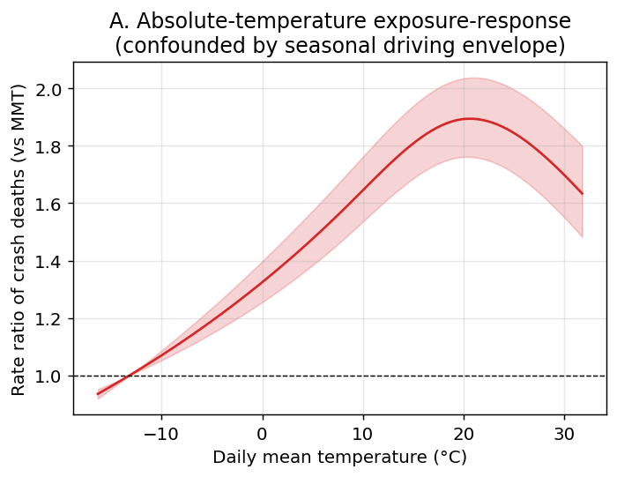
Fig. S1 United States absolute-temperature exposure-response for daily traffic-crash deaths (cumulative over lag 0-10 days), relative to the minimum-mortality temperature. The curve peaks at mild temperatures and declines at extreme heat, reflecting the seasonal driving-exposure envelope rather than an acute heat association.

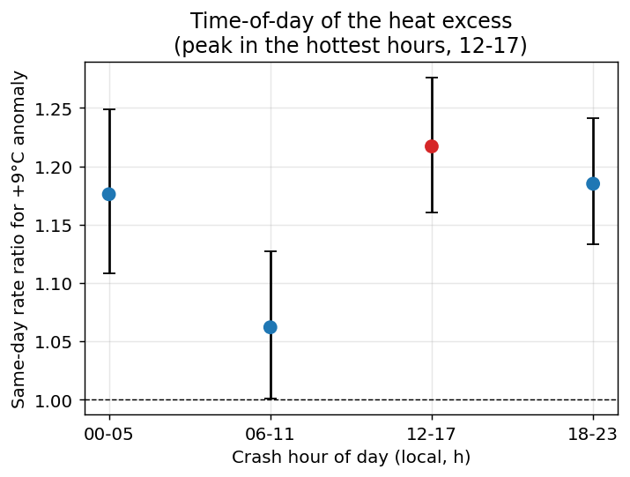
Fig. S2 United States same-day rate ratio of crash death for a +9 °C anomaly by crash hour of day. The excess is largest for crashes in the hottest part of the day (12-17 h) and weakest in the cool morning (06-11 h); the overnight band is also elevated. Exploratory; not adjusted for multiple comparisons.

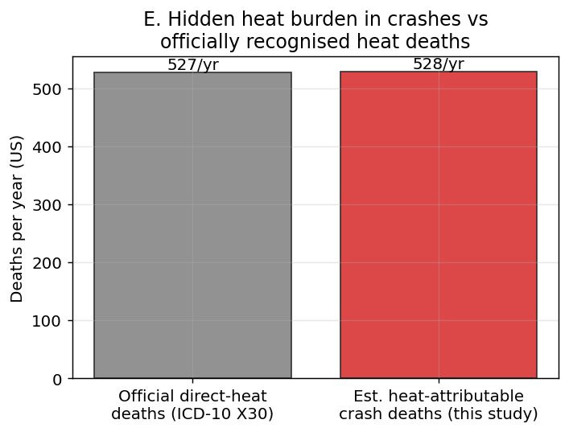
Fig. S3 United States comparison of estimated net heat-attributable crash deaths per year (a model-based attributable-burden estimate) with officially coded direct-heat deaths (ICD-10 X30) from CDC WONDER. The two quantities are different constructs and are shown for magnitude context only.

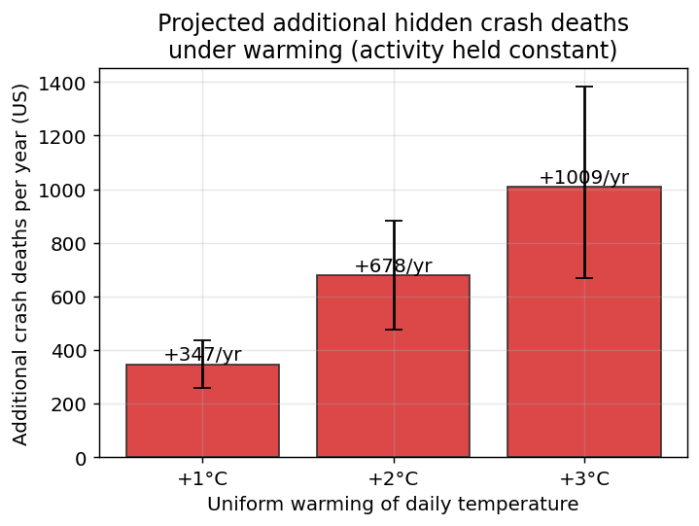
Fig. S4 United States additional traffic-crash deaths per year implied by the fitted anomaly association under a uniform +1, +2 or +3 °C shift of the daily temperature distribution, holding baseline population, driving activity, the vehicle fleet and adaptation constant. This is an illustrative scenario translation, not a forecast.

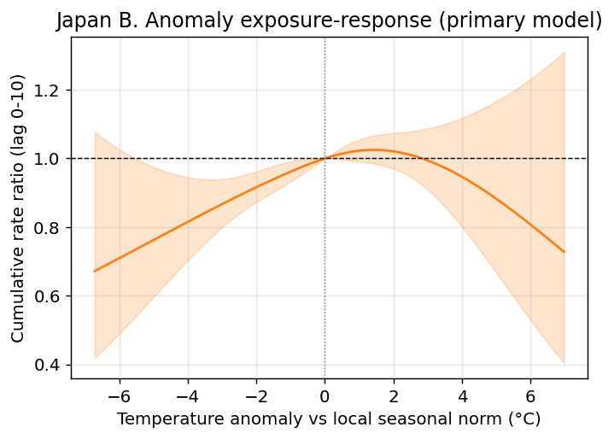
Fig. S5 Japan temperature-anomaly exposure-response (2019-2024). The estimate is imprecise: the confidence band is wide and includes the null throughout.

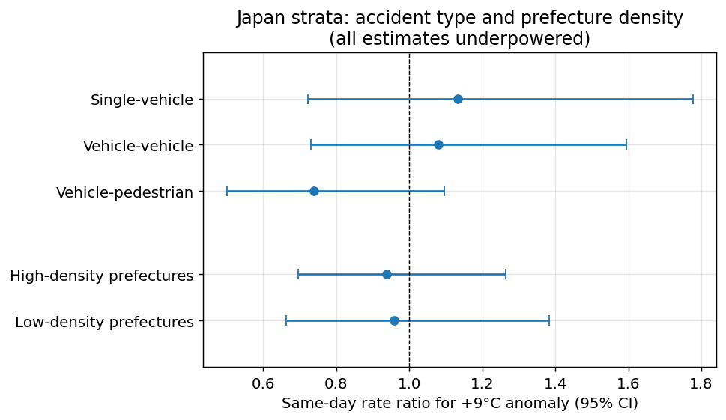
Fig. S6 Japan same-day rate ratio of crash death for a +9 °C anomaly by accident type and by prefecture population density (split at the median, a proxy for public-transport availability). All confidence intervals are wide and include the null; exploratory, not adjusted for multiple comparisons.

Table S2 United States same-day rate ratio of crash death for a +9 °C anomaly, by crash circumstances. Exploratory; not adjusted for multiple comparisons.
Stratum | Crash deaths | Same-day RR (95% CI)
Manner of collision: Single-vehicle (not a MVIT collision) | 160,517 | 1.199 (1.161-1.238)
Manner of collision: Multi-vehicle collision | 111,415 | 1.113 (1.066-1.162)
Weather condition: Clear or cloudy | 212,319 | 1.185 (1.148-1.224)
Weather condition: Adverse (rain, snow, fog, wind) | 44,401 | 1.119 (1.054-1.188)
Land use: Rural | 119,138 | 1.139 (1.096-1.184)
Land use: Urban | 153,418 | 1.190 (1.150-1.232)
Driver drinking: No drinking driver | 121,958 | 1.178 (1.133-1.224)
Driver drinking: Drinking driver involved | 47,963 | 1.191 (1.119-1.269)

Table S3 United States additional traffic-crash deaths per year implied by the fitted anomaly association under a uniform warming shift, holding activity, population and baseline rates constant; an illustrative scenario translation, not a forecast.
Uniform shift | Additional deaths/year (95% CI)
+1 °C | 347 (257-436)
+2 °C | 678 (474-881)
+3 °C | 1009 (667-1384)

Table S4 Japan same-day rate ratio of crash death for a +9 °C anomaly, by accident type and prefecture population density. All estimates are underpowered; exploratory, not adjusted for multiple comparisons.
Stratum | Crash deaths | Same-day RR (95% CI)
Accident type: Single-vehicle | 3,227 | 1.133 (0.722-1.778)
Accident type: Vehicle-vehicle | 4,280 | 1.079 (0.731-1.594)
Accident type: Vehicle-pedestrian | 3,968 | 0.740 (0.500-1.097)
Prefecture density: High-density prefectures (transit-rich proxy) | 7,583 | 0.938 (0.696-1.264)
Prefecture density: Low-density prefectures (transit-poor proxy) | 4,081 | 0.958 (0.664-1.383)

