Dilution-dependent antibacterial activity of honey: a systematic review and quantitative synthesis of physicochemical and microbiological evidence

Tatsuki Onishi a,*
a Data Science and AI Innovation Research Promotion Center, Shiga University, 1-1-1 Bamba, Hikone, Shiga 522-8522, Japan
* Corresponding author. E-mail address: bougtoir@gmail.com. ORCID: 0000-0001-7261-9062
Submitted to: International Journal of Food Microbiology

Abbreviations: MGO, methylglyoxal; MIC, minimum inhibitory concentration; MBC, minimum bactericidal concentration; H2O2, hydrogen peroxide; MRSA/MSSA, methicillin-resistant/susceptible Staphylococcus aureus; aw, water activity; LOSO, leave-one-study-out.

Abstract
Honey is a preserved food whose antimicrobial stability depends on intrinsic physicochemical factors, yet it is almost always assayed and used in diluted form. This systematic review and quantitative evidence synthesis asked how the antibacterial activity of honey changes across its dilution range. Searches of PubMed, Europe PMC and Crossref, citation mining and data-repository searches retrieved 4,042 records; 2,231 unique records were screened, 404 studies met eligibility criteria, and structured data were extracted from 102 open-access full texts (5,174 observations), predominantly against foodborne bacteria. All 10 extractable concentration series showed a positive association with honey concentration (median Spearman rho = 1.00), and the one complete pH ladder rose on dilution (rho = -1.00). Natural honeys exceeded sugar-equivalent controls in matched within-study comparisons (MIC potency ratio 1.81 across 12 pairs from 5 studies, with every contributing study's median above 1; median paired zone excess +0.6 mm in 2 studies). Catalase-treated honey retained a median 92% of activity (13 pairs, 2 studies). Physicochemical parameters predicted antibacterial outcomes within individual studies but not across them: leave-one-study-out cross-validated R2 was negative for chemistry- and label-based models. No extracted study measured antibacterial activity in an actual food matrix, and no extracted dataset reported a complete hydrogen peroxide dilution ladder with matched antibacterial endpoints. The evidence is consistent with dilution-dependent variation in the weight of osmotic, acidic, peroxide and non-peroxide contributions rather than a single mechanism, and it quantifies where the primary literature remains too sparse to support stronger claims.
Keywords: honey; food preservation; hydrogen peroxide; methylglyoxal; water activity; systematic review

1. Introduction
Honey occupies an unusual position in food microbiology: it is both a food documented to remain unspoiled over unusually long storage and a concentrated antimicrobial system whose intrinsic factors — water activity, acidity, enzymatic hydrogen peroxide production and plant-derived non-peroxide constituents — have been characterized for nearly a century (Molan, 1992; Willix et al., 1992). For a food microbiologist, honey is therefore best read as an ecosystem defined by its intrinsic properties: what survives in it, and why, is set by the same physical and chemical constraints that govern microbial survival in other foods (Kwakman et al., 2010; Kwakman et al., 2011).
Those constraints do not scale uniformly with dilution. Water activity rises and acidity weakens approximately in proportion to dilution, but glucose oxidase — the enzyme that generates hydrogen peroxide (H2O2) — is strongly constrained in undiluted honey and becomes appreciable mainly after partial dilution (Bang et al., 2003; Brudzynski, 2021), while non-peroxide factors such as methylglyoxal (MGO) simply attenuate with concentration (Kwakman et al., 2011). Whether dilution merely weakens honey's antibacterial activity or changes which mechanism accounts for it is an empirical question with direct consequences for how honey-derived antimicrobial activity should be measured, reported and modelled in food systems.
Prior reviews have treated these mechanisms largely in isolation: foundational accounts classified osmotic, peroxide and non-peroxide contributions qualitatively (Molan, 1992); mechanistic reviews have focused on the chemistry of H2O2 production (Brudzynski, 2021); and recent meta-analyses have pooled honey potency against pathogens without modelling the concentration axis (Cabezas-Mera et al., 2024). Single-laboratory dilution experiments exist (Bang et al., 2003; Willix et al., 1992), but no review has quantitatively synthesized, across studies, how antibacterial activity and its mechanistic correlates behave along the dilution range. This gap matters because assays performed near full strength may reflect constraints that dissipate once honey is incorporated into a diluted food environment.
We conducted a systematic review and quantitative evidence synthesis of primary studies of honey's antibacterial activity. We asked: (i) how activity varies with honey concentration; (ii) whether natural honey exceeds sugar-equivalent artificial-honey controls; (iii) how H2O2 production varies with dilution and whether it tracks measured activity; (iv) how much activity survives catalase-mediated H2O2 removal; (v) whether measured physicochemical parameters predict antibacterial outcomes beyond honey-type labels; and (vi) how results vary across organisms, with particular attention to foodborne bacteria. Causal or mechanistic language was reserved for within-study perturbation evidence (catalase treatment, matched artificial-honey controls); cross-study associations are reported as observational, and evidence density is reported explicitly so that sparse-evidence conclusions cannot be mistaken for strong ones.

2. Material and methods

2.1. Protocol and reporting
The review was conducted and reported with reference to the PRISMA 2020 guideline where applicable; the study flow is summarized in Fig. 1. The review was not prospectively registered; eligibility criteria, analysis decisions and the complete executable pipeline are released with this article (see Data availability).

2.2. Search strategy
We searched PubMed (NCBI E-utilities), Europe PMC (REST API) and Crossref (works API) for records combining honey-related terms with antibacterial, minimum inhibitory concentration (MIC), zone-of-inhibition, peroxide, methylglyoxal, water-activity and dilution terms; the full query strings, execution dates and hit counts are reported in Supplementary Table S1. Searches were executed programmatically and raw responses retained. Backward citation mining through Europe PMC contributed additional records, and Dryad, Figshare and Zenodo were searched for associated research data. All records were deduplicated on DOI, PubMed ID and normalized title.

2.3. Eligibility criteria
Records were eligible if they reported a primary in vitro antibacterial evaluation of natural honey with a quantitative endpoint (MIC, minimum bactericidal concentration (MBC), inhibition zone, biofilm inhibition or equivalent) and at least one of: a concentration or dilution series; an artificial-honey or sugar-equivalent comparator; a catalase or other mechanistic perturbation; or quantitative physicochemical characterization (H2O2, MGO, water activity, pH, phenolics). Reviews, non-antibacterial studies, non-honey studies, formulation studies in which honey could not be separated from the matrix, and records without a usable abstract were excluded. Eligibility was assigned by a deterministic rule-based classifier applied to titles and abstracts, followed by manual verification of included candidates; the classifier rules and per-record decisions are released with the dataset.

2.4. Data extraction
Open-access full texts were retrieved from PubMed Central as JATS XML. All tables were parsed programmatically, including nested tables, with merged header cells expanded and multi-row headers reconstructed. A rule-based extractor converted the dominant table layouts into long-format observations carrying study, table, row and column provenance. For key mechanistic datasets (catalase-treated versus untreated pairs, simulated-honey controls, concentration series and MGO-spike dose-response), rows were additionally curated manually after direct inspection of source tables and captions; manually curated rows are flagged and take precedence. Organism labels were harmonized to organism groups using a documented mapping. Concentrations embedded in sample labels were parsed into a dedicated field, and the reported concentration basis (percent weight/volume, volume/volume, weight/weight, mass concentration or unspecified) was preserved in a separate field; analyses were stratified by basis rather than pooled across incompatible units. Values reported with inequality signs were retained with a censoring flag.

2.5. Risk-of-bias and reporting-quality assessment
No validated risk-of-bias instrument exists for cross-study in vitro antibacterial data. We applied a structured framework covering five domains — assay standardization, comparator quality, dispersion reporting, mechanistic perturbation and reporting completeness — each scored 0-2. Availability of concentration-series data was recorded as an availability flag, not a quality judgement. Ratings (low, some or high concern) were derived from domain totals and used in sensitivity analyses.

2.6. Statistical analysis
Concentration-response was summarized by per-series Spearman correlations between concentration and response. A series was eligible when the honey, organism and assay were identified, the concentration basis was extractable and at least three distinct ordered concentrations were reported (four or more in a sensitivity check); no condition on the direction, monotonicity or significance of the response was applied. Natural versus artificial honey was compared within study, organism, outcome and concentration strata. MIC and MBC contrasts were expressed as log potency ratios (artificial/natural, so that values above 1 indicate greater natural-honey potency); inhibition-zone contrasts were expressed as absolute differences in millimetres, preserving zero-denominator pairs without division. Because pairs within a study are dependent, the study was the primary inferential unit: per-study median effects were computed per outcome scale and synthesized across studies descriptively, with a Wilcoxon signed-rank test across study medians where at least three studies contributed. Catalase-treated versus untreated observations were paired identically and expressed as residual activity fractions. Honey-level physicochemical parameters were joined to outcomes on study and normalized sample label; Spearman correlations were computed per parameter and outcome, and ordinary least squares models on log10(MIC) compared measured chemistry, a honey-type label and their combination. Because rows from the same study are not independent, model performance was evaluated by leave-one-study-out cross-validation rather than in-sample fit. Percentage-unit MICs were never pooled across concentration bases (w/v, v/v, w/w or unspecified); organism medians were computed within each basis class and pooled percentage rows only descriptively. Because rows within a study are not independent, inferential contrasts were also aggregated to study level; where independent studies were too few for a valid test, results are reported descriptively. Sensitivity analyses repeated key contrasts on the low-risk-of-bias subset, on each concentration basis separately, and after excluding manuka-labelled honeys; leave-one-study-out resampling was used to assess dependence on individual studies. Analyses were performed in Python 3.12 (pandas, SciPy, statsmodels); the released analysis scripts regenerate every reported number.

3. Results

3.1. Study selection and characteristics
Searches retrieved 4,042 records; after removing 1,811 duplicates, 2,231 records were screened and 1,367 excluded at title/abstract stage. Of 864 reports assessed, 404 met inclusion criteria (Fig. 1). Open-access full texts were obtained for 226 records, and quantitative data were extracted from 102 studies, yielding 5,174 harmonized observations (2,572 MIC, 1,433 inhibition-zone and 710 MBC values; the remainder comprise biofilm, phenol-equivalence and dilution-series measures). Physicochemical data were extracted for 59 studies. Risk-of-bias ratings were 'some concerns' for most extracted studies (90 of 102), reflecting incomplete dispersion reporting and inconsistent mechanistic characterization; 9 were rated low concern and 3 high concern.
The extracted subset is not a census of eligible studies. Of 404 eligible studies, 157 had no resolvable PubMed Central identifier, 21 had an identifier but no open-access full text, and 124 retrieved full texts yielded no machine-extractable outcome table meeting our parsing rules. A post-extraction audit removed 8 studies whose extracted tables did not constitute honey-specific primary antibacterial data (propolis, bee venom, isolated antimicrobial peptides, a botanical blend, a nanocomposite formulation, a review article and antibiotic-control-only captures), together with 289 non-honey comparator rows (antibiotics, essential oils, extracts, nanoparticles, combination arms and vehicle controls) in retained studies. Extracted studies were more recent than non-extracted studies (median year 2022 vs. 2020; Mann-Whitney p < 0.001) and overwhelmingly open-access (99% vs. 69% flagged open-access). Mechanistic content, however, was similar between the groups — dilution-related abstracts appeared in 40% of extracted versus 32% of non-extracted studies, peroxide-related in 25% versus 23%, and MGO-related in 21% versus 15% — indicating that selection operated mainly on access rather than on topic. Quantitative results below therefore describe the extractable subset; the selection mechanism is reported explicitly rather than treating the subset as a census of eligible work.
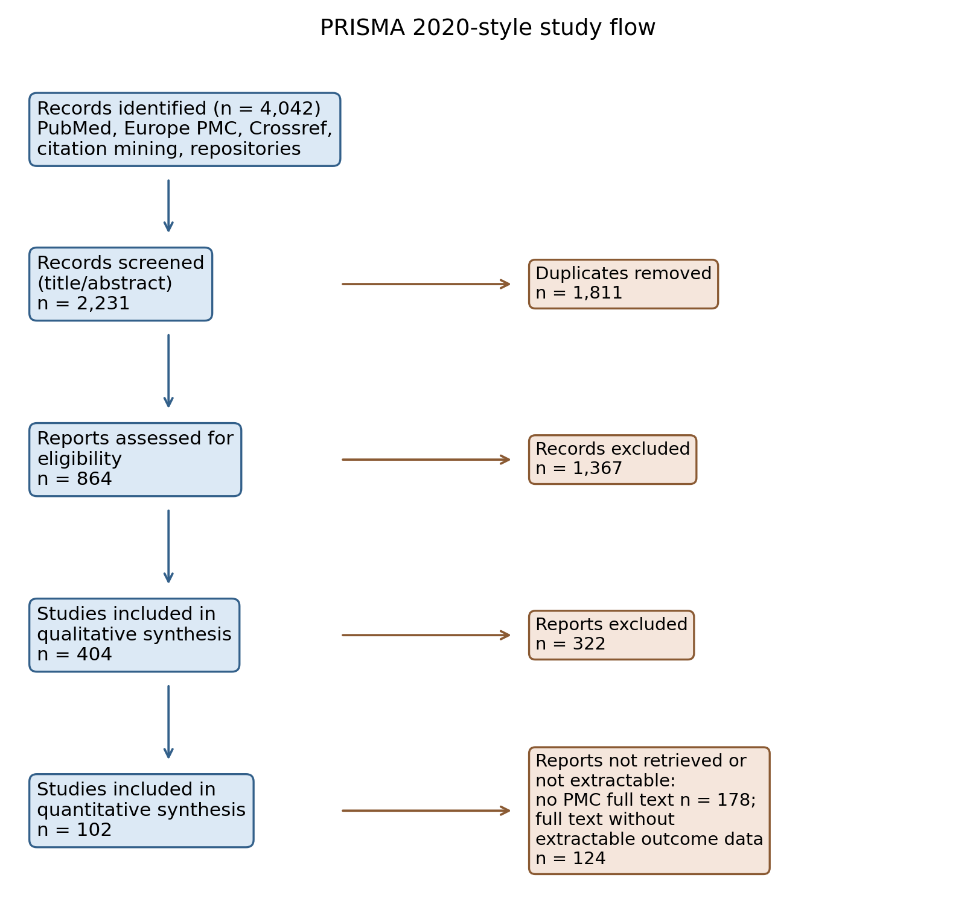
Fig. 1. PRISMA 2020-style flow of study identification, screening, eligibility and quantitative extraction.

3.2. Concentration-response
10 antibacterial concentration series were extractable across 3 studies, spanning inhibition zones, biofilm inhibition and carbapenemase-producer isolates. All 10 series showed a positive association between concentration and antibacterial response (median Spearman rho = 1.00; Fig. 2A-2C); restricting to the 7 series with four or more ordered concentrations left the direction unchanged (median rho = 1.00). In the one study reporting pH across a full dilution ladder, pH rose monotonically as honey was diluted for all four honeys examined (rho = -1.00; Fig. 2D), consistent with progressive weakening of the acidic constraint. Fitting log(response) on log(concentration) across the zone series gave a slope of 0.33 (SE 0.55); the sub-linear point estimate is compatible with a saturating diffusion-assay response but the interval is wide and should not be over-interpreted. Concentration-series data remained scarce, so these results describe direction rather than a pooled dose-response curve; series eligibility applied no outcome-side condition, so the uniform positive direction is a data feature, not a selection artifact, although with few extractable series it should be read as consistent direction rather than a universal law.
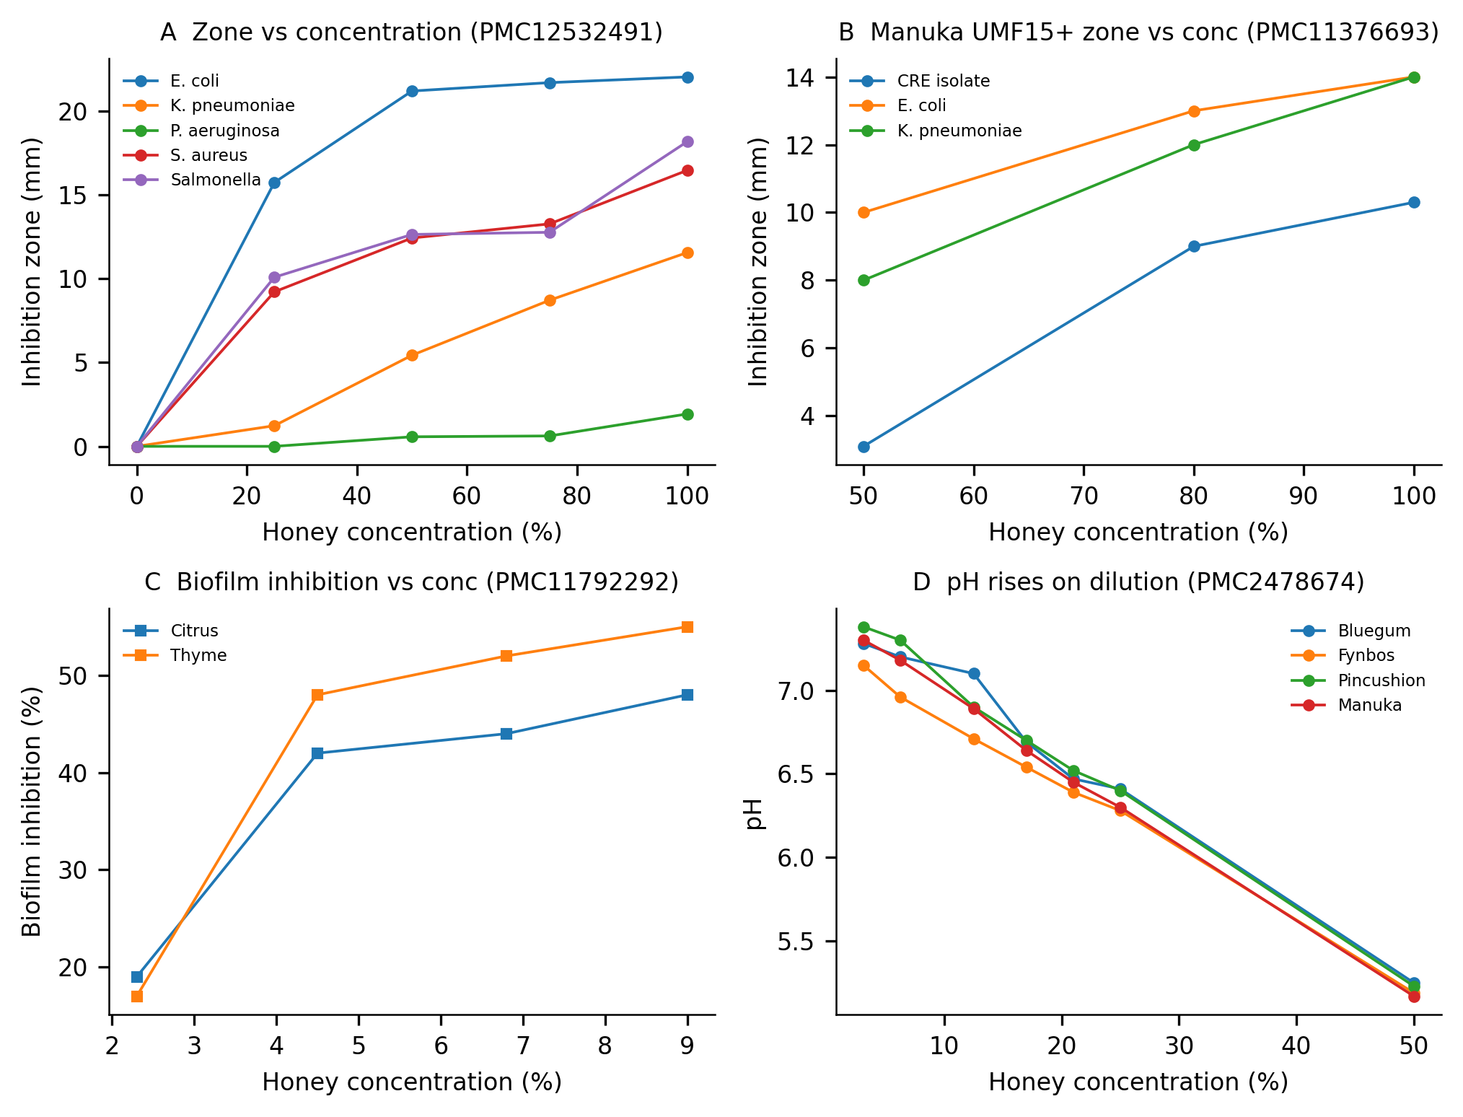
Fig. 2. Concentration-response series. (A) Inhibition zones versus honey concentration for five organisms (Kumera et al., 2025). (B) Manuka UMF15+ zones versus concentration for three organisms (Bukhari et al., 2024). (C) Biofilm inhibition versus concentration for two honeys (Alshaybawee et al., 2025). (D) pH versus concentration for four honeys (Basson and Grobler, 2008); pH rises as honey is diluted.

3.3. Natural versus artificial honey
25 paired comparisons of natural honey versus artificial or sugar-equivalent controls were identified (10 zone pairs, 13 MIC pairs, 2 MBC pairs); one MIC pair was excluded a priori because the artificial-honey control MIC was zero and a log potency ratio is undefined, leaving 24 pairs for outcome-specific analysis. Analysed on their native outcome scales and aggregated to study level, 5 studies contributed MIC contrasts (median potency ratio 1.81; every contributing study's median exceeded 1; Wilcoxon across study medians, p = 0.062), 1 study contributed MBC contrasts (ratio 1.06, descriptive only), and 2 studies contributed zone contrasts (median paired excess +0.6 mm, positive in both studies; pairs with a zero artificial-honey zone were preserved as differences, never converted to ratios). As an exploratory secondary view, a pair-level Wilcoxon on log potency ratios across all 25 pairs — which treats dependent pairs as independent — gave p = 0.001; the study-level analysis above is the primary inference (Fig. 3). Artificial honey thus reproduced part, but not all, of natural honey's effect — consistent with a substantial sugar/osmotic contribution while suggesting additional honey-specific effects in most, though not every, study. Because artificial honey is an imperfect osmotic control — few comparators were composition-matched on sugar, pH and water activity — these residual differences may reflect multiple compositional differences rather than a single isolated mechanism.
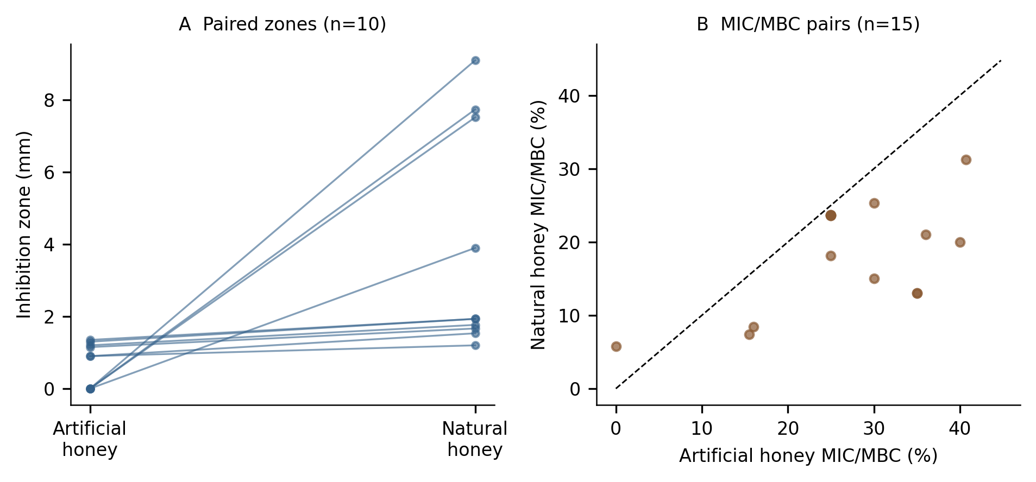
Fig. 3. Natural versus artificial honey. (A) Paired inhibition zones. (B) Paired MIC/MBC values; points below the diagonal indicate greater potency of natural honey.

3.4. Hydrogen peroxide and dilution
Directly matched dilution-resolved evidence on H2O2 was sparse. Within the extracted corpus, one study reported H2O2 detectable only at 6.25% and 3.12% honey and not at higher concentrations, and a second linked glucose oxidase activity, catalase sensitivity and H2O2 concentration to MIC; both are consistent with a peroxide contribution that is expressed preferentially at low concentrations rather than at full strength. Across studies, honey-level H2O2 measurements correlated weakly and positively with MIC (rho = 0.46, n = 29, 2 studies; Fig. 4), a direction opposite to a naive 'more peroxide, more potent' expectation, and most plausibly reflecting between-study confounding: potent non-peroxide honeys can be low in H2O2. We found no extracted dataset reporting a full H2O2 dilution ladder with matched antibacterial endpoints; the predicted intermediate-dilution peroxide peak is therefore supported only qualitatively, and we report it as an explicit evidence gap.
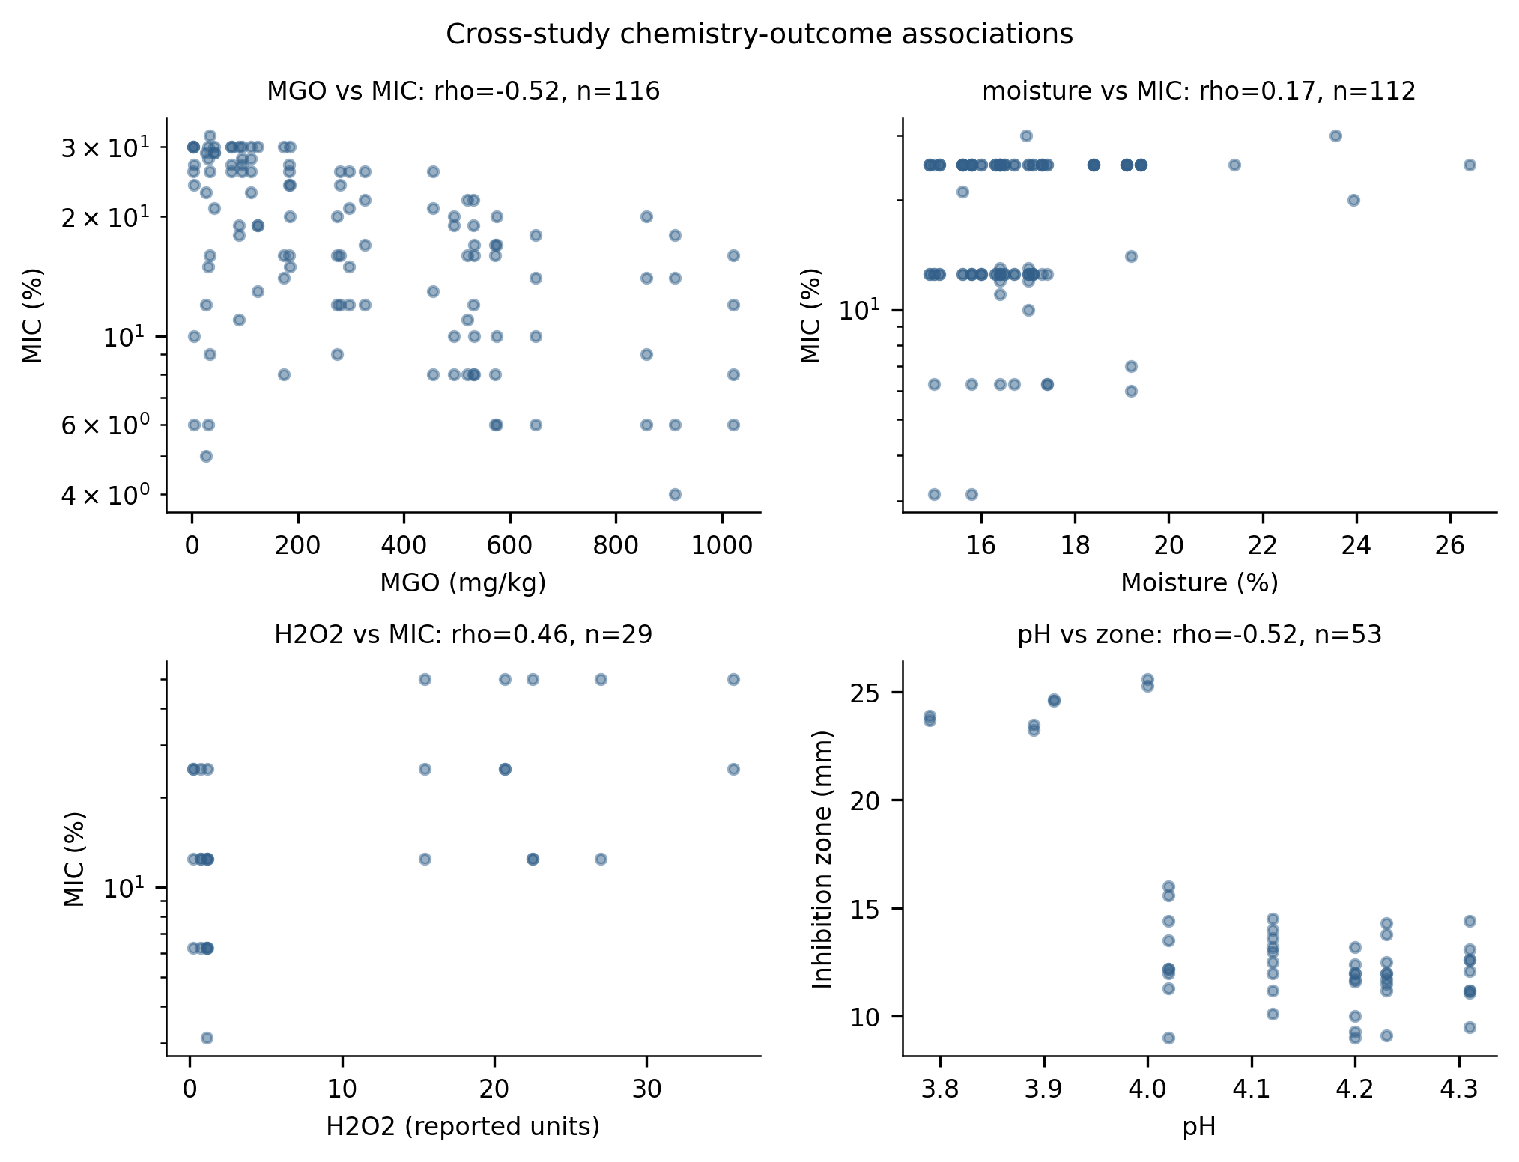
Fig. 4. Cross-study associations between honey-level physicochemical parameters and antibacterial outcomes (Spearman rho; MIC on a log scale).

3.5. Catalase perturbation and residual activity
13 paired catalase-perturbed observations were extracted from 2 studies. Catalase-treated honey retained a median 92% of untreated antibacterial activity (Fig. 5). This indicates substantial peroxide-independent activity in the honeys tested; with only two contributing studies the estimate is preliminary, and residual activity cannot be attributed to MGO or any other single constituent without further evidence.
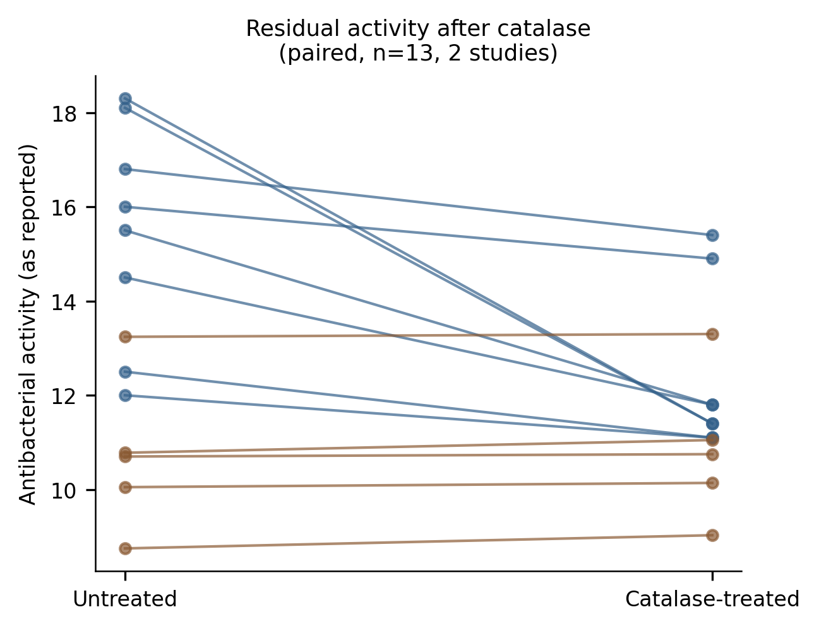
Fig. 5. Paired antibacterial activity before and after catalase treatment (13 pairs, 2 studies (Hussain et al., 2019; Mohd Hilmi et al., 2020)); residual activity indicates peroxide-independent components.

3.6. Physicochemistry versus label as predictors
Honey-level physicochemical measurements could be joined to antibacterial outcomes for 685 observations from 18 studies. Within the largest single-study block, MGO content correlated inversely with MIC (rho = -0.52, n = 116, one study), consistent with MGO-associated potency. Honey moisture correlated positively with MIC (rho = 0.17, n = 112, 3 studies), the expected direction if dilute, high-moisture honeys are less active. Honey pH showed no monotone association with MIC (rho = 0.07, n = 359) but a moderate inverse association with zone size (rho = -0.52, n = 53).
A linear model on log10(MIC) fitted to the largest complete-case block (116 observations, predictors MGO, pH, TPC) explained 30% of variance in-sample, versus 0% for a manuka/medical-grade label alone. However, this in-sample fit rested almost entirely on 1 study. Grouped validation told a different story: under leave-one-study-out cross-validation (n = 155, 3 studies, predictors pH, TPC), chemistry-based predictions performed far worse than a null model (cross-validated R2 = -32.32 vs. -0.12), and the label model was indistinguishable from null. Measured chemistry is therefore informative within individual studies but the fitted relationships did not transfer across studies in this dataset — a result we report explicitly because it bounds what cross-study chemistry-outcome synthesis can currently claim.

3.7. Organism heterogeneity
Median MIC differed markedly across organisms (Fig. 6); because organism identity is confounded with study, organism medians are reported descriptively rather than with a pooled test that would treat within-study replicates as independent. Organism medians were computed within each reported concentration basis (Table 1); bases are not commensurate and no pooled cross-basis ranking is reported. On the dominant unspecified-percentage basis, Gram-positive organisms tended to be inhibited at lower honey concentrations than Gram-negative organisms. Manuka-type honeys had a lower median MIC than other honeys (15% vs. 19%; nominal Mann-Whitney p = 0.001, which treats rows as independent). Within the 13 studies testing both types on the same reported basis, manuka MICs were a median 5.0 percentage points lower (7 studies lower, 6 equal, none higher; Wilcoxon across study medians, p = 0.016). The pooled contrast is nonetheless observational: UMF grading, geographic provenance and study design confound honey type, so the result should not be read as a botanical-type superiority claim (Table 1).
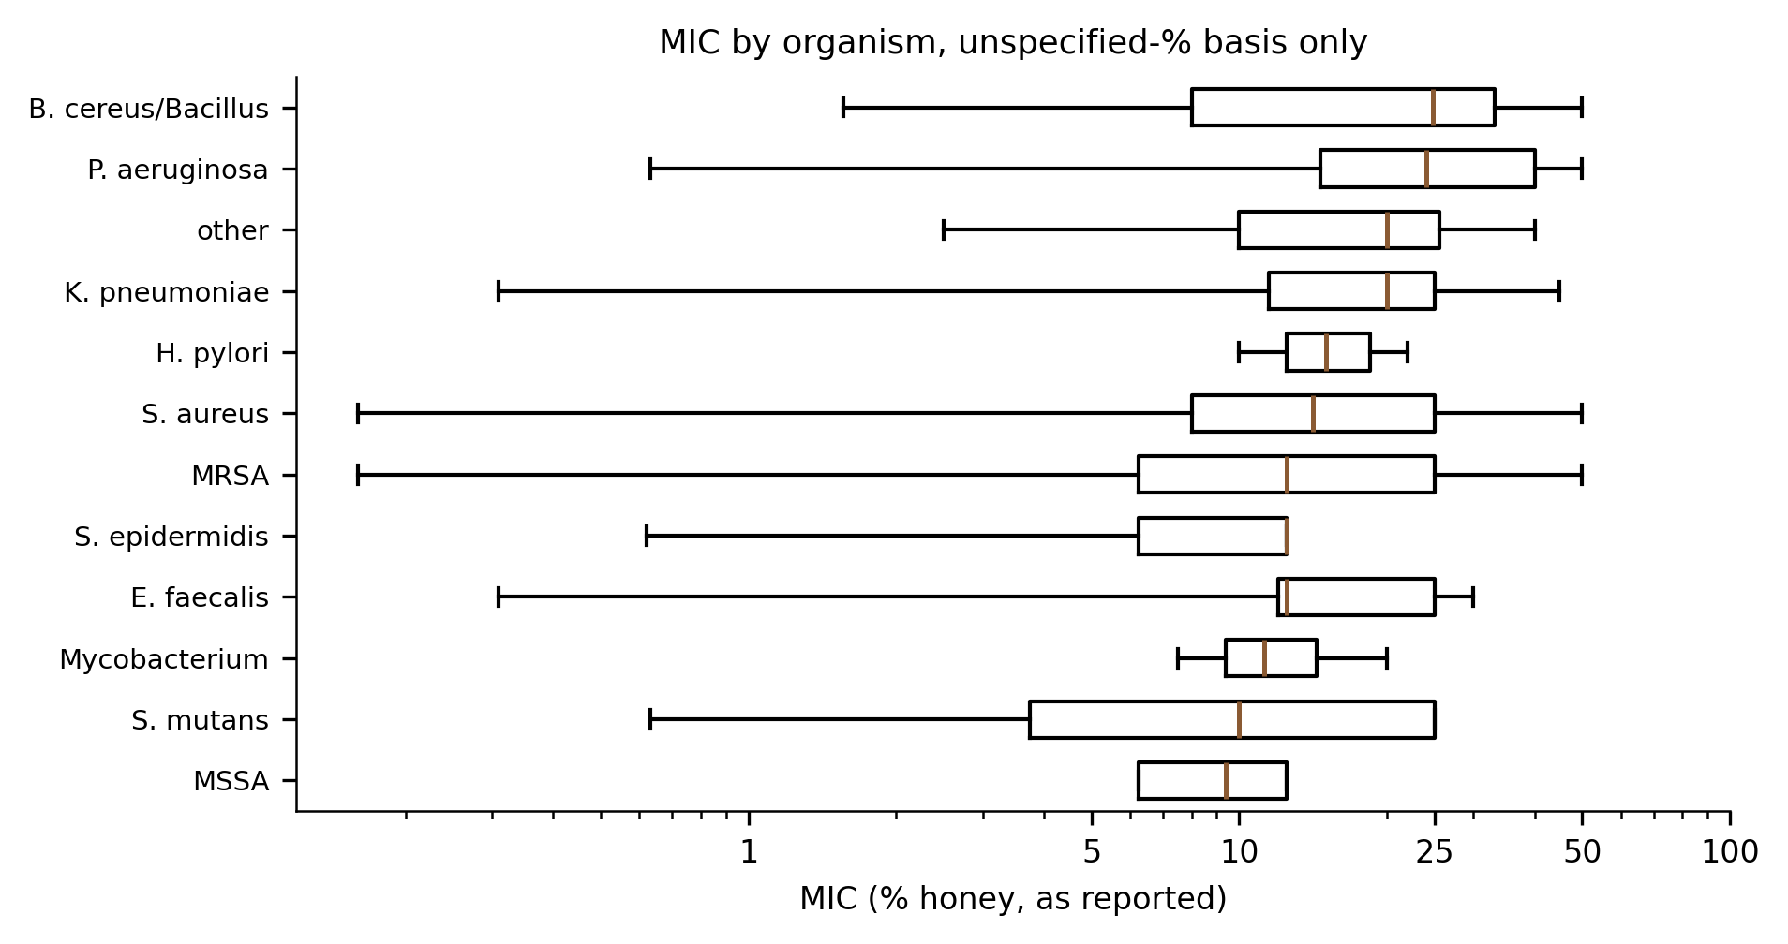
Fig. 6. MIC distributions by organism group (unspecified-basis percentage rows only, log scale). Bases are not commensurate; see Table 1 for per-basis medians.

Table 1. Median MIC (% honey) by organism and reported concentration basis.
Organism | % basis unspecified | % v/v | % w/v | % w/w
S. aureus | 19.0 [10.0-25.0]; 13/80/107 | 25.0 [4.0-25.0]; 5/17/37 | 12.4 [6.8-17.8]; 10/71/108 | 7.2 [6.5-9.3]; 1/20/20
MRSA | 12.5 [6.2-25.0]; 5/25/107 | 6.2 [6.2-20.0]; 3/13/13 | 10.0 [10.0-13.5]; 3/21/27 | -
S. epidermidis | 12.5 [6.2-12.5]; 3/23/30 | - | - | -
E. coli | 25.0 [16.0-40.0]; 14/162/291 | 8.0 [4.0-15.0]; 6/20/31 | 10.0 [10.0-18.0]; 6/75/83 | -
P. aeruginosa | 25.0 [18.2-40.0]; 12/100/179 | 10.2 [4.2-43.8]; 3/4/10 | 25.0 [18.0-38.0]; 11/80/97 | 15.0 [15.0-20.0]; 1/33/33
Salmonella | 22.9 [13.1-25.0]; 8/47/66 | 12.5 [6.2-25.0]; 5/23/233 | - | -
L. monocytogenes | 27.5 [21.2-46.2]; 3/14/18 | 2.0 [1.0-3.0]; 2/4/11 | - | -
Note: MIC, minimum inhibitory concentration; MRSA, methicillin-resistant S. aureus. Entries are median [IQR]; n studies/n honey samples/n observations. Bases are not commensurate and are never pooled; cells with fewer than five observations are suppressed.

3.8. Sensitivity analyses
Restricting MIC analyses to the low-risk-of-bias subset left the qualitative pattern unchanged (8 studies, 512 observations, median MIC 17%). Analyzed separately by reported concentration basis, median MIC was 14% on the percent weight/volume basis (n = 484), 12% on the percent volume/volume basis (n = 633) and 20% on the percent weight/weight basis (n = 86), confirming that bases are not interchangeable and must not be pooled. Excluding manuka-labelled honeys shifted the overall median MIC only slightly (18.0%; n = 2172). Restricting to studies that directly measured water activity (2 studies) or H2O2 (7 studies) gave medians of 25% and 16% respectively. No extracted rows came from preprint records, so a peer-reviewed-only analysis is identical to the primary set. The catalase and artificial-honey analyses could not be broadened beyond the studies that performed those experiments. Table 2 summarizes the paired mechanistic contrasts.
Table 2. Paired evidence for mechanistic contrasts.
Contrast | n pairs/obs | n studies | Effect | p value
Natural vs artificial honey, MIC potency ratio (study level) | 12 | 5 | median ratio 1.81; all study medians > 1 | 0.062
Natural vs artificial honey, zone difference (mm) | 10 | 2 | median +0.6 mm; positive in both studies | -
Catalase residual activity | 13 | 2 | median 92% retained | -
Activity vs concentration (series) | 10 | 3 | 10/10 positive; median rho = 1.00 | -
MGO vs MIC (within-study) | 116 | 1 | rho = -0.52 | < 0.001
pH vs inhibition zone | 53 | 2 | rho = -0.52 | < 0.001
Note: Potency ratio > 1 indicates greater natural-honey activity (zone: natural/artificial; MIC: artificial/natural). MGO, methylglyoxal; MIC, minimum inhibitory concentration.

4. Discussion
This synthesis is consistent with a dilution-dependent, multi-mechanism account of honey's antibacterial action. At high concentration, activity is compatible with dominance of water-activity/osmotic and acidity constraints: artificial sugar-equivalent honey, an imperfect osmotic control, recapitulated much, though not all, of natural honey's effect, solution pH rose toward neutrality on dilution in the one complete ladder available, and higher-moisture honeys tended to have higher MICs. On dilution those constraints weaken, and glucose oxidase can generate H2O2 under aqueous conditions; the limited within-study evidence located peroxide activity preferentially at low concentrations (Bang et al., 2003). Finally, catalase-resistant residual activity (median ~92% in two studies) and the within-study MGO-MIC association are compatible with a peroxide-independent component in at least some honeys.
For food microbiology the practical consequence is that assay concentration is mechanistically informative, not only quantitative. An MIC measured near full strength reflects constraints that dissipate once honey is diluted into a food environment, whereas activity at intermediate concentrations may be carried by different chemistry. Evaluations of honey as an antimicrobial ingredient or preservative should therefore report the concentration range tested and, where possible, pair outcome measurement with the candidate mechanisms (pH, water activity, H2O2, MGO) across the same dilution ladder.
A related caveat concerns in-matrix validation. The corpus is dominated by broth- and agar-based susceptibility assays against foodborne organisms; our full-text audit found no study that measured activity in an actual food matrix, let alone across a concentration range. Because matrix constituents (protein, catalase, competing solutes) can neutralize peroxide- and osmotic-based activity, extrapolating dilution-scaffold MICs to predicted preservative performance in real foods is not currently supported. We report this scarcity as a finding: it defines where the primary literature must be extended before honey's dilution-dependent activity can be modelled in food systems.
Several findings bound what can be claimed. Cross-study chemistry-outcome correlations are observational and vulnerable to between-study confounding; the positive H2O2-MIC correlation is the clearest example, since potent non-peroxide honeys can be low in H2O2. Grouped cross-validation showed that the apparent predictive value of measured chemistry did not survive leaving studies out: within-study gradients, notably the single-study MGO-MIC association, did not transfer across studies, and honey-type labels performed no better than a null model. Likewise, although the pooled manuka-versus-other MIC contrast was nominally significant and stable under leave-one-study-out resampling, it remains confounded by UMF grading, provenance and study design. What the data support is within-study association plus explicit uncertainty about generalization.
Other limitations qualify these results. First, quantitative extraction depended on open-access full texts and machine-readable tables: 102 of 404 eligible studies were extracted, and the extracted subset skews recent and open-access. Second, concentration-series data were rare, catalase pairs came from two studies, and no extracted dataset reported H2O2 across a dilution ladder with matched antibacterial endpoints; the peroxide-dilution hypothesis is supported qualitatively only. Third, assay heterogeneity (broth dilution, agar diffusion, differing inocula and media) limits pooling, and we deliberately avoided meta-analytic pooling across incompatible measurement bases. Fourth, automated table extraction, although validated against manual curation, may retain residual errors; all rows carry provenance for audit. Fifth, the risk-of-bias framework is a reporting-quality proxy, not a validated instrument, and the review was not prospectively registered.
Within these limits, the evidence is consistent with a model in which concentrated honey relies substantially on physicochemical constraints, partial dilution supports peroxide-associated activity, and non-peroxide components sustain residual activity in some honeys. The corpus does not demonstrate a universal mechanistic switch, and the decisive experiments — matched dilution ladders of H2O2, water activity, pH and antibacterial endpoints within single studies, extended into real food matrices — remain to be performed.

5. Conclusions
Honey's antibacterial activity increased with concentration in every extractable series, while the physicochemical constraints behind high-concentration activity weakened on dilution. Natural honey exceeded sugar-equivalent controls in most matched pairs, catalase-resistant residual activity was substantial where measured, and within-study chemistry-outcome associations did not generalize across studies. The evidence is consistent with a dilution-dependent balance of osmotic/acidic, peroxide and non-peroxide contributions, but it does not establish a universal mechanistic switch, and in-matrix validation is absent in the extracted corpus. Studies that report full dilution ladders with matched physicochemical and antibacterial measurements, extended into real food matrices, are needed before dilution-dependent activity can be predicted in food systems.

CRediT authorship contribution statement
Tatsuki Onishi: Conceptualization, Methodology, Software, Formal analysis, Data curation, Validation, Investigation, Writing — original draft, Writing — review & editing, Supervision, Project administration.

Declaration of competing interest
The author declares that he has no known competing financial interests or personal relationships that could have appeared to influence the work reported in this paper.

Data availability
All extracted data, the data dictionary, screening decisions, analysis code and figure scripts are released with this submission as supplementary material and repository archive. Raw database search responses are included; no primary experimental data were generated for this study.

Acknowledgements
None.

Funding
This research did not receive any specific grant from funding agencies in the public, commercial, or not-for-profit sectors.

Declaration of generative AI use
During the preparation of this work the author used a large language-model coding assistant to develop the reproducible search, extraction and analysis code and to assist with drafting. The author reviewed and edited all content and takes full responsibility for the integrity of the publication.

References
Alshaybawee, M.R., Asgari, S., Ghadersoltani, P., Mehrabian, A., Saniee, P. (2025). Exploring the antibacterial and anti-biofilm activity of two Iranian medical-grade kinds of honey on multidrug-resistant Pseudomonas aeruginosa. BMC Complementary Medicine and Therapies, 25(1), 39. https://doi.org/10.1186/s12906-025-04778-1
Bang, L.M., Buntting, C., Molan, P. (2003). The Effect of Dilution on the Rate of Hydrogen Peroxide Production in Honey and Its Implications for Wound Healing. The Journal of Alternative and Complementary Medicine, 9(2), 267-273. https://doi.org/10.1089/10755530360623383
Basson, N.J., Grobler, S.R. (2008). Antimicrobial activity of two South African honeys produced from indigenous Leucospermum cordifolium and Erica species on selected micro-organisms. BMC Complementary and Alternative Medicine, 8(1), 41. https://doi.org/10.1186/1472-6882-8-41
Brudzynski, K. (2021). A current perspective on hydrogen peroxide production in honey. A review. Food Chemistry, 335, 127229. https://doi.org/10.1016/j.foodchem.2020.127229
Bukhari, M.A., Qamash, R.A., Bulkhi, R.A., Bifari, J.A., Bakhsh, O.S., Hawsawi, K.O., Matuure, E.Y., Sulaimani, K.A., Hakim, A.T., Mujahid, M.S. (2024). Biological studies of the activity of Manuka honey against Carbapenem-resistant Enterobacterales (CRE) bacteria. Saudi Medical Journal, 45(9), 876-887. https://doi.org/10.15537/smj.2024.45.9.20240153
Cabezas-Mera, F.S., Cedeno-Pinargote, A.C., Tejera, E., Alvarez-Suarez, J.M., Machado, A. (2024). Antimicrobial activity of stingless bee honey (Tribe: Meliponini) on clinical and foodborne pathogens: A systematic review and meta-analysis. Food Frontiers, 5(3), 964-993. https://doi.org/10.1002/fft2.386
Hussain, M.B., Kamel, Y.M., Ullah, Z., Jiman-Fatani, A.A.M., Ahmad, A.S. (2019). In vitro evaluation of methicillin-resistant and methicillin-sensitive Staphylococcus aureus susceptibility to Saudi honeys. BMC Complementary and Alternative Medicine, 19(1), 185. https://doi.org/10.1186/s12906-019-2603-8
Kumera, B., Gebreamanule, B., Atnkut, B., Merid, M., Tilahun, T., Tsega, A., Fassil, A., Dessie, Y., Kassie, B. (2025). In Vitro Antibacterial Activity of Raw Honey From Apis mellifera , Awi Zone, Amhara, Ethiopia. MicrobiologyOpen, 14(5), e70076. https://doi.org/10.1002/mbo3.70076
Kwakman, P.H.S., Velde, A.A.t., de Boer, L., Speijer, D., Christina Vandenbroucke‐Grauls, M.J., Zaat, S.A.J. (2010). How honey kills bacteria. The FASEB Journal, 24(7), 2576-2582. https://doi.org/10.1096/fj.09-150789
Kwakman, P.H.S., te Velde, A.A., de Boer, L., Vandenbroucke-Grauls, C.M.J.E., Zaat, S.A.J. (2011). Two Major Medicinal Honeys Have Different Mechanisms of Bactericidal Activity. PLoS ONE, 6(3), e17709. https://doi.org/10.1371/journal.pone.0017709
Mohd Hilmi, A., Jibril, F., Aliyu, S. (2020). Effect of non-hydrogen peroxide on antibacterial activity of Malaysian Meliponini honey against Staphylococcus aureus. Journal of Pharmacy And Bioallied Sciences, 12(6), 831. https://doi.org/10.4103/jpbs.jpbs_280_19
Molan, P.C. (1992). The antibacterial activity of honey: 1. The nature of the antibacterial activity. Bee World, 73(1), 5-28. https://doi.org/10.1080/0005772X.1992.11099109
Willix, D., Molan, P., Harfoot, C. (1992). A comparison of the sensitivity of wound‐infecting species of bacteria to the antibacterial activity of manuka honey and other honey. Journal of Applied Bacteriology, 73(5), 388-394. https://doi.org/10.1111/j.1365-2672.1992.tb04993.x
The complete list of the 102 studies included in the quantitative synthesis is given in Supplementary Table S11.

