Dilution-Dependent Antibacterial Mechanisms of Honey: A Systematic Review and Cross-Study Quantitative Evidence Synthesis

[Author One] 1, [Author Two] 2 and [Corresponding Author] 1,*
1 [Affiliation 1]; 2 [Affiliation 2]
* Correspondence: [email]

Abstract
Honey exhibits broad-spectrum antibacterial activity, yet how its mechanism of action depends on dilution remains incompletely characterized. Concentrated honey is hypothesized to act primarily through low water activity, acidity and osmotic stress, whereas moderate dilution may enhance glucose oxidase-derived hydrogen peroxide (H2O2) production, and some honeys retain non-peroxide activity associated with methylglyoxal (MGO) or other constituents. We conducted a systematic review and quantitative evidence synthesis of published primary studies. Searches of PubMed, Europe PMC and Crossref (with backward citation mining) retrieved 4,042 records; 2,236 unique records were screened, 412 studies met eligibility criteria, and structured antibacterial and physicochemical data were extracted from 103 open-access full texts (5,026 observations). Concentration-response series were consistently positive: all 10 extractable antibacterial dilution series increased with honey concentration (median Spearman rho = 1.00), while measured pH rose monotonically on dilution (rho = -1.00, n = 4 series), consistent with weakening acidity as honey is diluted. Natural honeys modestly but consistently outperformed sugar-equivalent artificial-honey comparators (paired zone differences, median +0.6 mm, p = 0.002; MIC ratio 0.81). Catalase-treated honey retained a median 92% of untreated activity (13 paired observations, 2 studies), indicating substantial non-peroxide activity in the honeys examined. Within-study, honey-level MGO correlated inversely with MIC (rho = -0.52, n = 116), and a multivariable model using measured chemistry (pH, moisture) explained more outcome variance than botanical or medical-grade labels (R2 = 0.30 vs. 0.00). Antibacterial potency differed strongly across organisms (Kruskal-Wallis p < 0.0001). These findings support a model in which dilution shifts the dominant antibacterial mechanism of honey, and indicate that assays performed only at high concentration may misestimate activity under diluted conditions such as exudative environments.
Keywords: honey; antibacterial activity; dilution; hydrogen peroxide; methylglyoxal; water activity; catalase; systematic review; evidence synthesis

1. Introduction
Honey has been used as a topical antimicrobial for centuries, and its antibacterial properties are now well documented in vitro [104,105]. Multiple mechanisms contribute: high osmolarity and low water activity restrict microbial growth, acidity (typically pH 3.2-4.5) inhibits many pathogens, enzymatic generation of hydrogen peroxide by bee-derived glucose oxidase provides a peroxide-based mechanism in many honeys, and non-peroxide factors, most prominently methylglyoxal (MGO) in manuka-type honeys, add further activity [105,107]. These mechanisms do not respond identically to dilution. Osmotic and acidic constraints weaken progressively as honey is diluted, whereas glucose oxidase requires aqueous conditions and can generate more H2O2 after partial dilution than in undiluted honey, a phenomenon demonstrated experimentally by Bang and colleagues [108]. Non-peroxide mechanisms have their own dilution-response characteristics. It is therefore plausible that the dominant antibacterial mechanism of honey is dilution-dependent rather than simply dilution-attenuated.
This question matters for interpretation of the evidence base. In vitro assays performed on undiluted or highly concentrated honey may not represent conditions in which honey is substantially diluted, for example by wound exudate. If concentrated honey relies heavily on mechanisms that collapse on dilution (water activity, acidity) while peroxide-mediated activity only emerges or peaks at intermediate dilutions, then undiluted assays could systematically misestimate antibacterial performance under diluted conditions. Cross-study synthesis offers a route to examine this question at scale, because individual studies rarely measure all mechanisms across a dilution gradient simultaneously.
We performed a systematic review and quantitative evidence synthesis of published primary studies addressing the dilution dependence of honey's antibacterial mechanisms. We asked six questions: (RQ1) how antibacterial activity varies with honey concentration; (RQ2) whether natural honey outperforms artificial or sugar-equivalent controls; (RQ3) how H2O2 production varies with dilution and whether it corresponds to measured activity; (RQ4) what residual activity remains after catalase-mediated removal of H2O2; (RQ5) whether measured physicochemical parameters predict antibacterial outcomes beyond honey-type labels; and (RQ6) whether concentration-response relationships differ across organisms. We pre-specified that causal language would be reserved for perturbation evidence (for example catalase treatment), with cross-study associations reported as observational.

2. Materials and Methods

2.1. Protocol and reporting
This systematic review was conducted and reported with reference to the PRISMA 2020 guideline where applicable; a PRISMA-style flow diagram is given in Figure 1. The review was not prospectively registered; the full analytic pipeline is released as executable code (Data Availability Statement). Because no protocol registration exists, eligibility criteria and analysis decisions are reported here in full and the screening and extraction code is deterministic and versioned.

2.2. Search strategy
We searched PubMed (NCBI E-utilities), Europe PMC (REST API) and Crossref (works API) for records combining honey-related terms with antibacterial, minimum inhibitory concentration (MIC), zone-of-inhibition, peroxide, methylglyoxal, water-activity and dilution terms (full query strings are stored with the raw search output in the accompanying repository). Searches were executed programmatically and raw JSON responses were retained. Backward and forward citation mining was then performed through Europe PMC for candidate mechanistic studies, contributing additional records. All retrieved records were deduplicated on DOI, PubMed ID and normalized title.

2.3. Eligibility criteria
Records were eligible if they reported a primary in vitro antibacterial evaluation of natural honey with a quantitative endpoint (MIC, minimum bactericidal concentration, inhibition zone, biofilm inhibition or equivalent) and at least one of: a concentration or dilution series, an artificial-honey or sugar-equivalent comparator, a catalase or other mechanistic perturbation, or quantitative physicochemical characterization (H2O2, MGO, water activity, pH, phenolics). Reviews, non-antibacterial studies, non-honey studies and records without a usable abstract were excluded. Eligibility was assigned by a deterministic rule-based classifier applied to titles and abstracts, followed by manual verification of included candidates; the classifier rules and per-record decisions are released with the dataset.

2.4. Data extraction
Open-access full texts were retrieved from PubMed Central as JATS XML. All tables were parsed programmatically, including nested table structures, with merged header cells (colspan) expanded and multi-row headers reconstructed. A rule-based extractor converted the dominant table layouts into long-format observations with study, table, row and column provenance. For key mechanistic datasets (catalase-treated versus untreated pairs, simulated-honey controls, concentration series and MGO-spike dose-response), rows were additionally extracted manually after direct inspection of the source tables and captions; manually curated rows are flagged in the dataset and take precedence. Organism labels were harmonized to organism groups using a documented mapping. Concentrations embedded in sample labels were parsed into a dedicated concentration field. Values reported with inequality signs were retained with a censoring flag.

2.5. Risk-of-bias and reporting-quality assessment
No validated risk-of-bias instrument exists for cross-study in vitro antibacterial data. We therefore applied a structured, documented framework covering five domains: assay standardization, comparator quality, dispersion reporting, mechanistic perturbation and reporting completeness, each scored 0-2. Availability of concentration-series data was recorded separately as an availability flag rather than a quality judgement. Ratings (low, some, high concern) were assigned from domain totals and used in sensitivity analyses.

2.6. Statistical analysis
Analyses were restricted to comparable measurement bases (for example, MIC expressed as percentage honey). Concentration-response was summarized by per-series Spearman correlations between concentration and response. Natural versus artificial honey was compared within study, organism, outcome and concentration strata using paired differences, with Wilcoxon signed-rank tests. Catalase-treated versus untreated observations were paired identically and expressed as residual activity fractions. Honey-level physicochemical parameters were joined to antibacterial outcomes on study and normalized sample label; Spearman correlations were computed per parameter and outcome, and nested ordinary least squares models on log10(MIC) compared variance explained by measured chemistry versus a honey-type label. Organism heterogeneity was assessed with Kruskal-Wallis tests and distributional summaries. Sensitivity analyses repeated key contrasts on the low-risk-of-bias subset. Analyses were performed in Python 3.12 (pandas, SciPy, statsmodels); the analysis script regenerates every reported number.

3. Results

3.1. Study selection and characteristics
Searches retrieved 4,042 records; after removing 1,806 duplicates, 2,236 records were screened and 1,371 excluded at title/abstract stage. Of 865 reports assessed for eligibility, 412 met inclusion criteria (Figure 1). Open-access full texts were obtained for 376 records, and quantitative data were extracted from 103 studies, yielding 5,026 harmonized observations (MIC 2,616; inhibition zone 1,458; MBC 651; other endpoints and dilution-series measures the remainder). Physicochemical data were extracted for 59 studies (pH n = 400, H2O2 n = 272, MGO n = 74, water activity n = 74 observations). Risk-of-bias ratings were 'some concerns' for most extracted studies (90 of 103), reflecting incomplete dispersion reporting and inconsistent mechanistic characterization; 7 studies were rated low concern and 3 high concern.
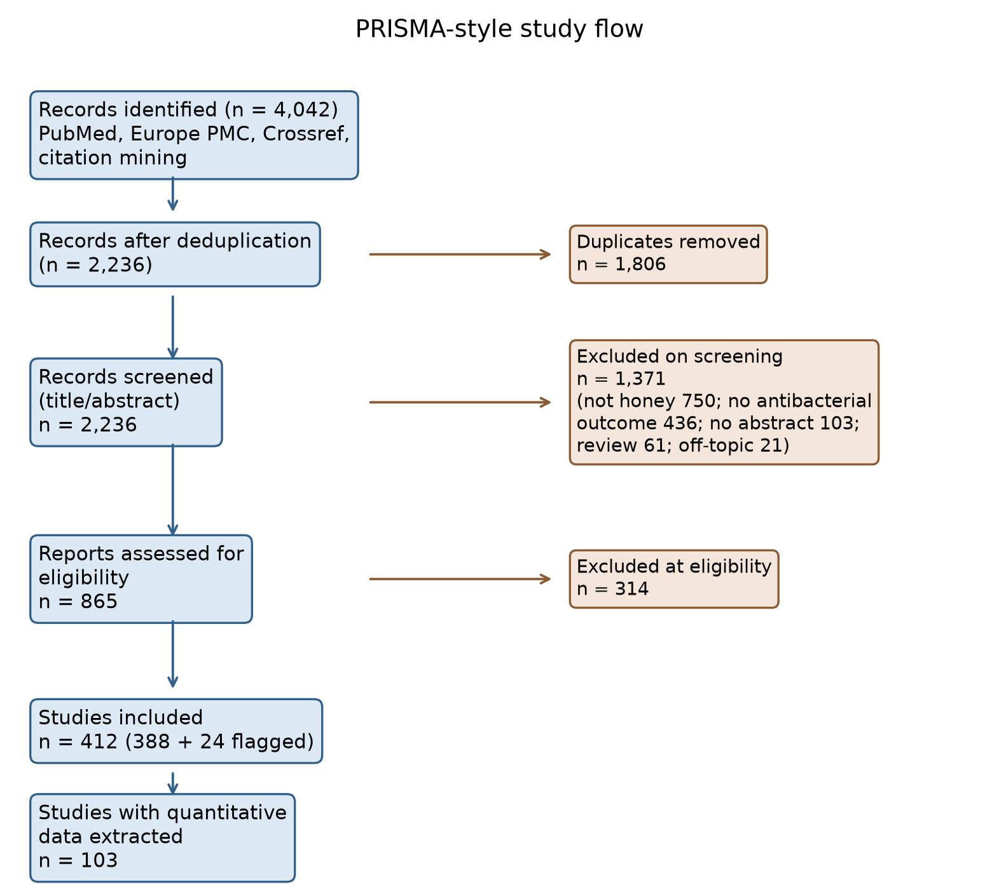
Figure 1. PRISMA-style flow of study identification, screening, eligibility and quantitative extraction.

3.2. Concentration-response (RQ1)
Ten antibacterial concentration-series were extractable across 4 studies, spanning inhibition zones, biofilm inhibition and carbapenemase-producer isolates. All 10 series showed positive monotonic trends of activity with concentration (median Spearman rho = 1.00; Figure 2A-2C). In parallel, the physicochemical constraints weakened with dilution: in the one study reporting pH across a full dilution ladder, pH rose monotonically from approximately 5.25 at 50% honey to 7.28 at 3.12% honey for all four honeys examined (rho = -1.00; Figure 2D). This pattern is consistent with the hypothesis that acidity- and osmolarity-based constraints dominate at high concentration and weaken progressively on dilution; however, series data were scarce (concentration-series flag positive in only 8 of 103 extracted studies), and publication of full dilution ladders is uncommon.
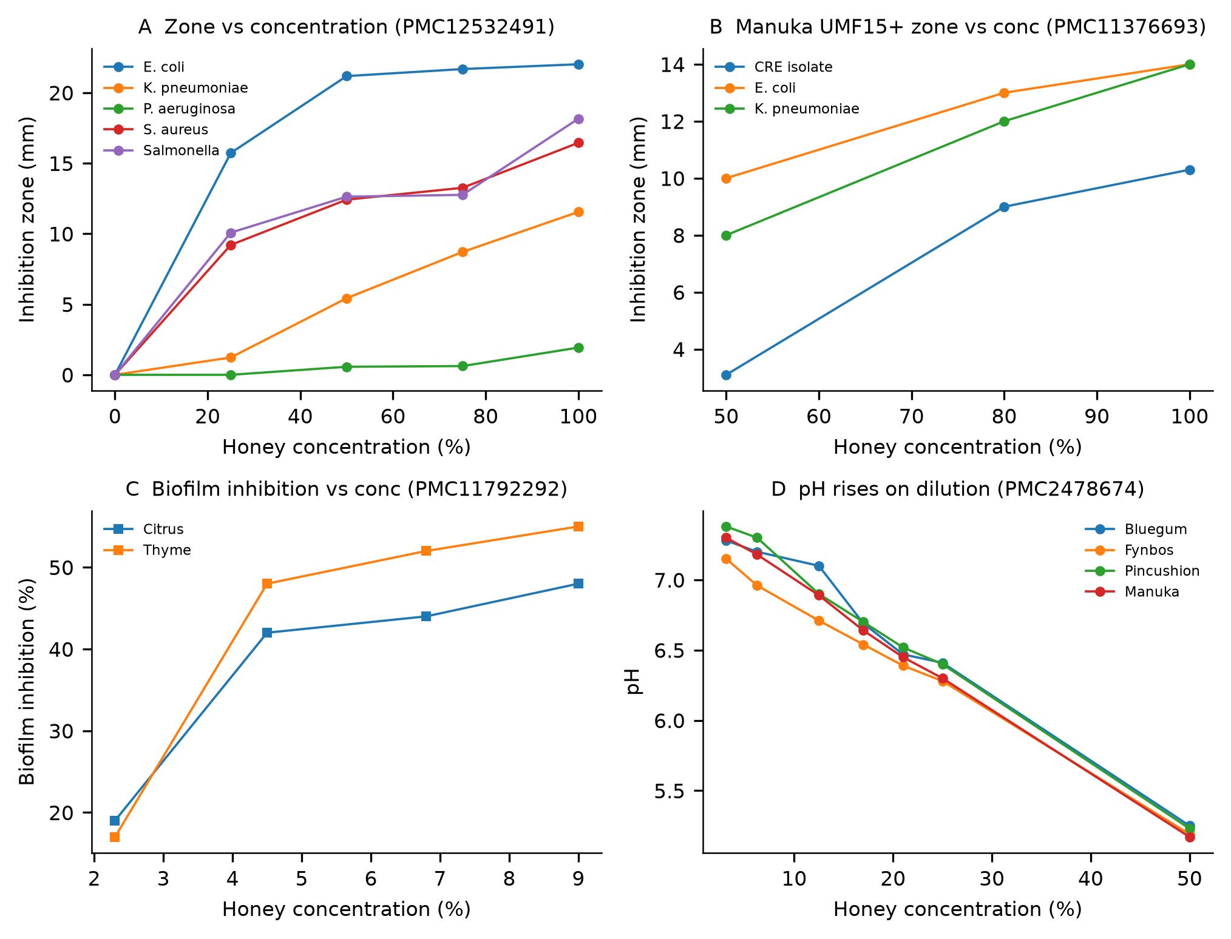
Figure 2. Concentration-response series. (A) Inhibition zones versus honey concentration for five organisms [32]. (B) Manuka UMF15+ zones versus concentration for three organisms [63]. (C) Biofilm inhibition versus concentration for two honeys [15]. (D) pH versus concentration for four honeys [89]; pH rises as honey is diluted.

3.3. Natural versus artificial honey (RQ2)
Twenty-one paired comparisons of natural honey versus artificial or sugar-equivalent controls were identified across 8 studies. Natural honeys produced larger inhibition zones than matched artificial controls (median paired difference +0.6 mm; Wilcoxon p = 0.002; Figure 3A) and lower MIC/MBC values (median ratio natural:artificial = 0.81; Figure 3B). Artificial honey therefore reproduced part, but not all, of natural honey's antibacterial effect, supporting an osmotic component that is real but incomplete as an explanatory model.
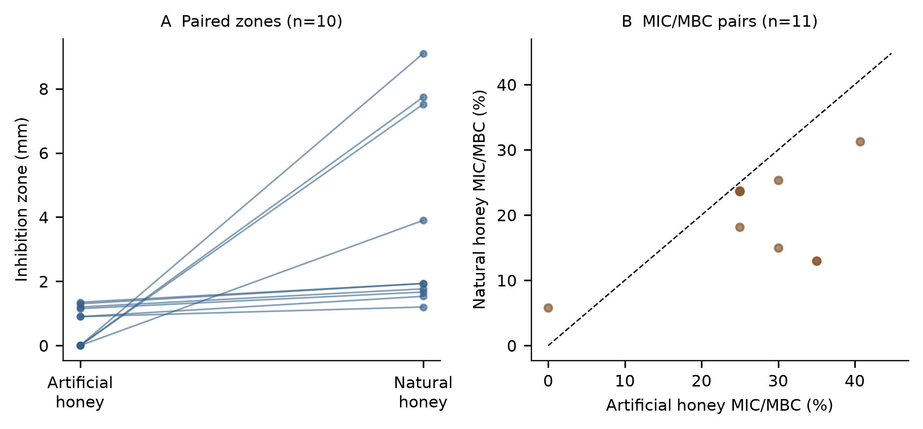
Figure 3. Natural versus artificial honey. (A) Paired inhibition zones. (B) Paired MIC/MBC values; points below the diagonal indicate greater potency of natural honey.

3.4. Hydrogen peroxide and dilution (RQ3)
Cross-study, honey-level H2O2 measurements correlated weakly and positively with MIC (rho = +0.46, n = 29, 2 studies; Figure 4). This direction is opposite to a simple 'more peroxide, more potent' expectation and most likely reflects confounding across studies (for example, highly active non-peroxide honeys with low H2O2), so it should not be read as a peroxide-dose effect. Direct within-study evidence on dilution was sparse but consistent with a dilution-dependent peroxide mechanism: in one extracted study, H2O2 was detectable only at 6.25% and 3.12% honey and not at higher concentrations, and a second study linked glucose oxidase activity, catalase sensitivity and H2O2 concentration to MIC. The predicted pattern of maximal peroxide production at intermediate dilution is therefore supported qualitatively, but the data do not permit estimation of a peak location or even confirmation of monotonicity; we report this as an evidence gap.
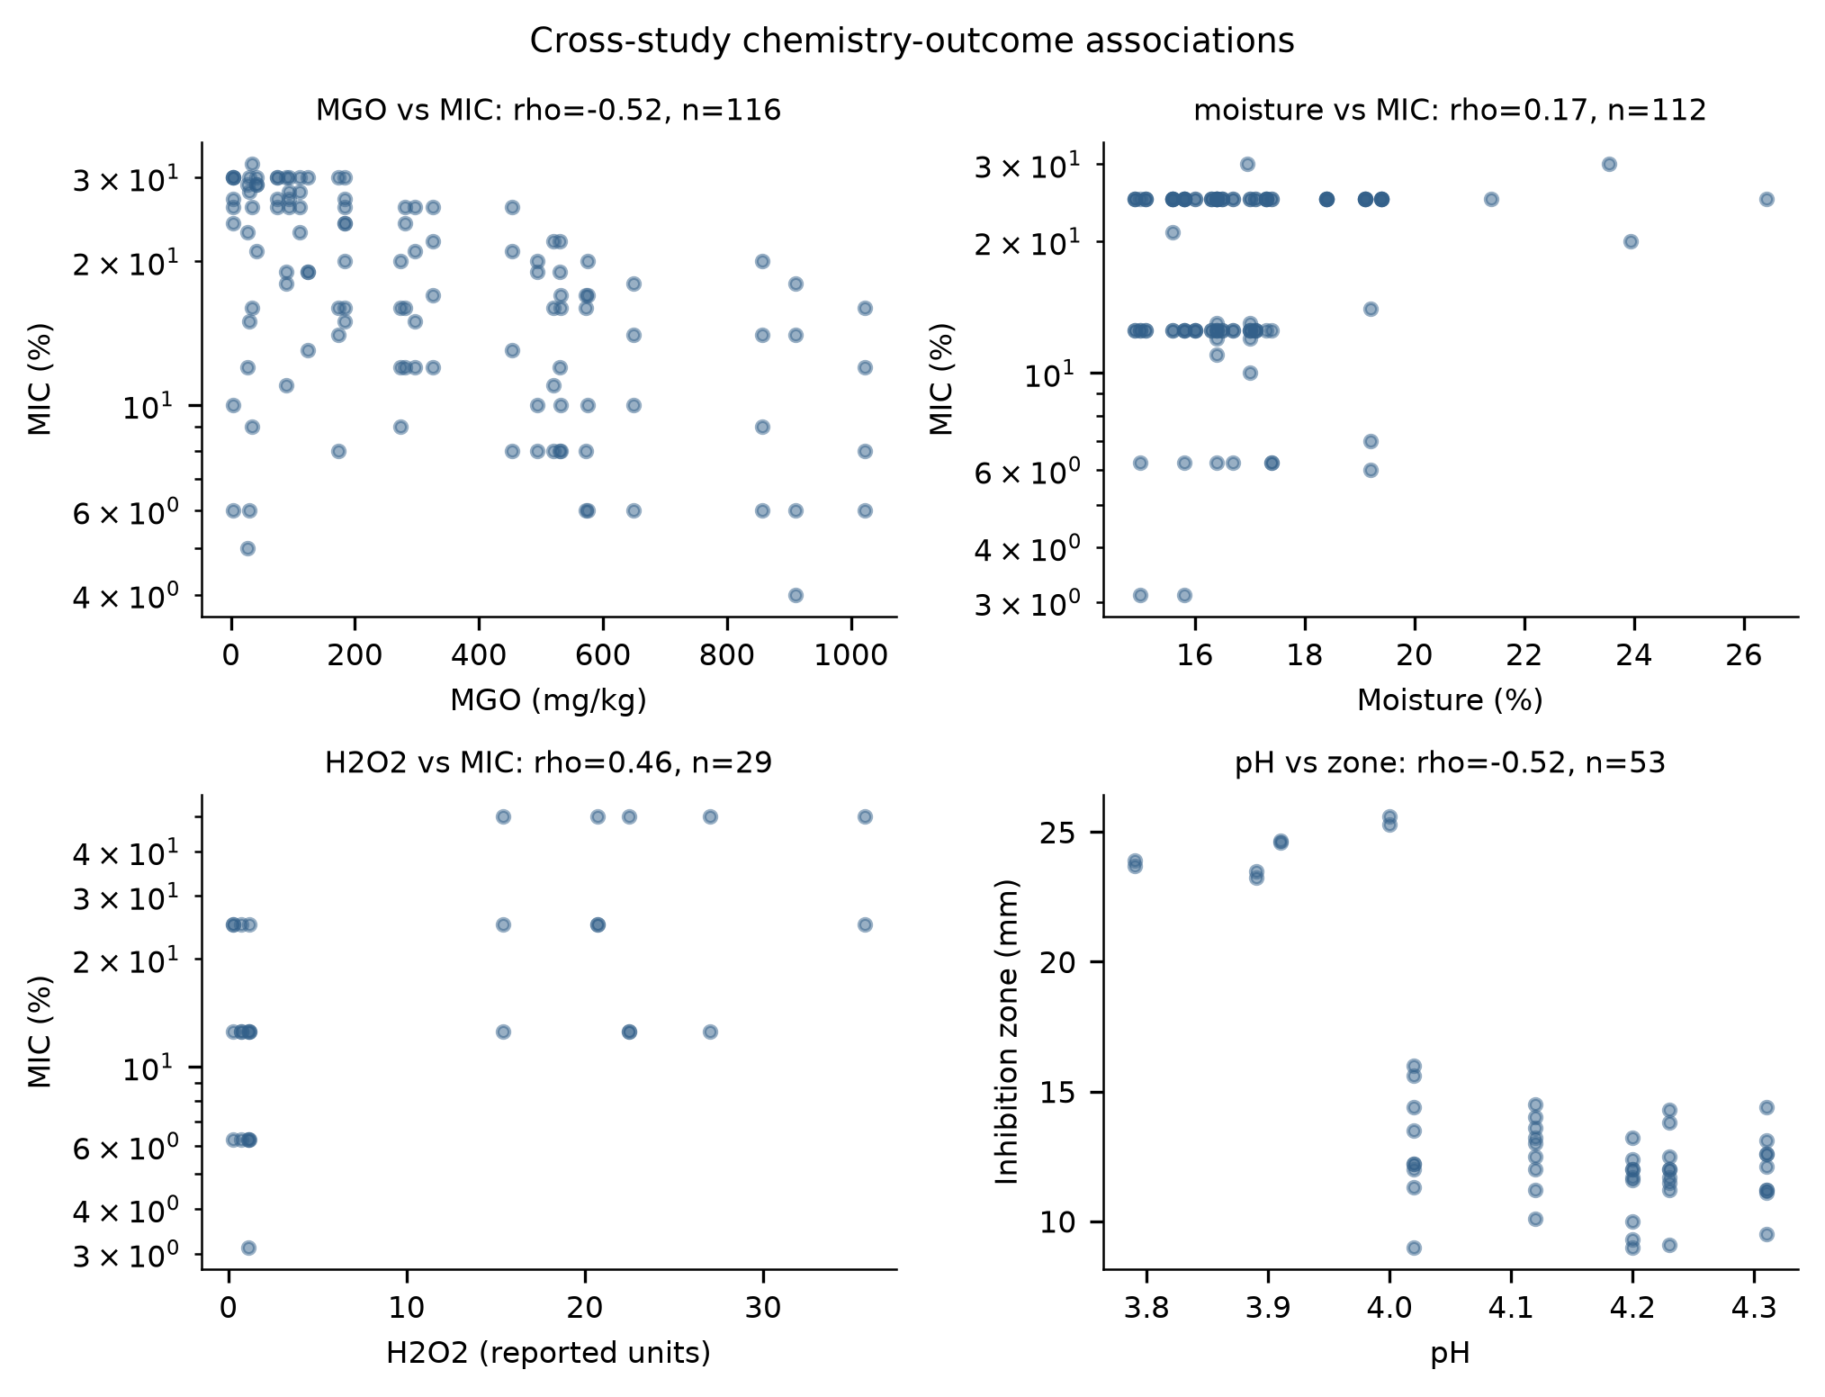
Figure 4. Cross-study associations between honey-level physicochemical parameters and antibacterial outcomes (Spearman rho; MIC on log scale).

3.5. Catalase perturbation and residual activity (RQ4)
Thirteen paired catalase-perturbed observations were extracted from 2 studies. Catalase-treated honey retained a median 92% of untreated antibacterial activity (range roughly 77-100%; Figure 5). This indicates substantial peroxide-independent activity in the honeys tested, but with only two contributing studies the estimate should be treated as preliminary, and residual activity cannot be attributed to MGO or any other single constituent without further evidence.
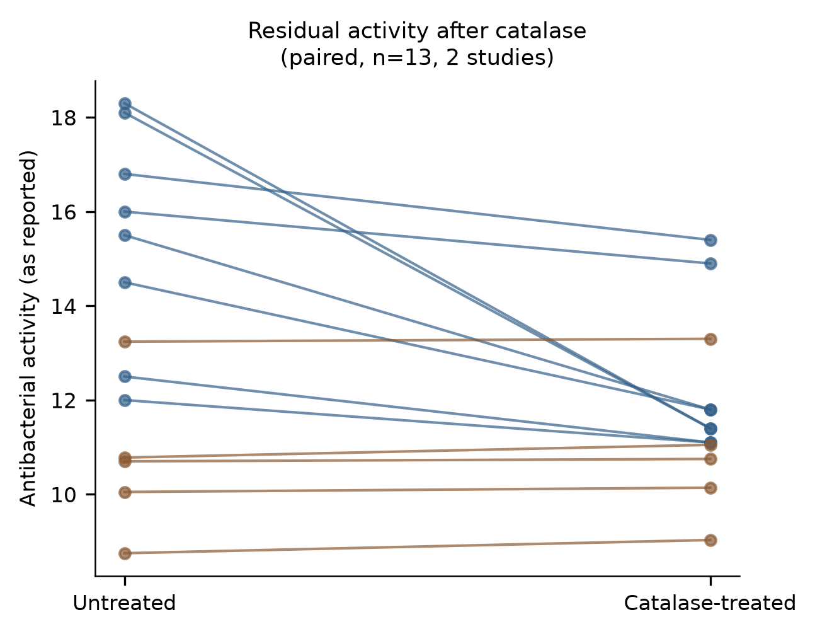
Figure 5. Paired antibacterial activity before and after catalase treatment (13 pairs, 2 studies); residual activity indicates peroxide-independent components.

3.6. Chemistry versus label prediction (RQ5)
Honey-level physicochemical measurements could be joined to antibacterial outcomes for 687 observations from 18 studies. Within the largest single-study block, honey MGO content correlated inversely with MIC (rho = -0.52, n = 116), consistent with MGO-associated potency. Honey moisture correlated positively with MIC (rho = +0.32 unfiltered; +0.17 on the percentage-unit subset), the expected direction if water activity constrains growth. Honey pH showed no monotone association with MIC (rho = 0.07) but a moderate inverse association with inhibition-zone size (rho = -0.52, n = 53). On the largest complete-case block (112 MIC observations, 3 studies), a linear model using measured pH and moisture explained 30% of log10(MIC) variance, while a medical/manuka label alone explained 0%; adding the label to chemistry provided no improvement. Measured chemistry therefore carried more predictive information than the label in this subset, though the modest absolute fit and small study count limit generalization.

3.7. Organism heterogeneity (RQ6)
MIC distributions differed strongly across organisms (Kruskal-Wallis H = 173, p = 2.2 x 10-27; Figure 6). Gram-positive organisms tended to be inhibited at lower honey concentrations (median MIC: S. epidermidis 8.1%, S. aureus 12.5%, MRSA 12.5%) than Gram-negative organisms (E. coli 20%, P. aeruginosa 20%, Salmonella 20.3%) or fungi (27.5%). Manuka-type honeys showed a lower median MIC than other honeys on the percentage-unit subset (15% vs. 18%), but the difference did not reach significance once all comparable data were included (p = 0.065).
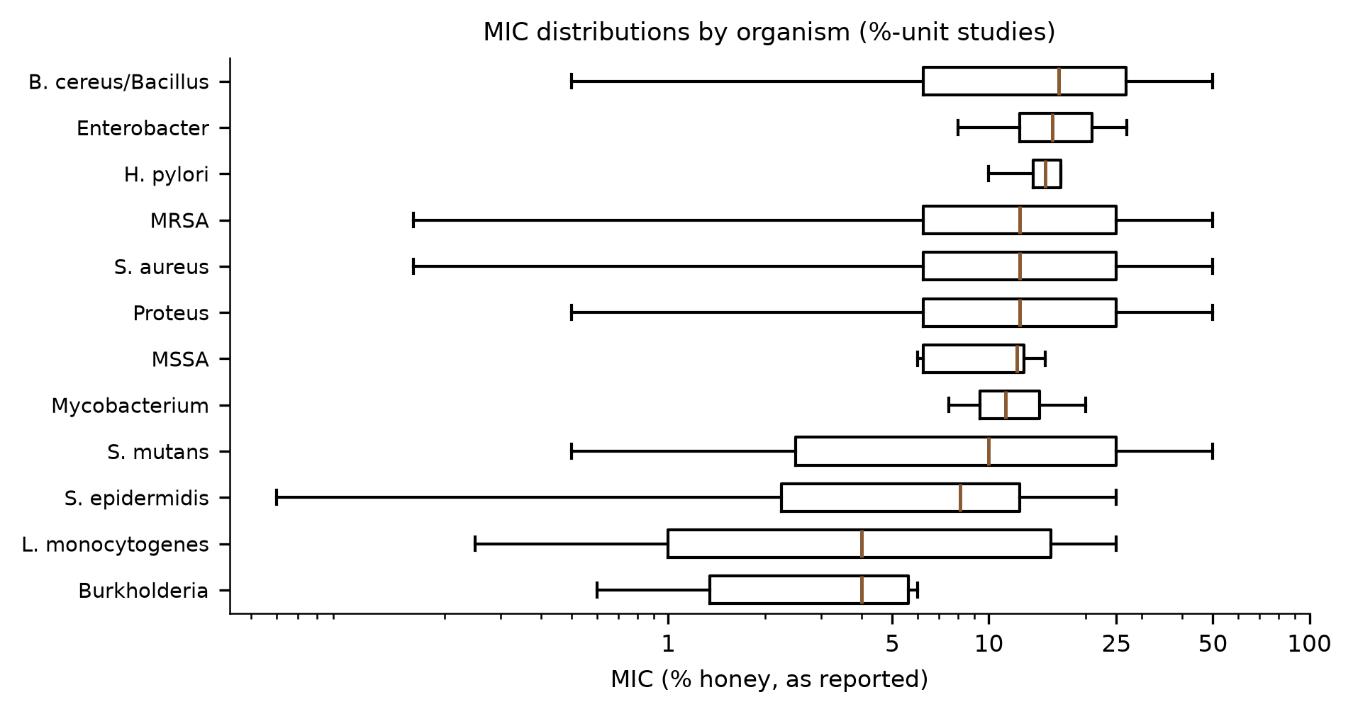
Figure 6. MIC distributions by organism group (percentage-unit studies, log scale).

Table 2. Median MIC (% honey) by organism group, percentage-unit studies.
Organism group | Median MIC (%)
Burkholderia | 4.0
L. monocytogenes | 4.0
S. epidermidis | 8.12
S. mutans | 10.0
Mycobacterium | 11.25
MSSA | 12.25
Proteus | 12.5
S. aureus | 12.5
MRSA | 12.5
H. pylori | 15.0
Enterobacter | 15.75
B. cereus/Bacillus | 16.5
K. pneumoniae | 18.0
E. coli | 20.0
P. aeruginosa | 20.0

3.8. Sensitivity analyses
Restricting MIC analyses to the low-risk-of-bias subset left the qualitative pattern unchanged (6 studies, 185 observations, median MIC 25% reflecting the organisms assayed in those studies). Concentration-response conclusions were insensitive to whether auto-extracted or manually curated rows were used, and MIC distributions were robust to excluding mass-unit endpoints. The catalase and artificial-honey analyses could not be broadened beyond the studies that performed those experiments. Table 1 summarizes the paired mechanistic contrasts.
Table 1. Paired evidence for mechanistic contrasts.
Contrast | n pairs | n studies | Effect | p value
Natural vs artificial honey, zones (mm) | 10 | 8+ | median +0.6 mm | 0.002
Natural vs artificial honey, MIC ratio | 11 | 8+ | median 0.81 | -
Catalase residual activity | 13 | 2 | median 92% retained | -
Activity vs concentration (series) | 10 | 4 | 10/10 positive, rho = 1.00 | -
MGO vs MIC (within-study) | 116 obs | 1 | rho = -0.52 | <0.001
pH vs inhibition zone | 53 obs | 2 | rho = -0.52 | <0.001

4. Discussion
This synthesis supports a dilution-dependent, multi-mechanism account of honey's antibacterial action. At high concentration, activity is consistent with dominance of water-activity/osmotic and acidity constraints: artificial sugar-equivalent honey recapitulated much (though not all) of natural honey's effect, pH rose monotonically toward neutrality on dilution in the one full ladder available, and honeys with higher moisture content tended to have higher MICs. As honey is diluted, these constraints weaken; independently, glucose oxidase can generate H2O2 under diluted aqueous conditions, and within-study evidence indicated peroxide detectable only after substantial dilution [108]. Finally, the high residual activity after catalase (median 92%) in the two studies performing that perturbation, together with the within-study MGO-MIC association, supports a peroxide-independent component in at least some honeys. The three mechanisms are therefore not simply additive along the dilution axis: their relative contributions plausibly shift, with osmotic/acidic activity strongest at high concentration and peroxide activity most relevant at intermediate dilution.
The practical implication for the evidence base is that assay concentration matters mechanistically, not only quantitatively. An MIC measured near the top of the concentration range may reflect constraints (water activity, acidity) that disappear on dilution, whereas activity at intermediate concentrations may be carried by different chemistry entirely. Environments in which honey is substantially diluted, such as exudative wounds, may therefore not be well represented by undiluted assays, and the effective concentration range rather than a single endpoint may be the relevant exposure metric. This observation is restricted to the biological and physicochemical phenomenon; no downstream application is implied.
The cross-study associations should be read cautiously. The positive H2O2-MIC correlation across studies likely reflects confounding (non-peroxide honeys can be both potent and low in H2O2) rather than any perverse peroxide effect; within-study perturbation evidence (catalase, artificial honey, dilution ladders) is the appropriate level for mechanistic claims, and we have reserved directional claims for those contrasts. Similarly, the label-versus-chemistry comparison suggests measured parameters are more informative than botanical or marketing designations, but the absolute variance explained remained modest, and MGO, water activity and H2O2 were measured together in too few honeys to build a joint model.
Several limitations qualify these findings. First, extraction depended on open-access full texts and machine-readable tables; the 103 extracted studies are a subset of the 412 eligible studies, and the extracted subset may over-represent recent open-access work. Second, concentration-series data were rare (8 of 103 studies), catalase pairs came from only 2 studies, and no extractable dataset measured H2O2 across a dilution ladder with matched antibacterial outcomes; RQ3 is therefore supported only qualitatively. Third, assay heterogeneity (broth dilution, agar diffusion, different inocula and media) limits pooling, and we deliberately avoided formal meta-analytic pooling where measurement bases differed. Fourth, automated table extraction, although validated against manual curation, may retain residual errors; all rows carry provenance for audit. Fifth, the rule-based risk-of-bias framework is a reporting-quality proxy, not a validated instrument. Finally, the review was not prospectively registered.

5. Conclusions
Honey's antibacterial activity rises consistently with concentration in extractable series, while the physicochemical constraints plausibly responsible for high-concentration activity weaken on dilution. Natural honey exceeds sugar-equivalent controls, catalase-resistant residual activity is substantial where measured, and measured chemistry predicts outcomes better than honey-type labels. The evidence is consistent with a dilution-dependent shift between osmotic/acidic, peroxide and non-peroxide mechanisms, but direct dilution-resolved measurements of H2O2 paired with antibacterial endpoints remain a clear gap. Future studies should report full dilution ladders with paired chemistry.

Author Contributions
[To be completed by the authors.]

Funding
This research received no external funding.

Institutional Review Board Statement
Not applicable; this study synthesizes previously published data.

Informed Consent Statement
Not applicable.

Data Availability Statement
All extracted data, the data dictionary, screening decisions, analysis code and figure scripts are released with this submission (see accompanying repository archive). Raw database search responses are included as JSON.

Acknowledgments
None.

Conflicts of Interest
The authors declare no conflicts of interest.

References
0. Hussain MB, Kamel YM, Ullah Z, Jiman-Fatani AAM, Ahmad AS. In vitro evaluation of methicillin-resistant and methicillin-sensitive Staphylococcus aureus susceptibility to Saudi honeys. BMC complementary and alternative medicine 2019. https://doi.org/10.1186/s12906-019-2603-8
1. Halawani EM. Potential effects of Saudi Shaoka (Fagonia bruguieri) honey against multi-drug-resistant bacteria and cancer cells in comparison to Manuka honey. Saudi journal of biological sciences 2021. https://doi.org/10.1016/j.sjbs.2021.08.055
2. Boateng J, Diunase KN. Comparing the Antibacterial and Functional Properties of Cameroonian and Manuka Honeys for Potential Wound Healing-Have We Come Full Cycle in Dealing with Antibiotic Resistance?. Molecules 2015. https://doi.org/10.3390/molecules200916068
3. Brown E, O'Brien M, Georges K, Suepaul S. Physical characteristics and antimicrobial properties of Apis mellifera, Frieseomelitta nigra and Melipona favosa bee honeys from apiaries in Trinidad and Tobago. BMC complementary medicine and therapies 2020. https://doi.org/10.1186/s12906-020-2829-5
4. Gkoutzouvelidou M, Panos G, Xanthou MN, Papachristoforou A, Giaouris E. Comparing the Antimicrobial Actions of Greek Honeys from the Island of Lemnos and Manuka Honey from New Zealand against Clinically Important Bacteria. Foods 2021. https://doi.org/10.3390/foods10061402
5. Fernandes KE, Levina A, Cokcetin NN, Haley D, Li J, Brooks P, Gloag R, Carter DA. Strong antimicrobial activity and unique physicochemical characteristics in honey from Australian stingless bees &lt;i&gt;Tetragonula carbonaria&lt;/i&gt;, &lt;i&gt;Tetragonula hockingsi&lt;/i&gt;, and &lt;i&gt;Austroplebeia australis&lt;/i&gt;. Applied and environmental microbiology 2025. https://doi.org/10.1128/aem.02523-24
6. Stavropoulou E, Voidarou CC, Rozos G, Vaou N, Bardanis M, Konstantinidis T, Vrioni G, Tsakris A. Antimicrobial Evaluation of Various Honey Types against Carbapenemase-Producing Gram-Negative Clinical Isolates. Antibiotics 2022. https://doi.org/10.3390/antibiotics11030422
7. Girma A, Seo W, She RC. Antibacterial activity of varying UMF-graded Manuka honeys. PloS one 2019. https://doi.org/10.1371/journal.pone.0224495
8. Sherlock O, Dolan A, Athman R, Power A, Gethin G, Cowman S, Humphreys H. Comparison of the antimicrobial activity of Ulmo honey from Chile and Manuka honey against methicillin-resistant Staphylococcus aureus, Escherichia coli and Pseudomonas aeruginosa. BMC complementary and alternative medicine 2010. https://doi.org/10.1186/1472-6882-10-47
9. Green KJ, Lawag IL, Locher C, Hammer KA. Correlation of the antibacterial activity of commercial manuka and Leptospermum honeys from Australia and New Zealand with methylglyoxal content and other physicochemical characteristics. PloS one 2022. https://doi.org/10.1371/journal.pone.0272376
10. Fernandes KE, Dong A, Ayton J, Groves L, Graham K, Brooks P, Cokcetin N, Carter DA. Diverse Forage Enhances the Antimicrobial Potency of Australian Honey. MicrobiologyOpen 2026. https://doi.org/10.1002/mbo3.70238
11. Stagos D, Soulitsiotis N, Tsadila C, Papaeconomou S, Arvanitis C, Ntontos A, Karkanta F, Adamou-Androulaki S, Petrotos K, Spandidos DA, Kouretas D, Mossialos D. Antibacterial and antioxidant activity of different types of honey derived from Mount Olympus in Greece. International journal of molecular medicine 2018. https://doi.org/10.3892/ijmm.2018.3656
12. Hillebrand J, Oltmanns H, Meißner J. &lt;i&gt;In vitro&lt;/i&gt; efficacy of four potential antimicrobial substances against &lt;i&gt;Klebsiella&lt;/i&gt; species and &lt;i&gt;Streptococcus uberis&lt;/i&gt; isolated from bovine mastitis. Frontiers in veterinary science 2026. https://doi.org/10.3389/fvets.2026.1782821
13. Fernandes L, Ribeiro H, Oliveira A, Sanches Silva A, Freitas A, Henriques M, Rodrigues ME. Portuguese honeys as antimicrobial agents against Candida species. Journal of traditional and complementary medicine 2021. https://doi.org/10.1016/j.jtcme.2020.02.007
14. Alshaybawee MR, Asgari S, Ghadersoltani P, Mehrabian A, Saniee P. Exploring the antibacterial and anti-biofilm activity of two Iranian medical-grade kinds of honey on multidrug-resistant Pseudomonas aeruginosa. BMC complementary medicine and therapies 2025. https://doi.org/10.1186/s12906-025-04778-1
15. Skadiņš I, Labsvārds KD, Grava A, Amirian J, Tomsone LE, Ruško J, Viksna A, Bandere D, Brangule A. Antimicrobial and Antibiofilm Properties of Latvian Honey against Causative Agents of Wound Infections. Antibiotics 2023. https://doi.org/10.3390/antibiotics12050816
16. Chen C, Campbell LT, Blair SE, Carter DA. The effect of standard heat and filtration processing procedures on antimicrobial activity and hydrogen peroxide levels in honey. Frontiers in microbiology 2012. https://doi.org/10.3389/fmicb.2012.00265
17. Barvelink M, Brok B, Djajadiningrat-Laanen SC, Vernooij JCM, Broens EM, Slenter IJM. In Vitro Activity of Manuka Honey, Either Alone or in Combination With Topical Antibiotics, Against Bacteria Commonly Found in Equine Ulcerative Keratitis. Veterinary ophthalmology 2026. https://doi.org/10.1111/vop.70111
18. Fernandes KE, Dong AZ, Levina A, Cokcetin NN, Brooks P, Carter DA. Long-term stability and the physical and chemical factors predictive for antimicrobial activity in Australian honey. PloS one 2024. https://doi.org/10.1371/journal.pone.0303095
19. Ndungu NN, Kegode TM, Kurgat JK, Baleba SBS, Cheseto X, Turner S, Tasse Taboue GC, Kasina JM, Subramanian S, Nganso BT. Bio-functional properties and phytochemical composition of selected Apis mellifera honey from Africa. Heliyon 2024. https://doi.org/10.1016/j.heliyon.2024.e30839
20. Grabek-Lejko D, Miłek M, Dżugan M. The comparison of the antioxidant, antibacterial and antiviral potential of Polish fir honeydew and Manuka honeys. Scientific reports 2024. https://doi.org/10.1038/s41598-024-82429-0
21. Zhang YZ, Si JJ, Li SS, Zhang GZ, Wang S, Zheng HQ, Hu FL. Chemical Analyses and Antimicrobial Activity of Nine Kinds of Unifloral Chinese Honeys Compared to Manuka Honey (12+ and 20+). Molecules 2021. https://doi.org/10.3390/molecules26092778
22. Qu Y, McGiffin D, Kure C, McLean J, Duncan C, Peleg AY. In vitro Evaluation of Medihoney Antibacterial Wound Gel as an Anti-biofilm Agent Against Ventricular Assist Device Driveline Infections. Frontiers in microbiology 2020. https://doi.org/10.3389/fmicb.2020.605608
23. Anand S, Deighton M, Livanos G, Morrison PD, Pang ECK, Mantri N. Antimicrobial Activity of Agastache Honey and Characterization of Its Bioactive Compounds in Comparison With Important Commercial Honeys. Frontiers in microbiology 2019. https://doi.org/10.3389/fmicb.2019.00263
24. Tsavea E, Vardaka FP, Savvidaki E, Kellil A, Kanelis D, Bucekova M, Grigorakis S, Godocikova J, Gotsiou P, Dimou M, Loupassaki S, Remoundou I, Tsadila C, Dimitriou TG, Majtan J, Tananaki C, Alissandrakis E, Mossialos D. Physicochemical Characterization and Biological Properties of Pine Honey Produced across Greece. Foods 2022. https://doi.org/10.3390/foods11070943
25. Brudzynski K, Abubaker K, Wang T. Powerful bacterial killing by buckwheat honeys is concentration-dependent, involves complete DNA degradation and requires hydrogen peroxide. Frontiers in microbiology 2012. https://doi.org/10.3389/fmicb.2012.00242
26. Dong AZ, Cokcetin N, Carter DA, Fernandes KE. Unique antimicrobial activity in honey from the Australian honeypot ant (Camponotus inflatus). PeerJ 2023. https://doi.org/10.7717/peerj.15645
27. Nagy-Radványi L, Ormai E, Koloh R, Ángyán VD, Kocsis B, Bencsik-Kerekes E, Szabó P, Csikós E, Farkas Á, Horváth G, Kocsis M, Balázs VL. Biofilm Inhibition Activity of Fennel Honey, Fennel Essential Oil and Their Combination. Microorganisms 2024. https://doi.org/10.3390/microorganisms12112309
28. Bouddine T, Kachmar MR, Akdad M, Bouymajane A, Ajebli M, Mothana RA, Alanzi AR, Hajjaj H, Khallouki F, Reybroeck W, Van Poucke C, Hajji L. Authentication of Ziziphus lotus Honey from the Middle Atlas Mountains of Morocco: Physicochemical Properties, Mineral Content, Sugar, Polyphenol Profiles, and Antioxidant Capacity. ACS omega 2024. https://doi.org/10.1021/acsomega.4c04284
29. Assaggaf HM, Naceiri Mrabti H, Naceiri Mrabti H, Rajab BS, Attar AA, Hamed M, Sheikh RA, Omari NE, Menyiy NE, Belmehdi O, Mahmud S, Alshahrani MM, Park MN, Kim B, Zengin G, Bouyahya A. Singular and Combined Effects of Essential Oil and Honey of Eucalyptus Globulus on Anti-Inflammatory, Antioxidant, Dermatoprotective, and Antimicrobial Properties: In Vitro and In Vivo Findings. Molecules 2022. https://doi.org/10.3390/molecules27165121
30. Bazaid AS, Aldarhami A, Patel M, Adnan M, Hamdi A, Snoussi M, Qanash H, Imam M, Monjed MK, Khateb AM. The Antimicrobial Effects of Saudi Sumra Honey against Drug Resistant Pathogens: Phytochemical Analysis, Antibiofilm, Anti-Quorum Sensing, and Antioxidant Activities. Pharmaceuticals 2022. https://doi.org/10.3390/ph15101212
31. Kumera B, Gebreamanule B, Atnkut B, Merid M, Tilahun T, Tsega A, Fassil A, Dessie Y, Kassie B. In Vitro Antibacterial Activity of Raw Honey From Apis mellifera, Awi Zone, Amhara, Ethiopia. MicrobiologyOpen 2025. https://doi.org/10.1002/mbo3.70076
32. Clare J, Lindley MR, Ratcliffe E. The Antimicrobial and Antibiofilm Abilities of Fish Oil Derived Polyunsaturated Fatty Acids and Manuka Honey. Microorganisms 2024. https://doi.org/10.3390/microorganisms12040778
33. Elgazar AA, Ghazy MG, Badria FA. Egyptian fennel honey as a potential sustainable and economical alternative to manuka honey: a multi-parameter comparative study. RSC advances 2026. https://doi.org/10.1039/d6ra02816k
34. Jibril FI, Mohd Hilmi AB, Aliyu S. Effect of Non-hydrogen Peroxide on Antibacterial Activity of Malaysian Meliponini Honey against Staphylococcus aureus. Journal of pharmacy & bioallied sciences 2020. https://doi.org/10.4103/jpbs.jpbs_280_19
35. Hamadou WS, Bouali N, Badraoui R, Hadj Lajimi R, Hamdi A, Alreshidi M, Patel M, Adnan M, Siddiqui AJ, Noumi E, Noumi E, Rao Pasupuleti V, Snoussi M. Chemical Composition and the Anticancer, Antimicrobial, and Antioxidant Properties of Acacia Honey from the Hail Region: The in vitro and in silico Investigation. Evidence-based complementary and alternative medicine : eCAM 2022. https://doi.org/10.1155/2022/1518511
36. Liang J, Adeleye M, Onyango LA. Combinatorial efficacy of Manuka honey and antibiotics in the in vitro control of staphylococci and their small colony variants. Frontiers in cellular and infection microbiology 2023. https://doi.org/10.3389/fcimb.2023.1219984
37. Balázs VL, Nagy-Radványi L, Bencsik-Kerekes E, Koloh R, Szabó D, Kocsis B, Kocsis M, Farkas Á. Antibacterial and Antibiofilm Effect of Unifloral Honeys against Bacteria Isolated from Chronic Wound Infections. Microorganisms 2023. https://doi.org/10.3390/microorganisms11020509
38. Feás X, Iglesias A, Rodrigues S, Estevinho LM. Effect of Erica sp. honey against microorganisms of clinical importance: study of the factors underlying this biological activity. Molecules 2013. https://doi.org/10.3390/molecules18044233
39. Zainol MI, Mohd Yusoff K, Mohd Yusof MY. Antibacterial activity of selected Malaysian honey. BMC complementary and alternative medicine 2013. https://doi.org/10.1186/1472-6882-13-129
40. Mohapatra DP, Thakur V, Brar SK. Antibacterial efficacy of raw and processed honey. Biotechnology research international 2011. https://doi.org/10.4061/2011/917505
41. Alotibi IA, Harakeh SM, Al-Mamary M, Mariod AA, Al-Jaouni SK, Al-Masaud S, Alharbi MG, Al-Hindi RR. Floral markers and biological activity of Saudi honey. Saudi journal of biological sciences 2018. https://doi.org/10.1016/j.sjbs.2018.05.021
42. Sakač M, Jovanov P, Marić A, Četojević-Simin D, Novaković A, Plavšić D, Škrobot D, Kovač R. Antioxidative, Antibacterial and Antiproliferative Properties of Honey Types from the Western Balkans. Antioxidants 2022. https://doi.org/10.3390/antiox11061120
43. Mansour SH, El-Shazly AI, Gamal AA, Elsayed EA, Wadaan MA, Esawy MA. Potential antibacterial, antioxidant and anticancer activities of Nigerian mountain honey in relation to its bacterial flora. Journal, genetic engineering & biotechnology 2025. https://doi.org/10.1016/j.jgeb.2025.100559
44. Li J, Wang J, Wang Y, Yang W. Physicochemical Properties, Antioxidant and Antibacterial Activities and Anti-Hepatocarcinogenic Effect and Potential Mechanism of &lt;i&gt;Schefflera oleifera&lt;/i&gt; Honey Against HepG2 Cells. Foods 2025. https://doi.org/10.3390/foods14132376
45. Aburayyan WS, Seder N, Al-Fawares O, Fararjeh A, Majali IS, Al-Hajaya Y. Characterization of Antibiofilm and Antimicrobial Effects of Trigona Stingless Bee Honey Compared to Stinging Bee Centaurea hyalolepis and Citrus Honeys. Journal of evidence-based integrative medicine 2024. https://doi.org/10.1177/2515690x241271978
46. Chin SW, Azman AS, Yap MKK, Tan JW. Evaluation of the Antimicrobial Potential of Malaysian Kelulut Honeydew Honey Against Acne Pathogens. Current microbiology 2026. https://doi.org/10.1007/s00284-026-04866-6
47. Luca L, Pauliuc D, Ursachi F, Oroian M. Physicochemical parameters, microbiological quality, and antibacterial activity of honey from the Bucovina region of Romania. Scientific reports 2025. https://doi.org/10.1038/s41598-025-88613-0
48. Ángyán VD, Balázs VL, Kocsis M, Kocsis B, Horváth G, Farkas Á, Nagy-Radványi L. Synergistic Antibiofilm Effects of Chestnut and Linden Honey with Lavender Essential Oil Against Multidrug-Resistant Otitis Media Pathogens. Antibiotics 2025. https://doi.org/10.3390/antibiotics14020146
49. Hayashi K, Fukushima A, Hayashi-Nishino M, Nishino K. Effect of methylglyoxal on multidrug-resistant Pseudomonas aeruginosa. Frontiers in microbiology 2014. https://doi.org/10.3389/fmicb.2014.00180
50. Nagy-Radványi L, Balázs V, Kocsis B, Csikós E, Ángyán V, Szabó P, Biró V, Kocsis M, Farkas Á. Antibacterial activity of Hungarian varietal honeys against respiratory pathogens as a function of storage time. Scientific reports 2024. https://doi.org/10.1038/s41598-024-60961-3
51. Sindi A, Chawn MVB, Hernandez ME, Green K, Islam MK, Locher C, Hammer K. Anti-biofilm effects and characterisation of the hydrogen peroxide activity of a range of Western Australian honeys compared to Manuka and multifloral honeys. Scientific reports 2019. https://doi.org/10.1038/s41598-019-54217-8
52. Wasfi R, Elkhatib WF, Khairalla AS. Effects of Selected Egyptian Honeys on the Cellular Ultrastructure and the Gene Expression Profile of Escherichia coli. PloS one 2016. https://doi.org/10.1371/journal.pone.0150984
53. Camplin AL, Maddocks SE. Manuka honey treatment of biofilms of Pseudomonas aeruginosa results in the emergence of isolates with increased honey resistance. Annals of clinical microbiology and antimicrobials 2014. https://doi.org/10.1186/1476-0711-13-19
54. Wasihun AG, Kasa BG. Evaluation of antibacterial activity of honey against multidrug resistant bacteria in Ayder Referral and Teaching Hospital, Northern Ethiopia. SpringerPlus 2016. https://doi.org/10.1186/s40064-016-2493-x
55. Jenkins R, Wootton M, Howe R, Cooper R. A demonstration of the susceptibility of clinical isolates obtained from cystic fibrosis patients to manuka honey. Archives of microbiology 2015. https://doi.org/10.1007/s00203-015-1091-6
56. Masalha M, Abu-Lafi S, Abu-Farich B, Rayan M, Issa N, Zeidan M, Rayan A. A New Approach for Indexing Honey for Its Heath/Medicinal Benefits: Visualization of the Concept by Indexing Based on Antioxidant and Antibacterial Activities. Medicines 2018. https://doi.org/10.3390/medicines5040135
57. Owayss AA, Elbanna K, Iqbal J, Abulreesh HH, Organji SR, Raweh HSA, Alqarni AS. In vitro antimicrobial activities of Saudi honeys originating from Ziziphus spina-christi L. and Acacia gerrardii Benth. trees. Food science & nutrition 2020. https://doi.org/10.1002/fsn3.1320
58. Mireles-Villanueva MV, Reyna-Fuentes JH, Vázquez-Sauceda ML, Vargas MB, Cornejo J, Neira M, Muñoz-Sánchez RA, Lapierre L. Chilean Honey as Alternative Antibacterial: In Vitro Activity Against Multidrug-Resistant Canine Bacterial Pathogens. Animals : an open access journal from MDPI 2026. https://doi.org/10.3390/ani16071125
59. Al-Kafaween MA, Al-Jamal HAN, Hilmi ABM, Elsahoryi NA, Jaffar N, Zahri MK. Antibacterial properties of selected Malaysian Tualang honey against Pseudomonas aeruginosa and Streptococcus pyogenes. Iranian journal of microbiology 2020. https://doi.org/10.18502/ijm.v12i6.5031
60. Akpınar S, Mutlu N. Multidimensional analysis of honey from Eastern Anatolia (Kars): Pollen spectrum, physicochemical properties, and antimicrobial activity. PloS one 2025. https://doi.org/10.1371/journal.pone.0327861
61. Guttentag A, Krishnakumar K, Cokcetin N, Harry E, Carter D. Factors affecting the production and measurement of hydrogen peroxide in honey samples. Access microbiology 2021. https://doi.org/10.1099/acmi.0.000198
62. Bukhari MA, Qamash RA, Bulkhi RA, Bifari JA, Bakhsh OS, Hawsawi KO, Matuure EY, Sulaimani KA, Hakim AT, Mujahid MS. Biological studies of the activity of Manuka honey against Carbapenem-resistant Enterobacterales (CRE) bacteria. Saudi medical journal 2024. https://doi.org/10.15537/smj.2024.45.9.20240153
63. Bazaid AS, Alsolami A, Patel M, Khateb AM, Aldarhami A, Snoussi M, Almusheet SM, Qanash H. Antibiofilm, Antimicrobial, Anti-Quorum Sensing, and Antioxidant Activities of Saudi Sidr Honey: In Vitro and Molecular Docking Studies. Pharmaceutics 2023. https://doi.org/10.3390/pharmaceutics15092177
64. Brudzynski K. Unexpected Value of Honey Color for Prediction of a Non-Enzymatic H&lt;sub&gt;2&lt;/sub&gt;O&lt;sub&gt;2&lt;/sub&gt; Production and Honey Antibacterial Activity: A Perspective. Metabolites 2023. https://doi.org/10.3390/metabo13040526
65. Qasem A, Assaggaf H, Montesano D, Khalil Z, Al-Mijalli SH, Baaboua AE, El Omari N, El Menyiy N, Bakrim S, Sheikh RA, Alshahrani MM, Awadh AAA, Zengin G, Bouyahya A, Mrabti HN. Determination of Chemical Compounds and Investigation of Biological Properties of Matricaria chamomilla Essential Oils, Honey, and Their Mixture. Molecules 2022. https://doi.org/10.3390/molecules27185850
66. Bereksi-Reguig D, Allali H, Taib N, Aissaoui N, Wlodarczyk-Stasiak M, Kowalski R. Bioactive Compounds, Antioxidant Properties, and Antimicrobial Profiling of a Range of West Algerian Honeys: In Vitro Comparative Screening Prior to Therapeutic Purpose. Foods 2024. https://doi.org/10.3390/foods13244120
67. Helmy AK, Sidkey NM, Abdel-Aziz MM, El-Hela AA. Chemical composition of Egyptian propolis and studying its antimicrobial activity and synergistic action with honey against some multidrug-resistant uropathogens. Scientific reports 2025. https://doi.org/10.1038/s41598-025-00773-1
68. Bouacha M, Ayed H, Grara N. Honey Bee as Alternative Medicine to Treat Eleven Multidrug-Resistant Bacteria Causing Urinary Tract Infection during Pregnancy. Scientia pharmaceutica 2018. https://doi.org/10.3390/scipharm86020014
69. Ayub R, Umer M, Maan AA, Rasool B, Khan MKI, Younis T, Abbas S, Sajjad M, Kaleem I, Imran M, Ullah A, Afzal MS, Shah ZH, Ahmed S, Aslam F, Chaudhary N, Afzal MI. Antibiotics, Acid and Heat Tolerance of Honey adapted Escherichia coli, Salmonella Typhi and Klebsiella pneumoniae. Foods 2020. https://doi.org/10.3390/foods9030311
70. Alzahrani HA, Alsabehi R, Boukraâ L, Abdellah F, Bellik Y, Bakhotmah BA. Antibacterial and antioxidant potency of floral honeys from different botanical and geographical origins. Molecules 2012. https://doi.org/10.3390/molecules170910540
71. Tan W, Tian Y, Zhang Q, Miao S, Wu W, Miao X, Kuang H, Yang W. Antioxidant and antibacterial activity of Apis laboriosa honey against Salmonella enterica serovar Typhimurium. Frontiers in nutrition 2023. https://doi.org/10.3389/fnut.2023.1181492
72. Getachew T, Ashenafi M, Tigu F, Birri DJ, Naoli A, Desalegn A. Probiotic potential of 'lactobacilli' isolated from traditionally fermented Ethiopian honey wine (Tej). BMC microbiology 2025. https://doi.org/10.1186/s12866-025-04326-4
73. Balázs VL, Nagy-Radványi L, Filep R, Kerekes E, Kocsis B, Kocsis M, Farkas Á. In Vitro Antibacterial and Antibiofilm Activity of Hungarian Honeys against Respiratory Tract Bacteria. Foods 2021. https://doi.org/10.3390/foods10071632
74. Ratajczak M, Kaminska D, Matuszewska E, Hołderna-Kedzia E, Rogacki J, Matysiak J. Promising Antimicrobial Properties of Bioactive Compounds from Different Honeybee Products. Molecules 2021. https://doi.org/10.3390/molecules26134007
75. Barbarić A, Saftić Martinović L, Marijanović Z, Juretić L, Jurič A, Petrović D, Šoljić V, Gobin I. Integrated Chemical and Biological Evaluation of Linden Honeydew Honey from Bosnia and Herzegovina: Composition and Cellular Effects. Foods 2025. https://doi.org/10.3390/foods14101668
76. Hulea C, Obistioiu D, Hulea A, Suleiman MA, Floares Oarga D, Alexa E, Imbrea IM, Neacșu AG, Pentea M, Popescu CA, Imbrea F. Integrated Assessment of Antibacterial Activity, Polyphenol Composition, Molecular Docking, and ADME Properties of Romanian Oak and Fir Honeydew Honeys. Antibiotics 2025. https://doi.org/10.3390/antibiotics14060592
77. Mundanchira AV, Wong A, Klos-Maki K, Strand J, Marques CNH. Activity of Biocidin&lt;sup&gt;®&lt;/sup&gt; against microbial biofilms. Frontiers in antibiotics 2025. https://doi.org/10.3389/frabi.2025.1692653
78. Suwannapong G, Benbow ME, Ponkit R, Boonsriwong W, Naree S. The Effect of Temperature Variations on the 5-Hydroxymethylfurfural Content, Antioxidant and Antimicrobial Properties of Honey. Life 2026. https://doi.org/10.3390/life16081366
79. Otręba M, Marek Ł, Tyczyńska N, Stojko J, Rzepecka-Stojko A. Bee Venom, Honey, and Royal Jelly in the Treatment of Bacterial Infections of the Oral Cavity: A Review. Life 2021. https://doi.org/10.3390/life11121311
80. Tiang ER, Han L, Hu F. Physicochemical Characteristics, Antioxidant Capacity, and Antimicrobial Activity of Stingless Bee Honey from Malaysia: &lt;i&gt;Heterotrigona itama&lt;/i&gt;, &lt;i&gt;Lophotrigona canifrons&lt;/i&gt;, and &lt;i&gt;Tetrigona binghami&lt;/i&gt;. Foods 2025. https://doi.org/10.3390/foods14060995
81. Hameed OM, Shaker OM, Ben Slima A, Makni M. Biochemical Profiling and Physicochemical and Biological Valorization of Iraqi Honey: A Comprehensive Analysis. Molecules 2024. https://doi.org/10.3390/molecules29030671
82. Mežnarić S, Brčić Karačonji I, Crnković G, Lesar A, Pavlešić T, Vučković D, Gobin I. Combined Inhibitory Effect of Fir (Abies alba Mill.) Honeydew Honey and Probiotic Bacteria Lactiplantibacillus plantarum on the Growth of Salmonella enterica Serotype Typhimurium. Antibiotics 2022. https://doi.org/10.3390/antibiotics11020145
83. Miłek M, Ciszkowicz E, Sidor E, Hęclik J, Lecka-Szlachta K, Dżugan M. The Antioxidant, Antibacterial and Anti-Biofilm Properties of Rapeseed Creamed Honey Enriched with Selected Plant Superfoods. Antibiotics 2023. https://doi.org/10.3390/antibiotics12020235
84. Ismail SA, Wahba MI, Nour SA, Gamal AA, Ezzat A, Hashem AM. &lt;i&gt;Bacillus subtilis&lt;/i&gt; EGY1 glucansucrase: optimization, characterization and immobilization using activated carrier of pectin-egg white protein beads. 3 Biotech 2026. https://doi.org/10.1007/s13205-025-04609-7
85. Jantakee K, Tragoolpua Y. Activities of different types of Thai honey on pathogenic bacteria causing skin diseases, tyrosinase enzyme and generating free radicals. Biological research 2015. https://doi.org/10.1186/0717-6287-48-4
86. ALaerjani WMA, Khan KA, Al-Shehri BM, Ghramh HA, Hussain A, Mohammed MEA, Imran M, Ahmad I, Ahmad S, Al-Awadi AS. Chemical Profiling, Antioxidant, and Antimicrobial Activity of Saudi Propolis Collected by Arabian Honey Bee (Apis mellifera jemenitica) Colonies. Antioxidants 2022. https://doi.org/10.3390/antiox11071413
87. Julianti E, Rajah KK, Fidrianny I. Antibacterial Activity of Ethanolic Extract of Cinnamon Bark, Honey, and Their Combination Effects against Acne-Causing Bacteria. Scientia pharmaceutica 2017. https://doi.org/10.3390/scipharm85020019
88. Basson NJ, Grobler SR. Antimicrobial activity of two South African honeys produced from indigenous Leucospermum cordifolium and Erica species on selected micro-organisms. BMC complementary and alternative medicine 2008. https://doi.org/10.1186/1472-6882-8-41
89. Adgaba N, Al-Ghamdi A, Sharma D, Tadess Y, Alghanem SM, Ali Khan K, Javed Ansari M, Mohamed GKA. Physico-chemical, antioxidant and anti-microbial properties of some Ethiopian mono-floral honeys. Saudi journal of biological sciences 2020. https://doi.org/10.1016/j.sjbs.2020.05.031
90. Voidarou CC, Rozos G, Alexopoulos A, Plessas S, Mantzourani I, Stavropoulou E, Tzora A, Bezirtzoglou E. In Vitro Screening Potential Antibacterial Properties of the Greek Oregano Honey against Clinical Isolates of Helicobacter pylori. Foods 2021. https://doi.org/10.3390/foods10071568
91. Nolan VC, Harrison J, Cox JAG. Manuka honey in combination with azithromycin shows potential for improved activity against &lt;i&gt;Mycobacterium abscessus&lt;/i&gt;. Cell surface (Amsterdam, Netherlands) 2022. https://doi.org/10.1016/j.tcsw.2022.100090
92. Rodríguez Machado A, Caro CM, Hurtado-Murillo JJ, Gomes Lobo CJ, Zúñiga RN, Franco W. Unconventional Yeasts Isolated from Chilean Honey: A Probiotic and Phenotypic Characterization. Foods 2024. https://doi.org/10.3390/foods13101582
93. Ailli A, Zibouh K, Eddamsyry B, Drioiche A, Fetjah D, Ayyad FZ, Mothana RA, Hawwal MF, Radi M, Tarik R, Elomri A, Mouradi A, Zair T. Physicochemical Characterization of Moroccan Honey Varieties from the Fez-Meknes Region and Their Antioxidant and Antibacterial Properties. Metabolites 2024. https://doi.org/10.3390/metabo14070364
94. Eid N, El-Seedi HR, Ahmed HB, Emam HE. Bio-fabrication of biologically active copper nanocomposite. Heliyon 2024. https://doi.org/10.1016/j.heliyon.2024.e40202
95. Šola I, Vujčić Bok V, Fabijanić I, Jablan J, Borgese L, Humski A, Mikulić M, Sanković K, Franić Z, Rusak G. Influence of Season, Hive Position, Extraction Method and Storage Temperature on Polyphenols and Antioxidant Activity of Croatian Honey. Molecules 2025. https://doi.org/10.3390/molecules30040919
96. Nishio EK, Ribeiro JM, Oliveira AG, Andrade CG, Proni EA, Kobayashi RK, Nakazato G. Antibacterial synergic effect of honey from two stingless bees: Scaptotrigona bipunctata Lepeletier, 1836, and S. postica Latreille, 1807. Scientific reports 2016. https://doi.org/10.1038/srep21641
97. Isidorov V, Zalewski A, Zambrowski G, Swiecicka I. Chemical Composition and Antimicrobial Properties of Honey Bee Venom. Molecules 2023. https://doi.org/10.3390/molecules28104135
98. Sufya N, Matar N, Kaddura R, Zorgani A. Evaluation of bactericidal activity of Hannon honey on slowly growing bacteria in the chemostat. Drug, healthcare and patient safety 2014. https://doi.org/10.2147/DHPS.S66496
99. Sateriale D, Facchiano S, Colicchio R, Pagliuca C, Varricchio E, Paolucci M, Volpe MG, Salvatore P, Pagliarulo C. In vitro Synergy of Polyphenolic Extracts From Honey, Myrtle and Pomegranate Against Oral Pathogens, S. mutans and R. dentocariosa. Frontiers in microbiology 2020. https://doi.org/10.3389/fmicb.2020.01465
100. Lewoyehu M, Amare M. Comparative Assessment on Selected Physicochemical Parameters and Antioxidant and Antimicrobial Activities of Honey Samples from Selected Districts of the Amhara and Tigray Regions, Ethiopia. International journal of food science 2019. https://doi.org/10.1155/2019/4101695
101. Taherpour A, Mirzavi F, Shafaei E, Zarban A, Shakibaie M. Combined effects of honey and silver nanoparticles on wound healing in human dermal fibroblast cells. BMC complementary medicine and therapies 2025. https://doi.org/10.1186/s12906-025-05171-8
102. Brudzynski K, Sjaarda C. Honey glycoproteins containing antimicrobial peptides, Jelleins of the Major Royal Jelly Protein 1, are responsible for the cell wall lytic and bactericidal activities of honey. PloS one 2015. https://doi.org/10.1371/journal.pone.0120238
104. Willix DJ, Molan PC, Harfoot CG. A comparison of the sensitivity of wound-infecting species of bacteria to the antibacterial activity of manuka honey and other honey. The Journal of applied bacteriology 1992. https://doi.org/10.1111/j.1365-2672.1992.tb04993.x
105. Kwakman PH, te Velde AA, de Boer L, Speijer D, Vandenbroucke-Grauls CM, Zaat SA. How honey kills bacteria. FASEB journal : official publication of the Federation of American Societies for Experimental Biology 2010. https://doi.org/10.1096/fj.09-150789
106. Cooper RA, Molan PC, Harding KG. Antibacterial activity of honey against strains of Staphylococcus aureus from infected wounds. Journal of the Royal Society of Medicine 1999. https://doi.org/10.1177/014107689909200604
107. Kwakman PH, Te Velde AA, de Boer L, Vandenbroucke-Grauls CM, Zaat SA. Two major medicinal honeys have different mechanisms of bactericidal activity. PloS one 2011. https://doi.org/10.1371/journal.pone.0017709
108. Bang LM, Buntting C, Molan P. The effect of dilution on the rate of hydrogen peroxide production in honey and its implications for wound healing. Journal of alternative and complementary medicine (New York, N.Y.) 2003. https://doi.org/10.1089/10755530360623383

