Dilution-dependent antibacterial mechanisms of honey: a systematic review and cross-study quantitative evidence synthesis

[Author One] a, [Author Two] b, [Corresponding Author] a,*
a [Affiliation 1]; b [Affiliation 2]
* Corresponding author. E-mail address: [email]

Abstract
Honey exhibits broad-spectrum antibacterial activity, but whether its mechanism of action changes with dilution — rather than simply weakening — remains incompletely resolved. We conducted a systematic review and cross-study quantitative evidence synthesis. Searches of PubMed, Europe PMC and Crossref, plus citation mining and data-repository searches, retrieved 4,042 records; 2,231 unique records were screened, 412 studies met eligibility criteria, and structured data were extracted from 103 open-access full texts (4,650 observations). All 10 extractable antibacterial concentration series increased monotonically with honey concentration (median Spearman rho = 1.00), while solution pH rose on dilution (rho = -1.00), consistent with weakening acidity. Natural honeys exceeded sugar-equivalent artificial controls in 16 of 21 matched pairs (median potency ratio 1.38, p = 0.005). Catalase-treated honey retained a median 92% of activity (13 pairs, 2 studies). Cross-study associations between honey chemistry and outcomes were detectable within studies but did not generalize: leave-one-study-out cross-validated R2 was negative for chemistry-based and label-based models alike. Directly matched dilution-resolved hydrogen peroxide and antibacterial measurements were rare. The evidence is consistent with dilution-dependent reweighting of osmotic, acidic, peroxide and non-peroxide mechanisms, but does not establish a universal mechanistic switch; dilution-resolved mechanistic measurement remains the key evidence gap.
Keywords: honey; dilution; hydrogen peroxide; methylglyoxal; water activity; systematic review

1. Introduction
Honey is a complex food matrix with well-documented in vitro antibacterial activity (Kwakman et al., 2010; Willix et al., 1992). Its activity arises from several partially independent mechanisms: high osmolarity and low water activity constrain microbial growth, its acidity (typically pH 3.2-4.5) inhibits many pathogens, bee-derived glucose oxidase generates hydrogen peroxide (H2O2) under aqueous conditions, and non-peroxide constituents — most prominently methylglyoxal (MGO) in manuka-type honeys — contribute additional activity (Kwakman et al., 2010; Kwakman et al., 2011).
These mechanisms respond differently to dilution. Osmotic and acidic constraints weaken progressively as honey is diluted, whereas glucose oxidase activity is strongly constrained in undiluted honey and becomes appreciable mainly after partial dilution, as shown experimentally by Bang and colleagues (Bang et al., 2003). Non-peroxide components have their own concentration-response behaviour. It is therefore plausible that the dominant antibacterial mechanism of honey is dilution-dependent: the mechanism that explains activity at 80% honey may not be the mechanism that explains activity at 10% honey.
This question is relevant to food microbiology and food functionality, where honey is evaluated as a natural antimicrobial ingredient or surface treatment and is frequently used in diluted form. If high-concentration activity rests largely on constraints that collapse on dilution while peroxide-associated activity appears predominantly at intermediate dilutions, then assays performed on concentrated honey could systematically misestimate performance under realistic, diluted conditions. Because individual studies rarely measure all candidate mechanisms across a dilution gradient, cross-study synthesis is needed to assess the pattern.
We conducted a systematic review and quantitative evidence synthesis of primary studies addressing the dilution dependence of honey's antibacterial mechanisms. We asked: (i) how antibacterial activity varies with honey concentration; (ii) whether natural honey exceeds sugar-equivalent artificial-honey controls; (iii) how H2O2 production varies with dilution and whether it tracks measured activity; (iv) how much activity survives catalase-mediated H2O2 removal; (v) whether measured physicochemical parameters predict antibacterial outcomes beyond honey-type labels; and (vi) how results vary across organisms. We pre-specified that causal or mechanistic language would be reserved for within-study perturbation evidence (for example catalase treatment or artificial-honey comparators), with cross-study associations reported as observational.

2. Material and methods

2.1. Protocol and reporting
The review was conducted and reported with reference to the PRISMA 2020 guideline where applicable; the study flow is summarized in Fig. 1. The review was not prospectively registered; eligibility criteria, analysis decisions and the complete executable pipeline are released with this article (see Data availability).

2.2. Search strategy
We searched PubMed (NCBI E-utilities), Europe PMC (REST API) and Crossref (works API) for records combining honey-related terms with antibacterial, minimum inhibitory concentration (MIC), zone-of-inhibition, peroxide, methylglyoxal, water-activity and dilution terms; the full query strings, execution dates and hit counts are reported in Supplementary Table S1. Searches were executed programmatically and raw responses retained. Backward citation mining through Europe PMC contributed additional records, and Dryad, Figshare and Zenodo were searched for associated research data. All records were deduplicated on DOI, PubMed ID and normalized title.

2.3. Eligibility criteria
Records were eligible if they reported a primary in vitro antibacterial evaluation of natural honey with a quantitative endpoint (MIC, minimum bactericidal concentration (MBC), inhibition zone, biofilm inhibition or equivalent) and at least one of: a concentration or dilution series; an artificial-honey or sugar-equivalent comparator; a catalase or other mechanistic perturbation; or quantitative physicochemical characterization (H2O2, MGO, water activity, pH, phenolics). Reviews, non-antibacterial studies, non-honey studies, formulation studies in which honey could not be separated from the matrix, and records without a usable abstract were excluded. Eligibility was assigned by a deterministic rule-based classifier applied to titles and abstracts, followed by manual verification of included candidates; the classifier rules and per-record decisions are released with the dataset.

2.4. Data extraction
Open-access full texts were retrieved from PubMed Central as JATS XML. All tables were parsed programmatically, including nested tables, with merged header cells expanded and multi-row headers reconstructed. A rule-based extractor converted the dominant table layouts into long-format observations carrying study, table, row and column provenance. For key mechanistic datasets (catalase-treated versus untreated pairs, simulated-honey controls, concentration series and MGO-spike dose-response), rows were additionally curated manually after direct inspection of source tables and captions; manually curated rows are flagged and take precedence. Organism labels were harmonized to organism groups using a documented mapping. Concentrations embedded in sample labels were parsed into a dedicated field, and the reported concentration basis (percent weight/volume, volume/volume, weight/weight, mass concentration or unspecified) was preserved in a separate field; analyses were stratified by basis rather than pooled across incompatible units. Values reported with inequality signs were retained with a censoring flag.

2.5. Risk-of-bias and reporting-quality assessment
No validated risk-of-bias instrument exists for cross-study in vitro antibacterial data. We applied a structured framework covering five domains — assay standardization, comparator quality, dispersion reporting, mechanistic perturbation and reporting completeness — each scored 0-2. Availability of concentration-series data was recorded as an availability flag, not a quality judgement. Ratings (low, some or high concern) were derived from domain totals and used in sensitivity analyses.

2.6. Statistical analysis
Concentration-response was summarized by per-series Spearman correlations between concentration and response; a series was eligible when it contained at least four ordered concentrations with a monotone-reported endpoint. Natural versus artificial honey was compared within study, organism, outcome and concentration strata; to make inhibition-zone and MIC/MBC contrasts directionally comparable, effects were expressed as a potency ratio (natural/artificial for zones; artificial/natural for MIC/MBC, so that values above 1 always indicate greater natural-honey potency) and tested with a Wilcoxon signed-rank test on log ratios. Catalase-treated versus untreated observations were paired identically and expressed as residual activity fractions. Honey-level physicochemical parameters were joined to outcomes on study and normalized sample label; Spearman correlations were computed per parameter and outcome, and ordinary least squares models on log10(MIC) compared measured chemistry, a honey-type label and their combination. Because rows from the same study are not independent, model performance was evaluated by leave-one-study-out cross-validation rather than in-sample fit. Organism heterogeneity was assessed with Kruskal-Wallis tests. Sensitivity analyses repeated key contrasts on the low-risk-of-bias subset, on each concentration basis separately, and after excluding manuka-labelled honeys; leave-one-study-out resampling was used to assess dependence on individual studies. Analyses were performed in Python 3.12 (pandas, SciPy, statsmodels); the released analysis scripts regenerate every reported number.

3. Results

3.1. Study selection and characteristics
Searches retrieved 4,042 records; after removing 1,811 duplicates, 2,231 records were screened and 1,367 excluded at title/abstract stage. Of 864 reports assessed, 412 met inclusion criteria (Fig. 1). Open-access full texts were obtained for 234 records, and quantitative data were extracted from 103 studies, yielding 4,650 harmonized observations (2,378 MIC, 1,362 inhibition-zone and 628 MBC values; the remainder comprise biofilm, phenol-equivalence and dilution-series measures). Physicochemical data were extracted for 59 studies. Risk-of-bias ratings were 'some concerns' for most extracted studies (93 of 103), reflecting incomplete dispersion reporting and inconsistent mechanistic characterization; 7 were rated low concern and 3 high concern.
The extracted subset is not a census of eligible studies. Of 412 eligible studies, 157 had no resolvable PubMed Central identifier, 21 had an identifier but no open-access full text, and 131 retrieved full texts yielded no machine-extractable outcome table meeting our parsing rules. Extracted studies were more recent than non-extracted studies (median year 2022 vs. 2020; Mann-Whitney p < 0.001) and overwhelmingly open-access (99% vs. 70% flagged open-access). Mechanistic content, however, was similar between the groups — dilution-related abstracts appeared in 34% of extracted versus 33% of non-extracted studies, peroxide-related in 21% versus 23%, and MGO-related in 17% versus 16% — indicating that selection operated mainly on access rather than on topic. Quantitative results below therefore describe the extractable subset; the selection mechanism is reported explicitly rather than treating the subset as a census of eligible work.
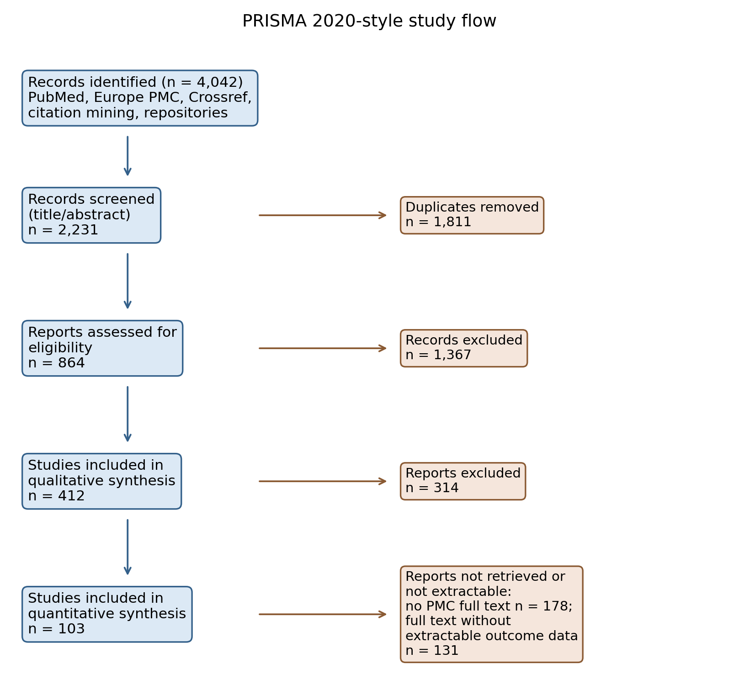
Fig. 1. PRISMA 2020-style flow of study identification, screening, eligibility and quantitative extraction.

3.2. Concentration-response
10 antibacterial concentration series were extractable across 3 studies, spanning inhibition zones, biofilm inhibition and carbapenemase-producer isolates. All 10 series increased monotonically with honey concentration (median Spearman rho = 1.00; Fig. 2A-2C). In the one study reporting pH across a full dilution ladder, pH rose monotonically as honey was diluted for all four honeys examined (rho = -1.00; Fig. 2D), consistent with progressive weakening of the acidic constraint. Fitting log(response) on log(concentration) across the zone series gave a slope of 0.33 (SE 0.55); the sub-linear point estimate is compatible with a saturating diffusion-assay response but the interval is wide and should not be over-interpreted. Concentration-series data remained scarce, so these results describe direction rather than a pooled dose-response curve.
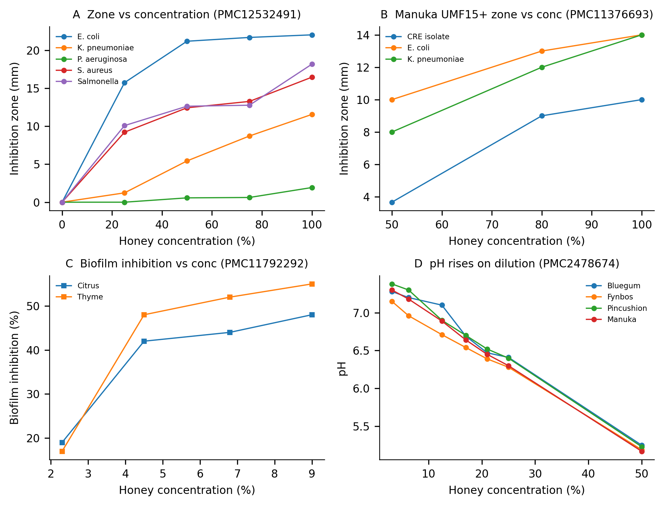
Fig. 2. Concentration-response series. (A) Inhibition zones versus honey concentration for five organisms (Kumera et al., 2025). (B) Manuka UMF15+ zones versus concentration for three organisms (Bukhari et al., 2024). (C) Biofilm inhibition versus concentration for two honeys (Alshaybawee et al., 2025). (D) pH versus concentration for four honeys (Basson and Grobler, 2008); pH rises as honey is diluted.

3.3. Natural versus artificial honey
21 paired comparisons of natural honey versus artificial or sugar-equivalent controls were identified (10 zone pairs, 11 MIC/MBC pairs). Direction-normalized, natural honey was more potent in 16 of 21 pairs (median potency ratio 1.38; Wilcoxon on log ratios, p = 0.005; Fig. 3). In zone units the median paired excess was +0.6 mm; in MIC units the median natural:artificial ratio was 0.81. Artificial honey thus reproduced part, but not all, of natural honey's effect — consistent with a substantial sugar/osmotic contribution while suggesting additional honey-specific effects in most, though not every, study. Because artificial honey is an imperfect osmotic control, these residual differences may reflect multiple compositional differences rather than a single isolated mechanism.
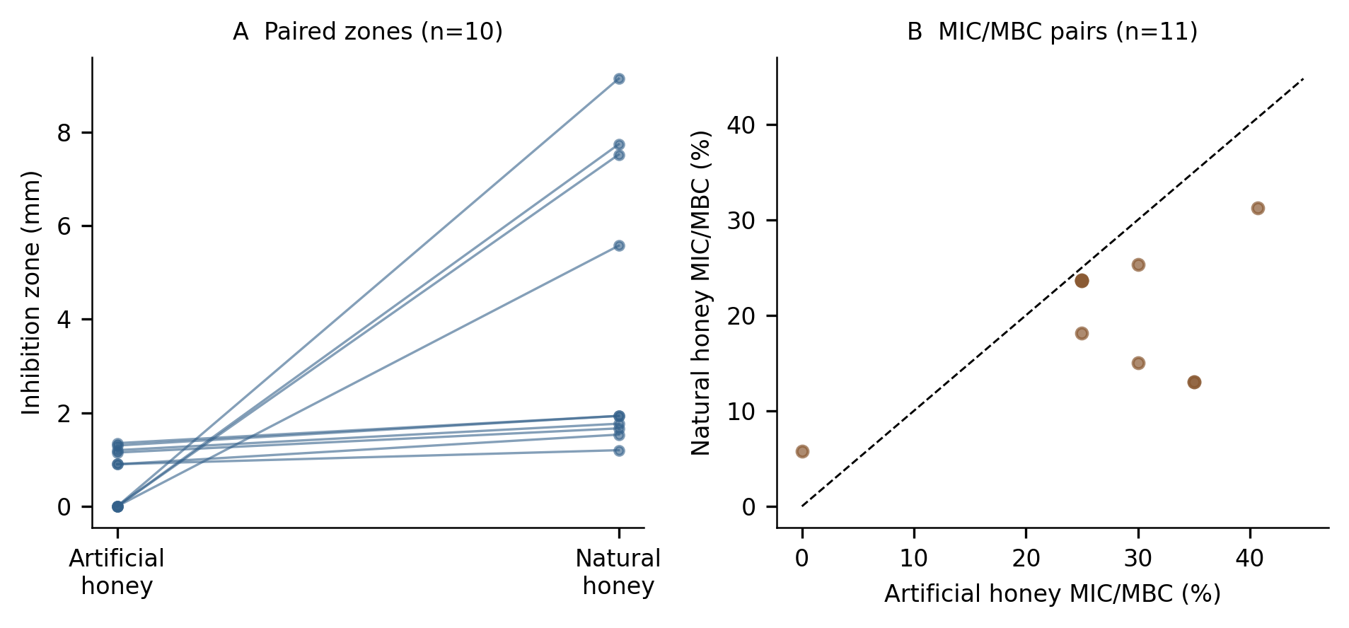
Fig. 3. Natural versus artificial honey. (A) Paired inhibition zones. (B) Paired MIC/MBC values; points below the diagonal indicate greater potency of natural honey.

3.4. Hydrogen peroxide and dilution
Directly matched dilution-resolved evidence on H2O2 was sparse. Within the extracted corpus, one study reported H2O2 detectable only at 6.25% and 3.12% honey and not at higher concentrations, and a second linked glucose oxidase activity, catalase sensitivity and H2O2 concentration to MIC; both are consistent with a peroxide contribution that is expressed preferentially at low concentrations rather than at full strength. Across studies, honey-level H2O2 measurements correlated weakly and positively with MIC (rho = 0.46, n = 29, 2 studies; Fig. 4) — a direction opposite to a naive 'more peroxide, more potent' expectation and most plausibly reflecting between-study confounding (potent non-peroxide honeys can be low in H2O2). We found no extracted dataset reporting a full H2O2 dilution ladder with matched antibacterial endpoints; the predicted intermediate-dilution peroxide peak is therefore supported only qualitatively, and we report it as an explicit evidence gap.
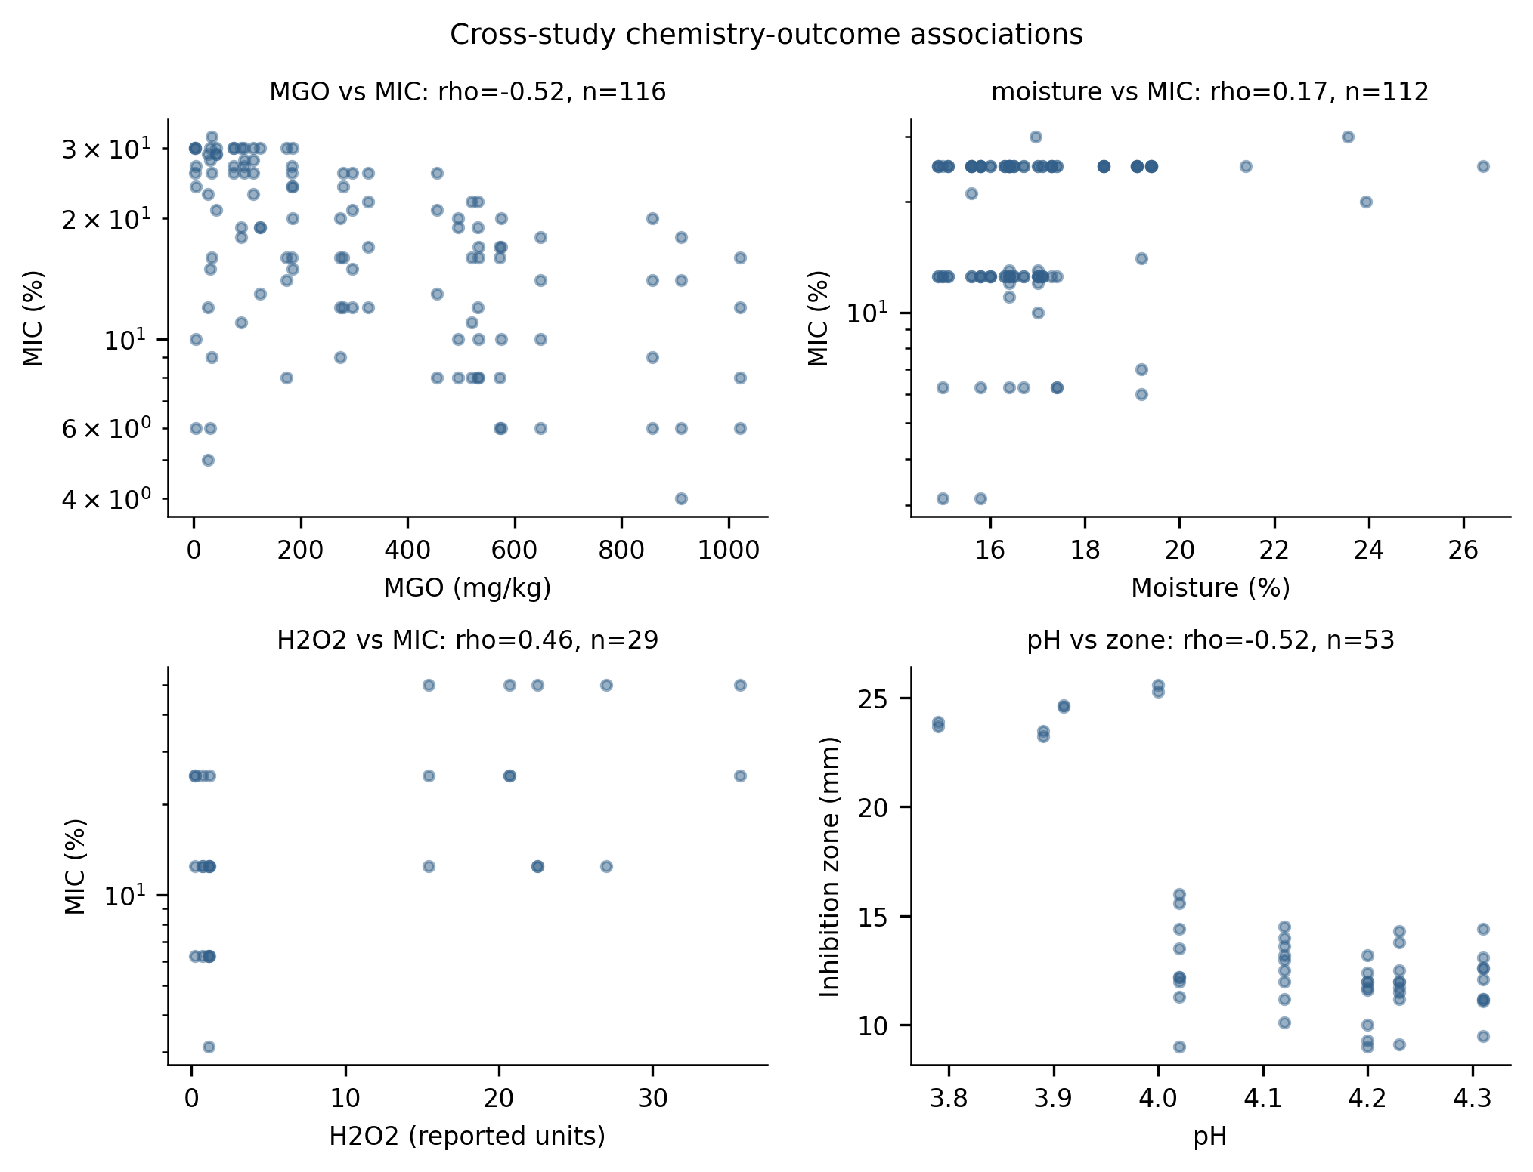
Fig. 4. Cross-study associations between honey-level physicochemical parameters and antibacterial outcomes (Spearman rho; MIC on a log scale).

3.5. Catalase perturbation and residual activity
13 paired catalase-perturbed observations were extracted from 2 studies. Catalase-treated honey retained a median 92% of untreated antibacterial activity (Fig. 5). This indicates substantial peroxide-independent activity in the honeys tested; with only two contributing studies the estimate is preliminary, and residual activity cannot be attributed to MGO or any other single constituent without further evidence.
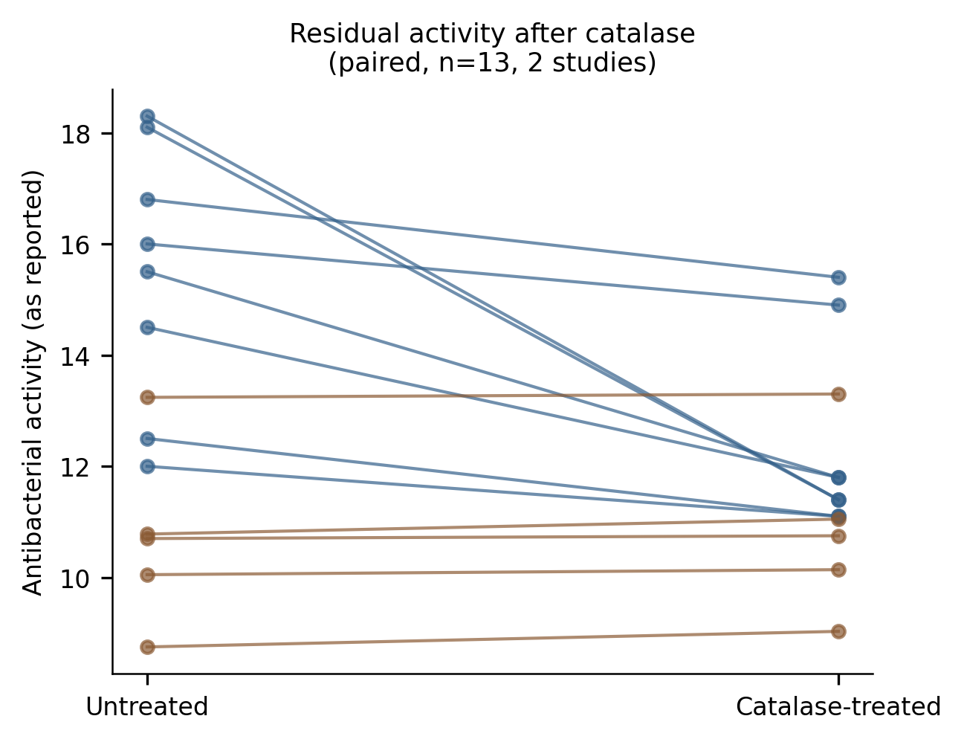
Fig. 5. Paired antibacterial activity before and after catalase treatment (13 pairs, 2 studies (Hussain et al., 2019; Mohd Hilmi et al., 2020)); residual activity indicates peroxide-independent components.

3.6. Physicochemistry versus label as predictors
Honey-level physicochemical measurements could be joined to antibacterial outcomes for 685 observations from 18 studies. Within the largest single-study block, MGO content correlated inversely with MIC (rho = -0.52, n = 116, one study), consistent with MGO-associated potency. Honey moisture correlated positively with MIC (rho = 0.17, n = 112, 3 studies), the expected direction if dilute, high-moisture honeys are less active. Honey pH showed no monotone association with MIC (rho = 0.07, n = 359) but a moderate inverse association with zone size (rho = -0.52, n = 53).
A linear model on log10(MIC) fitted to the largest complete-case block (116 observations, predictors MGO, pH, TPC) explained 30% of variance in-sample, versus 0% for a manuka/medical-grade label alone. However, this in-sample fit rested almost entirely on 1 study. Grouped validation told a different story: under leave-one-study-out cross-validation (n = 155, 3 studies, predictors pH, TPC), chemistry-based predictions performed far worse than a null model (cross-validated R2 = -32.32 vs. -0.12), and the label model was indistinguishable from null. Measured chemistry is therefore informative within individual studies but the fitted relationships did not transfer across studies in this dataset — a result we report explicitly because it bounds what cross-study chemistry-outcome synthesis can currently claim.

3.7. Organism heterogeneity
MIC distributions differed strongly across organisms (Kruskal-Wallis H = 170, p < 0.001; Fig. 6). Gram-positive organisms tended to be inhibited at lower honey concentrations (median MIC: S. epidermidis 11.25%, S. aureus 12.5%, MRSA 12.5%) than Gram-negative organisms (E. coli 20.0%, P. aeruginosa 21.0%). Manuka-type honeys had a nominally lower median MIC than other honeys (15% vs. 20%; Mann-Whitney p = 0.011); however, the contrast was unstable under leave-one-study-out resampling, which returned non-significant comparisons in 38% of iterations. The direction is therefore suggestive but not robust enough to support a general superiority claim for manuka-type honeys (Table 1).
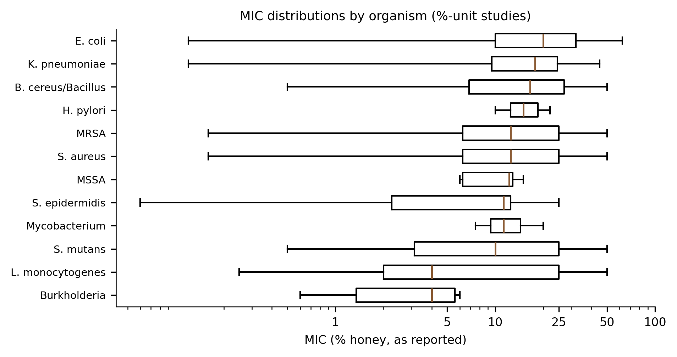
Fig. 6. MIC distributions by organism group (percentage-unit studies, log scale).

Table 1. Median MIC (% honey) by organism group, percentage-unit studies.
Organism group | Median MIC (%)
Burkholderia | 4.0
L. monocytogenes | 4.0
S. mutans | 10.0
Mycobacterium | 11.25
S. epidermidis | 11.25
MSSA | 12.25
S. aureus | 12.5
MRSA | 12.5
H. pylori | 15.0
B. cereus/Bacillus | 16.5
K. pneumoniae | 17.75
E. coli | 20.0
other | 20.0
Enterobacter | 21.0
P. aeruginosa | 21.0
Note: MIC, minimum inhibitory concentration; MRSA/MSSA, methicillin-resistant/susceptible S. aureus. Values are medians of extracted MIC rows restricted to percentage-unit bases.

3.8. Sensitivity analyses
Restricting MIC analyses to the low-risk-of-bias subset left the qualitative pattern unchanged (6 studies, 185 observations, median MIC 25%). Analyzed separately by reported concentration basis, median MIC was 15% on the percent weight/volume basis (n = 315) and 8% on the percent volume/volume basis (n = 157), confirming that bases are not interchangeable and must not be pooled. Excluding manuka-labelled honeys shifted the overall median MIC only slightly (20.0%; n = 1932). Restricting to studies that directly measured water activity (2 studies) or H2O2 (7 studies) gave medians of 25% and 16% respectively. No extracted rows came from preprint records, so a peer-reviewed-only analysis is identical to the primary set. The catalase and artificial-honey analyses could not be broadened beyond the studies that performed those experiments. Table 2 summarizes the paired mechanistic contrasts.
Table 2. Paired evidence for mechanistic contrasts.
Contrast | n pairs/obs | n studies | Effect | p value
Natural vs artificial honey (potency ratio) | 21 | 6 | 16/21 pairs > 1; median 1.38 | 0.005
Natural vs artificial honey, zone difference (mm) | 10 | 2 | median +0.6 mm | 0.002
Catalase residual activity | 13 | 2 | median 92% retained | -
Activity vs concentration (series) | 10 | 3 | 10/10 positive; median rho = 1.00 | -
MGO vs MIC (within-study) | 116 | 1 | rho = -0.52 | < 0.001
pH vs inhibition zone | 53 | 2 | rho = -0.52 | < 0.001
Note: Potency ratio > 1 indicates greater natural-honey activity (zone: natural/artificial; MIC: artificial/natural). MGO, methylglyoxal; MIC, minimum inhibitory concentration.

4. Discussion
This synthesis is consistent with a dilution-dependent, multi-mechanism account of honey's antibacterial action. At high concentration, activity is compatible with dominance of water-activity/osmotic and acidity constraints: artificial sugar-equivalent honey — an imperfect osmotic control — recapitulated much, though not all, of natural honey's effect, solution pH rose monotonically toward neutrality on dilution in the one complete ladder available, and higher-moisture honeys tended to have higher MICs. On dilution those constraints weaken, and glucose oxidase can generate H2O2 under aqueous conditions; the limited within-study evidence located peroxide activity preferentially at low concentrations (Bang et al., 2003). Finally, catalase-resistant residual activity (median ~92% in two studies) and the within-study MGO-MIC association are compatible with a peroxide-independent component in at least some honeys. The three mechanism classes are therefore plausibly reweighted — not merely attenuated — along the dilution axis.
For food science applications the practical implication is that assay concentration is mechanistically informative, not only quantitative. An MIC measured near the top of the concentration range may reflect constraints that disappear on dilution, whereas activity at intermediate concentrations may be carried by different chemistry. Evaluations of honey as an antimicrobial ingredient or preservative should therefore report the concentration range tested and, where possible, pair outcome measurement with the candidate mechanisms (pH, water activity, H2O2, MGO) across the same dilution ladder.
Several findings bound what can be claimed. Cross-study chemistry-outcome correlations are observational and vulnerable to between-study confounding — the positive H2O2-MIC correlation is the clearest example. More importantly, grouped cross-validation showed that the apparent predictive value of measured chemistry did not survive leaving studies out: within-study gradients (notably the single-study MGO-MIC association) do not transfer across studies, and honey-type labels performed no better than a null model. Any claim that measured chemistry predicts potency across the literature would therefore overstate the evidence; what the data support is within-study association plus explicit uncertainty about generalization.
Other limitations qualify these results. First, quantitative extraction depended on open-access full texts and machine-readable tables: 103 of 412 eligible studies were extracted, and the extracted subset skews recent and open-access. Second, concentration-series data were rare, catalase pairs came from two studies, and no extracted dataset reported H2O2 across a dilution ladder with matched antibacterial endpoints; the peroxide-dilution hypothesis is supported qualitatively only. Third, assay heterogeneity (broth dilution, agar diffusion, differing inocula and media) limits pooling, and we deliberately avoided meta-analytic pooling across incompatible measurement bases. Fourth, automated table extraction, although validated against manual curation, may retain residual errors; all rows carry provenance for audit. Fifth, the risk-of-bias framework is a reporting-quality proxy, not a validated instrument, and the review was not prospectively registered.
Within these limits, the evidence supports a model in which concentrated honey relies substantially on physicochemical constraints, partial dilution supports peroxide-associated activity, and non-peroxide components sustain residual activity in some honeys. It does not demonstrate a universal mechanistic switch, and the decisive experiment — matched dilution ladders of H2O2, water activity, pH and antibacterial endpoints within single studies — remains to be performed at scale.

5. Conclusions
Honey's antibacterial activity increased consistently with concentration in every extractable series, while the physicochemical constraints plausibly responsible for high-concentration activity weakened on dilution. Natural honey exceeded sugar-equivalent controls in most matched pairs, catalase-resistant residual activity was substantial where measured, and within-study chemistry-outcome associations — though real — did not generalize across studies. The evidence is consistent with dilution-dependent reweighting of osmotic/acidic, peroxide and non-peroxide mechanisms, but it does not establish a universal switch. Future studies should report full dilution ladders with matched physicochemical and antibacterial measurements, including concentration basis, so that mechanistic claims can be tested within studies rather than inferred across them.

CRediT authorship contribution statement
[Author One]: Conceptualization, Methodology, Software, Formal analysis, Data curation, Writing — original draft. [Author Two]: Validation, Investigation, Writing — review & editing. [Corresponding Author]: Supervision, Project administration, Writing — review & editing.

Declaration of competing interest
The authors declare that they have no known competing financial interests or personal relationships that could have appeared to influence the work reported in this paper.

Data availability
All extracted data, the data dictionary, screening decisions, analysis code and figure scripts are released with this submission as supplementary material and repository archive. Raw database search responses are included; no primary experimental data were generated for this study.

Acknowledgements
None.

Funding
This research did not receive any specific grant from funding agencies in the public, commercial, or not-for-profit sectors.

Declaration of generative AI use
During the preparation of this work the authors used a large language-model coding assistant to develop the reproducible search, extraction and analysis code and to assist with drafting. The authors reviewed and edited all content and take full responsibility for the integrity of the publication.

References
Alshaybawee, M.R., Asgari, S., Ghadersoltani, P., Mehrabian, A., Saniee, P. (2025). Exploring the antibacterial and anti-biofilm activity of two Iranian medical-grade kinds of honey on multidrug-resistant Pseudomonas aeruginosa. BMC Complementary Medicine and Therapies, 25(1), 39. https://doi.org/10.1186/s12906-025-04778-1
Bang, L.M., Buntting, C., Molan, P. (2003). The Effect of Dilution on the Rate of Hydrogen Peroxide Production in Honey and Its Implications for Wound Healing. The Journal of Alternative and Complementary Medicine, 9(2), 267-273. https://doi.org/10.1089/10755530360623383
Basson, N.J., Grobler, S.R. (2008). Antimicrobial activity of two South African honeys produced from indigenous Leucospermum cordifolium and Erica species on selected micro-organisms. BMC Complementary and Alternative Medicine, 8(1), 41. https://doi.org/10.1186/1472-6882-8-41
Bukhari, M.A., Qamash, R.A., Bulkhi, R.A., Bifari, J.A., Bakhsh, O.S., Hawsawi, K.O., Matuure, E.Y., Sulaimani, K.A., Hakim, A.T., Mujahid, M.S. (2024). Biological studies of the activity of Manuka honey against Carbapenem-resistant Enterobacterales (CRE) bacteria. Saudi Medical Journal, 45(9), 876-887. https://doi.org/10.15537/smj.2024.45.9.20240153
Hussain, M.B., Kamel, Y.M., Ullah, Z., Jiman-Fatani, A.A.M., Ahmad, A.S. (2019). In vitro evaluation of methicillin-resistant and methicillin-sensitive Staphylococcus aureus susceptibility to Saudi honeys. BMC Complementary and Alternative Medicine, 19(1), 185. https://doi.org/10.1186/s12906-019-2603-8
Kumera, B., Gebreamanule, B., Atnkut, B., Merid, M., Tilahun, T., Tsega, A., Fassil, A., Dessie, Y., Kassie, B. (2025). In Vitro Antibacterial Activity of Raw Honey From Apis mellifera , Awi Zone, Amhara, Ethiopia. MicrobiologyOpen, 14(5), e70076. https://doi.org/10.1002/mbo3.70076
Kwakman, P.H.S., Velde, A.A.t., de Boer, L., Speijer, D., Christina Vandenbroucke‐Grauls, M.J., Zaat, S.A.J. (2010). How honey kills bacteria. The FASEB Journal, 24(7), 2576-2582. https://doi.org/10.1096/fj.09-150789
Kwakman, P.H.S., te Velde, A.A., de Boer, L., Vandenbroucke-Grauls, C.M.J.E., Zaat, S.A.J. (2011). Two Major Medicinal Honeys Have Different Mechanisms of Bactericidal Activity. PLoS ONE, 6(3), e17709. https://doi.org/10.1371/journal.pone.0017709
Mohd Hilmi, A., Jibril, F., Aliyu, S. (2020). Effect of non-hydrogen peroxide on antibacterial activity of Malaysian Meliponini honey against Staphylococcus aureus. Journal of Pharmacy And Bioallied Sciences, 12(6), 831. https://doi.org/10.4103/jpbs.jpbs_280_19
Willix, D., Molan, P., Harfoot, C. (1992). A comparison of the sensitivity of wound‐infecting species of bacteria to the antibacterial activity of manuka honey and other honey. Journal of Applied Bacteriology, 73(5), 388-394. https://doi.org/10.1111/j.1365-2672.1992.tb04993.x
The complete list of the 103 studies included in the quantitative synthesis is given in Supplementary Table S11.

