A coherence diagnostic for hidden population structure in observational studies:

a simulation study of stratification-based extraction
Onishi Tatsuki

Abstract
Background. Observational treatment-effect estimates can be distorted by hidden effect modification and confounding. We propose two exploratory coherence diagnostics—C1 (between-stratum heterogeneity of treatment effects) and W (within-stratum homogeneity of conditional average treatment effects)—and benchmark stratification-based extraction in a simulation with explicit confounding and effect modification. Methods. Data were generated for a binary treatment, binary outcome and measured covariates carrying traces of an unmeasured confounder/modifier. We compared four proposed IONE methods, six PCA variants, three active comparators (propensity-score quintiles, Gaussian mixture model, prognostic-score stratification) and two oracle baselines. Discovery/evaluation splitting was used for all outcome-informed methods. The estimand was the population risk-difference ATE; performance was measured by ARI with the true Z partition, C1, W and ATE bias reduction. Results. In the primary scenario (n=2000, K=5), extraction performance was modest (best ARI = 0.032). Bias reduction was also modest: the best absolute reduction was 0.00758 (relative 0.418), from a crude absolute bias of 0.01816 to a stratified absolute bias of 0.01057, achieved by 1B_residual. Outcome-free methods were more stable, while residual-based outcome-informed methods showed larger W but required sample splitting to avoid circularity. Sensitivity analyses showed that stronger Z→X traces and larger sample sizes improved both diagnostics and bias reduction; non-linear Z→X mappings degraded PCA but not clustering-based methods. Semi-synthetic illustrations of Simpson's paradox showed high ARI only when pseudo-general variables were strongly correlated with the known confounder. Conclusions. IONE provides transparent, exploratory diagnostics for hidden population structure, but extraction remains conditional and modest. It should be used as a sensitivity complement to, not a replacement for, established causal-inference methods.

Keywords: hidden population structure; effect modification; unmeasured confounding; stratification; Simpson's paradox; diagnostic sensitivity study

1. Introduction
Treatment-effect estimates from observational data are valid only under assumptions that are often only partly testable¹. When a population is composed of subgroups with different treatment effects or different confounding structures, a marginal estimate can be non-robust or even qualitatively wrong (Simpson's paradox)³. Standard adjustment methods rely on measured covariates and cannot reveal hidden effect modification by unmeasured modifiers. We study whether routine measured variables (X) can be used to stratify the population so that the resulting subgroups are more coherent in their treatment-response pattern. The goal is not to replace propensity-score or regression adjustment⁵, but to provide an exploratory diagnostic that warns analysts when a population may be incoherent and that suggests where subgroup-specific analysis may be warranted.

2. Methods

2.1 Data-generating mechanism
The simulation generates n independent subjects with three critical variables (Z1 continuous age-like, Z2 binary sex-like, Z3 ordered category) and ten measured variables (X1–X10) that are influenced by Z. A binary treatment A is generated from a logistic model with confounders Z and covariates X. The binary outcome Y is generated from a logistic model with main effects of Z, weak direct effects of X, a treatment main effect, and Z×A interactions (effect modification)². The population risk-difference ATE is computed by averaging the true individual CATE over the simulated super-population. Default parameters were calibrated so that the crude marginal risk difference is on the order of 0.02 and the true ATE is on the order of 0.01, reflecting a realistic low-to-moderate confounding scenario. Sensitivity analyses vary sample size (500, 2000, 10000), Z→Y strength, Z→X influence, number of strata (3, 5, 10), and non-linear Z→X mappings.

2.2 Stratification methods
Proposed IONE methods are divided into two families. Family 1 (outcome-informed) uses predicted probability (1A), absolute residuals from a Y~X model (1B), cross-validated decision scores (1C), and random-forest uncertainty (1D). Family 2 (outcome-free) uses PCA (2A, six cumulative-variance/fixed-component configurations) and k-means on X (2B). Active comparators are propensity-score quintiles, a Gaussian mixture model on X, and prognostic-score stratification from a Y~X model fitted in the untreated. Oracle baselines stratify the true Z by k-means or by the first Z quantile. Random stratification provides a lower baseline. All methods use equal-frequency quantile-based strata after producing a one-dimensional score, except clustering-based methods.

2.3 Evaluation metrics
For each method and scenario we report: (i) ARI versus a constructed true-Z partition; (ii) C1 = 1 − I² from stratum-specific log odds ratios of A→Y; (iii) W_true and W_est measuring within-stratum CATE homogeneity (W_true uses the known individual CATE, W_est uses a flexible Y~X+A+X×A logistic model); and (iv) ATE bias reduction on the risk-difference scale. Outcome-informed methods use a 50/50 discovery/evaluation split: strata are learned on the discovery half and all metrics are computed on the evaluation half. Monte Carlo standard errors are reported for every mean.

3. Results

3.1 Phase 1 proof-of-concept
Table 1 summarises the primary phase-1 scenario (n=2000, K=5, strong Z→X trace). Extraction performance, as measured by ARI with the constructed true-Z partition, was modest for all methods. C1 values were high for most methods, reflecting between-stratum heterogeneity in observed log odds ratios, but this did not always translate into strong ATE bias reduction. Figure 1 shows the same metrics graphically.
Method | ARI | C1 | W_true | W_est | Abs bias crude | Abs bias strat | Bias reduction | Relative reduction
1A_predicted_prob | 0.028 | 0.929 | 0.360 | 0.078 | 0.018 | 0.016 | 0.003 | 0.145
1B_residual | 0.032 | 0.895 | 0.367 | 0.058 | 0.018 | 0.011 | 0.008 | 0.418
1C_cv_decision | 0.028 | 0.929 | 0.360 | 0.078 | 0.018 | 0.016 | 0.003 | 0.145
1D_ml_uncertainty | 0.011 | 0.938 | 0.201 | 0.041 | 0.018 | 0.017 | 0.001 | 0.074
2A_PCA_cum40 | 0.022 | 0.854 | 0.204 | 0.071 | 0.018 | 0.016 | 0.002 | 0.128
2A_PCA_cum60 | 0.017 | 0.883 | 0.158 | 0.063 | 0.018 | 0.015 | 0.003 | 0.157
2A_PCA_cum80 | 0.014 | 0.886 | 0.132 | 0.061 | 0.018 | 0.016 | 0.002 | 0.131
2A_PCA_k1 | 0.025 | 0.932 | 0.342 | 0.079 | 0.018 | 0.016 | 0.003 | 0.145
2A_PCA_k2 | 0.029 | 0.900 | 0.310 | 0.082 | 0.018 | 0.016 | 0.002 | 0.126
2A_PCA_k3 | 0.025 | 0.916 | 0.242 | 0.065 | 0.018 | 0.016 | 0.002 | 0.118
2B_clustering | 0.024 | 0.902 | 0.214 | 0.145 | 0.018 | 0.017 | 0.002 | 0.087
GMM | 0.016 | 0.879 | 0.135 | 0.089 | 0.018 | 0.017 | 0.001 | 0.046
PS_propensity_score | 0.011 | 0.894 | 0.113 | 0.066 | 0.018 | 0.016 | 0.002 | 0.111
Prognostic_score | 0.027 | 0.909 | 0.337 | 0.083 | 0.018 | 0.016 | 0.003 | 0.145
baseline_oracle_kmeans | 0.374 | 0.911 | 0.379 | 0.032 | 0.018 | 0.015 | 0.003 | 0.188
baseline_oracle_quantile | 0.095 | 0.896 | 0.438 | 0.033 | 0.018 | 0.014 | 0.004 | 0.226
baseline_random | -0.000 | 0.876 | 0.003 | 0.004 | 0.018 | 0.018 | 0.000 | 0.010
Table 1. Phase 1 primary scenario (n=2000, K=5): means over simulations.

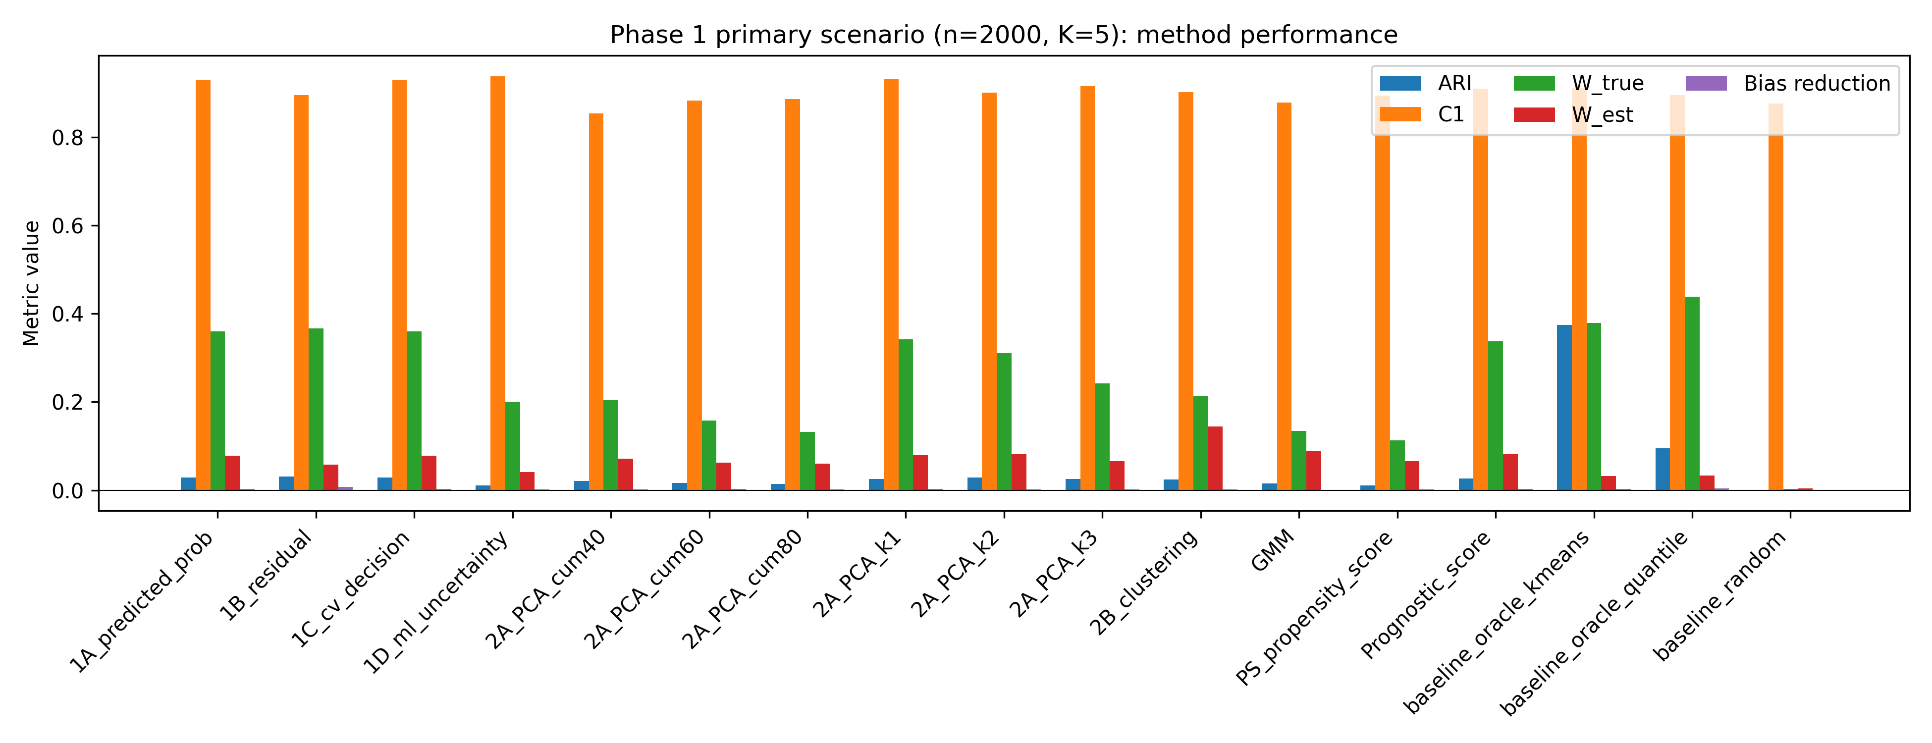
Figure 1. Phase 1 primary metrics across methods.

3.2 Sensitivity and non-linearity analyses
Bias reduction increased with stronger Z→X traces and larger sample sizes, but remained modest overall. Non-linear Z→X mappings reduced PCA-based performance but had less impact on clustering-based methods. Figure 2 illustrates the dependence of bias reduction on Z→X influence for selected methods (n=2000, K=5). Supplementary Tables S1–S4 give the full numerical results.
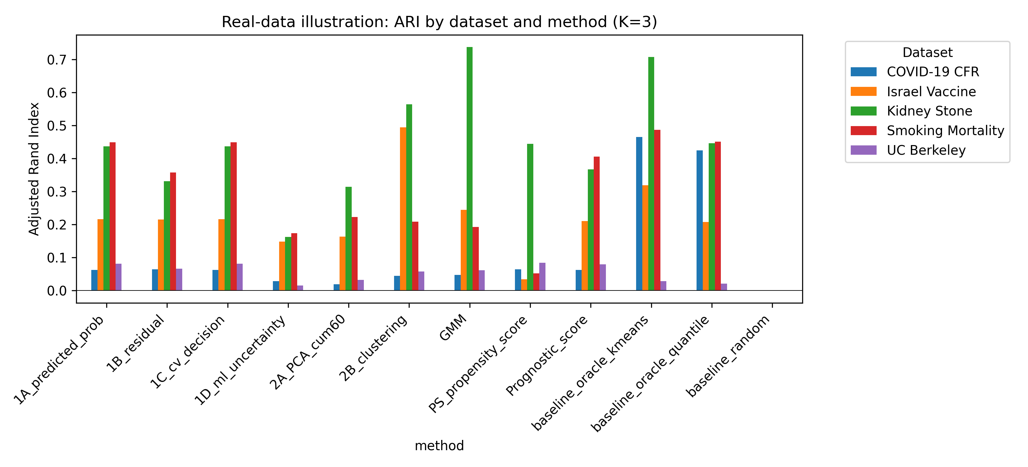
Figure 3. Real-data ARI by dataset and method.

3.3 Semi-synthetic illustrations
Five well-known Simpson's-paradox examples were reconstructed as pseudo-individual records and pseudo-general variables were generated to mimic proxies of the known confounder⁸⁹¹⁰. High ARI was obtained only when the pseudo-variables were strongly correlated with a low-dimensional confounder (kidney stone, Israeli vaccine). Multi-level confounders produced near-zero ARI (UC Berkeley, COVID-19 CFR). These examples are illustrations of favourable vs. unfavourable settings, not validation of out-of-the-box performance. Figure 3 summarises ARI across datasets.
Dataset | Method | K | ARI | C1 | W_est | Bias reduction
COVID-19 CFR | baseline_oracle_kmeans | 9 | 0.685 | 0.303 | 0.022 | 0.028
Israel Vaccine | 2B_clustering | 2 | 0.746 | 0.048 | 0.289 | 0.011
Kidney Stone | baseline_oracle_kmeans | 2 | 0.972 | 0.870 | 0.168 | 0.093
Smoking Mortality | baseline_oracle_kmeans | 7 | 0.790 | 1.000 | 0.109 | 0.111
UC Berkeley | PS_propensity_score | 3 | 0.084 | 0.284 | 0.177 | 0.031
Table 2. Best real-data illustration result per dataset.

4. Discussion
This study reframes IONE as an exploratory diagnostic-sensitivity tool rather than a mature two-stage workflow. The simulations show that hidden population structure can sometimes be detected and partially corrected, but success is strongly conditional on the confounder leaving strong traces in measured variables and on a simple, low-dimensional hidden structure. Outcome-informed methods can capitalise on outcome heterogeneity but require sample splitting to avoid overfitting and induced bias; outcome-free methods are more robust but lack the outcome signal. C1 and W provide transparent diagnostics, but they are not calibrated decision rules and should not replace propensity-score or regression adjustment. Limitations include the stylised DGM, the constructed nature of the true-Z partition, and the absence of a real individual-level cohort. Future work should calibrate C1/W thresholds on individual-level clinical data and compare IONE with latent-class and mixture-model approaches.

Data and code availability
The simulation code and semi-synthetic example data are available in the public repository https://github.com/bougtoir/ione-stratification-framework. All numerical results in this manuscript are produced by scripts in the repository; no estimates are hard-coded.

References
^{1.} Manski CF. Nonparametric bounds on treatment effects. Am Econ Rev. 1990;80(2):319-323.
^{2.} VanderWeele TJ. Explanation in Causal Inference: Methods for Mediation and Interaction. Oxford University Press; 2015.
^{3.} Pearl J. Causality. 2nd ed. Cambridge University Press; 2009.
^{4.} Rubin DB. Estimating causal effects of treatments in randomized and nonrandomized studies. J Educ Psychol. 1974;66(5):688-701.
^{5.} Austin PC, Stuart EA. Moving towards best practice when using inverse probability of treatment weighting (IPTW) using the propensity score to estimate causal treatment effects in observational studies. Stat Med. 2015;34(28):3661-3679.
^{6.} Robins JM, Greenland S. Identifiability and exchangeability for direct and indirect effects. Epidemiology. 1992;3(2):143-155.
^{7.} Hernán MA, Robins JM. Causal Inference: What If. Boca Raton: Chapman & Hall/CRC; 2020.
^{8.} Morris S. Israeli vaccine efficacy data: a public-domain Simpson’s paradox example. 2021. Available from: https://sgmorris.net/posts/science/simpsons-paradox-israels-vaccine-data/
^{9.} Appleton DR, French NR, Vanderpump MP. Ignoring a covariate: an example of Simpson’s paradox. Am Stat. 1996;50(4):340-341.
^{10.} Julious SA, Mullee MA. Confounding and Simpson’s paradox. BMJ. 1994;309(6967):1480-1481.

