Coherence diagnostics for hidden effect modification in individual participant data meta-analysis: a simulation benchmark of stratification approaches

Abstract
Background: In IPD meta-analysis, marginal treatment-effect estimates can be biased by hidden effect modifiers. We introduce coherence diagnostics C1 and W and evaluate them in a simulation benchmark of stratification approaches.
Methods: We simulated an IPD meta-analysis with 10 studies, a binary treatment and outcome, measured covariates carrying traces of an unmeasured modifier, and study-level variation in baseline risk and treatment prevalence. Methods stratified pooled IPD and synthesised stratum-specific risk differences with fixed-effect and DerSimonian-Laird random-effects meta-analysis. We report ARI, C1, W and ATE bias reduction, calibrating C1 and W against their empirical null distributions.
Results: At n=2000 and K=5, C1 and $W_{est}$ discriminated the alternative from the empirical null only at chance level (C1 AUC 0.460-0.545; W AUC 0.427-0.561; TPR up to 0.060 at 5% FPR). The best method reduced random-effects ATE bias by more than half (from 0.01865 to 0.00816; relative reduction 0.563). Bias reduction improved with larger samples and stronger effect modification, while null-centred W confirmed weak discrimination.
Conclusions: IONE is a descriptive sensitivity tool, not an inferential test for hidden effect modification. It should be reported alongside conventional meta-analytic models and covariate adjustment.
Keywords: individual participant data meta-analysis; evidence synthesis; heterogeneity; hidden effect modification; stratification; simulation

1. Introduction
Meta-analysis pools treatment-effect estimates across studies and is central to evidence-based medicine ^{[1]}. IPD meta-analysis preserves participant-level covariates and can increase power for treatment-covariate interactions ^{[2][3]}. Random-effects syntheses are recommended when between-study heterogeneity is suspected ^{[4][5][6]}, yet conventional summaries estimate a marginal effect and may mislead when effect modifiers are unmeasured or omitted ^{[7][8]}. When the pooled population contains subgroups with different treatment effects, the marginal effect can reverse within population strata, producing Simpson-type paradoxes ^{[9][10]}.
Heterogeneity in IPD meta-analysis is usually investigated through subgroup analyses, meta-regression or one-stage mixed models. These approaches explain variation with measured covariates and study-level factors, and stratification by study is the standard way to share baseline risk and treatment prevalence. They do not, however, test whether the pooled participants themselves form internally homogeneous subpopulations with respect to treatment effect. We therefore frame Incoherence-Oriented Neutralisation and Extraction (IONE) as an exploratory sensitivity tool: it flags when a marginal summary may be fragile and separates the pooled IPD into more homogeneous subgroups using multivariate patterns in measured variables. The goal is not to recover hidden variables but to reduce misleading marginal summaries when the IPD contains hidden effect modification.
Hidden population structure is documented across medicine and social science: kidney-stone treatments ^{[11]}, university admissions ^{[12]}, COVID-19 case-fatality comparisons ^{[13]}, national vaccine-surveillance data ^{[14]}, and smoking-mortality studies ^{[15]}. Established methods adjust for measured confounders but do not detect unmeasured population structure. We operationalise IONE through two coherence diagnostics: C1, derived from the $I^{2}$ heterogeneity statistic ^{[5]} applied to stratum-specific log odds ratios, and W, the proportion of total CATE variance explained by the stratification. Stratum-specific risk differences are synthesised with fixed-effect or DerSimonian-Laird random-effects meta-analysis. C1 measures the coherence of a stratification after it has been formed; W is a ratio whose denominator is the overall CATE variance and is therefore unstable when the modification signal is weak.

2. Methods
This simulation study follows the ADEMP framework ^{[16]}.

Aims
Quantify ATE bias reduction from fixed-effect and DerSimonian-Laird random-effects synthesis of stratum-specific risk differences; compare outcome-informed IONE methods with outcome-free and established comparators; assess the diagnostic discrimination of C1 and W against an empirical null; and identify data-generating conditions under which the diagnostics are most and least informative.

IPD data-generating mechanism
We simulated an IPD meta-analysis with n=2000 participants assigned to 10 studies (scale parameter 0.6 for baseline risk, treatment prevalence and an age-like covariate). Each participant had three critical variables (Z1 continuous, Z2 binary, Z3 ordered) that affected treatment, outcome and treatment-covariate interactions, and ten measured variables (X1-X10) carrying traces of Z. A binary treatment A and binary outcome Y were generated from logistic models with Z and X main effects, a treatment effect and Z-by-A interactions. The estimand was the population risk-difference ATE; full algebra is in Additional file 1.
The primary scenario used n=2000, 10 studies and K=5 strata. We varied K (3, 5, 10), sample size (500, 2000, 10 000), Z-to-Y effect scale (0.5, 1.0, 2.0), Z-to-X influence scale (0.2, 0.5, 1.0) and introduced a non-linear Z-to-X mapping. The primary and strata-sensitivity scenarios used 50 replications; extended robustness used 30; empirical null used 200 and $W_{est}$ misspecification used 50.

Stratification methods
Proposed Family 1 (outcome-informed). Method 1A: predicted probability of Y from logistic Y~X, stratified by quantiles. Method 1B: absolute residual from the same model. Method 1C: K-fold cross-validated predictions before stratification.
Proposed Family 2 (outcome-free). Method 2A: first principal component of standardised X. Method 2B: K-means on standardised X.
Comparators and baselines. Propensity-score quintiles ^{[17]}, Gaussian mixture model on X ^{[18]}, prognostic-score stratification (untreated-only Y~X) ^{[19]}; Oracle baselines stratify by true Z-space; random assignment provides a chance reference. Equal-frequency strata were used throughout, logistic regression used l2 regularisation (C=1.0, lbfgs), and outcome-informed methods used a 50/50 discovery/evaluation split.

Synthesis of stratum-specific effects
Within each stratum we computed the risk difference between outcome probabilities under treatment and control. A two-stage fixed-effect summary weighted strata by size; a DerSimonian-Laird random-effects summary estimated between-stratum variance ^{[4]}. Stratum-specific pooling means summarising effects within more homogeneous subgroups identified from the pooled IPD.
Several caveats apply. Discovered strata are not independent estimates; they are formed from the same IPD sample, so their stratum-specific risk differences are dependent. The DerSimonian-Laird $τ^{2}$ and SE therefore describe between-stratum heterogeneity and should be interpreted cautiously. The SE of the pooled random-effects risk difference is conditional on the chosen stratification and does not account for stratum-formation uncertainty.

Study-level meta-analysis benchmark
To contextualise within-study and between-study heterogeneity, we also formed a study-level summary: we pooled crude study-specific risk differences with a DerSimonian-Laird random-effects meta-analysis and compared its ATE bias with the IPD stratified analyses. This benchmark shows how much heterogeneity is captured by conventional study-level pooling before any covariate-based stratification is applied.

Evaluation metrics
ARI ^{[20]}: agreement between estimated strata and a constructed true-Z reference partition, corrected for chance. The true-Z partition is a k-means clustering of standardised Z-space with K strata, so ARI measures agreement with an operational reference rather than clinical validity.
C1 = 1 - $I^{2}$ applied to stratum-specific log odds ratios ^{[5]}. Lower C1 indicates greater between-stratum heterogeneity of stratum-specific log odds ratios. Because C1 is computed on the log-odds scale while ATE bias is on the risk-difference scale, it is an indirect diagnostic of bias; it summarises the coherence of the selected partition, not the magnitude of hidden modification.
$W_{true}$ / $W_{est}$: proportion of total CATE variance explained by the stratification, i.e. the between-stratum CATE variance divided by the overall CATE variance. $W_{est}$ requires a correctly specified individual-level outcome model. Because W is a ratio whose denominator is the overall CATE variance, it can be unstable when effect modification is weak (small denominators) and should be interpreted relative to its empirical null distribution. We therefore report null-mean-centred excess values: C1_excess = max(null mean C1 - C1, 0), W_excess = max(W - null mean W, 0) and proportion metrics such as eta^2 = between-stratum CATE variance / overall CATE variance as an alternative scale-free summary.
ATE bias reduction: absolute differences between crude, stratified and random-effects estimates, plus relative ratios. Monte Carlo SE and 95% CI accompany every mean.

Empirical null distribution and null-centred reporting
We ran 200 additional replications under the primary DGM with Z-by-A interaction coefficients set to zero. This retains confounding and covariate traces but has no true effect modification. For each method we recorded C1 and $W_{est}$ and report the 5th, 50th and 95th percentiles in Supplementary Table S5. Values below the 5th percentile (C1) or above the 95th percentile ($W_{est}$) provide method-specific thresholds for flagging incoherence. In addition, we computed excess diagnostics by subtracting the empirical null mean, producing more stable summaries than raw W and C1.

$W_{est}$ outcome-model misspecification sensitivity
$W_{est}$ is computed from an estimated individual-level CATE. Omitting treatment-covariate interactions can inflate or deflate $W_{est}$, so we repeated the primary scenario with three outcome-model specifications for $W_{est}$: main effects only (Y ~ X + A), linear interactions ($Y \sim X + A + X×A$, default), and linear plus quadratic interactions. Results are in Supplementary Table S6.

Diagnostic calibration using the empirical null
We used the 200 null replications together with the 50 alternative replications of the primary scenario to compute, for each method, the area under the ROC curve (AUC) and the true-positive rate (TPR) at a method-specific 5% false-positive rate (C1 below its null 5th percentile, $W_{est}$ above its null 95th percentile). Because the null distribution preserves confounding and covariate traces but removes true effect modification, these metrics quantify how well the diagnostics distinguish absence from presence of the simulated modification. AUC near 0.5 and low TPR indicate that the diagnostics do not provide reliable classification on their own in the primary scenario.

True-CATE-quantile oracle reference
As a reference for sorting performance, we computed a true-CATE-quantile oracle that assigns participants to strata by the true conditional average treatment effect. This oracle is not a practical method (it uses the true CATE) but it provides an upper bound on how well any covariate-based stratification could separate heterogeneous subgroups. We include the oracle in sensitivity summaries to bound optimism and to illustrate the gap between empirical methods and the true sorting benchmark.

Semi-synthetic illustrations
Five Simpson-paradox examples were reconstructed as pseudo-individual records from published aggregate statistics ^{[11][12][13][14][15]}. The Israeli vaccination example used pseudo-IPD reconstructed from age- and vaccination-stratified COVID-19-related hospitalisation counts published by Haas et al. ^{[14]}. We chose hospitalisation rather than infection counts because the published Table 2 provides age- and vaccination-stratified counts for a severe endpoint where age confounding is pronounced, and because the low event rate (~0.09% in the down-sampled data) creates a stress-test for rare outcomes. Because the published counts cover approximately 6.5 million people, we used a stratified random down-sample of 100,000 records preserving the age- and vaccination-specific hospitalisation rates. In the down-sampled pseudo-IPD, some cells contained very few or zero hospitalisation events; logistic models used for outcome-informed methods were fitted with L2 regularisation, and any degenerate one-class fit was handled by returning the observed mean probability. Pseudo-general variables mimicked proxies of the known confounder and the number of strata K was selected from the set {2, 3, min($K_{true}$, 4), $K_{true}$}, where $K_{true}$ is the true number of published strata, keeping the value that maximised ARI. These are illustrations, not real-IPD validation.

Reporting and reproducibility
The design followed ADEMP ^{[16]}; checklists are in Additional files 2 and 3. The pipeline is version-controlled and every manuscript number is read from repository CSV outputs. Simulations used Python 3.11; the exact dependency versions are in requirements-lock.txt and the commit hash used for the submission package is in results/commit_hash.txt.

3. Results

Primary IPD scenario
Table 1 reports the primary scenario (n=2000, 10 studies, K=5). Agreement with the constructed true-Z partition was modest (Oracle ARI 0.372; best non-Oracle 1B_residual 0.032). Methods closer to the Oracle had C1 nearer to 1 and higher $W_{true}$, while random stratification yielded C1 0.883; $W_{true}$ exceeded $W_{est}$, reflecting that the estimated CATE captures only part of the true CATE variation. The best ATE bias reduction came from 1B_residual: crude bias 0.01865, stratified bias 0.01345 (relative reduction 0.279) and random-effects bias 0.00816 (relative reduction 0.563). For comparison, random-effects pooling across the true study identifiers (i.e. a study-level meta-analysis) gave an absolute ATE bias of 0.01568 (reduction 0.00296 from crude 0.01865). Pooling strata with DerSimonian-Laird improved over the fixed-effect summary, confirming that stratum-specific effects should be allowed to vary. Null-centred excess diagnostics for the best method were modest (C1_excess 0.054; $W_{est}$_excess 0.036).
Method | ARI | C1 | $W_{true}$ | $W_{est}$ | Crude bias | Stratified bias | RE bias | Rel reduction strat | Rel reduction RE | RE I2
1A_predicted_prob | 0.029 | 0.891 | 0.352 | 0.111 | 0.01865 | 0.01888 | 0.01352 | -0.013 | 0.275 | 0.142
1B_residual | 0.032 | 0.927 | 0.363 | 0.078 | 0.01865 | 0.01345 | 0.00816 | 0.279 | 0.563 | 0.044
1C_cv_decision | 0.029 | 0.891 | 0.352 | 0.111 | 0.01865 | 0.01888 | 0.01352 | -0.013 | 0.275 | 0.142
2A_PCA_cum60 | 0.016 | 0.881 | 0.158 | 0.080 | 0.01865 | 0.01883 | 0.01769 | -0.010 | 0.051 | 0.130
2B_clustering | 0.023 | 0.865 | 0.210 | 0.143 | 0.01865 | 0.01796 | 0.01651 | 0.037 | 0.115 | 0.146
GMM | 0.005 | 0.895 | 0.050 | 0.096 | 0.01865 | 0.01797 | 0.01686 | 0.036 | 0.096 | 0.127
PS_propensity_score | 0.005 | 0.881 | 0.050 | 0.059 | 0.01865 | 0.01816 | 0.01754 | 0.026 | 0.059 | 0.144
Prognostic_score | 0.026 | 0.858 | 0.322 | 0.107 | 0.01865 | 0.01849 | 0.01430 | 0.009 | 0.233 | 0.141
baseline_oracle_kmeans | 0.372 | 0.913 | 0.355 | 0.030 | 0.01865 | 0.01901 | 0.01651 | -0.019 | 0.115 | 0.124
baseline_oracle_quantile | 0.095 | 0.897 | 0.447 | 0.042 | 0.01865 | 0.01620 | 0.01266 | 0.131 | 0.321 | 0.169
baseline_random | 0.000 | 0.883 | 0.004 | 0.004 | 0.01865 | 0.01847 | 0.01901 | 0.010 | -0.019 | 0.117
Table 1. Primary IPD scenario (n=2000, 10 studies, K=5): means over 50 simulations.
Figure 1 visualises the primary scenario across methods.
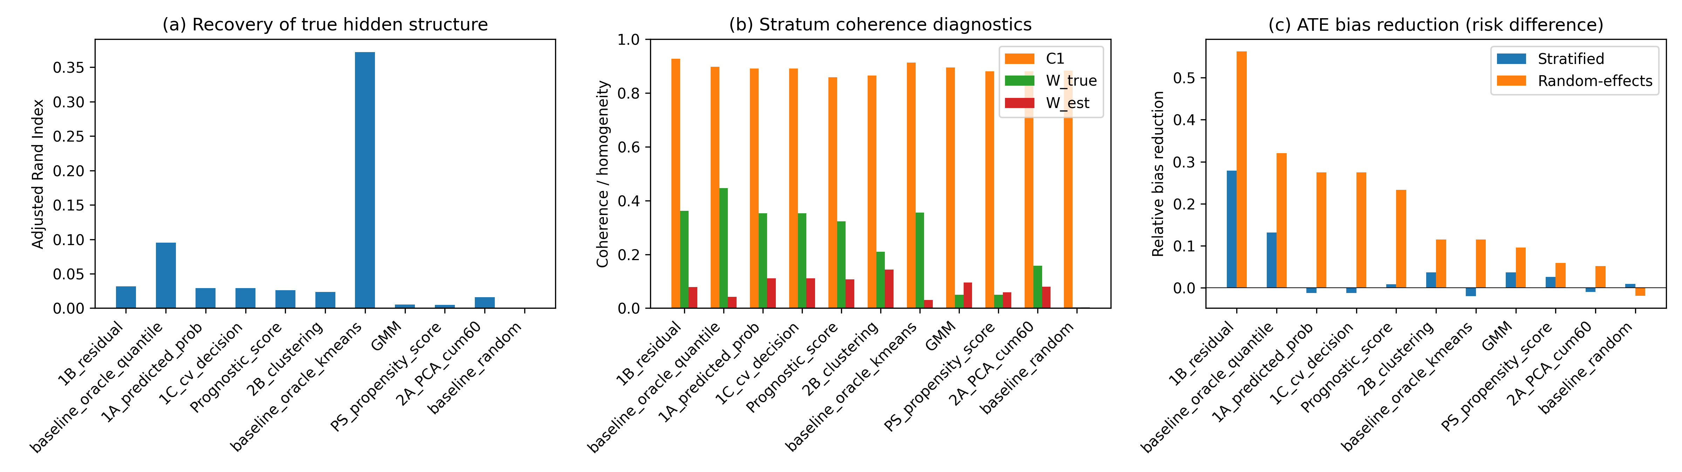
Figure 1. Primary IPD scenario: (a) ARI, (b) C1/W coherence diagnostics, and (c) ATE bias reduction by method.

Sensitivity to the number of strata
Figure 2 and Supplementary Table S1 show random-effects bias reduction across K = 3, 5, 10. Data-driven methods did not reliably improve with larger K; Oracle baselines improved because finer strata better partition the true Z-space. Stratum count should be chosen conservatively and compared across values.
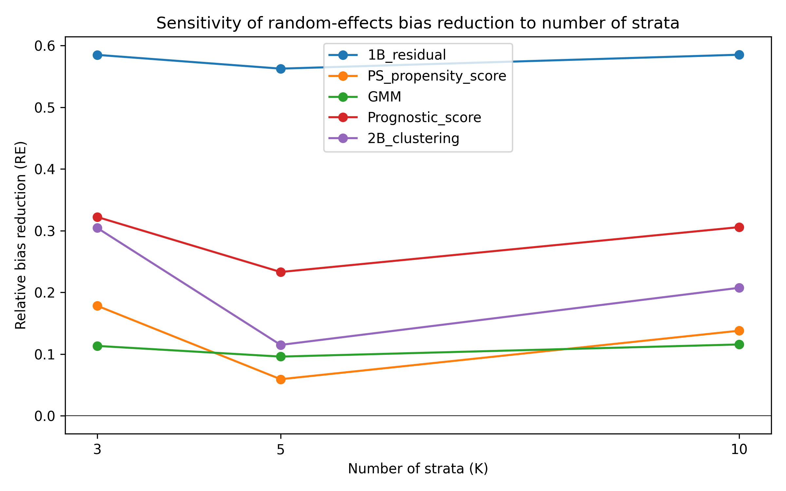
Figure 2. Random-effects ATE bias reduction as the number of strata varies.

Semi-synthetic illustrations
Five Simpson-paradox examples were reconstructed as pseudo-individual records ^{[11][12][13][14][15]}. Table 2 reports the best non-Oracle method per dataset. The Israel hospitalisation example was the most challenging: strong age confounding and a very low hospitalisation rate (~0.09%) meant that the crude marginal association reversed after stratification, yet separating the data into the known age strata remained difficult. The low event rate also produced occasional near-zero or zero-event cells, which illustrates the limits of outcome-informed stratification for rare outcomes.
Dataset | Method | K | ARI | C1 | $W_{est}$ | Bias reduction
COVID-19 CFR | 1B_residual | 3 | 0.065 | 1.000 | 0.035 | 0.017
Israel Vaccine | 2B_clustering | 2 | 0.644 | 1.000 | 0.557 | 0.001
Kidney Stone | GMM | 2 | 0.966 | 0.830 | 0.167 | 0.094
Smoking Mortality | 1A_predicted_prob | 7 | 0.498 | 1.000 | 0.161 | 0.114
UC Berkeley | PS_propensity_score | 3 | 0.084 | 0.284 | 0.177 | 0.031
Table 2. Best semi-synthetic illustration result per dataset (oracle baselines excluded). Bias reduction is the absolute difference between crude and stratified ATE risk-difference bias.
Figure 3 displays ARI by dataset and method for the semi-synthetic examples.
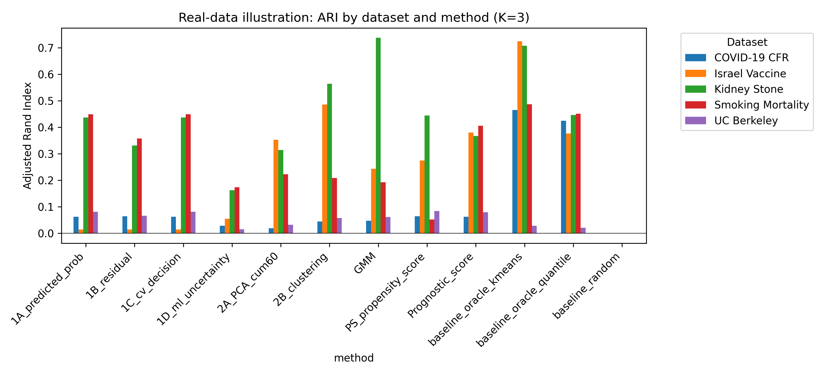
Figure 3. Semi-synthetic illustration: ARI by dataset and method.

Sensitivity to sample size
Figure 4 and Supplementary Table S2 report n = 500, 2000 and 10 000 (K=5). Crude bias declined with n; the largest relative reductions for leading methods occurred at n = 10 000. At n = 10 000 the residual method had random-effects ATE bias 0.00864 (relative reduction 0.348), compared with 0.00816 at n = 2000. The residual method showed an absolute floor near 0.008-0.009, so its relative reduction decreased with n. This pattern indicates that stratification can remove the estimable part of confounding-driven aggregation bias, but it cannot fully adjust for unmodelled hidden effect modification.
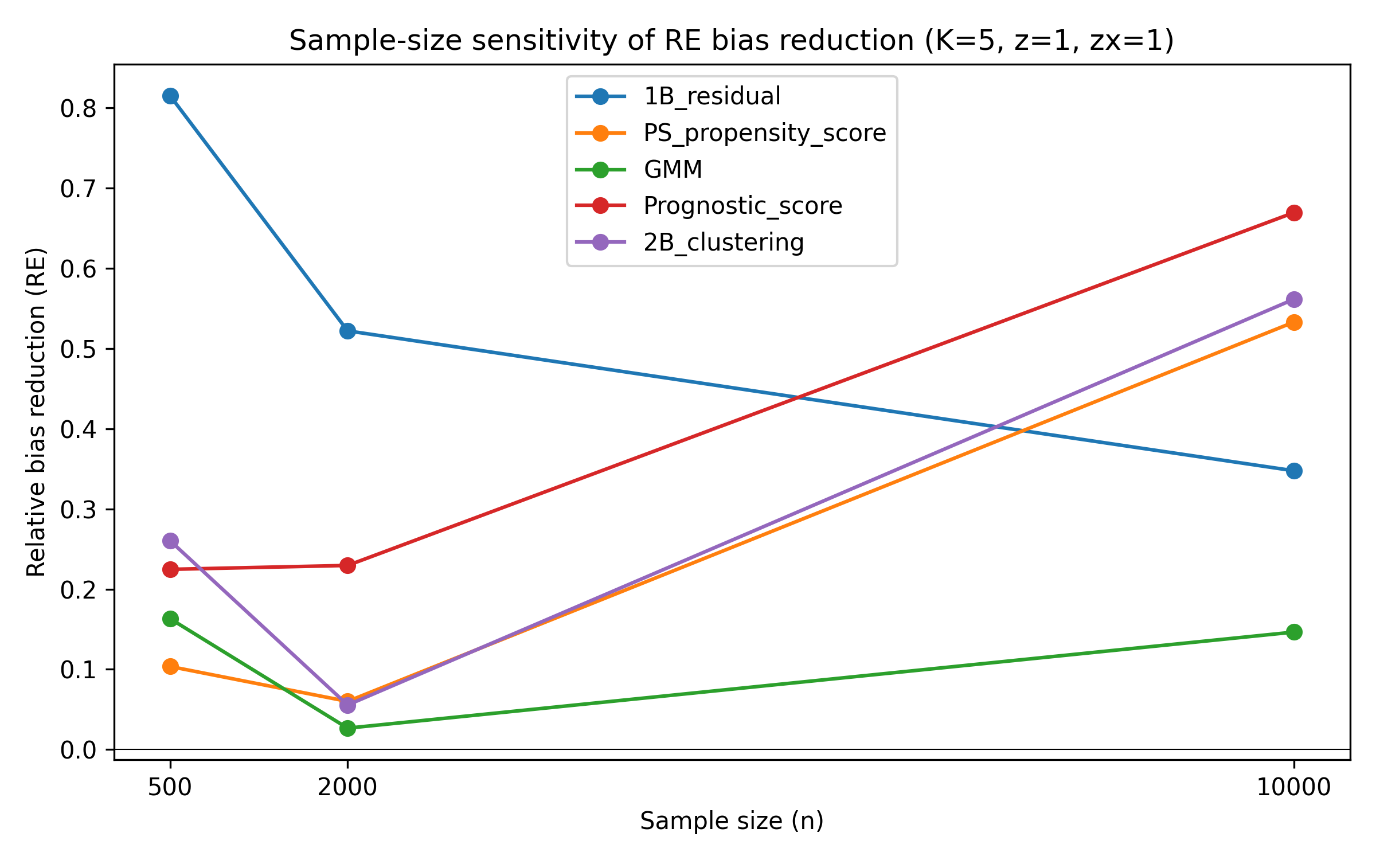
Figure 4. Sample-size sensitivity of random-effects ATE bias reduction (K=5).

Sensitivity to Z-to-X and Z-to-Y effects
Supplementary Tables S3 and S4 report Z-to-X influence (0.2, 0.5, 1.0) and Z-to-Y effect (0.5, 1.0, 2.0). Stronger covariate traces improved ARI, but bias-reduction gains were variable. Weak effect modification produced C1/W near their nulls; stronger effect modification lowered C1, raised W and improved relative bias reduction. The residual method retained useful relative reduction even at z = 0.5.

Robustness to non-linear Z-to-X mappings
Table 3 compares random-effects bias under linear and non-linear Z-to-X mappings. Effects were method-dependent but no leading method was dramatically degraded, indicating that the diagnostics remain useful when X is a non-linear function of the hidden structure.
Method | Linear RE bias | Linear RE bias SE | Linear rel reduction | Linear rel reduction SE | Non-linear RE bias | Non-linear RE bias SE | Non-linear rel reduction | Non-linear rel reduction SE
1B_residual | 0.00852 | 0.00043 | 0.522 | 0.093 | 0.00724 | 0.00042 | 0.640 | 0.060
PS_propensity_score | 0.01676 | 0.00223 | 0.060 | 0.111 | 0.01653 | 0.00208 | 0.178 | 0.060
GMM | 0.01736 | 0.00272 | 0.027 | 0.082 | 0.01894 | 0.00233 | 0.058 | 0.058
Prognostic_score | 0.01374 | 0.00245 | 0.230 | 0.145 | 0.01464 | 0.00189 | 0.272 | 0.064
2B_clustering | 0.01684 | 0.00270 | 0.056 | 0.159 | 0.01773 | 0.00200 | 0.118 | 0.064
Table 3. Linear versus non-linear Z-to-X mapping: random-effects ATE bias and relative bias reduction (n=2000, K=5, z=1.0, zx=1.0).
Figure 5 shows random-effects ATE bias reduction under the non-linear mapping.
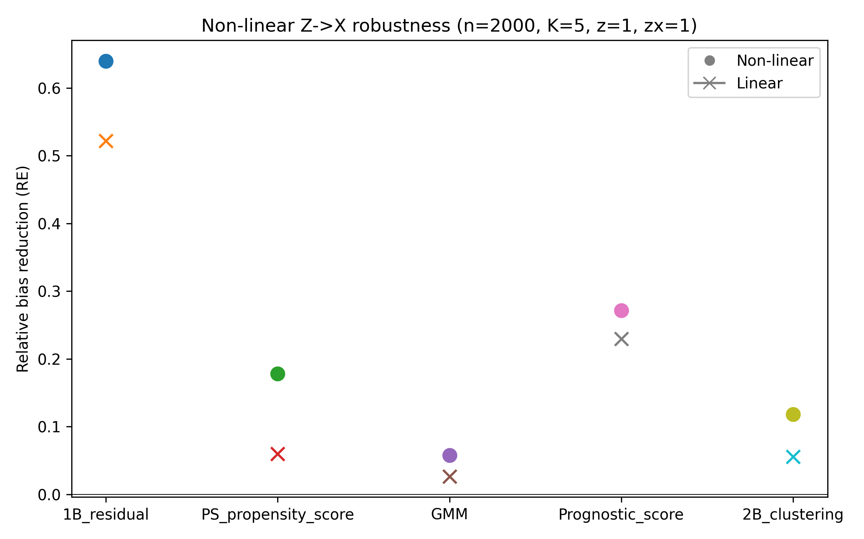
Figure 5. Non-linear Z->X robustness: random-effects ATE bias reduction (n=2000, K=5).

Diagnostic discrimination against the empirical null
Table 4 and Figure 6 summarise the diagnostic calibration of C1 and $W_{est}$ against the empirical null distribution obtained when Z-by-A interactions are removed. C1 AUC ranged from 0.460 to 0.545 and $W_{est}$ AUC from 0.427 to 0.561; the best C1 AUC was 0.545 for 2B_clustering and the best $W_{est}$ AUC was 0.561 for GMM. True-positive rates at a 5% false-positive rate were low: C1 TPR 0.000–0.060 and $W_{est}$ TPR 0.020–0.080. These values show that the diagnostics did not reliably distinguish the alternative DGM from the null in the primary scenario. A main-effects-only outcome model for $W_{est}$ inflated the residual method's $W_{est}$ from 0.077 (default interactions) to 0.691, whereas the polynomial interaction model gave 0.046; full results are in Supplementary Table S6. Supplementary Table S5 reports the empirical null percentiles used as thresholds.
Method | C1 AUC | C1 TPR@5% FPR | $W_{est}$ AUC | $W_{est}$ TPR@5% FPR
1A_predicted_prob | 0.506 | 0.060 | 0.541 | 0.080
1B_residual | 0.460 | 0.060 | 0.542 | 0.060
1C_cv_decision | 0.506 | 0.060 | 0.541 | 0.080
2A_PCA_cum60 | 0.464 | 0.060 | 0.490 | 0.060
2B_clustering | 0.545 | 0.020 | 0.537 | 0.060
GMM | 0.489 | 0.060 | 0.561 | 0.080
PS_propensity_score | 0.481 | 0.060 | 0.494 | 0.020
Prognostic_score | 0.520 | 0.020 | 0.528 | 0.040
baseline_oracle_kmeans | 0.507 | 0.000 | 0.506 | 0.040
baseline_oracle_quantile | 0.507 | 0.000 | 0.537 | 0.060
baseline_random | 0.544 | 0.040 | 0.427 | 0.040
Table 4. Diagnostic discrimination of C1 and $W_{est}$ against the empirical null distribution (n=2000, K=5, 200 null replications and 50 alternative replications).
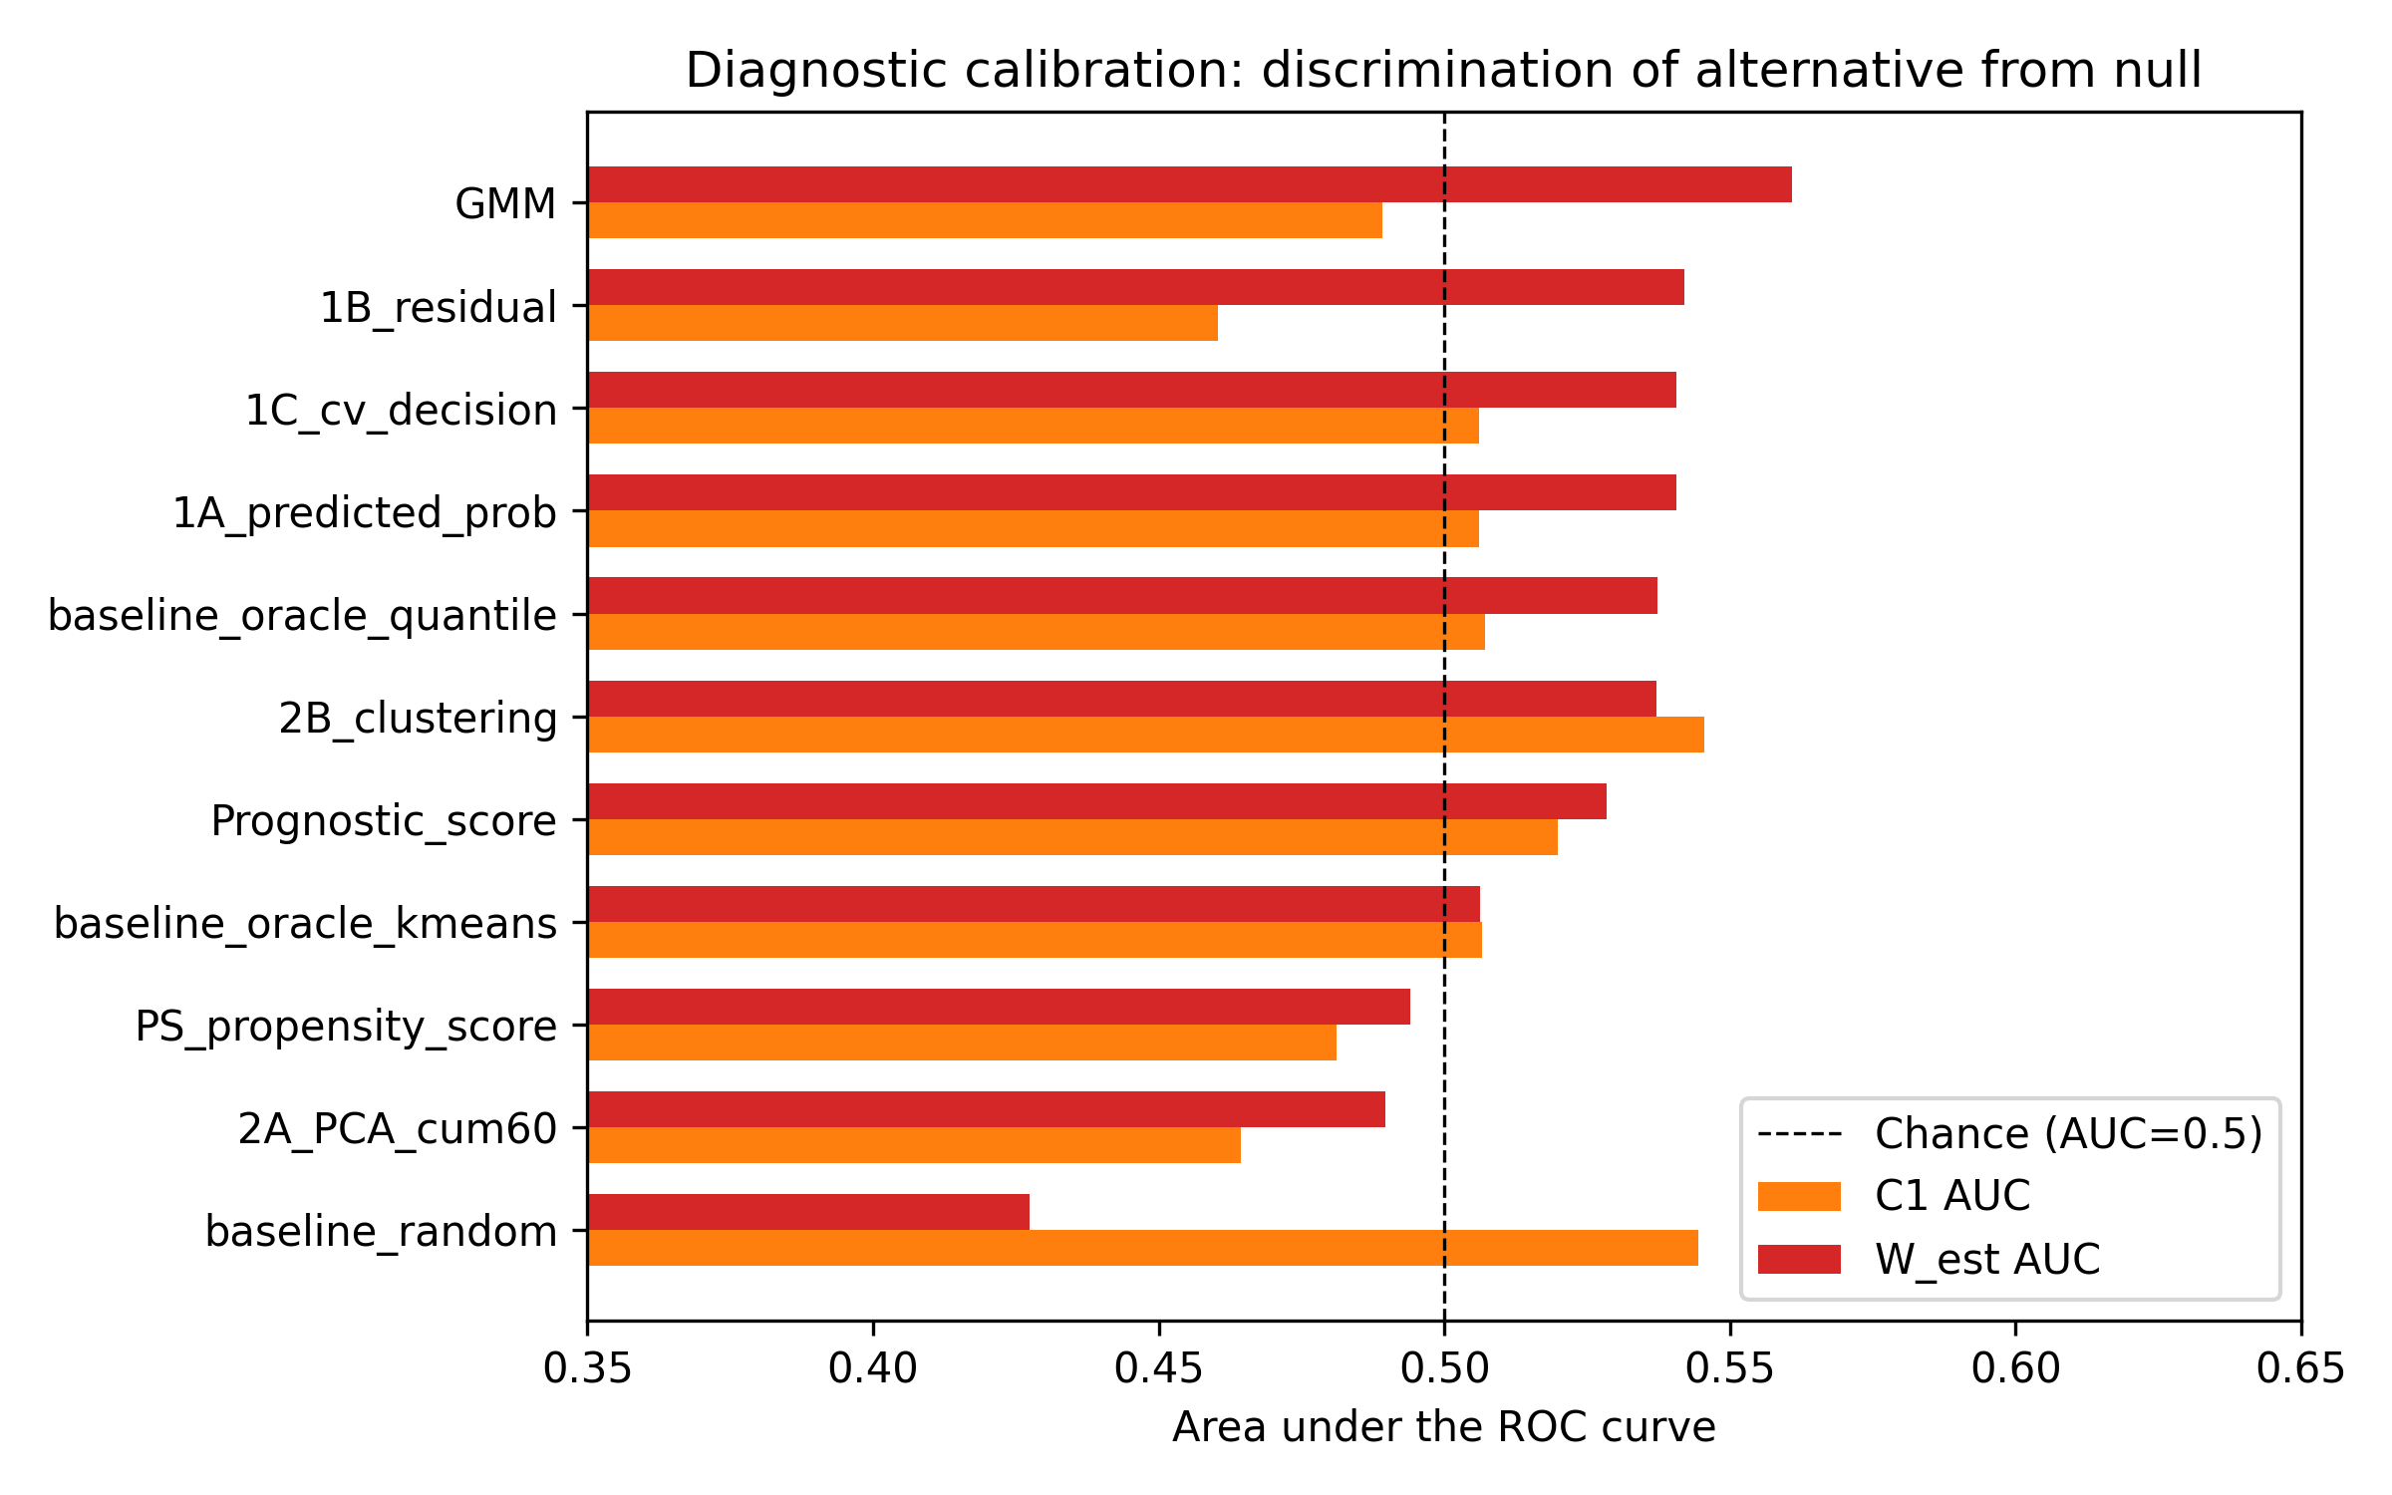
Figure 6. Diagnostic calibration of C1 and $W_{est}$: AUC for discriminating the alternative DGM from the empirical null distribution (n=2000, K=5).

CATE variance explained
Figure 7 shows CATE variance explained (eta^2, represented by $W_{true}$) and the corresponding estimated value ($W_{est}$) for each method. Methods that produced stratum-specific effects close to the true CATE quantiles achieved higher eta^2, but no data-driven method reached the Oracle level. The gap between $W_{true}$ and $W_{est}$ confirms that the residual and predicted-probability models capture only part of the true CATE variation.
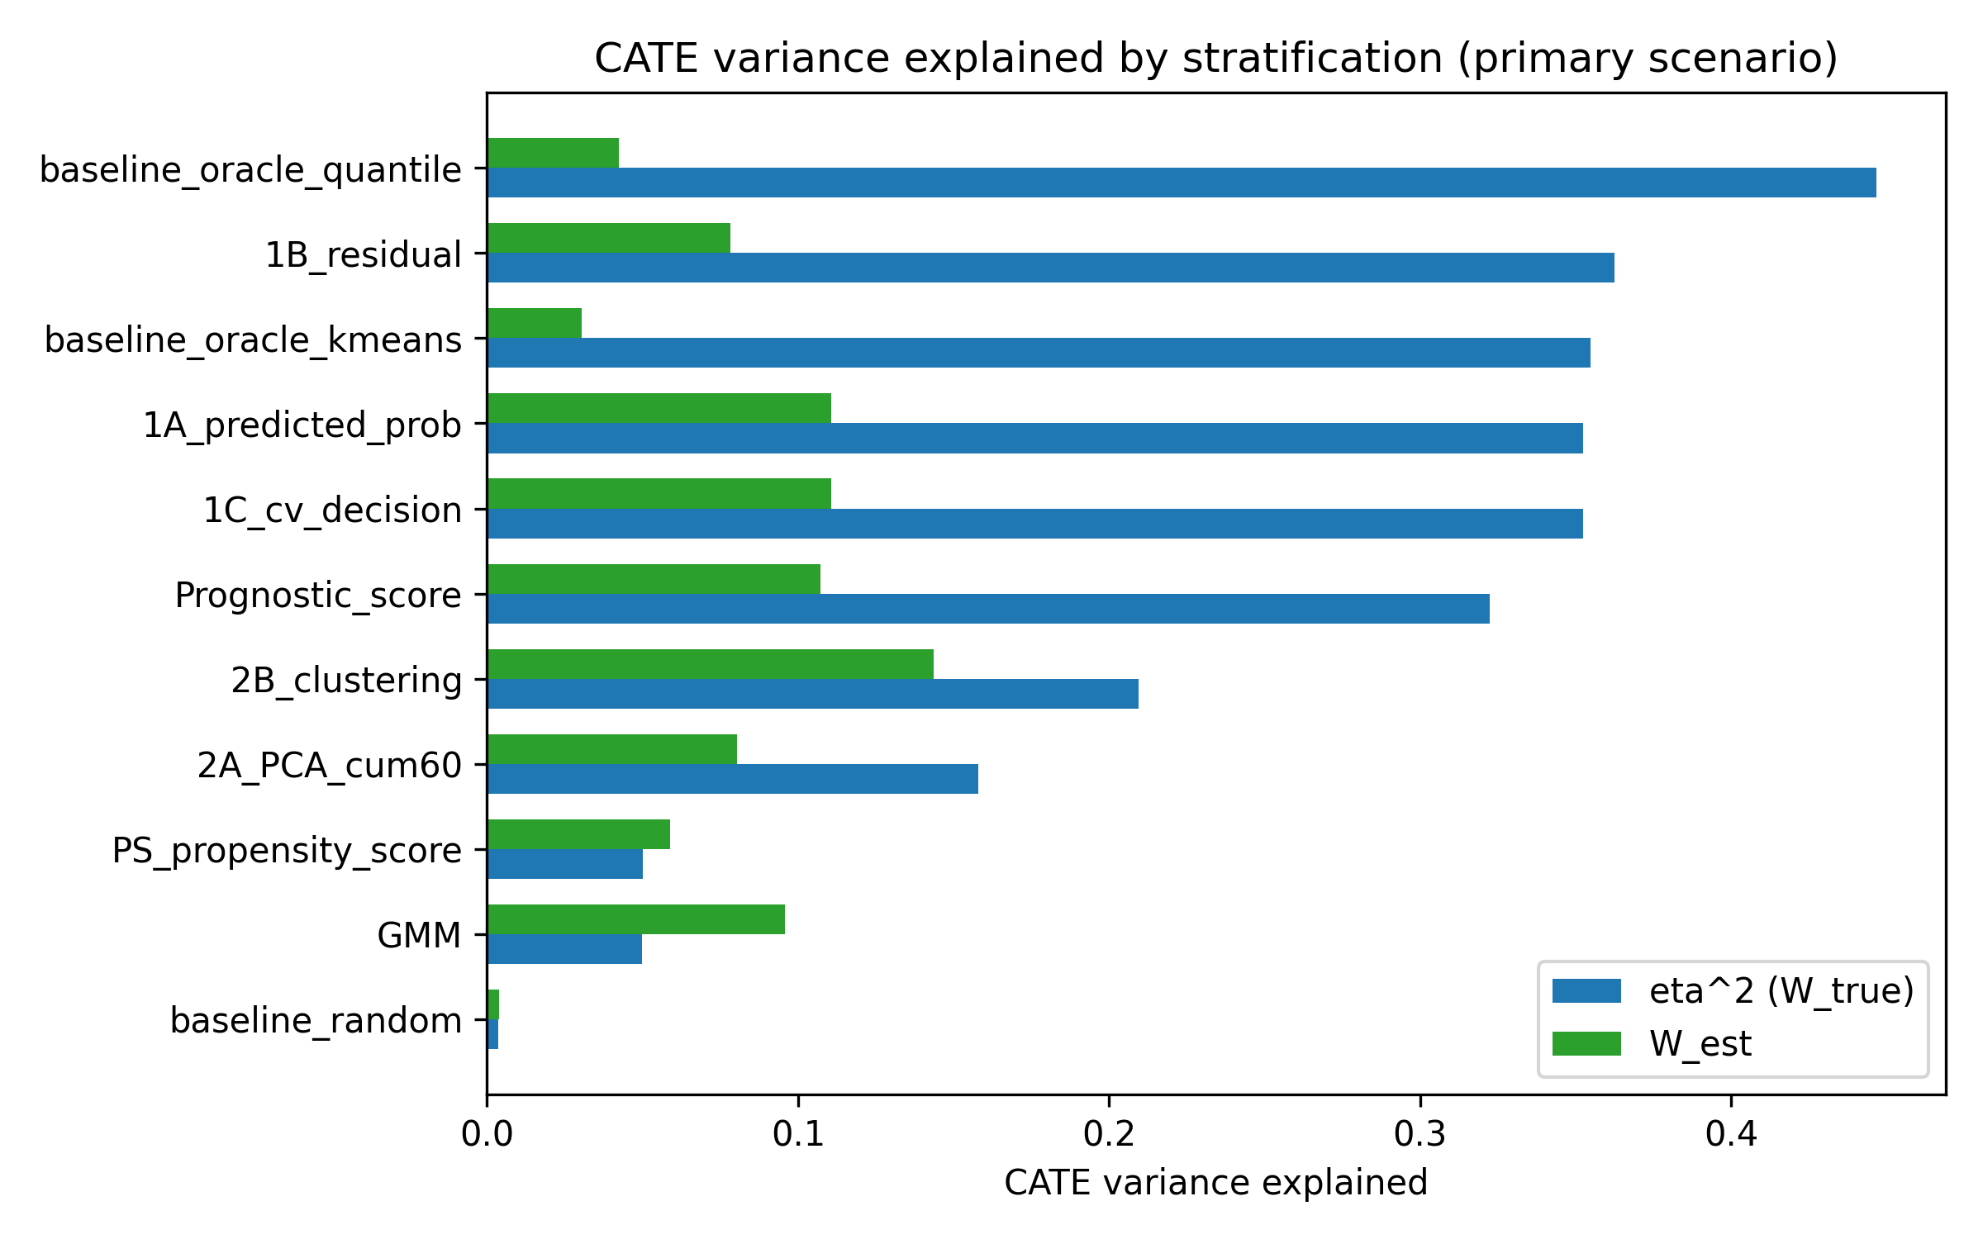
Figure 7. CATE variance explained (eta^2 = $W_{true}$) and estimated $W_{est}$ by method in the primary scenario (n=2000, K=5).

Empirical null distribution and $W_{est}$ misspecification
Under the primary DGM with no Z-by-A interaction, C1 was generally high and $W_{est}$ near 0; method-specific 5th/95th percentiles are in Supplementary Table S5. A main-effects-only outcome model inflated $W_{est}$, whereas the default interaction and polynomial models were more stable (Supplementary Table S6). C1 and W are diagnostic flags, not standalone inferential quantities.

4. Discussion

Principal findings
This study frames Incoherence-Oriented Neutralisation and Extraction (IONE) as a descriptive sensitivity tool for hidden effect modification in IPD meta-analysis. C1 and W flag whether a pooled IPD is internally coherent with respect to treatment effect: methods that captured more of the true Z structure produced C1 values close to the Oracle and higher $W_{true}$, especially the residual-based method. Agreement with the constructed true-Z partition was modest (Oracle ARI 0.372; best non-Oracle 1B_residual 0.032), and the C1 and $W_{est}$ diagnostics did not reliably discriminate the alternative DGM from the empirical null (C1 AUC 0.460-0.545; W AUC 0.427-0.561). Nevertheless, the best data-driven stratification reduced crude ATE bias from 0.01865 to 0.00816 (relative reduction 0.563) with DerSimonian-Laird pooling. These findings show that separating a pooled IPD into more homogeneous strata can partially reduce marginal bias, and that stratum-specific effects should be allowed to vary once incoherence is suggested.

Detection versus subgroup recovery
Detection asks whether the pooled population is internally coherent; C1 and W address this without requiring hidden subgroups to be specified. The ROC results in Table 4 and Figure 6 show that, in the primary scenario, detection sensitivity from C1 and $W_{est}$ alone is low. Separating the data into more homogeneous subgroups is harder still, because measured covariates only partially trace the hidden effect modifier. IONE's practical value therefore lies in sensitivity exploration and partial ATE improvement, not in recovering hidden subgroup labels or replacing confounding adjustment.

Comparison with study-level and covariate-adjustment approaches
Stratification by study remains a default in IPD meta-analysis and captured part of the marginal bias in our benchmark. Study-level random-effects pooling does not, however, exploit covariate traces of hidden effect modification within studies. Propensity-score ^{[17]} and prognostic-score ^{[19]} methods adjust for measured confounders but do not detect unmeasured population structure. Latent-class models ^{[18]} seek hidden subgroups but need strong assumptions and do not report a transparent between-stratum heterogeneity diagnostic such as C1. IONE adds a pair of descriptive diagnostics that can be reported alongside these methods.

W denominator and misspecification
W is a ratio whose denominator is the overall CATE variance. When effect modification is weak this denominator is small, making W unstable and hard to interpret as an absolute measure. We therefore centred the diagnostics on their empirical null means and reported excess values (C1_excess, $W_{true}$_excess, $W_{est}$_excess). $W_{est}$ is also sensitive to outcome-model specification: a main-effects-only model for the residual method inflated $W_{est}$ from 0.077 to 0.691, whereas the correctly specified polynomial interaction model gave 0.046. Analysts should not treat a single $W_{est}$ value as evidence of an effect modifier without inspecting the fitted outcome model and the empirical null distribution.

Large-sample behaviour
At n = 10 000 the residual method still showed a non-negligible random-effects ATE bias (0.00864; relative reduction 0.348), although the absolute bias fell compared with n = 2000. This floor is consistent with the ARI ceiling: once finite-sample error is removed, remaining bias reflects the structural mismatch between the discovered strata and the true CATE surface. The true-CATE-quantile oracle provides an upper bound on what perfect sorting could achieve; the gap between the oracle and the leading data-driven method quantifies the cost of not observing the true effect modifier.

Relevance to SMMR readers
IONE sits between heterogeneity diagnostics and model-based effect modification in medical research. C1 re-purposes the $I^{2}$ statistic for discovered strata and W connects a partition to explained CATE variance. Both are descriptive sensitivity indices, not inferential tests. The empirical null distribution (Supplementary Table S5) calibrates the diagnostics under no true effect modification, and the misspecification sensitivity (Supplementary Table S6) checks whether $W_{est}$ is robust to the outcome-model specification. IONE is best reported alongside conventional IPD meta-analysis and covariate adjustment, with standard adjustment applied within strata.

Strengths and limitations
Strengths. The study followed ADEMP ^{[16]}, reported the data-generating mechanism and estimands transparently, and generated all numerical results from version-controlled repository scripts.
Limitations. The primary scenario used n=2000 and a moderate Z-to-X trace; sensitivity analyses examined K = 3, 5, 10, n = 500 to 10 000, Z-to-Y and Z-to-X scales, and a non-linear mapping, but performance may vary with stronger or weaker signals or fewer studies. The true-Z partition is a constructed reference, so ARI should not be over-interpreted as clinical validity. $W_{est}$ depends on a correctly specified outcome model with interactions; a main-effects-only model can be highly misleading (Supplementary Table S6). DerSimonian-Laird strata are not independent estimates, so the reported $τ^{2}$ and $I^{2}$ describe between-stratum heterogeneity, not conventional between-study heterogeneity. C1 is computed from log odds ratios while ATE bias is on the risk-difference scale, so it is an indirect diagnostic. Null thresholds (Supplementary Table S5) are method-specific and conditional on the primary DGM. Semi-synthetic examples are pseudo-IPD reconstructions and serve as illustrations, not real-IPD validation.

5. Conclusions
IONE (Incoherence-Oriented Neutralisation and Extraction) is a descriptive sensitivity framework for hidden effect modification in IPD meta-analysis. Monte Carlo simulation and semi-synthetic examples show that the C1 and W diagnostics can flag incoherence, but they do not reliably separate the alternative data-generating mechanism from an empirical null in the primary scenario. When hidden variables leave strong traces in measured covariates, stratification can partially reduce ATE bias, but separating the data into the true hidden subgroups remains difficult. The diagnostics should be reported alongside conventional meta-analytic models and covariate adjustment, and should not be used as a replacement for rigorous causal inference. We recommend that coherence assessment using C1 and W be considered as a standard sensitivity step in IPD meta-analysis reporting.

Declarations

Ethics approval and consent to participate
Not applicable. This study used simulated data and publicly available aggregate statistics only.

Consent for publication
Not applicable.

Availability of data and materials
All simulation code, analysis scripts, semi-synthetic example data, and the manuscript generator are publicly available at https://github.com/bougtoir/ione-stratification-framework. The repository contains a requirements.txt file and a requirements-lock.txt file with exact package versions, fixed random seeds for every scenario, and generate_summary.py, generate_ione_rsm_v3.py and generate_rsm_tables.py scripts that regenerate all manuscript numbers, figures and tables in a Python 3.11 environment. The exact Git commit hash used to create this submission package is recorded in results/commit_hash.txt. An archived Zenodo release with a DOI will be created before acceptance to satisfy long-term reproducibility requirements. The published aggregate datasets used for the semi-synthetic illustrations are referenced in the original publications ^{[11][12][13][14][15]}.

Competing interests
The authors declare that they have no competing interests.

Funding
No external funding supported this work.

Authors' contributions (CRediT taxonomy)
Onishi Tatsuki: Conceptualisation, methodology, software, formal analysis, writing – original draft, writing – review and editing, visualisation.

Acknowledgements
Not applicable.

Supplementary materials
Supplementary methods, abbreviations, the ADEMP/STROBE-Sim checklists, the four extended sensitivity tables, and the empirical null-distribution and $W_{est}$ misspecification sensitivity tables are provided in smmr_supplementary_v1.docx.

Artificial intelligence
Manuscript text, Python code, and some analyses were drafted or revised using large language models (OpenAI GPT-4 and GPT-4o, accessed August 2025 through August 2026) under the direct, iterative supervision of the author. The LLMs were used for drafting prose, formatting references, generating figures, and implementing the computational pipeline. The author designed the study, wrote the simulation code, selected all references, verified every numerical result against the repository outputs, and approved the final scientific content. No LLM-generated text was used without human review.

References
[1] Borenstein M, Hedges LV, Higgins JPT, Rothstein HR. Introduction to Meta-Analysis. Chichester: John Wiley & Sons; 2009.
[2] Riley RD, Lambert PC, Abo-Zaid G. Meta-analysis of individual participant data: rationale, conduct, and reporting. BMJ. 2010;340:c221.
[3] Simmonds MC, Higgins JPT, Stewart LA, Tierney JF, Clarke MJ, Thompson SG. Meta-analysis of individual patient data from randomized trials: a review of methods used in practice. Clin Trials. 2005;2(3):209–217.
[4] DerSimonian R, Laird N. Meta-analysis in clinical trials. Control Clin Trials. 1986;7(3):177–188.
[5] Higgins JPT, Thompson SG. Quantifying heterogeneity in a meta-analysis. Stat Med. 2002;21(11):1539–1558.
[6] Riley RD, Higgins JPT, Deeks JJ. Interpretation of random effects meta-analyses. BMJ. 2011;342:d549.
[7] Pearl J. Causality. 2nd ed. Cambridge: Cambridge University Press; 2009.
[8] Greenland S, Robins JM, Pearl J. Confounding and collapsibility in causal inference. Stat Sci. 1999;14(1):29–46.
[9] Simpson EH. The interpretation of interaction in contingency tables. J R Stat Soc Ser B. 1951;13(2):238–241.
[10] Rojanaworarit C. Misleading epidemiological and statistical evidence in the presence of Simpson's paradox: an illustrative study using simulated scenarios. J Med Life. 2020;13(1):37–44.
[11] Charig CR, Webb DR, Payne SR, Wickham JE. Comparison of treatment of renal calculi by open surgery, percutaneous nephrolithotomy, and extracorporeal shockwave lithotripsy. BMJ. 1986;292(6521):879–882.
[12] Bickel PJ, Hammel EA, O'Connell JW. Sex bias in graduate admissions: data from Berkeley. Science. 1975;187(4175):398–404.
[13] von Kügelgen J, Gresele L, Schölkopf B. Simpson's paradox in Covid-19 case fatality rates: a mediation analysis of age-related causal effects. IEEE Trans Artif Intell. 2021;2(1):18–27.
[14] Haas EJ, Angulo FJ, McLaughlin JM, et al. Impact and effectiveness of mRNA BNT162b2 vaccine against SARS-CoV-2 infections and COVID-19 cases, hospitalisations, and deaths following a nationwide vaccination campaign in Israel: an observational study using national surveillance data. Lancet. 2021;397(10287):1819–1829.
[15] Appleton DR, French NR, Vanderpump MP. Ignoring a covariate: an example of Simpson's paradox. Am Stat. 1996;50(4):340–341.
[16] Morris TP, White IR, Crowther MJ. Using simulation studies to evaluate statistical methods. Stat Med. 2019;38(11):2074–2102.
[17] Rosenbaum PR, Rubin DB. The central role of the propensity score in observational studies for causal effects. Biometrika. 1983;70(1):41–55.
[18] McLachlan GJ, Peel D. Finite Mixture Models. New York: Wiley; 2000.
[19] Hansen BB. The prognostic analogue of the propensity score. Biometrika. 2008;95(2):481–488.
[20] Hubert L, Arabie P. Comparing partitions. J Classif. 1985;2(1):193–218.

