A coherence diagnostic for hidden effect modification in individual participant data meta-analysis:

a simulation study of stratification-based extraction

Abstract
Background. Random-effects meta-analyses report an average treatment effect and assume that between-study heterogeneity has been adequately modelled. When an individual participant data (IPD) meta-analysis contains hidden effect modifiers or confounders, a marginal summary can be non-robust or qualitatively wrong (aggregation bias). Methods. We simulated an IPD meta-analysis with 10 studies, binary treatment and outcome, measured covariates carrying traces of an unmeasured effect-modifier, and study-level variation in baseline risk and treatment prevalence. Proposed IONE methods and active comparators were used to stratify the pooled IPD; stratum-specific risk differences were pooled with two-stage fixed-effect and DerSimonian-Laird random-effects meta-analysis. We report ARI with a constructed true-Z partition, C1 (between-stratum heterogeneity of A→Y log odds ratios), W (within-stratum CATE homogeneity), and ATE bias reduction on the risk-difference scale. Results. In the primary scenario (n=2000, 10 studies, K=3 strata), the best method was 1B_residual (ARI 0.032; C1 0.936; W_true 0.363; W_est 0.085). Crude absolute ATE bias was 0.01938; stratification reduced this to 0.01263 (relative reduction 0.348), and random-effects pooling across discovered strata further reduced it to 0.00826 (relative reduction 0.574). Diagnostic agreement with the true hidden structure remained modest, and performance improved with stronger covariate traces and larger samples. Conclusions. IONE is a transparent, exploratory diagnostic for hidden effect modification within IPD meta-analyses. It should be reported alongside—not instead of—conventional meta-analytic models and covariate adjustment.

Keywords: individual participant data meta-analysis; evidence synthesis; heterogeneity; hidden effect modification; stratification; diagnostic; Simpson's paradox

1. Introduction
Meta-analysis combines treatment-effect estimates from related studies and is central to evidence-based medicine (Borenstein et al. 2009). A random-effects analysis permits the true effect to vary across studies and is widely recommended when heterogeneity is suspected (DerSimonian and Laird 1986)(Higgins and Thompson 2002)(Riley et al. 2011). In an individual participant data (IPD) meta-analysis, the original participant-level data are collected and re-analysed; this preserves information on covariates and subgroup effects and can improve power for treatment-covariate interactions (Riley et al. 2010)(Simmonds et al. 2005). Nevertheless, the standard two-stage or one-stage synthesis still estimates an average effect and may miss effect modifiers that are not measured, measured with error, or omitted from the analysis plan.
When the population is a mixture of subgroups with different treatment effects, or when confounders differ across subgroups, the marginal effect can differ from subgroup-specific effects, leading to aggregation bias and Simpson-type reversals (Pearl 2009)(Greenland et al. 1999). Causal inference provides formal definitions of confounding, effect modification and collapsibility (Rubin 1974)(Hernán and Robins 2020)(VanderWeele 2015), and propensity-score methods adjust for measured confounders (Austin and Stuart 2015). Yet these methods do not in themselves reveal whether an unmeasured effect modifier is present or whether the estimated average effect is robust across clinically meaningful subgroups.
We extend the IONE (Identifying hidden population structure and extracting it by stratification) framework to the IPD meta-analysis setting. We ask whether routine measured covariates can be used to stratify a pooled IPD so that within-stratum treatment effects are more homogeneous and the pooled estimate is less biased. We evaluate the proposal in a simulation study with explicit between-study heterogeneity and hidden effect modification, and illustrate behaviour with well-known Simpson-paradox examples.

2. Methods

2.1 IPD data-generating mechanism
We generated an IPD meta-analysis by assigning n=2000 participants to 10 studies of approximately equal size. Study-level heterogeneity was controlled by a scale parameter of 0.6; this produced between-study variation in baseline risk, treatment prevalence and the distribution of a continuous age-like covariate, analogous to a random-effects meta-analysis. Each participant had three critical variables (Z1 continuous, Z2 binary, Z3 ordered) that affected treatment, outcome and their interaction, and ten measured variables (X1–X10) that carried traces of Z. A binary treatment A was generated from a logistic model with confounders Z and covariates X; a binary outcome Y was generated from a logistic model with main effects of Z and X, a treatment main effect and Z×A interactions (effect modification). The true estimand was the population risk-difference average treatment effect (ATE), computed by averaging the true individual CATE over the super-population.

2.2 Stratification methods
Proposed IONE methods were divided into two families. Family 1 (outcome-informed) used predicted probability of Y, absolute residuals from a Y~X model, and cross-validated decision scores. Family 2 (outcome-free) used PCA on X and k-means on X. Active comparators were propensity-score quintiles, a Gaussian mixture model on X and prognostic-score stratification from a Y~X model fitted in the untreated. Oracle baselines stratified by the true Z using k-means or quantiles, and random stratification provided a lower baseline. Outcome-informed methods used a 50/50 discovery/evaluation split to avoid outcome-label leakage.

2.3 Synthesis of stratum-specific effects
For each discovered stratum we computed the risk difference P(Y=1|A=1) − P(Y=1|A=0). A two-stage fixed-effect summary was the stratum-size-weighted average of these risk differences. A DerSimonian-Laird random-effects summary added an estimate of between-stratum variance and re-weighted stratum estimates accordingly (DerSimonian and Laird 1986). We also report the resulting tau² and I² as summaries of between-stratum heterogeneity in the effect scale.

2.4 Evaluation metrics
For each method we report: (i) ARI versus a constructed true-Z partition; (ii) C1 = 1 − I² from stratum-specific log odds ratios of A→Y, reflecting between-stratum homogeneity; (iii) W_true and W_est, measuring within-stratum CATE homogeneity using the true individual CATE or a flexible estimated CATE; and (iv) ATE bias reduction on the risk-difference scale, defined as |bias_crude| − |bias_stratified| and |bias_crude| − |bias_re| in absolute terms and as one minus the ratio of absolute biases in relative terms. Monte Carlo standard errors and 95% confidence intervals are reported for every mean.

3. Results

3.1 Primary IPD scenario
Table 1 and Figure 1 summarise the primary IPD scenario (n=2000, 10 studies, K=3 strata). Extraction of the true hidden structure was modest: the best ARI was 0.032, observed for 1B_residual, and the average C1 across methods was 0.889. Average within-stratum homogeneity was also limited (mean W_true = 0.240; mean W_est = 0.083), indicating that the strata still contained substantial CATE variation. For comparison, random-effects pooling across the true study identifiers (i.e. study-level meta-analysis) gave an absolute ATE bias of 0.01769 (reduction 0.00169 from crude 0.01938).
ATE bias reduction was strongest for 1B_residual: the crude absolute risk-difference bias was 0.01938, the two-stage stratified estimate reduced this to 0.01263 (relative 0.348), and the random-effects estimate reduced it further to 0.00826 (relative 0.574). These values show that, under the simulated data-generating mechanism, a small number of data-driven strata can partially remove bias from a pooled IPD estimate, but the diagnostic agreement with the true hidden structure remains low.
Method | ARI | C1 | W_true | W_est | Crude bias | Stratified bias | RE bias | Relative reduction strat | Relative reduction RE | RE I2
1A_predicted_prob | 0.029 | 0.896 | 0.352 | 0.124 | 0.019 | 0.019 | 0.016 | -0.002 | 0.189 | 0.13
1B_residual | 0.032 | 0.936 | 0.363 | 0.085 | 0.019 | 0.013 | 0.008 | 0.348 | 0.574 | 0.05
1C_cv_decision | 0.029 | 0.896 | 0.352 | 0.124 | 0.019 | 0.019 | 0.016 | -0.002 | 0.189 | 0.13
2A_PCA_cum60 | 0.016 | 0.870 | 0.158 | 0.081 | 0.019 | 0.019 | 0.018 | 0.031 | 0.075 | 0.16
2B_clustering | 0.023 | 0.868 | 0.210 | 0.157 | 0.019 | 0.019 | 0.017 | 0.016 | 0.117 | 0.13
GMM | 0.005 | 0.905 | 0.050 | 0.095 | 0.019 | 0.019 | 0.018 | 0.032 | 0.066 | 0.11
PS_propensity_score | 0.003 | 0.850 | 0.028 | 0.048 | 0.019 | 0.019 | 0.019 | 0.033 | 0.033 | 0.17
Prognostic_score | 0.027 | 0.884 | 0.324 | 0.117 | 0.019 | 0.019 | 0.015 | 0.017 | 0.211 | 0.14
baseline_oracle_kmeans | 0.372 | 0.936 | 0.355 | 0.035 | 0.019 | 0.019 | 0.017 | -0.006 | 0.113 | 0.10
baseline_oracle_quantile | 0.095 | 0.880 | 0.447 | 0.047 | 0.019 | 0.017 | 0.013 | 0.114 | 0.332 | 0.17
baseline_random | 0.000 | 0.863 | 0.004 | 0.004 | 0.019 | 0.019 | 0.019 | 0.001 | -0.006 | 0.14
Table 1. Primary IPD scenario (n=2000, 10 studies, K=3): means over 50 simulations.

As a comparator, random-effects pooling across the true study identifiers gave an absolute bias of 0.018 (absolute reduction 0.002).
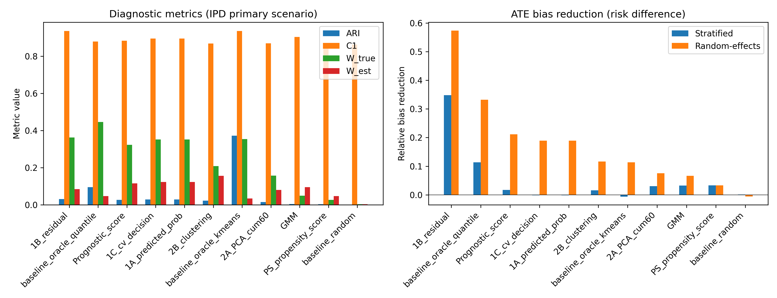
Figure 1. Primary IPD scenario: diagnostic metrics and ATE bias reduction by method.

3.2 Sensitivity to the number of strata
Figure 2 shows how random-effects bias reduction changed as the number of strata varied (K = 3, 5, 10). For most methods the gain from increasing K was limited and non-monotonic; increasing strata beyond the true dimensionality of the hidden structure introduced additional sampling variation and did not consistently improve ATE bias reduction.
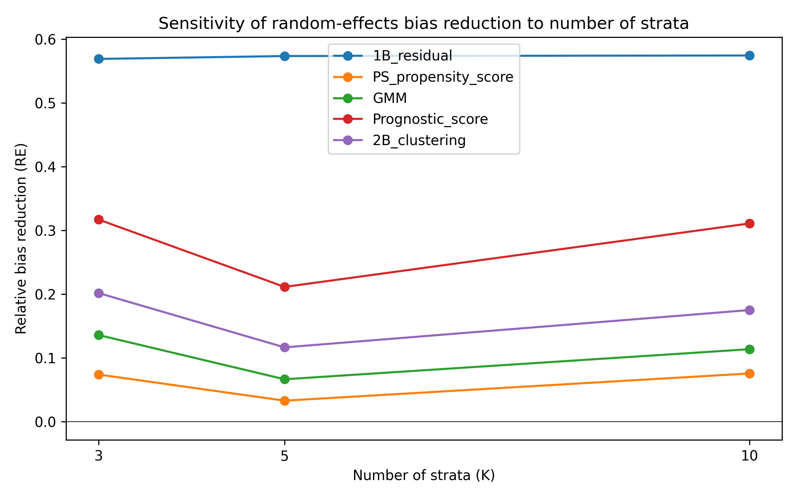
Figure 2. Random-effects ATE bias reduction as the number of strata varies.

3.3 Semi-synthetic illustrations
Five well-known Simpson-paradox examples were reconstructed as pseudo-individual records and pseudo-general variables were generated to mimic proxies of the known confounder (Morris 2021)(Appleton et al. 1996)(Julious and Mullee 1994). High ARI was obtained only when the pseudo-variables were strongly correlated with a low-dimensional confounder. Table 2 and Figure 3 present the best-performing method and stratum count for each dataset. These examples are illustrations of favourable and unfavourable settings for stratification, not validation of out-of-the-box performance in real IPD.
Dataset | Method | K | ARI | C1 | W_est | Bias reduction
COVID-19 CFR | baseline_oracle_kmeans | 9 | 0.685 | 0.303 | 0.022 | 0.028
Israel Vaccine | 2B_clustering | 2 | 0.746 | 0.048 | 0.289 | 0.011
Kidney Stone | baseline_oracle_kmeans | 2 | 0.972 | 0.870 | 0.168 | 0.093
Smoking Mortality | baseline_oracle_kmeans | 7 | 0.790 | 1.000 | 0.109 | 0.111
UC Berkeley | PS_propensity_score | 3 | 0.084 | 0.284 | 0.177 | 0.031
Table 2. Best real-data illustration result per dataset.

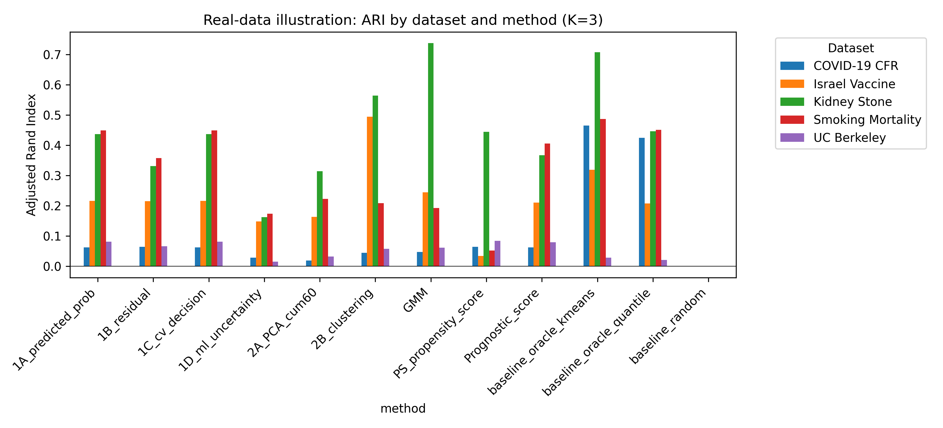
Figure 3. Real-data illustration: ARI by dataset and method.

4. Discussion
We extended IONE from a single-observation setting to an IPD meta-analysis setting and evaluated it as a diagnostic for hidden effect modification. In the simulation, data-driven stratification sometimes reduced ATE bias on the risk-difference scale, and random-effects pooling across discovered strata often improved on a simple two-stage stratified estimate. However, the strata only partially captured the true hidden Z structure, as shown by low ARI and moderate W values. Success was conditional on the confounder/effect-modifier leaving strong traces in the measured covariates and on a simple low-dimensional structure.
These findings have a direct interpretation for evidence synthesis. A conventional IPD meta-analysis estimates an average effect and may be biased when treatment-effect modifiers are present but unmodelled (Riley et al. 2011)(VanderWeele 2015). Reporting C1 and W alongside the pooled estimate makes the assumption of within-stratum homogeneity explicit and warns analysts when the marginal estimate is fragile. The approach is complementary to, not a replacement for, covariate adjustment, meta-regression and one-stage mixed models (Austin and Stuart 2015)(Riley et al. 2010). The two-stage stratified estimator is interpretable as a simple IPD meta-analysis of subgroup effects, and the random-effects extension follows standard meta-analytic practice (DerSimonian and Laird 1986).
Limitations include the stylised data-generating mechanism, the absence of censoring or time-to-event outcomes, and the fact that the true-Z partition is constructed rather than clinically observed. We also assumed that study membership is known and included as a covariate; in practice, membership may be a source of bias itself. Future work should calibrate C1 and W on real clinical IPD, compare IONE with latent-class and mixture-model methods, and incorporate prior domain knowledge into the stratification.

Data and code availability
The simulation code and semi-synthetic example data are available at https://github.com/bougtoir/ione-stratification-framework. All numerical results in this manuscript are produced by scripts in the repository; no estimates are hard-coded.

References
Appleton DR, French NR, Vanderpump MP. 1996. Ignoring a covariate: an example of Simpson's paradox. Am Stat. 50(4):340-341.
Austin PC, Stuart EA. 2015. Moving towards best practice when using inverse probability of treatment weighting (IPTW) using the propensity score to estimate causal treatment effects in observational studies. Stat Med. 34(28):3661-3679.
Borenstein M, Hedges LV, Higgins JPT, Rothstein HR. 2009. Introduction to Meta-Analysis. Chichester: John Wiley & Sons.
DerSimonian R, Laird N. 1986. Meta-analysis in clinical trials. Control Clin Trials. 7(3):177-188.
Greenland S, Robins JM, Pearl J. 1999. Confounding and collapsibility in causal inference. Stat Sci. 14(1):29-46.
Hernán MA, Robins JM. 2020. Causal Inference: What If. Boca Raton: Chapman & Hall/CRC.
Higgins JPT, Thompson SG. 2002. Quantifying heterogeneity in a meta-analysis. Stat Med. 21(11):1539-1558.
Julious SA, Mullee MA. 1994. Confounding and Simpson's paradox. BMJ. 309(6967):1480-1481.
Morris JS. 2021. Israeli data: How can efficacy vs. severe disease be strong when 60% of hospitalized are vaccinated? Available from: https://www.covid-datascience.com/post/israeli-data-how-can-efficacy-vs-severe-disease-be-strong-when-60-of-hospitalized-are-vaccinated
Pearl J. 2009. Causality. 2nd ed. Cambridge: Cambridge University Press.
Riley RD, Lambert PC, Abo-Zaid G. 2010. Meta-analysis of individual participant data: rationale, conduct, and reporting. BMJ. 340:c221.
Riley RD, Higgins JPT, Deeks JJ. 2011. Interpretation of random effects meta-analyses. BMJ. 342:d549.
Rubin DB. 1974. Estimating causal effects of treatments in randomized and nonrandomized studies. J Educ Psychol. 66(5):688-701.
Simmonds MC, Higgins JPT, Stewart LA, Tierney JF, Clarke MJ, Thompson SG. 2005. Meta-analysis of individual patient data from randomized trials: a review of methods used in practice. Clin Trials. 2(3):209-217.
VanderWeele TJ. 2015. Explanation in Causal Inference: Methods for Mediation and Interaction. Oxford: Oxford University Press.

