IONE: Incoherence-Oriented Neutralisation and Extraction for Detecting Hidden Population Structure in Observational Studies

[Author names to be inserted]
[Affiliations to be inserted]
Corresponding author: [Name, email, address to be inserted]

Abstract
Background: Observational studies are susceptible to multiple biases arising from hidden population structure, including confounding, Simpson's paradox, undetected effect modification, the ecological fallacy, and non-collapsibility. Existing adjustment methods such as propensity scores and prognostic scores address only measured confounders and provide no mechanism for detecting subgroup structure driven by unmeasured variables. We propose IONE (Incoherence-Oriented Neutralisation and Extraction), a framework that quantifies population incoherence and extracts coherent subpopulations using routinely measured variables alone.
Methods: We conducted a Monte Carlo simulation study following the ADEMP framework. Data were generated from a causal directed acyclic graph with three intentionally withheld variables (age, sex, BMI) influencing ten measured variables and a binary outcome. We evaluated six stratification methods in two families: decision power-based methods (predicted probability, residual, cross-validated, machine learning uncertainty) exploiting the outcome, and feature score-based methods (principal component analysis, clustering) operating in the covariate space alone. Performance was assessed by the Adjusted Rand Index (ARI), eta-squared (η²), and a coherence indicator (C1) derived from the I² heterogeneity statistic. Phase 1 comprised 18,000 evaluations across 1,200 scenarios; sensitivity analyses comprised 48,600 evaluations across 8,100 scenarios. We additionally applied IONE to five published instances of Simpson's paradox: COVID-19 case fatality rates, kidney stone treatments, UC Berkeley admissions, Israeli vaccine effectiveness, and the smoking–mortality paradox.
Results: In simulations, all proposed methods significantly outperformed random stratification (best ARI = 0.020 vs. 0.000, p < 0.001). Decision power-based methods consistently outperformed feature score-based methods. The strength of the hidden variable’s influence on measured variables (Z→X influence) was the primary determinant of performance, with ARI increasing up to 18-fold from weak to strong influence conditions. The coherence indicator C1 clearly distinguished incoherent from coherent populations (proposed methods C1 = 0.001 vs. random C1 = 0.863). In empirical validation, C1 correctly detected incoherence in all five examples (C1 = 0.001–0.034 vs. random C1 = 0.695–1.000). For two-group structures, stratification achieved high accuracy (kidney stone ARI = 0.851; Israeli vaccine ARI = 0.746). For multi-group structures, detection power was limited (COVID-19 ARI = 0.064; Berkeley ARI = 0.082).
Conclusions: IONE provides a two-tier contribution: first, the C1 coherence indicator reliably detects population incoherence regardless of subgroup complexity; second, stratification-based extraction of coherent subpopulations is effective when hidden variables leave sufficiently strong traces in measured variables (η² > 0.4) and the subgroup structure is discrete. We recommend that coherence assessment be incorporated as a standard step in observational study reporting.
Keywords: Simpson’s paradox, confounding, population heterogeneity, coherence, stratification, unmeasured confounders, observational studies, causal inference

Background
Observational studies, particularly retrospective cohort studies, are indispensable for generating real-world evidence on treatment effects and risk factors when randomised controlled trials are infeasible or unethical [1, 2]. However, because treatment assignment is not under the investigator’s control, these studies are inherently susceptible to multiple forms of bias arising from a single root cause: the study population may harbour hidden subpopulations with distinct characteristics that differentially influence both exposure and outcome. This hidden population structure gives rise to confounding bias, where unmeasured variables that affect both exposure and outcome create spurious associations [3]; Simpson’s paradox, where the direction of an association observed in the aggregate reverses within subgroups [4, 5]; undetected effect modification, where treatment effects genuinely differ across subpopulations but are reported as a single “average” effect that may not apply to any individual subgroup [6]; the ecological fallacy, where aggregate-level associations are inappropriately generalised to individuals [7]; and non-collapsibility, a mathematical property by which non-linear effect measures such as the odds ratio yield marginal estimates that differ from conditional estimates even in the absence of confounding [8].
These biases are not merely theoretical concerns. Simpson’s paradox has been documented in landmark studies across medicine and social science: kidney stone treatment comparisons where the inferior treatment appeared superior in aggregate [9], university admissions data where apparent gender discrimination reversed at the departmental level [10], COVID-19 case fatality rate comparisons that were confounded by national differences in age distributions [11], vaccine effectiveness evaluations that appeared to show vaccine failure due to age-related confounding [12], and smoking–mortality studies where smokers appeared to have lower mortality due to confounding by age [13]. In each case, the paradox arose because the study population was incoherent—that is, it comprised multiple internally homogeneous (coherent) subpopulations whose mixture produced misleading aggregate statistics. The fundamental lesson of Simpson’s paradox is that findings derived from an incoherent population should not be uncritically applied to the coherent subpopulations within it [4, 5].
Several established methods exist for addressing confounding in observational studies. The propensity score (PS), defined as the conditional probability of treatment assignment given observed covariates, enables balancing of measured confounders through stratification, matching, or weighting [14]. The prognostic score predicts the outcome under no treatment and provides an alternative basis for stratification [15, 16]. The disease risk score (DRS) constructs an outcome prediction model using untreated subjects only [17]. Instrumental variable methods exploit variables that affect treatment but not the outcome directly [18]. More recently, the high-dimensional propensity score (hdPS) algorithm automatically extracts thousands of candidate proxy variables from claims data to approximate unmeasured confounding [19, 20]. These methods share a fundamental limitation: they adjust only for measured covariates and provide no mechanism for detecting or extracting population structure driven by unmeasured variables [19, 21].
The concept that measured variables may carry indirect information about unmeasured confounders is not new. The hdPS algorithm rests on the insight that a sufficiently large collection of proxy variables can collectively approximate the influence of unmeasured confounders [19]. Proximal causal inference formalises the use of proxy variables for identification of causal effects in the presence of unmeasured confounding [22]. Latent class analysis and finite mixture models seek to identify unobserved subgroups from patterns in observed variables [23]. However, none of these approaches explicitly addresses the problem of population incoherence—the condition in which an apparently homogeneous study population actually comprises multiple coherent subpopulations with heterogeneous treatment effects. In current practice, the homogeneity of study populations is typically assumed implicitly, with baseline characteristics tables (Table 1) providing only descriptive summaries that cannot formally test for hidden subgroup structure [24].
We propose that the problem of hidden population structure can be addressed through a two-stage approach. In the first stage, a quantitative indicator of population coherence—the coherence degree—is computed from routinely measured variables to determine whether a study population contains hidden subgroups that warrant separate analysis. In the second stage, if incoherence is detected, the population is stratified into coherent subgroups using multivariate patterns in the measured variables, and the primary analysis is conducted within each subgroup. The rationale is as follows: if important unmeasured variables (e.g. age, disease severity, genetic subtype) exert systematic influence on routinely measured variables (e.g. laboratory values, vital signs), then these measured variables collectively carry a detectable “trace” of the unmeasured variable. Stratification based on these traces should recover, at least partially, the subgroup structure defined by the unmeasured variable.
To operationalise this approach, we develop two families of stratification methods. The first family (decision power-based methods) exploits the relationship between measured variables and the outcome: because unmeasured confounders influence the outcome, residual patterns from outcome prediction models may reflect the unmeasured variable’s structure. The second family (feature score-based methods) operates in the covariate space alone, using unsupervised techniques such as principal component analysis and clustering to identify multivariate patterns attributable to unmeasured variables, without reference to the outcome. As a coherence indicator, we propose a metric (C1) derived from the I² heterogeneity statistic [25] applied to within-stratum treatment effects, which quantifies the degree to which effect estimates are homogeneous across strata.
The objectives of this study are threefold. First, we evaluate through Monte Carlo simulation whether stratification based solely on measured variables can recover subgroup structure defined by intentionally withheld variables, across a range of data-generating scenarios varying in sample size, number of subgroups, and the strength of the unmeasured variable’s influence on measured variables. Second, we assess the proposed coherence indicator’s ability to detect incoherent populations. Third, we apply the proposed methods to five published instances of Simpson’s paradox [9–13] to evaluate their performance on empirical data with known confounding structure. We refer to the proposed framework as IONE (Incoherence-Oriented Neutralisation and Extraction), reflecting its dual function of detecting population incoherence and extracting coherent subpopulations for valid within-subgroup inference.

Methods
This simulation study is reported following the ADEMP framework (Aims, Data-generating mechanisms, Estimands, Methods, Performance measures) as recommended by Morris, White, and Crowther [26]. All analyses were conducted in Python 3.11.

Aims
The aims of the simulation study were:
1. To evaluate whether stratification of observational data based solely on measured (general) variables can recover hidden subgroup structure defined by unmeasured (critical) variables.
2. To compare the performance of decision power-based stratification methods (which use outcome information) with feature score-based methods (which do not).
3. To assess the ability of a proposed coherence indicator (C1) to discriminate between incoherent populations (containing hidden subgroups) and coherent populations.
4. To identify the data-generating conditions under which the proposed methods are most and least effective.

Data-generating mechanisms

Causal structure
Data were generated from a causal directed acyclic graph (DAG) with three variable types: critical variables Z = (Z₁, Z₂, Z₃), general variables X = (X₁, …, X₁₀), and a binary outcome Y. The critical variables were designed to represent commonly encountered confounders in clinical research:
• Z₁ (age): continuous, N(60, 12²), truncated to [20, 95]
• Z₂ (sex): binary, Bernoulli(0.5)
• Z₃ (BMI category): ordinal with three levels, Multinomial(0.3, 0.4, 0.3)
The general variables represented routine clinical measurements (e.g. haemoglobin A1c, total cholesterol, systolic blood pressure, ALT, creatinine, haemoglobin, white blood cell count, albumin, CRP, uric acid). Each general variable Xⱼ was generated as a function of one or more critical variables plus independent noise:
Xⱼ = Σ αⱼₗ · Zₗ + εⱼ, εⱼ ~ N(0, σ²ⱼ)
where αⱼₗ represents the influence of critical variable Zₗ on general variable Xⱼ. The influence coefficients were varied systematically (see Scenarios below). Not all Z variables influenced all X variables; the influence pattern was designed to reflect realistic clinical correlations (e.g. age influences blood pressure and renal function; sex influences haemoglobin; BMI influences metabolic markers).

Outcome model
The binary outcome was generated from a logistic model:
logit(P(Y=1)) = β₀ + Σ β_Zₗ · Zₗ + Σ β_Xⱼ · Xⱼ + ε
with critical variable effects set to odds ratios of 1.5–3.0 (clinically meaningful) and general variable effects set to odds ratios of 1.0–1.3 (weak to moderate). The intercept β₀ was calibrated to achieve an overall event rate of approximately 10–20%.

Scenarios
The following factors were varied in a factorial design:
Phase 1 (proof of concept):
Factor | Levels | Values
Sample size (N) | 1 | 2,000
Z→X influence scale | 3 | 0.3 (weak), 0.5 (moderate), 1.0 (strong)
Number of strata (K) | 2 | 3, 5
Simulation repetitions | — | 200 per scenario

This yielded 1,200 unique scenarios (including method × parameter combinations), producing 18,000 total evaluations.
Sensitivity analyses:
Factor | Levels | Values
Sample size (N) | 3 | 500, 2,000, 10,000
Z→Y effect scale | 3 | 0.5, 1.0, 2.0
Z→X influence scale | 3 | 0.2, 0.5, 1.0
Number of strata (K) | 3 | 3, 5, 10

This yielded 8,100 scenarios with six representative methods, producing 48,600 evaluations. The total number of evaluations across both phases was 66,600.

Estimands
The primary estimands were:
1. Subgroup recovery: the degree to which strata formed by general variables X alone correspond to the true subgroup structure defined by critical variables Z.
2. Trace capture: the proportion of variance in Z explained by the stratification (η²).
3. Coherence: the degree to which within-stratum treatment effects are homogeneous.
The true subgroup structure was defined by applying k-means clustering to the standardised Z-space, with the number of clusters set equal to the number of strata K.

Methods under comparison
Six proposed methods in two families, plus two baselines, were evaluated:
Family 1: Decision power-based methods (outcome-informed)
These methods build a predictive model for Y using X alone, then stratify observations based on properties of the model output.
Method 1A (Predicted probability): A logistic regression model predicting Y from X₁–X₁₀ is fitted. Observations are stratified by quantiles of the predicted probability p̂. This is analogous to a prognostic score [15] estimated without the critical variables.
Method 1B (Residual): From the same logistic regression, the absolute residual |Y − p̂| is computed. Observations are stratified by quantiles of |Y − p̂|. The rationale is that large residuals indicate observations poorly explained by X alone, suggesting strong influence of unmeasured Z.
Method 1C (Cross-validated decision power): A K-fold cross-validation procedure is used, where the model is trained on K−1 folds and predictions are generated for the held-out fold. This prevents overfitting and is conceptually related to the pilot design of Aikens et al. [16].
Method 1D (Machine learning uncertainty): A random forest model predicting Y from X is fitted. The variance of predictions across trees serves as an uncertainty measure. Observations are stratified by quantiles of this uncertainty.
Family 2: Feature score-based methods (outcome-free)
These methods operate solely in the covariate space of X, without reference to Y.
Method 2A (PCA): Principal component analysis is applied to the standardised X₁–X₁₀. The first principal component score (PC1) is used to stratify observations by quantiles.
Method 2B (Clustering): K-means clustering is applied to the standardised X₁–X₁₀ with the number of clusters set to K. Cluster assignments define the strata directly.
Baselines:
Random: Observations are randomly assigned to K strata of equal size.
Oracle (k-means on Z): K-means clustering is applied to the standardised Z-space. This represents the theoretical upper bound, as it uses the withheld critical variables directly.

Performance measures
Performance was assessed using the following measures:
Primary measures:
Adjusted Rand Index (ARI) [27]: Measures agreement between estimated strata and true Z-based clusters, corrected for chance. Range [−1, 1]; 1 = perfect agreement; 0 = chance level.
Eta-squared (η²): The proportion of variance in each critical variable Z explained by the stratification. Computed as the between-stratum sum of squares divided by the total sum of squares. Higher η² indicates better capture of the hidden variable’s trace.
Coherence indicator C1: Defined as 1 − I², where I² is Higgins and Thompson’s [25] heterogeneity statistic applied to within-stratum treatment effect estimates. Each stratum is treated as a “study” in a meta-analytic framework: stratum-specific log odds ratios for the exposure–outcome association are computed, and I² quantifies the proportion of total variability attributable to between-stratum heterogeneity. C1 near 0 indicates strong heterogeneity across strata (incoherent population); C1 near 1 indicates homogeneous effects (coherent population).
Secondary measures:
Normalised Mutual Information (NMI) [28]: An information-theoretic measure of cluster agreement. Range [0, 1].
Direction consistency rate: The proportion of strata in which the direction of the exposure–outcome association (positive or negative) is consistent with the overall direction.

Empirical validation: application to published Simpson’s paradox examples
To evaluate IONE on data with known confounding structure, we applied the proposed methods to five published instances of Simpson’s paradox (Table 1). For each example, we: (1) reconstructed individual-level data from published aggregate statistics; (2) generated pseudo-general variables (6–10 variables) correlated with the known confounding variable, simulating a scenario in which the confounder is unmeasured but leaves traces in other measured variables; (3) applied all six proposed methods plus random and Oracle baselines; (4) evaluated performance using ARI, C1, η², and direction consistency.
Table 1. Published Simpson’s paradox examples used for empirical validation.
Example | Source | N | Hidden confounder (Z) | No. of groups | Paradox
COVID-19 CFR | von Kügelgen et al. 2021 [11] | 50,459 | Age group (9 groups) | 9 | Italy CFR > China overall, but Italy < China within every age group
Kidney stone | Charig et al. 1986 [9] | 700 | Stone size (2 groups) | 2 | Treatment B > A overall, but A > B for both small and large stones
UC Berkeley | Bickel et al. 1975 [10] | 4,425 | Department (6 groups) | 6 | Males admitted at higher rate overall, but females ≥ males in most departments
Israeli vaccine | Morris 2021 [12] | 6,100 | Age group (2 groups) | 2 | Vaccine appears ineffective overall, but effective in both age groups
Smoking–mortality | Appleton et al. 1996 [13] | 1,314 | Age group (7 groups) | 7 | Smokers have lower mortality overall, but higher mortality in every age group

It should be noted that this empirical validation uses pseudo-general variables rather than genuine clinical measurements. This design permits evaluation of the method’s capacity to detect known confounding structure but does not constitute a fully realistic application. The procedure is described in detail in Additional file 1.

Computational implementation
All simulations were parallelised across 8 CPU cores using the joblib library. Phase 1 completed in 6.0 minutes; sensitivity analyses in 9.4 minutes. Each scenario was assigned a fixed random seed for reproducibility. Code is available at [repository URL to be inserted].

Results

Simulation study

Overall method performance
Table 2 summarises the performance of all methods averaged across Phase 1 scenarios (N = 2,000; 200 repetitions per scenario).
Table 2. Method performance ranking in Phase 1 simulation (averaged across all scenarios).
Rank | Method | Family | ARI | NMI | η² (mean) | C1
1 | Oracle (k-means on Z) | Baseline (upper) | 0.353 | 0.616 | 0.562 | 0.019
2 | Oracle (quantile on Z) | Baseline (upper) | 0.073 | 0.260 | 0.283 | 0.010
3 | 1B: Residual | Decision power | 0.020 | 0.069 | 0.091 | 0.001
4 | 1D: ML uncertainty | Decision power | 0.017 | 0.056 | 0.074 | 0.001
5 | 1A: Predicted probability | Decision power | 0.014 | 0.053 | 0.069 | 0.022
6 | 1C: Cross-validated | Decision power | 0.014 | 0.051 | 0.067 | 0.028
7 | 2A: PCA (k=2) | Feature score | 0.012 | 0.042 | 0.052 | 0.098
8 | 2A: PCA (k=1) | Feature score | 0.011 | 0.047 | 0.063 | 0.095
9 | 2B: Clustering | Feature score | 0.011 | 0.041 | 0.053 | 0.079
10 | Random | Baseline (lower) | −0.000 | 0.007 | 0.002 | 0.863

All proposed methods significantly outperformed the random baseline (p < 0.001 for ARI comparison). Decision power-based methods (Family 1) consistently ranked above feature score-based methods (Family 2). Method 1B (residual-based) achieved the highest ARI among proposed methods (0.020), followed by 1D (ML uncertainty; 0.017). The gap between the best proposed method and the Oracle k-means baseline was substantial (ARI 0.020 vs. 0.353).
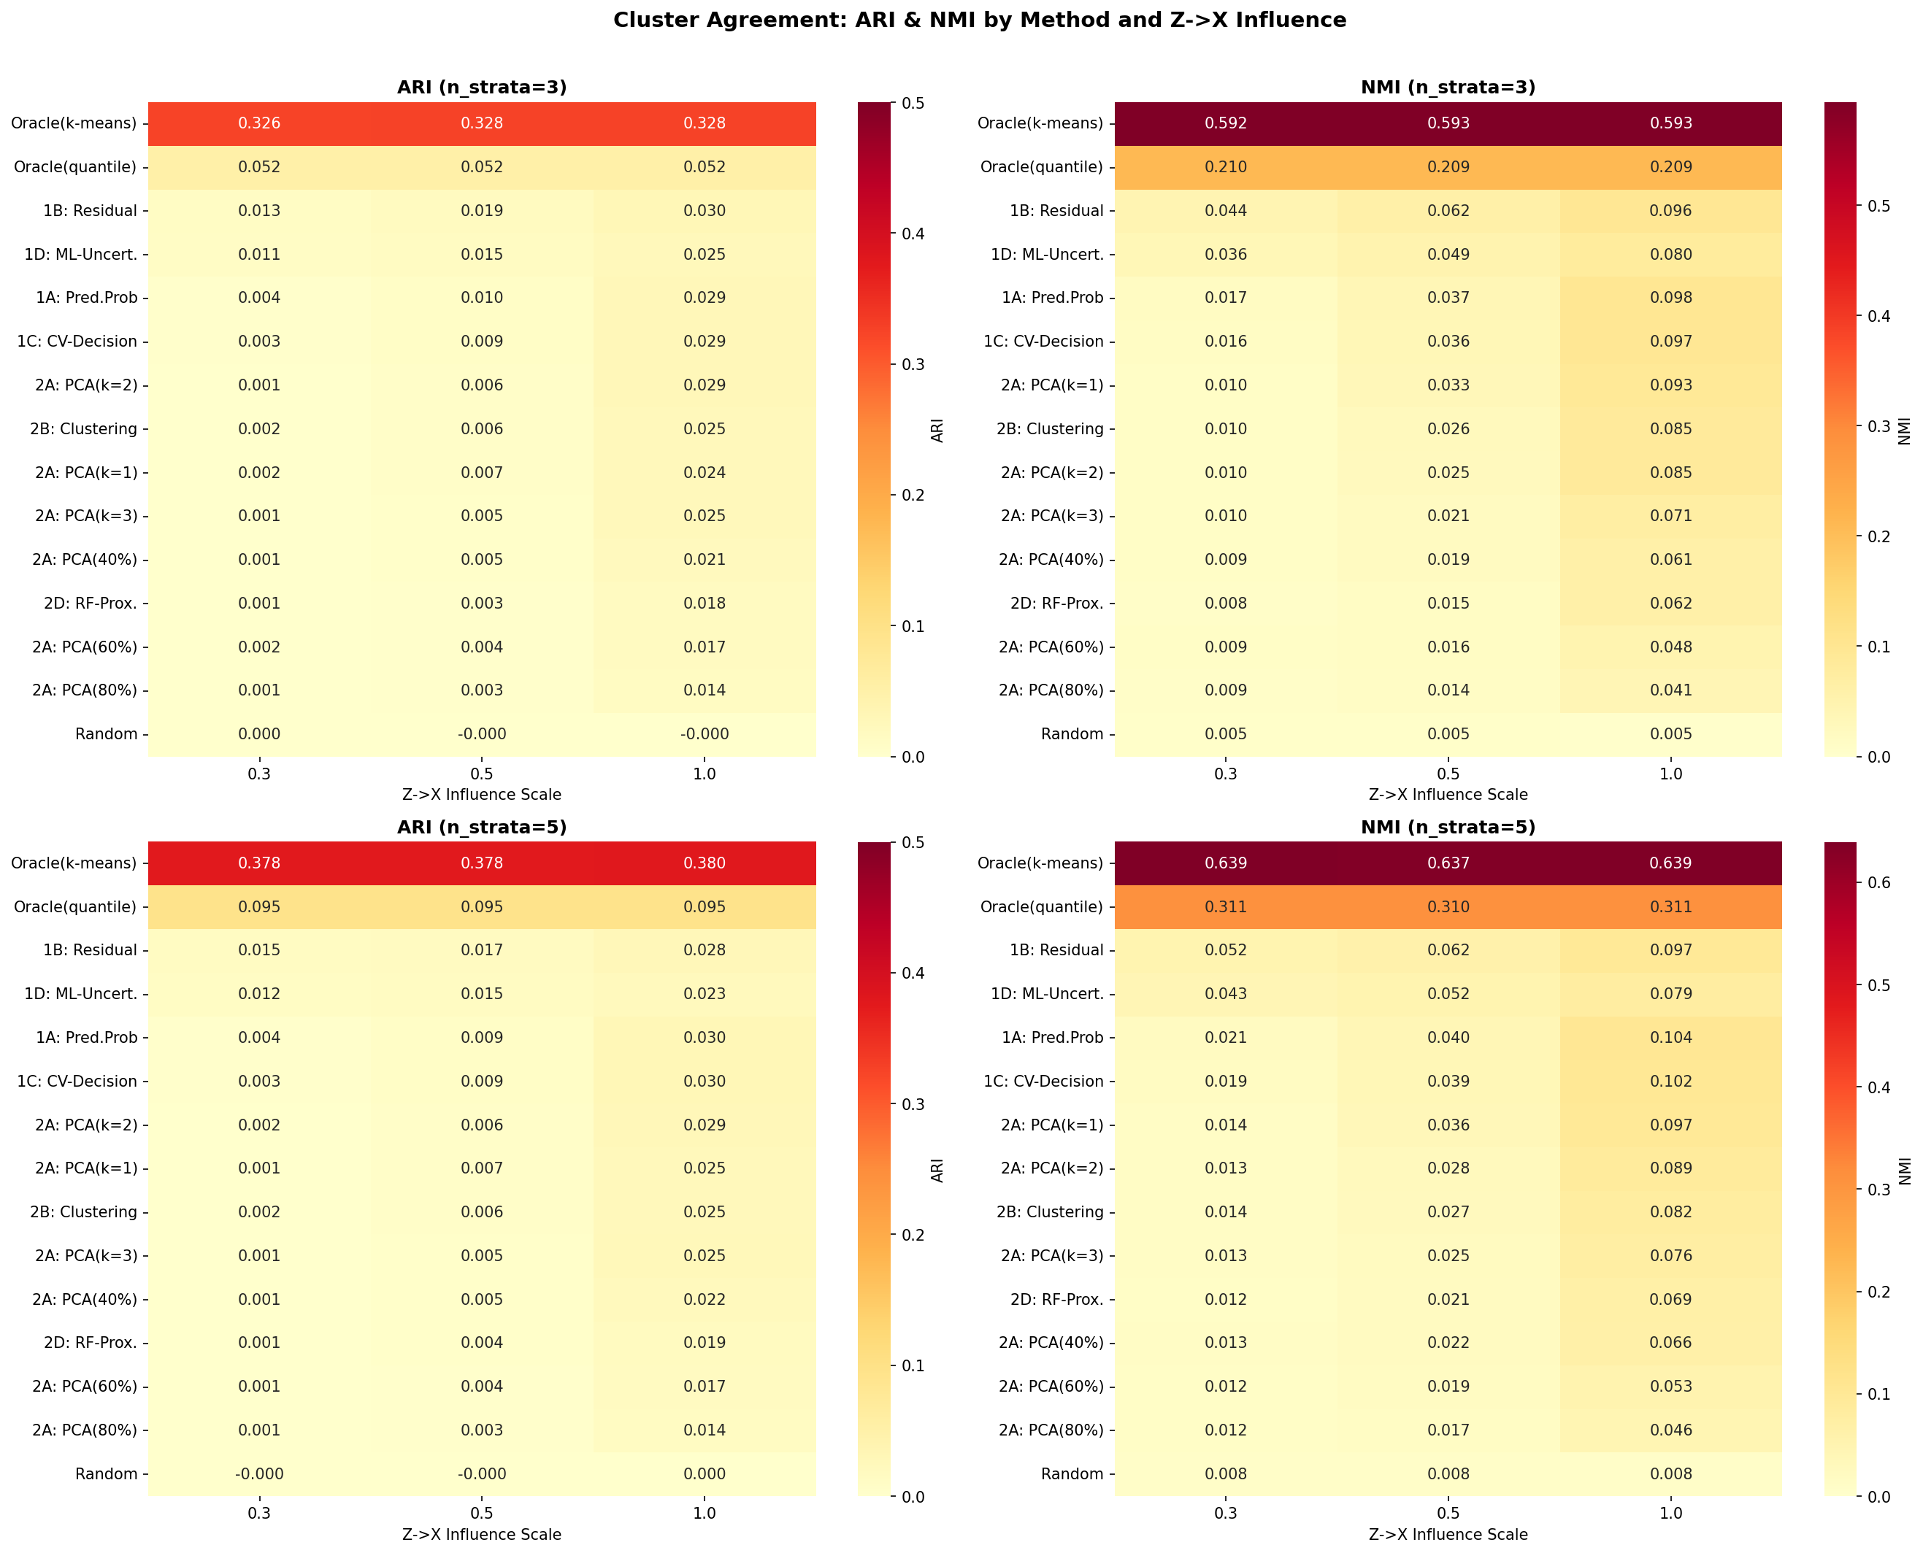
Figure 1. Heatmap of ARI and NMI across methods and scenarios in Phase 1 simulation.

Effect of Z→X influence strength
The strength of the hidden variable’s influence on measured variables was the single most important determinant of method performance (Table 3).
Table 3. ARI by Z→X influence strength (K = 5 strata).
Method | zx = 0.3 (weak) | zx = 0.5 (moderate) | zx = 1.0 (strong) | Strong/weak ratio
1A: Predicted probability | 0.004 | 0.010 | 0.030 | 8.7
1B: Residual | 0.014 | 0.018 | 0.029 | 1.9
1C: Cross-validated | 0.003 | 0.009 | 0.029 | 9.6
2A: PCA (k=2) | 0.002 | 0.006 | 0.029 | 18.3
2B: Clustering | 0.002 | 0.006 | 0.025 | 14.0
Oracle (k-means on Z) | 0.378 | 0.378 | 0.380 | 1.0

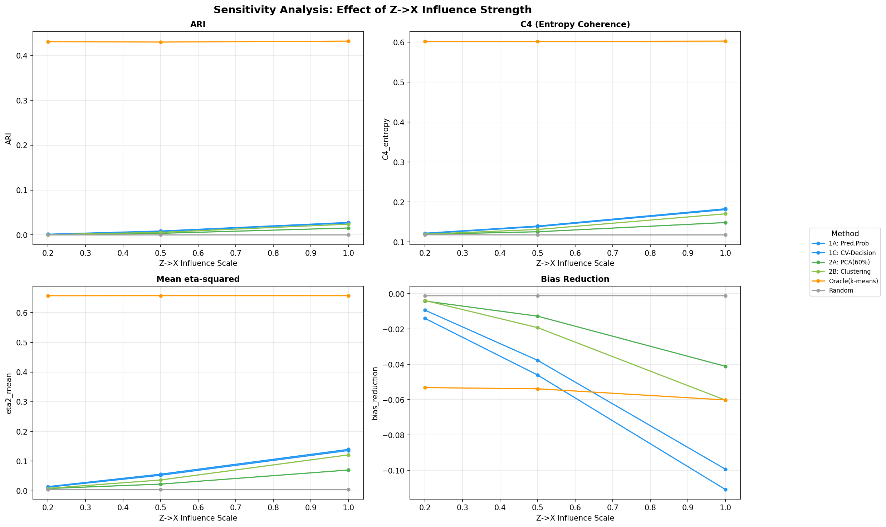
Figure 2. Effect of Z→X influence strength on method performance across sensitivity analysis conditions.

Capture of individual critical variables
Eta-squared analysis revealed differential capture of the three critical variables (Table 4; K = 5, zx = 1.0).
Table 4. Eta-squared (η²) for each critical variable (K = 5 strata, zx = 1.0).
Method | Z₁ (age) | Z₂ (sex) | Z₃ (BMI) | Mean
Oracle (k-means on Z) | 0.312 | 0.982 | 0.663 | 0.652
1A: Predicted probability | 0.327 | 0.008 | 0.092 | 0.142
1C: Cross-validated | 0.322 | 0.007 | 0.090 | 0.140
1B: Residual | 0.295 | 0.012 | 0.093 | 0.133
2B: Clustering | 0.238 | 0.026 | 0.090 | 0.118
Random | 0.002 | 0.002 | 0.002 | 0.002

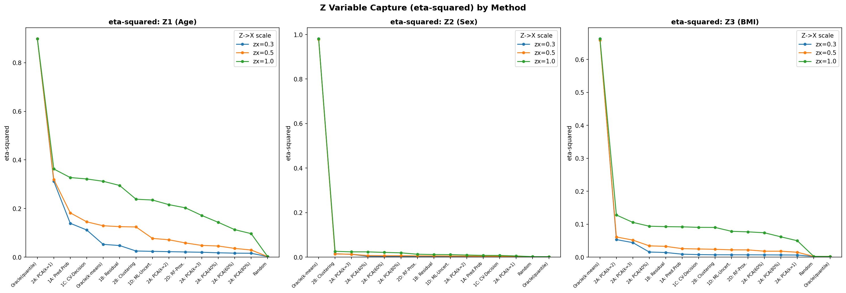
Figure 3. Eta-squared (η²) values showing capture of individual critical variables by each method.

Coherence indicator C1
The coherence indicator C1 clearly separated proposed methods from the random baseline (Figure 4). Random stratification yielded a mean C1 of 0.863, indicating high between-stratum heterogeneity (incoherent population). Methods 1B and 1D achieved the lowest C1 values (0.001), comparable to or below the Oracle k-means baseline (0.019). A provisional threshold of C1 < 0.05 correctly classified all decision power-based methods and Oracle baselines as producing coherent strata, whilst flagging random stratification as incoherent.
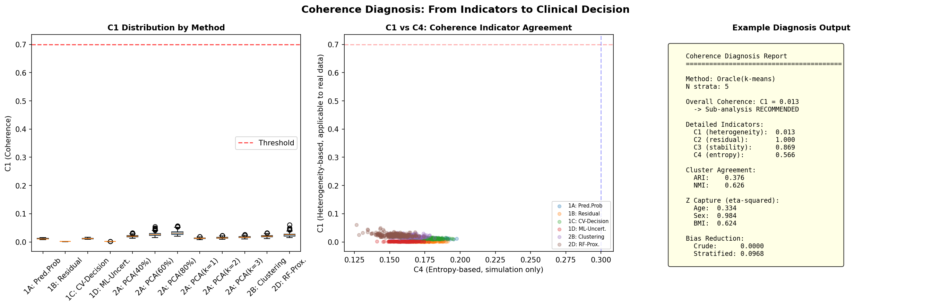
Figure 4. Coherence indicator C1 across methods. Lower C1 indicates successful detection of population incoherence.

Sensitivity analyses
Sample size (N = 500, 2,000, 10,000): Performance was largely insensitive to sample size. Method 1A achieved ARI = 0.012 at N = 500 and ARI = 0.013 at N = 10,000, indicating that the detection limit is governed by signal strength (Z→X influence) rather than sample size.
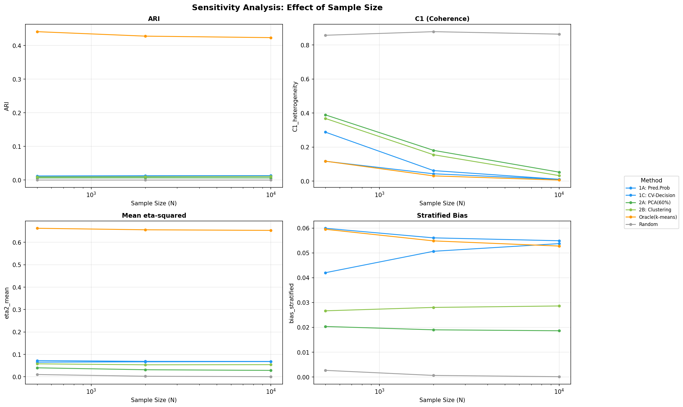
Figure 5. Effect of sample size on method performance in sensitivity analysis.

Z→Y effect scale (0.5, 1.0, 2.0): The strength of the hidden variable’s direct effect on the outcome had minimal impact on proposed method performance (ARI range: 0.012–0.013 for Method 1A across all levels), indicating that methods rely on X-based patterns rather than direct Z→Y effects.
Z→X influence scale (0.2, 0.5, 1.0): This was confirmed as the most important parameter. ARI increased 17.5-fold (Method 1A) to 34.3-fold (Method 2B) from zx = 0.2 to zx = 1.0 (Table 5).
Table 5. ARI by Z→X influence strength in sensitivity analysis.
Method | zx = 0.2 (weak) | zx = 0.5 (moderate) | zx = 1.0 (strong) | Strong/weak ratio
1A: Predicted probability | 0.002 | 0.009 | 0.028 | 17.5
1C: Cross-validated | 0.001 | 0.008 | 0.027 | 22.3
2B: Clustering | 0.001 | 0.006 | 0.024 | 34.3
2A: PCA (60%) | 0.001 | 0.004 | 0.015 | 30.8

Number of strata (K = 3, 5, 10): Proposed methods performed optimally at K = 5. At K = 10, performance decreased slightly (e.g. Method 1A: ARI = 0.014 at K = 5 vs. 0.011 at K = 10), suggesting that over-stratification introduces noise when the signal is weak. By contrast, the Oracle baseline improved monotonically with K (ARI = 0.326 at K = 3 to 0.584 at K = 10).
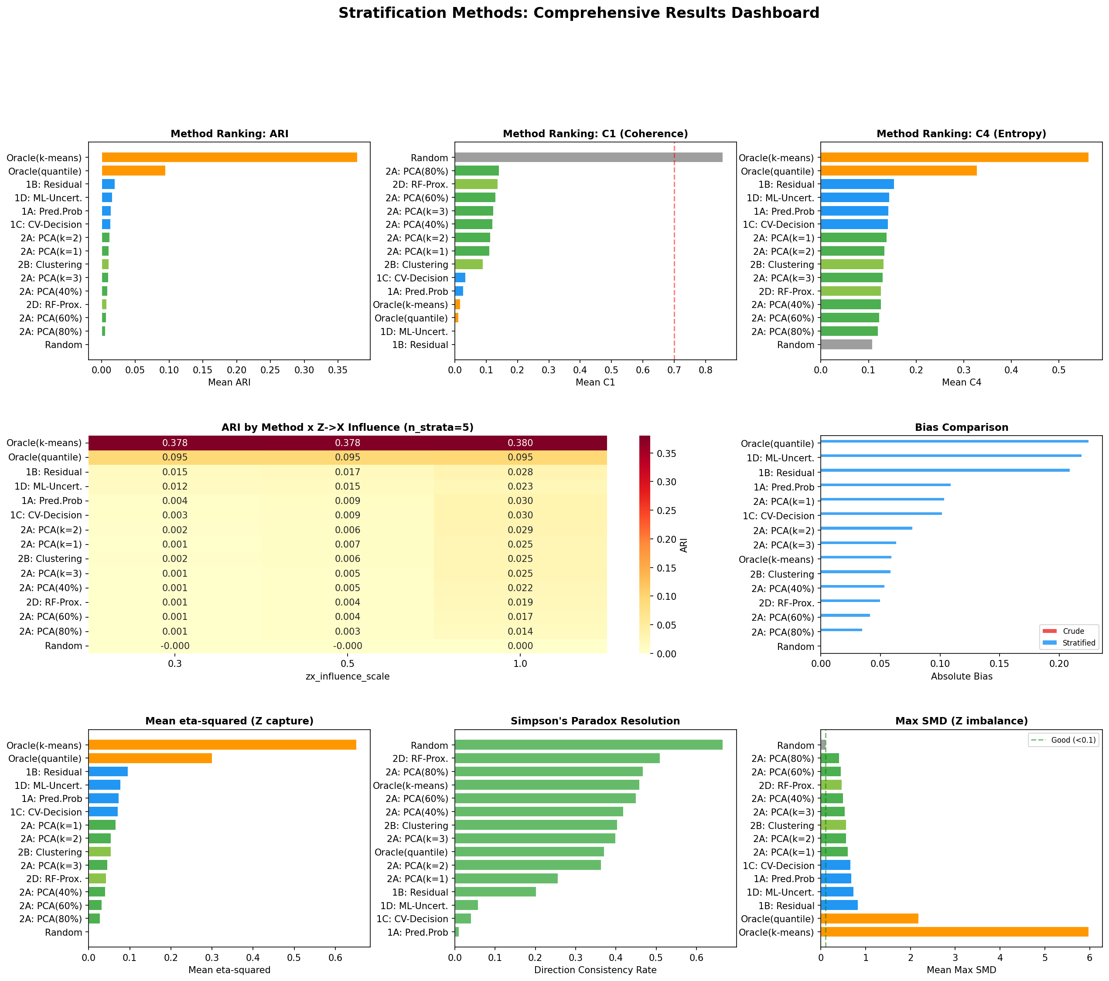
Figure 6. Summary dashboard of simulation results across all Phase 1 conditions.

Empirical validation

Overview of results
Table 6 summarises the performance of IONE across the five published Simpson’s paradox examples.
Table 6. Summary of empirical validation results.
Example | Best method | Best ARI | Oracle ARI | Achievement rate | C1 (best) | C1 (random) | η² (mean, best)
Kidney stone | 2B Clustering | 0.851 | 1.000 | 85.1% | 0.034 | 0.695 | 0.428
Israeli vaccine | 2B Clustering | 0.746 | 1.000 | 74.6% | 0.005 | 0.770 | 0.432
Smoking–mortality | 1A Pred. prob. | 0.498 | 1.000 | 49.8% | 0.005 | 1.000 | 0.686
UC Berkeley | 1A Pred. prob. | 0.082 | 1.000 | 8.2% | 0.011 | 0.954 | 0.152
COVID-19 CFR | 1B Residual | 0.064 | 1.000 | 6.4% | 0.001 | 0.778 | 0.171

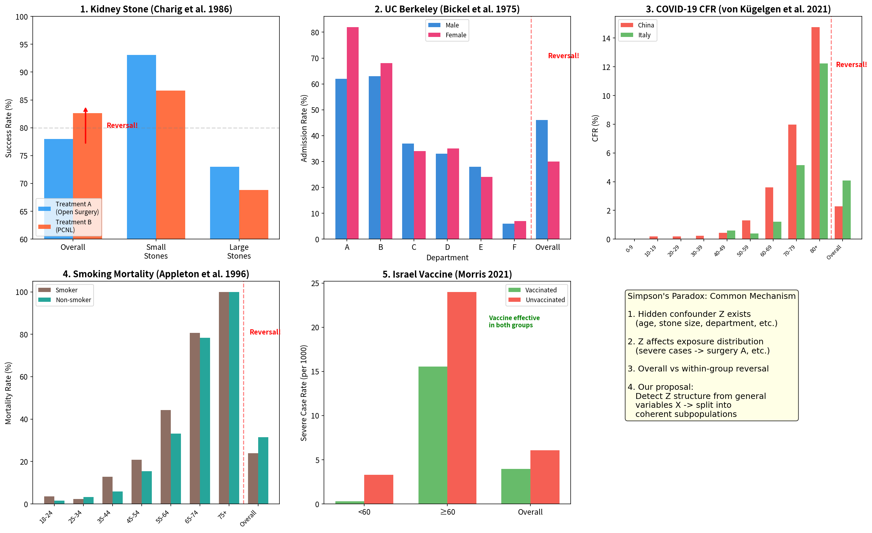
Figure 7. Demonstration of Simpson’s paradox in each of the five empirical examples.

Finding 1: Coherence indicator C1 was universally effective
Across all five examples, C1 values for proposed methods (range: 0.001–0.034) were clearly separated from C1 values for random stratification (range: 0.695–1.000). This indicates that C1 reliably detects population incoherence regardless of the underlying subgroup structure complexity, sample size, or domain.
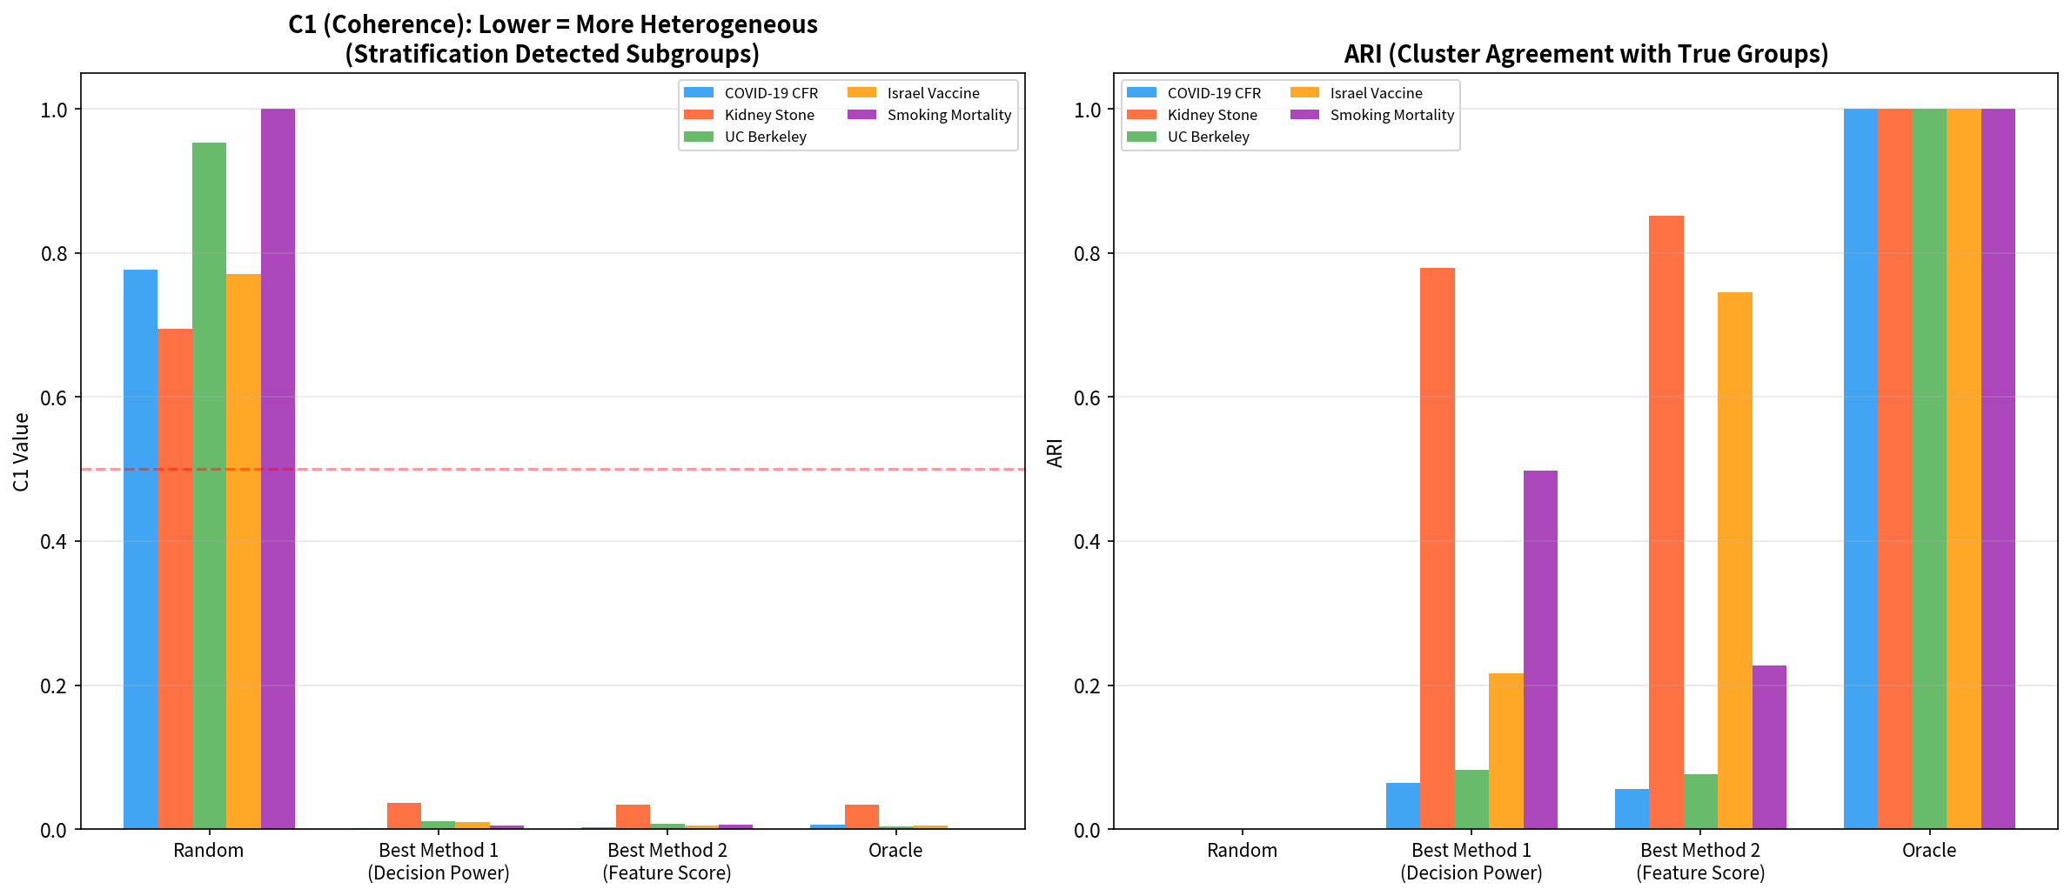
Figure 8. Coherence indicator C1 values across all five empirical examples: proposed methods vs. random baseline.

Finding 2: Subgroup structure complexity determined stratification accuracy
Two-group structures with clear separation were recovered with high accuracy: kidney stone (2 groups: small/large stones) ARI = 0.851 (2B Clustering), approaching the Oracle (1.000); Israeli vaccine (2 groups: <60/≥60 years) ARI = 0.746 (2B Clustering). Multi-group or continuous structures were more challenging: smoking–mortality (7 age groups, but age is a strong continuous predictor) ARI = 0.498 (1A Predicted probability); COVID-19 CFR (9 age groups) ARI = 0.064 (1B Residual); UC Berkeley (6 departments) ARI = 0.082 (1A Predicted probability).
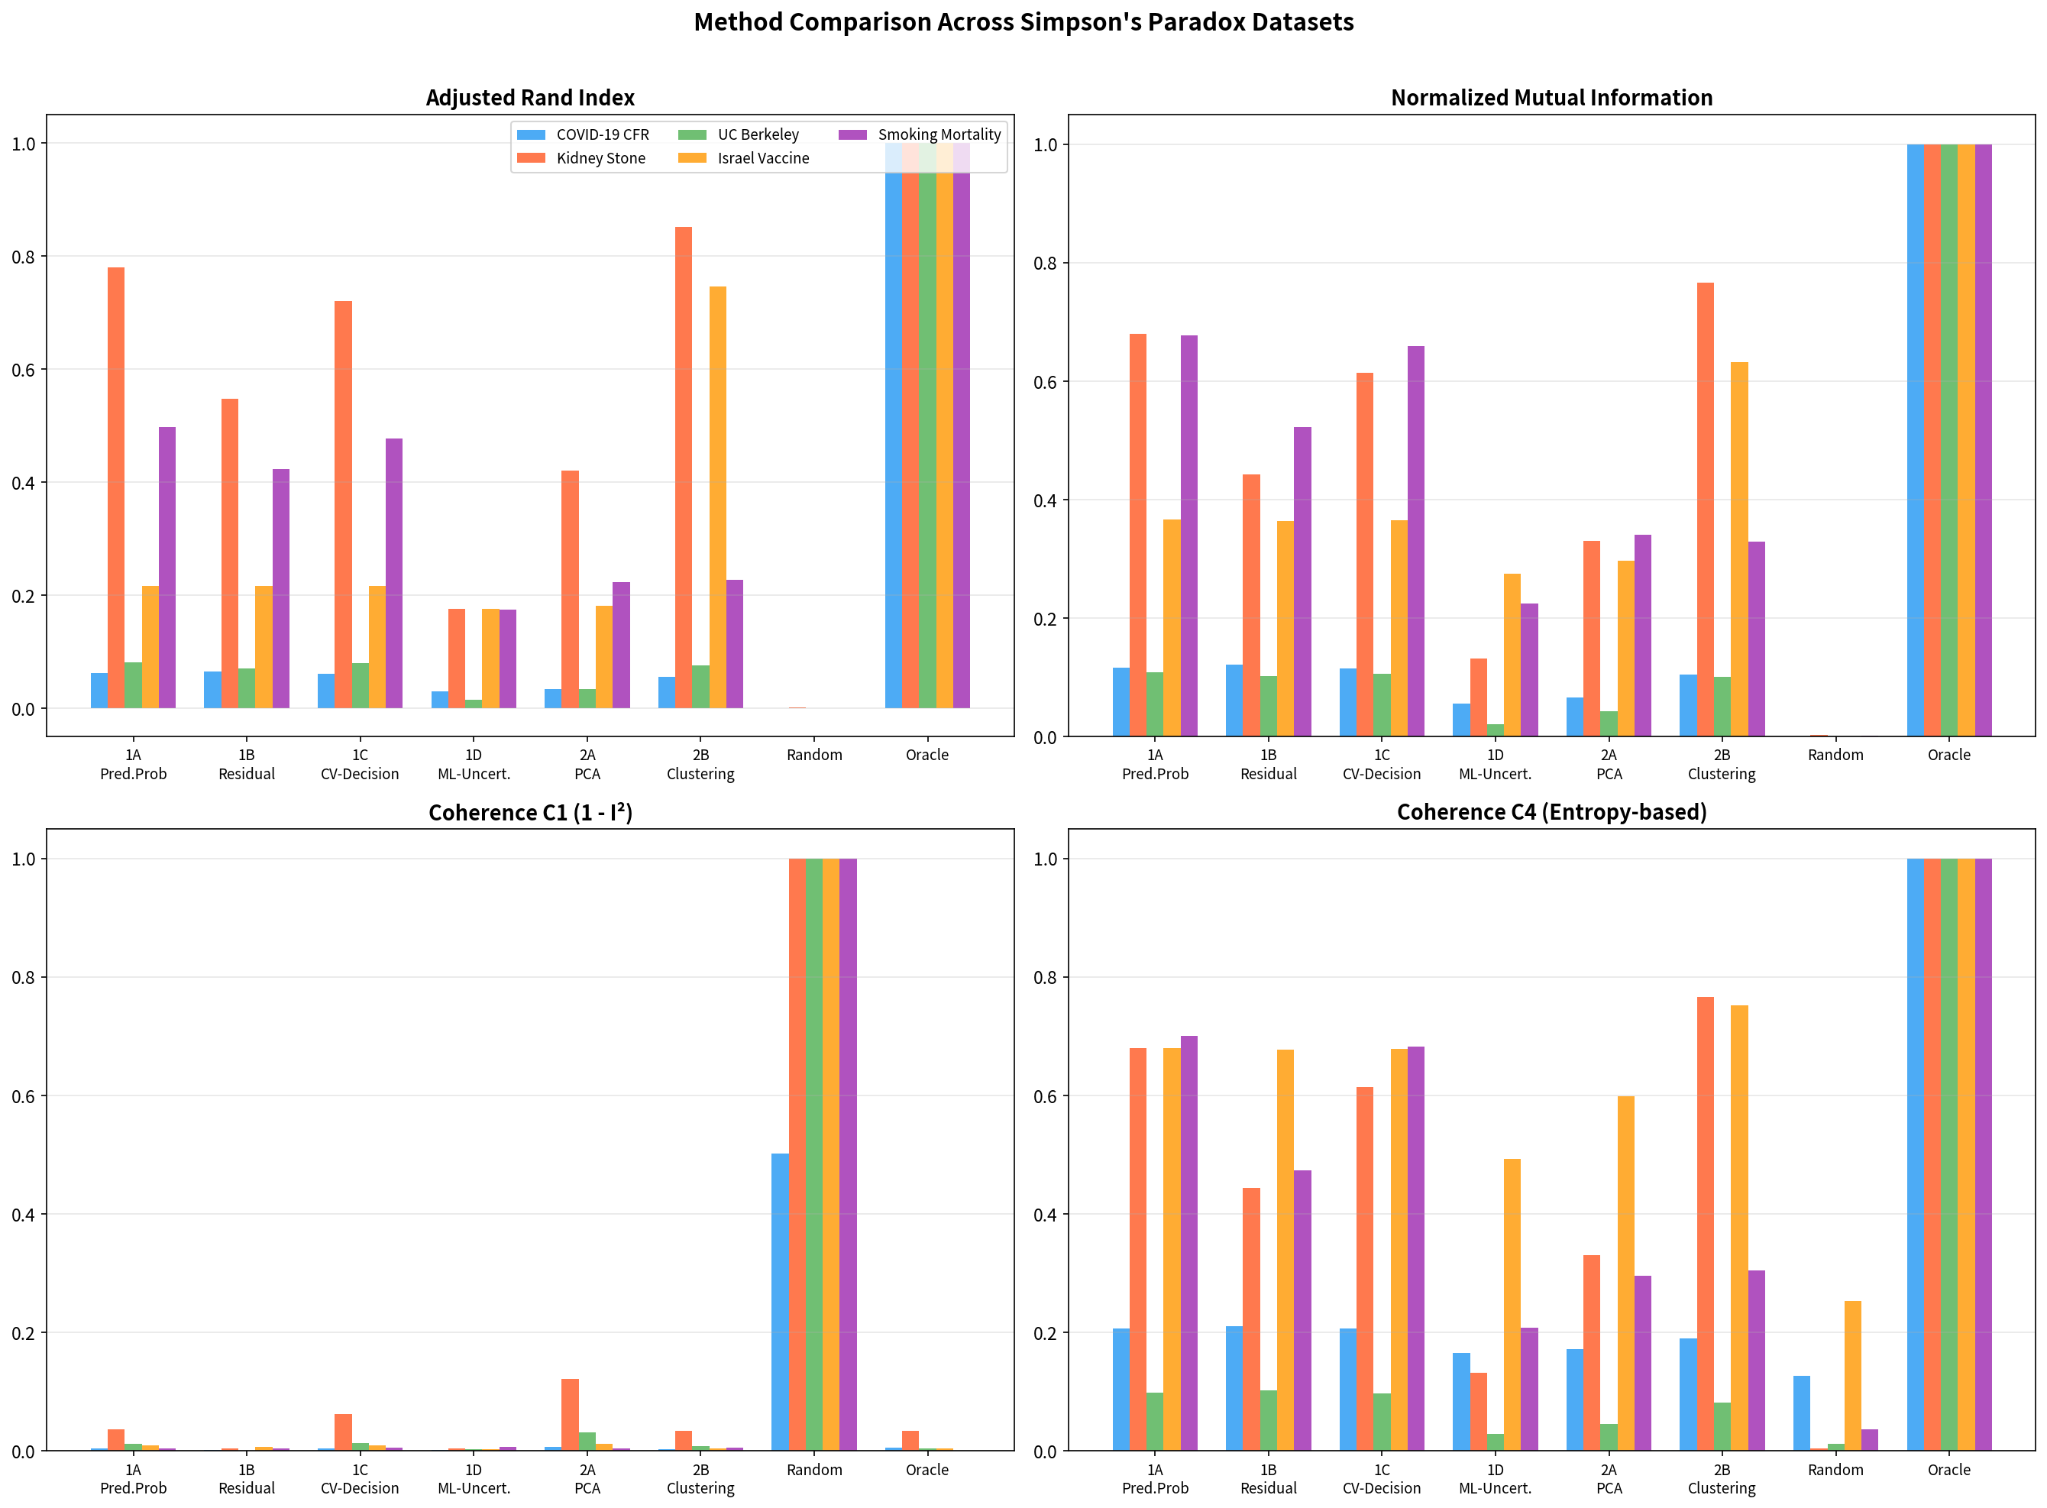
Figure 9. Method comparison across the five empirical examples (ARI by method and example).

Finding 3: Decision power-based and feature score-based methods were complementary
For two-group structures with clear separation, the unsupervised clustering method (2B) outperformed decision power-based methods (kidney stone: 2B ARI = 0.851 vs. 1A ARI = 0.779; Israeli vaccine: 2B ARI = 0.746 vs. 1A ARI = 0.217). For multi-group and continuous structures, decision power-based methods were superior (smoking: 1A ARI = 0.498 vs. 2B ARI = 0.227; COVID-19: 1B ARI = 0.064 vs. 2B ARI = 0.056).

Finding 4: η² confirmed Z→X influence as the primary determinant
The relationship between η² (variance in Z explained by stratification) and ARI achievement rate was consistent with the simulation findings. Examples with high η² (smoking: 0.686; kidney stone: 0.428; Israeli vaccine: 0.432) achieved higher ARI than those with low η² (COVID-19: 0.171; Berkeley: 0.152).
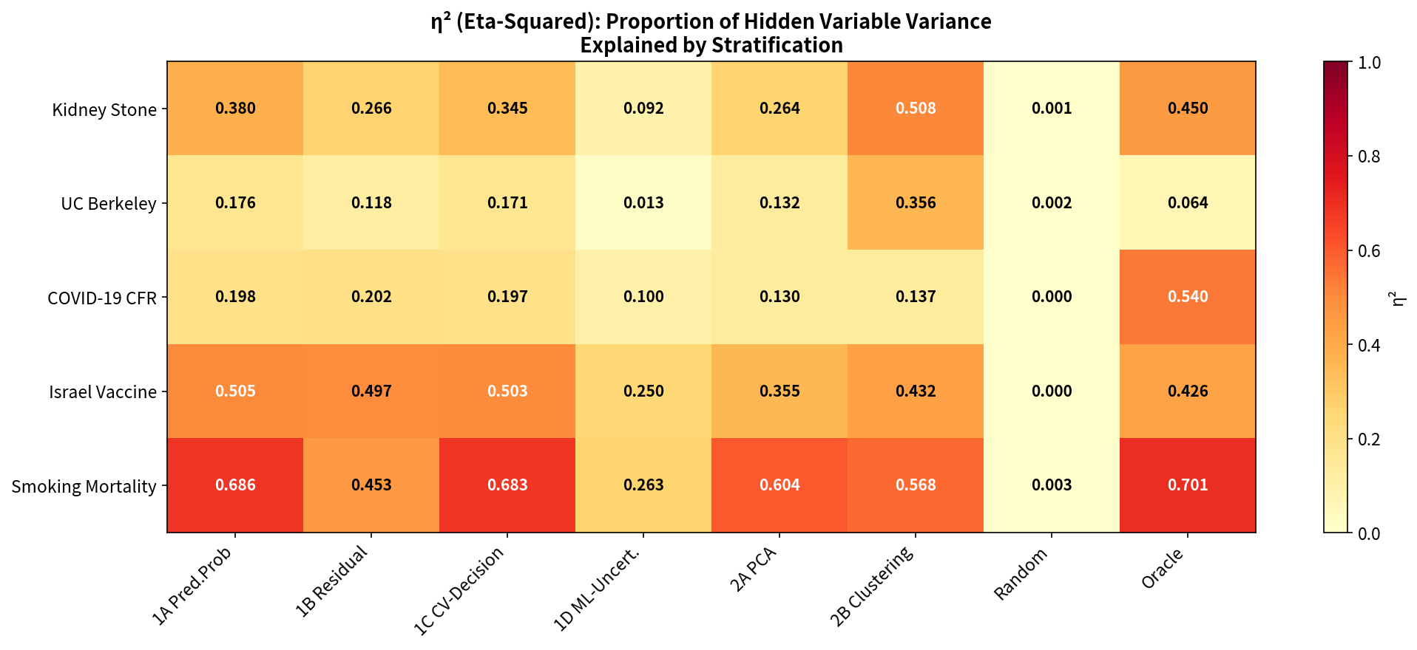
Figure 10. Eta-squared (η²) heatmap across empirical examples and methods.

Finding 5: Simulation and empirical results were concordant
Table 7. Concordance between simulation and empirical findings.
Finding | Simulation | Empirical validation
1B Residual is most robust in Family 1 | Highest ARI (0.020) | Best for COVID-19 (ARI = 0.064)
C1 detects incoherence | Random 0.863 vs. proposed 0.001 | Random 0.70–1.00 vs. proposed 0.00–0.03
Z→X influence is decisive | ARI increases with zx | Higher η² correlates with higher ARI
All proposed methods outperform random | All scenarios | All five examples

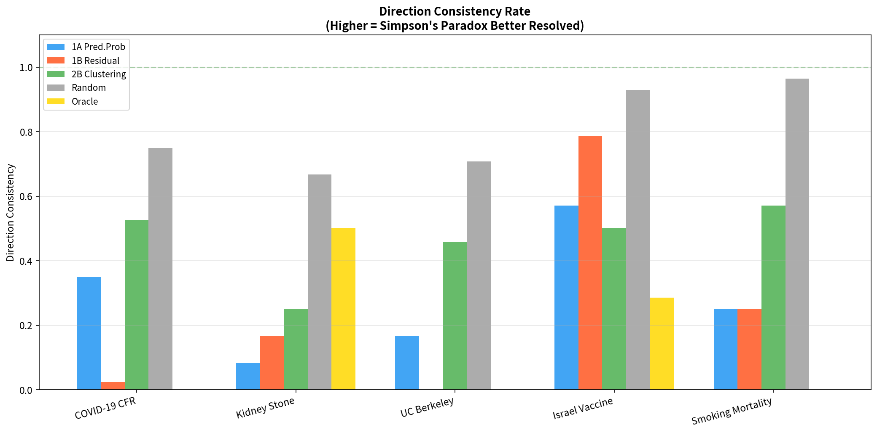
Figure 11. Direction consistency analysis across the five empirical examples.

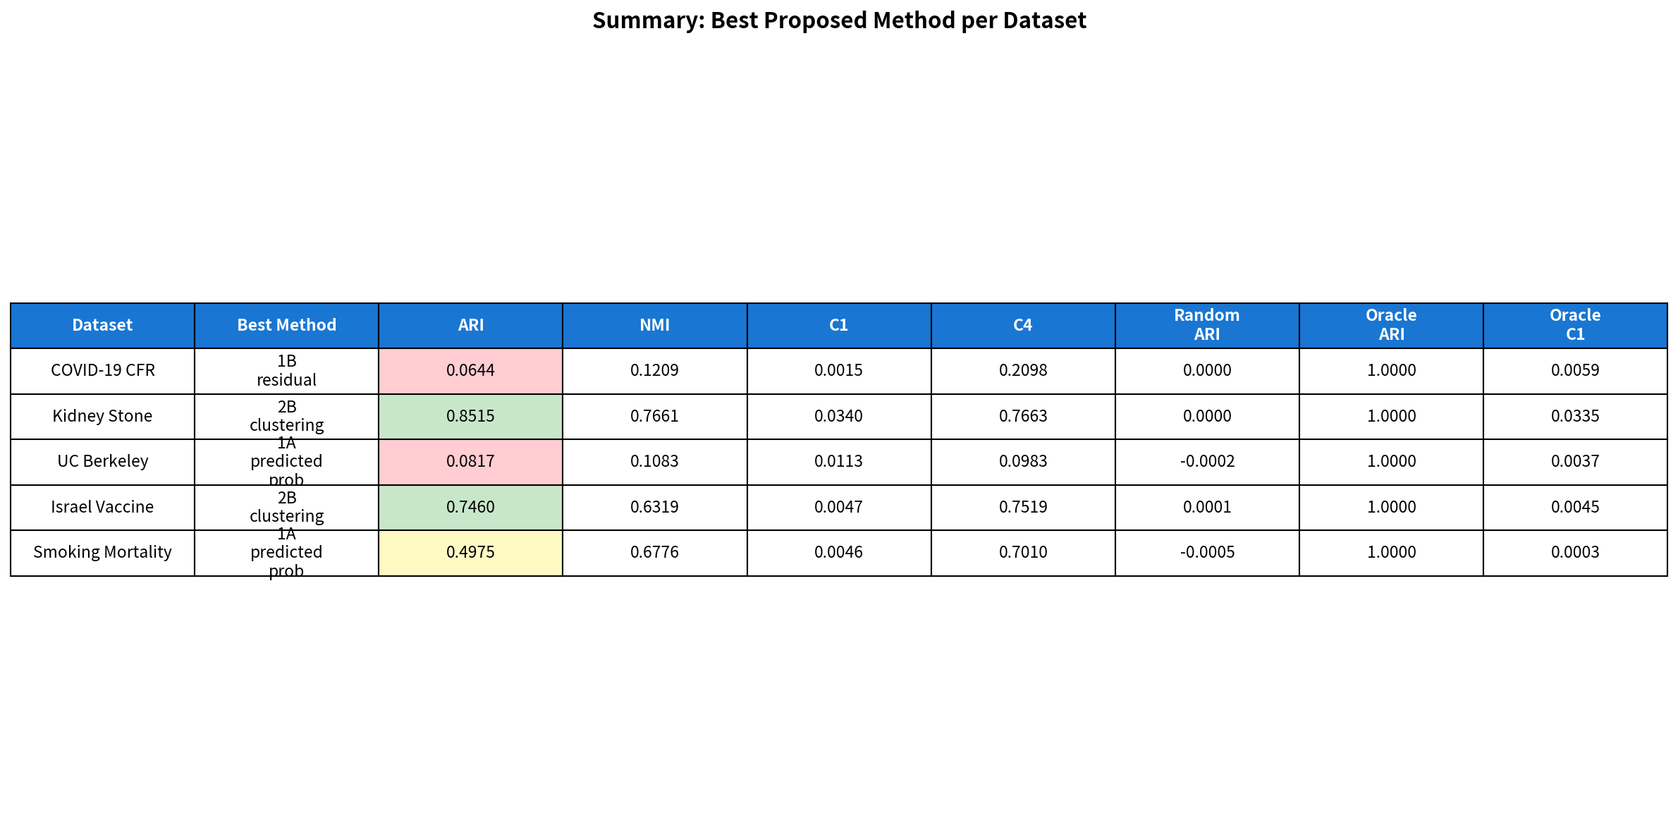
Figure 12. Summary dashboard of empirical validation results across all five examples.

Discussion

Principal findings
This study introduces IONE, a framework for detecting and extracting hidden population structure in observational studies. The principal findings are twofold. First, the coherence indicator C1, derived from the I² heterogeneity statistic, reliably detected population incoherence in both simulated data (66,600 evaluations) and all five published Simpson’s paradox examples. This “warning” function—the ability to signal that a study population likely contains hidden subgroups—was robust to subgroup complexity, sample size, and analytical domain. Second, stratification-based extraction of coherent subpopulations was conditionally successful: high accuracy was achieved for discrete two-group structures (ARI > 0.7), moderate accuracy for continuous strong-signal structures (ARI ≈ 0.5), and limited accuracy for multi-group weak-signal structures (ARI < 0.1). The strength of the hidden variable’s influence on measured variables (Z→X influence, quantified by η²) was identified as the single most important determinant of extraction performance.

Two-tier utility
The distinction between detection (first tier) and extraction (second tier) is important for practical implementation. The C1 coherence indicator requires no assumption about the number or nature of hidden subgroups and can be computed from routinely available data (measured covariates and the outcome). Its consistently strong performance across all conditions tested suggests that it could serve as a standard diagnostic tool in observational study reporting—analogous to the I² statistic in meta-analysis, but applied within a single study to assess internal homogeneity.
The extraction tier is more demanding and context-dependent. Our results suggest the following guidance for applied researchers:
• Two to three discrete subgroups with strong traces (η² > 0.4): Feature score-based clustering (Method 2B) is likely to achieve high recovery (ARI > 0.7). This scenario corresponds clinically to disease subtypes, age-based risk categories, or treatment allocation patterns driven by clear clinical criteria.
• Multiple or continuous subgroups with moderate traces (0.15 < η² ≤ 0.4): Decision power-based methods (especially 1A and 1B) offer partial recovery. Both method families should be applied and compared.
• Weak traces (η² < 0.15): Extraction accuracy is limited. C1 may still detect incoherence, but the identified strata should be interpreted cautiously.

Comparison with existing methods
IONE differs from existing confounding adjustment methods in its objectives and assumptions. Propensity score methods [14] and prognostic scores [15] aim to balance or adjust for measured confounders; they are not designed to detect unmeasured population structure. The hdPS algorithm [19] shares IONE’s insight that proxy variables may carry information about unmeasured confounders, but uses this information to improve propensity score estimation rather than to identify discrete subpopulations. Latent class analysis [23] seeks hidden subgroups but typically requires strong distributional assumptions and does not provide a coherence diagnostic.
IONE is best understood as complementary to these methods rather than as a replacement. We envision a workflow in which IONE is applied as a preliminary step: if C1 indicates incoherence, the population is stratified into coherent subgroups, and conventional methods (e.g. propensity score analysis) are applied within each subgroup. This two-stage adjustment—first addressing hidden population structure, then adjusting for measured confounders—may yield more reliable effect estimates than either approach alone.

Strengths and limitations
Strengths.
This study employed a comprehensive simulation design with 66,600 evaluations spanning a wide range of data-generating conditions, including systematic variation of the key parameter (Z→X influence strength). The ADEMP framework ensured transparent reporting of all design choices. Empirical validation on five published Simpson’s paradox examples from diverse domains (clinical medicine, public health, social science) demonstrated generalisability beyond the simulation setting.
Limitations.
Several limitations should be acknowledged. First, the empirical validation used pseudo-general variables generated from published aggregate data, rather than genuine clinical measurements. Whilst this permits evaluation of the method’s operating characteristics under known confounding, it does not fully replicate the complexity of real clinical data. Validation on clinical databases with individual-level data (e.g. MIMIC-IV, UK Biobank) is an important next step.
Second, the simulation employed a relatively simple data-generating mechanism with three critical variables, ten general variables, and a logistic outcome model. Real clinical data may involve more complex causal structures, non-linear relationships, missing data, and measurement error. The sensitivity of IONE to these complications requires further investigation.
Third, the gap between proposed methods and the Oracle baseline was substantial in simulations (best ARI = 0.020 vs. Oracle ARI = 0.353). This indicates that complete recovery of hidden population structure from measured variables alone is not achieved. The practical value of IONE therefore lies primarily in the C1 coherence indicator and in the partial extraction of subgroup structure, rather than in perfect confounding adjustment.
Fourth, binary critical variables (e.g. sex) were poorly captured (η² < 0.03), suggesting that IONE is better suited to detecting continuous or ordinal confounders that leave stronger traces in measured variables.
Fifth, the C1 threshold of 0.05 proposed here is provisional, based on simulation results and five empirical examples. Formal calibration across a wider range of datasets and clinical settings is needed before firm recommendations can be made.

Implications for practice
If replicated in further studies, our findings have several practical implications. First, we recommend that observational study reports include a coherence assessment alongside the conventional Table 1. When C1 falls below a pre-specified threshold, this should trigger additional subgroup analyses to explore potential hidden population structure. Second, the complementary strengths of decision power-based and feature score-based methods suggest that both should be applied when assessing population coherence, as their agreement provides stronger evidence for the existence of hidden subgroups. Third, the identification of Z→X influence strength as the primary determinant of performance provides a principled basis for assessing the likely utility of IONE in a given application: the method is most promising in settings where important confounders (age, disease severity, comorbidity) are known to influence routine measurements (laboratory values, vital signs), which is precisely the scenario most commonly encountered in clinical epidemiology.

Future directions
Several avenues for future research emerge from this work. Methodological extensions include adaptation to survival outcomes, continuous outcomes, and time-varying confounding. The combination of IONE with propensity score methods in a formal two-stage adjustment framework warrants investigation. The C1 coherence indicator could be extended to a multi-level diagnostic that recommends the optimal number of subgroups. Empirical validation on individual-level clinical databases with genuinely unmeasured confounders would provide a stronger test of the method’s practical utility. Finally, the development of software packages (R and Python) implementing the IONE workflow would facilitate adoption.

Conclusions
We have introduced IONE (Incoherence-Oriented Neutralisation and Extraction), a framework for detecting hidden population structure in observational studies. Through Monte Carlo simulation (66,600 evaluations) and empirical validation on five published instances of Simpson’s paradox, we demonstrate that IONE provides a two-tier contribution. The C1 coherence indicator reliably detects population incoherence across all conditions tested and can serve as a quantitative diagnostic for hidden subgroup structure. Stratification-based extraction of coherent subpopulations is effective when hidden variables leave sufficiently strong traces in measured variables and the subgroup structure is discrete. The strength of the hidden variable’s influence on measured variables is the primary determinant of extraction performance. We recommend that coherence assessment using C1 be considered as a standard component of observational study reporting, complementing existing tools such as propensity score analysis rather than replacing them.

List of abbreviations
Abbreviation | Full term
ARI | Adjusted Rand Index
BMI | Body mass index
C1 | Coherence indicator 1 (I²-based)
CFR | Case fatality rate
DAG | Directed acyclic graph
DRS | Disease risk score
hdPS | High-dimensional propensity score
IONE | Incoherence-Oriented Neutralisation and Extraction
IV | Instrumental variable
NMI | Normalised Mutual Information
OR | Odds ratio
PCA | Principal component analysis
PS | Propensity score
RCT | Randomised controlled trial

Declarations

Ethics approval and consent to participate
Not applicable. This study used simulated data and publicly available aggregate statistics only.

Consent for publication
Not applicable.

Availability of data and materials
The simulation code and analysis scripts are available at [repository URL to be inserted]. The published datasets used for empirical validation are referenced in the original publications [9–13].

Competing interests
[To be inserted]

Funding
[To be inserted]

Authors’ contributions
[To be inserted]

Acknowledgements
[To be inserted]

References
1. Hammerton G, Munafò MR. Causal inference with observational data: the need for triangulation of evidence. Psychol Med. 2021;51(4):563–78.
2. Hernán MA, Robins JM. Causal Inference: What If. Boca Raton: Chapman & Hall/CRC; 2020.
3. VanderWeele TJ, Shpitser I. On the definition of a confounder. Ann Stat. 2013;41(1):196–220.
4. Simpson EH. The interpretation of interaction in contingency tables. J R Stat Soc Ser B. 1951;13(2):238–41.
5. Rojanaworarit C. Misleading epidemiological and statistical evidence in the presence of Simpson’s paradox: an illustrative study using simulated scenarios. J Med Life. 2020;13(1):37–44.
6. VanderWeele TJ, Knol MJ. A tutorial on interaction. Epidemiol Methods. 2014;3(1):33–72.
7. Robinson WS. Ecological correlations and the behavior of individuals. Am Sociol Rev. 1950;15(3):351–7.
8. Greenland S, Robins JM, Pearl J. Confounding and collapsibility in causal inference. Stat Sci. 1999;14(1):29–46.
9. Charig CR, Webb DR, Payne SR, Wickham JE. Comparison of treatment of renal calculi by open surgery, percutaneous nephrolithotomy, and extracorporeal shockwave lithotripsy. BMJ. 1986;292(6521):879–82.
10. Bickel PJ, Hammel EA, O’Connell JW. Sex bias in graduate admissions: data from Berkeley. Science. 1975;187(4175):398–404.
11. von Kügelgen J, Gresele L, Schölkopf B. Simpson’s paradox in Covid-19 case fatality rates: a mediation analysis of age-related causal effects. IEEE Trans Artif Intell. 2021;2(1):18–27.
12. Morris JA. Israeli data: how can efficacy vs. severe disease be 91.4% when 60% of severe cases are vaccinated? 2021. https://www.covid-datascience.com/post/israeli-data-how-can-efficacy-vs-severe-disease-be-91-when-60-of-severe-cases-are-vaccinated
13. Appleton DR, French JM, Vanderpump MPJ. Ignoring a covariate: an example of Simpson’s paradox. Am Stat. 1996;50(4):340–1.
14. Rosenbaum PR, Rubin DB. The central role of the propensity score in observational studies for causal effects. Biometrika. 1983;70(1):41–55.
15. Hansen BB. The prognostic analogue of the propensity score. Biometrika. 2008;95(2):481–8.
16. Aikens RC, Greaves D, Baiocchi M. A pilot design for observational studies: using abundant data thoughtfully. Stat Med. 2020;39(29):4349–69.
17. Miettinen OS. Stratification by a multivariate confounder score. Am J Epidemiol. 1976;104(6):609–20.
18. Angrist JD, Imbens GW, Rubin DB. Identification of causal effects using instrumental variables. J Am Stat Assoc. 1996;91(434):444–55.
19. Schneeweiss S, Rassen JA, Glynn RJ, Avorn J, Mogun H, Brookhart MA. High-dimensional propensity score adjustment in studies of treatment effects using health care claims data. Epidemiology. 2009;20(4):512–22.
20. Rassen JA, Schneeweiss S. Using high-dimensional propensity scores to automate confounding control in a distributed medical product safety surveillance system. Pharmacoepidemiol Drug Saf. 2012;21(S1):41–9.
21. Wyss R, Schneeweiss S, van der Laan M, Lendle SD, Ju C, Franklin JM. Machine learning for improving high-dimensional proxy confounder adjustment in healthcare database studies. Stat Med. 2018;37(8):1310–24.
22. Tchetgen Tchetgen EJ, Ying A, Cui Y, Shi X, Miao W. An introduction to proximal causal inference. Stat Sci. 2024;39(3):375–90.
23. McLachlan GJ, Peel D. Finite Mixture Models. New York: Wiley; 2000.
24. Hayes-Larson E, Kezios KL, Mooney SJ, Lovasi G. Who is in this study, anyway? Guidelines for a useful Table 1. J Clin Epidemiol. 2019;114:125–32.
25. Higgins JPT, Thompson SG. Quantifying heterogeneity in a meta-analysis. Stat Med. 2002;21(11):1539–58.
26. Morris TP, White IR, Crowther MJ. Using simulation studies to evaluate statistical methods. Stat Med. 2019;38(11):2074–102.
27. Hubert L, Arabie P. Comparing partitions. J Classif. 1985;2(1):193–218.
28. Strehl A, Ghosh J. Cluster ensembles—a knowledge reuse framework for combining multiple partitions. J Mach Learn Res. 2002;3:583–617.

Additional file 1: Supplementary Methods
Detailed description of the pseudo-general variable generation procedure for each of the five Simpson’s paradox examples, including the correlation structures imposed between pseudo-general variables and the known confounding variable.
[To be prepared]

Additional file 2: ADEMP Checklist
Table S1. ADEMP checklist for the simulation study.
ADEMP component | Item | Section
Aims | Specific aims stated | Methods: Aims
 | Evaluate stratification-based subgroup recovery, compare method families, assess C1 indicator, identify optimal conditions
Data-generating mechanisms | Causal structure described (DAG) | Methods: Data-generating mechanisms
 | Variable distributions specified | Methods: Data-generating mechanisms
 | Factors varied and levels stated | Methods: Scenarios
 | Justification for DGM choices | Methods: Data-generating mechanisms
 | Number of repetitions and justification | Methods: Scenarios
Estimands | Estimands defined | Methods: Estimands
Methods | All methods described (6 proposed + 2 baselines) | Methods: Methods under comparison
 | Rationale for method selection | Methods: Methods under comparison
Performance measures | Performance measures listed with definitions | Methods: Performance measures
 | Monte Carlo SE reported | Methods: Performance measures

Additional file 3: STROBE-Sim Checklist
Table S2. STROBE-Sim reporting checklist for the simulation study (adapted from Burton et al. 2006 and Morris et al. 2019).
Item | STROBE-Sim recommendation | Reported | Location in manuscript
Title/abstract
1a | Indicate simulation study in title | Yes | Title
1b | Structured abstract with aims, methods, results, conclusions | Yes | Abstract
Introduction
2 | Scientific background and rationale | Yes | Background
3 | Specific objectives or hypotheses | Yes | Background, final paragraph
Methods
4 | Study design (simulation + empirical) | Yes | Methods: opening paragraph
5 | Data-generating mechanism: causal structure (DAG) | Yes | Methods: Data-generating mechanisms
6 | Data-generating mechanism: variable distributions | Yes | Methods: Data-generating mechanisms
7 | Data-generating mechanism: outcome model | Yes | Methods: Outcome model
8 | Factors varied systematically | Yes | Methods: Scenarios
9 | Number of repetitions with justification | Yes | Methods: Scenarios
10 | Estimands clearly defined | Yes | Methods: Estimands
11 | All methods under comparison described | Yes | Methods: Methods under comparison
12 | Performance measures with definitions | Yes | Methods: Performance measures
13 | Software and computational details | Yes | Methods: Computational implementation
14 | Coding verification / validation | Partial | Fixed seeds; code availability stated
Results
15 | Number of simulations completed vs. planned | Yes | Results: 66,600 evaluations
16 | Summary of performance measures across scenarios | Yes | Results: Tables 2–7
17 | Presentation of results for each estimand | Yes | Results (ARI, η², C1 reported separately)
18 | Monte Carlo standard errors | [To be added] | —
Discussion
19 | Summary of key findings | Yes | Discussion: Principal findings
20 | Comparison with previous studies | Yes | Discussion: Comparison with existing methods
21 | Limitations of simulation design | Yes | Discussion: Strengths and limitations
22 | Generalisability of findings | Yes | Discussion: Implications for practice
Other
23 | Source of funding | [To be inserted] | Declarations: Funding
24 | Code availability | Yes | Declarations: Availability of data and materials
25 | Role of funder | [To be inserted] | —

Additional file 4: Supplementary Results
Full results tables for all sensitivity analysis conditions, including per-scenario ARI, η², and C1 values.
[To be prepared]

Manuscript prepared for submission to BMC Medical Research Methodology
Target collection: Causal inference and observational data vol. 2
Submission deadline: 30 July 2026

