Coherence diagnostics for hidden effect modification in individual participant data meta-analysis: the Incoherence-Oriented Neutralisation and Extraction (IONE) framework and a simulation benchmark
Onishi Tatsukiª
ªData Science AI Innovation Research Promotion Center, Shiga University, 1-1-1 Bamba, Hikone, Shiga 522-8522, Japan
ORCID: 0000-0001-7261-9062
Corresponding author: Onishi Tatsuki
bougtoir@gmail.com

Abstract
Background: In individual participant data (IPD) meta-analysis, marginal effect estimates can be biased by hidden effect modifiers. We introduce the Incoherence-Oriented Neutralisation and Extraction (IONE) framework, two coherence diagnostics (C1 and W), and a reproducible simulation benchmark of seven stratification approaches.
Methods: We simulated an IPD meta-analysis with 10 studies and n=2000 participants, binary treatment and outcome, measured covariates carrying traces of an unmeasured modifier, and study-level variation in baseline risk and treatment prevalence. Seven methods—two outcome-informed, two outcome-free, propensity-score, prognostic-score and Gaussian-mixture stratification—were compared; stratum-specific risk differences were synthesised with fixed-effect and DerSimonian-Laird random-effects meta-analysis. We report ARI, C1, W and average treatment effect (ATE) bias reduction, calibrating the diagnostics against empirical null distributions.
Results: At n=2000 and K=5, C1 and $W_{est}$ discriminated the alternative from the empirical null only at chance level (C1 AUC 0.460-0.545; W AUC 0.427-0.561). The residual-based method achieved the largest random-effects ATE bias reduction (from 0.01865 to 0.00816; relative reduction 0.563). Its absolute bias plateaued near 0.00824 (n=500), 0.00852 (n=2000) and 0.00864 (n=10 000), indicating a structural bias floor that persists as sample size increases.
Conclusions: IONE is a descriptive sensitivity framework, not an inferential test for hidden effect modification. The benchmark shows that data-driven stratification can reduce marginal ATE bias when measured covariates carry strong traces of hidden effect modification, but C1 and W must be interpreted relative to method-specific empirical nulls and are not standalone decision criteria.
Keywords: meta-analysis; heterogeneity; effect modification; stratification; simulation; reproducibility; causal inference

1. Introduction
Meta-analysis pools treatment-effect estimates across studies and is central to evidence-based medicine ¹. Individual participant data (IPD) meta-analysis preserves participant-level covariates and can increase power for treatment-covariate interactions ²³. Random-effects syntheses are recommended when between-study heterogeneity is suspected ⁴⁵⁶, yet conventional summaries estimate a marginal effect and may mislead when effect modifiers are unmeasured or omitted ⁷⁸. When the pooled population contains subgroups with different treatment effects, the marginal effect can reverse within population strata, producing Simpson-type paradoxes ⁹¹⁰.
Heterogeneity in IPD meta-analysis is usually investigated through subgroup analyses, meta-regression or one-stage mixed models. These approaches explain variation with measured covariates and study-level factors, and stratification by study is the standard way to share baseline risk and treatment prevalence. They do not, however, test whether the pooled participants themselves form internally homogeneous subpopulations with respect to treatment effect. We therefore frame Incoherence-Oriented Neutralisation and Extraction (IONE) as an exploratory sensitivity tool: it flags when a marginal summary may be fragile and separates the pooled IPD into more homogeneous subgroups using multivariate patterns in measured variables. The aim is not to recover hidden variables, but to flag marginal summaries that may be misleading when the IPD contains hidden effect modification.
Hidden population structure is documented across medicine and social science: kidney-stone treatments ¹¹, university admissions ¹², COVID-19 case-fatality comparisons ¹³, national vaccine-surveillance data ¹⁴, and smoking-mortality studies ¹⁵. Established methods adjust for measured confounders but do not detect unmeasured population structure. We use IONE with two coherence diagnostics: C1, derived from the $I^{2}$ heterogeneity statistic ⁵ applied to stratum-specific log odds ratios, and W, the proportion of total conditional average treatment effect (CATE) variance explained by the stratification. Stratum-specific risk differences are synthesised with fixed-effect or DerSimonian-Laird random-effects meta-analysis. C1 measures coherence within the formed strata; W is a ratio whose denominator is the overall CATE variance and is therefore unstable when the modification signal is weak.
Because the finite-sample distributions of discovered-stratum risk differences depend on the unknown joint distribution of unmeasured modifiers and measured covariates, closed-form theoretical comparisons of the competing stratification methods are not available. We therefore use an ADEMP-based simulation benchmark to quantify relative performance and the operating characteristics of C1 and W.

2. Methods
This simulation study follows the ADEMP framework ¹⁶.

Aims
Quantify average treatment effect (ATE) bias reduction from fixed-effect and DerSimonian-Laird random-effects synthesis of stratum-specific risk differences; compare outcome-informed IONE methods with outcome-free and established comparators; assess the diagnostic discrimination of C1 and W against an empirical null; and identify data-generating conditions under which the diagnostics are most and least informative.

IPD data-generating mechanism
We simulated an IPD meta-analysis with n=2000 participants assigned to 10 studies (scale parameter 0.6 for baseline risk, treatment prevalence and an age-like covariate). Each participant had three critical variables (Z1 continuous, Z2 binary, Z3 ordered) that affected treatment, outcome and treatment-covariate interactions, and ten measured variables (X1-X10) carrying traces of Z. A binary treatment A and binary outcome Y were generated from logistic models with Z and X main effects, a treatment effect and Z-by-A interactions. The estimand was the population risk-difference ATE; full algebra is in Additional file 1.
The primary scenario used n=2000, 10 studies and K=5 strata. We varied K (3, 5, 10), sample size (500, 2000, 10 000), Z-to-Y effect scale (0.5, 1.0, 2.0), Z-to-X influence scale (0.2, 0.5, 1.0) and introduced a non-linear Z-to-X mapping. The primary and strata-sensitivity scenarios used 50 replications; extended robustness used 30; empirical null used 200 and $W_{est}$ misspecification used 50.

Stratification methods
Proposed Family 1 (outcome-informed). Method 1A: predicted probability of Y from logistic Y~X, stratified by quantiles. Method 1B: absolute residual from the same model.
Proposed Family 2 (outcome-free). Method 2A: first principal component of standardised X. Method 2B: K-means on standardised X.
Comparators and baselines. Propensity-score quintiles ¹⁷, Gaussian mixture model on X ¹⁸, prognostic-score stratification (untreated-only Y~X) ¹⁹; Oracle baselines stratify by true Z-space; random assignment provides a chance reference. Equal-frequency strata were used throughout, logistic regression used l2 regularisation (C=1.0, lbfgs), and outcome-informed methods used a 50/50 discovery/evaluation split.

Synthesis of stratum-specific effects
Within each stratum we computed the risk difference between outcome probabilities under treatment and control. A two-stage fixed-effect summary weighted strata by size; a DerSimonian-Laird random-effects summary estimated between-stratum variance ⁴. Stratum-specific pooling means summarising effects within more homogeneous subgroups identified from the pooled IPD.
Several caveats apply. Discovered strata are not independent estimates; they are formed from the same IPD sample, so their stratum-specific risk differences are dependent. The DerSimonian-Laird $τ^{2}$ and SE therefore describe between-stratum heterogeneity and should be interpreted cautiously. The SE of the pooled random-effects risk difference is conditional on the chosen stratification and does not account for stratum-formation uncertainty.

Study-level meta-analysis benchmark
To contextualise within-study and between-study heterogeneity, we also formed a study-level summary: we pooled crude study-specific risk differences with a DerSimonian-Laird random-effects meta-analysis and compared its ATE bias with the IPD stratified analyses. This benchmark shows how much heterogeneity is captured by conventional study-level pooling before any covariate-based stratification is applied.

Evaluation metrics

Formal definitions
For a stratification with K strata, let $θ_{k}$ denote the stratum-specific log odds ratio, $τ^{2}$ the between-stratum variance, and $v_{w}$ a typical within-stratum sampling variance. Then
$C1 = 1 - I^{2} = 1 - \frac{τ^{2}}{τ^{2} + v_{w}}$,
where lower C1 indicates greater between-stratum heterogeneity of stratum-specific log odds ratios. For estimated individual CATEs $τ(X_{i})$, let $τ_{k}$ be the stratum mean and tau the overall mean. The proportion of total CATE variance explained by the stratification is
$W = \frac{Σ_{k} n_{k} {(τ_{k} - τ)}^{2}}{Σ_{i} {(τ_{i} - τ)}^{2}}$,
where the numerator is the between-stratum variance weighted by stratum size and the denominator is the total variance of estimated individual CATEs. Both C1 and W are descriptive indices; they flag incoherence but are not inferential tests for hidden effect modification.
ARI ²⁰: agreement between estimated strata and an operational approximation of the true-Z partition, corrected for chance. Because the true hidden modifier is multidimensional and has no unique clinical representation, the reference partition was formed by k-means clustering of standardised Z-space into K strata. ARI therefore measures how well a method recovers this k-means approximation, not recovery of a clinically validated true subgroup structure. Values near zero indicate chance agreement; the Oracle and true-CATE-quantile references provide computational upper bounds relative to this approximation.
C1 = 1 - $I^{2}$ applied to stratum-specific log odds ratios ⁵. Lower C1 indicates greater between-stratum heterogeneity of stratum-specific log odds ratios. Because C1 is computed on the log-odds scale while ATE bias is on the risk-difference scale, it is an indirect diagnostic of bias; it summarises the coherence of the selected partition, not the magnitude of hidden modification.
$W_{true}$ / $W_{est}$: proportion of total conditional average treatment effect (CATE) variance explained by the stratification, i.e. the between-stratum CATE variance divided by the overall CATE variance. $W_{est}$ requires a correctly specified individual-level outcome model. Because W is a ratio whose denominator is the overall CATE variance, it can be unstable when effect modification is weak (small denominators) and should be interpreted relative to its empirical null distribution. We therefore report excess values centred on the empirical null mean (${C1}_{excess}$ and $W_{excess}$) and include eta-squared, the ratio of between-stratum CATE variance to overall CATE variance, as an alternative scale-free summary.
ATE bias reduction: absolute differences between crude, stratified and random-effects estimates, plus relative ratios. Monte Carlo SE and 95% CI accompany every mean.

Empirical null distribution and null-centred reporting
We ran 200 additional replications under the primary data-generating mechanism (DGM) with Z-by-A interaction coefficients set to zero. This retains confounding and covariate traces but has no true effect modification. For each method we recorded C1 and $W_{est}$ and report the 5th, 50th and 95th percentiles in the Supplementary Material. Values below the 5th percentile (C1) or above the 95th percentile ($W_{est}$) provide method-specific thresholds for flagging incoherence. In addition, we computed excess diagnostics by subtracting the empirical null mean, producing more stable summaries than raw W and C1.

$W_{est}$ outcome-model misspecification sensitivity
$W_{est}$ is computed from an estimated individual-level CATE. Omitting treatment-covariate interactions can inflate or deflate $W_{est}$, so we repeated the primary scenario with three outcome-model specifications for $W_{est}$: main effects only (Y ~ X + A), linear interactions ($Y \sim X + A + X×A$, default), and linear plus quadratic interactions. Results are reported in the Supplementary Material.

Diagnostic calibration using the empirical null
We used the 200 null replications together with the 50 alternative replications of the primary scenario to compute, for each method, the area under the ROC curve (AUC) and the true-positive rate (TPR) at a method-specific 5% false-positive rate (C1 below its null 5th percentile, $W_{est}$ above its null 95th percentile). Because the null distribution preserves confounding and covariate traces but removes true effect modification, these metrics quantify how well the diagnostics distinguish absence from presence of the simulated modification. AUC near 0.5 and low TPR indicate that the diagnostics do not provide reliable classification on their own in the primary scenario; for some methods C1 AUC fell below 0.5, indicating that the alternative DGM shifted C1 in the opposite direction to the lower-tail hypothesis, so the one-sided threshold is not universally valid.

Practical recipes for real individual participant data
In real IPD studies the empirical null must be reconstructed because the true no-modification DGM is unknown. We recommend three operational recipes. (1) Permutation null: randomly permute the treatment indicator within studies and re-compute C1 and $W_{est}$ for the chosen stratification. This destroys any true treatment-by-covariate interaction while preserving the covariate distribution and study structure; repeating this B = 200–1000 times yields method-specific null percentiles. (2) Parametric residual null: fit the no-modification outcome model Y ~ X + A + study indicators to the data, simulate outcomes from the fitted probabilities, and compute the diagnostics on the simulated data. This null is fast and convenient but relies on the correctness of the main-effects model. (3) Bootstrap null: resample participants (or study clusters, when studies are few) with replacement, refit the stratification model, and compute C1 and $W_{est}$ on each bootstrap sample to obtain a sampling null. The excess diagnostics ${C1}_{excess}$ and $W_{est excess}$ are reported as the observed value minus the mean of the chosen null. We report percentiles in Supplementary Table S5 and recommend cross-checking at least two of the three nulls before interpreting a flag.

True-CATE-quantile oracle reference
As a reference for sorting performance, we computed a true-CATE-quantile oracle that assigns participants to strata by the true conditional average treatment effect. This oracle is not a practical method (it uses the true CATE) but it provides an upper bound on how well any covariate-based stratification could separate heterogeneous subgroups. We include the oracle in sensitivity summaries to bound optimism and to illustrate the gap between empirical methods and the true sorting benchmark.

Semi-synthetic illustrations
Five Simpson-paradox examples were reconstructed as pseudo-individual records from published aggregate statistics ¹¹¹²¹³¹⁴¹⁵. The Israeli vaccination example used pseudo-IPD reconstructed from age- and vaccination-stratified COVID-19-related hospitalisation counts published by Haas et al. ¹⁴. We chose hospitalisation rather than infection counts because the age-vaccination stratification table in the source publication provides age- and vaccination-stratified counts for a severe endpoint where age confounding is pronounced, and because the low event rate (~0.09% in the down-sampled data) creates a stress-test for rare outcomes. Because the published counts cover approximately 6.5 million people, we used a stratified random down-sample of 100,000 records preserving the age- and vaccination-specific hospitalisation rates. In the down-sampled pseudo-IPD, some cells contained very few or zero hospitalisation events; logistic models used for outcome-informed methods were fitted with L2 regularisation, and any degenerate one-class fit was handled by returning the observed mean probability. Pseudo-general variables mimicked proxies of the known confounder and the number of strata K was selected from the set {2, 3, min($K_{true}$, 4), $K_{true}$}, where $K_{true}$ is the true number of published strata, keeping the value that maximised ARI. These are illustrations, not real-IPD validation.

Computational implementation
All simulations and manuscript generation were implemented in Python using NumPy, SciPy, scikit-learn, pandas, statsmodels and python-docx. The submission package was generated on a Devin-managed VM with 2 vCPUs (INTEL(R) XEON(R) PLATINUM 8559C), 7.8 GB RAM and Python 3.10.12. Pseudo-random numbers were generated with numpy.random.default_rng, with independent seeds for each replication and scenario stored in the repository scripts and results/summary/ metadata. Stratification used quantile-based equal-frequency bins, k-means clustering (scikit-learn, 10 random initializations, maximum 300 iterations) and Gaussian mixture models (scikit-learn, full covariance, 10 EM initializations, maximum 100 iterations). Logistic regressions were fit with scikit-learn.linear_model.LogisticRegression (L2 penalty, C=1.0, lbfgs solver, maximum 1000 iterations). DerSimonian-Laird random-effects summaries used statsmodels.stats.meta_analysis. The primary scenario required approximately 5–10 minutes of wall-clock time on a single modern CPU core; the full benchmark—primary scenario, strata/sample-size/Z-to-X/Z-to-Y sensitivities, 200-replication empirical null, $W_{est}$ misspecification and semi-synthetic illustrations—completed in approximately 2–3 hours on a single core. Exact dependency versions are pinned in requirements-lock.txt and the code commit used for the submission package is recorded in results/commit_hash.txt.

Reporting and reproducibility
The design followed ADEMP ¹⁶; checklists are in Additional files 2 and 3. The pipeline is version-controlled and every manuscript number is read from repository CSV outputs. generate_summary.py, generate_rsm_tables.py and generate_ione_rsm_v3.py regenerate all results, figures, tables and submission files in a Python environment with the pinned dependencies.

3. Results

Primary IPD scenario
Table 1 reports the primary scenario (n=2000, 10 studies, K=5). Agreement with the operational k-means true-Z partition was modest (Oracle ARI 0.372; best non-Oracle 1B_residual 0.032). Oracle and residual methods had the highest $W_{true}$ values, but C1 was high across most methods (even random stratification yielded C1 0.883), indicating that C1 alone did not separate useful from chance stratifications; $W_{true}$ separated the methods better. $W_{true}$ exceeded $W_{est}$, reflecting that the estimated CATE captures only part of the true CATE variation. The best ATE bias reduction came from 1B_residual: crude bias 0.01865, stratified bias 0.01345 (relative reduction 0.279) and random-effects bias 0.00816 (relative reduction 0.563). For comparison, random-effects pooling across the true study identifiers (i.e. a study-level meta-analysis) gave an absolute ATE bias of 0.01568 (reduction 0.00296 from crude 0.01865). Pooling strata with DerSimonian-Laird improved over the fixed-effect summary, indicating that stratum-specific effects should be allowed to vary. Null-centred excess diagnostics for the best method were modest (${C1}_{excess}$ 0.054; $W_{est excess}$ 0.036).
Method | ARI | C1 | $W_{true}$ | $W_{est}$ | Crude bias | Stratified bias | RE bias | Rel reduction strat | Rel reduction RE | RE I2
1A_predicted_prob | 0.029 | 0.891 | 0.352 | 0.111 | 0.01865 | 0.01888 | 0.01352 | -0.013 | 0.275 | 0.142
1B_residual | 0.032 | 0.927 | 0.363 | 0.078 | 0.01865 | 0.01345 | 0.00816 | 0.279 | 0.563 | 0.044
2A_PCA_cum60 | 0.016 | 0.881 | 0.158 | 0.080 | 0.01865 | 0.01883 | 0.01769 | -0.010 | 0.051 | 0.130
2B_clustering | 0.023 | 0.865 | 0.210 | 0.143 | 0.01865 | 0.01796 | 0.01651 | 0.037 | 0.115 | 0.146
GMM | 0.005 | 0.895 | 0.050 | 0.096 | 0.01865 | 0.01797 | 0.01686 | 0.036 | 0.096 | 0.127
PS_propensity_score | 0.005 | 0.881 | 0.050 | 0.059 | 0.01865 | 0.01816 | 0.01754 | 0.026 | 0.059 | 0.144
Prognostic_score | 0.026 | 0.858 | 0.322 | 0.107 | 0.01865 | 0.01849 | 0.01430 | 0.009 | 0.233 | 0.141
baseline_oracle_kmeans | 0.372 | 0.913 | 0.355 | 0.030 | 0.01865 | 0.01901 | 0.01651 | -0.019 | 0.115 | 0.124
baseline_oracle_quantile | 0.095 | 0.897 | 0.447 | 0.042 | 0.01865 | 0.01620 | 0.01266 | 0.131 | 0.321 | 0.169
baseline_random | 0.000 | 0.883 | 0.004 | 0.004 | 0.01865 | 0.01847 | 0.01901 | 0.010 | -0.019 | 0.117
Table 1. Primary IPD scenario (n=2000, 10 studies, K=5): means over 50 simulations.
Figure 1 visualises the primary scenario across methods.
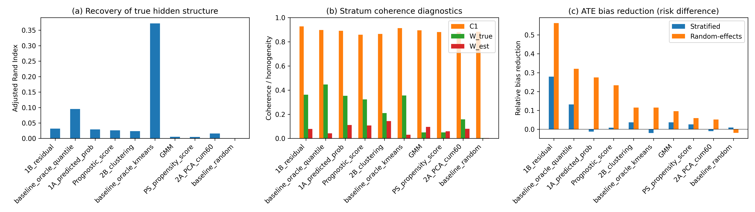
Figure 1. Primary IPD scenario: (a) ARI, (b) C1/W coherence diagnostics, and (c) ATE bias reduction by method.

Sensitivity to the number of strata
Figure 2 and Supplementary Table S1 show random-effects bias reduction across K = 3, 5, 10. Data-driven methods did not reliably improve with larger K; Oracle baselines improved because finer strata better partition the true Z-space. Stratum count should be chosen conservatively and compared across values.
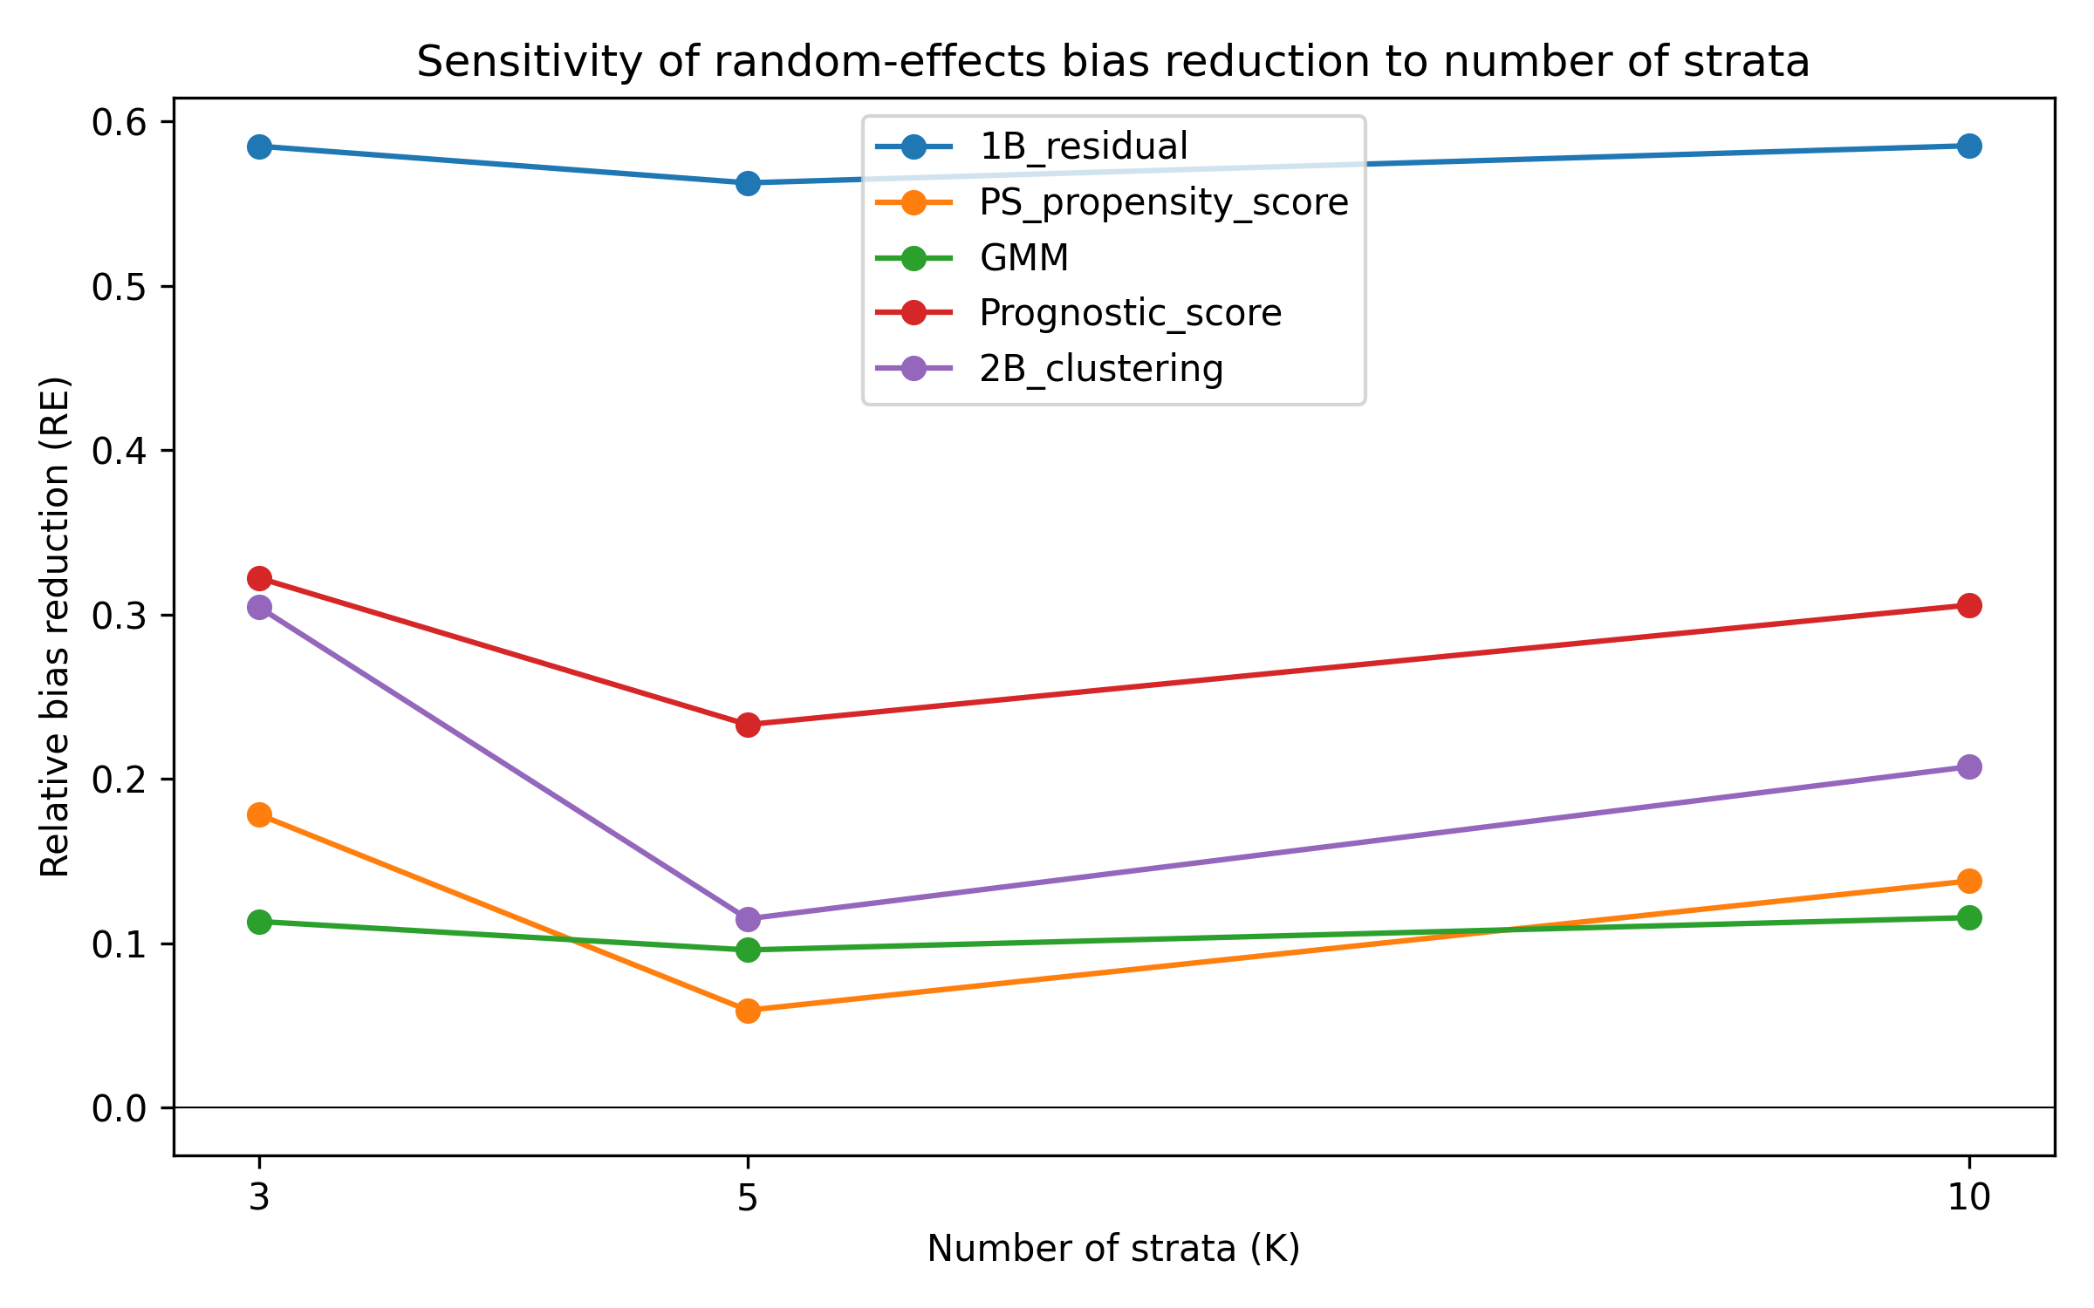
Figure 2. Random-effects ATE bias reduction as the number of strata varies.

Semi-synthetic illustrations
Five Simpson-paradox examples were reconstructed as pseudo-individual records ¹¹¹²¹³¹⁴¹⁵. Table 2 reports the best non-Oracle method per dataset. The Israel hospitalisation example was the most challenging: strong age confounding and a very low hospitalisation rate (~0.09%) meant that the crude marginal association reversed after stratification, yet separating the data into the known age strata remained difficult. The low event rate also produced occasional near-zero or zero-event cells, which illustrates the limits of outcome-informed stratification for rare outcomes.
Dataset | Method | K | ARI | C1 | $W_{est}$ | Bias reduction
COVID-19 CFR | 1B_residual | 3 | 0.065 | 1.000 | 0.035 | 0.017
Israel Vaccine | 2B_clustering | 2 | 0.644 | 1.000 | 0.557 | 0.001
Kidney Stone | GMM | 2 | 0.966 | 0.830 | 0.167 | 0.094
Smoking Mortality | 1A_predicted_prob | 7 | 0.498 | 1.000 | 0.161 | 0.114
UC Berkeley | PS_propensity_score | 3 | 0.084 | 0.284 | 0.177 | 0.031
Table 2. Best semi-synthetic illustration result per dataset (oracle baselines excluded). Bias reduction is the absolute difference between crude and stratified ATE risk-difference bias.
Figure 3 displays ARI by dataset and method for the semi-synthetic examples.
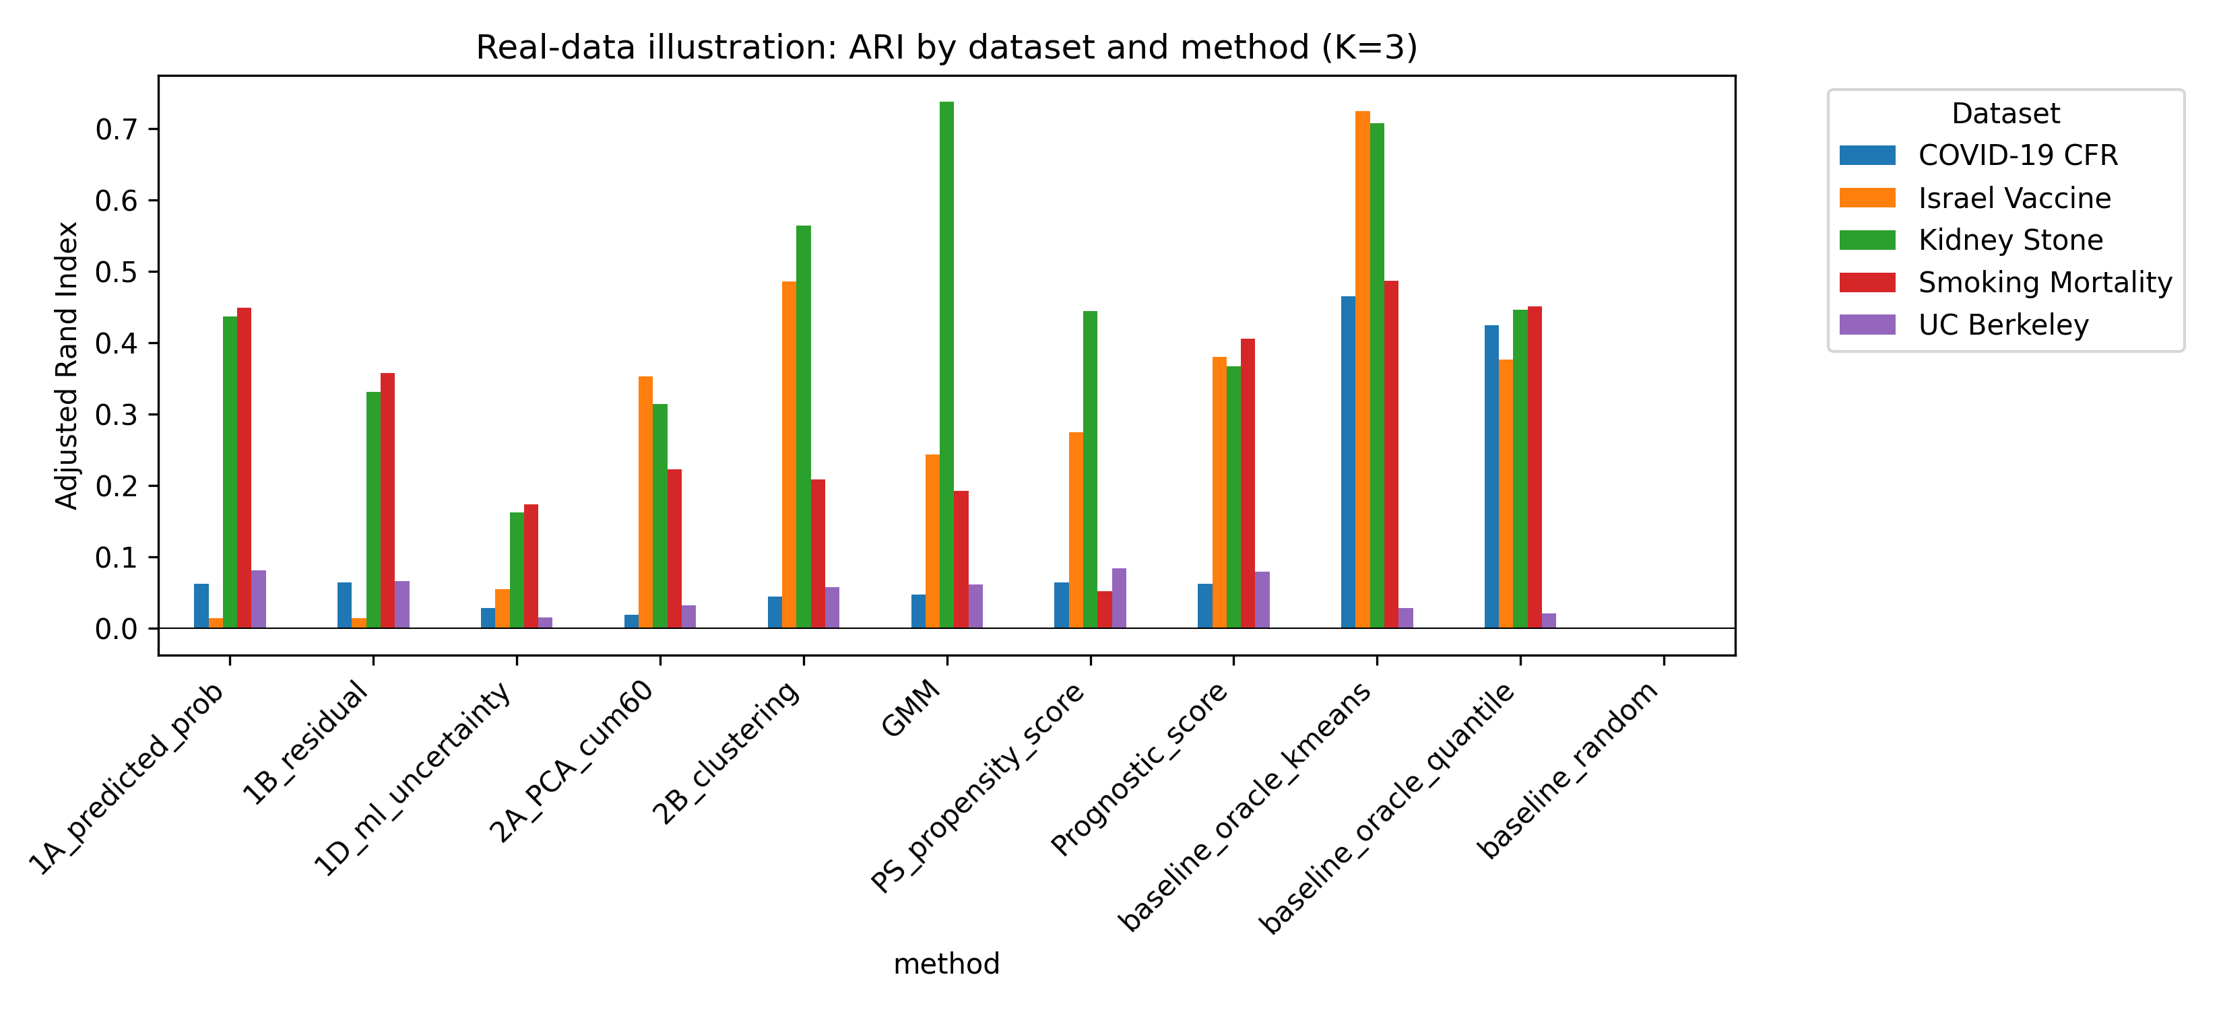
Figure 3. Semi-synthetic illustration: ARI by dataset and method.

Sensitivity to sample size
Figure 4 and Supplementary Table S2 report n = 500, 2000 and 10 000 (K=5). These estimates are from a separate 30-replication sensitivity batch, so point estimates are noisier than the primary scenario. Crude bias declined with n. The residual method's absolute random-effects ATE bias plateaued near 0.008–0.009 across the three sample sizes (0.00824 at n=500, 0.00852 at n=2000 and 0.00864 at n=10 000); the slight differences between this n=2000 value and the 50-replication primary value in Table 1 (0.00816) reflect Monte Carlo variation. Its relative reduction therefore fell as the crude marginal estimate became more precise. Propensity-score, prognostic-score and clustering-based methods achieved larger relative reductions at n=10 000 (range 0.533–0.669), showing that performance depends on the method as well as sample size. This pattern indicates that stratification can reduce the component of aggregation bias that is predictable from measured covariates, but it cannot fully adjust for unmodelled hidden effect modification.
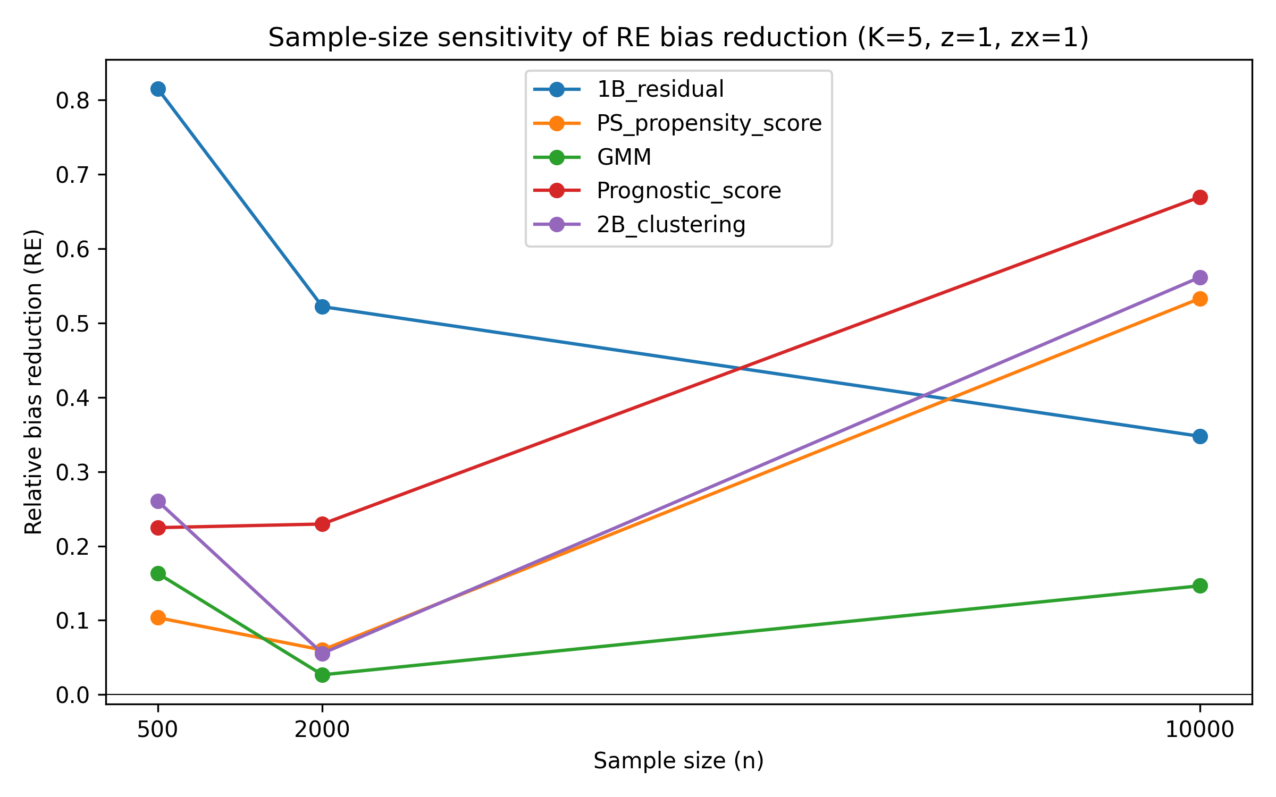
Figure 4. Sample-size sensitivity of random-effects ATE bias reduction (K=5). The residual method reaches a structural bias floor that does not vanish with sample size; propensity-score, prognostic-score and clustering approaches overtake it at n = 10 000 once finite-sample error is small relative to structural mismatch.

Sensitivity to Z-to-X and Z-to-Y effects
Supplementary Tables S3 and S4 report Z-to-X influence (0.2, 0.5, 1.0) and Z-to-Y effect (0.5, 1.0, 2.0). Stronger covariate traces improved ARI, but bias-reduction gains were variable. Weak effect modification produced C1/W near their nulls; stronger effect modification lowered C1, raised W and improved relative bias reduction. The residual method retained useful relative reduction even at z = 0.5.

Robustness to non-linear Z-to-X mappings
Table 3 compares random-effects bias under linear and non-linear Z-to-X mappings. Effects were method-dependent but no leading method was dramatically degraded, indicating that the diagnostics remain useful when X is a non-linear function of the hidden structure.
Method | Linear RE bias | Linear RE bias SE | Linear rel reduction | Linear rel reduction SE | Non-linear RE bias | Non-linear RE bias SE | Non-linear rel reduction | Non-linear rel reduction SE
1B_residual | 0.00852 | 0.00043 | 0.522 | 0.093 | 0.00724 | 0.00042 | 0.640 | 0.060
PS_propensity_score | 0.01676 | 0.00223 | 0.060 | 0.111 | 0.01653 | 0.00208 | 0.178 | 0.060
GMM | 0.01736 | 0.00272 | 0.027 | 0.082 | 0.01894 | 0.00233 | 0.058 | 0.058
Prognostic_score | 0.01374 | 0.00245 | 0.230 | 0.145 | 0.01464 | 0.00189 | 0.272 | 0.064
2B_clustering | 0.01684 | 0.00270 | 0.056 | 0.159 | 0.01773 | 0.00200 | 0.118 | 0.064
Table 3. Linear versus non-linear Z-to-X mapping: random-effects ATE bias and relative bias reduction (n=2000, K=5, z=1.0, zx=1.0).
Figure 5 shows random-effects ATE bias reduction under the non-linear mapping.
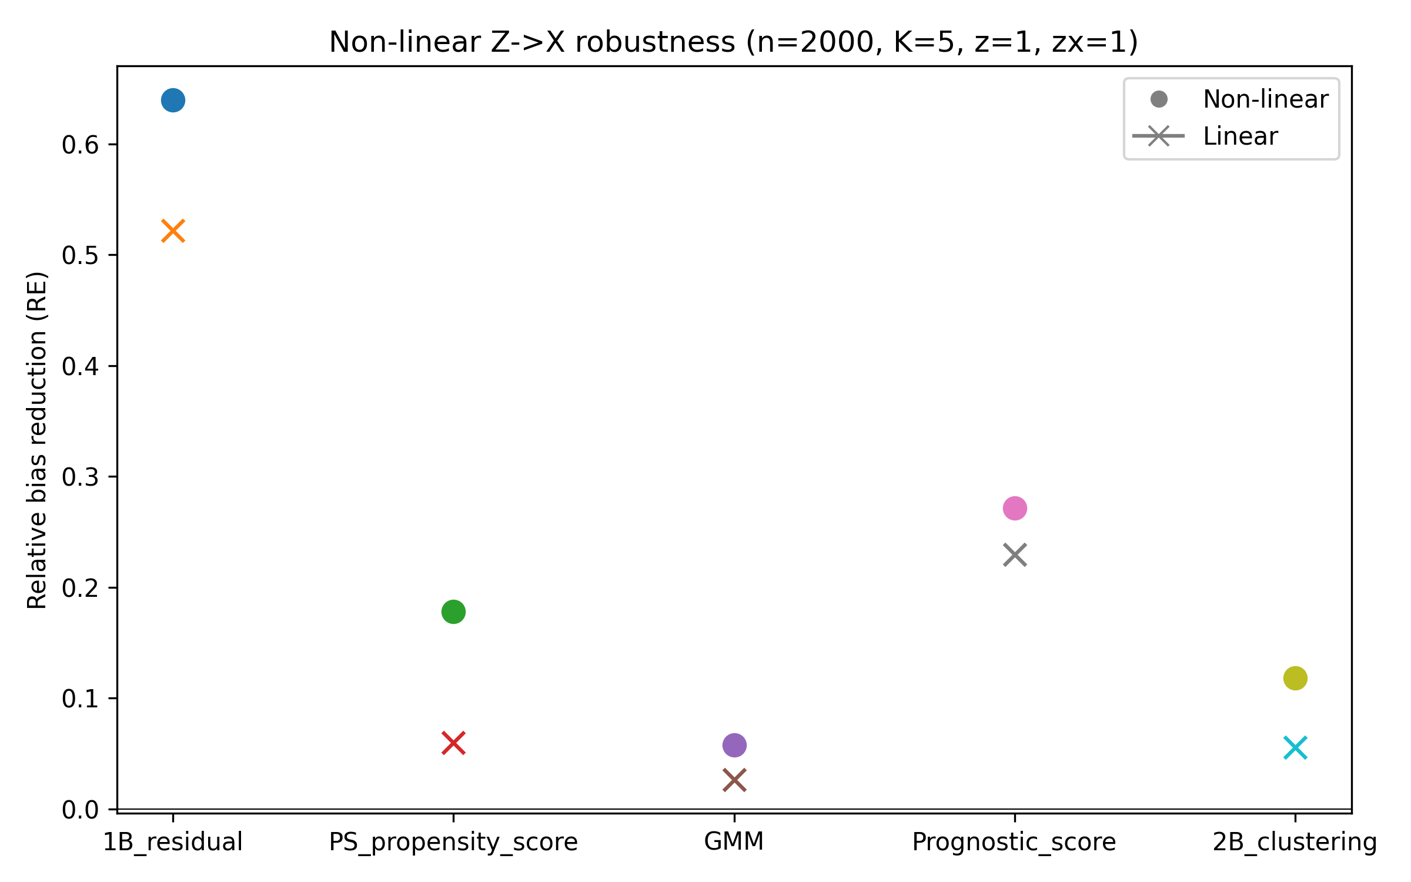
Figure 5. Non-linear Z-to-X robustness: random-effects ATE bias reduction (n=2000, K=5).

Diagnostic discrimination against the empirical null
Table 4 and Figure 6 summarise the diagnostic calibration of C1 and $W_{est}$ against the empirical null distribution obtained when Z-by-A interactions are removed. C1 AUC ranged from 0.460 to 0.545 and $W_{est}$ AUC from 0.427 to 0.561; the best C1 AUC was 0.545 for 2B_clustering and the best $W_{est}$ AUC was 0.561 for GMM. True-positive rates at a 5% false-positive rate were low: C1 TPR 0.000–0.060 and $W_{est}$ TPR 0.020–0.080. These values show that the diagnostics did not reliably distinguish the alternative DGM from the null in the primary scenario; the C1 AUCs at or below 0.5 for several methods show that the lower-tail null threshold does not match the direction of the alternative DGM shift for those methods. Supplementary Table S5 reports the empirical null percentiles used as thresholds. A main-effects-only outcome model for $W_{est}$ inflated the residual method's $W_{est}$ from 0.077 (default interactions) to 0.691, whereas the polynomial interaction model gave 0.046; full results are in Supplementary Table S6. Supplementary Table S7 reports absolute-deviation scores using distance from the empirical null mean (e.g. residual C1 abs-AUC 0.473); these did not rescue discrimination, indicating that the weak ROC performance is structural rather than an artifact of the one-sided lower-tail threshold.
Method | C1 AUC | C1 TPR@5% FPR | $W_{est}$ AUC | $W_{est}$ TPR@5% FPR
1A_predicted_prob | 0.506 | 0.060 | 0.541 | 0.080
1B_residual | 0.460 | 0.060 | 0.542 | 0.060
2A_PCA_cum60 | 0.464 | 0.060 | 0.490 | 0.060
2B_clustering | 0.545 | 0.020 | 0.537 | 0.060
GMM | 0.489 | 0.060 | 0.561 | 0.080
PS_propensity_score | 0.481 | 0.060 | 0.494 | 0.020
Prognostic_score | 0.520 | 0.020 | 0.528 | 0.040
baseline_oracle_kmeans | 0.507 | 0.000 | 0.506 | 0.040
baseline_oracle_quantile | 0.507 | 0.000 | 0.537 | 0.060
baseline_random | 0.544 | 0.040 | 0.427 | 0.040
Table 4. Diagnostic discrimination of C1 and $W_{est}$ against the empirical null distribution (n=2000, K=5, 200 null replications and 50 alternative replications).
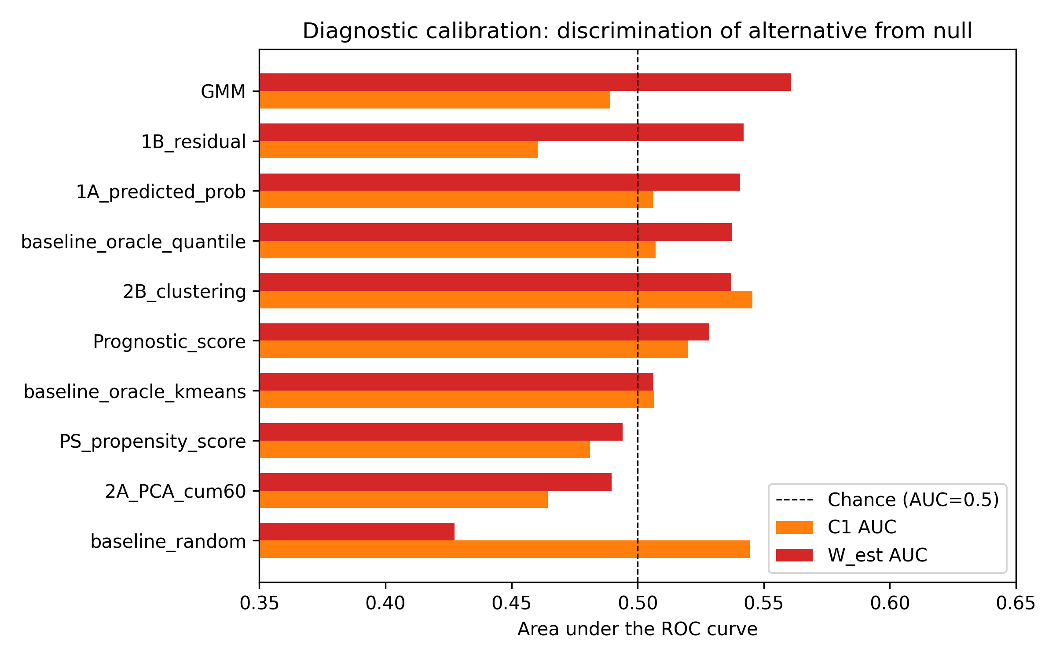
Figure 6. Diagnostic calibration of C1 and $W_{est}$: AUC for discriminating the alternative DGM from the empirical null distribution (n=2000, K=5). C1 and $W_{est}$ do not provide reliable classification on their own in the primary scenario; they should be used only as descriptive flags calibrated to the empirical null.

CATE variance explained
Figure 7 shows CATE variance explained (eta-squared, represented by $W_{true}$) and the corresponding estimated value ($W_{est}$) for each method. Methods that produced stratum-specific effects close to the true CATE quantiles achieved higher eta-squared, but no data-driven method reached the Oracle level. The gap between $W_{true}$ and $W_{est}$ shows that the residual and predicted-probability models capture only part of the true CATE variation.
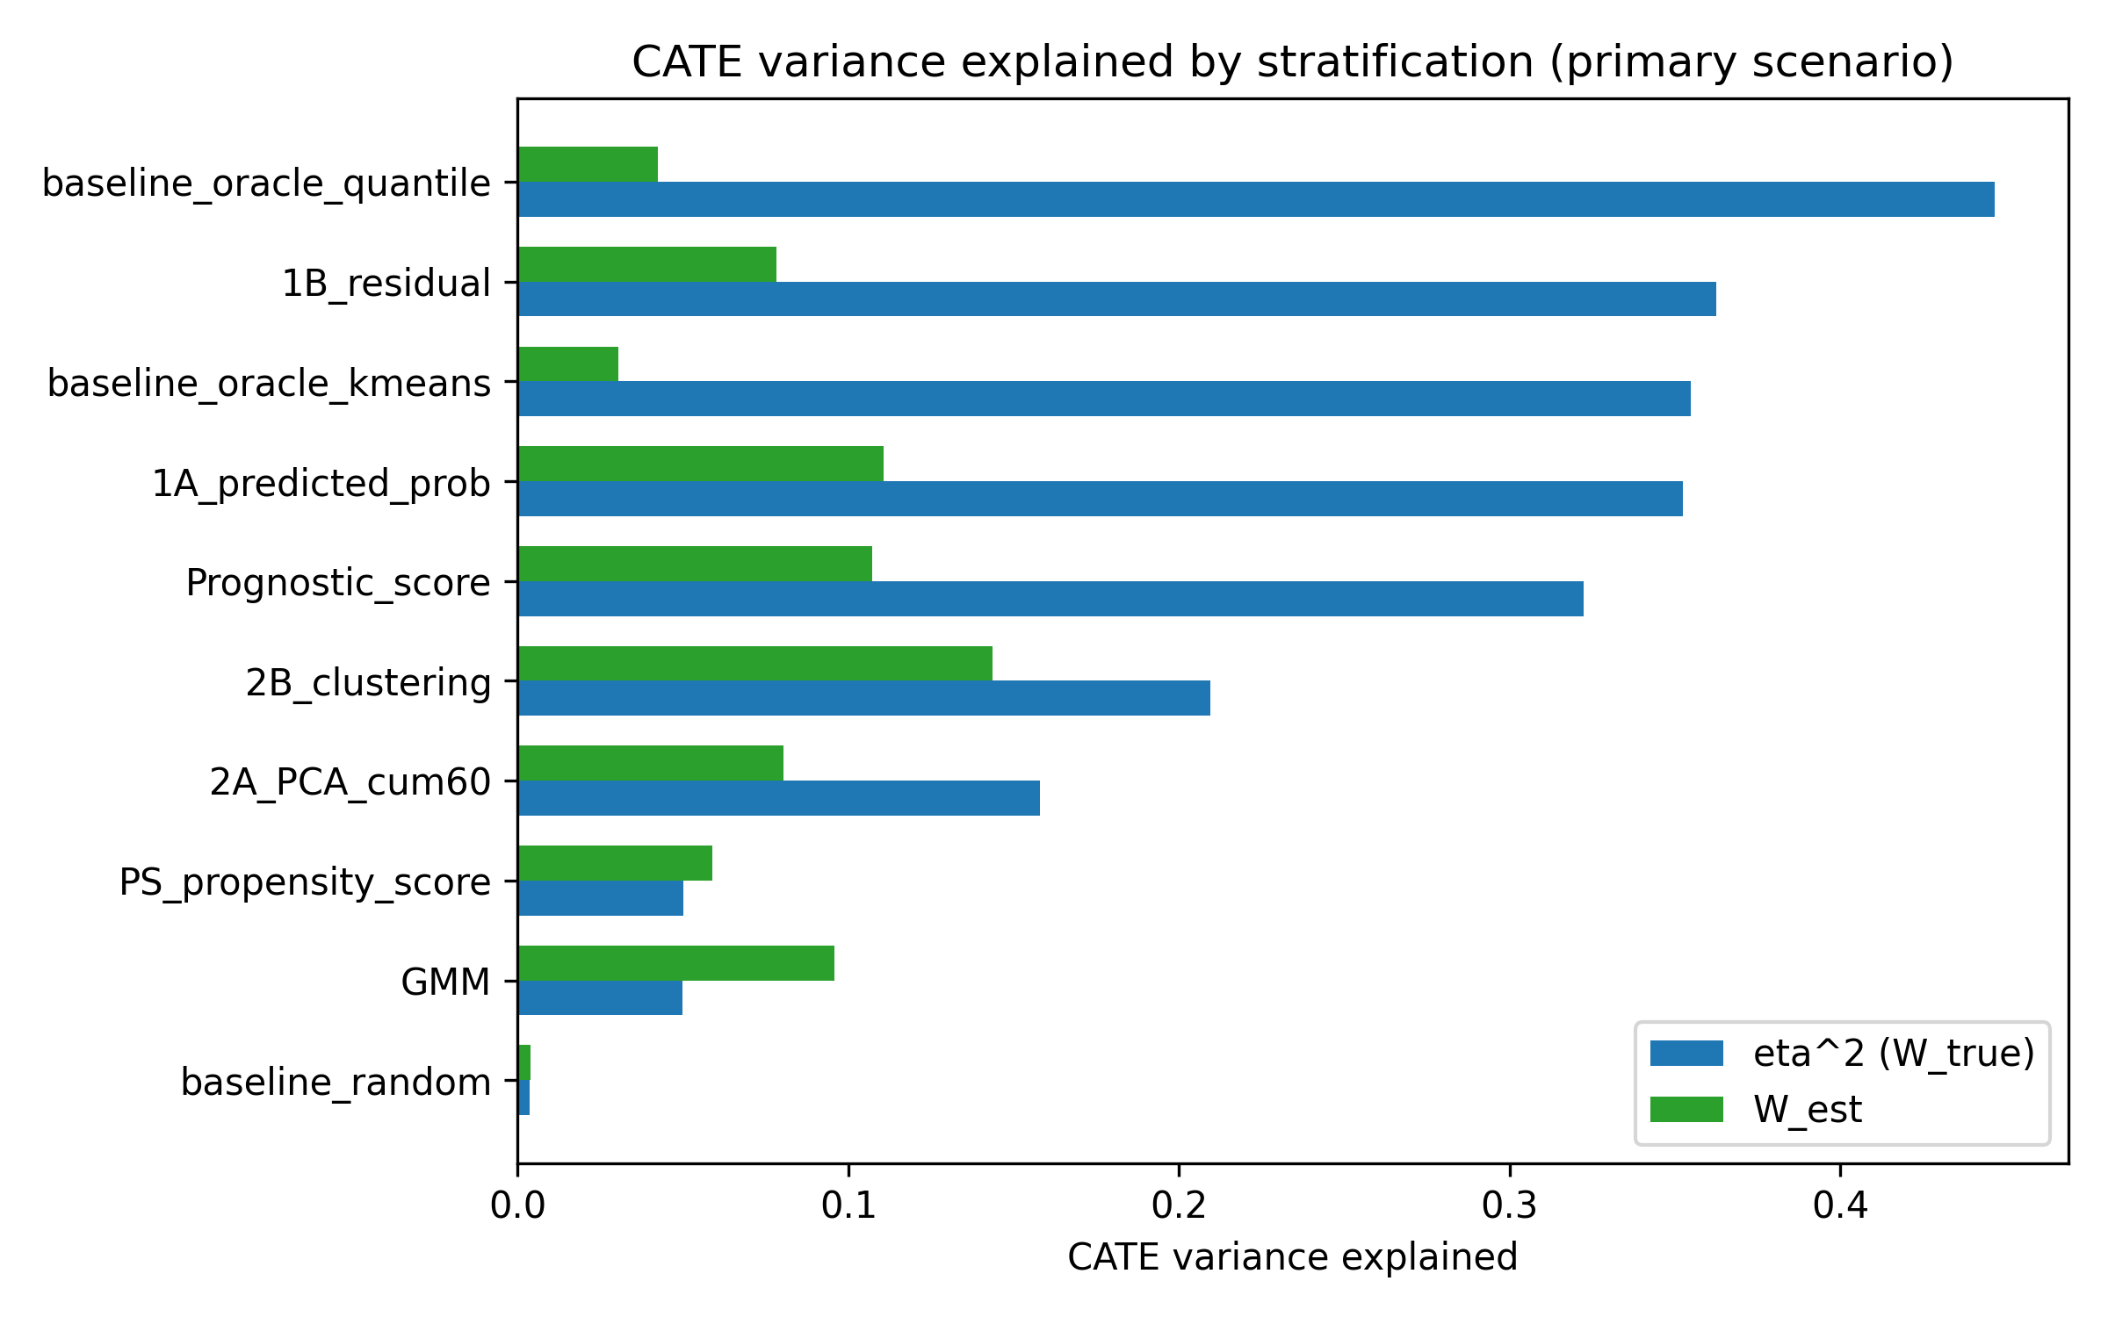
Figure 7. CATE variance explained (eta-squared = $W_{true}$) and estimated $W_{est}$ by method in the primary scenario (n=2000, K=5).

Recommendations for method choice
Table 5 translates the simulation results into practical guidance. It links scenario characteristics to the method that performed best in the benchmark, states the rationale, and notes the key caveat. The recommendations reflect the patterns in Tables 1–4 and Supplementary Tables S1–S4; they are not derived from a new optimisation and should be treated as heuristics for sensitivity analysis rather than prescriptive rules.
Scenario characteristic | Recommended method | Rationale | Caveat
Strong covariate trace of a hidden modifier and moderate-to-large sample (n ~ 2000) | Residual-based IONE (1B) | Highest random-effects ATE bias reduction and $W_{true}$ in the primary scenario | Hits a structural bias floor that does not vanish with sample size; requires a correctly specified outcome model with treatment-covariate interactions
Small sample (n ~ 500) with moderate modification | Residual-based IONE (1B) | Achieved the largest relative bias reduction and the smallest absolute random-effects bias at n = 500 | Relative reduction partly reflects large crude bias; residual models can overfit when events are sparse
Large sample (n ~ 10 000) and strong measured confounding | Prognostic-score stratification (1A predicted-probability as a close alternative) | Smallest absolute RE bias and largest relative reduction at n = 10 000; predicted-probability stratification was second and comparable | Relative ranking depends on the sample size and chosen metric; choose the method whose constraints match the clinical question
Outcome model unavailable, misspecified or rare events | Outcome-free methods (PCA or k-means) or prognostic-score stratification | Do not use the outcome for stratification, so avoid degenerate logistic fits and overfitting | ATE bias reduction is generally smaller; C1 and W discrimination remains near chance
Need a descriptive flag for internal incoherence in real IPD | Report ${C1}_{excess}$ and $W_{est excess}$, calibrated against a permutation or residual null | Empirically centred on a no-modification null; use one of the three recipes described in the Methods | Do not use as a standalone inferential test; thresholds are method-specific and DGM-conditional; cross-check at least two nulls
Table 5. Recommendations for choosing a stratification method in an IPD meta-analysis sensitivity analysis.

Empirical null distribution and $W_{est}$ misspecification
Under the primary DGM with no Z-by-A interaction, C1 was generally high and $W_{est}$ near 0; method-specific 5th/95th percentiles are in Supplementary Table S5. A main-effects-only outcome model inflated $W_{est}$, whereas the default interaction and polynomial models were more stable (Supplementary Table S6). C1 and W are diagnostic flags, not standalone inferential quantities.

4. Discussion

Principal findings
We treat Incoherence-Oriented Neutralisation and Extraction (IONE) as a descriptive sensitivity tool for hidden effect modification in IPD meta-analysis. C1 and W flag whether a pooled IPD is internally coherent with respect to treatment effect: methods that captured more of the true Z structure produced C1 values close to the Oracle and higher $W_{true}$, especially the residual-based method. Agreement with the operational k-means true-Z partition was modest (Oracle ARI 0.372; best non-Oracle 1B_residual 0.032), and the C1 and $W_{est}$ diagnostics did not reliably discriminate the alternative DGM from the empirical null (C1 AUC 0.460-0.545; W AUC 0.427-0.561). Nevertheless, the best data-driven stratification reduced crude ATE bias from 0.01865 to 0.00816 (relative reduction 0.563) with DerSimonian-Laird pooling. These findings show that separating a pooled IPD into more homogeneous strata can reduce some of the marginal bias that is predictable from the measured covariates. For the residual method, DerSimonian-Laird pooling improved over fixed-effect pooling, suggesting that stratum-specific effects should be allowed to vary when the selected partition shows evidence of heterogeneity.

Detection versus subgroup recovery
Detection asks whether the pooled population is internally coherent; C1 and W address this without requiring hidden subgroups to be specified. The ROC results in Table 4 and Figure 6 show that, in the primary scenario, detection sensitivity from C1 and $W_{est}$ alone is low. Separating the data into more homogeneous subgroups is harder still, because measured covariates only partially trace the hidden effect modifier. IONE's practical value therefore lies in sensitivity exploration and partial ATE improvement, not in recovering hidden subgroup labels or replacing confounding adjustment.

Comparison with study-level and covariate-adjustment approaches
Stratification by study remains a default in IPD meta-analysis and captured part of the marginal bias in our benchmark. Study-level random-effects pooling does not, however, exploit covariate traces of hidden effect modification within studies. Propensity-score ¹⁷ and prognostic-score ¹⁹ methods adjust for measured confounders but do not detect unmeasured population structure. Latent-class models ¹⁸ seek hidden subgroups but need strong assumptions and do not report a transparent between-stratum heterogeneity diagnostic such as C1. IONE adds a pair of descriptive diagnostics that can be reported alongside these methods.

W denominator and misspecification
W is a ratio whose denominator is the overall CATE variance. When effect modification is weak this denominator is small, making W unstable and hard to interpret as an absolute measure. We therefore centred the diagnostics on their empirical null means and reported excess values (${C1}_{excess}$, $W_{true excess}$, $W_{est excess}$). $W_{est}$ is also sensitive to outcome-model specification: a main-effects-only model for the residual method inflated $W_{est}$ from 0.077 to 0.691, whereas the correctly specified polynomial interaction model gave 0.046. Analysts should not treat a single $W_{est}$ value as evidence of an effect modifier without inspecting the fitted outcome model and the empirical null distribution.

Large-sample behaviour
At n = 10 000 the residual method still showed a non-negligible random-effects ATE bias (0.00864; relative reduction 0.348), similar to the absolute floor observed at n=500 (0.00824) and n=2000 (0.00852). This floor is consistent with the bounded sorting accuracy reflected in the modest ARI values: once finite-sample error is removed, remaining bias reflects the structural mismatch between the discovered strata and the true CATE surface. The true-CATE-quantile oracle provides an upper bound on what perfect sorting could achieve; the gap between the oracle and the leading data-driven method quantifies the cost of not observing the true effect modifier.

Strengths and limitations
Strengths. The study followed ADEMP ¹⁶, reported the data-generating mechanism and estimands transparently, and generated all numerical results from version-controlled repository scripts.
Limitations. The primary scenario used n=2000 and a moderate Z-to-X trace; sensitivity analyses examined K = 3, 5, 10, n = 500 to 10 000, Z-to-Y and Z-to-X scales, and a non-linear mapping, but performance may vary with stronger or weaker signals or fewer studies. The true-Z partition is a constructed reference, so ARI should not be over-interpreted as clinical validity. $W_{est}$ depends on a correctly specified outcome model with interactions; a main-effects-only model can be highly misleading (Supplementary Table S6). DerSimonian-Laird strata are not independent estimates, so the reported $τ^{2}$ and $I^{2}$ describe between-stratum heterogeneity, not conventional between-study heterogeneity. C1 is computed from log odds ratios while ATE bias is on the risk-difference scale, so it is an indirect diagnostic. Null thresholds (Supplementary Table S5) are method-specific and conditional on the primary DGM. Semi-synthetic examples are pseudo-IPD reconstructions and serve as illustrations, not real-IPD validation.

5. Conclusions
IONE (Incoherence-Oriented Neutralisation and Extraction) is a descriptive sensitivity framework for hidden effect modification in IPD meta-analysis. Monte Carlo simulation and semi-synthetic examples show that the C1 and W diagnostics can flag incoherence, but they do not reliably separate the alternative data-generating mechanism from an empirical null in the primary scenario. When hidden variables leave strong traces in measured covariates, stratification can partially reduce ATE bias, but separating the data into the true hidden subgroups remains difficult. Conventional meta-analytic models and covariate adjustment should remain the primary analysis; C1 and W should be reported alongside them as sensitivity checks. Two practical recommendations are: (1) use C1 and W only as descriptive flags, not as inferential tests for hidden effect modification, and (2) pre-specify potential effect modifiers and reserve data-driven stratification for exploratory sensitivity analyses, not for decision-making.

Declarations

Ethics approval and consent to participate
Not applicable. This study used simulated data and publicly available aggregate statistics only.

Consent for publication
Not applicable.

Availability of data and materials
All simulation code, analysis scripts, semi-synthetic example data, and the manuscript generator are publicly available at https://github.com/bougtoir/ione-stratification-framework. The repository contains a requirements.txt file and a requirements-lock.txt file with exact package versions, fixed random seeds for every scenario, and generate_summary.py, generate_ione_rsm_v3.py and generate_rsm_tables.py scripts that regenerate all manuscript numbers, figures and tables in a Python 3.10.12 environment. The exact Git commit hash used to create this submission package is recorded in results/commit_hash.txt. An archived Zenodo release with a DOI will be created before acceptance to satisfy long-term reproducibility requirements. The published aggregate datasets used for the semi-synthetic illustrations are referenced in the original publications ¹¹¹²¹³¹⁴¹⁵.

Competing interests
The authors declare that they have no competing interests.

Funding
No external funding supported this work.

Authors' contributions (CRediT taxonomy)
Onishi Tatsuki: Conceptualisation, methodology, software, formal analysis, writing – original draft, writing – review and editing, visualisation.

Acknowledgements
Not applicable.

Supplementary materials
Supplementary methods, abbreviations, the ADEMP/STROBE-Sim checklists, the four extended sensitivity tables, and the empirical null-distribution and $W_{est}$ misspecification sensitivity tables are provided in jcmds_supplementary_v1.docx.

Declaration of generative AI and AI-assisted technologies in the manuscript preparation process
During the preparation of this work the author(s) used OpenAI GPT-4 and GPT-4o (accessed August 2025 through the date of submission) to draft and revise prose, format references, generate figures, and implement the computational pipeline. After using these tools, the author reviewed and edited the content as needed and takes full responsibility for the content of the published article. The author designed the study, wrote the simulation code, selected all references, verified every numerical result against the repository outputs, and approved the final scientific content. No AI-generated text was used without human review.

References
1. Borenstein M, Hedges LV, Higgins JPT, Rothstein HR. Introduction to Meta-Analysis. Chichester: John Wiley & Sons; 2009. doi: 10.1002/9780470743386
2. Riley RD, Lambert PC, Abo-Zaid G. Meta-analysis of individual participant data: rationale, conduct, and reporting. BMJ. 2010;340:c221. doi: 10.1136/bmj.c221
3. Simmonds MC, Higgins JPT, Stewart LA, Tierney JF, Clarke MJ, Thompson SG. Meta-analysis of individual patient data from randomized trials: a review of methods used in practice. Clin Trials. 2005;2(3):209–217. doi: 10.1191/1740774505cn087oa
4. DerSimonian R, Laird N. Meta-analysis in clinical trials. Control Clin Trials. 1986;7(3):177–188. doi: 10.1016/0197-2456(86)90046-2
5. Higgins JPT, Thompson SG. Quantifying heterogeneity in a meta-analysis. Stat Med. 2002;21(11):1539–1558. doi: 10.1002/sim.1186
6. Riley RD, Higgins JPT, Deeks JJ. Interpretation of random effects meta-analyses. BMJ. 2011;342:d549. doi: 10.1136/bmj.d549
7. Pearl J. Causality. 2nd ed. Cambridge: Cambridge University Press; 2009. doi: 10.1017/cbo9780511803161
8. Greenland S, Robins JM, Pearl J. Confounding and collapsibility in causal inference. Stat Sci. 1999;14(1):29–46. doi: 10.1214/ss/1009211805
9. Simpson EH. The interpretation of interaction in contingency tables. J R Stat Soc Ser B. 1951;13(2):238–241. doi: 10.1111/j.2517-6161.1951.tb00088.x
10. Rojanaworarit C. Misleading epidemiological and statistical evidence in the presence of Simpson's paradox: an illustrative study using simulated scenarios. J Med Life. 2020;13(1):37–44. doi: 10.25122/jml-2019-0120
11. Charig CR, Webb DR, Payne SR, Wickham JE. Comparison of treatment of renal calculi by open surgery, percutaneous nephrolithotomy, and extracorporeal shockwave lithotripsy. BMJ. 1986;292(6524):879–882. doi: 10.1136/bmj.292.6524.879
12. Bickel PJ, Hammel EA, O'Connell JW. Sex bias in graduate admissions: data from Berkeley. Science. 1975;187(4175):398–404. doi: 10.1126/science.187.4175.398
13. von Kügelgen J, Gresele L, Schölkopf B. Simpson's paradox in Covid-19 case fatality rates: a mediation analysis of age-related causal effects. IEEE Trans Artif Intell. 2021;2(1):18–27. doi: 10.1109/TAI.2021.3073088
14. Haas EJ, Angulo FJ, McLaughlin JM, et al. Impact and effectiveness of mRNA BNT162b2 vaccine against SARS-CoV-2 infections and COVID-19 cases, hospitalisations, and deaths following a nationwide vaccination campaign in Israel: an observational study using national surveillance data. Lancet. 2021;397(10287):1819–1829. doi: 10.1016/S0140-6736(21)00947-8
15. Appleton DR, French NR, Vanderpump MP. Ignoring a covariate: an example of Simpson's paradox. Am Stat. 1996;50(4):340–341. doi: 10.1080/00031305.1996.10473563
16. Morris TP, White IR, Crowther MJ. Using simulation studies to evaluate statistical methods. Stat Med. 2019;38(11):2074–2102. doi: 10.1002/sim.8086
17. Rosenbaum PR, Rubin DB. The central role of the propensity score in observational studies for causal effects. Biometrika. 1983;70(1):41–55. doi: 10.1093/biomet/70.1.41
18. McLachlan GJ, Peel D. Finite Mixture Models. New York: Wiley; 2000. doi: 10.1002/0471721182
19. Hansen BB. The prognostic analogue of the propensity score. Biometrika. 2008;95(2):481–488. doi: 10.1093/biomet/asn004
20. Hubert L, Arabie P. Comparing partitions. J Classif. 1985;2(1):193–218. doi: 10.1007/bf01908075

