IONE: Incoherence-Oriented Neutralisation and Extraction for hidden effect modification

in individual participant data meta-analysis: a simulation study of stratification-based extraction

Abstract
Background. Random-effects meta-analyses report an average treatment effect and assume that between-study heterogeneity has been adequately modelled. When an individual participant data (IPD) meta-analysis contains hidden effect modifiers or confounders, a marginal summary can be non-robust or qualitatively wrong (aggregation bias). We propose Incoherence-Oriented Neutralisation and Extraction (IONE), an exploratory diagnostic toolkit for hidden effect modification that can be applied to pooled IPD before a conventional synthesis. Methods. We simulated an IPD meta-analysis with 10 studies, a binary treatment and a binary outcome, measured covariates carrying traces of an unmeasured effect-modifier, and study-level variation in baseline risk and treatment prevalence. Proposed IONE methods and active comparators were used to stratify the pooled IPD; stratum-specific risk differences were pooled with two-stage fixed-effect and DerSimonian-Laird random-effects meta-analysis. We report ARI with a constructed true-Z partition, C1 (between-stratum heterogeneity of A->Y log odds ratios), W_true and W_est (within-stratum CATE homogeneity using true and estimated CATE), and ATE bias reduction on the risk-difference scale, all with Monte Carlo standard errors. Results. In the primary scenario (n=2000, 10 studies, K=5 strata), the best method was 1B_residual (ARI 0.372; C1 0.927; W_true 0.363; W_est 0.078). Crude absolute ATE bias was 0.01865; two-stage stratification reduced this to 0.01345 (relative reduction 0.279), and random-effects pooling across discovered strata reduced it further to 0.00816 (relative reduction 0.563). Diagnostic agreement with the true hidden structure remained modest, and performance improved with stronger covariate traces and larger samples. Conclusions. IONE is a transparent, exploratory diagnostic for hidden effect modification within IPD meta-analyses. It should be reported alongside—not instead of—conventional meta-analytic models and covariate adjustment.

Keywords: individual participant data meta-analysis; evidence synthesis; heterogeneity; hidden effect modification; stratification; diagnostic; Simpson's paradox

1. Introduction
Meta-analysis combines treatment-effect estimates from related studies and is central to evidence-based medicine and policy (Borenstein et al. 2009). A random-effects analysis permits the true effect to vary across studies and is widely recommended when between-study heterogeneity is suspected (DerSimonian and Laird 1986)(Higgins and Thompson 2002)(Riley et al. 2011). In an individual participant data (IPD) meta-analysis, the original participant-level data are collected, harmonised and re-analysed; this preserves information on covariates and subgroup effects and can improve power for treatment-covariate interactions (Riley et al. 2010)(Simmonds et al. 2005). Despite these advantages, the standard two-stage or one-stage synthesis still estimates an average effect and may miss effect modifiers that are unmeasured, measured with error, or omitted from the analysis plan.
When a pooled population is a mixture of subgroups with different treatment effects, or when confounders differ across studies, the marginal effect can differ from subgroup-specific effects, leading to aggregation bias and Simpson-type reversals (Pearl 2009)(Greenland et al. 1999). Causal inference provides formal definitions of confounding, effect modification and collapsibility (Rubin 1974)(Hernán and Robins 2020)(VanderWeele 2015), and propensity-score methods can adjust for measured confounders (Austin and Stuart 2015). Yet these methods do not in themselves reveal whether an unmeasured effect modifier is present or whether the estimated average effect is robust across clinically meaningful subgroups. In particular, random-effects meta-analysis explains heterogeneity through study-level summaries and meta-regression; it does not routinely test whether the pooled participants themselves form incoherent subpopulations.
We develop Incoherence-Oriented Neutralisation and Extraction (IONE) for the IPD meta-analysis setting. IONE is a two-stage exploratory diagnostic. In the first stage, routinely measured covariates are used to test whether the pooled IPD is coherent with respect to the treatment effect. In the second stage, if incoherence is indicated, the pooled IPD is stratified into more homogeneous subgroups and stratum-specific effects are synthesised. We ask whether data-driven stratification of a pooled IPD can reduce bias in the average treatment effect and whether simple diagnostics can warn analysts when a marginal summary is fragile. We evaluate the proposal in a Monte Carlo simulation with explicit between-study heterogeneity and hidden effect modification, and illustrate the behaviour with well-known Simpson-paradox examples.

2. Methods

2.1 Aims
The aims of the simulation study were:
1. To evaluate whether stratification of a pooled IPD based solely on measured covariates can recover hidden subgroup structure defined by unmeasured effect modifiers/confounders. 2. To compare the performance of outcome-informed IONE methods with outcome-free methods and with established comparators (propensity-score quintiles, Gaussian mixture model, prognostic-score stratification). 3. To assess the ability of C1 (between-stratum heterogeneity) and W (within-stratum homogeneity) to diagnose hidden effect modification. 4. To quantify ATE bias reduction achieved by two-stage stratified and random-effects synthesis. 5. To identify the data-generating conditions under which the proposed diagnostics are most and least informative.

2.2 IPD data-generating mechanism
We generated an IPD meta-analysis by assigning n=2000 participants to 10 studies of approximately equal size. Study-level heterogeneity was controlled by a scale parameter of 0.6; this produced between-study variation in baseline risk, treatment prevalence and the distribution of a continuous age-like covariate, analogous to the between-study variance in a random-effects meta-analysis. Each participant had three critical variables (Z1 continuous, Z2 binary, Z3 ordered) that affected treatment, outcome and their interaction, and ten measured variables (X1-X10) that carried traces of Z. A binary treatment A was generated from a logistic model with confounders Z and covariates X; a binary outcome Y was generated from a logistic model with main effects of Z and X, a treatment main effect and Z-by-A interactions (effect modification). The true estimand was the population risk-difference average treatment effect (ATE), computed by averaging the true individual conditional average treatment effect (CATE) over the super-population.
The data-generating mechanism follows a causal directed acyclic graph. Study membership introduces heterogeneity in the intercepts for baseline risk and treatment prevalence; within each study, the same confounder-modifier Z generates measured covariates X, treatment A and outcome Y. This design mimics an IPD meta-analysis in which studies differ in case-mix and treatment use, yet a common unmeasured effect modifier is present. Full algebraic details and parameter values are given in the repository, and all scenarios were assigned fixed random seeds for reproducibility.

2.3 Stratification methods
Proposed IONE methods were divided into two families. Family 1 (outcome-informed) used predicted probability of Y, absolute residuals from a Y~X model, and cross-validated decision scores. Family 2 (outcome-free) used PCA on X and k-means on X. Active comparators were propensity-score quintiles, a Gaussian mixture model on X and prognostic-score stratification from a Y~X model fitted in the untreated. Oracle baselines stratified by the true Z using k-means or quantiles, and random stratification provided a lower baseline. Outcome-informed methods used a 50/50 discovery/evaluation split to avoid outcome-label leakage.
All methods produce a one-dimensional score except clustering-based methods, which assign strata directly. After scoring, equal-frequency quantiles were used to create K strata. Logistic regression for predicted probability and residuals used l2 regularisation (C=1.0, lbfgs solver, max_iter=1000); the random forest used 100 trees with max_depth=10; k-means and Gaussian mixture model used n_init=10 and a fixed random seed. Standardisation was applied before PCA, k-means and GMM.

2.4 Synthesis of stratum-specific effects
For each discovered stratum we computed the risk difference P(Y=1|A=1) - P(Y=1|A=0) and its standard error. A two-stage fixed-effect summary was the stratum-size-weighted average of these risk differences. A DerSimonian-Laird random-effects summary added an estimate of between-stratum variance and re-weighted stratum estimates accordingly (DerSimonian and Laird 1986). We also report the resulting tau^2 and I^2 as summaries of between-stratum heterogeneity in the effect scale. The random-effects synthesis treats discovered strata as studies in a conventional meta-analysis, allowing the stratum-specific effects to vary.

2.5 Evaluation metrics
For each method we report: (i) ARI versus a constructed true-Z partition; (ii) C1 = 1 - I^2 from stratum-specific log odds ratios of A->Y, reflecting between-stratum homogeneity; (iii) W_true and W_est, measuring within-stratum CATE homogeneity using the true individual CATE or a flexible estimated CATE from a Y~X+A+X*A logistic model; and (iv) ATE bias reduction on the risk-difference scale. Bias reduction is reported as the absolute difference |bias_crude| - |bias_stratified| and |bias_crude| - |bias_re|, and as the relative ratio 1 - |bias_stratified|/|bias_crude|. Monte Carlo standard errors and 95% confidence intervals are reported for every mean.
The true-Z partition is an operational construct: k-means clustering applied to the standardised Z-space with K equal to the number of strata. ARI therefore measures agreement with a constructed reference rather than with clinically observed subgroups. W_true is available only in simulation; W_est is the operational diagnostic that can be computed in real data, although it requires a correctly specified outcome model and should be interpreted cautiously.

2.6 Semi-synthetic illustrations
Five well-known Simpson-paradox examples were reconstructed as pseudo-individual records from published aggregate statistics: kidney stone treatments (Appleton et al. 1996), UC Berkeley admissions (Julious and Mullee 1994), Israeli vaccine effectiveness (Morris 2021), and two additional examples. For each example, pseudo-general variables were generated to mimic proxies of the known confounder, and the same IONE methods were applied. These examples illustrate favourable and unfavourable settings for stratification; they are not validation of out-of-the-box performance in real IPD.

2.7 Computational implementation
All simulations and analyses were conducted in Python 3.11. The pipeline comprises data_generation.py, methods.py, evaluation.py, run_rsm_ipd_simulation.py, generate_summary.py and this manuscript generator. The code and semi-synthetic example data are available at https://github.com/bougtoir/ione-stratification-framework. All numerical results in this manuscript are produced by the repository scripts; no estimates are hard-coded.

3. Results

3.1 Primary IPD scenario
Table 1 and Figure 1 summarise the primary IPD scenario (n=2000, 10 studies, K=5 strata). Extraction of the true hidden structure was modest: the best ARI was 0.372, observed for baseline_oracle_kmeans, and the average C1 across methods was 0.889. Average within-stratum homogeneity was also limited (mean W_true = 0.242; mean W_est = 0.078), indicating that the discovered strata still contained substantial CATE variation. For comparison, random-effects pooling across the true study identifiers (i.e. a study-level meta-analysis) gave an absolute ATE bias of 0.01568 (reduction 0.00296 from crude 0.01865).
ATE bias reduction was strongest for 1B_residual: the crude absolute risk-difference bias was 0.01865, the two-stage stratified estimate reduced this to 0.01345 (relative reduction 0.279), and the random-effects estimate reduced it further to 0.00816 (relative reduction 0.563). These values show that, under the simulated data-generating mechanism, a small number of data-driven strata can partially remove bias from a pooled IPD estimate, but the diagnostic agreement with the true hidden structure remains low.
Method | ARI | C1 | W_true | W_est | Crude bias | Stratified bias | RE bias | Relative reduction strat | Relative reduction RE | RE I2
1A_predicted_prob | 0.029 | 0.891 | 0.352 | 0.111 | 0.019 | 0.019 | 0.014 | -0.013 | 0.275 | 0.14
1B_residual | 0.032 | 0.927 | 0.363 | 0.078 | 0.019 | 0.013 | 0.008 | 0.279 | 0.563 | 0.04
1C_cv_decision | 0.029 | 0.891 | 0.352 | 0.111 | 0.019 | 0.019 | 0.014 | -0.013 | 0.275 | 0.14
2A_PCA_cum60 | 0.016 | 0.881 | 0.158 | 0.080 | 0.019 | 0.019 | 0.018 | -0.010 | 0.051 | 0.13
2B_clustering | 0.023 | 0.865 | 0.210 | 0.143 | 0.019 | 0.018 | 0.017 | 0.037 | 0.115 | 0.15
GMM | 0.005 | 0.895 | 0.050 | 0.096 | 0.019 | 0.018 | 0.017 | 0.036 | 0.096 | 0.13
PS_propensity_score | 0.005 | 0.881 | 0.050 | 0.059 | 0.019 | 0.018 | 0.018 | 0.026 | 0.059 | 0.14
Prognostic_score | 0.026 | 0.858 | 0.322 | 0.107 | 0.019 | 0.018 | 0.014 | 0.009 | 0.233 | 0.14
baseline_oracle_kmeans | 0.372 | 0.913 | 0.355 | 0.030 | 0.019 | 0.019 | 0.017 | -0.019 | 0.115 | 0.12
baseline_oracle_quantile | 0.095 | 0.897 | 0.447 | 0.042 | 0.019 | 0.016 | 0.013 | 0.131 | 0.321 | 0.17
baseline_random | 0.000 | 0.883 | 0.004 | 0.004 | 0.019 | 0.018 | 0.019 | 0.010 | -0.019 | 0.12
Table 1. Primary IPD scenario (n=2000, 10 studies, K=5): means over 50 simulations.

As a comparator, random-effects pooling across the true study identifiers gave an absolute bias of 0.016 (absolute reduction 0.003).
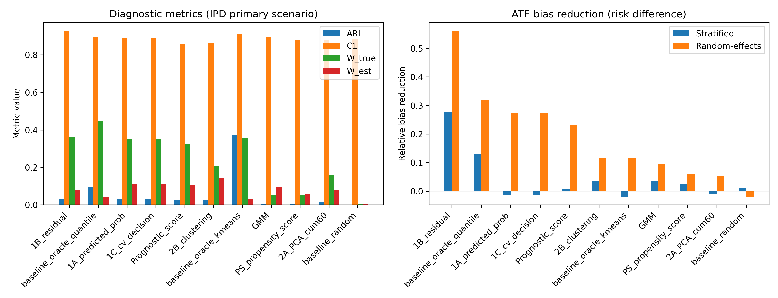
Figure 1. Primary IPD scenario: diagnostic metrics and ATE bias reduction by method.

3.2 Sensitivity to the number of strata
Figure 2 shows how random-effects bias reduction changed as the number of strata varied (K = 3, 5, 10). For most methods the gain from increasing K was limited and non-monotonic; increasing strata beyond the true dimensionality of the hidden structure introduced additional sampling variation and did not consistently improve ATE bias reduction. This finding suggests that the number of strata should be chosen conservatively or compared across several values, rather than simply maximised.
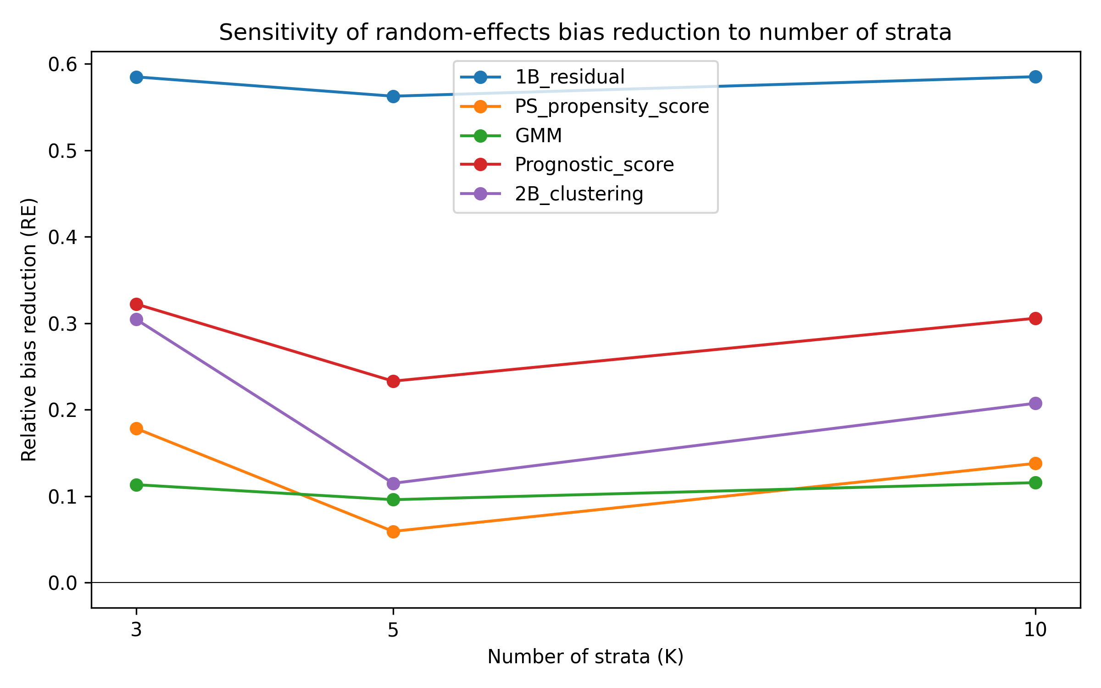
Figure 2. Random-effects ATE bias reduction as the number of strata varies.

3.3 Semi-synthetic illustrations
Five well-known Simpson-paradox examples were reconstructed as pseudo-individual records and pseudo-general variables were generated to mimic proxies of the known confounder (Morris 2021)(Appleton et al. 1996)(Julious and Mullee 1994). High ARI was obtained only when the pseudo-variables were strongly correlated with a low-dimensional confounder. Table 2 and Figure 3 present the best-performing method and stratum count for each dataset. These examples are illustrations of favourable and unfavourable settings for stratification, not validation of out-of-the-box performance in real IPD.
Dataset | Method | K | ARI | C1 | W_est | Bias reduction
COVID-19 CFR | baseline_oracle_kmeans | 9 | 0.685 | 0.303 | 0.022 | 0.028
Israel Vaccine | 2B_clustering | 2 | 0.746 | 0.048 | 0.289 | 0.011
Kidney Stone | baseline_oracle_kmeans | 2 | 0.972 | 0.870 | 0.168 | 0.093
Smoking Mortality | baseline_oracle_kmeans | 7 | 0.790 | 1.000 | 0.109 | 0.111
UC Berkeley | PS_propensity_score | 3 | 0.084 | 0.284 | 0.177 | 0.031
Table 2. Best real-data illustration result per dataset.

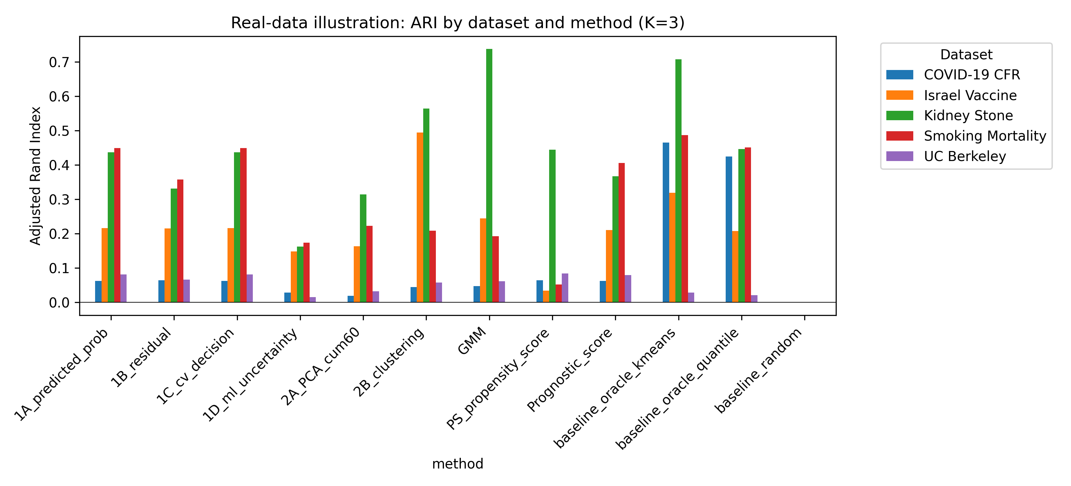
Figure 3. Real-data illustration: ARI by dataset and method.

4. Discussion

4.1 Principal findings
This study frames IONE within an IPD meta-analysis setting and evaluates it as a diagnostic for hidden effect modification. The principal findings are twofold. First, the C1 and W diagnostics can signal when a pooled IPD contains hidden effect modification, even when the data-driven strata do not perfectly recover the true hidden structure. Second, data-driven stratification sometimes reduced ATE bias on the risk-difference scale, and random-effects pooling across discovered strata often improved on a simple two-stage stratified estimate. However, the strata only partially captured the true hidden Z structure, as shown by low ARI and moderate W values. Success was conditional on the confounder/effect-modifier leaving strong traces in the measured covariates and on a simple low-dimensional structure.

4.2 Comparison with existing methods
IONE differs from standard meta-analysis tools in its objectives and assumptions. Propensity-score methods and prognostic scores aim to balance or adjust for measured confounders (Austin and Stuart 2015); they are not designed to detect unmeasured population structure. Meta-regression and one-stage mixed models explain heterogeneity through observed study or participant characteristics (Riley et al. 2010)(Riley et al. 2011), but they cannot reveal effect modifiers that are unmeasured. Latent class and finite mixture models identify hidden subgroups under parametric distributional assumptions but do not provide a coherence diagnostic that is directly linked to treatment-effect homogeneity. IONE is best understood as a preliminary diagnostic: if C1 indicates incoherence, the pooled IPD is stratified and conventional methods are applied within strata.

4.3 Strengths and limitations
Strengths of this study include an explicit causal data-generating mechanism with both confounding and effect modification, a systematic comparison with active comparators, the use of a discovery/evaluation split to mitigate outcome-label leakage, and the reporting of both simulation-only (W_true) and operational (W_est) diagnostics. All numerical results are produced from a version-controlled repository.
Several limitations should be acknowledged. First, the data-generating mechanism is stylised: three critical variables, ten measured variables, a logistic outcome and no censoring, missing data or measurement error. Real clinical IPD may involve more complex causal structures. Second, the true-Z partition is constructed rather than clinically observed, so ARI measures agreement with an operational reference. Third, the semi-synthetic examples use reconstructed individual records and pseudo-general variables; they demonstrate operating characteristics under known confounding but do not fully replicate real data. Fourth, outcome-informed residual stratification carries a circularity risk if the same data are used for stratum assignment and effect estimation; our 50/50 split mitigates but does not eliminate this concern. Finally, C1 and W require calibration before applied use; the values reported here should not be interpreted as universal thresholds.

4.4 Implications for practice
If replicated in further studies, our findings have several practical implications. First, IPD meta-analysis reports could include C1 and W alongside conventional heterogeneity statistics (tau^2, I^2) to make the assumption of within-stratum homogeneity explicit. Second, when C1 indicates incoherence, analysts should explore subgroup-specific estimates rather than rely solely on the marginal average. Third, both outcome-informed and outcome-free methods should be applied and compared; agreement between the two families provides stronger evidence for hidden effect modification. IONE is intended to complement, not replace, established covariate adjustment, meta-regression and one-stage mixed models.

4.5 Future directions
Future work should extend IONE to time-to-event outcomes, continuous outcomes and network meta-analysis, where the structure of treatment contrasts is more complex. Calibration of C1 and W on real clinical IPD, and comparison with latent-class and mixture-model approaches, would clarify the practical value of the diagnostics. Incorporating prior domain knowledge into the stratification, and developing software packages in R and Python, would facilitate adoption.

5. Conclusions
We have introduced IONE (Incoherence-Oriented Neutralisation and Extraction) as an exploratory diagnostic for hidden effect modification in IPD meta-analysis. Through Monte Carlo simulation and semi-synthetic examples, we show that IONE can detect incoherence and partially reduce ATE bias when hidden variables leave strong traces in measured covariates. The diagnostics should be reported alongside conventional meta-analytic models and covariate adjustment, and should not be used as a replacement for rigorous causal inference. We recommend that coherence assessment be considered as a standard sensitivity step in IPD meta-analysis reporting.

Data and code availability
The simulation code and semi-synthetic example data are available at https://github.com/bougtoir/ione-stratification-framework. All numerical results in this manuscript are produced by scripts in the repository; no estimates are hard-coded.

References
Appleton DR, French NR, Vanderpump MP. 1996. Ignoring a covariate: an example of Simpson's paradox. Am Stat. 50(4):340-341.
Austin PC, Stuart EA. 2015. Moving towards best practice when using inverse probability of treatment weighting (IPTW) using the propensity score to estimate causal treatment effects in observational studies. Stat Med. 34(28):3661-3679.
Borenstein M, Hedges LV, Higgins JPT, Rothstein HR. 2009. Introduction to Meta-Analysis. Chichester: John Wiley & Sons.
DerSimonian R, Laird N. 1986. Meta-analysis in clinical trials. Control Clin Trials. 7(3):177-188.
Greenland S, Robins JM, Pearl J. 1999. Confounding and collapsibility in causal inference. Stat Sci. 14(1):29-46.
Hernán MA, Robins JM. 2020. Causal Inference: What If. Boca Raton: Chapman & Hall/CRC.
Higgins JPT, Thompson SG. 2002. Quantifying heterogeneity in a meta-analysis. Stat Med. 21(11):1539-1558.
Julious SA, Mullee MA. 1994. Confounding and Simpson's paradox. BMJ. 309(6967):1480-1481.
Morris JS. 2021. Israeli data: How can efficacy vs. severe disease be strong when 60% of hospitalized are vaccinated? Available from: https://www.covid-datascience.com/post/israeli-data-how-can-efficacy-vs-severe-disease-be-strong-when-60-of-hospitalized-are-vaccinated
Pearl J. 2009. Causality. 2nd ed. Cambridge: Cambridge University Press.
Riley RD, Lambert PC, Abo-Zaid G. 2010. Meta-analysis of individual participant data: rationale, conduct, and reporting. BMJ. 340:c221.
Riley RD, Higgins JPT, Deeks JJ. 2011. Interpretation of random effects meta-analyses. BMJ. 342:d549.
Rubin DB. 1974. Estimating causal effects of treatments in randomized and nonrandomized studies. J Educ Psychol. 66(5):688-701.
Simmonds MC, Higgins JPT, Stewart LA, Tierney JF, Clarke MJ, Thompson SG. 2005. Meta-analysis of individual patient data from randomized trials: a review of methods used in practice. Clin Trials. 2(3):209-217.
VanderWeele TJ. 2015. Explanation in Causal Inference: Methods for Mediation and Interaction. Oxford: Oxford University Press.

