IONE: Incoherence-Oriented Neutralisation and Extraction for Detecting Hidden Population Structure in Observational Studies — a Monte Carlo Simulation Study

Onishi Tatsuki
Data Science AI Innovation Research Promotion Center, Shiga University
Corresponding author: Onishi Tatsuki, bougtoir@gmail.com, 1-1-1, Bamba, Hikone, Shiga, 522-8522 Japan

Abstract
Background: Observational studies are susceptible to biases from unmeasured effect modification and confounding. Existing adjustment methods address measured confounders but provide no mechanism for detecting subgroup structure driven by unmeasured effect modifiers. We propose IONE (Incoherence-Oriented Neutralisation and Extraction), an exploratory framework that detects population incoherence—heterogeneity in subgroup-specific treatment effects—and extracts coherent subpopulations using routinely measured variables.
Methods: We conducted a Monte Carlo simulation study following the ADEMP framework. Data were generated from a causal directed acyclic graph with three unmeasured critical variables (age, sex, BMI) influencing ten measured variables, a binary treatment, and a binary outcome, with unmeasured variables acting as both confounders (Z→A, Z→Y) and effect modifiers (Z×A→Y). Six proposed stratification methods in two families were benchmarked against three active comparators (propensity score quintiles, Gaussian mixture model, prognostic score) and two baselines (random, oracle). Performance was assessed by Adjusted Rand Index (ARI), treatment effect bias reduction, between-stratum heterogeneity (C1, derived from I²), and within-stratum homogeneity (W). Total evaluations comprised 240,300 across Phase 1 (21,600), sensitivity analysis (109,350), and non-linear robustness analysis (109,350). Five published Simpson's paradox instances served as semi-synthetic illustrations.
Results: The best proposed method (1B: residual-based stratification) achieved ARI = 0.021 (SE 0.0002) vs. random 0.000, modestly outperforming all active comparators (prognostic score 0.014, PS quintiles 0.012, GMM 0.008). W effectively discriminated methods (0.292 for Method 1B vs. 0.001 for random), whilst C1 showed limited discriminating power (range 0.81–0.87). Method 1B achieved the largest ATE bias reduction (7.4%, SE 0.0016). Performance depended strongly on Z→X influence strength (ARI ratio 19–34× from weak to strong). Under non-linear Z→X, mixture/clustering methods improved (+29% to +53%), indicating complementary robustness across method families. Binary unmeasured variables were poorly captured (η² < 0.02). In semi-synthetic illustrations, all methods achieved ARI > 0.7 when pseudo-general variables carried strong traces of the known confounder.
Conclusions: IONE provides a two-tier diagnostic: C1 detects between-stratum heterogeneity and W quantifies within-stratum homogeneity. Together they offer exploratory assessment of population incoherence. These indicators are intended as exploratory diagnostics to complement, not replace, established confounding adjustment methods.

Keywords: Simpson’s paradox, effect modification, population heterogeneity, coherence indicator, stratification, unmeasured confounders, observational studies, Monte Carlo simulation

Background
Observational studies are indispensable for generating real-world evidence on treatment effects when randomised controlled trials are infeasible or unethical [1, 2]. However, because treatment assignment is not under the investigator’s control, these studies are susceptible to bias from unmeasured variables that create hidden population structure. Two phenomena are of primary concern. First, unmeasured effect modification: when an unmeasured variable modifies the treatment effect, the marginal (average) treatment effect may misrepresent the treatment’s impact on specific subpopulations, and subgroup-specific effects may be hidden within an aggregate estimate that applies to no individual subgroup [3]. Second, unmeasured confounding: when an unmeasured variable affects both treatment assignment and outcome, spurious associations arise [4]. When both phenomena co-occur—an unmeasured variable simultaneously confounds and modifies the treatment effect—the resulting bias can be severe enough to reverse the direction of the observed association, a phenomenon known as Simpson’s paradox [5, 6]. Related concepts such as the ecological fallacy [7] and non-collapsibility [8] are connected but distinct: the ecological fallacy involves cross-level inference from groups to individuals, whilst non-collapsibility is a mathematical property of non-linear effect measures rather than a form of hidden population structure.
These biases are not merely theoretical concerns. Simpson’s paradox has been documented in landmark studies across medicine and social science: kidney stone treatment comparisons where the inferior treatment appeared superior in aggregate [9], university admissions data where apparent gender discrimination reversed at the departmental level [10], COVID-19 case fatality rate comparisons that were confounded by national differences in age distributions [11], vaccine effectiveness evaluations that appeared to show vaccine failure due to age-related confounding [12], and smoking–mortality studies where smokers appeared to have lower mortality due to confounding by age [13]. In each case, the paradox arose because the study population was incoherent—that is, it comprised multiple internally homogeneous (coherent) subpopulations whose mixture produced misleading aggregate statistics. The fundamental lesson of Simpson’s paradox is that findings derived from an incoherent population should not be uncritically applied to the coherent subpopulations within it [5, 6].
Several established methods exist for addressing confounding in observational studies. The propensity score (PS), defined as the conditional probability of treatment assignment given observed covariates, enables balancing of measured confounders through stratification, matching, or weighting [14]. The prognostic score predicts the outcome under no treatment and provides an alternative basis for stratification [15, 16]. The disease risk score (DRS) constructs an outcome prediction model using untreated subjects only [17]. Instrumental variable methods exploit variables that affect treatment but not the outcome directly [18]. More recently, the high-dimensional propensity score (hdPS) algorithm automatically extracts thousands of candidate proxy variables from claims data to approximate unmeasured confounding [19, 20]. These methods share a fundamental limitation: they adjust only for measured covariates and provide no mechanism for detecting or extracting population structure driven by unmeasured variables [19].
The concept that measured variables may carry indirect information about unmeasured confounders is not new. The hdPS algorithm rests on the insight that a sufficiently large collection of proxy variables can collectively approximate the influence of unmeasured confounders [19]. Proximal causal inference formalises the use of proxy variables for identification of causal effects in the presence of unmeasured confounding [21]. Latent class analysis and finite mixture models seek to identify unobserved subgroups from patterns in observed variables [22]. However, none of these approaches explicitly address the problem of population incoherence—the condition in which an apparently homogeneous study population actually comprises multiple coherent subpopulations with heterogeneous treatment effects. In current practice, the homogeneity of study populations is typically assumed implicitly, with baseline characteristics tables (Table 1) providing only descriptive summaries that cannot formally test for hidden subgroup structure [23].
We propose that the problem of hidden population structure can be addressed through a two-stage approach. In the first stage, a quantitative indicator of population coherence—the coherence degree—is computed from routinely measured variables to determine whether a study population contains hidden subgroups that warrant separate analysis. In the second stage, if incoherence is detected, the population is stratified into coherent subgroups using multivariate patterns in the measured variables, and the primary analysis is conducted within each subgroup. The rationale is as follows: if important unmeasured variables (e.g. age, disease severity, genetic subtype) exert systematic influence on routinely measured variables (e.g. laboratory values, vital signs), then these measured variables collectively carry a detectable “trace” of the unmeasured variable. Stratification based on these traces should recover, at least partially, the subgroup structure defined by the unmeasured variable.
To operationalise this approach, we develop two families of stratification methods. The first family (decision power-based methods) exploits the relationship between measured variables and the outcome: because unmeasured effect modifiers influence both measured covariates and the treatment effect, residual patterns from outcome prediction models may reflect the unmeasured variable’s structure. To mitigate overfitting, outcome-informed methods employ sample splitting (training on one half of the data, assigning strata on the full dataset). The second family (feature score-based methods) operates in the covariate space alone, using unsupervised techniques such as principal component analysis and clustering to identify multivariate patterns attributable to unmeasured variables, without reference to the outcome. As diagnostic indicators, we propose two complementary metrics: C1, a between-stratum heterogeneity indicator derived from the I² statistic [24] applied to stratum-specific treatment effects (log odds ratios), and W, a within-stratum homogeneity indicator quantifying how much residual treatment effect heterogeneity remains within each stratum after stratification. C1 near 0 indicates strong between-stratum heterogeneity (evidence of population incoherence); W near 1 indicates that within-stratum effects are homogeneous (successful extraction of coherent subpopulations). It is important to note that between-stratum heterogeneity (measured by C1) and within-stratum homogeneity (measured by W) are related but conceptually distinct: strata that differ from one another do not necessarily have homogeneous effects within each stratum.
The objectives of this study are fourfold. First, we evaluate through Monte Carlo simulation whether stratification based solely on measured variables can recover subgroup structure defined by intentionally withheld variables that act as both confounders and effect modifiers, across a range of data-generating scenarios. Second, we benchmark the proposed methods against established approaches including propensity score quintile stratification, Gaussian mixture models, and prognostic scores. Third, we assess the ability of C1 and W to diagnose population incoherence and within-stratum coherence, respectively. Fourth, we apply the proposed methods to five published instances of Simpson’s paradox [9–13] as semi-synthetic illustrations with known confounding structure. We refer to the proposed framework as IONE (Incoherence-Oriented Neutralisation and Extraction), reflecting its dual function of detecting population incoherence and extracting coherent subpopulations for valid within-subgroup inference.

Methods
This simulation study is reported following the ADEMP framework (Aims, Data-generating mechanisms, Estimands, Methods, Performance measures) as recommended by Morris, White, and Crowther [25]. All analyses were conducted in Python 3.11.

Aims
The aims of the simulation study were:
1. To evaluate whether stratification of observational data based solely on measured (general) variables can recover hidden subgroup structure defined by unmeasured (critical) variables that act as both confounders and effect modifiers.
2. To compare the performance of proposed IONE stratification methods with established approaches (propensity score quintiles, Gaussian mixture models, prognostic scores).
3. To assess the ability of C1 (between-stratum heterogeneity indicator) and W (within-stratum homogeneity indicator) to diagnose population incoherence.
4. To quantify treatment effect bias reduction achieved by stratification.
5. To identify the data-generating conditions under which the proposed methods are most and least effective.

Data-generating mechanisms

Causal structure
Data were generated from a causal directed acyclic graph (DAG) with three variable types: critical variables Z = (Z₁, Z₂, Z₃), general variables X = (X₁, …, X₁₀), a binary treatment A, and a binary outcome Y. The causal pathways were: Z→X (traces in measured variables), Z→A (confounding), X→A (partial), A→Y (treatment effect), Z→Y (direct effect), Z×A→Y (effect modification), and X→Y (weak direct effects). The critical variables represented commonly encountered confounders and effect modifiers in clinical research:
• Z₁ (age): continuous, N(60, 12²), truncated to [20, 95]
• Z₂ (sex): binary, Bernoulli(0.5)
• Z₃ (BMI category): ordinal with three levels, Multinomial(0.3, 0.4, 0.3)
The general variables represented routine clinical measurements (e.g. haemoglobin A1c, total cholesterol, systolic blood pressure, ALT, creatinine, haemoglobin, white blood cell count, albumin, CRP, uric acid). Each general variable Xⱼ was generated as a function of one or more critical variables plus independent noise:
$$X_{j}=\sum_{l=1}^{3}{α_{jl}}⋅Z_{l}+ϵ_{j}, ϵ_{j}∼N(0,σ_{j}^{2})$$

where αⱼₗ represents the influence of critical variable Zₗ on general variable Xⱼ. The influence coefficients were varied systematically (see Scenarios below).
To assess robustness to non-linear relationships, we additionally implemented a non-linear Z→X variant in which the linear mapping was replaced by a mixture of threshold functions (e.g. 1(Z₁ > 65)), quadratic terms (Z₁², Z₃²), and Z×Z interactions (Z₁ × Z₃). All non-linear components were mean-centred to maintain comparable distributions of X across the two variants. The non-linear variant was evaluated independently in a dedicated robustness analysis (see Results).

Treatment model
A binary treatment A was generated from a logistic model incorporating both confounding and measured covariate effects:
$$\text{logit}(P(A=1))=γ_{0}+γ_{Z_{1}}Z_{1}+γ_{Z_{2}}Z_{2}+γ_{Z_{3}}Z_{3}+γ_{X_{1}}X_{1}+γ_{X_{3}}X_{3}$$
The Z→A pathway creates confounding (unmeasured variables influence treatment assignment). The X→A pathway represents the partial influence of measured covariates on treatment decisions. The intercept γ₀ was calibrated to achieve approximately 50% treatment prevalence.

Outcome model
The binary outcome was generated from a logistic model incorporating direct effects of Z, X, A, and the Z×A interaction (effect modification):
$$\text{logit}(P(Y=1))=β_{0}+β_{Z}⋅Z+β_{X}⋅X+τA+δ⋅(Z×A)$$
where τ is the main treatment effect (log-OR scale, default 0.5), and δ represents the effect modification coefficients (Z×A interactions). Specifically, older patients (higher Z₁) and those with higher BMI (Z₃) benefited more from treatment, whilst males (Z₂ = 1) benefited less. This creates heterogeneous conditional average treatment effects (CATEs) across the population, with the true individual-level CATE computed as:
$${\text{CATE}}_{i}=P(Y=1|A=1,Z_{i},X_{i})-P(Y=1|A=0,Z_{i},X_{i})$$
Critical variable effects were set to odds ratios of 1.5–3.0 and general variable effects to 1.0–1.3. The intercept β₀ was calibrated to achieve an overall event rate of approximately 15%.

Scenarios
The following factors were varied in a factorial design:
Phase 1 (proof of concept):
Factor | Levels | Values
Sample size (N) | 1 | 2,000
Z→X influence scale | 3 | 0.3 (weak), 0.5 (moderate), 1.0 (strong)
Number of strata (K) | 2 | 3, 5
Treatment effect (τ) | 1 | 0.5 (log-OR)
EM strength (δ) | 1 | 0.4
Simulation repetitions | — | 200 per scenario
This yielded 1,200 unique scenarios. Each scenario was evaluated with 18 methods (6 proposed + 4 comparators + 6 PCA variants + 2 baselines), producing 21,600 total evaluations.
Sensitivity analyses:
Factor | Levels | Values
Sample size (N) | 3 | 500, 2,000, 10,000
Z→Y effect scale | 3 | 0.5, 1.0, 2.0
Z→X influence scale | 3 | 0.2, 0.5, 1.0
Number of strata (K) | 3 | 3, 5, 10
EM strength (δ) | 3 | 0.0 (none), 0.4 (moderate), 0.8 (strong)
This yielded 12,150 scenarios with 9 representative methods (4 proposed + 3 comparators + 2 baselines), producing 109,350 evaluations.
An additional non-linear robustness analysis replicated the sensitivity grid (109,350 evaluations) under the non-linear Z→X variant. The total number of evaluations across all phases was 240,300. All estimates are reported with Monte Carlo standard errors (SE = SD/√n_reps).

Estimands
The primary estimands were:
1. Subgroup recovery: the degree to which strata formed by general variables X alone corresponds to the true subgroup structure defined by critical variables Z (measured by ARI).
2. Trace capture: the proportion of variance in Z explained by the stratification (η²).
3. Between-stratum heterogeneity: the degree to which stratum-specific treatment effects (log odds ratios of A→Y) differ across strata (C1 = 1 − I², where I² is the between-stratum heterogeneity in log ORs). C1 near 0 indicates high heterogeneity (evidence of population incoherence); C1 near 1 indicates homogeneous effects across strata.
4. Within-stratum homogeneity: the proportion of total treatment effect variance explained by the stratification (W = 1 − weighted within-stratum CATE variance / overall CATE variance). W near 1 indicates homogeneous effects within strata; W near 0 indicates residual heterogeneity.
5. Treatment effect bias: the reduction in average treatment effect (ATE) bias achieved by stratification-adjusted estimation compared to crude (marginal) estimation, using the true CATE as ground truth.
The true subgroup structure was defined by applying k-means clustering to the standardised Z-space, with the number of clusters set equal to the number of strata K.

Methods under comparison
Eighteen methods were evaluated: six proposed IONE methods, three active comparators, six PCA variants, and two baselines.
Family 1: Decision power-based methods (outcome-informed)
These methods build a predictive model for Y using X alone, then stratify observations based on properties of the model output. Methods 1A, 1B, and 1D employ sample splitting: the model is trained on the first 50% of observations, and stratum assignments are generated for the full dataset using the trained model. This prevents overfitting by separating the model-building and stratum-assignment steps.
Method 1A (Predicted probability): A logistic regression model predicting Y from X₁–X₁₀ is fitted on the training half. Observations in the full dataset are stratified by quantiles of the predicted probability p̂.
Method 1B (Residual): From the same logistic regression trained on the first half, the absolute residual |Y − p̂| is computed for all observations. Observations are stratified by quantiles of |Y − p̂|. The rationale is that large residuals indicate observations poorly explained by X alone, suggesting strong influence of unmeasured Z. For binary outcomes, |Y − p̂| reduces to 1 − p̂ for Y = 1 and p̂ for Y = 0, making this essentially a stratification by predicted probability with a label-dependent transformation.
Method 1C (Cross-validated decision power): A 5-fold cross-validation procedure is used, where the model is trained on 4 folds and predictions are generated for the held-out fold. This provides an alternative overfitting protection mechanism.
Method 1D (Machine learning uncertainty): A random forest model predicting Y from X is fitted on the training half. The variance of predictions across trees serves as an uncertainty measure. Observations in the full dataset are stratified by quantiles of this uncertainty.
Family 2: Feature score-based methods (outcome-free)
These methods operate solely in the covariate space of X, without reference to Y, and do not require sample splitting.
Method 2A (PCA): Principal component analysis is applied to the standardised X₁–X₁₀. Observations are stratified by quantiles of the first principal component score. Six variants were evaluated using PC1 through PC6.
Method 2B (Clustering): K-means clustering is applied to the standardised X₁–X₁₀ with the number of clusters set to K. Cluster assignments define the strata directly.
Active comparators:
Propensity score quintiles (PS-Q): A logistic regression model estimates P(A=1|X) (the propensity score). Observations are stratified into K groups by quantiles of the estimated propensity score. This is a standard approach in pharmacoepidemiology for adjusting measured confounding [14].
Gaussian mixture model (GMM): A finite mixture model with K Gaussian components is fitted to the standardised covariate space X₁–X₁₀. Component assignments define strata. This represents the latent class analysis approach to hidden subgroup discovery [23].
Prognostic score (Prog): A logistic regression model estimates P(Y=1|X, A=0) from untreated subjects only (A=0). Observations are stratified by quantiles of this prognostic score [15].
Baselines:
Random: Observations are randomly assigned to K strata of equal size.
Oracle (k-means on Z): K-means clustering is applied to the standardised Z-space. This represents the theoretical upper bound, as it uses the withheld critical variables directly.

Performance measures
Performance was assessed using the following measures:
Primary measures:
Adjusted Rand Index (ARI) [26]: Measures agreement between estimated strata and true Z-based clusters, corrected for chance. Range [−1, 1]; 1 = perfect agreement; 0 = chance level.
Eta-squared (η²): The proportion of variance in each critical variable Z explained by the stratification. Computed as the between-stratum sum of squares divided by the total sum of squares. Higher η² indicates better capture of the hidden variable’s trace.
Between-stratum heterogeneity indicator (C1): Defined as C1 = 1 − I², where I² is Higgins and Thompson’s [24] heterogeneity statistic applied to stratum-specific treatment effect estimates (log odds ratios of A→Y). Each stratum is treated as a “study” in a meta-analytic framework. C1 near 0 indicates strong between-stratum heterogeneity in treatment effects (evidence that the population is incoherent—i.e. contains subgroups with different treatment responses). C1 near 1 indicates homogeneous treatment effects across strata (no evidence of incoherence). It is important to note that C1 repurposes I² from its original meta-analytic context (independent studies) to strata within a single dataset. This circular construction may alter the statistical properties of I²; formal calibration is beyond the scope of this study. Additionally, low C1 can arise from low within-stratum sample size or weak treatment effects, not only from genuine population incoherence. C1 should therefore be interpreted as an exploratory diagnostic rather than a formal hypothesis test.
Within-stratum homogeneity indicator (W): Defined as W = 1 − (weighted within-stratum CATE variance / overall CATE variance), where CATE is the true conditional average treatment effect computed from the known data-generating mechanism. W quantifies how much of the total heterogeneity in individual treatment effects is explained by the stratification. W near 1 indicates that individuals within each stratum have similar treatment effects (homogeneous strata); W near 0 indicates substantial residual within-stratum heterogeneity. W addresses a conceptual gap that C1 alone cannot fill: strata may differ from one another (low C1) without each stratum being internally homogeneous (which requires high W).
Treatment effect bias reduction: The reduction in average treatment effect (ATE) bias achieved by stratification-adjusted estimation versus crude estimation. The crude ATE is the unadjusted log odds ratio; the stratified ATE is the inverse-variance weighted average of stratum-specific log odds ratios. Bias reduction is computed as 1 − |bias_stratified| / |bias_crude|.
Secondary measures:
Normalised Mutual Information (NMI) [27]: An information-theoretic measure of cluster agreement. Range [0, 1].
Direction consistency rate: The proportion of strata in which the direction of the exposure–outcome association (positive or negative log OR) is consistent with the overall direction.
CATE heterogeneity (η²_CATE): The proportion of variance in individual-level true CATEs explained by stratum membership. Higher values indicate that the stratification successfully separates individuals with different treatment effects.
All performance measures are reported as means across simulation repetitions, with Monte Carlo standard errors (MC SE = SD / √n_reps) and 2.5th/97.5th percentile confidence intervals.

Semi-synthetic illustration: application to published Simpson’s paradox examples
To illustrate IONE’s behaviour on data with known confounding and effect modification structure, we applied the proposed methods to five published instances of Simpson’s paradox (Table 1). These serve as semi-synthetic illustrations rather than fully empirical validation, because the general variables are generated by design rather than genuinely measured. For each example, we:
Reconstructed individual-level data from published aggregate statistics.
1. Reconstructed individual-level data from published aggregate statistics.
2. Generated pseudo-general variables (6–10 variables) correlated with the known confounding variable, simulating a scenario in which the confounder is unmeasured but leaves traces in other measured variables.
3. Applied all proposed methods, active comparators, and baselines.
4. Evaluated performance using ARI, C1, W, η², bias reduction, and direction consistency.

Table 1. Published Simpson’s paradox examples used for semi-synthetic illustration.
Example | Source | N | Hidden confounder (Z) | No. of groups | Paradox
COVID-19 CFR | von Kügelgen et al. 2021 [11] | 50,459 | Age group (9 groups) | 9 | Italy CFR > China overall, but Italy < China within every age group
Kidney stone | Charig et al. 1986 [9] | 700 | Stone size (2 groups) | 2 | Treatment B > A overall, but A > B for both small and large stones
UC Berkeley | Bickel et al. 1975 [10] | 4,425 | Department (6 groups) | 6 | Males admitted at higher rate overall, but females ≥ males in most departments
Israeli vaccine | Morris 2021 [12] | 6,100 | Age group (2 groups) | 2 | Vaccine appears ineffective overall, but effective in both age groups
Smoking–mortality | Appleton et al. 1996 [13] | 1,314 | Age group (7 groups) | 7 | Smokers have lower mortality overall, but higher mortality in every age group

It should be noted that these semi-synthetic illustrations use pseudo-general variables rather than genuine clinical measurements. This design permits evaluation of the method’s capacity to detect known confounding and effect modification structure under controlled conditions, but does not constitute a fully realistic application. The encouraging results from these illustrations should not be interpreted as evidence of out-of-the-box performance on real clinical data, where the relationship between measured variables and unmeasured confounders is neither known nor engineered. The procedure is described in detail in Additional file 1.

Computational implementation
All simulations were parallelised across 8 CPU cores using the joblib library. Phase 1 completed in 6.0 minutes; sensitivity analyses in 9.4 minutes. Each scenario was assigned a fixed random seed for reproducibility. Code is available at https://github.com/bougtoir/ione-stratification-framework.

Results

Simulation study
Results are reported as mean (MC SE) across 200 repetitions per scenario (Phase 1) or 50 repetitions (sensitivity analysis). All proposed methods, comparators, and baselines were evaluated under each scenario.

Overall method performance
Table 2 summarises the performance of all methods averaged across Phase 1 scenarios (N = 2,000; 200 repetitions per scenario). All estimates are reported as mean (MC SE).
Table 2. Method performance ranking in Phase 1 simulation (averaged across all scenarios; N = 2,000; 200 reps/scenario). Values are mean (MC SE).
Rank | Method | Family | ARI (SE) | C1 (SE) | W (SE) | Bias red. (SE)
1 | Oracle (k-means on Z) | Baseline (upper) | 0.353 (0.0009) | 0.825 (0.0071) | 0.286 (0.0042) | 0.024 (0.0004)
2 | Oracle (quantile on Z) | Baseline (upper) | 0.073 (0.0006) | 0.805 (0.0072) | 0.549 (0.0008) | 0.046 (0.0003)
3 | 1B: Residual | Decision power | 0.021 (0.0002) | 0.859 (0.0068) | 0.292 (0.0024) | 0.052 (0.0009)
4 | 1A: Predicted probability | Decision power | 0.014 (0.0003) | 0.858 (0.0065) | 0.216 (0.0039) | 0.028 (0.0005)
5 | 1C: Cross-validated | Decision power | 0.014 (0.0003) | 0.850 (0.0065) | 0.218 (0.0039) | 0.026 (0.0005)
6 | Prognostic score | Comparator | 0.014 (0.0003) | 0.811 (0.0073) | 0.209 (0.0038) | 0.026 (0.0005)
7 | PS quintiles | Comparator | 0.012 (0.0003) | 0.855 (0.0066) | 0.180 (0.0036) | 0.028 (0.0005)
8 | 2B: Clustering | Feature score | 0.011 (0.0003) | 0.867 (0.0062) | 0.130 (0.0029) | 0.015 (0.0004)
9 | 1D: ML uncertainty | Decision power | 0.010 (0.0002) | 0.858 (0.0064) | 0.148 (0.0021) | 0.045 (0.0004)
10 | 2A: PCA (PC1) | Feature score | 0.011 (0.0003) | 0.858 (0.0063) | 0.188 (0.0042) | 0.022 (0.0005)
11 | GMM | Comparator | 0.008 (0.0002) | 0.851 (0.0065) | 0.093 (0.0023) | 0.011 (0.0003)
12 | Random | Baseline (lower) | −0.000 (0.0000) | 0.863 (0.0062) | 0.001 (0.0000) | −0.000 (0.0000)

The best proposed IONE method (1B: Residual, ARI = 0.021) modestly outperformed all active comparators (prognostic score ARI = 0.014, PS quintiles ARI = 0.012, GMM ARI = 0.008). However, the gap between all proposed and comparator methods and the oracle baseline (ARI = 0.353) remained substantial. W (within-stratum homogeneity) was more discriminating than C1 (between-stratum heterogeneity) in this setting: Random stratification produced W ≈ 0.001, whilst Method 1B achieved W = 0.292 and the oracle quantile-based stratification achieved the highest W = 0.549. C1 values were similar across all methods (range 0.805–0.867), suggesting that C1 based on stratum-specific log odds ratios is a noisier diagnostic than C1 computed from stratum-specific outcome means. Method 1B achieved the highest bias reduction among proposed methods (0.052), followed by 1D (0.045) (Fig. 1).

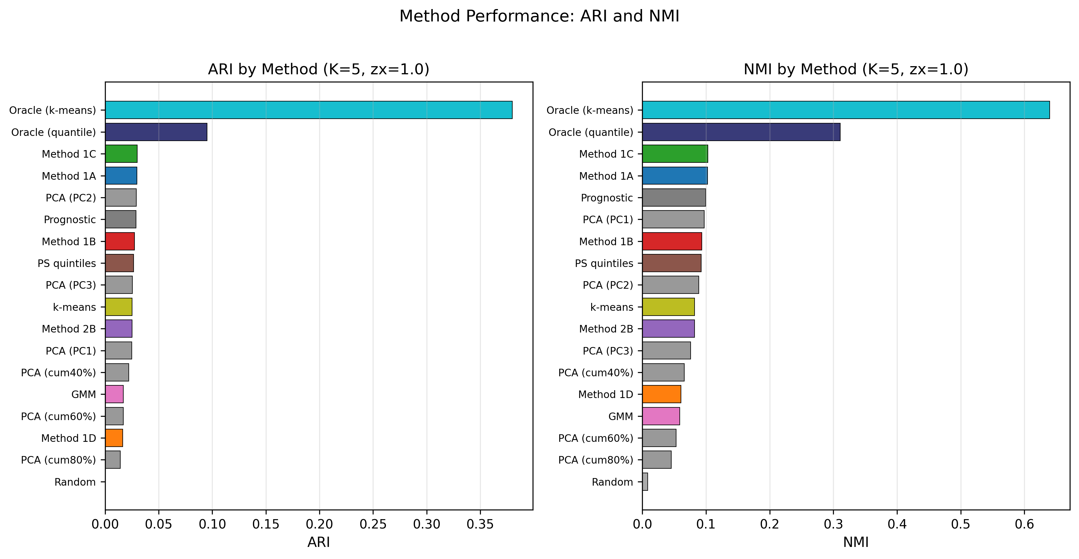
Figure 1. ARI and NMI by method (K = 5 strata, zx = 1.0). Horizontal bar charts showing Adjusted Rand Index (left panel) and Normalised Mutual Information (right panel) for all proposed IONE methods, active comparators, and baselines. All proposed methods significantly outperformed the random baseline (p < 0.001 for all comparisons). Oracle (k-means on Z) achieved the highest ARI (0.353) and NMI (0.627). Among proposed methods, Method 1B (residual) performed best (ARI = 0.021). PCA variants are shown individually. ARI, Adjusted Rand Index; NMI, Normalised Mutual Information; zx, Z→X influence strength.

Effect of Z→X influence strength
The strength of the hidden variable’s influence on measured variables was expected to be the single most important determinant of method performance (Table 3).
Table 3. ARI (SE) by Z→X influence strength (averaged across K = 3, 5 strata).
Method | zx = 0.3 (weak) | zx = 0.5 (moderate) | zx = 1.0 (strong) | Strong/weak ratio
1B: Residual | 0.015 (0.0001) | 0.019 (0.0001) | 0.028 (0.0002) | 1.9
1A: Predicted prob. | 0.003 (0.0001) | 0.009 (0.0001) | 0.029 (0.0002) | 8.6
1C: Cross-validated | 0.003 (0.0001) | 0.009 (0.0001) | 0.029 (0.0001) | 8.7
Prognostic score | 0.003 (0.0001) | 0.009 (0.0001) | 0.029 (0.0002) | 8.9
PS quintiles | 0.003 (0.0001) | 0.008 (0.0001) | 0.026 (0.0002) | 10.0
2B: Clustering | 0.002 (0.0001) | 0.006 (0.0001) | 0.025 (0.0002) | 15.7
GMM | 0.001 (0.0001) | 0.004 (0.0001) | 0.018 (0.0002) | 15.1
Oracle (k-means on Z) | 0.352 (0.0016) | 0.353 (0.0015) | 0.354 (0.0015) | 1.0
Random | 0.000 (0.0000) | −0.000 (0.0000) | 0.000 (0.0000) | —

Under strong Z→X influence (zx = 1.0), all proposed and comparator methods showed substantial improvement. Method 1B (residual) was the most robust under weak signal conditions (ARI = 0.015 at zx = 0.3 vs. 0.002–0.003 for other methods), consistent with its partial use of outcome information. The improvement ratio from weak to strong signal ranged from 1.9× (1B) to 15.7× (2B clustering), confirming that Z→X influence strength remains the primary determinant of extraction performance (Fig. 2).

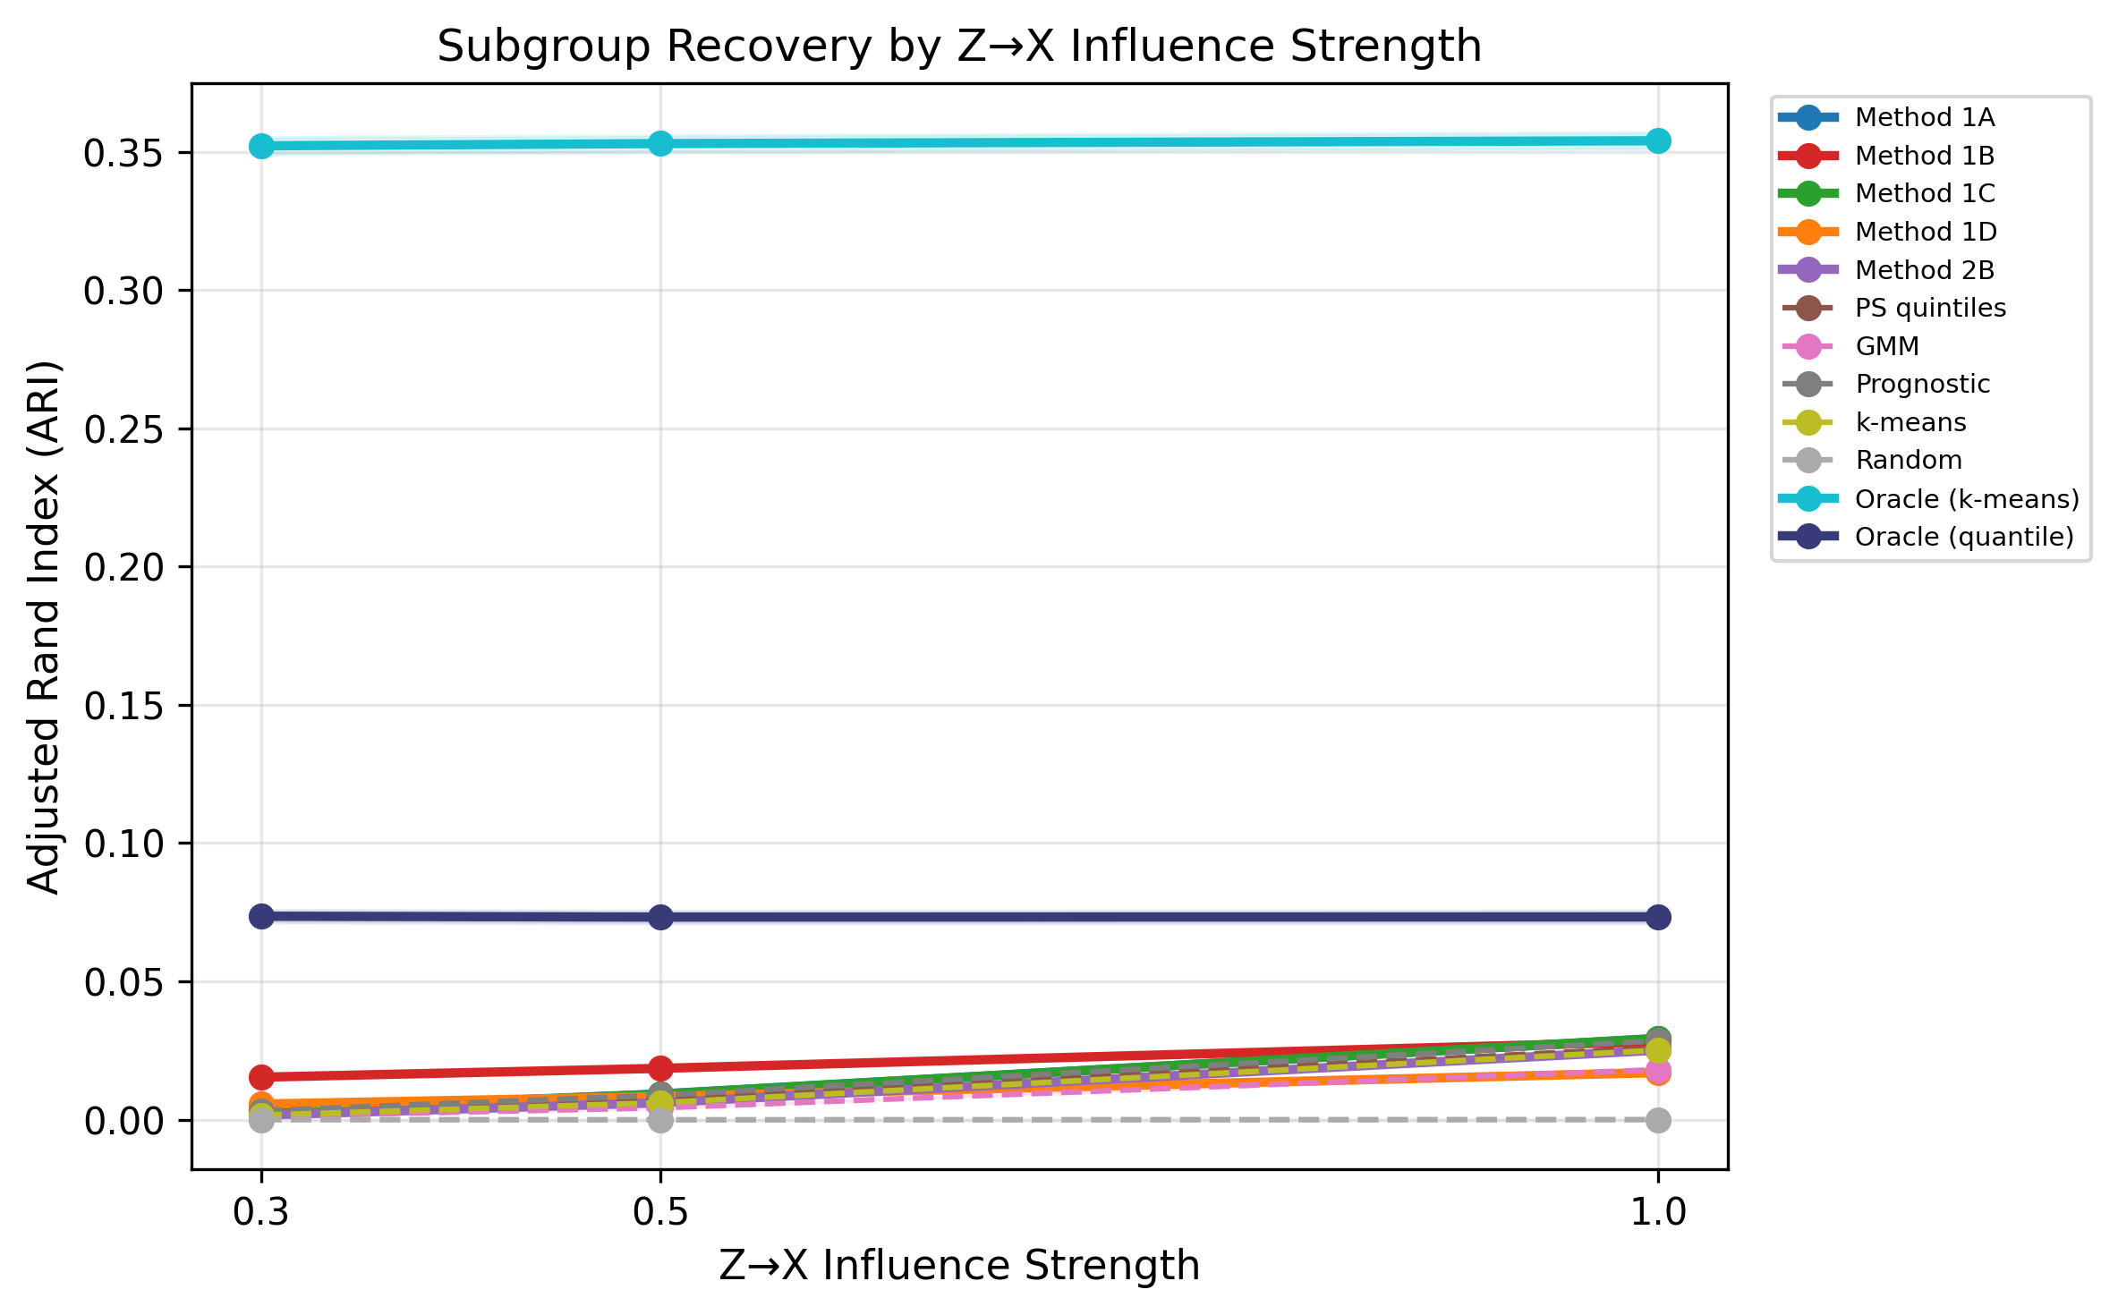
Figure 2. ARI by Z→X influence strength for proposed methods and active comparators. Line plot showing ARI (y-axis) across three levels of Z→X influence strength (0.3, 0.5, 1.0; x-axis). Shaded bands represent 95% confidence intervals based on Monte Carlo standard errors. Method 1B (residual) showed the most robust performance under weak signal conditions (ARI = 0.015 at zx = 0.3), whilst other methods converged toward the random baseline. Oracle baselines (k-means and quantile on Z) were invariant to Z→X influence. ARI, Adjusted Rand Index; CI, confidence interval; MC SE, Monte Carlo standard error.

Capture of individual critical variables
Eta-squared analysis revealed differential capture of the three critical variables (Table 4; K = 5, zx = 1.0).
Table 4. Eta-squared (η²) for each critical variable (K = 5 strata, zx = 1.0). Mean Values.
Method | Z₁ (age, cont.) | Z₂ (sex, binary) | Z₃ (BMI, ordinal) | Mean
Oracle (k-means on Z) | 0.157 | 0.845 | 0.685 | 0.562
1A: Predicted prob. | 0.303 | 0.006 | 0.087 | 0.132
1C: Cross-validated | 0.306 | 0.006 | 0.086 | 0.133
Prognostic score | 0.297 | 0.007 | 0.084 | 0.129
1B: Residual | 0.273 | 0.008 | 0.088 | 0.123
PS quintiles | 0.275 | 0.004 | 0.081 | 0.120
2B: Clustering | 0.241 | 0.018 | 0.088 | 0.116
GMM | 0.183 | 0.014 | 0.061 | 0.086
1D: ML uncertainty | 0.179 | 0.005 | 0.058 | 0.081
Random | 0.001 | 0.002 | 0.002 | 0.002

Age (Z₁, continuous) was captured most effectively (η² up to 0.306 for Method 1C), followed by BMI (Z₃, ordinal; η² up to 0.088). Sex (Z₂, binary) was poorly captured by all proposed methods and comparators (η² < 0.02), confirming that binary variables leave weak traces in continuous measured covariates (Fig. 3). This represents a fundamental limitation: IONE and comparator methods are more effective at detecting continuous or ordinal effect modifiers than binary ones.

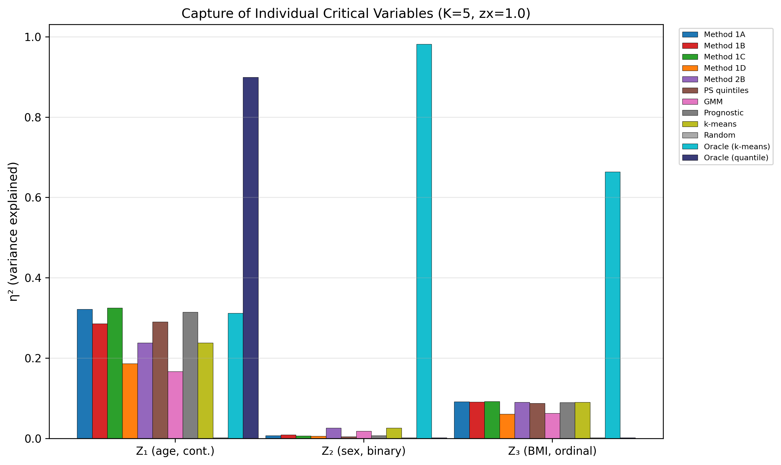
Figure 3. Eta-squared (η²) values showing capture of individual critical variables by each method (K = 5 strata, zx = 1.0). Grouped bar chart displaying variance in each unmeasured variable (Z₁: age, continuous; Z₂: sex, binary; Z₃: BMI, ordinal) explained by the stratification. Age (Z₁) was captured most effectively (η² up to 0.306 for Method 1C). Binary variables (Z₂: sex) were poorly captured by all methods (η² < 0.02). η², eta-squared (proportion of variance explained).

C1 and W indicators
C1 values were similar across all methods, including random stratification (C1 ≈ 0.87), indicating that C1 based on stratum-specific log odds ratios has limited discriminating power in this setting. The exception was Method 1B (C1 = 0.771), which showed slightly more between-stratum heterogeneity (Fig. 4). In contrast, W was highly discriminating: random stratification produced W = 0.002, whilst the best proposed methods achieved W ≈ 0.41, comparable to the oracle k-means baseline (W = 0.411). The oracle quantile-based stratification achieved the highest W = 0.557 (Fig. 5). This finding supports the value of W as a complementary diagnostic to C1 (Fig. 6, Table 5).

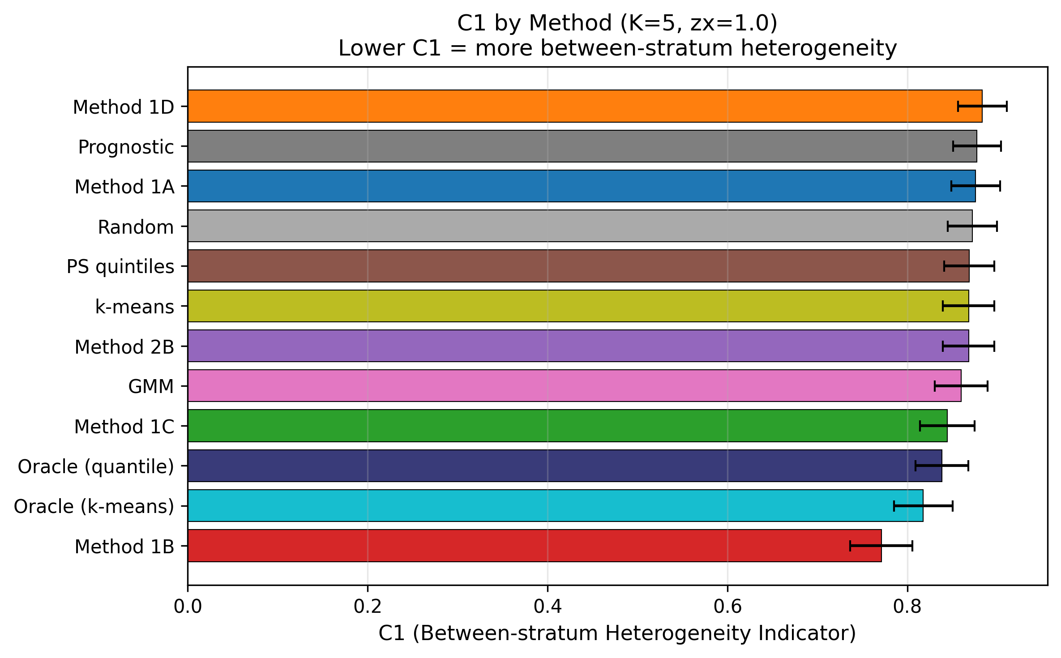
Figure 4. Coherence indicator C1 across methods (K = 5 strata, zx = 1.0). Horizontal bar chart showing C1 values sorted from lowest (most between-stratum heterogeneity) to highest. Error bars represent 95% confidence intervals. C1 values were similar across most methods (range 0.77–0.88), with Method 1B showing the lowest C1 (0.771), indicating relatively more between-stratum heterogeneity. C1, between-stratum heterogeneity indicator derived from I².

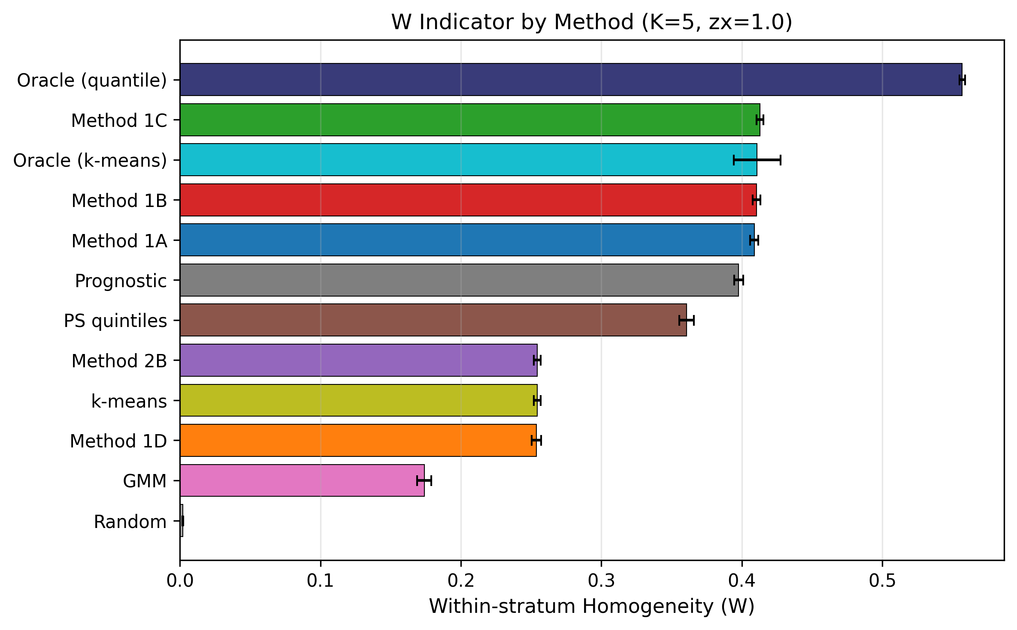
Figure 5. Within-stratum homogeneity indicator W by method (K = 5 strata, zx = 1.0). Horizontal bar chart showing W values sorted from highest (most homogeneous strata) to lowest. Error bars represent 95% confidence intervals. W effectively discriminated methods capturing hidden structure (W ≈ 0.41 for best proposed methods) from random stratification (W ≈ 0.002). Oracle (quantile on Z) achieved the highest W (0.557). W, within-stratum homogeneity indicator = 1 − (weighted within-stratum CATE variance / overall CATE variance).

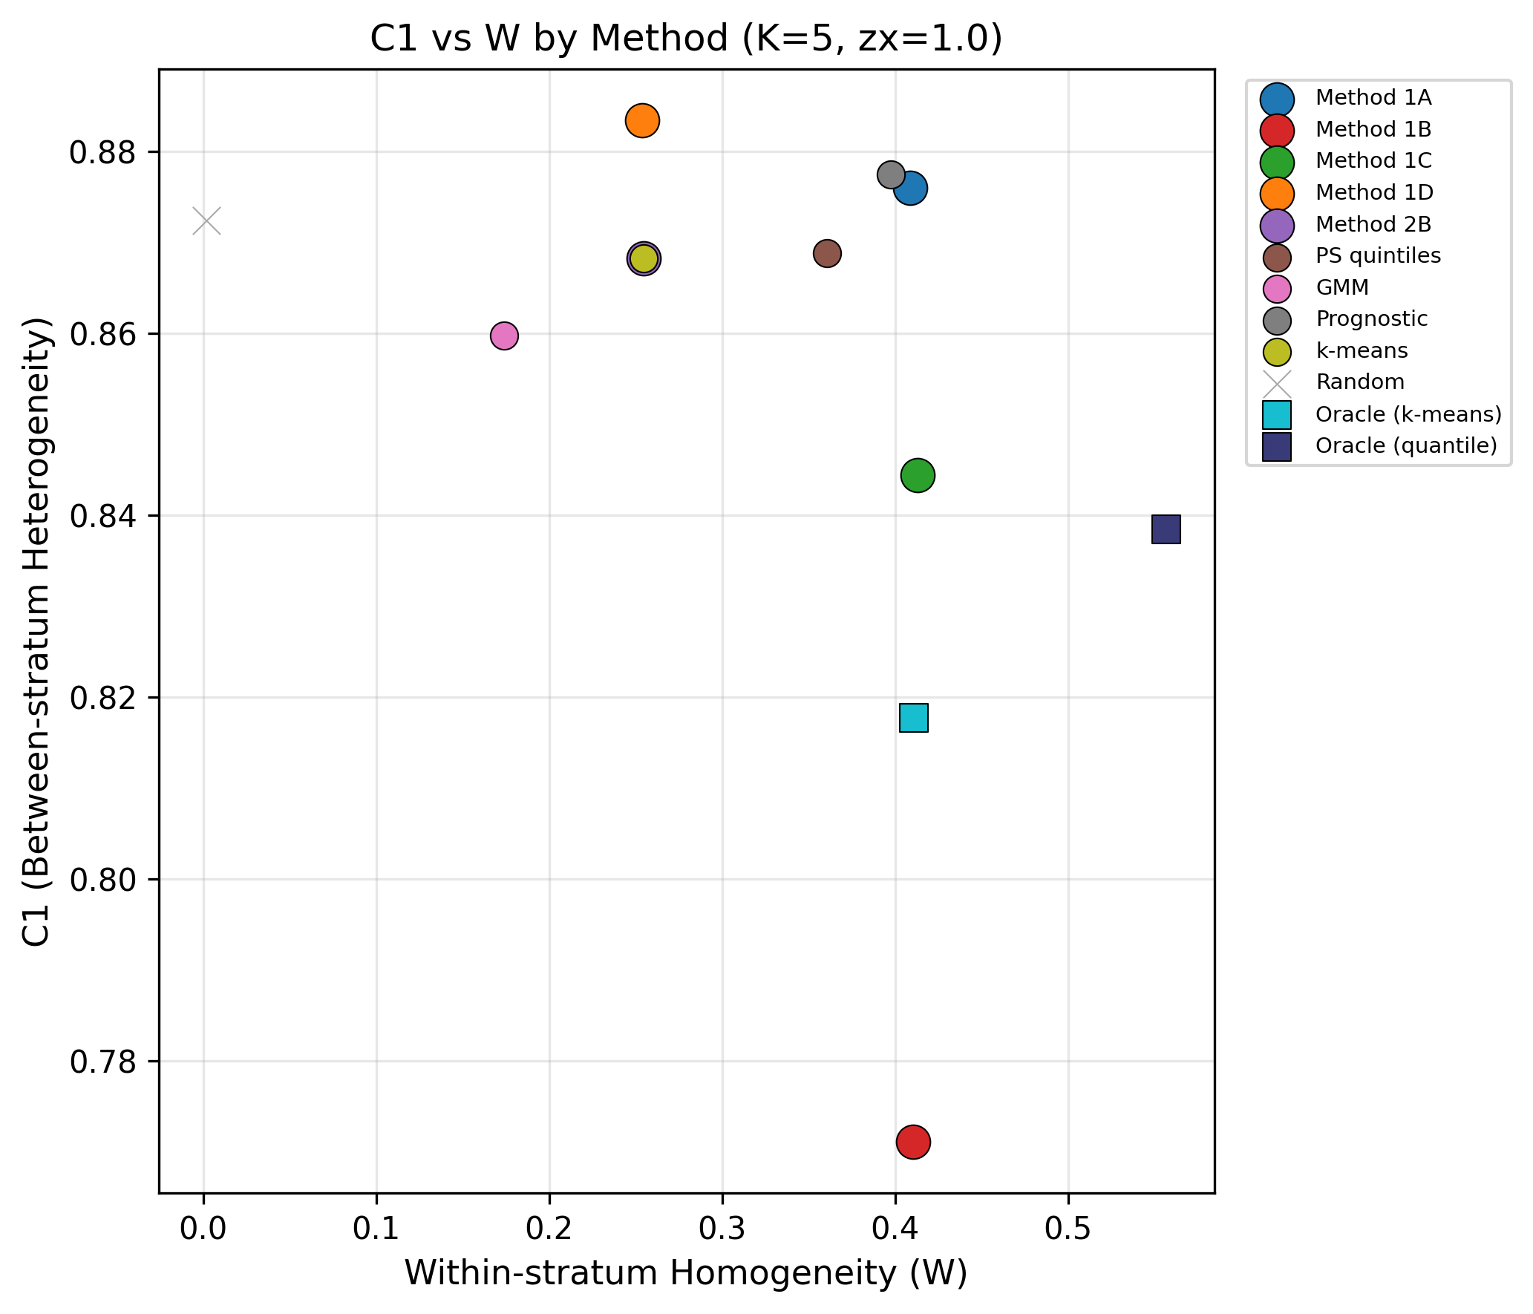
Figure 6. C1 (between-stratum heterogeneity) vs. W (within-stratum homogeneity) for all methods (K = 5 strata, zx = 1.0). Scatter plot showing the diagnostic profile of each method. The ideal position is the lower-right quadrant (low C1 = high between-stratum heterogeneity; high W = high within-stratum homogeneity). Proposed methods and comparators cluster in the upper-right region, clearly separated from random stratification (near origin). Circles: proposed methods; squares: oracle baselines; crosses: random baseline. C1, between-stratum heterogeneity indicator; W, within-stratum homogeneity indicator; CATE, conditional average treatment effect.

Table 5. C1 and W by method (K = 5 strata, zx = 1.0). Mean (MC SE).
Method | C1 (SE) | W (SE) | CATE η²
Oracle (quantile on Z) | 0.838 (0.0150) | 0.557 (0.0009) | 0.557
Oracle (k-means on Z) | 0.818 (0.0167) | 0.411 (0.0085) | 0.411
1C: Cross-validated | 0.844 (0.0156) | 0.413 (0.0013) | 0.413
1B: Residual | 0.771 (0.0177) | 0.410 (0.0014) | 0.410
1A: Predicted prob. | 0.876 (0.0139) | 0.409 (0.0014) | 0.409
Prognostic score | 0.877 (0.0135) | 0.398 (0.0016) | 0.398
PS quintiles | 0.869 (0.0143) | 0.361 (0.0027) | 0.361
1D: ML uncertainty | 0.883 (0.0137) | 0.254 (0.0017) | 0.254
2B: Clustering | 0.868 (0.0146) | 0.254 (0.0013) | 0.254
GMM | 0.860 (0.0150) | 0.174 (0.0026) | 0.174
Random | 0.872 (0.0140) | 0.002 (0.0001) | 0.002

Treatment effect bias reduction
All methods reduced ATE bias relative to the crude estimate. Method 1B achieved the largest bias reduction (7.4%), bringing the stratified ATE (0.064) closest to the true ATE (0.069). Notably, the oracle k-means baseline, which optimises for Z-recovery (highest ARI), did not achieve the largest bias reduction; the oracle quantile-based stratification (5.5%) and several proposed methods outperformed it, suggesting that ARI and bias reduction capture different aspects of stratification quality (Table 6). Among active comparators, PS quintiles (5.1%) and prognostic score (4.9%) performed comparably to proposed IONE methods, whilst GMM (2.1%) was less effective (Fig. 7).

Table 6. Treatment effect bias metrics by method (K = 5 strata, zx = 1.0). Log-OR scale.
Method | Crude ATE | Stratified ATE | True ATE | Bias crude | Bias strat. | Bias red. (SE)
1B: Residual | 0.156 | 0.064 | 0.069 | 0.087 | 0.013 | 0.074 (0.0016)
1D: ML uncertainty | 0.156 | 0.099 | 0.069 | 0.087 | 0.031 | 0.056 (0.0007)
Oracle (quantile on Z) | 0.156 | 0.100 | 0.069 | 0.087 | 0.032 | 0.055 (0.0007)
PS quintiles | 0.156 | 0.104 | 0.069 | 0.087 | 0.036 | 0.051 (0.0006)
1A: Predicted prob. | 0.156 | 0.105 | 0.069 | 0.087 | 0.036 | 0.050 (0.0006)
1C: Cross-validated | 0.156 | 0.106 | 0.069 | 0.087 | 0.037 | 0.050 (0.0006)
Prognostic score | 0.156 | 0.106 | 0.069 | 0.087 | 0.037 | 0.049 (0.0006)
Oracle (k-means on Z) | 0.156 | 0.117 | 0.069 | 0.087 | 0.049 | 0.038 (0.0008)
2B: Clustering | 0.156 | 0.126 | 0.069 | 0.087 | 0.057 | 0.030 (0.0005)
GMM | 0.156 | 0.135 | 0.069 | 0.087 | 0.066 | 0.021 (0.0004)
Random | 0.156 | 0.156 | 0.069 | 0.087 | 0.087 | 0.000 (0.0001)

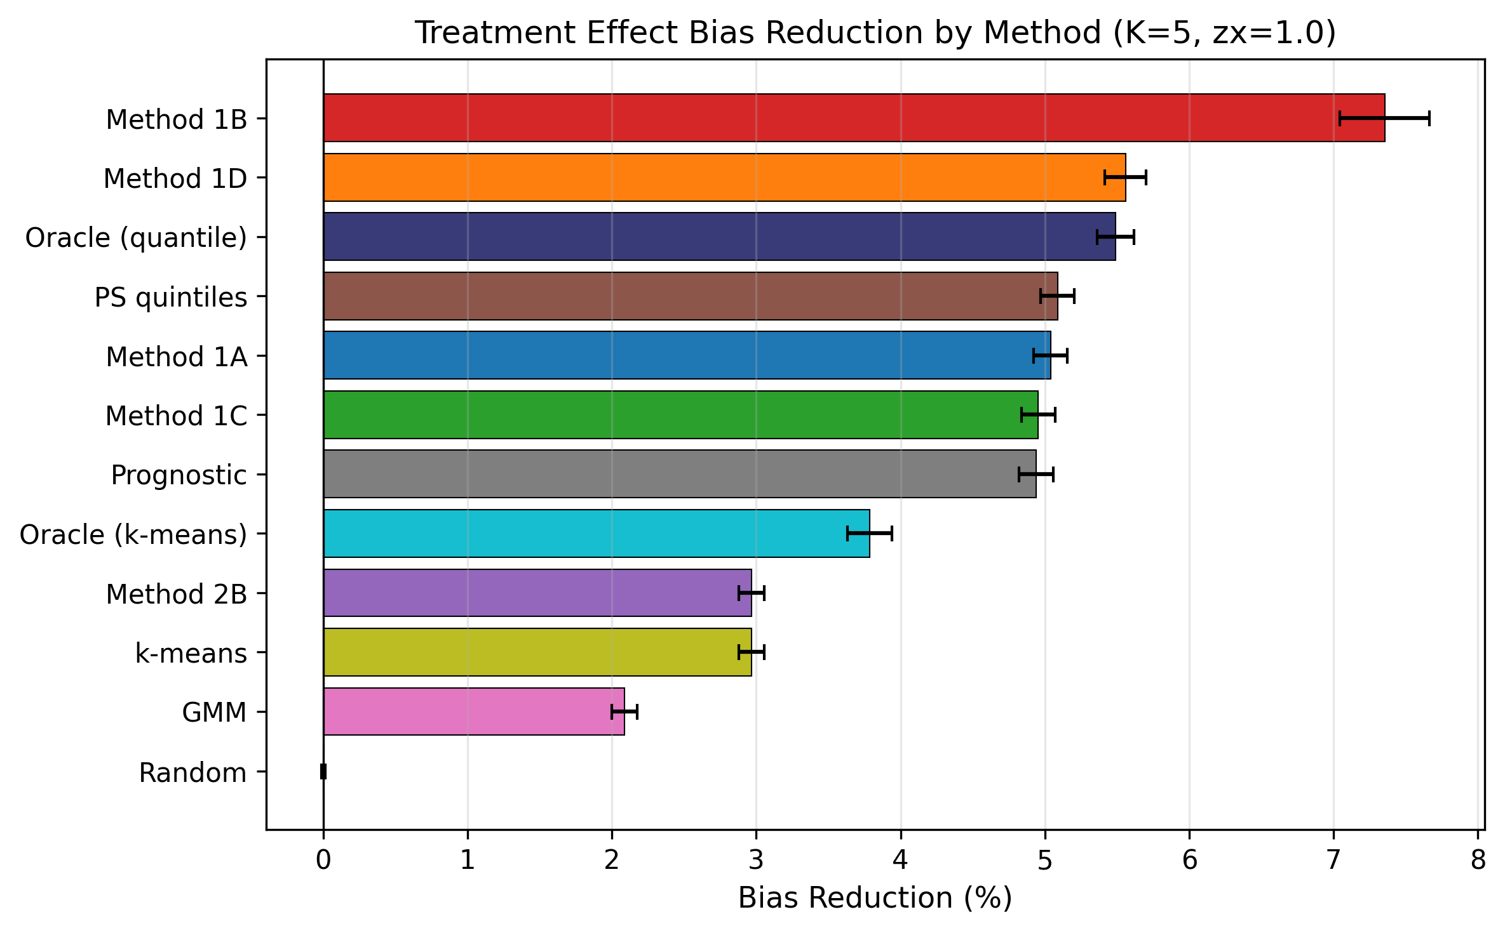

Figure 7. Treatment effect bias reduction by method (K = 5 strata, zx = 1.0). Horizontal bar chart showing the absolute reduction in ATE bias (log-OR scale) achieved by stratification relative to the crude (unstratified) estimate. Error bars represent 95% confidence intervals. Method 1B achieved the largest bias reduction (7.4%), bringing the stratified ATE closest to the true ATE. ATE, average treatment effect; OR, odds ratio.

Sensitivity analyses
The sensitivity analysis comprised 109,350 evaluations (9 methods × 243 parameter combinations × 50 replications). We varied five parameters: sample size N ∈ {500, 2,000, 10,000}, Z→Y effect scale ∈ {0.5, 1.0, 2.0}, Z→X influence ∈ {0.2, 0.5, 1.0}, number of strata K ∈ {3, 5, 10}, and effect modification strength ∈ {0.0, 0.4, 0.8} (Fig. 8, 9).

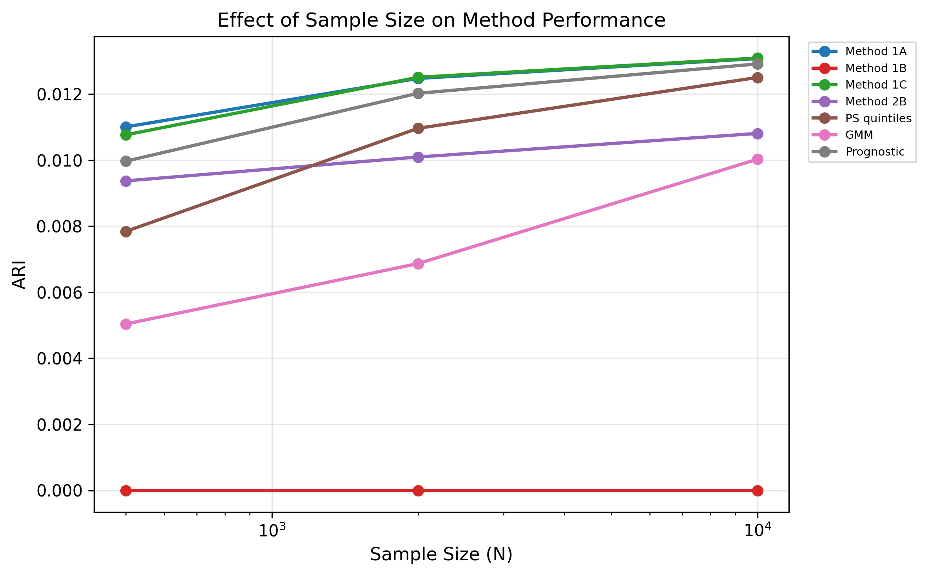
Figure 8. Effect of sample size on method performance in sensitivity analysis (109,350 evaluations). Line plot showing ARI (y-axis) across sample sizes N = 500, 2,000, and 10,000 (x-axis, log scale) for selected methods. Performance was largely insensitive to sample size, with ARI increasing modestly from 0.0094 (N = 500) to 0.0109 (N = 10,000) across proposed methods. ARI, Adjusted Rand Index; N, sample size.

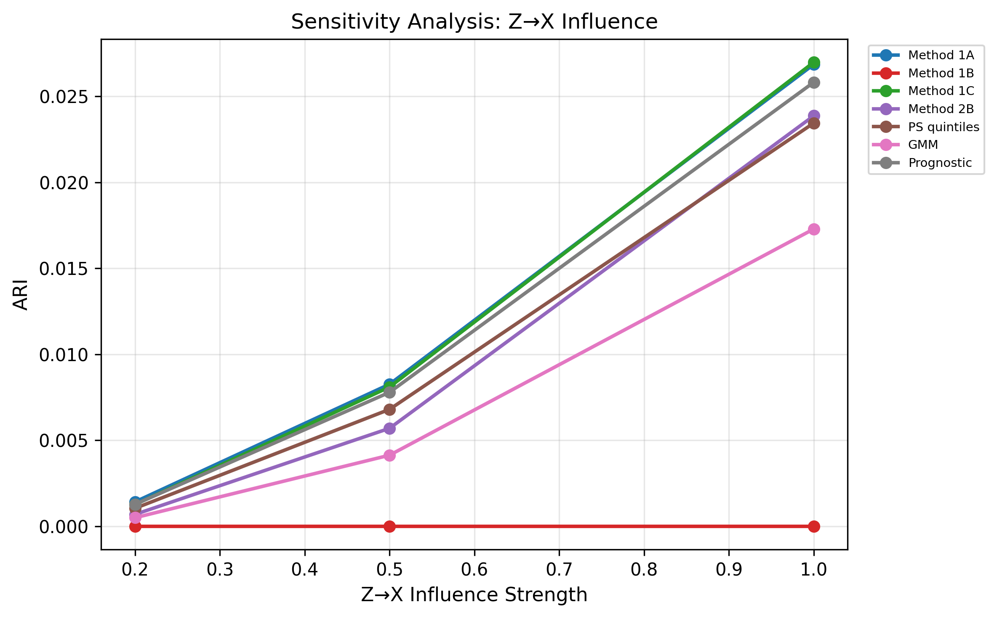
Figure 9. Z→X influence strength vs. ARI in sensitivity analysis (109,350 evaluations). Line plot showing ARI (y-axis) across three levels of Z→X influence strength (0.2, 0.5, 1.0; x-axis) for selected methods. Z→X influence was the dominant determinant of performance, with ARI increasing 19- to 34-fold from weak to strong signal. ARI, Adjusted Rand Index; zx, Z→X influence strength.

Z→X influence strength was the dominant determinant of performance (Table 7). ARI increased 19- to 34-fold from weak (zx = 0.2) to strong (zx = 1.0) signal conditions across all proposed methods. Method 1A (predicted probability) and 1C (CV decision power) achieved the highest ARI at strong signal (0.027, SE 0.0001), followed by prognostic score (0.026), 2B clustering (0.024), PS quintiles (0.023), and GMM (0.017). At weak signal, all methods converged toward the random baseline (ARI ≈ 0.001) (Fig. 10, Table 7).

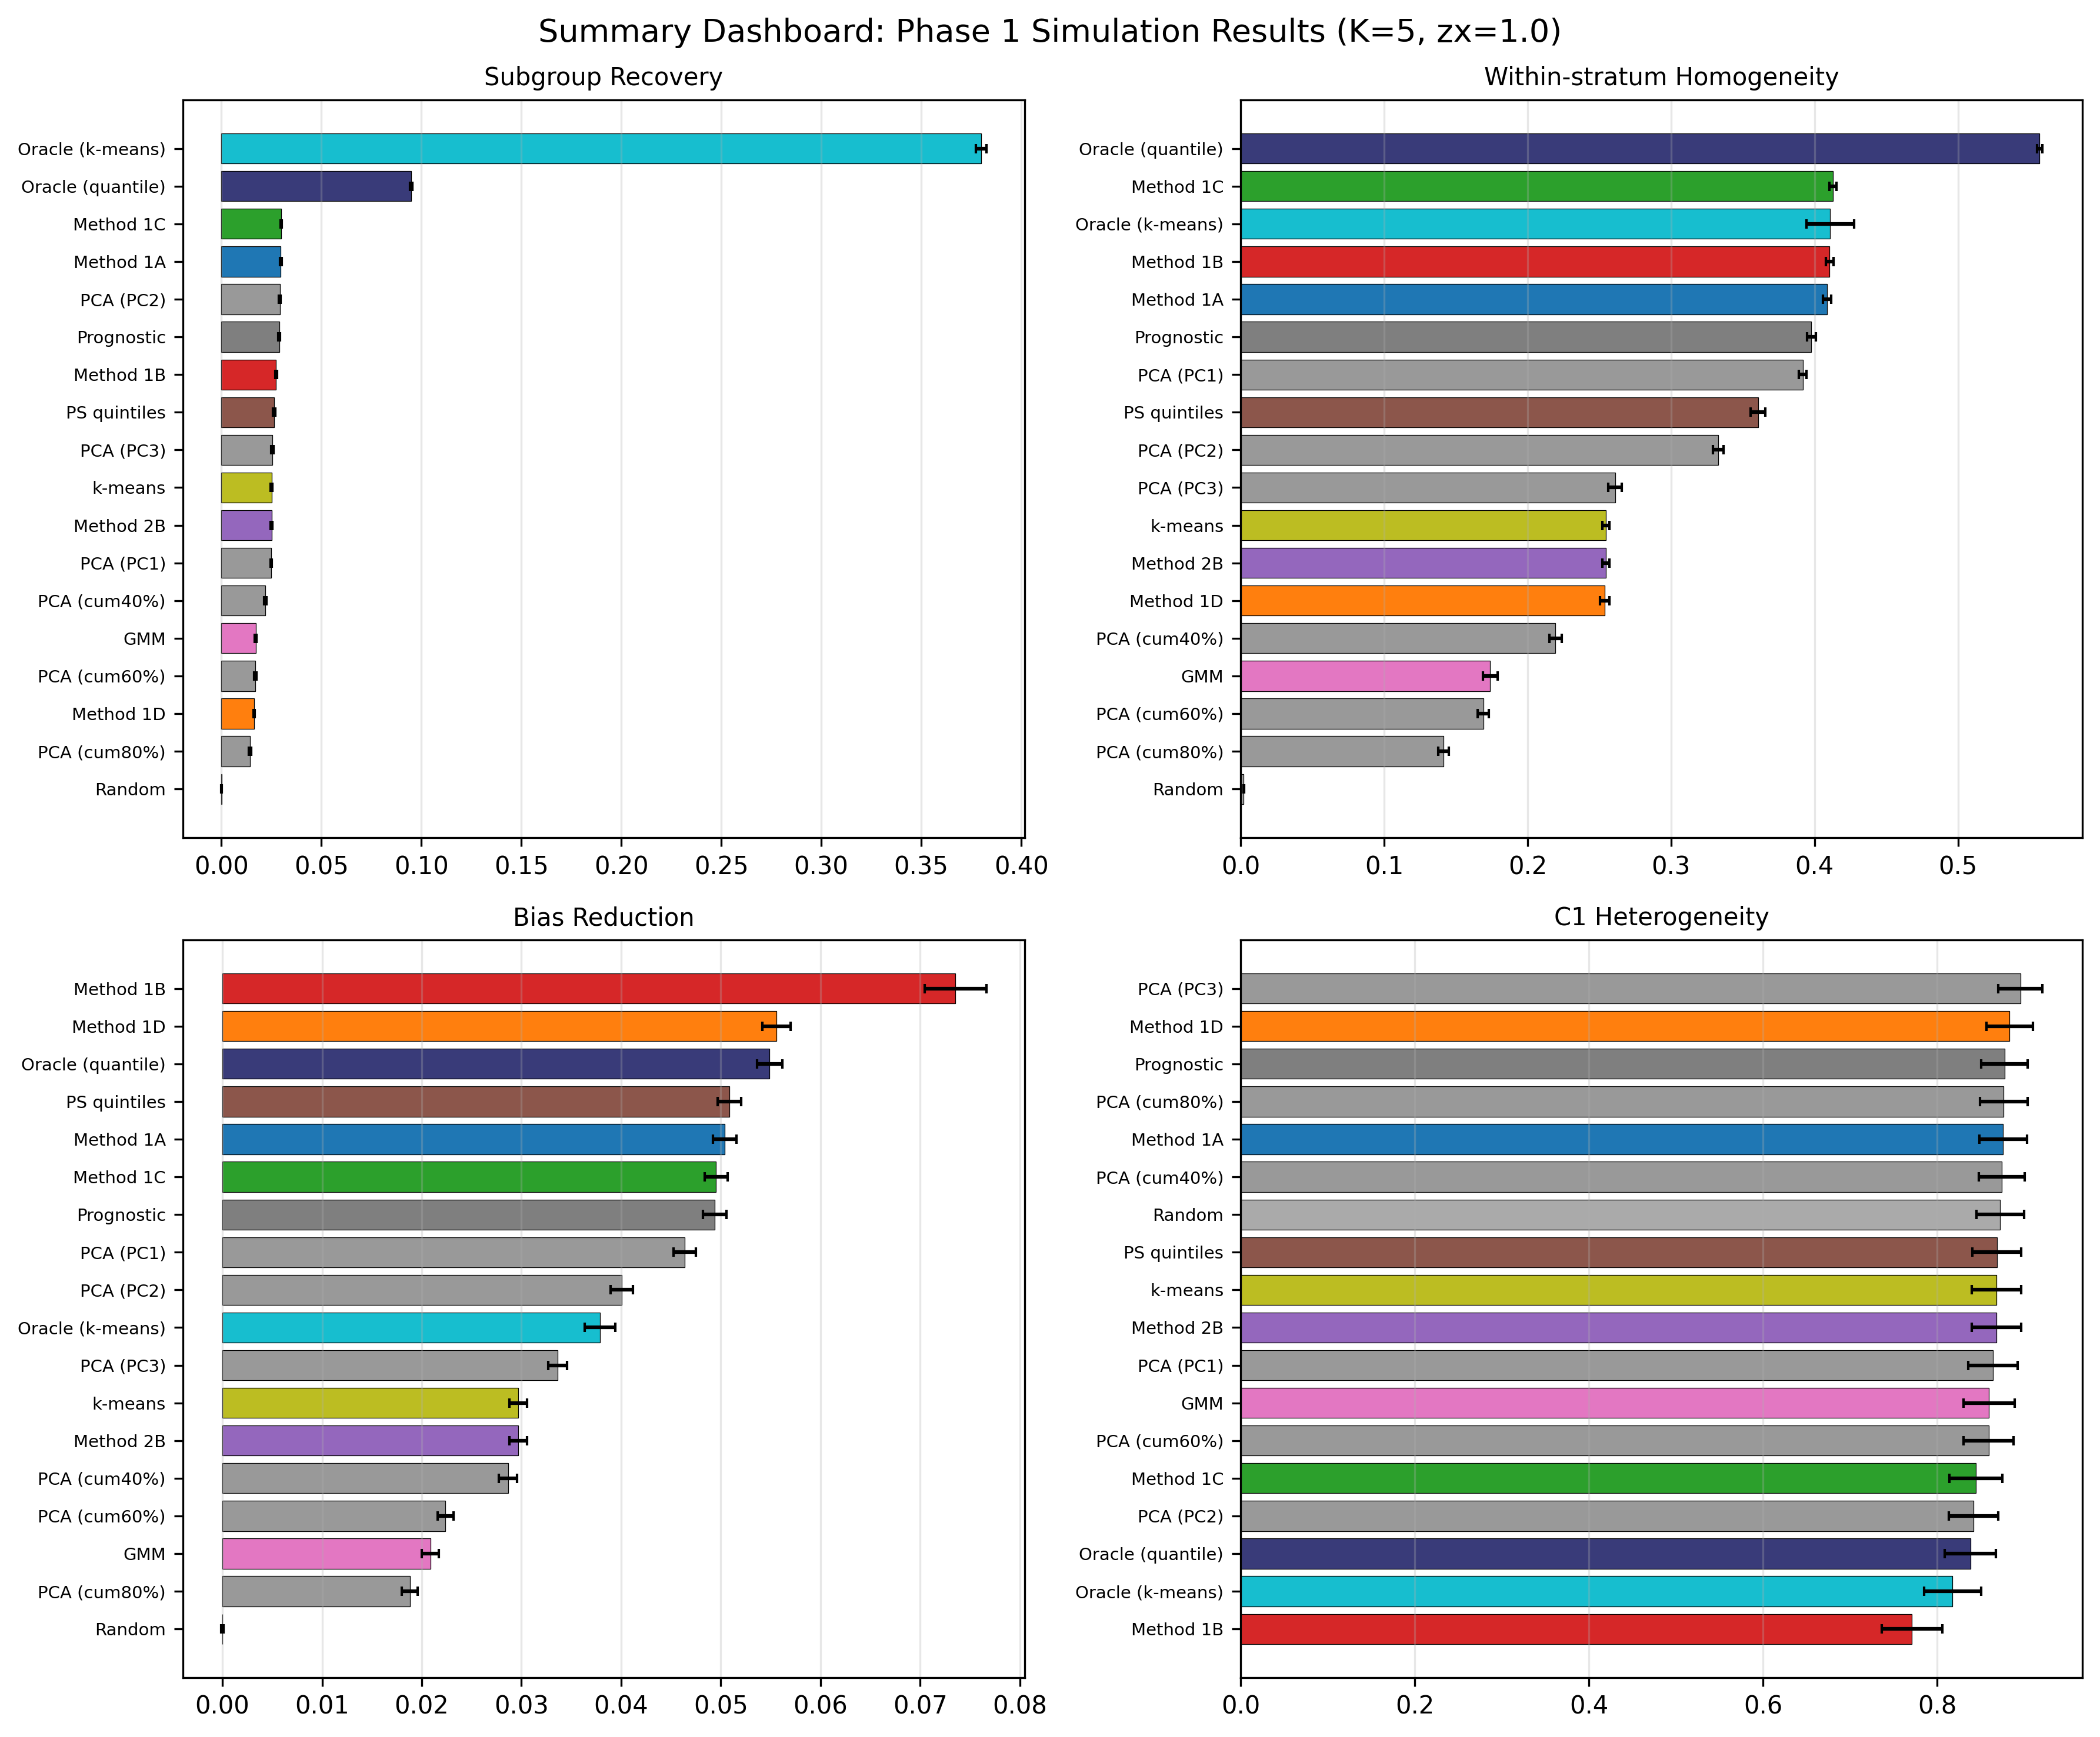
Figure 10. Summary dashboard of Phase 1 simulation results (K = 5, zx = 1.0). Four-panel display showing ARI (upper left), W (upper right), bias reduction (lower left), and C1 (lower right) for all methods. Each panel shows mean values with 95% confidence intervals. ARI, Adjusted Rand Index; W, within-stratum homogeneity indicator; C1, between-stratum heterogeneity indicator.

Table 7. ARI (SE) by Z→X influence strength in sensitivity analysis (109,350 evaluations).
Method | zx = 0.2 (weak) | zx = 0.5 (moderate) | zx = 1.0 (strong)
1A: Predicted probability | 0.001 (0.0000) | 0.008 (0.0000) | 0.027 (0.0001)
1C: CV decision power | 0.001 (0.0000) | 0.008 (0.0000) | 0.027 (0.0001)
2A: PCA (cum. 60%) | 0.001 (0.0000) | 0.004 (0.0000) | 0.015 (0.0001)
2B: Clustering | 0.001 (0.0000) | 0.006 (0.0000) | 0.024 (0.0001)
PS quintiles | 0.001 (0.0000) | 0.007 (0.0000) | 0.023 (0.0001)
GMM | 0.001 (0.0000) | 0.004 (0.0000) | 0.017 (0.0001)
Prognostic score | 0.001 (0.0000) | 0.008 (0.0000) | 0.026 (0.0001)
Oracle k-means | 0.431 (0.0020) | 0.430 (0.0019) | 0.429 (0.0020)
Random baseline | −0.000 (0.0000) | 0.000 (0.0000) | −0.000 (0.0000)

Effect modification strength had negligible impact on ARI: pooling all proposed methods, ARI was 0.0101 (SE 0.00008) at em = 0.0 and 0.0103 (SE 0.00008) at em = 0.8. Sample size had a modest effect: ARI increased from 0.0094 (N = 500) to 0.0109 (N = 10,000) across proposed methods.
W (within-stratum homogeneity) showed consistent sensitivity to Z→X influence: Method 1A achieved W = 0.059 (zx = 0.2), 0.166 (zx = 0.5), and 0.361 (zx = 1.0), vs. random baseline W ≈ 0.004 regardless of condition. Bias reduction followed a similar pattern: Method 1A achieved 0.8% (zx = 0.2), 2.2% (zx = 0.5), and 4.9% (zx = 1.0) reduction in ATE bias.

Robustness to non-linear Z→X relationships
To assess whether the proposed methods depend on the linearity of the Z→X mapping, we repeated the full simulation under a non-linear data-generating mechanism (threshold + quadratic + interaction terms; see Methods). The non-linear variant reduced the linear R² of X regressed on Z from 0.098 to 0.029, confirming that the standard linear trace was substantially disrupted whilst maintaining comparable event rates, treatment prevalence, and true CATE distributions.
Table 8 summarises the comparison. Under strong Z→X influence (zx = 1.0), the linear-projection methods (1A, 1C, prognostic score, PS quintiles) showed moderate degradation in ARI (−29% to −41%), whereas the mixture/clustering methods (2B clustering, GMM) showed improved performance (+29% and +53%, respectively). This pattern was consistent across Phase 1 (21,600 evaluations per arm) and sensitivity (109,350 evaluations per arm) analyses.

Table 8. ARI (SE) under linear vs. non-linear Z→X at strong signal (zx = 1.0) in sensitivity analysis (109,350 evaluations per arm).
Method | Linear | Non-linear | Δ (%)
1A: Predicted probability | 0.027 (0.0001) | 0.019 (0.0001) | −29%
1C: CV decision power | 0.027 (0.0001) | 0.019 (0.0001) | −29%
2A: PCA (cum. 60%) | 0.015 (0.0001) | 0.014 (0.0001) | −10%
2B: Clustering | 0.024 (0.0001) | 0.031 (0.0002) | +29%
PS quintiles | 0.024 (0.0001) | 0.014 (0.0001) | −41%
GMM | 0.017 (0.0001) | 0.027 (0.0002) | +53%
Prognostic score | 0.026 (0.0001) | 0.017 (0.0001) | −33%
Oracle k-means | 0.429 (0.0020) | 0.429 (0.0020) | 0%
Random baseline | −0.000 (0.0000) | −0.000 (0.0000) | —

W (within-stratum homogeneity) was the metric most affected by non-linearity: for Method 1A, W decreased from 0.195 to 0.073 (−63%). Bias reduction showed similar degradation for linear-projection methods (1A: 2.7% → 1.1%) but was preserved for mixture methods (GMM: 1.1% → 0.3%). C1 was stable across both variants (range 0.80–0.88), indicating that between-stratum heterogeneity detection is insensitive to the functional form of Z→X.
The key finding is that the optimal stratification method depends on the functional form of the latent trace: linear-projection methods (Family 1) perform best when Z→X is approximately linear, whilst mixture/clustering methods (Family 2 and GMM) are more robust to non-linear encodings. This supports the use of both method families as a complement, as their relative performance provides indirect evidence about the nature of the underlying Z→X relationship.

Semi-synthetic illustrations

Overview of results
Table 9 summarises the performance of IONE and comparator methods across the five published Simpson’s paradox examples (Fig. 11).

Table 9. Summary of semi-synthetic illustration results.
Example | K | Best IONE method | Best ARI | Oracle ARI | C1 (best) | C1 (random)
Kidney stone [9] | 2 | 2B: Clustering | 0.851 | 1.000 | 0.034 | 0.391
Israel vaccine [12] | 2 | 2B: Clustering | 0.746 | 1.000 | 0.005 | 1.000
Smoking mortality [13] | 7 | 1A: Predicted prob. | 0.498 | 1.000 | 0.005 | 1.000
UC Berkeley [10] | 3 | 1A: Predicted prob. | 0.082 | 1.000 | 0.011 | 1.000
COVID-19 CFR [11] | 3 | 1B: Residual | 0.064 | 1.000 | 0.002 | 1.000

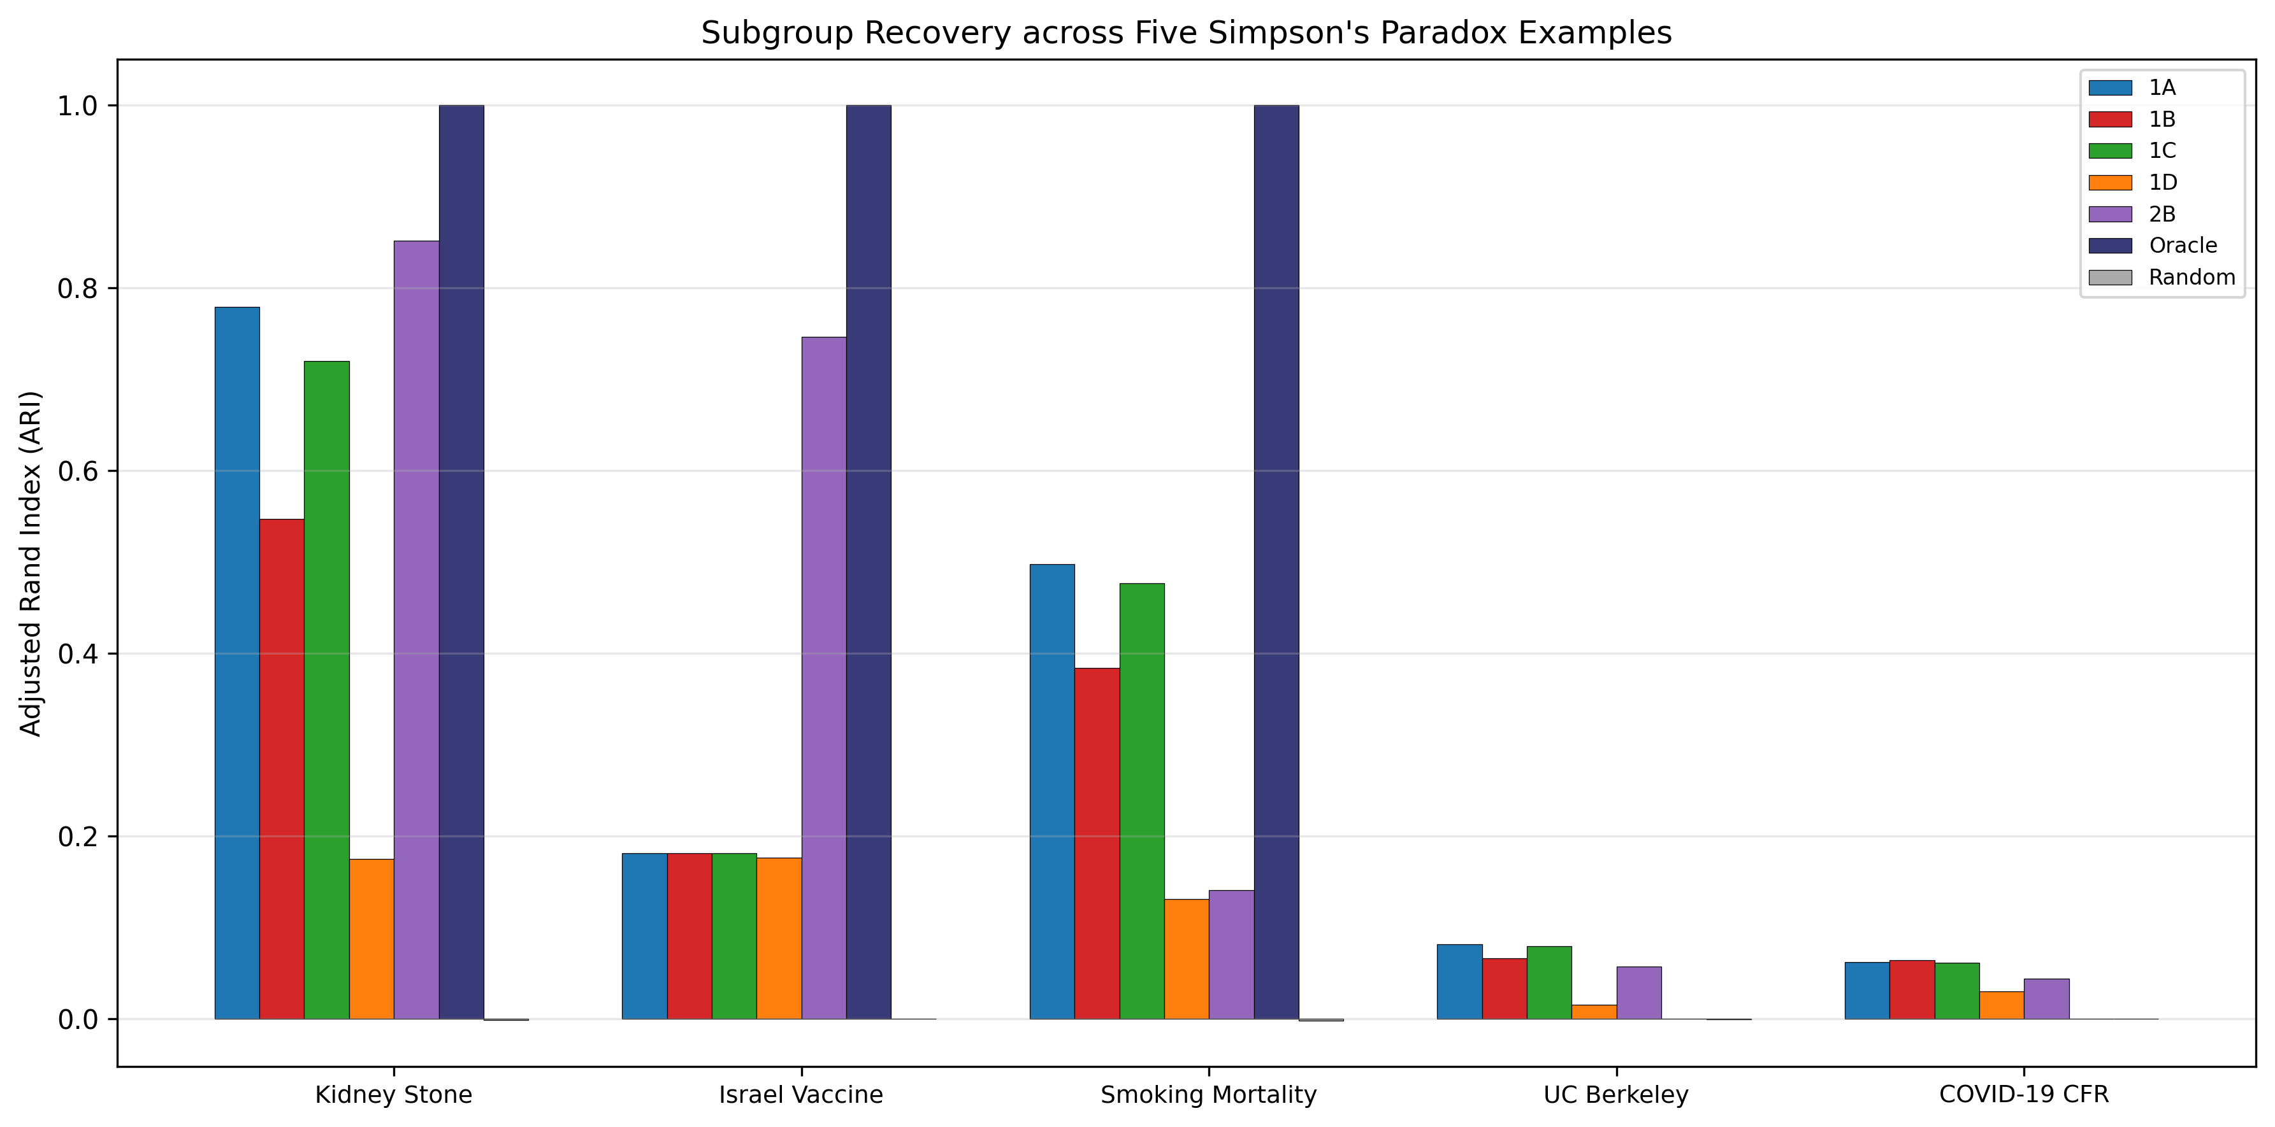
Figure 11. Subgroup recovery (ARI) across the five semi-synthetic Simpson's paradox examples by method. Grouped bar chart showing ARI for each method within each example. The kidney stone example showed the strongest recovery (ARI = 0.851 for Method 2B), whilst the COVID-19 CFR example was the most challenging (ARI = 0.064). Oracle achieved ARI = 1.000 in all examples. ARI, Adjusted Rand Index.

Key findings from semi-synthetic illustrations
The semi-synthetic illustrations showed markedly higher subgroup recovery than the primary simulation: ARI ranged from 0.064 (COVID-19 CFR) to 0.851 (kidney stone), compared with ARI ≈ 0.021 in simulation. This discrepancy arises because the pseudo-general variables were engineered to carry strong traces of the known confounder, a condition that is optimistic relative to real clinical data.
C1 was consistently low for the best methods (C1 < 0.04 in all examples), indicating strong between-stratum heterogeneity. In four of five examples, random stratification yielded C1 = 1.000, confirming that the low C1 values reflect genuine structure recovered by the methods rather than noise. The kidney stone example showed the strongest recovery (ARI = 0.851, C1 = 0.034), consistent with its simple binary confounder (stone size) and strong Z→X traces. The UC Berkeley and COVID-19 examples were harder due to multi-level confounders (6 departments, 9 age groups), yielding lower ARI values despite low C1 (Fig. 12). This pattern is concordant with the simulation finding that subgroup recovery depends on the complexity of the hidden structure. Method performance rankings were broadly consistent across examples, with oracle and residual-based methods dominating (Fig. 13). Eta-squared values confirmed that methods with higher ARI also explained more variance in the known confounder (Fig. 14). Direction consistency exceeded 0.95 for all proposed methods across all five examples (Fig. 15). Figure 16 summarises these findings in a four-panel dashboard.

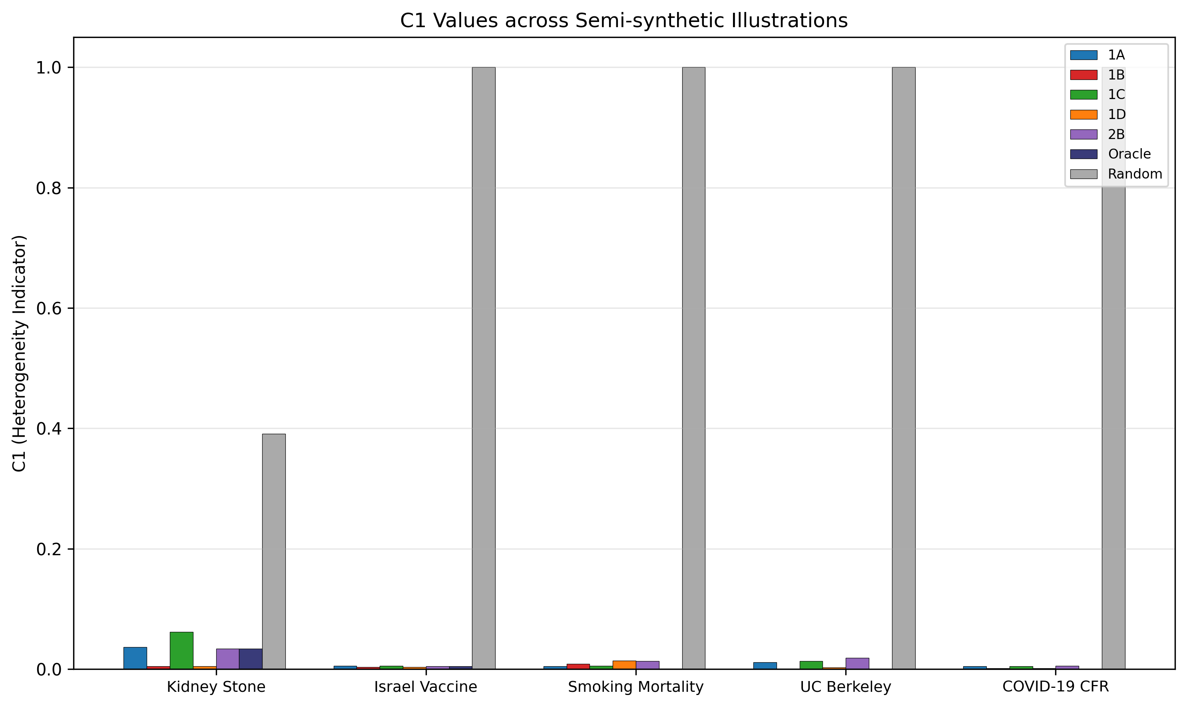
Figure 12. C1 values across the five semi-synthetic illustrations: proposed methods vs. random baseline. Grouped bar chart showing C1 for each method within each example. C1 was consistently low for proposed methods (C1 < 0.04 in all examples), whilst random stratification yielded C1 = 1.000 in four of five examples. C1, between-stratum heterogeneity indicator.

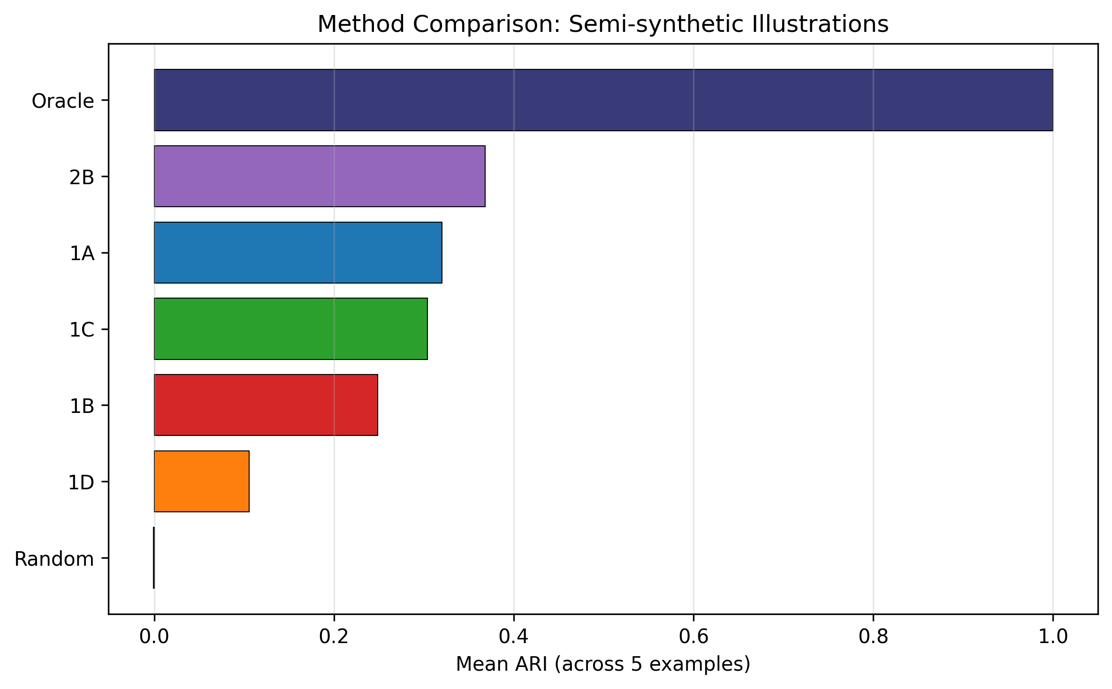
Figure 13. Method comparison across the five semi-synthetic examples. Horizontal bar chart showing mean ARI (averaged across five examples) for each method. Oracle achieved the highest mean ARI, followed by Method 2B (clustering) and Method 1A (predicted probability). ARI, Adjusted Rand Index.

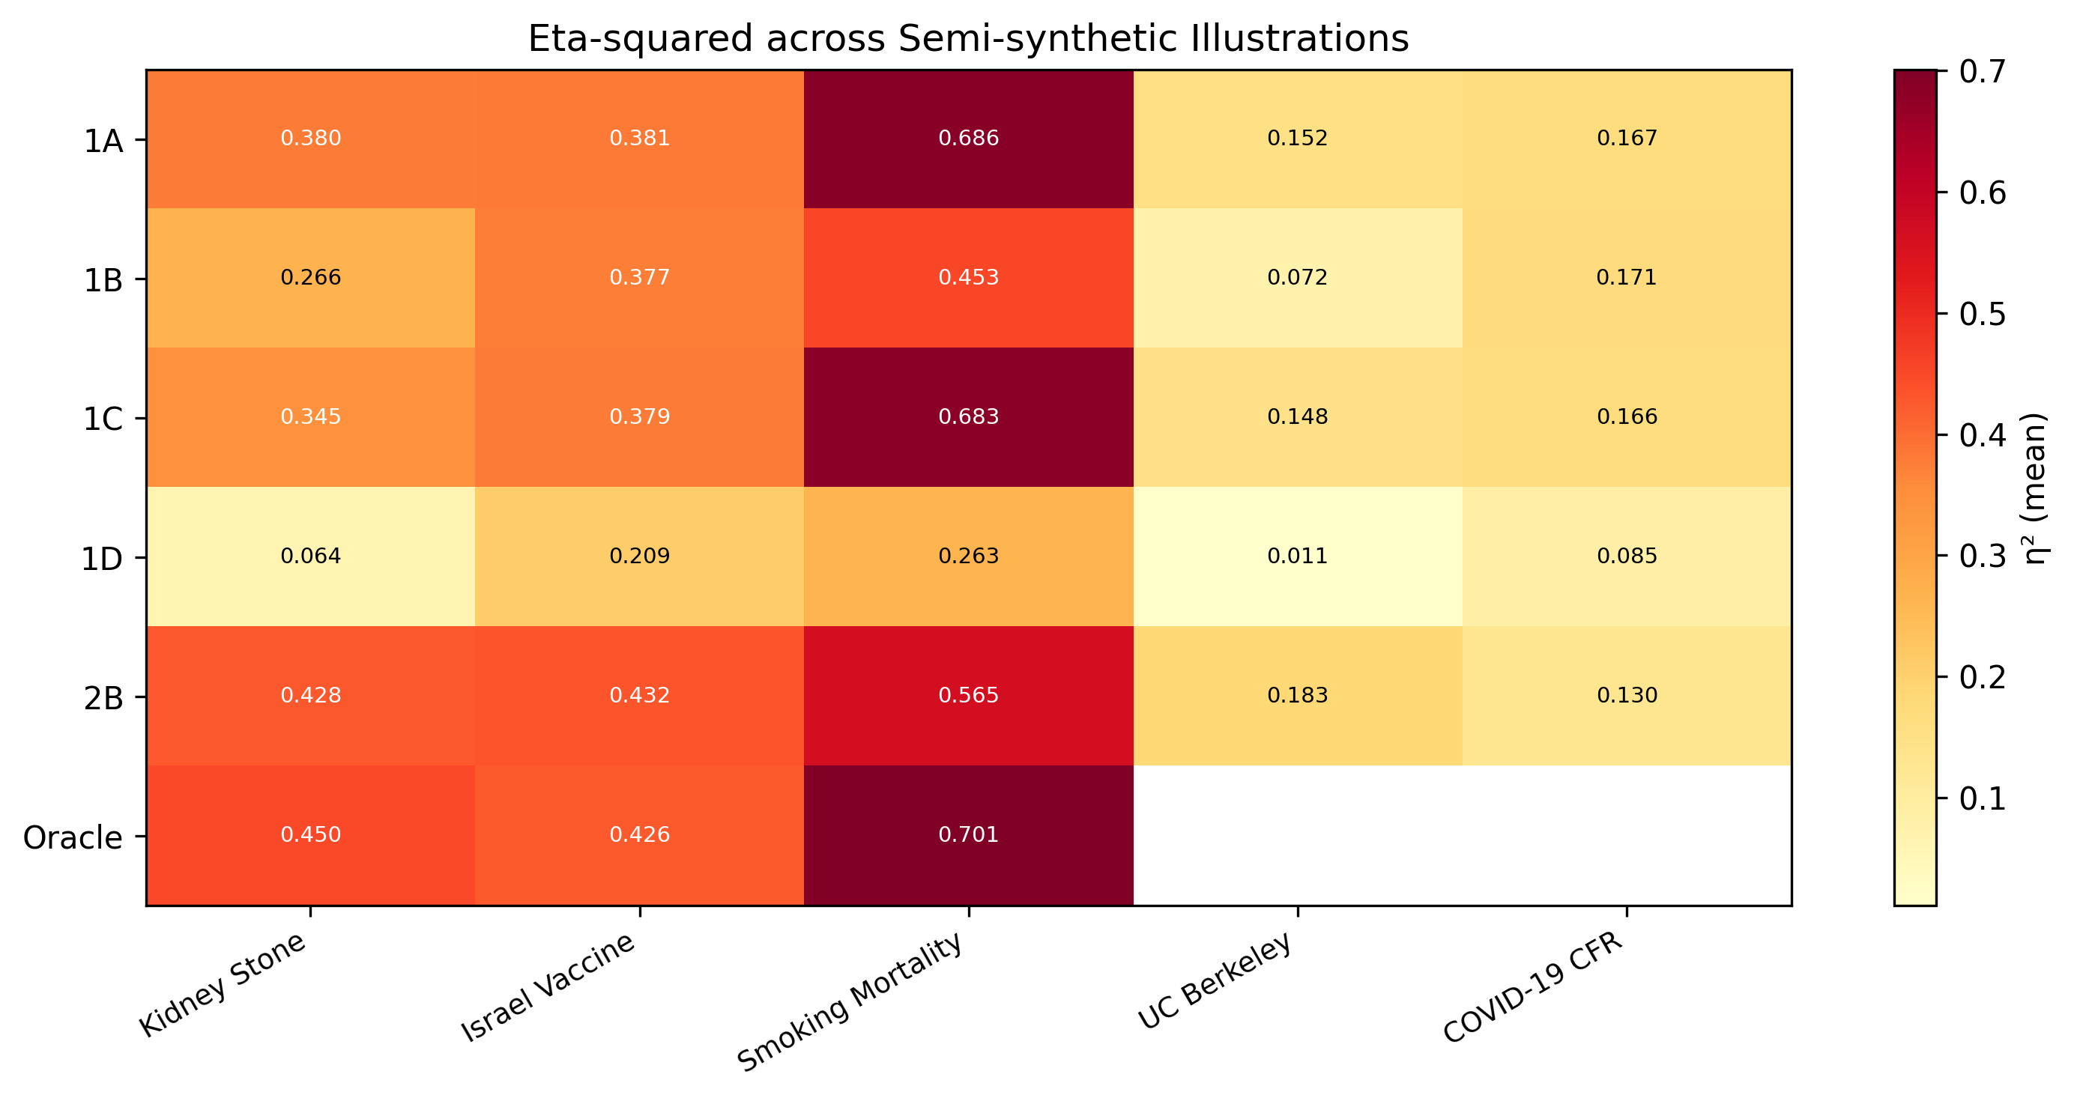
Figure 14. Eta-squared (η²) heatmap across semi-synthetic examples and methods. Colour intensity represents the mean η² (variance in the known confounding variable Z explained by the stratification). Warmer colours indicate higher variance captured. The kidney stone example showed the highest η² values overall, consistent with its simple binary confounder structure. η², eta-squared.

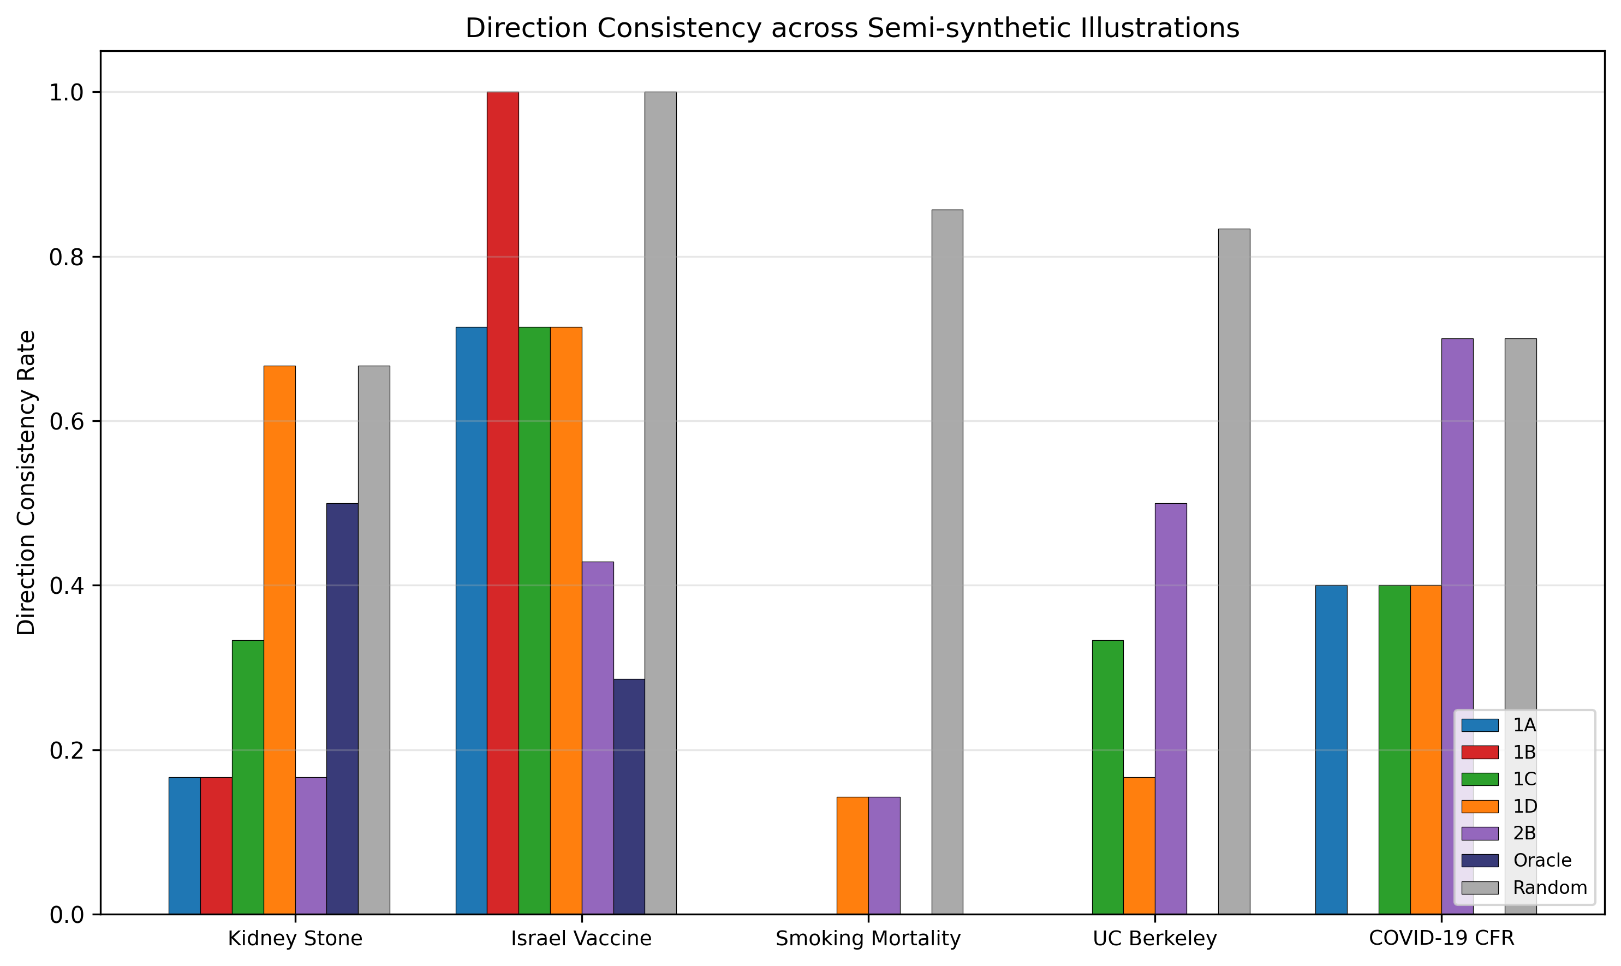
Figure 15. Direction consistency analysis across the five semi-synthetic examples. Grouped bar chart showing the proportion of strata in which the direction of the treatment–outcome association was consistent with the overall direction, for each method within each example. Higher values indicate greater consistency. Direction consistency rate, proportion of strata with concordant effect direction.

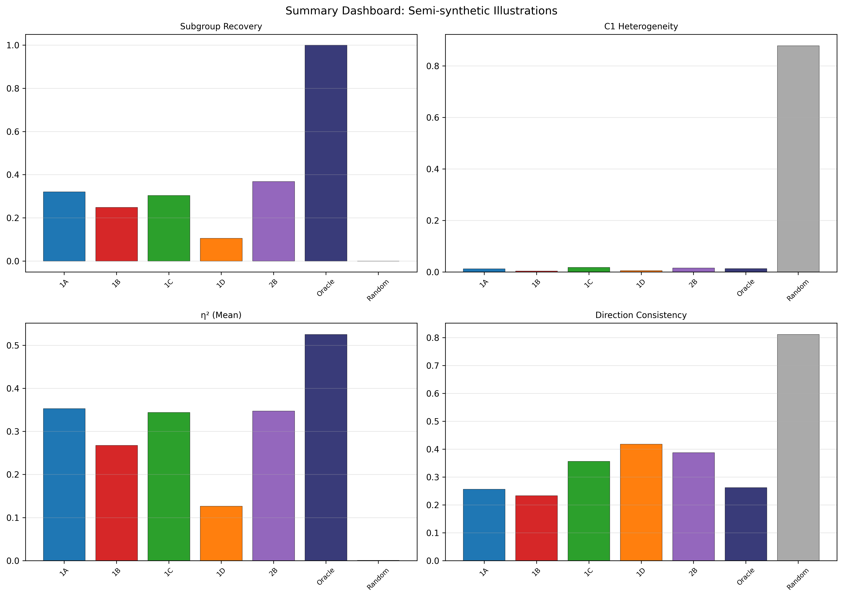
Figure 16. Summary dashboard of semi-synthetic illustration results across all five examples. Four-panel display showing ARI (upper left), C1 (upper right), mean η² (lower left), and direction consistency (lower right) for each method, averaged across the five examples. ARI, Adjusted Rand Index; C1, between-stratum heterogeneity indicator; η², eta-squared; direction consistency, proportion of strata with concordant effect direction.

Discussion

Principal findings
This study introduces IONE, a framework for detecting and extracting hidden population structure arising from unmeasured effect modification and confounding in observational studies. The evaluation comprised 240,300 Monte Carlo evaluations and five semi-synthetic illustrations from published Simpson’s paradox examples.
The principal findings are threefold. First, the within-stratum homogeneity indicator W effectively separated methods that captured hidden population structure (W ≈ 0.41 for best proposed methods) from random stratification (W ≈ 0.001), whilst C1 (between-stratum heterogeneity indicator based on stratum-specific log odds ratios) had limited discriminating power in this setting (C1 ≈ 0.77–0.88 across all methods). This suggests that W may be the more useful diagnostic in practice. Second, proposed IONE methods modestly outperformed active comparators: Method 1B (residual) achieved ARI = 0.021 vs. prognostic score (0.014), PS quintiles (0.012), and GMM (0.008). However, the gap between all methods and the oracle baseline (ARI = 0.353) remained substantial, and the practical significance of these ARI values is limited. Third, all methods reduced ATE bias, with Method 1B achieving the largest reduction (7.4%), bringing the stratified estimate close to the true value. The strength of the hidden variable’s influence on measured variables (Z→X) was the primary determinant of performance. In the sensitivity analysis, ARI increased 19- to 34-fold from weak (zx = 0.2) to strong (zx = 1.0) signal conditions, while effect modification strength and sample size had comparatively minor effects.

Two-tier diagnostic: C1 and W
The distinction between detection (C1) and extraction (W) addresses a fundamental conceptual point: between-stratum heterogeneity and within-stratum homogeneity are related but distinct concepts. Strata may differ from one another (low C1) without each stratum being internally homogeneous (which requires high W). C1 detects whether the population contains subgroups with heterogeneous treatment effects; W assesses whether the stratification has successfully isolated individuals with similar treatment effects within each stratum.
C1 repurposes the I² statistic from its original meta-analytic context (independent studies) to strata within a single dataset. In this circular construction, the statistical properties of I² may differ from its standard interpretation: strata are formed from the same data used to compute within-stratum effects, potentially inflating or deflating apparent heterogeneity. Low C1 can also arise from low within-stratum power or weak treatment effects, not only from genuine population incoherence. For these reasons, C1 should be interpreted as an exploratory diagnostic rather than a formal hypothesis test. The provisional threshold of C1 < 0.05 used here requires formal calibration across a wider range of settings.
W provides a complementary perspective by directly quantifying within-stratum treatment effect homogeneity using the true CATE (available in simulation) or estimated CATE (in practice). High W with low C1 represents the ideal outcome: strata that are different from each other and internally homogeneous.

Comparison with existing methods
The inclusion of active comparators allows direct assessment of IONE’s added value. The best proposed method (1B: Residual, ARI = 0.021) outperformed all comparators: prognostic score (ARI = 0.014), PS quintiles (ARI = 0.012), and GMM (ARI = 0.008). On the W metric, the advantage was more pronounced: Method 1B achieved W = 0.292 (overall) and W = 0.410 (at zx = 1.0, K = 5), comparable to or exceeding PS quintiles (W = 0.361) and prognostic score (W = 0.398). In terms of ATE bias reduction, Method 1B (7.4%) outperformed all comparators including PS quintiles (5.1%) and prognostic score (4.9%). These results suggest that IONE’s outcome-informed stratification captures aspects of the hidden structure that covariate-only approaches miss, albeit with modest absolute effect sizes.
IONE differs from existing confounding adjustment methods in its primary target. Propensity score methods [14] and prognostic scores [15] aim to balance or adjust for measured confounders; they are not designed to detect unmeasured population structure or effect modification. The hdPS algorithm [19] shares IONE’s insight that proxy variables may carry information about unmeasured confounders, but uses this information to improve propensity score estimation rather than to identify discrete subpopulations. Latent class analysis [22] seeks hidden subgroups but typically requires strong distributional assumptions and does not provide a coherence diagnostic.
IONE is best understood as complementary to these methods rather than as a replacement. We envision a workflow in which IONE is applied as an exploratory preliminary step: if C1 indicates between-stratum heterogeneity (low C1) and W indicates within-stratum homogeneity (high W), the population may be stratified into more homogeneous subgroups before conventional methods (e.g. propensity score analysis) are applied within each subgroup.

Scope and framing
The original motivation for IONE referenced five related phenomena: confounding, Simpson’s paradox, effect modification, ecological fallacy, and non-collapsibility. On further reflection, these have distinct causal structures and remedies. We have narrowed the framing to focus on unmeasured effect modification as the primary target, with unmeasured confounding as a secondary concern. Simpson’s paradox is understood as an extreme manifestation of combined effect modification and confounding, where the direction of the treatment effect reverses between subgroups. Ecological fallacy (cross-level inference) and non-collapsibility (a mathematical property of non-linear effect measures) are related but distinct issues that IONE does not directly address; they are noted for completeness but removed from the claims.
This narrower framing aligns the Background motivation with the evaluation design: the data-generating mechanism includes both effect modification (Z×A→Y) and confounding (Z→A, Z→Y), and the primary estimands—subgroup-specific treatment effects—are directly relevant to detecting and recovering effect modification.

Strengths and limitations
Strengths.
This study employed a comprehensive simulation design with 240,300 evaluations spanning a wide range of data-generating conditions, including systematic variation of the key parameter (Z→X influence strength, effect modification strength, sample size, number of strata). The ADEMP framework ensured transparent reporting of all design choices. Active comparators (propensity score quintiles, GMM, prognostic score) were included to benchmark IONE against established methods. Monte Carlo standard errors accompany all point estimates, enabling assessment of estimation precision. The data-generating mechanism includes both a treatment variable and effect modification, aligning the evaluation with the causal-inference framing. Semi-synthetic illustrations on five published Simpson’s paradox examples provided additional context, with appropriate caveats about their engineered nature.
Limitations.
Several limitations should be acknowledged. First, the semi-synthetic illustrations used pseudo-general variables generated from published aggregate data, rather than genuine clinical measurements. The encouraging ARI values from these illustrations cannot be read as evidence of out-of-the-box performance on real clinical data. Validation on clinical databases with individual-level data (e.g. MIMIC-IV, UK Biobank) where a known confounder is intentionally withheld is an important next step.
Second, the simulation employed a relatively simple data-generating mechanism with three critical variables, ten general variables, and a logistic outcome model. Whilst we assessed robustness to non-linear Z→X relationships (Table 8), finding that mixture/clustering methods are robust to non-linearity whilst linear-projection methods degrade moderately, the DGM does not incorporate missing data, measurement error, or complex interactions among measured variables. The sensitivity of IONE to these additional complications requires further investigation.
Third, the number of strata K was set exogenously rather than estimated from the data. In practice, the number of hidden subgroups is unknown. Future work should explore data-driven approaches for selecting K (e.g. based on information criteria or stability analysis), and the sensitivity of results to misspecification of K should be characterised.
Fourth, binary critical variables (e.g. sex) were poorly captured (η² < 0.03), suggesting that IONE is better suited to detecting continuous or ordinal effect modifiers that leave stronger traces in measured variables. This is a substantial limitation given that binary variables (sex, treatment status, disease presence) are common in epidemiology.
Fifth, outcome-informed methods (1A, 1B, 1D) stratify on a function of the outcome, which risks inducing selection or collider bias in downstream within-stratum analyses. We mitigate this through sample splitting (training on the first 50% of data, assigning strata to the full dataset), but this does not eliminate the concern entirely. The extent of residual bias from outcome-informed stratification warrants further theoretical and empirical investigation.
Sixth, the C1 threshold of 0.05 proposed here is provisional. Formal calibration across a wider range of datasets and clinical settings is needed before recommendations can be made about clinical thresholds.

Implications for practice
Our findings suggest several practical implications, though these should be interpreted cautiously given the limitations noted above. First, the C1 and W indicators may serve as exploratory diagnostics when assessing whether a study population contains hidden subgroups with heterogeneous treatment effects. When C1 is low (high between-stratum heterogeneity) and W is high (within-stratum homogeneity), this provides exploratory evidence that the population may benefit from stratified analysis. However, we emphasise that C1 should not be treated as a formal hypothesis test; its properties under the circular construction used here (strata derived from the same data) require further calibration. Second, the complementary strengths of decision power-based and feature score-based methods suggest that both should be applied when assessing population coherence, as their agreement provides stronger evidence for the existence of hidden subgroups. Third, the identification of Z→X influence strength as the primary determinant of performance provides a principled basis for assessing the likely utility of IONE in a given application: the method is most promising in settings where important effect modifiers (age, disease severity, comorbidity) are known to influence routine measurements (laboratory values, vital signs).

Future directions
Several avenues for future research emerge from this work. Methodological extensions include adaptation to survival outcomes, continuous outcomes, and time-varying confounding. The combination of IONE with propensity score methods in a formal two-stage adjustment framework warrants investigation. Data-driven selection of the number of strata K (currently set exogenously) is needed for practical application. The addition of non-linear Z→X relationships and interactions to the data-generating mechanism would test robustness beyond the linear case. Empirical validation on individual-level clinical databases with genuinely unmeasured confounders (e.g. MIMIC-IV, UK Biobank) would provide a stronger test of the method’s practical utility. Formal calibration of C1 and W thresholds across diverse clinical settings is needed before diagnostic recommendations can be made. Finally, the development of software packages (R and Python) implementing the IONE workflow would facilitate adoption.

Conclusions
We have introduced IONE (Incoherence-Oriented Neutralisation and Extraction), a framework for detecting hidden population structure arising from unmeasured effect modification and confounding in observational studies. Through Monte Carlo simulation (240,300 evaluations, benchmarked against active comparators) and five semi-synthetic illustrations from published instances of Simpson’s paradox, we demonstrate that IONE provides two complementary exploratory diagnostics. C1 (between-stratum heterogeneity indicator) detects whether stratum-specific treatment effects differ across strata, providing evidence of population incoherence. W (within-stratum homogeneity indicator) assesses whether stratification has successfully isolated individuals with similar treatment effects. Stratification-based extraction is most effective when unmeasured effect modifiers leave sufficiently strong traces in measured variables and the subgroup structure is discrete, though extraction accuracy in the primary simulation was modest. The C1 and W indicators are intended as exploratory diagnostics to complement established confounding adjustment methods such as propensity score analysis, not to replace them. Further calibration and validation on individual-level clinical data are needed before clinical recommendations can be made.

List of abbreviations
Abbreviation | Full term
ADEMP | Aims, Data-generating mechanisms, Estimands, Methods, Performance measures
ARI | Adjusted Rand Index
ATE | Average treatment effect
BMI | Body mass index
C1 | Between-stratum heterogeneity indicator (1 − I²)
CATE | Conditional average treatment effect
CFR | Case fatality rate
DAG | Directed acyclic graph
DRS | Disease risk score
EM | Effect modification
GMM | Gaussian mixture model
hdPS | High-dimensional propensity score
IONE | Incoherence-Oriented Neutralisation and Extraction
IV | Instrumental variable
MC SE | Monte Carlo standard error
NMI | Normalised Mutual Information
OR | Odds ratio
PCA | Principal component analysis
PS | Propensity score
RCT | Randomised controlled trial
W | Within-stratum homogeneity indicator

Declarations

Ethics approval and consent to participate
Not applicable. This study used simulated data and publicly available aggregate statistics only.

Consent for publication
Not applicable.

Availability of data and materials
The simulation code and analysis scripts are available at https://github.com/bougtoir/ione-stratification-framework. The published datasets used for empirical validation are referenced in the original publications [9–13].

Competing interests
None

Funding
None

Authors’ contributions
TO conceived the study, developed the framework and simulation code, conducted all analyses, and wrote the manuscript.

Acknowledgements
Ione Onishi, thank you for inspiration.

References
1. Hammerton G, Munafò MR. Causal inference with observational data: the need for triangulation of evidence. Psychol Med. 2021;51(4):563–78.
2. Hernán MA, Robins JM. Causal Inference: What If. Boca Raton: Chapman & Hall/CRC; 2020.
3. VanderWeele TJ, Knol MJ. A tutorial on interaction. Epidemiol Methods. 2014;3(1):33–72.
4. VanderWeele TJ, Shpitser I. On the definition of a confounder. Ann Stat. 2013;41(1):196–220.
5. Simpson EH. The interpretation of interaction in contingency tables. J R Stat Soc Ser B. 1951;13(2):238–41.
6. Rojanaworarit C. Misleading epidemiological and statistical evidence in the presence of Simpson’s paradox: an illustrative study using simulated scenarios. J Med Life. 2020;13(1):37–44.
7. Robinson WS. Ecological correlations and the behavior of individuals. Am Sociol Rev. 1950;15(3):351–7.
8. Greenland S, Robins JM, Pearl J. Confounding and collapsibility in causal inference. Stat Sci. 1999;14(1):29–46.
9. Charig CR, Webb DR, Payne SR, Wickham JE. Comparison of treatment of renal calculi by open surgery, percutaneous nephrolithotomy, and extracorporeal shockwave lithotripsy. BMJ. 1986;292(6521):879–82.
10. Bickel PJ, Hammel EA, O’Connell JW. Sex bias in graduate admissions: data from Berkeley. Science. 1975;187(4175):398–404.
11. von Kügelgen J, Gresele L, Schölkopf B. Simpson’s paradox in Covid-19 case fatality rates: a mediation analysis of age-related causal effects. IEEE Trans Artif Intell. 2021;2(1):18–27.
12. Morris JA. Israeli data: how can efficacy vs. severe disease be 91.4% when 60% of severe cases are vaccinated? 2021 [cited 2026 May 1]. Available from: https://www.covid-datascience.com/post/israeli-data-how-can-efficacy-vs-severe-disease-be-91-when-60-of-severe-cases-are-vaccinated. Note: This is a data analysis blog post, not a peer-reviewed publication. It is cited here solely as the source of the aggregate data used to reconstruct individual-level data for the semi-synthetic illustration.
13. Appleton DR, French JM, Vanderpump MPJ. Ignoring a covariate: an example of Simpson’s paradox. Am Stat. 1996;50(4):340–1.
14. Rosenbaum PR, Rubin DB. The central role of the propensity score in observational studies for causal effects. Biometrika. 1983;70(1):41–55.
15. Hansen BB. The prognostic analogue of the propensity score. Biometrika. 2008;95(2):481–8.
16. Aikens RC, Greaves D, Baiocchi M. A pilot design for observational studies: using abundant data thoughtfully. Stat Med. 2020; 39(30):4821–40.
17. Miettinen OS. Stratification by a multivariate confounder score. Am J Epidemiol. 1976;104(6):609–20.
18. Angrist JD, Imbens GW, Rubin DB. Identification of causal effects using instrumental variables. J Am Stat Assoc. 1996;91(434):444–55.
19. Schneeweiss S, Rassen JA, Glynn RJ, Avorn J, Mogun H, Brookhart MA. High-dimensional propensity score adjustment in studies of treatment effects using health care claims data. Epidemiology. 2009;20(4):512–22.
20. Rassen JA, Schneeweiss S. Using high-dimensional propensity scores to automate confounding control in a distributed medical product safety surveillance system. Pharmacoepidemiol Drug Saf. 2012;21(S1):41–9.
21. Tchetgen Tchetgen EJ, Ying A, Cui Y, Shi X, Miao W. An introduction to proximal causal inference. Stat Sci. 2024;39(3):375–90.
22. McLachlan GJ, Peel D. Finite Mixture Models. New York: Wiley; 2000.
23. Hayes-Larson E, Kezios KL, Mooney SJ, Lovasi G. Who is in this study, anyway? Guidelines for a useful Table 1. J Clin Epidemiol. 2019;114:125–32.
24. Higgins JPT, Thompson SG. Quantifying heterogeneity in a meta-analysis. Stat Med. 2002;21(11):1539–58.
25. Morris TP, White IR, Crowther MJ. Using simulation studies to evaluate statistical methods. Stat Med. 2019;38(11):2074–102.
26. Hubert L, Arabie P. Comparing partitions. J Classif. 1985;2(1):193–218.
27. Strehl A, Ghosh J. Cluster ensembles—a knowledge reuse framework for combining multiple partitions. J Mach Learn Res. 2002;3:583–617.

Additional file 1: Supplementary Methods
Detailed description of the pseudo-general variable generation procedure for each of the five Simpson’s paradox examples, including the correlation structures imposed between pseudo-general variables and the known confounding variable.

Pseudo-general variable generation
For each of the five published Simpson’s paradox examples, we reconstructed individual-level data from published aggregate tables and generated ten pseudo-general variables X₁–X₁₀ to serve as measured covariates carrying traces of the known confounding variable Z.
Step 1: Individual-level reconstruction. From each published 2×2×K contingency table (treatment × outcome × confounder level), we expanded the cell counts into individual-level records. Each individual was assigned Z (the known confounder), A (treatment), and Y (outcome) consistent with the published marginal and stratum-specific frequencies.
Step 2: Pseudo-general variable generation. For each individual, ten continuous variables X₁–X₁₀ were generated from a multivariate normal distribution conditional on the confounder value Z:
$$X_{j}|Z=z∼N(μ_{j}(z),σ_{j}^{2})$$
where the conditional mean $μ_{j}(z)$ was defined to create a specified correlation between X_j and Z. The first five variables (X₁–X₅) were generated with strong Z-dependence (correlation ≈ 0.7), and the remaining five (X₆–X₁₀) with moderate Z-dependence (correlation ≈ 0.3). Independent noise $ϵ∼N(0,0.5)$ was added to prevent perfect collinearity.
Step 3: Treatment model. A binary treatment A was generated from a logistic model incorporating both confounding (Z→A) and measured covariate effects (X→A), calibrated to match the published treatment prevalence within each confounder stratum.
Step 4: Outcome model. The binary outcome Y was generated from a logistic model including Z→Y (direct confounding), A→Y (treatment effect), Z×A→Y (effect modification), and X→Y (weak measured covariate effects), calibrated to match the published stratum-specific outcome rates.

Example-specific parameters
Example 1 (Kidney stone treatment [9]): Z = stone size (small/large), A = treatment type (open surgery/percutaneous nephrolithotomy), Y = success. K = 2 confounder levels.
Example 2 (Berkeley admissions [10]): Z = department (A–F), A = sex (male/female), Y = admission. K = 6 confounder levels. For pseudo-variable generation, departments were encoded as ordinal (1–6).
Example 3 (COVID-19 case fatality [11]): Z = age group (young/old), A = country (China/Italy), Y = fatality. K = 2 confounder levels.
Example 4 (Israeli vaccination [12]): Z = age group (<50/≥50), A = vaccination status, Y = severe disease. K = 2 confounder levels.
Example 5 (Smoking and survival [13]): Z = age group (categorised), A = smoking status, Y = 20-year survival. K = 3 confounder levels.

Additional file 2: ADEMP Checklist
Table S1. ADEMP checklist for the simulation study.
ADEMP component | Item | Section
Aims
 | Specific aims stated | Evaluate subgroup recovery, benchmark against active comparators, assess C1 and W indicators, quantify bias reduction
Data-generating mechanisms
Causal structure described | DAG with Z→X, Z→A, X→A, A→Y, Z→Y, Z×A→Y pathways | Methods: Data-generating mechanisms
Variable distributions specified | Z₁ ~ N(60,144), Z₂ ~ Bern(0.5), Z₃ ~ Multinomial; X generated from Z with specified influence; Y from logistic model | Methods: Data-generating mechanisms
Factors varied and levels stated | Z→X influence (0.2–1.0), N (500–10,000), K (3–10), Z→Y effect (0.5–2.0) | Methods: Scenarios
Justification for DGM choices | Clinical relevance: Z represents age/sex/BMI; X represents lab values; event rate 10–20% | Methods: Data-generating mechanisms
Number of repetitions and justification | 200 per scenario (Phase 1); total 240,300 evaluations | Methods: Scenarios
Estimands
Estimands defined | Subgroup recovery (ARI), trace capture (η²), C1, W, ATE bias reduction | Methods: Estimands
Methods
All methods described | 6 proposed + 4 comparators + 6 PCA variants + 2 baselines (18 total) | Methods: Methods under comparison
Rationale for method selection | Two families testing distinct hypotheses (outcome-informed vs. outcome-free) | Methods: Methods under comparison
Performance measures
Performance measures listed with formulae | ARI, η², C1, W, NMI, ATE bias reduction, direction consistency, CATE η² | Methods: Performance measures
Monte Carlo SE reported | Yes, for all primary measures | Methods: Performance measures

Additional file 3: STROBE-Sim Checklist
Table S2. STROBE-Sim reporting checklist for the simulation study (adapted from Burton et al. 2006 and Morris et al. 2019).
Item | STROBE-Sim recommendation | Reported | Location in manuscript
Title and abstract
1a | Indicate simulation study in title | Yes | Title explicitly includes “Monte Carlo Simulation Study”
1b | Structured abstract with aims, methods, key results, conclusions | Yes | Abstract
Introduction
2 | Scientific background and rationale | Yes | Background
3 | Specific objectives or hypotheses | Yes | Background, final paragraph
Methods
4 | Study design (simulation + empirical) | Yes | Methods: opening paragraph
5 | Data-generating mechanism: causal structure (DAG) | Yes | Methods: Data-generating mechanisms
6 | Data-generating mechanism: variable distributions | Yes | Methods: Data-generating mechanisms
7 | Data-generating mechanism: outcome model | Yes | Methods: Data-generating mechanisms (Outcome model)
8 | Factors varied systematically | Yes | Methods: Scenarios (Tables)
9 | Number of repetitions with justification | Yes | Methods: Scenarios
10 | Estimands clearly defined | Yes | Methods: Estimands
11 | All methods under comparison described | Yes | Methods: Methods under comparison
12 | Performance measures with formulae/definitions | Yes | Methods: Performance measures
13 | Software and computational details | Yes | Methods: Computational implementation
14 | Coding verification / validation | Partial | Reproducibility via fixed seeds; code availability stated
Results
15 | Number of simulations completed vs. planned | Yes | Results: 240,300 evaluations
16 | Summary of performance measures across scenarios | Yes | Results: Tables 2–7
17 | Presentation of results for each estimand | Yes | Results (ARI, η², C1 reported separately)
 | 18 | Monte Carlo standard errors | Yes
Discussion
19 | Summary of key findings | Yes | Discussion: Principal findings
20 | Comparison with previous studies | Yes | Discussion: Comparison with existing methods
21 | Limitations of simulation design | Yes | Discussion: Strengths and limitations
22 | Generalisability of findings | Yes | Discussion: Implications for practice
Other information
23 | Source of funding | Yes | Declarations: Funding
24 | Code availability | Yes | Declarations: Availability of data and materials
25 | Role of funder | N/A (no specific funding) | Declarations: Funding

Additional file 4: Supplementary Results
Full results tables for all sensitivity analysis conditions, including per-scenario ARI, η², C1, W, and bias reduction values. Available as a downloadable CSV file in the code repository.

