Do Cultural Labels Predict Analgesic Need? A 47-Prefecture Ecological Study of Pain Prescribing Variation in Japan

Tatsuki Onishi, MD

Department of Anesthesiology, [Institution], [Address], [City], [Postal code], Japan

Corresponding author: Tatsuki Onishi, MD, Department of Anesthesiology, [Institution], [Address], [City], [Postal code], Japan. E-mail: [email]

Abstract
Background Clinicians frequently rely on cultural labels—such as “Japanese patients are stoic”—when estimating analgesic requirements, yet whether pain-related prescribing varies within Japan has not been examined at the population level. Japan’s National Database of Health Insurance Claims (NDB) provides population-complete prescribing data enabling direct testing of whether cultural labels predict analgesic use.
Methods This ecological study used the 10th edition of Japan’s NDB Open Data (population-complete insurance claims, April 2023–March 2024) to map pain-related prescribing across all 47 prefectures and nine regional blocks. Phase 1 examined acute perioperative analgesic prescribing (NSAIDs, opioid alkaloids, synthetic narcotics) per inpatient surgery. Phase 2 examined outpatient neuropathic pain drug prescribing (pregabalin, mirogabalin, duloxetine, tramadol, neurotropin) as a chronic postsurgical pain (CPSP) proxy, adjusted for confounding diseases (diabetic neuropathy, postherpetic neuralgia, depression, anxiety) using multiple regression. Standardised claim ratios (SCR) using indirect age-sex standardisation confirmed findings independent of demographic composition.
Findings In Phase 1, the inpatient analgesic-per-surgery index varied 1·97-fold across prefectures (Gifu 25·20 to Kagoshima 49·75; Kruskal–Wallis P<0·001). Tohoku—traditionally considered Japan’s most stoic region—prescribed more, not fewer, analgesics (mean 39·97 vs non-Tohoku 35·17; Cohen’s d=0·87), and this pattern was consistent across all three drug classes. In Phase 2, unadjusted neuropathic pain prescribing showed a large Tohoku excess (d=2.81), but diabetes drug prescribing was a strong confounder (r=0·87). After adjustment for all four disease proxies, the Tohoku effect was attenuated by 84% and became nonsignificant (P=0.32). SCR confirmed 2.33-fold variation in analgesic prescribing after age-sex standardisation.
Interpretation Nearly twofold within-country variation demonstrates that cultural labels do not predict analgesic need at the population level. Confounding diseases, particularly diabetes, substantially modified the apparent regional pattern, underscoring the need for confounder adjustment in ecological pain studies. Any clinician—whether surgeon, internist, or pain specialist—who adjusts prescribing based on a patient’s cultural background rather than individual assessment risks both over- and under-treatment.
Funding None.

Research in Context
Evidence before this study We searched PubMed and Google Scholar for studies published up to January 2025 using the terms "pain" AND ("regional variation" OR "geographic variation" OR "ecological") AND "Japan", with no language restrictions. Cross-cultural studies consistently characterise Japanese people as stoic toward pain, yet all prior comparisons treated Japan as a homogeneous unit. Wakaizumi et al (2024) reported 1·6-fold regional variation in chronic pain prevalence across Japanese prefectures using an internet survey, and Matsuoka et al (2025) found 4-fold variation in cancer opioid prescribing. No study has tested whether cultural labels predict actual analgesic prescribing across all 47 prefectures using population-complete claims data.
Added value of this study Using Japan’s NDB Open Data covering the entire insured population (≈125 million people), we found 1·97-fold variation in acute perioperative analgesic prescribing and substantial regional clustering. Tohoku—traditionally perceived as Japan’s most stoic region—prescribed more analgesics, not fewer. The apparent Tohoku excess in neuropathic pain prescribing was largely explained by confounding disease prevalence (especially diabetes), demonstrating that ecological pain studies must adjust for disease confounders. Per-capita neuropathic pain prescribing rates and age-sex standardised claim ratios confirmed the prefecture-level heterogeneity.
Implications of all the available evidence Cultural labels do not predict analgesic need: pain-related prescribing is not uniform within Japan despite the widespread perception of uniform stoicism. Clinicians—surgeons, internists, and pain specialists alike—should base analgesic decisions on individual patient assessment rather than cultural assumptions. The within-database confounder-adjustment framework demonstrated here is replicable in other countries with national claims databases.

Introduction
When prescribing analgesics, clinicians routinely make assumptions about how much pain a patient can tolerate. These assumptions are often anchored to cultural labels.^{1,2} Since Zborowski’s landmark observation that ethnic groups differ in pain behaviour,³ a large body of literature has established that cultural norms influence pain reporting, treatment-seeking, and analgesic use.⁴ Japan is a case in point: Hobara found that Japanese respondents rated pain behaviours as less appropriate than Euro-Americans,⁵ and Feng et al showed that Japanese participants were far less willing to trade time to avoid pain on the EQ-5D than respondents in the UK and the Netherlands.⁶ The resulting cultural label—“Japanese patients are stoic”—carries clinical risk whenever a clinician—whether surgeon, internist, or anaesthesiologist—assumes that a stoic presentation indicates lower analgesic need.
Most cross-cultural pain studies compare behaviour between nations, treating each country as a homogeneous unit. However, substantial cultural heterogeneity exists within countries. Cohen and Nisbett demonstrated that the “culture of honour” in the southern United States produces measurably different behavioural responses from the North, including physiological stress responses.⁷ In Japan, regional cultural identities remain strong despite the discourse of national homogeneity. The Tohoku region (northeastern Honshu) is traditionally perceived as embodying stoic endurance,⁸ and even the Japanese word for throbbing pain (uzuku) shows distinct regional usage patterns that map onto historical dialect boundaries.⁹ A 2017 Pfizer Japan survey found that the proportion of chronic pain patients “enduring pain without seeking treatment” ranged from 48·7% to 81·6% across prefectures.¹⁰ Yet whether such differences translate into measurable differences in healthcare utilisation at the population level remains unknown.
Japan’s universal health insurance system, standardised drug pricing, and the National Database of Health Insurance Claims (NDB)—capturing virtually all reimbursed healthcare utilisation for approximately 125 million insured individuals¹¹—provide a unique setting for ecological analysis of regional prescribing variation. Recent work has documented up to 1·6-fold regional variation in chronic pain prevalence using a large internet survey¹² and 4-fold variation in cancer opioid prescribing using hospital claims data.¹³ Taira et al demonstrated substantial regional inequality in dental care utilisation using NDB-derived standardised claim ratios across all 47 prefectures.¹⁴ However, no study has applied this population-complete ecological framework to pain-related prescribing.
The perioperative setting offers a further methodological advantage: because all patients in Phase 1 are hospitalised for surgery, healthcare access—a major confounder in community-based pain studies—is neutralised by design. This study had three objectives: (1) map regional variation in acute perioperative analgesic prescribing across 47 prefectures; (2) examine outpatient neuropathic pain prescribing as a chronic postsurgical pain (CPSP) proxy after adjustment for confounding diseases; and (3) integrate acute and chronic pain findings at the population level.

Methods

Study design and reporting
This ecological study analysed prefecture-level aggregate data from the NDB Open Data. It is reported following the Strengthening the Reporting of Observational Studies in Epidemiology (STROBE) statement¹⁵ and the REporting of studies Conducted using Observational Routinely-collected health Data (RECORD) extension.¹⁶ As only publicly available aggregate data were used, ethical approval was not required.

Data source
The 10th edition of the NDB Open Data (April 2023–March 2024) was used.¹¹ The NDB captures claims from all insurers within Japan’s universal coverage system, encompassing approximately 125 million insured individuals. Aggregate prescription and procedure data are published at the prefecture level (n=47) with suppression of cells containing fewer than ten events. Prefecture-level population estimates (October 2023, by five-year age group and sex) from the Statistics Bureau of Japan were used to compute per-capita rates and standardised claim ratios (SCR).

Regional classification
Prefectures were grouped into nine standard regional blocks following the classification used by the Statistics Bureau of Japan: Hokkaido (1 prefecture), Tohoku (6: Aomori, Iwate, Miyagi, Akita, Yamagata, Fukushima), Kanto (7: Ibaraki, Tochigi, Gunma, Saitama, Chiba, Tokyo, Kanagawa), Hokuriku-Koshinetsu (6), Tokai (4), Kinki (6), Chugoku (5), Shikoku (4), and Kyushu-Okinawa (8). Tohoku was designated as the primary region of interest a priori, based on its traditional cultural characterisation as embodying patient endurance (gaman).

Phase 1: Acute perioperative analgesic prescribing
Inpatient prescription data were extracted for three analgesic drug classes commonly used in perioperative pain management: Class 114 (antipyretic analgesics including NSAIDs and acetaminophen), Class 811 (opium alkaloid narcotics including morphine and codeine), and Class 821 (synthetic narcotics including fentanyl and pethidine). Inpatient surgical procedure counts were extracted from the K Surgery section of the claims data. The analgesic-per-surgery index was calculated for each prefecture as: total inpatient analgesic prescription quantity (units) divided by total inpatient surgical procedure count. This ratio provides a standardised measure of analgesic intensity that accounts for differences in surgical volume between prefectures. Separate sub-analyses were conducted for each drug class to assess consistency.

Phase 2: Outpatient neuropathic pain prescribing
Five classes of outpatient oral neuropathic pain medications were extracted: pregabalin (78 formulations), mirogabalin (8 formulations), duloxetine (33 formulations), tramadol (3 formulations), and neurotropin (1 formulation). These agents are first-line or commonly used medications for neuropathic pain in Japan and serve as a population-level proxy for chronic neuropathic pain burden. The neuropathic pain prescribing-per-surgery index was calculated as total outpatient neuropathic pain drug quantity divided by total inpatient surgical procedure count, using surgery count as a denominator that normalises for healthcare system capacity. Per-capita neuropathic pain prescribing rates (units per thousand population) were additionally computed using prefecture population data to provide complementary population-standardised estimates independent of surgical volume.

Confounder disease proxies
Four confounder disease proxies were extracted from outpatient data: oral hypoglycaemic agents (261 formulations; proxy for diabetic neuropathy, the most common cause of neuropathic pain in Japan), herpes zoster antivirals (47 formulations; proxy for postherpetic neuralgia), antidepressants excluding duloxetine (128 formulations; proxy for depression, which shares gabapentinoid prescribing), and anxiolytics (112 formulations; proxy for anxiety disorders). Each proxy was expressed per surgery to maintain consistency with the primary outcome. Outpatient nerve block procedure counts (73 codes) served as an additional independent CPSP-related proxy.

Statistical analysis
Regional differences in Phase 1 were assessed using the Kruskal–Wallis test across nine regional blocks, followed by post-hoc Mann–Whitney U tests with Bonferroni correction for pairwise comparisons. Effect sizes were quantified using Cohen’s d. For Phase 2, five regression models were fitted to examine the Tohoku regional effect with progressive confounder adjustment:
- Model 1: Unadjusted Tohoku vs non-Tohoku comparison (t-test)
- Model 2: Neuropathic pain ~ diabetes + herpes + antidepressants + anxiolytics + Tohoku indicator
- Model 3: Core neuropathic drugs (pregabalin + mirogabalin) ~ same confounders
- Model 4: Nerve blocks ~ same confounders
- Model 5: Neuropathic pain ~ acute analgesic index + confounders (integrated model)
The adjusted CPSP index was derived as residuals from regressing neuropathic pain prescribing on the four confounder proxies. Pearson and Spearman correlations assessed inter-index relationships. All analyses used Python 3.11 (NumPy 1.24, SciPy 1.11, matplotlib 3.8).

Age-sex standardisation
Standardised claim ratios (SCR) were computed by indirect age-sex standardisation, following the method of Taira et al.¹⁴ National age-sex-specific prescription rates (18 five-year age groups × 2 sexes) from the NDB sex-age table were applied to each prefecture’s population structure from the October 2023 population estimates. SCR = (observed / expected) × 100, where expected is the sum of national age-sex rates weighted by the prefecture’s demographic composition.

Role of the funding source
The funder had no role in study design, data collection, analysis, interpretation, or writing.

Results

Phase 1: Regional variation in acute perioperative analgesic prescribing
During April 2023–March 2024, the NDB recorded 7,903,515 inpatient surgical procedures and 274,579,851 analgesic prescription units across 47 prefectures. The national mean analgesic-per-surgery index was 35·78 (SD 5·56), ranging from 25·20 (Gifu) to 49·75 (Kagoshima)—a 1·97-fold difference (Kruskal–Wallis P<0·001 across nine regions; table 1).
Table 1. Regional summary of inpatient analgesic prescribing per surgery across nine regional blocks. Values are analgesic-per-surgery index (mean ± SD). Kruskal–Wallis P<0·001.
Region | n (prefectures) | Mean ± SD | Range
Hokkaido | 1 | 46.12 | 46.12–46.12
Tohoku | 6 | 39.97 ± 3.53 | 35.18–44.51
Kanto | 7 | 33.00 ± 2.09 | 29.82–35.36
Hokuriku-Koshinetsu | 6 | 35.38 ± 3.54 | 31.17–40.04
Tokai | 4 | 27.62 ± 2.18 | 25.20–30.07
Kinki | 6 | 30.02 ± 2.03 | 27.92–32.78
Chugoku | 5 | 35.73 ± 4.18 | 30.99–40.19
Shikoku | 4 | 36.33 ± 3.27 | 33.49–41.02
Kyushu-Okinawa | 8 | 42.26 ± 4.33 | 35.81–49.75

Substantial regional clustering was observed. Tokai and Kinki (western Japan) had the lowest indices, while Kyushu-Okinawa and Hokkaido had the highest. Tohoku, culturally perceived as Japan’s most stoic region, ranked seventh of nine with a mean index of 39·97 (SD 3·53), significantly above the non-Tohoku mean of 35·17 (Mann–Whitney U=190, P=0·031; Cohen’s d=0·87). All six Tohoku prefectures ranked in the upper half nationally. This pattern was consistent across all three drug classes: NSAIDs (P=0·044), opioid alkaloids (P=0·003), and synthetic opioids (P=0·001).

Phase 2: Outpatient neuropathic pain prescribing (unadjusted)
Nationally, outpatient neuropathic pain drug prescriptions totalled 2,289,549,163 units, comprising pregabalin (40·2%), neurotropin (20·1%), mirogabalin (19·6%), duloxetine (15·3%), and tramadol (4·9%). Tohoku had a markedly higher neuropathic pain prescribing-per-surgery index (432.8 vs 282.5; P<0·001; d=2.81), with Iwate (566·7), Aomori (519·3), and Akita (461·1) occupying the top three nationally (figure 1). Per-capita neuropathic pain prescribing ranged from 16,476 units per thousand population (Tochigi) to 31,378 (Aomori), confirming the regional pattern independent of surgical volume standardisation.
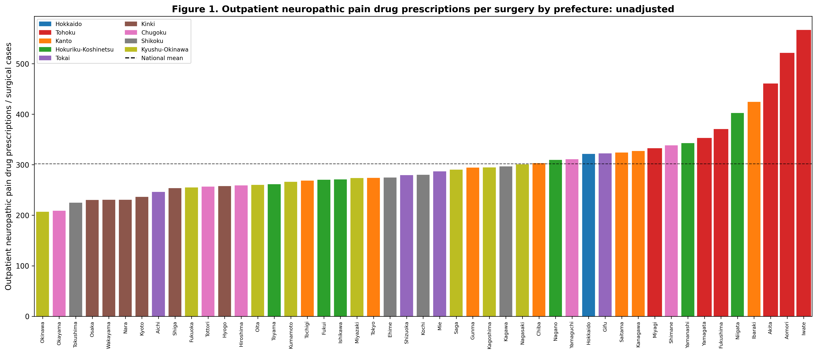
Figure 1. Outpatient neuropathic pain drug prescribing per surgery by prefecture (unadjusted). Tohoku prefectures (red) cluster at the high end. Dashed line = national mean.

Confounder analysis and adjustment
Neuropathic pain prescribing showed strong correlations with confounder disease proxies. Diabetes drug prescribing was the strongest correlate (r=0·87, P<0·001), followed by anxiolytics (r=0·75), antidepressants (r=0·46), and herpes antivirals (r=0·19). These four confounders collectively explained 81.4% of between-prefecture variance in neuropathic pain prescribing (R²=0.814 in Model 2; figure 2).
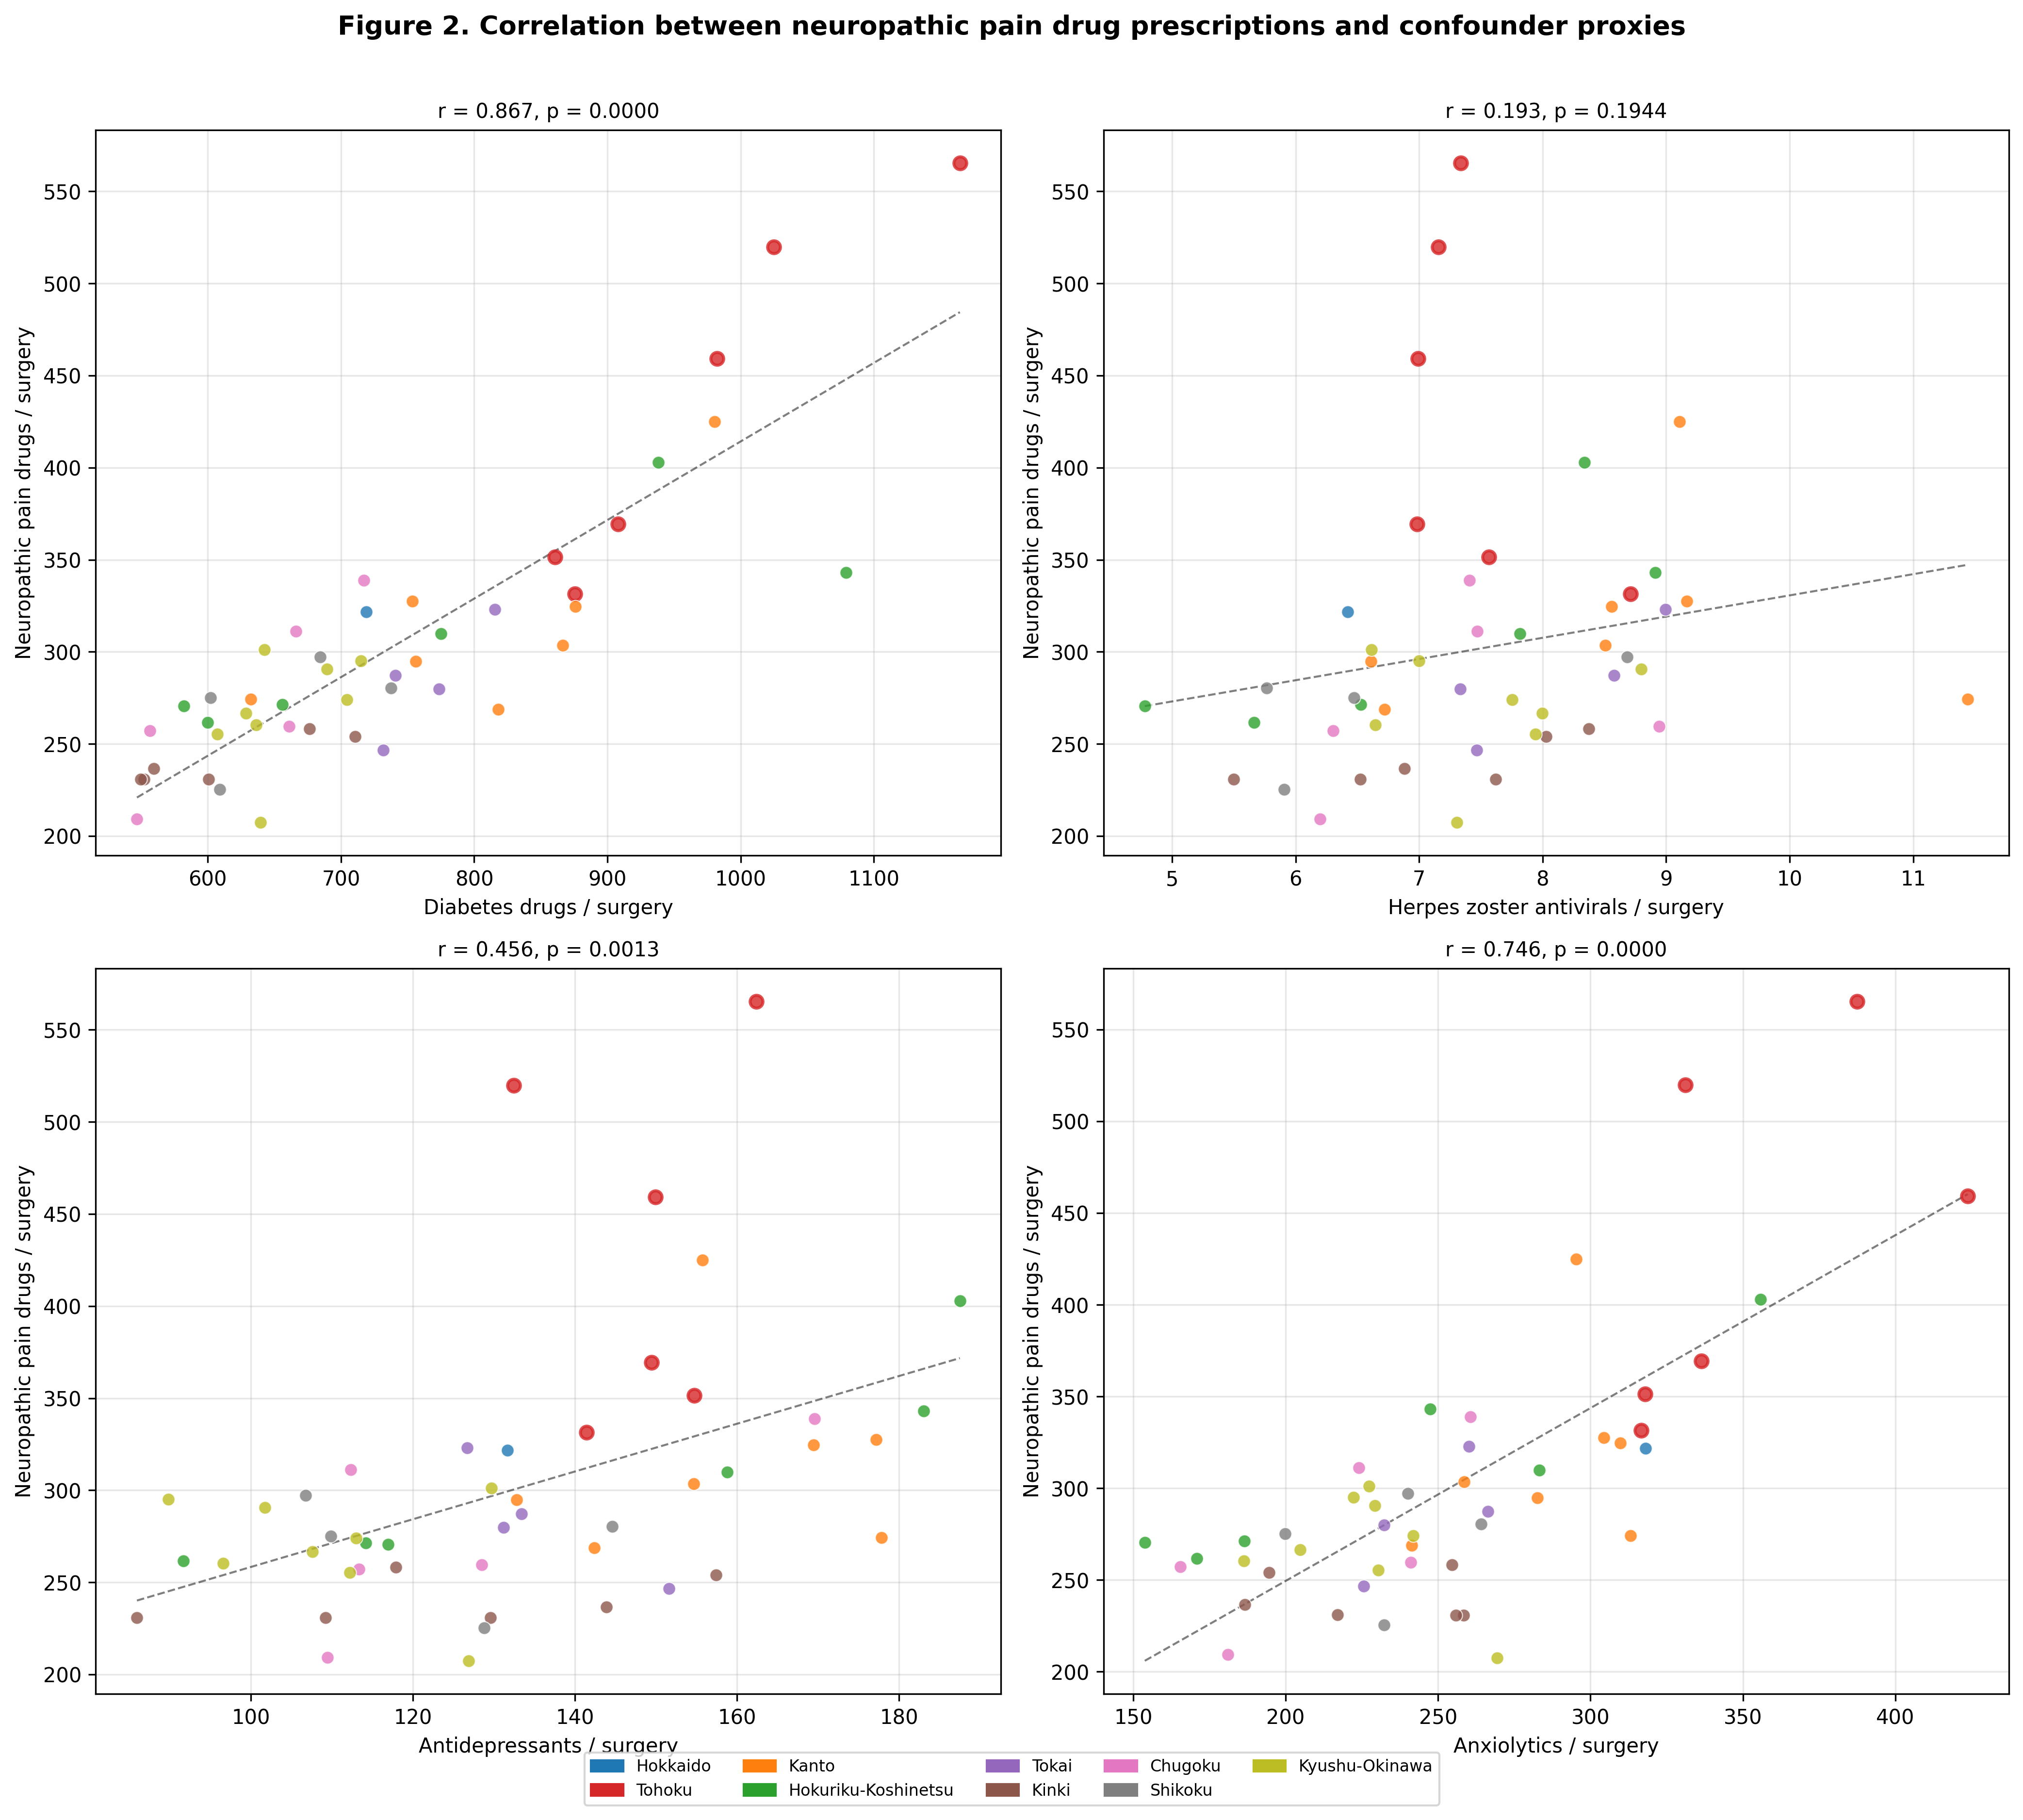
Figure 2. Correlation between neuropathic pain prescribing and confounder disease proxies. Each dot represents one prefecture. Tohoku prefectures are marked with red borders. Diabetes drugs show the strongest correlation (r=0·87).
After adjustment for all four confounders, the Tohoku effect was attenuated and became nonsignificant in Model 2 (β=32.6, P=0.15). This was consistent across specifications: Model 3 (core neuropathic drugs only; β=15.7, P=0.23), Model 4 (nerve blocks; P=0.86), and Model 5 (integrated; β=31.5, P=0.15; table 2).
Table 2. Regression models for outpatient neuropathic pain prescribing with Tohoku indicator and confounder adjustment.
Model | Tohoku β | Tohoku P | Fit | Note
Model 1 (unadjusted) | — | — | d=2.81 | P<0·001
Model 2 (all confounders) | 32.6 | 0.150 | R²=0.814
Model 3 (core neuro) | 15.7 | 0.229 | R²=0.811
Model 4 (nerve blocks) | 0.1 | 0.863 | R²=0.145
Model 5 (integrated) | 31.5 | 0.149 | R²=0.832

The adjusted CPSP index showed a dramatically different geographic pattern from the unadjusted data. The Tohoku mean shifted from markedly positive to a modest, nonsignificant excess (+12.4 vs -1.8; t=0.999, P=0.32; d=0.44; figure 3). Chugoku emerged as having the highest adjusted index, while Tokai had the lowest.
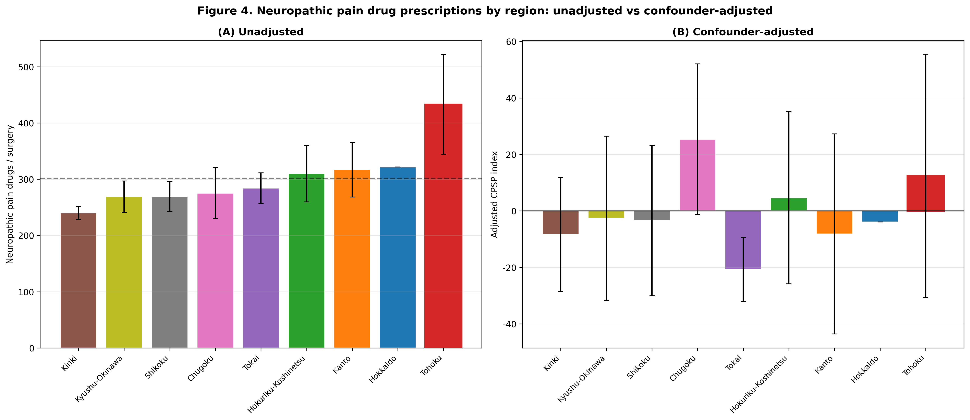
Figure 3. Regional comparison of neuropathic pain prescribing: (a) unadjusted and (b) after confounder adjustment. Tohoku (red) shifts from the highest region to mid-range after adjustment. Error bars = SD.

Phase 1–Phase 2 integration
Acute perioperative prescribing correlated positively with unadjusted neuropathic pain prescribing (r=0·38, P=0·008). After confounder adjustment, this correlation was attenuated (r=0·29, P=0·052). In Model 5, the acute pain index remained a significant predictor of chronic neuropathic pain prescribing (β=1.90, P=0.044), while the Tohoku effect remained nonsignificant (β=31.5, P=0.15). After adjustment, the Tohoku effect was attenuated by 84%.

Age-sex standardised claim ratios
After indirect age-sex standardisation, inpatient analgesic SCR ranged from 63.6 to 147.9 (2.33-fold variation), confirming that the prescribing heterogeneity was not attributable to differences in prefectural age-sex composition. Outpatient neuropathic pain drug SCR ranged from 74.7 to 152.0 (2.04-fold). Tohoku retained elevated neuropathic pain SCR (mean 126.3) relative to non-Tohoku prefectures (96.3), consistent with the crude analysis.

Discussion
This study is the first to map perioperative and chronic pain-related prescribing across all 47 prefectures of Japan, leveraging freely available NDB Open Data that capture virtually the entire insured population. The answer to the question posed in the title is no: cultural labels do not predict analgesic need. Three principal findings support this conclusion and carry implications for any clinician who prescribes analgesics.

Cultural labels fail: 1·97-fold variation within one culture
Despite Japan’s well-documented cultural stoicism toward pain,^{5,6} we found 1·97-fold variation in acute perioperative analgesic prescribing across prefectures and significant differences across regional blocks. This parallels findings from other domains: Cohen and Nisbett’s work on the “culture of honour” in the United States demonstrated that even within a single nation, regional cultural norms produce measurably different behavioural outcomes.⁷ Our finding suggests that Japan’s pain culture is not monolithic; regional demographics, healthcare infrastructure, and local clinical practices generate heterogeneity beneath the surface of a nationally shared cultural norm.

Why this matters for every prescriber
The 1·97-fold within-Japan variation has direct clinical relevance for any physician who writes an analgesic prescription—not only pain specialists but also surgeons, internists, and general practitioners. A large body of evidence demonstrates that cultural stereotypes influence clinician pain assessment and prescribing behaviour. Anderson et al showed that racial and ethnic minorities in the United States consistently receive less adequate pain management across acute, chronic, cancer, and palliative settings.¹⁷ Campbell and Edwards identified that clinician expectations about a patient’s cultural pain behaviour can lead to systematic under- or over-treatment.¹⁸ Rogger et al emphasised that cultural framing affects not only patient reporting but also how clinicians interpret and respond to pain cues.²
The broader lesson is that within-country heterogeneity in pain prescribing challenges the use of national cultural stereotypes in clinical practice—not only in Japan but in any country where cultural generalisations guide prescribing decisions. The nihonjinron discourse (theories of Japanese uniqueness) has long promoted the notion that Japanese people constitute a uniform population sharing a single set of behavioural norms.¹⁹ Yet this “hegemony of homogeneity,” as Befu termed it, is an ideological construct rather than an empirical fact. Burgess showed that the “illusion” of homogeneous Japan has tangible consequences for social policy and public perception.²⁰ In the clinical context, the combination of two stereotypes—“Japanese are stoic” and “Japanese are homogeneous”—creates a doubly misleading assumption: that all Japanese patients will tolerate pain equally and require less analgesia. Our finding of 1·97-fold within-Japan variation directly refutes this assumption. If this degree of heterogeneity exists within a society widely regarded as culturally uniform, the same fragility of cultural labels likely applies to every other national-level pain stereotype—“Stoic Scandinavians,” “expressive Mediterranean patients,” or any similar generalisation that reduces a diverse population to a single behavioural expectation.
Put simply, there is no such entity as “the Japanese patient” whose pain behaviour can be predicted from nationality alone—there are only individual patients from 47 diverse prefectures, each with distinct demographic profiles, clinical environments, and pain-related prescribing cultures. The revised IASP definition describes pain as inherently subjective,²¹ and no cultural label can substitute for direct measurement of a patient’s nociceptive state. Objective nociception monitoring, such as normalised pulse volume, may help standardise perioperative assessment regardless of cultural background.²² This message is particularly relevant for clinicians in the Western Pacific region and beyond who treat Japanese patients in multicultural settings.

Confounders explain Tohoku’s apparent excess
The most methodologically important finding is that the dramatic regional variation in neuropathic pain prescribing (unadjusted d=2.81 for Tohoku vs rest) was largely explained by confounding disease proxies. Diabetes drug prescribing alone correlated at r=0·87 with neuropathic pain prescribing, reflecting the known high prevalence of diabetic neuropathy requiring gabapentinoids. After adjustment, the Tohoku effect was attenuated by 84% and became nonsignificant. This has important implications for ecological pain research: studies using neuropathic pain drug prescribing as a population-level CPSP proxy must account for confounding diseases. Without such adjustment, regional differences in diabetes prevalence could be misinterpreted as differences in CPSP. The within-database confounder adjustment demonstrated here—using disease-specific drug proxies from the same data source—provides a replicable framework for other countries with national claims databases.

A population-level acute–chronic pain continuum
The positive correlation between Phase 1 (acute) and Phase 2 (chronic, adjusted) indices (r=0·29, P=0·052) suggests a modest link between regional acute pain management intensity and subsequent chronic pain-related prescribing. While ecological correlations cannot establish causation, this finding is consistent with individual-level evidence that the intensity of acute postoperative pain is a risk factor for CPSP.²³ Prefectures with relatively low acute analgesic use but high adjusted CPSP indices may warrant investigation for potential under-treatment of acute pain leading to chronification. The significant contribution of the acute pain index in Model 5 (β=1.90, P=0.044), even after confounder adjustment, supports the hypothesis that regional patterns of acute pain management have downstream consequences for chronic pain burden.

Strengths and limitations
Strengths of this study include the use of population-complete data covering all insurance-reimbursed healthcare in Japan, the novel integration of acute and chronic pain proxies within a single analytical framework, the transparent confounder-adjustment methodology, and the use of a perioperative design that neutralises healthcare access as a confounder (all Phase 1 patients are inpatients by definition). The exploratory design allows hypothesis generation for future confirmatory studies.
The main limitations are inherent to the ecological design. The unit of analysis is the prefecture, not the individual patient; ecological correlations may not reflect individual-level associations (ecological fallacy). NDB Open Data do not contain diagnosis codes, so CPSP cannot be directly identified; the neuropathic pain drug proxy captures all indications, not CPSP specifically. Drug prescribing proxies may not capture disease prevalence accurately (eg, fibromyalgia has no specific drug proxy and shares pregabalin as first-line treatment). The cross-sectional design cannot distinguish temporal sequences (surgery → acute pain → CPSP), and unmeasured confounders such as surgical case mix and regional prescribing culture may contribute to residual variation. Although indirect age-sex standardisation via SCR confirmed that demographic composition did not explain the observed heterogeneity, individual-level confounders remain unmeasured in the aggregate NDB data.

Regional stigma in an era of mobility
Beyond the statistical evidence, the very premise of region-based stereotyping is increasingly untenable in contemporary Japan and across the Western Pacific. Domestic migration, urbanisation, and an ageing workforce have fundamentally reshaped the demographic composition of every prefecture. A patient presenting in a Singapore hospital may have been born in Japan, raised in Australia, and working across Southeast Asia—rendering any assumption based on nationality or ethnicity meaningless. Internationally, the growth of medical tourism and expatriate healthcare in the Asia-Pacific region means that clinicians encounter patients from diverse cultural backgrounds with increasing frequency. In this context, applying regional or national stereotypes—whether “Tohoku patients are stoic” or “Japanese patients tolerate pain well”—is not merely inaccurate but potentially harmful. Medicine is, and must remain, an encounter between a clinician and an individual patient—not between a clinician and a cultural category. Individualised assessment—through structured pain scales, functional outcome measures, and, where available, objective nociception monitoring—provides the only reliable basis for analgesic decision-making in a mobile, multicultural world.

Implications and future directions
This exploratory study demonstrates that Japan’s NDB Open Data can serve as a hypothesis-generating platform for population-level pain research. Future studies using the NDB sampling dataset (Level 3 access) could enable individual-level longitudinal tracking from surgery to new neuropathic pain prescriptions, providing a direct CPSP measure. Procedure-specific analyses (eg, total knee arthroplasty, mastectomy) would reduce surgical case-mix confounding. From an international perspective, replicating this within-country ecological framework in other nations with national claims databases (eg, South Korea, Taiwan, the UK) would test whether within-country prescribing heterogeneity is the rule rather than the exception—further undermining the validity of national-level cultural stereotypes in clinical decision-making.

Conclusion
Do cultural labels predict analgesic need? Our population-complete data show they do not. Despite Japan’s culturally ingrained norm of pain endurance (gaman), perioperative and chronic pain-related prescribing varies up to 1·97-fold across prefectures. Confounding diseases, particularly diabetes, substantially modify the apparent regional pattern of neuropathic pain prescribing. Any clinician—surgeon, internist, or anaesthesiologist—who adjusts analgesic dosing based on the label “Japanese patient” risks both over- and under-treatment. The same principle applies to every cultural label applied to any patient population. Individualised pain assessment should replace culturally stereotyped assumptions to ensure equitable care across all clinical settings in the Western Pacific region and beyond.

Contributors
TO conceived and designed the study, obtained and verified the underlying data, performed all analyses, created visualisations, and wrote the manuscript. TO had full access to all data and had final responsibility for the decision to submit.

Declaration of interests
The author declares no competing interests.

Data sharing
The NDB Open Data used in this study are publicly available from the Ministry of Health, Labour and Welfare website (https://www.mhlw.go.jp/stf/seisakunitsuite/bunya/0000177221_00016.html). Analysis code is available at https://github.com/bougtoir/wip/tree/main/ndb-pain-regional-variation-japan.

Acknowledgements
The author thanks the Ministry of Health, Labour and Welfare for making the NDB Open Data publicly available. Parts of data processing and manuscript preparation were assisted by generative AI (Claude, Anthropic). The author takes full responsibility for the accuracy and content of the manuscript.

References
1 Callister LC. Cultural influences on pain perceptions and behaviors. Home Health Care Manag Pract 2003; 15: 207–11.
2 Rogger R, Bello C, Romero CS, Urman RD, Luedi MM, Filipovic MG. Cultural framing and the impact on acute pain and pain services. Curr Pain Headache Rep 2023; 27: 429–36.
3 Zborowski M. People in Pain. San Francisco: Jossey-Bass, 1969.
4 Okolo CA, Olorunsogo T, Babawarun O. Cultural variability in pain perception: a review of cross-cultural studies. Int J Sci Res Arch 2024; 11: 2550–6.
5 Hobara M. Beliefs about appropriate pain behavior: cross-cultural and sex differences between Japanese and Euro-Americans. Eur J Pain 2005; 9: 389–93.
6 Feng Y, Herdman M, van Nooten F, et al. An exploration of differences between Japan and two European countries in the self-reporting and valuation of pain and discomfort on the EQ-5D. Qual Life Res 2017; 26: 2067–78.
7 Cohen D, Nisbett RE, Bowdle BF, Schwarz N. Insult, aggression, and the southern culture of honor: an "experimental ethnography." J Pers Soc Psychol 1996; 70: 945–60.
8 Kumagai S. Media representations reproducing images of Tohoku: the Tohoku reconstruction corner in "Secret Kenmin SHOW." Kotoba 2020; 41: 21–38. [in Japanese]
9 Takeda K, Yarimizu K. Regional differences in the pain expression uzuku. NINJAL Research Papers 2016; 10: 85–107. [in Japanese]
10 Pfizer Japan Inc. 47-prefecture survey on chronic pain. https://www.pfizer.co.jp/pfizer/company/press/2017 (accessed Feb 1, 2025).
11 Ministry of Health, Labour and Welfare. NDB Open Data, 10th edition. https://www.mhlw.go.jp/stf/seisakunitsuite/bunya/0000177221_00016.html (accessed Jan 15, 2025).
12 Wakaizumi K, Tanaka C, Shinohara Y, et al. Geographical variation in high-impact chronic pain and psychological associations at the regional level: a multilevel analysis of a large-scale internet-based cross-sectional survey. Front Public Health 2024; 12: 1482177.
13 Matsuoka Y, Morishima T, Sato A, Ogawa T, Miyashiro I. Population-based claims study of regional and hospital function differences in opioid prescribing for cancer patients who died in hospital in Japan. Jpn J Clin Oncol 2025; 55: hyaf149.
14 Taira K, Mori T, Ishimaru M, et al. Regional inequality in dental care utilization in Japan: an ecological study using the National Database of Health Insurance Claims. Lancet Reg Health West Pac 2021; 12: 100170.
15 von Elm E, Altman DG, Egger M, et al. The Strengthening the Reporting of Observational Studies in Epidemiology (STROBE) statement: guidelines for reporting observational studies. Lancet 2007; 370: 1453–7.
16 Benchimol EI, Smeeth L, Guttmann A, et al. The REporting of studies Conducted using Observational Routinely-collected health Data (RECORD) statement. PLoS Med 2015; 12: e1001885.
17 Anderson KO, Green CR, Payne R. Racial and ethnic disparities in pain: causes and consequences of unequal care. J Pain 2009; 10: 1187–204.
18 Campbell CM, Edwards RR. Ethnic differences in pain and pain management. Pain Manag 2012; 2: 219–30.
19 Befu H. Hegemony of Homogeneity: An Anthropological Analysis of Nihonjinron. Melbourne: Trans Pacific Press, 2001.
20 Burgess C. The "illusion" of homogeneous Japan and national character: discourse as a tool to transcend the "myth" vs. "reality" binary. Asia Pac J 2010; 8(9): 1–22.
21 Raja SN, Carr DB, Cohen M, et al. The revised International Association for the Study of Pain definition of pain: concepts, challenges, and compromises. Pain 2020; 161: 1976–82.
22 Onishi T, Onishi Y. Normalized pulse volume as a superior predictor of respiration recovery and quantification of nociception anti-nociception balance compared to opioid effect site concentration: a prospective, observational study. F1000Research 2024; 13: 233.
23 Kehlet H, Jensen TS, Woolf CJ. Persistent postsurgical pain: risk factors and prevention. Lancet 2006; 367: 1618–25.

