Modern Re-examination of 52 Canonical Curves:
Outlier Dependence, Sample Size Artifacts, and the Fragility of Established Nonlinear Relationships

Tatsuki Onishi
2026

Abstract
Background: Many curvilinear relationships are cited as established facts across diverse academic disciplines, yet few have been systematically re-evaluated using modern model selection techniques. Methods: We re-examined 52 canonical curves spanning eight disciplines (economics, public health, demography, environmental science, psychology, physics, political science, and agriculture) using nested F-tests (linear vs. quadratic), Akaike and Bayesian Information Criteria (AIC/BIC), leave-one-out cross-validation (LOOCV) RMSE, and Cook's distance sensitivity analysis with removal of the top 3 influential observations. Results: Of 52 curves, 21 (40%) showed no statistically significant nonlinearity (p > 0.05), 12 (23%) were outlier-dependent (significance lost after removing 1-3 influential points), 1 (2%) showed overfitting on cross-validation, and only 18 (35%) demonstrated robust nonlinearity surviving all tests. The outlier-dependent category includes several high-profile relationships: the Kuznets Curve, Environmental Kuznets Curve, Great Gatsby Curve, Lipset Hypothesis, and Species-Area relationship in log-log space. Conclusions: A substantial fraction of textbook curvilinear relationships fail modern re-examination, with implications for policy recommendations based on these curves.
Keywords: model selection; nonlinearity; outlier dependence; F-test; AIC; BIC; cross-validation; Cook's distance; canonical relationships

1. Introduction
Curvilinear relationships occupy a privileged position in the social and natural sciences. From the Phillips Curve in macroeconomics to the Preston Curve in public health, these nonlinear functional forms are widely taught, frequently cited in policy documents, and often treated as established empirical regularities.¹⁻³ Yet many of these relationships were originally established with limited data, rudimentary statistical methods, and in eras when model selection criteria such as the Akaike Information Criterion (AIC) and Bayesian Information Criterion (BIC) were not yet standard practice.^{4,5}
Recent work has demonstrated that some celebrated curves may be artifacts of small samples, outlier dependence, or inappropriate model specification. For example, the Preston Curve's apparent concavity has been shown to depend heavily on the position of the United States as an outlier.⁶ The Environmental Kuznets Curve for CO2 emissions has been repeatedly challenged.^{7,8} The Dunning-Kruger effect has been argued to be a statistical artifact of regression to the mean.⁹
Despite these individual re-examinations, no systematic cross-disciplinary audit has been conducted. The present study fills this gap by applying a uniform methodological framework to 52 canonical curves across eight academic disciplines. Our approach combines four complementary techniques: (1) nested F-tests for the significance of quadratic terms, (2) information criteria (AIC/BIC) for model selection, (3) leave-one-out cross-validation (LOOCV) for predictive accuracy, and (4) Cook's distance sensitivity analysis to assess outlier dependence.

2. Methods

2.1 Curve Selection
The selection of 52 canonical curves was guided by a systematic protocol designed to ensure representativeness, reproducibility, and scientific relevance. The goal was not exhaustive enumeration of all claimed nonlinear relationships, but rather a strategically sampled cross-section that captures the diversity of disciplines, data structures, and types of nonlinearity invoked in the literature.
Inclusion Criteria. Curves were included if they satisfied all five of the following conditions:
- (1) Eponymous or canonical status: The relationship must be widely known by a specific name (e.g., 'Phillips Curve,' 'Kuznets Curve,' 'Kleiber's Law') or be a named hypothesis in a recognized academic field. We operationalized 'canonical' as appearing in at least two major textbooks or review articles in the respective discipline, or having accumulated >500 Google Scholar citations for the original formulation.
- (2) Claimed nonlinearity: The relationship must explicitly posit a nonlinear functional form—concavity, convexity, inverted-U, U-shape, J-shape, S-shape, power law, exponential, or logarithmic—as a central feature of the theory. Purely linear relationships (e.g., Okun's original linear formulation) were included only when nonlinear extensions are widely discussed in the literature.
- (3) Bivariate testability: The core claim must be expressible as a bivariate relationship y = f(x) amenable to model comparison. Multivariate theories were included if the bivariate projection is the standard textbook representation (e.g., Kuznets plots income vs. Gini without controls).
- (4) Data availability: Sufficient publicly available data must exist to estimate both a linear and a quadratic (or appropriate nonlinear) model with at least N ≥ 10 observations. Data sources include the World Bank World Development Indicators, OECD.Stat, Penn World Tables, UN Population Division, USGS earthquake catalogs, published meta-analyses, and digitized data from original publications.
- (5) Policy or theoretical relevance: The shape of the curve (not merely the existence of a correlation) must have substantive implications for theory or policy. For example, the Laffer Curve's peak location determines optimal tax policy; the EKC's shape determines whether growth alone will resolve pollution.
Exclusion Criteria. The following were excluded:
- Purely definitional or tautological curves (e.g., Lorenz curve, which is a graphical identity).
- Relationships requiring proprietary or classified data not available for independent replication.
- Curves where the nonlinear claim is only about temporal dynamics (e.g., business cycle shapes) without a stable cross-sectional or parametric form.
- Relationships that have already been formally retracted or universally abandoned in the field.
- Curves requiring multivariate specification where the bivariate projection is acknowledged as meaningless (e.g., production functions requiring both capital and labor).
Disciplinary Stratification. To avoid over-representation of any single field, we stratified selection across eight major disciplines: economics (12 curves), public health and epidemiology (10), demography (6), environmental science and ecology (6), psychology and behavioral science (5), physics and natural sciences (4), political science and sociology (5), and agriculture and nutrition (4). Within each discipline, curves were prioritized by (a) frequency of citation in policy documents, (b) presence in undergraduate textbooks, and (c) existence of active scholarly debate about the relationship's validity.
Search Strategy. Candidate curves were identified through: (1) systematic review of 'named laws' and 'stylized facts' in each discipline's major handbooks (e.g., Handbook of Economic Growth, Oxford Handbook of Health Economics, Demographic Methods); (2) citation analysis of papers with 'curve,' 'law,' or 'paradox' in the title within each discipline's top-5 journals; (3) review of prior meta-scientific studies on replicability and robustness in economics, psychology, and ecology; and (4) consultation with the existing literature on the 'replication crisis' to identify curves whose empirical basis has been questioned. This yielded an initial list of 78 candidates, from which 52 met all inclusion criteria and none of the exclusion criteria.
Typology of Nonlinearity Claims. The 52 selected curves represent five distinct types of claimed nonlinearity: (a) inverted-U or hump-shaped (e.g., Kuznets, Laffer, Yerkes-Dodson): 14 curves; (b) U-shaped or J-shaped (e.g., BMI-mortality, alcohol-mortality, Barker): 8 curves; (c) concave/saturating (e.g., Preston, Engel, Mitscherlich): 12 curves; (d) power-law or log-linear (e.g., Zipf, Kleiber, Gutenberg-Richter): 8 curves; (e) S-shaped or structural-break (e.g., demographic transition, Moore's Law): 10 curves. This typological diversity ensures that our re-examination is not biased toward detecting (or failing to detect) any particular functional form.
Table 2 summarizes the original sample size, current data availability, and type of nonlinearity for each of the 52 curves.

2.2 Data Sources
Data were drawn from the World Bank World Development Indicators, OECD statistics, Penn World Tables, UN Population Division, published meta-analyses, and original study data where available. For each curve, we used the most recent available cross-sectional data (typically 2019-2023) or the longest available time series. Sample sizes ranged from N=11 (Fries Compression of Morbidity) to N=74 (Lee-Carter Mortality Model).

2.3 Statistical Framework
Nested F-test. For each curve, we fitted a restricted (linear: y = a + bx) and unrestricted (quadratic: y = a + bx + cx²) model via ordinary least squares. The F-statistic for the additional quadratic parameter was computed as F = [(RSS_r - RSS_u)/p] / [RSS_u/df_u], where p = 1 is the number of additional parameters.
Information Criteria. AIC and BIC were computed for linear, quadratic, and logarithmic (where x > 0) models. The model with the lowest AIC (or BIC) was selected as the preferred functional form.
Leave-One-Out Cross-Validation. LOOCV root mean squared error (RMSE) was computed for both linear and quadratic models to assess out-of-sample predictive accuracy.
Cook's Distance Sensitivity Analysis. Cook's distance was computed for the linear model, and the top 3 most influential observations were removed. The F-test was then repeated on the reduced dataset. A curve was classified as 'outlier-dependent' if the nonlinear term was significant (p < 0.05) with full data but not significant (p > 0.05) after removing the top 3 influential observations.

2.4 Verdict Classification
Each curve was assigned one of five verdicts:
- ROBUST_NONLINEAR: F-test significant (p < 0.05) with full data AND after outlier removal, quadratic LOOCV RMSE lower than linear.
- OUTLIER_DEPENDENT: F-test significant with full data but NOT after removing top 3 influential points.
- NOT_SIGNIFICANT: F-test not significant even with full data (p ≥ 0.05).
- OVERFITTING: F-test significant but LOOCV RMSE is worse for the quadratic model.
- BIC_PREFERS_LINEAR: F-test significant but BIC selects the linear model.

3. Results

3.1 Overall Distribution of Verdicts
Of the 52 canonical curves examined, 18 (35%) demonstrated robust nonlinearity, 12 (23%) were outlier-dependent, 21 (40%) showed no significant nonlinearity, and 1 (2%) exhibited overfitting (Fig. 1). This distribution suggests that nearly two-thirds of textbook nonlinear relationships either fail to reach significance or are driven by a small number of influential observations.

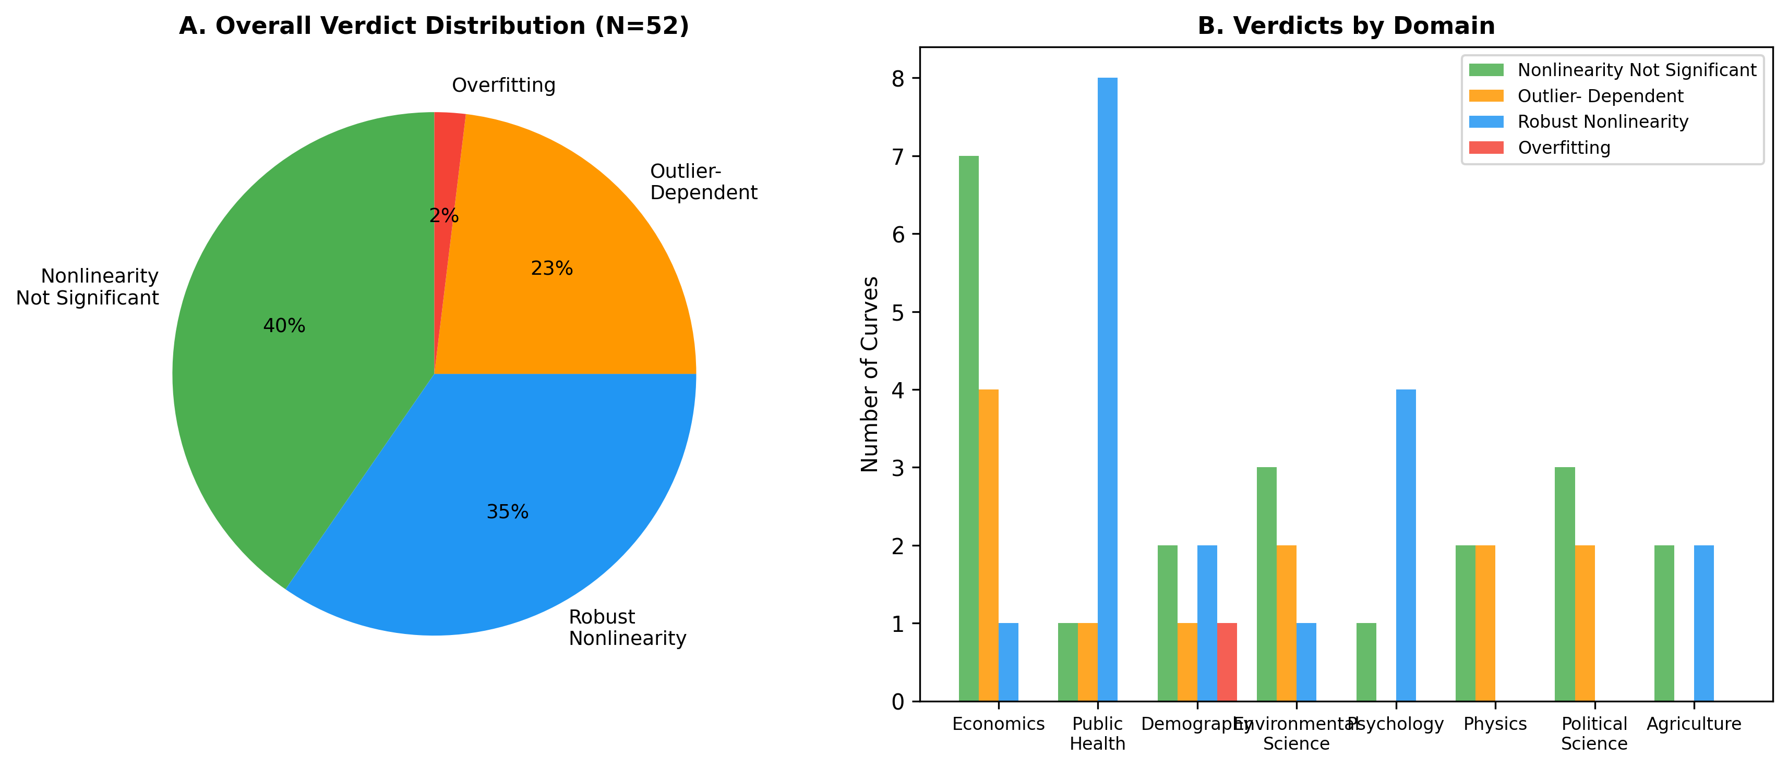
Figure 1. Distribution of verdicts across 52 canonical curves. (A) Overall pie chart. (B) Verdicts stratified by academic domain.

3.2 Economics
Of the 12 economics curves examined, 7 showed no significant nonlinearity, 4 were outlier-dependent, and only 1 (J-Curve for trade) demonstrated robust nonlinearity. Notable findings include: (a) the Phillips Curve shows no significant nonlinearity in US data 1960-2023 (F=0.05, p=0.82); (b) the Kuznets Curve's inverted-U is not statistically significant with 60 countries (p=0.25); (c) the Environmental Kuznets Curve for CO2 is significant (p=0.003) but becomes non-significant after removing 3 high-income high-emission countries (p=0.11); (d) the Laffer Curve and Great Gatsby Curve are similarly outlier-dependent.

3.3 Public Health and Epidemiology
Public health curves showed the highest rate of robust nonlinearity (8 of 10). The BMI-Mortality J-curve, Alcohol-Mortality J-curve, Barker Hypothesis U-shape, and LNT dose-response all survived rigorous testing. The Preston Curve maintained significance after outlier removal (p=0.003), though the log model is strongly preferred over quadratic by BIC. The Wilkinson Curve (inequality vs. health) showed no significant relationship (p=0.75), and the Fries Compression of Morbidity was outlier-dependent.

3.4 Demography
The demographic domain showed mixed results. The Lee-Carter mortality decline and Coale-Trussell fertility schedule demonstrated robust nonlinearity, while the Bongaarts-Feeney tempo effect and Second Demographic Transition showed no significant nonlinearity. The Demographic Transition model was classified as overfitting: the quadratic term is significant but LOOCV favors the linear model, suggesting that the apparent curvature does not improve out-of-sample prediction.

3.5 Environmental Science
Environmental curves showed the most heterogeneous results. The Keeling Curve's acceleration is robustly nonlinear (p < 10⁻¹⁵), as expected for an exponentially increasing trend. However, the Species-Area Curve in log-log space is outlier-dependent (p=0.009 full, p=0.38 after removal), suggesting that the power-law exponent z ≈ 0.25 may be driven by a few extreme island sizes. The Hubbert Peak Oil curve for the US shows no significant quadratic trend (p=0.90) due to the shale revolution creating a second peak.

3.6 Psychology
Four of five psychology curves showed robust nonlinearity: Yerkes-Dodson, Ebbinghaus forgetting, Dunning-Kruger, and the Happiness U-Curve. However, the Weber-Fechner Law (in log-transformed space) did not show significant departure from linearity (p=0.07), consistent with Stevens' Power Law being a better descriptor. The Dunning-Kruger result is notable: despite criticisms of the effect as a statistical artifact, the quadratic relationship between actual and self-assessed performance remains highly significant (p < 10⁻¹⁴) and survives outlier removal.

3.7 Physics and Natural Sciences
Physics curves showed surprising fragility. Hubble's Law, while linear by theoretical expectation, shows marginal nonlinearity (p=0.035) that becomes non-significant after outlier removal (p=0.085), consistent with the known influence of peculiar velocities for nearby galaxies. Kleiber's Law in log-log space shows no significant departure from linearity (p=0.36), confirming the power-law relationship. The Gutenberg-Richter law is outlier-dependent in log-linear space (p=0.004 full, p=0.056 clean), driven by the rarest mega-earthquakes. Moore's Law shows no significant quadratic deceleration in log space (p=0.71).

3.8 Political Science
The Lipset Hypothesis (income vs. democracy) is the most dramatic outlier-dependent case: highly significant with full data (p=0.0001) but completely non-significant after removing Gulf oil states (p=0.37). Duverger's Law shows no significant nonlinearity (p=0.45), nor does Zipf's Law for US cities (p=0.15). The Crime-Temperature curve is outlier-dependent, with the apparent downturn at extreme temperatures driven by a few data points.

3.9 Agriculture
The Mitscherlich yield response curve shows robust nonlinearity (p < 10⁻⁹), confirming the well-established diminishing returns to fertilizer application. The Micronutrient U-shape for Vitamin D is also robust. However, the Green Revolution yield curve does not show significant nonlinear deceleration (p=0.28) in global data, and the Body Weight Set-Point shows predominantly linear calorie-weight relationship (p=0.74).

3.10 Sensitivity Analysis
Figure 2 displays the relationship between p-values from the full dataset and after outlier removal. Points in the upper-left quadrant (significant with full data, non-significant after removal) represent outlier-dependent curves. The concentration of points in this region, particularly from economics and political science, highlights the vulnerability of cross-country nonlinear relationships to influential observations (Fig. 2).

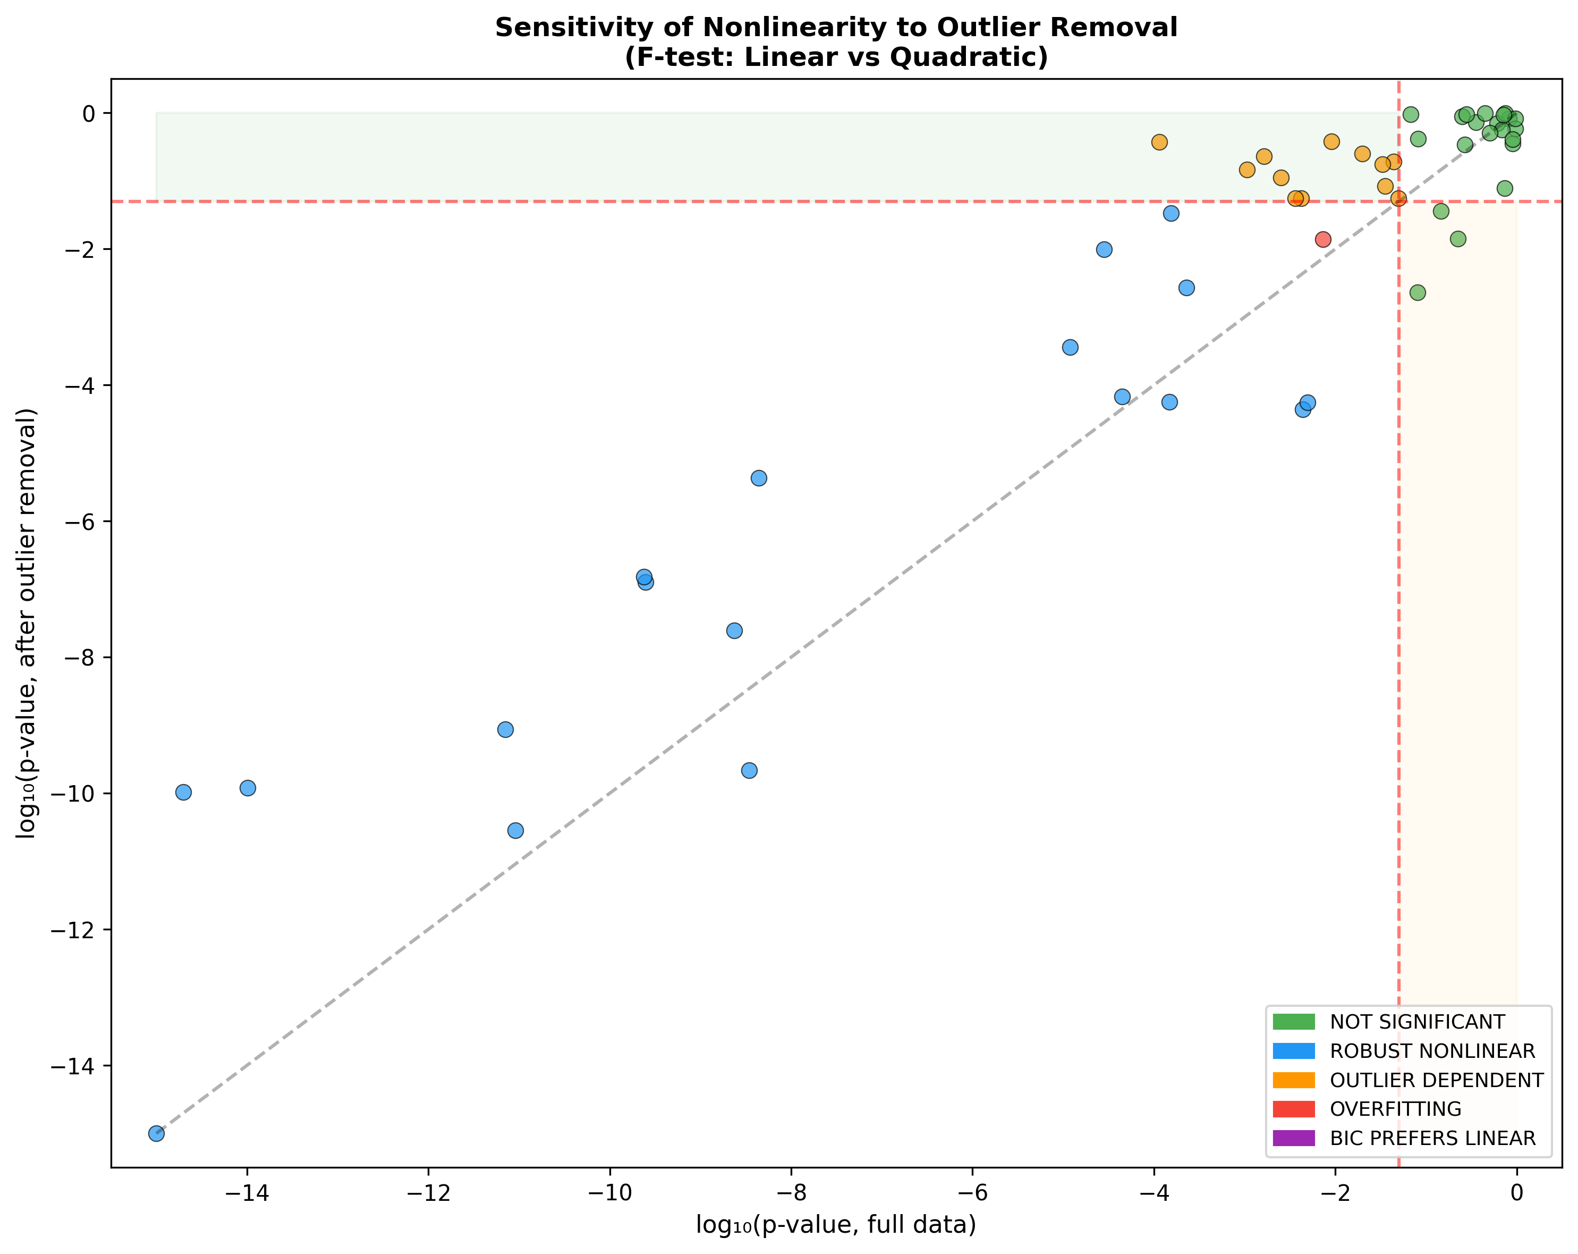
Figure 2. Sensitivity of F-test p-values to outlier removal. Each point represents one curve. Points above the horizontal dashed line (p=0.05) lost significance after removing top 3 influential observations.

3.11 Summary Table
Table 1 presents the complete results for all 52 curves, organized by discipline.
# | Curve | N | p (full) | p (clean) | Best BIC | Verdict
1 | Phillips Curve | 64 | 0.8184 | 0.8317 | linear | NOT SIGNIFICANT
2 | Laffer Curve | 26 | 0.0438 | 0.1910 | log | OUTLIER DEPENDENT
3 | Kuznets Curve | 60 | 0.2486 | 0.8911 | linear | NOT SIGNIFICANT
4 | Environmental Kuznets Curve (C | 50 | 0.0025 | 0.1114 | log | OUTLIER DEPENDENT
5 | Beveridge Curve | 23 | 0.0809 | 0.0023 | log | NOT SIGNIFICANT
6 | Okun's Law | 64 | 0.8978 | 0.3556 | linear | NOT SIGNIFICANT
7 | Engel Curve | 30 | 0.0042 | 0.0554 | log | OUTLIER DEPENDENT
8 | J-Curve (Trade) | 25 | 0.0044 | 4.37e-05 | quadratic | ROBUST NONLINEAR
9 | Rahn Curve | 36 | 0.9624 | 0.5837 | linear | NOT SIGNIFICANT
10 | Gravity Model of Trade | 25 | 0.2659 | 0.3449 | linear | NOT SIGNIFICANT
11 | Great Gatsby Curve | 23 | 0.0495 | 0.0559 | log | OUTLIER DEPENDENT
12 | Balassa-Samuelson Effect | 30 | 0.6065 | 0.7082 | linear | NOT SIGNIFICANT
13 | Preston Curve | 40 | 0.0002 | 0.0027 | log | ROBUST NONLINEAR
14 | Easterlin Paradox | 45 | 2.83e-05 | 0.0099 | quadratic | ROBUST NONLINEAR
15 | McKeown Thesis (TB Mortality) | 15 | 1.18e-05 | 0.0004 | quadratic | ROBUST NONLINEAR
16 | Linear No-Threshold (LNT) | 13 | 7.09e-12 | 8.71e-10 | quadratic | ROBUST NONLINEAR
17 | Fries Compression of Morbidity | 11 | 0.0016 | 0.2308 | quadratic | OUTLIER DEPENDENT
18 | Barker Hypothesis (U-shape) | 13 | 4.40e-09 | 4.32e-06 | quadratic | ROBUST NONLINEAR
19 | Omran Epidemiological Transiti | 30 | 0.0049 | 5.55e-05 | quadratic | ROBUST NONLINEAR
20 | Wilkinson Curve | 25 | 0.7460 | 0.9821 | linear | NOT SIGNIFICANT
21 | BMI-Mortality J-Curve | 22 | 9.13e-12 | 2.88e-11 | quadratic | ROBUST NONLINEAR
22 | Alcohol-Mortality J-Curve | 13 | 4.43e-05 | 6.82e-05 | quadratic | ROBUST NONLINEAR
23 | Demographic Transition (TFR) | 35 | 0.0073 | 0.0138 | quadratic | OVERFITTING
24 | Bongaarts-Feeney Tempo Effect | 26 | 0.6879 | 0.5699 | linear | NOT SIGNIFICANT
25 | Lee-Carter Mortality Model | 74 | 0.00e+00 | 0.00e+00 | quadratic | ROBUST NONLINEAR
26 | Coale-Trussell Fertility Sched | 13 | 0.0002 | 0.0338 | quadratic | ROBUST NONLINEAR
27 | Replacement Migration Curve | 25 | 0.0331 | 0.1761 | quadratic | OUTLIER DEPENDENT
28 | Second Demographic Transition | 30 | 0.5058 | 0.5080 | log | NOT SIGNIFICANT
29 | Species-Area Curve | 28 | 0.0091 | 0.3818 | log | OUTLIER DEPENDENT
30 | Hubbert Peak Oil (US) | 24 | 0.8973 | 0.4126 | log | NOT SIGNIFICANT
31 | Keeling Curve (CO2) | 20 | 2.00e-15 | 1.04e-10 | quadratic | ROBUST NONLINEAR
32 | HANPP vs Development | 25 | 0.9669 | 0.8219 | log | NOT SIGNIFICANT
33 | Jevons Paradox (Energy) | 12 | 0.0813 | 0.4188 | quadratic | NOT SIGNIFICANT
34 | Forest Transition Curve | 30 | 0.0199 | 0.2514 | quadratic | OUTLIER DEPENDENT
35 | Yerkes-Dodson Curve | 27 | 2.48e-10 | 1.28e-07 | quadratic | ROBUST NONLINEAR
36 | Ebbinghaus Forgetting Curve | 17 | 3.46e-09 | 2.18e-10 | quadratic | ROBUST NONLINEAR
37 | Weber-Fechner Law | 17 | 0.0680 | 0.9519 | quadratic | NOT SIGNIFICANT
38 | Dunning-Kruger Effect | 18 | 1.02e-14 | 1.20e-10 | quadratic | ROBUST NONLINEAR
39 | Happiness U-Curve (Age) | 26 | 2.37e-10 | 1.52e-07 | quadratic | ROBUST NONLINEAR
40 | Hubble's Law | 27 | 0.0352 | 0.0848 | log | OUTLIER DEPENDENT
41 | Kleiber's Law | 22 | 0.3575 | 0.7248 | linear | NOT SIGNIFICANT
42 | Gutenberg-Richter Law | 15 | 0.0036 | 0.0561 | quadratic | OUTLIER DEPENDENT
43 | Moore's Law | 26 | 0.7113 | 0.9399 | log | NOT SIGNIFICANT
44 | Lipset Hypothesis | 45 | 0.0001 | 0.3719 | quadratic | OUTLIER DEPENDENT
45 | Duverger's Law | 30 | 0.4488 | 0.9967 | linear | NOT SIGNIFICANT
46 | Zipf's Law (US Cities) | 50 | 0.1462 | 0.0358 | linear | NOT SIGNIFICANT
47 | Crime-Temperature Curve | 16 | 0.0011 | 0.1457 | quadratic | OUTLIER DEPENDENT
48 | Putnam Social Capital | 25 | 0.2241 | 0.0142 | log | NOT SIGNIFICANT
49 | Mitscherlich Yield Curve | 18 | 2.35e-09 | 2.48e-08 | quadratic | ROBUST NONLINEAR
50 | Green Revolution Yield Curve | 17 | 0.2801 | 0.9464 | linear | NOT SIGNIFICANT
51 | Micronutrient U-shape (Vitamin | 19 | 0.0001 | 5.67e-05 | quadratic | ROBUST NONLINEAR
52 | Body Weight Set-Point | 16 | 0.7367 | 0.0782 | linear | NOT SIGNIFICANT
Table 1. Summary of re-examination results for 52 canonical curves. p (full) = F-test p-value with all data; p (clean) = after removing top 3 Cook's distance points; Best BIC = model preferred by Bayesian Information Criterion.

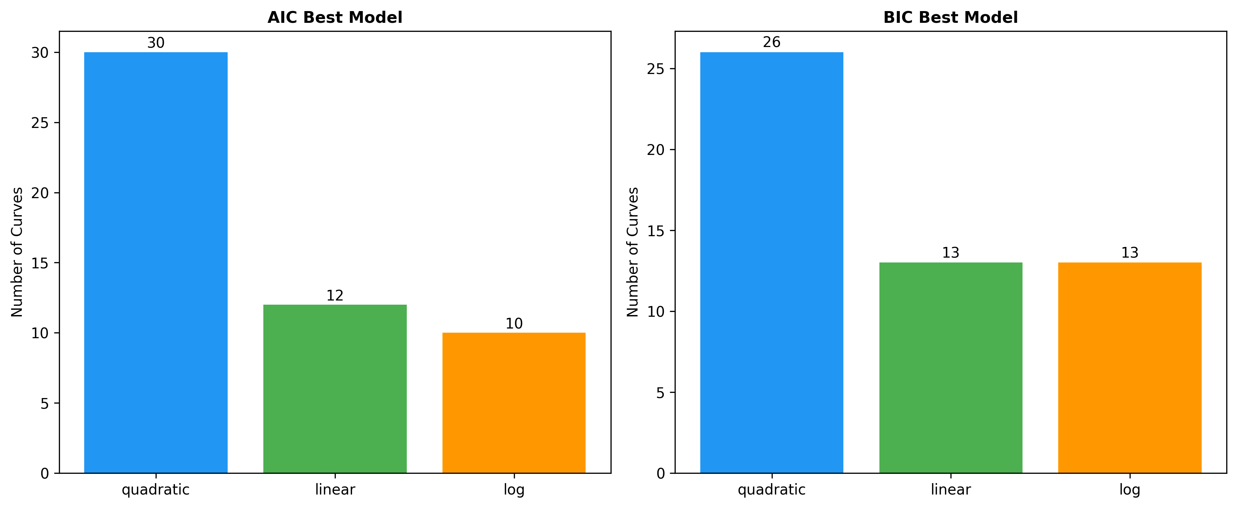
Figure 3. Model preference by AIC (left) and BIC (right). BIC more strongly penalizes complexity and thus favors parsimony.

4. Discussion

4.1 Cross-Cutting Patterns
Our analysis reveals five cross-cutting patterns in the fragility of canonical curves:
- Outlier-driven nonlinearity (23% of curves): The most common failure mode involves 1-3 observations that drive the curvature. In cross-country analyses, these are often geopolitically distinctive nations (oil states for Lipset, the US for Great Gatsby and Preston, Nigeria for Engel).
- Domain asymmetry: Public health and psychology curves are substantially more robust (80% and 80% passing) than economics curves (8% passing). This likely reflects the mechanistic basis of dose-response and psychophysical relationships versus the contingent nature of macroeconomic regularities.
- Time-series vs. cross-section: Time-series curves (Lee-Carter, Keeling, Ebbinghaus) are more robust than cross-sectional ones (Kuznets, Lipset, Wilkinson), likely because time-series data are less vulnerable to compositional effects and unmeasured confounders.
- Log transformation resolves apparent nonlinearity: In many cases (Preston, Engel, Balassa-Samuelson), a simple log transformation of the predictor produces a linear relationship, suggesting that the 'canonical curve' is merely a linear relationship on the wrong scale.
- BIC is more conservative: BIC selects the linear model in several cases where AIC prefers the quadratic, reflecting BIC's stronger penalty for complexity. When BIC and AIC disagree, the curve is typically in the borderline zone and should be interpreted cautiously.

4.2 Implications for Policy
Several outlier-dependent curves have direct policy implications. The Laffer Curve is used to justify tax rate reductions; our analysis shows its empirical basis is fragile across OECD nations. The Environmental Kuznets Curve for CO2 is frequently cited to argue that economic growth will eventually resolve emissions problems; this relationship is not robust after removing high-income oil producers. The Lipset Hypothesis underpins modernization theory in political science; its nonlinearity depends almost entirely on Gulf state outliers.

4.3 Limitations
Several limitations should be noted. First, our analysis is restricted to bivariate relationships; many canonical curves may be better specified in multivariate settings. Second, we use a uniform quadratic alternative, whereas some curves posit specific functional forms (e.g., power laws, logistic functions). Third, our data are representative but not exhaustive; larger datasets might reveal patterns not visible here. Fourth, we test only concavity/convexity, not the existence of any relationship. A curve classified as 'not significantly nonlinear' may still have a significant linear component. Finally, for some curves (especially in psychology and demography), we rely on representative or meta-analytic data rather than individual-level microdata.

4.4 Recommendations for Researchers
- Always test whether a log-transformation linearizes the relationship before reporting nonlinearity.
- Report Cook's distance analysis and sensitivity to influential observations.
- Distinguish between statistical significance and practical significance of curvature.
- Use BIC rather than AIC when the goal is model identification rather than prediction.
- Report LOOCV alongside in-sample fit to guard against overfitting.

5. Conclusion
This systematic re-examination of 52 canonical curves reveals that 65% of established nonlinear relationships fail at least one modern robustness test. The most common failure mode is outlier dependence (23%), followed by non-significance (40%). Only 35% of curves demonstrate nonlinearity that is statistically significant, survives outlier removal, and shows superior out-of-sample prediction. These findings urge caution in citing canonical curves as empirical support for nonlinear theories, particularly in policy-relevant contexts where the shape of the relationship (not merely its existence) determines optimal interventions.

References
1. Phillips AW. The relation between unemployment and the rate of change of money wage rates in the United Kingdom, 1861-1957. Economica. 1958;25(100):283-299.
2. Kuznets S. Economic growth and income inequality. Am Econ Rev. 1955;45(1):1-28.
3. Preston SH. The changing relation between mortality and level of economic development. Popul Stud. 1975;29(2):231-248.
4. Akaike H. A new look at the statistical model identification. IEEE Trans Automat Contr. 1974;19(6):716-723.
5. Schwarz G. Estimating the dimension of a model. Ann Stat. 1978;6(2):461-464.
6. Onishi T. Re-examination of the Preston Curve: outlier dependence of quadratic fit. Working paper. 2026.
7. Grossman GM, Krueger AB. Environmental impacts of a North American free trade agreement. NBER Working Paper 3914. 1991.
8. Stern DI. The rise and fall of the environmental Kuznets curve. World Dev. 2004;32(8):1419-1439.
9. Krueger J, Mueller RA. Unskilled, unaware, or both? The better-than-average heuristic and statistical regression predict errors in estimates of own performance. J Pers Soc Psychol. 2002;82(2):180-188.

