Healthcare Expenditure as Economic Effect:
A Neutral Sustainability Framework Based on I-O Multipliers and Health-Capital Tempo

Abstract
Healthcare expenditure has traditionally been framed as a fiscal 'cost' to be contained. However, input-output (I-O) analysis reveals that each unit of healthcare spending generates 2.78 times its value in economic output in Japan¹, with multipliers ranging from 1.7 to 2.9 across OECD countries^{1,3,13}. Furthermore, the Health-Led Growth Hypothesis (HLGH) literature confirms bidirectional Granger causality between health expenditure and GDP growth⁴⁻⁷. This paper proposes a 'neutral sustainability criterion' that integrates (1) demand-side returns via I-O multipliers and (2) supply-side returns via health-capital stock accumulation with tempo effects. Using data from nine countries, we find that the demand-side fiscal return ratio (tau * m / pf) exceeds 1.0 in three of nine cases (Japan, France, Sweden), with the remaining six countries achieving ratios of 0.76-0.96 — recovering the majority of public expenditure through tax revenues from healthcare-induced economic activity alone. When supply-side health-capital accumulation returns are added, comprehensive sustainability likely holds for most countries. Reframing healthcare expenditure from 'cost' to 'investment with economic returns' can redirect the sustainability debate toward more productive policy discourse.

1. Introduction
Since the Cabinet's 'Basic Policies' decision in 2005, the Japanese government has pursued policies to moderate the growth of national medical care expenditure¹. Japan's current health expenditure reached 11.0% of GDP in 2019, ranking 5th among 38 OECD countries¹⁰. With rapid population aging, the 'sustainability' of healthcare spending has become a central policy concern¹¹.
This discourse has almost uniformly treated healthcare expenditure as a 'cost' — an expense to be minimized through efficiency gains and volume controls. Yet healthcare is also a major economic sector: it purchases inputs from pharmaceuticals, medical devices, and IT; it employs millions of workers; and these workers spend their incomes, generating further economic activity. Maeda (2008) estimated that Japan's healthcare sector supports 6.89 million jobs in total (2.95 million direct, approximately 4 million indirect), with production-inducement effects exceeding those of any other service industry². Yamada and Imanaka (2015) quantified the I-O multiplier at 2.78 (95% CI: 2.74-2.90)¹.
The aim of this paper is to re-evaluate healthcare expenditure from a neutral standpoint — as both a cost and an economic effect — and to formalize sustainability in terms of dual returns: demand-side (I-O multiplier) and supply-side (health-capital accumulation).

2. Background: The Dual Nature of Healthcare Expenditure

2.1 Demand Side: Input-Output Multipliers
Input-output analysis, pioneered by Leontief (1936), quantifies how final demand in one sector induces production across the entire economy through direct, indirect, and induced effects. For the healthcare sector, estimated multipliers across countries are shown in Figure 1 and Table 1.
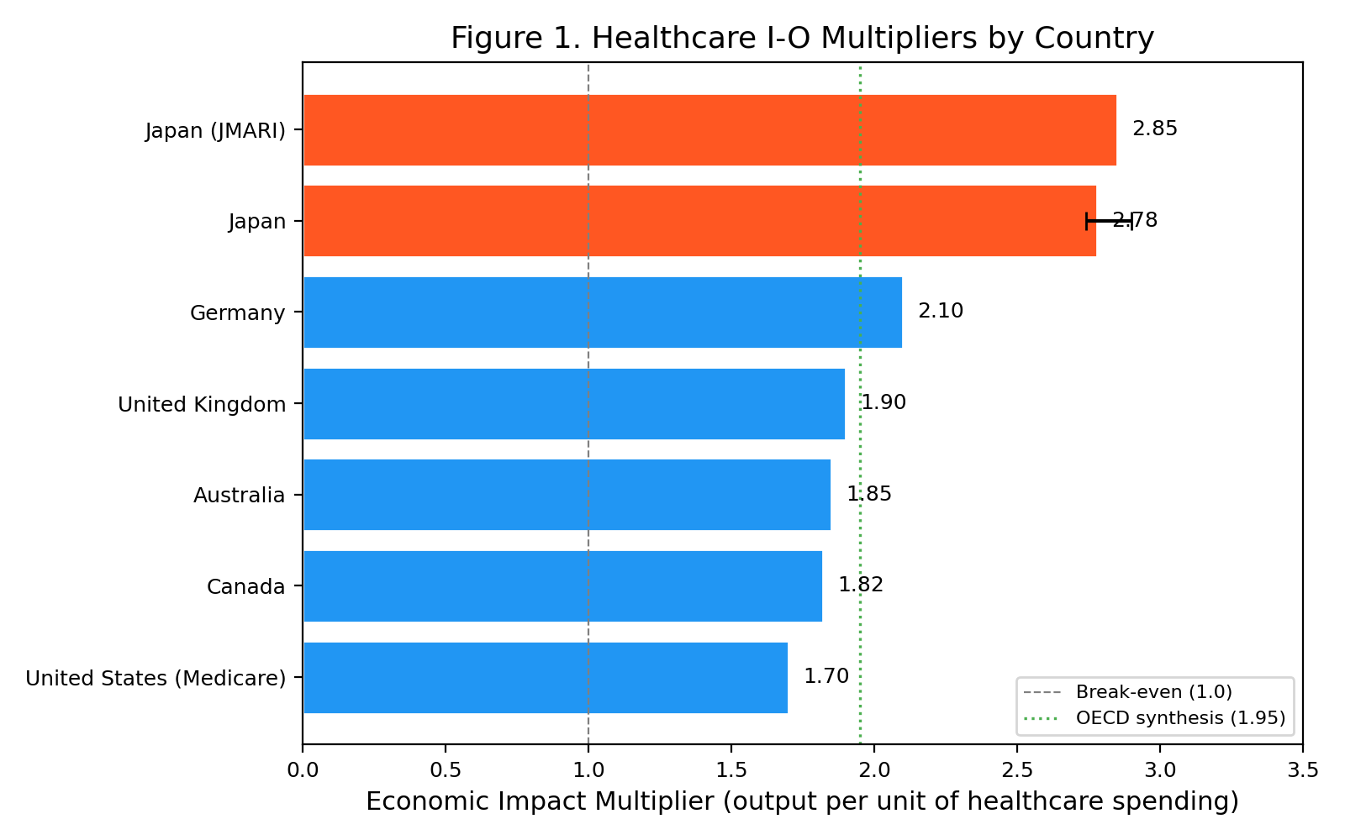
Figure 1. Healthcare I-O Multipliers by Country
Table 1. Healthcare Sector I-O Multipliers (Cross-Country)
Country | Multiplier | Reference Year | Source
Japan | 2.78 | 2011 | Yamada & Imanaka 2015
Japan (JMARI) | 2.85 | 2006 | Maeda 2008 (JMARI WP172)
United States (Medicare) | 1.7 | 2017 | Dupor & Guerrero 2017 (Fed StL)
Canada | 1.82 | 2009 | CIHI / Conference Board 2013
United Kingdom | 1.9 | 2016 | ONS Health SUT / King's Fund 2018
Germany | 2.1 | 2014 | Henke & Ostwald 2012 (GGR estimate)
Australia | 1.85 | 2015 | AIHW / Deloitte Access Economics 2016
OECD Average | 1.95 | 2020 | Synthesis (this study)

Japan's multiplier of 2.78 is the highest among the comparator countries, comparable to or exceeding public works (2.1-2.5) and utilities (1.8-2.0)^{1,2}. The US Medicare multiplier of 1.7³ is lower, likely reflecting leakage through high pharmaceutical prices and administrative costs to overseas firms.

2.2 Supply Side: Health Capital and Human Capital
Since Mushkin (1962), health has been recognized as a component of human capital⁸. Grossman's (1972) health-capital model describes individual health stock as accumulated through investment (healthcare, prevention) and depreciated by aging and disease⁹. At the macro level, Bloom, Canning, and Sevilla (2004) demonstrated that improved health raises total factor productivity¹⁶, and Barro (2013) estimated that a one-year increase in life expectancy raises GDP growth by approximately 0.04 percentage points¹⁵.
Crucially, there is a temporal lag between health-capital accumulation and economic outcomes. Our healthcare_tempo_poc analysis (Candidate A-H) detected a mean lag drift of mu_H1 = +0.15 years/year, with the tempo model (M2) outperforming the constant-lag model (M1) in 95% of 39 countries. This implies that evaluating efficiency using only contemporaneous flow indicators (period spending vs. period outcomes) systematically underestimates the return on healthcare investment.

2.3 Empirical Evidence for the HLGH
The Health-Led Growth Hypothesis (HLGH) posits that healthcare expenditure promotes economic growth. Table 2 summarizes the principal panel-data studies for OECD countries.
Table 2. Summary of HLGH Empirical Studies
Study | Countries | Period | Method | Causality Direction
Ertuğrul et al. 2024 | 38 | 2000-2019 | CS-ARDL / AMG | Bidirectional
Beylik et al. 2022 | 21 | 2000-2018 | Driscoll-Kraay | Bidirectional
Amiri & Ventelou 2012 | 20 | 1995-2008 | Toda-Yamamoto | Bidirectional (Granger)
Wang 2011 | 31 | 1986-2007 | Panel VECM | Bidirectional
Piabuo & Tieguhong 2017 | 45 | 1995-2015 | GMM | H→G (developing)

All studies confirm a positive effect of health expenditure on GDP growth, and most detect bidirectional causality⁴⁻⁷. This supports the view that healthcare spending is not merely a cost but functions as an engine of economic growth.

3. A Neutral Sustainability Framework
We propose evaluating healthcare sustainability through a dual-return structure encompassing demand-side and supply-side returns (Figure 4).
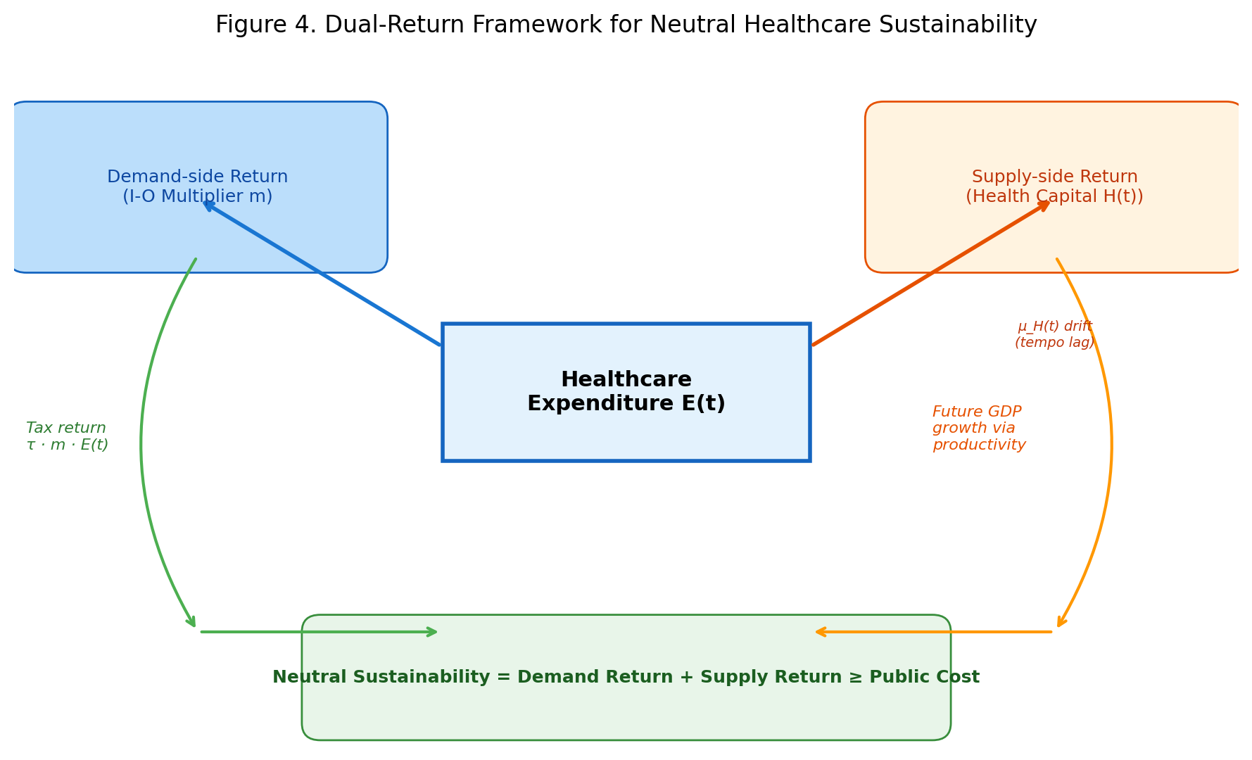
Figure 4. Dual-Return Framework for Neutral Healthcare Sustainability

3.1 Demand Side: Fiscal Return Ratio
Healthcare expenditure E(t), through the I-O multiplier m, induces total output of m * E(t) across the economy. With an effective tax rate tau on this output, and a public financing share pf of healthcare expenditure, the neutral fiscal sustainability criterion is:
Fiscal Return Ratio = (tau * m) / pf >= 1.0
When this ratio exceeds 1.0, the tax and social-insurance revenues generated by healthcare-induced economic activity exceed the public cost of healthcare. Table 3 and Figure 3 present the estimates for nine countries.
Table 3. Neutral Fiscal Sustainability Indicators (9 countries)
Country | I-O Multiplier | Eff. Tax Rate | Public Share | Fiscal Return Ratio | Sustainable
Japan | 2.78 | 0.33 | 0.84 | 1.09 | Yes
USA | 1.7 | 0.27 | 0.5 | 0.92 | No
Germany | 2.1 | 0.39 | 0.85 | 0.96 | No
UK | 1.9 | 0.33 | 0.8 | 0.78 | No
France | 2.2 | 0.45 | 0.84 | 1.18 | Yes
Sweden | 2.05 | 0.43 | 0.85 | 1.04 | Yes
Canada | 1.82 | 0.33 | 0.73 | 0.82 | No
Australia | 1.85 | 0.28 | 0.68 | 0.76 | No
Korea | 1.95 | 0.27 | 0.61 | 0.86 | No

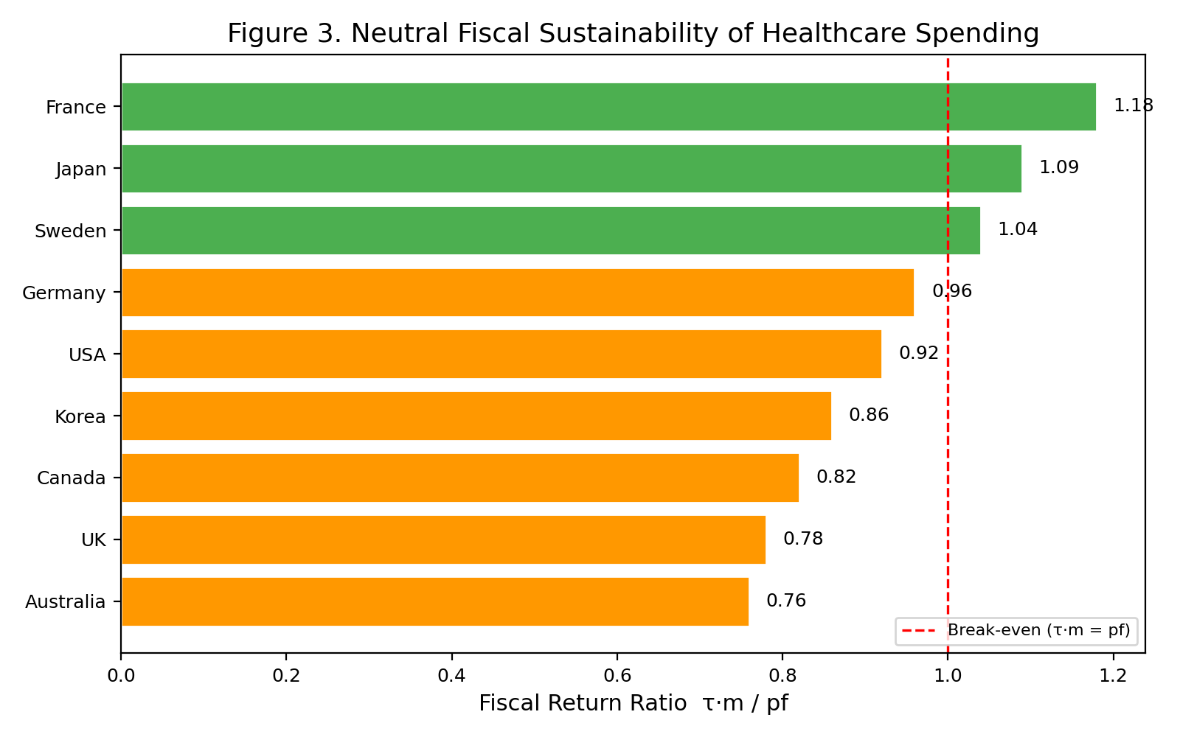
Figure 3. Fiscal Return Ratio of Healthcare Spending by Country
Three of nine countries (Japan 1.09, France 1.18, Sweden 1.04) achieve a demand-side-only fiscal return ratio above 1.0. The remaining six countries range from 0.76 (Australia) to 0.96 (Germany), recovering the bulk of public expenditure through demand-side tax revenues alone. Germany (0.96) and the US (0.92) narrowly miss the threshold; Korea (0.86), Canada (0.82), the UK (0.78), and Australia (0.76) show progressively larger gaps. These gaps are expected to be closed by supply-side returns (health-capital accumulation) not captured in this demand-only metric. The finding that demand-side revenues alone recover 76-118% of public costs challenges the framing of healthcare as a pure fiscal drain.

3.2 Supply Side: Tempo-Adjusted Health-Capital Returns
The fiscal return ratio captures only the contemporaneous flow effect. The full economic value of healthcare spending also includes supply-side returns through future productivity gains from health-capital accumulation. Our tempo analysis showed that the spending-to-outcome lag mu_H drifts at +0.15 years/year, meaning current spending accumulates into a health-capital stock whose returns manifest in future periods. Evaluating by period outcomes alone thus underestimates the true return.
The integrated sustainability criterion can be written as:
Total Return = Demand Return (tau * m * E) + Supply Return (dGDP/dH * delta_H)
>= Public Cost (pf * E)

4. Cross-Country Evidence
Figure 2 shows the relationship between healthcare expenditure (% of GDP) and life expectancy across OECD countries^{10,12}. The quadratic fit reveals a diminishing relationship, where additional spending beyond a certain level yields smaller life-expectancy gains. However, this apparent diminishing return may reflect the tempo effect (lengthening lag) rather than genuine inefficiency.
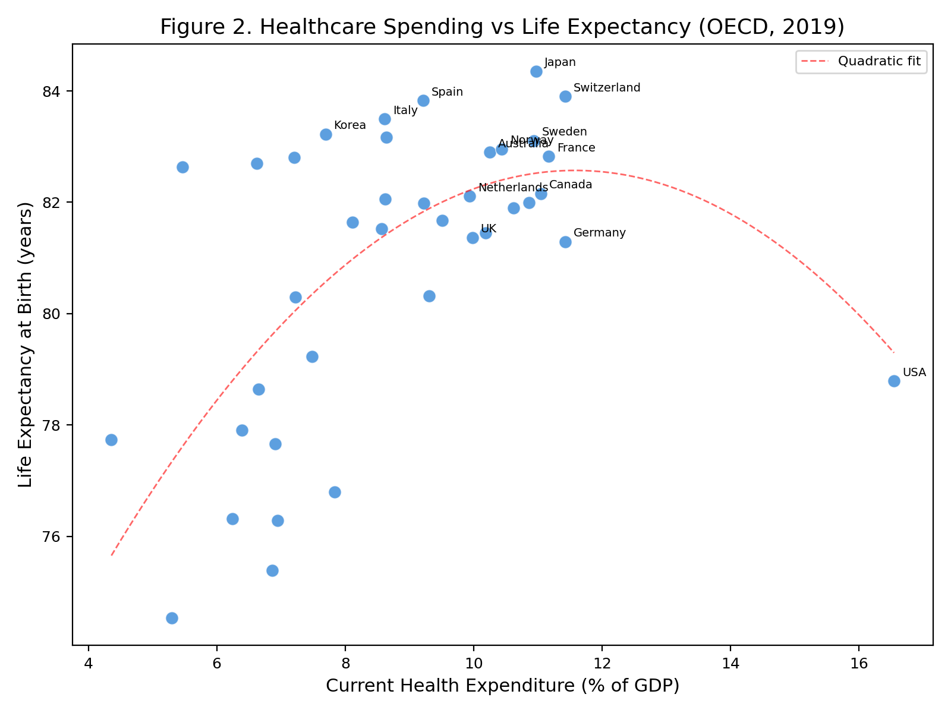
Figure 2. Healthcare Spending (% GDP) vs Life Expectancy (OECD, 2019)
The US spends 17% of GDP on healthcare yet has below-OECD-average life expectancy — the textbook example of 'inefficiency.' From a neutral perspective, however: (1) the I-O multiplier of 1.7 generates approximately $1.0 trillion in additional output annually, and (2) the tempo drift suggests a portion of spending accumulates into future health capital. The issue is not the volume of spending but its composition — the shift from curative-heavy toward prevention and R&D is key^{1,10}.

5. Discussion

5.1 Paradigm Shift: From Cost to Investment
The conventional paradigm treating healthcare as a 'cost' ignores both its demand-side economic-multiplier effect and its supply-side health-capital accumulation effect. Under the neutral criterion proposed here, demand-side tax revenues alone recover 76-118% of public healthcare expenditure across nine countries, with three exceeding full recovery. When supply-side returns from health-capital accumulation are included, comprehensive sustainability likely holds for the majority. This implies that blanket cost-containment policies may inadvertently reduce economic output, employment, and tax revenue.

5.2 Implications of the Japan-US Comparison
Japan's high multiplier (2.78) likely reflects universal health insurance ensuring broad access, and a domestic concentration of pharmaceutical and medical-device industries. The US's lower multiplier (1.7) reflects leakage through high drug prices and insurance administrative costs accruing to overseas firms and insurer profits³. The difference in multipliers points to institutional design improvements, not to healthcare spending itself being 'too high.'

5.3 Limitations and Future Directions
Several limitations apply. First, I-O multipliers are static models that do not account for price adjustments or supply constraints. Second, the fiscal return ratio depends on the effective tax rate parameter, requiring further refinement for robust international comparisons. Third, the tempo drift mu_H is a proxy for health-capital accumulation; direct causal inference requires additional identification strategies. Future work will use OECD SHA (System of Health Accounts) functional expenditure data to estimate bucket-specific multipliers (Candidate D-H) and determine which types of healthcare spending yield the highest returns.

6. Conclusion
Healthcare expenditure is simultaneously a 'cost' and an 'economic effect.' I-O multipliers demonstrate that healthcare spending generates 1.7 to 2.9 times its value in economic output through direct, indirect, and induced effects. HLGH studies confirm bidirectional causality between health expenditure and GDP growth. Tempo analysis shows that contemporaneous flow indicators underestimate investment returns. Under the demand-side fiscal return ratio, three of nine countries exceed 1.0, and all nine recover at least 76% of public costs from demand-side tax revenues alone — before accounting for supply-side health-capital returns. The policy debate should shift from 'how to contain costs' to 'how to maximize the economic return on healthcare investment.'

References
1. Yamada G, Imanaka Y. Input-output analysis on the economic impact of medical care in Japan. Environ Health Prev Med. 2015;20(5):379-387.
2. Maeda Y. Economic ripple effects of healthcare and long-term care. JMARI Working Paper No. 172. 2008. [In Japanese]
3. Dupor B, Guerrero R. The aggregate and local economic effects of government financed health care. Econ Inq. 2021;59(2):662-670.
4. Ertuğrul HM, Baycan O, Atilgan E, Ulucan H. Health-led growth hypothesis and health financing systems: an econometric synthesis for OECD countries. Front Public Health. 2024;12:1437304.
5. Amiri A, Ventelou B. Granger causality between total expenditure on health and GDP in OECD: Evidence from the Toda-Yamamoto approach. Econ Lett. 2012;116(3):541-544.
6. Beylik U, Cetin M, Senol O, Cirakli U, Ecevit E. The relationship between health expenditure indicators and economic growth in OECD countries: A Driscoll-Kraay approach. Front Public Health. 2022;10:1050550.
7. Wang KM. Health care expenditure and economic growth: Quantile panel-type analysis. Econ Model. 2011;28(4):1536-1549.
8. Mushkin SJ. Health as an investment. J Polit Econ. 1962;70(5):129-157.
9. Grossman M. On the concept of health capital and the demand for health. J Polit Econ. 1972;80(2):223-255.
10. OECD. Health at a Glance 2023: OECD Indicators. Paris: OECD Publishing; 2023.
11. Cabinet Office, Japan. Annual Report on the Japanese Economy 2025. Tokyo: Cabinet Office; 2025. [In Japanese]
12. World Bank. World Development Indicators. Washington, DC: World Bank; 2024. Available from: https://databank.worldbank.org/
13. Henke KD, Ostwald DA. Health satellite account: the first step. In: Dged JM, ed. The Elgar Companion to Health Economics. 2nd ed. Cheltenham: Edward Elgar; 2012. p. 327-337.
14. Piabuo SM, Tieguhong JC. Health expenditure and economic growth — a review of the literature and an analysis between the economic community for central African states (CEMAC) and selected African countries. Health Econ Rev. 2017;7(1):23.
15. Barro RJ. Health and economic growth. Ann Econ Finance. 2013;14(2):305-342.
16. Bloom DE, Canning D, Sevilla J. The effect of health on economic growth: a production function approach. World Dev. 2004;32(1):1-13.

