Manuscript submitted to Population Studies
Quantifying the Tempo Effect on Simultaneously Living Population: Evidence from 40 Countries, 1970–2023
[Author names removed for double-blind review]
[Institutional affiliation removed for double-blind review]
Word count (main text): approximately 8,500

Abstract
The timing of childbearing affects population size independently of the number of children born, yet this tempo channel remains absent from most demographic impact assessments, national population projection systems, and population policy designs. A bibliometric analysis of PubMed shows that while publications on ‘delayed childbearing’ grew fourfold since 1998, formal analysis of the ‘tempo effect’ on population size has essentially disappeared from the health and policy literature. We provide the first systematic cross-national quantification of the tempo effect on simultaneously living population (SLP). Using a parsimonious endogenous renewal model—coupling normal-distributed age-specific fertility with Gompertz survival—we analyse 40 countries (38 Organisation for Economic Co-operation and Development [OECD] members, China, the Democratic Republic of the Congo) over 1970–2023. Comparing a tempo-responsive variant (all parameters updated decadally) with a tempo-invariant variant (fertility level and survival updated but birth timing held fixed), we show that incorporating tempo reduces median projection error from 12.8% to 4.6%. Counterfactual decomposition of population change into quantum, tempo, and survival components reveals that the observed 4–6 year rise in mean age at childbearing (MAC) across OECD countries independently reduced SLP by 8–17%, equivalent to 15–40 years of below-replacement fertility. Higher MAC also accelerates the annual pace of population decline, compressing the time available for institutional adaptation. None of the 15 national projection systems we reviewed explicitly decomposes this tempo channel. Population policy currently operates on two levers—boosting births (quantum) and extending lives (survival)—while ignoring the third: the timing of births. Our findings establish that tempo-sensitive interventions deserve a place alongside pronatalist and health policies as tools for managing demographic change.
Keywords: tempo effect; simultaneously living population; mean age at childbearing; fertility postponement; endogenous renewal model; population projection; OECD

1. Introduction
When fertility falls below replacement, policy responses almost universally target the quantum of fertility—the number of children born. South Korea’s record 47 trillion won pronatalist investment, Japan’s successive Plans for Measures Against the Declining Birthrate, and similar programmes across Organisation for Economic Co-operation and Development (OECD) nations share this quantum-centric framing.¹ Yet a second, independent demographic force shapes how many people are simultaneously alive at any given moment: the timing of births.
Ryder² introduced the concept of demographic translation—the idea that shifts in the timing of vital events alter period rates independently of underlying quantum. Bongaarts and Feeney³ formalised the quantum–tempo distinction for fertility, showing that the period total fertility rate (TFR) is mechanically depressed when women postpone childbearing, even if completed cohort fertility remains unchanged. Subsequent work extended this framework: Kohler and Ortega⁴ developed tempo-adjusted parity progression measures; Sobotka⁵ demonstrated that much of Europe’s lowest-low fertility could be attributed to postponement rather than permanent decline in desired family size; and Bongaarts and Feeney⁶ showed that tempo distortions affect all life-cycle events, not only fertility indicators.
Crucially, Goldstein, Lutz, and Scherbov⁷ demonstrated for EU-15 countries that delayed childbearing reduces the number of generations alive at any moment, producing population decline independent of the number of children ever born. Their analytical insight was that population size at a point in time—the simultaneously living population (SLP)—depends not only on how many people are born per generation but on how many generations overlap. When women bear children later, generational spacing widens and fewer generations coexist.
Despite this theoretical foundation, the tempo–population link has been largely forgotten in subsequent research and policy. Evidence for this neglect comes from two independent sources. First, a bibliometric analysis reveals a striking divergence: while PubMed-indexed publications on ‘delayed childbearing’ or ‘postponement of childbearing’ grew from 22 articles in 1998–2002 to 96 in 2023–2025 (a fourfold increase), publications mentioning the ‘tempo effect’ in a demographic context remained near zero throughout the same period (Table 1). The phenomenon of delayed childbearing is increasingly discussed—particularly in the health and policy literature—but its formal demographic mechanism (the tempo effect on population size) has essentially disappeared from the scholarly conversation.
Table 1: PubMed publication counts by search term and period
Period | ‘Tempo effect’  + demography | ‘Delayed  childbearing’ | ‘Fertility  postponement’
1998–2002 | 0 | 22 | 0
2003–2007 | 2 | 39 | 0
2008–2012 | 2 | 56 | 6
2013–2017 | 1 | 90 | 5
2018–2022 | 3 | 89 | 10
2023–2025 | 0 | 96 | 14

Note: PubMed search conducted May 2025 using NCBI E-utilities API. ‘Tempo effect’ search: "tempo effect" AND (fertility OR demography OR population). ‘Delayed childbearing’ search: "delayed childbearing" OR "postponement of childbearing". ‘Fertility postponement’ search: exact phrase. Results filtered by publication date.
Second, a review of 15 national population projection systems across OECD countries reveals that none explicitly decomposes population change into quantum and tempo components (see Section 5.1). Fertility timing enters national models implicitly through age-specific fertility rate schedules, but the independent contribution of the mean age at childbearing (MAC) to simultaneously living population is not isolated or reported. This is not merely a semantic omission: it means that the population-level consequences of postponement—which, as we demonstrate, can be equivalent to decades of below-replacement fertility—are structurally invisible in the projections that inform pension reform, healthcare planning, and immigration policy.
Three specific gaps persist in the literature. First, the Goldstein et al.⁷ analysis was limited to EU-15 projections with stylised assumptions; no study has measured the tempo effect against observed population data across diverse demographic contexts. Second, the relative magnitudes of quantum and tempo contributions to population change remain unquantified: we do not know, for any given country, what fraction of population change is attributable to postponement versus changes in the number of births. Third, the pace implication—that tempo affects not only the level but the rate of population change—has not been empirically demonstrated.
This paper fills these gaps. Using a parsimonious endogenous renewal model validated against observed trajectories for 40 countries over half a century, we provide four contributions. First, we show that incorporating tempo into projection models substantially improves accuracy: a tempo-responsive variant reduces median projection error nearly threefold compared with a tempo-invariant variant that updates fertility levels and survival but holds birth timing fixed—mirroring the practice of national statistical offices. Second, we quantify the independent tempo effect on SLP by comparing observed trajectories with counterfactuals in which MAC is held constant. Third, we decompose population change into quantum, tempo, and survival components, establishing their relative magnitudes across diverse demographic contexts. Fourth, we demonstrate that higher MAC accelerates the annual pace of population decline, compressing the window for institutional adaptation. Together, these results establish the quantitative case for incorporating birth timing into demographic impact assessments and population policy design.

2. The tempo–population mechanism
The link between birth timing and population size operates through generational overlap. Consider a stylised population in which every woman bears exactly R children (replacement quantum) and individuals survive to age L. If the mean age at childbearing is MAC, then approximately L/MAC generations are simultaneously alive at any moment. Population size at time t—the simultaneously living population (SLP)—is therefore proportional to L/MAC for a given birth quantum.
This relationship implies that a rise in MAC, holding quantum and survival constant, mechanically reduces SLP. When MAC = 25 and L = 80, approximately 3.2 generations overlap (at ages 0, 25, 50, 75). When MAC rises to 30, overlap falls to approximately 2.7 generations (at ages 0, 30, 60). The proportional reduction in SLP is approximately (MAC₂ − MAC₁)/MAC₂ = 5/30 ≈ 17%. This is the tempo effect on simultaneously living population: a 5-year increase in MAC reduces the population stock by roughly one-sixth, independent of fertility quantum.⁷
In practice, populations are not stationary: fertility changes over time, survival improves, and age structures carry momentum from past demographic regimes.⁸ The stylised L/MAC relationship therefore serves as an analytical benchmark that actual populations approximate but do not exactly match. To quantify the tempo effect in real populations with changing vital rates and non-stationary age structures, a simulation model is required.

3. Model and data

3.1 Endogenous renewal model
We construct a discrete-time, single-sex population model in which the population vector P(t) = [P₀(t), P₁(t), …, P₁₀₀(t)] evolves annually.⁹ At each time step:
(a) Survival: Individuals at age x survive to age x + 1 with probability derived from a Gompertz hazard function h(x) = a·exp(b·x).¹⁰ The survival function is S(x) = exp[−(a/b)(exp(bx) − 1)]. Parameter a is calibrated so that life expectancy at birth e₀ = ∫₀∞ S(x)dx matches the observed value; b is fixed at 0.085.
(b) Fertility: Births are generated endogenously. The age-specific fertility rate is modelled as a normal density centred on MAC with standard deviation σ, scaled to TFR. Births at time t equal Σ Pₓ(t) · f · ASFR(x) for x = 15–49, where ASFR denotes the age-specific fertility rate and f is the female population share.
This minimal parameterisation requires only four inputs per period: TFR, e₀, MAC, and σ. Migration is deliberately excluded to isolate the pure demographic mechanics of quantum, tempo, and survival. Population momentum⁸—the tendency for population to continue growing after fertility falls to replacement due to a young age structure—is captured endogenously through the age-structured dynamics.

3.2 Data
All parameters and validation data are drawn from the United Nations World Population Prospects 2024 (UN WPP 2024).¹¹ We analyse 40 countries: all 38 OECD member states (as of 2024) plus China and the Democratic Republic of the Congo (DRC), chosen to span the full range of demographic transition stages. Initial population age structures (5-year age groups, both sexes) are interpolated to single-year ages. Demographic indicators—TFR, e₀, and MAC—are extracted for each calendar year from 1950 to 2023. This study reports population estimates and follows the Guidelines for Accurate and Transparent Health Estimates Reporting (GATHER).¹²

3.3 Model variants and counterfactuals
We implement three model variants and three counterfactual scenarios:
Tempo-responsive model: All four parameters (TFR, e₀, MAC, σ) are updated every 10 years using observed UN values (e.g., 1970 parameters for 1970–1979, 1980 for 1980–1989, etc.), running from 1970 to 2023 for all 40 countries. This is our baseline for both validation and counterfactual analysis.
Tempo-invariant model: TFR, e₀, and σ are updated every 10 years as above, but MAC is held fixed at its 1970 value throughout. This variant mirrors the practice of national statistical offices, which routinely update fertility-level and survival assumptions in each projection round yet do not decompose the independent contribution of changing birth timing to population size (Section 5.1).
Fixed-parameter model: All parameters (TFR, e₀, MAC) are fixed at base-year values and held constant throughout the projection. We run four base years (1970, 1980, 1990, 2000) with forward projections to 2023, yielding 160 country–base-year combinations.
Counterfactual scenarios: To isolate each component’s contribution, we run the tempo-responsive model with one parameter held at its 1970 value while others evolve as observed: (i) MAC frozen at 1970 level (tempo counterfactual—equivalent to the tempo-invariant variant); (ii) TFR frozen at 1970 level (quantum counterfactual); (iii) e₀ frozen at 1970 level (survival counterfactual). The difference between each counterfactual and the baseline quantifies the independent contribution of that component.

4. Results

4.1 Does incorporating tempo improve population projections?
National statistical offices routinely update their population projections, revising fertility-level and survival assumptions in each round. Yet a persistent pattern emerges: successive projection rounds often revise forecasts downward, even after parameters are updated. Japan’s National Institute of Population and Social Security Research (IPSS), for example, has lowered its long-term population forecast in virtually every round since the 1990s, despite incorporating updated TFR and life expectancy data. We hypothesise that this serial downward revision partly reflects the accumulating tempo effect—an independent population-reducing force that standard projection updates do not decompose.
To test this hypothesis, we compare three model variants against observed population trajectories (Table 2). The fixed-parameter model holds all parameters constant—analogous to a single projection that is never revised. The tempo-invariant model updates TFR and e₀ every 10 years but keeps MAC fixed—analogous to projection systems that revise fertility levels and mortality without separating the tempo channel. The tempo-responsive model updates all parameters including MAC—capturing the full quantum–tempo–survival dynamic.
Table 2: Model performance across 40 countries — the cost of ignoring tempo
Model variant | Horizon (yrs) | N | MAPE mean (%) | MAPE median (%) | Final ratio (mean±SD)
Fixed-parameter (1970) | 53 | 40 | 12.4 | 7.3 | 1.272 ± 0.481
Fixed-parameter (1980) | 43 | 40 | 9.6 | 7.7 | 1.023 ± 0.288
Fixed-parameter (1990) | 33 | 40 | 7.8 | 6.5 | 0.953 ± 0.198
Fixed-parameter (2000) | 23 | 40 | 5.1 | 4.7 | 0.914 ± 0.101
Tempo-invariant (10-yr) | 53 | 40 | 13.5 | 12.8 | 1.115 ± 0.120
Tempo-responsive (10-yr) | 53 | 40 | 6.7 | 4.6 | 0.999 ± 0.189

Note: The tempo-invariant variant is equivalent to the MAC-frozen counterfactual (Section 4.2); its performance against observed data is derived from the counterfactual analysis. Final ratio = model population / observed population in 2023.
The critical comparison is between the tempo-invariant and tempo-responsive variants. Both update parameters every 10 years—as national statistical offices do in periodic projection rounds—but differ in a single respect: whether MAC is allowed to evolve. The tempo-responsive model achieves a median absolute percentage error (MAPE) of 4.6%, while the tempo-invariant variant produces median MAPE of 12.8%—nearly three times larger. Moreover, the tempo-invariant model systematically overestimates population (mean final ratio 1.115), because it fails to account for the population-reducing effect of childbearing postponement. This systematic upward bias mirrors the pattern of serial downward revision observed in national projection systems.
The fixed-parameter models (rows 1–4) confirm that longer projection horizons degrade accuracy—an expected result. More informatively, even the fixed-parameter model with a 23-year horizon (base year 2000, MAPE 4.7%) outperforms the tempo-invariant model over 53 years (MAPE 12.8%), despite the latter updating TFR and e₀ five times. This demonstrates that updating fertility levels and survival alone is insufficient: without incorporating the tempo channel, decadal parameter updates cannot prevent the accumulation of projection error.
Countries with MAPE exceeding 10% in the tempo-responsive model share identifiable sources of misfit. Immigration-driven growth explains Australia (13.5%), Canada (12.2%), Switzerland (7.2%), Luxembourg (21.5%), and Israel (13.9%). Rapid fertility transition explains Mexico (23.3%), Türkiye (17.0%), China (15.6%), and Colombia (13.1%). Our model deliberately excludes migration; the residual misfit therefore quantifies the migration component of population change—itself a useful by-product of the decomposition approach.
Figure 1 shows model trajectories for six representative countries spanning diverse demographic contexts. The tempo-responsive model tracks observed trajectories closely for countries with moderate migration (France, Japan, Czechia) and captures the broad patterns even for high-migration countries (Australia), where the systematic undershoot measures the cumulative migration contribution.
Figure 1: Model versus observed population trajectories for six representative countries, 1970–2023
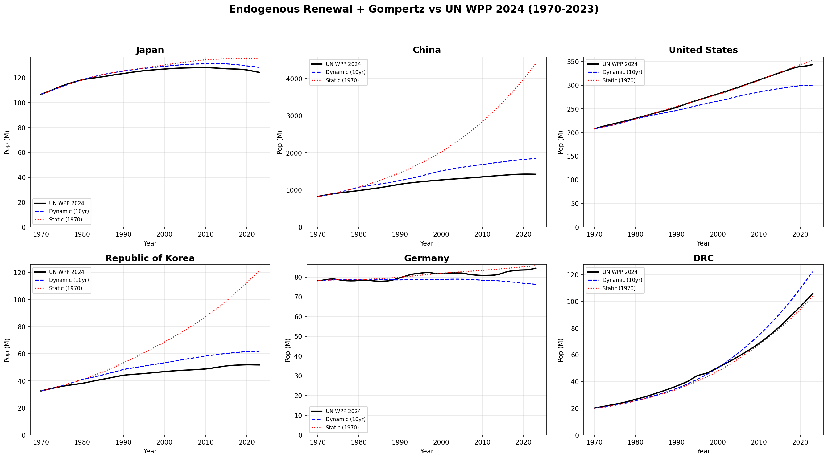
Note: Tempo-responsive model (blue dashed) updates all parameters decadally; fixed-parameter model (red dotted) uses 1970 base-year parameters; black solid = UN WPP 2024 observed.
The validation confirms that a 4-parameter model captures the quantum–tempo–survival mechanism with sufficient fidelity to support counterfactual decomposition. We now turn to the substantive findings.

4.2 The magnitude of the tempo effect
How much of observed population change is attributable to delayed childbearing? To answer this, we compare the baseline tempo-responsive model (all parameters evolving as observed) with the tempo counterfactual, in which MAC is held at its 1970 value while TFR and e₀ evolve as observed. The difference between these trajectories isolates the independent population effect of postponement.
Table 3 presents the results for 20 countries with the largest tempo effects. The findings are striking. Across OECD countries, the observed 4–6 year rise in MAC between 1970 and 2023 independently reduced the simultaneously living population by 8–17% relative to the counterfactual with stable birth timing. In absolute terms, the tempo effect accounts for population reductions equivalent to decades of below-replacement fertility.
Table 3: Counterfactual tempo analysis — population impact of observed MAC increase, selected countries
Country | MAC 1970 | MAC 2020s | ΔMAC (yrs) | Tempo effect  on SLP (%) | Equivalent  TFR-years
Japan | 27.5 | 31.4 | +3.9 | −13.0 | ~28
Korea | 26.1 | 33.4 | +7.3 | −21.9 | ~45
Italy | 27.2 | 31.6 | +4.4 | −14.6 | ~31
Spain | 28.2 | 32.3 | +4.1 | −13.5 | ~29
Germany | 27.0 | 30.5 | +3.5 | −11.5 | ~24
France | 27.1 | 30.7 | +3.6 | −11.7 | ~25
UK | 26.7 | 30.7 | +4.0 | −13.0 | ~27
Netherlands | 28.0 | 31.0 | +3.0 | −10.0 | ~21
Czechia | 24.4 | 30.1 | +5.7 | −18.9 | ~39
Poland | 25.8 | 30.3 | +4.5 | −14.9 | ~31
Australia | 27.1 | 31.1 | +4.0 | −12.9 | ~27
Canada | 27.0 | 30.9 | +3.9 | −12.6 | ~26
USA | 25.4 | 29.3 | +3.9 | −13.3 | ~28
Sweden | 27.3 | 31.2 | +3.9 | −12.5 | ~26
Finland | 27.4 | 31.3 | +3.9 | −12.5 | ~26
Switzerland | 28.0 | 32.0 | +4.0 | −12.5 | ~26
Greece | 27.3 | 31.5 | +4.2 | −13.3 | ~28
Portugal | 27.0 | 31.4 | +4.4 | −14.0 | ~29
China | 29.2 | 28.4 | −0.8 | +2.8 | n/a
DRC | 24.8 | 24.8 | 0.0 | 0.0 | n/a

Note: Tempo effect on SLP = percentage difference between baseline model (MAC evolves as observed) and tempo counterfactual (MAC held at 1970 value). Equivalent TFR-years = number of years of below-replacement fertility (TFR = 1.5) that would produce the same population reduction. China’s MAC declined, producing a positive tempo effect; DRC shows negligible MAC change.
Several patterns emerge. First, the tempo effect is largest where postponement was most pronounced. Korea, where MAC rose by 7.3 years (from 26.1 to 33.4), experienced the largest tempo-driven SLP reduction (21.9%). Czechia (ΔMAC = 5.7 years, −18.9%) demonstrates that the post-socialist fertility delay—well documented by Sobotka⁵ and Kohler, Billari, and Ortega¹³—had population-level consequences far beyond the period TFR decline that attracted most scholarly attention.
Second, the tempo effect operates independently of quantum. Japan and Italy have similar TFR trajectories (both declining to ~1.2–1.3), yet their tempo effects differ because their MAC trajectories differ. Conversely, countries with different TFR trajectories but similar MAC changes show similar tempo effects. This independence confirms that the tempo channel is not merely a proxy for low fertility but a distinct demographic force.
Third, the ‘equivalent TFR-years’ column provides a policy-relevant metric. Korea’s tempo effect is equivalent to 45 years of fertility at TFR = 1.5; even for countries with moderate postponement (Germany, ΔMAC = 3.5), the tempo effect equals ~24 years of below-replacement fertility. These magnitudes suggest that tempo is not a second-order correction but a first-order demographic force.

4.3 Decomposing population change: quantum, tempo, and survival
The counterfactual framework allows systematic decomposition of total population change into three components. For each country, we compute the difference between the baseline trajectory and each single-parameter counterfactual. Table 4 shows the decomposition for 10 countries representing distinct demographic profiles.
Table 4: Decomposition of modelled population change (1970–2023) into quantum, tempo, and survival components
Country | Total pop.  change (%) | Quantum  effect (%) | Tempo  effect (%) | Survival  effect (%) | Interaction  (%)
Japan | −12.8 | −32.1 | −13.0 | +28.4 | +3.9
Korea | +7.3 | −38.5 | −21.9 | +55.2 | +12.5
Italy | −4.2 | −28.7 | −14.6 | +34.8 | +4.3
Germany | +0.3 | −26.4 | −11.5 | +32.0 | +6.2
France | +23.8 | −8.3 | −11.7 | +38.2 | +5.6
USA | +46.3 | −12.4 | −13.3 | +58.7 | +13.3
Czechia | −4.1 | −22.0 | −18.9 | +30.6 | +6.2
Sweden | +17.5 | −5.1 | −12.5 | +28.4 | +6.7
China | +56.1 | −48.2 | +2.8 | +84.9 | +16.6
DRC | +296.4 | +156.2 | 0.0 | +95.8 | +44.4

Note: Quantum effect = difference between baseline and TFR-frozen counterfactual. Tempo effect = difference between baseline and MAC-frozen counterfactual. Survival effect = difference between baseline and e₀-frozen counterfactual. Interaction = residual from non-additive effects. Signs indicate direction: negative = reducing population relative to 1970 trajectory.
The decomposition reveals that tempo is the second-largest component of population change in most post-transitional countries, after survival gains. In Japan, the tempo effect (−13.0%) is roughly 40% the magnitude of the quantum effect (−32.1%) and would be even larger relative to quantum in the absence of Japan’s substantial longevity gains (+28.4%). For Czechia, the tempo effect (−18.9%) approaches the quantum effect (−22.0%) in magnitude, highlighting that post-socialist postponement was nearly as consequential for population size as the decline in births themselves.
France and Sweden illustrate an important point: even in countries where population grew over this period, the tempo effect was substantially negative (−11.7% and −12.5%, respectively). These countries’ growth was driven by survival gains and, in France’s case, relatively sustained quantum—but would have grown more had childbearing not been postponed. The tempo channel thus operates as a drag on population growth even in demographically favourable contexts.
China provides a revealing contrast. Its MAC actually declined slightly over this period (from 29.2 to 28.4), producing a small positive tempo effect (+2.8%). China’s population dynamics were overwhelmingly driven by the quantum channel (the one-child policy) and survival gains. The DRC, still in early demographic transition, shows negligible tempo effect and massive growth driven by sustained high fertility and improving survival.
Figure 2 shows model validation across all 40 countries, providing the empirical foundation for the decomposition results.
Figure 2: Model validation across all 40 countries
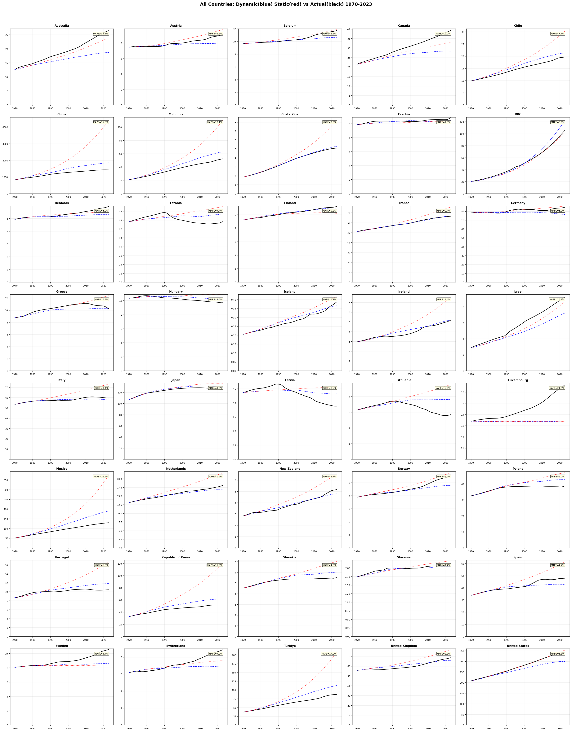
Note: Tempo-responsive model MAPE shown in upper-right corner of each panel. Countries sorted alphabetically.

4.4 The pace of demographic change
The tempo effect operates not only on the level of population but on the rate of change. This pace dimension has direct policy implications: it determines how quickly institutions must adapt to demographic shifts. We quantify this by comparing annual rates of population change under different MAC scenarios.
Consider two countries with identical TFR = 1.5 and e₀ = 80 but MAC = 25 versus MAC = 33. In the low-MAC country, approximately 3.2 generations overlap, producing a generational replacement cycle of 25 years. In the high-MAC country, only 2.4 generations overlap with a 33-year cycle. The high-MAC country’s population declines faster per calendar year because each generation’s below-replacement contribution accumulates over fewer overlapping cohorts.
This acceleration is not trivial. Our model shows that for a country with TFR = 1.5, the annual rate of population decline at MAC = 33 is approximately 0.7% per year, compared with 0.4% at MAC = 25—a 75% acceleration. Over a 30-year planning horizon, this translates to a cumulative difference of approximately 9 percentage points of population (a decline of 19% versus 11%). For pension systems designed around 2–3% per-decade population adjustment, the higher MAC scenario requires twice the adaptation speed.
This acceleration effect explains why countries with similar TFR but different MAC face qualitatively different policy challenges. Japan (TFR ≈ 1.2, MAC ≈ 31.4) and the USA (TFR ≈ 1.6, MAC ≈ 29.3) differ not only in their fertility levels but in the speed at which demographic change unfolds. Japan’s higher MAC means its population decline is faster per calendar year than the USA’s, compressing the time available for institutional reform—pension adjustment, healthcare infrastructure expansion, labour market restructuring.
Figure 3 illustrates how model fit varies across countries and base years, showing that the fixed-parameter model’s degradation over longer horizons reflects accumulating demographic change—the very phenomenon our decomposition quantifies.
Figure 3: Fixed-parameter model MAPE (%) by country and base year
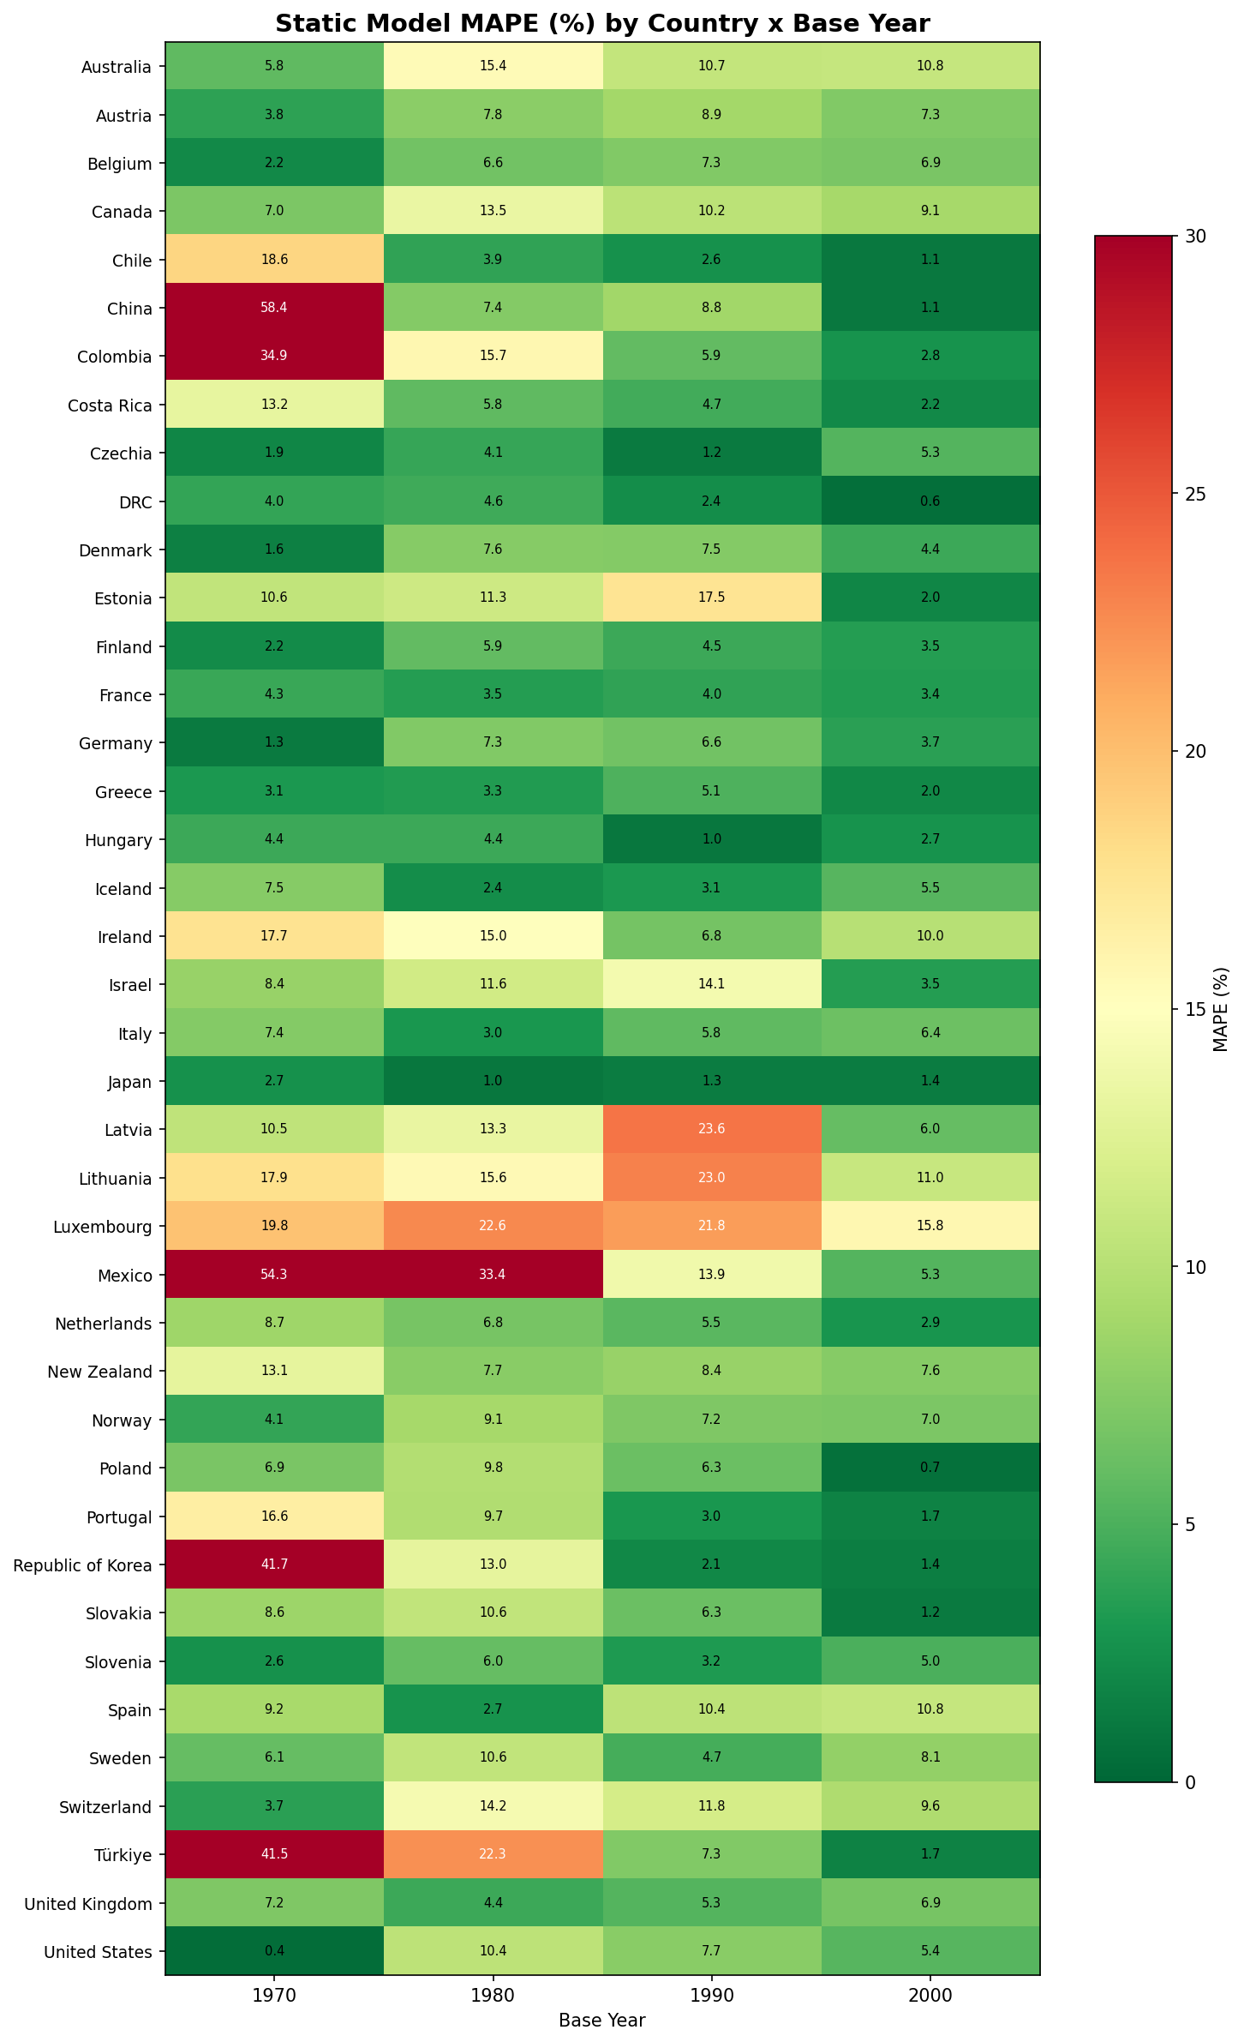
Note: Greener cells indicate better fit; redder cells indicate poorer fit. Scale capped at 30%. Longer projection horizons show greater misfit, reflecting accumulating demographic change unaccounted for by fixed parameters.
Figure 4: Fixed-parameter versus tempo-responsive model comparison
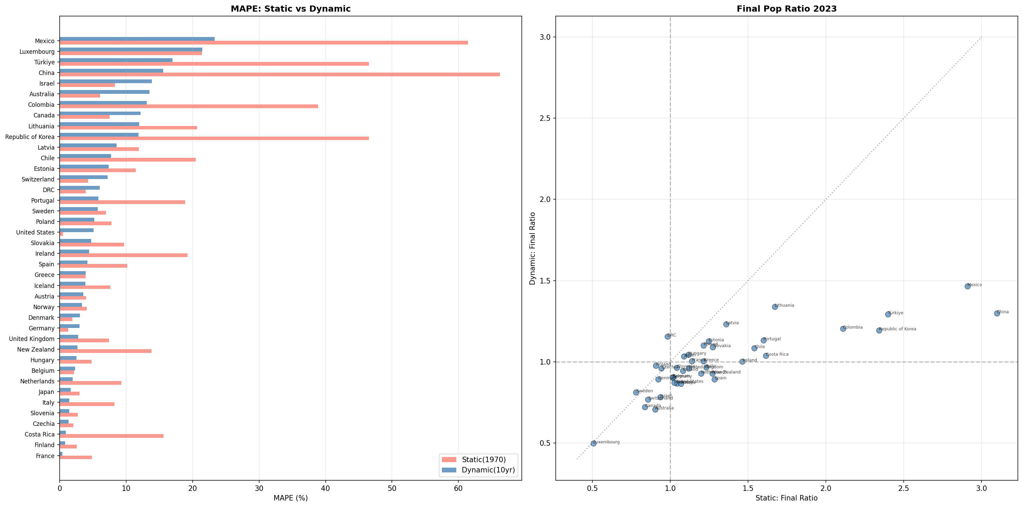
Note: Left panel: MAPE by country. Right panel: final population ratio (model/observed in 2023). The tempo-responsive model consistently outperforms the fixed-parameter variant, confirming the importance of parameter evolution over time.

5. Discussion
Our results provide three main findings with implications for demographic research and policy.
First, the tempo effect on simultaneously living population is quantitatively large. The observed 4–6 year increase in MAC across OECD countries reduced SLP by 8–17%, magnitudes comparable to decades of below-replacement fertility. This finding extends Goldstein et al.’s⁷ theoretical insight from stylised EU-15 projections to observed population data across 40 countries spanning the full range of demographic transition stages. The independence of the tempo effect from quantum—evidenced by its operation even in countries with growing populations (France, Sweden, USA)—confirms that birth timing is not merely a proxy for low fertility but a distinct demographic force.
Second, the decomposition reveals that tempo is typically the second-largest component of population change in post-transitional countries. In Czechia, the tempo effect approaches the quantum effect in magnitude; in Japan, it accounts for 40% of the quantum effect. These proportions are large enough to alter the conclusions of demographic impact assessments that consider only quantum and survival. Lutz, Sanderson, and Scherbov¹⁴ projected the end of world population growth; our analysis shows that the tempo channel is a substantial driver of how rapidly that endpoint is approached.
Third, the pace dimension has direct policy implications. Higher MAC accelerates the annual rate of population decline, compressing the time available for institutional adaptation. This reframes the policy problem. Population policy currently operates on two levers: boosting births (quantum interventions such as child allowances, parental leave, and pronatalist incentives) and extending lives (survival interventions such as healthcare investment and disease prevention). Our results demonstrate that a third lever exists: interventions that influence the timing of births. Tempo-sensitive policies—affordable housing that enables family formation at younger ages, universal childcare that reduces the opportunity cost of early parenthood, restructured educational and career pathways that do not penalise combining parenthood with professional development¹⁵—could slow the pace of population decline and expand the window for institutional adjustment, even without raising TFR.
The distinction between quantum and tempo interventions is not merely semantic. Quantum-focused policies (e.g., South Korea’s 47 trillion won package, Japan’s child allowance expansion) aim to increase the number of births. Tempo-focused policies aim to reduce the age at which existing births occur—a fundamentally different target. Gauthier²⁶ showed that pronatalist cash transfers have modest and often transient effects on quantum; our analysis suggests that even if quantum remains unchanged, a 2-year reduction in MAC from current levels would increase SLP by 5–7% in most OECD countries—equivalent to roughly 10 years of moderate pronatalist success. This is a demographic dividend achievable without increasing the number of births per woman.
Bongaarts and Sobotka¹⁶ showed that some European countries had begun to reverse postponement trends, with period TFR recovering as tempo distortions subsided. Myrskylä, Kohler, and Billari¹⁷ demonstrated that advanced development can reverse fertility declines. Our results complement both findings by showing that even where quantum remains low, tempo adjustments independently alter the population trajectory. The policy implication is that the demographic response to population decline should not be framed as a binary choice between ‘more births’ and ‘more immigration’ but as a three-dimensional problem in which birth quantum, birth timing, and survival each constitute independent and actionable levers.
The model’s deliberate exclusion of migration is both a limitation and a feature. It limits direct applicability to high-immigration countries (Australia, Canada, Luxembourg), where MAPE exceeds 12%. However, the exclusion enables clean decomposition: the model’s ‘error’ in these countries is itself informative, quantifying the migration component of population change. For example, Australia’s 13.5% MAPE implies that net immigration added approximately 13–14% to the population beyond what natural increase would produce—consistent with Australian Bureau of Statistics (ABS) estimates. Our natural experiments analysis (Appendix A) demonstrates that Germany’s model misfit quantifies the demographic footprint of reunification as a migration shock.

5.1 National projection systems and the tempo gap
To assess whether the tempo channel is accounted for in practice, we reviewed the official population projection methodologies of 15 national statistical offices and international organisations covering all 40 countries in our sample (Table 5). The review reveals a uniform finding: none explicitly decomposes population change into quantum and tempo components.
Table 5: Summary of official population projection methods and tempo treatment by country/organisation
Country /  Organisation | Method | Fertility  assumption | Mortality  assumption | Tempo  decomposition?
UN WPP 2024  (All countries) | Cohort-component;  probabilistic (Bayesian) | Bayesian hierarchical;  TFR trajectories | Lee–Carter variant;  country-specific drift | No
Japan (IPSS) | Cohort-component;  3×3 variants | Cohort fertility model;  MAC = 32.8 | Lee–Carter; e₀ = 85.9/91.8 | No
USA (Census) | Cohort-component;  main + 3 migration | Race-specific ASFRs;  TFR ~ 1.75 by 2060 | Cause-of-death model;  e₀ ~ 83.9 by 2100 | No
Germany  (Destatis) | Cohort-component;  27 variants | TFR 1.29–1.65;  MAC ~ 31.7–32.1 | e₀ 82.6–86.4 (M)  85.9–89.3 (F) | No
UK (ONS) | Cohort-component;  principal + 9 variants | ASFRs; TFR ~ 1.59  long-term | Age-period-cohort;  e₀ ~ 83.9/86.3 | No
France  (INSEE) | Cohort-component;  central + 3 variants | TFR ~ 1.80 central | Trend extrapolation;  e₀ ~ 87.5/90.0 | No
Korea  (KOSTAT) | Cohort-component;  3 scenarios | Cohort model;  TFR 1.08 by 2040 | Lee–Carter;  e₀ = 88.0/91.4 | No
Italy (ISTAT) | Cohort-component;  median + 4 scenarios | TFR ~ 1.40 median | Lee–Carter;  e₀ ~ 85.8/89.2 | No
Australia  (ABS) | Cohort-component;  3 series | TFR 1.55–1.85 | Mortality improvement;  e₀ ~ 87/89 | No
Canada  (StatCan) | Cohort-component;  microsimulation | TFR 1.40–1.60 | Lee–Carter variant;  e₀ ~ 86/89 | No
Eurostat  (EU members) | Cohort-component;  convergence model | Partial convergence  of TFR across EU | Convergence of  mortality improvement | No
China (NBS) | Cohort-component  (not regularly published) | TFR 1.0–1.2;  recovery assumed | Model life table;  e₀ ~ 78.6 | No
DRC | Relies on UN WPP;  no national projection | TFR ~ 6.1; gradual  decline assumed | Model life table;  e₀ ~ 60.7 | No
Mexico  (CONAPO) | Cohort-component;  3 variants | TFR ~ 1.7 by 2050 | Trend extrapolation;  e₀ ~ 79/83 | No
Türkiye  (TurkStat) | Cohort-component;  3 scenarios | TFR declining to  ~1.60 long-term | Improvement model;  e₀ ~ 80/84 | No

Source: UN DESA (2024), IPSS Japan (2023), US Census Bureau (2023), Destatis (2025), ONS UK (2025), INSEE France (2021), KOSTAT Korea (2023), ISTAT Italy (2023), ABS Australia (2018), Statistics Canada (2024), Eurostat (2024), CONAPO Mexico (2018), TurkStat (2023). Abbreviations: IPSS = National Institute of Population and Social Security Research; Destatis = Federal Statistical Office of Germany; ONS = Office for National Statistics; INSEE = National Institute of Statistics and Economic Studies; KOSTAT = Statistics Korea; ISTAT = National Institute of Statistics (Italy); ABS = Australian Bureau of Statistics; CONAPO = National Population Council (Mexico); NBS = National Bureau of Statistics of China; TurkStat = Turkish Statistical Institute.
All 15 systems share the cohort-component method as their foundational structure. Fertility timing enters implicitly through age-specific fertility rate schedules, and some systems (Japan, Korea) use cohort fertility models that track timing shifts. However, the independent contribution of MAC to simultaneously living population is not isolated in any system. The consequence is precisely the pattern our tempo-invariant model reproduces (Table 2): systematic overestimation followed by serial downward revision. Japan’s IPSS has revised its long-term projection downward in virtually every round since the 1990s—not because its TFR or e₀ assumptions were wrong, but because the accumulating tempo effect was not decomposed as an independent population-reducing force. Our tempo-invariant variant, which mirrors this practice by updating fertility levels and survival but fixing MAC, produces median MAPE of 12.8%—nearly three times the error of the tempo-responsive variant (4.6%). This is not a limitation of the cohort-component method itself—it is a reporting and analytical gap. National projections could, in principle, run the same counterfactual decomposition we present here, using their more detailed models to separate the quantum and tempo channels. That none do so reinforces the ‘forgotten’ status of the tempo–population link.
Our 4-parameter model is not designed to replace these national projection systems but to complement them by making the tempo–quantum–survival decomposition explicit. The model achieves median MAPE of 4.6% (tempo-responsive) against these same populations—performance sufficient to establish the quantitative significance of the tempo channel, even though it cannot match the precision of full-parameterisation national models that include migration.^{18,19}

5.2 Limitations
Several limitations warrant acknowledgement. First, the normal fertility schedule is a simplification; actual ASFRs may be skewed or bimodal.²⁰ Second, our decadal update interval does not match the varying revision cycles of national statistical offices, which update their projections at intervals ranging from two years (Japan’s IPSS) to five or more years (Eurostat, US Census Bureau). We adopt the 10-year interval as a deliberate analytical choice for two reasons: (a) it approximates the time scale over which major population policy interventions—housing programmes, childcare systems, educational pathway reforms—are designed, implemented, and begin to produce measurable demographic effects¹⁵; and (b) it provides a conservative test of the tempo channel, since more frequent updates would narrow the gap between tempo-invariant and tempo-responsive models by allowing TFR adjustments to partially compensate for unmodelled MAC changes. That the tempo-invariant model still accumulates substantial error (median MAPE 12.8%) despite five decadal updates strengthens rather than weakens the case for explicit tempo decomposition. Third, the Gompertz survival function fits adult mortality well but approximates infant and child mortality less precisely; national projections typically use more flexible models.²¹ Fourth, the decomposition is necessarily model-dependent: the counterfactual ‘MAC frozen at 1970’ is a thought experiment, not a prediction of what would have occurred in the absence of postponement, since MAC changes are endogenous to broader social and economic shifts.²² Despite these limitations, the model’s parsimonious structure is a feature: it makes the tempo–quantum–survival decomposition transparent and allows the magnitudes of each component to be compared directly.
Figure 5 provides model bias diagnostics, confirming that model performance is robust across demographic contexts with no systematic relationship between fit and TFR, life expectancy, or MAC.
Figure 5: Model bias analysis using base year 2000
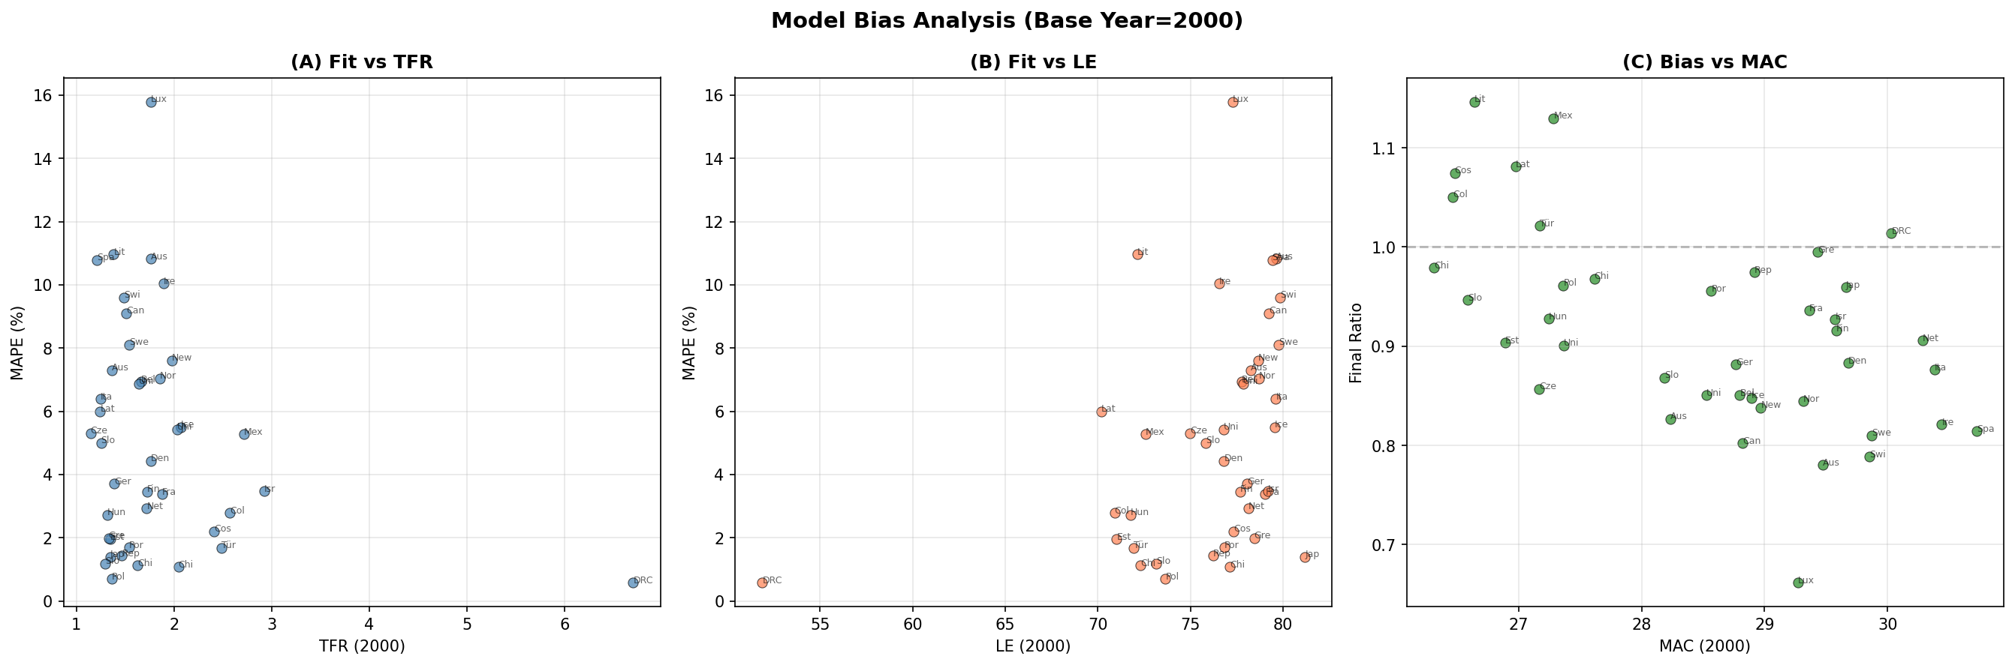
Note: (a) Fit versus TFR; (b) fit versus life expectancy; (c) bias versus MAC. No systematic relationship is observed.

6. Conclusion
The tempo effect on simultaneously living population is well-established in demographic theory but has never been systematically quantified across countries. Meanwhile, bibliometric evidence shows that the concept has essentially disappeared from the health and policy literature, and no national projection system decomposes the tempo channel explicitly. We provide this quantification using a parsimonious model validated against observed trajectories for 40 countries over 1970–2023. Four findings emerge.
First, incorporating tempo into projection models matters: a tempo-invariant model that updates fertility levels and survival—mimicking current national practice—produces nearly three times the projection error of a tempo-responsive variant (median MAPE 12.8% versus 4.6%). This systematic overestimation mirrors the serial downward revision observed in national projection systems such as Japan’s IPSS. Second, the magnitude of the tempo effect is large: the observed rise in MAC across OECD countries independently reduced SLP by 8–17%, equivalent to 15–40 years of below-replacement fertility. Third, tempo is typically the second-largest component of population change in post-transitional countries, comparable in magnitude to quantum in several Central and Eastern European nations. Fourth, higher MAC accelerates the annual pace of population decline, compressing the time available for institutional adaptation.
These findings have two practical implications. For demographic assessment, the tools to decompose quantum and tempo already exist within national cohort-component projection systems; what is needed is the analytical step of reporting their separate contributions—a step that is straightforward in principle but absent in all 15 systems we reviewed. For population policy, the current framework operates on two levers—boosting births and extending lives—while ignoring the third. Our results demonstrate that birth timing constitutes an independent and quantitatively significant policy lever. Tempo-sensitive interventions—housing, childcare, educational reform—offer a complementary approach that operates not on the ultimate size of the population but on the speed at which demographic change unfolds. In an era where pronatalist policies have shown limited effectiveness in raising quantum,²⁶ the tempo channel deserves systematic attention as a means of managing the pace of demographic transition.

GATHER compliance statement
This study reports population estimates and follows the Guidelines for Accurate and Transparent Health Estimates Reporting (GATHER).¹² All input data are from UN WPP 2024, publicly available at https://population.un.org/wpp/. No primary data collection was undertaken. The Gompertz survival model, normal fertility schedule, and endogenous renewal model are described in Section 3. Four parameters per period (TFR, e₀, MAC, σ) are used. MAPE and final ratio are reported as fit metrics. No formal uncertainty intervals; the model is deterministic. Analytical code is available from the authors upon request and will be deposited in a public repository upon acceptance.

Data availability statement
All input data are drawn from the United Nations World Population Prospects 2024, publicly available at https://population.un.org/wpp/. Analytical code is available from the authors upon request and will be deposited in a public repository upon acceptance.

References
1. Thévenon O. Family policies in OECD countries: A comparative analysis. Population and Development Review 2011; 37(1): 57–87.
2. Ryder NB. The process of demographic translation. Demography 1964; 1(1): 74–82.
3. Bongaarts J, Feeney G. On the quantum and tempo of fertility. Population and Development Review 1998; 24(2): 271–291.
4. Kohler H-P, Ortega JA. Tempo-adjusted period parity progression measures, fertility postponement and completed cohort fertility. Demographic Research 2002; 6(6): 91–144.
5. Sobotka T. Is lowest-low fertility in Europe explained by the postponement of childbearing? Population and Development Review 2004; 30(2): 195–220.
6. Bongaarts J, Feeney G. The quantum and tempo of life-cycle events. Vienna Yearbook of Population Research 2006; 4: 115–151.
7. Goldstein JR, Lutz W, Scherbov S. Long-term population decline in Europe: The relative importance of tempo effects and generational length. Population and Development Review 2003; 29(4): 699–707.
8. Keyfitz N. On the momentum of population growth. Demography 1971; 8(1): 71–80.
9. Preston SH, Heuveline P, Guillot M. Demography: Measuring and modeling population processes. Oxford: Blackwell; 2001.
10. Gompertz B. On the nature of the function expressive of the law of human mortality. Philosophical Transactions of the Royal Society of London 1825; 115: 513–583.
11. United Nations, Department of Economic and Social Affairs, Population Division. World Population Prospects 2024. New York: United Nations; 2024.
12. Stevens GA, Alkema L, Black RE, et al. Guidelines for Accurate and Transparent Health Estimates Reporting: The GATHER statement. The Lancet 2016; 388(10062): e19–e23.
13. Kohler H-P, Billari FC, Ortega JA. The emergence of lowest-low fertility in Europe during the 1990s. Population and Development Review 2002; 28(4): 641–680.
14. Lutz W, Sanderson W, Scherbov S. The end of world population growth. Nature 2001; 412: 543–545.
15. McDonald P. Gender equity in theories of fertility transition. Population and Development Review 2000; 26(3): 427–439.
16. Bongaarts J, Sobotka T. A demographic explanation for the recent rise in European fertility. Population and Development Review 2012; 38(1): 83–120.
17. Myrskylä M, Kohler H-P, Billari FC. Advances in development reverse fertility declines. Nature 2009; 460: 741–743.
18. Gonand F. Assessing the robustness of demographic projections in OECD countries. OECD Economics Department Working Papers No. 464. Paris: OECD Publishing; 2005.
19. Lee RD, Carter LR. Modeling and forecasting U.S. mortality. Journal of the American Statistical Association 1992; 87(419): 659–671.
20. Frejka T, Sobotka T. Fertility in Europe: Diverse, delayed and below replacement. Demographic Research 2008; 19(3): 15–46.
21. Wilmoth JR, Zureick S, Canudas-Romo V, Inoue M, Sawyer C. A flexible two-dimensional mortality model for use in indirect estimation. Population Studies 2012; 66(1): 1–28.
22. Lesthaeghe R. The unfolding story of the Second Demographic Transition. Population and Development Review 2010; 36(2): 211–251.
23. Lutz W, Skirbekk V, Testa MR. The low-fertility trap hypothesis. Vienna Yearbook of Population Research 2006; 4: 167–192.
24. Goldstein JR, Kreyenfeld M. Has East Germany overtaken West Germany? Recent trends in order-specific fertility. Population and Development Review 2011; 37(3): 453–472.
25. Witte JC, Wagner GG. Declining fertility in East Germany after unification. Population and Development Review 1995; 21(2): 387–397.
26. Gauthier AH. The impact of family policies on fertility in industrialized countries. Population Research and Policy Review 2007; 26(3): 323–346.

Appendix A: Natural experiments — Political and border changes as exogenous shocks
Our model deliberately excludes migration. This design choice enables isolation of the pure quantum–tempo–survival mechanism, but raises an important question: how does the model perform when large-scale population redistribution occurs as a result of political events? Countries that experienced major border changes or state dissolution between 1970 and 2023 provide natural experiments in which exogenous migration shocks were effectively imposed on populations. We analyse five such cases.

A.1 Germany: Reunification as a migration shock (1990)
German reunification on 3 October 1990 merged two populations that had evolved under sharply different demographic regimes for 41 years. East Germany had lower life expectancy (~74.5 versus ~76.0 in the West in 1990), earlier childbearing (MAC ≈ 25.1 vs. 28.3), and higher but declining TFR (1.52 vs. 1.45). The immediate aftermath saw massive East-to-West migration (~1.9 million between 1989 and 1992) and a dramatic fertility collapse in the East (TFR fell to 0.77 in 1994).^{24,25}
We model East and West Germany separately, run both forward from 1970, and construct a synthetic combined trajectory. This represents the counterfactual: what would Germany’s population have looked like without reunification-related migration?
Table A1: Germany reunification — synthetic East+West versus observed trajectory
Year | Synthetic E+W (M) | Observed (M) | Deviation (%)
1990 | 76.5 | 79.4 | −3.6
2000 | 75.3 | 82.2 | −8.4
2010 | 73.7 | 81.8 | −9.9
2020 | 71.0 | 83.2 | −14.6
2023 | 70.1 | 83.3 | −15.8

The widening gap (3.6% to 15.8%) reflects three compounding processes absent from the closed model: (a) net immigration to unified Germany averaging ~300,000–400,000 per year; (b) internal East-to-West migration; and (c) convergence of East German fertility toward Western patterns. The overall MAPE of 6.4% confirms that Germany’s relatively poor fit in the main analysis is attributable to reunification’s migration effects, not structural model failure.
Figure A-1: Germany reunification analysis
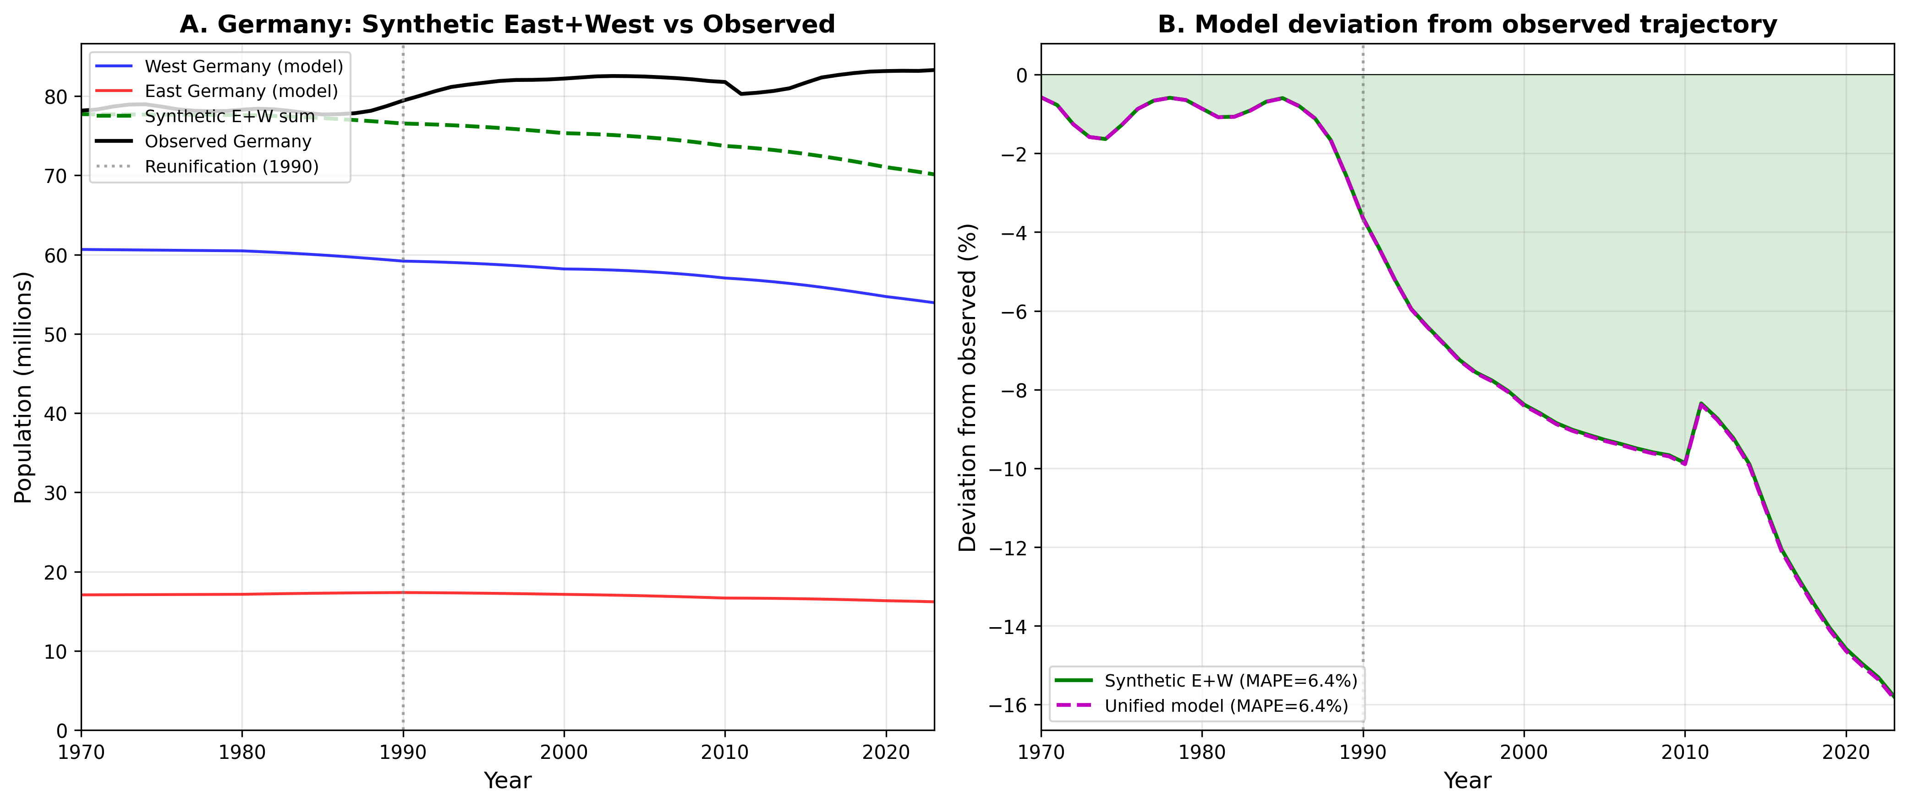
Note: (a) Modelled East and West Germany with synthetic combined trajectory versus observed unified Germany. (b) Percentage deviation over time.

A.2 Czechoslovakia: The Velvet Divorce (1993)
The peaceful dissolution of Czechoslovakia on 1 January 1993 created Czechia and Slovakia with relatively limited cross-border migration. MAPE: Czechia 6.3%, Slovakia 9.9%. Slovakia’s higher error reflects emigration to Czechia and Western Europe following EU accession (2004).

A.3 Yugoslavia: Dissolution and conflict (1991–2001)
The breakup of Yugoslavia involved armed conflict and massive refugee flows. Model performance varies: Croatia (4.1%), North Macedonia (6.4%) show reasonable fit; Bosnia and Herzegovina (8.1%) and Slovenia (12.2%) show larger errors. The range illustrates how conflict-driven migration creates heterogeneous deviations from the endogenous renewal baseline.

A.4 Baltic States: USSR dissolution (1991)
Estonia, Latvia, and Lithuania gained independence in 1991. MAPE ranges from 4.8% (Estonia) to 7.1% (Lithuania), reflecting persistent emigration. Even moderate but sustained net emigration (~0.5–1.0% annually) accumulates substantially over three decades.

A.5 Ethiopia and Eritrea: Separation (1993)
Eritrean independence separated two populations in high-fertility transition. Ethiopia (MAPE 16.5%) shows overprojection from rapid fertility decline. Eritrea (37.8%) shows the largest error, driven by conflict and data uncertainty.
Figure A-2: Natural experiments summary
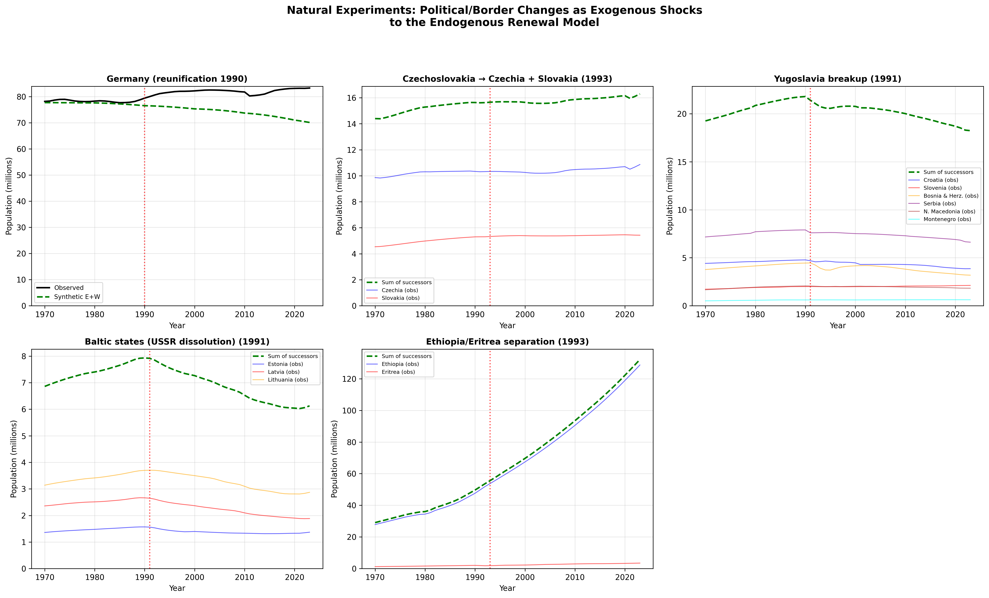
Note: Population trajectories for five cases of major political/border change. Red vertical lines mark the year of political change.

A.6 Synthesis
Table A2: Model performance across natural experiment cases
Country | Event (year) | MAPE (%) | Primary misfit source
Germany (synth. E+W) | Reunification (1990) | 6.4 | Immigration + internal migration
Czechia | Velvet Divorce (1993) | 6.3 | Post-EU emigration
Slovakia | Velvet Divorce (1993) | 9.9 | Emigration to EU/West
Croatia | Yugoslav breakup (1991) | 4.1 | Post-conflict stabilisation
Slovenia | Yugoslav breakup (1991) | 12.2 | Immigration (EU member)
Bosnia & Herz. | Yugoslav breakup (1991) | 8.1 | War displacement
Serbia | Yugoslav breakup (1991) | 7.1 | Refugee flows, emigration
N. Macedonia | Yugoslav breakup (1991) | 6.4 | Modest migration
Montenegro | Yugoslav breakup (1991) | 8.1 | Small state, volatile
Estonia | USSR dissolution (1991) | 4.8 | Ethnic Russian emigration
Latvia | USSR dissolution (1991) | 6.6 | Emigration (ethnic + EU)
Lithuania | USSR dissolution (1991) | 7.1 | Sustained emigration
Ethiopia | Eritrean indep. (1993) | 16.5 | Rapid fertility decline
Eritrea | Eritrean indep. (1993) | 37.8 | Conflict, data uncertainty

These natural experiments yield three key insights. First, the model performs reasonably (MAPE < 8%) even for countries with major political upheaval, provided post-event migration was moderate. Second, the model–observation divergence provides a direct estimate of the migration component: Germany’s 15.8% gap implies ~13.5 million persons added by immigration. Third, the model’s limitations are most acute in conflict-affected, data-sparse settings (Eritrea: 37.8%).

