Re-auditing legacy standards after technological change: a pre-specified protocol for static benchmarks and transition-evidence gates
Abstract
Technological capability can expand feasible sensing, prediction, computation, communication, and control, but a static technical advantage does not establish that a persistent standard is inefficient or should be redesigned. We present a pre-specified, reproducible Legacy Standard Audit separating a historically defensible incumbent problem—without assuming historical optimality—a current case-specific frictionless benchmark, and a transition-evidence gate. We screened 122 candidates in 12 domains and froze 7 heterogeneous cases before confirmatory estimation, preserving null and insufficient-evidence outcomes. Simulated perfect-remaining-life maintenance and a perfect-weather reference-crop comparison met pre-specified material-mismatch thresholds. Perfect-label lighting and bounded fixed-price load shifting remained small or uncertain; a traffic delay proxy and container compatibility were insufficient, while repeated-halving geometry returned the narrow analytic null. Objectives and units differ, so results are not pooled and do not estimate a population rate. Removing both threshold-meeting oracle cases eliminated material primary labels. No case had Level A transition evidence; only native-unit break-even ceilings are identified. Documented capability change can therefore trigger re-audit, whereas redesign requires case-compatible implementation, safety, network, and regulatory evidence.
Keywords: standards; path dependence; technological change; adaptive control; switching costs; reproducibility; technology governance

1. Introduction
Standards coordinate expectations, reduce interface uncertainty, and permit complementary investment. Those same benefits can make an incumbent persistent after the problem environment changes. Research on dominant designs and technological trajectories explains how technologies stabilize and later face discontinuities (Utterback and Abernathy, 1975; Dosi, 1982; Abernathy and Clark, 1985; Tushman and Anderson, 1986; Henderson and Clark, 1990). Research on increasing returns, compatibility, and infrastructure lock-in explains why persistence can remain privately or socially rational (Farrell and Saloner, 1985; Arthur, 1989; Liebowitz and Margolis, 1995; Pierson, 2000; Unruh, 2000). The analytical error is therefore not persistence itself, but inferring either efficiency or inefficiency from persistence without reconstructing the decision problem.
Digital technologies sharpen this problem. Cheap sensing, computation, communication, and adaptive control can relax information constraints that once favored fixed schedules, fixed intervals, or static allocations. Digital innovation also changes architectures and organizing logics rather than merely improving a component (Yoo et al., 2010; Nambisan et al., 2017). Yet real-time information does not erase compatibility, investment, safety, regulation, or collective-action costs. Standards scholarship accordingly shows that dominance depends on installed bases, participation, governance, and the interaction between standardization and innovation (Allen and Sriram, 2000; Suarez, 2004; Wiegmann et al., 2017; van de Kaa et al., 2018; Blind et al., 2022, 2023).
This article contributes a pre-specified measurement and governance protocol. It does not offer a new general theory of lock-in. Instead, it operationalizes a question that spans standards economics, technological transitions, and adaptive systems: when a technology changes the feasible information or control set, how should an incumbent standard be re-audited without selecting only striking examples or forcing a redesign conclusion? The protocol estimates case-specific static benchmark gaps and applies a separate transition-evidence gate, preserves null and insufficient-evidence cases, and forbids pooling outcomes with incomparable objectives.
The protocol is not a claim to have invented standards review. ISO systematic review already supports confirmation, revision or amendment, and withdrawal, while the NIST FACTS framework analyzes standards across lifecycle, stakeholder, implementation, comparison, and testing perspectives (International Organization for Standardization, n.d.; Witherell et al., 2013). The narrower distinction here is an empirical evidence sequence linking a documented capability change to a case-specific static benchmark and then to a separate redesign gate.
We make three bounded contributions. First, the protocol freezes case selection, comparators, thresholds, raw-input provenance, and null retention before confirmatory estimation. Second, it separates static benchmark evidence from a graded transition-evidence gate, preventing technical improvement from becoming an automatic redesign recommendation. Third, the heterogeneous frozen cases test whether the common audit architecture remains usable across non-common objectives without pooling magnitudes or claiming population prevalence. The cases are present-day audit demonstrations, not reconstructions of historical optima.

2. Theory and audit propositions
Path dependence can arise through increasing returns and coordination, but historical persistence alone does not establish market failure. Critical work on escape from lock-in and technological trajectories emphasizes that incumbent systems may be difficult to displace even when alternatives improve (Cowan and Hultén, 1996; Dolfsma and Leydesdorff, 2009; Heinrich, 2014). Sociological and organizational accounts add that standards are enacted through practices and institutions rather than imposed as purely technical rules (Orlikowski, 1992; Timmermans and Epstein, 2010). Exploration and exploitation create a related governance tension: reassessment has option value, but continual change can destroy coordination value (March, 1991).
Transition research frames system change as a co-evolution of technology, institutions, infrastructure, and user practices (Geels, 2002, 2004, 2005). Governance experiments can reveal transition conditions, but their success is contextual (Bos and Brown, 2012). Standards participation and policy further shape whose objectives and constraints enter a redesign process (Choung et al., 2012; Blind and von Laer, 2022). Consumer switching research likewise shows that comparative technical value is only one component of adoption (Kamolsook et al., 2019).
The framework yields five falsifiable expectations. First, where source evidence supports information scarcity as a plausible generating constraint, fixed rules should show larger static mismatch when reliable real-time control becomes feasible. Second, a responsive comparator should rank better under the specified objective only when information and control gains exceed error and implementation costs. Third, non-technological changes such as demand, prices, demography, and regulation may explain apparent mismatch and must be modeled or named. Fourth, network and switching costs can rationally preserve an incumbent despite a positive frictionless benchmark gap. Fifth, some inherited standards should remain aligned with their specified objective and appear as null controls.

3. The Legacy Standard Audit
Let the incumbent be $x_{inc}$. The historical optimum $x_{h}^{∗}$ minimizes loss under the historical feasible set and parameters; the current frictionless optimum $x_{c}^{∗}$ minimizes current loss without switching costs; and the transition-adjusted optimum $x_{T}^{∗}$ adds switching, compatibility, and coordination costs. Figure 1 shows the resulting decision sequence.
Here $x_{h}^{∗}$ is a conceptual benchmark, not an empirical assumption that $x_{inc}=x_{h}^{∗}$. If the historical objective, feasible set, or chronology cannot be verified, the audit records only a historically defensible incumbent problem and classifies the historical optimum as unidentified.
$$x_{h}^{∗}=\underset{x∈X_{h}}{arg min}L_{h}(x;θ_{h})$$
$$x_{c}^{∗}=\underset{x∈X_{c}}{arg min}L_{c}(x;θ_{c})$$
$$x_{T}^{∗}=\underset{x∈X_{c}}{arg min}[L_{c}(x;θ_{c})+C_{switch}(x_{inc},x)]$$
$$R_{static}=L_{c}(x_{inc};θ_{c})−L_{c}(x_{c}^{∗};θ_{c})$$
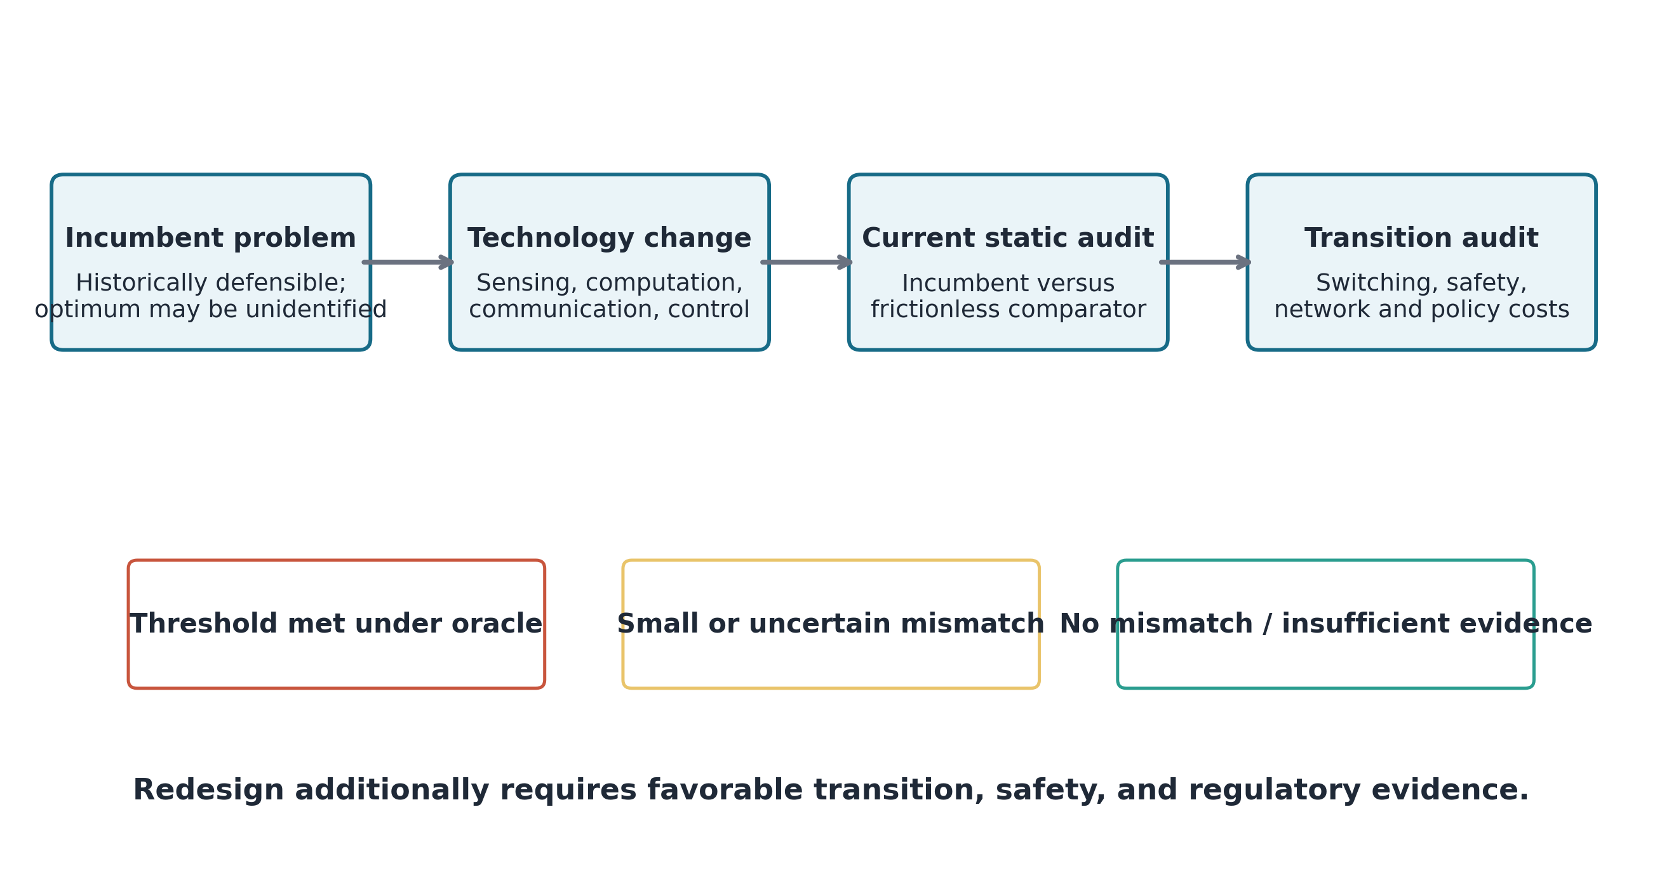
Figure 1. Legacy Standard Audit. Technological change can trigger reassessment; a redesign recommendation requires case-compatible transition evidence.
Table 1 defines the five audit stages. A case can show a positive static benchmark gap and still retain the incumbent if discounted gains do not exceed conversion, coordination, stranded-asset, safety, or regulatory costs. Conversely, a null case is informative because it demonstrates that persistence need not indicate technological inertia.
Table 1. Legacy Standard Audit stages.
Audit stage | Required evidence | Decision output
Historical reconstruction | Objective, information set, feasible set, coordination conditions | Historically defensible incumbent problem
Technology-mediated change | Sensing, computation, communication, automation, adaptive control | Changed parameter or feasible-set claim
Static audit | Incumbent and contemporary comparator under a common objective | Case-specific static benchmark gap
Transition audit | Switching, compatibility, safety, regulation, network effects | Transition-adjusted estimate or break-even gate
Governance | Frozen cases, uncertainty, null controls, falsification | Material, uncertain, null, or insufficient classification

4. Data and pre-specified methods
Candidate selection preceded confirmatory estimation. The registry covered the built environment, transport, automotive interfaces, work, education, healthcare, packaging, paper and digital legacies, utilities, household and demographic systems, information-scarcity systems, and null controls. Screening used historical evidence, technology relevance, decision clarity, public-data availability, identifiability, counterfactual feasibility, transition-cost feasibility, source quality, and comparability. The frozen roles were four primary cases, one supplementary case, one network control, and one analytic null control. The candidate universe, scoring protocol, case roles, comparators, thresholds, and analysis configuration were fixed before confirmatory outputs were estimated; no case was replaced after its result was known.
The candidate universe contained 122 candidates in 12 domains, and 7 cases were frozen before confirmatory estimation. Scoring excluded expected effect direction, magnitude, statistical significance, and narrative usefulness. The frozen case set is stored as a machine-readable artifact with its own hash and the hash of every input it references, so later changes to roles or sources are detectable.
Every public input was saved as a local raw snapshot and registered with its URL, identifier, version, access time, retrieval conditions, file size, SHA-256 hash, terms, and completeness. Raw inputs were not overwritten. Analysis configuration, random seed, and bootstrap settings were fixed in a machine-readable configuration. Temporal uncertainty used circular block resampling, except that UI09 drew non-circular blocks wholly contained within annual growing seasons; the C-MAPSS engine was the independent simulation unit. A copyrighted ISO 216 sample is retained locally for verification and excluded from the public repository.
Classifications were operational decision labels rather than significance tests. BE03 required the lower uncertainty bound to exceed 20% with no labeled occupied false-off events; WK07 required a positive lower regret bound and relative regret above 5%; UI09 required the lower normalized-regret bound to exceed 5%. UI01 remained uncertain because response and equilibrium were not identified, while TR01 and NC01 required incumbent and transition evidence unavailable in the registered sources. The thresholds organize the frozen audit and are not universal welfare criteria.
Case-specific analytical rules were fixed as follows; their sources are listed at the end of this subsection.
BE03 parses the UCI occupancy file row-wise; 2 embedded repeated header rows fail timestamp and occupancy conversion and are removed from the processed table without altering the raw file. The incumbent is a weekday 07:00–19:00 nominal lighting schedule, and the schedule sensitivity settings are 08:00–18:00, 07:00–19:00, and 06:00–20:00. The comparator uses perfect retained occupancy labels with a 10-minute rolling hold and is not a deployed sensor policy.
WK07 uses NASA C-MAPSS FD001 simulated run-to-failure trajectories. Training lifetime is the maximum observed cycle of each training engine; evaluation lifetime is the maximum observed test cycle plus the supplied remaining useful life. A renewal cost rate with preventive cost 1 and failure-cost ratio 5 selects the fixed replacement age on the training simulation. The comparator replaces each evaluation engine 5 cycles before failure with perfect remaining-life information.
UI01 retains Germany-Luxembourg hourly load and day-ahead prices only for complete 24-hour UTC days. Within each day, a bounded fraction of observed hourly load (1%, applied as a symmetric hourly bound) is shifted toward lower observed prices while daily energy is conserved. Prices are held fixed; the procedure is neither a retail-tariff response model nor a market re-equilibration.
UI09 calculates daily FAO-56 reference evapotranspiration from NASA POWER temperature, humidity, wind, radiation, precipitation, latitude, and elevation, after converting shortwave radiation from kWh m⁻² day⁻¹ to MJ m⁻² day⁻¹. Weekly net requirement is non-negative evapotranspiration minus precipitation within the 04-01 to 09-30 (month-day) growing season. The calendar rule is the training-period (2015–2019) median weekly requirement, evaluated in 2020–2024 against perfect-weather weekly requirements with a shortfall penalty of 5. Bootstrap blocks are wholly contained within one growing season and never cross the excluded winter gap.
TR01 selects, by a deterministic rule, the traffic-count segment with the most days observed in both directions of one axis, using the segment identifier as the tie-breaker. Training estimates a fixed directional allocation, and evaluation compares it with hourly demand-proportional allocation using a convex saturation-delay proxy; this is not a deployed signal model. NC01 and NC03 test, respectively, an unquantified compatibility case and an exact geometric null.
Source attribution is UCI Machine Learning Repository (2024) for BE03, National Aeronautics and Space Administration (n.d.) for WK07, Open Power System Data (2020) for UI01, Food and Agriculture Organization of the United Nations (2025) and National Aeronautics and Space Administration POWER Project (n.d.) for UI09, United States Federal Highway Administration (2008) and New York City Department of Transportation (n.d.) for TR01, and International Organization for Standardization (2007, 2020) for the controls.
Table 2 lists the analysis unit, comparator, and primary threat to interpretation for each frozen case. These limitations are part of the result rather than post-estimation caveats.
Table 2. Frozen case design and evidentiary limits.
Case | Role | Persisted input | Analysis unit | Contemporary comparator | Critical limitation
BE03 | Primary | UCI office occupancy | 20,560 minute-observations | Perfect-label occupancy comparator, 10-minute hold | No sensor error, power, commissioning, or installation cost
WK07 | Primary | NASA C-MAPSS FD001 simulation | 100 evaluation units | Perfect remaining-life condition policy | Simulated trajectories; no observed maintenance program
UI01 | Primary | OPSD load and day-ahead prices | 725 complete days | 1.0% bounded load shift | Fixed prices; no tariff assignment or customer response
UI09 | Primary | NASA POWER weather and FAO-56 | 135 evaluation weeks | Perfect-weather reference-crop requirement | No crop coefficient, soil storage, efficiency, or yield model
TR01 | Supplementary | NYC directional traffic counts | 18 evaluation days | Demand-proportional directional allocation proxy | No verified intersection or deployed timing plan
NC01 | Network control | ISO container-standard metadata | Not estimable | Break-even identity only | No fleet, conversion, or network-cost data
NC03 | Analytic null | ISO 216 geometric principle | Exact analytic objective | Positive solution r = √2 | Applies only to repeated-halving similarity

5. Results
BE03 retained 20,560 valid minute-observations after removing embedded repeated header rows. The perfect-label occupancy comparator reduced nominal on-time by 25.7% (95% block interval 18.0%–34.9%) while both policies had zero occupied false-off observations under the retained labels. The result was classified as small or uncertain because schedule choice strongly changed the estimate and deployment costs and sensor errors were unavailable.
WK07 selected a fixed replacement age of 134 cycles on the training simulation. In the evaluation simulation, the fixed policy cost rate was 0.00746 and the perfect-remaining-life condition rate was 0.00496, yielding static regret 0.00250 normalized cost per cycle (95% interval 0.00229–0.00271) and relative regret 33.5%. This simulated oracle comparison met the pre-specified material-mismatch threshold; it is not observed fleet savings.
UI01 retained 725 complete days. With 1.0% of each hourly load available for bounded intraday reallocation, the fixed-price arithmetic saving was EUR 0.072 per MWh of baseline load (95% block interval 0.068–0.076), equal to 0.19% of baseline procurement cost. The small estimate, fixed-price assumption, and absence of customer response support a small-or-uncertain classification.
UI09 used 135 training and 135 evaluation weeks. The calendar application was 121.69 mm/week, compared with a perfect-weather reference-crop mean of 121.87 mm/week. Normalized objective regret was 36.9% (95% block interval 31.7%–39.9%). The result met the pre-specified material-mismatch threshold across loss-weight checks, but it is a reference-crop, perfect-weather oracle with omitted agronomic constraints; the objective gap is not physical water savings.
TR01 retained 18 evaluation days and produced a 27.2% reduction in a directional delay proxy (95% block interval 22.3%–31.0%). Because the data do not establish an intersection, incumbent timing plan, pedestrian constraints, queues, saturation flows, or safety outcomes, the case remained insufficient evidence. NC01 also remained unquantified. NC03 returned the exact positive repeated-halving ratio 1.414214 with numerically zero loss for that narrow objective.
Figure 2 reports primary-case benchmarks on separate scales to prevent false comparability. Table 3 reports the corresponding classifications.
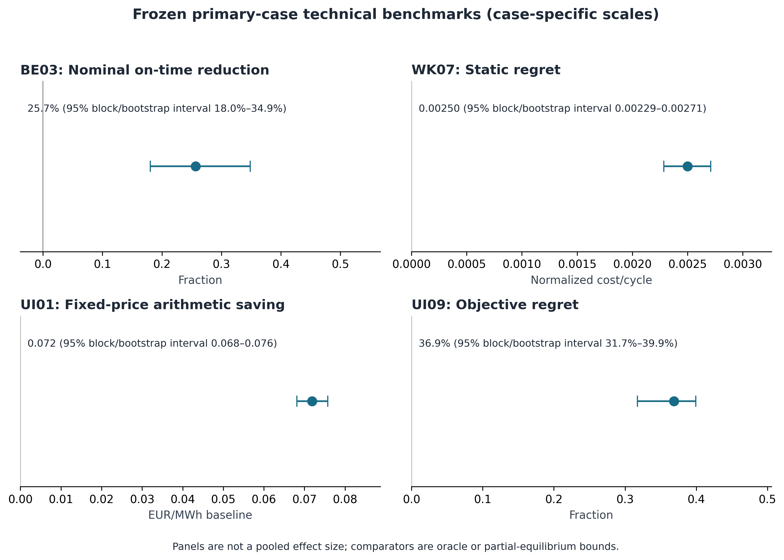
Figure 2. Frozen primary-case technical benchmarks. Each panel uses a case-specific objective and scale; estimates are not pooled.
Table 3. Case-specific technical benchmark results.
Case | Pre-specified metric | Estimate | 95% interval | Classification
BE03 | Nominal lighting on-time reduction | 25.7% | 18.0%–34.9% | small or uncertain mismatch
WK07 | Static regret, normalized cost/cycle | 0.00250 | 0.00229–0.00271 | material mismatch under oracle benchmark
UI01 | Fixed-price arithmetic saving, EUR/MWh baseline | 0.072 | 0.068–0.076 | small or uncertain mismatch
UI09 | Normalized objective regret | 36.9% | 31.7%–39.9% | material mismatch under oracle benchmark
TR01 | Delay-proxy reduction | 27.2% | 22.3%–31.0% | insufficient evidence
NC01 | Static/transition regret | Not estimated | Not estimated | insufficient evidence
NC03 | Repeated-halving loss | 4.930e-32 | Exact analytic result | no mismatch for repeated halving objective

Figure 3 reports every pre-specified model or loss alternative for the four primary cases. Under the alternative fixed schedules, the BE03 point estimate ranged from 7.8% to 37.7%, spanning the 20% material threshold, so the position of the BE03 point estimate relative to that threshold depends on which fixed schedule is treated as the incumbent. WK07 regret ranged from 0.0021 to 0.00301 normalized cost per cycle across failure-cost ratios and warning leads, remaining positive in every setting. UI01 savings ranged from 0.0359 to 0.359 EUR per MWh baseline load and scaled with the assumed flexible-load fraction. UI09 normalized regret ranged from 18.9% to 58.6% across median or mean calendar rules and shortfall penalties, above the 5% threshold in every setting. The alternatives change magnitudes, not the sign of the WK07 and UI09 gaps; the full parameter grid is released with the code.
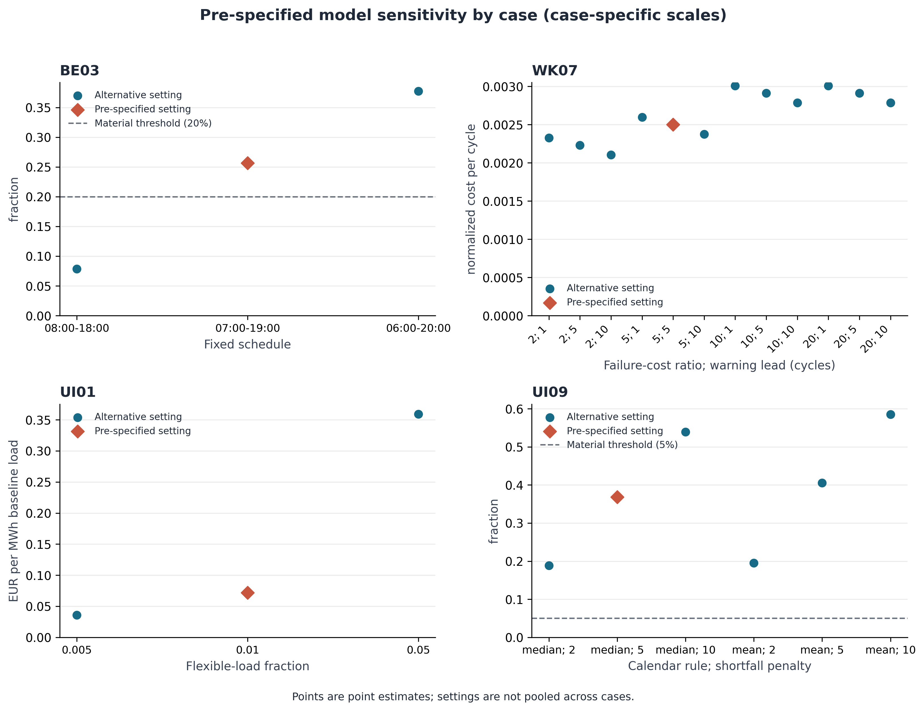
Figure 3. Pre-specified model sensitivity for the primary cases. Diamonds mark the pre-specified setting; dashed lines mark material thresholds where the threshold is defined on the plotted scale. Each panel uses its own case-specific unit; points are point estimates and are not pooled.

6. Cross-case synthesis and falsification
Two of 4 primary cases met the pre-specified material-mismatch label under oracle comparison, while the remaining primary cases were small or uncertain. That count is descriptive; no universal or pooled effect size was computed. Removing either threshold-meeting case reduced the count to one; excluding simulated C-MAPSS evidence also left one. Removing both threshold-meeting oracle cases reduced the count to 0. The cross-case result therefore does not establish a stable population rate of mismatch.
Heterogeneity is a design feature for testing protocol portability, not a basis for estimating a common effect. Each case retains its own objective function, denominator, comparator, and native unit. The common architecture consists only of the technology mechanism, static-evidence state, transition-evidence gate, and final audit classification. Cross-case synthesis therefore compares audit states and evidence completeness rather than magnitudes.
Exploratory lower classification thresholds increased the primary-case count from 2 to 3; the higher explored thresholds left it at 2. As Figure 3 showed, supported model and loss alternatives preserved positive WK07 and UI09 gaps but changed their magnitudes, while BE03 crossed classification-relevant ranges under alternative fixed schedules. Table 4 collects case removal, domain removal (UI01 and UI09 share the utilities and infrastructure domain), source-quality, threshold, model, and control checks in one place. These checks weaken any result-frequency claim but not the procedural conclusion that evidence state and comparator quality must be audited case by case.
Figure 4 demonstrates why frozen null and insufficient-evidence cases matter. The outcomes span all intended categories rather than converging on a redesign narrative. The strongest evidence is conditional: inexpensive information and control can create a measurable static benchmark gap under a specified objective, but redesign recommendations remain unidentified without implementation, network, safety, and coordination costs. Real-time foresight can improve preparedness in dynamic networks (Weber et al., 2015), but it cannot substitute for case-specific institutional evidence.
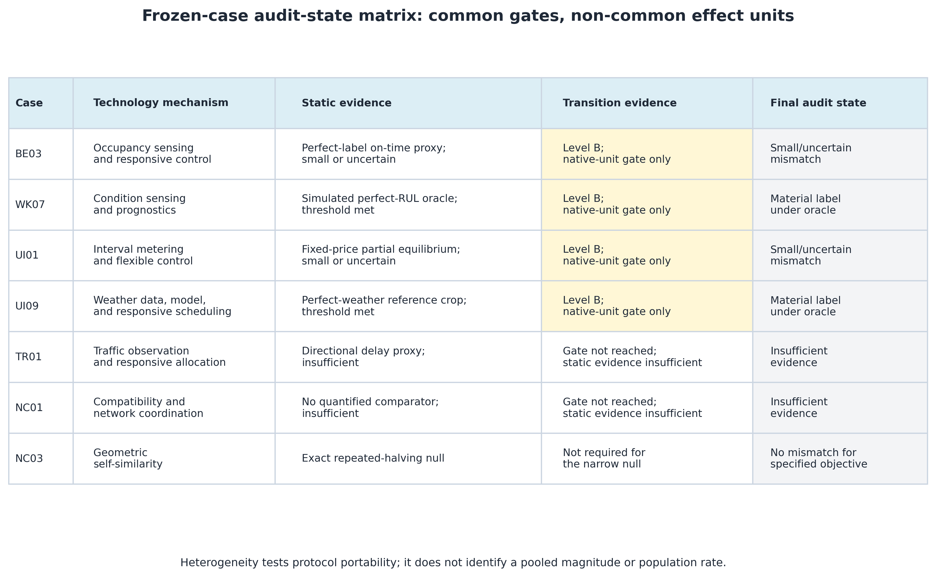
Figure 4. Audit-state matrix for all pre-specified frozen cases. Common columns show technology mechanism and evidence gates; static effect units remain case specific and are not pooled.
Table 4. Cross-case falsification: case and domain removal, source quality, thresholds, supported model or loss alternatives, and controls. Counts refer to primary cases meeting the material-mismatch label.
Test (scope) | Result | Claim weakened? | Interpretation
Baseline (all primary cases) | 2 of 4 primary cases meet the oracle-threshold label | No | Descriptive classification count only; no pooled magnitude or population rate.
Leave one primary case out | BE03 2/3; WK07 1/3; UI01 2/3; UI09 1/3 | Yes—material-count claim (WK07, UI09) | The procedural claim survives; the number of material oracle labels depends on the strongest cases.
Leave one domain out | BE03 2/3; WK07 1/3; UI01+UI09 1/2 | Yes—material-count claim (WK07, UI01+UI09) | UI01 and UI09 share utilities/infrastructure; domain deletion is not identical to every case deletion.
Remove WK07 and UI09 together (both strongest oracle cases) | 0 of 2 retained primary cases meets the label | Yes—empirical material-mismatch claim | The procedural and heterogeneous-outcome claims survive; evidence of material primary mismatch does not.
Exclude simulated C-MAPSS (source-quality sensitivity) | 1 of 3 retained primary cases meets the label | Yes—material-count claim | Material mismatch is not supported by more than one primary case after excluding simulation.
Classification thresholds (lower, pre-specified, higher) | lower (BE03 10%; WK07 2.5%; UI09 2.5%) 3/4; pre-specified (BE03 20%; WK07 5%; UI09 5%) 2/4; higher (BE03 30%; WK07 10%; UI09 10%) 2/4 | lower: Yes—classification count; pre-specified: No; higher: No | Threshold variation is exploratory; it does not alter the frozen reported classifications.
Model or loss alternatives (BE03: Schedule alternatives) | range 0.0783925 to 0.377177 fraction | Yes—case magnitude and threshold status | Nominal on-time reduction varies strongly with the assumed fixed schedule.
Model or loss alternatives (WK07: Failure-cost and warning-lead alternatives) | range 0.00210467 to 0.00300736 normalized cost per cycle | No—sign; yes—magnitude | Static regret remains positive across supported settings but remains a simulated perfect-information comparison.
Model or loss alternatives (UI01: Flexible-load fractions) | range 0.0359227 to 0.359227 EUR per MWh baseline load | No—interpretation | Arithmetic savings scale with assumed flexibility; customer response and equilibrium remain unidentified.
Model or loss alternatives (UI09: Median/mean calendar rule and shortfall penalties) | range 0.188772 to 0.585607 fraction | No—sign; yes—magnitude | The objective gap remains positive but depends strongly on the normative loss function.
Null and network controls (NC03 and NC01) | NC03 is an exact narrow null; NC01 remains unquantified | No—procedural claim strengthened | The frozen design does not force every incumbent into a redesign narrative.

7. Discussion
The central audit lesson is that a documented capability change is a reason to reassess an incumbent, not evidence that replacement is desirable. Static, transition, and institutional evidence answer different questions and must not be collapsed into a single claim of technological improvement.
The methodological contribution is procedural. A standard should be audited as part of a decision problem, not as an old object. The procedure begins by stating a historically defensible incumbent problem and the limits of its reconstruction, identifies which constraints a technology plausibly changed, estimates a current technical counterfactual, and then asks whether transition costs reverse the ranking. This ordering prevents two symmetric errors: celebrating persistence as evidence of efficiency and treating a positive static benchmark gap as sufficient evidence for redesign.
The cases illustrate three technology mechanisms. Occupancy detection and weather data reduce the cost of sensing current state. Prognostics and interval metering reduce the cost of computing and communicating condition-dependent actions. Responsive control changes the feasible frequency of adjustment. Yet the same cases show why technological capability is not welfare evidence. Sensor errors, response costs, market equilibrium, crop biology, safety, and installed-base compatibility can dominate a frictionless gain.
The empirical demonstration is deliberately heterogeneous. Two material labels depend on perfect-information comparators and are sensitive in magnitude to retained models or loss functions. Removing both threshold-meeting oracle cases eliminated material primary labels. Small, null, and insufficient outcomes are equally consequential because they show that the protocol does not force a positive redesign narrative.
For technology governance, the implication is to institutionalize periodic audits rather than automatic sunset rules. The audit trigger should be a measurable change in information, control, production, or coordination conditions. The output should be a transparent classification with an explicit evidence gap. Regulators and standards bodies can then commission the missing transition evidence before altering a coordinated system. Multi-mode standardization and participation research suggests that this process should include affected implementers and complementors rather than treat the technical counterfactual as dispositive (Wiegmann et al., 2017; Blind and von Laer, 2022).
Existing research already explains lock-in, standards battles, transition governance, digital innovation, and switching behavior. The narrower added value is the reproducible integration of frozen selection, case-specific benchmarks, graded transition evidence, controls, and explicit insufficient-evidence states.

8. Limitations
First, the analyses do not fully reconstruct the historical optimum for every case, and they do not assume that any incumbent equals $x_{h}^{∗}$. They are frozen demonstrations of the current-audit stages. Second, four comparators are oracle or proxy bounds; none identifies a realized causal deployment effect. Third, the transition audit found 0 Level A, 11 Level B, and 2 Level C sources. Level B permits threshold analysis only, while Level C supports no case inference; consequently only native-unit break-even ceilings—not transition-adjusted point estimates—are reported. Fourth, the case set is purposive and heterogeneous, so neither the frequency nor magnitude of mismatch generalizes to legacy standards as a population. Fifth, uncertainty intervals quantify sampling variation under the retained model but do not capture all structural uncertainty. Sixth, the largest normalized result, UI09, depends on a normative shortfall penalty and omits crop and soil processes.
Future work should prospectively apply the audit to a second frozen set, acquire case-specific switching and implementation costs, and validate technical comparators against deployed controls. A particularly valuable extension would estimate one full transition-adjusted case from incumbent reconstruction through realized implementation.

9. Conclusion
Technological change can make a fixed standard reassessable without making it obsolete. The Legacy Standard Audit converts that distinction into a pre-specified workflow: state a historically defensible incumbent problem, identify the changed technology constraint, estimate static regret, incorporate transition costs, and retain null or insufficient-evidence outcomes. In the frozen demonstrations, 2 oracle technical comparisons met pre-specified material-mismatch thresholds, others were small, one analytic standard remained exactly aligned with its narrow objective, and a high-network compatibility case could not be quantified. The defensible conclusion is not that inherited standards should be replaced. It is that standards governance should make re-audit reproducible, conditional, and explicit about the evidence still required for change.

Data and code availability
All analysis code, frozen selection records, source registry, checksums, and generated values are provided in the accompanying repository. Public raw data are retrieved from registered sources and retained as immutable local snapshots. Copyrighted ISO sample material is not redistributed; its provenance and local checksum are recorded. The source registry records each source's URL, identifier, version, access time, file size, SHA-256 hash, terms, and completeness; the complete model-sensitivity grid and the unabridged falsification output are released as machine-readable files. After installing the pinned dependencies, the command make all regenerates analyses, figures, tables, manuscript files, and audits, and make test and make audit rerun the regression tests and integrity checks. The article is self-contained; no additional file is required to interpret it.

Declaration of generative AI and AI-assisted technologies in the manuscript preparation process
During the preparation of this work, the authors used Devin, an AI software-engineering assistant built by Cognition AI, to support code generation, document assembly, and consistency checks. After using this tool, the authors reviewed and edited the content as needed and take full responsibility for the content of the published article. The AI system is not an author.

Declarations
Funding: [AUTHOR ACTION REQUIRED: confirm the funding statement before submission.]
Competing interests: [AUTHOR ACTION REQUIRED: complete Elsevier's declarations tool and insert the confirmed statement before submission.]
Ethics: The study uses public secondary data and simulations; no human participants were recruited.

References
Apinya Kamolsook, Yuosre F. Badir, Björn Frank (2019). Consumers' switching to disruptive technology products: The roles of comparative economic value and technology type. Technological Forecasting and Social Change. https://doi.org/10.1016/j.techfore.2018.12.023
Christina Weber, Klaus Sailer, Bernhard Katzy (2015). Real-time foresight — Preparedness for dynamic networks. Technological Forecasting and Social Change. https://doi.org/10.1016/j.techfore.2015.05.016
F.W. Geels (2005). Processes and patterns in transitions and system innovations: Refining the co-evolutionary multi-level perspective. Technological Forecasting and Social Change. https://doi.org/10.1016/j.techfore.2004.08.014
Fernando F. Suarez (2004). Battles for technological dominance: an integrative framework. Research Policy. https://doi.org/10.1016/j.respol.2003.07.001
Food and Agriculture Organization of the United Nations (2025). Crop evapotranspiration: Guidelines for computing crop water requirements, revised edition. FAO Irrigation and Drainage Paper 56 Rev.1.
Frank W. Geels (2002). Technological transitions as evolutionary reconfiguration processes: a multi-level perspective and a case-study. Research Policy. https://doi.org/10.1016/s0048-7333(02)00062-8
Frank W. Geels (2004). From sectoral systems of innovation to socio-technical systems. Research Policy. https://doi.org/10.1016/j.respol.2004.01.015
Geerten van de Kaa, Marijn Janssen, Jafar Rezaei (2018). Standards battles for business-to-government data exchange: Identifying success factors for standard dominance using the Best Worst Method. Technological Forecasting and Social Change. https://doi.org/10.1016/j.techfore.2018.07.041
Giovanni Dosi (1982). Technological paradigms and technological trajectories. Research Policy. https://doi.org/10.1016/0048-7333(82)90016-6
Gregory C Unruh (2000). Understanding carbon lock-in. Energy Policy. https://doi.org/10.1016/s0301-4215(00)00070-7
International Organization for Standardization (2007). ISO 216:2007 Writing paper and certain classes of printed matter—Trimmed sizes—A and B series, and indication of machine direction. https://www.iso.org/standard/36631.html
International Organization for Standardization (2020). ISO 668:2020 Series 1 freight containers—Classification, dimensions and ratings. https://www.iso.org/standard/76912.html
International Organization for Standardization (n.d.). Systematic Review. ISO/TC 211 good-practice guidance. https://committee.iso.org/sites/tc211/home/resolutions/isotc-211-good-practices/--systematic-review.html
J.J. Bos, R.R. Brown (2012). Governance experimentation and factors of success in socio-technical transitions in the urban water sector. Technological Forecasting and Social Change. https://doi.org/10.1016/j.techfore.2012.04.006
Jae-Yong Choung, Tahir Hameed, Illyong Ji (2012). Catch-up in ICT standards: Policy, implementation and standards-setting in South Korea. Technological Forecasting and Social Change. https://doi.org/10.1016/j.techfore.2011.10.007
James G. March (1991). Exploration and Exploitation in Organizational Learning. Organization Science. https://doi.org/10.1287/orsc.2.1.71
James M Utterback, William J Abernathy (1975). A dynamic model of process and product innovation. Omega. https://doi.org/10.1016/0305-0483(75)90068-7
Joseph Farrell, Garth Saloner (1985). Standardization, Compatibility, and Innovation. The RAND Journal of Economics. https://doi.org/10.2307/2555589
Knut Blind, Bastian Krieger, Maikel Pellens (2022). The interplay between product innovation, publishing, patenting and developing standards. Research Policy. https://doi.org/10.1016/j.respol.2022.104556
Knut Blind, Martin Kenney, Aija Leiponen, Timothy Simcoe (2023). Standards and innovation: A review and introduction to the special issue. Research Policy. https://doi.org/10.1016/j.respol.2023.104830
Knut Blind, Maximilian von Laer (2022). Paving the path: drivers of standardization participation at ISO. The Journal of Technology Transfer. https://doi.org/10.1007/s10961-021-09871-4
Michael L. Tushman, Philip Anderson (1986). Technological Discontinuities and Organizational Environments. Administrative Science Quarterly. https://doi.org/10.2307/2392832
National Aeronautics and Space Administration (n.d.). C-MAPSS turbofan engine degradation simulation data. https://data.nasa.gov/docs/legacy/CMAPSSData.zip
National Aeronautics and Space Administration POWER Project (n.d.). Daily agricultural meteorology for Davis, California, 2015–2024. https://power.larc.nasa.gov/
New York City Department of Transportation (n.d.). Traffic Volume Counts (Historical). https://data.cityofnewyork.us/d/btm5-ppia
Open Power System Data (2020). Time series, 60-minute single-index data package, version 2020-10-06. https://data.open-power-system-data.org/time_series/2020-10-06/
Paul Moritz Wiegmann, Henk J. de Vries, Knut Blind (2017). Multi-mode standardisation: A critical review and a research agenda. Research Policy. https://doi.org/10.1016/j.respol.2017.06.002
Paul Pierson (2000). Increasing Returns, Path Dependence, and the Study of Politics. American Political Science Review. https://doi.org/10.2307/2586011
Paul W. Witherell, Sudarsan Rachuri, Anantha Narayanan Narayanan, Jae H. Lee (2013). FACTS: A Framework for Analysis, Comparison, and Test of Standards. NISTIR 7935. https://doi.org/10.6028/NIST.IR.7935
Rebecca M. Henderson, Kim B. Clark (1990). Architectural Innovation: The Reconfiguration of Existing Product Technologies and the Failure of Established Firms. Administrative Science Quarterly. https://doi.org/10.2307/2393549
Robert H Allen, Ram D Sriram (2000). The Role of Standards in Innovation. Technological Forecasting and Social Change. https://doi.org/10.1016/s0040-1625(99)00104-3
Robin Cowan, Staffan Hultén (1996). Escaping lock-in: The case of the electric vehicle. Technological Forecasting and Social Change. https://doi.org/10.1016/0040-1625(96)00059-5
Satish Nambisan, Kalle Lyytinen, Ann Majchrzak, Michael Song (2017). Digital Innovation Management: Reinventing Innovation Management Research in a Digital World. MIS Quarterly. https://doi.org/10.25300/misq/2017/41:1.03
Stan J. Liebowitz, Stephen E. Margolis (1995). Path Dependence, Lock-In, and History. The Journal of Law, Economics, and Organization. https://doi.org/10.1093/oxfordjournals.jleo.a036867
Stefan Timmermans, Steven Epstein (2010). A World of Standards but not a Standard World: Toward a Sociology of Standards and Standardization. Annual Review of Sociology. https://doi.org/10.1146/annurev.soc.012809.102629
Torsten Heinrich (2014). Standard wars, tied standards, and network externality induced path dependence in the ICT sector. Technological Forecasting and Social Change. https://doi.org/10.1016/j.techfore.2013.04.015
UCI Machine Learning Repository (2024). Occupancy Detection [Dataset]. https://doi.org/10.24432/C5X01N
United States Federal Highway Administration (2008). Traffic Signal Timing Manual. FHWA-HOP-08-024.
W. Brian Arthur (1989). Competing Technologies, Increasing Returns, and Lock-In by Historical Events. The Economic Journal. https://doi.org/10.2307/2234208
Wanda J. Orlikowski (1992). The Duality of Technology: Rethinking the Concept of Technology in Organizations. Organization Science. https://doi.org/10.1287/orsc.3.3.398
Wilfred Dolfsma, Loet Leydesdorff (2009). Lock-in and break-out from technological trajectories: Modeling and policy implications. Technological Forecasting and Social Change. https://doi.org/10.1016/j.techfore.2009.02.004
William J. Abernathy, Kim B. Clark (1985). Innovation: Mapping the winds of creative destruction. Research Policy. https://doi.org/10.1016/0048-7333(85)90021-6
Youngjin Yoo, Ola Henfridsson, Kalle Lyytinen (2010). The New Organizing Logic of Digital Innovation: An Agenda for Information Systems Research. Information Systems Research. https://doi.org/10.1287/isre.1100.0322

