Supplementary material
Legacy standards as frozen solutions to obsolete optimization problems: a framework for technological change and adaptive re-optimization

S1. Pre-specification and frozen selection
The candidate universe contained 122 candidates in 12 domains. 7 roles were frozen before confirmatory estimation. The artifact hash and every input hash are stored in frozen_case_set.json and frozen_case_set.sha256. Expected effect direction, magnitude, significance, and narrative usefulness were excluded from scoring.

S2. Source preservation
Public analysis inputs were saved under data/raw before use. SOURCE_REGISTRY.csv records URL, identifier, version or date, UTC access time, retrieval conditions, local path, file size, SHA-256, terms, completeness, and notes. Existing raw snapshots are never overwritten. A copyrighted ISO 216 sample is retained locally for verification but excluded from the public Git repository.
Table S2. Registered case-specific evidence and data sources.
Case | Source ID | Title | Identifier | SHA-256 prefix
BE03 | SEL-BE03-UCI-META | UCI Occupancy Detection dataset metadata | UCI dataset 357; DOI 10.24432/C5X01N | 3615bf0faa2a
BE03 | SEL-BE03-UCI-DATA | Occupancy Detection data | UCI dataset 357; DOI 10.24432/C5X01N | 3648f2aa7026
WK07 | SEL-WK07-NASA-DATA | C-MAPSS turbofan engine degradation simulation data | NASA C-MAPSS legacy dataset | 74bef434a34d
WK07 | SEL-WK07-NASA-PAPER | Review and Analysis of Algorithmic Approaches Developed for Prognostics on CMAPSS Dataset | NASA NTRS 20150007677 | 5b42232526e3
UI01 | SEL-UI01-OPSD-DATA | Open Power System Data time series, 60-minute single-index format | OPSD time_series 2020-10-06 | 6a7f2bc57131
UI01 | SEL-UI01-DOE-RATES | Customer Acceptance, Retention, and Response to Time-Based Rates | DOE Consumer Behavior Studies final program impact report | 6abbf75f3c09
UI09 | SEL-UI09-FAO56 | Crop evapotranspiration: Guidelines for computing crop water requirements, revised edition | FAO Irrigation and Drainage Paper 56 Rev.1; ISBN 978-92-5-140060-9 | 85c5657fa6b8
UI09 | SEL-UI09-NASA-POWER | NASA POWER daily agricultural meteorology for Davis, California | NASA POWER point request, Davis CA, 2015-01-01 to 2024-12-31 | a8b5e65faf0c
TR01 | SEL-TR01-FHWA | Traffic Signal Timing Manual | FHWA-HOP-08-024 | 675df7afec87
TR01 | SEL-TR01-NYC-META | Traffic Volume Counts (Historical) metadata | NYC Open Data btm5-ppia | aeef606b1956
TR01 | SEL-TR01-NYC-DATA | Traffic Volume Counts (Historical), complete Socrata export | NYC Open Data btm5-ppia | a7ee5895d8d0
NC01 | SEL-NC01-ISO668 | ISO 668:2020 Series 1 freight containers — Classification, dimensions and ratings | ISO 668:2020 | 1113d2ed8a76
NC03 | SEL-NC03-ISO216 | ISO 216:2007 Writing paper and certain classes of printed matter — Trimmed sizes | ISO 216:2007 | 0fa0831048c2
BE03 | SEL-BE03-UCI-PAPER | Crossref metadata: Accurate occupancy detection of an office room | 10.1016/j.enbuild.2015.11.071 | b1f62383e89c
BE03 | SEL-BE03-DOE-SCHEDULES | DOE Commercial Building Energy Asset Score assumptions | Energy Asset Score assumptions document | ffcd5b637bb8
WK07 | SEL-WK07-NASA-PBM | Developing Deep Learning Models for System Prognostics | NASA NTRS 20220009583 | ab4da4fcc6bb
UI09 | SEL-UI09-SENSOR-REVIEW | Crossref metadata: Soil water sensors for irrigation scheduling in the United States | 10.1016/j.agwat.2023.108148 | e618a518064e
NC03 | AN-NC03-ISO216-SAMPLE | ISO 216:2007 sample pages including the halving and similarity principles | ISO 216:2007 sample 36631 | edf66d45765b

S3. Detailed analytical rules
BE03. The UCI CSV is parsed row-wise. Two embedded header rows fail timestamp and occupancy conversion and are removed from the processed analysis table; the raw file is not altered. Fixed schedules are evaluated at 06:00–20:00, 07:00–19:00, and 08:00–18:00. The adaptive policy is an oracle rolling occupancy indicator with the configured hold.
WK07. Training lifetime is the maximum observed cycle for each FD001 training unit. Evaluation lifetime is maximum observed test cycle plus the supplied remaining useful life. A renewal cost rate selects fixed replacement age in the training simulation. The comparator replaces each evaluation unit a configured number of cycles before failure with perfect information.
UI01. Germany-Luxembourg hourly load and day-ahead prices are retained only for complete 24-hour UTC days. Flexible energy is shifted within each day, bounded symmetrically by the configured fraction of observed hourly load, while daily energy is conserved. The procedure holds prices fixed and is not a retail-tariff response model.
UI09. Daily FAO-56 reference evapotranspiration is calculated from NASA POWER temperature, humidity, wind, radiation, precipitation, latitude, and elevation. Shortwave radiation is converted from kWh m−2 day−1 to MJ m−2 day−1 before the FAO-56 calculation. Weekly net requirement is non-negative evapotranspiration minus precipitation. The calendar rule uses the training-period median; sensitivity also uses the mean and multiple shortfall penalties. Each bootstrap block is wholly contained within one annual growing season and cannot cross the excluded winter gap.
TR01. The deterministic segment rule selects the segment with the greatest number of days having both NB/SB or EB/WB observations, with segment identifier as the tie-breaker. Training estimates a fixed directional allocation. Evaluation compares it with hourly demand-proportional allocation using a convex saturation-delay proxy. This is not a deployed signal model.

S4. Model sensitivity
Table S1. Pre-specified model sensitivity.
Case | Setting | Estimate | Unit
BE03 | fixed_schedule_hours: 08:00-18:00 | 0.0783925 | fraction
BE03 | fixed_schedule_hours: 07:00-19:00 | 0.256686 | fraction
BE03 | fixed_schedule_hours: 06:00-20:00 | 0.377177 | fraction
WK07 | failure_cost_ratio_and_lead: cost=2;lead=1 | 0.00232759 | normalized cost per cycle
WK07 | failure_cost_ratio_and_lead: cost=2;lead=5 | 0.00223097 | normalized cost per cycle
WK07 | failure_cost_ratio_and_lead: cost=2;lead=10 | 0.00210467 | normalized cost per cycle
WK07 | failure_cost_ratio_and_lead: cost=5;lead=1 | 0.00259603 | normalized cost per cycle
WK07 | failure_cost_ratio_and_lead: cost=5;lead=5 | 0.00249941 | normalized cost per cycle
WK07 | failure_cost_ratio_and_lead: cost=5;lead=10 | 0.00237311 | normalized cost per cycle
WK07 | failure_cost_ratio_and_lead: cost=10;lead=1 | 0.00300736 | normalized cost per cycle
WK07 | failure_cost_ratio_and_lead: cost=10;lead=5 | 0.00291074 | normalized cost per cycle
WK07 | failure_cost_ratio_and_lead: cost=10;lead=10 | 0.00278444 | normalized cost per cycle
WK07 | failure_cost_ratio_and_lead: cost=20;lead=1 | 0.00300736 | normalized cost per cycle
WK07 | failure_cost_ratio_and_lead: cost=20;lead=5 | 0.00291074 | normalized cost per cycle
WK07 | failure_cost_ratio_and_lead: cost=20;lead=10 | 0.00278444 | normalized cost per cycle
UI01 | flexible_load_fraction: 0.005 | 0.0359227 | EUR per MWh baseline load
UI01 | flexible_load_fraction: 0.01 | 0.0718454 | EUR per MWh baseline load
UI01 | flexible_load_fraction: 0.05 | 0.359227 | EUR per MWh baseline load
UI09 | calendar_estimator_and_shortfall_penalty: median;penalty=2 | 0.188772 | fraction
UI09 | calendar_estimator_and_shortfall_penalty: median;penalty=5 | 0.368698 | fraction
UI09 | calendar_estimator_and_shortfall_penalty: median;penalty=10 | 0.53908 | fraction
UI09 | calendar_estimator_and_shortfall_penalty: mean;penalty=2 | 0.195298 | fraction
UI09 | calendar_estimator_and_shortfall_penalty: mean;penalty=5 | 0.405336 | fraction
UI09 | calendar_estimator_and_shortfall_penalty: mean;penalty=10 | 0.585607 | fraction
TR01 | static_green_share: training_estimate | 0.272042 | fraction
NC03 | aspect_ratio: sqrt(2) | 4.93038e-32 | squared ratio difference

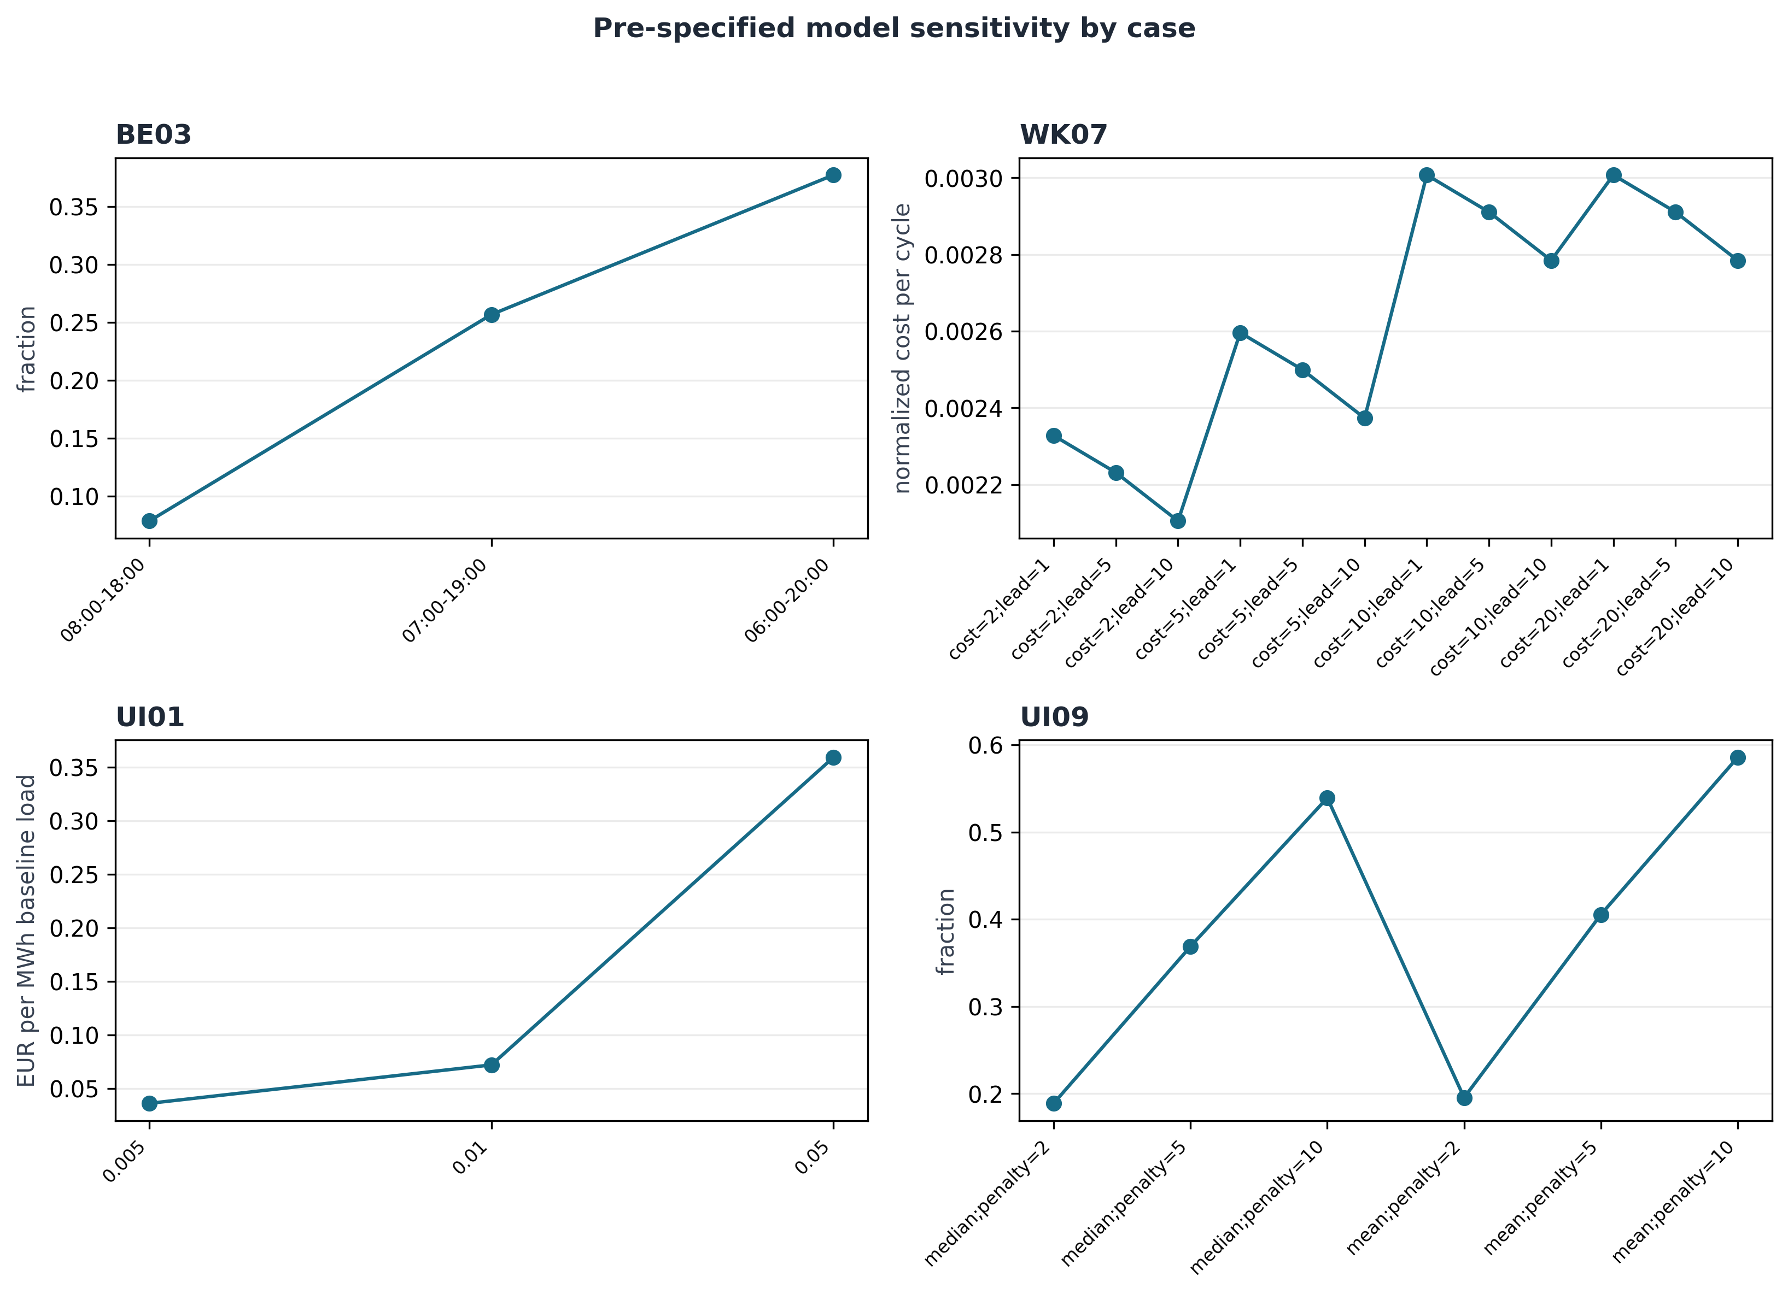
Figure S1. Pre-specified model sensitivity. Each panel uses its own scale.

S5. Cross-case falsification
The analyses do not compute a universal effect size. Leave-one-case-out is also leave-one-domain-out because each primary case represents a distinct domain. A source-quality sensitivity excludes the simulated C-MAPSS case. The negative controls retain the exact repeated-halving null and the unquantified container compatibility case.
Table S3. Full cross-case falsification output.
test | omitted_case | primary_cases_retained | material_oracle_mismatches | insufficient_or_uncertain | interpretation
baseline_primary_classification_count |  | 4 | 2 | 2 | Classification count only; incomparable case outcomes are not pooled into a universal effect size.
leave_one_case_and_domain_out | BE03 | 3 | 2 | 1 | No leave-one-out result licenses a population causal claim; the frozen cases are a designed audit set.
leave_one_case_and_domain_out | WK07 | 3 | 1 | 2 | No leave-one-out result licenses a population causal claim; the frozen cases are a designed audit set.
leave_one_case_and_domain_out | UI01 | 3 | 2 | 1 | No leave-one-out result licenses a population causal claim; the frozen cases are a designed audit set.
leave_one_case_and_domain_out | UI09 | 3 | 1 | 2 | No leave-one-out result licenses a population causal claim; the frozen cases are a designed audit set.
exclude_simulated_case | WK07 | 3 | 1 | 2 | Source-quality sensitivity excluding C-MAPSS simulation.
negative_controls |  | 4 | 2 | 2 | NC03 returns the pre-specified analytic null; NC01 remains unquantified because transition-cost evidence is absent.

S6. Reproduction
From the project root, create an environment from requirements.lock and run `make all`, `make test`, and `make audit`. Generated case-level processed files are written under outputs/analysis. The manuscript, supplement, figures, tables, and submission archive are regenerated without manual transcription.

