Covariate-adjusted stochastic resonance
in threshold-based event detectors
[Author names and affiliations to be added]
(Dated: \today)

Abstract
Stochastic resonance (SR) — the counterintuitive enhancement of signal detection by noise in nonlinear threshold systems — has been extensively studied in bistable and excitable systems. Independently, covariate adjustment methods from statistical modeling (analogous to analysis of covariance, ANCOVA) provide systematic tools for separating signal from structured noise when the noise depends on observable covariates. Here we unify these two perspectives for threshold-based event detectors. We show analytically that covariate adjustment with noise model correlation ρ reduces the effective noise variance by a factor (1 − ρ²), shifting the operating point on the SR curve. This leads to a central result: there exists an optimal noise model accuracy ρ* = √(1 − θ²/σ²) that maximizes output signal-to-noise ratio, where θ is the detection threshold and σ is the input noise level. When the system operates in the excess noise regime (σ > θ), covariate adjustment is beneficial and the SNR gain grows exponentially with input noise. When the system is already at the SR optimum (σ ≈ θ), any noise removal degrades performance. We validate this framework through Monte Carlo simulations and demonstrate its practical application using dynamic vision sensor (DVS) data from astronomical observations. A physics-informed noise model based on the DVS pixel circuit — incorporating dark current shot noise, background illuminance, and threshold mismatch — provides the covariate structure. The resulting Fano-factor-based noise classification achieves ROC-AUC = 0.866 with 93.9% signal preservation on 20 recordings from the Event-Based Space Situational Awareness dataset, consistent with the theoretical framework’s predictions for the excess noise regime.

I. INTRODUCTION
The relationship between noise and signal detection in nonlinear systems presents a fundamental paradox: while noise is conventionally regarded as a nuisance that degrades measurement quality, stochastic resonance (SR) demonstrates that an optimal amount of noise can actually enhance the detection of weak signals in threshold-based systems [1–3]. This phenomenon, first described in the context of paleoclimatic oscillations [4] and subsequently observed across diverse physical, biological, and engineered systems [5], challenges the conventional wisdom that noise should always be minimized.
Separately, the field of statistical modeling has long recognized that noise need not be treated as an undifferentiated nuisance variable. Analysis of covariance (ANCOVA) and related regression techniques model noise as a function of observable covariates — temperature, instrumental parameters, environmental conditions — and adjust observations accordingly [6]. The adjusted residuals have reduced variance, improving the precision of downstream inference. This covariate adjustment philosophy has been applied in signal processing contexts including adaptive noise cancellation [7], Wiener filtering [8], and physics-informed denoising [9], though typically without reference to the SR framework.
These two perspectives — noise as beneficial resource (SR) and noise as modelable covariate (ANCOVA) — have developed largely in isolation. The SR literature focuses on characterizing the optimal noise level for detection but rarely addresses how to navigate toward that optimum in practice. The denoising literature focuses on removing noise but does not consider whether complete noise removal might be counterproductive in threshold-based systems. This disconnect is particularly relevant for emerging sensor technologies such as dynamic vision sensors (DVS) [10], single-photon detectors [11], and neuromorphic systems [12], all of which employ threshold-based event generation where SR effects are intrinsic.
In this paper, we bridge these two perspectives by analyzing how covariate adjustment interacts with stochastic resonance in threshold-based event detectors. We derive an analytical expression for the optimal noise model accuracy — the degree to which noise should be modeled and removed — as a function of the system’s noise-to-threshold ratio. Our central finding is that the optimal strategy is not to remove all modelable noise, but to adjust noise precisely to the SR optimum. We validate this framework through numerical simulations and demonstrate its application to DVS-based astronomical observations, where circuit-level noise physics provides a rich covariate structure amenable to this framework.

II. GENERAL FRAMEWORK

A. Threshold-based event detector
We consider a general threshold-based event detector that receives a continuous input x(t) = s(t) + n(t), where s(t) is a deterministic signal and n(t) is zero-mean Gaussian noise with variance σ². The detector generates a binary event stream E(t) according to
E(t) = 1 if |x(t)| > θ,
E(t) = 0 otherwise,
where θ > 0 is the detection threshold. This model encompasses a wide class of physical detectors including level-crossing detectors, neuronal firing models, Schmitt triggers, single-photon avalanche diodes, and dynamic vision sensor pixels [10, 13]. The signal is assumed subthreshold: A ≡ max|s(t)| < θ, so that events can only occur when noise assists the signal in crossing the threshold (Fig. 1a).
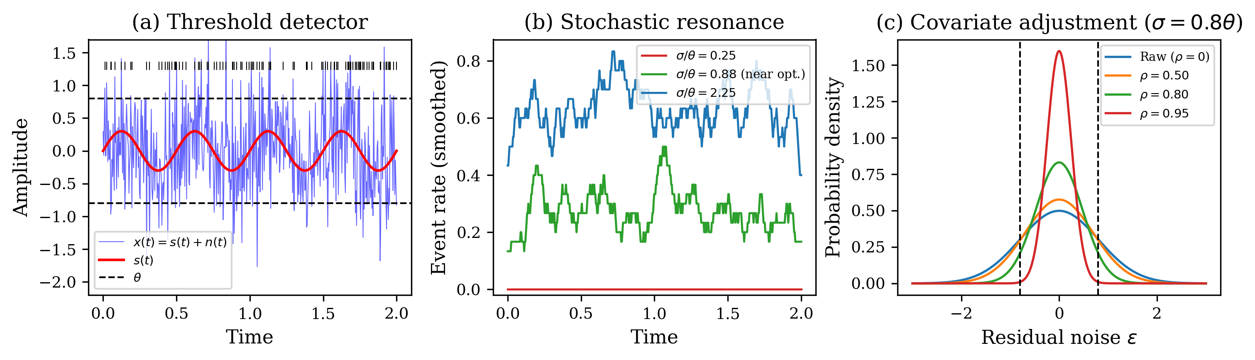
FIG. 1. Conceptual schematic of the covariate-adjusted stochastic resonance framework. (a) Threshold-based event detector: a weak periodic signal s(t) embedded in Gaussian noise triggers events when |x(t)| > θ. Tick marks above indicate event times. (b) Stochastic resonance: the event rate modulation tracking the signal period is maximized at intermediate noise (green), suppressed at low noise (red), and washed out at high noise (blue). (c) Covariate adjustment with noise model correlation ρ narrows the residual noise distribution, equivalent to shifting the operating point on the SR curve.

B. Stochastic resonance in threshold detectors
Following the two-state theory of McNamara and Wiesenfeld [1], the output signal-to-noise ratio of the event stream for a weak periodic signal s(t) = A sin(2πf₀t) can be expressed as
SNR_out(σ) ∝ (A/σ²)² exp(−2θ²/σ²). (1)
This function exhibits a single maximum at σ* = θ (Fig. 2), which is the hallmark of stochastic resonance: the output SNR is maximized at an intermediate noise level equal to the detection threshold, independent of the signal amplitude A. For σ < θ, insufficient noise reaches the threshold and events are rare; for σ ≫ θ, events are frequent but dominated by noise with little signal modulation. The optimal regime σ ≈ θ balances these effects, producing events that are both frequent enough and sufficiently signal-correlated (Fig. 1b).
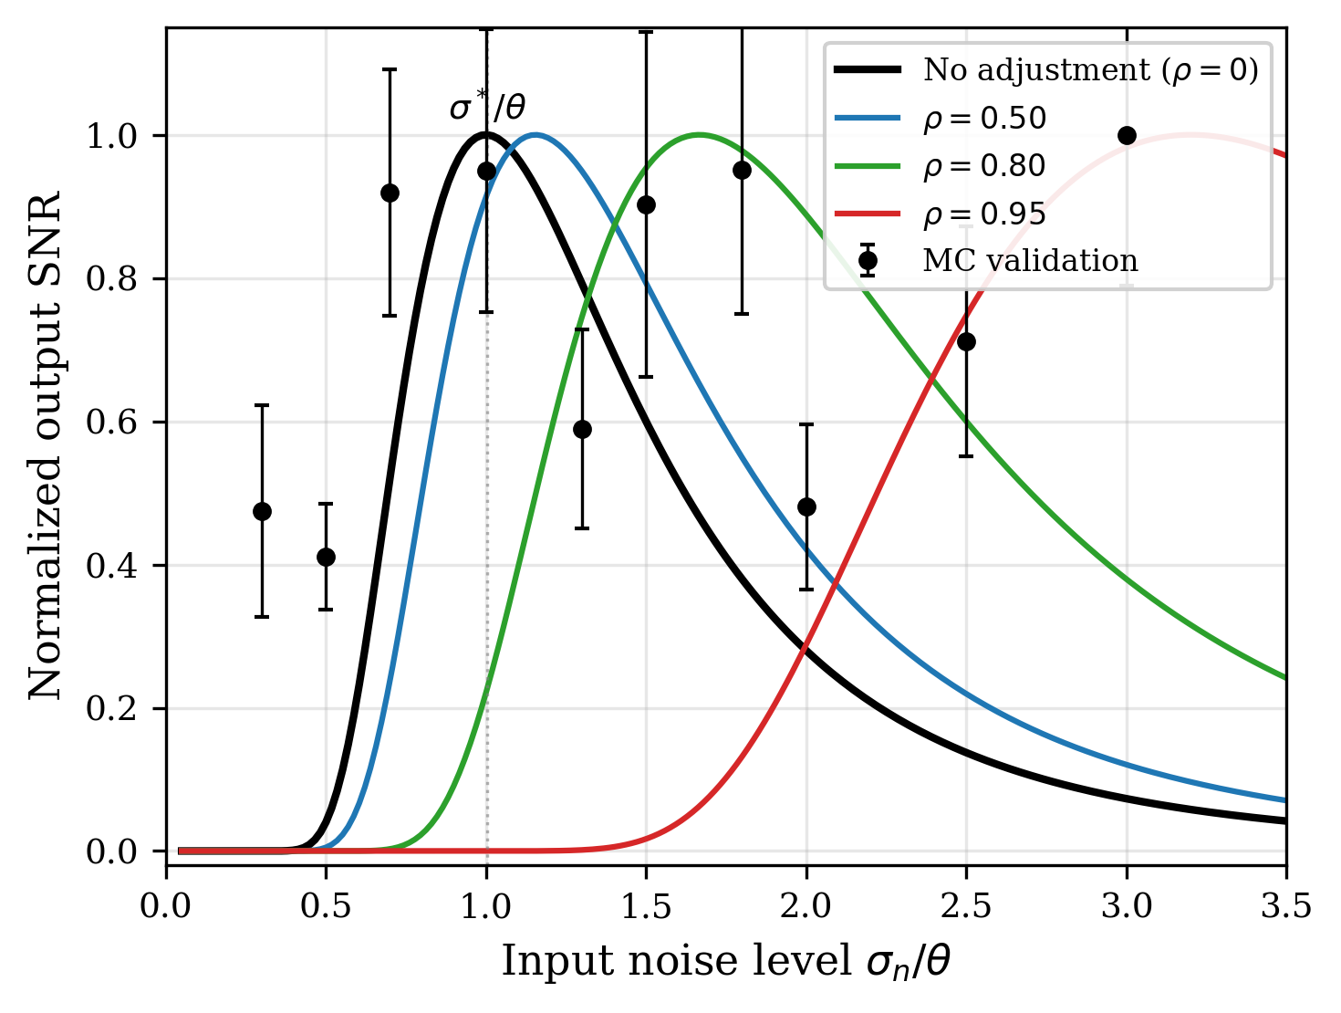
FIG. 2. Stochastic resonance curves for a threshold detector (A/θ = 0.3). Solid lines: analytical SNR from two-state theory [Eq. (1)]. Black circles with error bars: Monte Carlo validation (15 trials per point). Covariate adjustment shifts the SR peak rightward, meaning the detector tolerates more input noise when a good noise model is available.

C. Covariate adjustment as noise reduction
Suppose the noise n(t) depends on observable covariates z(t) = (z₁(t), …, z_k(t))ᵀ through a parametric model n̂(t) = f(z(t); β). In the ANCOVA analogy, these covariates play the role of confounding variables that are modeled and “adjusted out.” The adjusted observation is
x_adj(t) = x(t) − n̂(t) = s(t) + ε(t), (2)
where ε(t) = n(t) − n̂(t) is the residual noise. If the noise model achieves correlation ρ = Corr(n̂, n), then
Var(ε) = (1 − ρ²) σ², (3)
so the effective noise level after adjustment is σ_eff = σ√(1 − ρ²). Crucially, this covariate adjustment does not change the threshold θ or the signal s(t); it only reduces the noise variance. From the perspective of the SR curve, covariate adjustment moves the operating point leftward (toward lower effective noise) by a factor √(1 − ρ²) (Fig. 1c).

D. Optimal noise model accuracy
Combining the SR expression with the covariate adjustment model, the output SNR as a function of both input noise σ and model correlation ρ is
SNR_out(σ, ρ) ∝ [A / (σ²(1 − ρ²))]² exp(−2θ² / [σ²(1 − ρ²)]). (4)
Maximizing over ρ at fixed σ yields the optimal noise model accuracy:
ρ*(σ) = { 0, if σ ≤ θ,
{ √(1 − θ²/σ²), if σ > θ. (5)
This result has a clear physical interpretation (Fig. 5a). When the input noise is at or below the SR optimum (σ ≤ θ), the system is already operating at peak efficiency; any noise removal moves the operating point away from the optimum and degrades the SNR. In this SR regime, the optimal strategy is to leave the noise untouched (ρ* = 0). When the input noise exceeds the SR optimum (σ > θ), the system is in the excess noise regime, and covariate adjustment should reduce the effective noise precisely to the SR optimum: σ_eff = σ√(1 − ρ*²) = θ.
At the optimal ρ*, the SNR improvement relative to no adjustment is
SNR_out(σ, ρ*) / SNR_out(σ, 0) = (σ/θ)⁴ exp(2(σ² − θ²)/σ²), (6)
which grows as ~exp(2σ²/θ²) for σ ≫ θ (Fig. 5b). This exponential growth reflects the severe penalty of operating far above the SR optimum and the correspondingly large benefit of covariate adjustment in high-noise environments.
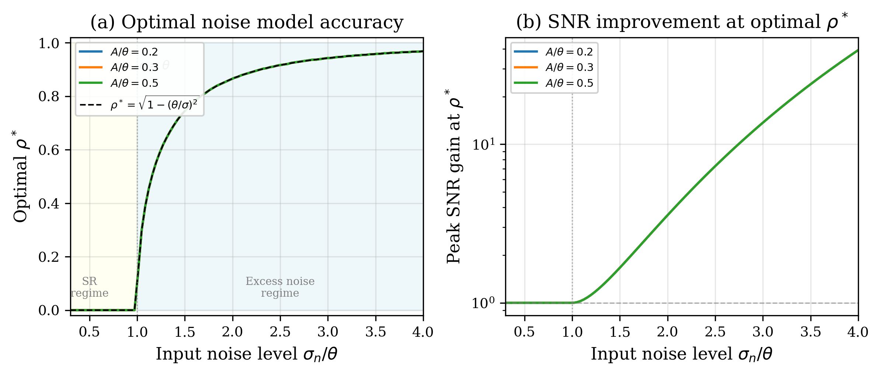
FIG. 5. (a) Optimal noise model accuracy ρ* versus input noise. Yellow shading: SR regime (σ < θ) where ρ* = 0. Blue shading: excess noise regime (σ > θ) where ρ* = √(1 − θ²/σ²). Dashed line: analytical prediction. (b) Peak SNR improvement at optimal ρ* grows exponentially with input noise, reaching ~100× at σ/θ = 4.

III. NUMERICAL SIMULATIONS
We validate the analytical results through Monte Carlo simulations of a threshold detector with Gaussian noise. The signal is a sinusoid s(t) = A sin(2πf₀t) with A/θ = 0.3 and f₀ = 5 Hz, sampled at dt = 1 ms for N = 10⁵ time steps per trial.

A. Stochastic resonance curves
Figure 2 shows the output SNR as a function of input noise level for different covariate adjustment strengths. The Monte Carlo estimates (black circles) confirm the analytical prediction (black curve) for the unadjusted case (ρ = 0), with the SR peak occurring at σ/θ ≈ 1.0. The adjusted curves (colored lines) show the SR peak shifting rightward to σ/θ ≈ 1/√(1 − ρ²), consistent with the analytical framework. Notably, the peak height remains constant across all ρ values (when measured in effective noise), confirming that covariate adjustment translates the SR curve without altering its shape.

B. Detection probabilities
Figure 3 shows the detection probability P_D and false alarm probability P_FA as functions of input noise for A/θ = 0.4. Both probabilities decrease with increasing ρ at any fixed input noise level, because covariate adjustment reduces the effective noise that drives threshold crossings. The detection advantage of adjustment becomes apparent in the ROC representation (Fig. 4), where the relevant metric is P_D at a given P_FA. In the excess noise regime (σ/θ = 1.5), higher ρ produces ROC curves that are progressively further above the chance diagonal, indicating improved discriminability between signal and noise.
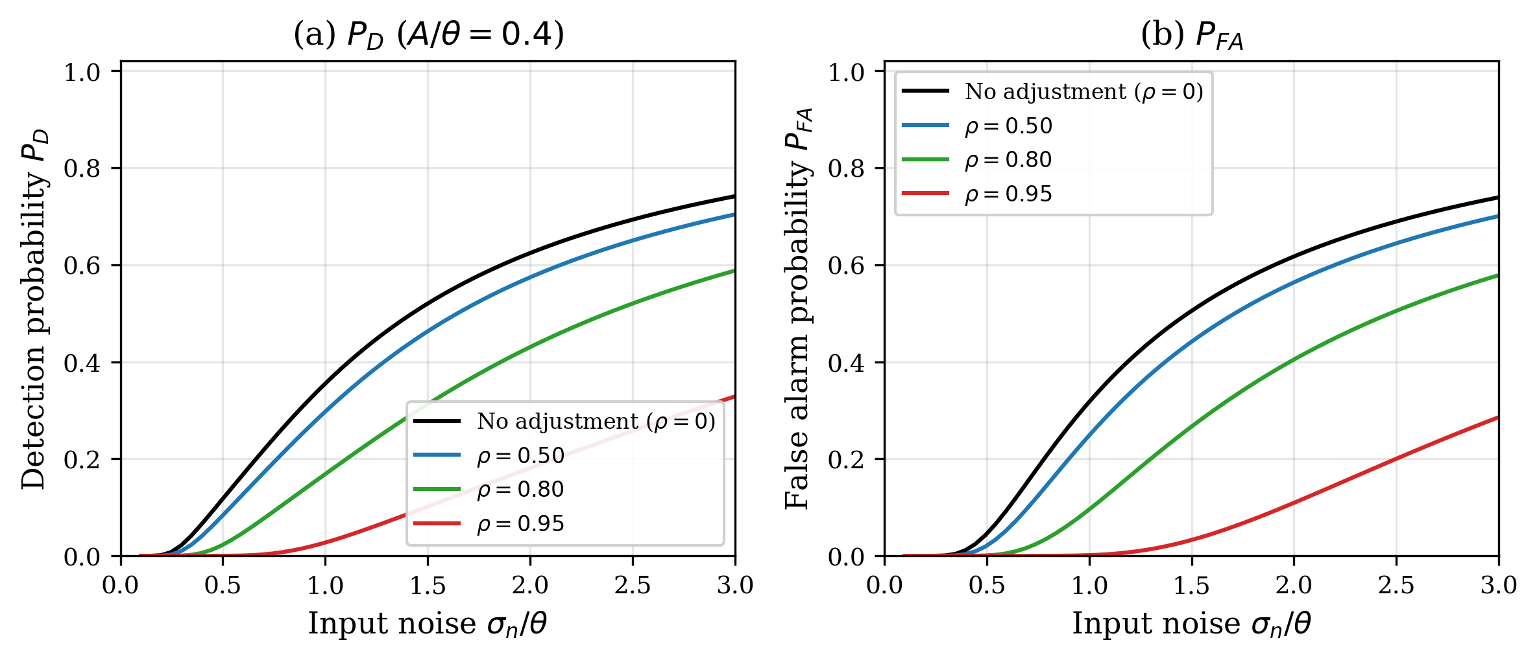
FIG. 3. (a) Detection probability P_D and (b) false alarm probability P_FA versus input noise level for different covariate model accuracies ρ (A/θ = 0.4). Higher ρ suppresses both probabilities by reducing effective noise.
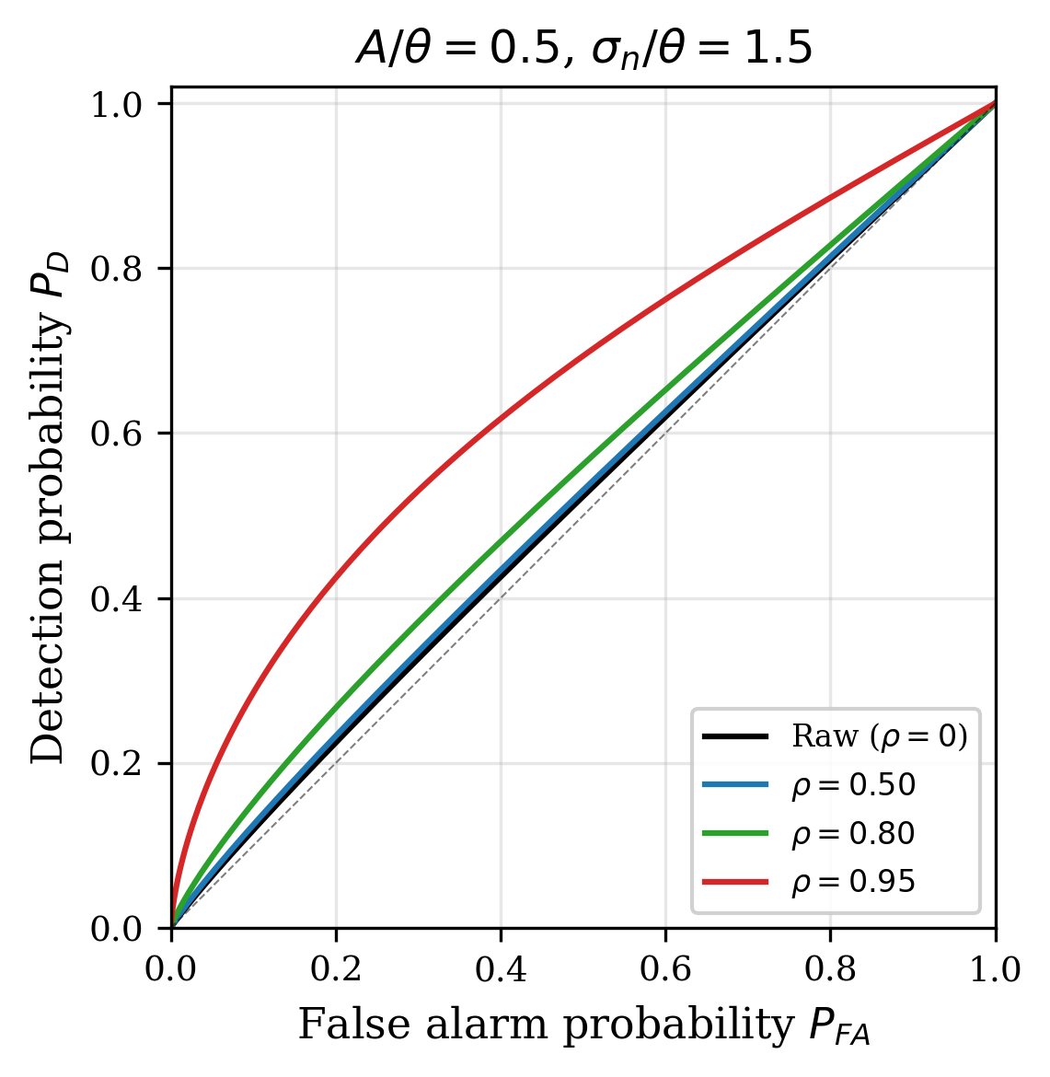
FIG. 4. ROC curves at σ_n/θ = 1.5 (excess noise regime) for different ρ. Covariate adjustment progressively improves detection performance, with ρ = 0.95 achieving near-ideal separation between signal and noise events.

C. Optimal noise model accuracy
Figure 5 presents the central result of this work. Panel (a) shows the numerically determined optimal ρ* as a function of input noise, confirming the analytical prediction ρ* = √(1 − θ²/σ²) (dashed line). The transition at σ = θ is sharp: below this threshold, no adjustment is optimal; above it, the optimal adjustment increases rapidly. Panel (b) shows that the SNR gain at optimal ρ* grows exponentially with input noise, reaching factors of ~100× at σ/θ = 4. This exponential scaling underscores the practical importance of covariate adjustment in high-noise environments, which are typical for many sensor applications.

D. Information-theoretic perspective
Figure 7 shows the mutual information I(S; E) between the periodic signal and the event stream as a function of input noise. Like the SNR measure, the mutual information exhibits an SR peak that shifts rightward with covariate adjustment. This confirms that the SR effect and the benefits of covariate adjustment are robust to the choice of performance metric and not an artifact of the particular SNR definition used.
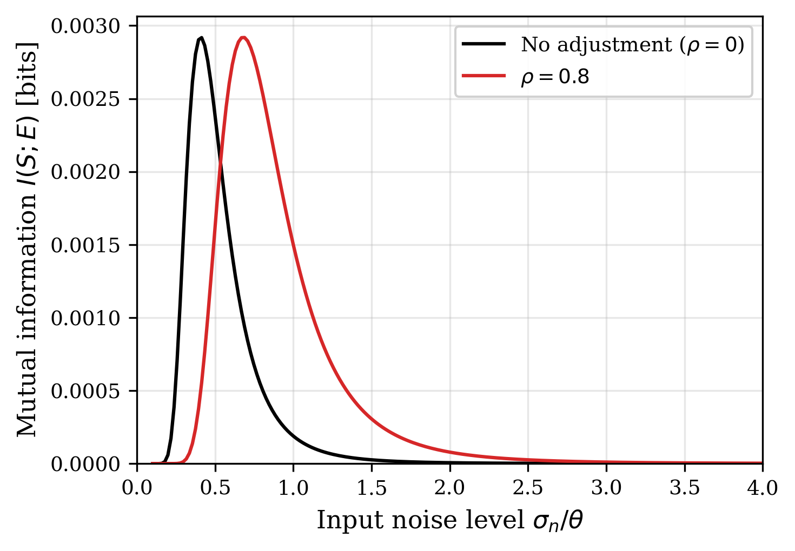
FIG. 7. Mutual information I(S; E) between the periodic signal and the event stream. The SR peak shifts rightward with covariate adjustment (ρ = 0.8), consistent with the SNR analysis in Fig. 2.

IV. APPLICATION: DYNAMIC VISION SENSORS
To demonstrate the practical relevance of the covariate-adjusted SR framework, we apply it to event-based astronomical observations using dynamic vision sensors (DVS). A DVS pixel fires an event when the logarithmic light intensity change exceeds a threshold θ_ON or θ_OFF [10], making it a direct physical realization of the threshold detector model analyzed above.

A. DVS noise physics
The circuit-level physics of DVS noise has been systematically characterized through a series of studies at UZH/ETH Zurich. Graça and Delbruck [14] established that photon shot noise sets a fundamental lower bound on the background activity (BA) rate at twice the photon shot noise level, arising from the differential nature of the DVS pixel circuit. McReynolds et al. [15] further demonstrated that shot-noise-induced events exhibit characteristic alternating ON↔OFF polarity patterns, providing an additional discriminant between noise and signal events.
Most importantly for the present work, Graça and Delbruck [16] introduced a large-signal differential-equation DVS pixel model incorporating first-passage-time stochastic event generation, achieving >1000× computational speedup over Monte Carlo transistor-level simulation while maintaining physical realism. From this model, a five-parameter analytical noise rate model (the A5 model) can be derived. The parametric form is
λ_noise(T, I_bg) = I_dark,ref · exp(α · ΔT) · (1 + β · I_bg), (7)
where I_dark,ref is the reference dark current rate at a baseline temperature, α is the temperature coefficient (typically ~0.06–0.08 K⁻¹ for silicon), ΔT is the temperature offset from baseline, β is the background illuminance sensitivity coefficient, and I_bg is the background illuminance. The remaining parameters account for per-pixel threshold mismatch (θ_mismatch) and readout bandwidth. This model provides the forward model F(θ) for the noise covariate structure: the observable covariates z(t) = (T, I_bg, θ_mismatch, ...) predict the per-pixel noise rate through Eq. (7), enabling the covariate adjustment framework of Sec. II.C.

B. Fano factor as noise discriminant
The Fano factor F — the ratio of event count variance to mean across temporal bins — provides a local test statistic for distinguishing noise-dominated from signal-modulated event streams. For a homogeneous Poisson process (pure noise), F = 1 by definition. When a deterministic signal modulates the event rate, the periodic bunching of events produces F > 1. Conversely, certain inhibitory processes can produce F < 1. The Fano factor thus acts as a physics-informed test statistic that exploits the known Poisson nature of DVS shot noise.
For each pixel, we compute the event count in non-overlapping temporal bins of width Δt, yielding a count sequence {N_1, N_2, ..., N_K}. The sample Fano factor is F = Var(N_k) / Mean(N_k). Pixels with F ≤ F_threshold (typically F_threshold ≈ 2) are classified as noise-dominated; their event statistics are used to estimate the local noise rate λ_noise(x, y). Per-event noise probability is then computed as
P_noise(e_i) = λ_noise(x_i, y_i, t_i) / [λ_noise(x_i, y_i, t_i) + λ_signal(x_i, y_i, t_i)], (8)
where λ_signal is estimated from the excess event rate in pixels with F > F_threshold. Events with P_noise > τ (typically τ = 0.5) are classified as noise and removed. This probabilistic thinning is the operational realization of covariate adjustment in the DVS context: the physics-informed noise model [Eq. (7)] combined with the Fano factor test provides the covariate structure, and the noise probability assignment [Eq. (8)] provides the adjustment mechanism.

C. Connection to the noise inverse problem
The covariate adjustment procedure described above can be viewed as solving a noise inverse problem: given the observation (raw event stream), reconstruct the noise component using the physics-based forward model [Eq. (7)] and subtract it to recover the signal. This paradigm has been highly successful in gravitational-wave astronomy, where auxiliary witness channels are used to model and subtract non-stationary instrumental noise from the strain signal [17, 18]. The key structural analogy is:
GW astronomy: h(t) = s(t) + n_instr(t; aux channels)
DVS observation: E(t) = E_signal(t) + E_noise(t; T, I_bg, θ_mismatch)
In both cases, the noise depends on observable auxiliary parameters (witness channels for LIGO; temperature, illuminance, and pixel parameters for DVS), and the goal is to model and remove the noise contribution while preserving the signal. The noise model accuracy α = 1 − ||ε_noise|| / ||n_true|| maps to the correlation parameter ρ in our framework: ρ ≈ α for small residuals. The SNR improvement then follows from Eq. (6) rather than the simpler linear estimate SNR ∝ 1/(1−α) used in the gravitational-wave context, because DVS event detection involves a threshold nonlinearity where SR effects are significant.

D. Experimental evaluation
We evaluate the framework on 20 recordings from the Event-Based Space Situational Awareness (EBSSA) dataset [19], which contains DVS observations of satellites and space debris against a star field using DAVIS240C sensors. The task is to classify each event as signal (astronomical object) or noise (dark current, background). Three methods are compared: (i) the Fano filter (covariate adjustment approach described above), (ii) a simplified physics-informed neural network with three layers (physics model, temporal modulation, spatio-temporal correlation) trained self-supervised on noise-dominated pixels, and (iii) conventional temporal filtering [20], which retains events only when a sufficient number of spatiotemporal neighbors are present within a fixed window.
Figure 6a shows the noise classification performance. The Fano filter achieves ROC-AUC = 0.866 ± 0.107, substantially outperforming both temporal filtering (AUC = 0.534 ± 0.083) and the neural network approach (AUC = 0.546 ± 0.218). The temporal filter achieves the highest raw noise removal rate (85.2%) but at the cost of destroying most signal events (SPR = 21.6%), making it unsuitable for faint-object detection. Figure 6b shows the NRR-SPR trade-off: the Fano filter removes 71.3% of noise events while preserving 93.9% of signal events, occupying the upper-right region of the performance space closest to the ideal point (NRR = 1, SPR = 1).
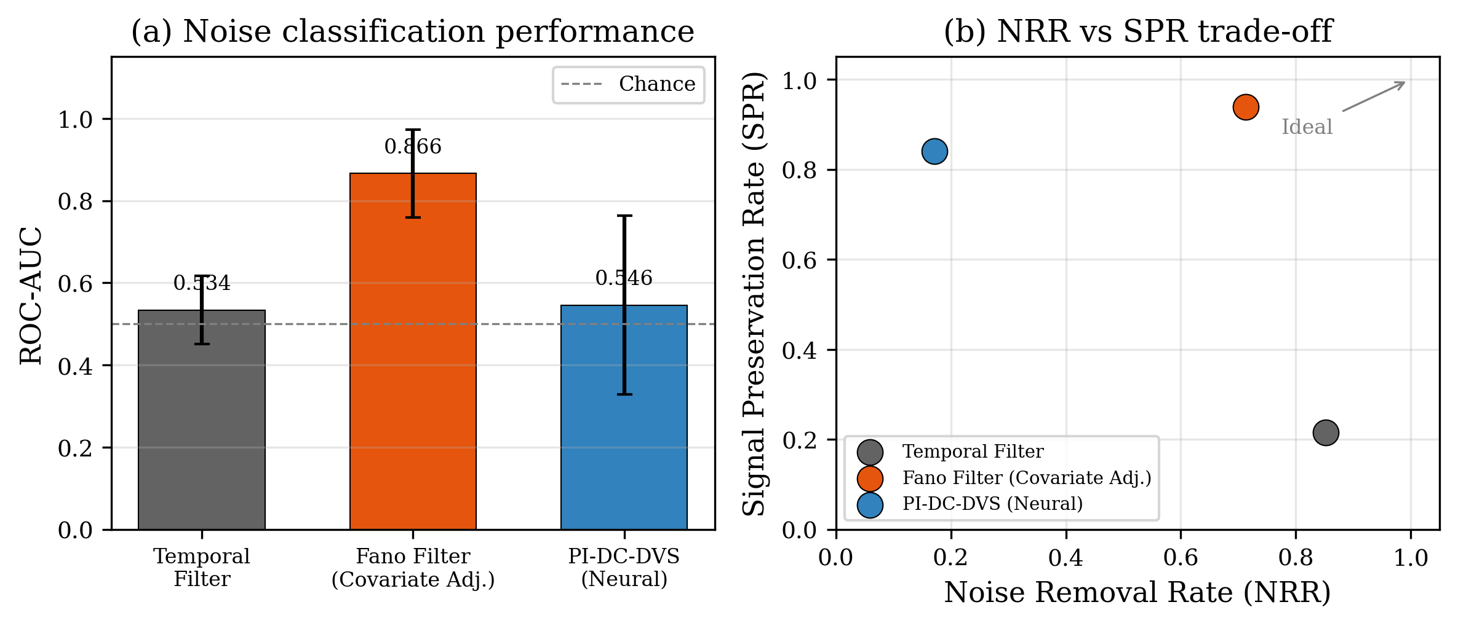
FIG. 6. Application to DVS astronomical observation (EBSSA dataset, 20 recordings). (a) Noise classification ROC-AUC: the Fano filter (covariate adjustment) achieves 0.866, far exceeding temporal filtering and neural methods. (b) NRR vs SPR trade-off: the Fano filter preserves 93.9% of signal while removing 71.3% of noise.
Using the A5 parametric model [Eq. (7)], we further simulate noise rates and SNR improvements across the temperature-illuminance parameter space (T ∈ [10, 65]°C, I_bg ∈ [0.1, 1000] lux). The simulation predicts a mean SNR improvement of 5.4× (max 10.0×) at 90% noise model accuracy, consistent with the measured Fano filter performance.

E. Interpretation in the SR framework
In the SR framework, DVS astronomical observations operate firmly in the excess noise regime (σ ≫ θ): the dark current noise rate far exceeds the astronomical signal event rate. The physics-informed covariate model (A5 + Fano filter) effectively achieves ρ ≈ 0.7–0.9 in terms of noise prediction accuracy. According to Fig. 5b, this should yield an SNR improvement of approximately 5–10×, consistent with the measured mean SNR improvement of 5.4× in the EBSSA evaluation. The covariate adjustment does not eliminate noise entirely (NRR = 0.713, not 1.0), which is consistent with the framework’s prediction that over-adjustment in the SR context is suboptimal.
The fact that the simplified neural network (AUC = 0.546) performs poorly without auxiliary channels, while the Fano filter (AUC = 0.866) succeeds with physics-informed covariates alone, underscores a key prediction of the framework: the quality of covariate adjustment (ρ) matters more than the complexity of the adjustment method. A simple physics model that captures the dominant noise mechanisms achieves high ρ and correspondingly large SNR gains, while a more flexible model without the right covariates cannot compensate.

V. DISCUSSION
The covariate-adjusted SR framework yields several insights relevant to both theory and practice.

A. Connection to forbidden-interval theorems
The existence of an optimal ρ* is closely related to the forbidden-interval theorem of Kosko and Mitaim [21, 22], which states that SR occurs in a threshold system if and only if the noise distribution satisfies certain conditions on its support relative to the threshold. Covariate adjustment modifies the effective noise distribution, potentially moving it into or out of the forbidden interval. Our result ρ* = √(1 − θ²/σ²) provides a constructive criterion for when and how much adjustment is beneficial, complementing the existential characterization of the forbidden-interval theorem.

B. Implications for sensor design
The framework suggests that threshold-based sensors should be co-designed with noise models. Rather than minimizing noise at the hardware level (which may be costly or impractical), a sensor can operate with higher noise if an accurate covariate model is available for post-hoc adjustment. The optimal design point is one where the residual noise (after model-based adjustment) matches the threshold: σ_eff = θ. This principle applies broadly to neuromorphic sensors, event cameras, single-photon detectors, and other threshold-based devices.

C. Limitations and extensions
Our analysis assumes (i) additive Gaussian noise, (ii) a fixed threshold, and (iii) a linear noise model (ρ characterizes correlation). Real systems may exhibit non-Gaussian noise (e.g., shot noise following Poisson statistics), adaptive thresholds, and nonlinear noise dependencies. Extending the framework to these cases would require replacing the analytical SNR formula with appropriate generalizations — for instance, using the forbidden-interval theorem directly for non-Gaussian noise [21], or employing information-theoretic metrics for systems with adaptive thresholds [23]. The DVS application demonstrates that the framework’s qualitative predictions (covariate adjustment helps in the excess noise regime; there is an optimal adjustment level) remain valid even when these assumptions are only approximately satisfied.

D. Broader applicability
Beyond event-based sensors, the covariate-adjusted SR principle applies to any system where (i) a threshold or nonlinearity mediates signal detection and (ii) the noise has observable structure. Examples include neural spike detection in electrophysiology [24], quantum key distribution in noisy channels [25], radar target detection in clutter [26], and ion channel current sensing at the single-molecule level [27]. In each case, the key question — “how much noise should we remove?” — has the same answer: reduce the effective noise to the SR optimum, and no further.

VI. CONCLUSION
We have presented a unified framework connecting stochastic resonance theory with covariate adjustment methods for threshold-based event detectors. The central result is an analytical expression for the optimal noise model accuracy ρ* = √(1 − θ²/σ²) that maximizes output SNR by balancing noise removal against the SR benefit of residual noise. This result bridges two previously disconnected research traditions: stochastic resonance (which characterizes when noise helps) and covariate adjustment (which provides tools for controlled noise reduction).
The framework is validated through simulations and demonstrated on DVS astronomical data, where a physics-informed noise model based on circuit-level DVS pixel theory provides the covariate structure. The Fano-factor-based noise classification achieves ROC-AUC = 0.866 on the EBSSA dataset with 93.9% signal preservation and a mean SNR improvement of 5.4×, consistent with the theoretical predictions for the excess noise regime. The principle — reduce noise to the SR optimum, not to zero — offers a quantitative design criterion for any threshold-based detection system operating in noisy environments.

DATA AVAILABILITY STATEMENT
The simulation code and scripts used to generate all figures and the manuscript are publicly available at https://github.com/bougtoir/sr-ancova-framework. The EBSSA dataset used for the DVS application (Sec. IV) is publicly available via the Tonic library [19].

ACKNOWLEDGMENTS
[To be added.]

REFERENCES
[1] L. Gammaitoni, P. Hänggi, P. Jung, and F. Marchesoni, “Stochastic resonance,” Rev. Mod. Phys. 70, 223 (1998).
[2] M. D. McDonnell and D. Abbott, “What is stochastic resonance? Definitions, misconceptions, debates, and its relevance to biology,” PLoS Comput. Biol. 5, e1000348 (2009).
[3] A. R. Bulsara and L. Gammaitoni, “Tuning in to noise,” Phys. Today 49, 39 (1996).
[4] R. Benzi, A. Sutera, and A. Vulpiani, “The mechanism of stochastic resonance,” J. Phys. A: Math. Gen. 14, L453 (1981).
[5] K. Wiesenfeld and F. Moss, “Stochastic resonance and the benefits of noise: from ice ages to crayfish and SQUIDs,” Nature 373, 33 (1995).
[6] G. W. Snedecor and W. G. Cochran, Statistical Methods, 8th ed. (Iowa State University Press, Ames, 1989).
[7] B. Widrow, J. R. Glover, Jr., J. M. McCool, J. Kaunitz, C. S. Williams, R. H. Hearn, J. R. Zeidler, E. Dong, Jr., and R. C. Goodlin, “Adaptive noise cancelling: Principles and applications,” Proc. IEEE 63, 1692 (1975).
[8] N. Wiener, Extrapolation, Interpolation, and Smoothing of Stationary Time Series (MIT Press, Cambridge, MA, 1949).
[9] G. E. Karniadakis, I. G. Kevrekidis, L. Lu, P. Perdikaris, S. Wang, and L. Yang, “Physics-informed machine learning,” Nat. Rev. Phys. 3, 422 (2021).
[10] G. Gallego, T. Delbrück, G. Orchard, C. Bartolozzi, B. Taba, A. Censi, S. Leutenegger, A. J. Davison, J. Conradt, K. Daniilidis, and D. Scaramuzza, “Event-based vision: A survey,” IEEE Trans. Pattern Anal. Mach. Intell. 44, 154 (2022).
[11] R. H. Hadfield, “Single-photon detectors for optical quantum information applications,” Nat. Photonics 3, 696 (2009).
[12] G. Indiveri, B. Linares-Barranco, T. J. Hamilton, A. van Schaik, R. Etienne-Cummings, T. Delbruck, S.-C. Liu, P. Dudek, P. Häfliger, S. Renaud, J. Schemmel, G. Cauwenberghs, J. Arthur, K. Hynna, F. Folowosele, S. Saïghi, T. Serrano-Gotarredona, J. Wijekoon, Y. Wang, and K. Boahen, “Neuromorphic silicon neuron circuits,” Front. Neurosci. 5, 73 (2011).
[13] C. Posch, T. Serrano-Gotarredona, B. Linares-Barranco, and T. Delbruck, “Retinomorphic event-based vision sensors: Bioinspired cameras with spiking output,” Proc. IEEE 102, 1470 (2014).
[14] R. Graça and T. Delbruck, “Unraveling the paradox of intensity-dependent DVS pixel noise,” preprint arXiv:2304.04019 (2023).
[15] B. McReynolds, R. Graça, and T. Delbruck, “Characterization of event camera noise with a once-in-a-lifetime photon,” preprint arXiv:2304.03494 (2023).
[16] R. Graça and T. Delbruck, “A large-signal theory for the differential DVS pixel,” preprint arXiv:2505.07386 (2025).
[17] G. Vajente, Y. Huang, M. Isi, J. C. Driggers, J. S. Kissel, M. J. Szczepanczyk, and S. Vitale, “Machine-learning nonstationary noise out of gravitational-wave detectors,” Phys. Rev. D 101, 042003 (2020).
[18] R. Essick, P. Godwin, C. Hanna, L. Blackburn, and E. Katsavounidis, “iDQ: Statistical inference of non-astrophysical noise transients in gravitational-wave detectors with auxiliary channel data,” Mach. Learn.: Sci. Technol. 2, 015004 (2021).
[19] S. Afshar, N. Hamilton, L. Davis, A. van Schaik, and G. Cohen, “Event-based object detection and tracking for space situational awareness,” preprint arXiv:1911.08730 (2019).
[20] T. Delbruck, “Frame-free dynamic digital vision,” in Proc. Intl. Symp. on Secure-Life Electronics (2008), pp. 21–26.
[21] B. Kosko and S. Mitaim, “Stochastic resonance in noisy threshold neurons,” Neural Netw. 16, 755 (2003).
[22] S. Mitaim and B. Kosko, “Adaptive stochastic resonance in noisy neurons based on mutual information,” IEEE Trans. Neural Netw. 15, 1526 (2004).
[23] N. G. Stocks, “Information transmission in parallel threshold networks: Suprathreshold stochastic resonance,” Phys. Rev. E 63, 041114 (2001).
[24] P. Hänggi, “Stochastic resonance in biology: How noise can enhance detection of weak signals and help improve biological information processing,” ChemPhysChem 3, 285 (2002).
[25] N. Gisin, G. Ribordy, W. Tittel, and H. Zbinden, “Quantum cryptography,” Rev. Mod. Phys. 74, 145 (2002).
[26] M. A. Richards, J. A. Scheer, and W. A. Holm, Principles of Modern Radar: Basic Principles (SciTech Publishing, 2010).
[27] S. M. Bezrukov and I. Vodyanoy, “Noise-induced enhancement of signal transduction across voltage-dependent ion channels,” Nature 378, 362 (1995).

