Risk perception versus structural incentives in physician specialty choice: a Japanese panel study

Abstract
Specialty maldistribution is a persistent workforce problem, and malpractice litigation is often assumed to push physicians away from high-risk fields. Using national administrative data for 12 clinical specialties in Japan (2008-2024), we tested whether litigation risk predicts physician supply and hospital facility counts. Exposure was malpractice claims per 1,000 physicians; we regressed biennial log-changes in physician and facility counts on the lagged litigation rate using specialty and wave fixed effects, clustered standard errors, and equivalence tests. Litigation rate was unrelated to physician growth (coefficient -0.0009; 95% CI -0.0043 to +0.0025; p=0.56) or facility-count growth (p=0.90), and a one-SD higher rate shifted physician growth by less than +/-1% (TOST p=0.023). Although perceived risk is high, structural incentives -- training costs, fee-for-service income, and status-quo bias -- keep physicians in high-risk fields. Reducing litigation exposure is unlikely to correct specialty maldistribution; no-fault compensation and payment design are more promising.
Keywords: behavioural public policy; malpractice litigation; physician workforce; risk perception; equivalence testing; structural incentives

Introduction
Specialty maldistribution is a persistent healthcare workforce problem: high-acuity fields such as surgery, obstetrics and gynaecology, paediatrics and anaesthesiology are widely perceived as understaffed across many health systems. (Matsumoto et al., 2010) A recurring policy intuition is that the fear of malpractice litigation and medical safety incidents pushes physicians away from these high-risk specialties. (Studdert, Mello and Brennan, 2004; Hiyama et al., 2006) If this behavioural assumption were true, reducing litigation exposure would be an instrument for correcting workforce maldistribution.
Behavioural economics suggests, however, that the link between perceived risk and actual behaviour is not automatic. Rare, salient adverse events are highly available in memory and in media coverage, and loss aversion causes a low-probability outcome to be overweighted in career deliberations. (Tversky and Kahneman, 1973; Kahneman and Tversky, 1979) At the same time, the decision to enter or leave a specialty is constrained by expected income, sunk training costs, switching costs and status-quo bias. (Samuelson and Zeckhauser, 1988) The relevant policy question is not whether physicians report anxiety about litigation, but whether that anxiety translates into aggregate workforce shifts. We treat the litigation-workforce question as a test case for evaluating a behavioural public policy instrument: can a salient, cognitively available risk be used to change the specialty distribution of physicians?
Japan provides a well-documented national setting in which to examine this question. The Supreme Court reports closed malpractice claims by specialty, the Ministry of Health, Labour and Welfare publishes biennial physician counts and annual hospital facility counts, and the country shares the fee-for-service pressures seen in other high-income countries. (Supreme Court of Japan, 2024; Ministry of Health, Labour and Welfare, 2024a; Ministry of Health, Labour and Welfare, 2024b) It also introduced the Japan Obstetric Compensation System for Cerebral Palsy (JOCS-CP) in 2009, a no-fault scheme intended partly to address obstetric workforce concerns. (Japan Council for Quality Health Care (JOCS-CP), 2009; Hasegawa et al., 2016) Surveys of residents in Japan, Korea and Taiwan report litigation as a negative factor, but workload, lifestyle and professional interest dominate specialty choice. (Lin et al., 2022)
Prior empirical work in this area often related raw annual counts of incidents or lawsuits to raw counts of physicians or facilities. Two features make such designs prone to spurious association. First, counts are not adjusted for specialty size: a larger specialty mechanically accumulates more procedures, more claims and more physicians, so count-based associations can arise without any behavioural mechanism. Second, the physician census is collected only biennially; interpolating it to an annual series and analysing it as if each year were an independent observation inflates the degrees of freedom of any lag-based method. These pitfalls are not unique to malpractice research; they arise whenever administrative counts are used to infer behavioural responses in healthcare organisations. We address them with a transparent analytical framework that uses rates rather than counts, uses only measured biennial physician observations, and applies pre-specified equivalence testing, which can provide positive evidence for the absence of a meaningful effect rather than merely failing to reject a null. (Lakens, 2017; Schuirmann, 1987)

Methods

Data sources
We report this observational study following the Strengthening the Reporting of Observational Studies in Epidemiology (STROBE) guidance. (von Elm et al., 2007) We studied 12 core clinical specialties in Japan for which the Supreme Court reports specialty-specific litigation. Three official primary series drove the main analysis: physician counts by specialty from the biennial Statistics of Physicians, Dentists and Pharmacists (Ministry of Health, Labour and Welfare, 2024a); closed malpractice claims by specialty from the Supreme Court of Japan (Supreme Court of Japan, 2024); and hospital counts by specialty from the annual Survey of Medical Institutions. (Ministry of Health, Labour and Welfare, 2024b) Hospital counts are the number of facilities reporting each specialty, not beds or staffing. Two sensitivity series were also used: annual medical accident investigation reports by specialty (2015-2024) from the Japan Medical Safety Research Organisation (Japan Medical Safety Research Organisation (JMSR), 2025) and total national newspaper article counts from Nikkei Telecom 21 (2004-2018; the sensitivity analysis uses 2009-2018; keywords: medical error + medical malpractice). (Nikkei Inc, 2024) The full extraction pipeline (with source identifiers and SHA-256 checksums) is documented in the accompanying repository (URL omitted for anonymised peer review).
One source disagreement is documented in the extraction provenance. The 2017 internal medicine count is 179 in the consolidated Supreme Court releases (2022/2024/2025) and 181 in the contemporaneous 2017 committee minutes; we retained 179 in the primary series because it is the figure in the released statistics. (Supreme Court of Japan, 2024) The disagreement does not alter the rate-based exposure materially, but it is recorded for transparency.
Physician counts use the principal-specialty classification; broad categories were matched to the Supreme Court's specialty labels, and subspecialties were aggregated in code. Because the Court assigns multi-specialty cases to a single principal specialty and states that the counts do not represent the intrinsic risk of each specialty, we treat litigation as an exposure signal rather than a measure of incident risk. (Supreme Court of Japan, 2024) We distinguish litigation from the Medical Accident Investigation System, which began in 2015 and covers only deaths and stillbirths judged unforeseen by the hospital administrator; it is not a general incident-reporting system and is not used as an exposure here. (Medical Accident Investigation System, 2015) Primary data sources and their resolution are summarised in Table 3.
Table 3. Primary data sources and their resolution.
Series | Source | Resolution | Years | Role
Physicians by specialty | MHLW Statistics of Physicians | Biennial | 2004-2024 | Denominator & outcome
Closed malpractice claims | Supreme Court, by specialty | Annual | 2008-2024 | Exposure (numerator)
Hospitals by specialty | MHLW Survey of Medical Institutions | Annual | 2008-2024 | Outcome
Clinics by specialty | MHLW Survey (static) | Every 3 years | 2008-2023 | Descriptive only
JMSR report counts | JMSR / MAIS | Annual | 2015-2024 | Sensitivity (2016-2024)
Newspaper article counts | Nikkei Telecom 21 | Annual | 2008-2018 | Sensitivity (2009-2018)

The 12 specialties are not arbitrary selections but represent the core clinical categories in which Japanese physicians typically obtain initial board certification. Japan's specialist training programme is a two-tiered system: physicians first complete residency and gain certification in one of the core specialties (e.g., internal medicine, surgery, obstetrics and gynaecology, paediatrics, anaesthesiology), after which some proceed to a narrower subspecialty within that primary field. Biennial physician counts and Supreme Court litigation statistics are both reported at this primary-specialty level, so our analysis captures the broad workforce-allocation decision at the first tier of the training pipeline. Subspecialties are not separately tracked in the official biennial series, so we analyse the 12 primary fields as the relevant units of specialty choice and policy intervention.

Statistical analysis
We used a transparent sensitivity-analysis framework that varies the exposure definition (counts versus rates), panel frequency (measured biennial waves versus interpolated annual values), and potential confounders while holding the specialty-level panel structure constant. Figure 5 summarises the framework. The exposure was the litigation rate, defined as closed claims per 1,000 physicians in each specialty-year, which removes specialty-size confounding because large specialties generate more claims for reasons unrelated to per-physician risk. The primary analysis used the 9 measured biennial physician waves (2008-2024). For each specialty we computed the biennial log-change in physicians (and, separately, in hospital facility counts) and regressed it on the lagged litigation rate at the start of the interval, in a panel with specialty and wave fixed effects, clustered standard errors, and a JOCS-CP indicator for obstetrics and gynaecology from 2009 onward. (Angrist and Pischke, 2009) Clusters are defined by specialty, so G=12 and the small-cluster correction uses a t-distribution with G-1 degrees of freedom. (Cameron and Miller, 2015) The primary estimating equation, for specialty s and wave t, was as follows.
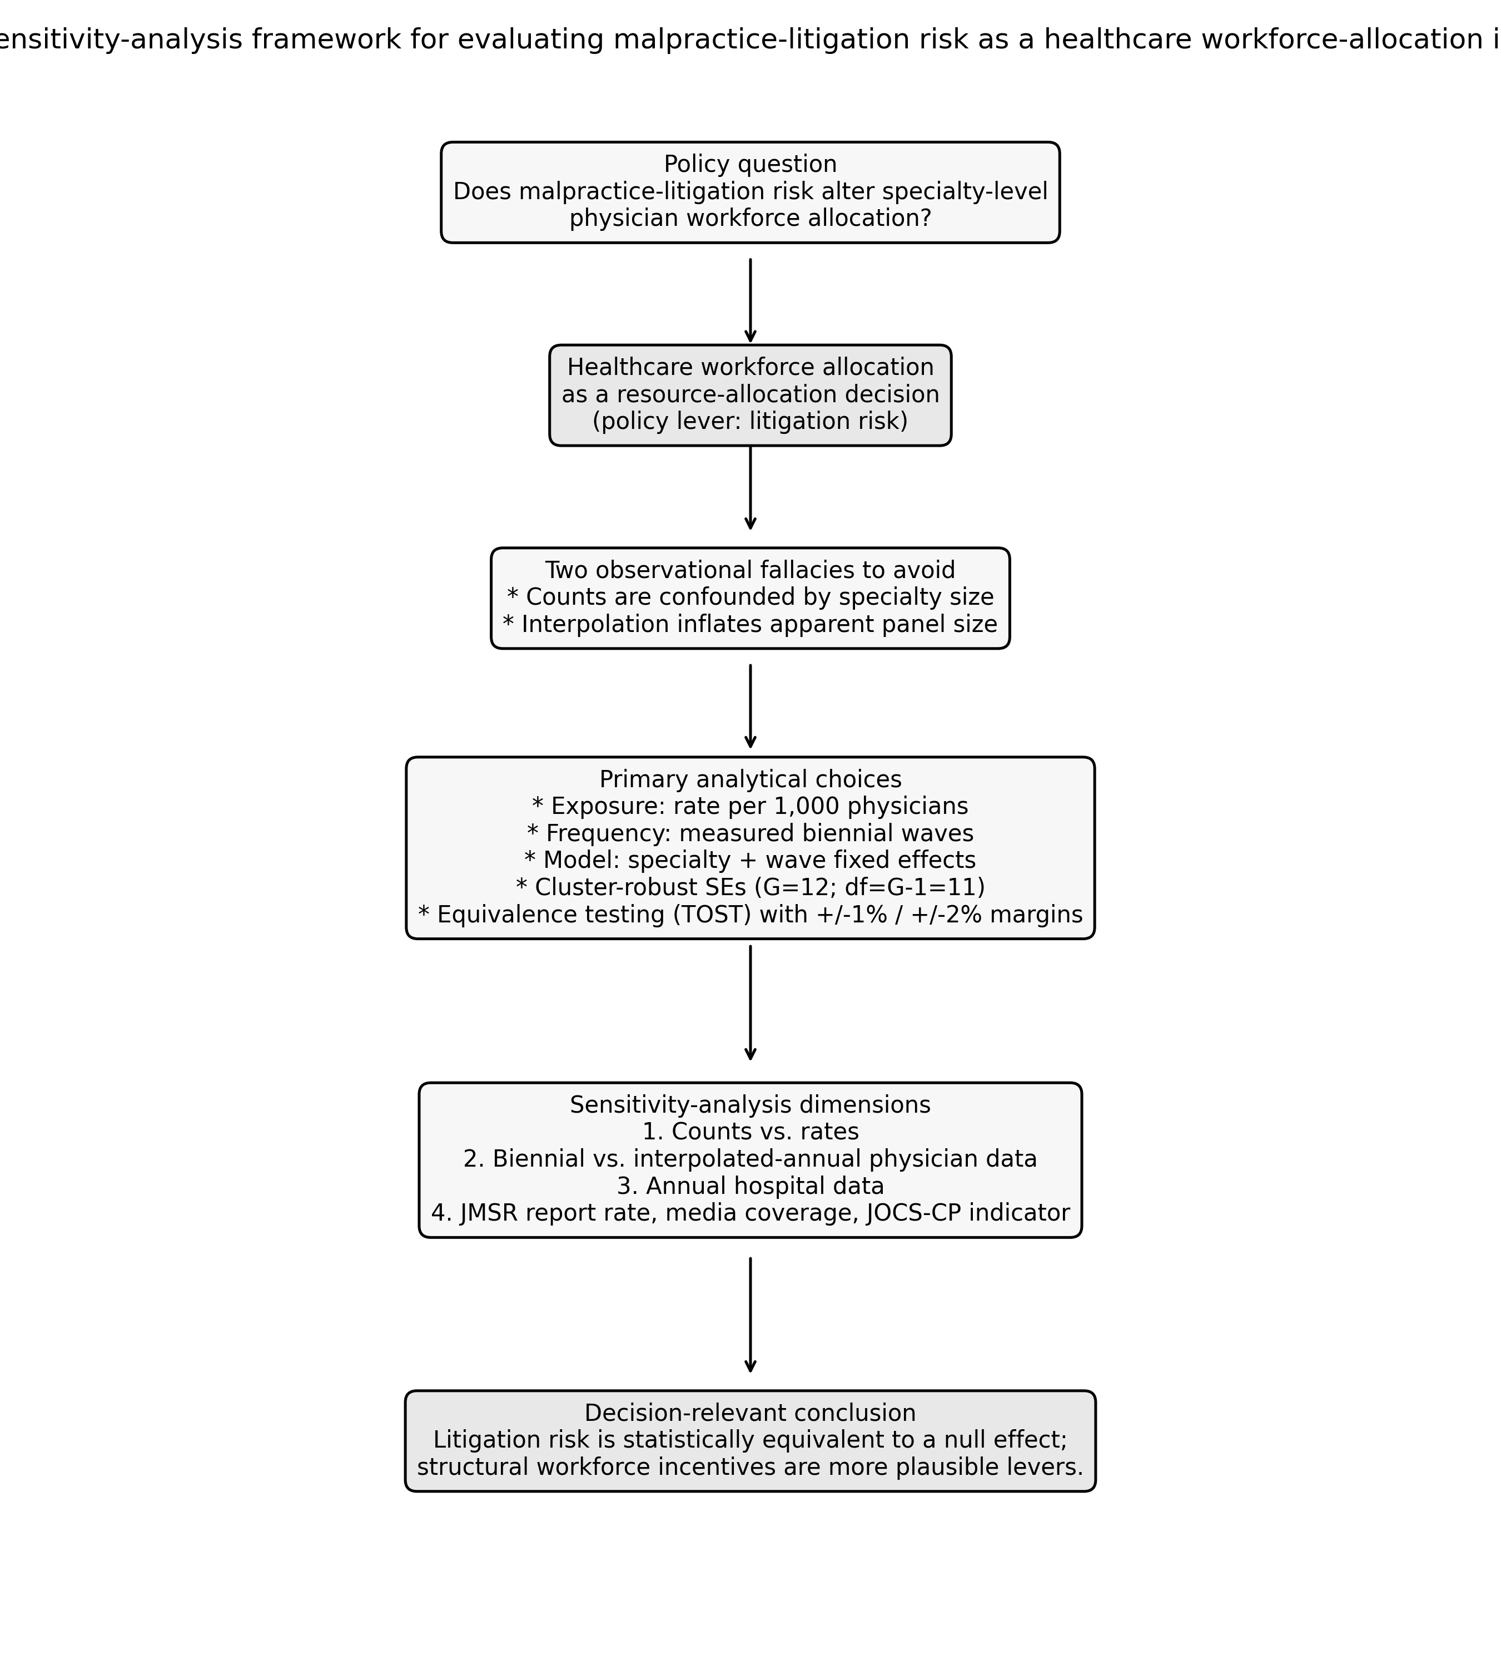
Figure 5. Sensitivity-analysis framework for evaluating malpractice-litigation risk as a healthcare workforce-allocation instrument.

$Δlog(Y_{st})=α_{s}+δ_{t}+β·{\text{litrate}}_{s,t−1}+γ·{\text{JOCS-CP}}_{s,t−1}+ϵ_{st}$
Here, Y is either physician counts or hospital facility counts, alpha_s are specialty fixed effects, delta_t are wave fixed effects, and standard errors are clustered by specialty. For the equivalence analysis we standardised litrate to a z-score, so beta gives the expected biennial log-change per one-SD increase in the litigation rate.
We assessed equivalence to a null effect using two one-sided tests (TOST) with pre-specified margins of +/-1% and +/-2% biennial workforce change. The margins were chosen to be smaller than the policy-relevant workforce shifts that structural tools have produced: for example, targeted residency subsidies raised primary-care physician supply by about 4% in a comparable setting. (McNamara and Pineda-Torres, 2025) That 4% is a total programme effect, whereas our +/-1% and +/-2% margins are biennial, so the margins are substantially smaller than the policy-relevant shift and therefore conservative. The TOST procedure itself is standard for equivalence testing. (Lakens, 2017; Schuirmann, 1987) Equivalence is declared when the per-SD coefficient lies inside the margin. Inference was complemented by a cluster block-bootstrap (B = 1,999) and by the minimum detectable effect (MDE) at 80% power and the power to declare equivalence when the true effect is zero. Full formulas and the heterogeneity and time-trend sensitivity checks are documented in the analysis code repository.

Policy simulation
To translate the regression results into a practical policy benchmark, we projected physician counts to 2034 under three stylised policy scenarios. The baseline used each specialty's observed mean biennial log-growth from 2004 to 2024. The two litigation-reduction scenarios set the litigation rate to zero and applied the point estimate and the 95% lower-bound coefficient, respectively, so they show both the central projection and the most favourable effect consistent with the data. The third scenario added the minimum detectable per-SD effect (1.08% per biennium) to baseline growth as a benchmark for the smallest policy effect this panel could detect with 80% power. The projections are deterministic counterfactuals, not forecasts, and are reported as the marginal percent change in 2034 relative to the baseline drift.
All confidence intervals and two-sided p-values use the small-cluster correction with G-1 = 11 degrees of freedom. (Cameron and Miller, 2015) The JOCS-CP indicator captures the post-2009 obstetrics-and-gynaecology period. (JOCS-CP, 2009) Sensitivity analyses repeat the models on the annual hospital series, an interpolated annual-physician series, raw counts instead of rates, and annual hospital series controlling for the JMSR report rate (2016-2024) or total Nikkei Telecom article counts (2009-2018); details are in Table 3. The JOCS-CP indicator and all sensitivity models are exploratory; we report raw and Holm step-down adjusted p-values. Code and data are available in the accompanying repository (URL omitted for anonymised peer review).

Results

Workforce and litigation trends
Litigation rates per 1,000 physicians varied several-fold across specialties and fell over time in 10 of 12 fields (Figure 6). Over the same period the physician workforce grew in 11 of 12 specialties (Figure 7; Table 1); the only exception was general surgery, which was nearly flat (-2.3% across 16 years). Exposure and workforce did not move in opposite directions as a flight-from-risk account would predict.
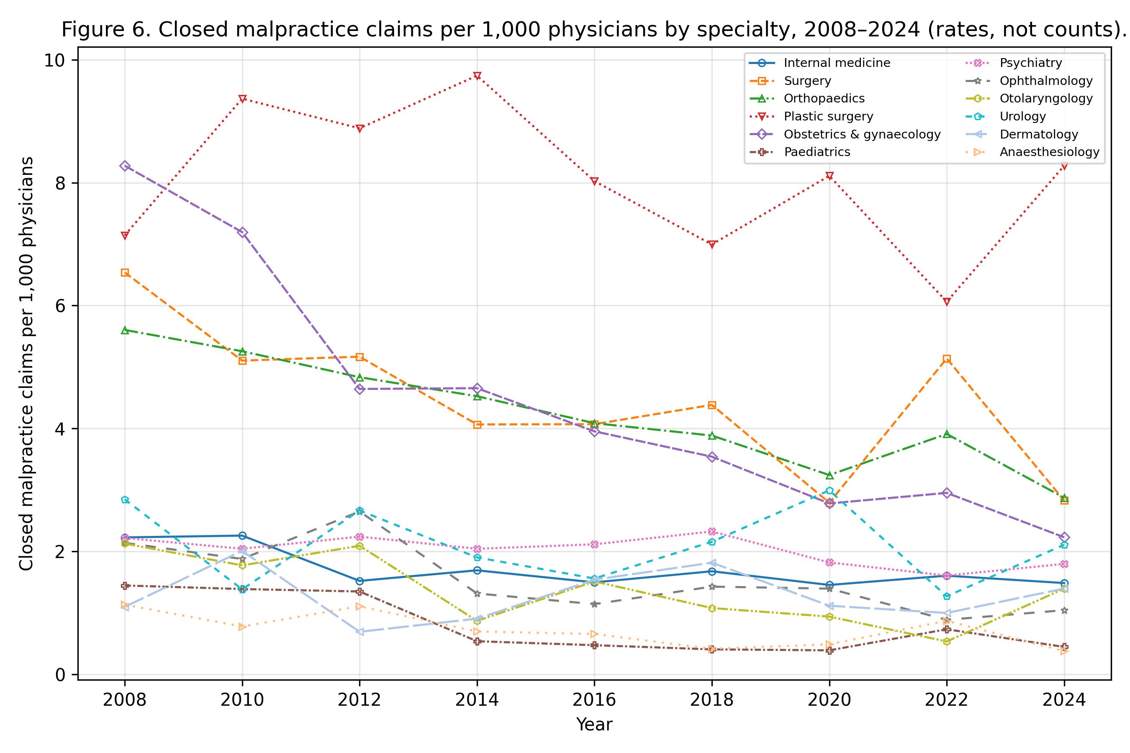
Figure 6. Closed malpractice claims per 1,000 physicians by specialty, 2008-2024 (rates, not counts).

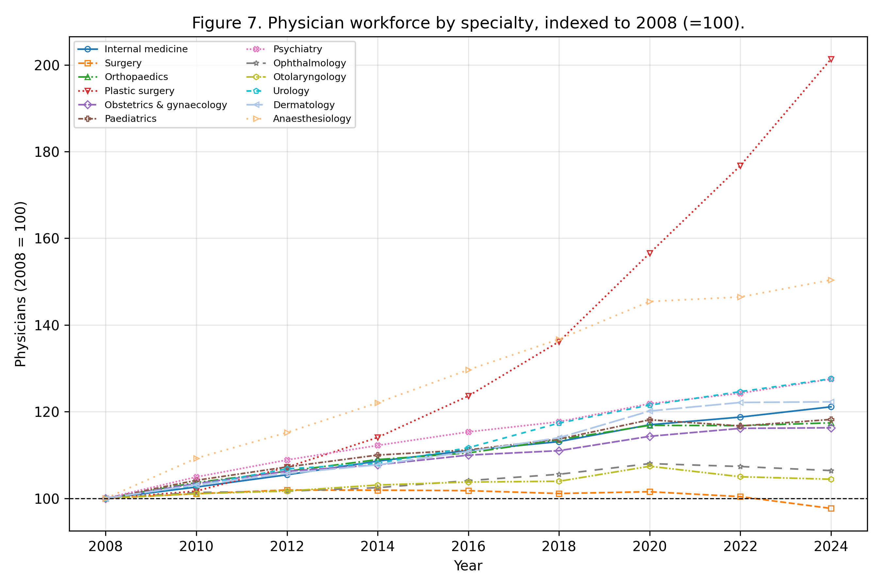
Figure 7. Physician workforce by specialty, indexed to 2008 (=100).

Table 1. Physicians, litigation rate (per 1,000 physicians) and hospital facilities by specialty, first and last waves.
Specialty | Physicians 2008 | Physicians 2024 | Lit. rate 2008 | Lit. rate 2024 | Hospital facilities 2008 | Hospital facilities 2024
Internal medicine | 102388 | 124010 | 2.23 | 1.48 | 7725 | 7163
Surgery | 27525 | 26885 | 6.54 | 2.83 | 4994 | 4300
Orthopaedics | 19273 | 22630 | 5.60 | 2.87 | 5094 | 4844
Plastic surgery | 2520 | 5074 | 7.14 | 8.28 | 1090 | 1475
Obstetrics & gynaecology | 11961 | 13908 | 8.28 | 2.23 | 1319 | 1052
Paediatrics | 15236 | 18009 | 1.44 | 0.44 | 2932 | 2446
Psychiatry | 13534 | 17259 | 2.22 | 1.80 | 2618 | 2881
Ophthalmology | 12627 | 13436 | 2.14 | 1.04 | 2501 | 2310
Otolaryngology | 8936 | 9330 | 2.13 | 1.39 | 2039 | 1937
Urology | 6324 | 8069 | 2.85 | 2.11 | 2799 | 2893
Dermatology | 8214 | 10043 | 1.10 | 1.39 | 3040 | 3066
Anaesthesiology | 7067 | 10628 | 1.13 | 0.38 | 2525 | 2798

Primary association and equivalence
The lagged litigation rate was not associated with biennial physician growth (coefficient -0.0009; 95% CI -0.0043 to +0.0025; p=0.56; n=96) or with hospital facility-count growth (coefficient +0.0003; p=0.90). Equivalence testing (Figure 1; Table 2) showed that a 1-SD higher litigation rate changed biennial physician growth by less than +/-1% (TOST p=0.023; point estimate -0.21% with 90% CI -0.84% to +0.42%). For hospital facility-count growth the point estimate was +0.07% (90% CI -0.91% to +1.06%): it was within the +/-2% margin (p=0.002) but not the stricter +/-1% margin (p=0.059). Thus the data are consistent with the absence of a policy-relevant effect on physician growth, and with at most a small effect on hospital facility-count growth. Detailed TOST results by margin are reported in Table 4.
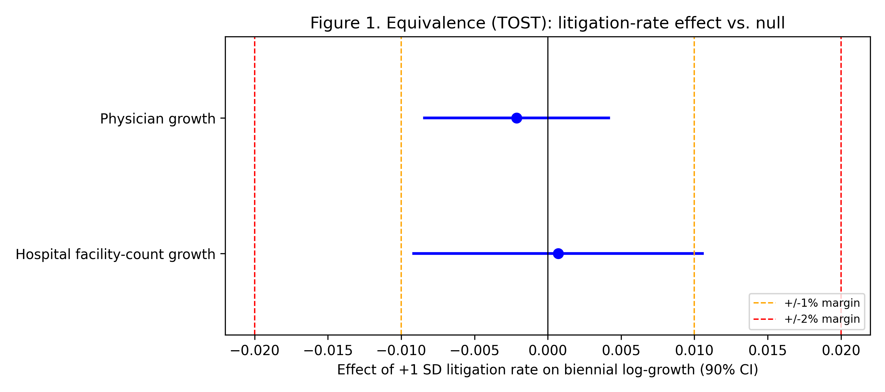
Figure 1. Equivalence (TOST) of the litigation-rate effect against +/-1% and +/-2% margins; horizontal bars are 90% confidence intervals.

Table 2. Panel fixed-effects models and sensitivity analyses.
Model | Coefficient | 95% CI | p | n
Physician growth ~ lagged rate | -0.0009 | -0.0043, +0.0025 | 0.56 | 96
Hospital facility-count growth ~ lagged rate | +0.0003 | -0.0050, +0.0056 | 0.90 | 96
Counts contrast (physician) | +0.0002 | -- | 0.51 | 96
Annual hospital facility-count growth (sensitivity) | +0.0000 | -- | 0.99 | 192
Interpolated physician (sensitivity) | -0.0010 | -- | 0.39 | 192
Reverse (workforce->litigation) | +0.097 | -- | 0.85 | 96

Table 4. Equivalence (TOST) results (effect per +1 SD litigation rate).
Outcome | Coef per SD | 90% CI | Margin | TOST p | Equivalent
Physician growth | -0.21% | -0.84%, +0.42% | +/-1% | 0.023 | Yes
Physician growth | -0.21% | -0.84%, +0.42% | +/-2% | <0.001 | Yes
Hospital growth | +0.07% | -0.91%, +1.06% | +/-1% | 0.059 | No
Hospital growth | +0.07% | -0.91%, +1.06% | +/-2% | 0.002 | Yes

Counts versus rates, and confounders
Using raw litigation counts rather than rates did not reveal a negative association in this measured-only design (p=0.51). Figure 2 shows the contrast: the count exposure is confounded by specialty size (panel a), whereas the rate-adjusted exposure is not (panel b); points are coloured and shaped by specialty so readers can identify which fields drive any apparent pattern. The annual hospital and interpolated annual-physician sensitivity analyses were also null (p=0.99 and p=0.39), confirming that the null result holds across panel frequency and exposure definition. The JOCS-CP indicator was positive in sign in the obstetric-hospital model (coefficient +0.024, raw p=0.013), but it did not remain significant after the small-cluster correction and Holm adjustment for the exploratory sensitivity family (Holm p=0.250); we treat it as exploratory and do not interpret it as a causal policy effect.
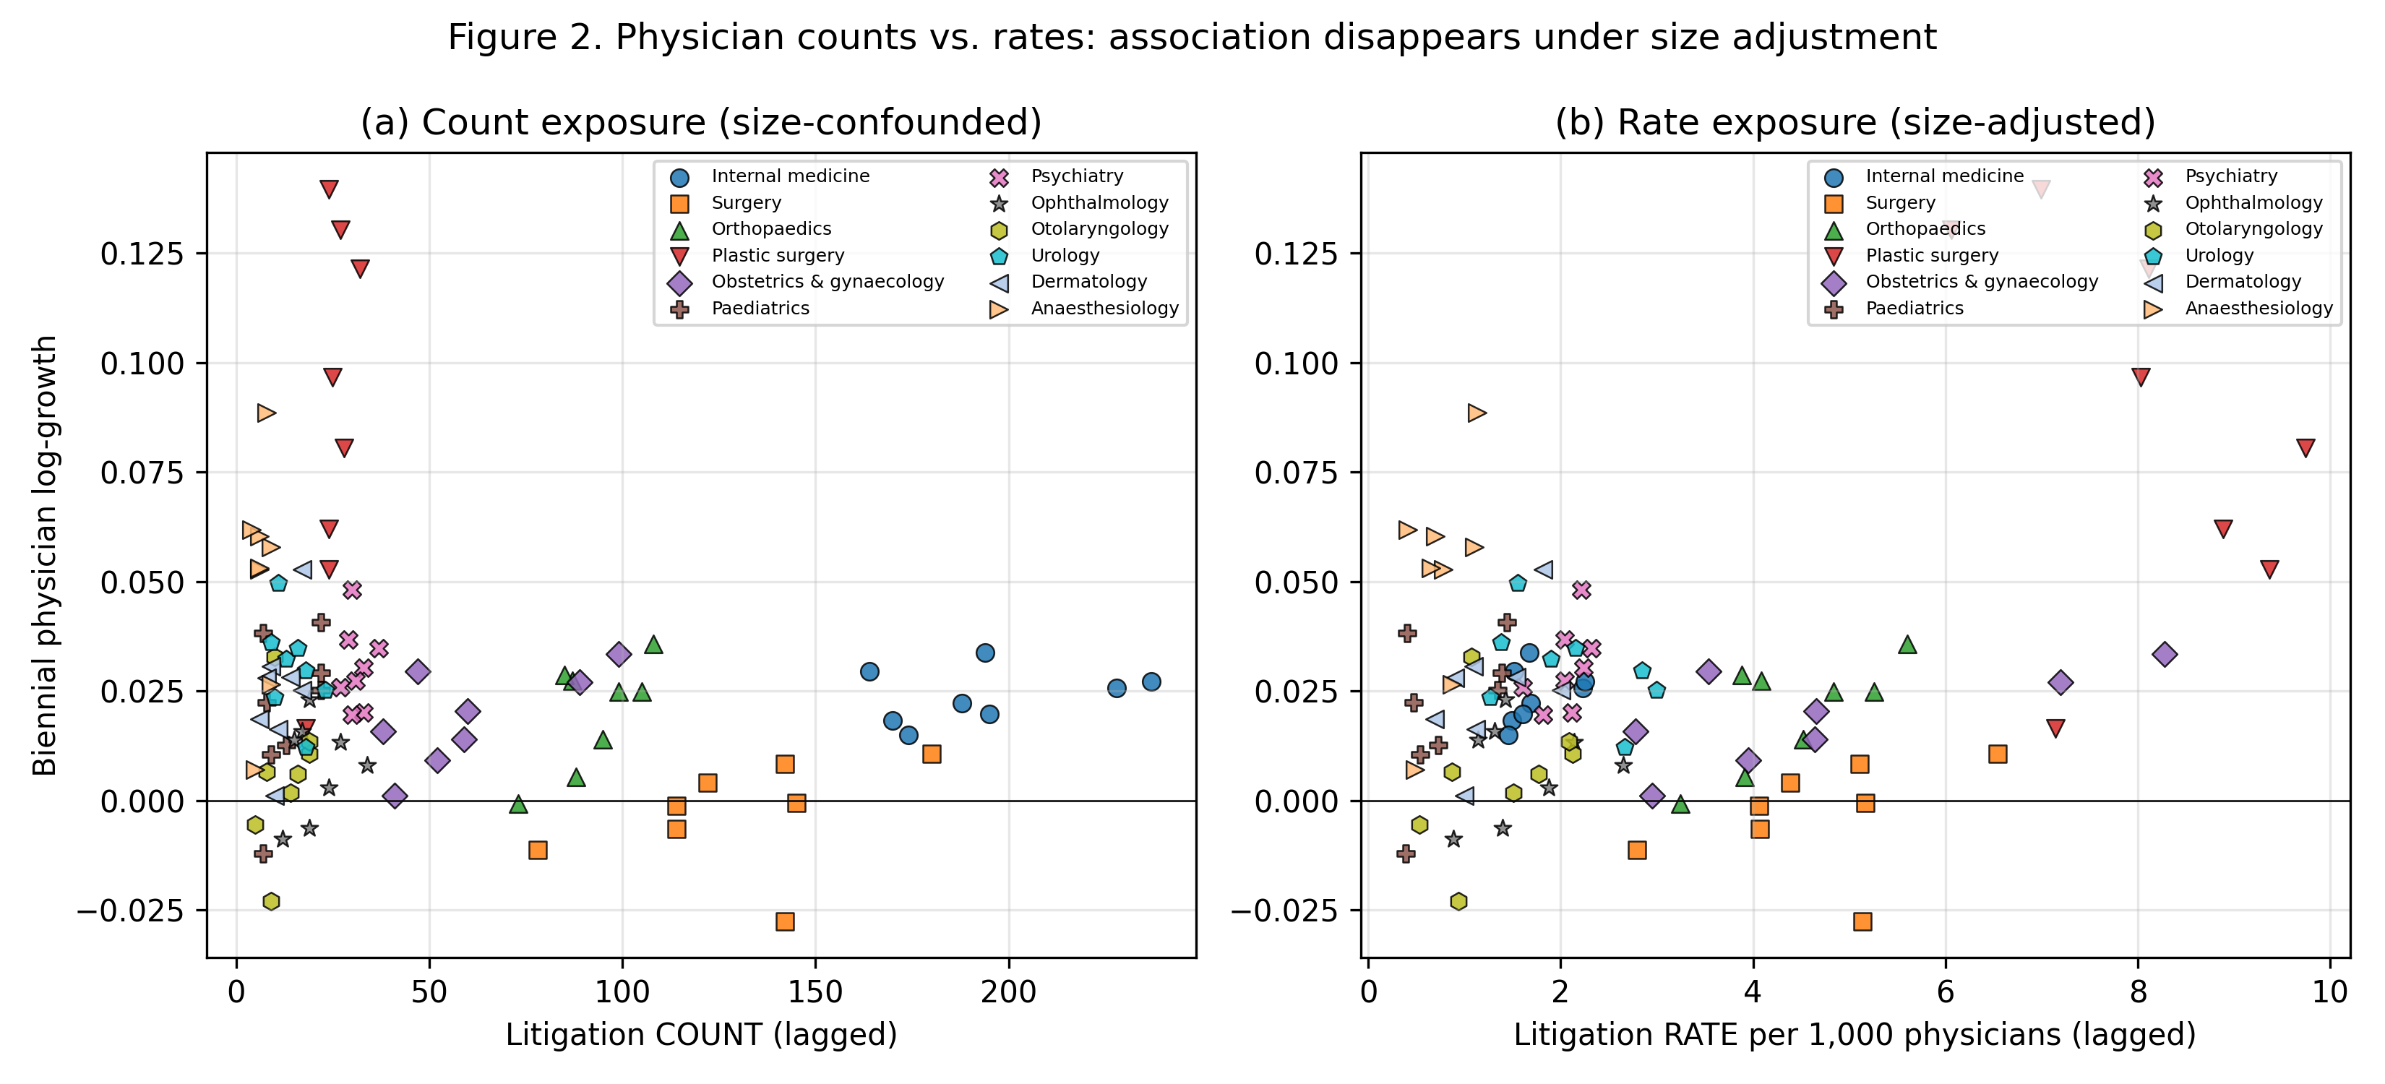
Figure 2. Biennial physician growth against lagged litigation exposure measured as (a) counts and (b) rates. Points are coloured by specialty; the count panel shows the size confounding that the rate panel removes.

The same count-versus-rate contrast for biennial hospital facility-count growth is shown in Figure 3. As with physician growth, the count exposure creates a spurious size confound that disappears once the rate-adjusted exposure is used.
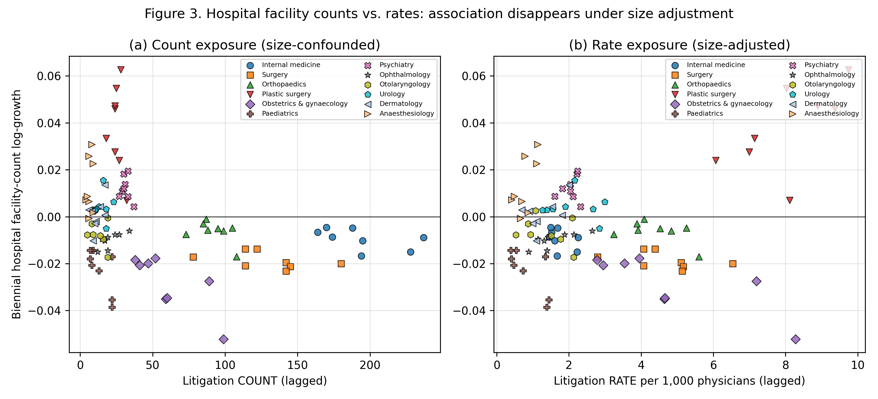
Figure 3. Biennial hospital facility-count growth against lagged litigation exposure measured as (a) counts and (b) rates. Points are coloured by specialty; the rate-adjusted panel shows no systematic association.

Descriptively, per-specialty rank correlations between the lagged litigation rate and physician growth were positive in 10 of 12 specialties and statistically significant in 0; the direction is, if anything, opposite to a flight-from-risk hypothesis.
A reverse specification (change in litigation rate regressed on lagged log physicians) was also null (coefficient +0.097, p=0.85; Table 2), making a reverse-causation interpretation of the null unlikely.
We also evaluated JMSR medical-accident investigation report counts as a potential confounder or competing exposure. (JMSR, 2025) From 2015 to 2024, raw litigation and JMSR report counts were strongly correlated across specialties (Pearson r=0.82), because large specialties generate more of both. After removing specialty-specific levels and trends, however, the within-specialty correlation was negligible (r=-0.02). A model of annual hospital facility-count growth for 2016-2024 that included both the lagged litigation rate and the lagged JMSR report rate left the litigation coefficient little changed (+0.0021; p=0.28) and the JMSR term was not associated with hospital facility-count growth (p=0.66; Table 5). The null litigation result is neither explained nor masked by broader medical-accident reporting.
Table 5. JMSR-adjusted annual hospital facility-count growth model (2016-2024) with both exposures entered simultaneously.
Exposure | Coefficient | p | n
Lagged litigation rate | +0.0021 | 0.28 | 108
Lagged JMSR report rate | -0.0009 | 0.66 | 108

Finally, we tested national newspaper coverage from Nikkei Telecom 21 as a potential confounder. (Nikkei Inc, 2024) Total annual article counts (keywords: medical error + medical malpractice) and total litigation counts were correlated (Pearson r=0.81), consistent with greater public attention in high-litigation years. Within the annual hospital panel, however, the lagged litigation rate and the media-count series were only weakly correlated. A model of annual hospital facility-count growth for 2009-2018 that included both the lagged litigation rate and the lagged article count (per 1,000 articles) left the litigation coefficient little changed and the media term was not associated with hospital facility-count growth (p=0.21; Table 6). Media coverage does not explain the null litigation effect either. Holm step-down adjusted p-values for the exploratory sensitivity family are reported in Table 7.
Table 6. Media-adjusted annual hospital facility-count growth model (2009-2018) with a linear time trend; full year fixed effects are omitted because the national article-count series is collinear with them.
Exposure | Coefficient | p | n
Lagged litigation rate | -0.0003 | 0.72 | 120
Lagged media count (per 1,000 articles) | -0.0014 | 0.21 | 120

Table 7. Holm step-down adjusted p-values for the exploratory sensitivity tests and the JOCS-CP indicator.
Test | Raw p | Holm-adjusted p
Biennial physician growth ~ lagged litigation rate (JOCS-CP indicator) | 0.249 | 1.000
Biennial hospital growth ~ lagged litigation rate (JOCS-CP indicator) | 0.013 | 0.250
COUNTS contrast: physician growth ~ lagged litigation COUNT | 0.506 | 1.000
Annual hospital growth ~ lagged litigation rate (2008-2024) | 0.994 | 1.000
SENSITIVITY interpolated-annual physician growth ~ lag rate | 0.389 | 1.000
JMSR-adjusted annual hospital growth (2016-2024) ~ lit rate + JMSR rate (litigation rate) | 0.283 | 1.000
JMSR-adjusted annual hospital growth (2016-2024) ~ lit rate + JMSR rate (JMSR report rate) | 0.664 | 1.000
Media-adjusted annual hospital growth (2009-2018) ~ lit rate + media count (litigation rate) | 0.718 | 1.000
Media-adjusted annual hospital growth (2009-2018) ~ lit rate + media count (media count) | 0.209 | 1.000
Heterogeneity (high-litigation) physician growth ~ lagged litigation rate (main effect) | 0.269 | 1.000
Heterogeneity (high-litigation) physician growth ~ lagged litigation rate (interaction) | 0.240 | 1.000
Heterogeneity (surgical) physician growth ~ lagged litigation rate (main effect) | 0.239 | 1.000
Heterogeneity (surgical) physician growth ~ lagged litigation rate (interaction) | 0.391 | 1.000
Heterogeneity (high-litigation) hospital growth ~ lagged litigation rate (main effect) | 0.988 | 1.000
Heterogeneity (high-litigation) hospital growth ~ lagged litigation rate (interaction) | 0.928 | 1.000
Heterogeneity (surgical) hospital growth ~ lagged litigation rate (main effect) | 0.124 | 1.000
Heterogeneity (surgical) hospital growth ~ lagged litigation rate (interaction) | 0.064 | 1.000
Trend robustness: physician growth ~ lagged litigation rate + specialty trends | 0.728 | 1.000
Trend robustness: hospital growth ~ lagged litigation rate + specialty trends | 0.114 | 1.000

Small-cluster validation and power
Because inference is based on only 12 specialty clusters, we checked the primary results with a cluster block-bootstrap (B = 1,999). For physician growth the bootstrap 95% CI for the lagged litigation-rate coefficient was -0.0048 to +0.0021 and the bootstrap p-value was 0.57; for hospital facility-count growth the bootstrap 95% CI was -0.0043 to +0.0042 and the bootstrap p-value was 0.90. Both intervals comfortably contain zero. Power diagnostics make the panel information explicit. For physician growth, the minimum detectable effect was 1.08% per SD at 80% power, and the power to declare equivalence within the +/-1% margin if the true effect were zero was 98.4%. For hospital facility-count growth the minimum detectable effect was 1.69% per SD and the equivalent power for the +/-1% margin was 90.4%. The panel is informative enough to rule out policy-relevant effects for physicians, and to bound any hospital effect within a small margin.
Full bootstrap diagnostics and power calculations are reported in Table 8.
Table 8. Cluster block-bootstrap p-values, percentile 95% confidence intervals, equivalence power (if true effect is zero), and minimum detectable effect per 1-SD litigation-rate increase.
Outcome | Bootstrap p | Bootstrap 95% CI | Equivalence margin | Power if true null | MDE (80% power)
Physician growth | 0.573 | -0.00476, 0.00212 | +/-1% | 98.4% | 1.08%
Physician growth | 0.573 | -0.00476, 0.00212 | +/-2% | 100.0% | 1.08%
Hospital growth | 0.903 | -0.00431, 0.00416 | +/-1% | 90.4% | 1.69%
Hospital growth | 0.903 | -0.00431, 0.00416 | +/-2% | 99.6% | 1.69%

Counterfactual simulation
The counterfactual projection made the practical implications of the null regression result explicit. Under the point estimate, eliminating all malpractice litigation would add only 1.1% to the projected 2034 national physician stock relative to baseline drift. Even under the 95% lower-bound (most favourable) coefficient it would add 5.2%, comparable to the 5.5% gain from a generic benchmark equal to the minimum detectable effect. General surgery, the only specialty with negative baseline drift, illustrates the break-even arithmetic: its projected 2024-2034 decline of -2.2% would be reduced to -0.1% under the point estimate and reversed to 7.7% under the 95% lower bound. The latter requires eliminating every remaining closed claim and assumes the most adverse (most negative) coefficient compatible with the data; a more realistic policy would achieve far less. Full projected 2034 physician counts by specialty and scenario are reported in Table 9; Figure 4 summarises the same information as marginal percentage changes. Litigation reduction is not a high-impact instrument for workforce allocation in this setting.
Table 9. Counterfactual 2034 physician counts by specialty and policy instrument. Counts are projected from observed biennial baseline drift plus the indicated effect; marginal percentage changes are shown in Figure 4.
Specialty | 2024 count | Baseline 2034 | Litigation zero (point) | Litigation zero (95% lower) | MDE benchmark
Internal medicine | 124,010 | 136,909 | 138,010 | 142,075 | 144,492
Surgery | 26,885 | 26,299 | 26,853 | 28,960 | 27,755
Orthopaedics | 22,630 | 24,848 | 25,346 | 27,239 | 26,224
Plastic surgery | 5,074 | 7,874 | 8,177 | 9,376 | 8,310
Obstetrics & gynaecology | 13,908 | 14,877 | 15,191 | 16,387 | 15,700
Paediatrics | 18,009 | 19,949 | 20,023 | 20,295 | 21,054
Psychiatry | 17,259 | 20,199 | 20,391 | 21,102 | 21,317
Ophthalmology | 13,436 | 13,957 | 14,058 | 14,430 | 14,730
Otolaryngology | 9,330 | 9,460 | 9,520 | 9,744 | 9,984
Urology | 8,069 | 9,333 | 9,425 | 9,766 | 9,849
Dermatology | 10,043 | 11,411 | 11,479 | 11,732 | 12,042
Anaesthesiology | 10,628 | 13,699 | 13,745 | 13,915 | 14,458
All specialties | 279,281 | 308,815 | 312,218 | 325,021 | 325,915

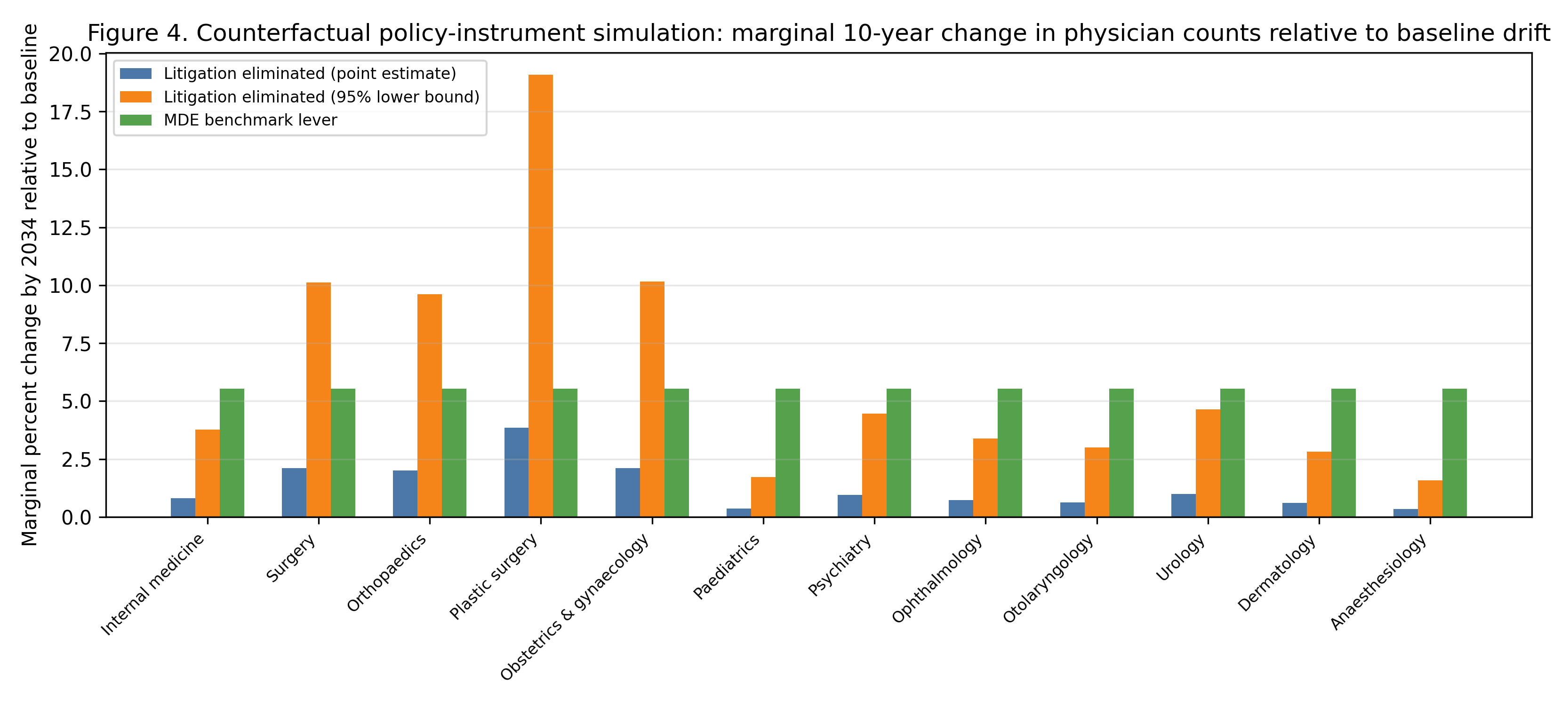
Figure 4. Counterfactual policy simulation: marginal 10-year change in physician counts by specialty relative to the projected baseline drift. The MDE benchmark is the minimum detectable per-SD effect from the primary analysis.

Training-system context
As a reference for the size of the specialist-training pipeline, first-year specialist-trainee (senkoi) positions in 2018 covered 18.3% of physicians in the third to fifth year after medical registration in 2014 (weighted by specialty stock), with specialty-specific coverage ranging from 7.2% (paediatrics) to 81.7% (surgery). (Ministry of Health, Labour and Welfare, 2018; Ministry of Health, Labour and Welfare, 2015) These coverage rates are not an outcome of the litigation-risk model, but they confirm that the 12 primary specialties capture the main initial specialization decision in Japan; Table 10 reports the counts by specialty.
Table 10. Specialist-trainee coverage by specialty. Coverage is the number of 2018 first-year specialist trainees divided by the number of physicians reported 3-5 years after medical registration in 2014, by primary specialty.
Specialty | 2018 specialist trainees (senkoi) | Physicians 3-5 yr after registration (2014) | H24 cohort 3rd year (2012) | H24 cohort 5th year (2014) | Coverage
Internal medicine | 2,670 | 21,536 | 2,630 | 2,621 | 12.4%
Surgery | 805 | 985 | 735 | 774 | 81.7%
Orthopaedics | 552 | 2,291 | 457 | 472 | 24.1%
Plastic surgery | 163 | 317 | 144 | 148 | 51.4%
Obstetrics & gynaecology | 441 | 1,383 | 327 | 342 | 31.9%
Paediatrics | 573 | 7,950 | 447 | 433 | 7.2%
Psychiatry | 441 | 637 | 314 | 354 | 69.2%
Ophthalmology | 328 | 1,051 | 211 | 213 | 31.2%
Otolaryngology | 267 | 617 | 195 | 193 | 43.3%
Urology | 274 | 568 | 206 | 194 | 48.2%
Dermatology | 271 | 1,405 | 228 | 210 | 19.3%
Anaesthesiology | 495 | 1,091 | 378 | 385 | 45.4%

Heterogeneity and trend sensitivity
We tested whether the null association concealed a differential response in high-litigation or surgical specialties, or whether it depended on assuming common wave fixed effects. In high-litigation specialties the main litigation coefficient for physician growth was +0.0098 (p=0.27) and the interaction was -0.0119 (p=0.24); for hospital facility-count growth the main coefficient was -0.0001 (p=0.99) and the interaction was +0.0004 (p=0.93). For the surgical-specialty interaction the physician main effect was -0.0045 (p=0.24) and the interaction was +0.0057 (p=0.39); for hospital facility-count growth the main effect was +0.0044 (p=0.12) and the interaction was -0.0066 (p=0.06). Allowing specialty-specific linear trends also left the litigation coefficient small and non-significant for physician growth (+0.0010; p=0.73) and hospital facility-count growth (+0.0027; p=0.11). None of the interactions or trend-stability checks suggest that a negative litigation effect is hiding in a clinically exposed subgroup (Table 11).
Table 11. Heterogeneity and trend-stability checks. High-litigation and surgical models include an interaction between the lagged litigation rate and a binary group indicator (the main effect of the group is absorbed by specialty fixed effects). The trend-stability model adds specialty-specific linear time trends.
Outcome | Group / check | Main coefficient (SE) | p | Interaction coefficient (SE) | p | n
Physician growth | High litigation | +0.0098 (+0.0084) | 0.27 | -0.0119 (+0.0096) | 0.24 | 96
Physician growth | Surgical | -0.0045 (+0.0037) | 0.24 | +0.0057 (+0.0064) | 0.39 | 96
Hospital growth | High litigation | -0.0001 (+0.0034) | 0.99 | +0.0004 (+0.0043) | 0.93 | 96
Hospital growth | Surgical | +0.0044 (+0.0027) | 0.12 | -0.0066 (+0.0032) | 0.06 | 96
Physician growth | Specialty trends | +0.0010 (+0.0028) | 0.73 | -- | -- | 96
Hospital growth | Specialty trends | +0.0027 (+0.0016) | 0.11 | -- | -- | 96

Discussion
Using national primary data, rates rather than counts, and only measured biennial physician observations, we found no association between specialty-level malpractice-litigation risk and subsequent physician or hospital decline. Equivalence testing showed that any effect of litigation risk on biennial physician growth is smaller than 1% (90% CI within the 1% margin), and any effect on hospital facility-count growth is smaller than 2% (but not confidently smaller than 1%). These data do not support the hypothesis that physicians systematically abandon high-litigation specialties over 16 years of official statistics.
The null result is not merely a failure to detect an effect. The narrow confidence intervals, pre-specified equivalence margins, and power diagnostics allow us to say that, if litigation risk does influence specialty-level workforce growth, the magnitude is too small to matter for workforce planning. For behavioural public policy, this is an important distinction: a widely discussed risk can be highly available and emotionally salient without being a reliable policy tool. The public policy question is not whether physicians worry about litigation, but whether a policy that reduces litigation risk would materially change aggregate specialty supply. Our evidence suggests it would not.

Behavioural mechanisms
Several behavioural mechanisms are consistent with this finding. First, litigation risk may affect clinical behaviour on the intensive margin (defensive medicine) rather than the extensive margin (specialty exit). Kessler and McClellan showed that U.S. malpractice reforms reduced medical expenditures for elderly heart-disease patients without increasing mortality or complications, suggesting that defensive practice is one margin of adjustment to liability pressure. (Kessler and McClellan, 1996) Subsequent reassessments have debated the magnitude and consistency of this effect, but the conceptual point remains: physicians can respond to liability risk by changing how they practise rather than by exiting a specialty. (Sloan and Shadle, 2008) Fee-for-service reimbursement in Japan rewards the high-acuity procedural work that also carries litigation exposure, so the financial return to remaining in surgery, obstetrics, or interventional specialties may dominate any deterrent from civil claims.
Second, the discrepancy between perceived risk and measured workforce supply is consistent with well-documented behavioural-economics mechanisms. Media coverage of sensational malpractice or criminal prosecutions makes litigation risk highly available to physicians and trainees, and loss aversion can cause a rare but salient adverse outcome to be overweighted in career deliberations. (Tversky and Kahneman, 1973; Kahneman and Tversky, 1979) Yet the decision to leave a specialty is governed by expected income, sunk training costs, switching costs and status-quo bias, all of which discourage exit even when perceived risk is high. (Samuelson and Zeckhauser, 1988) The gap between reported anxiety and measured supply is not a contradiction; it is exactly what one would expect when a vivid, low-probability risk meets strong economic and institutional incentives to remain.
For behavioural public policy, the lesson is that changing the perceived risk alone is unlikely to alter aggregate workforce allocation when the underlying choice architecture preserves strong structural incentives to remain. Status-quo bias and loss aversion now work in the opposite direction: once a physician has incurred the sunk cost of specialty training, leaving feels like a sure loss, while the rare possibility of a malpractice judgment remains an abstract, low-probability event. No-fault compensation, payment design, and training subsidies change the payoff structure directly; litigation-avoidance messaging targets only the perceived risk. Our results suggest that the former are the more reliable tools.

Institutional context and international evidence
The civil litigation environment in Japan itself dampens the likelihood of a flight-from-risk response. Taniguchi and colleagues analysed all closed malpractice claims reported by the Supreme Court from 2006 to 2021 and found that more than half ended in settlement, plaintiffs won only about a quarter of judgments, and the number of claims has been declining, especially in obstetrics and gynaecology. (Taniguchi, Watari and Nagoshi, 2023) The Court data we use describe a civil system that is low-volume, settlement-prone, and comparatively favourable to physicians. This context makes it unlikely that routine civil litigation risk alone would drive physicians out of high-risk fields.
No-fault obstetric compensation (JOCS-CP, 2009) illustrates a different mechanism. It was introduced partly because of a shortage of young obstetricians and regional gaps in maternity care, and it combined no-fault compensation with investigation and prevention. (Hasegawa et al., 2016) The hospital-level JOCS-CP indicator was directionally positive (coefficient +0.024, raw p=0.013), but it did not remain significant after the small-cluster correction and Holm adjustment for the exploratory sensitivity family (Holm p=0.250). This suggests that, if the JOCS-CP did support obstetric hospital supply, the effect would be too small or too confounded by concurrent obstetric policies to be isolated here. Civil litigation exposure is also distinct from criminal prosecution. Morita studied the 2004 Fukushima obstetrician prosecution and found a 13 percent decline in obstetricians, with some switching to gynaecology. (Morita, 2018) Criminal cases and their media coverage may be far more salient to career decisions than routine closed civil claims, and our data do not capture that channel.
The obstetrics and gynaecology case is the most discussed example of the litigation-workforce nexus, and it is consistent with our interpretation. A recent Japan-U.S. comparison of medical-legal claims in obstetrics and gynaecology found that the proportion of malpractice claims in this specialty fell from 15.1 percent in 2004 to 5.2 percent in 2022, and that claims per 100 OB/GYN physicians fell from 0.9 in 2007 to 0.4 in 2016, while maternal and neonatal mortality also declined. (Kamijo et al., 2025) The authors attribute this to heightened awareness after a wrongful criminal charge, the JOCS-CP no-fault scheme, standardised clinical guidelines, and the adverse-event investigation system. This is not evidence that lowering litigation risk caused the workforce to grow; it is evidence that obstetric litigation, workforce support, and safety interventions moved together. Surveys of OB/GYN residents in Japan, Korea, and Taiwan likewise show that litigation is reported as a negative factor, but that its perceived importance is smaller where no-fault compensation exists and that workload, lifestyle, and professional interest remain dominant. (Lin et al., 2022) These findings echo our specialty-level result: litigation may matter for perceptions, but it is not the binding constraint on supply.
International evidence on tort reform and physician supply is consistent with a small or context-specific effect, especially in systems with low litigation volume and predictable damages. (Helland and Seabury, 2015; Matsa, 2007; Hyman et al., 2015; Frakes, Frank and Seabury, 2020) Against this backdrop, a null effect of civil litigation risk on Japanese specialty supply is not surprising.
The raw-count sensitivity did not reveal a negative association in these data, illustrating that the apparent count-litigation relationship does not translate into a behavioural effect once specialty size is accounted for (Figure 2). This is a cautionary example for workforce research that pairs administrative count series, and shows why rate-based, measured-only designs are preferable when testing litigation-workforce hypotheses.

Policy implications
Reducing civil malpractice litigation is unlikely to be a powerful tool for correcting specialty maldistribution. The 10-year counterfactual showed that eliminating all claims would add only 1.1% to the projected national physician stock under the point estimate, and 5.2% under the most favourable 95% lower-bound coefficient. A generic benchmark equal to the minimum detectable effect would add 5.5%. Effects of this size are too small to rebalance a workforce whose distribution is shaped by training costs, reimbursement and seniority.
The weak response reflects the institutional structure of career choice, not a lack of concern. Once a physician has entered a specialty, the costs of switching -- foregone fellowship income, lost seniority and professional identity -- generate powerful status-quo bias, while fee-for-service income rewards the high-acuity work that also carries litigation risk. No-fault compensation, payment design and training subsidies alter the payoffs and defaults that matter for a loss-averse trainee; they are more reliable tools than risk communication. (Samuelson and Zeckhauser, 1988; Kahneman and Tversky, 1979) New Zealand and the Nordic administrative-compensation systems show how separating compensation from blame can protect patients and providers without relying on litigation, and Japan's JOCS-CP moves in the same direction for obstetric cerebral palsy. (Bismark and Paterson, 2006; Mello, Kachalia and Studdert, 2011; Hasegawa et al., 2016)
Information campaigns that publicise the rarity of claims are therefore unlikely to alter aggregate supply. The availability heuristic means that vivid cases dominate decision weights regardless of their frequency, so a national trend line does not remove salient exemplars from memory or media coverage. (Tversky and Kahneman, 1973; Kahneman and Tversky, 1979; Lin et al., 2022) The behavioural lesson is that policymakers should redesign the choice architecture -- payment, training slots and compensation rules -- rather than expect litigation-avoidance messaging to drive career decisions. Our null result is evidence that structural defaults and loss aversion outweigh rare-event risk perception in the aggregate workforce.

Limitations
This is an ecological, specialty-level analysis and cannot establish individual-level causality. We do not directly observe individual physicians' subjective risk perceptions, so the behavioural interpretation of the null result in terms of availability, loss aversion and status-quo bias is theoretically informed rather than directly tested. The 12 specialties correspond to the primary-specialty tier of Japan's two-tiered specialist training programme; the analysis describes workforce allocation at the initial board-certification stage and may not extend to narrower subspecialties that are not separately tracked in the biennial census. The physician census is biennial, giving 9 measured waves; we addressed the limited power directly through equivalence testing and by pooling across specialties, but residual power constraints remain and the equivalence margins are a judgement. Litigation rates may be endogenous to physician supply if a smaller workforce increases workload and hence incidents; the lagged exposure, fixed effects, and reverse specification make reverse causation unlikely, yet unobserved confounders at the specialty or prefecture level cannot be fully ruled out. Cluster block-bootstrap and power diagnostics are reported in Table 8. Because clusters are defined by the 12 specialties, the small-cluster correction uses G-1=11 degrees of freedom; this is the minimum at which cluster-level t inference is recommended and is inherent to the data. Specialty-specific litigation counts could be recovered only from 2008; pre-2008 specialty tables were not retrievable from primary sources. Clinic counts by specialty are published only every 3 years and were used descriptively. JMSR report counts are available only from 2015 and were used in a 2016-2024 sensitivity. Media article counts are available only for 2009-2018 and are a national total, so they cannot be decomposed by specialty and are collinear with full wave fixed effects. Litigation counts are assigned to a principal specialty and, by the Court's own note, do not measure intrinsic specialty risk. (Supreme Court of Japan, 2024) Finally, these findings are embedded in the country's particular legal, cultural and institutional context -- including its no-fault obstetric compensation scheme, its fee-for-service reimbursement structure and its comparatively low-volume malpractice-litigation culture -- so physician responses to litigation risk may differ in health systems with different liability regimes, compensation mechanisms or professional norms; the results should not be assumed to generalise across cultural spheres.

Conclusions
Across 2008-2024, specialty-level malpractice-litigation risk was not associated with physician or hospital decline in these national data, and the physician effect was statistically equivalent to null within a small margin. From a behavioural public policy perspective, malpractice litigation is not a reliable tool for correcting specialty maldistribution in this setting. Policymakers may more productively target structural incentives, especially no-fault compensation and payment design, rather than rely on the assumption that reducing litigation will retain physicians in high-risk specialties. The transparent, reproducible sensitivity-analysis framework used here is exportable to other healthcare workforce-policy tools. More generally, the results caution against treating highly salient risks as reliable policy tools when the underlying choice architecture preserves strong structural incentives. Behavioural public policy is most effective when it redesigns the decision context rather than attempting to counteract it through information alone.

References
Angrist, J.D. and Pischke, J.S. (2009), Mostly Harmless Econometrics: An Empiricist's Companion. Princeton: Princeton University Press.
Bismark, M. and Paterson, R. (2006), 'No-fault compensation in New Zealand: harmonizing injury compensation, provider accountability, and patient safety', Health Aff. 25(1): 278-286.
Cameron, A.C. and Miller, D.L. (2015), 'A practitioner's guide to cluster-robust inference', J Hum Resour. 50(2): 317-372.
Frakes, M.D., Frank, M.B. and Seabury, S.A. (2020), 'The effect of malpractice law on physician supply: Evidence from negligence-standard reforms', J Health Econ. 70: 1-16.
Hasegawa, J., Toyokawa, S., Ikenoue, T., et al. (2016), 'Relevant obstetric factors for cerebral palsy: from the Nationwide Obstetric Compensation System in Japan', PLoS One. 11(1): e0148122.
Helland, E. and Seabury, S.A. (2015), 'Tort reform and physician labor supply: a review of the evidence', Int Rev Law Econ. 42: 192-202.
Hiyama, T., Yoshihara, M., Tanaka, S., et al. (2006), 'Defensive medicine practices among gastroenterologists in Japan', World J Gastroenterol. 12(47): 7671-7675. doi:10.3748/wjg.v12.i47.7671
Hyman, D.A., Silver, C., Black, B. and Paik, M. (2015), 'Does tort reform affect physician supply? Evidence from Texas', Int Rev Law Econ. 42: 203-218.
Japan Council for Quality Health Care (JOCS-CP) (2009), Japan Obstetric Compensation System for Cerebral Palsy. Tokyo: Japan Council for Quality Health Care.
Japan Medical Safety Research Organisation (JMSR) (2025), Annual reports of medical accident investigations (2015-2024). Tokyo: JMSR.
Kahneman, D. and Tversky, A. (1979), 'Prospect theory: an analysis of decision under risk', Econometrica. 47(2): 263-291.
Kamijo, K., Wada, Y., Ishida, K., Warsof, S.L., Saade, G. and Kawakita, T. (2025), 'Medical-legal claims in obstetrics and gynecology: Japan versus the United States', J Healthc Risk Manag. 44(4): 5-11. doi:10.1002/jhrm.70001
Kessler, D.P. and McClellan, M.B. (1996), 'Do doctors practice defensive medicine?', Q J Econ. 111(2): 353-390.
Lakens, D. (2017), 'Equivalence tests: a practical primer for t tests, correlations, and meta-analyses', Soc Psychol Personal Sci. 8(4): 355-362.
Lin, P.L., Huang, J.P., Fujii, T., Cho, E.H. and Huang, M.C. (2022), 'A survey of specialty choice among obstetrics and gynecology residents in Japan, Korea, and Taiwan', J Obstet Gynaecol Res. 48(7): 1968-1977.
Matsa, D.A. (2007), 'Does malpractice liability keep the doctor away? Evidence from tort reform damage caps', J Legal Stud. 36(S2): S143-S182.
Matsumoto, M., Inoue, K., Bowman, R. and Kajii, E. (2010), 'Self-employment, specialty choice, and geographical distribution of physicians in Japan: a comparison with the United States', Health Policy. 96(3): 239-244. doi:10.1016/j.healthpol.2010.02.008
McNamara, C. and Pineda-Torres, M. (2025), 'Medical residency subsidies and physician shortages', J Public Econ. 251: 105494. doi:10.1016/j.jpubeco.2025.105494
Medical Accident Investigation System (2015), Act on the Promotion of Medical Safety. Tokyo: Ministry of Health, Labour and Welfare.
Mello, M.M., Kachalia, A. and Studdert, D.M. (2011), Administrative compensation for medical injuries: lessons from three foreign systems. New York: The Commonwealth Fund.
Ministry of Health, Labour and Welfare (2015), Number of physicians 3-5 years after medical registration, by principal specialty. Tokyo: MHLW. Available at: https://www.mhlw.go.jp/file/06-Seisakujouhou-10800000-Iseikyoku/323.pdf (Accessed 15 August 2026).
Ministry of Health, Labour and Welfare (2018), Adoption status of specialist trainees under the new specialist training system (toward the FY2018 launch). Tokyo: MHLW. Available at: https://www.mhlw.go.jp/content/10803000/000452411.pdf (Accessed 15 August 2026).
Ministry of Health, Labour and Welfare (2024a), Statistics of physicians, dentists and pharmacists. Tokyo: MHLW. Available at: https://www.mhlw.go.jp/toukei/list/33-20b.html (Accessed 11 August 2026).
Ministry of Health, Labour and Welfare (2024b), Survey of medical institutions (Dynamic). Tokyo: MHLW. Available at: https://www.mhlw.go.jp/toukei/list/79-1a.html (Accessed 11 August 2026).
Morita, H. (2018), 'Criminal prosecution and physician supply', Int Rev Law Econ. 55: 1-11.
Nikkei Inc (2024), Nikkei Telecom 21. Tokyo: Nikkei Inc. Available at: https://telecom.nikkei.co.jp/ (Accessed 2024).
Samuelson, W. and Zeckhauser, R. (1988), 'Status quo bias in decision making', J Risk Uncertain. 1(1): 7-59.
Schuirmann, D.J. (1987), 'A comparison of the two one-sided tests procedure and the power approach for assessing the equivalence of average bioavailability', J Pharmacokinet Biopharm. 15(6): 657-680.
Sloan, F.A. and Shadle, J.H. (2008), 'Is there empirical evidence for "Defensive Medicine"? A reassessment', J Health Econ. 27(2): 481-491.
Studdert, D.M., Mello, M.M. and Brennan, T.A. (2004), 'Medical malpractice', N Engl J Med. 350(3): 283-292.
Supreme Court of Japan, Committee on Medical Litigation (2024), Statistics on medical malpractice litigation (closed cases by specialty). Tokyo: Supreme Court of Japan. Available at: https://www.courts.go.jp/ (Accessed 11 August 2026).
Taniguchi, K., Watari, T. and Nagoshi, K. (2023), 'Characteristics and trends of medical malpractice claims in Japan between 2006 and 2021', PLoS One. 18(12): e0296155.
Tversky, A. and Kahneman, D. (1973), 'Availability: a heuristic for judging frequency and probability', Cogn Psychol. 5(2): 207-232.
von Elm, E., Altman, D.G., Egger, M., et al. (2007), 'The STROBE statement', Lancet. 370(9596): 1453-1457.

Declaration of artificial intelligence use
During the preparation of this work the author(s) used generative artificial intelligence tools to assist with literature synthesis, drafting, code generation for data analysis, and manuscript preparation. All generated content was reviewed, edited, and verified by the author(s), who take full responsibility for the final content.

Funding
This research received no specific grant from any funding agency in the public, commercial or not-for-profit sectors.

Competing interests
The authors declare no competing interests.

Data availability
All primary data files, extraction scripts and analysis code are openly available in the project repository (URL omitted for anonymised peer review), enabling full reproduction of every reported number. The full repository URL is provided to the editor on request.

Ethics approval
This study used publicly available aggregated national statistics and did not involve human subjects, identifiable data or patient records; no ethics approval was required.

