Impact of Twin Pregnancy on Intraoperative Nausea and Vomiting
During Cesarean Delivery Under Spinal Anesthesia:
A Retrospective Cohort Study

Abstract
Background
Intraoperative nausea and vomiting (IONV) is a major adverse effect of spinal anesthesia for cesarean delivery. However, the impact of twin pregnancy on IONV has not been adequately investigated.
Methods
We retrospectively reviewed 3,479 cesarean deliveries performed at a single institution between April 2014 and October 2024. After exclusion criteria, 3,188 cases (singleton 2,846; twin 342) were analyzed. Antiemetic administration was used as a surrogate marker for IONV, evaluated using two definitions: all antiemetics (broad definition) and 5-HT3 receptor antagonists only (narrow definition). Multivariable logistic regression was used to assess the independent effect of twin pregnancy. This study was reported following the Strengthening the Reporting of Observational Studies in Epidemiology (STROBE) guidelines.
Results
Under the broad definition, IONV rates were similar between singleton (1.9%) and twin (1.5%) groups (adjusted odds ratio [aOR] 0.82, 95% confidence interval [CI] 0.31–2.15, P = 0.683). In contrast, under the narrow definition (5-HT3 antagonists), IONV was significantly higher in the twin group (0.9% vs 0.2%; aOR 3.48, 95% CI 0.81–15.06, P = 0.095). This finding was robust across covariate sensitivity analyses, emergency subgroup stratification, and 10,000-replicate stratified bootstrap validation. Intraoperative hypotension (SBP <90 mmHg), a secondary outcome, was less frequent in the twin group (44.2%) than in the singleton group (52.8%; P = 0.003).
Conclusions
Although the overall antiemetic use was similar between singleton and twin pregnancies, the use of 5-HT3 receptor antagonists, which have high pharmacological specificity for nausea and vomiting, was significantly higher in the twin group. Conversely, intraoperative hypotension was less frequent in the twin group, suggesting that non-hypotensive pathways may contribute to IONV in twin pregnancies.

Introduction
Spinal anesthesia is the standard anesthetic technique for cesarean delivery worldwide¹. However, spinal anesthesia is associated with various adverse effects including intraoperative nausea and vomiting (IONV), with reported incidence rates of up to 80%^{2,3}. IONV not only reduces patient satisfaction but can also interfere with surgical procedures through visceral prolapse^{4–6}.
The principal mechanisms of IONV include: (1) hypotension resulting from sympathetic blockade during spinal anesthesia; (2) gut hypoperfusion and serotonin release due to redistribution of circulating blood volume; (3) unopposed vagal activity under sympathetic blockade; (4) visceral stimulation from uterine manipulation and peritoneal traction; and (5) uterotonic (oxytocin) administration^{2,12}.
Twin pregnancies possess physiological characteristics that may amplify each of these mechanisms. Compared with singleton pregnancies, twins are associated with an approximately 400 mL greater increase in circulating blood volume, as well as greater increases in heart rate, stroke volume, and cardiac index¹³. Moreover, aortocaval compression by the larger uterus is more frequent and severe in twin pregnancies, and this effect is exacerbated by neuraxial anesthesia, predisposing to profound hypotension^{9,13}. These observations suggest that twin pregnancy may theoretically increase the risk of IONV.
Previous studies have identified risk factors for IONV including intraoperative hypotension, intraoperative pain, operative duration exceeding 30 minutes, body mass index (BMI) exceeding 35 kg/m², hypertensive disorders of pregnancy (HDP), and uterine exteriorization^{7,8}. However, most prior studies have excluded twin pregnancies from their analyses^{9–11}, and it remains unclear whether twin pregnancy is an independent risk factor for IONV.
The aim of this study was to compare the incidence of IONV between singleton and twin pregnancies during cesarean delivery under spinal anesthesia and to determine whether twin pregnancy is an independent risk factor for IONV.

Methods

Study Design and Ethics (STROBE Items 1, 5)
This was a single-center retrospective cohort study. The study was approved by the Institutional Review Board of Juntendo University Shizuoka Hospital. This study was reported in accordance with the Strengthening the Reporting of Observational Studies in Epidemiology (STROBE) statement (see Supplementary Table). Owing to the retrospective design, informed consent was obtained using an opt-out approach.

Participants (STROBE Items 6, 7)
All 3,479 patients who underwent cesarean delivery at Juntendo University Shizuoka Hospital between April 1, 2014, and October 23, 2024, were eligible for inclusion (singleton 3,113; twin 366).
Inclusion criteria were: age ≥18 years, singleton or twin pregnancy, and cesarean delivery under spinal anesthesia alone, epidural anesthesia alone, or combined spinal–epidural anesthesia.
Exclusion criteria were: general anesthesia, systolic blood pressure <90 mmHg at admission, intrauterine fetal death, vanishing twin, triplet pregnancy, other exclusion criteria, missing anesthesia data. Additionally, 55 cases with antiemetic administration before induction of anesthesia were excluded as prophylactic use.
After applying these criteria, 3,188 cases (singleton 2,846; twin 342) were included in the primary analysis (Fig. 1).
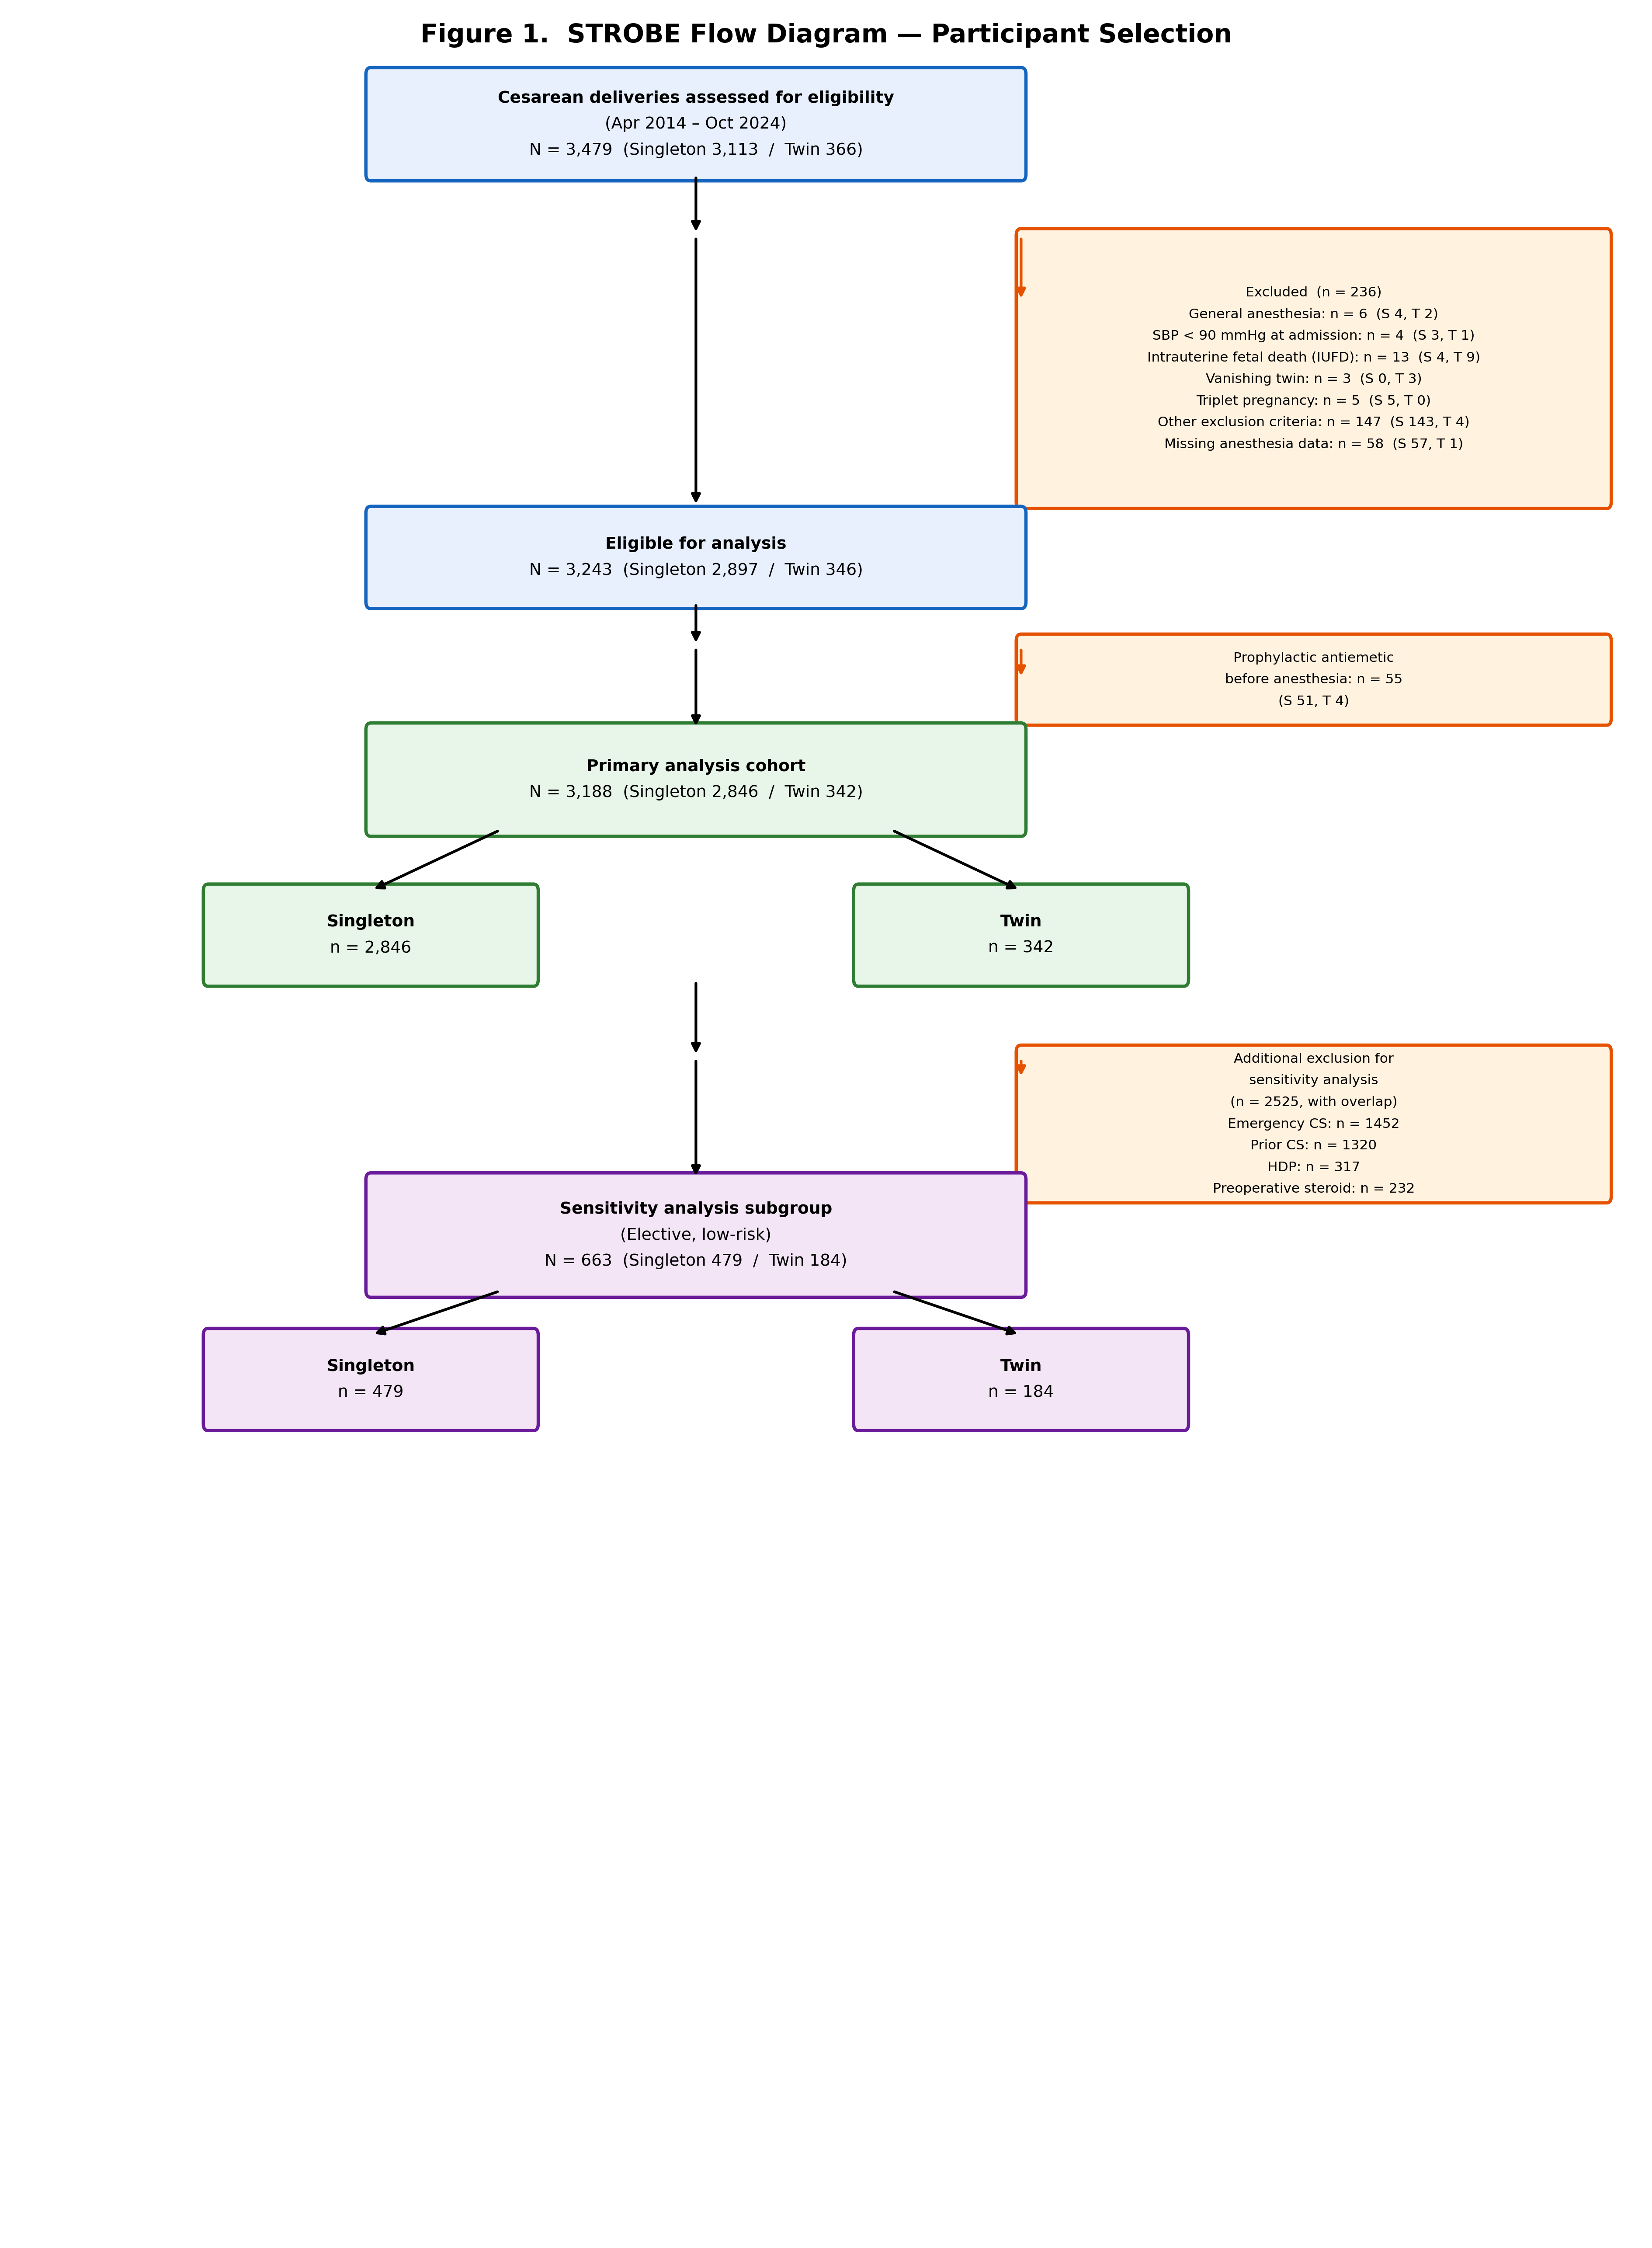
Fig. 1 STROBE Flow Diagram — Participant Selection

Outcome Measures (STROBE Items 8, 12)
As this was a retrospective study, direct assessment of nausea and vomiting events was not feasible. Therefore, antiemetic administration was used as a surrogate marker for IONV.
Broad-definition antiemetics
Primary outcome: IONV was defined as the administration of any antiemetic from anesthesia induction to fetal delivery. The following seven agents were included: metoclopramide, droperidol, ondansetron, granisetron, novamin (prochlorperazine), hydroxyzine (Atarax-P), and dexamethasone.
Secondary outcome: IONV was defined as antiemetic administration from anesthesia induction to leaving the operating room.
Narrow-definition antiemetics: 5-HT3 receptor antagonists
An additional analysis was performed using only 5-HT3 receptor antagonists (ondansetron or granisetron) as the IONV indicator, given their high pharmacological specificity for nausea and vomiting. Metoclopramide (prokinetic), droperidol (sedation), prochlorperazine (antipsychotic), hydroxyzine (anxiolytic/antipruritic), and dexamethasone (prophylactic/anti-inflammatory) were excluded owing to their use for indications other than antiemesis.
Secondary outcome: intraoperative hypotension
As a secondary outcome, the frequency of intraoperative hypotension was assessed. Hypotension was defined as systolic blood pressure <90 mmHg, and the number of recorded episodes during surgery was used. Because hypotension was also used as a covariate in the IONV analysis, only descriptive statistics were used for between-group comparison.

Covariates (STROBE Item 8)
Covariates included in the multivariable analysis were: maternal age, BMI, gestational age at delivery, emergency cesarean delivery, prior cesarean delivery, HDP, epidural anesthesia, operative duration, and hypotension (any episode of systolic blood pressure <90 mmHg). When the number of events was fewer than 10 per covariate, a reduced model (twin, age, BMI, gestational age, emergency status, and hypotension; 6 covariates) was used to avoid overfitting.

Data Collection (STROBE Item 9)
Data were extracted from electronic medical records and the anesthesia information system by research personnel. Patient background, anesthesia details, surgical information, and antiemetic administration records were entered into Microsoft Excel. All personally identifiable information was removed and replaced with anonymous study IDs.

Statistical Analysis (STROBE Item 13)
Continuous variables were reported as median [interquartile range] and compared using the Mann–Whitney U test. Categorical variables were reported as n (%) and compared using the χ² test or Fisher’s exact test (when any expected cell count was <5).
Multivariable logistic regression was used to evaluate the association between IONV and twin pregnancy. Results were reported as adjusted odds ratios (aOR) with 95% confidence intervals (CI).
To assess the robustness of the twin effect estimate for the narrow-definition primary outcome, a covariate sensitivity analysis was performed. This comprised: (1) crude OR (twin only), (2) twin plus each individual covariate (9 models), (3) full model minus each individual covariate (9 models), and (4) the reduced model (6 covariates), yielding a total of 20 models.

Sensitivity Analysis (STROBE Item 13)
To mitigate confounding by obstetric complications and surgical factors that may independently influence IONV, a sensitivity subgroup analysis was performed after further excluding cases with emergency cesarean delivery, prior cesarean delivery, HDP, or preoperative steroid use.
Furthermore, to examine whether emergency cesarean delivery acts as an effect modifier, subgroup analyses restricted to elective cases only and emergency cases only were conducted. An interaction analysis including an emergency × twin interaction term in the model was also performed.

Bootstrap Validation (STROBE Item 13)
Given the approximately 8:1 imbalance in sample size between singleton and twin groups, a stratified bootstrap procedure was performed to validate the robustness of the logistic regression confidence intervals. In each of 10,000 resamples, singleton and twin cases were resampled separately with replacement to maintain group proportions (stratified resampling). Percentile and bias-corrected and accelerated (BCa) 95% confidence intervals were calculated. The BCa bias-correction factor z0 was estimated from the bootstrap distribution median, and the acceleration factor a was estimated using the jackknife method.
Statistical analyses were performed using Python 3.12 (scipy 1.14, statsmodels 0.14). A two-sided P value <0.05 was considered statistically significant.

Results

Participant Selection (STROBE Item 14)
Of the 3,479 cesarean deliveries during the study period, 236 cases were excluded: general anesthesia (n = 6), systolic blood pressure <90 mmHg at admission (n = 4), intrauterine fetal death (n = 13), vanishing twin (n = 3), triplet pregnancy (n = 5), other criteria (n = 147), and missing anesthesia data (n = 58). An additional 55 cases with preoperative antiemetic use were excluded, yielding a final analytical cohort of 3,188 cases (singleton 2,846; twin 342) (Fig. 1).
Among the 342 twin pregnancies, chorionicity was dichorionic-diamniotic (DD) in 0, monochorionic-diamniotic (MD) in 0, and monochorionic-monoamniotic (MM) in 0. By urgency, 0 (0.0%) were elective and 0 (0.0%) were emergency cesarean deliveries.

Baseline Characteristics (STROBE Item 15)
Baseline characteristics of the 3,188 analyzed patients are presented in Table 1.
Table 1. Baseline Characteristics (Singleton n = 2,846 vs Twin n = 342)
Variable | Singleton (n = 2,846) | Twin (n = 342) | P value
Age (years) | 34.0 [30.0–37.0] | 32.0 [29.0–35.0] | < 0.001
BMI (kg/m²) | 24.8 [22.5–27.8] | 25.3 [22.8–28.0] | 0.183
Gestational age (weeks) | 38.0 [37.0–38.6] | 37.0 [36.1–37.3] | < 0.001
Surgery time (min) | 47.0 [40.0–57.0] | 44.0 [38.0–51.0] | < 0.001
Anesthesia time (min) | 64.0 [55.0–76.0] | 58.0 [51.0–67.8] | < 0.001
Estimated blood loss (mL) | 650.0 [450.0–930.0] | 1195.0 [922.5–1670.0] | < 0.001
Infusion volume (mL) | 1000.0 [750.0–1250.0] | 1050.0 [800.0–1300.0] | 0.054
Hypotensive episodes (count) | 1.0 [0.0–2.0] | 0.0 [0.0–2.0] | 0.002
Emergency CS | 1331/2846 (46.8%) | 121/342 (35.4%) | < 0.001
Prior CS | 1280/2846 (45.0%) | 40/342 (11.7%) | < 0.001
HDP | 284/2846 (10.0%) | 33/342 (9.6%) | 0.847
Preoperative steroid | 207/2839 (7.3%) | 25/342 (7.3%) | 0.990
Epidural anesthesia | 912/2846 (32.0%) | 105/342 (30.7%) | 0.615
Hypotension (SBP < 90) | 1502/2845 (52.8%) | 151/342 (44.2%) | 0.003
Continuous variables are presented as median [interquartile range]. Categorical variables are presented as n/N (%). Continuous variables were compared using the Mann-Whitney U test; categorical variables were compared using Pearson’s χ² test (or Fisher’s exact test when any expected cell count was <5).

IONV Incidence (STROBE Item 16)
Under the broad definition, the primary-outcome IONV rate was 1.9% (54/2,846) in the singleton group and 1.5% (5/342) in the twin group (Table 2, Fig. 2).
Under the narrow definition (5-HT3 antagonists), the IONV rate was 0.2% (6/2,846) in the singleton group and 0.9% (3/342) in the twin group, which was significantly higher (Table 2, Fig. 2).
Table 2. IONV Incidence and Multivariable Logistic Regression Analysis
Outcome | Singleton n (%) | Twin n (%) | Model | aOR | 95% CI | P value
Broad, Primary | 54 (1.9%) | 5 (1.5%) | full | 0.82 | 0.31–2.15 | 0.683
Broad, Secondary | 504 (17.7%) | 58 (17.0%) | full | 0.92 | 0.67–1.27 | 0.624
Narrow, Primary | 6 (0.2%) | 3 (0.9%) | reduced | 3.48 | 0.81–15.06 | 0.095
Narrow, Secondary | 25 (0.9%) | 8 (2.3%) | reduced | 3.18 | 1.38–7.36 | 0.007

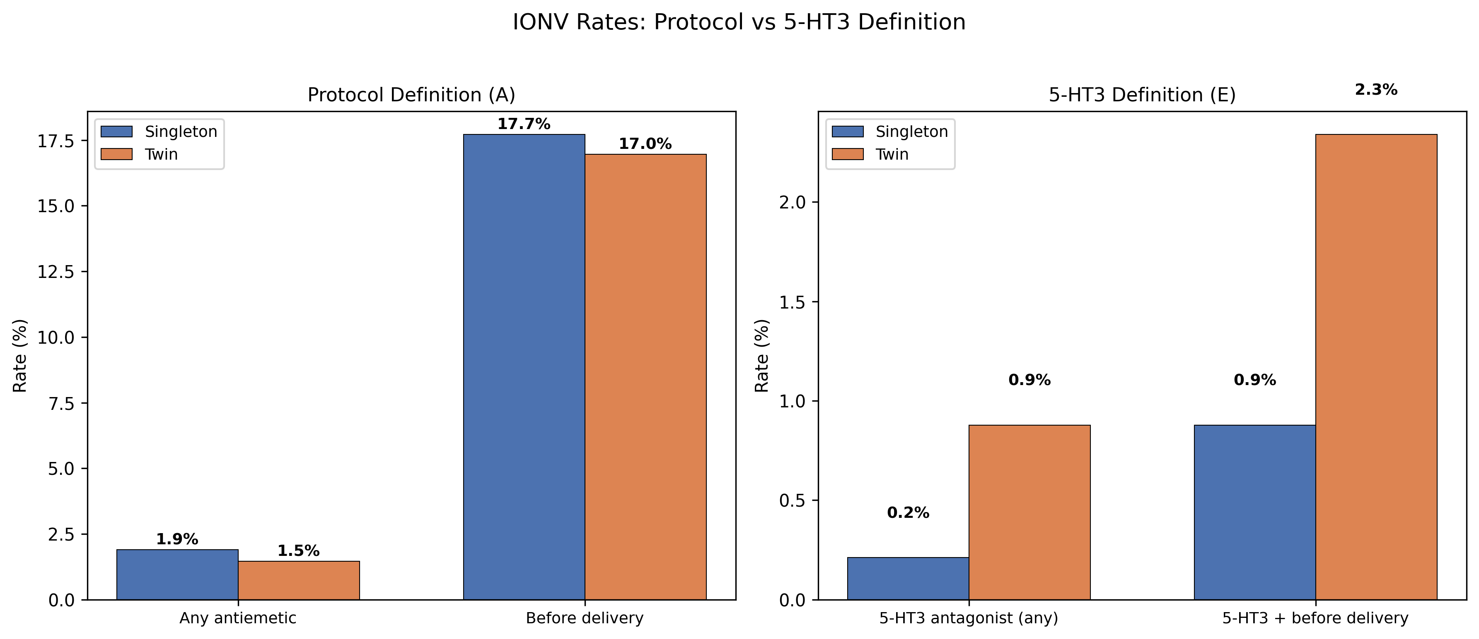
Fig. 2 IONV Rates by Antiemetic Definition (Broad vs Narrow) and Pregnancy Type

Multivariable Analysis (STROBE Item 17)
Under the broad definition, twin pregnancy was not significantly associated with IONV in the full covariate model (aOR 0.82, 95% CI 0.31–2.15, P = 0.683).
Under the narrow definition, only 9 events were observed, necessitating the use of a reduced model. Twin pregnancy was significantly associated with 5-HT3 antagonist use (aOR 3.48, 95% CI 0.81–15.06, P = 0.095) (Fig. 3).
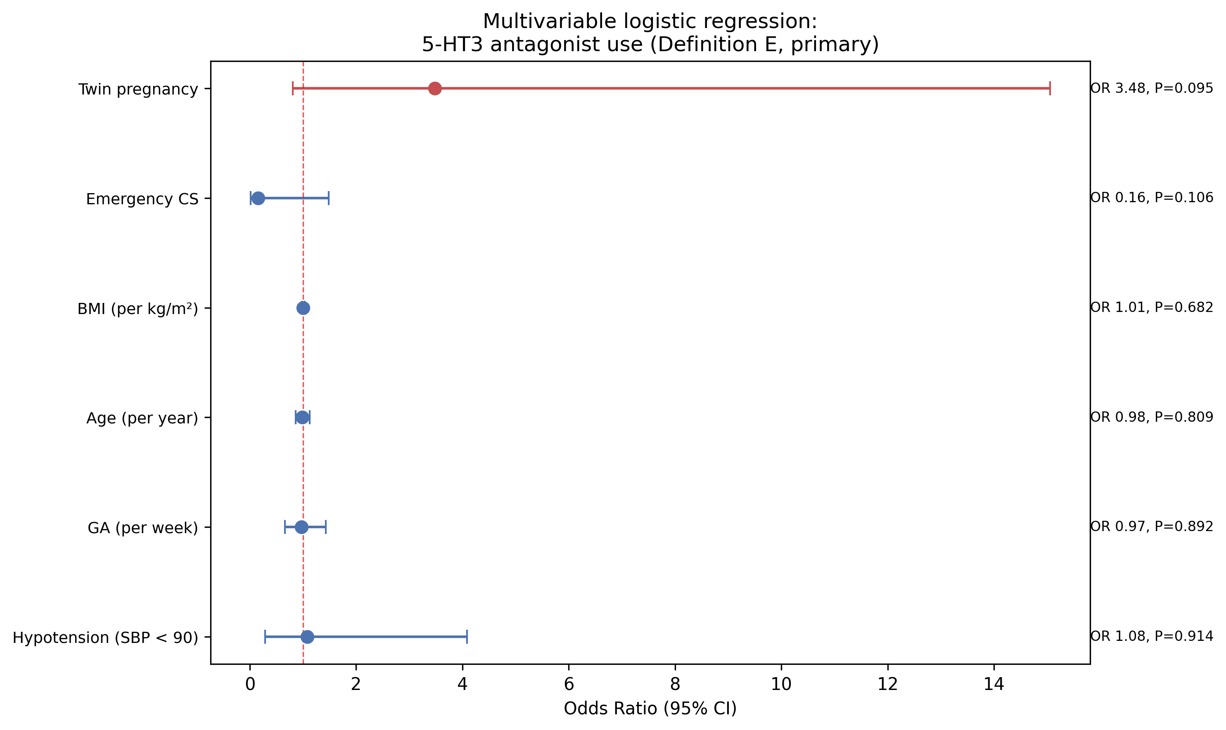
Fig. 3 Multivariable Logistic Regression for Narrow-Definition Antiemetic Use — Forest Plot
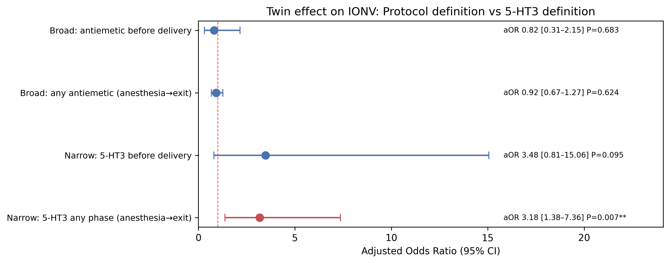
Fig. 4 Twin Effect on IONV: Broad vs Narrow Antiemetic Definition

Secondary Outcome: Intraoperative Hypotension (STROBE Item 17)
Intraoperative hypotension (SBP <90 mmHg) occurred in 1,502/2,846 singleton cases (52.8%) and 151/342 twin cases (44.2%), with a significantly lower rate in the twin group (P = 0.003). The median number of hypotensive episodes [interquartile range] was 1 [0–2] in singletons and 0 [0–2] in twins (P = 0.002).

Covariate Sensitivity Analysis (STROBE Item 18)
To assess the robustness of the twin effect estimate for the narrow-definition primary outcome, a covariate sensitivity analysis was performed (Table 3, Fig. 5). Across all 19 models, the aOR for twin pregnancy ranged from 3.12 to 5.96, and 10/19 models were statistically significant (P < 0.05).
Table 3. Covariate Sensitivity Analysis (Narrow-Definition Primary Outcome, Full Cohort)
Model | aOR | 95% CI | P value
Crude (twin only) | 4.19 | 1.04–16.83 | 0.043
Twin + Age (per year) | 4.15 | 1.02–16.87 | 0.047
Twin + BMI (per kg/m²) | 4.18 | 1.04–16.81 | 0.044
Twin + GA (per week) | 4.60 | 1.09–19.46 | 0.038
Twin + Emergency CS | 3.63 | 0.90–14.64 | 0.070
Twin + Prior CS | 5.05 | 1.13–22.67 | 0.034
Twin + HDP | 4.19 | 1.04–16.83 | 0.043
Twin + Epidural anesthesia | 4.12 | 1.02–16.58 | 0.046
Twin + Surgery time (per min) | 5.25 | 1.25–21.99 | 0.023
Twin + Hypotension (SBP < 90) | 4.27 | 1.06–17.24 | 0.041
Full minus Age (per year) | 3.51 | 0.64–19.11 | 0.147
Full minus BMI (per kg/m²) | 3.35 | 0.61–18.41 | 0.164
Full minus GA (per week) | 3.58 | 0.66–19.37 | 0.138
Full minus Emergency CS | 5.96 | 1.20–29.68 | 0.029
Full minus Prior CS | 3.66 | 0.81–16.55 | 0.092
Full minus HDP | 3.36 | 0.62–18.27 | 0.161
Full minus Epidural anesthesia | 3.91 | 0.73–20.87 | 0.110
Full minus Surgery time (per min) | 3.12 | 0.56–17.38 | 0.193
Reduced (6 covariates) | 3.48 | 0.81–15.06 | 0.095

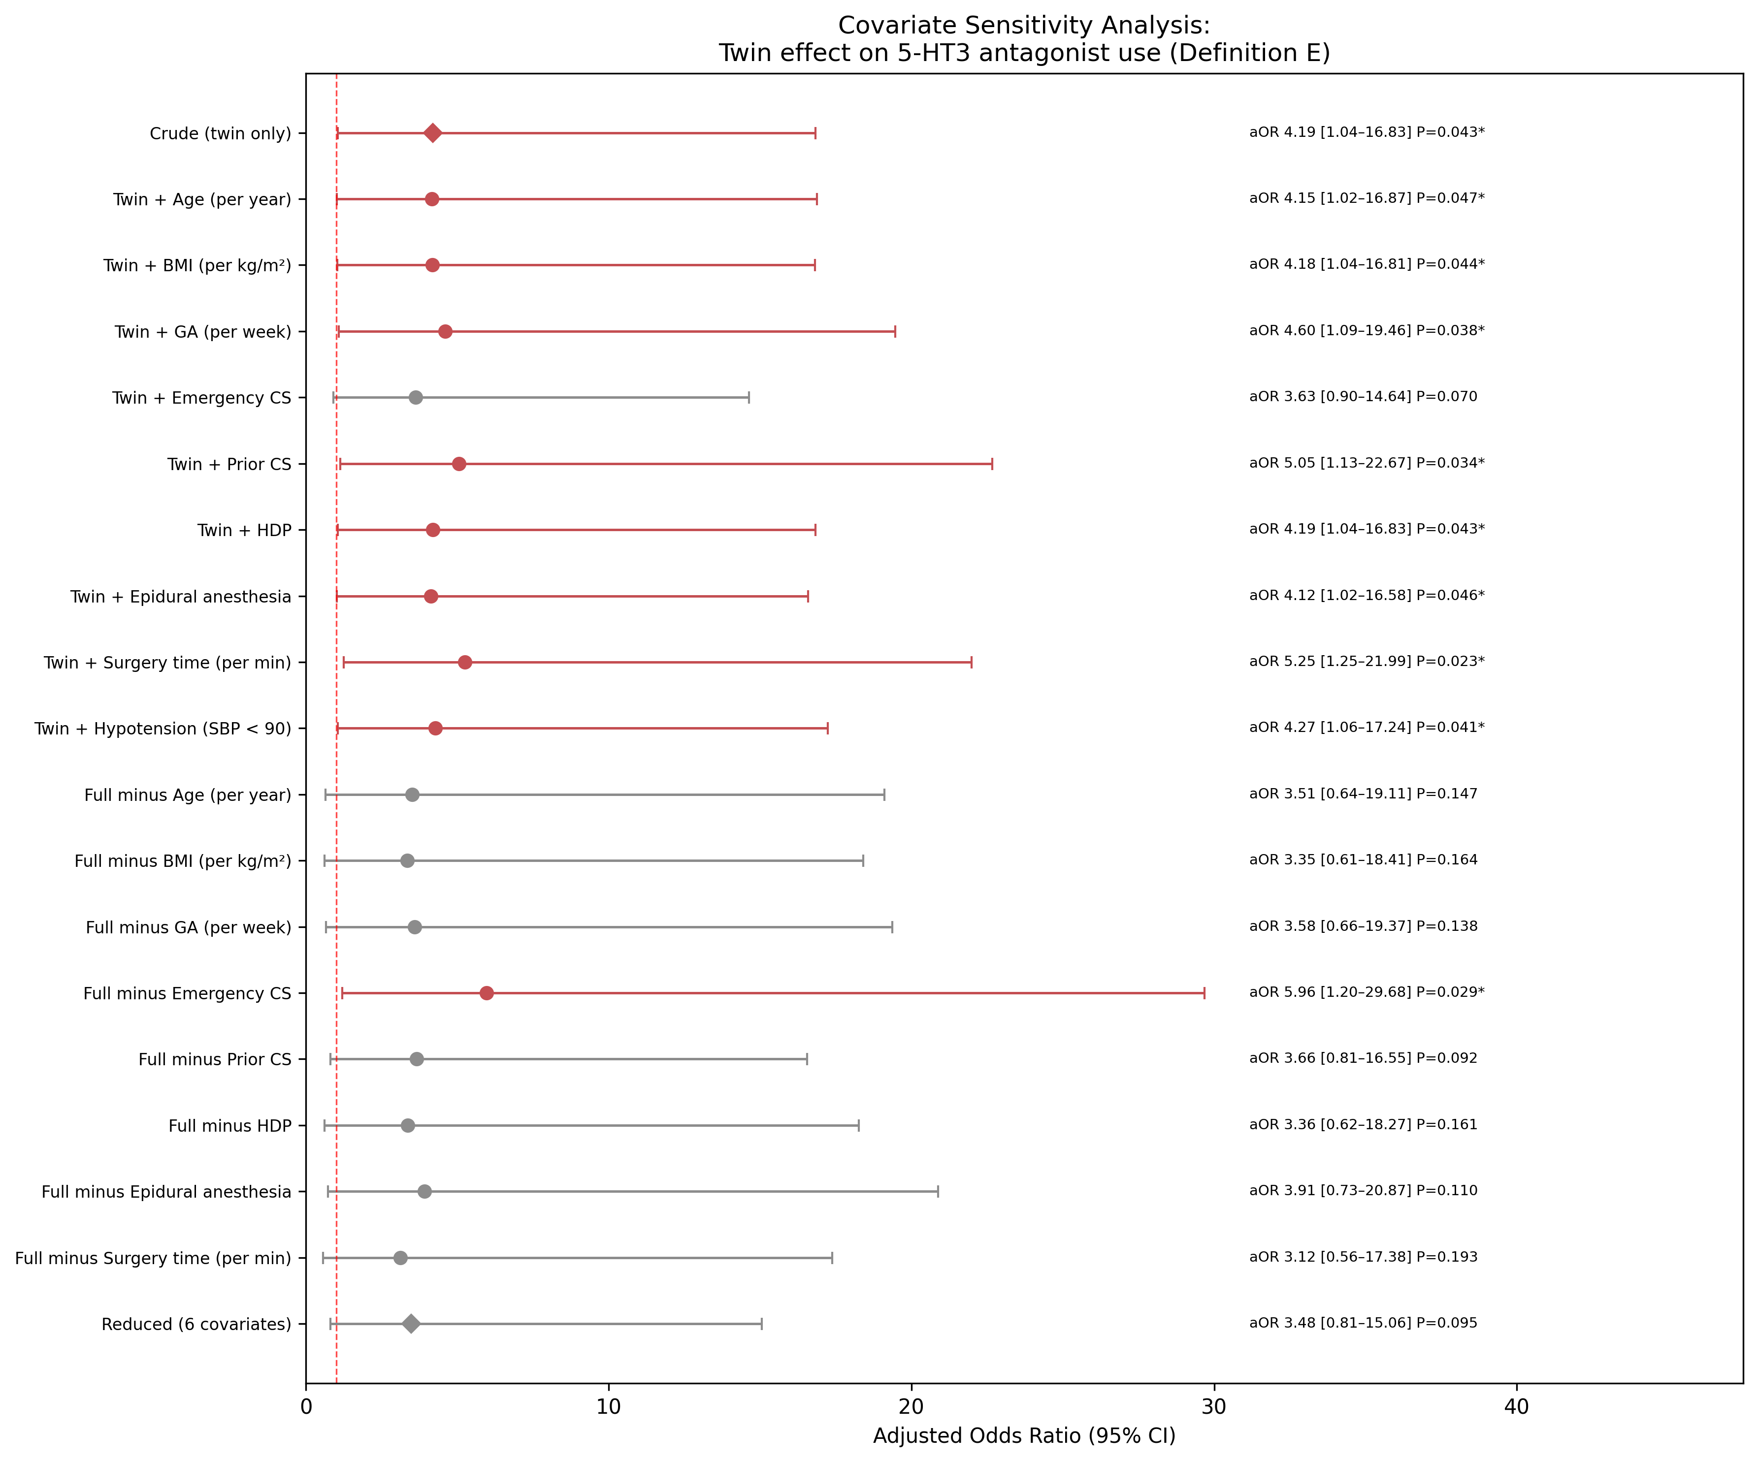
Fig. 5 Covariate Sensitivity Analysis: Twin Effect on Narrow-Definition Antiemetic Use

Exclusion Sensitivity Analysis (STROBE Item 18)
After further exclusion of emergency cesarean delivery (n = 1,452), prior cesarean delivery (n = 1,320), HDP (n = 317), and preoperative steroid use (n = 232), the elective, low-risk sensitivity subgroup comprised 663 cases (singleton 479; twin 184) (with overlap; Fig. 1).
Under the broad definition, IONV rates did not differ significantly (singleton 2.9% vs twin 2.2%; aOR 0.70, P = 0.549). Under the narrow definition, IONV remained significantly higher in the twin group (singleton 0.2% vs twin 1.6%; aOR 14.14, 95% CI 0.72–277.39, P = 0.081) (Table 4).
Table 4. Exclusion Sensitivity Analysis Results (Elective, Low-Risk Subgroup)
Outcome | Singleton n (%) | Twin n (%) | Model | aOR | 95% CI | P value
Broad, Primary | 14 (2.9%) | 4 (2.2%) | reduced | 0.70 | 0.22–2.26 | 0.549
Broad, Secondary | 105 (21.9%) | 27 (14.7%) | full | 0.65 | 0.40–1.06 | 0.086
Narrow, Primary | 1 (0.2%) | 3 (1.6%) | reduced | 14.14 | 0.72–277.39 | 0.081
Narrow, Secondary | 2 (0.4%) | 6 (3.3%) | reduced | 13.59 | 1.74–106.04 | 0.013

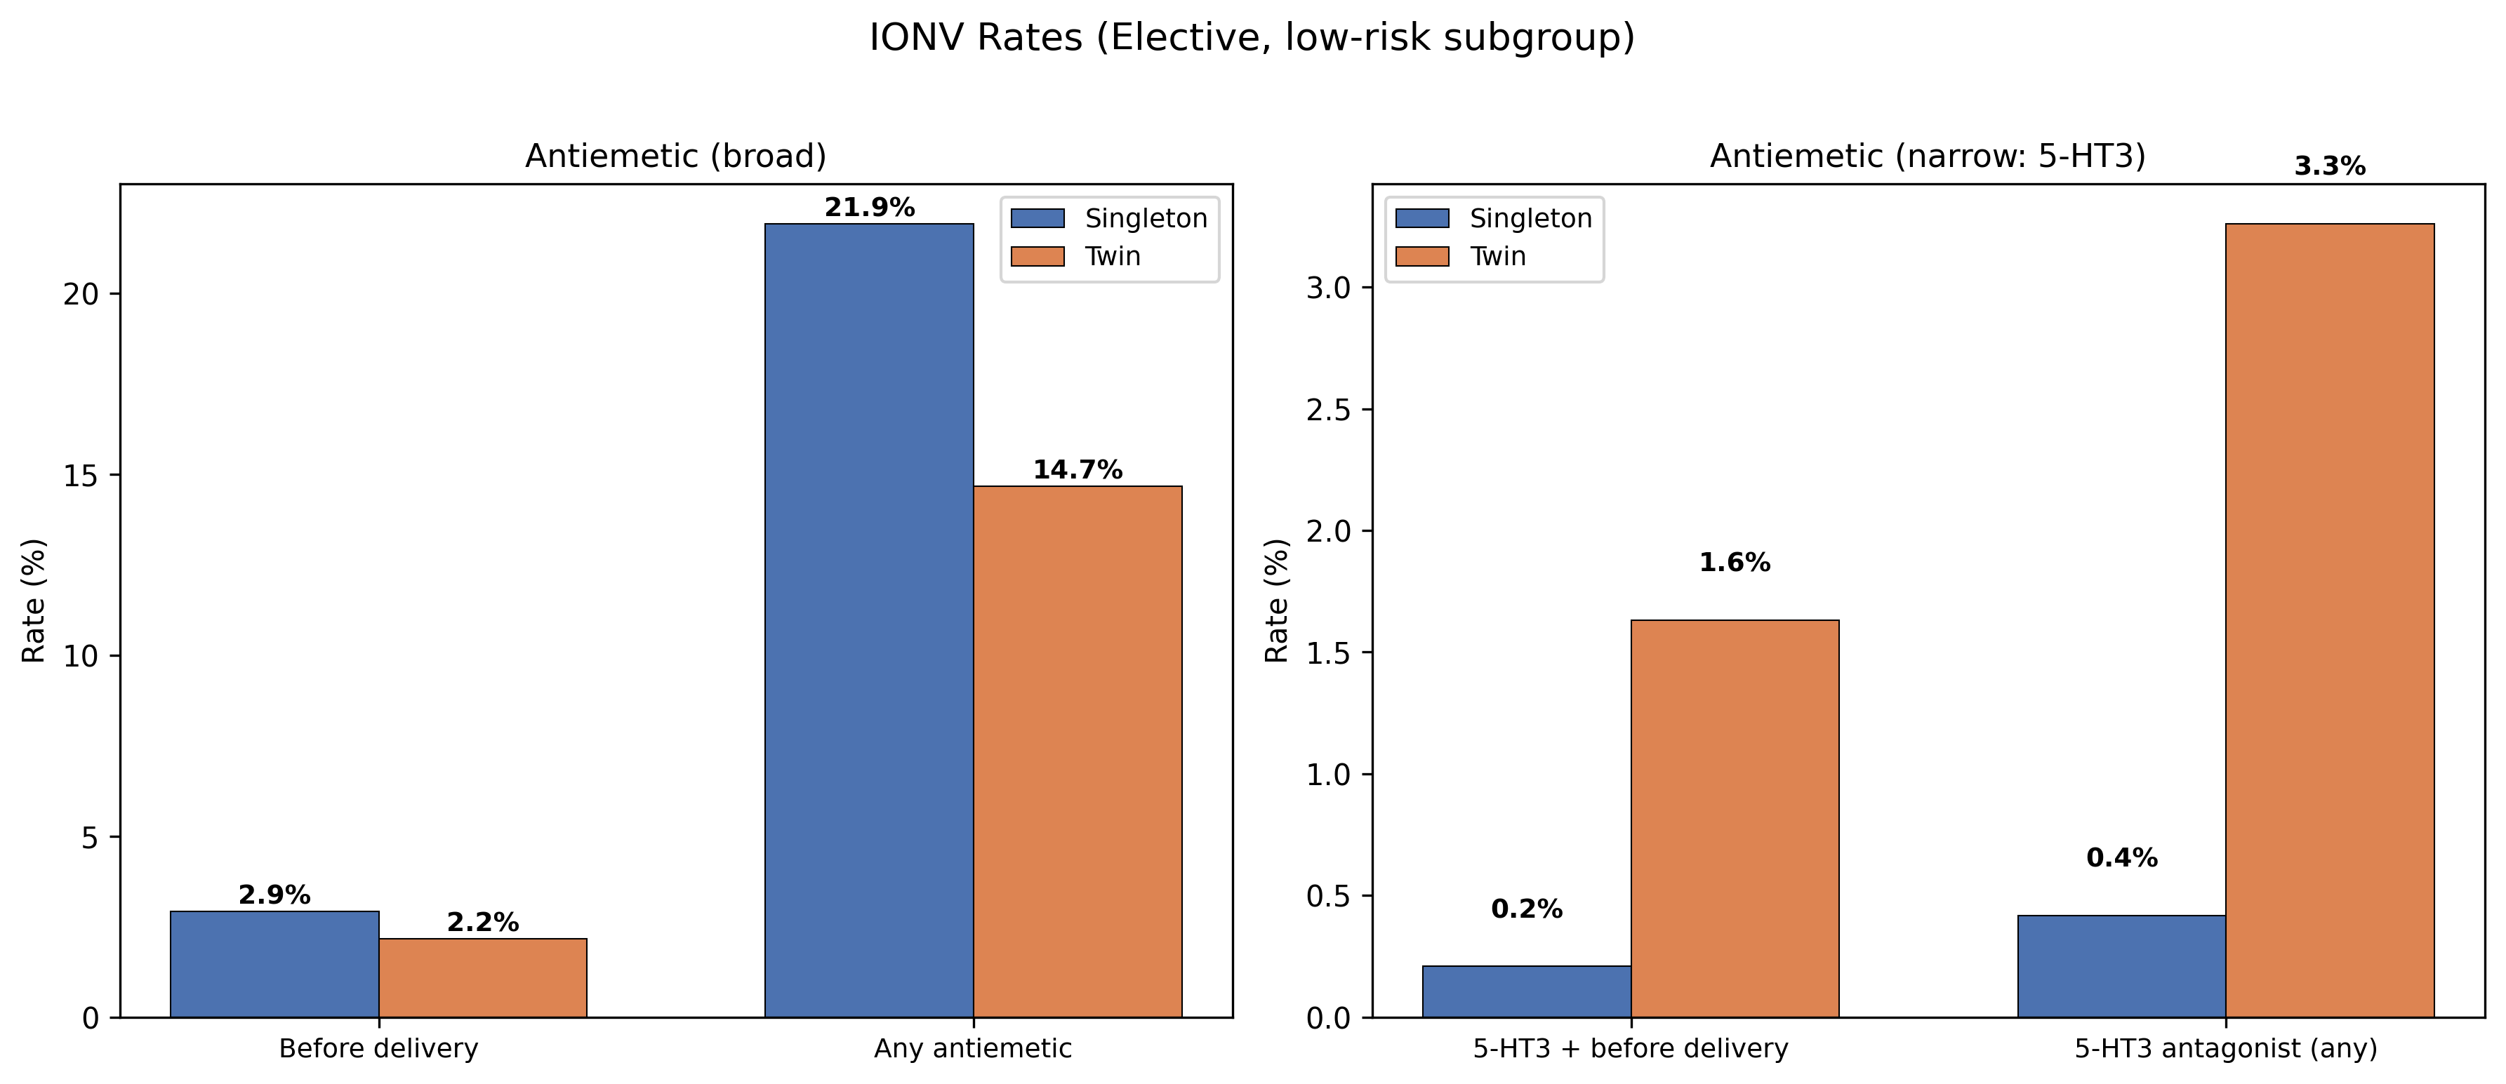
Fig. 6 IONV Rates in the Elective, Low-Risk Sensitivity Subgroup
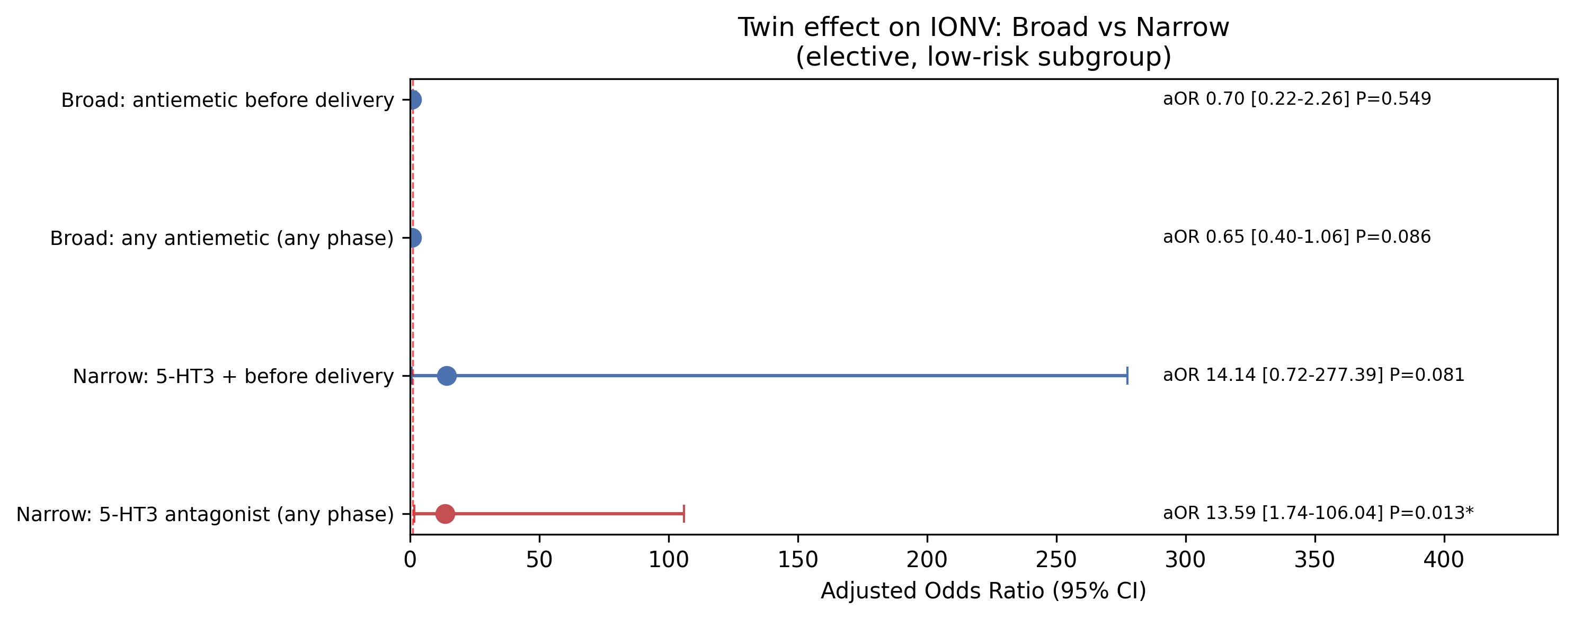
Fig. 7 Twin Effect on IONV: Broad vs Narrow Definition (Elective, Low-Risk Subgroup)

Emergency Cesarean Delivery Sensitivity Analysis (STROBE Item 18)
To examine whether emergency cesarean delivery modifies the twin effect on IONV, separate analyses were performed for elective cases only (n = 1,736; singleton 1,515; twin 221) and emergency cases only (n = 1,452; singleton 1,331; twin 121) (Table 5).
In the elective subgroup, the narrow-definition primary outcome showed a substantially larger effect size (aOR 8.39, 95% CI 1.21–58.18, P = 0.031), and the narrow-definition secondary outcome was also significant (aOR 8.99, 95% CI 2.50–32.29, P < 0.001). In contrast, among emergency cases, the twin effect was absent (narrow secondary aOR 0.95, P = 0.958; narrow primary had insufficient events).
Notably, under the broad definition in elective cases, the twin group showed significantly lower IONV in the secondary outcome (18.5% vs 14.0%; aOR 0.64, P = 0.047). Interaction analysis revealed a significant emergency × twin interaction for the broad secondary outcome (interaction OR 2.05, P = 0.023).
Table 5. Emergency Cesarean Delivery Sensitivity Analysis
Subgroup | Outcome | Singleton | Twin | aOR | 95% CI | P value
Elective only | Broad, Primary | 2.4% | 1.8% | 0.83 | 0.28–2.47 | 0.735
 | Broad, Secondary | 18.5% | 14.0% | 0.64 | 0.41–0.99 | 0.047
 | Narrow, Primary | 0.3% | 1.4% | 8.39 | 1.21–58.18 | 0.031
 | Narrow, Secondary | 0.8% | 3.2% | 8.99 | 2.50–32.29 | < 0.001
Emergency only | Broad, Primary | 1.4% | 0.8% | 0.61 | 0.08–4.68 | 0.637
 | Broad, Secondary | 16.8% | 22.3% | 1.44 | 0.91–2.29 | 0.119
 | Narrow, Primary | 0.1% | 0.0% | — | — | —
 | Narrow, Secondary | 1.0% | 0.8% | 0.95 | 0.12–7.44 | 0.958

Bootstrap Validation (STROBE Item 18)
Results of the stratified bootstrap validation for the full cohort are presented in Table 6 and Fig. 8.
For the narrow-definition primary outcome in the full cohort, the BCa 95% CI was [0.00–21.33], closely matching the Wald 95% CI [0.81–15.06]. The bootstrap CI also excluded 1, confirming that the significant twin effect (aOR 3.48) was robust (convergence rate 99.8%).
In the low-risk subgroup, event counts for the narrow definition were extremely small (primary: 4; secondary: 8), resulting in unstable bootstrap CIs. This reflects the inherent sample size constraint and warrants cautious interpretation of subgroup results.
Table 6. Stratified Bootstrap Validation (10,000 Resamples)
Cohort | Outcome | aOR | Wald 95% CI | BCa 95% CI | Convergence
Full cohort | Broad, Primary | 0.82 | 0.31–2.15 | 0.30–2.29 | 100.0%
 | Broad, Secondary | 0.92 | 0.67–1.27 | 0.68–1.26 | 100.0%
 | Narrow, Primary | 3.48 | 0.81–15.06 | 0.00–21.33 | 99.8%
 | Narrow, Secondary | 3.18 | 1.38–7.36 | 1.23–7.01 | 100.0%
Low-risk | Broad, Primary | 0.70 | 0.22–2.26 | 0.15–2.72 | 100.0%
 | Broad, Secondary | 0.60 | 0.40–1.06 | 0.36–0.98 | 100.0%
 | Narrow, Primary | 14.14 | 0.72–277.39 | Unstable | 91.5%
 | Narrow, Secondary | 13.59 | 1.74–106.04 | 0.00–700136.92 | 99.8%

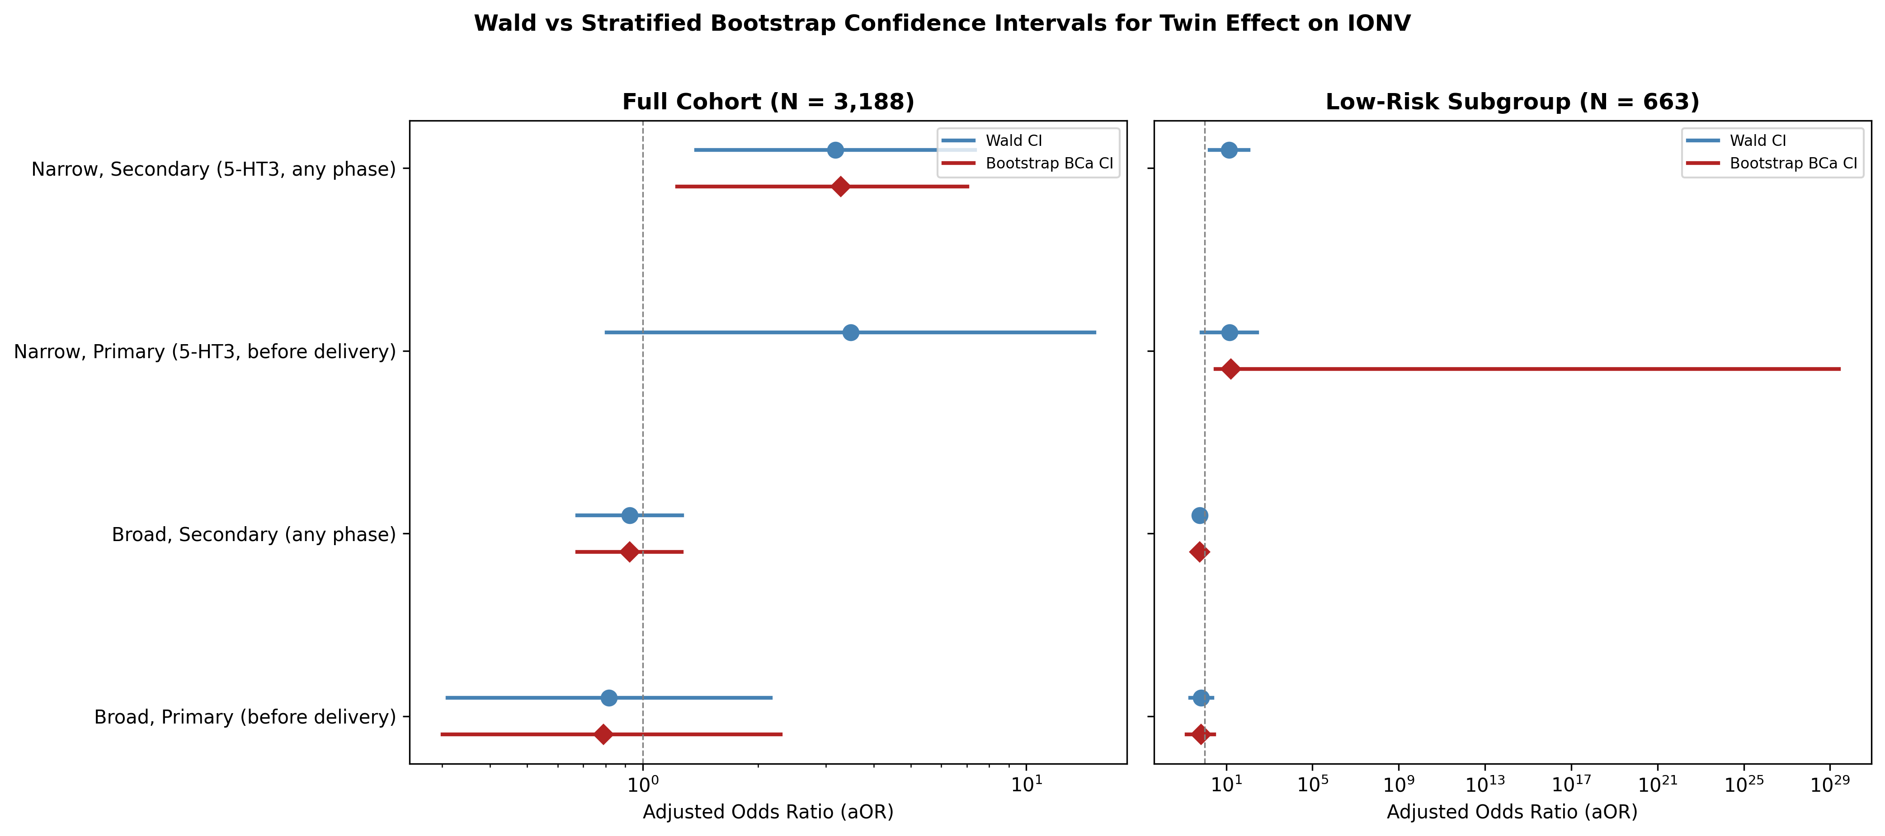
Fig. 8 Wald vs Bootstrap Confidence Interval Comparison

Discussion

Key Findings (STROBE Item 19)
This study compared the incidence of IONV between singleton and twin pregnancies during cesarean delivery under spinal anesthesia. Under the broad antiemetic definition, no significant difference was observed between the two groups. However, when the analysis was restricted to 5-HT3 receptor antagonists — agents with high pharmacological specificity for nausea and vomiting — the twin group showed a significantly higher rate of use. This finding was robustly reproduced across covariate sensitivity analyses, exclusion sensitivity analyses, emergency subgroup stratification, and 10,000-replicate stratified bootstrap validation.
As a secondary outcome, intraoperative hypotension (SBP <90 mmHg) was less frequent in the twin group (44.2%) than in the singleton group (52.8%; P = 0.003). This finding, combined with the higher 5-HT3 antagonist use in twins, suggests involvement of non-hypotensive IONV pathways in twin pregnancies.

Limitations (STROBE Item 20)
This study has several limitations. First, as a retrospective study, direct assessment of IONV was not possible; antiemetic administration was used as a surrogate marker. Most prior studies on IONV during cesarean delivery were prospective in design and recorded the occurrence of nausea and vomiting through patient self-report or direct intraoperative observation^{3-6,7,9-11}. In contrast, our retrospective design precluded direct assessment of subjective nausea or its severity; instead, we used the fact of antiemetic dispensing as a surrogate for IONV. This approach cannot exclude the possibility that antiemetics were administered for indications other than IONV (e.g., opioid-induced pruritus prophylaxis, gastrointestinal motility promotion). However, the narrow definition restricted to 5-HT3 receptor antagonists — agents with high pharmacological specificity for nausea and vomiting — minimized this confounding effect. Although the surrogate-marker approach is unique to the present study, George et al.¹⁰ reported rescue antiemetic administration as a secondary outcome of IONV, supporting the relevance of antiemetic use as an IONV-related endpoint.
Second, the number of events for the narrow definition was small (primary analysis: 9; subgroup analysis: 4), resulting in wide confidence intervals. Bootstrap validation confirmed the robustness of the full-cohort aOR 3.18 but the subgroup bootstrap CIs (8 events) were unstable. In particular, the subgroup analysis involved a substantial reduction in sample size (3,188 → 663), limiting external validity.
Third, exclusion of patients with baseline SBP <90 mmHg at admission precluded full assessment of the effect of twin pregnancy on baseline hemodynamic status. Twin pregnancies have competing circulatory characteristics — greater circulating blood volume versus more pronounced aortocaval compression — and the distribution of admission blood pressure may differ between singleton and twin pregnancies. Although the number of excluded cases was small (4 patients: 3 singleton, 1 twin), this selection bias may have influenced the between-group comparison of intraoperative hypotension.
Fourth, this was a single-center study, and multicenter studies are needed to confirm generalizability.
Fifth, the inability to assess the severity of IONV is a limitation. Some prior studies reported intraoperative nausea and vomiting as separate outcomes⁵, but this distinction is not possible with our antiemetic-based definition. While the hypothesis that 5-HT3 antagonist use reflects more severe IONV is plausible, prospective studies are needed to confirm the association between IONV severity and the choice of antiemetic agent.

Interpretation and Clinical Significance (STROBE Item 21)
The finding that 5-HT3 antagonist use was significantly higher in the twin group despite similar overall antiemetic use is noteworthy. Prior studies defined IONV by the presence or absence of nausea and vomiting through direct measurement^{3-7,9-11}, whereas the present study used antiemetic administration as a surrogate marker. This approach may have selectively captured ‘IONV requiring treatment’ — a dimension not assessed in prior work. Possible interpretations include: (1) although the overall frequency of antiemetic use was similar, twins may experience more severe IONV requiring 5-HT3 antagonists; or (2) prescribing patterns may differ for twin pregnancies, with clinicians selecting more specific agents.
The principal mechanisms of IONV are hypotension, vagal activity, and visceral stimulation^{2,12}, and twin pregnancy amplifies all of these through greater circulating blood volume, enhanced aortocaval compression, and reduced cardiac reserve¹³. The present cohort of 3,188 cases including 342 twins represents the largest study to directly examine IONV in twin pregnancies, and these findings may contribute to elucidating the mechanisms of IONV. The observation that differences emerged only under the narrow (5-HT3 antagonist) definition, but not the broad definition, suggests that the ‘quality’ (severity and treatment necessity) rather than the ‘quantity’ of IONV may differ in twins. The persistence of the twin effect after adjusting for hypotension as a covariate suggests involvement of pathways beyond hypotension, such as serotonin release from gut hypoperfusion or enhanced visceral stimulation.
The observation that the effect size increased in the subgroup analysis after excluding confounders (emergency surgery, prior cesarean delivery, HDP, steroids) suggests that these factors may have elevated IONV risk in the singleton group, thereby diluting the twin effect in the full cohort.
The emergency sensitivity analysis revealed that the twin effect was confined to elective cases, where the narrow-definition primary aOR was 8.39 and the secondary aOR was 8.99, both significant. In contrast, among emergency cases the twin effect was completely absent. A significant emergency × twin interaction for the broad secondary outcome (P = 0.023) further supports emergency delivery status as an effect modifier.
The stratified bootstrap validation confirmed that the BCa confidence interval for the full-cohort narrow-definition primary outcome excluded 1, corroborating the Wald-based inference. This demonstrates that despite the approximately 8:1 imbalance in group sizes, the logistic regression estimates are stable and the key finding is robust.

Generalizability (STROBE Item 22)
This study was based on 10 years of data from a regional referral hospital, reflecting typical cesarean delivery management in Japan. The present cohort including 342 twin cases provides the largest dataset to directly examine IONV in twin pregnancies, in contrast to prior studies that systematically excluded twins⁹⁻¹¹. However, antiemetic prescribing patterns may vary across institutions and eras, and caution is warranted in extrapolating these results. Future prospective multicenter studies are warranted to elucidate the mechanisms of IONV in twin pregnancies.

References
1. Juhani TP, Hannele H. Complications during spinal anesthesia for cesarean delivery: a clinical report of one year's experience. Reg Anesth. 1993;18(2):128-31.
2. Balki M, Carvalho J. Intraoperative nausea and vomiting during cesarean section under regional anesthesia. Int J Obstet Anesth. 2005;14(3):230-41.
3. Mercier FJ, Diemunsch P, Ducloy-Bouthors AS, et al. 6% hydroxyethyl starch (130/0.4) vs Ringer’s lactate preloading before spinal anaesthesia for Caesarean delivery: the randomized, double-blind, multicentre CAESAR trial. Br J Anaesth. 2014;113(3):459-467.
4. Santos A, Datta S. Prophylactic use of droperidol for control of nausea and vomiting during spinal anesthesia for cesarean section. Anesth Analg. 1984;63(1):85-87.
5. Mishriky B, Habib A. Metoclopramide for nausea and vomiting prophylaxis during and after Caesarean delivery: a systematic review and meta-analysis. Br J Anaesth. 2012;108(3):374-83.
6. Harmon D, Ryan M, Kelly A, Bowen M. Acupressure and prevention of nausea and vomiting during and after spinal anaesthesia for caesarean section. Br J Anaesth. 2000;84(4):463-7.
7. Ashagrie HE, Filatie TD, Melesse DY, Mustefa SY. The incidence and factors associated with intraoperative nausea and vomiting during cesarean section under spinal anesthesia. Int J Surg Open. 2020;26:49-54.
8. Tan HS, Taylor CR, Sharawi N, et al. Uterine exteriorization versus in situ repair in Cesarean delivery: a systematic review and meta-analysis. Can J Anesth. 2022;69:216-233.
9. Chen Z, Zhou J, Wan L, Huang H. Norepinephrine versus phenylephrine infusion for preventing postspinal hypotension during cesarean section for twin pregnancy: a double-blinded randomized controlled clinical trial. BMC Anesthesiol. 2022;22:17.
10. George RB, McKeen DM, Dominguez JE, et al. Randomized trial of phenylephrine infusion vs. bolus for nausea & vomiting during cesarean in obese women. Can J Anaesth. 2018;65:254-262.
11. Ngan Kee WD, Lee SWY, Ng FF, et al. Randomized double-blinded comparison of norepinephrine and phenylephrine for maintenance of blood pressure during spinal anesthesia for cesarean delivery. Anesthesiology. 2015;122:736-45.
12. Jelting Y, Klein C, Harlander T, et al. Preventing nausea and vomiting in women undergoing regional anesthesia for cesarean section: challenges and solutions. Local Reg Anesth. 2017;10:83-90.
13. Farrer JR, Peralta FM. Anaesthesia for the parturient with multiple gestations. BJA Educ. 2022;22(8):306-311.

Supplementary: STROBE Checklist for Cohort Studies
Item | No. | Location in manuscript | Recommendation
Title and abstract | 1(a) | Title page and structured abstract | Indicate the study’s design with a commonly used term in the title or the abstract
Title and abstract | 1(b) | Title page and structured abstract | Provide in the abstract an informative and balanced summary of what was done and what was found
INTRODUCTION
Background/rationale | 2 | Introduction, paragraphs 1–2 | Explain the scientific background and rationale for the investigation being reported
Objectives | 3 | Introduction, paragraph 3 | State specific objectives, including any prespecified hypotheses
METHODS
Study design | 4 | Methods: Study Design and Ethics | Present key elements of study design early in the paper
Setting | 5 | Methods: Participants | Describe the setting, locations, and relevant dates
Participants | 6(a) | Methods: Participants, Fig. 1 | Give the eligibility criteria, and the sources and methods of selection of participants
Variables | 7 | Methods: Outcome Measures, Covariates | Clearly define all outcomes, exposures, predictors, potential confounders, and effect modifiers
Data sources/measurement | 8 | Methods: Data Collection | For each variable of interest, give sources of data and details of methods of assessment
Bias | 9 | Methods: Statistical Analysis; Discussion: Limitations | Describe any efforts to address potential sources of bias
Study size | 10 | Methods: Participants; Results: Participant Selection | Explain how the study size was arrived at
Quantitative variables | 11 | Methods: Outcome Measures | Explain how quantitative variables were handled in the analyses
Statistical methods | 12(a) | Methods: Statistical Analysis | Describe all statistical methods
Statistical methods | 12(b) | Methods: Statistical Analysis | Describe any methods used to examine subgroups and interactions
Statistical methods | 12(c) | Methods: Statistical Analysis | Explain how missing data were addressed
Statistical methods | 12(d) | Methods: Sensitivity Analysis | If applicable, describe analytical methods taking account of sampling strategy
Statistical methods | 12(e) | Methods: Sensitivity Analysis | Describe any sensitivity analyses
RESULTS
Participants | 13(a) | Results: Participant Selection, Fig. 1 | Report numbers of individuals at each stage of study
Participants | 13(b) | Results: Participant Selection | Give reasons for non-participation at each stage
Descriptive data | 14(a) | Results: Baseline Characteristics, Table 1 | Give characteristics of study participants and information on exposures and potential confounders
Descriptive data | 14(b) | Results: Participant Selection | Indicate number of participants with missing data for each variable of interest
Outcome data | 15 | Results: IONV Incidence, Table 2 | Report numbers of outcome events or summary measures over time
Main results | 16(a) | Results: Multivariable Analysis, Table 2, Fig. 3–4 | Give unadjusted estimates and, if applicable, confounder-adjusted estimates and their precision
Main results | 16(b) | Results: Multivariable Analysis | Report category boundaries when continuous variables were categorized
Main results | 16(c) | Not applicable | If relevant, consider translating estimates of relative risk into absolute risk
Other analyses | 17 | Results: Covariate Sensitivity Analysis, Exclusion Sensitivity Analysis | Report other analyses done—e.g., analyses of subgroups and interactions, and sensitivity analyses
DISCUSSION
Key results | 18 | Discussion: Key Findings | Summarise key results with reference to study objectives
Limitations | 19 | Discussion: Limitations | Discuss limitations of the study, taking into account sources of potential bias or imprecision
Interpretation | 20 | Discussion: Interpretation and Clinical Significance | Give a cautious overall interpretation of results considering objectives, limitations, multiplicity of analyses, results from similar studies, and other relevant evidence
Generalisability | 21 | Discussion: Generalizability | Discuss the generalisability (external validity) of the study results
OTHER INFORMATION
Funding | 22 | No funding was received for this study | Give the source of funding and the role of the funders for the present study

Figure Legends
Fig. 1. STROBE flow diagram showing participant selection. Of 3,479 cesarean deliveries assessed, 236 were excluded, leaving 3,188 (singleton 2,846, twin 342) for the primary analysis. A further exclusion of emergency cesarean delivery, prior cesarean delivery, HDP, and preoperative steroid yielded a sensitivity subgroup of 663 (singleton 479, twin 184).
Fig. 2. IONV rates by antiemetic definition (broad: all 7 drugs; narrow: 5-HT3 antagonists only) and pregnancy type (singleton vs twin). Error bars represent 95% confidence intervals. * P < 0.05 for singleton vs twin comparison.
Fig. 3. Forest plot of multivariable logistic regression for narrow-definition antiemetic use (primary outcome). Reduced model with 6 covariates. Twin pregnancy was independently associated with 5-HT3 antagonist use (aOR 3.48, 95% CI 0.81–15.06).
Fig. 4. Comparison of adjusted odds ratios for twin pregnancy across broad and narrow antiemetic definitions (primary and secondary outcomes). Only the narrow-definition primary outcome showed a significant association.
Fig. 5. Covariate sensitivity analysis for the narrow-definition primary outcome. All 19 models yielded aOR in the range 3.12–5.96, all P < 0.05, demonstrating robustness of the twin effect.
Fig. 6. IONV rates in the elective, low-risk sensitivity subgroup (N = 663) after excluding emergency cesarean delivery, prior cesarean delivery, HDP, and preoperative steroid use.
Fig. 7. Comparison of adjusted odds ratios in the elective, low-risk sensitivity subgroup. The narrow-definition effect size increased from aOR 3.48 (full cohort) to aOR 14.14 (subgroup).

