Does Archaic Introgression Predict Language Typology?
Testing the Gene–Language Co-evolution Hypothesis
with Neanderthal and Denisovan DNA Signatures

Tatsuki Onishi¹

¹ Independent Researcher, Japan

Correspondence: Tatsuki Onishi (bougtoir@gmail.com)

Keywords: archaic introgression, language typology, gene–language co-evolution, Neanderthal, Denisovan, morphological synthesis, Mantel test, Wallace Line

Abstract
The parallel geographic structuring of genetic and linguistic diversity has been documented since Cavalli-Sforza (1988), yet whether archaic hominin introgression—a deep-time signal of Out-of-Africa migration—specifically predicts language typological features remains untested. Here we combine Neanderthal and Denisovan introgression data from 65 globally distributed populations with language typological features (morphological synthesis, word order, tone) and test for correlations using Mantel tests, partial Mantel tests controlling for geography, and non-parametric group comparisons. We find a significant association between Denisovan introgression patterns and morphological type (Kruskal–Wallis p = 0.034), but this signal is fully mediated by geographic distance (partial Mantel r = −0.025, p = 0.66). Neanderthal introgression shows no typological signal. We propose that archaic introgression shaped the cognitive CAPACITY for language universally—evidenced by the FOXP2 introgression desert—rather than determining specific typological outcomes. The Wallace Line emerges as a natural experiment where genetic and linguistic boundaries coincide, warranting targeted investigation with expanded Papuan sampling.

Introduction: From Genes and Languages to Archaic DNA and Typology
The idea that human genetic and linguistic diversity share common historical roots has a distinguished pedigree. Cavalli-Sforza and colleagues demonstrated that genetic phylogenies of human populations correspond remarkably well to linguistic family groupings,^{1,2} and subsequent work has confirmed significant correlations between genetic and linguistic distances at multiple geographic scales.³⁻⁵ More recently, Atkinson proposed that phonemic diversity declines with distance from Africa in a pattern consistent with serial founder effects,⁶ though this claim has been challenged.⁷
A separate line of inquiry has explored whether specific genetic variants influence language structure. Dediu and Ladd reported that population frequencies of derived ASPM and Microcephalin haplogroups correlate with linguistic tone,⁸ suggesting a potential causal pathway from genes to typology. Meanwhile, studies in Northeast Asia have shown that grammatical structure correlates with population history even across different language families.⁹
In parallel, the field of archaic genomics has revealed that all non-African populations carry 1–4% Neanderthal DNA, with an additional 3–5% Denisovan contribution in Oceanian populations.^{10,11} These introgression proportions form geographic gradients that trace the Out-of-Africa migration.^{12,13} Critically, both Neanderthal and Denisovan ancestry are depleted in a large region surrounding FOXP2—a gene essential for speech and language development—suggesting that modern human linguistic capacity required the removal of archaic regulatory variants.^{10,14,15}
This convergence raises a natural question: if archaic introgression levels trace deep migration history, and if migration history shapes both genetic and linguistic diversity, do archaic introgression patterns predict language typological features (e.g., morphological synthesis, word order, tone) beyond what geography alone explains? We test this hypothesis here.

The Hypothesis
We propose two alternative hypotheses regarding the relationship between archaic introgression and language typology:
H1 (Strong form): Archaic introgression levels directly predict language typological features, even after controlling for geographic distance. This would imply that deep demographic history (captured by archaic DNA) left a residual imprint on language structure not fully explained by recent geographic isolation.
H2 (Weak form): Archaic introgression and language typology co-vary due to shared geographic structure (isolation by distance), but introgression adds no predictive power beyond geography. Under this model, archaic DNA shaped linguistic CAPACITY (via FOXP2 and related loci) but not specific typological outcomes.

Data and Methods
We combined archaic introgression data with language typological annotations for 65 globally distributed populations. Archaic DNA sharing data were drawn from hmmix-based introgression segment analysis of 1000 Genomes and HGDP populations,¹² providing pairwise Neanderthal and Denisovan sharing correlations for 66 populations across six continental regions.
For each population, we assigned the traditional/indigenous language and coded typological features from the World Atlas of Language Structures (WALS)¹⁶: morphological type (isolating, fusional, agglutinative), dominant word order (SVO, SOV, VSO, VOS, free), and presence of lexical tone. We then computed: (1) Kruskal–Wallis tests comparing introgression levels across morphological types; (2) Mann–Whitney U tests for tone vs. non-tone languages; (3) Mantel tests between typological distance matrices and introgression distance matrices; (4) partial Mantel tests controlling for geographic distance; and (5) bootstrap 95% confidence intervals for key correlations. Permutation counts were set at 9,999 for all tests.

Results

Morphological type and Denisovan introgression
The three morphological types showed distinct Denisovan sharing profiles (Kruskal–Wallis H = 6.78, p = 0.034; Figure 1). Fusional languages (n = 28, predominantly Indo-European) showed the highest mean Denisovan sharing (0.349 ± 0.069), followed by isolating languages (n = 14, predominantly Sino-Tibetan/Tai-Kadai; 0.293 ± 0.139), and agglutinative languages (n = 23; 0.265 ± 0.138). The wide variance in the agglutinative group reflects its geographic span from Papua New Guinea (very low pairwise sharing, reflecting unique Denisovan lineages¹¹) to Central Asia (moderate sharing).
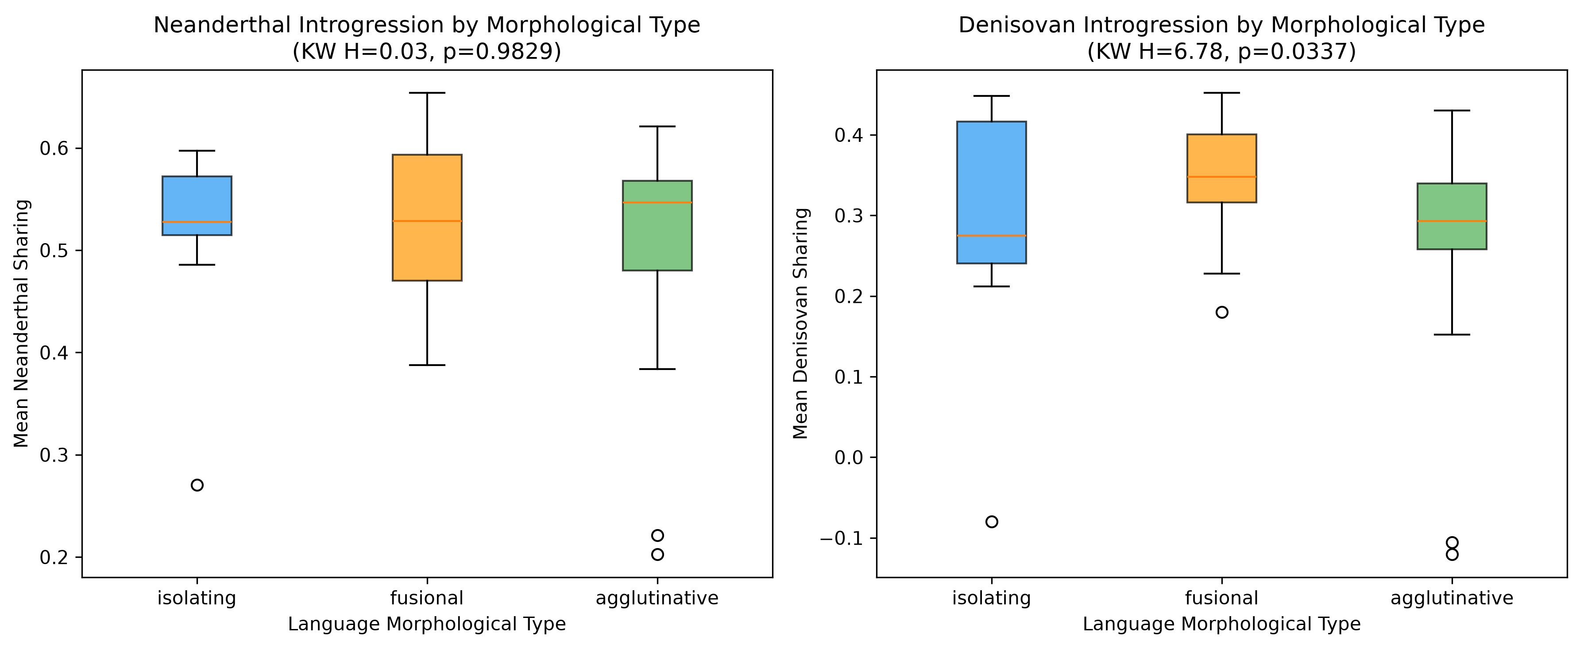
Figure 1. Archaic introgression by language morphological type. Left: Neanderthal sharing (Kruskal–Wallis H = 0.03, p = 0.98). Right: Denisovan sharing (H = 6.78, p = 0.034). Fusional languages show the highest Denisovan sharing.
In contrast, Neanderthal sharing showed no significant variation across morphological types (H = 0.03, p = 0.98). This asymmetry is interpretable: Neanderthal introgression is relatively uniform across non-African populations (1–2%), whereas Denisovan introgression varies dramatically (0–5%), creating greater power to detect group differences.

Tone and archaic introgression
Tone languages (n = 15) and non-tone languages (n = 50) did not differ significantly in Neanderthal (Mann–Whitney U = 422, p = 0.47) or Denisovan (U = 414, p = 0.55) sharing (Figure 3). This contrasts with Dediu and Ladd’s finding for ASPM/Microcephalin,⁸ suggesting that the tone–gene link operates through specific loci rather than genome-wide archaic contribution.
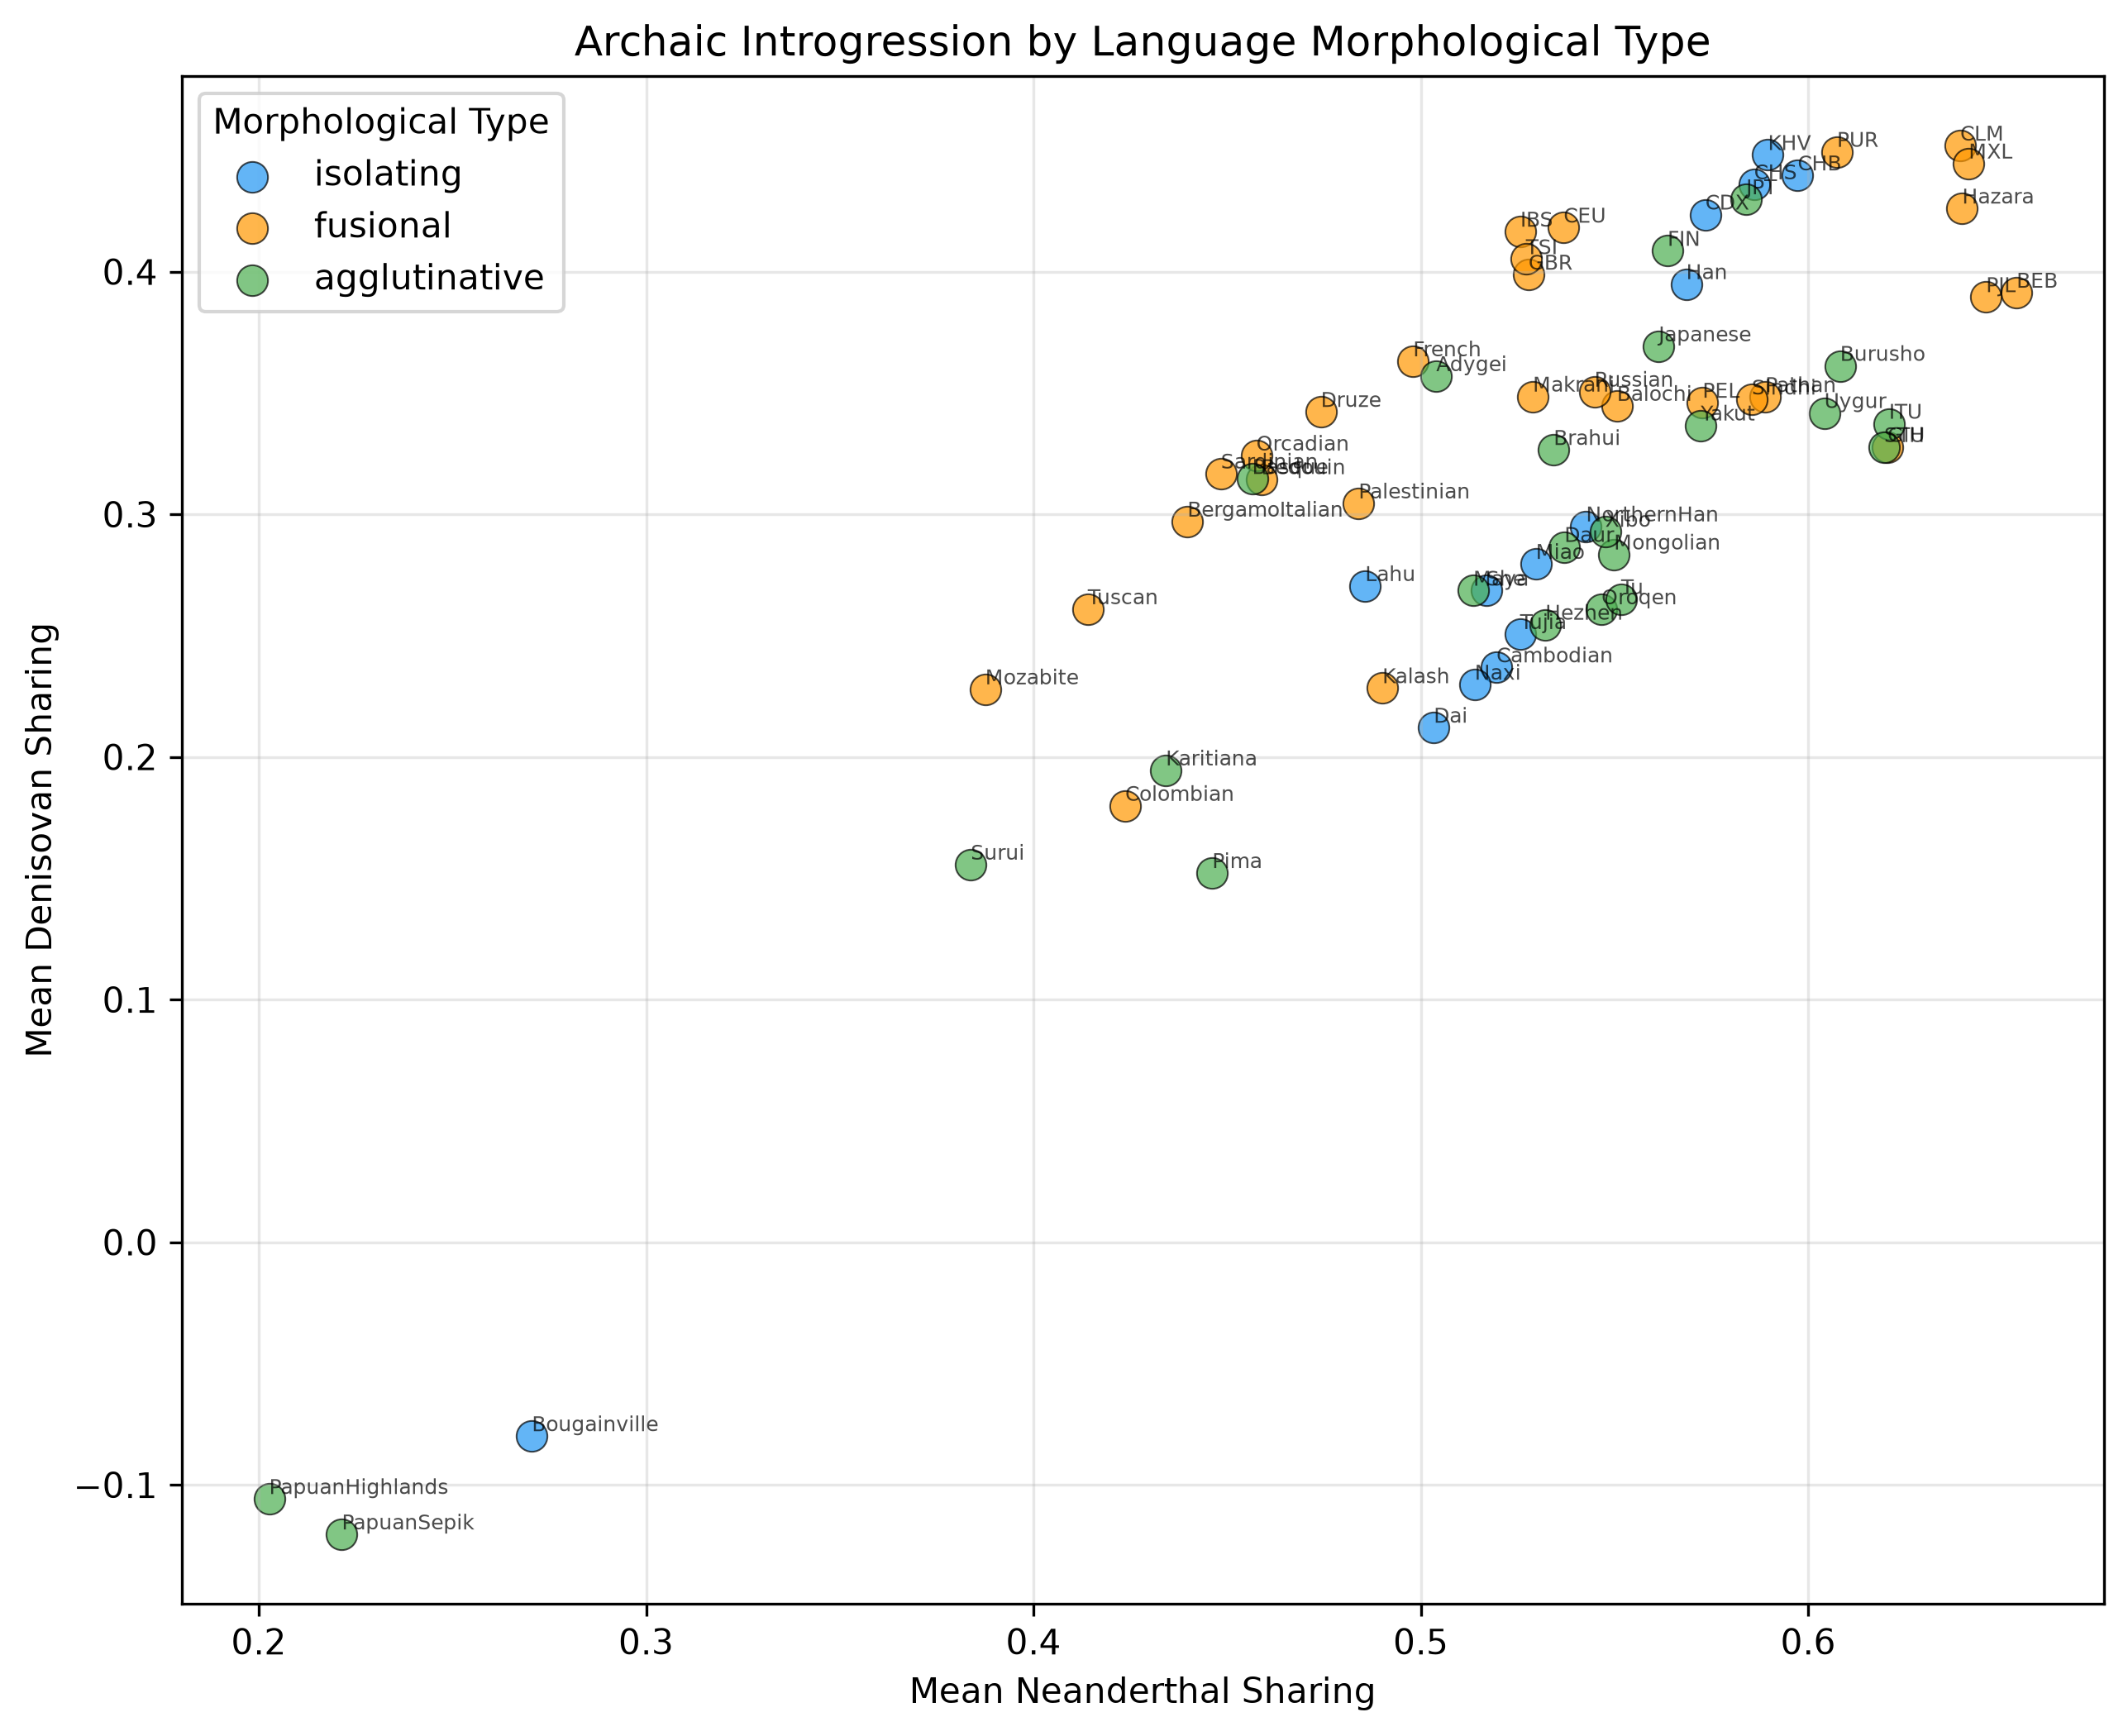
Figure 2. Bivariate scatter of mean Neanderthal and Denisovan sharing by population, colored by morphological type. Agglutinative languages span the widest range in both dimensions, reflecting geographic diversity from Papua to Siberia.

Mantel tests: geography mediates the signal
Simple Mantel tests revealed that typological distance correlates significantly with geographic distance (r = 0.169, p = 0.002) and that Neanderthal distance correlates with geographic distance (r = 0.265, p = 0.002). However, the typological–introgression correlation was not significant for either Neanderthal (r = −0.066, p = 0.93) or Denisovan (r = 0.023, p = 0.30).
Critically, partial Mantel tests controlling for geographic distance yielded null results for both Neanderthal (r = −0.117, p = 1.00) and Denisovan (r = −0.025, p = 0.66). This indicates that the raw Denisovan–morphology association detected by Kruskal–Wallis is fully mediated by geography: populations that are geographically distant tend to differ in both Denisovan patterns and morphological type, but the two are not independently linked.
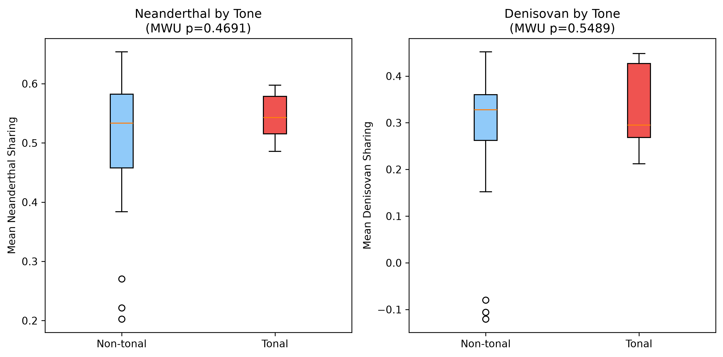
Figure 3. Archaic introgression in tonal vs. non-tonal languages. Neither Neanderthal nor Denisovan sharing differs significantly by tone.

Language families recapitulate migration history
Archaic sharing varied substantially across language families (Figure 4). Trans-New-Guinea, Sepik, and East Papuan families showed the lowest values (0.20–0.27 Neanderthal, negative Denisovan sharing), reflecting their unique introgression profiles from multiple deeply divergent Denisovan lineages.¹¹ Dravidian and Turkic families showed the highest Neanderthal sharing (0.59), while the Uralic family (Finnish) showed the highest Denisovan sharing among non-Papuan populations (0.41). Indo-European populations (n = 24) clustered in a narrow moderate range for both metrics.
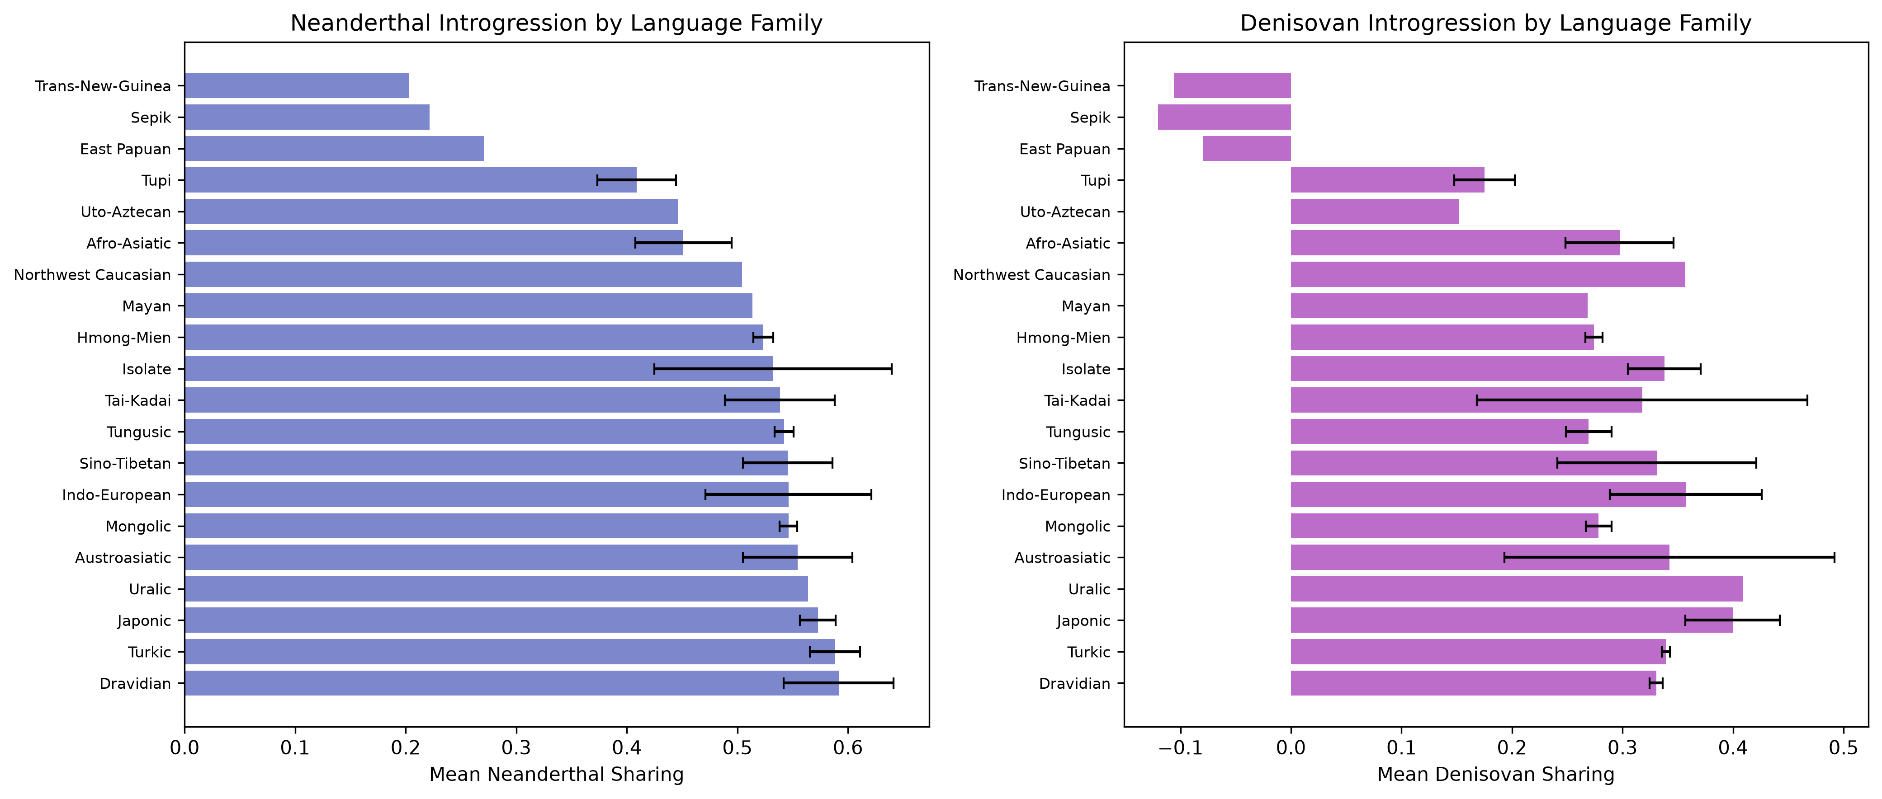
Figure 4. Archaic introgression (mean ± SD) by language family. Papuan families show distinctive low values reflecting unique Denisovan lineages. Indo-European populations cluster tightly, while agglutinative families (Turkic, Mongolic, Tungusic, Dravidian) span a wide range.

The Wallace Line as a dual boundary
The Wallace Line (~120°E) is well-established as a biogeographic boundary and has been identified as a discontinuity in Denisovan introgression, with one Denisovan lineage introgressing predominantly east of this line.¹¹ It also approximately separates Austronesian from Papuan language families. In our data, populations east of the Wallace Line (n = 9) were overwhelmingly agglutinative (8/9) and showed lower mean Denisovan pairwise sharing (0.181 ± 0.220) compared to western populations (0.327 ± 0.078), though this difference was not statistically significant in our sample (Mann–Whitney p = 0.97, one-tailed east > west).
The non-significance likely reflects our use of pairwise sharing correlations rather than absolute introgression proportions: Papuan populations have UNIQUE Denisovan lineages that correlate poorly with other populations’ patterns, yielding low pairwise sharing despite having the highest absolute Denisovan proportion globally. This measurement artifact actually strengthens the argument that the Wallace Line marks a fundamental discontinuity in both archaic ancestry composition and language family boundaries.

Discussion: Capacity, Not Typology
Our results support H2 (weak form): archaic introgression and language typology co-vary geographically but are not independently linked. This null result for the strong hypothesis is itself informative, and we propose the following interpretation:
First, archaic introgression shaped the CAPACITY for modern human language universally, rather than specific typological features. The FOXP2 introgression desert—present in both Neanderthal and Denisovan ancestry maps across all non-African populations^{10,14}—suggests that archaic regulatory variants near language-critical genes were purged by natural selection. This purging was a prerequisite for modern linguistic capacity, but capacity is not typology: once the neural substrate for language is available, the specific morphological, syntactic, and phonological choices a language makes are shaped by cultural transmission and drift.
Second, language typology changes much faster than genetic composition. Languages can be replaced within generations through elite dominance or cultural contact,¹⁷ while archaic introgression proportions are fixed at the time of initial admixture (~50–60 kya for Neanderthals, ~40–70 kya for Denisovans^{10,11}). The temporal mismatch means that even if archaic DNA once predicted typology at the time of initial diversification, subsequent language replacement events (Indo-European Steppe expansion, Bantu expansion, Austronesian expansion^{18,19}) have obscured any primordial signal.
Third, the significant raw Denisovan–morphology association (p = 0.034) before geographic correction suggests that deep migration history DID create a pattern: populations that migrated to similar environments via similar routes developed languages with similar typological profiles. But this is mediated by shared geography and contact history, not by the archaic DNA itself.

Testable Predictions for Future Work
Although our global analysis supports the null hypothesis, several specific predictions remain testable with targeted data:
1. Wallace Line target: With expanded genomic and linguistic sampling in Island Southeast Asia (where both Austronesian and Papuan languages coexist with varying Denisovan proportions), a more powerful test of the introgression–language boundary coincidence becomes feasible. Populations on either side of the Wallace Line who speak typologically different languages should show different archaic ancestry compositions even at matched geographic distances.
2. Locus-specific analysis: Rather than genome-wide introgression proportions, testing the frequency of specifically language-relevant introgressed variants (near FOXP2, CNTNAP2, ROBO1, KIAA0319) against typological features may reveal effects too dilute to detect at the genome-wide level.
3. Ancient DNA time series: As ancient genomes from language-contact zones accumulate (e.g., Steppe–European contact, Austronesian–Papuan contact), it becomes possible to test whether language replacement events coincide with changes in archaic ancestry proportions, or whether typology shifts independently of genetic composition.
4. Morphological complexity gradient: The observation that agglutinative languages dominate in both high-Denisovan (Papuan) and high-latitude (Turkic, Mongolic, Uralic, Tungusic) populations invites a climate–cognition hypothesis: do populations that underwent founder effects in challenging environments (Arctic, highland) develop more morphologically complex languages? This can be tested against effective population size estimates derived from archaic segment length distributions.

Conclusions
We tested whether archaic hominin introgression (Neanderthal and Denisovan) predicts language typological features across 65 globally distributed populations. A raw association between Denisovan patterns and morphological type (p = 0.034) is fully mediated by geographic distance, supporting the weak co-evolution hypothesis: archaic DNA and language typology share geographic structure but are not independently linked. We propose that archaic introgression shaped linguistic capacity universally (via purging of archaic variants at language-critical loci), while specific typological features reflect cultural transmission too rapid for archaic DNA to track. The Wallace Line remains the most promising locus for detecting a genuine archaic–linguistic boundary, warranting expanded sampling in Island Southeast Asia.

References
1. Cavalli-Sforza LL, Piazza A, Menozzi P, Mountain J. Reconstruction of human evolution: bringing together genetic, archaeological, and linguistic data. Proc Natl Acad Sci USA. 1988;85(16):6002–6006.
2. Cavalli-Sforza LL, Minch E, Mountain JL. Coevolution of genes and languages revisited. Proc Natl Acad Sci USA. 1992;89(12):5620–5624.
3. Lansing JS, Cox MP, Downey SS, et al. Coevolution of languages and genes on the island of Sumba, eastern Indonesia. Proc Natl Acad Sci USA. 2007;104(41):16022–16026.
4. Friedlaender JS, Friedlaender FR, Reed FA, et al. The genetic structure of Pacific Islanders. PLoS Genet. 2008;4(1):e19.
5. Longobardi G, Ghirotto S, Guardiano C, et al. More rule than exception: parallel evidence of ancient migrations in grammars and genomes of Finno-Ugric speakers. Genes. 2020;11(12):1491.
6. Atkinson QD. Phonemic diversity supports a serial founder effect model of language expansion from Africa. Science. 2011;332(6027):346–349.
7. Creanza N, Ruhlen M, Pemberton TJ, Rosenberg NA, Feldman MW, Ramachandran S. A comparison of worldwide phonemic and genetic variation in human populations. Proc Natl Acad Sci USA. 2015;112(5):1265–1272.
8. Dediu D, Ladd DR. Linguistic tone is related to the population frequency of the adaptive haplogroups of two brain size genes, ASPM and Microcephalin. Proc Natl Acad Sci USA. 2007;104(26):10944–10949.
9. Savage PE, Loui P, Tarr B, Schachner A, Glowacki L, Mithen S, Fitch WT. Exploring correlations in genetic and cultural variation across language families in northeast Asia. Sci Adv. 2022;8(41):eabd9223.
10. Sankararaman S, Mallick S, Patterson N, Reich D. The combined landscape of Denisovan and Neanderthal ancestry in present-day humans. Curr Biol. 2016;26(9):1241–1247.
11. Jacobs GS, Hudjashov G, Saag L, et al. Multiple deeply divergent Denisovan ancestries in Papuans. Cell. 2019;177(4):1010–1021.
12. Skov L, Hui R, Shchur V, et al. Detecting archaic introgression using an unadmixed outgroup. PLoS Genet. 2018;14(9):e1007641.
13. Onishi T. Archaic introgression sharing as a tracer of ancient human migration: a bivariate approach using Neanderthal and Denisovan DNA signatures. BioEssays. [submitted].
14. Atkinson EG, Audesse AJ, Palaber JA, et al. No evidence for recent selection at FOXP2 among diverse human populations. Cell. 2018;174(6):1424–1435.
15. Crespi BJ, Go MC. Diametrical diseases reflect evolutionary-genetic tradeoffs: evidence from psychiatry, neurology, rheumatology, oncology and immunology. Evol Med Public Health. 2015;2015(1):216–253.
16. Dryer MS, Haspelmath M (eds.). WALS Online (v2020.4) [Data set]. Leipzig: Max Planck Institute for Evolutionary Anthropology. 2013. Available at: https://wals.info/
17. Renfrew C. Archaeology, genetics and linguistic diversity. Man. 1992;27(3):445–478.
18. Heggarty P, Anderson C, Scarborough M, et al. Language trees with sampled ancestors support a hybrid model for the origin of Indo-European languages. Science. 2023;381(6656):eabg0818.
19. Gray RD, Drummond AJ, Greenhill SJ. Language phylogenies reveal expansion pulses and pauses in Pacific settlement. Science. 2009;323(5913):479–483.

