Divergent hazard shapes of tuberculosis treatment loss to follow-up: a reproducible analysis of published curves quantifying the heterogeneity that hinders a unified retention intervention
Brief Report
Abstract
Background Loss to follow-up (LTFU) during tuberculosis (TB) treatment is a major barrier to cure and transmission control¹. Its determinants are multilevel and context-dependent² and interventions to prevent it show inconsistent, setting-specific effectiveness³, but whether the *timing* of LTFU follows a consistent hazard shape across settings has not been quantified.
Methods We fitted two-parameter Weibull cumulative-incidence models F(t)=1−exp(−(t/λ)^k) to four real, published time-to-event curves recovered by figure digitization: two TB treatment cohorts (Ethiopia⁴, China⁵) and two non-TB comparators (HIV/ART retention⁶; antipsychotic time-to-discontinuation⁷). The shape parameter k (k>1 increasing-failure-rate [IFR]; k<1 decreasing-failure-rate [DFR]) was estimated with a bootstrap 95% confidence interval (CI) and compared with exponential and log-normal fits by the Akaike information criterion (AIC).
Results The shape parameter diverged within TB: Ethiopia k=1.68 (95% CI 1.29–1.95) (IFR) versus China k=0.44 (95% CI 0.43–0.50) (DFR) — opposite sides of k=1 from only two cohorts, with non-identical outcome definitions. Both comparators were DFR (HIV/ART k=0.63 (95% CI 0.54–0.73); antipsychotic k=0.49 (95% CI 0.42–0.57)), i.e. mutually consistent.
Conclusions TB LTFU is not uniformly increasing-hazard: its hazard shape is heterogeneous across countries, plausibly because the country-specific mechanisms that generate LTFU differ. This gives a compact, reproducible quantification of why pooled TB evidence and a one-size retention intervention are hard to build, whereas the comparator interventions may pool more readily. The cause of the divergence is unknown and warrants individual-level study.
Keywords Tuberculosis; Loss to follow-up; Treatment adherence; Weibull; Hazard function; Survival analysis; Age at onset; Health systems
Background
LTFU interrupts TB treatment, promotes acquired drug resistance and sustains transmission¹. Two things are already established. First, the determinants of treatment interruption are multilevel and strongly context-dependent, differing by health system, case mix and social setting². Second, interventions intended to keep patients in care—community-based, behavioural and digital approaches—show inconsistent, setting-specific effectiveness, so no single strategy has proved universally transferable³. What has been missing is a *quantitative* description of the phenomenon that plausibly underlies this: whether patients across settings even disengage on the same time-course. Programmatic reports usually give a single cumulative LTFU proportion, hiding *when* during treatment patients leave. The hazard shape carries direct operational meaning: an increasing hazard (k>1) argues for intensified support late in treatment, a decreasing hazard (k<1) for front-loading it in the earliest weeks. We therefore asked a narrow question: across TB cohorts that publish a time-resolved LTFU curve, is the Weibull hazard shape consistent, and how does it compare with dropout in unrelated chronic treatments? A divergence within TB but consistency among comparators would give a concrete, reproducible measure of why TB retention resists a unified approach.
Methods
We used only real, published curves. TB data were the competing-risk LTFU cumulative incidence at Ambo General Hospital, Ethiopia⁴, and the all-patient time-to-LTFU Kaplan–Meier curve from a 5-year Chinese cohort⁵. Comparators were an HIV/ART retention curve⁶ and an antipsychotic time-to-discontinuation curve⁷. Curves were digitized from the published figures by an in-house pixel extractor with axis calibration read from figure tick marks (values taken from curve pixels, not entered by hand). For each dataset we fitted the Weibull cumulative-incidence model F(t)=1−exp(−(t/λ)^k) by nonlinear least squares, obtained a bootstrap 95% CI for k, and compared fit with exponential (k=1) and log-normal models by AIC. The shape parameter k is unit-free, so mixed follow-up units (months, days) do not affect the cross-study comparison. Data, code and a one-command build are in the public repository (Data and code availability).
Results
Fitted parameters are shown in Table 1 and the fits are overlaid on the digitized data in Figure 1. Within TB, the two cohorts fell on opposite sides of k=1: the Ethiopian competing-risk CIF accelerated over the 6-month course (k=1.68 (95% CI 1.29–1.95), IFR), whereas the Chinese all-patient curve was strongly front-loaded (k=0.44 (95% CI 0.43–0.50), DFR), most LTFU occurring in the first months. Both non-TB comparators were DFR (HIV/ART k=0.63 (95% CI 0.54–0.73); antipsychotic k=0.49 (95% CI 0.42–0.57)), i.e. dropout risk highest early then decelerating.
Table 1. Weibull fits to digitized treatment-dropout curves (source of truth: results/weibull_fits.csv).
Dataset (source) | k (95% CI) | λ | R² | Hazard pattern
TB-Ethiopia — PMC10290796 Fig.1a (competing-risk CIF, 6 mo) | 1.68 (1.29–1.95) | 21.5 | 0.978 | IFR (k>1)
TB-China — PMC10167013 Fig.3 (All-TB KM retention, 12 mo) | 0.44 (0.43–0.50) | 957.3 | 0.920 | DFR (k<1)
ART/HIV — PMC12953970 Fig.1A (retention KM, months) | 0.63 (0.54–0.73) | 228.3 | 0.926 | DFR (k<1)
Antipsychotic — PMC12437960 (time-to-discontinuation KM, days) | 0.49 (0.42–0.57) | 104.8 | 0.958 | DFR (k<1)

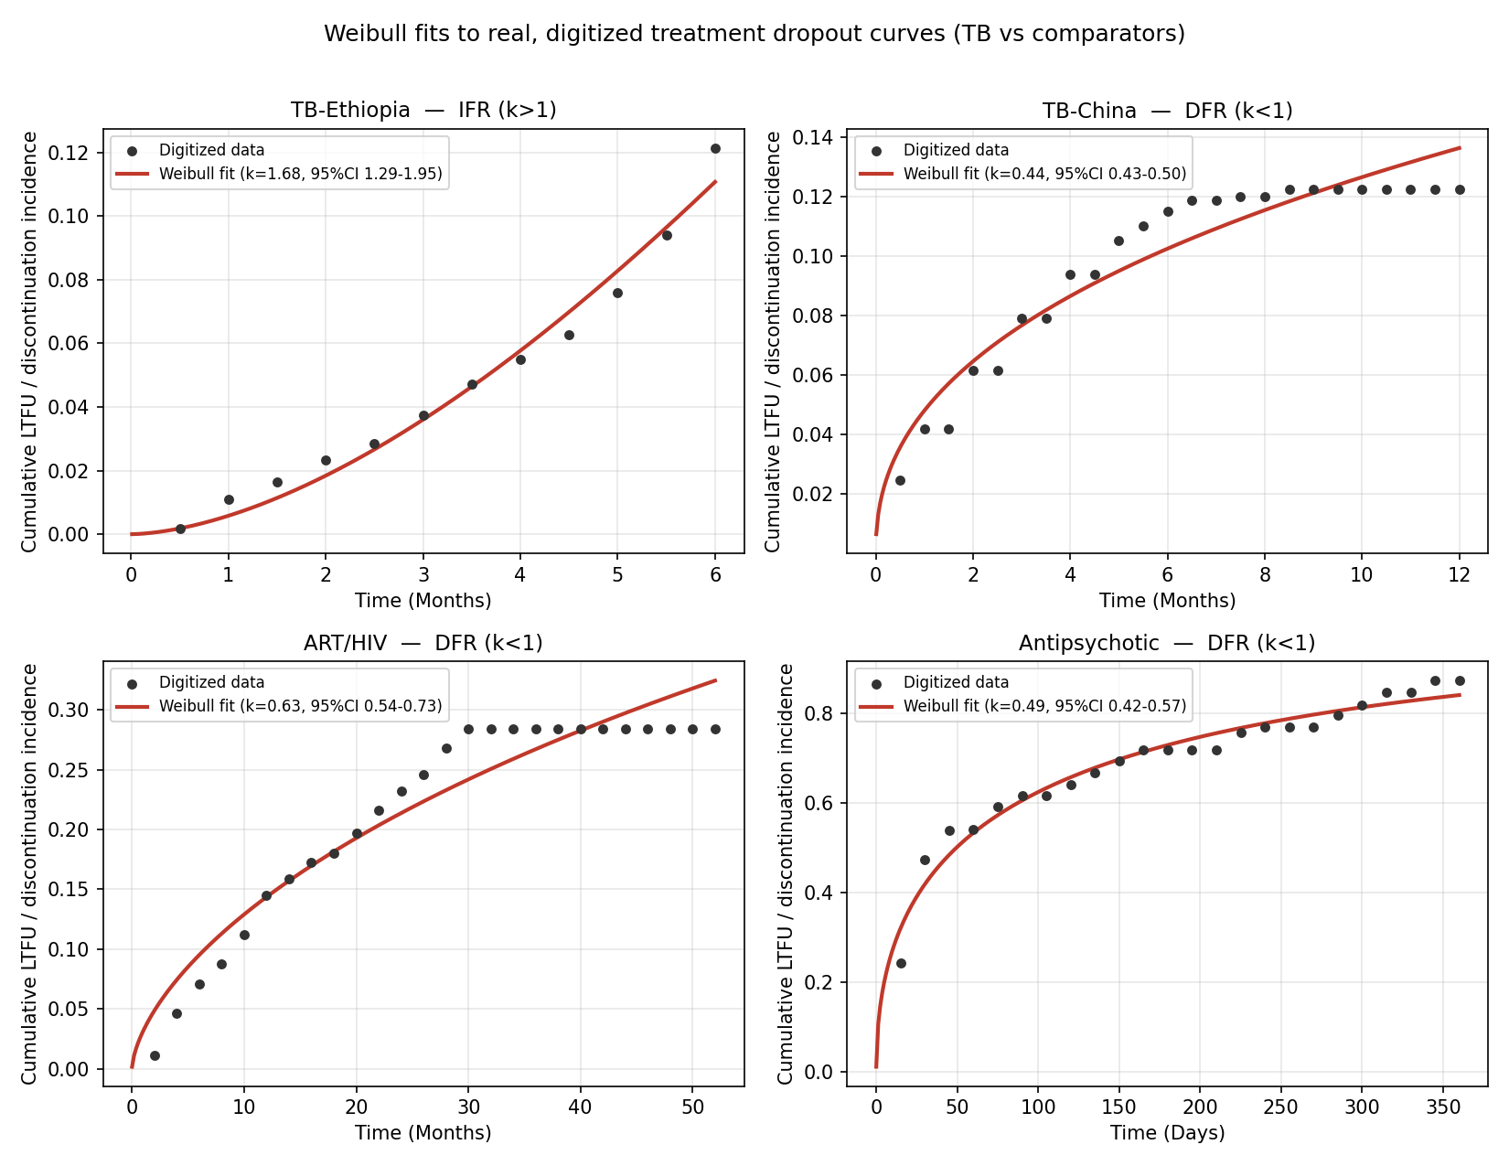
Figure 1. Weibull cumulative-incidence fits (red) to digitized dropout curves (points) for two TB cohorts and two comparators. TB is split between IFR (Ethiopia) and DFR (China), spanning the whole range; comparators are consistently DFR.
Discussion
The result puts a number on an accepted but qualitative problem. It is already known that TB LTFU determinants are context-dependent² and that retention interventions do not transfer cleanly between settings³; our contribution is to show that this heterogeneity is visible in the hazard shape itself. Two TB cohorts fell on opposite sides of k=1 — one late-accelerating (IFR), one strongly front-loaded (DFR) — spanning the entire range that the two unrelated comparators occupied only on the DFR side. In other words, the comparator interventions were mutually consistent (both DFR) and would plausibly support a common time-course model, whereas the two TB settings did not share even the *direction* of their hazard. This is a compact, reproducible illustration of why pooled TB evidence and a single unified retention intervention are hard to construct: if countries differ in *when* patients disengage, an intervention timed for one will be mistimed for another.
We cannot explain the divergence, and we do not claim to. It is confounded with different outcome definitions (competing-risk CIF vs all-patient KM), case mix, programme context and the 6- vs 12-month observation windows, and it rests on digitized aggregate curves rather than individual patient data. That the mechanism is unknown is precisely the open question worth stating: the country-specific processes that generate LTFU appear to differ enough to change the hazard shape, and identifying what drives this — regimen phase, health-system factors, or case mix — would require more TB cohorts with individual-level data and harmonized LTFU definitions. Until then, the honest reading is that TB retention is a heterogeneous target, not a single one.
One candidate deserves explicit mention because it could unify the two observations — that the unrelated comparators behaved alike while the two TB settings did not — namely the age structure of disease onset. The two TB cohorts arise from demographically divergent epidemics: TB in China is increasingly concentrated in the elderly⁸, whereas high-burden sub-Saharan settings such as Ethiopia are dominated by young adults, and age was itself a significant risk factor for LTFU in the Ethiopian cohort⁴. If the age-at-onset distribution governs competing mortality, comorbidity and the reasons patients disengage, it could plausibly determine whether the LTFU hazard rises or falls over the course of treatment — in effect a time-to-onset (age) distribution modulating the time-to-LTFU hazard. We stress that this is a hypothesis, not a result: our curves are aggregate and not age-stratified, so neither an age-at-onset distribution nor an age-by-LTFU-timing interaction can be fitted here without inventing data. Testing it would require age-stratified time-to-LTFU curves or individual patient data.
The observation has practical implications for TB programmes, particularly in resource-limited, high-burden settings where retention resources are scarce and must be targeted. Because the hazard shape encodes *when* patients disengage, it maps directly onto the timing of adherence support: a front-loaded (DFR) setting argues for concentrating counselling, financial or social support in the intensive phase, whereas a late-accelerating (IFR) setting argues for sustained or intensified support in the continuation phase. A retention package optimized for one hazard shape will be mistimed in the other, which offers a concrete, quantitative reason why globally standardized adherence interventions have shown inconsistent effects across programmes³. Routinely reporting the time-to-LTFU curve — not only the final cumulative proportion — would let national programmes locate their own hazard shape and time support accordingly, and would make cross-country evidence poolable in a way that a single summary statistic cannot.
Limitations
Only two TB and two comparator curves met the bar of a genuinely time-resolved, openly available dropout curve, so the analysis is small and hypothesis-generating. Estimates come from digitized aggregate curves, not individual patient data; the Ethiopian estimate is a competing-risk *subdistribution*-hazard shape; the antipsychotic cohort is small (n≈42) and illustrative; KM plateaus reflect administrative censoring. The findings are hypothesis-generating, not confirmatory.
Conclusions
Across the few TB cohorts that publish a time-resolved LTFU curve, the Weibull hazard shape is not consistent: two national settings fell on opposite sides of k=1, whereas two unrelated chronic-treatment comparators were mutually consistent (both DFR). The heterogeneity of TB LTFU is therefore visible in the hazard shape itself and offers a compact, reproducible explanation for why pooled TB evidence and a single unified retention strategy are difficult to construct. Individual-level data with harmonized LTFU definitions are needed to identify what drives the divergence.
Declarations
Ethics approval and consent to participate Not applicable. This study is a secondary analysis of aggregate, already-published, de-identified survival curves and involved no new human participants or individual-level data.
Consent for publication Not applicable.
Availability of data and materials All source figures, digitized CSV datasets, analysis code and a one-command build that regenerates every reported number, Table 1 and Figure 1 are openly available in the project repository. No result is hard-coded; every value is reproduced from the source data by the released code.
Competing interests The authors declare that they have no competing interests.
Funding This study received no specific funding.
Authors' contributions The author(s) conceived the study, digitized the source curves, implemented the analysis and wrote the manuscript. All authors read and approved the final manuscript.
Acknowledgements Not applicable.
References
1. World Health Organization. Global Tuberculosis Report 2024. Geneva: WHO; 2024.
2. Tsibiyane M, Faye LM, Ndayi K, Sineke N, Tyeshani L, Faleni M, et al. Multilevel determinants of tuberculosis treatment interruption in rural South Africa: insights from primary healthcare nurses. Int J Environ Res Public Health. 2026;23(5):598. doi:10.3390/ijerph23050598.
3. Kedthongma W, Usaprom S, Phakdeekul W. Community-based interventions to improve tuberculosis treatment outcomes: a meta-analysis. MethodsX. 2026;16:103893. doi:10.1016/j.mex.2026.103893.
4. Fufa DB, Diriba TA, Dame KT, Debusho LK. Competing risk models to evaluate the factors for time to loss to follow-up among tuberculosis patients at Ambo General Hospital. Arch Public Health. 2023;81:113. doi:10.1186/s13690-023-01130-2.
5. Jiang Y, Chen J, Ying M, Liu L, Li M, Lu S, et al. Factors associated with loss to follow-up before and after treatment initiation among patients with tuberculosis: a 5-year observation in China. Front Med. 2023;10:1136094. doi:10.3389/fmed.2023.1136094.
6. Daba O, Tsegaye D, Reshad M. Incidence and predictors of loss to follow-up among ART patients on follow-up at public health facilities in Southwest Ethiopia: a time-to-event analysis. J Int Assoc Provid AIDS Care. 2026;25:23259582261426232. doi:10.1177/23259582261426232.
7. Salas Aranda P, Garcia Cerdan C, Martin Gomez C, Lorenzo Romo C, Turrion Gomez M, Isidoro Garcia M, et al. Time to discontinuation in routine clinical practice of the initially prescribed antipsychotic treatment in patients with first-episode psychosis. Eur Psychiatry. 2025;68(Suppl):PMC12437960.
8. Yu Y, Xian S, Yang D, Mu L, Han Y, Luo W, et al. Temporal trends in tuberculosis incidence among the aging population in Southwest China: a retrospective study. BMC Geriatr. 2026;26:373. doi:10.1186/s12877-026-07373-2.

