Population-level replacement of interferon-based standard therapy for hepatitis C after interferon-free direct-acting antivirals: a new-treatment-anticipation / practical-drug-lag analysis of Japan's NDB Open Data

Abstract
Background: If population-level anticipation of a newly reported/reimbursed treatment is real, use of the prior standard therapy should fall sharply once the awaited option arrives; if not, either the anticipation/practical lag is absent or decision-makers are not reacting to the news. Methods: Using Japan's NDB Open Data (2014-2023), we tracked national dispensed quantity of interferon (IFN)-based standard therapy (peginterferon, ribavirin) and of interferon-free direct-acting antivirals (DAAs) for hepatitis C, against official approval/reimbursement milestones. Results: Peginterferon dispensing fell 99.2% from FY2014 to FY2023; ribavirin reached near-zero by FY2018. Total DAA dispensing peaked in FY2015 (19.5 million units, +158% vs FY2014) and then fell 92% by FY2023. Conclusion: The IFN-based standard therapy was replaced at the population level within about two years, and the DAA surge-then-decay is consistent with a finite pool of long-waiting patients being treated in a burst (pent-up demand) rather than steady substitution.

Introduction
When a new therapy is announced through the media or scheduled for reimbursement, advocates of the new treatment expect a population-wide shift away from the current standard of care. Chronic hepatitis C offers an unusually clean natural experiment: interferon-based therapy was the standard until interferon-free DAAs arrived in Japan in 2014-2015, when daclatasvir plus asunaprevir became the world's first all-oral, interferon- and ribavirin-free regimen¹. We use nationwide dispensing counts from NDB Open Data² to test whether the standard therapy was displaced at the population level around these announcement/reimbursement events.

Methods
We used NDB Open Data editions 1-10 (fiscal years 2014-2023)², extracting the national total dispensed quantity (総計/処方数量) for each drug from the sex- and age-stratified prescription-drug tables (oral, topical, injectable). Drugs were classified by their actual product names into IFN-based standard therapy (peginterferon, ribavirin) and 12 interferon-free DAA products. Conventional interferon is reported separately because it is not hepatitis-C-specific. The metric is dispensed quantity (tablets/capsules for oral drugs, syringes/vials for injections), not a patient count, and is compared within a product over time. Official approval and NHI drug-price listing milestones^{1,3} were used as intervention markers at fiscal-year resolution (Table 1). Analyses are descriptive; the full pipeline (download -> build -> analyze -> figures) is openly reproducible.
Table 1. Official approval / NHI drug-price listing milestones used as intervention markers.
FY | Month | Drug | Milestone | Source
2014 | 2014-07 | daclatasvir + asunaprevir | approval | Bristol-Myers Squibb K.K. press release 2014-07-04
2014 | 2014-09 | daclatasvir + asunaprevir | NHI listing | MHLW/Chuikyo NHI drug-price listing FY2014
2015 | 2015-03 | sofosbuvir | approval | PMDA new-drug approval / Gilead Sciences K.K. press release (2015-03)
2015 | 2015-05 | sofosbuvir | NHI listing | MHLW/Chuikyo NHI drug-price listing (2015-05)
2015 | 2015-07 | ledipasvir/sofosbuvir | approval | PMDA new-drug approval / Gilead Sciences K.K. press release (2015-07)
2015 | 2015-08 | ledipasvir/sofosbuvir | NHI listing | MHLW/Chuikyo NHI drug-price listing (2015-08)
2017 | 2017-09 | glecaprevir/pibrentasvir | approval | PMDA new-drug approval / AbbVie GK press release (2017-09)
2017 | 2017-11 | glecaprevir/pibrentasvir | NHI listing | MHLW/Chuikyo NHI drug-price listing (2017-11)

Results
The interferon-based standard therapy collapsed after IFN-free DAAs became available (Fig. 1). Peginterferon dispensing fell 99.2% from FY2014 to FY2023, and ribavirin reached near-zero by FY2018.
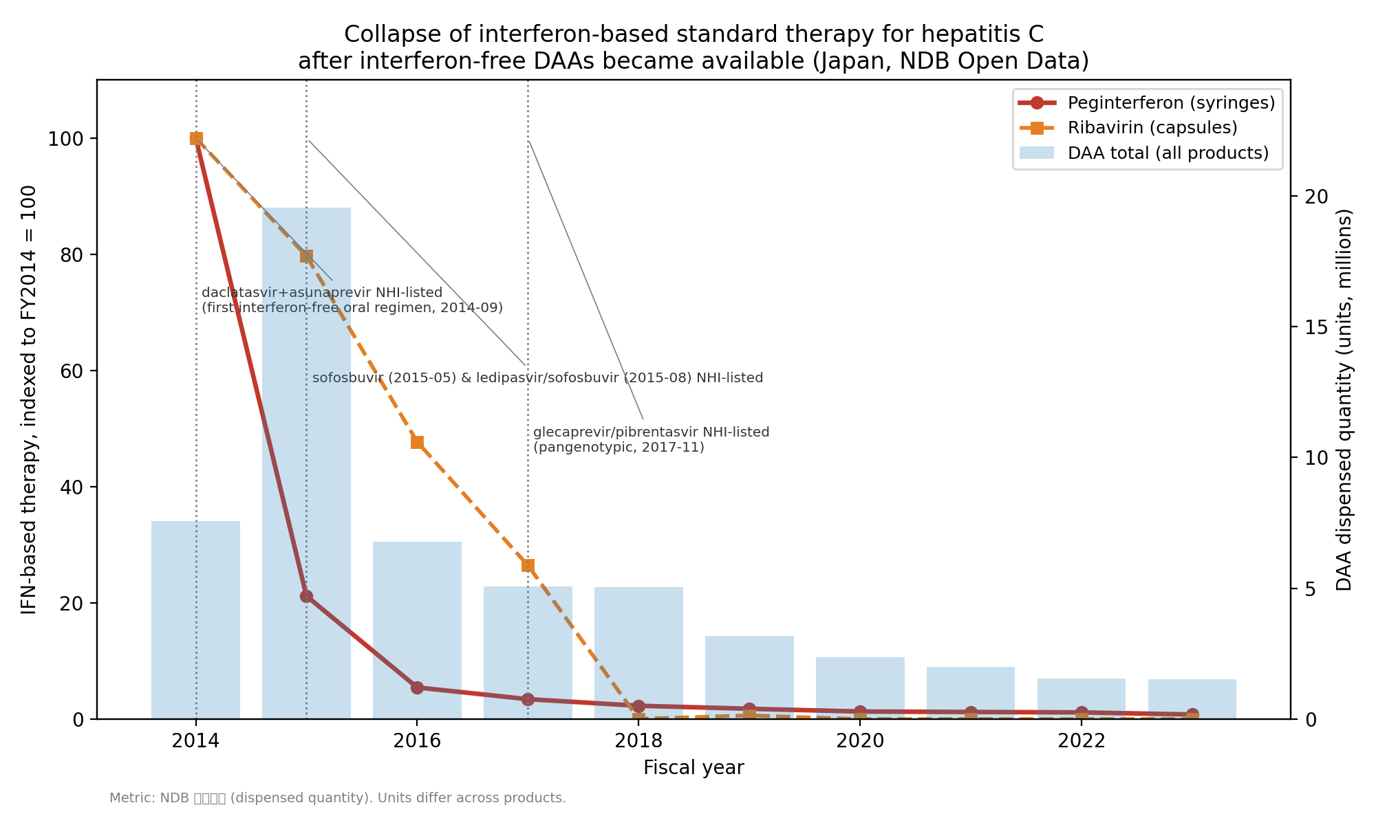
Fig. 1. Collapse of interferon-based standard therapy (indexed to FY2014 = 100) with total DAA dispensed quantity and dated announcement markers.
DAA use itself showed a surge-then-decay pattern (Fig. 2): total DAA dispensing peaked in FY2015 at 19.5 million units (+158% vs FY2014) and then declined 92% to 1.5 million units by FY2023, with successive products replacing earlier ones.
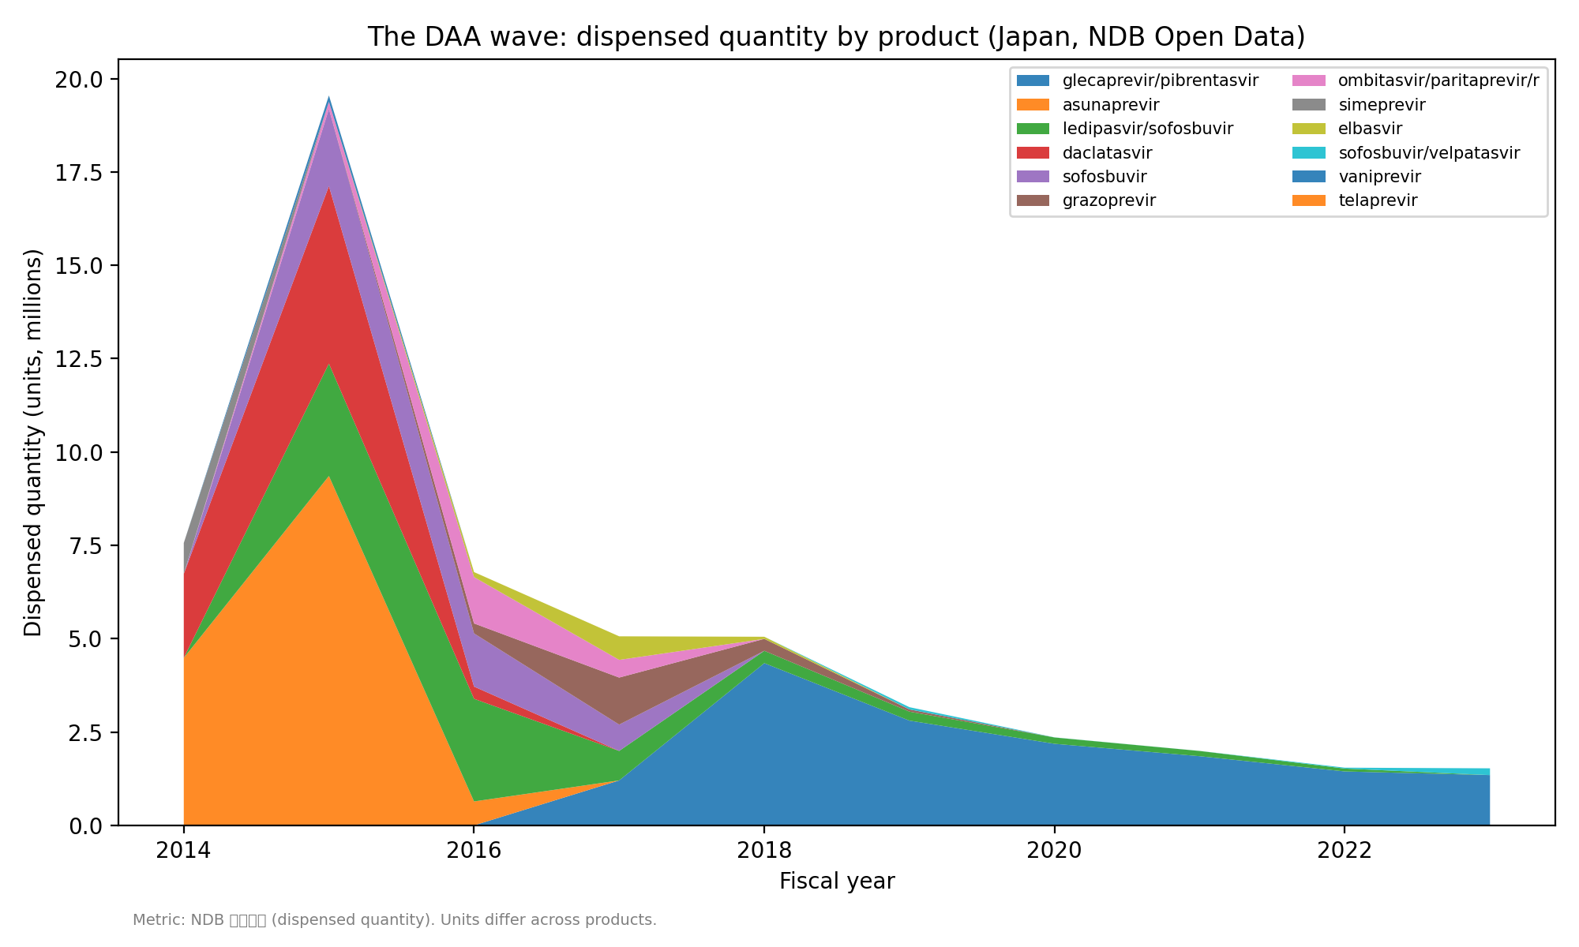
Fig. 2. The DAA wave: dispensed quantity by product.

Discussion
For hepatitis C DAAs there was no population-level practical lag: the standard therapy was displaced within about two years of the announcements/listings, indicating that decision-makers reacted rapidly. The DAA surge-then-decay is consistent with a finite stock of long-waiting patients being cured in a burst (pent-up demand) rather than a steady replacement flow. This is descriptive evidence supporting the anticipation hypothesis; it does not by itself establish that media coverage caused individual treatment choices.

Limitations
NDB Open Data begins in FY2014, the same period IFN-free DAAs launched, so there is no pre-DAA interferon baseline within NDB; the FY2014 value already reflects decline from the pre-2014 peak. The metric is dispensed quantity, not patient counts, and units differ across products, so the summed DAA quantity is not a patient count. Data are annual, precluding within-year interrupted time-series or formal causal estimation, and no control condition or placebo event is included.

Conclusion
In hepatitis C, the interferon-based standard therapy was replaced at the population level within about two years of interferon-free DAAs, and the surge-then-decay of DAA use is consistent with realized pent-up demand. This supports the existence of population-level new-treatment anticipation for this case, while cautioning that the same pattern need not generalize to therapies with weaker anticipation or greater practical constraints.

Data and code availability
Raw NDB Open Data workbooks are publicly available from MHLW and are re-downloadable via scripts/download_ndb.py; derived datasets, analysis code and figure/manuscript generators are in the project repository.

References
1. Bristol-Myers Squibb K.K. Press release: approval in Japan of the world's first all-oral, interferon- and ribavirin-free treatment for chronic hepatitis C (daclatasvir + asunaprevir). 4 July 2014.
2. Ministry of Health, Labour and Welfare (Japan). NDB Open Data (1st-10th editions). https://www.mhlw.go.jp/ndb/opendatasite/ (accessed for fiscal years 2014-2023).
3. Ministry of Health, Labour and Welfare / Central Social Insurance Medical Council (Chuikyo). NHI drug-price listings of direct-acting antivirals for hepatitis C (2014-2017).

