“Japanese Patient”? — A Patient.
Regional Heterogeneity in Pain-Related Prescribing Across Japan’s 47 Prefectures
Challenges the Stereotype of a Stoic Monolith

Running title: Pain prescribing variation in Japan

Tatsuki Onishi

Corresponding author: Tatsuki Onishi, Department of Anesthesiology, [Institution], [Address], [City], [Postal code], Japan. E-mail: [email]; Tel: [phone]; Fax: [fax]

Keywords: cultural pain behavior; ecological study; gaman; neuropathic pain; regional variation; prescribing patterns

Number of text pages: [to be determined after formatting]
Number of figures: 5 (+ 1 supplementary)
Number of tables: 3

Category: Original Article

Abstract
Background: Cross-cultural studies characterize Japanese people as stoic toward pain, yet whether this endurance varies regionally within Japan remains unexplored.
Methods: This ecological study used Japan’s National Database (NDB) Open Data (population-complete insurance claims, April 2023–March 2024) to map pain-related prescribing across 47 prefectures and nine regional blocks. Phase 1 examined acute perioperative analgesic prescribing; Phase 2 examined outpatient neuropathic pain prescribing as a chronic postsurgical pain (CPSP) proxy, adjusted for confounding diseases.
Results: In Phase 1, the inpatient analgesic-per-surgery index varied 1.97-fold (Gifu 25.20 to Kagoshima 49.75; Kruskal–Wallis P < 0.001). Contrary to popular perception, Tohoku—traditionally considered Japan’s most stoic region—prescribed more, not fewer, analgesics (mean 39.97 vs national 35.78; Cohen’s d = 0.87). In Phase 2, Tohoku had the highest unadjusted neuropathic pain index (d = 2.81), but this excess became nonsignificant after adjustment for confounding diseases (P = 0.323), with diabetes drug prescribing as the strongest confounder (r = 0.87).
Conclusions: Nearly twofold within-country variation challenges the assumption that “Japanese” constitutes a uniform category for pain behavior. Individualized pain assessment should replace culturally stereotyped assumptions in perioperative care.
Significance: This study provides the first population-level evidence of nearly twofold regional variation in pain-related prescribing within Japan, directly challenging the widespread clinical assumption that Japanese patients constitute a monolithic "stoic" population. This finding is clinically important for any setting where Japanese patients are treated, as cultural stereotyping may lead to systematic under-treatment of pain.

Introduction
Pain is a universal experience, yet its expression and management are profoundly shaped by culture (Callister, 2003; Rogger et al., 2023). Since Zborowski’s observation that ethnic groups differ in pain behavior (Zborowski, 1969), a large literature has established that cultural norms influence pain reporting, treatment-seeking, and analgesic use (Okolo et al., 2024). Japan is consistently characterized as stoic: Hobara found that Japanese respondents rated pain behaviors as less appropriate than Euro-Americans (Hobara, 2005), and Feng et al. showed that Japanese participants were far less willing to trade time to avoid pain on the EQ-5D (Feng et al., 2017). This culturally mediated endurance, encapsulated by the concept of gaman (我慢), carries clinical risk when clinicians assume stoic presentation indicates lower analgesic need.
Most studies compare pain behavior between nations. However, substantial heterogeneity exists within countries: Cohen and Nisbett showed that the “culture of honor” in the US South produces measurably different behavioral responses from the North (Cohen et al., 1996). In Japan, regional identities are strong—the Tohoku region is traditionally perceived as stoic (Kumagai, 2020), and even the word for throbbing pain (uzuku) shows regional usage patterns (Takeda and Yarimizu, 2016). A Pfizer Japan survey found the proportion of chronic pain patients “enduring pain” ranged from 48.7% to 81.6% across prefectures (Pfizer Japan, 2017). Yet whether such differences translate into measurable healthcare utilization differences remains unknown.
Japan’s universal health insurance, standardized drug pricing, and the NDB—capturing virtually all reimbursed utilization (Ministry of Health, Labour and Welfare, 2024)—provide an ideal setting. Recent work has documented up to 1.6-fold regional variation in chronic pain prevalence (Wakaizumi et al., 2024) and 4-fold variation in cancer opioid prescribing (Matsuoka et al., 2025). The perioperative setting offers a further advantage: because all patients are hospitalized, healthcare access—a major confounder in outpatient studies—is neutralized.
This exploratory study had three objectives: (1) map regional variation in acute perioperative analgesic prescribing across 47 prefectures; (2) examine outpatient neuropathic pain prescribing as a chronic postsurgical pain (CPSP) proxy after confounder adjustment; and (3) integrate acute and chronic findings at the population level.

Methods

Study design and reporting
This ecological study analyzed prefecture-level aggregate data from the NDB Open Data. It is reported following the Strengthening the Reporting of Observational Studies in Epidemiology (STROBE) statement (von Elm et al., 2007) and the REporting of studies Conducted using Observational Routinely-collected health Data (RECORD) extension (Benchimol et al., 2015). As only publicly available aggregate data were used, ethical approval was not required.

Data source
The 10th edition of the NDB Open Data (April 2023–March 2024) was used (Ministry of Health, Labour and Welfare, 2024). The NDB captures claims from all insurers within Japan’s universal coverage system, encompassing approximately 125 million insured individuals. Aggregate data are published at the prefecture level with suppression of cells <10 events.

Regional classification
Prefectures were grouped into nine standard regional blocks: Hokkaido (1), Tohoku (6: Aomori, Iwate, Miyagi, Akita, Yamagata, Fukushima), Kanto (7), Hokuriku-Koshinetsu (6), Tokai (4), Kinki (6), Chugoku (5), Shikoku (4), and Kyushu-Okinawa (8).

Phase 1: Acute perioperative analgesic prescribing
Inpatient prescription data were extracted for three analgesic drug classes: Class 114 (antipyretic analgesics/NSAIDs/acetaminophen), Class 811 (opium alkaloid narcotics), and Class 821 (synthetic narcotics). Inpatient surgical procedure counts were extracted from the K Surgery section. The analgesic-per-surgery index was calculated for each prefecture as: total inpatient analgesic quantity (units)/total inpatient surgical procedure count.

Phase 2: Outpatient neuropathic pain prescribing as CPSP proxy
Five classes of outpatient oral neuropathic pain medications were extracted: pregabalin (78 formulations), mirogabalin (8), duloxetine (33), tramadol (3), and neurotropin (1). The neuropathic pain prescribing-per-surgery index was calculated as: total outpatient neuropathic pain drug quantity/total inpatient surgical procedure count.

Confounder disease proxies
Four confounder disease proxies were extracted from outpatient data:
- Oral hypoglycemic agents (261 formulations): proxy for diabetic neuropathy
- Herpes zoster antivirals (47 formulations): proxy for postherpetic neuralgia
- Antidepressants excluding duloxetine (128 formulations): proxy for depression
- Anxiolytics (112 formulations): proxy for anxiety disorders
Each proxy was expressed per surgery. Outpatient nerve block procedure counts (73 codes) served as an independent CPSP proxy.

Statistical analysis
Regional differences in Phase 1 were assessed using the Kruskal–Wallis test, followed by post hoc Mann–Whitney U tests with Bonferroni correction. For Phase 2, five regression models were fitted:
- Model 1: Unadjusted regional comparison
- Model 2: Neuropathic pain ~ diabetes + herpes + antidepressants + anxiolytics + region
- Model 3: Core neuropathic drugs (pregabalin + mirogabalin) ~ same confounders
- Model 4: Nerve blocks ~ same confounders
- Model 5: Neuropathic pain ~ acute analgesic index + confounders (integrated)
The adjusted CPSP index was derived as residuals from regressing neuropathic pain prescribing on the four confounder proxies. Pearson and Spearman correlations assessed inter-index relationships. All analyses used Python 3.11 (NumPy 1.24, SciPy 1.11, matplotlib 3.8).

Results

Phase 1: Regional variation in acute perioperative analgesic prescribing
During April 2023–March 2024, the NDB recorded 7,903,515 inpatient surgical procedures and 274,579,851 analgesic prescription units across 47 prefectures. The national mean analgesic-per-surgery index was 35.78 (SD 5.56), ranging from 25.20 (Gifu) to 49.75 (Kagoshima)—a 1.97-fold difference (Kruskal–Wallis P < 0.001 across nine regions; Table 1).

Table 1. Phase 1: Regional summary of inpatient analgesic prescribing per surgery across nine regional blocks.
Region | N prefectures | Mean | SD | Range
Hokkaido | 1 | 46.12 | 0.00 | 46.12–46.12
Tohoku | 6 | 39.97 | 3.22 | 35.18–44.51
Kanto | 7 | 33.00 | 1.93 | 29.82–35.36
Hokuriku-Koshinetsu | 6 | 35.38 | 3.23 | 31.17–40.04
Tokai | 4 | 27.62 | 1.89 | 25.20–30.07
Kinki | 6 | 30.02 | 1.86 | 27.92–32.78
Chugoku | 5 | 35.73 | 3.74 | 30.99–40.19
Shikoku | 4 | 36.33 | 2.83 | 33.49–41.02
Kyushu-Okinawa | 8 | 42.26 | 4.05 | 35.81–49.75
National | 47 | 35.78 | 5.63 | 25.20–49.75
Values represent the analgesic-per-surgery index: total inpatient analgesic prescription units divided by total inpatient surgical procedure count for each prefecture. Kruskal–Wallis test across nine regions: P < 0.001.

Substantial regional clustering was observed. Tokai and Kinki (western Japan) had the lowest indices, while Kyushu-Okinawa and Hokkaido had the highest. Tohoku, culturally perceived as Japan’s most stoic region, ranked seventh of nine with a mean index of 39.97 (SD 3.53), significantly above the non-Tohoku mean of 35.17 (Mann–Whitney U = 190, P = 0.031; Cohen’s d = 0.87). All six Tohoku prefectures ranked in the upper half nationally. This pattern was consistent across drug classes: NSAIDs (P = 0.044), opioid alkaloids (P = 0.003), and synthetic opioids (P = 0.001).

Phase 2: Outpatient neuropathic pain prescribing (unadjusted)
Nationally, outpatient neuropathic pain drug prescriptions totaled 2,289,549,163 units, comprising pregabalin (40.2%), neurotropin (20.1%), mirogabalin (19.6%), duloxetine (15.3%), and tramadol (4.9%). Tohoku had a markedly higher index (432.8 vs 282.5; P < 0.001; Cohen’s d = 2.81), with Iwate (566.7), Aomori (519.3), and Akita (461.1) occupying the top three nationally (Fig. 1).
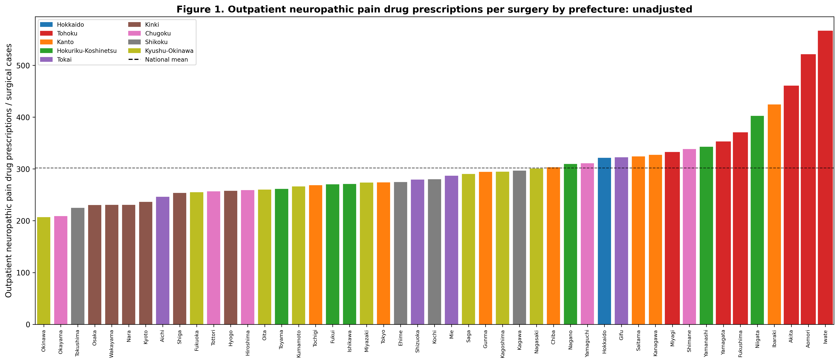
Figure 1. Outpatient neuropathic pain drug prescribing per surgery by prefecture (unadjusted). Bars represent total neuropathic pain prescriptions (pregabalin + mirogabalin + duloxetine + tramadol + neurotropin) divided by inpatient surgical procedure count. Tohoku prefectures (red bars with red borders) cluster at the high end. Dashed line = national mean.

Confounder analysis
Neuropathic pain prescribing showed strong correlations with confounder proxies. Diabetes drug prescribing was the strongest (r = 0.87, P < 0.001), followed by anxiolytics (r = 0.75), antidepressants (r = 0.46), and herpes antivirals (r = 0.19). These collectively explained 81.4% of variance (R² = 0.814 in Model 2; Fig. 2).
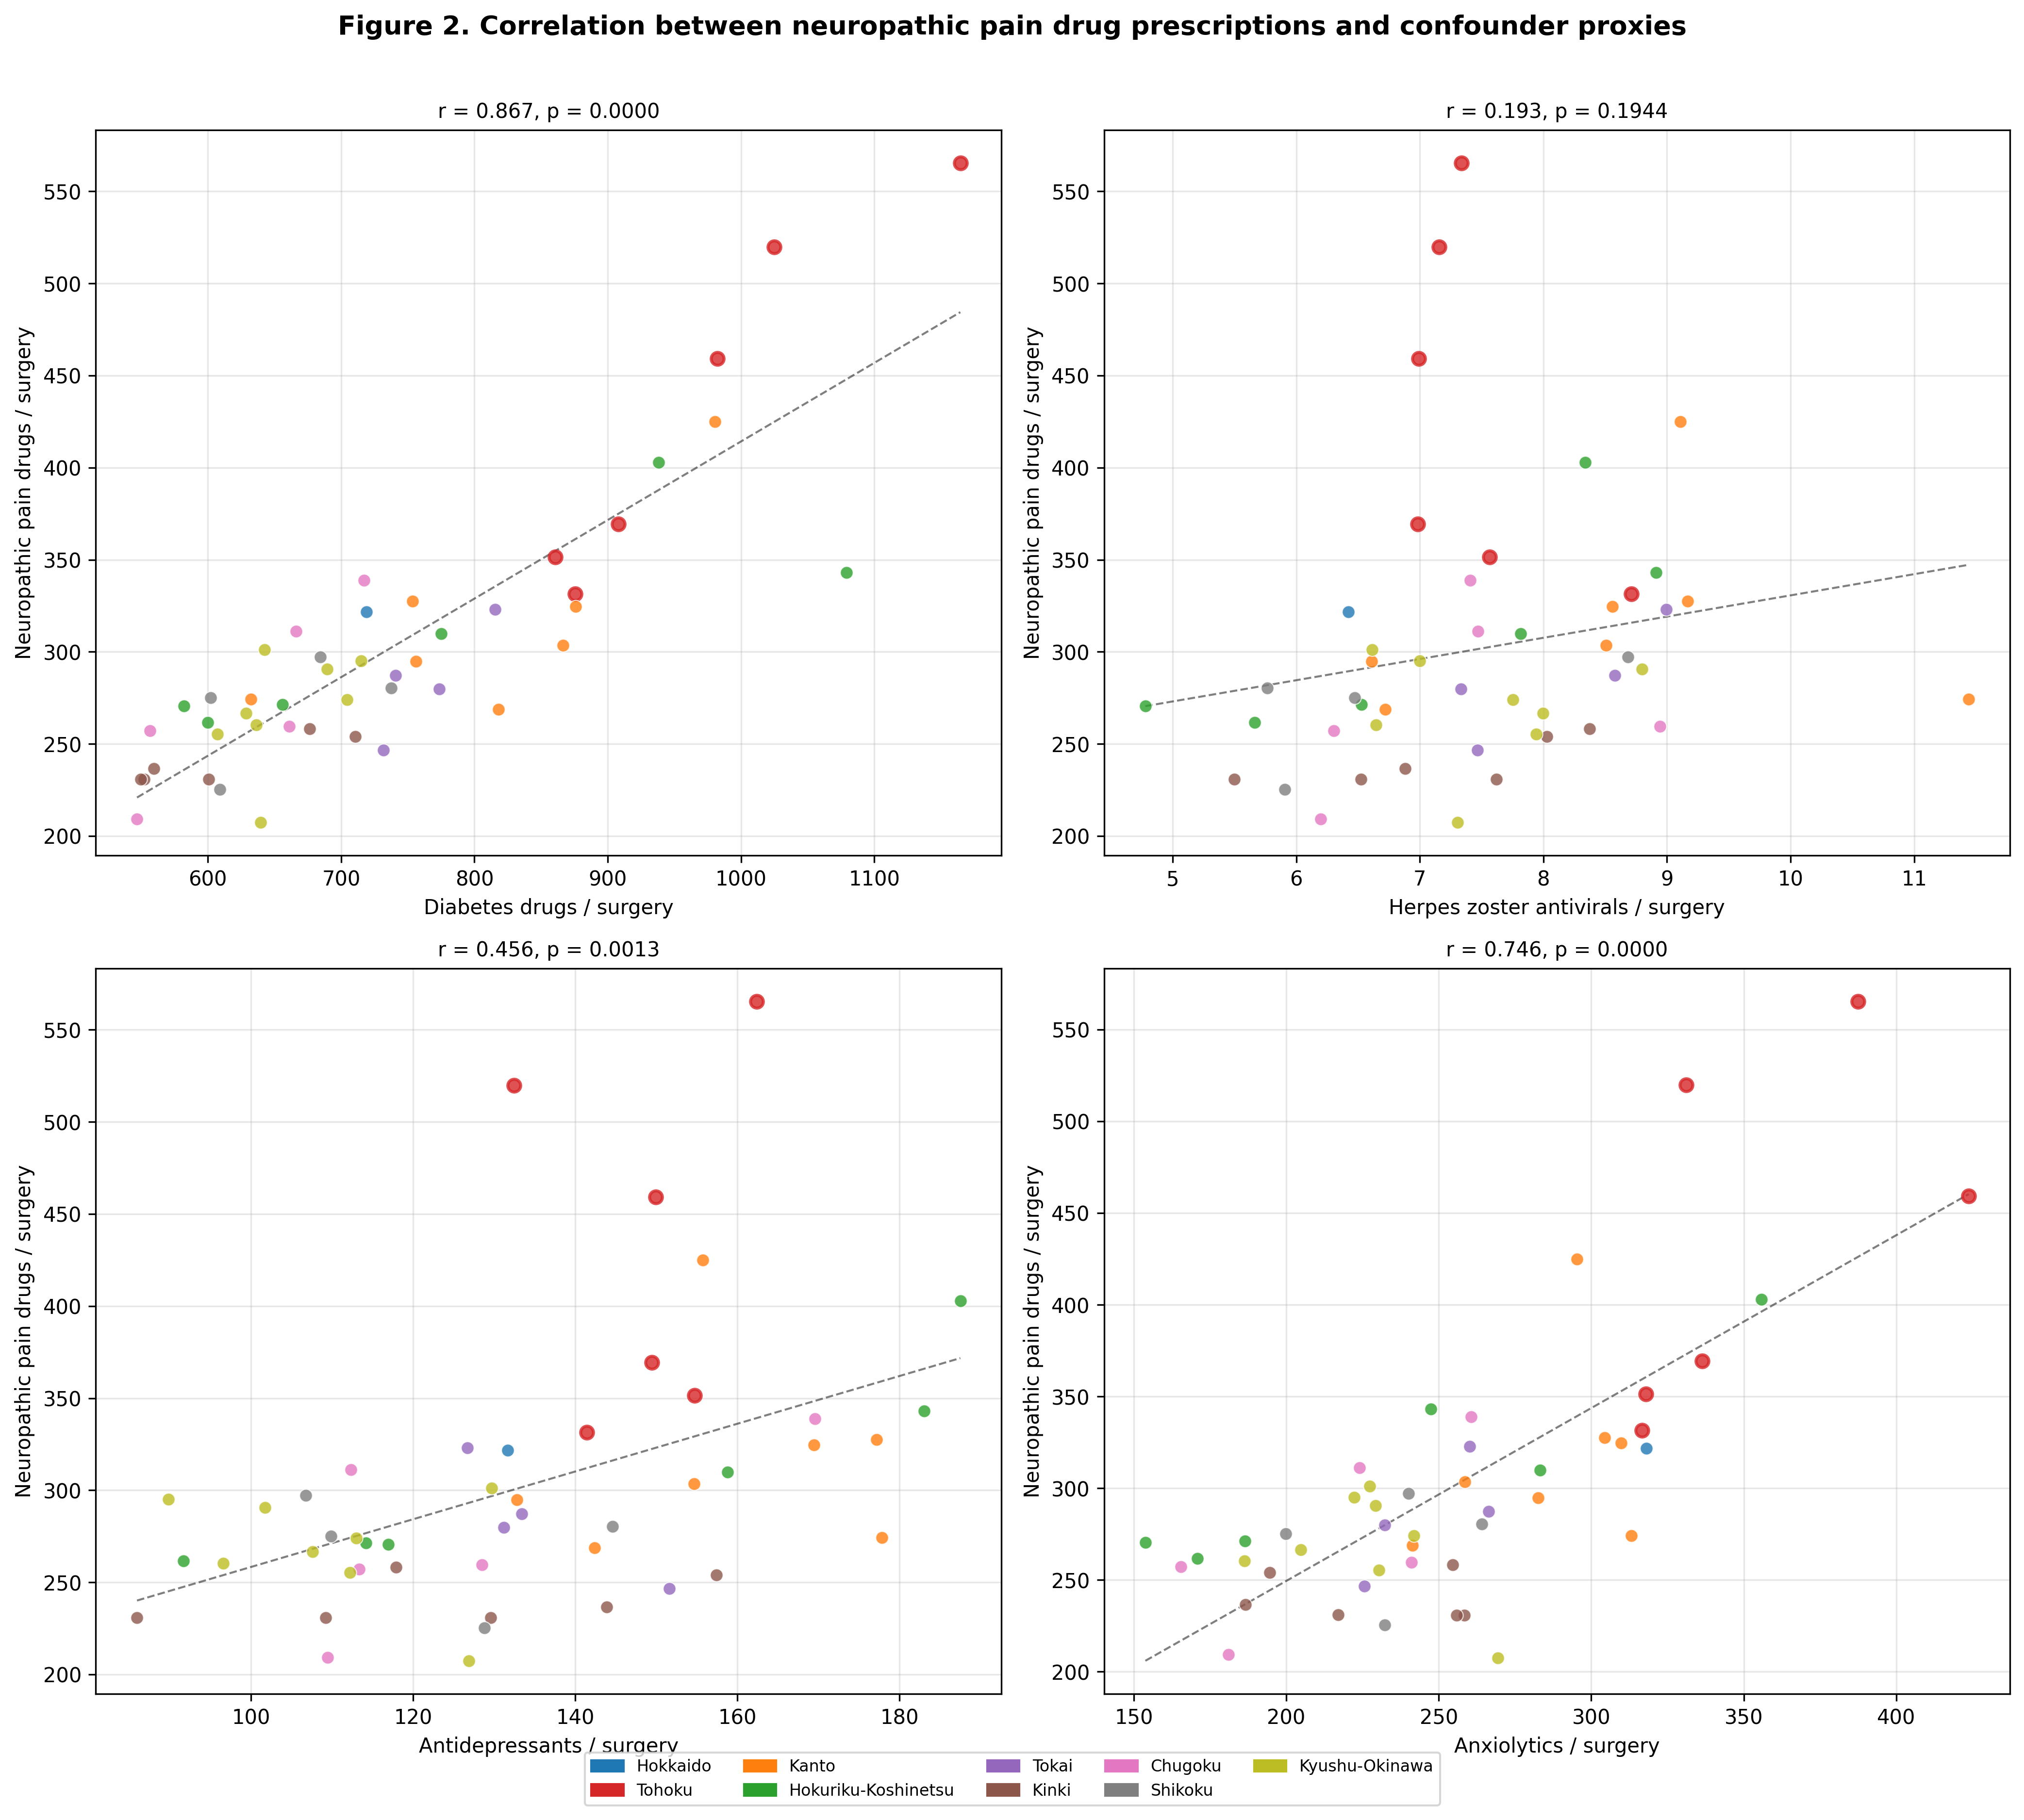
Figure 2. Correlation between outpatient neuropathic pain drug prescribing and confounder disease proxies. Each dot represents one prefecture. Tohoku prefectures are marked with red borders. Diabetes drugs show the strongest correlation (r = 0.87).

Confounder-adjusted analysis
After adjustment for all four confounders, the Tohoku effect was attenuated and became nonsignificant in Model 2 (β = 32.6, P = 0.150). This was consistent across specifications: Model 3 (β = 15.7, P = 0.229), Model 4 (P = 0.863), and Model 5 (β = 31.5, P = 0.149; Table 2).

Table 2. Phase 2: Regression models for outpatient neuropathic pain prescribing with Tohoku indicator and confounder adjustment.
Model | Dependent variable | Tohoku coefficient / effect size | P value | Significance
Model 1 | Unadjusted t-test | d = 2.806 | 7.40e-08 | ***
Model 2 | Neuropathic pain drugs / surgery (fully adjusted) | β = 32.6 | 0.1501 | ns
Model 3 | Core neuropathic drugs (PGB+MGB) (fully adjusted) | β = 15.7 | 0.2292 | ns
Model 4 | Nerve blocks / surgery (fully adjusted) | β = 0.08 | 0.8631 | ns
Model 5 | Neuropathic pain drugs (acute + confounder adj.) | β = 31.5 | 0.1488 | ns
Adj CPSP | Confounder-removed residual | d = 0.437 | 0.3230 | ns
*** P < 0.001; ns = not significant. Models 2–5: multiple linear regression with Tohoku indicator (binary) and confounder disease proxies. Adj CPSP: adjusted CPSP index derived as residuals from regressing neuropathic pain prescribing on four confounder proxies.

The adjusted CPSP index showed a dramatically different pattern from the unadjusted data (Fig. 3). The Tohoku mean shifted from markedly positive to a modest, nonsignificant excess (+12.4 vs -1.8; t = 0.999, P = 0.323; d = 0.44). Chugoku emerged as having the highest adjusted index, while Tokai had the lowest (Fig. 4).
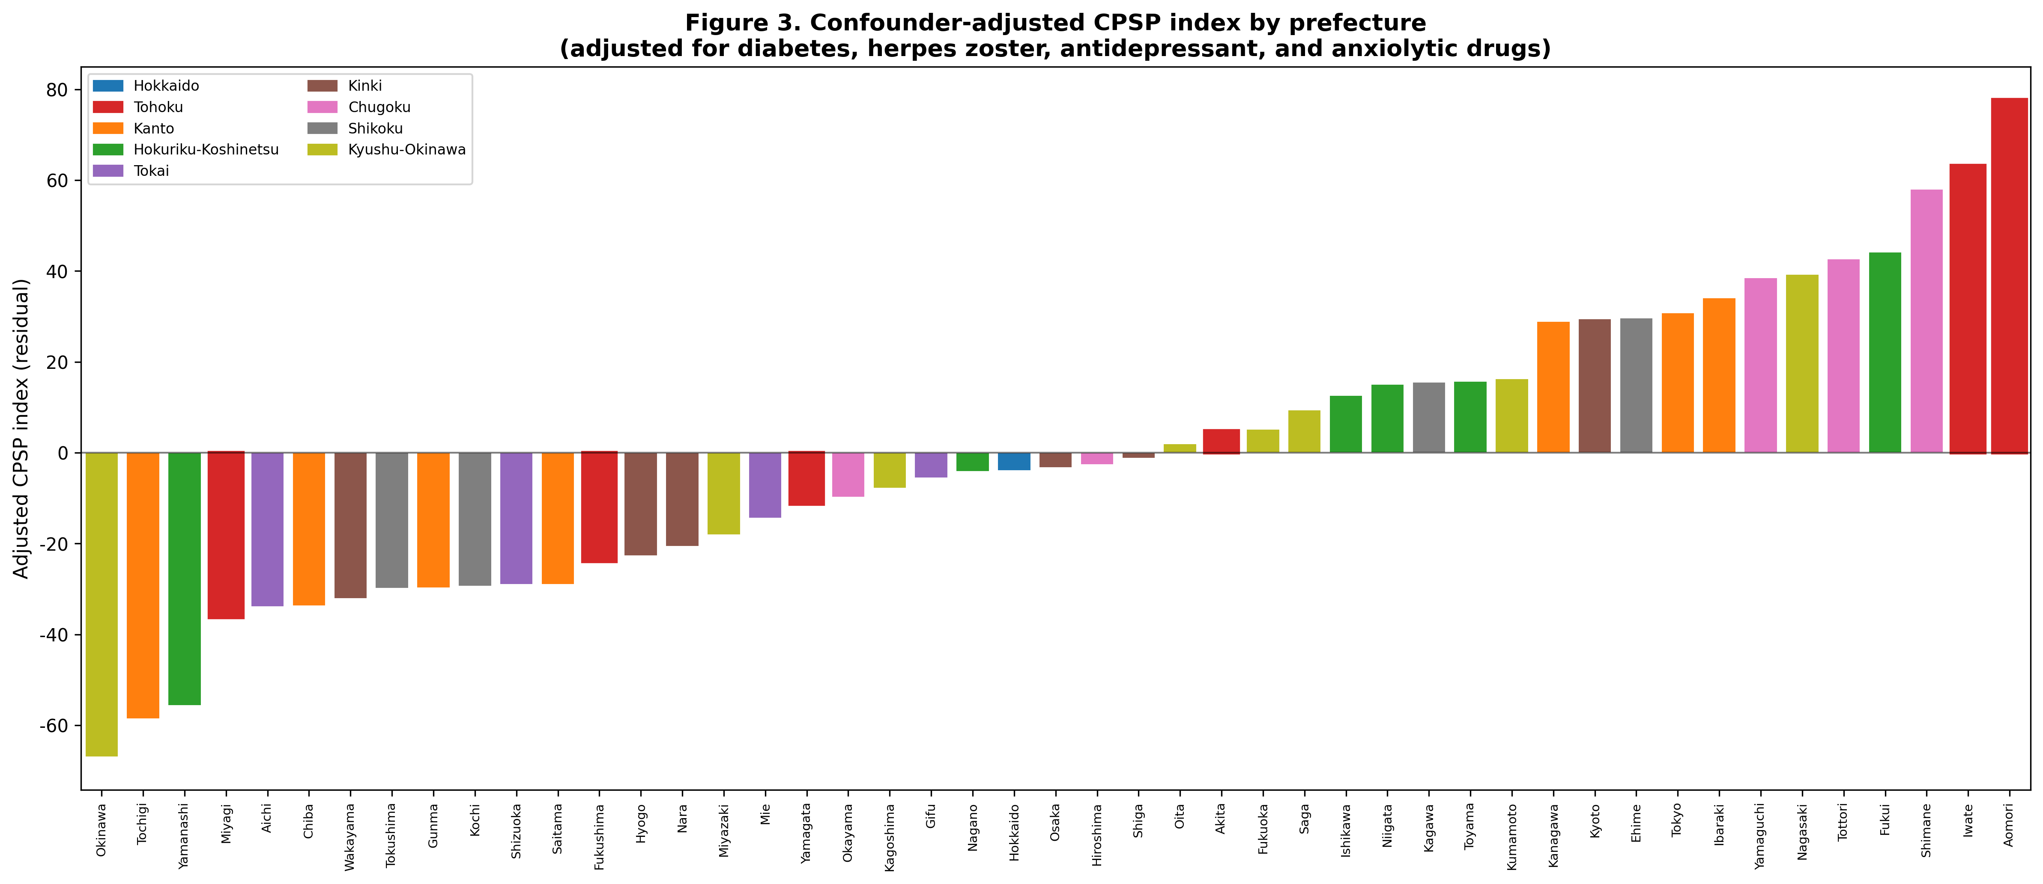
Figure 3. Confounder-adjusted CPSP index by prefecture. Residuals from regressing neuropathic pain prescribing on diabetes drugs, herpes antivirals, antidepressants, and anxiolytics. Positive values indicate higher neuropathic pain prescribing than expected given confounding disease prevalence. Tohoku prefectures (red borders) are dispersed across the distribution after adjustment.

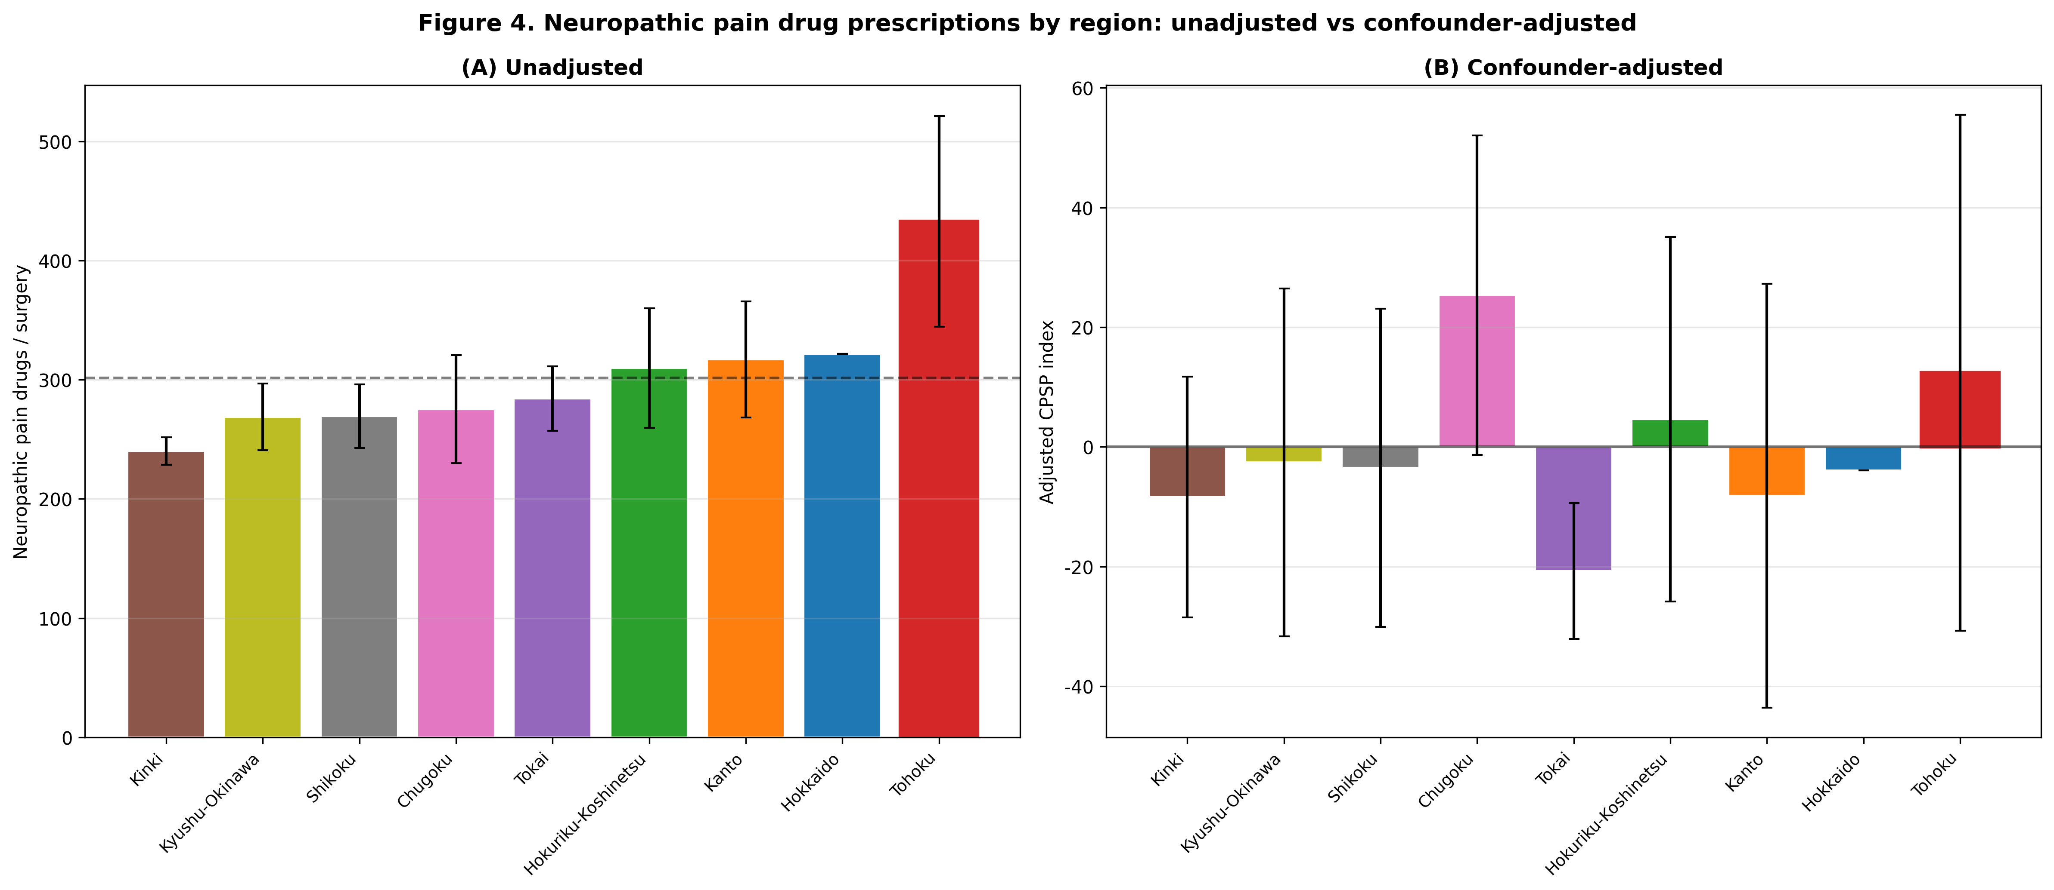
Figure 4. Regional comparison of neuropathic pain prescribing: (a) unadjusted and (b) after confounder adjustment. Tohoku (red border) shifts from the highest region to mid-range after adjustment. Error bars represent standard deviation.

Phase 1–Phase 2 integration
Acute perioperative prescribing correlated positively with unadjusted neuropathic pain prescribing (r = 0.38, P = 0.008; Fig. 5a). After confounder adjustment, this was attenuated (r = 0.29, P = 0.052; Fig. 5b). In Model 5, acute pain index remained a significant predictor (β = 1.90, P = 0.044), while the Tohoku effect remained nonsignificant (β = 31.5, P = 0.149). A comprehensive Z-score heatmap confirmed the heterogeneous multi-variable pattern (Supplementary Fig. 1). After adjustment, the Tohoku effect was attenuated by 84% and became nonsignificant (Table 3).
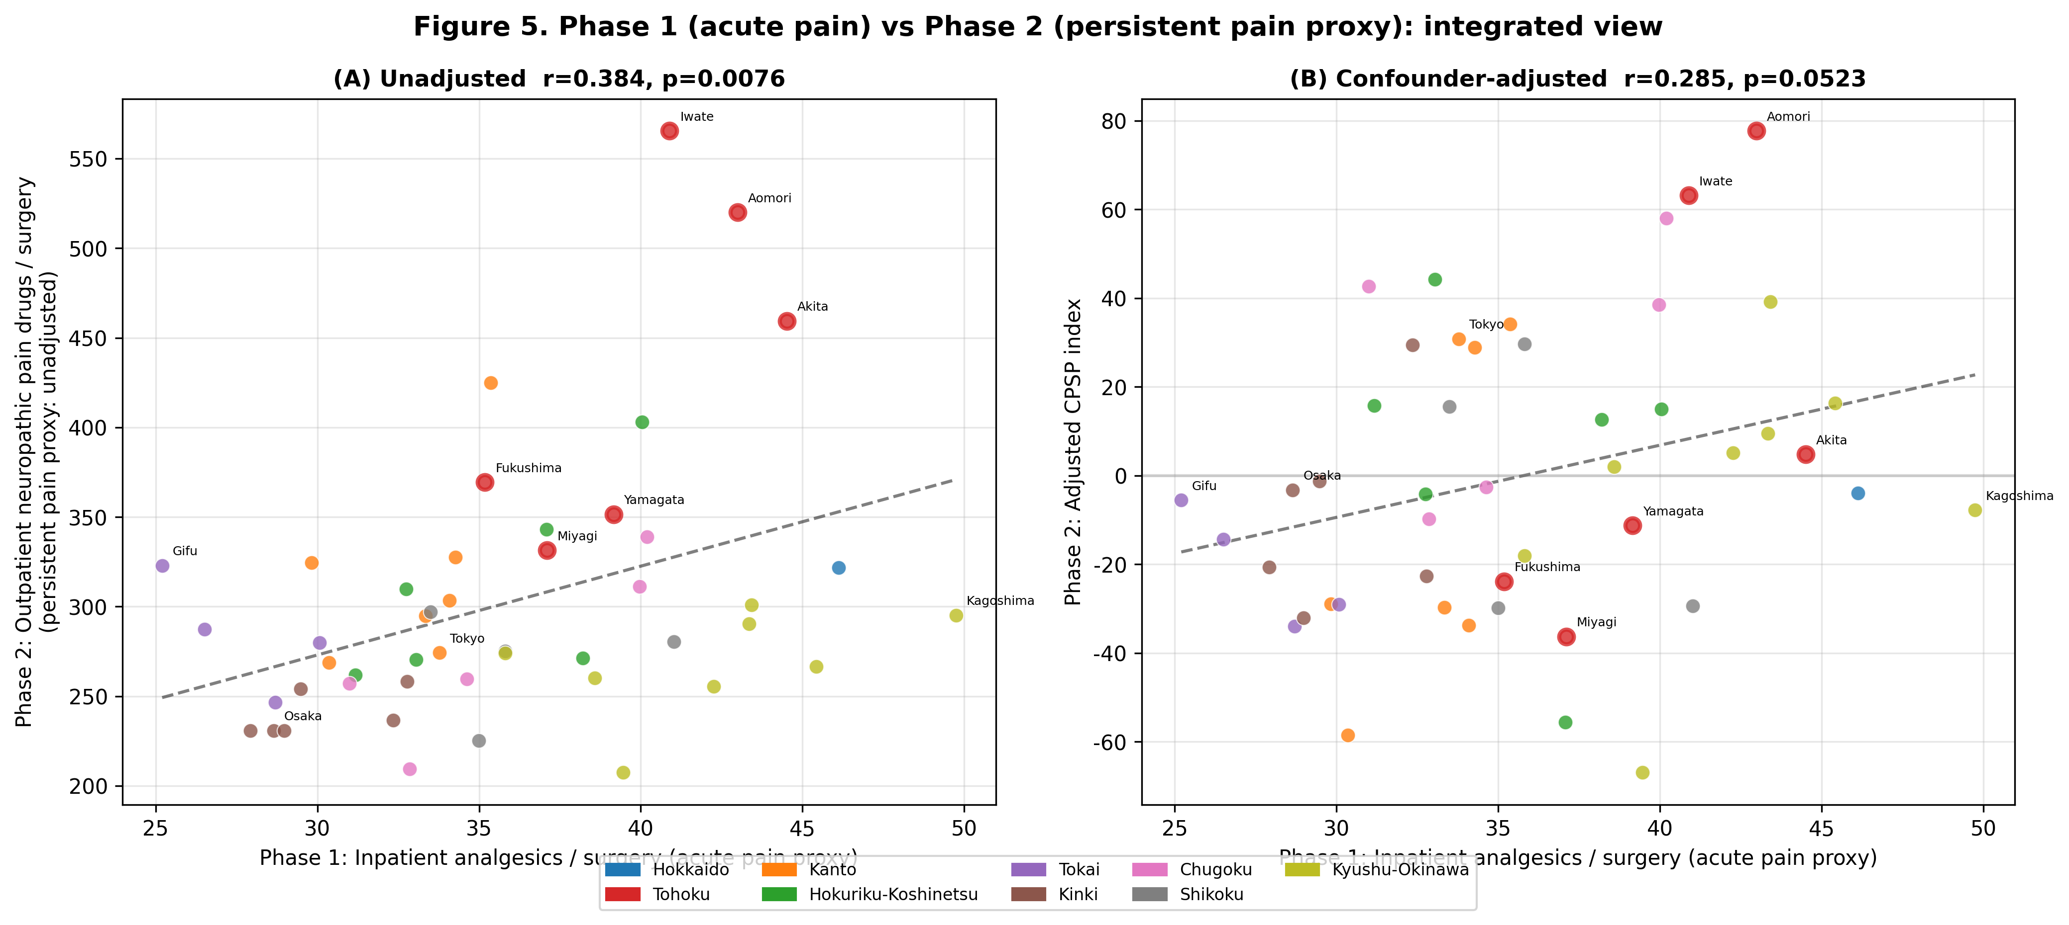
Figure 5. Integration of Phase 1 (acute perioperative analgesic prescribing) and Phase 2 (outpatient neuropathic pain prescribing as CPSP proxy). (a) Unadjusted: positive correlation (r = 0.38, P = 0.008). (b) Confounder-adjusted: attenuated correlation (r = 0.29, P = 0.052). Tohoku prefectures (red borders) cluster in the upper-right quadrant.

Table 3. Effect of confounder adjustment on Tohoku regional indicators.
Metric | Unadjusted | Confounder-adjusted | Change | Interpretation
Cohen's d (Tohoku vs rest) | 2.806 (P < 0.001) | 0.437 (P = 0.323) | 84% attenuation | Large → Small effect
Tohoku mean index | 432.8 | +12.4 (residual) | — | Excess largely explained by confounders
Non-Tohoku mean index | 282.5 | -1.8 (residual) | — | Reference group
Confounders: oral hypoglycemic agents (diabetes proxy), herpes zoster antivirals, antidepressants (excluding duloxetine), and anxiolytics. Adjustment reduced the Tohoku effect by 84% and rendered it nonsignificant.

Discussion
This study is the first to map perioperative and chronic pain-related prescribing across all 47 prefectures of Japan, leveraging freely available NDB Open Data. Three principal findings emerged from this exploratory analysis.

Regional variation within a stoic culture
Despite Japan’s well-documented cultural stoicism toward pain (Hobara, 2005; Feng et al., 2017), we found a 1.97-fold variation in acute perioperative analgesic prescribing across prefectures and significant differences across regional blocks. This parallels findings from other domains: Cohen and Nisbett’s work on the “culture of honor” in the United States demonstrated that even within a single nation, regional cultural norms produce measurably different behavioral outcomes (Cohen et al., 1996). Our finding suggests that Japan’s pain culture is not monolithic; regional demographics, healthcare infrastructure, and local clinical practices generate heterogeneity beneath the surface of a nationally shared cultural norm.

Clinical implications: the danger of monolithic cultural stereotypes
The 1.97-fold within-Japan variation documented here has direct clinical relevance beyond the domestic context. A large body of evidence demonstrates that ethnic and cultural stereotypes influence clinician pain assessment and analgesic prescribing. Anderson et al. showed that racial and ethnic minorities in the United States consistently receive less adequate pain management across acute, chronic, cancer, and palliative settings (Anderson et al., 2009). Campbell and Edwards identified that clinician expectations about a patient’s cultural pain behavior can lead to systematic under- or over-treatment (Campbell and Edwards, 2012). Rogger et al. emphasized that cultural framing affects not only patient reporting but also how clinicians interpret and respond to pain cues (Rogger et al., 2023).
This risk is compounded by the widespread perception of Japan as a culturally and ethnically homogeneous society. The nihonjinron discourse (theories of Japanese uniqueness) has long promoted the notion that Japanese people constitute a uniform population sharing a single set of behavioral norms (Befu, 2001). Yet this “hegemony of homogeneity,” as Befu termed it, is an ideological construct rather than an empirical fact. Burgess showed that this “illusion” of a homogeneous Japan has tangible consequences for social policy and public perception (Burgess, 2010). In the clinical context, the combination of two stereotypes—“Japanese are stoic” and “Japanese are homogeneous”—creates a doubly misleading assumption: that all Japanese patients will tolerate pain equally and require less analgesia. Our finding of 1.97-fold within-Japan variation in analgesic prescribing directly refutes this assumption.
Put simply, there is no such entity as “the Japanese patient” whose pain behavior can be predicted from nationality alone—there are only individual patients from 47 diverse prefectures, each with distinct demographic profiles, clinical environments, and pain-related prescribing cultures. For Japanese patients treated outside Japan, clinicians may be operating under a dual misapprehension: that Japanese culture is uniformly stoic, and that this stoicism translates into lower analgesic need. Our data challenge both premises.
We therefore argue that the monolithic characterization of any national population’s pain behavior carries a risk of clinical harm—and this argument extends well beyond Japan. Whenever clinicians allow cultural stereotypes to narrow the range of treatment options considered for a patient, the patient is placed at a therapeutic disadvantage (Raja et al., 2020). The aspiration behind this study is that fewer patients, regardless of nationality or ethnicity, should suffer the disadvantage of having their treatment options constrained by cultural stereotypes. Individualized pain assessment, rather than culturally stereotyped assumptions, remains the cornerstone of equitable perioperative care.

Pain as an individual experience
Fundamentally, pain is a personal experience. The revised IASP definition describes pain as “an unpleasant sensory and emotional experience associated with, or resembling that associated with, actual or potential tissue damage”—a definition that is inherently subjective (Raja et al., 2020). Our ecological data illustrate this principle at the population level: even within a single nation sharing the same language, insurance system, and broad cultural heritage, pain-related prescribing varies nearly twofold. No cultural label can substitute for direct measurement of a patient’s nociceptive state. Objective nociception monitoring, such as normalized pulse volume as a culture-independent indicator of the nociception–anti-nociception balance (Onishi and Onishi, 2024), may help standardize perioperative assessment regardless of cultural background.

Confounders explain Tohoku’s apparent excess
The most methodologically important finding is that the dramatic regional variation in neuropathic pain prescribing (unadjusted d = 2.81 for Tohoku vs rest) was largely explained by confounding disease proxies. Diabetes drug prescribing alone correlated at r = 0.87 with neuropathic pain prescribing, reflecting the known high prevalence of diabetic neuropathy requiring gabapentinoids. After adjustment, the Tohoku effect was attenuated by 84% and became nonsignificant (Table 3). This has important implications for ecological pain research: studies using neuropathic pain drug prescribing as a population-level CPSP proxy must account for confounding diseases. Without such adjustment, regional differences in diabetes prevalence could be misinterpreted as differences in CPSP. The within-database confounder adjustment demonstrated here—using disease-specific drug proxies from the same data source—provides a replicable framework.

A population-level acute–chronic pain continuum
The positive correlation between Phase 1 (acute) and Phase 2 (chronic, adjusted) indices (r = 0.29, P = 0.052) suggests a modest link between regional acute pain management intensity and subsequent chronic pain-related prescribing. While ecological correlations cannot establish causation, this finding is consistent with individual-level evidence that the intensity of acute postoperative pain is a risk factor for CPSP (Kehlet et al., 2006). Prefectures with relatively low acute analgesic use but high adjusted CPSP indices may warrant investigation for potential under-treatment of acute pain leading to chronification.

Strengths and limitations
Strengths of this study include the use of population-complete data covering all insurance-reimbursed healthcare in Japan, the novel integration of acute and chronic pain proxies, the transparent confounder-adjustment methodology, and the exploratory rather than confirmatory design that allows hypothesis generation. A further strength specific to the perioperative focus is that healthcare access does not confound the analgesic prescribing data: all patients in Phase 1 are inpatients by definition, eliminating the access-to-care heterogeneity that limits community-based pain studies.
The main limitations are inherent to the ecological design. The unit of analysis is the prefecture, not the individual patient; ecological correlations may not reflect individual-level associations (ecological fallacy). NDB Open Data do not contain diagnosis codes, so CPSP cannot be directly identified; the neuropathic pain drug proxy captures all indications, not CPSP specifically. Drug prescribing proxies may not capture disease prevalence accurately (e.g., fibromyalgia has no specific drug proxy and shares pregabalin as first-line treatment). The cross-sectional design cannot distinguish temporal sequences (surgery → acute pain → CPSP), and unmeasured confounders such as age distribution, surgical case mix, and prescribing culture may contribute to residual regional variation.

Implications and future directions
This exploratory study demonstrates that Japan’s NDB Open Data can serve as a hypothesis-generating platform for population-level pain research. Future studies using the NDB sampling dataset (Level 3 access) could enable individual-level longitudinal tracking from surgery to new neuropathic pain prescriptions, providing a direct CPSP measure. Procedure-specific analyses (e.g., total knee arthroplasty, mastectomy) would reduce surgical case-mix confounding. From an international perspective, prospective studies examining how cultural stereotypes influence analgesic prescribing for Japanese patients in multicultural clinical settings would directly test whether the “stoic Japanese” label translates into therapeutic disadvantage. Such research is increasingly urgent as global migration and medical tourism expose more patients to healthcare systems unfamiliar with their cultural background.

Conclusion
Despite Japan’s culturally ingrained norm of pain endurance (gaman), perioperative and chronic pain-related prescribing varies up to 1.97-fold across prefectures. Confounding diseases, particularly diabetes, substantially modify the apparent regional pattern of neuropathic pain prescribing. These findings demonstrate that Japan’s pain culture is not monolithic. Treating “Japanese” as a uniform category for pain behavior risks inadequate analgesia for Japanese patients treated abroad—and the same principle applies to every cultural label applied to any patient population. Individualized pain assessment should replace culturally stereotyped assumptions to ensure equitable perioperative care across all clinical settings.

Acknowledgments
The authors thank the Ministry of Health, Labour and Welfare for making the NDB Open Data publicly available. Parts of data processing and manuscript preparation were assisted by generative AI (Claude, Anthropic). The authors take full responsibility for the accuracy and content of the manuscript.

Author contributions
Tatsuki Onishi: Conceptualization, Data curation, Formal analysis, Investigation, Methodology, Software, Visualization, Writing – original draft, Writing – review & editing.

Conflict of interest statement
The authors have no conflicts of interest to declare.

Funding sources
This research did not receive any specific grant from funding agencies in the public, commercial, or not-for-profit sectors.

Data availability statement
The NDB Open Data used in this study are publicly available from the Ministry of Health, Labour and Welfare website (https://www.mhlw.go.jp/stf/seisakunitsuite/bunya/0000177221_00016.html). Analysis code is available at https://github.com/bougtoir/wip/tree/main/ndb-pain-regional-variation-japan.

References
Anderson, K.O., Green, C.R., Payne, R. (2009). Racial and ethnic disparities in pain: causes and consequences of unequal care. J Pain 10, 1187–1204.
Befu, H. (2001). Hegemony of Homogeneity: An Anthropological Analysis of Nihonjinron. Melbourne: Trans Pacific Press.
Benchimol, E.I., Smeeth, L., Guttmann, A., Harron, K., Moher, D., Petersen, I., Sorensen, H.T., von Elm, E., Langan, S.M. (2015). The REporting of studies Conducted using Observational Routinely-collected health Data (RECORD) statement. PLoS Med 12, e1001885.
Burgess, C. (2010). The “illusion” of homogeneous Japan and national character: discourse as a tool to transcend the “myth” vs. “reality” binary. Asia Pac J 8(9), 1–22.
Callister, L.C. (2003). Cultural influences on pain perceptions and behaviors. Home Health Care Manag Pract 15, 207–211.
Campbell, C.M., Edwards, R.R. (2012). Ethnic differences in pain and pain management. Pain Manag 2, 219–230.
Cohen, D., Nisbett, R.E., Bowdle, B.F., Schwarz, N. (1996). Insult, aggression, and the southern culture of honor: an “experimental ethnography.” J Pers Soc Psychol 70, 945–960.
Feng, Y., Herdman, M., van Nooten, F., Cleeland, C., Parkin, D., Ikeda, S., Igarashi, A., Devlin, N.J. (2017). An exploration of differences between Japan and two European countries in the self-reporting and valuation of pain and discomfort on the EQ-5D. Qual Life Res 26, 2067–2078.
Hobara, M. (2005). Beliefs about appropriate pain behavior: cross-cultural and sex differences between Japanese and Euro-Americans. Eur J Pain 9, 389–393.
Kehlet, H., Jensen, T.S., Woolf, C.J. (2006). Persistent postsurgical pain: risk factors and prevention. Lancet 367, 1618–1625.
Kumagai, S. (2020). Media representations reproducing images of Tohoku: the Tohoku reconstruction corner in “Secret Kenmin SHOW.” Kotoba 41, 21–38. [in Japanese]
Matsuoka, Y., Morishima, T., Sato, A., Ogawa, T., Miyashiro, I. (2025). Population-based claims study of regional and hospital function differences in opioid prescribing for cancer patients who died in hospital in Japan. Jpn J Clin Oncol 55, hyaf149.
Ministry of Health, Labour and Welfare. (2024). NDB Open Data, 10th edition. Available: https://www.mhlw.go.jp/stf/seisakunitsuite/bunya/0000177221_00016.html. Accessed January 15, 2025.
Okolo, C.A., Olorunsogo, T., Babawarun, O. (2024). Cultural variability in pain perception: a review of cross-cultural studies. Int J Sci Res Arch 11, 2550–2556.
Onishi, T., Onishi, Y. (2024). Normalized pulse volume as a superior predictor of respiration recovery and quantification of nociception anti-nociception balance compared to opioid effect site concentration: a prospective, observational study. F1000Research 13, 233.
Pfizer Japan Inc. (2017). 47-prefecture survey on chronic pain. Available: https://www.pfizer.co.jp/pfizer/company/press/2017. Accessed February 1, 2025.
Raja, S.N., Carr, D.B., Cohen, M., Finnerup, N.B., Flor, H., Gibson, S., Keefe, F.J., Mogil, J.S., Ringkamp, M., Sluka, K.A., Song, X.J., Stevens, B., Sullivan, M.D., Tutelman, P.R., Ushida, T., Vader, K. (2020). The revised International Association for the Study of Pain definition of pain: concepts, challenges, and compromises. Pain 161, 1976–1982.
Rogger, R., Bello, C., Romero, C.S., Urman, R.D., Luedi, M.M., Filipovic, M.G. (2023). Cultural framing and the impact on acute pain and pain services. Curr Pain Headache Rep 27, 429–436.
Takeda, K., Yarimizu, K. (2016). Regional differences in the pain expression uzuku. NINJAL Research Papers 10, 85–107. [in Japanese]
von Elm, E., Altman, D.G., Egger, M., Pocock, S.J., Gotzsche, P.C., Vandenbroucke, J.P. (2007). The Strengthening the Reporting of Observational Studies in Epidemiology (STROBE) statement: guidelines for reporting observational studies. Lancet 370, 1453–1457.
Wakaizumi, K., Tanaka, C., Shinohara, Y., Wu, Y., Takaoka, S., Kawate, M., Oka, H., Matsudaira, K. (2024). Geographical variation in high-impact chronic pain and psychological associations at the regional level: a multilevel analysis of a large-scale internet-based cross-sectional survey. Front Public Health 12, 1482177.
Zborowski, M. (1969). People in Pain. San Francisco: Jossey-Bass.

Supplementary material
Supplementary Figure 1. Z-score heatmap of all indices by prefecture. Each row represents a variable; each column represents a prefecture, sorted by neuropathic pain prescribing. Red = above average; blue = below average. Tohoku prefectures are marked with red vertical lines. The adjusted CPSP index shows a different pattern from the raw neuropathic index.

