Supporting Information
Population structure, not special connections: a dependence-aware baseline for archaic-segment sharing across 66 human populations
Figure S1. Complete 66-population Neanderthal and Denisovan profile-similarity matrices.
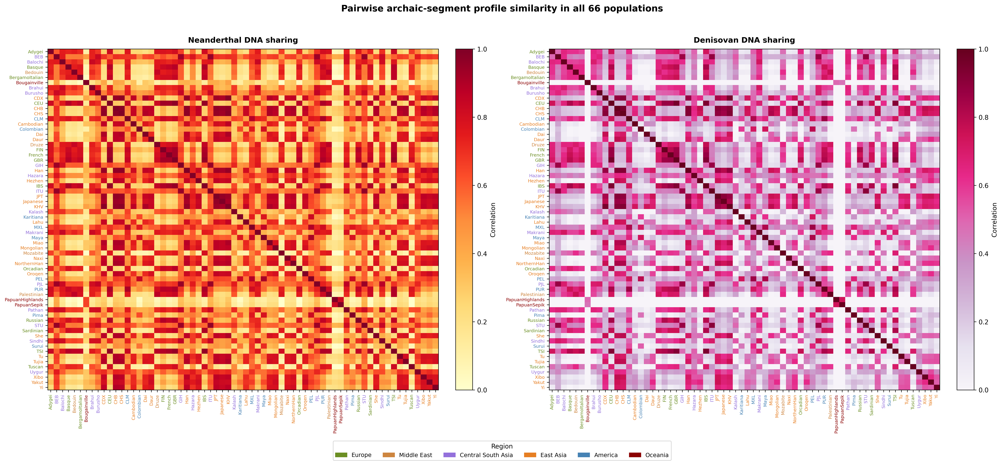

Figure S2. Minard-style schematic of human dispersal and archaic introgression. Band widths, branch positions, and event placement are illustrative and do not estimate migration magnitude, ancestry proportion, or a route supported by the present analysis.
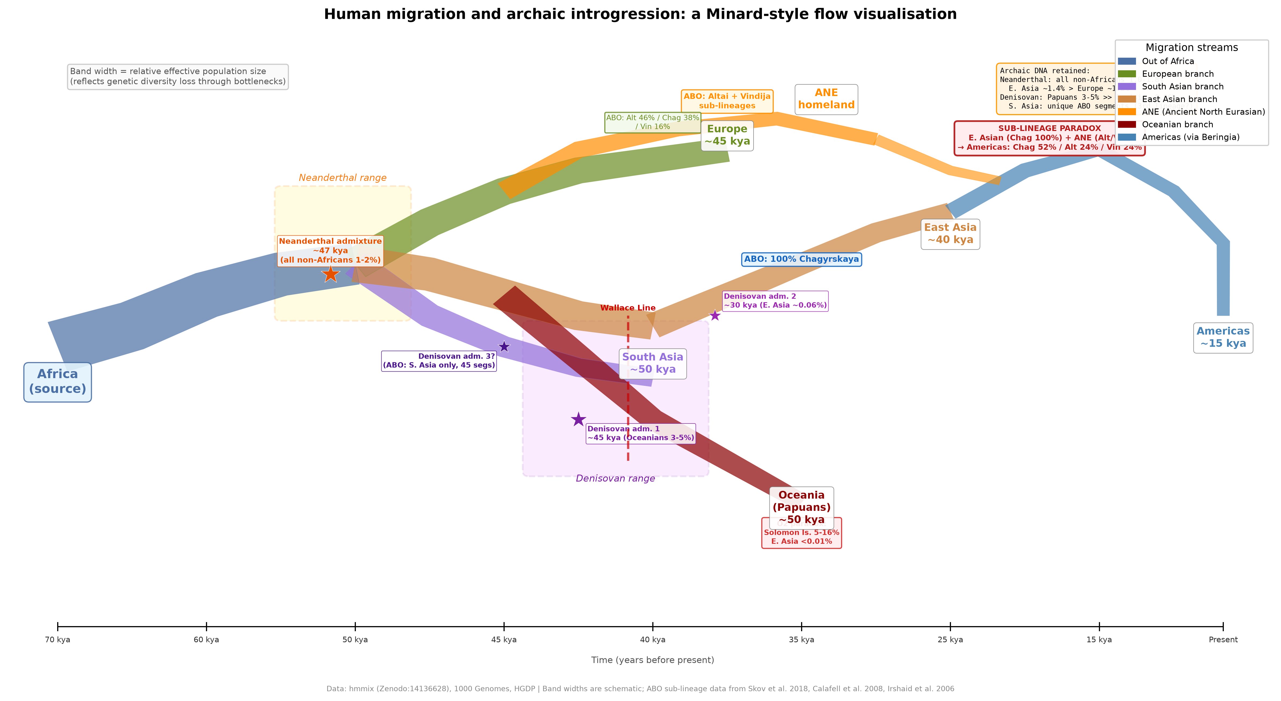

Figure S3. O2 blood-group subtype-defining allele frequencies and ABO-window segment-carrier frequencies. The panels use different sources and are not an association analysis; proximity does not establish that the O2 allele is Neanderthal-derived.
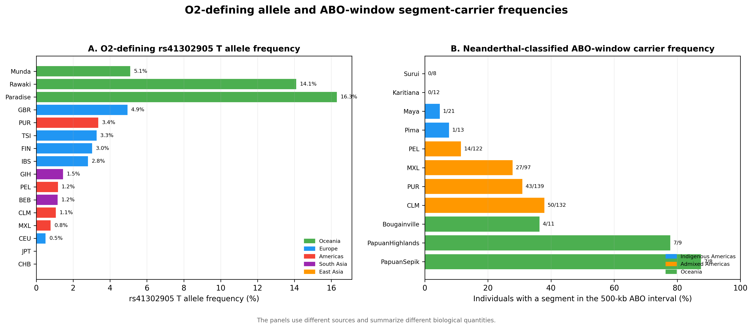

Figure S4. Ancient North Eurasian contextual hypothesis. Dashed arrows represent a testable narrative, not evidence that either observed segment followed the illustrated route.
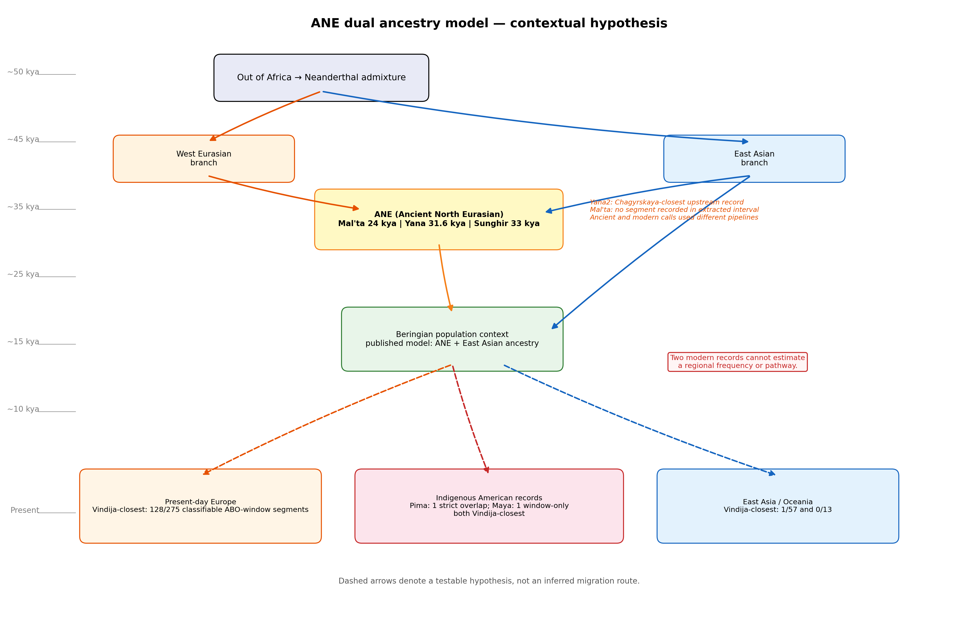

Figure S5. Descriptive ancient and modern ABO-window summaries generated by different pipelines; no formal temporal comparison is made.
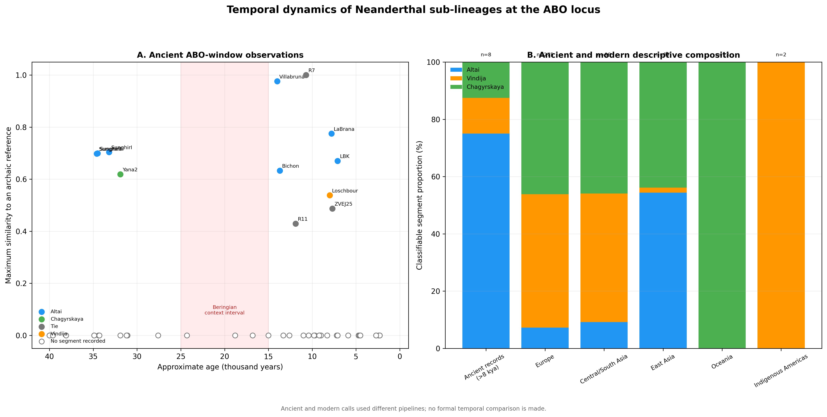

Figure S6. Literature-derived global context. Circle size represents approximate Neanderthal ancestry and color intensity represents approximate Denisovan ancestry. Values were not used in the pairwise statistical models.
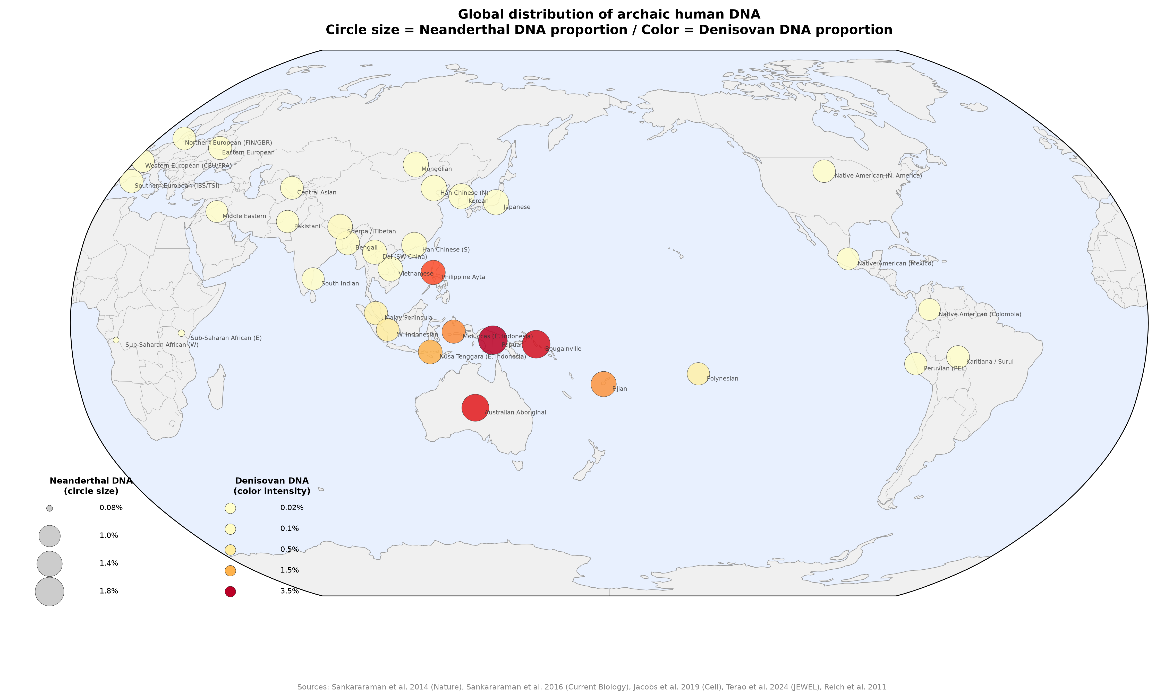

Supplementary Data Files
Supplementary Data 1: population_metadata.csv. Population, project, sample size, coordinates, continent assignment, and analysis inclusion.
Supplementary Data 2: pairwise_sharing_corrected.csv. Complete pairwise similarity, geographic, covariate, residual, permutation, and false discovery rate results.
Supplementary Data 3: model_summary.csv. Quadratic assignment procedure coefficients, permutation P values, descriptive R-squared values, and population-deletion intervals.
Supplementary Data 4: sensitivity_analysis.csv and window_size_sensitivity.csv. Metric, population-subset, and window-size robustness summaries.

