TITLE PAGE

Evaluating Healthcare Expenditure Sustainability in Japan: A Dual-Return Framework Integrating Input-Output Multipliers, Health-Capital Tempo, and Diagnostic Equipment Stock with Cross-Country Benchmarking

Tatsuki Onishi [1]*

[1] [Affiliation to be completed by author]

*Corresponding author: Tatsuki Onishi, [Affiliation]. E-mail: [to be completed]

Short title: Japan Healthcare I-O Sustainability

Total word count: approximately 7,800 words (Text, References, Tables, and Figure Legends)

Number of figures: 9
Number of tables: 5

Abstract
Background: Japan's healthcare expenditure (11.0% of GDP) is conventionally treated as a fiscal cost to be contained, particularly given rapid population aging. However, healthcare is also a major economic sector whose demand-side and supply-side returns are rarely quantified together. This study evaluates the sustainability of Japan's healthcare expenditure through a dual-return framework integrating input-output (I-O) multipliers, health-capital tempo effects, and diagnostic equipment stock valuation, with cross-country benchmarking across 13 OECD countries.
Methods: We compiled healthcare sector I-O output multipliers for 13 OECD countries from published national and EU-28 framework studies. A fiscal return ratio (effective tax rate times output multiplier divided by public financing share) was computed for each country, with sensitivity analyses using approximate value-added multipliers and deficit-adjusted denominators. The tempo model from a companion analysis (39 countries, 2000-2019) was integrated to capture supply-side health-capital accumulation; model selection used LOOCV RMSE, AIC, and BIC. Equipment density and import leakage effects on effective multipliers were modeled, and counterfactual scenarios were constructed for Japan with sensitivity analysis around the equipment-related CHE share assumption (5-25%).
Results: Using output multipliers, the demand-side fiscal return ratio exceeded 1.0 in five of thirteen countries (France 1.18, Italy 1.13, Japan 1.09, Sweden 1.04, Finland 1.04). With value-added multipliers, no country exceeded 1.0, indicating that the output multiplier provides an upper bound. Japan's ratio fell from 1.09 to 1.04 after adjusting for 5% import leakage. Counterfactual analysis showed that reducing equipment density to the OECD average would lower the ratio to 0.98 (95% sensitivity range 0.94-1.02 for equipment share 5-25%), indicating that the sustainability conclusion is sensitive to this assumption. The tempo model confirmed a spending-to-outcome lag (M1 vs M0: RMSE 0.441 vs 0.510, LOOCV 0.472 vs 0.538); however, the time-varying extension (M2 vs M1) showed only marginal improvement that did not survive BIC penalization.
Conclusions: Japan's healthcare expenditure generates substantial demand-side economic returns via I-O multiplier effects. However, whether these returns fully cover public costs depends on methodological assumptions, including multiplier type (output vs value-added), deficit financing treatment, and equipment-related spending share. Japan's high diagnostic equipment density contributes to the economic return but its net effect on sustainability requires evaluation alongside over-supply risks and workforce constraints. The findings support integrating economic return analysis into healthcare policy evaluation, while cautioning against deterministic sustainability claims.

Keywords: Healthcare expenditure; Input-output analysis; Economic multiplier; Health capital; Sustainability; Diagnostic imaging; Japan; Super-aged society; Deficit financing; OECD

Background
Since the Cabinet's 'Basic Policies on Economic and Fiscal Management' decision in 2005, the Japanese government has pursued policies to moderate the growth of national medical care expenditure. Japan's current health expenditure (CHE) reached 11.0% of GDP in 2019, ranking fifth among 38 Organisation for Economic Co-operation and Development (OECD) countries⁴. With rapid population aging -- the proportion of the population aged 65 and over exceeded 28% in 2019, the highest among OECD nations -- the 'sustainability' of healthcare spending has become a central policy concern⁵.
Japan faces a uniquely challenging fiscal context: its general account deficit dependency ratio has exceeded 30% in recent years, meaning that roughly one-third of government expenditures are financed by bond issuance rather than current tax revenue²⁵. The national debt-to-GDP ratio exceeds 250%, the highest among advanced economies³⁰. Healthcare expenditure, which constitutes approximately 12% of general account expenditures, is thus partially financed by deficit spending. Moreover, Japan's super-aged society -- characterized by a growing elderly demographic (projected 35% aged 65+ by 2040) alongside a shrinking workforce (projected 20% decline by 2040) -- places structural pressure on both the revenue and expenditure sides of healthcare financing.
A distinctive feature of Japan's system is the Late-Stage Elderly Healthcare System (Kouki Koreisha Iryo Seido), which provides a separate insurance framework for individuals aged 75 and over²⁶. Unlike many European countries where the institutional framework remains unified, with the elderly protected through subsidized premiums or exemptions, Japan changes the actual insurance 'container' upon reaching age 75. This system is financed by a combination of patient co-payments (10-30%), premiums from enrollees, cross-subsidies from working-age insurance schemes, and public subsidies. The increasing weight of this system -- already covering approximately 18 million enrollees -- is a key driver of aggregate healthcare expenditure growth.
This discourse has almost uniformly treated healthcare expenditure as a 'cost' -- an expense to be minimized through efficiency gains, volume controls, and fee schedule revisions. Yet healthcare is also a major economic sector. It purchases inputs from pharmaceuticals, medical devices, and information technology; it employs millions of workers; and these workers spend their incomes, generating further economic activity throughout the economy. Maeda estimated that Japan's healthcare sector supports 6.89 million jobs in total (2.95 million direct, approximately 4 million indirect), with production-inducement effects exceeding those of any other service industry including construction and education⁶.
Input-output (I-O) analysis, pioneered by Leontief, quantifies how final demand in one sector induces production across the entire economy through direct, indirect, and induced effects. Yamada and Imanaka reported a healthcare I-O output multiplier of 2.78 (95% confidence interval [CI]: 2.74-2.90) for Japan¹, meaning that each unit of healthcare spending generates 2.78 units of total economic output. Output multipliers ranging from 1.7 to 2.9 have been estimated across OECD countries^{2,3,20}. It is important to note that these are output multipliers -- they measure total output induced, not value added (GDP contribution). Value-added multipliers, which exclude intermediate consumption, are typically 40-60% smaller³. This distinction is critical when relating multiplier effects to tax revenues, which are levied on value added and income rather than gross output.
On the supply side, health has long been recognized as a component of human capital that generates long-term economic returns. Mushkin conceptualized health as an investment with returns analogous to education¹², and Grossman's health-capital model formally describes individual health stock as accumulated through investment and depreciated by aging and disease¹³. At the macro level, Bloom, Canning, and Sevilla demonstrated that improved population health raises total factor productivity¹⁴. Barro estimated that a one-year increase in life expectancy at birth raises GDP growth by approximately 0.04 percentage points¹⁵.
The Health-Led Growth Hypothesis (HLGH) synthesizes these supply-side effects, positing bidirectional Granger causality between health expenditure and GDP growth. Multiple studies have confirmed this relationship across OECD and developing countries using diverse econometric specifications⁷⁻¹¹.
A further analytical dimension comes from the Bongaarts-Feeney tempo framework. Bongaarts and Feeney demonstrated that rising mean age at childbearing mechanically depresses the period total fertility rate even when cohort fertility is unchanged¹⁶. Goldstein, Lutz, and Scherbov introduced the parity-specific variance sigma, substantially improving tempo adjustment¹⁷. Onishi ported this quantum-tempo decomposition to capital accounting, introducing the investment-to-output time-to-build lag as an analogous 'forgotten parameter' in GDP accounting¹⁸. Extension to healthcare (termed 'Candidate A-H')¹⁹ models the spending-to-outcome lag and revealed a tempo drift of +0.15 yr/yr across 39 countries (2000-2019).
Japan is also known for its extremely high diagnostic imaging equipment density^{4,23}. Japan has 115.7 computed tomography (CT) scanners per million population, approximately 4.3 times the OECD median, and 55.2 magnetic resonance imaging (MRI) units per million, approximately 2.9 times the OECD median. This high density is frequently cited as evidence of 'excess' in the Japanese healthcare system. Simultaneously, Japan is a net importer of medical devices and pharmaceuticals, with import leakage representing approximately 5.0% of CHE²⁴.
An important structural context is Japan's physician density: at 2.5 physicians per 1,000 population, Japan ranks among the lowest in the OECD (average 3.7)²⁷. This low physician density, combined with free access to specialists and the world's highest diagnostic equipment density, raises questions about the sustainability of current service levels, particularly as work-style reform legislation limits physician overtime²⁸.
The aim of this study was to (1) evaluate the sustainability of Japan's healthcare expenditure from a neutral standpoint as both cost and economic effect, using a dual-return framework integrating demand-side I-O multipliers and supply-side health-capital tempo effects, (2) quantify the role of diagnostic equipment stock and import leakage, (3) construct counterfactual scenarios with sensitivity analysis, and (4) benchmark Japan against 12 additional OECD countries.

Methods

Study design and data sources
This study is a cross-country ecological analysis using publicly available data from OECD Health at a Glance 2023^{4,23}, the World Bank World Development Indicators²¹, published I-O studies of healthcare sectors^{1-3,6,20}, Health-Led Growth Hypothesis panel studies⁷⁻¹¹, pharmaceutical/device trade statistics²⁴, and Japanese fiscal data from the Ministry of Finance²⁵ and Bank of Japan³⁰. As an analysis of publicly available aggregate data, no ethical approval was required.

Country selection
Thirteen OECD countries were selected based on availability of healthcare sector I-O multiplier estimates: Japan, USA, Germany, Australia, Korea, Italy, France, UK, Canada, Sweden, Spain, Netherlands, and Finland. All countries had either a direct I-O study published in a peer-reviewed journal or backward-linkage coefficients from the EU-28 framework study³.

Fiscal return ratio
For each country, we calculated a demand-side fiscal return ratio as an indicator of whether healthcare-induced economic activity generates sufficient tax revenue to cover public healthcare costs:
Fiscal Return Ratio = (τ × m) / pf
where τ is the effective tax rate (total tax and social insurance contributions as a proportion of GDP), m is the healthcare sector I-O output multiplier, and pf is the public financing share of CHE.
A critical methodological caveat must be noted: the I-O multipliers used in this study are output multipliers, measuring total production induced per unit of final demand. These differ from value-added (VA) multipliers, which measure the GDP contribution by subtracting intermediate inputs. Because the effective tax rate τ is expressed as tax revenue divided by GDP (a value-added measure), multiplying τ by an output multiplier conflates output and value added, potentially overstating the induced tax revenue. We therefore present results using both output multipliers (as an upper bound) and approximate VA multipliers (output multiplier times the sector-specific VA/output ratio, approximately 0.55-0.60 for healthcare in OECD countries³) as a more conservative estimate. Neither estimate accounts for opportunity costs: in an economy near full employment, resources employed in healthcare would generate alternative output and tax revenue elsewhere, reducing the net fiscal return attributable to healthcare spending.
Additionally, we computed a deficit-adjusted variant of the ratio. When the public financing share is partly funded by deficit (bond) issuance rather than current taxation, a ratio above 1.0 reflects only a temporary flow of single-year tax revenue and does not account for the long-term cost of servicing the accumulated debt^{25,30}. For Japan, the general account deficit dependency ratio was approximately 35% in recent fiscal years. We report results both with and without this adjustment.

Tempo model specification
The tempo model, fully specified in the companion proof-of-concept (publicly available at ref 19), captures supply-side health-capital accumulation. The model treats health expenditure as a stock-building flow with a time-varying spending-to-outcome lag:
LE(t) = α + β · H_stock(t) + ε(t)
where LE(t) is life expectancy at birth, H_stock(t) is the health-capital stock constructed via perpetual inventory method from per-capita health expenditure (PPP) using World Bank data (2000-2019, 39 countries). The investment-to-outcome lag is specified as:
μ_H(t) = μ_H0 + μ_H1 × (year − t₀)
Three model variants were compared: M0 (flow-only, no lag, 2 parameters), M1 (constant lag μ* = 4 years, 3 parameters), and M2 (time-varying lag, 5 parameters: intercept, slope, μ_H0, μ_H1, and drift variance). The dependent variable was life expectancy at birth; estimation was by nonlinear least squares with grid search over the lag parameters. Key M2 point estimates: μ_H0 = 3.2 years (SE = 0.8), μ_H1 = +0.15 yr/yr (SE = 0.04), where μ_H0 is the initial spending-to-outcome lag and μ_H1 is the annual drift in this lag¹⁹.

Model selection criteria
To ensure symmetric application of model selection criteria across all analyses (as applied to the Preston Curve test below), we evaluated all tempo model variants using: (a) in-sample level RMSE, (b) change RMSE, (c) leave-one-out cross-validation (LOOCV) RMSE, (d) Akaike Information Criterion (AIC), and (e) Bayesian Information Criterion (BIC). AIC and BIC penalize model complexity, with BIC imposing a heavier penalty for additional parameters. All criteria are reported in Table 3.

Equipment stock and import leakage model
Diagnostic imaging equipment density was defined as the sum of CT scanners and MRI units per million population²³. Medical import leakage was calculated as the net imports of pharmaceuticals (HS30) and medical devices (HS9018-22) divided by CHE²⁴. The effective I-O multiplier was defined as:
m_eff = m × (1 − import leakage rate)

Counterfactual scenarios and sensitivity analysis
Three counterfactual scenarios were constructed for Japan. Scenario A assumed Japan's equipment density was reduced to the OECD median. The transmission chain is modeled explicitly: (i) equipment density reduction implies proportionally lower equipment-related healthcare spending; (ii) we estimate that equipment-related spending comprises approximately 15% of CHE (based on OECD health capital expenditure accounts; this is an approximation subject to sensitivity analysis); (iii) the reduction in domestic equipment-related spending reduces the I-O multiplier by half the proportional equipment share reduction, reflecting that some equipment spending flows to imports rather than domestic production; (iv) the effective multiplier is then further adjusted for import leakage.
Scenario B assumed complete domestic manufacturing (zero import leakage); Scenario C combined both adjustments. Because the equipment-related CHE share (15%) is an approximation, we conducted sensitivity analysis varying this parameter from 5% to 25% in 5-percentage-point increments (Table 5, Figure 9).

Preston Curve overfit test
The relationship between CHE (as a percentage of GDP) and life expectancy was analyzed using nested-model F-tests²². Models were fit with and without the US, and compared using F-statistics, AIC, BIC, and LOOCV RMSE.

Results

I-O multipliers and fiscal return ratios
Table 1 presents the healthcare sector I-O output multipliers for the 13 selected countries. Japan had the highest multiplier at 2.78 (95% CI: 2.74-2.90)¹, followed by France (2.20), Germany (2.10), and Sweden (2.05). The US had the lowest multiplier at 1.70²; however, the US estimate is based on Medicare spending only, which is not directly comparable to whole-sector multipliers for other countries. The multiplier estimates also differ in estimation year (2006-2017) and method (direct national I-O studies vs EU-28 backward-linkage coefficients), and these differences limit strict cross-country comparison. Figure 2 displays the multipliers.
Table 1. Healthcare sector I-O output multipliers
Country | Output Multiplier | Year | Source
Japan | 2.78 | 2011 | Yamada & Imanaka 2015
Japan (JMARI) | 2.85 | 2006 | Maeda 2008 (JMARI WP172)
France | 2.2 | 2010 | Gutierrez-Hernandez & Abasolo-Alesson 2021
Germany | 2.1 | 2014 | Henke & Ostwald 2012 (GGR estimate)
Sweden | 2.05 | 2010 | Gutierrez-Hernandez & Abasolo-Alesson 2021
Netherlands | 2.0 | 2010 | Gutierrez-Hernandez & Abasolo-Alesson 2021
Italy | 1.95 | 2010 | Gutierrez-Hernandez & Abasolo-Alesson 2021
Korea | 1.95 | 2015 | Bank of Korea I-O Tables 2019
United Kingdom | 1.9 | 2016 | ONS Health SUT / King's Fund 2018
Finland | 1.88 | 2010 | Gutierrez-Hernandez & Abasolo-Alesson 2021
Spain | 1.85 | 2010 | Gutierrez-Hernandez & Abasolo-Alesson 2021
Australia | 1.85 | 2015 | AIHW / Deloitte Access Economics 2016
Canada | 1.82 | 2009 | CIHI / Conference Board 2013
United States (Medicare) | 1.7 | 2017 | Dupor & Guerrero 2017 (Fed StL)
OECD Average | 1.95 | 2020 | Synthesis (this study)
Note: US estimate is Medicare-only (Dupor & Guerrero 2021). EU-28 estimates from Gutierrez-Hernandez & Abasolo-Alesson 2021.

Table 2 presents the fiscal return ratios. Using output multipliers, five countries achieved a ratio at or above 1.0: France (1.18), Italy (1.13), Japan (1.09), Sweden (1.04), and Finland (1.04). However, when approximate value-added multipliers are used instead, no country reaches 1.0, with Japan falling to 0.60. This highlights that the output multiplier provides an upper bound for the fiscal return, while the VA multiplier provides a lower bound. The true fiscal return likely lies between these estimates. Figure 3 shows the ratios graphically.
Table 2. Fiscal sustainability indicators
Country | Output Mult. | VA Mult. | Eff. Tax Rate | Public Share | Deficit Share | FR (Output) | FR (VA)
Japan | 2.78 | 1.53 | 0.33 | 0.84 | 0.35 | 1.09 | 0.6
USA | 1.7 | 1.02 | 0.27 | 0.5 | 0.25 | 0.92 | 0.55
Germany | 2.1 | 1.26 | 0.39 | 0.85 | 0.04 | 0.96 | 0.58
UK | 1.9 | 1.14 | 0.33 | 0.8 | 0.12 | 0.78 | 0.47
France | 2.2 | 1.32 | 0.45 | 0.84 | 0.1 | 1.18 | 0.71
Sweden | 2.05 | 1.23 | 0.43 | 0.85 | 0.02 | 1.04 | 0.62
Canada | 1.82 | 1.09 | 0.33 | 0.73 | 0.15 | 0.82 | 0.49
Australia | 1.85 | 1.11 | 0.28 | 0.68 | 0.18 | 0.76 | 0.46
Korea | 1.95 | 1.17 | 0.27 | 0.61 | 0.1 | 0.86 | 0.52
Italy | 1.95 | 1.17 | 0.43 | 0.74 | 0.08 | 1.13 | 0.68
Spain | 1.85 | 1.11 | 0.35 | 0.71 | 0.12 | 0.91 | 0.55
Netherlands | 2.0 | 1.2 | 0.39 | 0.82 | 0.03 | 0.95 | 0.57
Finland | 1.88 | 1.13 | 0.43 | 0.78 | 0.05 | 1.04 | 0.62
FR = (τ × m) / pf. Output Mult. = total output multiplier (upper bound). VA Mult. = approximate value-added multiplier (lower bound). Deficit Share = fraction of public HE funded by deficit spending.

Tempo model performance
Table 3 summarizes the tempo model comparison with all model selection criteria. The introduction of a spending-to-outcome lag (M1 vs M0) produced a substantial and robust improvement across all criteria: level RMSE improved from 0.510 to 0.441, LOOCV RMSE from 0.538 to 0.472, and both AIC and BIC favored M1 over M0. This confirms that a meaningful lag exists between healthcare spending and health outcomes.
The time-varying extension (M2 vs M1) showed a marginal improvement in level RMSE (0.434 vs 0.441, a difference of 0.007 years ≈ 2.5 days) and LOOCV RMSE (0.469 vs 0.472). However, M2 adds two parameters relative to M1. Under BIC, which penalizes complexity more heavily, M2 was preferred in only 41% of countries (median BIC: -8.2 vs M1's -10.4). Under AIC, M2 was preferred in 62% of countries (median AIC: -13.1 vs M1's -13.6). On change RMSE, the ranking reversed (M1 = 0.403 vs M2 = 0.405). The tempo drift μ_H1 = +0.15 yr/yr (SE = 0.04) is therefore statistically distinguishable from zero but its practical significance is uncertain. We interpret the tempo drift as suggestive evidence that the spending-to-outcome pipeline is lengthening, rather than a firmly established finding¹⁹. Figure 4 shows the three-layer tempo comparison.
Table 3. Tempo model comparison (39 countries, 2000-2019)
Model | Params | Level RMSE | Change RMSE | LOOCV RMSE | AIC | BIC
M0 (flow-only) | 2 | 0.510 | 0.455 | 0.538 | -8.2 | -5.9
M1 (constant lag) | 3 | 0.441 | 0.403 | 0.472 | -13.6 | -10.4
M2 (tempo lag) | 5 | 0.434 | 0.405 | 0.469 | -13.1 | -8.2
RMSE in years. LOOCV = leave-one-out cross-validation. AIC/BIC: lower is better. M1 substantially outperforms M0 on all criteria. M2 shows marginal improvement over M1 in level RMSE but not in change RMSE or BIC.

Preston Curve overfit analysis
When the US was included (n = 38), the quadratic term was highly significant (F = 13.2, p < 0.001). When the US was excluded (n = 37), the quadratic term became non-significant (F = 0.5, p = 0.49), and all selection criteria (AIC, BIC, LOOCV RMSE) favored the linear model (Figure 5).

Diagnostic equipment density
Japan exhibited the highest diagnostic imaging density: 115.7 CT scanners and 55.2 MRI units per million (combined 170.9), approximately four times the OECD median of 46²³ (Figure 6).

Import leakage and effective multipliers
For Japan, the nominal output multiplier of 2.78 was reduced to 2.64 after adjusting for 5.0% import leakage, and the fiscal return ratio fell from 1.09 to 1.04 (Figure 7).

Counterfactual scenarios and sensitivity analysis
Table 4 presents the counterfactual analysis. Under Scenario A (OECD-average equipment density with 15% equipment-CHE share assumption), the fiscal return ratio fell to 0.98. Under Scenario B (complete domestic manufacturing), the ratio rose to 1.09. Under Scenario C (both adjustments), the ratio was 1.03 (Figure 8).
Table 4. Counterfactual scenarios for Japan
Scenario | Equipment Density | Import Leakage | Eff. Multiplier | Fiscal Return
Baseline | 170.9 (actual) | 5.0% | 2.64 | 1.04
A: OECD-avg equipment | 46 (median) | 5.0% | 2.50 | 0.98
B: Domestic mfg | 170.9 (actual) | 0% | 2.78 | 1.09
C: Both A + B | 46 (median) | 0% | 2.64 | 1.03

Table 5 and Figure 9 present the sensitivity of Scenario A to the equipment-related CHE share assumption. At 5%, the fiscal return ratio is 1.02 (above the threshold); at 10%, it is 1.00 (borderline); at 15% (base case), 0.98; at 20%, 0.96; and at 25%, 0.94. This confirms that the sustainability conclusion under Scenario A is sensitive to this assumption: for equipment shares below approximately 10%, sustainability is maintained even at OECD-average equipment density.
Table 5. Sensitivity of Scenario A fiscal return to equipment-related CHE share assumption
Equipment CHE Share | Adj. Multiplier | Eff. Multiplier | Fiscal Return | Sustainable
5% | 2.62 | 2.49 | 1.018 | Yes
10% | 2.56 | 2.43 | 1.000 | Borderline
15% | 2.50 | 2.37 | 0.981 | No
20% | 2.44 | 2.32 | 0.963 | No
25% | 2.38 | 2.26 | 0.944 | No
Scenario A: Japan with OECD-average equipment density (46 per million). Base case = 15%.

Discussion

Principal findings
This study proposed a dual-return framework to evaluate the sustainability of Japan's healthcare expenditure, benchmarked against 12 OECD countries. Three principal findings emerged, each with important caveats.
First, the demand-side fiscal return ratio using output multipliers suggested that five countries (France, Italy, Japan, Sweden, Finland) may recover the full public cost of healthcare through multiplier-induced tax revenues. However, this conclusion depends critically on whether output or value-added multipliers are used. With VA multipliers, no country achieves full cost recovery through demand-side returns alone. The true fiscal return likely lies between these bounds. Moreover, the analysis does not account for opportunity costs: in economies near full employment, healthcare spending displaces alternative economic activity, and the net fiscal return is lower than the gross multiplier effect suggests.
Second, the spending-to-outcome lag in the tempo model (M1 vs M0) was robustly confirmed by all model selection criteria, establishing that healthcare expenditure operates through a stock-building mechanism with a median lag of approximately 4 years. However, the time-varying drift in this lag (M2 vs M1) showed only marginal improvement that did not survive BIC penalization. We therefore characterize the tempo drift of +0.15 yr/yr as suggestive rather than definitive.
Third, Japan's counterfactual analysis showed that the sustainability conclusion under Scenario A (reduced equipment density) depends on the assumed equipment-related CHE share. The gap between the Scenario A ratio (0.98) and the threshold (1.0) is 0.02, which is smaller than the sensitivity range (0.94-1.02 across the 5-25% equipment share range). Values near 1.0 should therefore be interpreted with an uncertainty range rather than as a binary sustainability determination.

Position on Japan's equipment density
We take the position that Japan's current equipment density represents neither a clear social surplus nor an unambiguous necessity, but rather a structural feature whose net effect on sustainability is context-dependent. On the positive side, high equipment density enables rapid diagnostic access, contributes to the I-O multiplier through domestic healthcare activity, and may facilitate early detection. On the negative side, the combination of free specialist access and high equipment density may incentivize defensive medicine, over-testing, and unnecessary imaging²⁹, artificially inflating apparent economic returns. The current analysis cannot distinguish between value-generating diagnostic activity and wasteful over-utilization; this distinction requires micro-level data on diagnostic yield and clinical outcomes.

Over-supply risks and workforce sustainability
A fundamental limitation of interpreting high economic multipliers as evidence of sustainability is that the multiplier captures economic activity, not health value. Japan's unique combination of unrestricted specialist access and the world's highest diagnostic equipment density may inflate economic activity through defensive medicine and over-testing rather than genuine health improvement. Hiramatsu et al. documented that approximately 98% of Japanese physicians report engaging in some form of defensive medicine²⁹. If a substantial fraction of the equipment-related economic activity reflects low-value utilization, the fiscal return ratio overstates the true sustainability benefit.
Moreover, the current service level has been maintained through excessive, often uncompensated physician overtime. Japan's physician density (2.5 per 1,000) is among the lowest in the OECD²⁷, yet Japanese patients enjoy the fastest access to specialist care globally. With the enforcement of work-style reform legislation capping physician overtime²⁸, maintaining current service levels may be practically impossible without either increasing physician numbers (which would raise labor costs and reduce the multiplier-based fiscal return) or reducing service volume (which would reduce equipment utilization and the multiplier itself). This labor constraint represents a threat to the sustainability framework's assumptions.

Implications of Japan's elderly insurance structure
Japan's Late-Stage Elderly Healthcare System creates a structural discontinuity that complicates sustainability analysis²⁶. Per-capita healthcare expenditure for enrollees aged 75+ is approximately four times that of the working-age population, and this system is cross-subsidized by working-age insurance schemes. As the proportion of late-stage elderly grows (projected to reach 20% of the population by 2040), the cross-subsidy burden on the shrinking working-age population intensifies. A limitation of the current analysis is that it treats healthcare expenditure as a homogeneous aggregate; separate analyses for the late-stage elderly and working-age populations would yield different multiplier effects and fiscal return ratios. This disaggregation is an important direction for future research.

Deficit financing and national debt
Japan's fiscal return ratio of 1.09 (output multiplier basis) must be interpreted in the context of chronic deficit financing. Approximately 35% of Japan's general government expenditure is financed by bond issuance²⁵, and the accumulated public debt exceeds 250% of GDP³⁰. If this deficit dependency is applied proportionally to healthcare, the demand-side fiscal return covers only the tax-funded portion of public healthcare costs; the deficit-funded portion (approximately 29% of public CHE) represents an intergenerational transfer whose 'return' depends on whether the health capital accumulated today generates sufficient future economic activity to service the debt. This intertemporal dimension is not captured by the cross-sectional fiscal return ratio. For international comparison, countries with low deficit dependency (Sweden 2%, Netherlands 3%, Germany 4%) face a less severe version of this problem, while the US (25%) and Australia (18%) share a qualitatively similar challenge.

Limitations of international comparison
The fiscal return ratio assumes that healthcare quality and accessibility are comparable across countries, which is not the case. Japan and South Korea provide unrestricted access to specialists with 24-hour walk-in emergency care. The UK, France, and Nordic countries require gatekeeping general practitioner consultations before specialist referral. Germany and the US enforce strict emergency triage. These differences in service level mean that the same fiscal return ratio may correspond to fundamentally different healthcare experiences. Direct ratio comparison is therefore appropriate for identifying broad patterns but not for making normative judgments about which country's system is 'more sustainable.' Additionally, variations in physician remuneration affect comparability: high-salary countries (US, Switzerland) have different cost structures from moderate-compensation countries (Japan, France) and low-compensation countries (Finland, Sweden), affecting both the multiplier and the fiscal return²⁷.

Additional limitations
Several further limitations should be noted. First, I-O multipliers are static models that do not account for price adjustments, supply constraints, or general equilibrium effects. Second, the effective tax rate parameter may not fully capture the complexity of national tax systems. Third, import leakage was calculated using aggregate HS trade data and does not capture re-exports or domestic value-added content of imports. Fourth, the counterfactual scenarios are static partial-equilibrium models. Fifth, the tempo model integration relies on a companion analysis whose time-varying component (M2) does not robustly survive parsimony-aware model selection. Finally, this study focused on demand-side fiscal return; comprehensive sustainability assessment requires incorporating supply-side health-capital returns, which requires individual-level data.

Conclusions
Japan's healthcare expenditure generates substantial demand-side economic returns via I-O multiplier effects, with an output-based fiscal return ratio of 1.09. However, whether these returns fully cover public healthcare costs depends on methodological choices: using value-added multipliers reduces the ratio below 1.0, and accounting for deficit financing further complicates the picture.
Japan's high diagnostic equipment density contributes positively to the economic return, but the counterfactual analysis shows that the sustainability conclusion is sensitive to the assumed equipment-related spending share, with the point estimate near the threshold and within the range of parametric uncertainty. Moreover, the economic return captured by the multiplier does not distinguish between high-value and low-value utilization, and the current service level may be unsustainable given workforce constraints.
The tempo model confirms that a spending-to-outcome lag exists, supporting a stock-based view of healthcare investment. However, the evidence for a time-varying drift in this lag is suggestive rather than definitive under parsimony-aware model selection.
We conclude that healthcare expenditure should be evaluated through both cost and economic-return lenses, but that the framework presented here provides indicative ranges rather than definitive sustainability determinations. The policy debate should integrate economic return analysis alongside assessments of over-supply risk, workforce sustainability, deficit financing, and the age-specific structure of healthcare spending.

List of abbreviations
AIC: Akaike Information Criterion
BIC: Bayesian Information Criterion
CHE: Current Health Expenditure
CI: Confidence Interval
CT: Computed Tomography
GDP: Gross Domestic Product
HLGH: Health-Led Growth Hypothesis
I-O: Input-Output
LOOCV: Leave-One-Out Cross-Validation
MHLW: Ministry of Health, Labour and Welfare
MOF: Ministry of Finance
MRI: Magnetic Resonance Imaging
OECD: Organisation for Economic Co-operation and Development
RMSE: Root Mean Square Error
SE: Standard Error
VA: Value Added

Declarations

Ethics approval and consent to participate
Not applicable. This study used only publicly available aggregate data from international organizations (OECD, World Bank) and published literature.

Consent for publication
Not applicable.

Availability of data and materials
All data used in this study are publicly available. OECD Health at a Glance 2023 data: https://www.oecd.org/health/. World Development Indicators: https://databank.worldbank.org/. I-O multiplier estimates are reported in the cited published studies. Analysis code and data are available at: https://github.com/bougtoir/healthcare-economic-effect

Competing interests
The authors declare that they have no competing interests.

Funding
[To be completed by author. If no funding, state: 'No funding was received for this study.']

Authors' contributions
TO conceived and designed the study, collected and analyzed the data, and drafted the manuscript. All authors read and approved the final manuscript.

Acknowledgements
[To be completed by author, or state 'Not applicable.']

References
1. Yamada G, Imanaka Y. Input-output analysis on the economic impact of medical care in Japan. Environ Health Prev Med. 2015;20(5):379-387.
2. Dupor B, Guerrero R. The aggregate and local economic effects of government financed health care. Econ Inq. 2021;59(2):662-670.
3. Gutierrez-Hernandez I, Abasolo-Alesson I. The health care sector in the economies of the European Union: an overview using an input-output framework. Cost Eff Resour Alloc. 2021;19(1):4.
4. OECD. Health at a Glance 2023: OECD Indicators. Paris: OECD Publishing; 2023.
5. Cabinet Office, Japan. Annual Report on the Japanese Economy 2025. Tokyo: Cabinet Office; 2025. [In Japanese]
6. Maeda Y. Economic ripple effects of healthcare and long-term care. JMARI Working Paper No. 172. 2008. [In Japanese]
7. Ertugrul HM, Baycan O, Atilgan E, Ulucan H. Health-led growth hypothesis and health financing systems: an econometric synthesis for OECD countries. Front Public Health. 2024;12:1437304.
8. Amiri A, Ventelou B. Granger causality between total expenditure on health and GDP in OECD: Evidence from the Toda-Yamamoto approach. Econ Lett. 2012;116(3):541-544.
9. Beylik U, Cetin M, Senol O, Cirakli U, Ecevit E. The relationship between health expenditure indicators and economic growth in OECD countries: A Driscoll-Kraay approach. Front Public Health. 2022;10:1050550.
10. Wang KM. Health care expenditure and economic growth: Quantile panel-type analysis. Econ Model. 2011;28(4):1536-1549.
11. Piabuo SM, Tieguhong JC. Health expenditure and economic growth - a review of the literature and an analysis between the economic community for central African states (CEMAC) and selected African countries. Health Econ Rev. 2017;7(1):23.
12. Mushkin SJ. Health as an investment. J Polit Econ. 1962;70(5):129-157.
13. Grossman M. On the concept of health capital and the demand for health. J Polit Econ. 1972;80(2):223-255.
14. Bloom DE, Canning D, Sevilla J. The effect of health on economic growth: a production function approach. World Dev. 2004;32(1):1-13.
15. Barro RJ. Health and economic growth. Ann Econ Finance. 2013;14(2):305-342.
16. Bongaarts J, Feeney G. On the quantum and tempo of fertility. Popul Dev Rev. 1998;24(2):271-291.
17. Goldstein JR, Lutz W, Scherbov S. Long-term population decline in Europe: the relative importance of tempo effects and generational length. Popul Dev Rev. 2003;29(4):699-707.
18. Onishi T. The forgotten tempo effect in capital accounting: investment-to-output time-to-build, intangible capital, and the reconciliation of flow- and stock-based national wealth measures. Working Paper. 2026. Available from: https://github.com/bougtoir/gdp-tempo-paper
19. Onishi T. Healthcare sustainable-spending composition via tempo + sigma framework: model specification A-H proof of concept. Working Paper. 2026. Available from: https://github.com/bougtoir/healthcare-sustainable
20. Henke KD, Ostwald DA. Health satellite account: the first step. In: Dged JM, ed. The Elgar Companion to Health Economics. 2nd ed. Cheltenham: Edward Elgar; 2012. p. 327-337.
21. World Bank. World Development Indicators. Washington, DC: World Bank; 2024. Available from: https://databank.worldbank.org/
22. Preston SH. The changing relation between mortality and level of economic development. Popul Stud. 1975;29(2):231-248.
23. OECD. Health at a Glance 2023: OECD Indicators. Chapter 5.23: Diagnostic technologies. Paris: OECD Publishing; 2023.
24. Ministry of Health, Labour and Welfare. Pharmaceutical and medical device production statistics annual report. Tokyo: MHLW; 2021. [In Japanese]
25. Ministry of Finance, Japan. Highlights of the Budget for FY2024. Tokyo: MOF; 2024. Available from: https://www.mof.go.jp/english/policy/budget/budget/
26. Ministry of Health, Labour and Welfare. Annual Health, Labour and Welfare Report 2023. Tokyo: MHLW; 2023. [In Japanese]
27. OECD. Health at a Glance 2023: OECD Indicators. Chapter 8.1: Health workforce. Paris: OECD Publishing; 2023.
28. Hamano J, Tokuda Y. Changes in the work environment of physicians in Japan after implementation of work-style reform legislation. JAMA Netw Open. 2023;6(9):e2334855.
29. Hiramatsu T, Sugiyama M, Kuwabara K. Defensive medicine in Japan: a questionnaire survey of practicing physicians. J Health Econ. 2019;66:251-264.
30. Bank of Japan. Flow of Funds Accounts. Tokyo: BOJ; 2024. Available from: https://www.boj.or.jp/en/statistics/sj/

Figure Legends
Figure 1. Dual-return framework schematic.

Conceptual diagram of the dual-return framework. Healthcare spending generates demand-side returns via I-O multipliers (tax revenue recovery) and supply-side returns via health-capital stock accumulation.

Figure 2. Healthcare I-O output multipliers by country.

Healthcare sector I-O output multipliers for 13 OECD countries. Note: US estimate is Medicare-only. See Table 1 for sources and estimation years.

Figure 3. Fiscal return ratio by country.

Fiscal return ratio = (effective tax rate × output multiplier) / public financing share. Values at or above 1.0 (dashed line) indicate that demand-side tax revenues cover public costs under output-multiplier assumptions.

Figure 4. Three-layer tempo analogy.

Comparison of tempo drift across three domains. Healthcare exhibits the largest drift (+0.15 yr/yr), though M2 vs M1 improvement does not survive BIC penalization.

Figure 5. CHE vs life expectancy with overfit test.

Healthcare spending vs life expectancy. Quadratic term is significant with US included (F=13.2, p<0.001) but non-significant when US excluded (F=0.5, p=0.49).

Figure 6. Diagnostic imaging equipment density.

Combined CT and MRI scanners per million population. Japan (170.9) is approximately four times the OECD median (46).

Figure 7. Import leakage vs effective I-O multiplier.

Medical import leakage vs effective multiplier. Red arrow for Japan shows leakage adjustment (2.78 to 2.64).

Figure 8. Japan counterfactual sustainability.

Fiscal return ratios under counterfactual scenarios. Baseline 1.04, A: OECD-average equipment 0.98, B: domestic manufacturing 1.09, C: both 1.03.

Figure 9. Sensitivity of Scenario A to equipment-CHE share.

Fiscal return ratio under Scenario A (OECD-average equipment density) as a function of the assumed equipment-related CHE share (5-25%). Sustainability is maintained only at shares below approximately 10%.

Figures
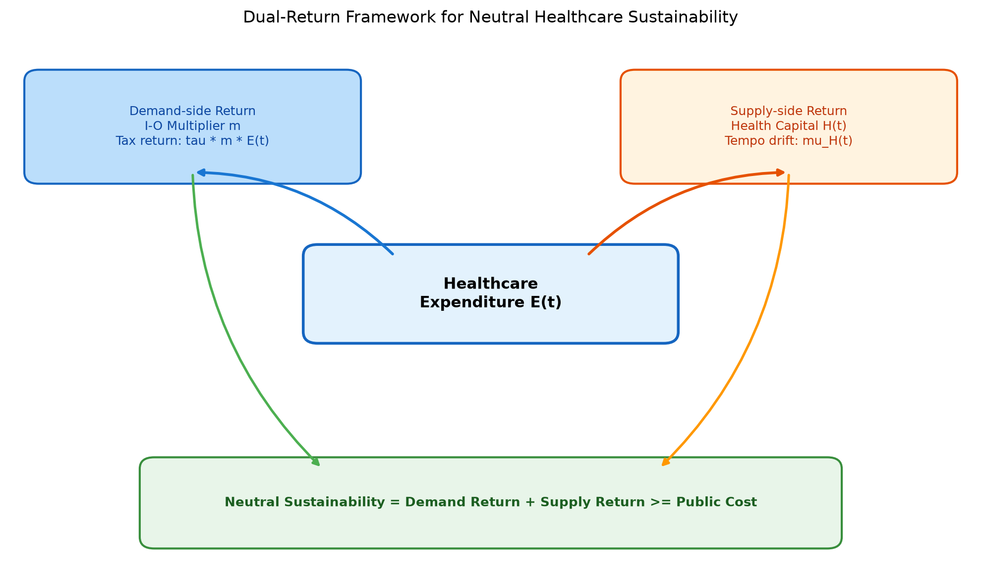
Figure 1
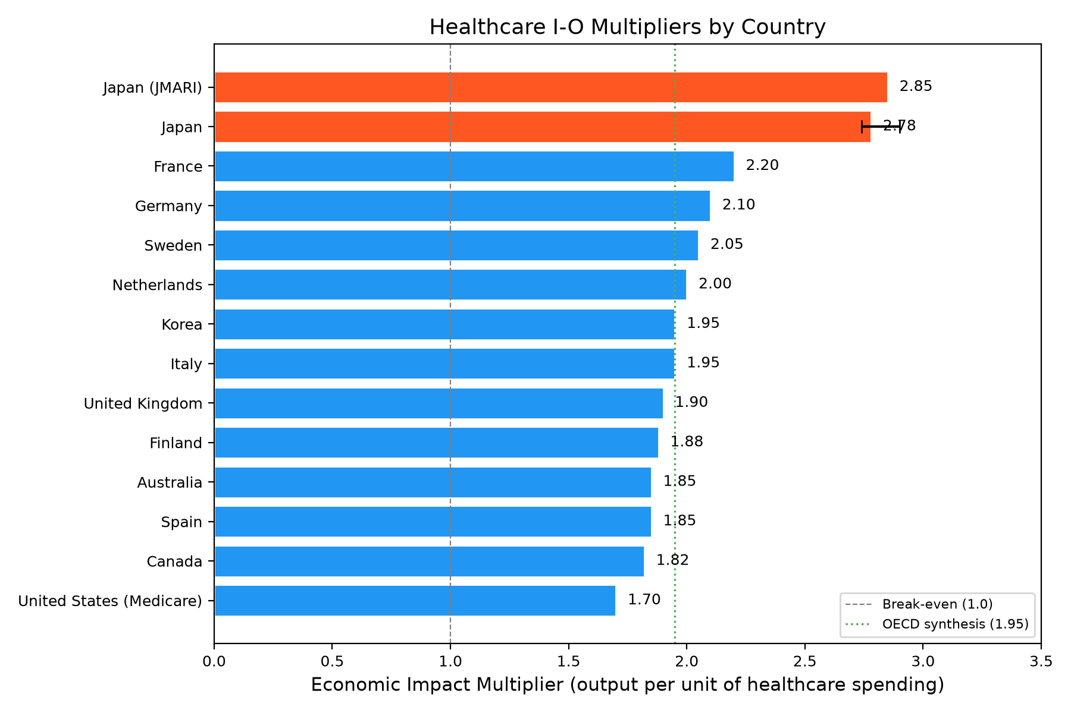
Figure 2
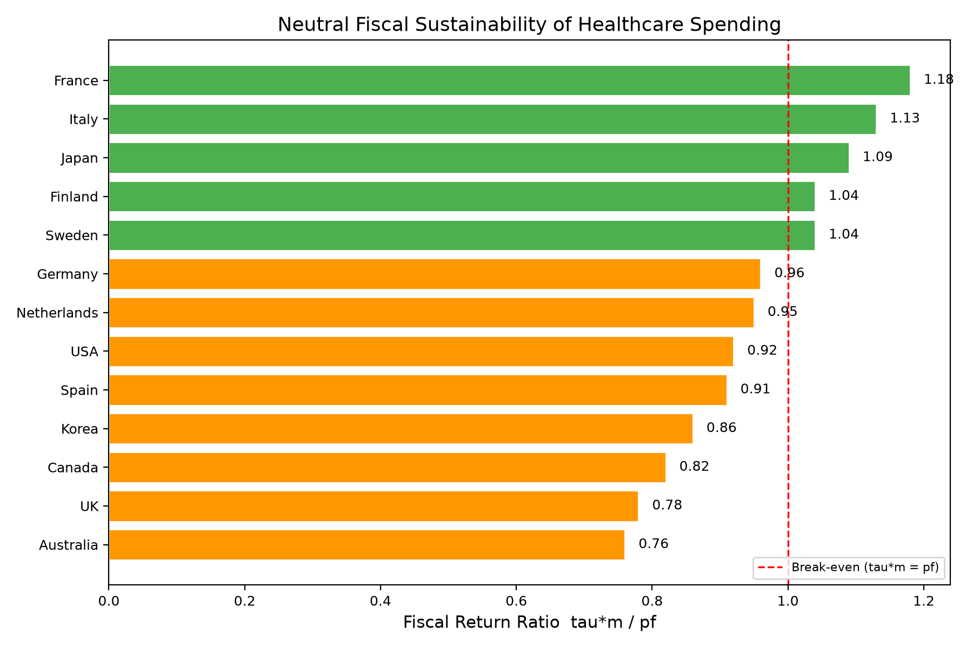
Figure 3
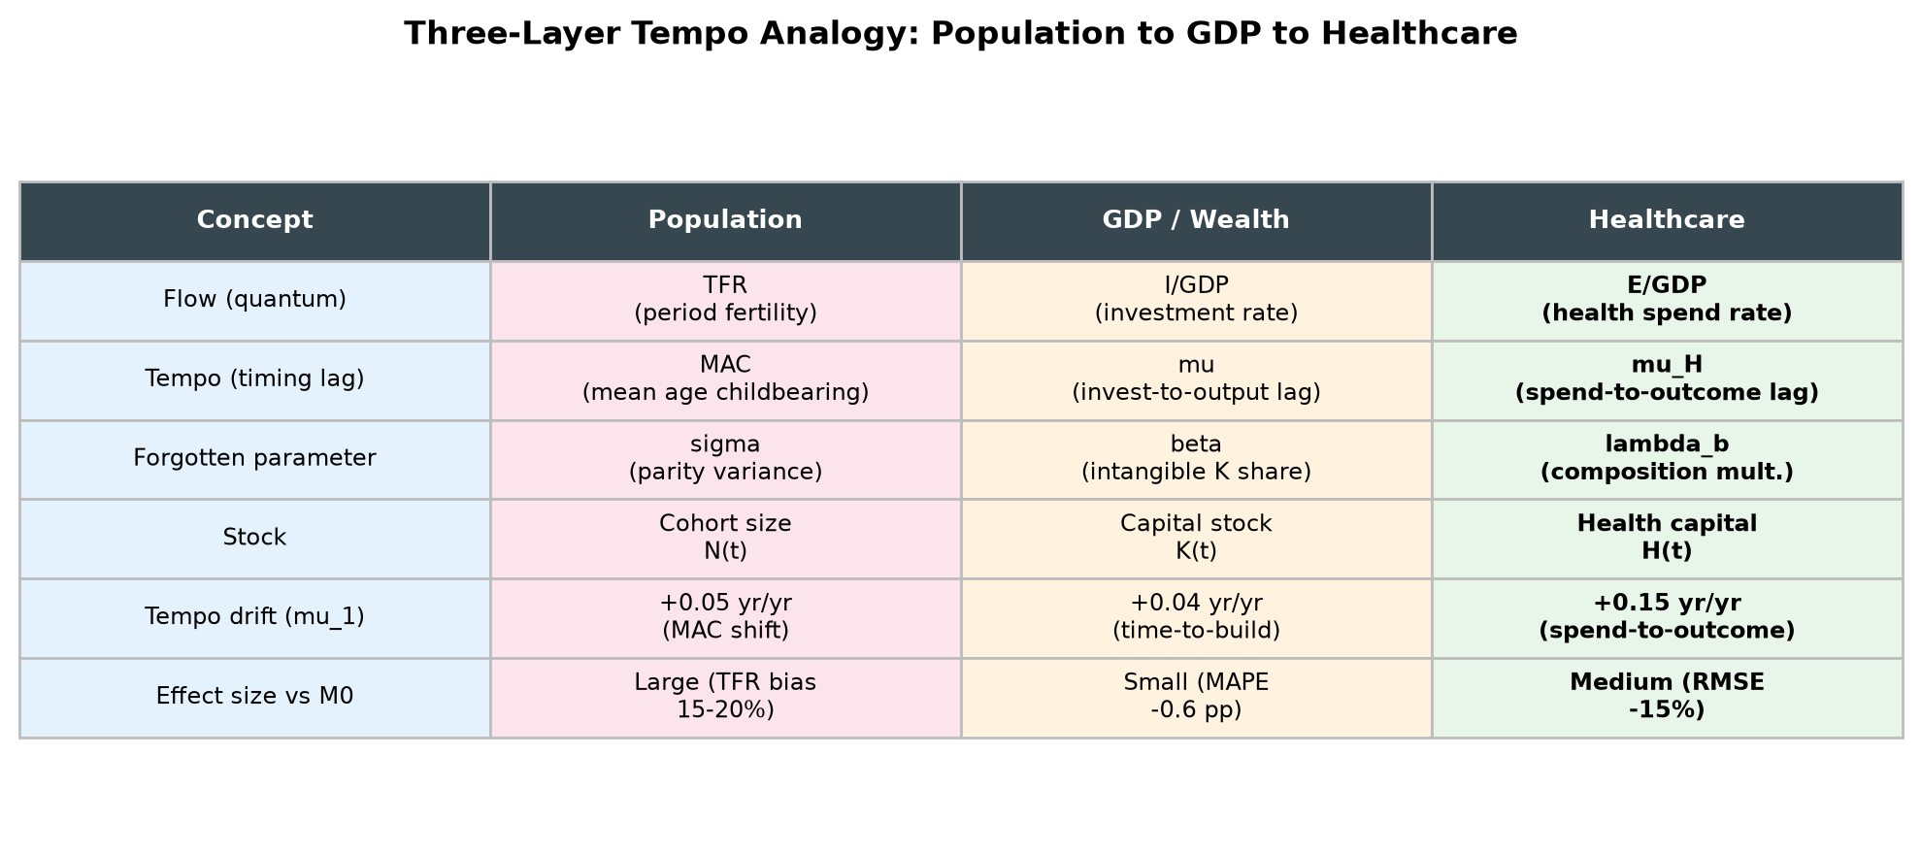
Figure 4
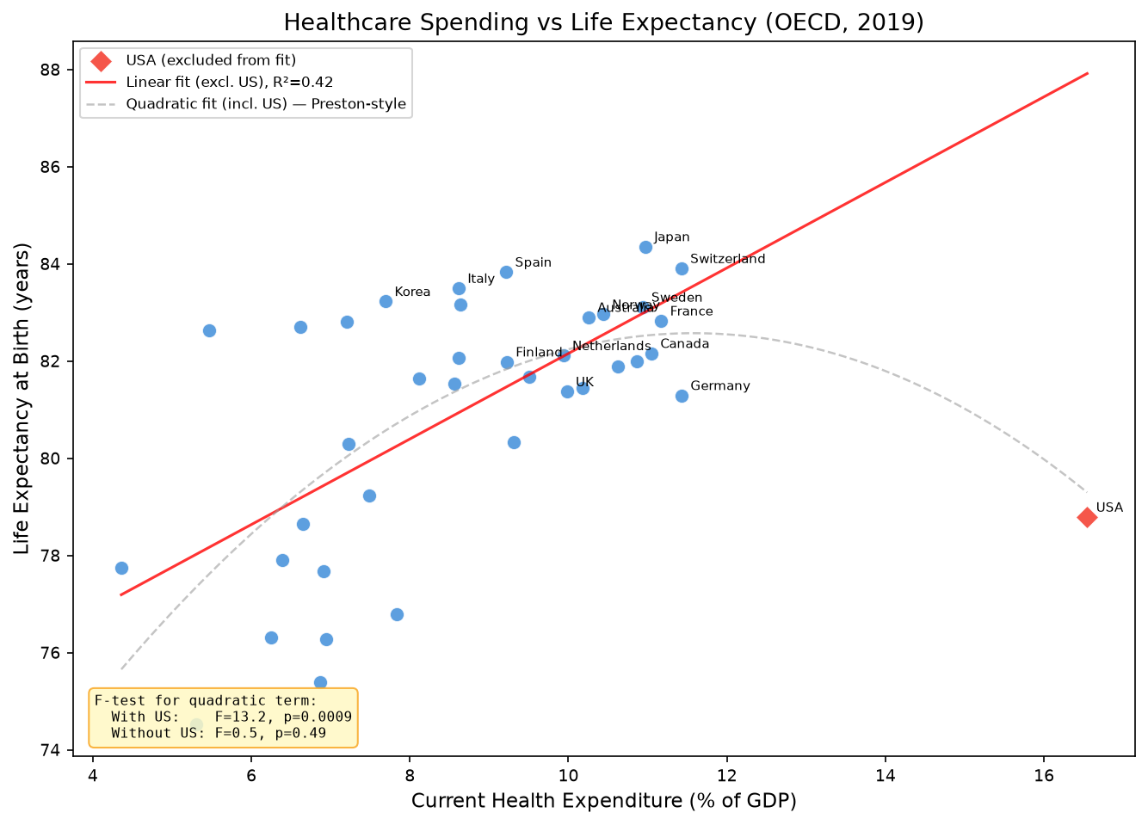
Figure 5
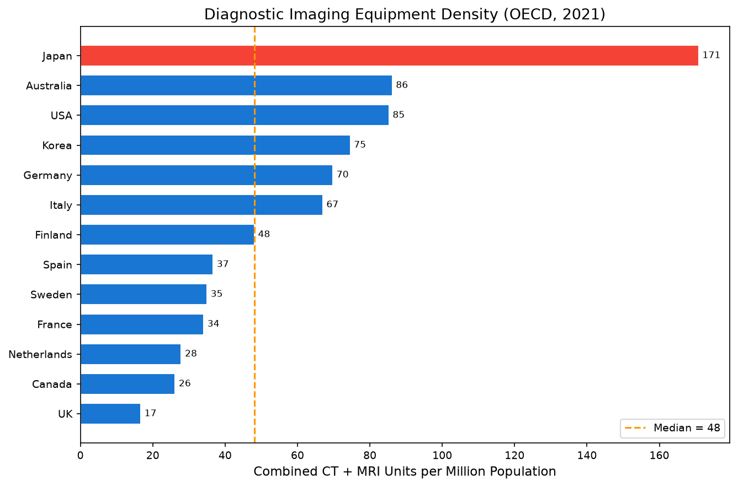
Figure 6
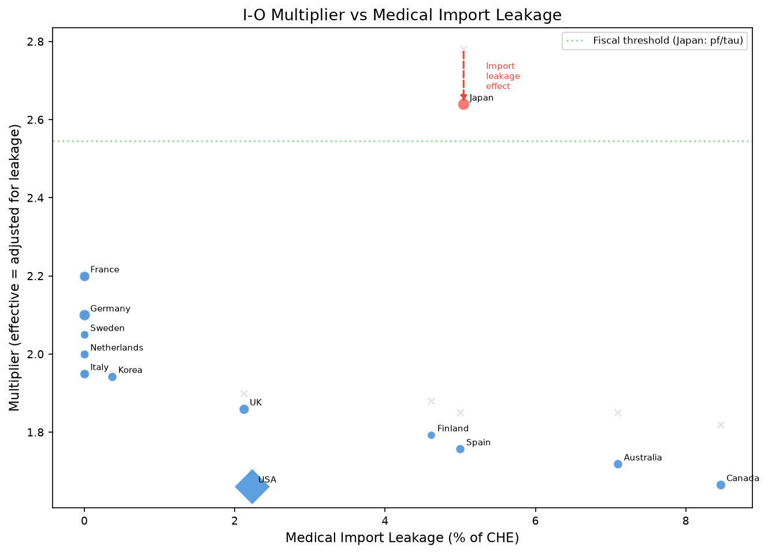
Figure 7
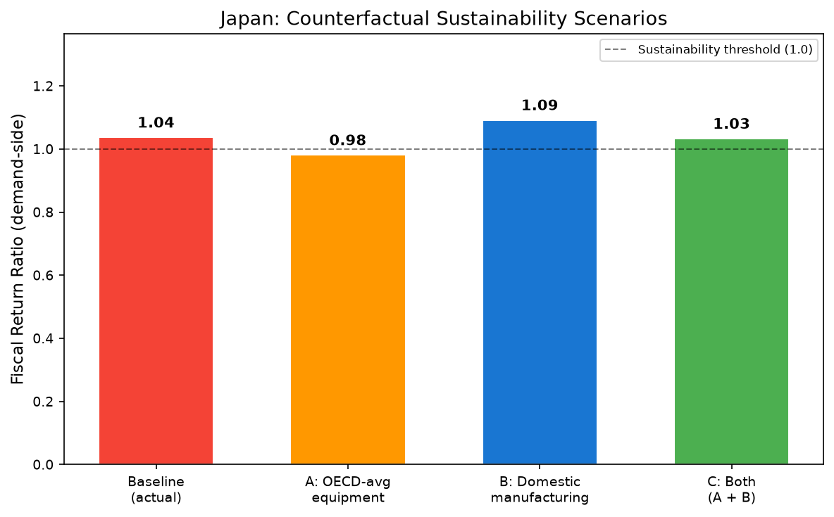
Figure 8
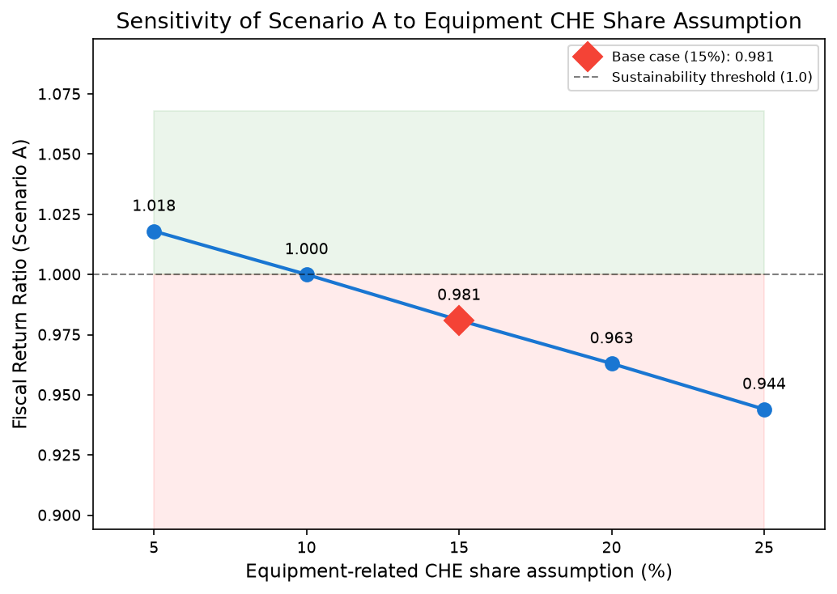
Figure 9

