Supplementary material
Supplementary Figure 1. Sensitivity-analysis framework for evaluating malpractice-litigation risk as a healthcare workforce-allocation lever.
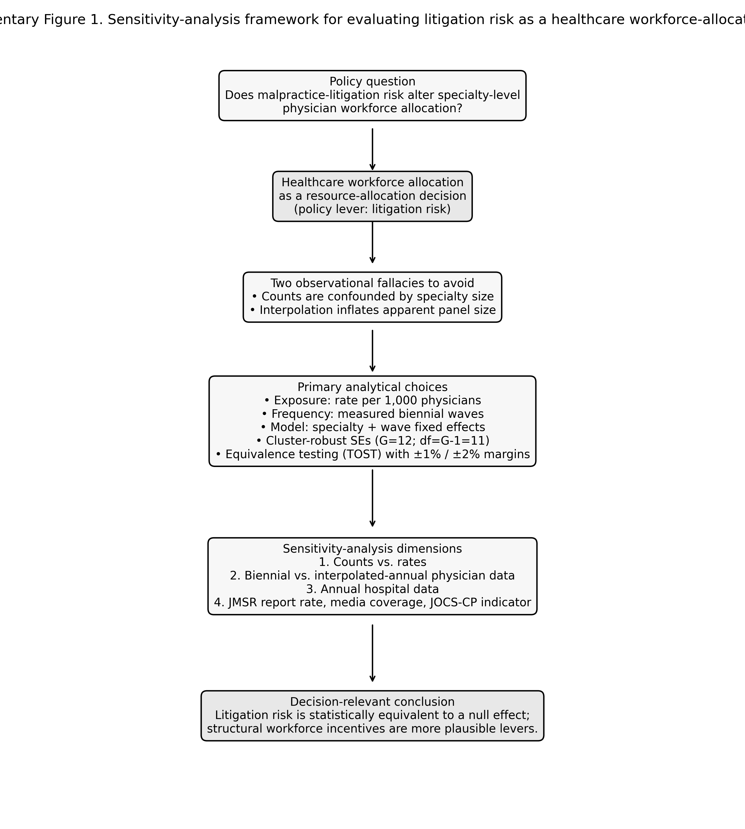

Supplementary Figure 2. Closed malpractice claims per 1,000 physicians by specialty, 2008–2024 (rates, not counts).
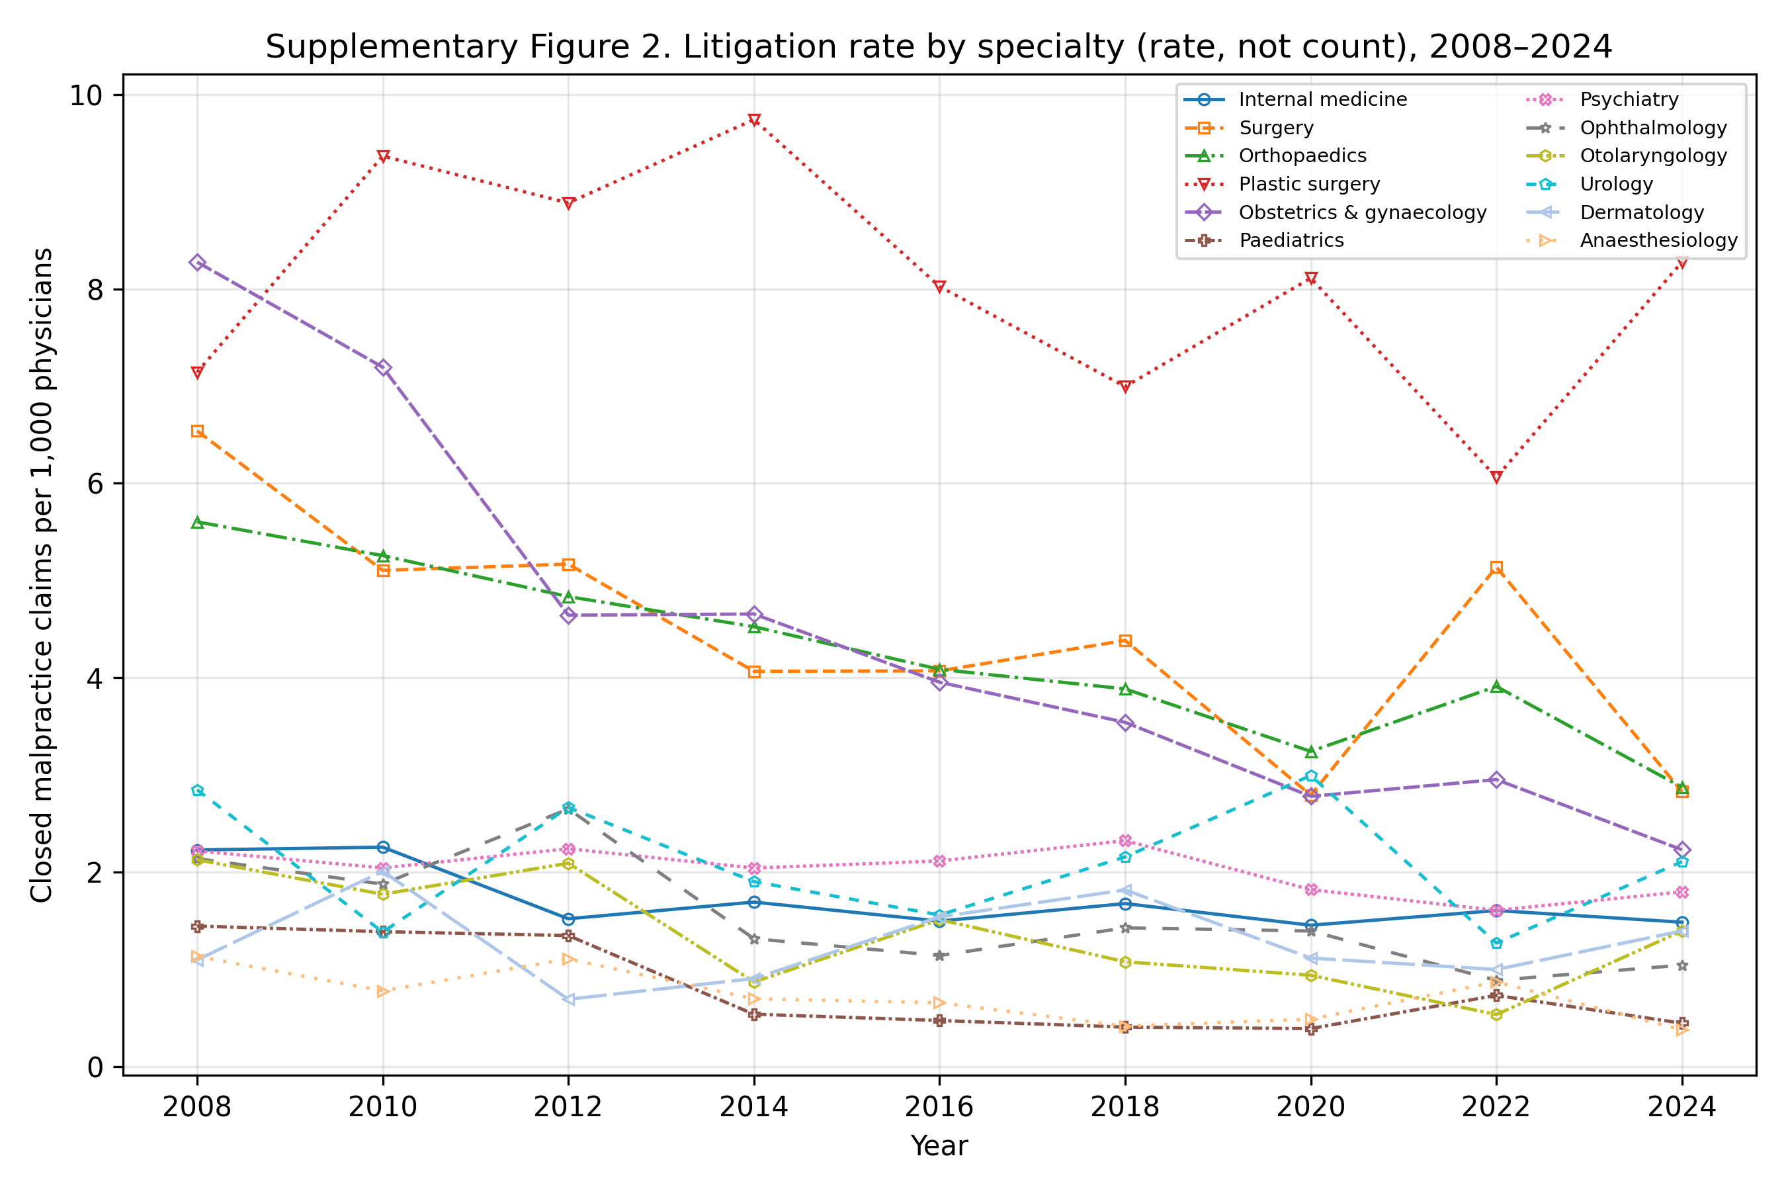

Supplementary Figure 3. Physician workforce by specialty, indexed to 2008 (=100).
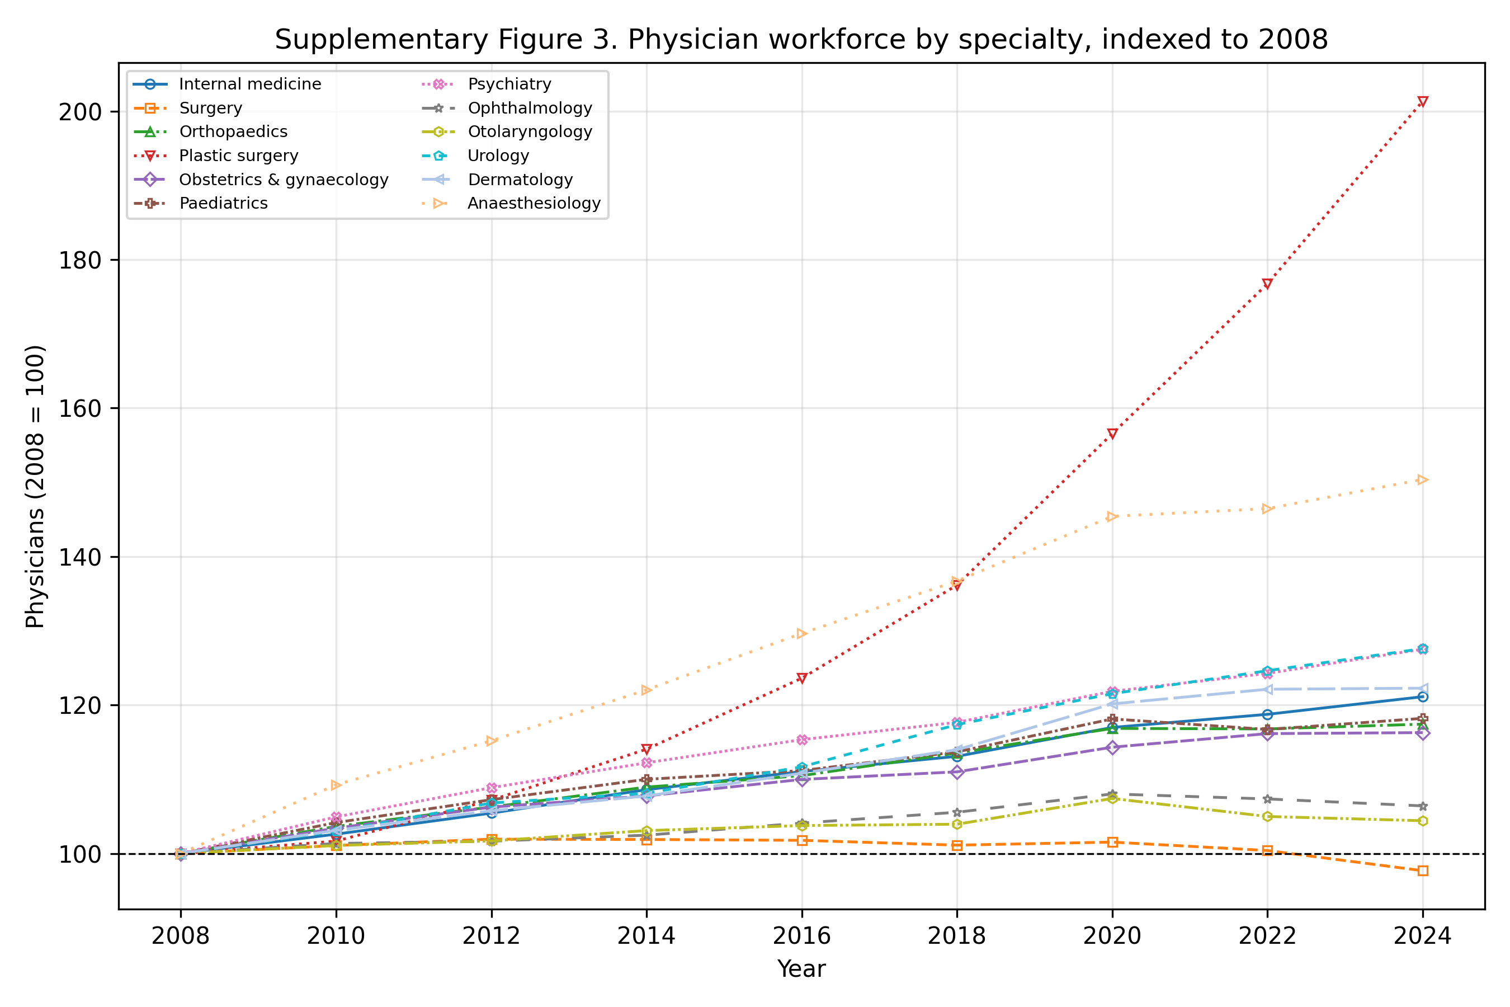

Supplementary Table 1. Primary data sources and their resolution.
Series | Source | Resolution | Years | Role
Physicians by specialty | MHLW Statistics of Physicians | Biennial | 2004–2024 | Denominator & outcome
Closed malpractice claims | Supreme Court, by specialty | Annual | 2008–2024 | Exposure (numerator)
Hospitals by specialty | MHLW Survey of Medical Institutions | Annual | 2008–2024 | Outcome
Clinics by specialty | MHLW Survey (static) | Every 3 years | 2008–2023 | Descriptive only
JMSR report counts | JMSR / MAIS | Annual | 2015–2024 | Sensitivity (2016-2024)
Newspaper article counts | Nikkei Telecom 21 | Annual | 2008–2018 | Sensitivity (2009-2018)

Supplementary Table 2. Equivalence (TOST) results (effect per +1 SD litigation rate).
Outcome | Coef per SD | 90% CI | Margin | TOST p | Equivalent
Physician growth | -0.21% | -0.84%, +0.42% | ±1% | 0.023 | Yes
Physician growth | -0.21% | -0.84%, +0.42% | ±2% | <0.001 | Yes
Hospital growth | +0.07% | -0.91%, +1.06% | ±1% | 0.059 | No
Hospital growth | +0.07% | -0.91%, +1.06% | ±2% | 0.002 | Yes

Supplementary Table 3. JMSR-adjusted annual hospital growth model (2016-2024) with both exposures entered simultaneously.
Exposure | Coefficient | p | n
Lagged litigation rate | +0.0021 | 0.28 | 108
Lagged JMSR report rate | -0.0009 | 0.66 | 108

Supplementary Table 4. Media-adjusted annual hospital growth model (2009-2018) with a linear time trend; full year fixed effects are omitted because the national article-count series is collinear with them.
Exposure | Coefficient | p | n
Lagged litigation rate | -0.0003 | 0.72 | 120
Lagged media count (per 1,000 articles) | -0.0014 | 0.21 | 120

Supplementary Table 5. Holm step-down adjusted p-values for the exploratory sensitivity tests and the JOCS-CP indicator.
Test | Raw p | Holm-adjusted p
Biennial physician growth ~ lagged litigation rate (JOCS-CP indicator) | 0.249 | 1.000
Biennial hospital growth ~ lagged litigation rate (JOCS-CP indicator) | 0.013 | 0.119
COUNTS contrast: physician growth ~ lagged litigation COUNT | 0.506 | 1.000
Annual hospital growth ~ lagged litigation rate (2008-2024) | 0.994 | 1.000
SENSITIVITY interpolated-annual physician growth ~ lag rate | 0.389 | 1.000
JMSR-adjusted annual hospital growth (2016-2024) ~ lit rate + JMSR rate (litigation rate) | 0.283 | 1.000
JMSR-adjusted annual hospital growth (2016-2024) ~ lit rate + JMSR rate (JMSR report rate) | 0.664 | 1.000
Media-adjusted annual hospital growth (2009-2018) ~ lit rate + media count (litigation rate) | 0.718 | 1.000
Media-adjusted annual hospital growth (2009-2018) ~ lit rate + media count (media count) | 0.209 | 1.000

Supplementary Table 6. Cluster block-bootstrap p-values, percentile 95% confidence intervals, equivalence power (if true effect is zero), and minimum detectable effect per 1-SD litigation-rate increase.
Outcome | Bootstrap p | Bootstrap 95% CI | Equivalence margin | Power if true null | MDE (80% power)
Physician growth | 0.573 | -0.00476, 0.00212 | ±1% | 98.4% | 1.08%
Physician growth | 0.573 | -0.00476, 0.00212 | ±2% | 100.0% | 1.08%
Hospital growth | 0.903 | -0.00431, 0.00416 | ±1% | 90.4% | 1.69%
Hospital growth | 0.903 | -0.00431, 0.00416 | ±2% | 99.6% | 1.69%

Supplementary Table 7. Counterfactual 2034 physician counts by specialty and policy lever. Counts are projected from observed biennial baseline drift plus the indicated effect; marginal percentage changes are shown in Figure 4.
Specialty | 2024 count | Baseline 2034 | Litigation zero (point) | Litigation zero (95% lower) | MDE benchmark
Internal medicine | 124,010 | 136,909 | 138,010 | 142,075 | 144,492
Surgery | 26,885 | 26,299 | 26,853 | 28,960 | 27,755
Orthopaedics | 22,630 | 24,848 | 25,346 | 27,239 | 26,224
Plastic surgery | 5,074 | 7,874 | 8,177 | 9,376 | 8,310
Obstetrics & gynaecology | 13,908 | 14,877 | 15,191 | 16,387 | 15,700
Paediatrics | 18,009 | 19,949 | 20,023 | 20,295 | 21,054
Psychiatry | 17,259 | 20,199 | 20,391 | 21,102 | 21,317
Ophthalmology | 13,436 | 13,957 | 14,058 | 14,430 | 14,730
Otolaryngology | 9,330 | 9,460 | 9,520 | 9,744 | 9,984
Urology | 8,069 | 9,333 | 9,425 | 9,766 | 9,849
Dermatology | 10,043 | 11,411 | 11,479 | 11,732 | 12,042
Anaesthesiology | 10,628 | 13,699 | 13,745 | 13,915 | 14,458
All specialties | 279,281 | 308,815 | 312,218 | 325,021 | 325,915

STROBE checklist
STROBE checklist for observational cohort studies.
Item | Description | Reported
1 | Title and abstract indicate the study design | Yes
2 | Background and rationale | Yes
3 | Specific objectives and hypotheses | Yes
4 | Key elements of study design | Yes
5 | Data sources, locations and dates | Yes
6 | Eligibility and selection criteria | Yes
7 | Definitions of outcomes, exposures and predictors | Yes
8 | Data sources and measurement methods | Yes
9 | Discussion of potential sources of bias | Yes
10 | Explanation of study size | Yes
11 | Quantitative variables: grouping and transformations | Yes
12 | Description of all statistical methods | Yes
13 | Numbers of participants at each stage | Yes
14 | Descriptive characteristics of participants | Yes
15 | Outcome data for each exposure category | Yes
16 | Main results with measures of uncertainty | Yes
17 | Other analyses (sensitivity and subgroup) | Yes
18 | Summary of key results with reference to objectives | Yes
19 | Limitations of bias and imprecision | Yes
20 | Cautious overall interpretation | Yes
21 | Generalisability to other populations | Yes
22 | Registration, protocol, funding, data and code availability | Yes

