Geographic distance decay in population-level Neanderthal and Denisovan segment profiles
Research Article
Onishi Tatsuki
Data Science and AI Innovation Research Promotion Center
Onishi Tatsuki, Data Science and AI Innovation Research Promotion Center; Email: bougtoir@gmail.com
Running title: Geography of archaic segment profiles

Abstract
Objectives: Archaic-like segments around the ABO blood-group locus have been proposed as clues to blood-group history and human dispersal, but their interpretation lacks a genome-wide geographic baseline. We tested whether population-level genomic profiles of inferred Neanderthal- and Denisovan-like segments become less similar with geographic distance. Materials and Methods: High-confidence hmmix calls from 3,134 individuals in 66 populations were summarized in 500-kb windows. Each individual-haplotype-window contributed at most one presence, constraining population frequencies to 0-1. Pearson similarity was calculated for 2,145 population pairs. Distance associations were evaluated with population-label quadratic assignment permutations, population-deletion analyses, and sensitivities to window size, similarity metric, sample-size threshold, dataset, zero-distance pairs, and regional omission. Results: Similarity declined with distance for Neanderthal (raw r=-0.497) and Denisovan (raw r=-0.462) profiles. Expanded descriptive models that also included designated recent-admixture involvement, same-continent status, and same-dataset status had partial distance correlations of -0.369 and -0.326; population-label permutation P values for distance were 0.0001 and 0.0002. No positive-residual non-admixed pair met both z>2 and false-discovery-rate q<0.10. Conclusions: Archaic-segment profile similarity contains a broad geographic distance-decay signal, but the analysis does not identify exceptional population connections or demonstrate specific migration routes. A secondary ABO-window analysis remains hypothesis-generating.
Keywords: archaic introgression; Neanderthal; Denisovan; population genetics; geographic distance; quadratic assignment procedure; ABO

Introduction
Genomic comparisons established gene flow from Neanderthals and Denisovans into ancestors of present-day populations outside Africa (Green et al. 2010; Reich et al. 2010). The amount and genomic distribution of introgressed sequence vary among populations because of demographic history, drift, selection, and multiple introgression histories (Sankararaman et al. 2014; Sankararaman et al. 2016; Jacobs et al. 2019). Most summaries emphasize the proportion of archaic ancestry within a population. A complementary question is whether two populations carry inferred archaic segments in similar genomic locations.
Geographic gradients in archaic ancestry may reflect range expansions and serial demographic processes rather than a single migration event (Quilodran et al. 2023). Pairwise profile similarity offers a direct descriptive measure of shared genomic distribution, but it creates dyadic data: every population appears in many pair rows. Standard row-wise regression tests, bootstraps, or response shuffles therefore do not preserve the population-level dependence structure. Quadratic assignment procedures address this problem by permuting population labels on a complete matrix (Krackhardt 1988; Dekker, Krackhardt, and Snijders 2007).
The primary objective was to test whether Neanderthal- and Denisovan-segment profile similarity declines with great-circle distance across 66 populations from the 1000 Genomes Project and Human Genome Diversity Project. We also tested robustness to alternative genomic windows, similarity metrics, sample-size thresholds, datasets, co-located pairs, and regional omission. A secondary analysis of the ABO-centered interval was retained because ABO has an unusually deep allelic history and has motivated founder-effect and archaic-background hypotheses (Calafell et al. 2008; Halverson and Bolnick 2008; Segurel et al. 2012; Condemi et al. 2021). This focal analysis was prespecified as exploratory and was not used to infer a migration route.

Materials and Methods

Data sources and population inclusion
We analyzed publicly archived hmmix segment calls from 1000 Genomes and HGDP samples in Zenodo record 14136628. Hmmix detects candidate archaic sequence without requiring an unadmixed modern outgroup (Skov et al. 2018). Source population definitions followed the 1000 Genomes and HGDP resources (1000 Genomes Project Consortium 2015; Bergström et al. 2020). SHA-256 checksums of both raw files are written to the analysis provenance record.
Segments with mean posterior probability below 0.8 were excluded. Populations with fewer than seven represented individuals were excluded, leaving 3,134 individuals in 66 populations. Source calls annotated as Neanderthal or Both entered the Neanderthal profile; calls annotated as Denisova or Both entered the Denisovan profile.

Population profiles and pairwise similarity
Autosomes were partitioned into 500-kb windows. Within each ancestry category, overlapping or fragmented source segments were collapsed so that each individual-haplotype-window contributed at most one presence. For each population and window, unique haplotype presences were divided by twice the number of represented individuals. A runtime validity check required every frequency to lie between 0 and 1.
For each population pair, Pearson correlation was calculated across the union of windows with a nonzero frequency in either population. Pairs required more than 100 union windows for Neanderthal and more than 50 for Denisovan profiles. The 66-population matrices contained 2,145 unique off-diagonal pairs. Correlations describe profile similarity and do not establish identity by descent. Spearman correlation and cosine similarity were calculated as metric sensitivities.
Population coordinates were consolidated in a versioned metadata table from source sampling locations or population centroids. Great-circle distance was calculated with the Haversine formula. Coordinate uncertainty and co-located population labels were assessed by excluding zero-distance pairs.

Dyadic regression and permutation inference
The primary expanded descriptive model regressed pairwise similarity on distance per 1,000 km, involvement of one of four designated recently admixed American populations (PUR, CLM, MXL, or PEL), same-continent status, and same-dataset status. These indicators are coarse sensitivity covariates, not individual ancestry estimates or causal controls. Distance-only models were also fit.
Coefficient P values used 9,999 quadratic assignment permutations. At each iteration, the response matrix was permuted by the same random population-label order on rows and columns, after which the model was refit. Two-sided P values were the proportion of permuted coefficient magnitudes at least as large as the observed magnitude, including a plus-one correction. Descriptive R-squared values quantify fit to the observed pair matrix and are not interpreted as independent observations or causal variance explained.
Population-deletion stability intervals were calculated by refitting the expanded model after removing every pair containing one population in turn and reporting the 2.5th and 97.5th percentiles of the resulting coefficients. These are sensitivity intervals rather than independent-sample confidence intervals.

Residual outliers and multiple testing
Outlier analysis was restricted to the complete matrix after removing PUR, CLM, MXL, and PEL. Similarity was modeled using distance, same-continent status, and same-dataset status. Positive residuals were standardized by the residual standard deviation. For every pair, a one-sided nominal P value was calculated from its own residual null distribution across 9,999 population-label permutations. The Benjamini-Hochberg procedure was applied jointly to all non-admixed pairs within each ancestry analysis (Benjamini and Hochberg 1995). A supported positive outlier required z>2 and q<0.10.

Robustness analyses
We repeated distance-only population-label tests for 250-kb, 500-kb, and 1-Mb windows. At 500 kb, robustness summaries compared Pearson, Spearman, and cosine similarity; minimum population sizes of 7, 10, 15, and 20; the complete dataset, non-admixed populations, 1000 Genomes-only and HGDP-only subsets; exclusion of zero-distance pairs; and leave-one-continent-out subsets. Full-window Pearson correlation and presence-absence Jaccard similarity assessed sensitivity to the nonzero-window union. Sensitivity tests used 999 population-label permutations. No genome-wide callable mask was available in the source release, so mask-adjusted profiles could not be evaluated.

Secondary ABO-centered analysis
The ABO gene was defined on GRCh38 as chr9:133,233,278-133,276,024. We distinguished strict gene overlap from any overlap with a 500-kb interval spanning chr9:133.0-133.5 Mb. Population carrier frequencies used unique individuals in the numerator and all represented source individuals in the denominator.
For Neanderthal or Both segments in the interval, similarity counts to Altai, Vindija, and Chagyrskaya were compared; tied maxima remained ties. The Vindija reference is a high-coverage Neanderthal genome (Prüfer et al. 2017). The O2-defining rs41302905 T allele was summarized from Ensembl/1000 Genomes frequencies and published Solomon Islands frequencies (Ohashi et al. 2006). Ancient-window observations were descriptively extracted from public outputs associated with Iasi et al. (2024); ancient and modern calls were not directly compared statistically.

Ethical review, community engagement, and interpretation
This computational secondary analysis used de-identified public data and involved no recruitment, contact, biospecimen collection, or new individual-level phenotype inference. The author did not obtain a separate institutional review determination for this secondary analysis; approvals, consent, and data-access procedures were those reported by the source studies. This limitation is disclosed rather than treating public availability as equivalent to unrestricted ethical reuse.
No source community or stakeholder representatives participated in the design, analysis, interpretation, or dissemination of the present secondary study, and no direct community return-of-results process was conducted. Because the dataset includes Indigenous participants and the topic can affect narratives of ancestry and migration, analyses were interpreted in light of Indigenous data-governance guidance and the CARE principles (Claw et al. 2018; Carroll et al. 2020). Population labels were retained only when needed for transparent source-data description; locus-level observations were not generalized to communities, and migration routes were not assigned from these data. The public article, code, and derived aggregate results are the current means of results availability. These disclosures follow the expanded AJBA guidance on ethical review and stakeholder communication (Turner 2025).

Results

Data-validity correction
Collapsing fragmented segments at the individual-haplotype-window level removed duplicate contributions that could otherwise make a nominal frequency exceed 1. In the rebuilt profiles, the maximum frequency was 1.0 for both ancestry categories and no population-window frequency exceeded 1. The analysis retained 66 populations, 3,134 individuals, and 2,145 unique population pairs.

Geographic distance decay
Neanderthal profile similarity declined with distance (raw r=-0.497); the corresponding Denisovan correlation was -0.462. Partial distance correlations from the expanded descriptive models were -0.369 and -0.326. Distance-only R-squared values were 0.247 and 0.213; expanded-model values were 0.546 and 0.511. The QAP distance coefficients per 1,000 km were -0.01892 (P=0.0001) and -0.01918 (P=0.0002) (Figure 1).
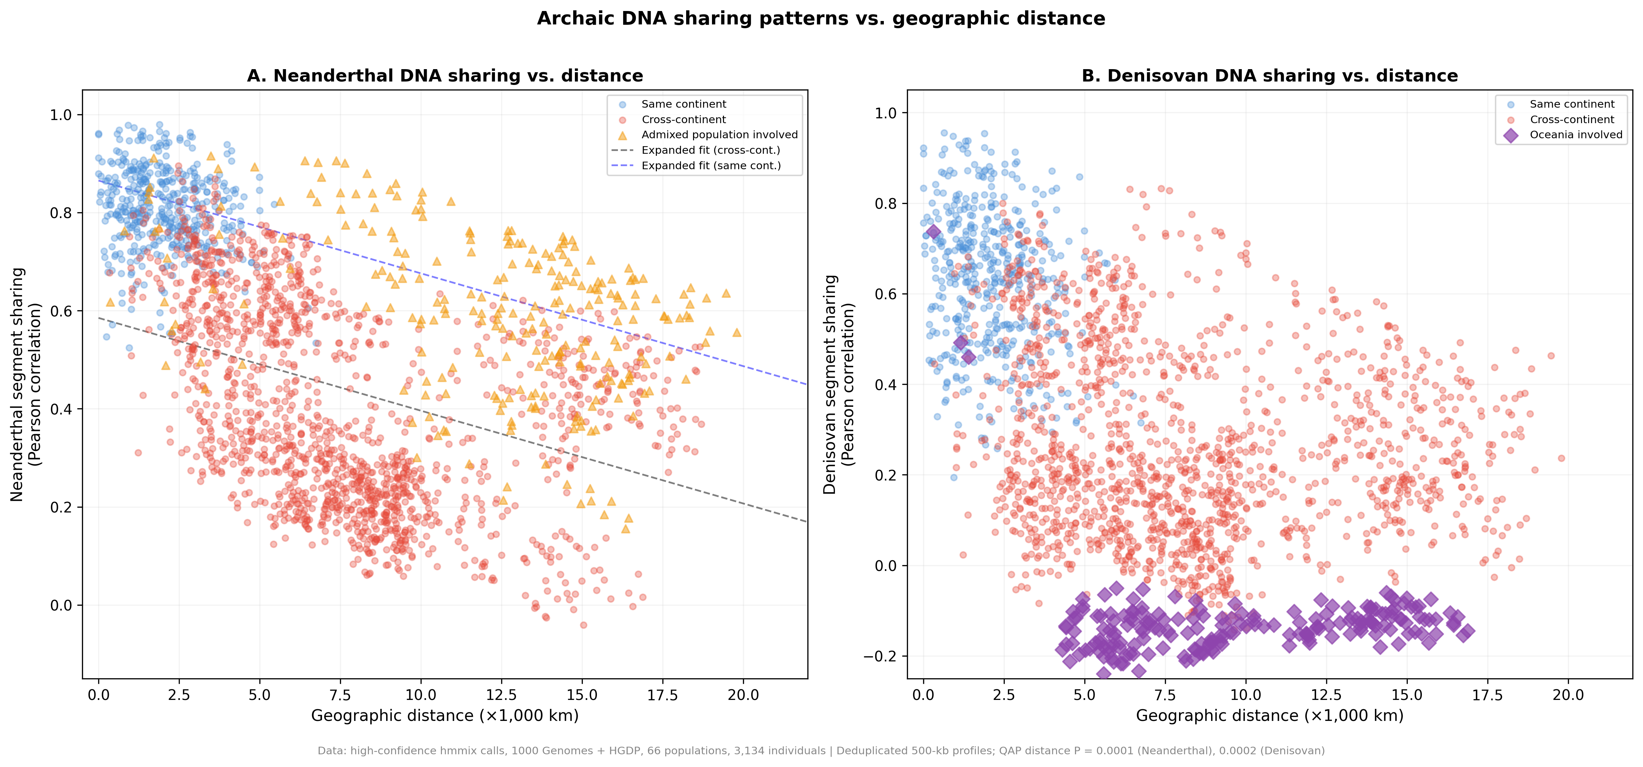
Figure 1. Archaic-segment profile similarity and geographic distance. Each point is a dependent population pair. Lines are descriptive distance-only fits; reported P values use population-label quadratic assignment permutations.

Population structure
The representative heat maps showed broad regional blocks and a stronger Oceanian contrast in the Denisovan profile (Figure 2). The complete 66-population heat map is provided as Figure S1.
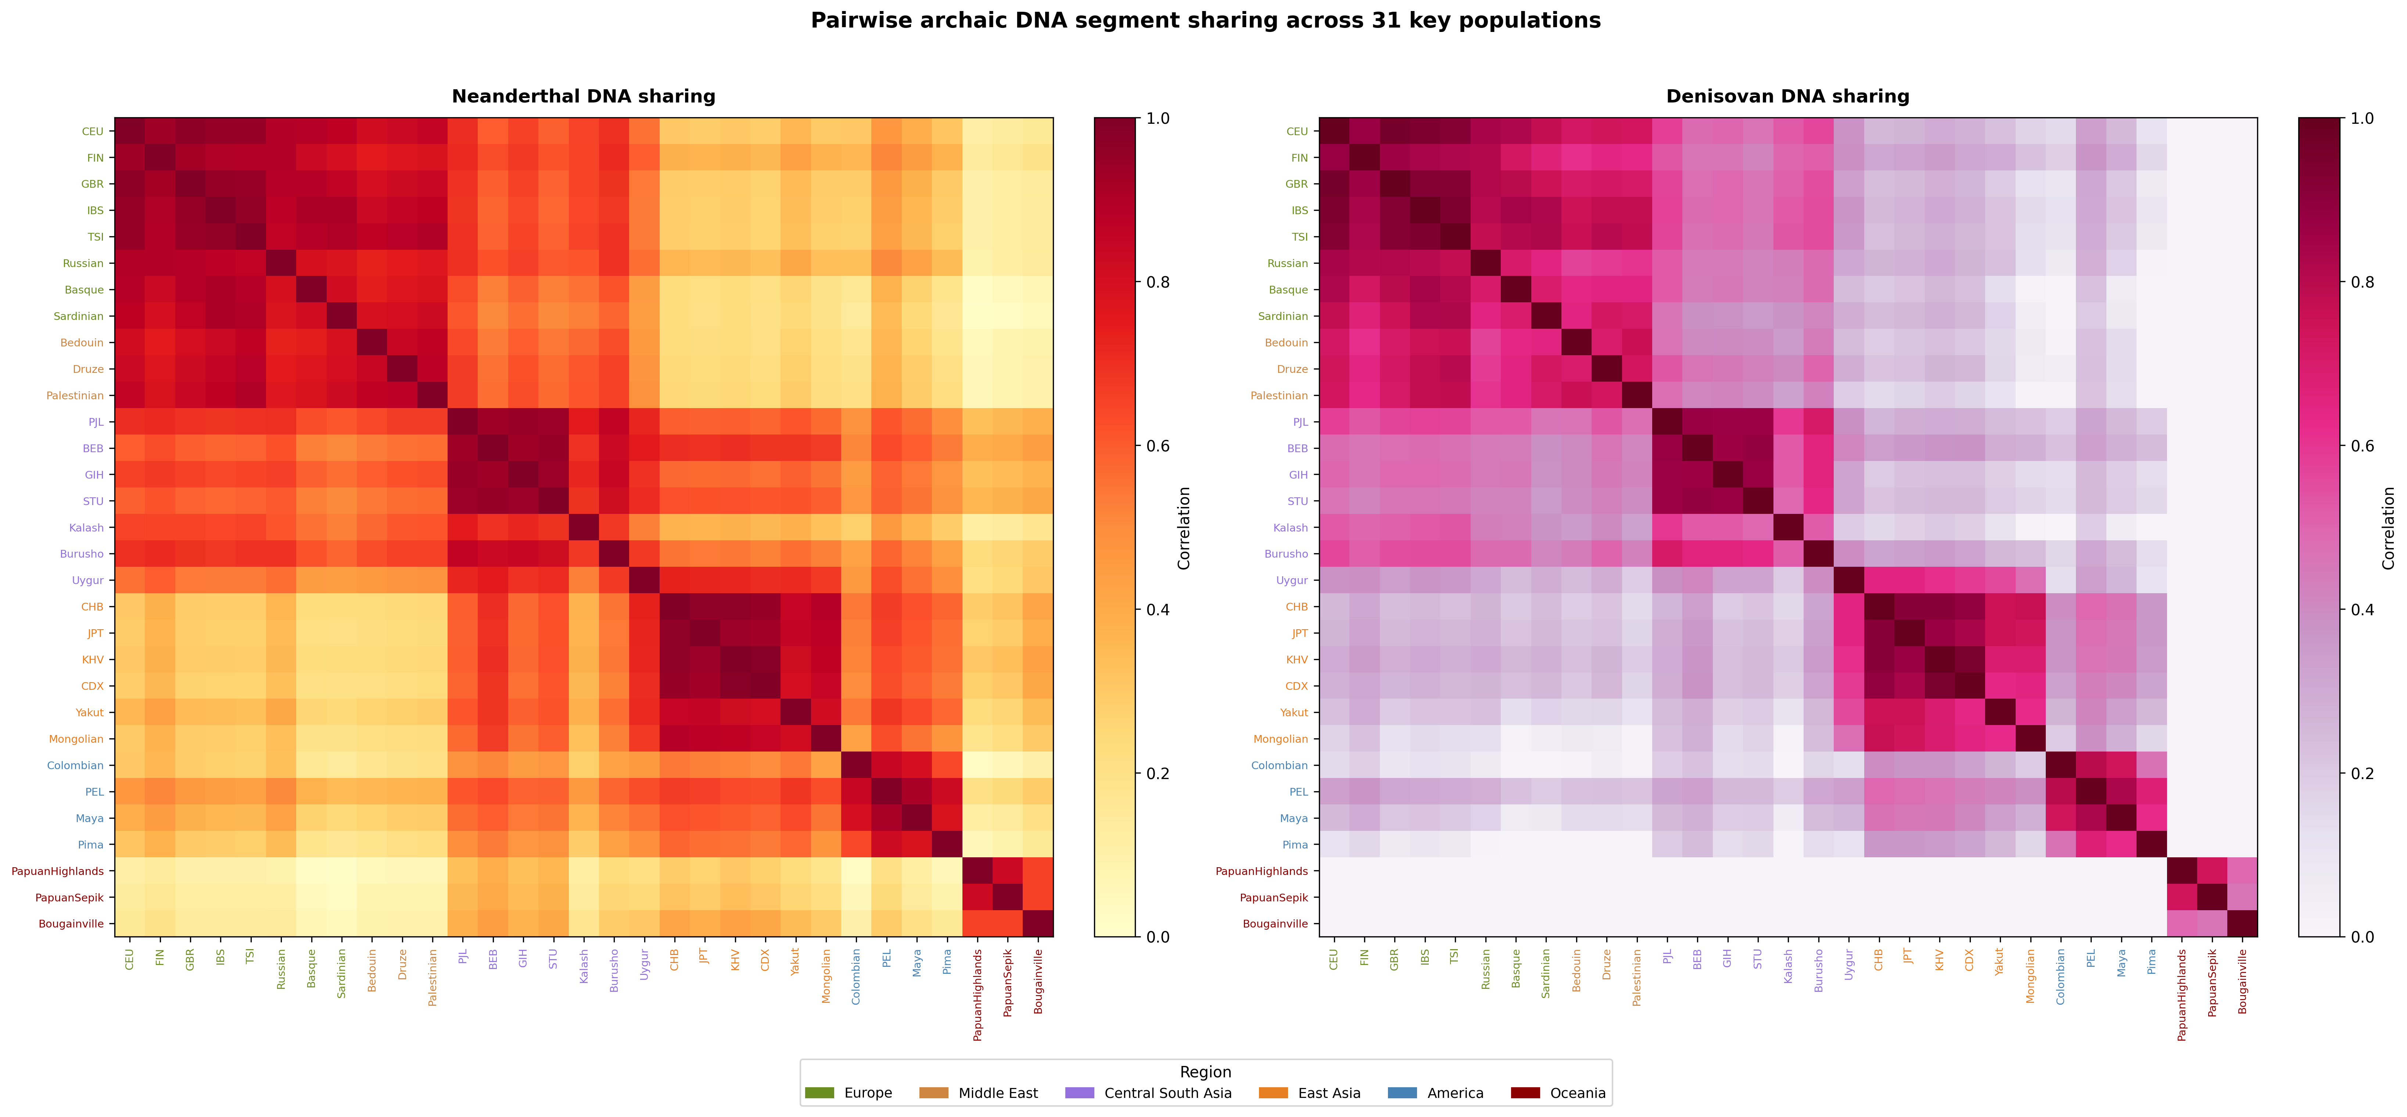
Figure 2. Pairwise archaic-segment profile similarity for 31 prespecified populations. The subset is displayed for legibility; all 66 populations were analyzed.

Schematic dispersal context
A polygon-based Minard diagram places the analysis within broad dispersal and archaic-introgression contexts (Figure 3). Band widths, branch positions, and event placement are schematic and are not estimates from the present pairwise analysis.
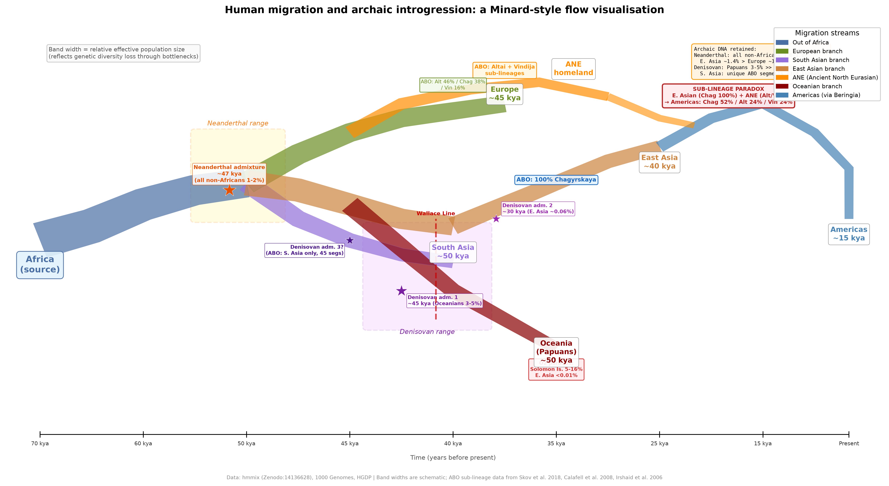
Figure 3. Polygon-based Minard-style schematic of human dispersal and archaic introgression. Band widths, branch positions, and event placement are illustrative and do not estimate migration magnitude, ancestry proportion, or a route supported by the present analysis.

Robustness analyses
Negative distance correlations were examined across admixture exclusions, within-dataset subsets, minimum sample sizes, and regional omissions. Figure 4 shows the effect of excluding designated recently admixed populations, and Figure 5 shows window-size results at 250 kb, 500 kb, and 1 Mb. These analyses were treated as robustness checks rather than independent confirmatory tests.
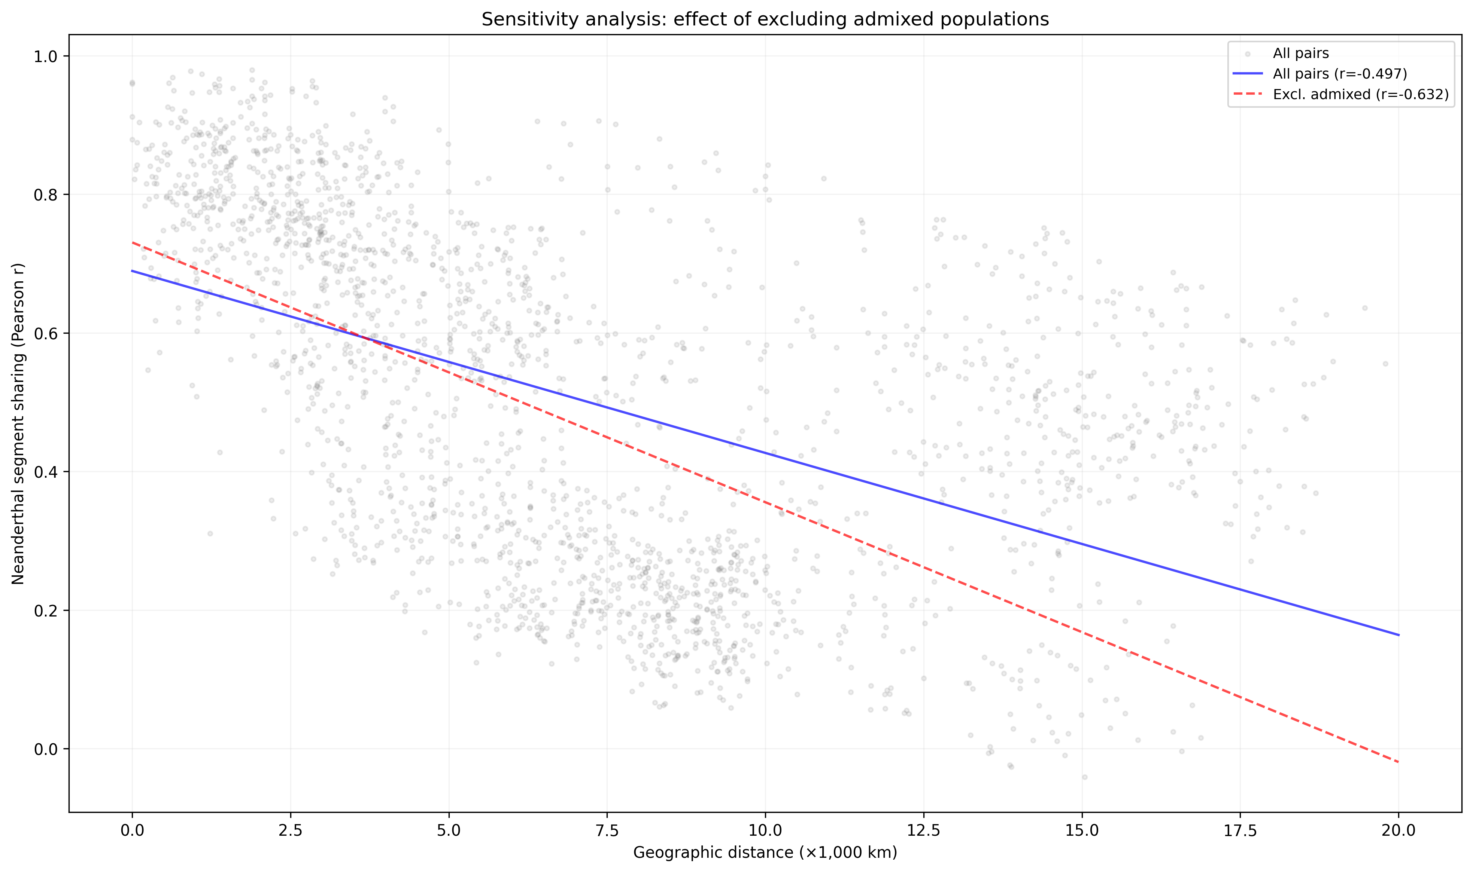
Figure 4. Sensitivity of the descriptive Neanderthal distance correlation to exclusion of designated recently admixed populations.
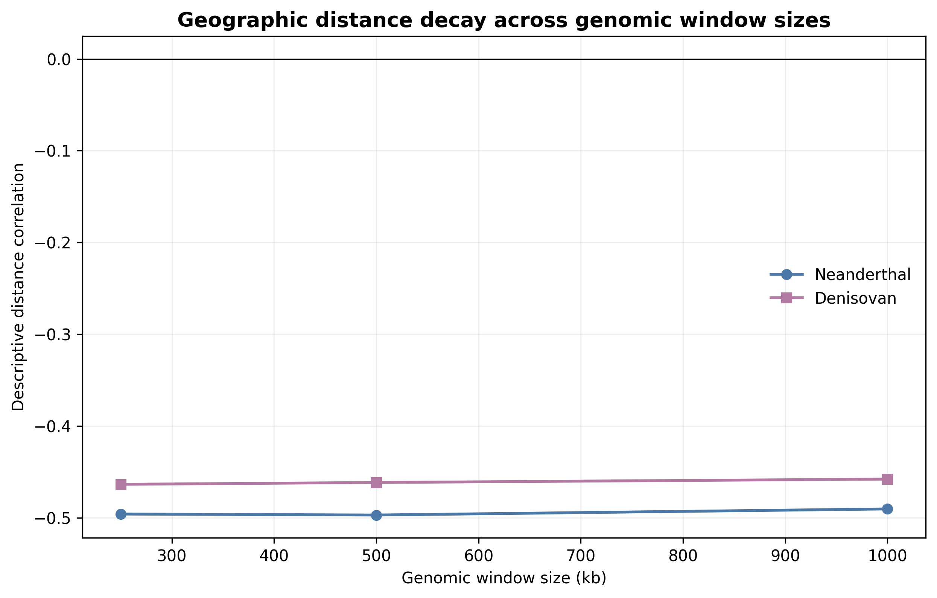
Figure 5. Descriptive geographic distance correlations at 250-kb, 500-kb, and 1-Mb window sizes. QAP results are tabulated in Supplementary Data.

Residual outlier testing
No non-admixed pair met both the positive-residual z>2 criterion and Benjamini-Hochberg q<0.10 for either ancestry category. Nominal residual ranks are retained in the full pairwise data table for auditability but are not interpreted as statistically supported population connections (Table 1).
Table 1. FDR-supported positive-residual Neanderthal population pairs
Population 1 | Population 2 | Region 1 | Region 2 | Distance (km) | Sharing (r) | z-score
No qualifying pair | — | — | — | — | — | No z>2 and q<0.10 result
Note. The prespecified family contains all non-admixed population pairs. No pair met both z>2 and Benjamini-Hochberg q<0.10; the Denisovan analysis likewise identified no qualifying pair. Complete nominal rankings and dependence-aware model results are provided in Supplementary Data.

Secondary ABO-window observations
The 500-kb ABO-centered scan identified 834 Neanderthal or Both source segments, of which 129 overlapped the ABO gene. Of the 834 interval segments, 335 had tied maximum reference similarity and were not forced to a lineage. In the Indigenous American HGDP subset, one Pima segment overlapped ABO and one Maya segment lay downstream within the wider interval. Both were Vindija-closest, but two segments among 41 represented individuals do not support a regional proportion or migration-route inference (Figure 6; Table 2).
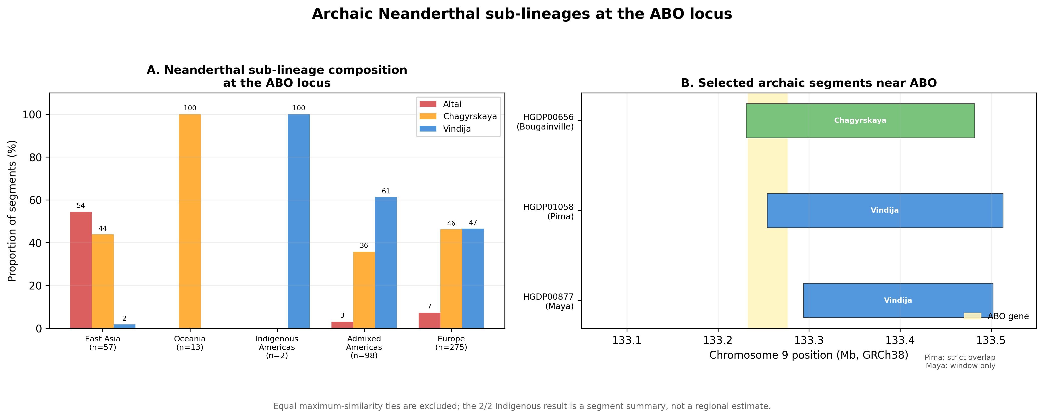
Figure 6. ABO-centered analysis preserving the historical grouped-bar and segment-map layout. Equal maximum-similarity ties are excluded from the displayed three-reference proportions and retained in Supplementary Data. The Pima segment overlaps ABO; the Maya segment is within the wider interval but does not overlap the gene. Counts are segments, not regional frequencies.
Table 2. ABO-window Neanderthal-reference composition
Region | n | Altai % | Vindija % | Chagyrskaya %
East Asia | 57 | 54.4 | 1.8 | 43.9
Europe | 275 | 7.3 | 46.5 | 46.2
Indigenous Americas | 2 | 0.0 | 100.0 | 0.0
Admixed Americas | 98 | 3.1 | 61.2 | 35.7
Central/South Asia | 98 | 9.2 | 44.9 | 45.9
Middle East | 44 | 11.4 | 52.3 | 36.4
Oceania | 13 | 0.0 | 0.0 | 100.0
Note. Counts are classifiable segments, not individuals. Percentages use the three-reference denominator shown by n. Equal maximum-similarity ties are excluded from these percentages but retained in Supplementary Data. The 2/2 Indigenous American value is not a regional frequency estimate; only one segment overlaps ABO.

ABO-related and global contextual figures
The O2-defining allele and ABO-window carrier summaries use different sources and are displayed descriptively rather than as an association analysis (Figure 7). The Ancient North Eurasian pathway is retained as a testable contextual hypothesis, not a route inferred from the two Indigenous American segment records (Figure 8). Ancient and modern ABO-window observations were produced by different pipelines and permit no formal temporal comparison (Figure 9). A literature-derived global bivariate map provides broad Neanderthal and Denisovan ancestry context; its approximate values were not used in the statistical models (Figure 10).
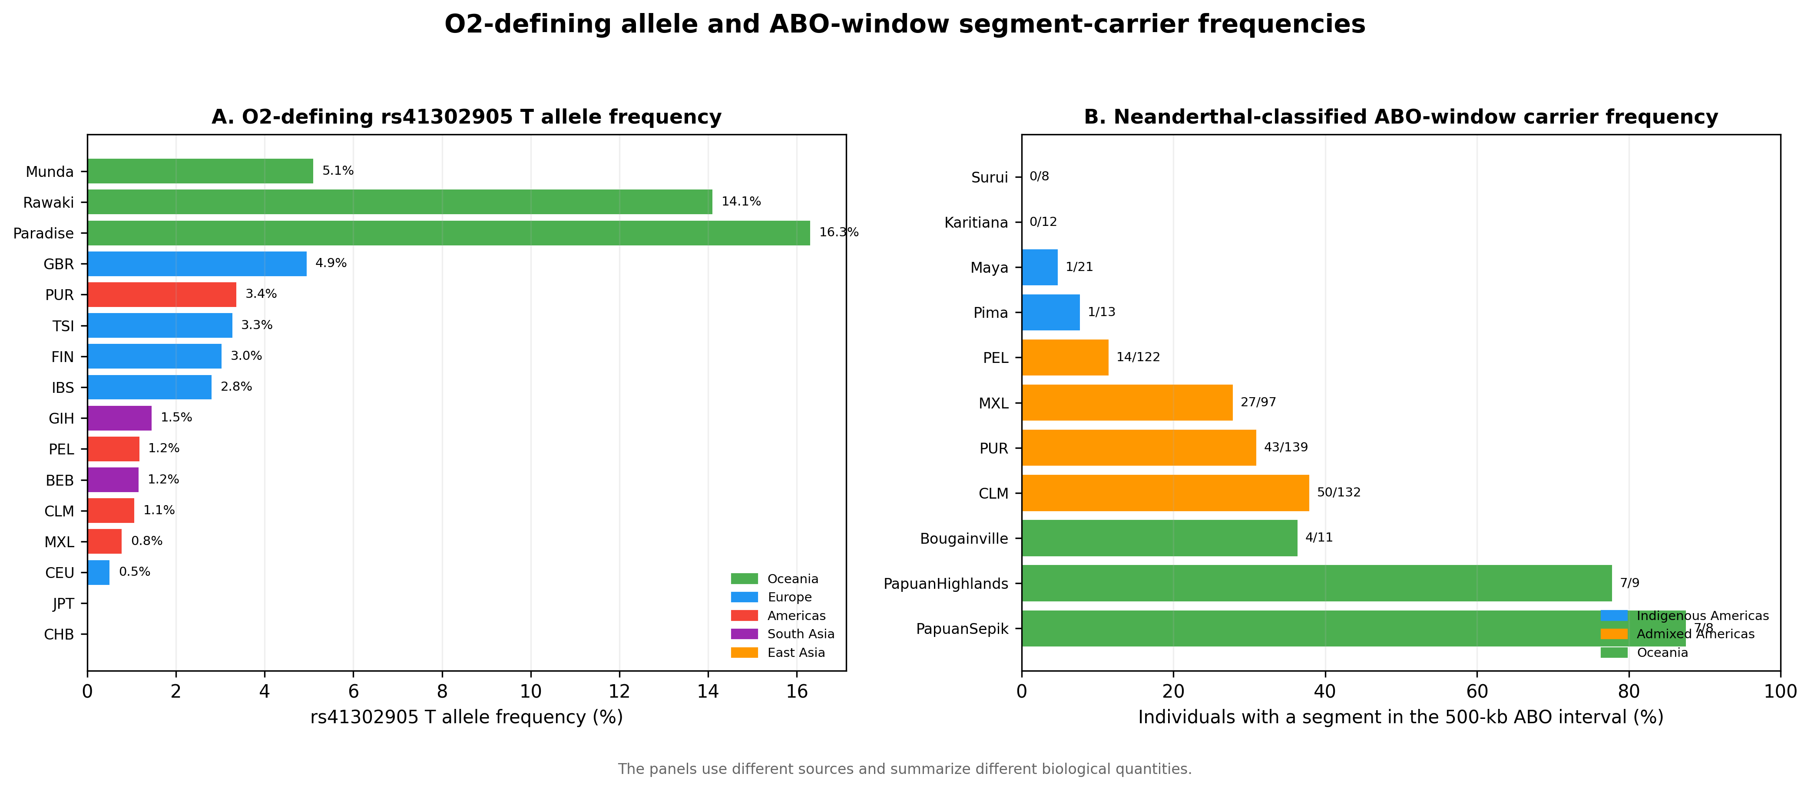
Figure 7. O2-defining allele frequencies and ABO-window segment-carrier frequencies. The panels use different sources and are not an association analysis; proximity does not establish that the O2 allele is Neanderthal-derived.
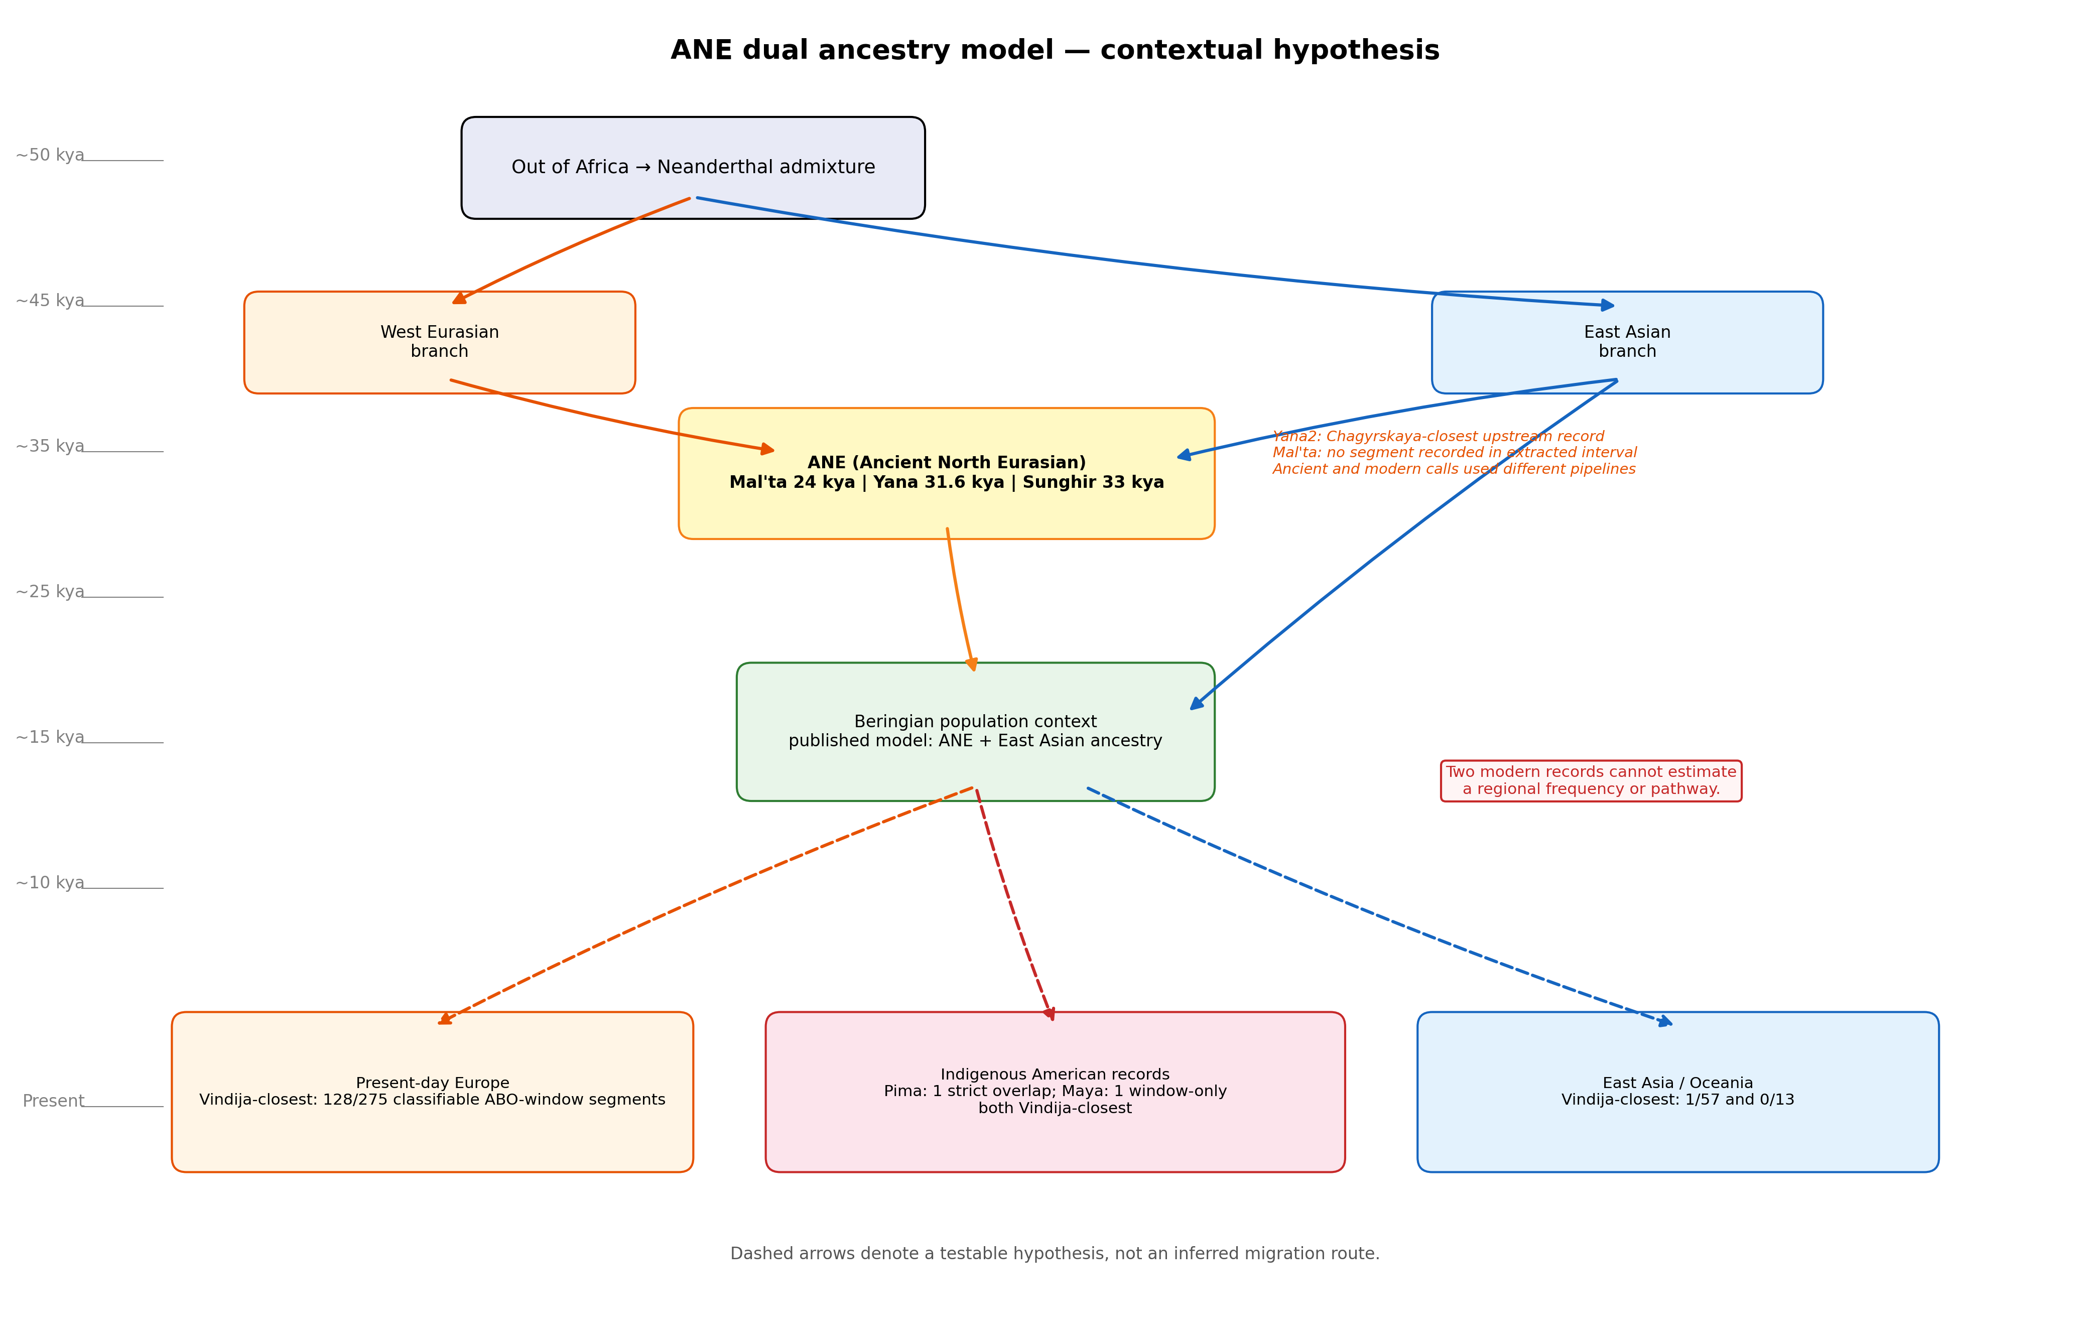
Figure 8. Ancient North Eurasian contextual hypothesis. Dashed arrows represent a testable narrative, not evidence that either observed segment followed the illustrated route.
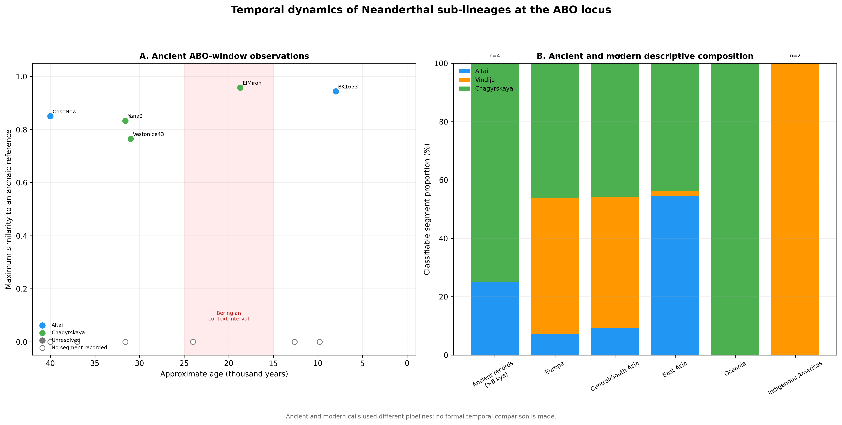
Figure 9. Descriptive ancient and modern ABO-window summaries generated by different pipelines; no formal temporal comparison is made.
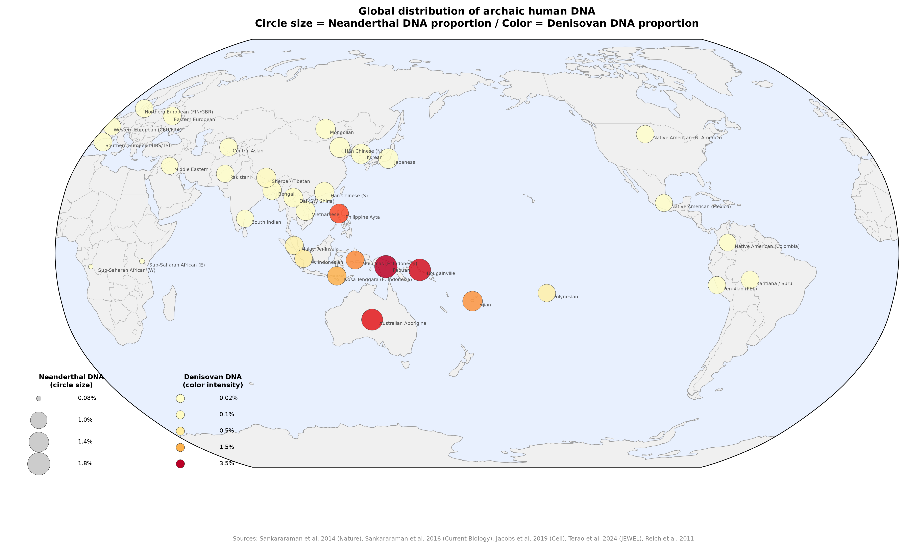
Figure 10. Literature-derived global context. Circle size represents approximate Neanderthal ancestry and color intensity represents approximate Denisovan ancestry. Values were not used in the pairwise statistical models.

Discussion
After correction of the population-frequency construction, both Neanderthal and Denisovan profile similarities retained negative geographic associations. The result is therefore not an artifact of allowing fragmented segments to contribute repeatedly to the same haplotype-window. The revised estimates are used throughout the manuscript and submission materials.
The population-label permutation is central to interpretation. A dataset of 2,145 pairs does not contain 2,145 independent geographic comparisons because each of 66 populations appears repeatedly. QAP preserves the complete matrix while testing whether the observed distance coefficient is unusual under population relabeling (Krackhardt 1988; Dekker, Krackhardt, and Snijders 2007). The expanded-model R-squared values remain descriptive; coarse same-continent, recent-admixture, and dataset indicators should not be read as causal adjustment.
The distance-decay signal is compatible with broad serial demographic structure and the spatial patterning of introgressed sequence described in earlier work (Sankararaman et al. 2014; Sankararaman et al. 2016; Quilodran et al. 2023). It does not identify the timing, direction, or number of migration or introgression events. Population coordinates are approximations, and archaic-call similarity can also reflect callability, allele-frequency differences, linkage, selection, and reference-panel composition.
The absence of FDR-supported residual outliers constrains the strongest historical claims. A highly ranked pair cannot be promoted as evidence for a special connection when its pair-specific permutation result does not survive the declared testing family. This is especially important for admixed American populations, for which recent mixture can alter both inferred archaic profiles and geographic interpretations.
The ABO analysis illustrates the limits of a focal-locus narrative. ABO has deep allelic history, and selection can affect the persistence of introgressed sequence (Segurel et al. 2012; Petr et al. 2019). Nevertheless, an inferred segment in a 500-kb interval is not an ABO allele, closest-reference similarity is not a transmission path, and the O2-defining variant cannot be labeled Neanderthal-derived from proximity alone. The Pima and Maya observations are individual segment records, not population prevalence estimates.
Published Ancient North Eurasian and multiple-founder models provide broader contexts for First American ancestry (Raghavan et al. 2014; Skoglund et al. 2015), but they do not validate a route for either ABO-window segment. Such a claim would require independently sampled ancient genomes, a phased local genealogy, method-matched calling, and explicit community-engaged governance for any new Indigenous genomic analysis.
Limitations include modest sizes for several populations, sparse Denisovan calls outside Oceania, centroid-based distances, lack of a common callable mask, and correlation measures that do not distinguish identity by descent from identity by state. The dataset combines two projects, and same-dataset status only partially represents technical heterogeneity. Population-deletion and sensitivity analyses assess stability but cannot replace validation in independent modern and ancient data.
In conclusion, population-level archaic-segment profiles show a broad geographic distance-decay pattern under dependence-aware permutation tests. The result supports a descriptive relationship between geography and the genomic distribution of inferred archaic segments. It does not establish an exceptional population pair, an ABO-mediated migration history, or a specific route through Beringia or island Southeast Asia.

Acknowledgements
The author acknowledges the participants, communities, and investigators whose contributions made the 1000 Genomes, HGDP, hmmix, and ancient-genome resources available. Public availability does not remove obligations of respectful reuse.

Data Availability
Analysis scripts, aggregate derived data, figures, and document-generation code are available at https://github.com/bougtoir/denisovan-archaic-dna-analysis and will be fixed as release ajba-critical-revision-2026-07 before submission. The source hmmix segment calls are available from Zenodo record 14136628 (https://doi.org/10.5281/zenodo.14136628). Raw-file SHA-256 checksums and all analysis parameters are included in analysis_provenance.json.

Funding
This research received no specific grant from any funding agency in the public, commercial, or not-for-profit sectors.

Conflict of Interest
The author declares no conflict of interest.

Ethics Statement
This secondary computational analysis used de-identified public genomic data and involved no recruitment, participant contact, biospecimen collection, or new phenotype inference. No separate institutional review determination was obtained; approvals, consent, and access procedures were those reported by the source studies. No source community representatives participated in this secondary study, and no direct community return-of-results process occurred. Because Indigenous genomic records are included, results are reported only at the minimum level needed for auditability, are not generalized to communities, and are not used to assign migration routes. The public article, code, and aggregate derived results are the current means of results availability.

Author Contributions
Onishi Tatsuki: Conceptualization, methodology, formal analysis, visualization, writing—original draft, and writing—review and editing.

Literature Cited
1000 Genomes Project Consortium. 2015. “A Global Reference for Human Genetic Variation.” Nature 526 (7571): 68–74. https://doi.org/10.1038/nature15393.
Benjamini, Yoav, and Yosef Hochberg. 1995. “Controlling the False Discovery Rate: A Practical and Powerful Approach to Multiple Testing.” Journal of the Royal Statistical Society: Series B 57 (1): 289–300. https://doi.org/10.1111/j.2517-6161.1995.tb02031.x.
Bergström, Anders, Shane A. McCarthy, Ruoyun Hui, et al. 2020. “Insights into Human Genetic Variation and Population History from 929 Diverse Genomes.” Science 367 (6484): eaay5012. https://doi.org/10.1126/science.aay5012.
Calafell, Francesc, Françoise Roubinet, Antonio Ramirez-Soriano, et al. 2008. “Evolutionary Dynamics of the Human ABO Gene.” Human Genetics 124 (2): 123–35. https://doi.org/10.1007/s00439-008-0530-8.
Carroll, Stephanie Russo, Ibrahim Garba, Oscar L. Figueroa-Rodríguez, et al. 2020. “The CARE Principles for Indigenous Data Governance.” Data Science Journal 19: 43. https://doi.org/10.5334/dsj-2020-043.
Claw, Katrina G., Dorothy Lippert, Jessica Bardill, et al. 2018. “A Framework for Enhancing Ethical Genomic Research with Indigenous Communities.” Nature Communications 9: 2957. https://doi.org/10.1038/s41467-018-05188-3.
Condemi, Silvana, Amandine Mazières, Pascal Faux, et al. 2021. “Blood Groups of Neandertals and Denisova Decrypted.” PLOS ONE 16 (7): e0254175. https://doi.org/10.1371/journal.pone.0254175.
Dekker, David, David Krackhardt, and Tom A. B. Snijders. 2007. “Sensitivity of MRQAP Tests to Collinearity and Autocorrelation Conditions.” Psychometrika 72: 563–81. https://doi.org/10.1007/s11336-007-9016-1.
Green, Richard E., Johannes Krause, Adrian W. Briggs, et al. 2010. “A Draft Sequence of the Neandertal Genome.” Science 328 (5979): 710–22. https://doi.org/10.1126/science.1188021.
Halverson, Melissa S., and Deborah A. Bolnick. 2008. “An Ancient DNA Test of a Founder Effect in Native American ABO Blood Group Frequencies.” American Journal of Physical Anthropology 137 (3): 342–47. https://doi.org/10.1002/ajpa.20887.
Iasi, Leonardo N. M., Manjusha Chintalapati, Laurits Skov, et al. 2024. “Neanderthal Ancestry through Time: Insights from Genomes of Ancient and Present-Day Humans.” Science 386 (6727): eadq3010. https://doi.org/10.1126/science.adq3010.
Jacobs, Guy S., Georgi Hudjashov, Lauri Saag, et al. 2019. “Multiple Deeply Divergent Denisovan Ancestries in Papuans.” Cell 177 (4): 1010–21.e32. https://doi.org/10.1016/j.cell.2019.02.035.
Krackhardt, David. 1988. “Predicting with Networks: Nonparametric Multiple Regression Analysis of Dyadic Data.” Social Networks 10 (4): 359–81. https://doi.org/10.1016/0378-8733(88)90004-4.
Ohashi, Jun, Izumi Naka, Ryosuke Kimura, et al. 2006. “Polymorphisms in the ABO Blood Group Gene in Three Populations in the New Georgia Group of the Solomon Islands.” Journal of Human Genetics 51 (5): 407–11. https://doi.org/10.1007/s10038-006-0375-8.
Petr, Martin, Svante Pääbo, Janet Kelso, and Benjamin Vernot. 2019. “Limits of Long-Term Selection against Neandertal Introgression.” Proceedings of the National Academy of Sciences 116 (5): 1639–44. https://doi.org/10.1073/pnas.1814338116.
Prüfer, Kay, Cesare de Filippo, Steffi Grote, et al. 2017. “A High-Coverage Neandertal Genome from Vindija Cave in Croatia.” Science 358 (6363): 655–58. https://doi.org/10.1126/science.aao1887.
Quilodran, Claudio S., Julie Rio, Athanasios Tsoupas, and Mathias Currat. 2023. “Past Human Expansions Shaped the Spatial Pattern of Neanderthal Ancestry.” Science Advances 9 (42): eadg9817. https://doi.org/10.1126/sciadv.adg9817.
Raghavan, Maanasa, Pontus Skoglund, Kelly E. Graf, et al. 2014. “Upper Palaeolithic Siberian Genome Reveals Dual Ancestry of Native Americans.” Nature 505 (7481): 87–91. https://doi.org/10.1038/nature12736.
Reich, David, Richard E. Green, Martin Kircher, et al. 2010. “Genetic History of an Archaic Hominin Group from Denisova Cave in Siberia.” Nature 468 (7327): 1053–60. https://doi.org/10.1038/nature09710.
Sankararaman, Sriram, Swapan Mallick, Michael Dannemann, et al. 2014. “The Genomic Landscape of Neanderthal Ancestry in Present-Day Humans.” Nature 507 (7492): 354–57. https://doi.org/10.1038/nature12961.
Sankararaman, Sriram, Swapan Mallick, Nick Patterson, and David Reich. 2016. “The Combined Landscape of Denisovan and Neanderthal Ancestry in Present-Day Humans.” Current Biology 26 (9): 1241–47. https://doi.org/10.1016/j.cub.2016.03.037.
Segurel, Laure, Emma E. Thompson, Timothée Flutre, et al. 2012. “The ABO Blood Group Is a Trans-Species Polymorphism in Primates.” Proceedings of the National Academy of Sciences 109 (45): 18493–98. https://doi.org/10.1073/pnas.1210603109.
Skoglund, Pontus, Swapan Mallick, Maria Cátira Bortolini, et al. 2015. “Genetic Evidence for Two Founding Populations of the Americas.” Nature 525 (7567): 104–8. https://doi.org/10.1038/nature14895.
Skov, Laurits, Ruoyun Hui, Vladimir Shchur, et al. 2018. “Detecting Archaic Introgression Using an Unadmixed Outgroup.” PLOS Genetics 14 (9): e1007641. https://doi.org/10.1371/journal.pgen.1007641.
Turner, Trudy R. 2025. “Changes to Submissions to the AJBA.” American Journal of Biological Anthropology 186: e70026. https://doi.org/10.1002/ajpa.70026.

