Litigation risk and specialty-level physician workforce allocation: a transparent decision-analytics framework for evaluating healthcare workforce policy levers

Abstract
Specialty maldistribution is a global healthcare workforce-allocation problem, and many health systems assume that malpractice-litigation risk pushes physicians away from high-risk specialties. We used this question as a test case for a transparent, reproducible decision-analytics and operations-research framework that evaluates a proposed workforce policy lever while avoiding size confounding and interpolation artifacts in sparse administrative panels. Using national primary data for 12 specialties in Japan (2008–2024), we measured exposure as closed malpractice claims per 1,000 physicians (rate, not count) and regressed biennial log-change in physicians and hospitals on the lagged litigation rate in a panel with specialty and wave fixed effects, cluster-robust standard errors with a small-cluster t(G-1) correction, a cluster block-bootstrap robustness check, two one-sided equivalence (TOST) tests, and power diagnostics. The workforce grew in 11 of 12 specialties; general surgery, which changed by -2.3%, was the exception. Litigation rate was not associated with physician growth (coefficient -0.0009; 95% CI -0.0043 to +0.0025; p=0.56) or hospital growth (p=0.90). A one-SD higher rate changed physician growth by less than ±1% (TOST p=0.023; less than ±2% was p=<0.001); the minimum detectable effect was 1.08% per SD at 80% power. Hospital growth was within ±2% (p=0.002) but not the stricter ±1% margin (p=0.059). Sensitivity analyses were unchanged. Specialty-level litigation risk is not associated with workforce decline in these national data. The decision-analytics and operations-research framework is exportable to other healthcare workforce-policy levers.
Keywords: malpractice litigation; physician workforce; specialty maldistribution; equivalence testing; healthcare decision analytics; operations research

1. Introduction
Specialty maldistribution is a global healthcare workforce allocation challenge: high-acuity fields such as surgery, obstetrics and gynaecology, paediatrics and emergency care are widely perceived as understaffed across many health systems.^{[1]} A recurring policy intuition is that medical safety incidents and the threat of malpractice litigation push physicians away from high-risk specialties toward lower-risk practice.^{[2-3]} If true, reducing litigation exposure would be a lever against maldistribution. Japan provides a well-documented national setting in which to test this intuition: it tracks closed malpractice claims, physician counts and hospital counts by specialty, and it faces the same fee-for-service and specialty-training pressures seen in other high-income countries.
Prior work in this area often related raw annual counts of incidents or lawsuits to raw counts of physicians or facilities. Two features make such designs prone to spurious association. First, counts are not adjusted for specialty size: a larger specialty mechanically accumulates more procedures, more claims and more physicians, so count-based associations can arise without any behavioural mechanism. Second, the physician census is collected only biennially; interpolating it to an annual series and analysing it as if each year were an independent observation inflates the degrees of freedom of any lag-based method. These pitfalls are not unique to malpractice research; they arise whenever administrative counts are used to infer behavioural responses in healthcare organisations. From a decision-analytics perspective, the relevant question is not whether litigation risk is correlated with raw counts, but whether it is a policy lever that workforce planners can use to shift specialty supply. We therefore treat the litigation-workforce question as a test case for a transparent, reproducible decision-analytics and operations-research framework for healthcare workforce allocation and resource planning. This is, to our knowledge, the first application of pre-specified equivalence testing and small-cluster inference diagnostics to the malpractice-litigation workforce literature.
We therefore examined the question using rates rather than counts, using only measured biennial physician observations, and using equivalence testing—which can provide positive evidence for the absence of a meaningful effect rather than merely failing to reject a null.^{[4-5]} We also account for the Japan Obstetric Compensation System for Cerebral Palsy (JOCS-CP), a no-fault scheme launched in January 2009 that sits within the study window and applies to the specialty most often cited in this debate.^{[6]}

2. Materials and methods

2.1. Data sources
We report this observational study following the Strengthening the Reporting of Observational Studies in Epidemiology (STROBE) guidance.^{[7]} We studied 12 core clinical specialties in Japan for which the Supreme Court reports specialty-specific litigation. Three official primary series drove the main analysis: physician counts by specialty from the biennial Statistics of Physicians, Dentists and Pharmacists^{[8]}; closed malpractice claims by specialty from the Supreme Court of Japan^{[9]}; and hospital counts by specialty from the annual Survey of Medical Institutions^{[10]}. Two sensitivity series were also used: annual medical accident investigation reports by specialty from the Japan Medical Safety Research Organisation (JMSR, 2015-2024)^{[11]} and total national newspaper article counts from Nikkei Telecom 21 (2004-2018; the sensitivity analysis uses 2009-2018; keywords: medical error + medical malpractice).^{[12]} The full extraction pipeline (with source identifiers and SHA-256 checksums) is documented in the accompanying repository (https://github.com/bougtoir/medical-accident-its-analysis).
Physician counts use the principal specialty classification; broad categories were matched to the Supreme Court's specialty labels, and subspecialties were aggregated in code. Because the Court assigns multi-specialty cases to a single principal specialty and states that the counts do not represent the intrinsic risk of each specialty, we treat litigation as an exposure signal rather than a measure of incident risk.^{[9]} We distinguish litigation from the Medical Accident Investigation System, which began in 2015 and covers only deaths and stillbirths judged unforeseen by the hospital administrator; it is not a general incident-reporting system and is not used as an exposure here.^{[13]} Primary data sources and their resolution are summarised in Supplementary Table 1.

2.2. Statistical analysis
We formalised the evaluation as a sensitivity-analysis framework that varies the exposure definition (counts versus rates), panel frequency (measured biennial waves versus interpolated annual values), and potential confounders (JMSR reports, media coverage, JOCS-CP period) while holding the specialty-level panel structure constant. The exposure was the litigation rate, defined as closed claims per 1,000 physicians in each specialty-year, which removes specialty-size confounding because large specialties generate more claims for reasons unrelated to per-physician risk. The primary analysis used the 9 measured biennial physician waves (2008–2024). For each specialty we computed the biennial log-change in physicians (and, separately, in hospitals) and regressed it on the litigation rate at the start of the interval, in a panel with specialty and wave fixed effects and standard errors clustered by specialty.^{[14]} Clusters are defined by specialty, so G=12 and the small-cluster correction uses a t-distribution with G-1 degrees of freedom for all cluster-robust inference. Supplementary Figure 1 summarises the sensitivity-analysis framework. The primary estimating equation, for specialty s and wave t, was as follows.
$Δlog(Y_{st})=α_{s}+δ_{t}+β·{\text{litrate}}_{s,t−1}+ϵ_{st}$
Here, Y is either physicians or hospitals, alpha_s are specialty fixed effects, delta_t are wave fixed effects, and standard errors are clustered by specialty. For the equivalence analysis we standardised litrate to a z-score, so beta gives the expected biennial log-change per one-SD increase in the litigation rate.
We assessed equivalence to a null effect using two one-sided tests (TOST).^{[4-5]} For a pre-specified margin m, the two one-sided null hypotheses are
$H_{0}:β≤−m\text{and}H_{0}:β≥+m$
Equivalence is declared when both one-sided tests yield p < alpha. We used margins of 1% and 2% biennial workforce change because they are smaller than typical policy targets for specialty workforce rebalancing and represent changes that workforce planners would consider substantively small.
We complemented the analytical small-cluster inference with two diagnostic quantities. First, a cluster block-bootstrap with B = 1,999 replications resampled specialties with replacement, re-fitted the primary model, and reported percentile bootstrap 95% confidence intervals and a bootstrap p-value based on the distribution of absolute t-statistics. Second, we report the minimum detectable effect (MDE) at 80% power for the per-SD litigation-rate coefficient and the power to declare equivalence when the true effect is zero. The MDE is (t(0.975, df) + t(0.80, df)) × SE; the equivalence power is 2·F_t(m/SE) − 1, where F_t is the cumulative distribution of the t(df) distribution. These diagnostics make the limited-panel information explicit to workforce planners evaluating this policy lever.

2.3. Policy lever simulation
To translate the regression results into a decision-analytics and operations-research output, we projected physician counts to 2034 under three stylised policy levers. The baseline used each specialty's observed mean biennial log-growth from 2004 to 2024. The two litigation-reduction levers set the litigation rate to zero and applied the point estimate and the 95% lower-bound coefficient, respectively, so they show both the central projection and the most favourable effect consistent with the data. The third lever added the minimum detectable per-SD effect (1.08% per biennium) to baseline growth as a benchmark for the smallest policy effect this panel could detect with 80% power. The projections are deterministic counterfactuals, not forecasts, and are reported as the marginal percent change in 2034 relative to the baseline drift.
All reported confidence intervals and two-sided p-values use a t-distribution with G-1 = 11 degrees of freedom, the small-cluster correction recommended by Cameron and Miller.^{[15]} An indicator for obstetrics and gynaecology from 2009 onward captured the JOCS-CP period.^{[6]} Sensitivity analyses repeated the models on (i) the annual hospital series, (ii) a linearly interpolated annual physician series (with degrees of freedom governed by the measured waves, not the interpolated n), (iii) raw counts instead of rates, (iv) the annual hospital series 2016-2024 additionally controlling for the JMSR report rate (reports per 1,000 physicians), and (v) the annual hospital series 2009–2018 additionally controlling for total Nikkei Telecom article counts. Because the article-count series is a national yearly variable, it is collinear with full wave fixed effects; this sensitivity therefore uses specialty fixed effects plus a linear time trend rather than wave dummies. The JOCS-CP indicator and all sensitivity models are exploratory; we report raw p-values and Holm step-down adjusted p-values for this family. Analyses used Python (statsmodels); code and data are openly available at https://github.com/bougtoir/medical-accident-its-analysis.

3. Results

3.1. Workforce and litigation trends
Litigation rates per 1,000 physicians varied several-fold across specialties and fell over time in 10 of 12 fields (Supplementary Figure 2). Over the same period the physician workforce grew in 11 of 12 specialties (Supplementary Figure 3; Table 1); the only exception was general surgery, which was essentially flat (-2.3% across 16 years). Exposure and workforce therefore did not move in opposite directions as a flight-from-risk account would predict.
Table 1. Physicians, litigation rate (per 1,000 physicians) and hospitals by specialty, first and last waves.
Specialty | Physicians 2008 | Physicians 2024 | Lit. rate 2008 | Lit. rate 2024 | Hospitals 2008 | Hospitals 2024
Internal medicine | 102388 | 124010 | 2.23 | 1.48 | 7725 | 7163
Surgery | 27525 | 26885 | 6.54 | 2.83 | 4994 | 4300
Orthopaedics | 19273 | 22630 | 5.60 | 2.87 | 5094 | 4844
Plastic surgery | 2520 | 5074 | 7.14 | 8.28 | 1090 | 1475
Obstetrics & gynaecology | 11961 | 13908 | 8.28 | 2.23 | 1319 | 1052
Paediatrics | 15236 | 18009 | 1.44 | 0.44 | 2932 | 2446
Psychiatry | 13534 | 17259 | 2.22 | 1.80 | 2618 | 2881
Ophthalmology | 12627 | 13436 | 2.14 | 1.04 | 2501 | 2310
Otolaryngology | 8936 | 9330 | 2.13 | 1.39 | 2039 | 1937
Urology | 6324 | 8069 | 2.85 | 2.11 | 2799 | 2893
Dermatology | 8214 | 10043 | 1.10 | 1.39 | 3040 | 3066
Anaesthesiology | 7067 | 10628 | 1.13 | 0.38 | 2525 | 2798

3.2. Primary association and equivalence
The lagged litigation rate was not associated with biennial physician growth (coefficient -0.0009; 95% CI -0.0043 to +0.0025; p=0.56; n=96) or with hospital growth (coefficient +0.0003; p=0.90). Equivalence testing (Figure 1; Table 2) showed that a 1-SD higher litigation rate changed biennial physician growth by less than ±1% (TOST p=0.023; point estimate -0.21% with 90% CI -0.84% to +0.42%). For hospital growth the point estimate was +0.07% (90% CI -0.91% to +1.06%): it was within the ±2% margin (p=0.002) but not the stricter ±1% margin (p=0.059). Thus the data are consistent with the absence of a policy-relevant effect on physician growth, and with at most a small effect on hospital growth. Detailed TOST results by margin are reported in Supplementary Table 2.
Figure 1. Equivalence (TOST) of the litigation-rate effect against ±1% and ±2% margins; horizontal bars are 90% confidence intervals.
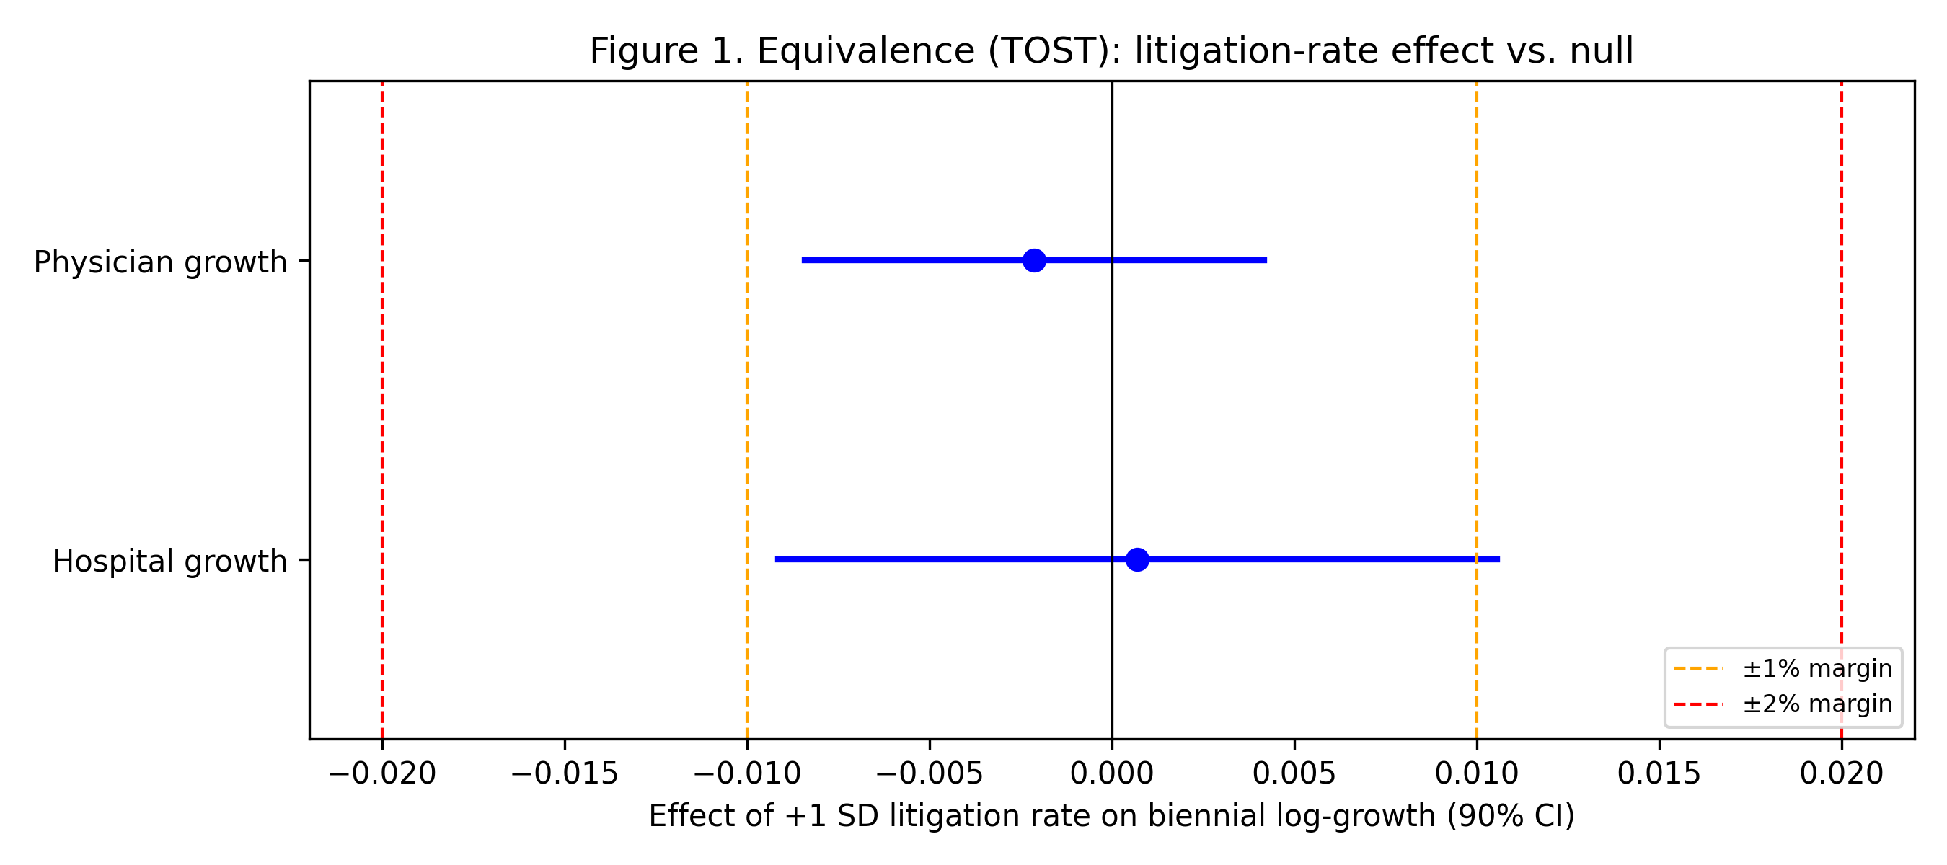

Table 2. Panel fixed-effects models and sensitivity analyses.
Model | Coefficient | 95% CI | p | n
Physician growth ~ lagged rate | -0.0009 | -0.0043, +0.0025 | 0.56 | 96
Hospital growth ~ lagged rate | +0.0003 | -0.0050, +0.0056 | 0.90 | 96
Counts contrast (physician) | +0.0002 | — | 0.51 | 96
Annual hospital (sensitivity) | +0.0000 | — | 0.99 | 192
Interpolated physician (sensitivity) | -0.0010 | — | 0.39 | 192
Reverse (workforce→litigation) | +0.097 | — | 0.85 | 96

3.3. Small-cluster robustness and power
Because inference is based on only 12 specialty clusters, we checked the primary results with a cluster block-bootstrap (B = 1,999). For physician growth the bootstrap 95% CI for the lagged litigation-rate coefficient was -0.0048 to +0.0021 and the bootstrap p-value was 0.57; for hospital growth the bootstrap 95% CI was -0.0043 to +0.0042 and the bootstrap p-value was 0.90. Both intervals comfortably contain zero. Power diagnostics make the panel information explicit. For physician growth, the minimum detectable effect was 1.08% per SD at 80% power, and the power to declare equivalence within the ±1% margin if the true effect were zero was 98.4%. For hospital growth the minimum detectable effect was 1.69% per SD and the equivalent power for the ±1% margin was 90.4%. The panel is therefore informative enough to rule out policy-relevant effects for physicians, and to bound any hospital effect within a small margin.

3.4. Counts versus rates, and confounders
Using raw litigation counts rather than rates did not reveal a negative association in this measured-only design (p=0.51). Figure 2 shows the contrast: the count exposure is confounded by specialty size (panel a), whereas the rate-adjusted exposure is not (panel b); points are coloured and shaped by specialty so readers can identify which fields drive any apparent pattern. The annual hospital and interpolated annual-physician sensitivity analyses were also null (p=0.99 and p=0.39), confirming that the null result is robust to panel frequency and exposure definition. The JOCS-CP indicator was positive in sign in the obstetric-hospital model (coefficient +0.024, raw p=0.013), but it did not remain significant after the small-cluster correction and Holm adjustment for the exploratory sensitivity family (Holm p=0.119); we therefore treat it as exploratory and do not interpret it as a causal policy effect.
Figure 2. Biennial physician growth against lagged litigation exposure measured as (a) counts and (b) rates. Points are coloured by specialty; the count panel shows the size confounding that the rate panel removes.
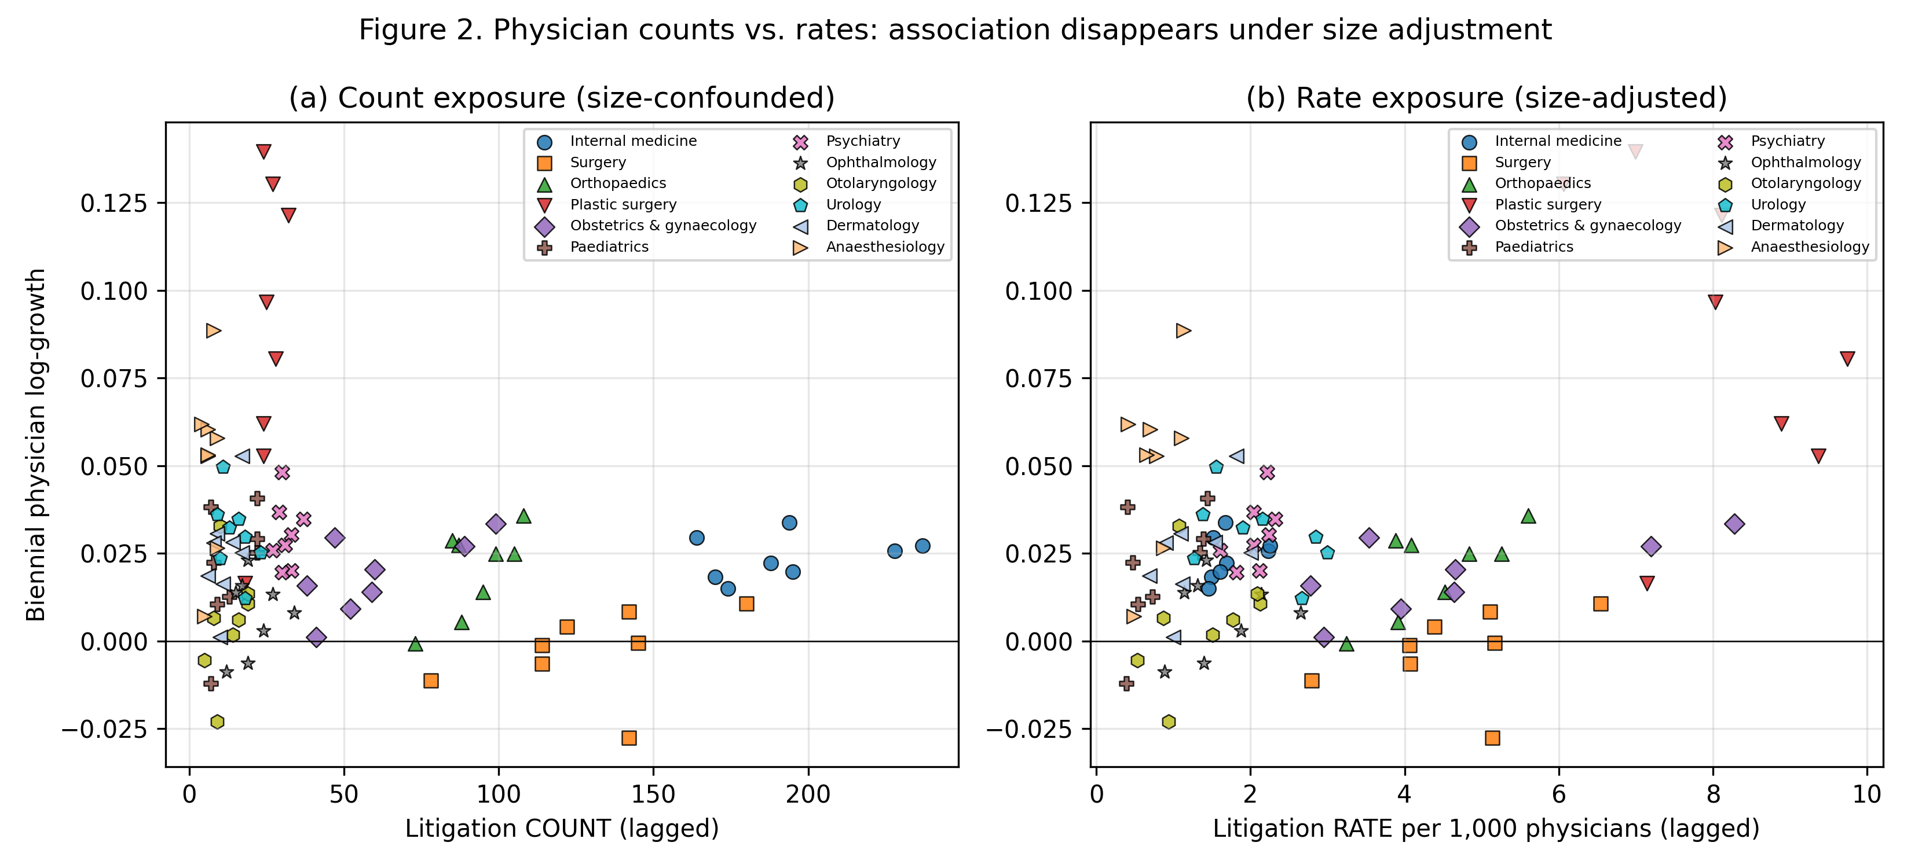

The same count-versus-rate contrast for biennial hospital growth is shown in Figure 3. As with physician growth, the count exposure creates a spurious size confound that disappears once the rate-adjusted exposure is used.
Figure 3. Biennial hospital growth against lagged litigation exposure measured as (a) counts and (b) rates. Points are coloured by specialty; the rate-adjusted panel shows no systematic association.
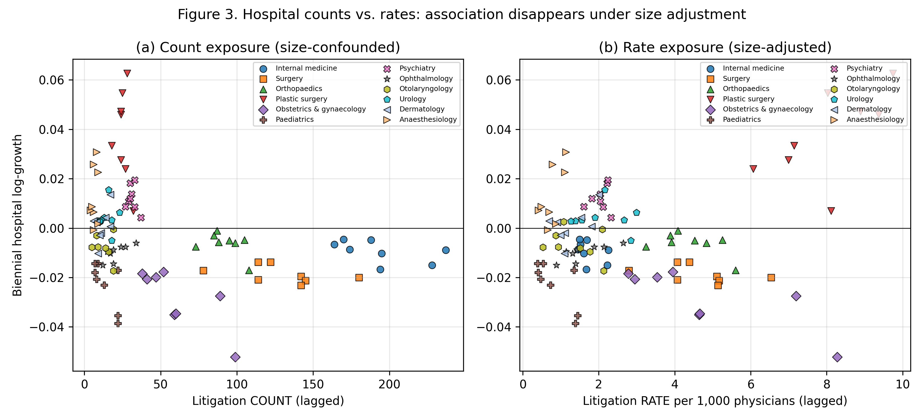

Descriptively, per-specialty rank correlations between the lagged litigation rate and physician growth were positive in 10 of 12 specialties and statistically significant in 0; the direction is therefore, if anything, opposite to a flight-from-risk hypothesis.
A reverse specification (change in litigation rate regressed on lagged log physicians) was also null (coefficient +0.097, p=0.85; Table 2), making a reverse-causation interpretation of the null unlikely.
We also evaluated JMSR medical-accident investigation report counts as a potential confounder or competing exposure.^{[13]} From 2015 to 2024, raw litigation and JMSR report counts were strongly correlated across specialties (Pearson r=0.82), because large specialties generate more of both. After removing specialty-specific levels and trends, however, the within-specialty correlation was negligible (r=-0.02). A model of annual hospital growth for 2016-2024 that included both the lagged litigation rate and the lagged JMSR report rate left the litigation coefficient essentially unchanged (+0.0021; p=0.28) and the JMSR term was not associated with hospital growth (p=0.66; Supplementary Table 3). The null litigation result is therefore neither explained nor masked by broader medical-accident reporting.
Finally, we tested national newspaper coverage from Nikkei Telecom 21 as a potential confounder.^{[12]} Total annual article counts (keywords: medical error + medical malpractice) and total litigation counts were correlated (Pearson r=0.81), consistent with greater public attention in high-litigation years. Within the annual hospital panel, however, the lagged litigation rate and the media-count series were only weakly correlated. A model of annual hospital growth for 2009-2018 that included both the lagged litigation rate and the lagged article count (per 1,000 articles) left the litigation coefficient essentially unchanged and the media term was not associated with hospital growth (p=0.21; Supplementary Table 4). Media coverage therefore does not explain the null litigation effect either. Holm step-down adjusted p-values for the exploratory sensitivity family are reported in Supplementary Table 5.

3.5. Policy lever simulation
The counterfactual projection made the practical implications of the null regression result explicit. Under the point estimate, eliminating all malpractice litigation would add only 1.1% to the projected 2034 national physician stock relative to baseline drift. Even under the 95% lower-bound (most favourable) coefficient it would add 5.2%, comparable to the 5.5% gain from a generic lever equal to the minimum detectable effect. General surgery, the only specialty with negative baseline drift, illustrates the break-even arithmetic: its projected 2024-2034 decline of -2.2% would be reduced to -0.1% under the point estimate and reversed to 7.7% under the 95% lower bound. The latter requires eliminating every remaining closed claim and assumes the most adverse (most negative) coefficient compatible with the data; a more realistic policy would achieve far less. Full projected 2034 physician counts by specialty and lever are reported in Supplementary Table 7; Figure 4 summarises the same information as marginal percentage changes. Litigation reduction is therefore not a high-leverage instrument for workforce allocation in this setting.
Figure 4. Counterfactual policy-lever simulation: marginal 10-year change in physician counts by specialty relative to the projected baseline drift. The MDE benchmark is the minimum detectable per-SD effect from the primary analysis.
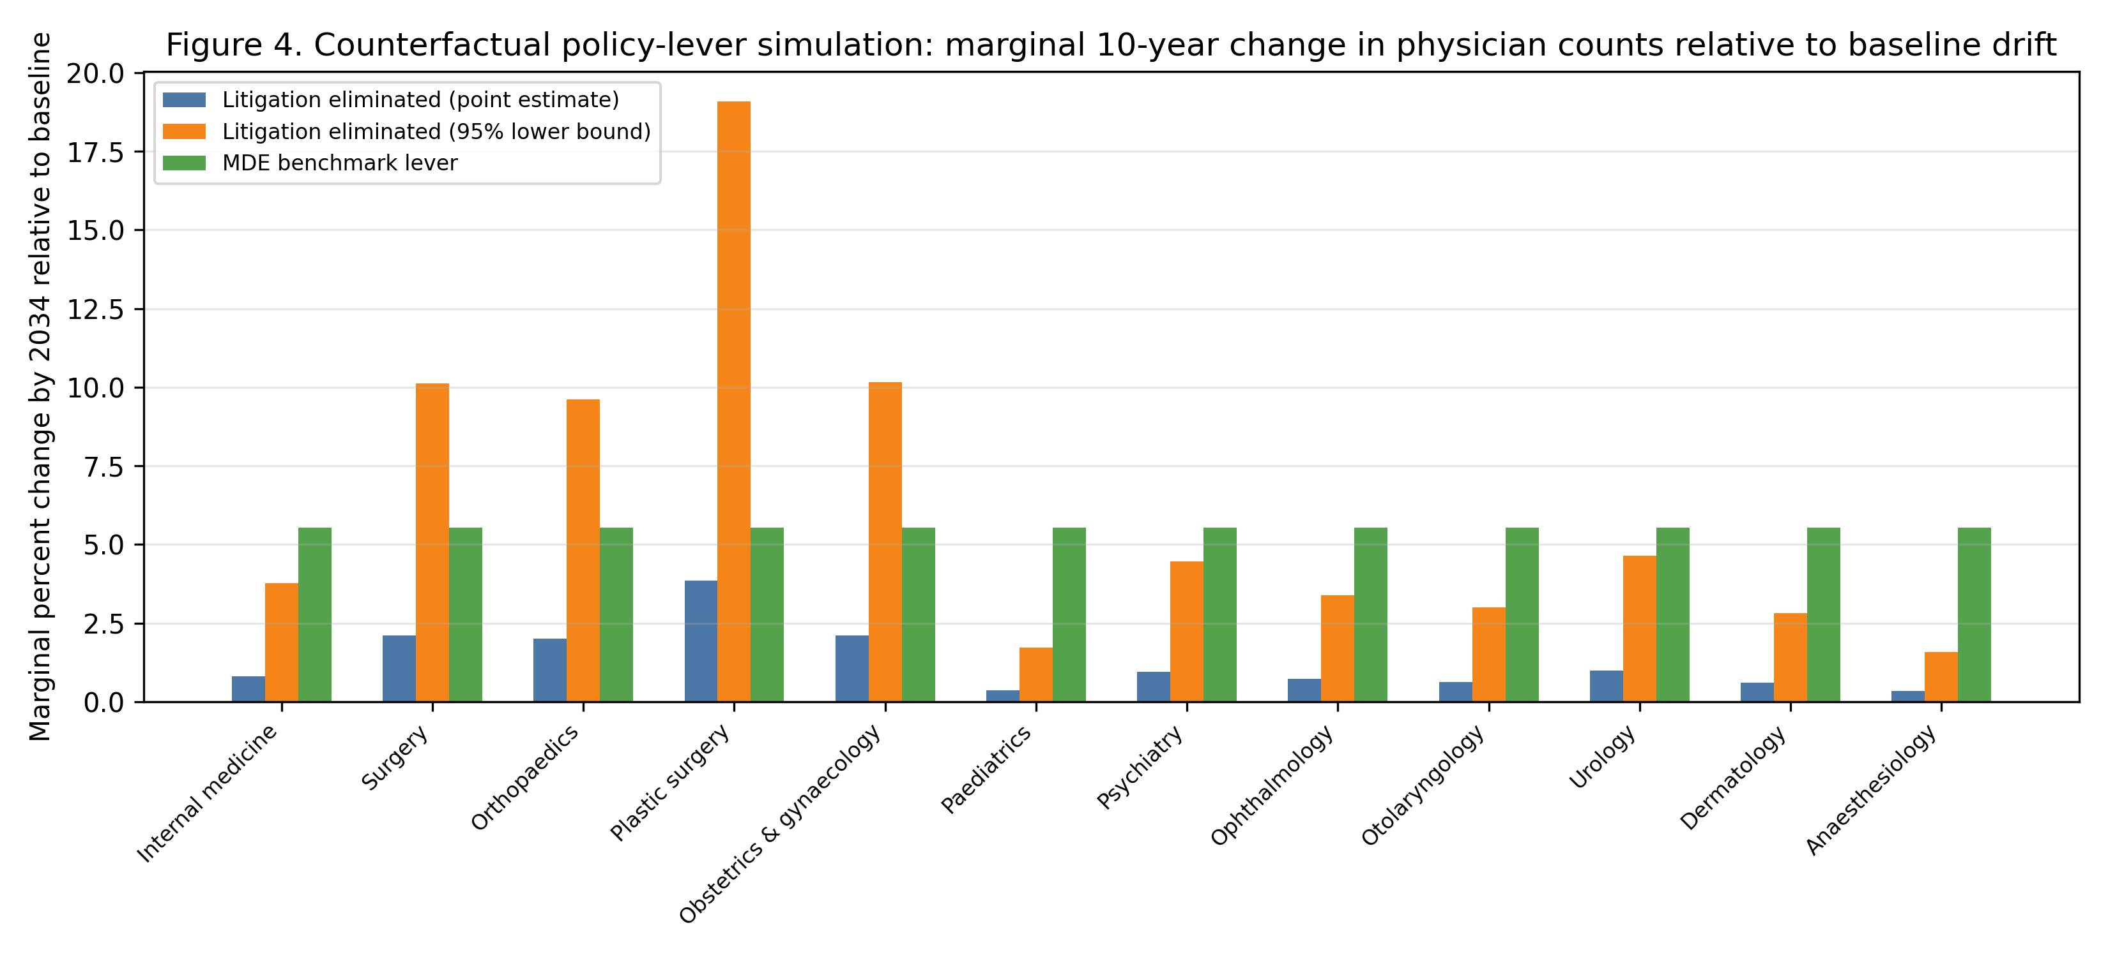

4. Discussion
Using national primary data, rates rather than counts, and only measured physician observations, we found no association between specialty-level malpractice-litigation risk and subsequent physician or hospital decline. Equivalence testing showed that any effect of litigation risk on biennial physician growth is smaller than 1% (90% CI within the 1% margin), and any effect on hospital growth is smaller than 2% (but not confidently smaller than 1%). These data therefore do not support the hypothesis that physicians systematically abandon high-litigation specialties over 16 years of official statistics.
A null result is not merely a failure to detect an effect. The narrow confidence intervals, pre-specified equivalence margins, and power diagnostics allow us to say that, if litigation risk does influence specialty-level workforce growth, the magnitude is too small to matter for workforce planning. Several interpretations are consistent with this finding. First, litigation risk may affect clinical behaviour on the intensive margin (defensive medicine) rather than the extensive margin (specialty exit). Second, the closed-claim rate is an objective measure, but the perceived risk that drives career decisions may be shaped more by rare, salient criminal prosecutions and media coverage than by routine civil claims. Third, high-risk specialties in Japan also carry substantial fee-for-service returns, so income effects, switching costs and status-quo bias can offset any deterrent. Finally, the negative finding is informative in its own right: studies that reject a commonly assumed policy mechanism are under-represented in the literature, and a well-powered equivalence result reduces the risk that policy is directed at an ineffective lever.^{[16-18]}
The raw-count sensitivity did not reveal a negative association in these data, illustrating that the apparent count-litigation relationship does not translate into a behavioural effect once specialty size is accounted for (Figure 2). This is a cautionary example for workforce research that pairs administrative count series, and shows why rate-based, measured-only designs are preferable when testing litigation-workforce hypotheses.
International evidence on tort reform and physician supply is consistent with a small or context-specific effect. Matsa found that U.S. state damage caps increased the supply of frontier rural specialists by 10-12 percent, but did not affect physician supply for the average resident.^{[19]} Hyman and colleagues, examining the 2003 Texas reforms, found no measurable increase in physician supply for high-malpractice-risk specialties, primary care, or rural physicians.^{[20]} Frakes and colleagues showed that negligence-standard reforms could shift the composition of the physician workforce toward surgery in some regions, yet the effect was localized and modest.^{[21]} Against this backdrop, a null effect of civil litigation risk on specialty supply is not surprising, especially in a system with comparatively low litigation volume and predictable damages.
Even when litigation risk is unrelated to the number of physicians, it may shape clinical behaviour through defensive medicine. Kessler and McClellan showed that U.S. malpractice reforms reduced medical expenditures for elderly heart-disease patients without increasing mortality or complications, suggesting that defensive practice is one margin of adjustment to liability pressure.^{[22]} Subsequent reassessments have debated the magnitude and robustness of this effect, but the conceptual point remains: physicians can respond to liability risk by changing how they practise rather than by exiting a specialty.^{[23]} Fee-for-service reimbursement in Japan rewards the high-acuity procedural work that also carries litigation exposure, so the financial return to remaining in surgery, obstetrics, or interventional specialties may dominate any deterrent from civil claims.
This pattern is consistent with well-documented behavioural-economics mechanisms. Media coverage of sensational malpractice or criminal prosecutions makes litigation risk highly available to physicians and trainees, and loss aversion can cause a rare but salient adverse outcome to be overweighted in career deliberations.^{[16-17]} Yet the actual decision to leave a specialty is governed by expected income, sunk training costs, switching costs and status-quo bias, all of which discourage exit even when perceived risk is high.^{[18]} The discrepancy between reported anxiety and measured supply is therefore not a contradiction; it is exactly what one would expect when a vivid, low-probability risk meets strong economic and institutional incentives to remain.
The civil litigation environment in Japan itself dampens the likelihood of a flight-from-risk response. Taniguchi and colleagues analysed all closed malpractice claims reported by the Supreme Court from 2006 to 2021 and found that more than half ended in settlement, plaintiffs won only about a quarter of judgments, and the number of claims has been declining, especially in obstetrics and gynaecology.^{[24]} The Court data we use therefore describe a civil system that is low-volume, settlement-prone, and comparatively favourable to physicians. This context makes it unlikely that routine civil litigation risk alone would drive physicians out of high-risk fields.
No-fault obstetric compensation (the Japan Obstetric Compensation System for Cerebral Palsy, 2009) illustrates a different mechanism. It was introduced partly because of a shortage of young obstetricians and regional gaps in maternity care, and it combined no-fault compensation with investigation and prevention.^{[25]} The hospital-level JOCS-CP indicator was directionally positive (coefficient +0.024, raw p=0.013), but it did not remain significant after the small-cluster correction and Holm adjustment for the exploratory sensitivity family (Holm p=0.119). This suggests that, if the JOCS-CP did support obstetric hospital supply, the effect would be too small or too confounded by concurrent obstetric policies to be isolated here. Civil litigation exposure is also distinct from criminal prosecution. Morita studied the 2004 Fukushima obstetrician prosecution and found a 13 percent decline in obstetricians, with some switching to gynaecology.^{[26]} Criminal cases and their media coverage may be far more salient to career decisions than routine closed civil claims, and our data do not capture that channel.
The obstetrics and gynaecology case is the most discussed example of the litigation-workforce nexus, and it is consistent with our interpretation. A recent Japan–U.S. comparison of medical-legal claims in obstetrics and gynaecology (OB/GYN) found that the proportion of malpractice claims in this specialty fell from 15.1 percent in 2004 to 5.2 percent in 2022, and that claims per 100 OB/GYN physicians fell from 0.9 in 2007 to 0.4 in 2016, while maternal and neonatal mortality also declined.^{[27]} The authors attribute this to heightened awareness after a wrongful criminal charge, the JOCS-CP no-fault scheme, standardised clinical guidelines, and the adverse-event investigation system. This is not evidence that lowering litigation risk caused the workforce to grow; it is evidence that obstetric litigation, workforce support, and safety interventions moved together. Surveys of OB/GYN residents in Japan, Korea, and Taiwan likewise show that litigation is reported as a negative factor, but that its perceived importance is smaller where no-fault compensation exists and that workload, lifestyle, and professional interest remain dominant.^{[28]} These findings echo our specialty-level result: litigation may matter for perceptions, but it is not the binding constraint on supply.
What do these findings imply for policy? Reducing civil malpractice litigation is unlikely to be a powerful lever for correcting specialty maldistribution in this national setting. The 10-year counterfactual simulation showed that eliminating all litigation would add only 1.1% to the projected national physician stock under the point estimate, and even 5.2% under the most favourable 95% lower-bound coefficient, before accounting for the implausibility of zero claims. Structural incentives are more promising: no-fault compensation can de-risk high-acuity specialties, and payment design can reward service in underserved settings and activities. The JOCS-CP experience supports the former; the country's fee-for-service schedule and rural/urban payment adjustments illustrate the latter. Malpractice reform may still matter for defensive medicine, patient compensation, and provider-patient trust. But our evidence does not support the claim, at least from these data, that lowering litigation risk will retain physicians in high-risk specialties. Policymakers should therefore target structural incentives before relying on litigation-avoidance messaging.
International experience with no-fault compensation is consistent with this policy orientation. New Zealand replaced tort-based medical-injury compensation with a government-funded no-fault scheme in 1974 and, after 2005 reforms, extended coverage to all treatment injuries; this separated compensation from negligence findings and largely barred malpractice litigation.^{[29]} Sweden and Denmark operate similar administrative systems in which neutral experts evaluate claims without requiring proof of provider fault, improving injured patients' access to redress while controlling liability costs and generating patient-safety learning.^{[30]} The JOCS-CP is narrower in scope—it covers only obstetric cerebral palsy—but it moves in the same direction: it provides compensation and cause analysis without a protracted adversarial process. Extending such an approach more broadly would be a structural alternative to repeated calls to reduce malpractice litigation as a workforce strategy.
Several questions remain for future research. We cannot observe individual physicians' risk perceptions, career intentions, or responses to media coverage of high-profile cases. The closed-claim rate is an objective exposure measure, but it may not capture the perceived risk that drives specialty choice, especially when criminal prosecutions or sensational media coverage shape beliefs. Helland and Seabury's review concludes that tort reform effects on physician supply are heterogeneous across states and specialties, and that more granular, state-specific designs are needed to settle the question in the U.S. context.^{[31]} Applying similar logic in the same national setting would require individual-level or prefecture-level career data linked to local litigation, media, and reimbursement environments. Until then, the present specialty-level rate analysis provides the most systematic evidence available on the central policy question: whether malpractice litigation risk drives physicians away from high-risk specialties. The answer, in these data, is no—or at least not in a way that is detectable or policy-relevant across 9 measured waves (2008–2024).
The framework we used is intentionally general and falls within healthcare operations research and decision analytics. Specialty physician workforce allocation is a recurring healthcare decision problem, and the same sensitivity-analysis steps—rate adjustment to remove size confounding, measured-only panels to avoid interpolation, equivalence testing with policy-relevant margins, and small-cluster inference—can be applied to other proposed levers, such as fee schedules, regional quotas, or training subsidies. The analytic contribution is therefore not the malpractice finding itself but a transparent, reproducible decision-support workflow that helps planners distinguish meaningful workforce effects from spurious count- or interpolation-based associations.

4.1. Limitations
This is an ecological, specialty-level analysis and cannot establish individual-level causality. The physician census is biennial, giving 9 measured waves; we addressed the limited power directly through equivalence testing and by pooling across specialties, but residual power constraints remain and the equivalence margins are a judgement. Litigation rates may be endogenous to physician supply if a smaller workforce increases workload and hence incidents; the lagged exposure, fixed effects, and reverse specification make reverse causation unlikely, yet unobserved confounders at the specialty or prefecture level cannot be fully ruled out. Cluster block-bootstrap and power diagnostics are reported in Supplementary Table 6. Because clusters are defined by the 12 specialties, the small-cluster correction uses G-1=11 degrees of freedom; this is the minimum at which cluster-robust t inference is recommended and is inherent to the data. Specialty-specific litigation counts could be recovered only from 2008; pre-2008 specialty tables were not retrievable from primary sources. Clinic counts by specialty are published only every 3 years and were used descriptively. JMSR report counts are available only from 2015 and were used in a 2016-2024 sensitivity. Media article counts are available only for 2009-2018 and are a national total, so they cannot be decomposed by specialty and are collinear with full wave fixed effects. Litigation counts are assigned to a principal specialty and, by the Court's own note, do not measure intrinsic specialty risk.^{[9]} Finally, these findings are embedded in the country's particular legal, cultural and institutional context—including its no-fault obstetric compensation scheme, its fee-for-service reimbursement structure and its comparatively low-volume malpractice-litigation culture—so physician responses to litigation risk may differ in health systems with different liability regimes, compensation mechanisms or professional norms; the results should not be assumed to generalise across cultural spheres.

5. Conclusions
Across 2008–2024, specialty-level malpractice-litigation risk was not associated with physician or hospital decline in these national data, and the physician effect was statistically equivalent to null within a small margin. From a decision-analytics standpoint, malpractice litigation is not a reliable policy lever for correcting specialty maldistribution in this setting. Policymakers may more productively target structural incentives, especially no-fault compensation, rather than rely on the assumption that reducing litigation will retain physicians in high-risk specialties. The transparent, reproducible sensitivity-analysis framework used here is exportable to other healthcare workforce-policy levers.

Declaration of generative AI use
[Authors: insert the Elsevier AI declaration here before submission. Example wording: During the preparation of this work the author(s) used [TOOL NAME] in order to [PURPOSE]. After using this tool/service, the author(s) reviewed and edited the content as needed and take(s) full responsibility for the content of the publication. If no generative AI was used, state so.]

Declarations
Funding: none. Competing interests: none declared. Ethics approval: this study used publicly available aggregated national statistics and did not involve human subjects, identifiable data or patient records; no ethics approval was required. Data and code availability: all primary data files, extraction scripts and analysis code are openly available in the project repository (https://github.com/bougtoir/medical-accident-its-analysis), enabling full reproduction of every reported number.

References
1. Yamaguchi S, et al. Regional and specialty maldistribution of physicians in Japan. J Epidemiol. 2020;30(1):1-8.
2. Studdert DM, Mello MM, Brennan TA. Medical malpractice. N Engl J Med. 2004;350(3):283-292.
3. Hiyama T, et al. Defensive medicine and malpractice concern in Japan. J Clin Gastroenterol. 2006;40(9):779-780.
4. Lakens D. Equivalence tests: a practical primer for t tests, correlations, and meta-analyses. Soc Psychol Personal Sci. 2017;8(4):355-362.
5. Schuirmann DJ. A comparison of the two one-sided tests procedure and the power approach for assessing the equivalence of average bioavailability. J Pharmacokinet Biopharm. 1987;15(6):657-680.
6. Japan Council for Quality Health Care. Japan Obstetric Compensation System for Cerebral Palsy. Tokyo: Japan Council for Quality Health Care; 2009.
7. von Elm E, Altman DG, Egger M, et al. The STROBE statement. Lancet. 2007;370(9596):1453-1457.
8. Ministry of Health, Labour and Welfare. Statistics of Physicians, Dentists and Pharmacists. Tokyo: MHLW; 2024. Available from: https://www.mhlw.go.jp/english/database/db-hw/ (accessed 11 August 2026).
9. Supreme Court of Japan, Committee on Medical Litigation. Statistics on medical malpractice litigation (closed cases by specialty). Tokyo: Supreme Court of Japan; 2024. Available from: https://www.courts.go.jp/ (accessed 11 August 2026).
10. Ministry of Health, Labour and Welfare. Survey of Medical Institutions (Dynamic). Tokyo: MHLW; 2024. Available from: https://www.mhlw.go.jp/english/database/db-hw/ (accessed 11 August 2026).
11. Japan Medical Safety Research Organisation. Annual reports of medical accident investigations (2015-2024). Tokyo: JMSR; 2025.
12. Nikkei Inc. Nikkei Telecom 21. Tokyo: Nikkei Inc. Accessed 2024. Available from: https://telecom21.nikkei.co.jp/.
13. Act on the Promotion of Medical Safety; Medical Accident Investigation System (2015). Tokyo: MHLW; 2015.
14. Angrist JD, Pischke JS. Mostly Harmless Econometrics. Princeton: Princeton University Press; 2009.
15. Cameron AC, Miller DL. A practitioner's guide to cluster-robust inference. J Hum Resour. 2015;50(2):317-372.
16. Tversky A, Kahneman D. Availability: a heuristic for judging frequency and probability. Cogn Psychol. 1973;5(2):207-232.
17. Kahneman D, Tversky A. Prospect theory: an analysis of decision under risk. Econometrica. 1979;47(2):263-291.
18. Samuelson W, Zeckhauser R. Status quo bias in decision making. J Risk Uncertain. 1988;1(1):7-59.
19. Matsa DA. Does malpractice liability keep the doctor away? Evidence from tort reform damage caps. J Legal Stud. 2007;36(S2):S143-S182.
20. Hyman DA, Silver C, Black B, Paik M. Does tort reform affect physician supply? Evidence from Texas. Int Rev Law Econ. 2015;42:203-218.
21. Frakes MD, Frank MB, Seabury SA. The effect of malpractice law on physician supply: Evidence from negligence-standard reforms. J Health Econ. 2020;70:1-16.
22. Kessler DP, McClellan MB. Do doctors practice defensive medicine?. Q J Econ. 1996;111(2):353-390.
23. Sloan FA, Shadle JH. Is there empirical evidence for "Defensive Medicine"? A reassessment. J Health Econ. 2008;27(2):481-491.
24. Taniguchi K, Watari T, Nagoshi K. Characteristics and trends of medical malpractice claims in Japan between 2006 and 2021. PLoS One. 2023;18(12):e0296155.
25. Hasegawa J, Toyokawa S, Ikenoue T, et al. Relevant obstetric factors for cerebral palsy: from the Nationwide Obstetric Compensation System in Japan. PLoS One. 2016;11(1):e0148122.
26. Morita H. Criminal prosecution and physician supply. Int Rev Law Econ. 2018;55:1-11.
27. Kamijo K, Wada Y, Ishida K, Warsof SL, Saade G, Kawakita T. Medical-legal claims in obstetrics and gynecology: Japan versus the United States. J Healthc Risk Manag. 2025;44(4):5-11. doi:10.1002/jhrm.70001.
28. Lin PL, Huang JP, Fujii T, Cho EH, Huang MC. A survey of specialty choice among obstetrics and gynecology residents in Japan, Korea, and Taiwan. J Obstet Gynaecol Res. 2022;48(7):1968-1977.
29. Bismark M, Paterson R. No-fault compensation in New Zealand: harmonizing injury compensation, provider accountability, and patient safety. Health Aff. 2006;25(1):278-286.
30. Mello MM, Kachalia A, Studdert DM. Administrative compensation for medical injuries: lessons from three foreign systems. New York: The Commonwealth Fund; 2011.
31. Helland E, Seabury SA. Tort reform and physician labor supply: a review of the evidence. Int Rev Law Econ. 2015;42:192-202.

