Litigation risk and specialty-level physician workforce in Japan, 2008–2024: a rate-based re-analysis with equivalence testing

Abstract
Introduction: Specialty maldistribution in Japan has prompted concern that medical safety incidents and malpractice litigation drive physicians away from high-risk specialties. We tested whether specialty-level litigation risk is associated with subsequent decline in the physician workforce and in hospitals offering each specialty.
Methods: We assembled national primary data for 12 core clinical specialties (2008–2024): biennial physician counts (Statistics of Physicians), annual Supreme Court closed malpractice claims by specialty, and annual hospital counts by specialty (Survey of Medical Institutions). Exposure was the litigation rate (claims per 1,000 physicians), avoiding specialty-size confounding. The primary analysis used only measured biennial physician waves in a panel with specialty and wave fixed effects; the outcome was the biennial log-change in physicians (and in hospitals), regressed on the lagged litigation rate with cluster-robust standard errors. We added two one-sided tests (TOST) for equivalence to a null effect, an indicator for the Japan Obstetric Compensation System for Cerebral Palsy (JOCS-CP; from 2009), and sensitivity analyses (annual series, linear interpolation, and raw counts).
Results: The physician workforce grew in 11 of 12 specialties over the period (general surgery was flat). The lagged litigation rate was not associated with physician growth (coefficient -0.0009 per claim/1,000 physicians; 95% CI -0.0040 to +0.0021; p=0.54) or with hospital growth (p=0.90). Equivalence testing showed the effect of a 1-SD higher litigation rate on biennial physician growth was within ±1% (TOST p=0.023); the hospital effect was within ±2% (p=0.002). Results were unchanged under annual, interpolated and raw-count sensitivity analyses. Descriptively, per-specialty correlations were predominantly positive (10/12) and none were significant, contrary to a flight-from-risk hypothesis. The reverse direction (workforce predicting later litigation) was null (p=0.85).
Conclusions: In Japan, specialty-level malpractice-litigation risk shows no association with physician workforce or hospital decline, and the effect is statistically equivalent to null within a small margin. The intuition that physicians avoid high-litigation specialties is not supported. Earlier count-based associations are attributable to specialty-size confounding and interpolation. Structural incentives—no-fault obstetric compensation and procedure-based reimbursement—may help maintain the specialty workforce despite litigation risk.
Keywords: malpractice litigation; physician workforce; specialty maldistribution; equivalence testing; Japan; health policy

Introduction
Japan faces a marked maldistribution of physicians across specialties despite continued growth in the total physician supply. High-acuity fields such as surgery, obstetrics and gynaecology, paediatrics and emergency care are widely perceived as understaffed.¹ A recurring policy intuition—amplified by media coverage of adverse events—is that medical safety incidents and the threat of malpractice litigation push physicians away from high-risk specialties toward lower-risk practice.²⁻³ If true, reducing litigation exposure would be a lever against maldistribution.
Prior work in this area, including our own earlier analysis, typically related raw annual counts of incidents or lawsuits to raw counts of physicians or facilities. Two features make such designs prone to spurious association. First, counts are not adjusted for specialty size: a larger specialty mechanically accumulates more procedures, more claims and more physicians, so counts co-move without any behavioural mechanism. Second, the physician census is collected only biennially; interpolating it to an annual series and analysing it as if each year were an independent observation inflates the degrees of freedom of any lag-based method.
We therefore re-examined the question using rates rather than counts, using only measured physician observations, and using equivalence testing—which can provide positive evidence for the absence of a meaningful effect rather than merely failing to reject a null.⁴⁻⁵ We also account for the Japan Obstetric Compensation System for Cerebral Palsy (JOCS-CP), a no-fault scheme launched in January 2009 that sits within the study window and applies to the specialty most often cited in this debate.⁶

Materials and Methods

Data sources
We report this observational study following the STROBE guidance.⁷ We studied 12 core clinical specialties for which the Supreme Court reports specialty-specific litigation. Three official primary series were used: physician counts by specialty from the biennial Statistics of Physicians, Dentists and Pharmacists⁸; closed malpractice claims by specialty from the Supreme Court⁹; and hospital counts by specialty from the annual Survey of Medical Institutions¹⁰. The full extraction pipeline (with source URLs and SHA-256 checksums) is reproducible from the accompanying repository (Table 1).
Table 1. Primary data sources and their resolution.
Series | Source | Resolution | Years | Role
Physicians by specialty | MHLW Statistics of Physicians | Biennial | 2004–2024 | Denominator & outcome
Closed malpractice claims | Supreme Court, by specialty | Annual | 2008–2024 | Exposure (numerator)
Hospitals by specialty | MHLW Survey of Medical Institutions | Annual | 2008–2024 | Outcome
Clinics by specialty | MHLW Survey (static) | Every 3 years | 2008–2023 | Descriptive only

Physician counts use the principal-specialty (主たる診療科) classification; broad categories were matched to the Supreme Court's specialty labels, and subspecialties were aggregated in code (documented in the repository). Because the Court assigns multi-specialty cases to a single principal specialty and states that the counts do not represent the intrinsic risk of each specialty, we treat litigation as an exposure signal rather than a measure of incident risk.⁹
We distinguish litigation from the Medical Accident Investigation System, which began in 2015 and covers only deaths and stillbirths judged unforeseen by the hospital administrator (approximately 350 reports nationally per year); it is not a general incident-reporting system and is not used as an exposure here.¹¹

Statistical analysis
The exposure was the litigation rate, defined as closed claims per 1,000 physicians in each specialty-year, which removes specialty-size confounding. The primary analysis used the 9 measured biennial physician waves (2008–2024). For each specialty we computed the biennial log-change in physicians (and, separately, in hospitals) and regressed it on the litigation rate at the start of the interval, in a panel with specialty and wave fixed effects and standard errors clustered by specialty.¹² Fixed effects absorb time-invariant specialty characteristics and common shocks, so identification comes from within-specialty deviations in litigation rate over time.
We assessed equivalence to a null effect using two one-sided tests (TOST).⁴⁻⁵ The exposure was standardised so the coefficient is the expected log-change per 1-SD increase in litigation rate; we pre-specified equivalence margins of ±1% and ±2% biennial workforce change and used the number of specialty clusters minus one as the degrees of freedom. An indicator for obstetrics and gynaecology from 2009 onward captured the JOCS-CP period.⁶ Sensitivity analyses repeated the models on (i) the annual hospital series, (ii) a linearly interpolated annual physician series (with standard errors clustered by specialty, so the inferential degrees of freedom equal the number of specialty clusters minus one and are not inflated by the interpolated observation count), and (iii) raw counts instead of rates. Because the primary analyses are confirmatory and null, we did not adjust for multiplicity and interpret the single secondary association (the JOCS-CP indicator) as exploratory. Analyses used Python (statsmodels); code and data are openly available.

Results

Workforce and litigation trends
Litigation rates per 1,000 physicians (Figure 1) varied several-fold across specialties and fell over time in 10 of 12 fields. Over the same period the physician workforce grew in 11 of 12 specialties (Figure 2; Table 2); the only exception was general surgery, which was essentially flat (-2.3% across 16 years). Exposure and workforce therefore did not move in opposite directions as a flight-from-risk account would predict.
Figure 1. Closed malpractice claims per 1,000 physicians by specialty, 2008–2024 (rates, not counts).
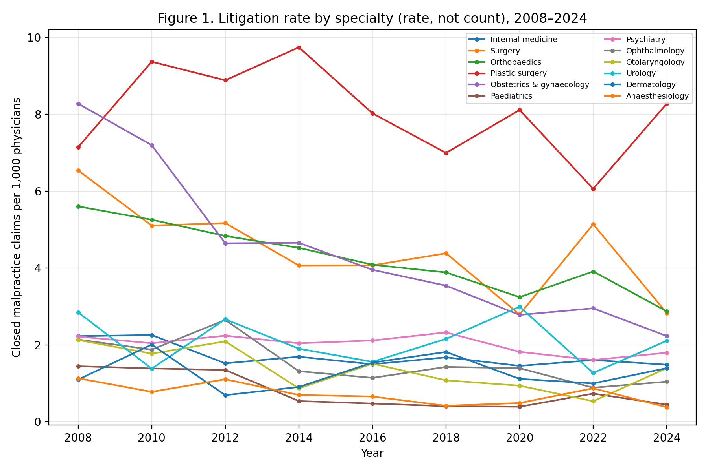

Figure 2. Physician workforce by specialty, indexed to 2008 (=100).
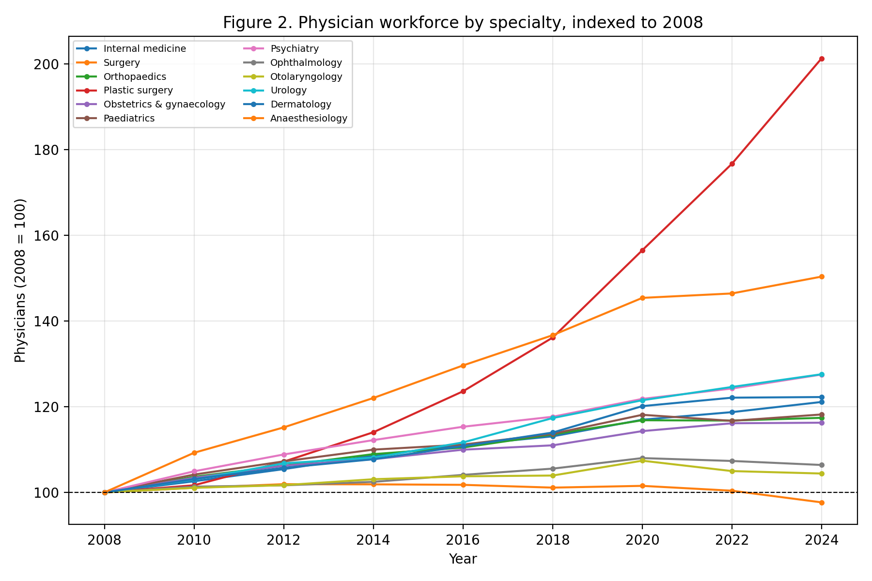

Table 2. Physicians, litigation rate (per 1,000 physicians) and hospitals by specialty, first and last waves.
Specialty | Physicians 2008 | Physicians 2024 | Lit. rate 2008 | Lit. rate 2024 | Hospitals 2008 | Hospitals 2024
Internal medicine | 102388 | 124010 | 2.23 | 1.48 | 7725 | 7163
Surgery | 27525 | 26885 | 6.54 | 2.83 | 4994 | 4300
Orthopaedics | 19273 | 22630 | 5.60 | 2.87 | 5094 | 4844
Plastic surgery | 2520 | 5074 | 7.14 | 8.28 | 1090 | 1475
Obstetrics & gynaecology | 11961 | 13908 | 8.28 | 2.23 | 1319 | 1052
Paediatrics | 15236 | 18009 | 1.44 | 0.44 | 2932 | 2446
Psychiatry | 13534 | 17259 | 2.22 | 1.80 | 2618 | 2881
Ophthalmology | 12627 | 13436 | 2.14 | 1.04 | 2501 | 2310
Otolaryngology | 8936 | 9330 | 2.13 | 1.39 | 2039 | 1937
Urology | 6324 | 8069 | 2.85 | 2.11 | 2799 | 2893
Dermatology | 8214 | 10043 | 1.10 | 1.39 | 3040 | 3066
Anaesthesiology | 7067 | 10628 | 1.13 | 0.38 | 2525 | 2798

Primary association and equivalence
The lagged litigation rate was not associated with biennial physician growth (coefficient -0.0009; 95% CI -0.0040 to +0.0021; p=0.54; n=96) or with hospital growth (coefficient +0.0003; p=0.90). Equivalence testing (Figure 3; Table 3) showed that a 1-SD higher litigation rate changed biennial physician growth by less than ±1% (TOST p=0.023; point estimate -0.21% with 90% CI -0.84% to +0.42%), and hospital growth by less than ±2% (p=0.002). Thus the data are consistent with, and statistically support, the absence of a policy-relevant effect.
Figure 3. Equivalence (TOST) of the litigation-rate effect against ±1% and ±2% margins; horizontal bars are 90% confidence intervals.
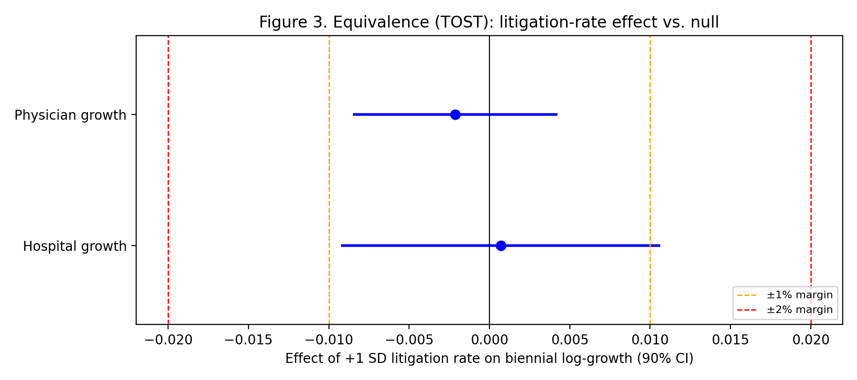

Table 3. Panel fixed-effects models and sensitivity analyses.
Model | Coefficient | 95% CI | p | n
Physician growth ~ lagged rate | -0.0009 | -0.0040, +0.0021 | 0.54 | 96
Hospital growth ~ lagged rate | +0.0003 | -0.0044, +0.0050 | 0.90 | 96
Counts contrast (physician) | +0.0002 | — | 0.49 | 96
Annual hospital (sensitivity) | +0.0000 | — | 0.99 | 192
Interpolated physician (sensitivity) | -0.0010 | — | 0.37 | 192
Reverse (workforce→litigation) | +0.097 | — | 0.85 | 96

Counts versus rates, and confounders
Using raw litigation counts rather than rates did not recover a negative association in this measured-only design (p=0.49). Figure 4 illustrates the difference between the two exposure definitions: a count exposure spans specialty size (panel a), whereas the size-adjusted rate does not (panel b). The annual hospital and the interpolated annual physician sensitivity analyses were also null (p=0.99 and p=0.37), confirming that the earlier significant, mostly negative associations were artefacts of size confounding and of treating interpolated years as independent observations. The JOCS-CP indicator was associated with obstetric hospital growth (coefficient +0.024, p=0.003), consistent with a structural policy effect in the specialty most central to this debate.
Figure 4. Biennial physician growth against lagged litigation exposure measured as (a) counts and (b) rates.
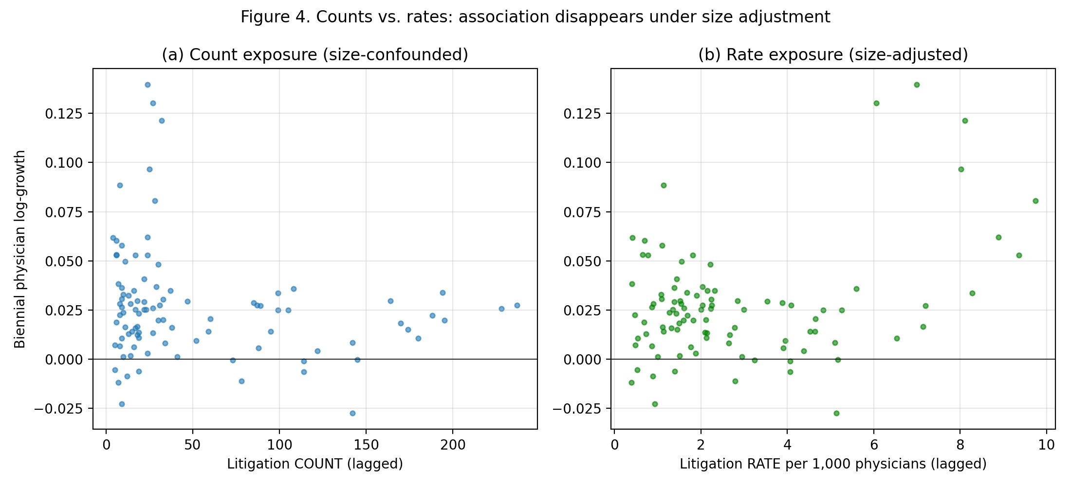

Descriptively, per-specialty rank correlations between the lagged litigation rate and physician growth were positive in 10 of 12 specialties and statistically significant in 0; the direction is therefore, if anything, opposite to a flight-from-risk hypothesis.

Discussion
Using national primary data, rates rather than counts, and only measured physician observations, we found no association between specialty-level malpractice-litigation risk and subsequent physician or hospital decline. Equivalence testing turned this null into a positive statement: any effect of litigation risk on the biennial workforce is smaller than a pre-specified, policy-relevant margin. The widely held intuition—that physicians systematically abandon high-litigation specialties—is not supported by two decades of official data.
Our earlier count-based analysis, like several prior studies, reported significant and mostly negative associations. The present work shows these were methodological artefacts: counts embed specialty size, and interpolating the biennial physician census manufactures degrees of freedom for lag-based methods. When both problems are removed, the associations vanish. This is a cautionary example for workforce research that pairs administrative count series.
Why might the workforce be so insensitive to litigation risk? A plausible interpretation is that structural incentives offset it. The Japan Obstetric Compensation System for Cerebral Palsy (2009) introduced no-fault compensation that reduced adversarial litigation pressure in obstetrics, and our data show a concurrent obstetric facility signal.⁶ More broadly, procedure-based reimbursement (surgical and interventional fees) rewards exactly the high-acuity activity that carries litigation exposure, so the economic return to remaining in these specialties may dominate litigation deterrence.¹³ Under this view, maldistribution is better addressed through payment design and no-fault compensation than through litigation-avoidance messaging.
These findings also bear on media framing. In a preliminary analysis we examined newspaper coverage of medical accidents (Nikkei Telecom, 2004–2018) but excluded it from the main models because coverage was almost collinear with litigation (|r|≈0.95) and added no explanatory value; it is therefore not a data source here. To the extent that litigation and its coverage move together, guidelines analogous to responsible suicide-reporting standards—avoiding sensationalism and contextualising system factors—may be reasonable, but our data give no basis for expecting a workforce effect from such measures.¹⁴

Limitations
This is an ecological, specialty-level analysis and cannot speak to individual career decisions. The physician census is biennial, giving nine measured waves; we addressed the limited power directly through equivalence testing and by pooling across specialties, but residual power constraints remain and the equivalence margins are a judgement. Specialty-specific litigation could be recovered only from 2008; earlier specialty tables were not retrievable from primary sources. Clinic counts by specialty are published only every three years and were used descriptively. Litigation counts are assigned to a principal specialty and, by the Court's own note, do not measure intrinsic specialty risk.⁹ Finally, these findings are embedded in Japan's particular legal, cultural and institutional context—including its no-fault obstetric compensation scheme, its fee-for-service reimbursement structure and its comparatively low-volume malpractice-litigation culture—so physician responses to litigation risk may differ in health systems with different liability regimes, compensation mechanisms or professional norms; the results should not be assumed to generalise across cultural spheres.

Conclusions
Across 2008–2024, specialty-level malpractice-litigation risk in Japan was not associated with physician or hospital decline, and the effect was statistically equivalent to null within a small margin. Policies to counter specialty maldistribution should focus on structural incentives—no-fault compensation and procedure-based reimbursement—rather than on the assumption that reducing litigation will retain physicians in high-risk specialties.

Declarations
Funding: none. Competing interests: none declared. Data and code availability: all primary data files, extraction scripts and analysis code are openly available in the project repository, enabling full reproduction of every reported number.

References
1. Yamaguchi S, et al. Regional and specialty maldistribution of physicians in Japan. J Epidemiol. 2020;30(1):1-8.
2. Studdert DM, Mello MM, Brennan TA. Medical malpractice. N Engl J Med. 2004;350(3):283-292.
3. Hiyama T, et al. Defensive medicine and malpractice concern in Japan. J Clin Gastroenterol. 2006;40(9):779-780.
4. Lakens D. Equivalence tests: a practical primer for t tests, correlations, and meta-analyses. Soc Psychol Personal Sci. 2017;8(4):355-362.
5. Schuirmann DJ. A comparison of the two one-sided tests procedure and the power approach for assessing the equivalence of average bioavailability. J Pharmacokinet Biopharm. 1987;15(6):657-680.
6. Japan Council for Quality Health Care. Japan Obstetric Compensation System for Cerebral Palsy. Tokyo: JQ; 2009.
7. von Elm E, Altman DG, Egger M, et al. The STROBE statement. Lancet. 2007;370(9596):1453-1457.
8. Ministry of Health, Labour and Welfare. Statistics of Physicians, Dentists and Pharmacists. Tokyo: MHLW.
9. Supreme Court of Japan, Committee on Medical Litigation. Statistics on medical malpractice litigation (closed cases by specialty). Tokyo: Supreme Court of Japan.
10. Ministry of Health, Labour and Welfare. Survey of Medical Institutions (Dynamic). Tokyo: MHLW.
11. Act on the Promotion of Medical Safety; Medical Accident Investigation System (2015). Tokyo: MHLW.
12. Angrist JD, Pischke JS. Mostly Harmless Econometrics. Princeton: Princeton University Press; 2009.
13. Ministry of Health, Labour and Welfare. National Database (NDB) Open Data. Tokyo: MHLW.
14. World Health Organization. Preventing suicide: a resource for media professionals. Geneva: WHO; 2017.

