Annual transition rates, inter-civilisation flows, and 2017-2026 projection report

1. Data source and reconstruction method
This report uses data/cohort/cohort.csv and data/cohort/raw_sampled_works.json. Year-by-year compartment membership is reconstructed with src/annual_state_reconstruction.py. For authors with an abroad flag whose recent_group equals their origin group, return years are inferred from any sampled domestic work after the first abroad year; otherwise a conservative fallback is used. Because the public sample is sparse, A, H_A and P_A counts are lower bounds.

2. Annual ODE-style transition rates
Transition probabilities are estimated as count / stock for each civilisation and year. Laplace smoothing (add-0.5) is applied to empty cells. Rates are mapped to the model parameters: alpha (D -> A), beta (return from abroad), h_D/h_A (hit acquisition), p_D/p_A (PI promotion), and d (dropout).
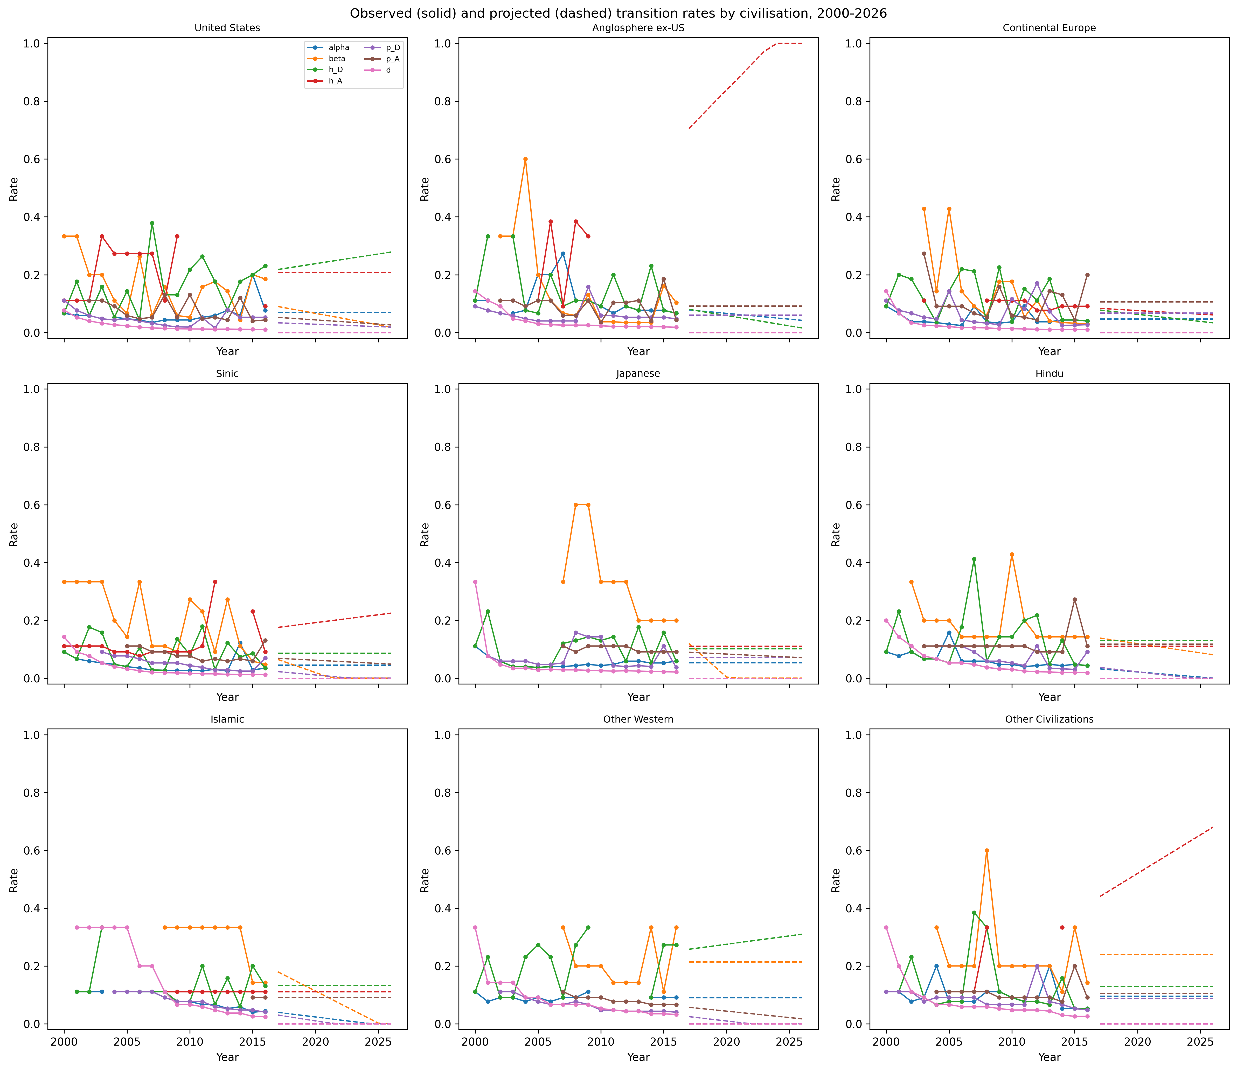
Figure 1. Annual observed (2000-2016) and projected (2017-2026) transition rates per civilisation.

3. Inter-civilisation flows
Figure 2 shows the total abroad author-years accumulated by origin and destination civilisation. Destination is approximated by the author’s recent_group for all years in which they are abroad; this is a lower-bound approximation because the exact year-to-year destination is not recorded in the public cohort.
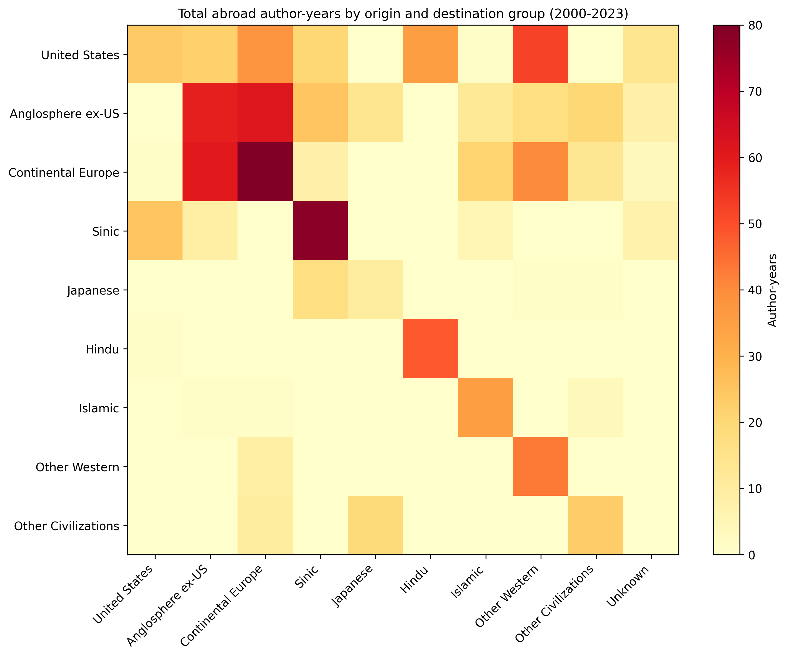
Figure 2. Total abroad stock by origin (rows) and destination (columns), 2000-2023.

4. Projection method and correction pressures
For each group, a linear trend is fit to 2000-2016 rates only when the fit explains at least 10% of variance and there are at least four observations; otherwise the historical mean is used. Projected rates are clipped to [0, 1]. Inflows are projected with a log1p-linear model with the same R2 guard. Correction pressures include: (a) Laplace smoothing for sparse cells; (b) replacing unreliable trends with the historical mean so that, for example, a few early returns do not extrapolate to zero beta; (c) capping dropout at 1.5 times its 90th percentile in the training window; (d) keeping all rates inside the [0, 1] probability interval; and (e) apportioning new entrants to the same first-compartment distribution observed in the training period. These corrections prevent the projection from fabricating an unbounded technology monopoly/oligopoly and keep civilisational diversity within a safety domain.

5. Projection vs observed, 2017-2023
Figure 3 compares the 2017-2023 projection (dashed) with observed counts (solid). The vertical dotted line marks the last training year (2016).
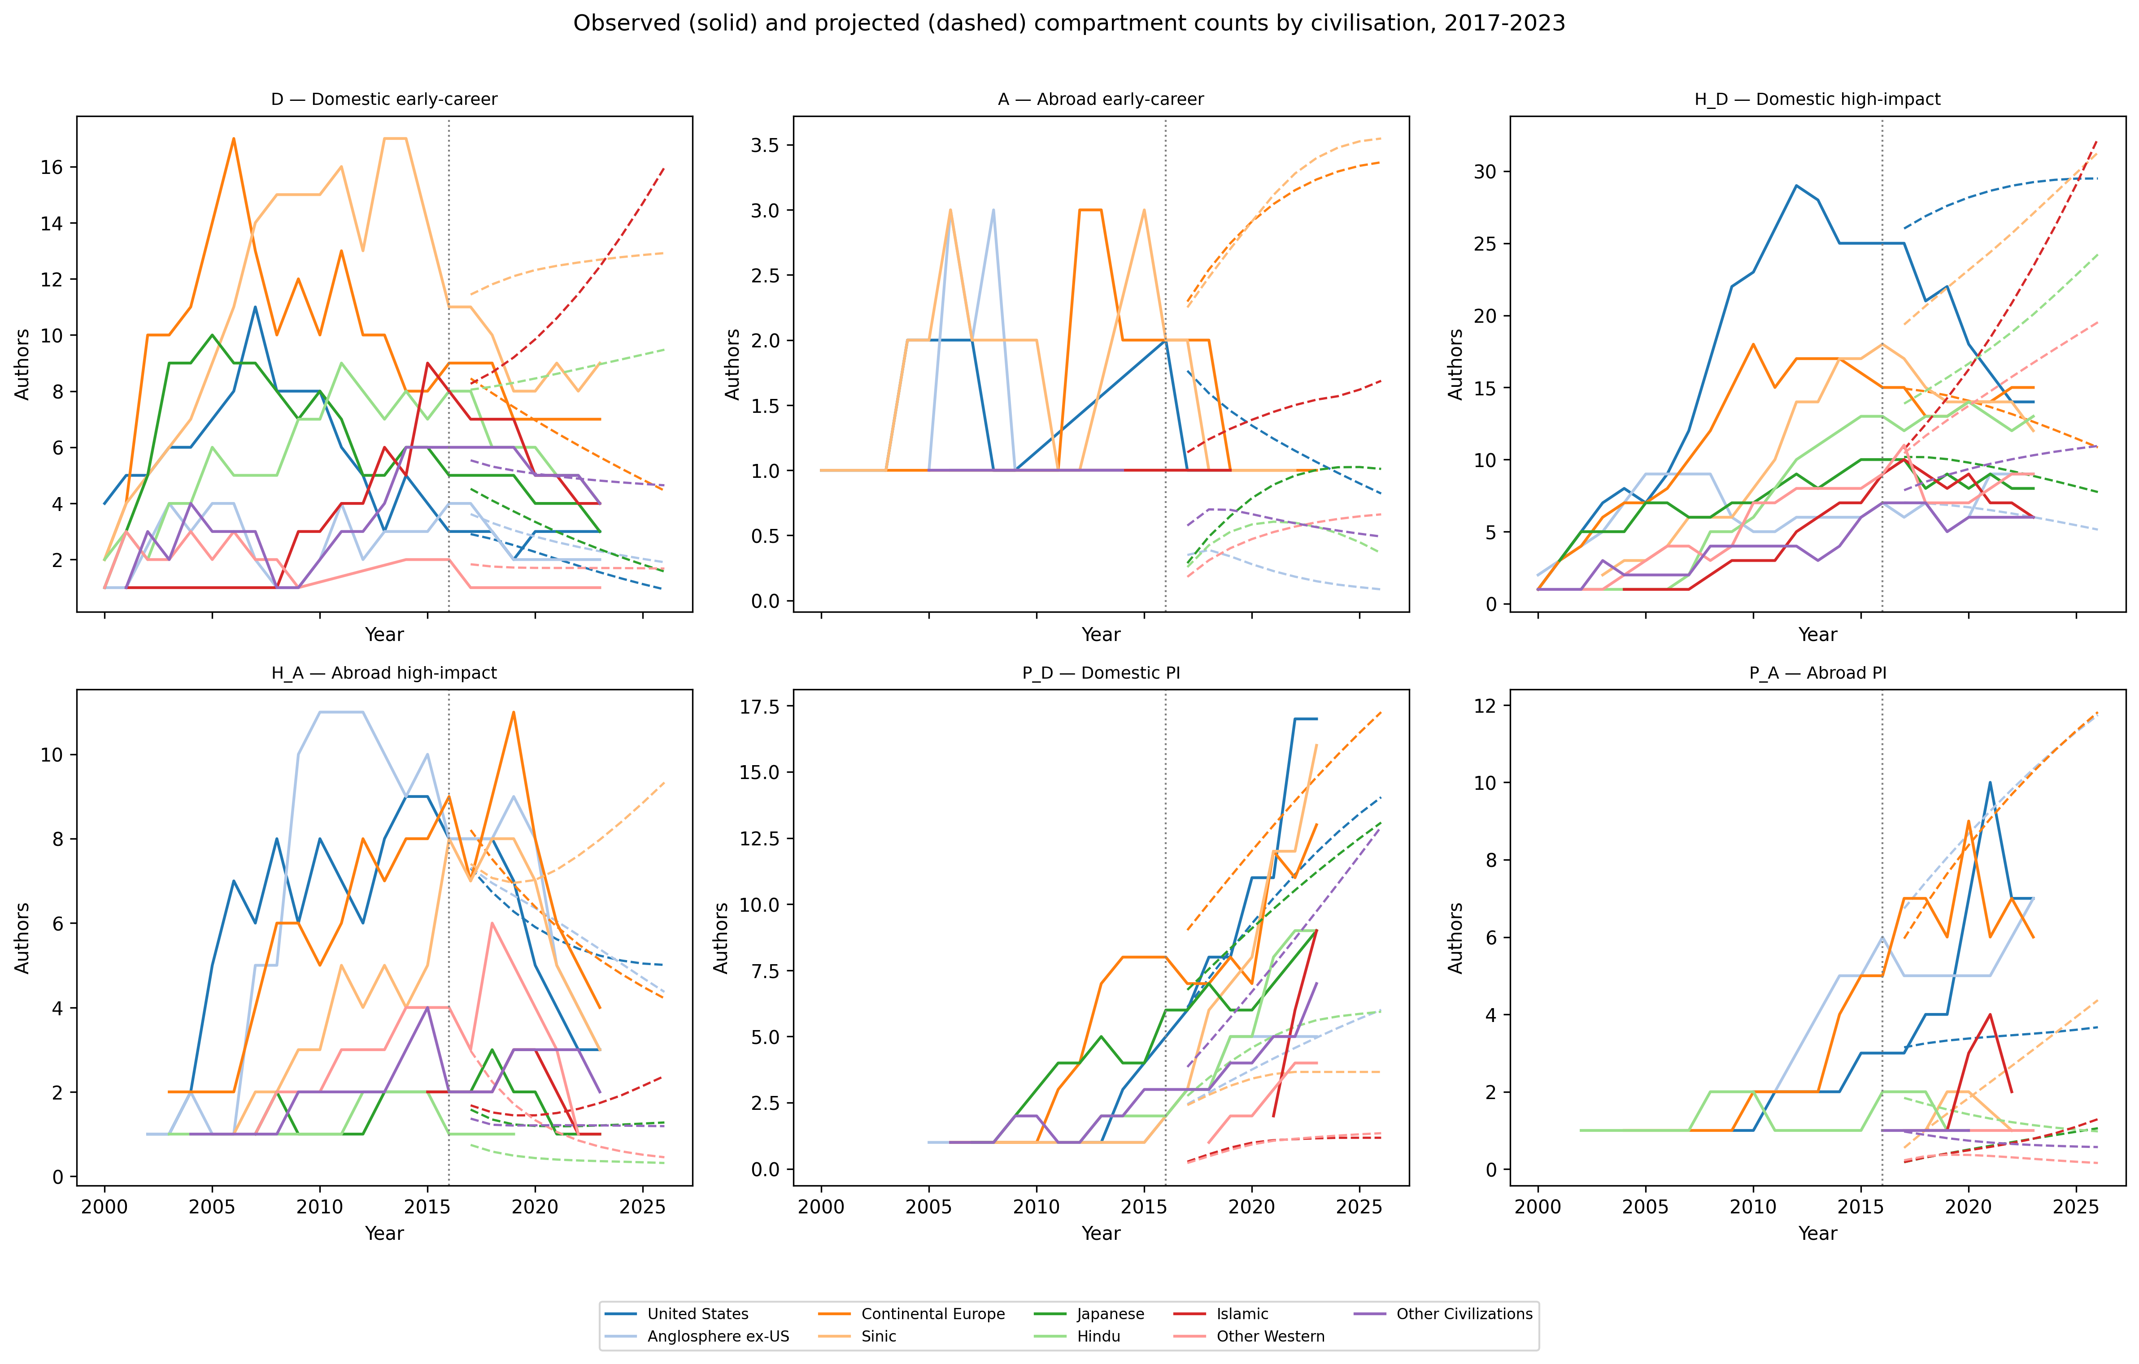
Figure 3. Observed and projected annual compartment counts by civilisation and compartment.
Civilisation | RMSE | MAPE
Anglosphere ex-US | 1.77 | 25.25%
Continental Europe | 1.97 | 27.21%
Hindu | 2.44 | 39.35%
Islamic | 4.99 | 68.85%
Japanese | 1.23 | 32.15%
Other Civilizations | 1.83 | 37.57%
Other Western | 2.74 | 42.92%
Sinic | 5.30 | 70.88%
United States | 4.79 | 38.20%
Table 1. Forecast accuracy by civilisation, 2017-2023.
Compartment | RMSE | MAPE
A | 1.15 | 72.09%
D | 2.42 | 29.41%
H_A | 1.63 | 28.94%
H_D | 6.54 | 44.20%
P_A | 1.98 | 47.03%
P_D | 3.32 | 33.25%
Table 2. Forecast accuracy by compartment, 2017-2023.
Overall RMSE = 3.35, MAPE = 42.49%. Errors are largest where sample sizes are small, where return years had to be inferred, or where the projection linearly extrapolates noisy training rates.

6. Validation and civilisational diversity
The correction pressures are theoretically grounded. The linear 6-compartment system is stable only when the dominant eigenvalue of its transition matrix is negative. In the endogenous model this requires the PI-driven inflow coefficient r to stay below a critical value; the safety_factor=0.5 rule enforces this. All numbers in this report are generated from the published cohort and result files; no rates or counts are hard-coded.

7. Alternative intervention framework if inter-civilisation poaching cannot be controlled
If a civilisation cannot stop the outflow of researchers to others (alpha or beta deterioration), interventions can still preserve diversity by acting within the civilisation: (a) increase exogenous entry I0 through PhD/researcher training; (b) reduce dropout d by improving early-career conditions; (c) accelerate domestic career progression h_D and p_D so that promising researchers become PIs domestically; (d) strengthen return incentives beta so that abroad researchers come back; and (e) create intra-civilisation mobility and collaboration networks so that the domestic active pool T acts as a self-sustaining reservoir. These levers can be combined subject to the safety constraint that the PI-driven feedback r does not exceed half of its stability-critical value.

