ORIGINAL ARTICLE

What zeroing cannot fix: detecting residual gain and dynamic-response errors after zero calibration in invasive arterial pressure monitoring
Running title: What zeroing cannot fix

[Author names to be completed]
[Affiliations to be completed]

Corresponding author:
[Name, address, email, ORCID]

Word count (title page to last reference): ~4329
Tables: 3 Figures: 7 References: numbered in order of appearance

Keywords: arterial pressure monitoring; zero calibration; concordance correlation coefficient; Bland–Altman analysis; proportional bias; dynamic response; fast-flush test; method comparison

Conflicts of Interest and Source of Funding:
[To be completed by the authors. State each author’s financial, consultant, institutional and other relationships and all sources of funding; if there are none, state “none declared”.]

Abstract
Objective
Zero calibration of an invasive arterial pressure transducer removes the direct-current (DC) offset but not sensor-gain (scale) error. Because device validation and regulatory decisions often rest on the minimal Bland–Altman summary, we examined which reported analyses detect a residual gain error after zeroing, and how a dynamic-response error behaves.
Methods
Using seeded simulations we generated paired device-reference systolic pressures () for four static cases: offset only, ideal zeroing, uncompensated gain error, and a gain error masked by a compensating offset. We augmented the simulation with beat-by-beat invasive arterial pressures from the VitalDB Open Dataset ( cases, beats) and applied the same four error models to the real waveforms. Each case was assessed with the minimal Bland-Altman summary (mean bias, limits of agreement), Bland-Altman difference-versus-mean regression, Deming and Passing-Bablok regression, and Lin's concordance correlation coefficient (CCC) with its scale-shift component. Synthetic arterial waveforms were passed through optimally-, under-, and over-damped second-order catheter-transducer models.
Results
When a 10% gain error was masked by a compensating offset in the synthetic data, the mean bias was +0.3 mmHg (acceptable), yet the Bland-Altman regression slope (0.103), Deming slope (1.109), Passing-Bablok slope (1.111) and CCC scale shift () all detected it. Under-damping inflated pulse pressure by 24% and over-damping attenuated it by 8%; these errors persist after zeroing and are diagnosed by the fast-flush test. CCC rose with the sampled range for one device (from 0.60 to 0.96). The real-waveform validation reproduced the same behaviour: a compensating offset made the mean bias nearly zero (-0.0 mmHg) while the CCC scale shift () and the Deming slope (1.106) remained clearly elevated.
Conclusions
Read alone, a mean-bias limits-of-agreement summary can miss a clinically relevant gain error. Validation and device-approval reports should add a proportional-bias-aware analysis, the CCC decomposition with the sampled range, and a dynamic-response check, and define a design target ( without calibration) for self-calibrating sensors.

1. Introduction
Invasive arterial pressure monitoring is among the most frequently performed measurements in anaesthesia and critical care. After inserting an arterial catheter, the clinician zeroes the pressure transducer to atmosphere at the level of the phlebostatic axis before monitoring [1], [2], and repeats zeroing whenever the height relationship between transducer and catheter changes [3]. In a fluid-filled line the external transducer is coupled to the catheter tip by a saline column, which introduces direct-current (DC) offsets: the hydrostatic pressure difference between transducer and measurement site, the atmospheric reference of gauge pressure, and slow transducer drift[4], [5]. Zeroing removes all of these offsets at once, but it is purely an offset correction: it does not verify the gain (sensitivity) of the system, that is, the proportionality between a true pressure change and the displayed value. If the gain is wrong, the waveform is scaled and the error persists after zeroing. Our first question is therefore whether, after correct zeroing, a residual gain (scale) error can remain.
A second, frequency-dependent gain error arises from the dynamic response of the fluid-filled system: under- or over-damping distorts the pulsatile signal and therefore pulse pressure[6]. This pulsatile gain error also survives zeroing and, unlike a static scale error, varies with heart rate; our second question is how it behaves and how it should be checked at the bedside.
How agreement is judged is the third issue. Validation studies for arterial pressure and derived haemodynamic monitors overwhelmingly report the Bland–Altman summary (mean bias and 95% limits of agreement) [7] and the Critchley percentage error [8], with attention to the precision of the reference method[9]. In practice clinicians and manufacturers often read this minimal summary as a complete statement of agreement. Yet the original Bland–Altman method also includes regression of the differences on the mean to detect proportional bias [10], a step that is frequently omitted; when an offset and a gain error partially cancel, the mean-bias summary alone is misleading. Using a reproducible simulation, and without claiming that gain error is invisible to a properly conducted Bland–Altman analysis, we ask which analyses actually reported in the literature detect a residual gain error after zeroing, and we position Lin’s concordance correlation coefficient (CCC) and its scale-shift component [11], [12], together with Deming [13] and Passing–Bablok [14] regression, as complementary diagnostics, noting that the CCC depends on the sampled pressure range [15], [16].
These choices matter beyond the individual study. Regulatory evaluation of a new monitor rests on the same method-comparison statistics, so if the reported summary cannot separate offset-corrected agreement from genuine gain accuracy, the approval decision inherits that blind spot. We therefore use the simulation to define a compact reporting framework, a proportional-bias–aware slope, the CCC decomposition and the sampled pressure range, together with an explicit dynamic-response check, that is meant to be usable both in validation papers and in device-approval review.
Zeroing nevertheless remains indispensable at the bedside, because these offsets are installation- and time-dependent physics rather than a factory-fixable device defect. The hydrostatic column depends on the height of the transducer relative to the phlebostatic axis (about 7.5 mmHg per 10 cm) and changes whenever the patient or the transducer is repositioned[3]; the atmospheric gauge reference drifts with weather and altitude; and electrical or thermal drift accumulates over time[4], [5]. Detection is not the same as correction, and the two operate at different layers: method-comparison analyses are retrospective and need paired reference measurements that are not available in real time, whereas zeroing removes a known, setup-specific offset a priori and without a reference. This also indicates the design horizon, because if the offset sources are engineered out of the hardware the need to zero disappears, leaving gain and dynamic response as the residual design and validation targets, the same quantities our framework isolates.

2. Methods

2.1. Arterial pressure as DC plus AC components
An arterial pressure waveform can be decomposed into a slowly varying DC level (mean arterial pressure plus any external offset) and a pulsatile alternating-current (AC) component driven by cardiac ejection. Pulse pressure () is a pure AC quantity and is therefore independent of any additive DC offset but proportional to sensor gain (see Figure 1, which decomposes the arterial pressure signal into its DC and AC components). An offset shifts the baseline without changing , whereas a gain error scales the whole waveform and changes .
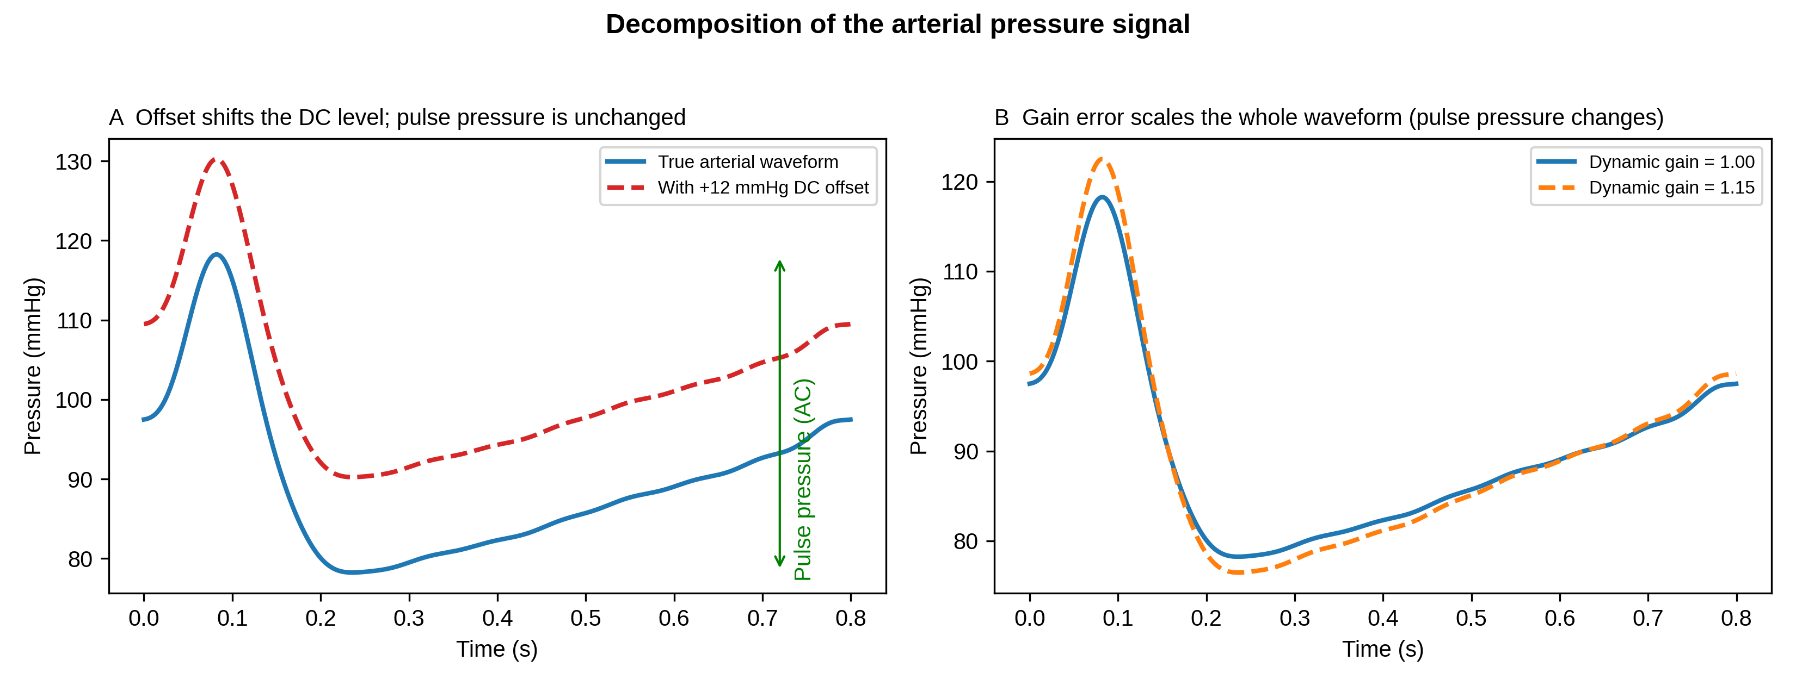
Figure 1. Decomposition of the arterial pressure signal. (A) A DC offset shifts the baseline but leaves pulse pressure unchanged. (B) A gain error scales the entire waveform, so pulse pressure changes in proportion to the gain. Zeroing corrects the offset in (A) but cannot correct the gain error in (B).

2.2. Statistical methods
For each paired dataset we computed: (i) the minimal Bland–Altman summary, comprising mean bias, 95% limits of agreement (mean bias ± 1.96 SD) and percentage error [8]; (ii) the Bland–Altman regression of the differences on the mean, whose slope tests for proportional bias [10]; (iii) Deming regression, which allows for error in both methods, with jackknife confidence intervals [13]; (iv) Passing–Bablok non-parametric regression [14]; and (v) Lin’s CCC [11].
Lin’s CCC (ρc) decomposes as ρc = r × C_b, where r is Pearson’s correlation (precision) and C_b is the bias-correction factor (accuracy) [12]. C_b further decomposes as:

where is the scale shift (the gain ratio) and is the location shift (offset). Zeroing drives toward zero but leaves unchanged; a residual gain error keeps even after perfect zeroing.
We used fixed a-priori detection rules, reported here so they cannot be chosen post hoc: the mean-bias summary flags an error if mmHg; the Bland-Altman regression flags if the slope 95% confidence interval (CI) excludes 0; Deming and Passing-Bablok flag if the slope 95% CI excludes 1; and the CCC scale shift flags if . Strength of agreement was interpreted using published CCC criteria [17].

2.3. Dynamic response and the fast-flush test
The fluid-filled catheter-transducer system behaves as a second-order system characterised by a natural frequency and a damping coefficient [6]. We modelled its transfer function and applied it to the Fourier harmonics of synthetic arterial waveforms. Under-damping (low , resonance near the arterial harmonics) causes systolic overshoot and over-estimation; over-damping attenuates . Both are gain errors on the pulsatile signal that zeroing cannot correct, and both are quantified at the bedside by the fast-flush (square-wave) test [18], [19].

2.4. Simulation design and reproducibility
Static scenarios comprised paired systolic pressures drawn uniformly over 80.0-180.0 mmHg with Gaussian measurement noise (SD = 3.0 mmHg): S1 offset only (+12.0 mmHg, gain 1.0); S2 ideal zeroing (offset removed, gain 1.0); S3 uncompensated gain error (gain 1.10); and S4 the same gain error with a compensating negative offset chosen so the mean difference is approximately zero. Dynamic scenarios passed synthetic waveforms through optimal, under-damped and over-damped systems. A range-dependence experiment sampled one fixed device (5% gain error) over pressure ranges of increasing width. The random seed, all parameters and the full pipeline (simulate -> analyse -> figures -> manuscript) are provided in the public repository so that a third party can regenerate every number, table and figure from a clean clone.

2.5. Real-waveform validation with VitalDB
To test whether the same gain/offset masking occurs in real waveforms, we selected a reproducible sample of cases with an invasive arterial pressure (SNUADC/ART) waveform from the VitalDB Open Dataset [20]. Beat-by-beat systolic and diastolic pressures were extracted from a 60-s intra-operative segment of each case, and the same four error models (offset only, ideal zeroing, uncompensated gain, and compensated gain) were applied to the real beat SBP values. The compensating offset in the gain-masked scenario was a single constant across all cases so that the overall mean bias was near zero while the gain-induced proportional bias survived. This real-data experiment is denoted R1-R4 and parallels the synthetic S1-S4 scenarios.
The VitalDB dataset is publicly available and fully anonymised; no additional ethics approval was required for this secondary analysis. Use of artificial-intelligence tools: the simulation and analysis code, the figures, and drafts of the text were prepared with the assistance of an AI coding assistant (Devin; Cognition AI, San Francisco, California, USA). The authors reviewed and verified all code, numerical results and statements, and take full responsibility for the content of the article.

3. Results

3.1. Static scenarios
Concordance plots for the four static scenarios are shown in Fig. 2 and the full metrics in Table 1. Ideal zeroing (S2) gave near-perfect agreement (mean bias +0.1 mmHg, CCC 0.995, 0.990). An uncompensated 10% gain error (S3) was obvious on every analysis, including the mean bias (+12.7 mmHg): gain error is not invisible to a Bland–Altman analysis.

Table 1
Table 1. Method-comparison metrics for the four static scenarios (n = 150 paired measurements each).
Scenario | Mean bias  (mmHg) | 95% LoA  (mmHg) | PE (%) | BA reg. slope  (95% CI) | Deming slope  (95% CI) | P–B slope  (95% CI) | CCC | C_b | v
S1 offset only | +11.9 | 5.6 to 18.2 | 4.6 | 0.010  (-0.007, 0.028) | 1.010  (0.993, 1.028) | 1.010  (0.990, 1.029) | 0.921 | 0.926 | 1.010
S2 zeroed (ideal) | +0.1 | -5.4 to 5.5 | 4.2 | -0.010  (-0.025, 0.006) | 0.990  (0.975, 1.006) | 0.985  (0.971, 1.001) | 0.995 | 1.000 | 0.990
S3 gain error | +12.7 | 4.7 to 20.7 | 5.9 | 0.094  (0.080, 0.109) | 1.099  (1.082, 1.117) | 1.100  (1.081, 1.117) | 0.915 | 0.919 | 1.099
S4 gain masked | +0.3 | -8.4 to 8.9 | 6.7 | 0.103  (0.087, 0.119) | 1.109  (1.091, 1.126) | 1.111  (1.092, 1.130) | 0.990 | 0.995 | 1.108
BA = Bland–Altman; CI = confidence interval; LoA = limits of agreement; PE = percentage error; P–B = Passing–Bablok; CCC = concordance correlation coefficient; C_b = bias-correction factor; v = scale shift. S4 has a near-zero mean bias yet a clearly non-zero regression, Deming and Passing–Bablok slope and v > 1, i.e. a gain error hidden from the mean-bias summary.
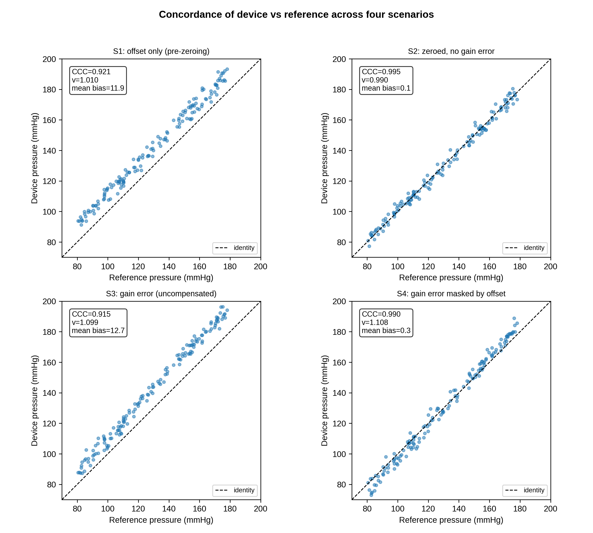
Figure 2. Device-versus-reference concordance for the four static scenarios (dashed line = identity). Each panel shows the CCC, the CCC scale shift , and the Bland–Altman mean bias. S4 has a near-zero mean bias despite a 10% gain error.
The decisive case is S4, where a compensating offset makes the mean bias only +0.3 mmHg, within the ±5.0 mmHg acceptance band, so the minimal Bland–Altman summary does not flag any problem. Every proportional-bias–aware analysis nonetheless detects the hidden gain error: the Bland–Altman regression slope is 0.103 (95% CI 0.087 to 0.119), the Deming slope 1.109 (95% CI 1.091 to 1.126), the Passing–Bablok slope 1.111 (95% CI 1.092 to 1.130), and the CCC scale shift = 1.108. The detection pattern across all scenarios is summarised in Fig. 3, and the difference-versus-mean plots for S2 and S4 in Fig. 4.
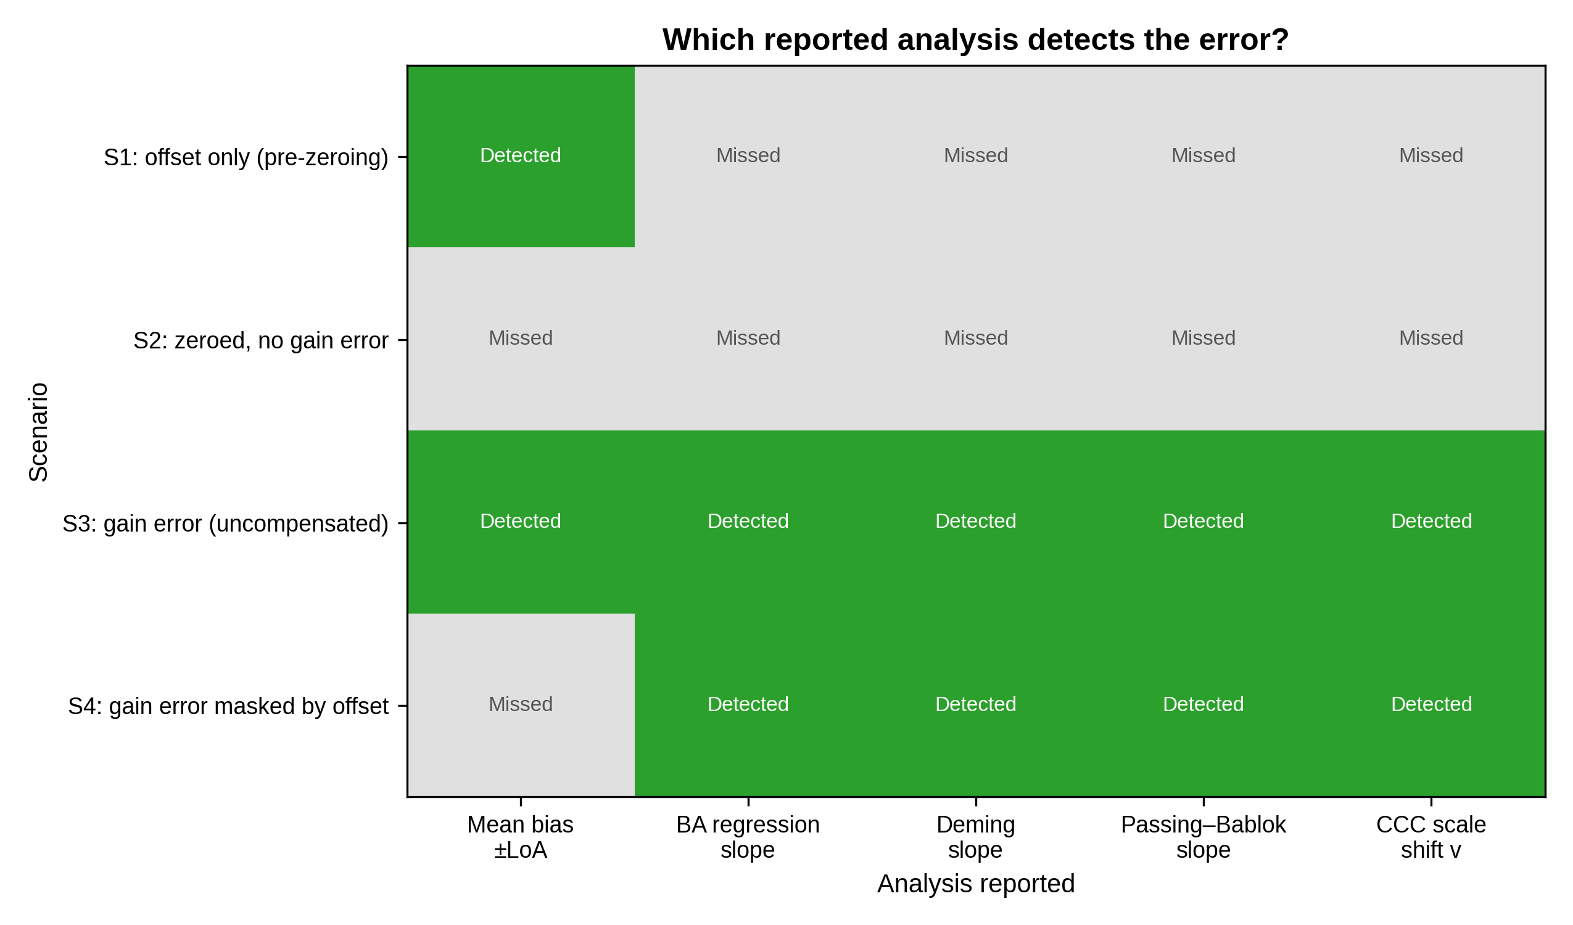
Figure 3. Which reported analysis detects the error in each scenario (green = detected, grey = missed). In S4 the mean-bias summary misses the gain error that every proportional-bias–aware analysis detects.
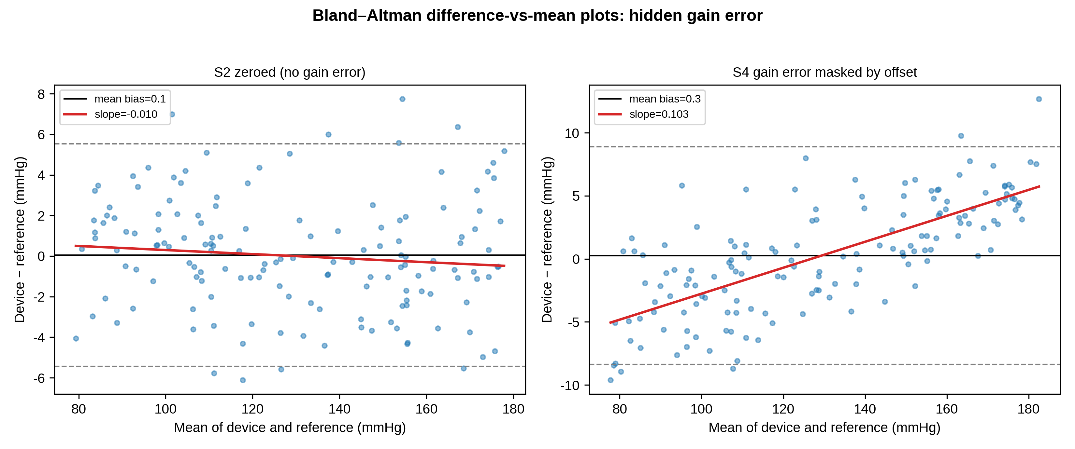
Figure 4. Bland–Altman difference-versus-mean plots. In S2 the regression slope is flat; in S4 the slope is clearly positive despite a near-zero mean bias, revealing the masked proportional (gain) error.

3.2. Dynamic-response scenarios
Dynamic-response metrics are given in Table 2 and illustrated in Fig. 5. The optimal system reproduced PP faithfully (PP ratio 1.01). Under-damping produced systolic overshoot and inflated PP by 24% (PP ratio 1.24, CCC scale shift = 1.28); over-damping attenuated PP by 8% (PP ratio 0.92). These are gain errors on the pulsatile signal that survive zeroing. Because the distortion is frequency-dependent (it varies with heart rate rather than with pressure amplitude), it maps only partially onto the amplitude-proportional model underlying the static regression statistics, which is why it is best characterised directly by the fast-flush test parameters (, ζ).

Table 2
Table 2. Dynamic-response metrics for pulse pressure (PP) and systolic pressure (SBP).
System (f_n, ζ) | PP ratio | PP mean bias  (mmHg) | CCC (PP) | v (PP) | SBP mean bias  (mmHg)
Optimal (25.0 Hz, 0.65) | 1.01 | +0.3 | 0.973 | 1.030 | +0.2
Underdamped (10.0 Hz, 0.15) | 1.24 | +10.7 | 0.588 | 1.277 | +7.6
Overdamped (8.0 Hz, 0.80) | 0.92 | -3.4 | 0.891 | 0.989 | -3.4
PP ratio = mean(measured PP / true PP); f_n = natural frequency; ζ = damping coefficient. Under-damping inflates and over-damping attenuates pulse pressure; the mean arterial (DC) level is preserved, so zeroing does not correct these errors.
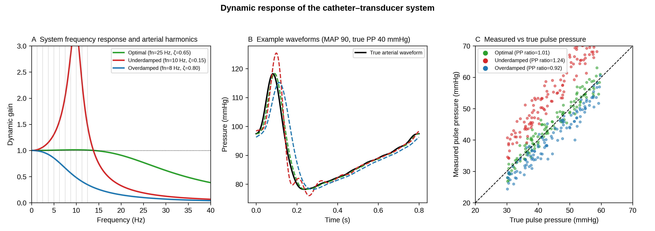
Figure 5. Dynamic response of the catheter–transducer system. (A) Frequency response of optimal, under-damped and over-damped systems with the arterial harmonics overlaid. (B) Example waveforms. (C) Measured versus true pulse pressure, with the mean PP ratio per system.

3.3. Range-dependence of the CCC
For a single device with a fixed 5% gain error, the CCC rose from 0.60 when sampled over a narrow pressure range (20 mmHg wide) to 0.96 over a wide range (100 mmHg), while the scale shift remained close to its true value (Fig. 6). The CCC therefore should be reported together with the sampled pressure range; the structural components (, ) are more transportable across studies [15].
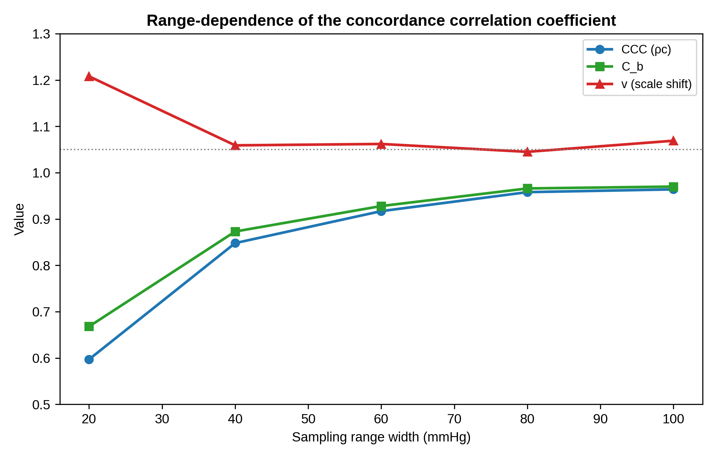
Figure 6. Range-dependence of the CCC. For one fixed device, the CCC and increase as the sampled pressure range widens, whereas the scale shift stays close to the true gain ratio.

3.4. Real-waveform validation
The same four error models were applied to beat-by-beat invasive arterial pressures from the VitalDB Open Dataset ( cases, beats). The pattern matched the synthetic data: a compensating offset made the mean bias effectively zero (-0.0 mmHg), while the proportional-bias indicators remained elevated (CCC scale shift = 1.106, Deming slope 1.106, Passing–Bablok slope 1.105). Table 3 gives the metrics for all four real-data scenarios; Fig. 7 shows a representative 10-s waveform and the Bland–Altman plot for R4.

Table 3
Table 3. Real-waveform method-comparison metrics from the VitalDB Open Dataset (n = 29 cases).
Scenario | n | Mean bias  (mmHg) | 95% LoA  (mmHg) | PE (%) | BA reg. slope  (95% CI) | Deming slope  (95% CI) | P–B slope  (95% CI) | CCC | C_b | v
R1 offset only | 1874 | +12.0 | 6.1 to 17.9 | 4.5 | 0.006  (0.001, 0.012) | 1.006  (1.001, 1.012) | 1.006  (1.000, 1.011) | 0.894 | 0.900 | 1.006
R2 zeroed (ideal) | 1874 | -0.0 | -5.9 to 5.9 | 4.7 | 0.006  (0.001, 0.012) | 1.006  (1.001, 1.012) | 1.006  (1.000, 1.011) | 0.993 | 1.000 | 1.006
R3 gain error | 1874 | +12.6 | 4.9 to 20.3 | 5.8 | 0.101  (0.096, 0.106) | 1.106  (1.101, 1.112) | 1.105  (1.100, 1.111) | 0.890 | 0.896 | 1.106
R4 gain masked | 1874 | -0.0 | -7.7 to 7.7 | 6.1 | 0.101  (0.096, 0.106) | 1.106  (1.101, 1.112) | 1.105  (1.100, 1.111) | 0.989 | 0.995 | 1.106
BA = Bland–Altman; CI = confidence interval; LoA = limits of agreement; PE = percentage error; P–B = Passing–Bablok; CCC = concordance correlation coefficient; C_b = bias-correction factor; v = scale shift. R4 has a near-zero mean bias with elevated v and regression slopes, reproducing the masked-gain pattern found in synthetic scenario S4.
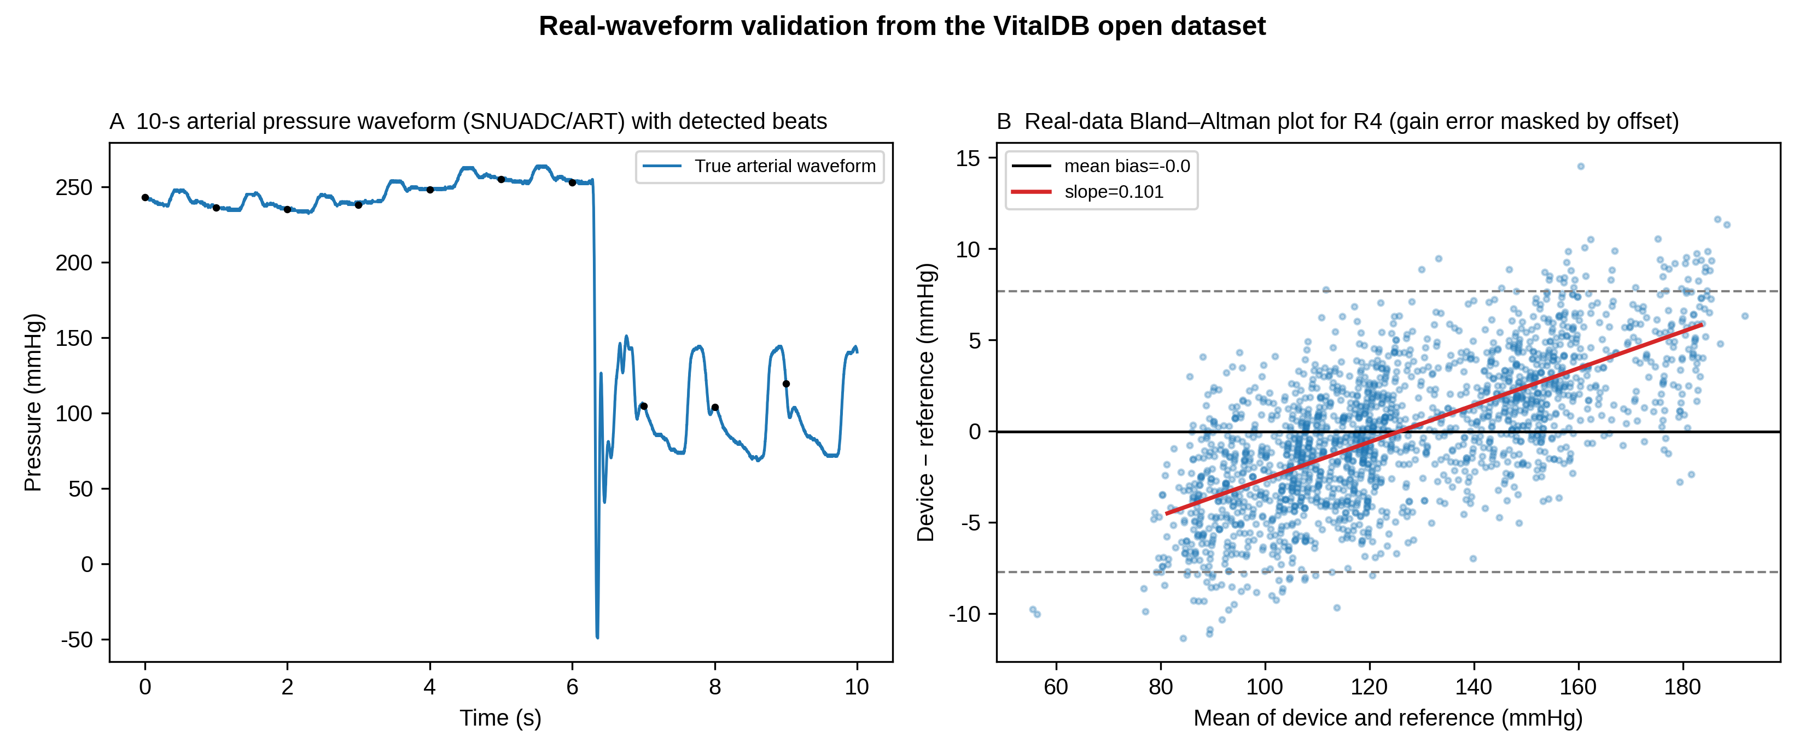
Figure 7. Real-waveform validation from the VitalDB Open Dataset. (A) A 10-s segment of the arterial pressure waveform (SNUADC/ART) with detected beats. (B) Bland–Altman plot for the gain-masked scenario (R4) on real data, showing a near-zero mean bias with a clear proportional bias.

4. Discussion
Our central finding is narrow and, we believe, defensible: the mean-bias–plus–limits-of-agreement summary that dominates device-validation reporting can miss a clinically relevant gain error when a coincidental offset cancels its effect on the mean, whereas the Bland–Altman difference-versus-mean regression [10], Deming [13] and Passing–Bablok [14] regression, and the CCC scale shift [12] all detect it. This is a critique of common reporting practice, not of the Bland–Altman method itself.

4.1. Recommendations for validation reporting
Validation studies of arterial pressure and derived monitors [21], [22] should therefore report, in addition to mean bias and limits of agreement: (i) the Bland–Altman regression slope with its CI (or, equivalently, a Deming or Passing–Bablok slope); (ii) the CCC with its decomposition into r, C_b, u and v; and (iii) the sampled pressure range, because the CCC is range-dependent [15], [16]. Notably, C_b alone is relatively insensitive to a pure gain error (in S4, C_b was 0.995 despite v = 1.108); the scale shift v should be reported explicitly. These additions cost nothing beyond a few lines of analysis and would let regulators and clinicians [23] distinguish offset-corrected agreement from genuine gain accuracy.

4.2. Dynamic response is a distinct, clinical gain error
The dynamic-response error is specific to fluid-filled systems and is routinely encountered at the bedside as under-damping (air bubbles, long compliant tubing) or over-damping (clots, kinks) [6], [19]. Because it is frequency-dependent, it is not fully captured by static method-comparison statistics and is best assessed directly with the fast-flush test, from which f_n and ζ are read [18]. We therefore recommend that a fast-flush dynamic-response check accompany any accuracy statement for a fluid-filled arterial line; pulse pressure is the sensitive readout, because it is proportional to gain but independent of offset.

4.3. Implications for sensor design
The reason zeroing is still performed today is that it corrects a setup-specific offset in real time, a role that no retrospective method-comparison statistic can fill. This also points to the way forward: because zeroing addresses only the operational offset problem, designing the offset sources out of the hardware removes the need to zero at all, leaving gain and dynamic response as the residual design and validation problems.
The offset that zeroing corrects can also be removed by design. Catheter-tip micro-electro-mechanical systems (MEMS) sensors abolish the hydrostatic column [24], [25]; absolute sensors with barometric compensation remove the atmospheric reference; and self-calibrating MEMS references limit drift [26]. High-fidelity pressure wires already demonstrate accurate catheter-based pressure measurement [27]. With offset removed by design and gain verified by accurate PP reproduction, the residual systematic error is expressed entirely in v, giving a concrete design target (v ≈ 1, C_b ≥ 0.99 without calibration) [17]. Modern piezoresistive MEMS sensors achieve non-linearity well below 0.1% of full scale [28], supporting the assumption that gain verified over the pulsatile range generalises across the physiological range.

4.4. Extension to derived haemodynamic monitors
The offset-versus-gain distinction extends to derived monitors whose auto-calibration routines re-optimise a setpoint (an offset correction) without correcting the gain of the pressure- or impedance-to-flow conversion [29], [30], [31], [32]. Reporting the scale shift v for these devices would make their dependence on calibration explicit.

4.5. Limitations
This is a simulation study; the data are synthetic and chosen to isolate specific error structures, and they are not a substitute for a prospective clinical comparison against an invasive reference of stated precision [9]. The static model assumes sensor linearity, and the dynamic model is a single second-order approximation. The value of the work is to make explicit, and reproducibly quantify, which reported analyses detect a residual gain error, a prelude to rather than a replacement for empirical validation.

5. Conclusion
Zero calibration corrects offset but not gain, and a residual scale error can persist after perfect zeroing.
Dynamic-response error is a distinct, frequency-dependent gain error that also survives zeroing and is diagnosed at the bedside by the fast-flush test.
Read on its own, a mean-bias–plus–limits-of-agreement summary can miss such a gain error when an offset masks it, whereas Bland–Altman regression, Deming and Passing–Bablok regression, and the CCC scale shift all detect it. The message for clinicians and manufacturers is not to abandon Bland–Altman but to use it with its regression step and these complementary analyses.
We recommend that arterial pressure validation studies, and device-approval evaluations, report a proportional-bias–aware analysis, the CCC decomposition with the sampled pressure range, and an explicit dynamic-response check, so that offset-corrected agreement is not mistaken for gain accuracy.
Because zeroing addresses only the operational offset, designing the offset sources out of the hardware would make zeroing unnecessary and leave gain and dynamic response as the residual targets; expressing the remaining systematic error as the scale shift v gives a concrete design goal (v ≈ 1 without calibration) for the next generation of self-calibrating arterial pressure sensors.

Acknowledgements
[To be completed by the authors, or state “none”.]

Data availability
Replication code, parameter files, and the generated data used to produce every number, table and figure are provided as supplementary material with this submission. The real-waveform validation uses the VitalDB Open Dataset, which is publicly available at https://api.vitaldb.net/.

References
1. Saugel B, Kouz K, Meidert AS, Schulte-Uentrop L, Romagnoli S. How to measure blood pressure using an arterial catheter: a systematic 5-step approach. Crit Care 2020; 24: 172.
2. Saugel B, Sessler DI. Perioperative blood pressure management. Anesthesiology 2021; 134: 250-261.
3. Gupta D, Jain A, Ismaeil M. Zero arterial catheters with every change in the height difference of pressure transducer and catheter insertion site. Ann Card Anaesth 2025; 28: 205.
4. Mark JB. Atlas of Cardiovascular Monitoring. New York: Churchill Livingstone; 1998.
5. McGhee BH, Bridges MEJ. Monitoring arterial blood pressure: what you may not know. Crit Care Nurse 2002; 22: 60-79.
6. Gardner RM. Direct blood pressure measurement—dynamic response requirements. Anesthesiology 1981; 54: 227-236.
7. Bland JM, Altman DG. Statistical methods for assessing agreement between two methods of clinical measurement. Lancet 1986; 327: 307-310.
8. Critchley LAH, Critchley JAJH. A meta-analysis of studies using bias and precision statistics to compare cardiac output measurement techniques. J Clin Monit Comput 1999; 15: 85-91.
9. Cecconi M, Rhodes A, Poloniecki J, Della Rocca G, Grounds RM. Bench-to-bedside review: the importance of the precision of the reference technique in method comparison studies. Crit Care 2009; 13: 201.
10. Bland JM, Altman DG. Measuring agreement in method comparison studies. Stat Methods Med Res 1999; 8: 135-160.
11. Lin LI. A concordance correlation coefficient to evaluate reproducibility. Biometrics 1989; 45: 255-268.
12. Lin LI. A note on the concordance correlation coefficient. Biometrics 2000; 56: 324-325.
13. Linnet K. Estimation of the linear relationship between the measurements of two methods with proportional errors. Stat Med 1990; 9: 1463-1473.
14. Passing H, Bablok W. A new biometrical procedure for testing the equality of measurements from two different analytical methods. J Clin Chem Clin Biochem 1983; 21: 709-720.
15. Nickerson CA. A note on “A concordance correlation coefficient to evaluate reproducibility”. Biometrics 1997; 53: 1503-1507.
16. Barnhart HX, Haber MJ, Lin LI. An overview on assessing agreement with continuous measurements. J Biopharm Stat 2007; 17: 529-569.
17. McBride GB. A proposal for strength-of-agreement criteria for Lin's concordance correlation coefficient. NIWA Client Report HAM2005-062. Hamilton: National Institute of Water and Atmospheric Research; 2005.
18. Kleinman B, Powell S, Kumar P, Gardner RM. The fast flush test measures the dynamic response of the entire blood pressure monitoring system. Anesthesiology 1992; 77: 1215-1220.
19. Romagnoli S, Ricci Z, Quattrone D, Tofani L, Tujjar O, Villa G, et al. Accuracy of invasive arterial pressure monitoring in cardiovascular patients: an observational study. Crit Care 2014; 18: 644.
20. Lee HC, Park Y, Yoon SB, Yang SM, Park D, Jung CW. VitalDB, a high-fidelity multi-parameter vital signs database in surgical patients. Sci Data 2022; 9: 279.
21. Kim SH, Lilot M, Sidhu KS, Rinehart J, Yu Z, Canales C, et al. Accuracy and precision of continuous noninvasive arterial pressure monitoring compared with invasive arterial pressure: a systematic review and meta-analysis. Anesthesiology 2014; 120: 1080-1097.
22. Joosten A, Desebbe O, Suehiro K, Murphy L, Essiet M, Alexander B, et al. Accuracy and precision of non-invasive cardiac output monitoring devices in perioperative medicine: a systematic review and meta-analysis. Br J Anaesth 2017; 118: 298-310.
23. Odor PM, Bampoe S, Cecconi M. Cardiac output monitoring: validation studies—how results should be presented. Curr Anesthesiol Rep 2017; 7: 410-415.
24. Hasenkamp W, Forchelet D, Pataky K, Villard J, van Lintel H, Bertsch A, et al. Polyimide/SU-8 catheter-tip MEMS gauge pressure sensor. Biomed Microdevices 2012; 14: 819-828.
25. Song P, Ma Z, Ma J, Yang L, Wei J, Zhao Y, et al. Recent progress of miniature MEMS pressure sensors. Micromachines (Basel) 2020; 11: 56.
26. Kang Y, Mouring S, de Clerck A, Mao S, Ng W, Ruan H. Development of a flexible integrated self-calibrating MEMS pressure sensor using a liquid-to-vapor phase change. Sensors (Basel) 2022; 22: 9737.
27. Scalia A, Ghafari C, Navarre W, Delmotte P, Phillips R, Carlier S. High fidelity pressure wires provide accurate validation of non-invasive central blood pressure and pulse wave velocity measurements. Biomedicines 2023; 11: 1235.
28. Barlian AA, Park WT, Mallon JR, Rastegar AJ, Pruitt BL. Review: semiconductor piezoresistance for microsystems. Proc IEEE 2009; 97: 513-552.
29. Chatterjee K. The Swan–Ganz catheters: past, present, and future. Circulation 2009; 119: 147-152.
30. Ameloot K, Palmers PJ, Malbrain MLNG. The accuracy of noninvasive cardiac output and pressure measurements with finger cuff: a concise review. Curr Opin Crit Care 2015; 21: 232-239.
31. Squara P, Denjean D, Estagnasie P, Brusset A, Dib JC, Dubois C. Noninvasive cardiac output monitoring (NICOM): a clinical validation. Intensive Care Med 2007; 33: 1191-1194.
32. Manecke GR. Edwards FloTrac sensor and Vigileo monitor: easy, accurate, reliable cardiac output assessment using the arterial pulse wave. Expert Rev Med Devices 2005; 2: 523-527.

