Supplementary material

Supplementary Note 1. Detailed statistical methods
This note records the full model specification, equivalence-testing rationale, and power diagnostics summarised in the main text. It also describes the heterogeneity and trend-stability checks reported in Supplementary Table 9.
Primary estimating equation. Let s index specialty, t index the biennial wave, and Y be the count of physicians or hospitals. The baseline model is
$Δlog(Y_{st})=α_{s}+δ_{t}+β·{\text{litrate}}_{s,t−1}+γ·{\text{JOCS-CP}}_{s,t−1}+ϵ_{st}$
where alpha_s are specialty fixed effects, delta_t are wave fixed effects, litrate is closed malpractice claims per 1,000 physicians, and JOCS-CP is an obstetrics-and-gynaecology-specific indicator from 2009 onward. Standard errors are clustered by specialty and inference uses a t-distribution with G-1 degrees of freedom, where G=12.
Equivalence testing. Two one-sided tests (TOST) evaluate whether the per-SD litigation-rate coefficient beta lies inside a pre-specified symmetric margin m. The null hypotheses are
$H_{0}:β≤−m\text{and}H_{0}:β≥+m$
Equivalence is declared when both one-sided tests yield p < 0.05. Margins of 1% and 2% biennial workforce change were chosen because they are smaller than typical policy targets for specialty rebalancing.
Power diagnostics. The minimum detectable effect (MDE) at 80% power for the per-SD coefficient is (t(0.975, df) + t(0.80, df)) x SE. The power to declare equivalence within margin m when the true effect is zero is 2 x F_t(m / SE) - 1, where F_t is the cumulative distribution function of the t(df) distribution. These quantities make the limited information in a 12-cluster panel explicit.
Heterogeneity and trend stability. To test whether the association differed by baseline litigation risk or surgical orientation, the model was augmented with an interaction between litrate and a binary group indicator:
$Δlog(Y_{st})=α_{s}+δ_{t}+β·{\text{litrate}}_{s,t−1}+δ_{g}·({\text{litrate}}_{s,t−1}×{\text{Group}}_{s})+ϵ_{st}$
Group_s is either high-litigation (above the median specialty mean lagged litigation rate) or surgical (surgery, orthopaedics, obstetrics and gynaecology, urology). The main effect of Group is absorbed by the specialty fixed effects and is omitted. A separate stability check added specialty-specific linear trends, C(specialty) x year, to the baseline specification.
Supplementary Figure 1. Sensitivity-analysis framework for evaluating malpractice-litigation risk as a healthcare workforce-allocation instrument.
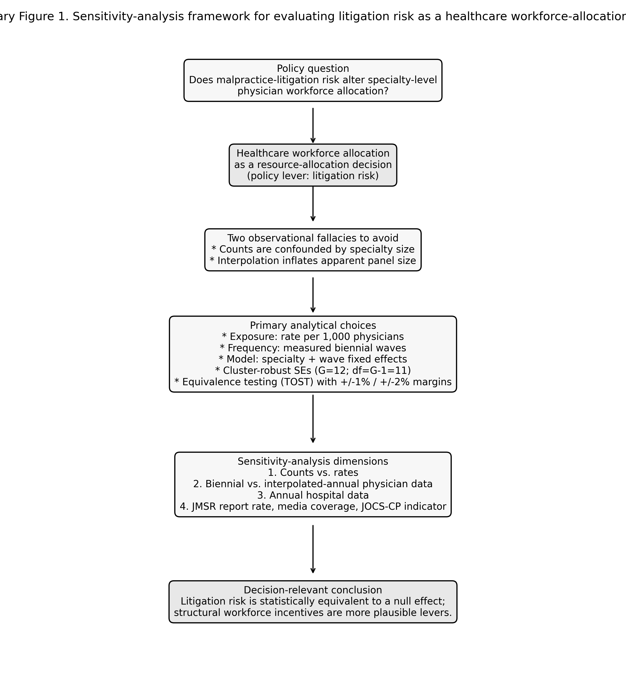

Supplementary Figure 2. Closed malpractice claims per 1,000 physicians by specialty, 2008-2024 (rates, not counts).
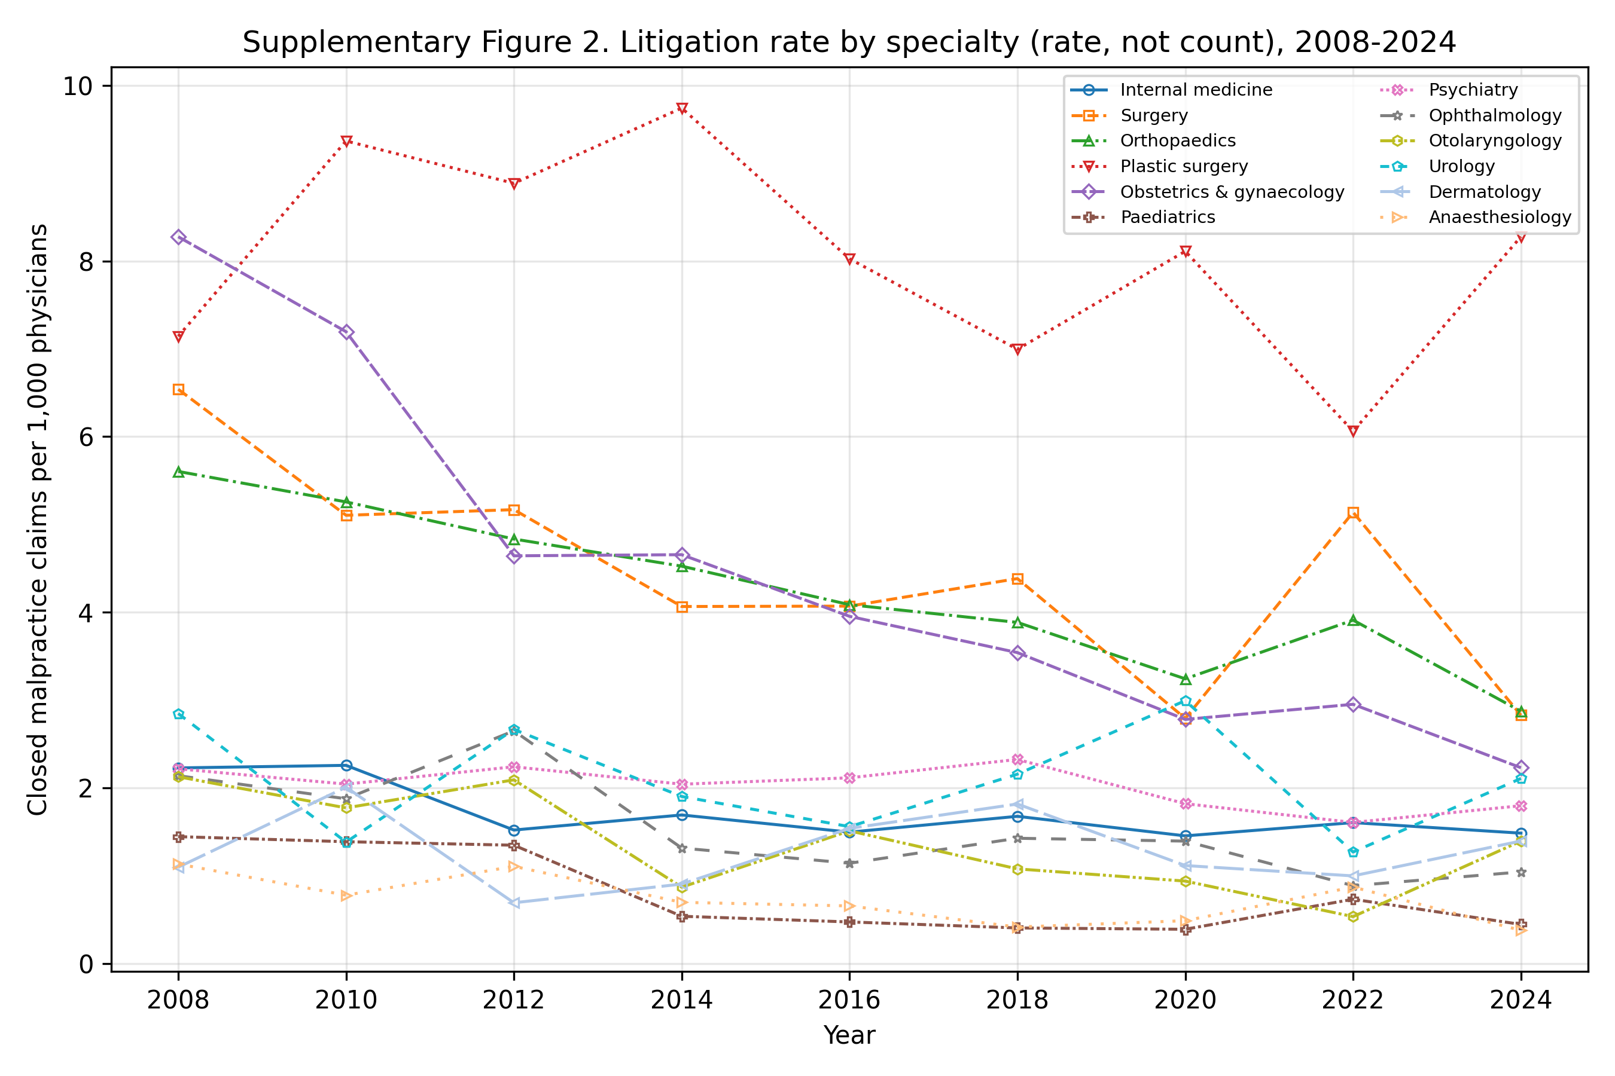

Supplementary Figure 3. Physician workforce by specialty, indexed to 2008 (=100).
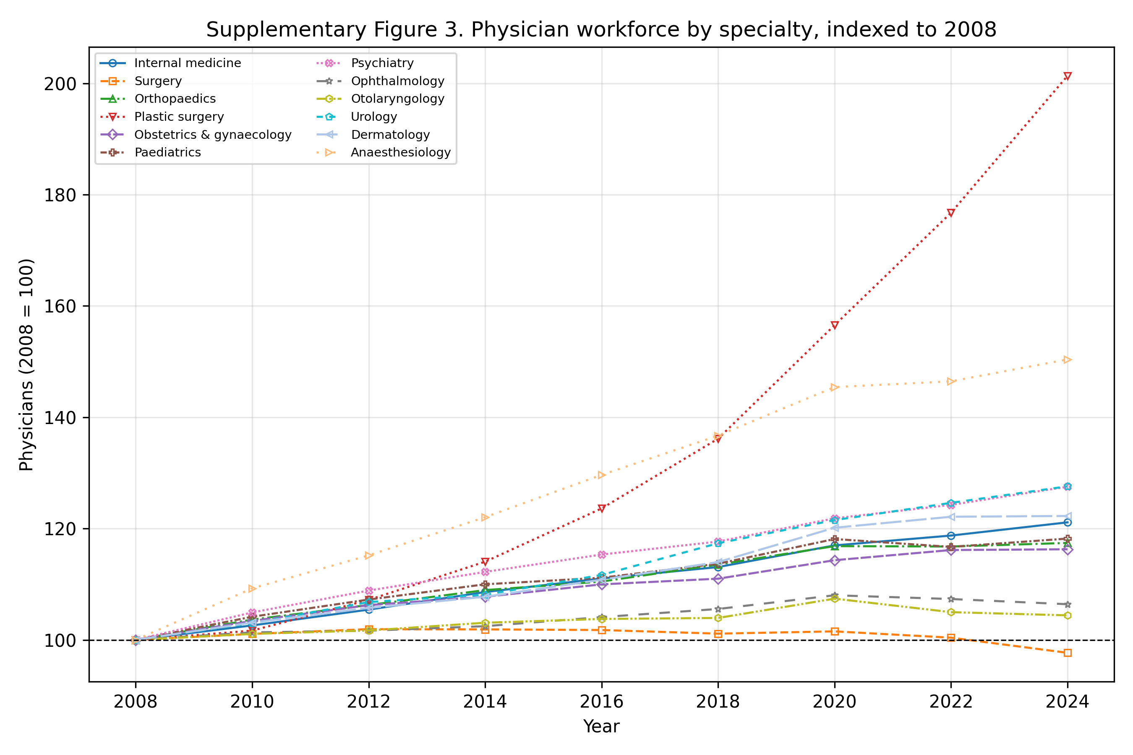

Supplementary Table 1. Primary data sources and their resolution.
Series | Source | Resolution | Years | Role
Physicians by specialty | MHLW Statistics of Physicians | Biennial | 2004-2024 | Denominator & outcome
Closed malpractice claims | Supreme Court, by specialty | Annual | 2008-2024 | Exposure (numerator)
Hospitals by specialty | MHLW Survey of Medical Institutions | Annual | 2008-2024 | Outcome
Clinics by specialty | MHLW Survey (static) | Every 3 years | 2008-2023 | Descriptive only
JMSR report counts | JMSR / MAIS | Annual | 2015-2024 | Sensitivity (2016-2024)
Newspaper article counts | Nikkei Telecom 21 | Annual | 2008-2018 | Sensitivity (2009-2018)

Supplementary Table 2. Equivalence (TOST) results (effect per +1 SD litigation rate).
Outcome | Coef per SD | 90% CI | Margin | TOST p | Equivalent
Physician growth | -0.21% | -0.84%, +0.42% | +/-1% | 0.023 | Yes
Physician growth | -0.21% | -0.84%, +0.42% | +/-2% | <0.001 | Yes
Hospital growth | +0.07% | -0.91%, +1.06% | +/-1% | 0.059 | No
Hospital growth | +0.07% | -0.91%, +1.06% | +/-2% | 0.002 | Yes

Supplementary Table 3. JMSR-adjusted annual hospital facility-count growth model (2016-2024) with both exposures entered simultaneously.
Exposure | Coefficient | p | n
Lagged litigation rate | +0.0021 | 0.28 | 108
Lagged JMSR report rate | -0.0009 | 0.66 | 108

Supplementary Table 4. Media-adjusted annual hospital facility-count growth model (2009-2018) with a linear time trend; full year fixed effects are omitted because the national article-count series is collinear with them.
Exposure | Coefficient | p | n
Lagged litigation rate | -0.0003 | 0.72 | 120
Lagged media count (per 1,000 articles) | -0.0014 | 0.21 | 120

Supplementary Table 5. Holm step-down adjusted p-values for the exploratory sensitivity tests and the JOCS-CP indicator.
Test | Raw p | Holm-adjusted p
Biennial physician growth ~ lagged litigation rate (JOCS-CP indicator) | 0.249 | 1.000
Biennial hospital growth ~ lagged litigation rate (JOCS-CP indicator) | 0.013 | 0.250
COUNTS contrast: physician growth ~ lagged litigation COUNT | 0.506 | 1.000
Annual hospital growth ~ lagged litigation rate (2008-2024) | 0.994 | 1.000
SENSITIVITY interpolated-annual physician growth ~ lag rate | 0.389 | 1.000
JMSR-adjusted annual hospital growth (2016-2024) ~ lit rate + JMSR rate (litigation rate) | 0.283 | 1.000
JMSR-adjusted annual hospital growth (2016-2024) ~ lit rate + JMSR rate (JMSR report rate) | 0.664 | 1.000
Media-adjusted annual hospital growth (2009-2018) ~ lit rate + media count (litigation rate) | 0.718 | 1.000
Media-adjusted annual hospital growth (2009-2018) ~ lit rate + media count (media count) | 0.209 | 1.000
Heterogeneity (high-litigation) physician growth ~ lagged litigation rate (main effect) | 0.269 | 1.000
Heterogeneity (high-litigation) physician growth ~ lagged litigation rate (interaction) | 0.240 | 1.000
Heterogeneity (surgical) physician growth ~ lagged litigation rate (main effect) | 0.239 | 1.000
Heterogeneity (surgical) physician growth ~ lagged litigation rate (interaction) | 0.391 | 1.000
Heterogeneity (high-litigation) hospital growth ~ lagged litigation rate (main effect) | 0.988 | 1.000
Heterogeneity (high-litigation) hospital growth ~ lagged litigation rate (interaction) | 0.928 | 1.000
Heterogeneity (surgical) hospital growth ~ lagged litigation rate (main effect) | 0.124 | 1.000
Heterogeneity (surgical) hospital growth ~ lagged litigation rate (interaction) | 0.064 | 1.000
Trend robustness: physician growth ~ lagged litigation rate + specialty trends | 0.728 | 1.000
Trend robustness: hospital growth ~ lagged litigation rate + specialty trends | 0.114 | 1.000

Supplementary Table 6. Cluster block-bootstrap p-values, percentile 95% confidence intervals, equivalence power (if true effect is zero), and minimum detectable effect per 1-SD litigation-rate increase.
Outcome | Bootstrap p | Bootstrap 95% CI | Equivalence margin | Power if true null | MDE (80% power)
Physician growth | 0.573 | -0.00476, 0.00212 | +/-1% | 98.4% | 1.08%
Physician growth | 0.573 | -0.00476, 0.00212 | +/-2% | 100.0% | 1.08%
Hospital growth | 0.903 | -0.00431, 0.00416 | +/-1% | 90.4% | 1.69%
Hospital growth | 0.903 | -0.00431, 0.00416 | +/-2% | 99.6% | 1.69%

Supplementary Table 7. Counterfactual 2034 physician counts by specialty and policy instrument. Counts are projected from observed biennial baseline drift plus the indicated effect; marginal percentage changes are shown in Figure 4.
Specialty | 2024 count | Baseline 2034 | Litigation zero (point) | Litigation zero (95% lower) | MDE benchmark
Internal medicine | 124,010 | 136,909 | 138,010 | 142,075 | 144,492
Surgery | 26,885 | 26,299 | 26,853 | 28,960 | 27,755
Orthopaedics | 22,630 | 24,848 | 25,346 | 27,239 | 26,224
Plastic surgery | 5,074 | 7,874 | 8,177 | 9,376 | 8,310
Obstetrics & gynaecology | 13,908 | 14,877 | 15,191 | 16,387 | 15,700
Paediatrics | 18,009 | 19,949 | 20,023 | 20,295 | 21,054
Psychiatry | 17,259 | 20,199 | 20,391 | 21,102 | 21,317
Ophthalmology | 13,436 | 13,957 | 14,058 | 14,430 | 14,730
Otolaryngology | 9,330 | 9,460 | 9,520 | 9,744 | 9,984
Urology | 8,069 | 9,333 | 9,425 | 9,766 | 9,849
Dermatology | 10,043 | 11,411 | 11,479 | 11,732 | 12,042
Anaesthesiology | 10,628 | 13,699 | 13,745 | 13,915 | 14,458
All specialties | 279,281 | 308,815 | 312,218 | 325,021 | 325,915

Supplementary Table 8. Specialist-trainee coverage by specialty. Coverage is the number of 2018 first-year specialist trainees divided by the number of physicians reported 3-5 years after medical registration in 2014, by primary specialty.
Specialty | 2018 specialist trainees (senkoi) | Physicians 3-5 yr after registration (2014) | H24 cohort 3rd year (2012) | H24 cohort 5th year (2014) | Coverage
Internal medicine | 2,670 | 21,536 | 2,630 | 2,621 | 12.4%
Surgery | 805 | 985 | 735 | 774 | 81.7%
Orthopaedics | 552 | 2,291 | 457 | 472 | 24.1%
Plastic surgery | 163 | 317 | 144 | 148 | 51.4%
Obstetrics & gynaecology | 441 | 1,383 | 327 | 342 | 31.9%
Paediatrics | 573 | 7,950 | 447 | 433 | 7.2%
Psychiatry | 441 | 637 | 314 | 354 | 69.2%
Ophthalmology | 328 | 1,051 | 211 | 213 | 31.2%
Otolaryngology | 267 | 617 | 195 | 193 | 43.3%
Urology | 274 | 568 | 206 | 194 | 48.2%
Dermatology | 271 | 1,405 | 228 | 210 | 19.3%
Anaesthesiology | 495 | 1,091 | 378 | 385 | 45.4%

Supplementary Table 9. Heterogeneity and trend-stability checks. High-litigation and surgical models include an interaction between the lagged litigation rate and a binary group indicator (the main effect of the group is absorbed by specialty fixed effects). The trend-stability model adds specialty-specific linear time trends.
Outcome | Group / check | Main coefficient (SE) | p | Interaction coefficient (SE) | p | n
Physician growth | High litigation | +0.0098 (+0.0084) | 0.27 | -0.0119 (+0.0096) | 0.24 | 96
Physician growth | Surgical | -0.0045 (+0.0037) | 0.24 | +0.0057 (+0.0064) | 0.39 | 96
Hospital growth | High litigation | -0.0001 (+0.0034) | 0.99 | +0.0004 (+0.0043) | 0.93 | 96
Hospital growth | Surgical | +0.0044 (+0.0027) | 0.12 | -0.0066 (+0.0032) | 0.06 | 96
Physician growth | Specialty trends | +0.0010 (+0.0028) | 0.73 | -- | -- | 96
Hospital growth | Specialty trends | +0.0027 (+0.0016) | 0.11 | -- | -- | 96

STROBE checklist
STROBE checklist for observational cohort studies.
Item | Description | Reported
1 | Title and abstract indicate the study design | Yes
2 | Background and rationale | Yes
3 | Specific objectives and hypotheses | Yes
4 | Key elements of study design | Yes
5 | Data sources, locations and dates | Yes
6 | Eligibility and selection criteria | Yes
7 | Definitions of outcomes, exposures and predictors | Yes
8 | Data sources and measurement methods | Yes
9 | Discussion of potential sources of bias | Yes
10 | Explanation of study size | Yes
11 | Quantitative variables: grouping and transformations | Yes
12 | Description of all statistical methods | Yes
13 | Numbers of participants at each stage | Yes
14 | Descriptive characteristics of participants | Yes
15 | Outcome data for each exposure category | Yes
16 | Main results with measures of uncertainty | Yes
17 | Other analyses (sensitivity and subgroup) | Yes
18 | Summary of key results with reference to objectives | Yes
19 | Limitations of bias and imprecision | Yes
20 | Cautious overall interpretation | Yes
21 | Generalisability to other populations | Yes
22 | Registration, protocol, funding, data and code availability | Yes

