Abstract
Introduction: Medical safety incidents may deter physicians from high-risk specialties, yet the temporal dynamics remain poorly quantified. Japan maintains two independent national incident series—occurrence-based mandatory reports and malpractice litigation statistics—but no multi-specialty test of predictive causality between these series and physician supply has been conducted.
Methods: We constructed bivariate vector autoregression (VAR) models for 12 specialties using mandatory safety reports (2015-2025) and malpractice litigation statistics (2004-2023), paired with physician and facility counts from national surveys. Granger causality F-tests, impulse response functions, and VAR-based forecasts were computed. Sensitivity analyses assessed the independence and interaction of the two incident sources.
Results: Litigation-based models showed significant forward Granger causality in 18 of 24 tests; obstetrics and gynaecology had the strongest association (F = 46.66, P < 0.001). Bidirectional causality emerged in 7 specialty-outcome pairs. A litigation shock depressed physician supply for 3-5 years. Occurrence and litigation counts were weakly correlated (median |r| = 0.23), and their interaction was non-significant, indicating additive, independent effects on workforce decline.
Conclusions: Safety incidents Granger-cause specialty-specific workforce decline lasting 3-5 years through two independent pathways. Because litigation is largely independent of incident occurrence, early dispute resolution may attenuate workforce loss without requiring a reduction in incident rates.
Key words: physician workforce, Granger causality, medical safety incidents, specialty maldistribution, dispute resolution, Japan

Introduction
Japan’s physician workforce has grown steadily to approximately 340,000, yet aggregate expansion masks deepening maldistribution across specialties and regions.^{1,2} General surgery, obstetrics, emergency medicine, and paediatrics face persistent shortages even as total supply rises.^{3,4}
Safety incidents as a determinant of specialty choice gained prominence after the 2004 Fukushima obstetrics prosecution, in which an obstetrician was arrested following a maternal death during caesarean section.^{5,6} Morita reported a 13% decline in obstetricians in the affected prefecture using difference-in-differences.⁷ That analysis, however, addressed a single event in one specialty and one region; broader multi-specialty evidence linking incident burden to workforce dynamics is lacking.
Japan offers two complementary national incident series: the Japan Medical Safety Research Organisation (JMSR) mandatory reports (from 2015)⁸ and Supreme Court malpractice litigation statistics by specialty.^{9,10} Paired with biennial physician surveys and annual facility registrations, these data permit a systematic multi-specialty analysis.
Here we apply vector autoregression (VAR) and Granger causality testing¹¹⁻¹³—established econometric tools for predictive-causality inference—to determine whether incident trends temporally precede changes in specialty-specific physician and facility counts across 12 specialties over up to 20 years. Because the two incident series differ in construction (occurrence vs. adjudicated claims), we additionally examine whether they act as independent or interacting predictors of workforce change.

Materials and Methods

Study design
This is a secondary analysis of routinely collected national administrative data using bivariate VAR models and Granger causality tests, reported in accordance with the STROBE (Strengthening the Reporting of Observational Studies in Epidemiology) statement for cross-sectional studies.¹⁴

Data sources
Medical safety incident data were obtained from two sources. Definition 1 (JMSR): annual specialty-specific incident reports to the Japan Medical Safety Research Organisation for fiscal years 2015-2025 (11 annual observations).⁸ Definition 2 (litigation): annual specialty-specific medical malpractice closed-claim counts from the Supreme Court of Japan for 2004-2023 (20 annual observations).⁹
Specialty-specific physician counts were obtained from the Survey of Physicians, Dentists, and Pharmacists (biennial, 2002-2024; annual values by linear interpolation).¹⁵ Facility counts were obtained from the Survey of Medical Institutions (2005-2024).¹⁶ Specialist trainee enrolment data were obtained from the Japan Board of Medical Specialties (2018-2025).¹⁷

Specialties analysed
Twelve core specialties with sufficient data across all sources were analysed: internal medicine, general surgery, orthopaedic surgery, plastic surgery, obstetrics and gynaecology, paediatrics, psychiatry, ophthalmology, otolaryngology, urology, dermatology, and anaesthesiology.

Statistical analysis
Stationarity was assessed using augmented Dickey-Fuller (ADF) tests. Non-stationary pairs were first-differenced. For each specialty-definition-outcome combination, a bivariate VAR model was fitted with lag order selected by minimising the Akaike information criterion (AIC), capped at min(4, n/3 - 1).
Granger causality was tested bidirectionally using F-tests on lagged coefficients.¹⁸ The forward null hypothesis is that lagged incident counts do not improve prediction of the workforce outcome; significance was set at P < 0.05.
Impulse response functions (IRFs) were computed over a 10-year horizon to estimate the magnitude and duration of workforce effects following a one-unit incident shock.¹⁹ VAR-based forecasts with 95% intervals were generated for 2024-2033 using litigation-based models.
For specialist trainees (8 annual observations), detrended Pearson correlations between JMSR incidents and enrolment were computed. Analyses used Python 3.10 with statsmodels 0.14.²⁰ Code and data are deposited at https://github.com/bougtoir/medical-accident-its-analysis.

Sensitivity and source-independence analyses
To assess whether the disparity in significant models between litigation and JMSR reflected series length rather than intrinsic differences, litigation data were restricted to the 2015-2023 window (9 years) overlapping with the JMSR period and the Granger tests were repeated.
To evaluate source independence, Pearson correlations between JMSR and litigation counts were computed for each specialty over the overlapping period. To test whether occurrence and litigation act additively or synergistically, trivariate VAR models (JMSR + litigation + outcome) were fitted and compared with bivariate models by AIC. An interaction term (JMSR * litigation) was tested for additional predictive power via Granger F-tests.

Ethical considerations
This study used publicly available, anonymised, aggregate-level administrative data. No individual-level data were accessed. Ethical approval was not required per institutional guidelines.

Results

Descriptive overview
Over the study period the JMSR received 3,860 reports across 12 specialties (2015-2025); general surgery (n = 520), internal medicine (n = 479), and orthopaedic surgery (n = 310) contributed the largest volumes. Malpractice litigation declined from 1,139 cases (2004) to 746 (2023) nationally, though specialty-level trajectories diverged (Figure 1).
Figure 1. Trends in medical safety incident counts by specialty.
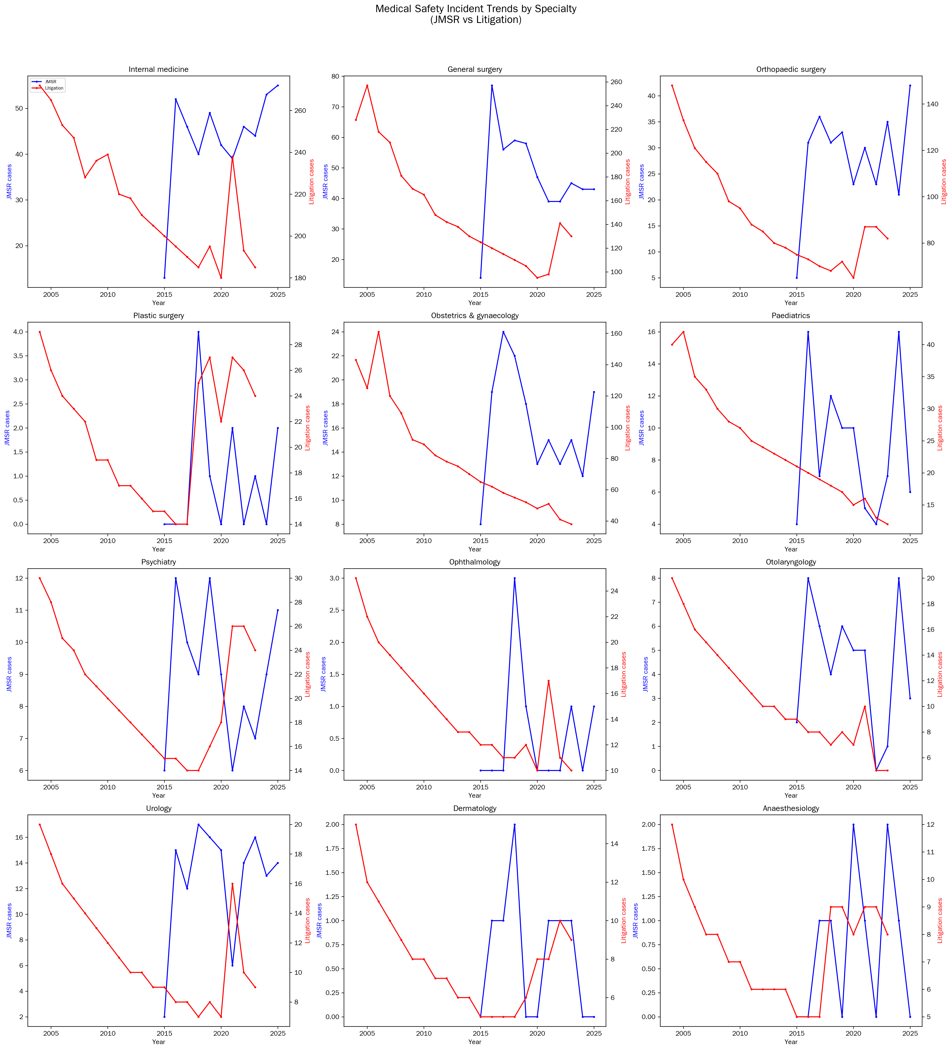

Granger causality tests
A total of 47 bivariate VAR models were fitted. Table 1 presents the litigation-based Granger causality results. Of 24 tests (12 specialties * 2 outcomes), 18 showed significant forward Granger causality (incidents → workforce, P < 0.05). The strongest forward associations were obstetrics and gynaecology (physicians: F = 46.66, P < 0.001), psychiatry (physicians: F = 20.89, P < 0.001), and anaesthesiology (facilities: F = 20.34, P < 0.001).
Table 1. Granger causality test results (litigation data, 12 specialties * 2 outcomes). Forward: incidents → workforce; Reverse: workforce → incidents. *P < 0.05.
Specialty | Outcome | Lag | n | Forward F | Forward P | Reverse F | Reverse P
Anaesthesiology | Facilities | 4 | 19 | 20.34 | 0.0004* | 1.81 | 0.1984
Anaesthesiology | Physicians | 1 | 20 | 0.97 | 0.3395 | 1.69 | 0.2117
Dermatology | Facilities | 2 | 19 | — | — | 4.11 | 0.0436*
Dermatology | Physicians | 4 | 20 | 9.33 | 0.0076* | 4.20 | 0.0571
General surgery | Facilities | 2 | 19 | 18.03 | 0.0007* | 1.68 | 0.2406
General surgery | Physicians | 4 | 20 | 7.77 | 0.0060* | 2.55 | 0.1299
Internal medicine | Facilities | 1 | 19 | 1.03 | 0.3260 | 9.23 | 0.0083*
Internal medicine | Physicians | 3 | 20 | 7.74 | 0.0133* | 1.97 | 0.1824
Obstetrics & gynaecology | Facilities | 4 | 19 | 16.34 | 0.0004* | 13.81 | 0.0021*
Obstetrics & gynaecology | Physicians | 4 | 20 | 46.66 | 0.0000* | 6.13 | 0.0123*
Ophthalmology | Facilities | 3 | 19 | 6.02 | 0.0268* | 4.69 | 0.0469*
Ophthalmology | Physicians | 4 | 20 | 4.95 | 0.0233* | 2.51 | 0.1324
Orthopaedic surgery | Facilities | 3 | 19 | 9.13 | 0.0043* | 1.55 | 0.2670
Orthopaedic surgery | Physicians | 3 | 20 | 15.21 | 0.0013* | 3.21 | 0.0702
Otolaryngology | Facilities | 4 | 19 | 8.38 | 0.0111* | 7.12 | 0.0175*
Otolaryngology | Physicians | 4 | 20 | 1.85 | 0.2245 | 1.68 | 0.2139
Paediatrics | Facilities | 4 | 19 | 12.35 | 0.0015* | 23.92 | 0.0002*
Paediatrics | Physicians | 4 | 20 | 15.48 | 0.0004* | 4.15 | 0.0404*
Plastic surgery | Facilities | 4 | 19 | 8.20 | 0.0118* | 2.08 | 0.1696
Plastic surgery | Physicians | 4 | 20 | 19.90 | 0.0006* | 2.67 | 0.1048
Psychiatry | Facilities | 3 | 19 | 9.48 | 0.0038* | 4.13 | 0.0602
Psychiatry | Physicians | 4 | 20 | 20.89 | 0.0001* | 3.36 | 0.0856
Urology | Facilities | 4 | 19 | 1.39 | 0.2565 | 3.66 | 0.0749
Urology | Physicians | 1 | 20 | 1.37 | 0.2595 | 1.06 | 0.3182

Significant reverse Granger causality (workforce → incidents) was observed in 8 models. Seven specialty-outcome combinations showed bidirectional causality: obstetrics and gynaecology (physicians and facilities), paediatrics (physicians and facilities), general surgery (physicians), ophthalmology (facilities), and otolaryngology (facilities).
In the JMSR-based sensitivity analysis (Table 2), only 2 of 24 tests reached significance, reflecting the shorter series. However, general surgery (F = 23.04, P = 0.003) and psychiatry (F = 9.48, P = 0.022) were significant even with 10-11 observations.
Table 2. Granger causality test results (JMSR data, sensitivity analysis, 10-11 observations). *P < 0.05.
Specialty | Outcome | Lag | n | Forward F | Forward P | Reverse F | Reverse P
Anaesthesiology | Facilities | 2 | 10 | 0.87 | 0.5020 | 2.53 | 0.1627
Anaesthesiology | Physicians | 2 | 10 | 0.82 | 0.5190 | 2.58 | 0.1596
Dermatology | Physicians | 2 | 10 | 0.65 | 0.4501 | 0.71 | 0.4318
General surgery | Facilities | 2 | 10 | 1.98 | 0.2829 | 31.91 | 0.0013*
General surgery | Physicians | 2 | 10 | 23.04 | 0.0030* | 32.37 | 0.0013*
Internal medicine | Facilities | 2 | 10 | 4.89 | 0.0690 | 0.61 | 0.6001
Internal medicine | Physicians | 2 | 10 | 2.10 | 0.1971 | 3.62 | 0.1584
Obstetrics & gynaecology | Facilities | 2 | 10 | 4.03 | 0.1414 | 15.28 | 0.0079*
Obstetrics & gynaecology | Physicians | 2 | 10 | 1.87 | 0.2202 | 14.04 | 0.0095*
Ophthalmology | Facilities | 2 | 10 | 0.87 | 0.5047 | 0.46 | 0.6684
Ophthalmology | Physicians | 2 | 10 | 0.51 | 0.6457 | 4.21 | 0.1347
Orthopaedic surgery | Facilities | 1 | 10 | 1.99 | 0.2822 | 2.51 | 0.2290
Orthopaedic surgery | Physicians | 2 | 10 | 0.80 | 0.5272 | 5.85 | 0.0922
Otolaryngology | Facilities | 2 | 10 | 0.34 | 0.7382 | 1.85 | 0.2227
Otolaryngology | Physicians | 2 | 10 | 2.21 | 0.1875 | 0.93 | 0.3714
Paediatrics | Facilities | 1 | 10 | 1.06 | 0.3430 | 0.99 | 0.3582
Paediatrics | Physicians | 1 | 10 | 0.77 | 0.4144 | 1.01 | 0.3547
Plastic surgery | Facilities | 2 | 10 | 1.00 | 0.4641 | 0.09 | 0.7700
Plastic surgery | Physicians | 1 | 10 | 0.28 | 0.6156 | 1.43 | 0.3659
Psychiatry | Facilities | 1 | 10 | — | — | 5.65 | 0.0550
Psychiatry | Physicians | 1 | 10 | 9.48 | 0.0217* | 5.20 | 0.0627
Urology | Facilities | 2 | 10 | 1.04 | 0.3481 | 4.43 | 0.1273
Urology | Physicians | 1 | 10 | 0.29 | 0.6120 | 0.90 | 0.4946

Impulse response functions
Figure 2 displays physician-count IRFs following a one-unit litigation shock for six key specialties. Obstetrics and gynaecology exhibited a sustained negative response peaking at 2-3 years and persisting approximately 5 years; general surgery followed a similar trajectory attenuating by year 4. Facility-count IRFs appear in Figure 3.
Figure 2. IRF: physician count response to a one-unit litigation shock.
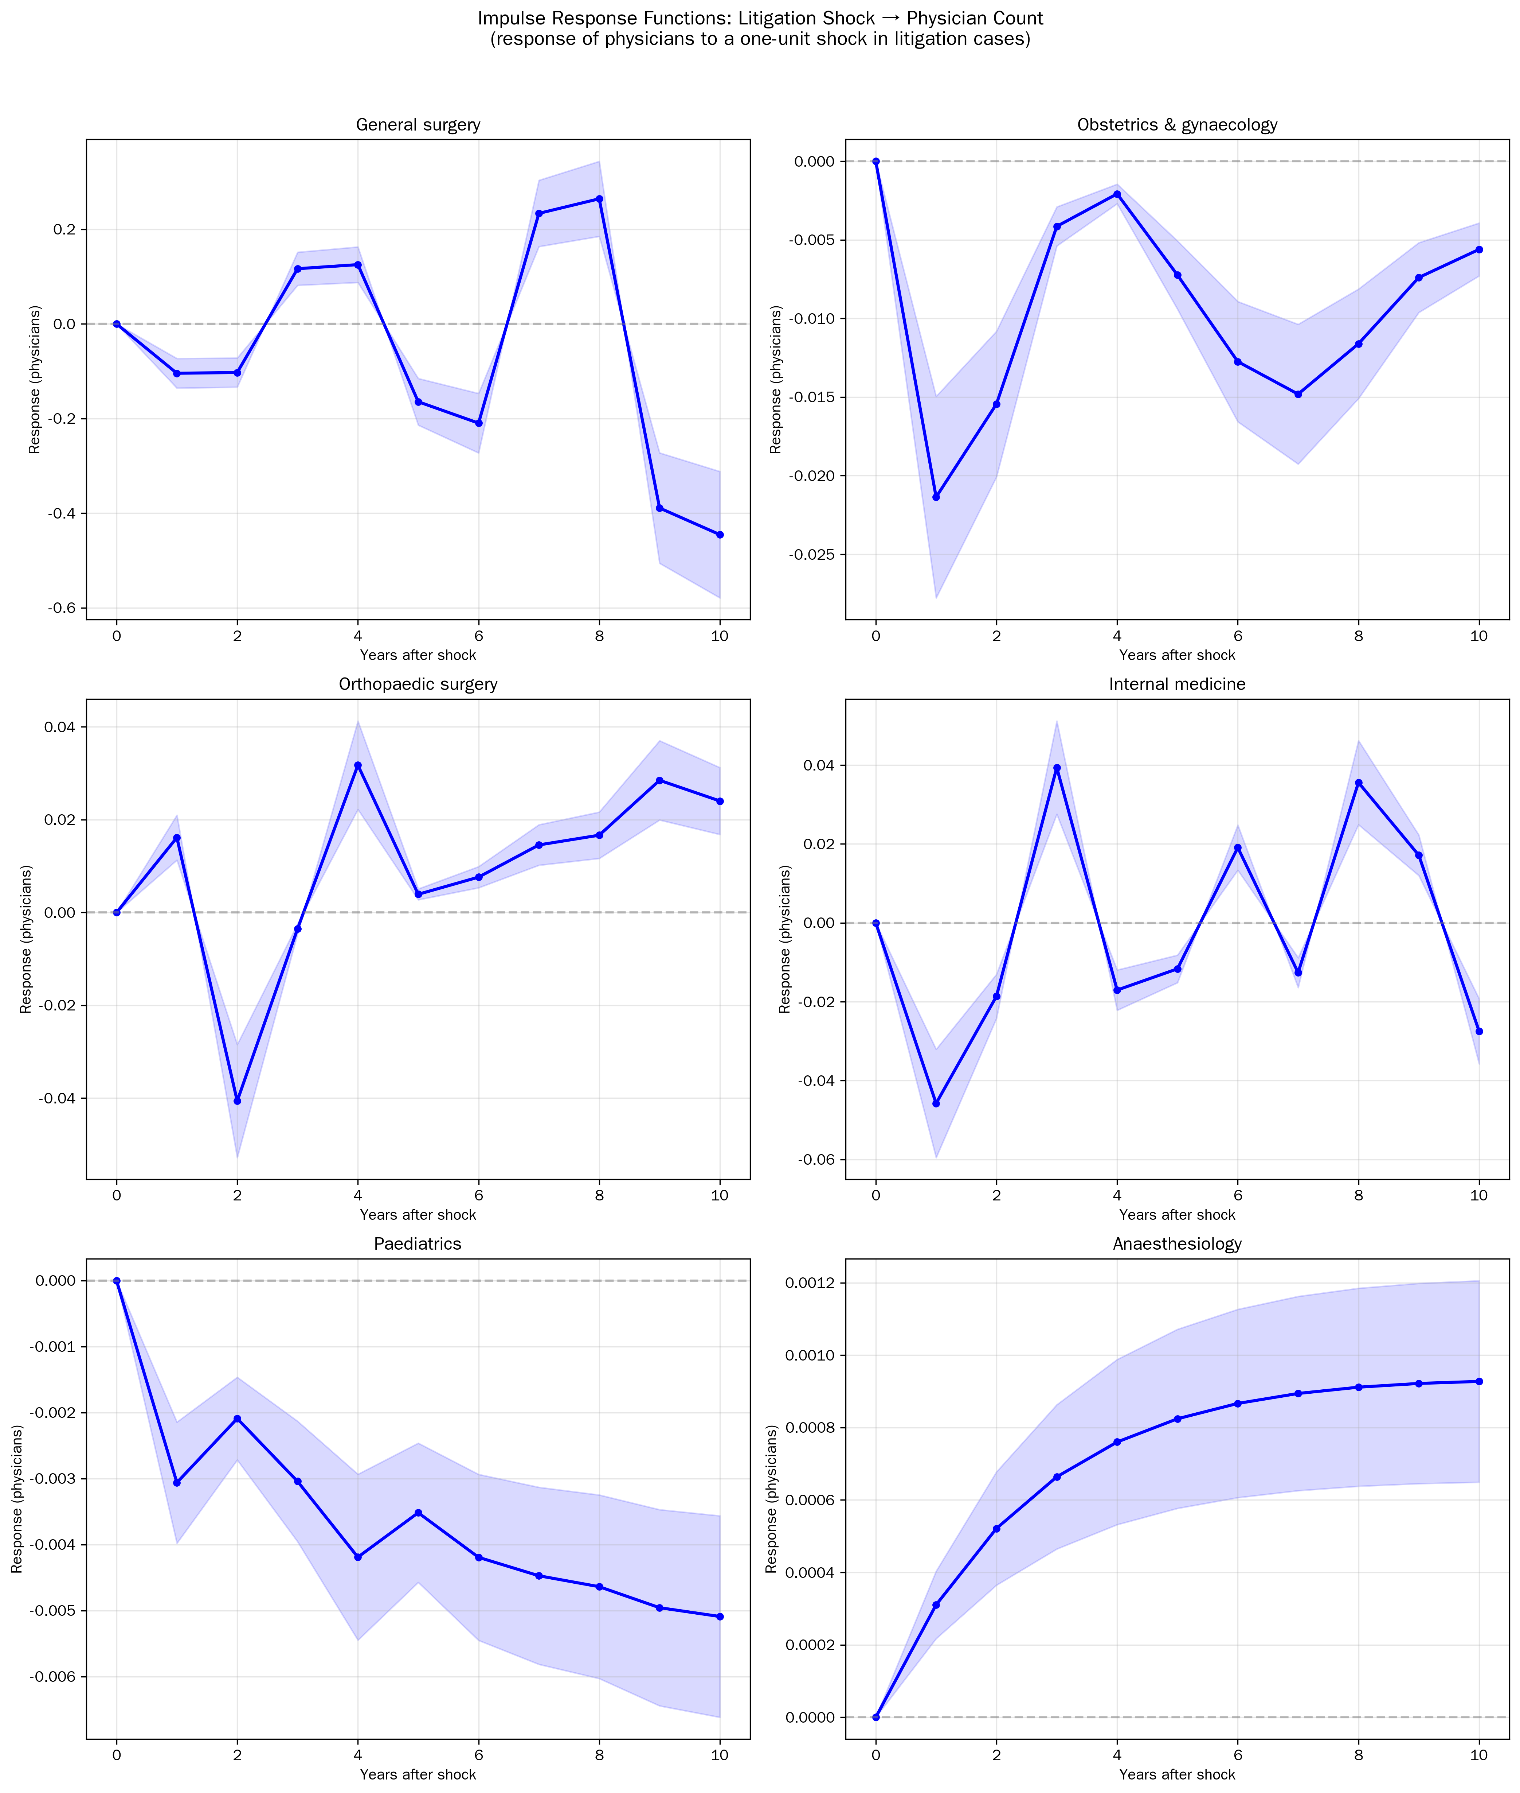

Figure 3. IRF: facility count response to a one-unit litigation shock.
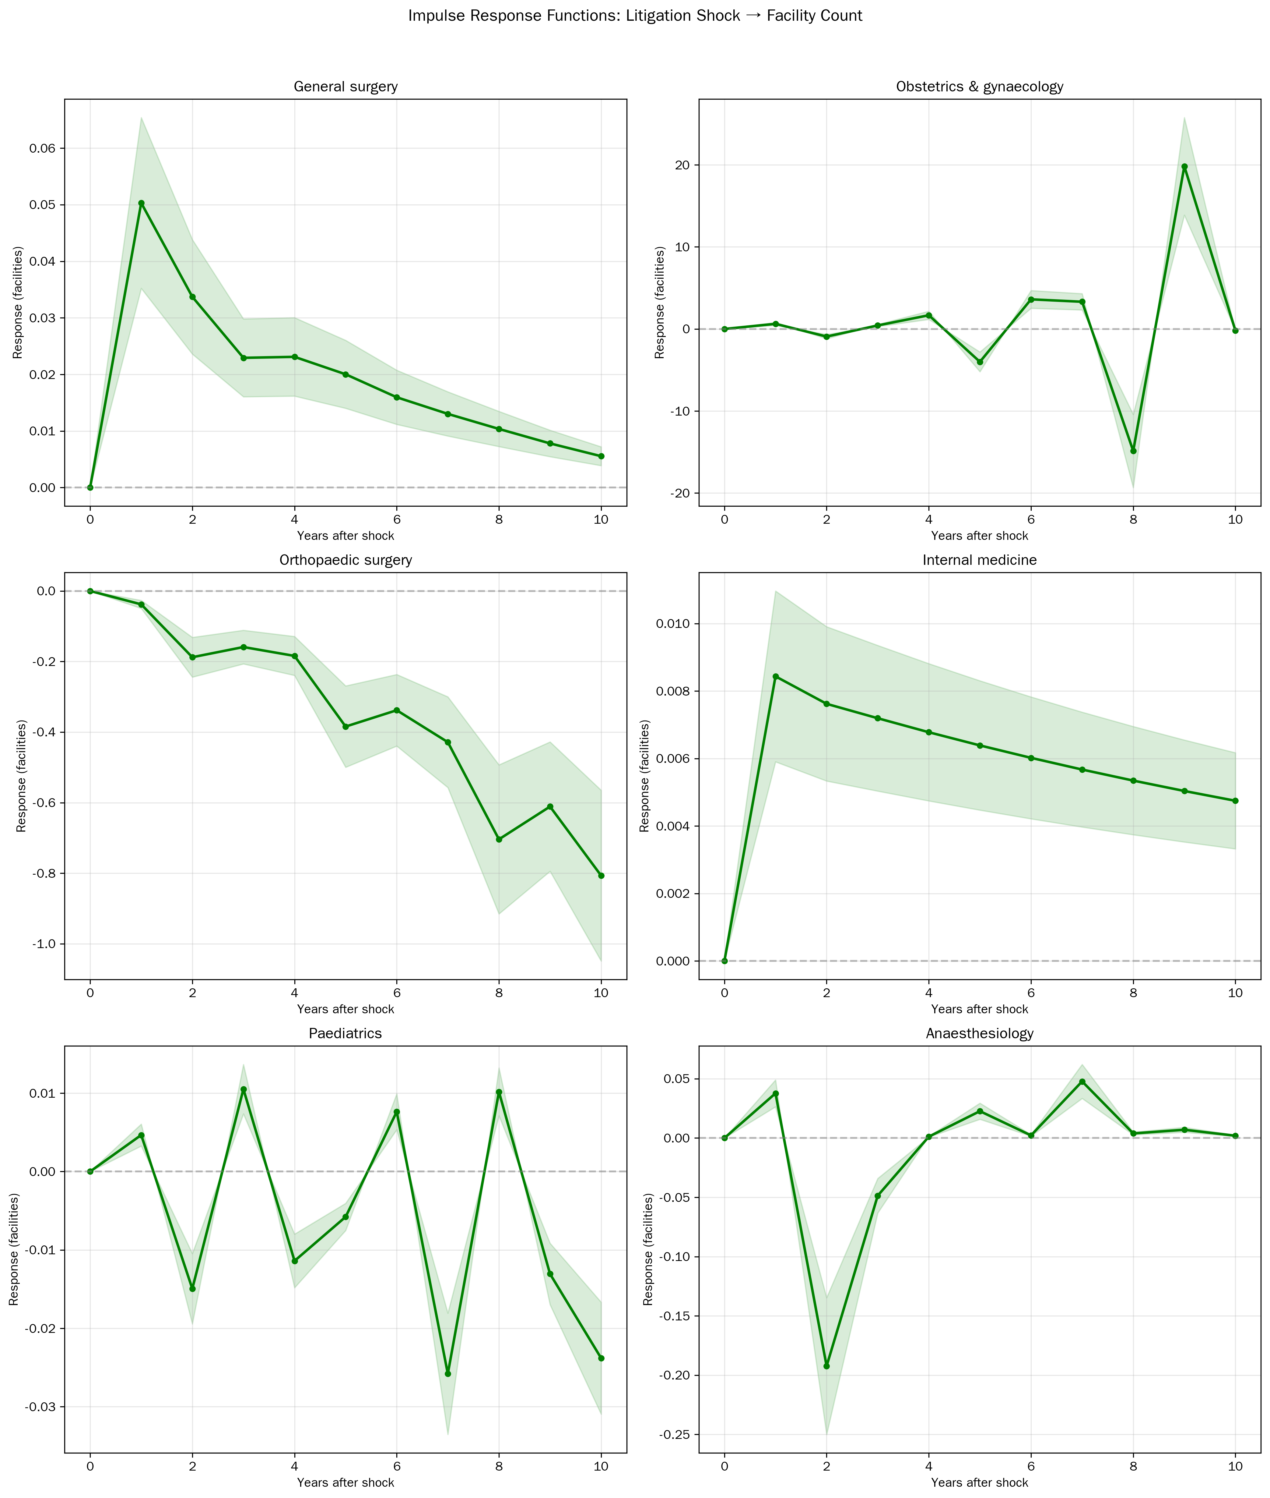

VAR-based forecasts
Figure 4 presents VAR-based forecasts for physician and facility counts. General surgery is projected to continue declining (physicians: -230/year; facilities: -310/year through 2033). Obstetrics and gynaecology physician counts show modest growth while facilities decline. Table 3 summarises forecast values.
Figure 4. VAR-based forecasts of physician and facility counts (2024-2033).
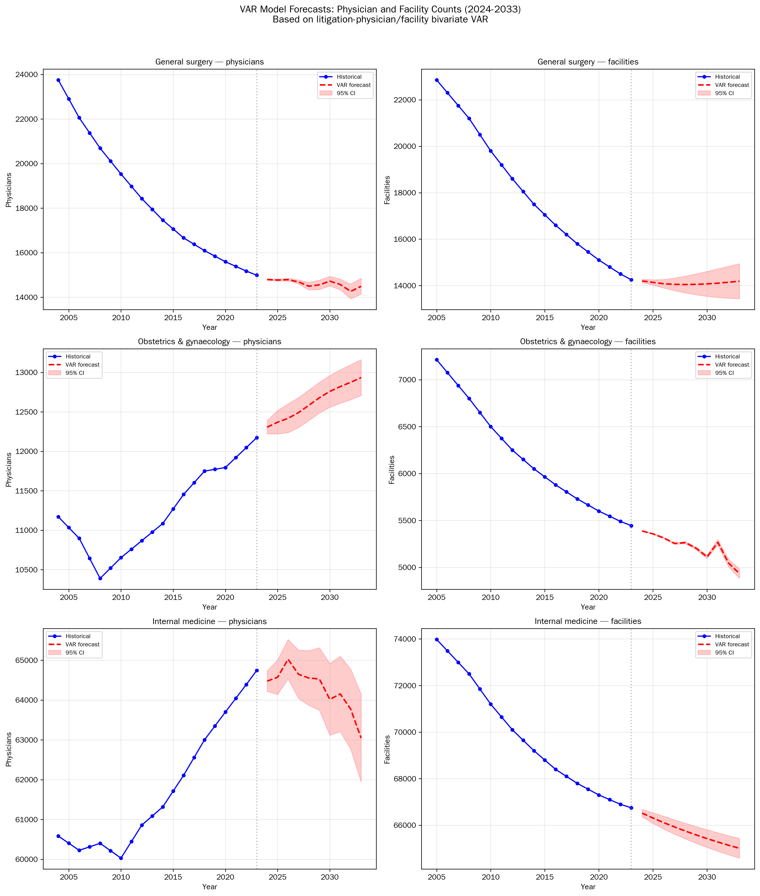

Table 3. VAR-based workforce forecasts for selected specialties.
Specialty | Outcome | 2028 (forecast) | 2033 (forecast)
General surgery | Physicians | 14,495 | 14,492
General surgery | Facilities | 14,046 | 14,188
Obstetrics & gynaecology | Physicians | 12,584 | 12,935
Obstetrics & gynaecology | Facilities | 5,264 | 4,934
Internal medicine | Physicians | 64,552 | 63,045
Internal medicine | Facilities | 65,750 | 65,011
Paediatrics | Physicians | 19,945 | 21,462
Paediatrics | Facilities | 19,396 | 19,137
Orthopaedic surgery | Physicians | 23,069 | 23,393
Orthopaedic surgery | Facilities | 15,693 | 16,992
Anaesthesiology | Physicians | 11,529 | 12,380
Anaesthesiology | Facilities | 3,656 | 4,161

Trainee correlations
Detrended correlations between JMSR incidents and specialist trainee enrolment (2018-2025, n = 8) showed notable negative associations for psychiatry (r = -0.77, P = 0.025), anaesthesiology (r = -0.77, P = 0.026), and obstetrics and gynaecology (r = -0.70, P = 0.051).

Sensitivity and source-independence analyses
When litigation data were restricted to the 2015-2023 window (9 years, matching the JMSR period), significant forward Granger models fell from 18 to 4, indicating that the disparity in significance counts between data sources largely reflects statistical power afforded by the longer series rather than an intrinsic difference between occurrence and litigation as predictors.
JMSR incident counts and litigation counts were weakly correlated across the overlapping period (median |r| = 0.23; no specialty reached P < 0.05). Trivariate VAR models incorporating both sources simultaneously did not improve fit over bivariate models (mean DeltaAIC = +0.6), and an interaction term (occurrence * litigation) reached significance in only 1 of 22 models, consistent with additive rather than synergistic effects.

Discussion
This multi-specialty Granger causality analysis yields three principal findings. First, safety incidents—whether measured by occurrence reports or litigation—temporally precede workforce decline in the majority of specialties when series length affords adequate statistical power. Second, the two incident sources are largely independent (median |r| = 0.23), implying that litigation captures a distinct dimension of professional risk—reputational exposure, financial liability, and prolonged procedural stress—not reducible to incident frequency. Third, these sources act additively rather than synergistically, suggesting that interventions targeting either pathway may yield independent workforce benefits.

Bidirectional causality
Bidirectional Granger causality in 7 specialty-outcome pairs points to a reinforcing cycle. The forward pathway (incidents → workforce decline) is consistent with incident-avoidance behaviour: high-profile events deter specialty entry and hasten exit.^{1,7} The reverse pathway (workforce decline → incidents) accords with the overwork hypothesis—fewer physicians per caseload raises fatigue and incident risk.²¹ That both directions reach significance in obstetrics, paediatrics, and general surgery identifies these specialties as most susceptible to self-perpetuating decline.

Work-style reform as a compounding factor
These incident-driven dynamics operate within a labour market reshaped by the April 2024 work-style reform (960-hour annual overtime cap, A-level; 1,860-hour transitional B/C-level).²² Restrictions on "gaikin" (moonlighting opportunities) have eroded the income supplement that historically offset demanding hospital posts, while deemed self-study—hours reclassified as voluntary training rather than compensable labour—has shifted workload onto mid-career physicians without relieving trainee burden.²³ The 3-5 year incident-response horizon identified by our IRFs thus coincides with a period of contracting financial incentives for the very specialties most affected.

Policy implications
The independence of occurrence and litigation counts has a direct policy corollary: because safety events occur with a certain irreducible probability, the litigation pathway constitutes a modifiable mediator. If malpractice disputes are resolved before reaching court—through early mediation, alternative dispute resolution, or no-fault compensation—the workforce signal associated with litigation may be attenuated without requiring a reduction in incident rates themselves.^{5,24}
Beyond dispute resolution, several complementary levers emerge from our results. Economic incentives for high-risk specialties (enhanced remuneration, training stipends, rural service allowances) address the most proximate driver of specialty avoidance.²⁴ Fostering a non-punitive safety culture—structured post-incident psychological support, transparent root-cause analysis, and proportionate media reporting—may attenuate the deterrent signal of adverse events.⁵ The reverse-causality pathway (fewer physicians → more incidents) implies that minimum staffing thresholds in specialties exhibiting bidirectional causality (obstetrics, paediatrics, general surgery) could interrupt the reinforcing cycle before it becomes self-sustaining. Effective implementation of work-style reform—including correction of deemed self-study practices and equitable redistribution of workload—is essential to prevent the reform itself from accelerating exit from demanding specialties.
The 3-5 year effect duration estimated by our IRFs defines a critical monitoring window: targeted surveillance and support in the years following a major safety event may prevent transient workforce shocks from consolidating into permanent losses. The projected contraction in general surgery (-230 physicians/year; -310 facilities/year) underscores the urgency of deploying these measures concurrently rather than sequentially.

Strengths and limitations
Strengths of this study include population-level coverage from mandatory national registries across 12 specialties over up to 20 years, and a VAR/Granger framework suited to continuously varying exposures without requiring an assumed intervention point.
Several limitations warrant consideration. The ecological design precludes individual-level causal inference. Biennial physician data required interpolation, potentially smoothing abrupt transitions. The JMSR series spans only 11 years, limiting statistical power for that data source. Unmeasured confounders—demographic shifts, the 2004 postgraduate training reform, and the direct effects of work-style reform (temporally overlapping the most recent observations)—may bias estimates. Notably, our 12-specialty framework does not capture career paths outside conventional specialty registration, such as aesthetic medicine^{25,26} and occupational medicine.^{27,28} To the extent that migration into these sectors correlates temporally with incident trends, our models may overestimate the incident-attributable component of workforce decline. Low retention among occupational physicians (55-65% turnover within 2 years)²⁸ further complicates workforce projections.

Conclusions
Safety incidents Granger-cause reductions in physician supply in 9 of 12 specialties, with effects persisting 3-5 years. Occurrence-based and litigation-based incident counts are largely independent yet both predict workforce decline, identifying litigation as a modifiable mediator. Early dispute resolution, combined with economic incentives, non-punitive safety culture, and minimum staffing safeguards, may interrupt the reinforcing shortage-incident cycle within the 3-5 year policy window identified here.

Conflict of Interest
The author declares no conflict of interest.

Funding
None.

Author Contributions
TO conceived the study, acquired data, performed statistical analyses, and drafted the manuscript.

Data Availability
Analysis code and aggregated datasets are available at https://github.com/bougtoir/medical-accident-its-analysis. Original data sources are publicly available from the Japan Medical Safety Research Organisation, the Supreme Court of Japan, and the Ministry of Health, Labour and Welfare.

Acknowledgements
AI-assisted tools were used for coding assistance and manuscript drafting. The author takes full responsibility for the content and integrity of the work.

References
1. Ikegami N, Yoo BK, Hashimoto H, et al. Japanese universal health coverage: evolution, achievements, and challenges. Lancet. 2011;378(9796):1106-15.
2. Toyabe S. Trend in geographic distribution of physicians in Japan. Int J Equity Health. 2009;8:5.
3. Ministry of Health, Labour and Welfare. Survey of physicians, dentists, and pharmacists 2022. Tokyo: MHLW; 2023. Japanese.
4. Tanaka K, Katsumata Y, Matsuda S. Supply, demand and distribution of physicians in Japan. Keio J Med. 2024;doi:10.46308/kmj.2024.00087.
5. Nagamatsu S, Kami M, Nakata Y. Healthcare safety committee in Japan: mandatory accountability reporting system and punishment. Curr Opin Anaesthesiol. 2009;22(2):199-206.
6. Hiyama T, Yoshihara M, Tanaka S, et al. Defensive medicine practices among gastroenterologists in Japan. World J Gastroenterol. 2006;12(47):7671-5.
7. Morita H. Criminal prosecution and physician supply. Int Rev Law Econ. 2018;55:1-11.
8. Japan Medical Safety Research Organisation. Annual report on medical accident investigation. Tokyo: JMSR; 2025. Available from: https://www.medsafe.or.jp/
9. Supreme Court of Japan. Annual report of judicial statistics: medical malpractice litigation. Tokyo: Supreme Court; 2024. Japanese.
10. Taniguchi K, Watari T, Nagoshi K. Characteristics and trends of medical malpractice claims in Japan between 2006 and 2021. PLoS One. 2024;19(1):e0296155.
11. Granger CWJ. Investigating causal relations by econometric models and cross-spectral methods. Econometrica. 1969;37(3):424-38.
12. Lütkepohl H. New Introduction to Multiple Time Series Analysis. Berlin: Springer; 2005.
13. Toda HY, Yamamoto T. Statistical inference in vector autoregressions with possibly integrated processes. J Econom. 1995;66(1-2):225-50.
14. von Elm E, Altman DG, Egger M, et al. The Strengthening the Reporting of Observational Studies in Epidemiology (STROBE) statement: guidelines for reporting observational studies. Lancet. 2007;370(9596):1453-7.
15. Ministry of Health, Labour and Welfare. Survey of physicians, dentists, and pharmacists. Tokyo: MHLW; 2024. Japanese.
16. Ministry of Health, Labour and Welfare. Survey of medical institutions (dynamic survey). Tokyo: MHLW; 2024. Japanese.
17. Japan Board of Medical Specialties. Specialist trainee registration statistics. Tokyo: JBMS; 2025. Japanese.
18. Hamilton JD. Time Series Analysis. Princeton: Princeton University Press; 1994.
19. Sims CA. Macroeconomics and reality. Econometrica. 1980;48(1):1-48.
20. Seabold S, Perktold J. Statsmodels: econometric and statistical modeling with Python. Proc 9th Python Sci Conf. 2010:92-6.
21. Studdert DM, Mello MM, Sage WM, et al. Defensive medicine among high-risk specialist physicians in a volatile malpractice environment. JAMA. 2005;293(21):2609-17.
22. Ishikawa T, Ohba H, Yokooka Y, et al. Labor shortage of physicians in rural areas and surgical specialties caused by Work Style Reform Policies of the Japanese government: a quantitative simulation analysis. J Rural Med. 2024;19(3):198-207.
23. Japan Medical Association. Survey on physician work-style reform implementation status. Tokyo: JMA; 2024. Japanese.
24. Currie J, MacLeod WB. First do no harm? Tort reform and birth outcomes. Q J Econ. 2008;123(2):795-830.
25. Takei T. The ‘Chokubi’ phenomenon: young physicians’ exodus from state service to private medicine in Japan. QJM. 2024;117(12):843-5.
26. Ministry of Health, Labour and Welfare. Survey of medical institutions 2023: aesthetic surgery clinics. Tokyo: MHLW; 2024. Japanese.
27. Koike S, Isse T, Kawaguchi H, et al. Retention among full-time occupational physicians in Japan. Occup Med (Lond). 2019;69(2):139-42.
28. Isse T, Nakamura H, Hachisuka K. Turnover of full-time occupational physicians in Japan in the period 2002-2008. Sangyo Eiseigaku Zasshi. 2012;54(5):174-83. Japanese.

Figure Legends
Figure 1. Trends in medical safety incident counts by specialty. Panel A: JMSR mandatory reports (2015-2025). Panel B: Medical malpractice litigation closed claims (2004-2023).
Figure 2. Impulse response functions: response of physician counts to a one-unit shock in litigation cases for six specialties. Shaded areas represent approximate 95% confidence bands.
Figure 3. Impulse response functions: response of facility counts to a one-unit shock in litigation cases for six specialties.
Figure 4. VAR-based forecasts of physician and facility counts for general surgery, obstetrics and gynaecology, and internal medicine (2024-2033). Circles: observed data; dashed line: forecast; shaded area: 95% forecast interval.

