Supplementary material (online supplement 1)
Malpractice litigation, physician supply and service capacity in Japan, 2008–2024: a national equivalence analysis
This file is the consolidated online supplement for the main manuscript and should be cited as online supplementary material.
Supplementary Figure 1. Closed malpractice claims per 1,000 physicians by specialty, 2008–2024 (rates, not counts).
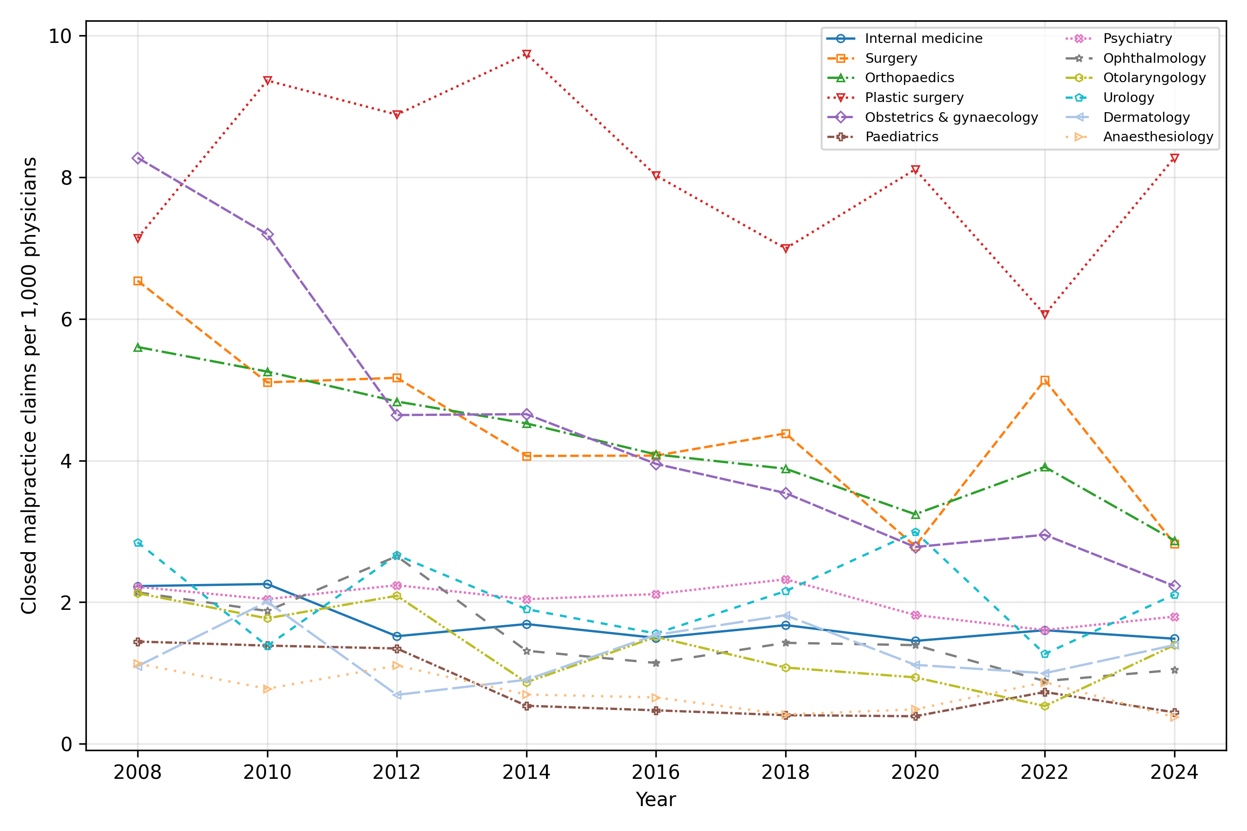

Supplementary Figure 2. Physician workforce by specialty, indexed to 2008 (=100).
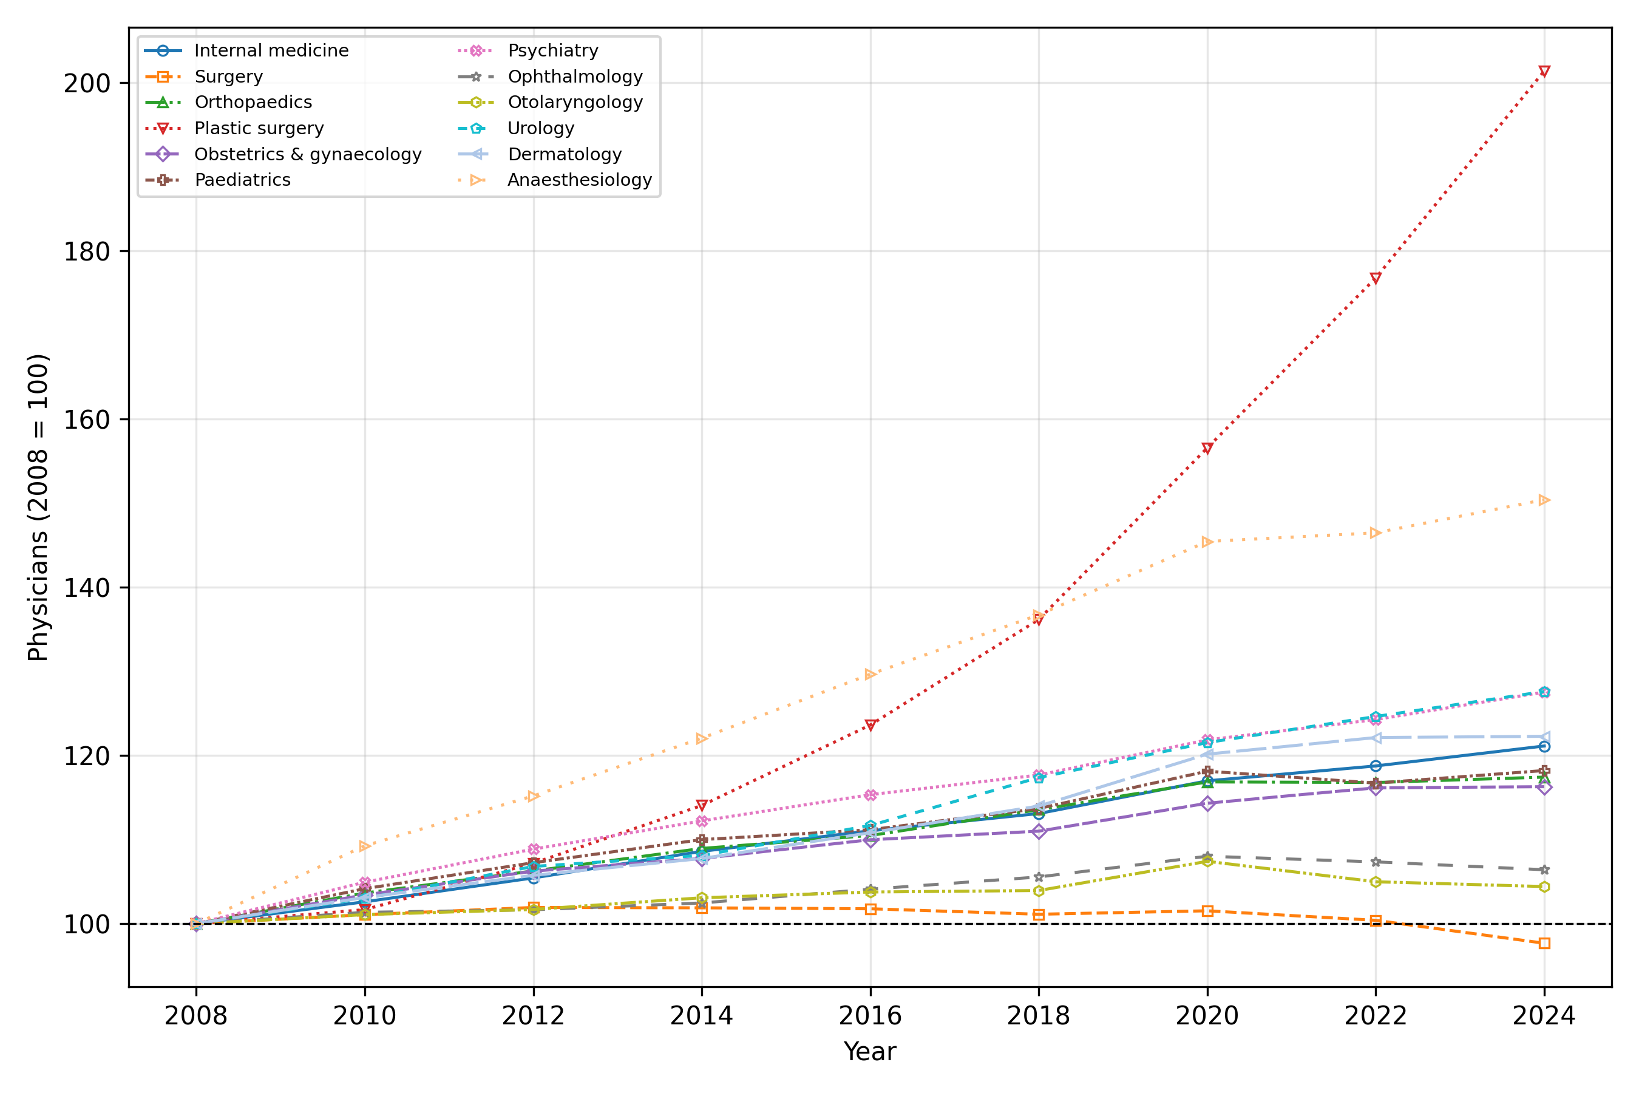

Supplementary Table 1. Primary data sources and their resolution.
Series | Source | Resolution | Years | Role
Physicians by specialty | MHLW Statistics of Physicians | Biennial | 2004–2024 | Denominator & outcome
Closed malpractice claims | Supreme Court, by specialty | Annual | 2008–2024 | Exposure (numerator)
Hospitals by specialty | MHLW Survey of Medical Institutions | Annual | 2008–2024 | Outcome
Clinics by specialty | MHLW Survey (static) | Every 3 years | 2008–2023 | Descriptive only
JMSR report counts | JMSR / MAIS | Annual | 2015–2024 | Sensitivity (2016-2024)
Newspaper article counts | Nikkei Telecom 21 | Annual | 2008–2018 | Sensitivity (2009-2018)

Supplementary Table 2. Equivalence (TOST) results (effect per +1 SD litigation rate).
Outcome | Coef per SD | 90% CI | Margin | TOST p | Equivalent
Physician growth | -0.21% | -0.84%, +0.42% | ±1% | 0.023 | Yes
Physician growth | -0.21% | -0.84%, +0.42% | ±2% | 0.000 | Yes
Hospital growth | +0.07% | -0.91%, +1.06% | ±1% | 0.059 | No
Hospital growth | +0.07% | -0.91%, +1.06% | ±2% | 0.002 | Yes

Supplementary Table 3. JMSR-adjusted annual hospital growth model (2016-2024) with both exposures entered simultaneously.
Exposure | Coefficient | p | n
Lagged litigation rate | +0.0021 | 0.28 | 108
Lagged JMSR report rate | -0.0009 | 0.66 | 108

Supplementary Table 4. Media-adjusted annual hospital growth model (2009-2018) with a linear time trend; full year fixed effects are omitted because the national article-count series is collinear with them.
Exposure | Coefficient | p | n
Lagged litigation rate | -0.0003 | 0.72 | 120
Lagged media count (per 1,000 articles) | -0.0014 | 0.21 | 120

