Nosological Relativity: Formalizing the Medical Sapir–Whorf Hypothesis
Tatsuki Onishi

Abstract
Background: The Sapir–Whorf hypothesis in linguistics posits that the structure of language influences cognition and perception. An analogous phenomenon may operate in medicine: nosological frameworks—the systems by which diseases are classified and named—may not merely describe clinical reality but actively shape it. While the notion that disease concepts influence medical practice is intuitive, we argue that the effects extend beyond the obvious and warrant formal theoretical treatment. Objective: This paper proposes the 'Nosological Relativity' framework, a formal analogue of the Sapir–Whorf hypothesis applied to medical classification systems. We define strong and weak forms of the hypothesis, delineate three levels of effect (cognitive, institutional, and population), and incorporate Ian Hacking's looping-effect mechanism as the central feedback dynamic. Methods: We synthesize insights from philosophy of science, medical anthropology, sociology of diagnosis, and clinical medicine to construct the theoretical framework. Case studies from pain medicine, occupational health (karoshi), and ICD revision history are analyzed as illustrative evidence. Counter-evidence from culture-independent disease manifestations (e.g., anorexia nervosa in non-thin-ideal societies) is integrated to delimit the framework's boundaries. Results: The Nosological Relativity framework identifies six propositions and three testable predictions. We demonstrate that nosological categories operate as cognitive constraints on clinical reasoning (diagnostic foreclosure), institutional determinants of research funding and therapeutic pathways, and population-level shapers of epidemiological patterns. The looping mechanism—whereby classification alters patient self-identification, which in turn generates data that reinforces the classification—is formalized as the central dynamic. Conclusions: The Nosological Relativity framework provides a structured theoretical lens for understanding how disease classification systems shape medical practice. The framework yields testable predictions amenable to natural-experiment designs, particularly around ICD revisions, and has practical implications for nosological policy and clinical education.
Keywords: Sapir–Whorf hypothesis; nosology; disease classification; linguistic relativity; looping effects; philosophy of medicine; ICD; diagnostic labels

1. Introduction
The Sapir–Whorf hypothesis, formulated in the early twentieth century by Edward Sapir and Benjamin Lee Whorf, proposes that the structure of a language influences its speakers' cognition and worldview.^{1,2} In its strong form (linguistic determinism), language determines thought; in its weak form (linguistic relativity), language influences habitual patterns of thought without fully constraining them.^{24,25} Although the strong form has been largely abandoned in linguistics, robust evidence supports the weak form across domains including color perception, spatial reasoning, and temporal cognition.²⁴
An analogous phenomenon may operate in medicine. Nosological frameworks—the formal systems by which diseases are classified, named, and organized—constitute the 'language' of clinical medicine. Just as natural language categories shape how speakers perceive and reason about the world, nosological categories may shape how clinicians perceive, diagnose, and treat patients. Warner first explored this analogy in 1976, arguing that linguistic structures in different cultures lead to fundamentally different conceptions of disease.³ However, the parallel has not been formally developed beyond initial observations.
The claim that 'disease concepts shape medical practice' might appear trivially true—medicine is, after all, organized around disease categories. However, we argue that the effects extend well beyond the obvious and warrant systematic theoretical treatment. The phenomenon includes cognitive effects on clinical reasoning (diagnostic foreclosure), institutional effects on research funding and treatment guidelines, and population-level effects on epidemiological patterns. Moreover, as Ian Hacking has demonstrated for psychiatric classifications, a distinctive looping mechanism operates: classification systems alter patient self-identification and symptom expression, which in turn generates data that reinforces the original classification.^{4,5}
At the same time, evidence constrains this hypothesis. Kleinman's observation that anorexia nervosa occurs even in cultures where thinness is not idealized^{6,10} suggests that some diseases possess a biological substrate that manifests independently of nosological framing. Any adequate theoretical framework must accommodate both the constructive power of nosological categories and the existence of nosology-independent disease phenomena.
In this paper, we propose the 'Nosological Relativity' (NR) framework—a formal analogue of the Sapir–Whorf hypothesis applied to medical classification systems. We define the framework's core propositions, distinguish strong and weak forms, delineate three levels of effect, and formalize the looping mechanism as the central feedback dynamic. We then illustrate the framework with case studies and derive testable predictions suitable for empirical investigation.

2. Background

2.x The Sapir–Whorf Hypothesis in Linguistics
The linguistic relativity hypothesis has undergone substantial revision since its original formulation.^{1,2} Contemporary research supports a moderate position: language does not rigidly determine thought, but it does influence habitual patterns of cognition.^{24,25} Boroditsky demonstrated that Mandarin and English speakers conceptualize time differently, consistent with structural differences in how each language encodes temporal relations.²⁴ Lupyan and Bergen showed that linguistic labels facilitate categorization and modulate perceptual processing.²⁵ These findings establish that symbolic classification systems exert measurable cognitive effects—a principle we extend to medical nosology.

2.x Prior Work on Language and Disease
Warner's 1976 paper represents the first explicit application of the Sapir–Whorf hypothesis to medicine.³ He argued that Indo-European linguistic structures—particularly the use of nouns rather than verbs to describe illness, the extensive use of spatial metaphors, and the subject–predicate dichotomy—encourage a static, unicausal, and dualistic conception of disease. Warner suggested that these linguistic features promote over-reliance on surgery and inhibit recognition of social and psychological factors in disease causation.
Subsequent work has expanded this perspective without formalization. Eisenberg distinguished between 'disease' (the biomedical construct) and 'illness' (the patient's lived experience), showing that the gap between these constructs is mediated by cultural and linguistic categories.²¹ Fabrega offered an interdisciplinary framework linking disease to social behavior.²⁰ Kleinman's medical anthropology demonstrated that cultural categories of sickness guide labeling, help-seeking, and therapeutic responses.⁶ Hacking's philosophy of human kinds introduced the looping-effect concept, showing that psychiatric classifications are not passive labels but active constituents of the phenomena they describe.^{4,5} Jutel's sociology of diagnosis showed that the diagnostic act itself is a social event with consequences that extend beyond the clinical encounter.⁷
Despite these rich intellectual traditions, no integrated formal framework exists for the proposition that nosological categories shape medical practice in ways analogous to linguistic relativity. The present paper fills this gap.

3. The Nosological Relativity Framework
We now present the Nosological Relativity (NR) framework. The framework consists of a core thesis, six formal propositions, three levels of effect, and a looping-mechanism model (Fig. 1).

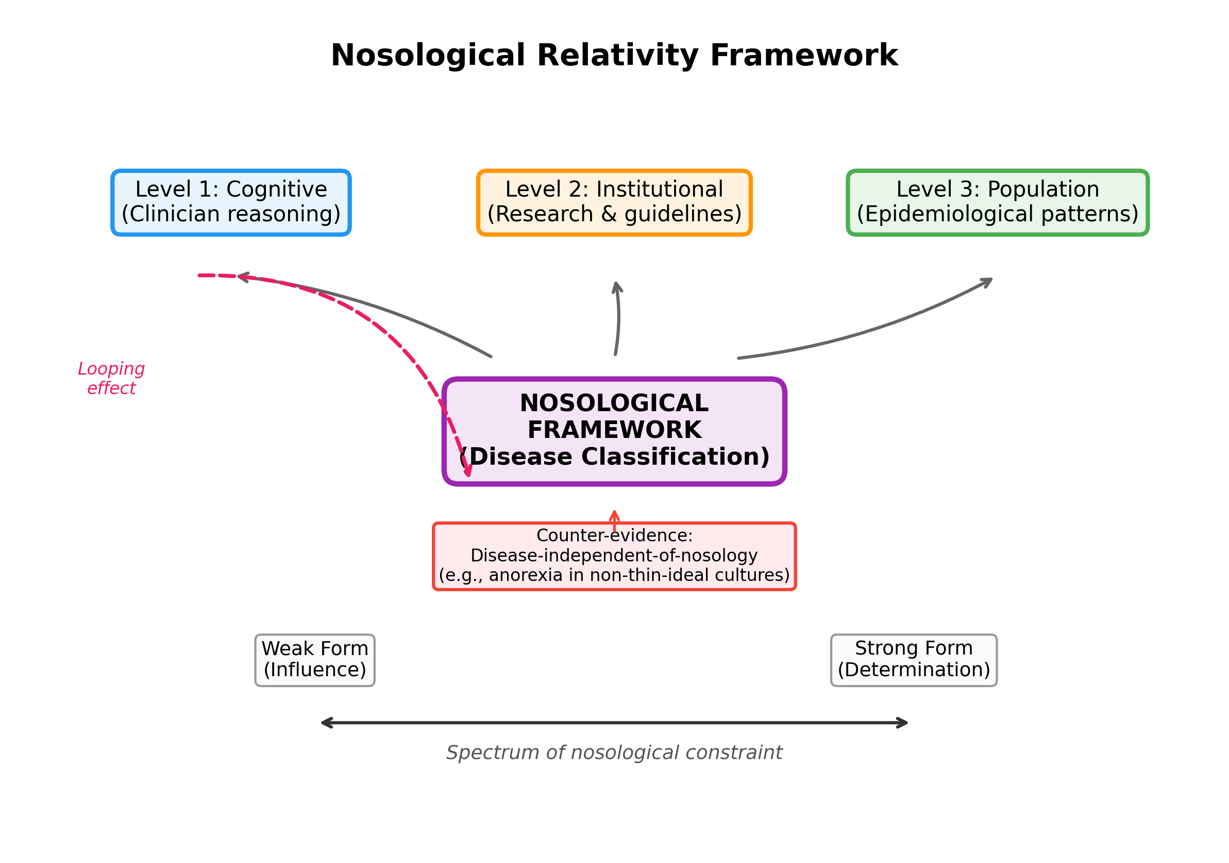
Fig. 1. The Nosological Relativity Framework. Nosological categories shape medical practice at three levels (cognitive, institutional, population) via the looping mechanism. The strength of effect varies along a spectrum from weak (influence) to strong (determination). Counter-evidence from nosology-independent diseases delineates the framework's boundary conditions.

3.1 Core Propositions
Proposition 1 (Core Thesis). Nosological frameworks—the systems by which diseases are classified and named—do not merely describe pre-existing clinical reality but actively shape the perception, categorization, and management of illness at multiple levels of the healthcare system.
Proposition 2 (Weak Form). Nosological categories influence but do not fully determine clinical reasoning, research priorities, and patient outcomes. Clinicians can reason outside the categories of their training, but such reasoning requires additional cognitive effort and is statistically less frequent.
Proposition 3 (Strong Form). For certain conditions—particularly those lacking objective biomarkers—nosological categories effectively determine clinical reality: a condition that does not exist in the classification system does not receive diagnosis, treatment, or research attention, and is therefore functionally non-existent within the healthcare system.
Proposition 4 (Cognitive Level). Nosological categories function as cognitive schemata for clinicians, producing diagnostic foreclosure (cessation of diagnostic reasoning once a category is assigned), anchoring bias toward category-consistent features, and difficulty perceiving cross-category patterns.
Proposition 5 (Institutional Level). Nosological categories structure research funding allocation, clinical guideline development, specialist training, and reimbursement systems. Conditions without nosological representation receive disproportionately less institutional support relative to their disease burden.
Proposition 6 (Population Level). Nosological categories shape epidemiological patterns through differential case-finding, diagnostic migration (reclassification of existing cases when categories change), and the creation of new illness identities that alter help-seeking behavior.

3.2 The Looping Mechanism
Central to the NR framework is the looping mechanism, adapted from Hacking's analysis of human kinds (Fig. 2).^{4,5} The mechanism operates as follows:
Stage 1 (Classification → Practice): A nosological category is introduced or revised within a formal system (e.g., ICD, DSM). This creates diagnostic criteria, treatment algorithms, and referral pathways organized around the category.
Stage 2 (Practice → Experience): Clinicians using the category communicate the diagnosis to patients, who incorporate it into their self-understanding. The diagnostic label provides a framework for interpreting symptoms, a basis for illness identity, and a social role.¹¹
Stage 3 (Experience → Data): Patients who self-identify with the diagnostic category generate health-seeking behavior, symptom reports, and clinical encounters that are coded using the category. This produces epidemiological data consistent with the category's existence.²⁶
Stage 4 (Data → Classification): Epidemiological data are used to validate and refine nosological categories. Categories that generate data consistent with their definitions appear empirically supported, completing the loop.
This looping mechanism creates a self-reinforcing cycle that can make it difficult to distinguish between categories that 'carve nature at its joints' and categories that generate the very patterns they claim to describe.^{18,19}

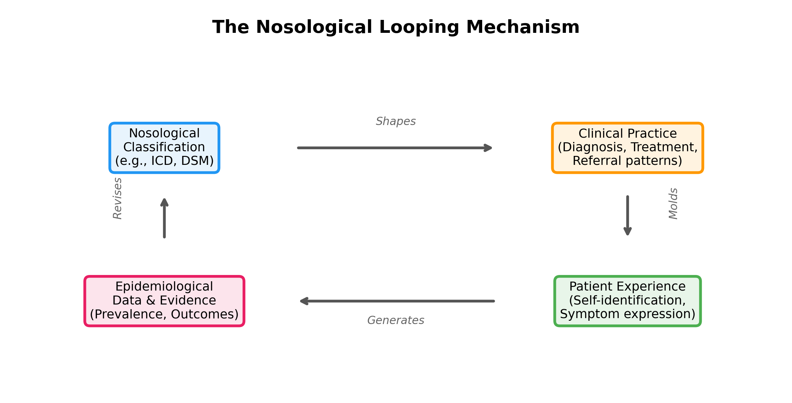
Fig. 2. The Nosological Looping Mechanism. A four-stage cycle in which nosological classification shapes clinical practice, which molds patient experience, which generates epidemiological data, which in turn revises the classification. This self-reinforcing loop is the central dynamic of the Nosological Relativity framework.

4. Evidence and Case Studies

4.1 Diagnostic Foreclosure in Pain Medicine
The recognition of chronic pain as an independent disease entity in ICD-11 (code MG30) illustrates the cognitive-level effects of nosological categories.¹⁷ Prior to ICD-11, chronic pain was classified exclusively as a symptom of underlying conditions. This nosological framing constrained clinical reasoning: once an underlying condition was identified (e.g., osteoarthritis), diagnostic exploration of pain mechanisms typically ceased—a phenomenon we term diagnostic foreclosure.⁴
The introduction of chronic pain as an independent diagnostic entity creates the conditions for a natural experiment. The NR framework predicts that following adoption of ICD-11's chronic pain categories, clinicians will: (a) refer more patients to pain specialists rather than treating pain exclusively through the lens of underlying conditions; (b) increase prescribing of pain-specific therapies; and (c) generate new epidemiological data on chronic pain prevalence that will be attributed to improved detection rather than to the nosological change itself.
Nickel et al. showed in a systematic review that different terminology for the same condition influences clinicians' and patients' management preferences.¹² This finding directly supports Proposition 2: nosological labels influence, but do not determine, clinical reasoning.

4.2 Karoshi: Culture-Specific Nosological Innovation
Karoshi (過労死, death from overwork) provides a compelling illustration of Proposition 3—the strong form of nosological relativity. The concept emerged in Japan in the 1970s as a legally and medically recognized cause of death, distinct from the underlying cardiovascular or cerebrovascular events.^{13,14} In other countries, identical pathophysiological events (myocardial infarction, stroke) occurring in the context of overwork are classified under their organ-specific categories without reference to occupational causation.
The existence of karoshi as a nosological category in Japan has produced a cascade of effects consistent with the NR framework: (a) at the cognitive level, Japanese clinicians consider occupational overwork in the differential diagnosis of sudden cardiovascular death in working-age adults, a consideration that is largely absent in countries without an equivalent category; (b) at the institutional level, Japan has developed a dedicated legal-medical apparatus for karoshi certification, with specific overtime-hour thresholds (the '80-hour karoshi line') that do not exist elsewhere; (c) at the population level, Japan reports karoshi statistics as a distinct epidemiological phenomenon, generating policy responses (the 2014 Act on Promotion of Measures to Prevent Karoshi) that are structurally impossible in countries where the category does not exist.
The ICD-11 inclusion of burnout (QD85) as a classifiable occupational phenomenon provides a partial international diffusion of this nosological innovation, and the NR framework predicts that countries adopting this code will begin to replicate—at a smaller scale—the institutional and epidemiological patterns observed in Japan.^{15,16}

4.3 ICD Revisions as Natural Experiments
Major revisions of the International Classification of Diseases constitute natural experiments for the NR framework. The transition from ICD-10 to ICD-11 introduced several nosological innovations whose effects can be tracked using before-after designs (Table 1).^{15,16}

Table 1. Selected ICD-11 Nosological Innovations and Predicted Effects Under the Nosological Relativity Framework
ICD-11 Change | Cognitive Level | Institutional Level | Population Level
Chronic pain as independent entity (MG30) | Clinicians consider pain as primary diagnosis, not merely symptom | Pain medicine receives dedicated funding streams and guidelines | Increased chronic pain prevalence rates attributed to improved detection
Burnout as occupational phenomenon (QD85) | Clinicians screen for occupational factors in exhaustion presentations | Occupational health services develop burnout-specific protocols | New epidemiological data on burnout prevalence emerge
Gaming disorder (6C51) | Clinicians identify pathological gaming as a diagnosable condition | Treatment centers and clinical guidelines for gaming disorder develop | Incidence data for gaming disorder are generated and reported
Complex PTSD (6B41) | Clinicians distinguish complex from simple PTSD in trauma patients | Research funding specifically allocated to complex PTSD mechanisms | Existing PTSD patients reclassified, altering prevalence estimates
Gender incongruence reclassification (HA60–HA6Z) | Reduced cognitive association with mental illness | Care pathways reorganized away from psychiatric services | Reduced stigma-related barriers to care access

Of particular theoretical interest is the reclassification of gender incongruence from Mental and Behavioural Disorders (ICD-10, Chapter V) to Conditions Related to Sexual Health (ICD-11, Chapter 17). The NR framework predicts that this reclassification will produce measurable changes at all three levels: reduced cognitive association with mental illness among clinicians, institutional reorganization of care pathways away from psychiatric services, and population-level reduction in stigma-related barriers to care.¹⁶

4.4 Counter-Evidence: Disease-Independent-of-Nosology
The NR framework must accommodate evidence that some diseases manifest independently of nosological framing. Kleinman documented that anorexia nervosa occurs in cultures where thinness is not idealized,⁶ and Swartz argued that anorexia should be understood as a culture-bound syndrome precisely because its form varies across cultures even when its core features persist.¹⁰ More broadly, infectious diseases with clear etiological agents (e.g., tuberculosis, malaria) manifest regardless of how they are classified.
These observations delineate the boundary conditions of nosological relativity. Boorse's biostatistical theory of health provides a useful reference point: to the extent that a condition deviates from species-typical function in ways measurable independently of nosological framing, it is less susceptible to nosological relativity.⁹ Kirmayer has further documented how cultural variations in the clinical presentation of depression and anxiety complicate simple universalist assumptions.³⁰ We propose that the strength of nosological effects is inversely proportional to the strength of the underlying biological signal: conditions with strong, objectively measurable biological substrates (e.g., fractures, infections with identifiable pathogens) are less susceptible to nosological shaping, while conditions defined primarily by symptom clusters, functional impairment, or subjective experience (e.g., fibromyalgia, chronic fatigue syndrome, many psychiatric disorders) are highly susceptible. This gradient constitutes a testable prediction of the NR framework.

5. Testable Predictions
The NR framework generates three empirically testable predictions:
Prediction 1 (ICD Revision Effect): Introduction of a new diagnostic category in ICD-11 will be followed by increased detection rates, specialist referrals, and targeted treatment prescriptions for the corresponding condition, independent of any change in the underlying biological incidence. This can be tested using interrupted time-series analysis of claims data around ICD transition dates.
Prediction 2 (Biomarker Gradient): The magnitude of nosological effects on diagnostic and treatment patterns will be inversely correlated with the availability and specificity of objective biomarkers for the condition. Conditions diagnosed purely on clinical criteria will show larger effects than those with definitive laboratory or imaging markers.
Prediction 3 (Cross-National Divergence): Countries with different nosological traditions for the same pathophysiological phenomenon (e.g., Japan's karoshi versus other countries' organ-specific coding of overwork-related cardiovascular death) will show systematically different patterns of diagnosis, treatment, occupational health policy, and patient self-identification for those conditions.

6. Discussion
The Nosological Relativity framework offers several implications for medical practice and nosological policy.
First, nosological revisions should be understood not merely as improved descriptions of clinical reality but as interventions that actively reshape clinical practice. This suggests that the process of revising classification systems should incorporate prospective impact assessment, analogous to regulatory impact assessment for legislation.^{8,27}
Second, clinical education should include explicit instruction in the cognitive effects of diagnostic categories. Awareness of diagnostic foreclosure—the tendency to cease diagnostic reasoning once a category is assigned—may partially mitigate its effects, analogous to debiasing training for other cognitive heuristics.²² Integration with biopsychosocial approaches may further counteract the reductionism inherent in categorical thinking.²³
Third, the framework provides a principled basis for evaluating proposals to create new diagnostic categories. The benefits of nosological recognition (improved detection, research funding, treatment development) must be weighed against the risks of reification (treating a provisional category as a natural kind) and looping effects (the category generating the very phenomenon it describes).^{26,29}
Limitations of this framework should be acknowledged. The NR framework is primarily a theoretical construct at this stage; the testable predictions outlined above require empirical validation. The analogy between natural language and nosological systems is imperfect: natural languages are acquired implicitly and used by entire populations, while nosological systems are explicitly constructed and primarily used by specialists. Additionally, the framework does not address the normative question of whether nosological categories should be designed to minimize or to harness their constructive effects.⁸

7. Conclusion
We have proposed the Nosological Relativity framework as a formal theoretical lens for understanding how disease classification systems shape medical practice. Drawing on the Sapir–Whorf hypothesis from linguistics, Hacking's looping-effect mechanism from philosophy of science, and evidence from medical anthropology and the sociology of diagnosis, we have defined six propositions, three levels of effect, and three testable predictions.
The framework does not deny the existence of biological disease substrates; rather, it argues that the nosological 'lens' through which these substrates are perceived, categorized, and managed introduces systematic and predictable distortions. By making these distortions explicit and testable, the NR framework opens new avenues for empirical research and provides principled guidance for nosological policy.^{27,28}
Future research should prioritize empirical testing of the three predictions outlined above, particularly using the ICD-10 to ICD-11 transition as a natural experiment. Cross-national comparative studies of conditions with divergent nosological traditions (such as karoshi) offer additional promising research designs. Ultimately, the Nosological Relativity framework invites a reflexive turn in medicine: the recognition that our systems for classifying disease are not neutral mirrors of biological reality, but active participants in the construction of clinical knowledge.

References
1. Sapir E. The status of linguistics as a science. Language. 1929;5(4):207–14.
2. Whorf BL. Language, thought, and reality: selected writings of Benjamin Lee Whorf. Carroll JB, editor. Cambridge (MA): MIT Press; 1956.
3. Warner R. The relationship between language and disease concepts. Int J Psychiatry Med. 1976;7(1):57–68.
4. Hacking I. The looping effects of human kinds. In: Sperber D, Premack D, Premack AJ, editors. Causal cognition: a multidisciplinary debate. Oxford: Clarendon Press; 1995. p. 351–94.
5. Hacking I. Making up people. London Review of Books. 2006;28(16):23–6.
6. Kleinman A. The illness narratives: suffering, healing, and the human condition. New York: Basic Books; 1988.
7. Jutel A. Sociology of diagnosis: a preliminary review. Sociol Health Illn. 2009;31(2):278–99.
8. Zachar P, Kendler KS. The philosophy of nosology. Annu Rev Clin Psychol. 2017;13:49–71.
9. Boorse C. Health as a theoretical concept. Philos Sci. 1977;44(4):542–73.
10. Swartz L. Anorexia nervosa as a culture-bound syndrome. Soc Sci Med. 1985;20(7):725–30.
11. Michaleff ZA, Glasziou P, Thomas R. Consequences of a diagnostic label: a systematic scoping review and thematic framework. Front Public Health. 2021;9:725877.
12. Nickel B, Moynihan R, Barratt A, Brito JP, McCaffery K. Words do matter: a systematic review on how different terminology for the same condition influences management preferences. BMJ Open. 2017;7(7):e014129.
13. Iwasaki K, Takahashi M, Nakata A. Health problems due to long working hours in Japan: working hours, workers' compensation (karoshi), and preventive measures. Ind Health. 2006;44(4):537–40.
14. Nishiyama K, Johnson JV. Karoshi—death from overwork: occupational health consequences of Japanese production management. Int J Health Serv. 1997;27(4):625–41.
15. World Health Organization. ICD-11 for Mortality and Morbidity Statistics. Geneva: WHO; 2019.
16. Reed GM, First MB, Kogan CS, et al. Innovations and changes in the ICD-11 classification of mental, behavioural and neurodevelopmental disorders. World Psychiatry. 2019;18(1):3–19.
17. Treede RD, Rief W, Barke A, et al. Chronic pain as a symptom or a disease: the IASP Classification of Chronic Pain for the International Classification of Diseases (ICD-11). Pain. 2019;160(1):19–27.
18. Tsou JY. Natural kinds, psychiatric classification and the history of the DSM. Hist Psychiatry. 2016;27(4):406–24.
19. Cooper R. Classifying madness: a philosophical examination of the Diagnostic and Statistical Manual of Mental Disorders. Dordrecht: Springer; 2005.
20. Fabrega H Jr. Disease and social behavior: an interdisciplinary perspective. Cambridge (MA): MIT Press; 1974.
21. Eisenberg L. Disease and illness: distinctions between professional and popular ideas of sickness. Cult Med Psychiatry. 1977;1(1):9–23.
22. Rosenhan DL. On being sane in insane places. Science. 1973;179(4070):250–8.
23. Thibault JM, Bhatt DL, Engel GL. The biopsychosocial model: past, present, future. Psychosomatics. 2003;44(4):267–75.
24. Boroditsky L. Does language shape thought? Mandarin and English speakers' conceptions of time. Cogn Psychol. 2001;43(1):1–22.
25. Lupyan G, Bergen B. How language programs the mind. Top Cogn Sci. 2016;8(2):408–24.
26. Conrad P. The medicalization of society: on the transformation of human conditions into treatable disorders. Baltimore: Johns Hopkins University Press; 2007.
27. Bowker GC, Star SL. Sorting things out: classification and its consequences. Cambridge (MA): MIT Press; 1999.
28. Craddock N, Owen MJ. The Kraepelinian dichotomy — going, going... but still not gone. Br J Psychiatry. 2010;196(2):92–5.
29. Frances A. Saving normal: an insider's revolt against out-of-control psychiatric diagnosis, DSM-5, Big Pharma, and the medicalization of ordinary life. New York: William Morrow; 2013.
30. Kirmayer LJ. Cultural variations in the clinical presentation of depression and anxiety: implications for diagnosis and treatment. J Clin Psychiatry. 2001;62 Suppl 13:22–8.

